CICADA User Guide
Keith Dodd, PhD, MS
Last Updated: 09/23/2026

Table of Contents
Introduction 2
CICADA Use Cases 2
Manuscript Language and Citation 3
Getting Started 4
CICADA Installation 6
How to Run Automatic CICADA 7
Running Automatic CICADA following fMRIPrep preprocessing: 9
Running Automatic CICADA for Preprocessed Data With or Without fMRIPrep: 11
Compare File Tag Options 12
Automatic CICADA Methods 13
Basescript 1: CICADA_1_MasksandICAs.sh 13
Basescript 2: CICADA_2_AutoLabeling.m 15
Basescript 3: CICADA_3_QC.m 17
Evaluating Subject-Level Quality Control Plots & Metrics 18
How to Run Manual CICADA 22
Manual CICADA Methods 23
How to Run Group CICADA 24
Group CICADA Methods 26
Group CICADA: Cicada_group_qc.m 27
Evaluating Group-Level Quality Control & Metrics 28

Introduction
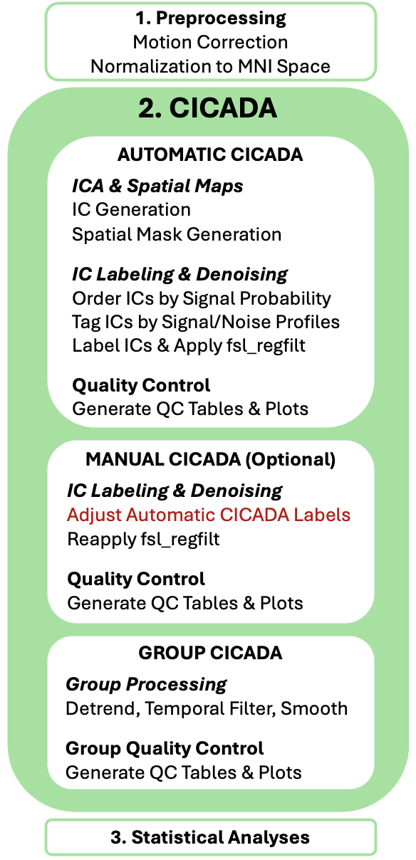Figure 1. Cicada Pipeline
The Comprehensive Independent Component Analysis Denoising Assistant (CICADA) is a novel ICA-based denoising method applicable for both resting-state and task-based fMRI data. CICADA evaluates independent-component spatial maps, time series, and power spectra to automate or streamline ICA-based signal/noise classification and provides subject- and group-level quality-control outputs.

CICADA is designed for after preprocessing (including normalization to MNI space but without smoothing) but before statistical analyses. CICADA uses manual IC classification guidelines¹ (the gold-standard of ICA denoising) to help identify all commonly established sources of fMRI noise. Specifically, CICADA uses the IC spatial maps, timeseries, and power spectrums to classify ICs as signal or various types of noise. CICADA can be split into three main different sections. First is Automatic CICADA, which performs subject-level ICA denoising and quality control automatically. Second is Manual CICADA, a fully optional step, which allows a user to perform a highly efficient version of manual IC denoising with quality control analyses. Third is Group CICADA, which will perform group-level processing and quality control of the CICADA-denoised data. Altogether, CICADA aims to effectively automate the manual gold standard, make the gold-standard more efficient and approachable, and significantly ease quality control analyses following denoising.
Beginning with v1.1.0, Automatic and Manual CICADA also generate additive subject-level signal-evidence and direct functional-data reliability products. Group CICADA can merge these products across retained images with an explicit volume-order manifest. These additions do not change CICADA denoising, automatic or manual IC classification, or the legacy group functional and signal-mask outputs.

More information on CICADA can be found in the manuscript and supplementary material:

Dodd KC, McHugo M, Sarabia L, Wylie KP, Legget KT, Cornier MA, Tregellas JR. CICADA: An automated and flexible tool for comprehensive fMRI noise reduction. Imaging Neuroscience. 2025.

CICADA Use Cases
CICADA’s bundled anatomical and network defaults are designed around MNI 2009c asym space. Data in another space require appropriately aligned anatomical/tissue inputs, and template-dependent products must be geometrically compatible with that space. CICADA works well with fMRIPrep preprocessing but fMRIPrep is not required. CICADA is compatible with resting-state and task data. See “How to Run Automatic CICADA” for more details.

If updates to CICADA are made, this will be detailed on the GitHub (https://github.com/keithcdodd/CICADA).

Manuscript Language and Citation
If you use CICADA for denoising your data, below is an example of the language you might use in your methods. Due to the flexibility of options that CICADA offers, however, this will almost certainly need to be adjusted. The provided example assumes the Automatic CICADA Pipeline was applied for all data, two CICADA outliers were detected, and that the Manual CICADA Pipeline was used to “rescue” one of these outliers. It also assumes that the newer “matched” version of temporal filtering and IC regression was applied vs the original sequential method (see temporal_cleanup_mode paragraph in Group CICADA Methods section). It is likely simpler and often sufficient to instead simply exclude all clear denoising outliers from the Automatic CICADA Pipeline rather than try to rescue data with the Manual CICADA Pipeline. The example below includes it, however, to assist with the language if that method is used.

Data Denoising and Quality Control
Denoising was performed using the Comprehensive Independent Component Analysis Denoising Assistant (CICADA; Dodd et al., 2025; https://github.com/keithcdodd/CICADA). CICADA classifies independent components as signal or noise using spatial, temporal, and spectral features and provides subject- and group-level quality-control outputs. In the current study, Automatic CICADA was used for IC classification. During Group CICADA processing, second-order polynomial detrending and Butterworth bandpass filtering (0.008–0.15 Hz) were applied identically to the original BOLD data and complete MELODIC mixing matrix before nonaggressive ICA cleanup, with only noise-classified IC contributions removed. The resulting data were spatially smoothed with a 6 mm FWHM Gaussian kernel. Denoising quality was assessed using subject- and group-level CICADA QC outputs. Two participants were automatically flagged as CICADA outliers; Manual CICADA improved denoising for one, while the other was excluded. All retained data were used for subsequent analyses.

Reference:
Dodd KC, McHugo M, Sarabia L, Wylie KP, Legget KT, Cornier MA, Tregellas JR. CICADA: An automated and flexible tool for comprehensive fMRI noise reduction. Imaging Neuroscience. 2025.

Getting Started
This section is meant to be a quick-and-easy reference for getting CICADA working with your data as quickly as possible. If you run into issues, please first refer to the rest of this document (and/or the manuscript, supplementary material, and coding comments) where more details are given. Otherwise, please report the issue on the GitHub, and I will try to address it. Thanks!

______________________________________________________________________________
General Set Up Steps:
- Have required software:
  - FSL (tested v6.0.5.2)
  - Matlab (tested version 2022a)
    - Toolboxes: Statistics & Machine Learning, Image Processing, Image Acquisition, Bioinformatics, Signal Processing Toolbox (new requirement as of 01/20/26).
    - Note: You can manage your toolboxes in Matlab via Home -> Add-Ons
  - CICADA: Clone or download whole CICADA folder from GitHub.
- Check Software Configuration:
  - Check/modify startup_fsl_CICADA_path.m file: This script will try to get your FSL and Matlab to play well together. It is almost certain a user will need to modify this script to fit their configuration! Auto_CICADA.m will also automatically use this script to try to set up your FSL and Matlab if it does not appear to be configured. You can then try to run the script and check that the following works (b-d):
  - Check that FSL saves files as .nii.gz
    - In terminal: echo $FSLOUTPUTTYPE should say NIFTI_GZ
  - Check that Matlab can call FSL
    - In Matlab: [status, output] = call_fsl('flirt -version') should show output as your FLIRT version
  - Check that Matlab can call CICADA
    - Add CICADA (with subfolders) to Matlab path, if it is not already
- Check Your Data Set Up
  - BIDS Formatting
    - CICADA/example_CICADA_flow/ReadMe gives an example of working file set-up.
______________________________________________________________________________
Running CICADA (Recommended methods):
- Set Up & Script Preparation
  - Check/modify startup_fsl_CICADA_path.m file to make sure it matches your system and configurations.
  - Refer to CICADA/example_CICADA_flow/ReadMe.docx to see how your data should be ideally structured.
  - CICADA/example_CICADA_flow/example_code has ready-made example scripts that you can configure/adapt for your data
- Automatic CICADA Pipeline
  - Run Either example_Auto_CICADA or example_fmriprep_auto_CICADA wrapper functions
  - You can check subject QC: qc_plots & network identifiability NIfTI (see Evaluating Subject-Level Quality Control Plots & Metrics section for more details)
  - Review the subject-level support_products folder for continuous signal/noise IC evidence, thresholded evidence derivatives, direct reliability, robust tSNR, and provenance.
- Manual CICADA Pipeline (optional alternative to Automatic CICADA Pipeline)
  - Still start with running Automatic CICADA Pipeline
  - Perform Expedited Manual Labeling:
    - Edit signal label column of IC_auto_checker.csv as needed and resave as IC_manual_checker.csv (see How to Run Manual CICADA section)
  - Now you can perform Manual CICADA:
    - Run example_Manual_CICADA or example_fmriprep_manual_CICADA (see “How to Run Manual CICADA” section for more details)
- Group CICADA Pipeline (mainly a Quality Control checker and data organizer)
  - Always run AFTER either Automatic CICADA Pipeline OR Manual CICADA Pipeline
  - In example_Group_CICADA: If you found data that you want to exclude from all analyses for sure, mark as an “exclude.” If you performed Manual CICADA on an image to correct IC classification, mark as an “adjusted.” The idea being that if some data is not sufficiently denoised by Automatic CICADA, a user could try to denoise it better with Manual CICADA. If successful, then the user can tell Group CICADA (via “adjusted” parameter) which data to use the Manual CICADA IC classification over the Automatic CICADA IC classification.
    - Recommendation: Only “exclude” truly terrible data (e.g., only 10 ICs in total are generated, or no signal ICs are observed, or some clearly obvious issue); CICADA will otherwise automatically flag badly denoised data as a “cicada_outlier.” Still, excluding truly terrible data may help CICADA better automatically recognize other potentially problematic data, given that cicada_outliers is looking for data outliers compared to the rest of the included data.
  - Recommendation: For Group CICADA, degree-2 polynomial detrending remains the default. Temporal bandpass filtering is optional and is not enabled by default. For resting-state analyses, [0.008, 0.15] Hz is an available commonly used option when scientifically appropriate. Task fMRI should not receive a generic resting-state bandpass without first considering the task design. Spatial smoothing and voxelwise scaling remain analysis-dependent; voxelwise scaling is off by default.
  - Check Group QC plots (There will be 2 different QC images: (1) a QC image for all the data that wasn’t explicitly excluded; (2) a QC image with cicada_outliers (denoising outliers that were automatically flagged by CICADA) removed. See Evaluating Group-Level Quality Control & Metrics section for more details.
  - Review the group support_products/core, support_products/qc, and support_products/provenance folders. Use the provenance manifest as the authoritative 4-D volume order.
- Run your favorite analyses on your denoised data!
  - Recommendation: More than likely, analyses should continue by removing cicada_outliers, which is simple to do given that cicada_outliers are marked in the group_qc_table output from Group CICADA. This is especially confirmed in the Group CICADA QC plots when/if the cicada_outliers removed plot looks clearly better than the ones without them removed.

CICADA Installation
The most recent version of CICADA is available for download from the author’s GitHub page (https://github.com/keithcdodd/CICADA). To install and use, a user needs to clone or download the CICADA script folder. The user must also have FSL and Matlab installed and working. Likely necessary Matlab Add-Ons include Statistics and Machine Learning Toolbox, Image Processing Toolbox, Image Acquisition Toolbox, Signal Processing Toolbox, and Bioinformatics Toolbox. More Matlab toolboxes (“Add-ons”) may be necessary.

CICADA Dependencies:
- FSL (tested on version 6.0.5.2)
- Matlab (tested on version 2022a)
  - Statistics & Machine Learning Toolbox, Image Processing Toolbox, Image Acquisition Toolbox, Bioinformatics Toolbox, Signal Processing Toolbox

FSL must be set up to work with gzipped nifti files (.nii.gz). For example, FSLOUTPUTTYPE must be ‘NIFTI_GZ’ and FSL must be able to connect to Matlab (e.g., path must include fsl/etc/matlab). Similarly, the system path ($PATH variable on mac/unix, PATH environmental variable on Windows) must have FSL in it, and the call_fsl Matlab function must be able to successfully run fsl commands. When run, the Auto_CICADA script will attempt to fix these variables for the user automatically. However, the correct set up may differ depending on the user, operating system configuration, or updates. The current methods can be referenced in the figure below (from the Auto_CICADA function) and adjusted to fit the needs of the user:

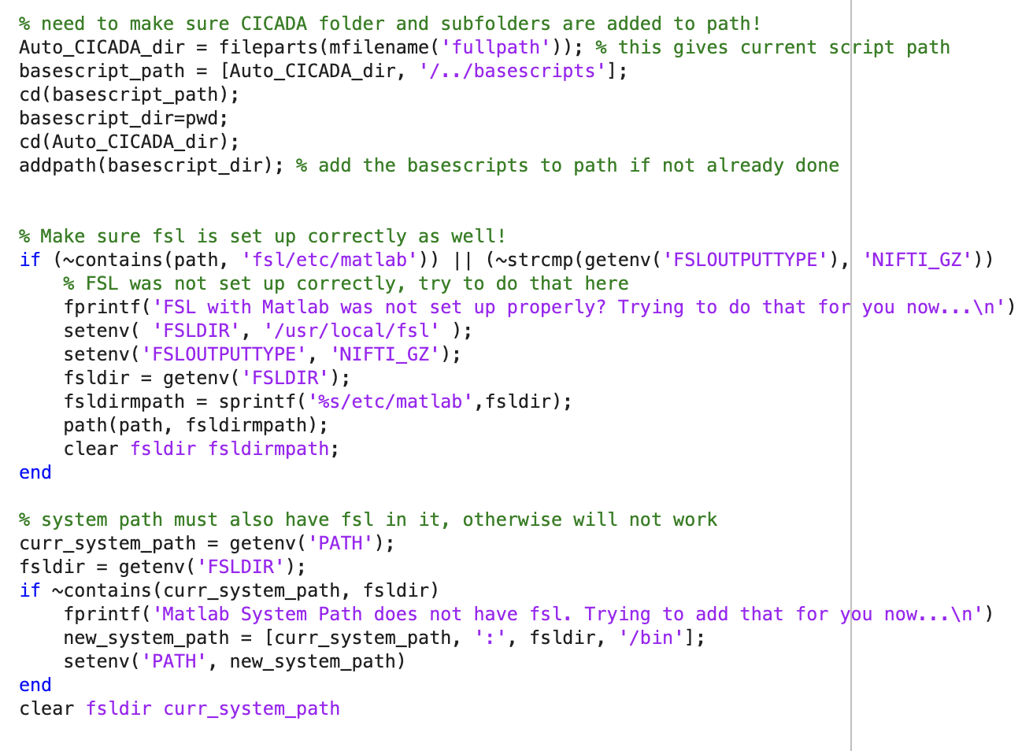
Figure 2. FSL & Matlab Compatibility Set Up

How to Run Automatic CICADA
Broadly, Automatic CICADA is carried out through three scripts (referred to as “base scripts”): 1. CICADA_1_MasksandICAs.sh, 2. CICADA_2_AutoLabeling.m, and 3. CICADA_3_QC.m. They are to be run in order for each fMRI scan. These scripts can be run either individually or, more commonly, can simply be automatically called by the wrapper script Auto_CICADA.m. Notably, if the data was preprocessed via fMRIPrep, this wrapper script can, perhaps more easily, be called as part of fmriprep_auto_CICADA.m wrapper function. The general flow of the Automatic CICADA Pipeline can be seen in the two figures below.

Required inputs for Automatic CICADA include: an output directory, the preprocessed functional file and functional mask, and a confounds file (with the 6 motion parameters, mean CSF and WM timeseries, DVARS, framewise displacement, and global signal). Optional, but highly recommended, inputs include an anatomical mask and gray matter, white matter, and CSF probability files. Those four inputs become necessary if your preprocessed data is not in MNI 2009c asym space, given that CICADA will use MNI 2009c asym templates if those inputs are not supplied. Similarly, a task events file is optional, but highly recommended if working with task-based data. Other optional inputs include the preprocessed anatomical file (does not have to be a T1), a MELODIC directory and flag (so a user can direct CICADA to a previous MELODIC folder instead of rerunning MELODIC), a compare file (an alternatively denoised file so a user can compare CICADA to it – will default to comparing to standard 8 parameter regression), and a tolerance value (default to 5; see Running Automatic CICADA following fMRIPrep preprocessing section).

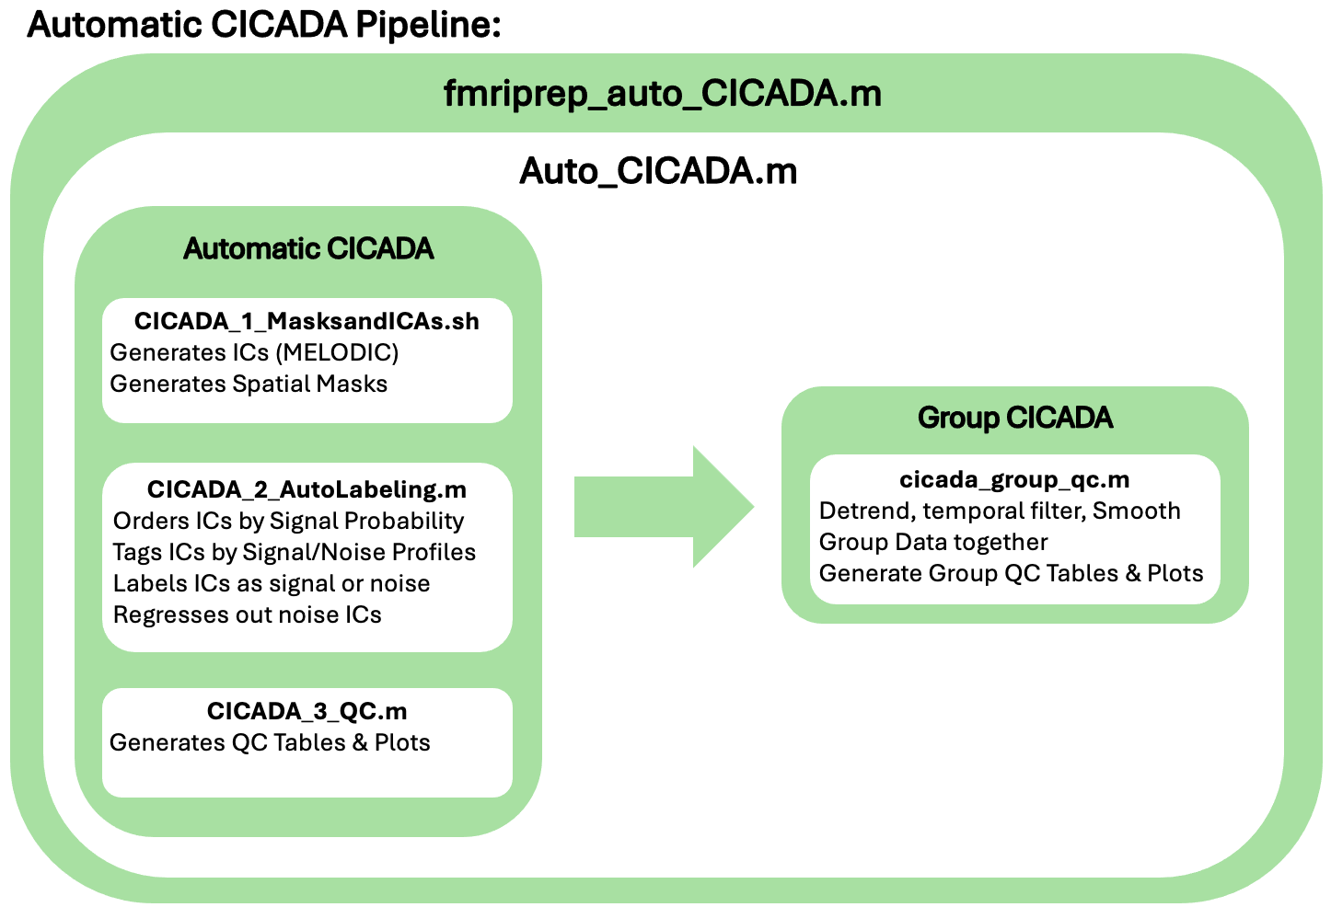
Figure 3. Script Flow for Automatic CICADA Pipeline. Of note, Auto_CICADA.m is sufficient to run the full Automatic CICADA pipeline. The fmriprep_auto_CICADA.m may just offer an easier method to implement the Automatic CICADA pipeline for datasets that have been preprocessed with fmriprep.

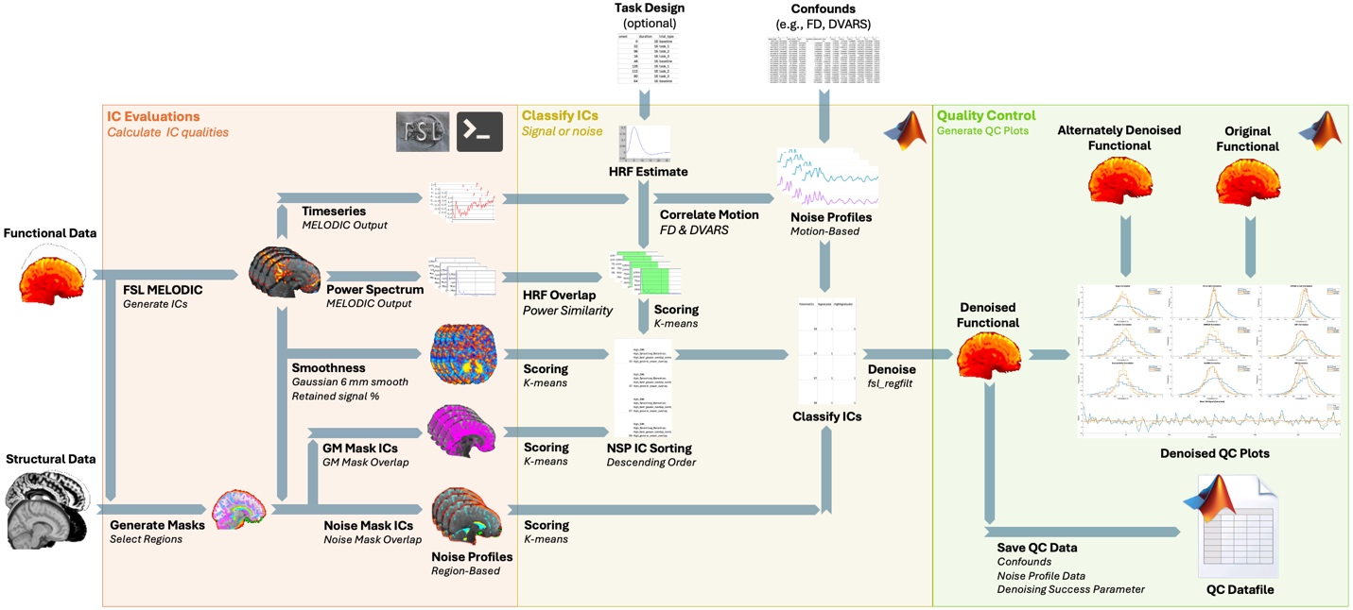
Figure 4. Schematic of Automatic CICADA Pipeline. Of note, structural files include a T1, brain mask, and GM, WM, and CSF probability files. Functional files include the functional file itself and a functional brain mask. A confound file (described in more detail later) includes commonly-utilized confound parameters. A task design file is always optional, and would only be relevant for task-design studies (described in more detail later).

Running Automatic CICADA following fMRIPrep preprocessing:
CICADA requires BIDS filenames and directory structure format (https:// https://github.com/bids-standard), as shown in the figure below. If the data was preprocessed using fMRIPrep (e.g., version 20.2.6), then the output files will already be in BIDS format.

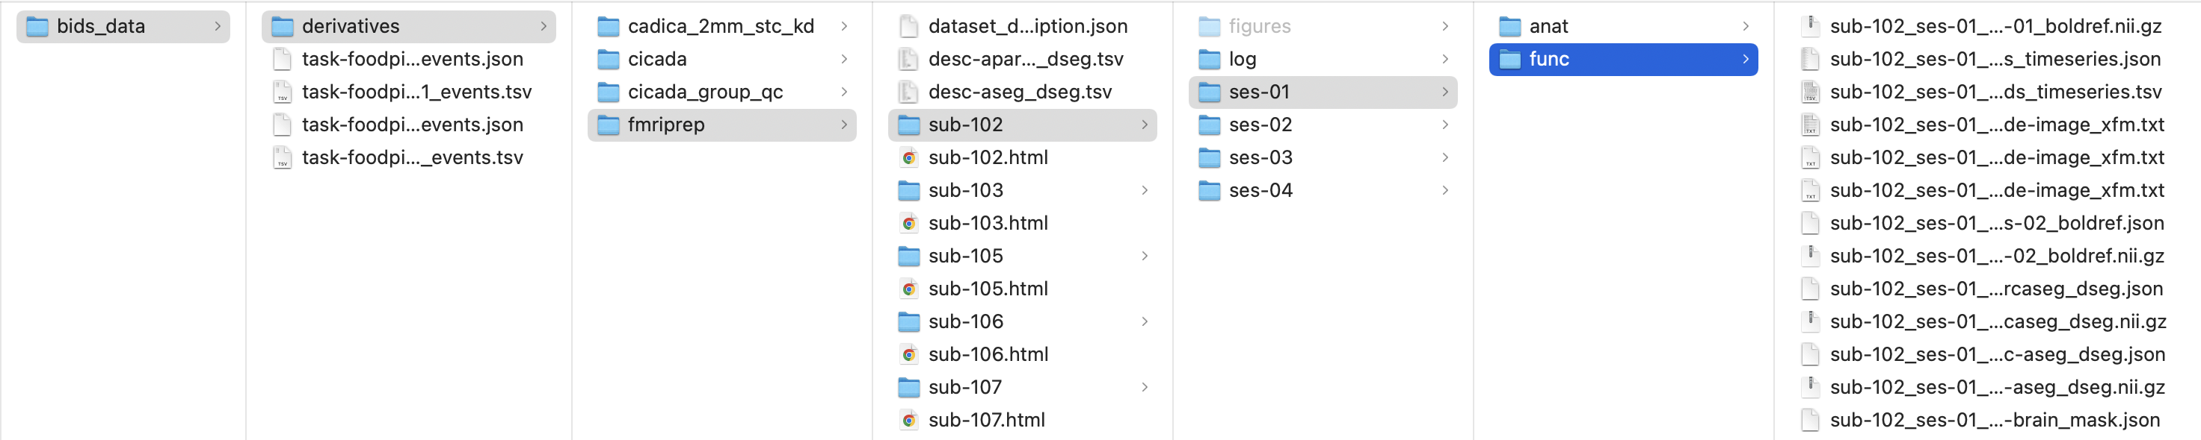
Figure 5. Necessary Directory Formatting (BIDS).

CICADA can typically be run on fMRIPrep processed data with the fmriprep_auto_CICADA.m command. However, the folder/file/naming format can differ depending on the version of fMRIPrep and the structure of the underlying data. Therefore, it is possible that instead of using the fmriprep_auto_CICADA.m command, a user should instead use the command Auto_CICADA.m which will allow a user to use CICADA even with different file naming or structure. If the fmriprep_auto_CICADA.m command is used, it should be applied to each folder for each image. For example, at the Matlab command prompt:

> fmriprep_auto_CICADA(/path/to/fmriprep/data/folder, /path/to/cicada/output/folder, sub_id, ses_id, task_name, anat_ses_id, redo_mel, mel_fol, task_events_file, compare_file, tolerance, despike)

Input argument “sub_id” is the subject ID number, “ses_id” is the session ID number, “task_name” is the name of the task, “anat_ses_id” is the ID number for the session where the best/preferred anatomical scan is from fMRIPrep (often times, this is either the same as the ses_id, or just the first session [“01”]). In the case that there is no best session where the anatomical scan is held (i.e., the anat folder is not held within a session folder), a user can either give an empty “anat_ses_id” (anat_ses_id = ‘’), or just set it to the same as the ‘ses_id’. The “redo_mel” numerical input should normally be 1, to always run melodic to generate ICs, regardless of if it has been run in the past.

Input “task_events_file” is the path to a task events file that details the task onsets (only relevant if it is a task design, in which case providing this is highly recommended but not necessary). If it is resting state, or a user would rather not include a task events file, this parameter can be left as an empty character string: ‘’. The task events file, if used, is often named similar to “task-foodpics_run-01_events.tsv” (see Figure 6). Specifically, the file must have the following columns: “onset” (in seconds), “duration” (in seconds) and “trial_type” (naming for the different trial types, without spaces). If a task events file is provided, CICADA will use it to generate individually estimated HRF responses for each trial type and one combined estimated HRF response, to help capture ICs that are related to each trial type. Thus, if this can be applicable to a user’s task-design, it is highly suggested to be included. Task data can be block or event-related design. If the task data is an event-related design, the duration (in seconds) would have to be adjusted accordingly (e.g., duration of 1 TR in seconds could be seen as relatively equivalent to an impulse or event). Specifically, the onset and durations columns are used by CICADA to create a box function to convolve with the HRF response.

The “compare_file” is the fMRI data to be compared to the CICADA-denoised data. By default, the compare file is the 8 parameter (8p) regression denoised image created by CICADA. You can also use '6p', '8p', '12p', '16p', '18p', '24p', ‘28p’, ‘30p’, '32p', or '36p' as the input for compare_file to compare to standard 6-parameter, 8-parameter, 12-parameter… etc. denoising. See section on compare file tag options for more information. The input “tolerance” is the tolerance value to use during “ CICADA_2_AutoLabeling.m”. In short, tolerance relates to the maximum number of signal-probability-sorted ICs in a row that CICADA labels as noise before automatically labeling all other ICs also as noise. For more details on tolerance, see details in “Basescript 2: CICADA_2_AutoLabeling.m” section. The default tolerance value (5) is suggested.

Finally, the optional “despike” option allows a user to apply light temporal despiking (in a manner inspired by AFNI 3dDespike -localedit -NEW) of their fMRI data BEFORE everything else (before MELODIC IC decomposition). The idea being that this may help lightly denoise the data to help IC decomposition in better separating out neuronal signal ICs from noise ICs. In short, large movement spikes may often “bleed” into gray matter significantly, which can make it difficult for IC decomposition to properly separate out gray matter neuronal signal from noise. By despiking the worse of the movement spikes first, hopefully this may also help better separate out signal from noise with MELODIC IC decomposition. Note, this was not used in the CICADA manuscript and has not been thoroughly tested. However, there is a chance that this may help particularly noisy data. The default is to not despike, in line with the CICADA manuscript. To apply despiking, set the “despike” parameter to 1.

In general, “mel_fol”, “task_events_file”, “compare_file”, and “tolerance” values are not necessary to run the fmriprep_auto_CICADA function (especially when the data is resting state with no “task_events”_file). If the image files are from task-based data, CICADA may also benefit from, but does not require, inputting a task events file. The task events file for CICADA is of the same format as in BIDS file formatting. In short, it must be a .tsv, and for CICADA, must at least include the following columns: onset, duration, and trial_type. Of note, baseline conditions should be labeled specifically as “baseline” in the trial_type column. This allows CICADA to ignore baseline when modeling hemodynamic response functions. An example file is shown below.
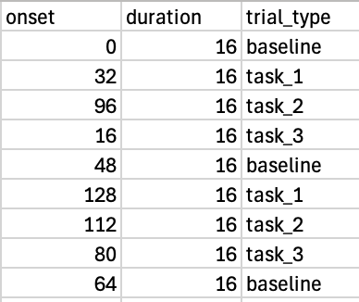
Figure 6. Task Events File Formatting Example.

For example, running CICADA on sub-102, ses-01, task-rest, and fmriprep folder located at /home/fmriprep, output directory /home/cicada, the Matlab command would be:

> fmriprep_auto_CICADA('/home/fmriprep', '/home/cicada', '102', '01', 'rest', '01', 1)

Running Automatic CICADA for Preprocessed Data With or Without fMRIPrep:
If the data was preprocessed outside of fMRIPrep, or the fMRIPrep folder/file structure is different than given above, the necessary inputs can always be provided through the Auto_CICADA.m function in the wrappers folder. The command looks like this:

> Auto_CICADA(output_dir, funcfile, funcmask, confoundsfile, redo_mel, mel_fol, compare_file, task_events_file, anatfile, anatmask, gm_prob, wm_prob, csf_prob, tolerance)

Where “output_dir” is the desired CICADA output directory, the “funcfile” is the functional file and “funcmask” is the funcmask. The “confoundsfile” input is normally, by default, the fMRIPrep confounds file. This file is usually named similar to “sub-102_ses-01_task-rest_desc-confounds_timeseries.tsv”. In the case where fMRIPrep was not used, a confounds file that is in the same format as the fMRIPrep file (e.g., .tsv filename) needs to be created. It should look like the following:

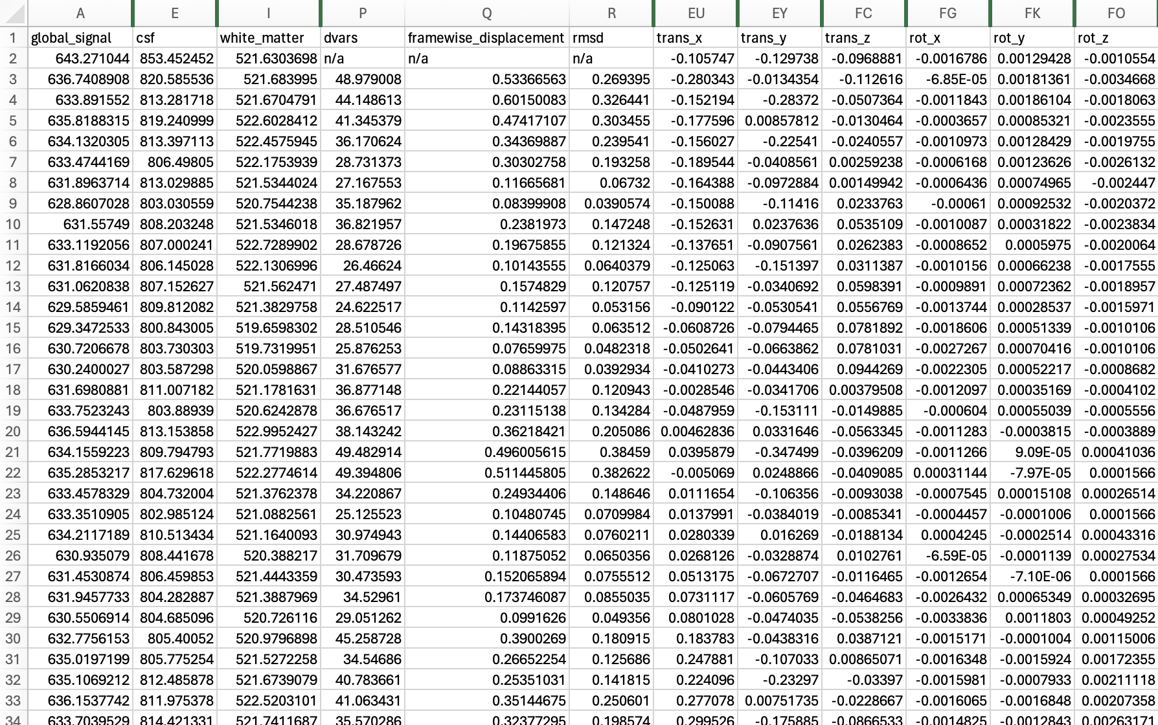
Figure 7. Confounds File Format.

The confounds file can contain many more confounds columns (like the fMRIPrep file), but it must have the confounds listed here, with the same column names. Altogether, it must have the nine common parameters (six motion, white_matter, csf, global_signal), as well as dvars, framewise_displacement, and rmsd. They must have the same naming as above for CICADA to find the appropriate confounds. The confound file structure mainly comes into play during Basescript 2: CICADA_2_AutoLabeling, so a user can refer to that script for more details.

The “redo_mel”, “mel_fol”, “compare_file”, “task_events_file”, and “tolerance” inputs are the same as mentioned in the “Running Automatic CICADA following fMRIPrep preprocessing” section.

The “anatfile” input is the anatomy file, usually a T1. If not provided, the MNI 2009c asym T1 will be used. The “anatmask” input is the anatomy mask. The “GM_prob”, “WM_prob”, and “CSF_prob” inputs are the probability files for gray matter, white matter, and cerebral spinal fluid. If these three probability files are not provided, CICADA will default to the standard MNI 2009c asym probability files as well. Of note, if the data is not in MNI 2009c asym space, then providing the anatomical mask and GM, WM, and CSF probability files are required.

Compare File Tag Options
When running CICADA, you can compare CICADA denoising to any other denoised file of interest. By default, CICADA will compare to eight parameter (‘8p’) denoising. However, CICADA allows for comparison to a great number of common denoising techniques. A table lists the options, and what they entail, below:

Compare File Tag | Denoising Regressors
‘6p’ | 6 motion parameters
‘8p’ | 6p + phys parameters (mean CSF and WM)
‘9p’ | 8p + mean global signal
‘12p’ | 6p + their derivatives
‘16p’ | 8p + their derivatives
‘18p’ | 9p + their derivatives
‘24p’ | 12p + motion quadratics & quadratic derivatives
‘28p’ | ‘24p’ + phys parameters & their derivatives
‘30p’ | 28p + mean global signal & its derivative
‘32p’ | 16p + quadratics & quadratic derivatives
‘36p’ | 18p + quadratics & quadratic derivatives

For more information, see relevant code in the second basescript.

Automatic CICADA Methods
CICADA methods are all contained within the basescripts which are called by Auto_CICADA.m. The methods used by each basescript are described in detail below.

Basescript 1: CICADA_1_MasksandICAs.sh
Broadly, the first basescript creates anatomical and functional masks, performs FSL’s MELODIC to generate ICs, and provides relevant calculations of these ICs, using the previously created masks, to prepare for IC classification in the second basescript.

Many new masks are generated by the first basescript. First, a new functional mask is created to ensure that areas outside of the brain tissue (but generally excluding the skull) are included. This helps ensure that CICADA will be able to characterize both sinus flow and edge artifact. This is accomplished by first taking the maximum of the original functional mask and the anatomy mask (resampled to functional space). Second, the output from the first step is masked both by a 6 mm gaussian smoothed anatomical mask and a lightly thresholded unmasked functional file to form the final functional mask. Altogether, this creates a functional mask large enough to include sinus flow and edge artifact, but without retaining large amounts of other material (e.g., skull, eyes, etc.). The unmasked functional file is then masked by this new functional mask (which is used as the functional mask for all future calculations as well).

Several region-based probability files and masks are then created. In each case, a probability file (an approximation of the relative chance that a voxel belongs to the given region) is created first. Then, a mask of this region is generated, usually by thresholding at a robust 67th percentile. First, a stringent susceptibility probability and mask is calculated. In short, functional file voxels whose values fall at or above the robust 50th percentile are given a susceptibility probability of 0% with susceptibility values increasing up to 100% as functional file voxels decrease to the 0th percentile. Next, the edge region is calculated. First, the susceptibility mask is subtracted from the functional mask. Second, an eroded and smoothed functional mask is subtracted to give the edge region. Gray matter (GM), white matter (WM), and cerebral spinal fluid (CSF) regions are then calculated. First, their corresponding probability files (which can be provided from the user but will default to the ones from fMRIPrep) are resampled, then the edge and susceptibility probability files are subtracted and then masked by the functional mask. Next, a subependymal region is calculated. In short, first, CSF and WM are masked by an eroded anatomy mask. The GM probability is then subtracted out and then smoothing is applied. The overlap between these modified CSF and WM files are then used to estimate the subependymal region. Next, a NotGM region is calculated by subtracting the GM region from the functional mask. An “inbrain” region is generated by subtracting the subependymal region from a combined GM and WM region. An “outbrain” region is then formed from subtracting this “inbrain” region from the functional mask. Finally, an “outbrain_only” region (a region containing mostly outside sinuses and not the inner CSF) is created by subtracting the CSF, subependymal, edge, susceptibility, and eroded anatomy mask regions from the outbrain region. This concludes the major region/mask generations of the first basescript. An example image of the most relevant region masks is detailed in the CICADA manuscript, but also provided here.

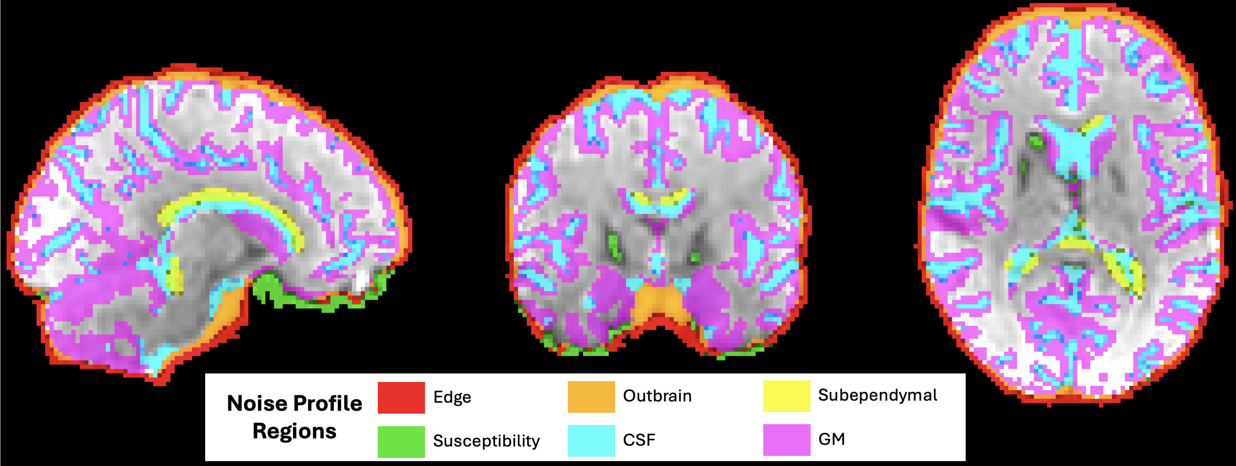
Figure 8. CICADA-Generated Noise Profile Regions Example

After creating the relevant masks, the first basescript then performs FSL’s MELODIC to generate the ICs. Next, estimates for IC smoothness and IC spatial map probabilities are calculated. Probabilities are calculated by merging and thresholding probability maps from MELODIC. Two different IC spatial maps are generated to later calculate smoothness. First, a non-thresholded IC z-stat map is created from MELODIC outputs and absolute valued. Second, the IC z-stat map is Gaussian smoothed using an 11 mm FWHM kernel (sigma = 4.6713 mm for FSL’s fslmaths -s) and then absolute valued. The second basescript later uses these two maps to calculate a “Smoothing_Retention” parameter, reflecting how much of the IC spatial-map magnitude is retained following smoothing. In general, spatially coherent ICs retain more of their magnitude following smoothing. The first basescript then also resamples a brain network template (from Guzmán-Vélez et al.², and adapted from Yeo et al.³) to the functional space.

Of note, the original CICADA implementation used FSL -s 6, which specifies sigma rather than FWHM and therefore corresponds to approximately 14.1 mm FWHM. The smoothing scale has been subsequently reevaluated using the original development and held-out validation data. Classification was stable across approximately 9–14 mm FWHM (tested between 6-20 mm FWHM), and 11 mm FWHM was selected as a central value within this stable range. On the held-out consensus-labeled validation cohort, the revised kernel changed only 4 of 4,783 IC classifications while preserving overall classification performance; blinded reassessment of those four changed ICs also favored the revised classifications. Historical sigma = 6 mm behavior remains available as an explicit reproducibility option. This Smoothing_Retention smoothing is a classifier-feature calculation and is distinct from preprocessing or group-level spatial smoothing and from smoothing used elsewhere in CICADA for mask construction.

The final part of basescript one involves calculating the IC spatial map overlap with each relevant mask generated near the start of this script (alongside the networks from the adult brain network template, if desired). This outputs the overlap mean and number of voxels. This then sets up for basescript two, which will calculate the total overlap for each relevant region from these values.

Basescript 2: CICADA_2_AutoLabeling.m
Broadly, the second basescript classifies the ICs and applies nonaggressive denoising. First, a smaller, more constrained, functional mask is generated. The purpose of this constrained mask is to help later generate an improved group functional mask. Next, an HRF response is estimated using a double gamma HRF. If the functional file is a task-based scan, and a task events file is provided, an HRF response estimate based on the task events file is also generated. Next, the second basescript uses the outputs of the first basescript to calculate the general IC spatial overlap with each relevant region and network. The relative proportion of each region overlap compared to the total spatial IC map is also calculated. Smoothness (“Smoothing_Retention”) is estimated by dividing the summed magnitude of the smoothed IC z-stat map by the corresponding summed magnitude of the unsmoothed map (see “Basescript 1: CICADA_1_MasksandICAs.sh” section). Next, general power frequency proportions are calculated and categorized by low frequency (<0.008 Hz), BOLD (0.008-0.15 Hz), and high frequency (>0.15 Hz). The overlap between the IC power frequencies and the estimated HRF responses power frequencies is also calculated (“hrf power frequency overlap”). Next, timeseries correlations to DVARS, Framewise Displacement (FD, the version proposed by Power 2012⁴), the six motion parameters, white matter, CSF, and global signal, are all calculated. These parameters are pulled from a user-provided confound file but will default to pull from the fMRIPrep confound file if it exists. Specifically, a detrended DVARS and FD are correlated to a detrended, differentiated, and absolute valued timeseries. This method is chosen as DVARS and FD are, by definition, differentiated and absolute valued parameters as well. General IC timeseries “spikiness” is also estimated by the maximum absolute value of the normalized timeseries.

The second basescript then uses k-means clustering, classified into three groups, to cycle through relevant noise profiles (see manuscript for more detail on noise profiles), brain networks, and other related variables detailed above. The initial k-means starting points are given as the minimum, median, and maximum values (“k-means classified” as low, medium, or high). Thus, the ICs are clustered as either high, medium, or low in that noise profile, network, or other variable. Many of these classifications are labeled as either “good” (highly likely to indicate neural signal) or “bad” (highly likely to indicate noise). Basescript two then re-sorts the ICs, from high to low, based on the following equation:

$$NSP=norm\left(S\right)*{norm\left(GMO\right)}^{2}*norm(PSO)$$

NSP is the relative “neural signal probability”, S is “smoothing”, GMO is “gray matter spatial map overlap”, and PSO is “power spectrum overlap.” In each case, “norm” refers to a normalization of each parameter to values ranging from [0,1]. Overall, this equation takes advantage of the fact that neural signal is characterized by ICs with higher smoothness, higher gray matter overlap, and higher power spectrum overlap with the estimated HRF response. GMO is squared to greater weight its value, as gray matter overlap is likely more specific of neural signal than either smoothness or power spectrum overlap. This can be inferred, for example, by the fact that certain noise profiles (e.g., subependymal) can be highly smooth and have great power spectrum overlap but not have high GM overlap.

After re-sorting the ICs from high to low based on NSP, CICADA loops through each IC to classify each IC as either (neural) signal, or noise. For an IC to labeled as signal, the IC needs to meet the following criteria:

IC Signal Labeling Criteria:
- The IC is k-means classified as high in either GMO, PSO, or S.
- The IC is either k-means classified as high in GMO or is not high in any other regional spatial overlap.
- The IC either has no noise-like k-means labels or is k-means classified as high in both GMO and either PSO or S.

While looping through each IC in NSP order, CICADA uses a tolerance value (default is 5 but can be modified by the user) to determine when to stop. Whenever CICADA labels an IC as noise, the tolerance value is reduced by one. Similarly, when CICADA labels an IC as signal, the tolerance value is increased by one (but is never raised above the starting value). If the tolerance value reaches 0, CICADA stops looping through the ICs and labels the rest of the ICs as noise. CICADA will also not loop through ICs whose NSP is less than the mean IC NSP. Therefore, any IC whose NSP is less than the mean NSP will also be labeled as noise.

If less than two ICs are labeled as signal initially, CICADA will correct this by labeling the highest two NSPs as signal. This acts as a failsafe to the code structure. Later, Group CICADA (see “Group CICADA Methods” section) will also label each image that has less than 3 ICs labeled as signal as outliers to not be used.

Next, the second basescript will create an excel spreadsheet (“IC_auto_checker.csv”) that details the selection process. The “IC_auto_checker.csv” includes the IC number, what CICADA labeled it as (signal or noise), if the IC was high in signal or noise, any good (signal-like) or bad (noise-like) classifications given to the IC, and if the IC may have been grouped toward a particular brain network. An example image of part of one of these files is given below. Of note, the “SignalLabel” column contains CICADA’s final decisions on IC classifications where a 1 is signal, and a 0 is noise.

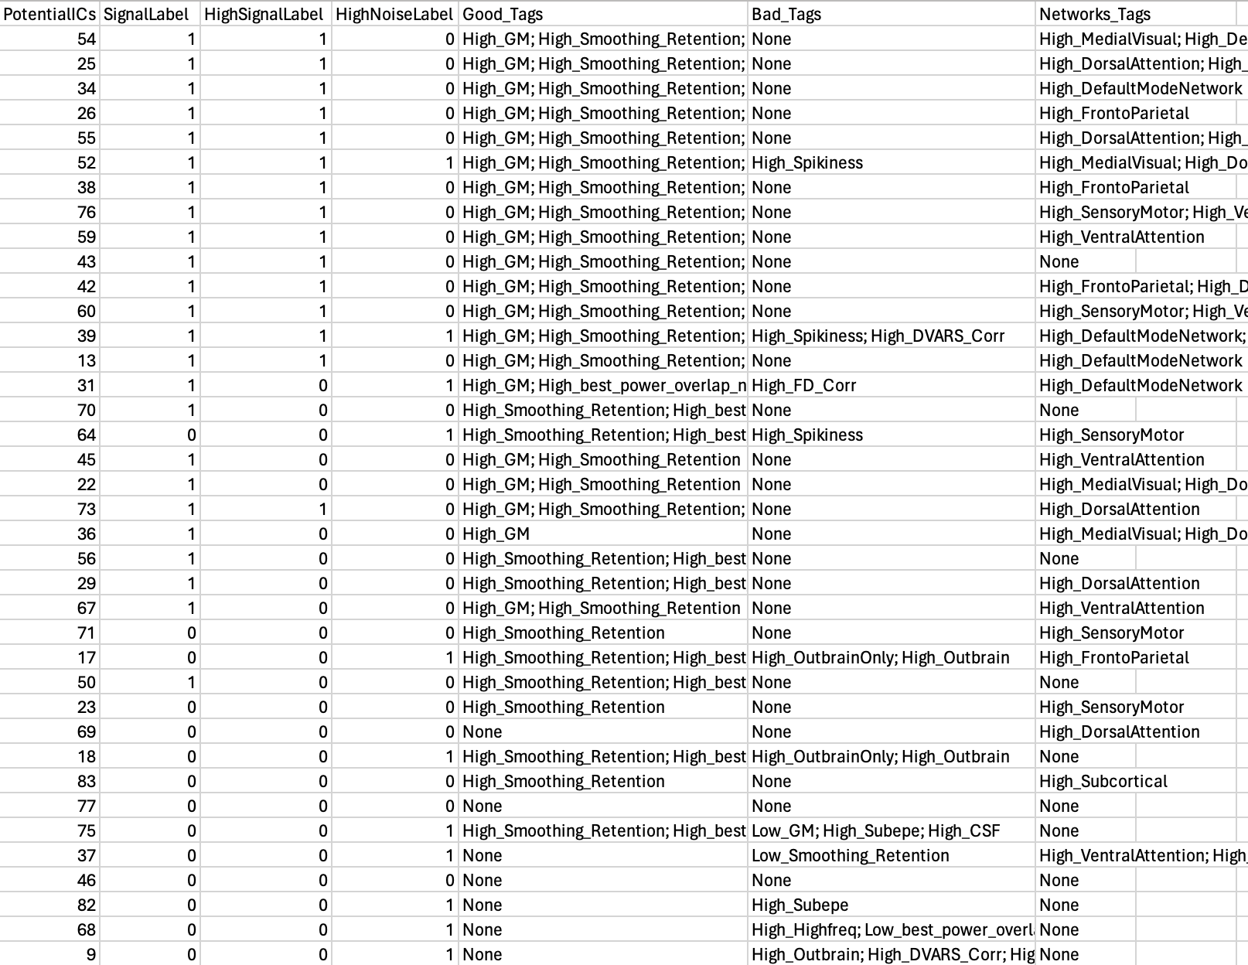
Figure 9. CICADA IC_auto_checker Example

Finally, basescript two performs a few last actions to make it easier for a user to examine the classification and output. CICADA creates structures to hold all relevant calculations, values, and classifications. CICADA also creates a “compare cleaning” table to compare the relative feature proportions of all ICs to just the ICs that CICADA labeled as signal. CICADA also generates a signal-to-noise ratio image and generates images containing all noise and all signal IC overlaps. Files to perform nonaggressive denoising (the standard default method) and aggressive denoising are saved and exported. Then, basescript two performs nonaggressive denoising via fsl_regfilt, alongside 8 parameter regression (six motion parameters + mean WM + mean CSF) and 9 parameter regression (8 parameter + mean global signal) for comparison. All relevant variables are saved and exported.
Beginning with v1.1.0, basescript two also creates a support_products folder for each completed Automatic CICADA image. This folder contains direct functional-data reliability and robust tSNR products; continuous signal and noise IC-overlap evidence maps; p50 and p95 thresholded evidence masks; 6-mm-smoothed extended signal-evidence derivatives; the constrained calculation domain; and provenance tables. The continuous signal IC-overlap map is the primary signal-support product. It describes the spatial evidence supplied by ICs labeled as signal, but it is not a calibrated probability of neuronal signal or a definitive tissue mask. These products are additive and do not alter IC labels or the denoised functional output.

Basescript 3: CICADA_3_QC.m
Basescript three generates useful quality control (QC) analyses for each fMRI image. This assists in quality control analyses and in evaluating how well CICADA performed. This also helps inform a user if the IC selection for an image should be adjusted and rerun (“Manual CICADA”). Altogether, CICADA creates 10 plots of QC metrics, including six “region-based” noise profile correlation plots, two “confound-based” noise profile correlation plots, a plot of the within-gray-matter correlation distribution, and a plot of the detrended mean gray matter signal. More information on interpreting the QC plots and metrics is provided in the following section “Interpreting QC Plots and Metrics.”

In creating QC plots, basescript three will default to comparing (denoted as “compare” in the QC plots) the CICADA-denoised file to the 8-parameter-denoised file, both generated by basescript two. The user, however, can provide the function with a different denoised file to compare to (e.g., 9 parameter denoising). First, basescript three estimates the final temporal degrees of freedom and outputs the percent of variance that is retained in the data following CICADA denoising. Basescript 3 then calculates the relative noise profile correlations (e.g., correlations within the edge region, correlations within CSF, correlations between GM and framewise displacement, etc. ). Finally, basescript three plots the noise profile correlations of both the CICADA denoised data and the comparison denoising data for reference. This concludes Automatic CICADA.

Evaluating Subject-Level Quality Control Plots & Metrics
QC Plots: Subject-level QC plots can be found in the qc folder for the given subject. These plots compare CICADA denoised (“cleaned”), 8 parameter denoising (regress 6 motion parameters, CSF, and WM), and the original data without any denoising. An example image of the QC plots is given below. In short, these plots include eight “noise profile” correlation distribution, a correlation distribution within gray matter, and the detrended mean gray matter signal. In this context, noise profile correlation distributions generally refer to randomly sampled (>10,000) voxel pair correlations within the given noise profile (more details are provided in the manuscript and supplementary material). In general, better denoised data is represented by smaller correlations between the voxel pairs. Therefore, a better denoised noise profile is a narrower correlation distribution more closely centered to zero (which would thereby result in a lower mean magnitude). As signal ICs are generally spatially smooth, regions that share closer proximity to gray matter (i.e., CSF) may maintain a degree of voxel-wise correlations. Thus, the CSF noise profile, in particular, may be less narrow and centered towards zero as compared to the other noise profile correlation distributions, despite successful denoising. In theory, successful denoising involves removal of noise throughout the image and retention of signal (and thus, connectivity) mainly within the gray matter. Therefore, a GM correlation distribution that is more positively skewed than the NotGM correlation distribution may also suggest successful denoising. This forms the basis for calculating the “denoising success” parameter as indicated in Table 2 (see Group CICADA section) and as presented in the manuscript. The mean GM signal plot, meanwhile, should retain some signal variance, but with reduction in clearly artifact-driven spiking.
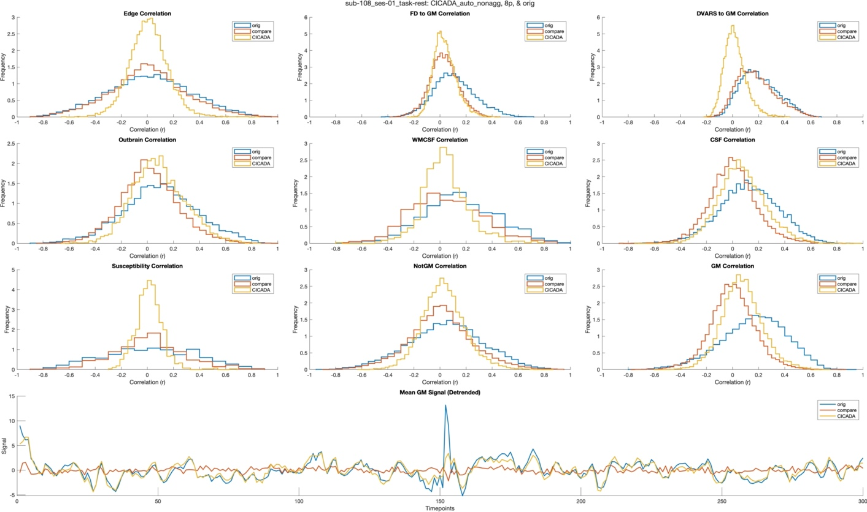
Figure 10. Noise Profile Correlation Histograms From Basescript 3. These plots assist in QC analyses and can be used to compare CICADA to both the original data and other forms of denoising. In this example, CICADA is compared to 8p denoising as detailed in the manuscript. Overall this shows successful denoising. The eight noise profile correlation distributions are narrow and more zero-centered than both the original data of 8p comparison (with the exception of CSF, which is not uncommon due to the proximity of CSF voxels to gray matter). The GM correlation distribution is slightly more right skewed than the NotGM correlation distribution (generally a positive sign), and most obvious noise artifact in the detrended mean GM signal is removed, while still retaining general signal variance.

Network Identifiability: CICADA also outputs “network identifiability” NIfTIs. These files can also be found in the qc folder for the given subject. These images similarly compare CICADA denoised (“cleaned”), 8-parameter denoising (“compare”; regress 6 motion parameters, CSF, and WM), and the original data (“orig”) without any denoising. In short, these images visualize identifiability of the major resting-state networks (by default: default mode, sensorimotor, visual, salience, dorsal attention, executive control, and limbic/reward). Identifiability is measured by extracting a representative time series from the Brainnetome seed regions for each network and correlating that seed time series with the time series of each voxel in the functional mask (cleaned, compare, orig). Voxels are then assigned a network label (e.g., 1–7 by default) corresponding to the network with the highest correlation. Voxels whose highest network correlation have a p-value > 0.5 (i.e., z-score < 0.67 after Fisher z-transform) are not assigned a network label. The network identifiability NIfTIs have three indices in the 4th dimension: the first is the cleaned (CICADA denoised) data, the second is the compare (8-parameter denoising), and the third/last is the original data without any denoising. Overall, better denoised data will result in network connectivity that is easier to visually identify. An example visual is provided below.

In addition to the network identifiability NIfTI images, CICADA also outputs a quantitative summary file (network_identifiability_results.csv), also located in the qc folder, which may aid in interpretation. This table provides a numerical complement to the visual network identifiability images and can be used to compare denoising approaches more directly. In brief, these metrics quantify how often voxels show high-confidence assignment to a single network, defined by both sufficient absolute correlation strength with the best-matching network and clear separation from the second-best network, rather than ambiguous connectivity across multiple networks. Values are computed within gray matter voxels that also fall within the functional mask and are reported as fractions between 0 and 1, with higher values indicating stronger and more distinct network assignments. Altogether, the table includes per-network metrics computed within each network’s seed regions (reflecting how cleanly each network’s core regions are identified), whole–gray-matter metrics computed across all gray-matter voxels (reflecting overall network separability), and difference values comparing CICADA-denoised data to the comparison and original data (with positive values indicating improved network identifiability with CICADA). Among these metrics, the “overall score” values for gray matter and for each network are intended to be the most informative summary measures, whereas the threshold- and separation-based component metrics provide additional context regarding the sources of these differences. Notably, quantitative assessment of network identifiability is inherently challenging due to several factors, including that large-scale brain networks are not strictly independent. As such, visual inspection remains the primary means for assessing network identifiability (with MELODIC component outputs recommended as the most informative visual representation, and the “network identifiability” NIfTIs serving as a complementary secondary visualization), with the quantitative results of the network_identifiability_results.csv serving as possible further supportive context.

The network seeds (“yeo_brainnetome_network_labels.nii.gz”) were generated by visually inspecting overlap between Brainnetome ⁵ regions and the Yeo 7-network template ³. Brainnetome regions that demonstrated strong alignment with the given network in the Yeo atlas, and had strong support in the literature, were included. The Brainnetome seeds for each network are given in Table 1.
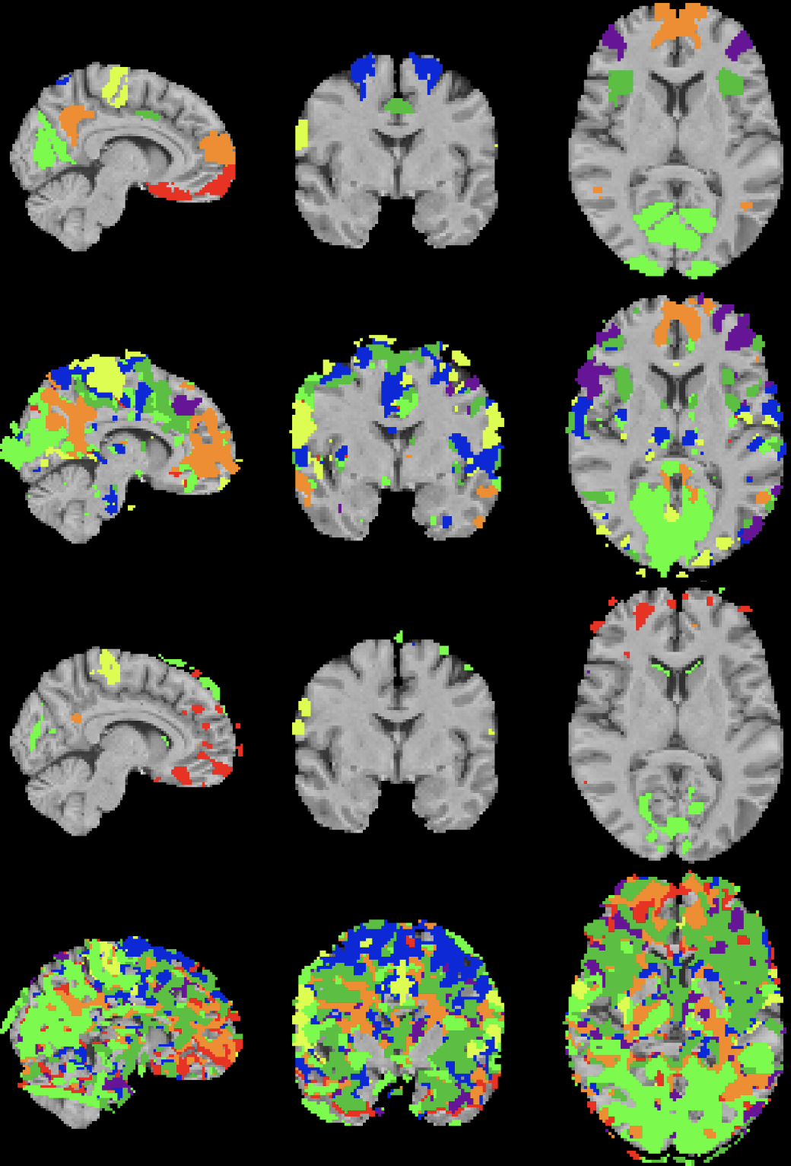
Figure 11. Network Identifiability of a Single Subject. From top to bottom: (1) the network seeds derived from Brainnetome and Yeo 7-network template; (2) example network identifiability from data denoised by CICADA; (3) network identifiability from the same data but denoised with classical 8-parameter regression; (4) the same data without any denoising applied. Overall, better denoised data will result in network connectivity that is easier to visually identify and has strong and wide overlap with the network seeds.

Table 1. Brainnetome Region Seeds and Their Associated Networks
Network | Brainnetome Regions (Bilateral)
Default Mode | A10m, A39rv, A31
Sensorimotor | A4ul, A4ll, A1/2/3ulhf
Visual | rCunG, vmPOS, OPC
Salience | A44op, dIa, A24cd
Dorsal Attention | A6dl, A7r
Executive Control | A9/46v, A39rd
Limbic/Reward | A11l, A11m, A13

How to Run Manual CICADA
To perform CICADA-assisted Manual IC denoising (“Manual CICADA”), or to adjust the labeling of Automatic CICADA for an image (e.g., upon QC inspection CICADA did not label the data accurately enough), the user should do the following general steps:

- Perform Manual IC Classification by adjusting the “IC_auto_checker.csv” signal labels and resave to “IC_manual_checker.csv”
  - Found in “sub/ses/task/ic_auto_selection/IC_auto_checker.csv”
- Resave the adjusted file as “IC_manual_checker.csv”

Performing manual IC classification in CICADA is designed to be an efficient process following the implementation of Automatic CICADA. First, the user should open the “IC_auto_checker.csv” created by Automatic CICADA. The user should then perform manual IC classification by adjusting the “SignalLabel” column, where a 1 is a signal label and a 0 is a noise label (following manual IC denoising guidelines¹). Next, the user should resave the file with the new name “IC_manual_checker.csv”. After this is accomplished, the user can run Manual CICADA. This is done in a similar manner (with similar inputs) to Automatic CICADA. Instead of fmriprep_auto_CICADA.m, use fmriprep_manual_CICADA.m. Instead of Auto_CICADA.m, use Manual_CICADA.m. To clarify, Automatic CICADA must be run first, then the IC_auto_checker.csv must be manually adjusted, and then Manual CICADA is run.

Altogether, Manual_CICADA calls CICADA_2_Manuallabeling.m and then CICADA_3_QC.m again on the manually-adjusted data. CICADA_2_Manuallabeling.m simply reads in the “IC_manual_checker.csv” file for the new labels, re-does the nonaggressive denoising, and re-outputs and saves new quality control variables and files. The inputs and actions of these scripts are otherwise similar to the Automated versions. Manual CICADA will not rerun the first basescript. The general flow of the Manual CICADA Pipeline can be seen in the figure below.

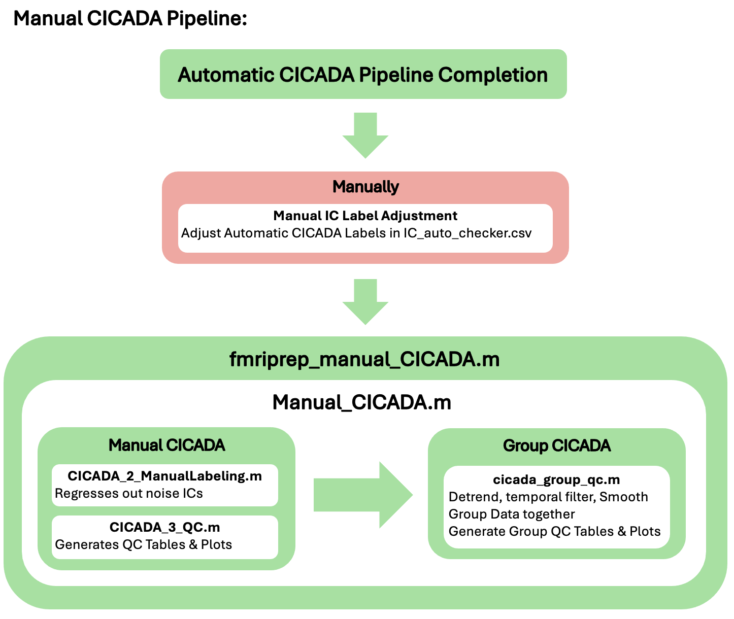
Figure 12. Script Flow for Manual CICADA Pipeline. Of note, Manual_CICADA.m is sufficient to run the full Manual CICADA pipeline. The fmriprep_manual_CICADA.m may just offer an easier method to implement the Automatic CICADA pipeline for datasets that have been preprocessed with fmriprep. Automatic CICADA must be completed first to generate the IC_auto_checker.csv.

Manual CICADA Methods
Manual CICADA methods are similar to Automatic CICADA. In short, Manual CICADA will use a user-adjusted “IC_auto_checker.csv” file (renamed as “IC_manual_checker.csv”) to perform manual IC denoising. This is accomplished with a greatly shortened basescript two (which reperforms nonaggressive denoising) and the same basescript three as in Automatic CICADA. Note, IC_auto_checker.csv is generally found in “sub/ses/task/ic_auto_selection/IC_auto_checker.csv”.
Beginning with v1.1.0, Manual CICADA also regenerates the subject support_products using the manual signal/noise labels. Thus, changes in manual IC classification are reflected in the component-evidence products, whereas direct functional-data reliability remains independent of the IC labels. The same interpretation cautions used for Automatic CICADA apply.

How to Run Group CICADA
After running all of either Automated or Manual CICADA on each individual fMRI image of interest, Group CICADA should be performed. In short, the purpose of Group CICADA is to run quality control analyses on the denoised data and reorganize the data and the quality control information in an easily accessible and understandable manner. Altogether, Group CICADA should be run on one task (“task_name”) at a time but should be able include any number of subjects/sessions.
Beginning with v1.1.0, Group CICADA also collects the available subject support/reliability products for all retained images. New products are isolated under group_qc_home/task_name/output_dirname/support_products, while all legacy Group CICADA files remain in their established locations in the parent group directory.

To perform Group CICADA, a user should run the cicada_group_qc.m function:

> cicada_group_qc(cicada_home, group_qc_home, task_name, output_dirname, file_tag, smoothing_kernel, fpass, redo_melodic, sub_ids, ses_ids, excludes, adjusteds, task_event_files, subject_level_data_table, temporal_cleanup_mode)

The “cicada_home” input is the CICADA output directory used in the Automatic/Manual CICADA (where the CICADA denoised data is held). The “group_qc_home” input is the desired parent output directory where the results of Group CICADA will be output. The “task_name” input is the same as in previous functions. The “output dirname” is the output folder name for the current image group/type. Altogether, when running cicada_group_qc.m on a set of image data, the output directory will be in “group_qc_home/task_name/output_dirname”. The “file_tag” input should be a string that is unique to the file naming of the type of denoised file in Group CICADA. For example, if running Group QC on Automatic CICADA, the “file_tag” could be ‘_auto_’, or for Manual CICADA ‘_manual_’, or for 8 parameter regression ‘_8p_’.

Automatic and Manual CICADA do not apply detrending, bandpass filtering, smoothing, or intensity normalization. Instead, detrending, temporal filtering, smoothing, and voxel-wise intensity normalization (generally in that order) can be applied at the group level near the end of Group CICADA (please see paragraph below on temporal_cleanup_mode for more details on application of ICA regression, detrending, and bandpass filtering). The “voxelwise_scale” is a binary (1 or 0) value that determines whether not to apply voxel-wise scaling (following detrending, bandpass filtering, and smoothing); this is not recommended for resting-state or functional connectivity (thus the default is to not perform voxel-wise scaling: voxelwise_scale = 0) but is often helpful for task-based GLM analyses, for example. Meanwhile, the “smoothing_kernel” is the gaussian smoothing kernel FWHM size in mm (default smoothing size is 1.5x the voxel size and can be automatically applied with smoothing_kernel = -1; or smoothing_kernel = 3;). Smoothing is mask normalized so as to not bias against edge voxels. The “fpass” input is the Hz for bandpassing (default is no bandpassing) given as an array from low to high (if used, fpass = [0.008, 0.15]; is recommended). The “detrend_degree” input is the degree of polynomial to detrend the data at (e.g., a value of 2 (the default) detrends the data at the quadratic (x²) level). Important to note, QC plotting following Group CICADA is easiest to interpret with minimal/no smoothing and no bandpass filtering. Smoothing, and likely bandpass filtering, will create new within-noise-profile-region correlations in the QC plots. Even without smoothing or bandpass filtering explicitly applied, CICADA denoising already inherently decreases low frequency (<0.008 Hz) and high frequency (>0.15 Hz) noise, and regardless, detrending to the 2nd polynomial is performed by default. If performing ROI analyses, no smoothing (smoothing_kernel = 0;) or bandpass filtering (fpass = [];) is recommended. Otherwise, minimal smoothing (from the default value and up to 6 mm), as well as no (fpass = []), or minimal (fpass = [0.008, 0.15]) bandpass filtering, is recommended, but remains up to the user. Voxel-wise scaling can bias resting-state and functional connectivity results, but may also be most appropriate for group-level task-based GLM analyses, for example. For voxel-wise scaling, we generally suggest not implementing it in CICADA, but implementing it as needed in your own following analyses. Altogether then, a user should carefully consider these four parameters, but for reference, the creator of CICADA typically prefers the following: 2nd polynomial detrending (remove potential remaining major drifts), bandpass filtering of [0.008, 0.15] (conservative minimization of unwanted frequencies, assuming this does not impact task design frequencies), a smoothing kernel of 3 mm (minimal, but evident, smoothing, so to still be mostly applicable to both ROI and voxel-wise analyses), and no voxel-wise scaling.

Group CICADA will also run MELODIC on the group level. The “redo_melodic” input, then, is the same as in previous functions, but for the group-level MELODIC. The “sub_ids” and “ses_ids” inputs are similar to previous functions (referring to the subject ID and session ID) but should be cell arrays of equal length that specify each subject/session pair for the task in the group analysis. For example, if the group analysis was on sub-102 session 01, sub-103 session 01, and sub-108 session 02 for Group CICADA, the variables would be set as follows: sub_ids = {‘102’, ‘103’, ‘108’}; and ses_ids = {‘01’, ‘01’, ‘02’};. Of note, typically Group CICADA would be run on a single type of session and task at a time, but this is all up to the user. The “task_event_files” parameter is also the same as in previous functions, but again as a cell array of the same length as sub_ids and ses_ids. This is optional, but like in previous functions, a good idea for task data.

The subject_level_data_table variable (new as of 02/24/26, v1.0.3) is optional but allows a user to include subject level measures (e.g., age, sex, outcome measures, etc.) to the Group CICADA call, simply so that when it makes its final table (group_qc_table.csv) it can include the relevant information for the user in that same table. A user might find this useful in subsequent analyses. The subject_level_table MUST have a column called ‘subject’ which is a char array where the rows include one match of each of the sub_ids (e.g., subject_level_data_table.subject equals [‘102’; ‘103’; ‘108’] to match the sub_ids example in the previous paragraph. From there, the subject_level_data_table should just have the subject measurements information of interest in other columns (e.g., an age column, a sex column, and outcome variable column, etc. ), also as a char array. See example_Group_CICADA.m in CICADA/example_CICADA_flow/example_code for an example. The simplest method to accomplish incorporating subject-level data is likely to create your own .csv table of subject-level data and then just use the readtable() function in Matlab to import the table. From there you can then feed that as the subject_level_data_table to cicada_group_qc. Ultimately, this just helps include subject-level data in the final group_qc_table.csv which may aid in the ease of performing future analyses.

The temporal_cleanup_mode parameter controls how Group CICADA coordinates temporal preprocessing with nonaggressive ICA cleanup. Historically, Group CICADA first used the subject-level CICADA-denoised image and then applied the requested detrending, temporal filtering, and spatial smoothing sequentially. This historical pathway remains available as temporal_cleanup_mode = 'legacy_sequential' for reproducibility. The current default is temporal_cleanup_mode = 'matched'. When detrending and/or temporal filtering is requested, Group CICADA loads the original BOLD data, the complete MELODIC mixing matrix, and the final Automatic or Manual CICADA IC classifications. The same temporal transform is then applied to the BOLD data and to every column of the complete MELODIC mixing matrix. By default, this transform consists of second-order polynomial detrending followed, when requested, by zero-phase Butterworth temporal filtering. Nonaggressive ICA cleanup is then performed using the complete transformed mixing matrix: all ICs participate in coefficient estimation, but only the contribution of ICs classified as noise is subtracted from the transformed BOLD data. The original BOLD voxel means are subsequently added back, after which spatial smoothing and optional voxelwise scaling are performed. Applying the same temporal transform to the BOLD data and the complete ICA design avoids fitting temporally transformed data with an ICA model represented in a different temporal space and preserves the conditioning role of retained ICs during nonaggressive regression. The matched pathway was therefore adopted as the default Group CICADA approach after mechanistic, QC, bandpass-stress, and regression validation. legacy_sequential remains available when exact reproduction of the historical Group CICADA ordering is required or desired by the user.

After running Group ICA (MELODIC), Group CICADA also outputs some potentially helpful files. In short, it uses the dice coefficient between a 7-network atlas (from Guzmán-Vélez et al.², and adapted from Yeo et al.³) and thresholded IC probability files (automatically generated by MELODIC) to identify the group ICs most likely to be a part of each of the 7-networks (visual, sensorimotor, dorsal attention, salience, executive control, default, subcortical). These networks specifically are chosen because they tend to align well with MELODIC ICs (e.g., subcortical regions tend to be identified by themselves). Group CICADA will list the kept ICs and what networks they belong to (kept_ICs.csv and Network_ICs.csv), and generates, for each network, an overall mask (IC_mask_networks.nii.gz), the highest probabilities for each voxel (IC_probs_networks), and the highest z-statistic for each voxel (IC_mel_networks_zmax). Overall, this is intended to both help the user evaluate group QC but also to assist with potential future analyses.

Finally, “excludes” and “adjusteds” are all parameters that can tell the script to handle specific data differently than the rest. Both parameters should be cell arrays the same length as “sub_ids” and “ses_ids” and should be a ‘1’ if they belong in the given group (“excludes”, or “adjusteds”).

“Excludes” is for data that the user does not want included in the Group QC analysis. This might apply, for example, to data where there was a scanner error, and the resulting image was found to be unusable. In the example from the previous paragraph, for example, perhaps MRIQC software identified sub-108 session 02 to be an extreme outlier in data quality from all other data (e.g., because of a scanner error). Alternatively, perhaps it only 10 total ICs were generated, or no signal ICs were identified making it unusable… Then we would set the excludes variable to excludes = {‘0’, ‘0’, ‘0’, ‘1’}; which would then ensure that sub-108 session 02 is not included.

“Adjusteds” parameter is for data that a user performed Manual CICADA on (they adjusted the signal labels of Automatic CICADA and then ran Manual CICADA). The “adjusted” parameter could be used if, when a user evaluates the individual and Group QC, an image is found to be an outlier, but Automatic CICADA did not label the ICs as accurately as desired. Then, a user could adjust the signal labeling and run Manual CICADA solely for that data and then mark it as an “adjusteds”. This ensures that Group CICADA correctly pulls the manually adjusted data for that image. For example, let’s say in our example that for sub-102 session 02, the QC plots show poor results but are greatly improved upon performing Manual CICADA. Then, a user could consider including the manually-adjusted data in the Group CICADA analyses, and mark it as an adjusteds like so: adjusteds = {‘0’, ‘1’, ‘0’, ‘0’};.

Group CICADA Methods
Group CICADA is performed through the cicada_group_qc.m function.

Group CICADA: Cicada_group_qc.m
Broadly, Cicada_group_qc.m performs group level adjustments, QC analyses, and prepares the data for statistical analyses. First, the function copies over all individual QC comparison plots originally generated by Automatic/Manual CICADA to one folder. This allows for easy QC plot comparison across images. Additionally, Cicada_group_qc.m copies over and combines all the individual data together into a single folder. For each image, the function uses user-defined inputs to determine if the current image should be entirely excluded or if Manual CICADA data (if it exists) should be used instead of Automatic CICADA. Cicada_group_qc.m also similarly pulls the original data for each image (before denoising) and the 8p denoised image for QC comparison. Next, the specified detrending, bandpass filtering, and smoothing of the CICADA, 8p, and original data is performed (as described above).

For the v1.1.0 support pathway, Group CICADA first resolves the same automatic, manual-adjusted, and excluded-image choices used by the legacy group workflow. It then merges the corresponding subject products in exact retained-image order. support_products/core contains the primary 4-D continuous signal IC-evidence stack (signal_ic_overlap_raw_maps.nii.gz), the 4-D direct-reliability stack (direct_reliability_masks.nii.gz), and their principal group summaries. support_products/qc contains robust tSNR, normalized intensity, p50/p95 signal and noise masks, smoothed overlap, extended evidence, signal-minus-noise balance, and other QC/sensitivity stacks and summaries. support_products/provenance contains support_products_manifest.tsv and README.txt. The manifest is the authoritative volume-to-image mapping and records zero-based and one-based volume indices, subject, session, task, CICADA mode, release metadata, task directory, and exact source paths. The support-products directory is staged, checked for the expected number of volumes, and replaced as a unit to avoid partial output. The legacy group_signal_funcmask.nii.gz and other legacy group outputs remain unchanged; v1.1.0 does not redefine the legacy group signal mask from the new evidence maps.

Following the processing of CICADA, 8p, and the original data, the relevant QC information relevant for group QC for each of the three images are calculated. This is accomplished in several steps. First, commonly used QC cut-off values are calculated. For example, Group CICADA calculates the median and mean FD values, the %FD > 0.2 mm, if there are any FD values > 5 mm, the median DVARS, and the mean RMSD. Next, correlations within each CICADA noise profile (Edge, FD, DVARS, Outbrain, WMCSF, CSF, NotGM, Suscept) and within GM are calculated in the same manner as CICADA_3_QC.m. Altogether, Group CICADA continues to calculate potentially relevant QC values and images. This includes, but is not limited to, a ratio of the gray matter mean temporal variance divided by the “NotGM” (area outside of GM) temporal variance, a signal and noise IC spatial overlap image, what proportion of gray matter is covered by signal ICs, what proportion of signal ICs is found within the gray matter, a dice coefficient of gray matter and signal IC overlap, and the number and percent of ICs labeled as signal. All relevant QC calculations are then combined into relevant tables.

From there, Group CICADA performs a few last steps to aid in QC analyses. In short, this involves concatenating the QC data for each image together and calculating potential data outliers. QC measures are marked as outliers if they are three scaled median absolute deviations from the median (“MAD outlier”). Altogether, Group CICADA automatically labels an image as a Group CICADA outlier if the image is a MAD outlier in any of the following:

Group CICADA Outlier Identification:
- Low gray matter to signal IC dice value
- Low ratio of GM to NotGM mean variance
- Low power overlap with the HRFO
- Low BOLD frequency to High Frequency ratio
- Low number of ICs labeled as signal

Data is also marked as a CICADA outlier if < 3 ICs total are labeled as signal, or if the mean absolute correlation between either FD or DVARS to gray matter voxels is ≥ 0.15, as this is typically when the associated QC plots break down visually.

Group CICADA will also label conservative outliers (where either the mean_FD > 0.25 mm, the %FD > 0.2mm is > 20%, or any FD > 5 mm) and liberal outliers (mean_FD > 0.55 mm). The cut-offs for conservative and liberal outliers are adapted from Satterthwaite et al. 2013⁶. Next, Group CICADA saves a group qc table (containing all calculated QC data for all images, including the different types of outliers [conservative, liberal, CICADA]), a group QC correlation table (containing the sampled noise profile correlations), and a Group QC plot (same as the ones from CICADA_3_QC.m but for the whole group instead of per image). Finally, group MELODIC is run to generate group-level ICs. The resulting ICs that best match each of the seven networks (Medial Visual, Sensory Motor, Dorsal Attention, Ventral Attention, FrontoParietal, Default Mode, Subcortical) from the brain network image are also returned. This is determined, in short, by sorting each IC by their dice coefficient to each network, and then testing, in order, if including the IC overall increases the resulting total dice coefficient. Altogether, this could help a user better evaluate the success of the denoising in capturing different common brain networks. Relatedly, the kept ICs and what networks they belong to are recorded (kept_ICs.csv and Network_ICs.csv), as well as, for each network, an overall mask (IC_mask_networks.nii.gz), the highest probabilities for each voxel (IC_probs_networks), and the highest z-statistic for each voxel (IC_mel_networks_zmax). This concludes Group CICADA. Following QC analysis, a user could, for example, use the image_names.txt in the Group CICADA folder to select the CICADA-denoised data and perform statistical analyses.

Evaluating Group-Level Quality Control & Metrics
QC Plot, QC Table, Noise Profile Correlations, Network Identifiability: Group-level quality control metrics include the same noise profile correlation distributions and the gray matter correlation distributions as seen on the subject-level in basescript 3, but now on the group level (i.e., “Group_QC_...plots.jpg”). Thus, the group-level QC plots can be interpreted in much the same manner as the subject-level QC plots (see Evaluating Subject-Level Quality Control & Metrics section). Group CICADA also aggregates all subject level QC plots in a single folder for ease of examination. Of note, Table 2 below denotes how a single summary value for each metric across group data is calculated. Importantly, the QC plots provided both on the subject and group levels do not calculate the mean magnitude of the noise profile correlation distribution. Instead, they simply show the distribution of the noise profile correlations. Group QC also creates a “Group QC Table” (i.e., group_qc_table.csv). This provides quality control information on all data in one convenient table. This includes, but is not limited to, the image paths and names, and common outlier flagging (e.g., standard conservative, liberal, and CICADA’s outlier flagging methods). Group QC also saves noise profile correlation distributions (i.e., group_qc_corrs_table.csv). This records the correlation distribution values for the noise profiles (the ones used in the Group Noise Profile Correlation Plots in the figure below). Therefore, this table allows a user to easily calculate the noise profile summary metric data, like that shown in Table 2. Finally, The network identifiability NIfTIs for the cleaned, compare, and original data are also aggregated into three separate 4D NIfTI files, one for each “denoising type” (i.e., network_identifiability_cleaned.nii.gz, network_identifiability_compare.nii.gz, network_identifiability_orig.nii.gz). See Evaluating Subject-Level Quality Control & Metrics section for more information on these and how to interpret them.

Support/reliability products: For downstream support-aware analyses, the primary group inputs are support_products/core/signal_ic_overlap_raw_maps.nii.gz and support_products/core/direct_reliability_masks.nii.gz. Always use support_products/provenance/support_products_manifest.tsv to identify the subject/session/task corresponding to each fourth-dimension volume. The thresholded and smoothed files in support_products/qc are intended for QC and sensitivity analyses; they are not ground-truth neural tissue masks. A downstream method may use the continuous stacks to define and validate an analysis-specific eligibility domain.

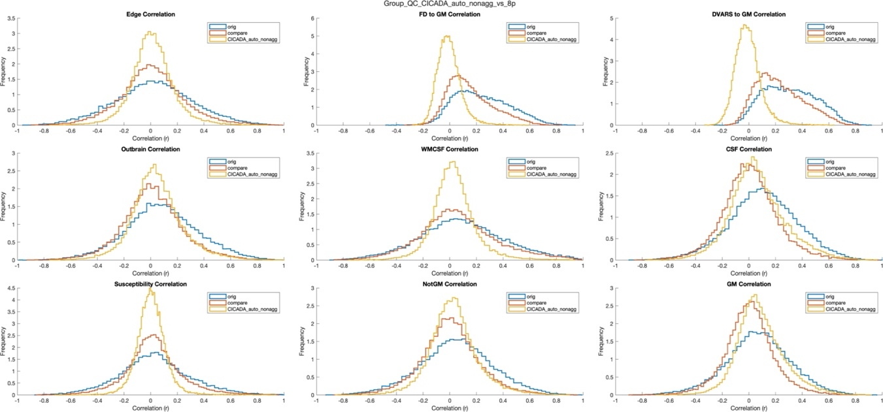
Figure 13. Noise Profile Correlation Histograms From Group CICADA. These plots assist in QC analyses and can be used to compare CICADA to both the original data and other forms of denoising across a whole dataset. In this example, CICADA is compared to 8p denoising as detailed in the manuscript.

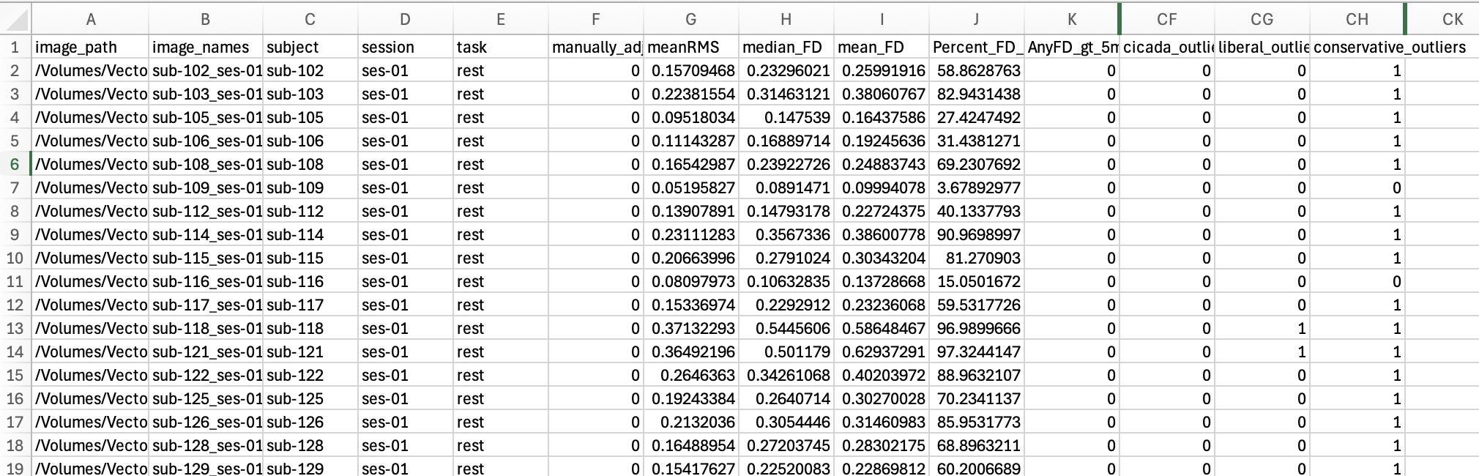
Figure 14. Group QC Table. A truncated version of a CICADA-generated Group QC Table is shown here for reference. This table assists in QC, general data examination, and for retrieving data for analyses. The group QC table includes flagging of outliers, as determined by standard (conservative and liberal) thresholds, and CICADA’s own outlier detection method as detailed above).

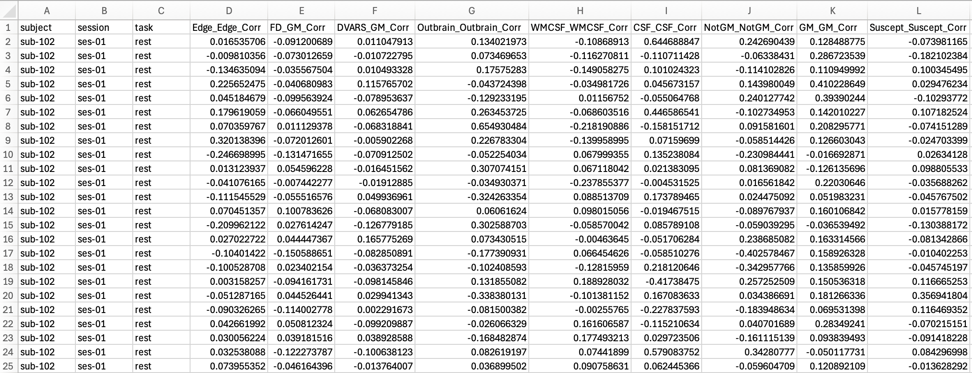
Figure 15. Group QC Correlation Distribution Table. A truncated version of a CICADA-generated Group QC Correlation Distribution Table is shown here for reference. This table gives the data necessary for a user to calculate the noise profile summary metrics as given in the CICADA manuscript and detailed more in Table 2. In short, a user just needs to take the mean of the magnitude off each column to calculate the associated noise profile metric. To calculate the Denoising Success parameter, a user would need to also calculate the NotGM and GM metrics for the original data (before denoising). We plan on adding this automatically to later versions of CICADA (if it is not already added) to make this easier.

Table 2. Quality Control Metrics Summary For Evaluating Automatic CICADA
QC Metric^{c} | Calculation | Improved Denoising  Directionª | Motion-Centric or  Non-Motion-Centric^{b}
Noise Profile: Region-based
Edge | $\overline{\left|r_{Edge}\right|}$ | Lower | Motion-Centric
Outbrain | $$\overline{\left|r_{Outbrain}\right|}$$ | Lower | Non-Motion-Centric
Subependymal | $$\overline{\left|r_{Subependymal}\right|}$$ | Lower | Non-Motion-Centric
CSF | $$\overline{\left|r_{CSF}\right|}$$ | Lower | Non-Motion-Centric
Susceptibility | $$\overline{\left|r_{Susceptibility}\right|}$$ | Lower | Non-Motion-Centric
NotGM | $$\overline{\left|r_{NotGM}\right|}$$ | Lower | Both
Noise Profile: Confound-based
FD | $$\overline{r(\left|GM^{'}\right|,FD)∨}$$ | Lower | Motion-Centric
DVARS | $$\overline{r(\left|GM^{'}\right|,DVARS)∨}$$ | Lower | Motion-Centric
DS | $$\frac{{\overline{\left|r_{GM}\right|}}/{\overline{\left|r_{NotGM}\right|}}}{{\overline{\left|r_{{GM}_{O}}\right|}}/{\overline{\left|r_{{NotGM}_{O}}\right|}}}$$ | Higher | Both
ª Improved denoising direction refers to the direction of the given quality control metric that would indicate better denoising.
^{b} Motion-centric refers to a metric that is heavily influenced by motion. Non-motion-centric metrics may still be influenced by motion but typically less so than the motion-centric metrics.
^{c} All QC metrics are calculated per participant. The final reported group metric is the mean participant metric.
Abbreviations: QC: Quality Control; QC-FC: The mean magnitude of the correlation between the median framewise displacement and functional connectivity; FC: Functional connectivity calculated as the correlation of the timeseries for a given ROI pair; mFD: median framewise displacement per participant; DD: Distance Dependence calculated as the mean magnitude of the correlation between functional connectivity of ROI pairs and the distance between the centroids of the ROIs per pair; Dist: Distance between the centroids of an ROI pair; CSF: Cerebral Spinal Fluid; NotGM: not gray matter; FD: framewise displacement; DVARS: temporal Derivative of root mean square VARiance over voxels; DS: The denoising success parameter; $\overline{\left|r_{NPR}\right|}$: mean magnitude of correlations of randomly sampled voxel pairs (default: 10,000 voxels per voxel correlation matrix) within the given noise profile region (NPR) following application of denoising method; $\overline{r(\left|GM^{'}\right|,NPC)∨}$: mean magnitude of the correlation between the mean derivative of randomly sampled voxels within gray matter and the given noise profile confound (NPC: FD, DVARS). GM: gray matter; $\overline{\left|r_{{NP}_{O}}\right|}$: mean magnitude correlation within the given noise profile before application of a denoising method (O: “original data”).

References

1. Griffanti, L. et al. Hand classification of fMRI ICA noise components. Neuroimage 154, 188–205 (2017).
2. Guzmán-Vélez, E. et al. Amyloid-β and tau pathologies relate to distinctive brain dysconnectomics in preclinical autosomal-dominant Alzheimer’s disease. Proc. Natl. Acad. Sci. U. S. A. 119, e2113641119 (2022).
3. Thomas Yeo, B. T. et al. The organization of the human cerebral cortex estimated by intrinsic functional connectivity. J. Neurophysiol. 106, 1125–1165 (2011).
4. Power, J. D., Barnes, K. A., Snyder, A. Z., Schlaggar, B. L. & Petersen, S. E. Spurious but systematic correlations in functional connectivity MRI networks arise from subject motion. NeuroImage 59, 2142–2154 (2012).
5. Fan, L. et al. The Human Brainnetome Atlas: A New Brain Atlas Based on Connectional Architecture. Cereb. Cortex N. Y. N 1991 26, 3508–3526 (2016).
6. Satterthwaite, T. D. et al. An improved framework for confound regression and filtering for control of motion artifact in the preprocessing of resting-state functional connectivity data. Neuroimage 64, 240–256 (2013).

