FARM RETURN NEXT

Product & UX
Specification
The canonical source of truth for the Farm Return Next experience, product behaviour, visual system and implementation sequence.

Version | 1.1
Date | 01 September 2026
Implementation branch | farm-return-next
North-star principle
“Open your farm, not an app.”
Farm Return should feel like a living, explorable farm world with a prompt-led assistant underneath it. The farmer primarily looks, taps, confirms and adjusts; the system observes, estimates, explains and learns.

PRODUCT INTENT

1. Executive summary
What Farm Return Next is
A software-first farm operating system that turns real farm context into useful, timely actions. It should feel closer to exploring a game world than operating an administrative dashboard, while remaining scientifically honest and operationally useful.
The product is organised around one behavioural loop:
Core loop
Observe → Estimate → Prompt → Decide → Act → Confirm → Actual → Learn

Non-negotiable product rules
- The farm itself is the primary environment. Maps, fields, animals, jobs and contextual markers should carry navigation wherever practical.
- Today / Farm / Plan / Records remain the primary navigation.
- Ask AI is available from every primary screen and inherits only real, explicit current context.
- Data capture should be incidental: infer and pre-fill from GPS, weather, plans, telemetry, previous estimates and other trusted sources; ask the farmer mainly to confirm or correct.
- Prompts, Notifications and Gates/Constraints are separate product concepts and must not be forced into one shape.
- Satellite v1 provides relative vegetation intelligence and historical comparison, not exact kg DM/ha.
- Breeding & Births is species-aware from the outset: initial UX must support cattle, sheep and horses without hard-coding cattle-only terminology.
- Scientific outputs must expose provenance, confidence and uncertainty when relevant. Never fabricate precision.
- The approved visual direction is light, calm, premium and spatial — not a dark command centre or a conventional enterprise dashboard.
- Every material recommendation, cost and derived data point must be reproducible through a Calculation & Evidence Ledger that records inputs, units, formula/method, source, source version/date, calculation version, output, confidence and provenance.
- Ask AI explains and orchestrates validated engines; it must not become an alternative source of unverified agronomic, financial or regulatory calculations.
- Feed & Finish and Financial Intelligence are first-class connected capabilities: requirements, scenarios, costs, margins and Actuals must update one another rather than exist as isolated calculators.
- Farm Return may ingest current data from trusted internet sources, but scientific or regulatory logic cannot silently change. Source changes must be versioned, reviewed, tested and released through an approval workflow.
- Request Quote replaces a direct group-buying marketplace in the initial commercial model. Farm Return calculates demand and routes farmer-approved quote requests to suppliers; farmer and supplier transact directly and Farm Return does not initially handle customer funds.

Immediate implementation objective
First demonstrable Farm Return Next experience
A farmer opens the living farm world, receives a real Prompt, acts on it, completes a real GPS-supported job, confirms the Actual, sees the Record, and can ask AI about any part of that flow.

IMPLEMENTATION BASELINE

2. Current build position
This specification starts from the current farm-return-next branch rather than from a greenfield product. The architecture already shipped should be reused, not replaced.
Area | Status | Implication
Framework / shared contracts | Complete | Preserve the existing Next orchestration model and contracts.
Decisions / jobs migrations | Applied in Dev; validation still outstanding | Run the hardened RLS validation against real Dev and only then promote to VALIDATED_DEV.
Vertical A — Observe / telemetry | Backend shipped and audited clean | telemetry_events, retention cron and durable farm-scoped IndexedDB outbox exist.
Vertical G — Notifications | Backend shipped and audited clean | Lifecycle/state-machine exists; UI must be designed around real Prompt-derived notifications.
Vertical H — Satellite | Real Sentinel-2 scene discovery shipped | Use real scenes; vegetation computation must not imply biomass precision.
Vertical B — Prompts | Multiple real Prompt candidates shipped | Use a genuine Prompt for the first end-to-end workflow.
Visual UI references | Approved | The lighter mock-ups in this document are canonical direction.

Known outstanding technical actions
1. Run supabase/validation/decisions_jobs_rls_validation.sql against the real Dev database and confirm PASS.
2. If and only if validation passes, promote the relevant migration status to VALIDATED_DEV.
3. Apply the telemetry, retention-job and notifications migrations to Dev if they are not yet applied; verify real database state.
4. Do not make NDVI/vegetation estimates depend on unavailable CDSE credentials unless the implementation explicitly requires authenticated downstream processing.
5. Do not surface the P-build-up eligibility check as a Prompt. Treat it as a Gate/Constraint until a deliberate product decision changes that.

DESIGN LANGUAGE

3. Canonical visual direction
The visual system should borrow the interaction principles of strong open-world and mission-hub games — spatial navigation, contextual overlays, progressive disclosure and an “alive” world — without copying their aesthetic or becoming theatrical.
Borrow  World as interface; spatial points of interest; restrained HUD; mission-like actions; clear active-task mode; environmental context. | Avoid  Dark tactical dashboards; heavy chrome; badge gamification; dense KPI grids; fake 3D; decorative complexity; GIS-tool language.

Approved light visual system
- Warm off-white / light neutral base surfaces.
- Restrained agricultural greens for primary actions, selected states and positive readiness.
- Satellite/aerial imagery provides visual depth; cards should remain light and legible over it.
- Serif/display type may be used for high-level page/field headings; clean sans-serif for functional information and numbers.
- Rounded cards, subtle borders, soft shadows; avoid heavy glassmorphism in the light theme.
- Amber is reserved for attention/needs-confirmation; red/orange only for genuine restriction or risk; blue may indicate informational/data-source states.
- Icons and markers should be simple, recognisable and consistent across Today, Farm, Plan and Records.
- Ask AI appears as a persistent but secondary affordance; it should be easy to reach without competing with the primary action.
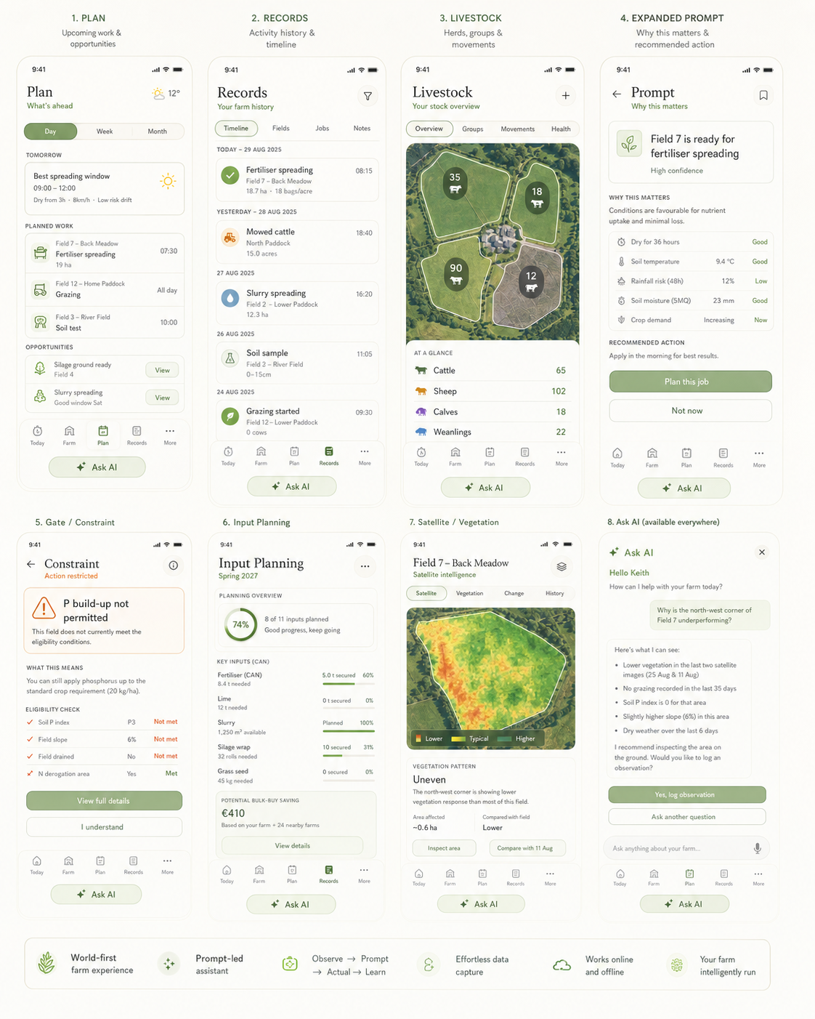
Approved direction: light, calm Farm Return system across Plan, Records, Livestock, Prompts, Constraints, Input Planning, Satellite and contextual AI.

WORLD STRUCTURE

4. Information architecture and navigation
Primary area | Question it answers | Primary interaction
Today | What matters on my farm right now? | See the living farm state, current Prompt(s), nearby context, ready work, active jobs and confirmations.
Farm | What is happening in this place / field / animal group? | Explore spatially from farm → field / yard / livestock group → intelligence → action.
Plan | What is ahead and when should I do it? | Review Today / Tomorrow / This week, planned jobs, genuine opportunities and windows.
Records | What actually happened? | Review activity timeline, provenance, Estimated vs Actual, and open any record in context.

Navigation hierarchy
Spatial first
Farm portfolio (if applicable) → Farm → Field / yard / livestock group → Prompt / job / observation / record → detail. Secondary modules should not become the primary mental model.

Canonical screen set
# | Screen archetype | Role
1 | Today / Living farm world | Home state, real Prompt(s), nearby/active work and immediate next action.
2 | Farm / Field exploration | Spatial exploration and contextual field intelligence.
3 | GPS Job Mode | Minimal active-task experience during physical work.
4 | Confirm Actual | Estimated vs Actual close-out and learning input.
5 | Plan | Upcoming work, windows, suggestions and commitments.
6 | Records | Activity/history timeline with provenance and actual status.
7 | Livestock world | Groups/animals anchored to paddocks, sheds and herd state.
8 | Breeding & Births | Species-aware breeding windows, pregnancy evidence and expected births.
9 | Soil / scientific detail | Data-rich but readable science, provenance and constraints.
10 | Satellite / vegetation intelligence | Relative vegetation pattern, change, history and ground inspection.
11 | Expanded Prompt / Why this matters | Evidence, confidence, explanation and recommended action.
12 | Gate / Constraint | Clear restriction, reason, evidence and permitted next step.
13 | Input Planning | Forecast needs, timing, secured quantities and bulk-buy opportunity.
14 | Ask AI contextual overlay | Query the exact context currently being viewed.
15 | Feed & Finish | Livestock feed requirement, finishing target, feed inventory, scenario comparison and estimated/actual cost.
16 | Financial Intelligence | Whole-farm and enterprise profitability, cost/revenue forecasts, scenarios and Estimate vs Actual.
17 | Calculation & Evidence | Trace any material number back through inputs, source, formula/model, version, confidence and provenance; export report.
18 | Quote & Procurement | Review calculated need, request a delivered supplier quote, compare/accept and update the plan with real quoted/actual cost.

CORE PRODUCT LOGIC

5. Behavioural model and interaction taxonomy
Canonical activity lifecycle
Suggested → Planned → Window approaching → Ready → In progress / Active → Completed—estimated → Completed—actual / confirmed

Prompt
A Prompt asks the farmer to make or review a decision. It must be grounded in real evidence or domain logic and should have a meaningful response such as accept, plan, edit, dismiss or inspect.
- Examples: spreading window, ageing soil test, commonage status, repeated vegetation anomaly worth checking.

Notification
A Notification informs the farmer that something happened, changed or now needs attention. It is not a substitute for a decision surface. Notification copy must originate from real Prompt/lifecycle state; do not invent unsupported events.

Gate / Constraint
A Gate tells the farmer that something is not permitted, not supported or conditional — and why. It is not an accept/edit/dismiss Prompt.
- Example: P build-up eligibility not met.
- Show what is restricted, the relevant criteria/evidence, and what is still permitted.

Observation
An Observation is evidence about the farm state: GPS presence, telemetry event, satellite variation, farmer note/photo/voice, weather observation or other trusted signal. Observations can lead to Estimates or Prompts, but do not automatically become decisions.

INTERACTION PRINCIPLE

6. Effortless data capture
Default farmer interaction
Look → tap → confirm → adjust. Avoid search → form → multi-field entry → save wherever a trusted estimate or inference can pre-fill the answer.
Signal | What Farm Return may infer | Farmer interaction
Phone GPS | Current field, movement, likely field entry/exit, job duration/area context | Confirm job / wrong field / not now; correct if needed.
Weather + timing | Readiness windows or constraints | Review Prompt; plan or defer.
Existing plan / estimate | Likely job type, field, rate, expected quantity | Confirm or edit.
Telemetry / Drive later | Machine identity/activity evidence | Usually passive; surface only when it changes confidence or requires confirmation.
Satellite scene | Relative vegetation variation and change | Inspect highlighted area; log ground observation.
AI docket / uploaded document | Potential service date, sire, animal, result | Confirm extracted data; never silently commit uncertain facts.
Vet / pregnancy scan | Confirmed pregnancy and refined gestational estimate | Record evidence and update expected birth window.

Provenance requirements
- Every important value should distinguish estimate, inferred observation and confirmed actual where relevant.
- Show source labels selectively (GPS-recorded, farmer-confirmed, satellite observation, vet scan, uploaded document, etc.).
- Confidence should increase when stronger evidence arrives; later evidence must not erase the history of earlier estimates.
- If required data is absent, fail closed: ask, defer or explain that an estimate cannot be made.

CROSS-CUTTING INTELLIGENCE

7. Ask AI — available everywhere
Global rule
Every primary screen must provide an Ask AI affordance. The assistant receives only the explicit current context technically available on that screen. Context is never invented.
Current screen | AI context supplied | Example question
Today | Farm + visible Prompt/job/notification summary | “What should I prioritise this morning?”
Field 7 | Field ID, real soil/activity/plan/constraint/satellite context | “When did I last spread this field?”
Expanded Prompt | Prompt, evidence, Estimate and confidence | “Why are you recommending this?”
GPS Job Mode | Active job + current field + real tracking state | “What rate did I plan for this job?”
Record | Selected activity + Estimate/Actual + provenance | “How did this compare with the last application?”
Satellite | Selected field, scene dates, derived relative pattern/change | “Why might this corner be worth inspecting?”
Breeding & Births | Selected species/group/animal and recorded reproductive evidence | “Which animals are due first?”
Input Planning | Visible forecast and secured quantities | “What am I short of for spring?”

AI behaviour rules
- Answer from Farm Return data first; distinguish retrieved facts from general agronomic knowledge.
- Never convert missing farm context into a confident farm-specific claim.
- When a question could change a regulated, veterinary or high-impact decision, explain the evidence and uncertainty rather than presenting the AI response as authority.
- Where useful, let AI create a proposed observation, plan or draft action — but require explicit farmer confirmation before committing farm records.
- Ask AI must work as an overlay or bottom sheet so the farmer does not lose their place in the world.

PRIORITY EXPERIENCE

8. Today, Farm and the first complete job loop

Today / Living farm world
Visual-reference note
The following early dark mock-ups are interaction and composition references only. Their colour treatment is superseded by the approved light visual system in Section 3. Implement these layouts in the light theme.
- Aerial/world view is the hero visual, with fields and yard acting as interactive places.
- Primary card: “What matters now”. One strongest genuine action, not a feed of everything.
- Spatial markers may show Ready, Active, Needs confirmation, informational or constraint states.
- A concise status strip may summarise ready jobs, active jobs and jobs awaiting confirmation.
- Location-aware card may say “Looks like you’re near Back Meadow” when real GPS context supports it.
- Weather is ambient context and should only dominate when it materially affects an action.
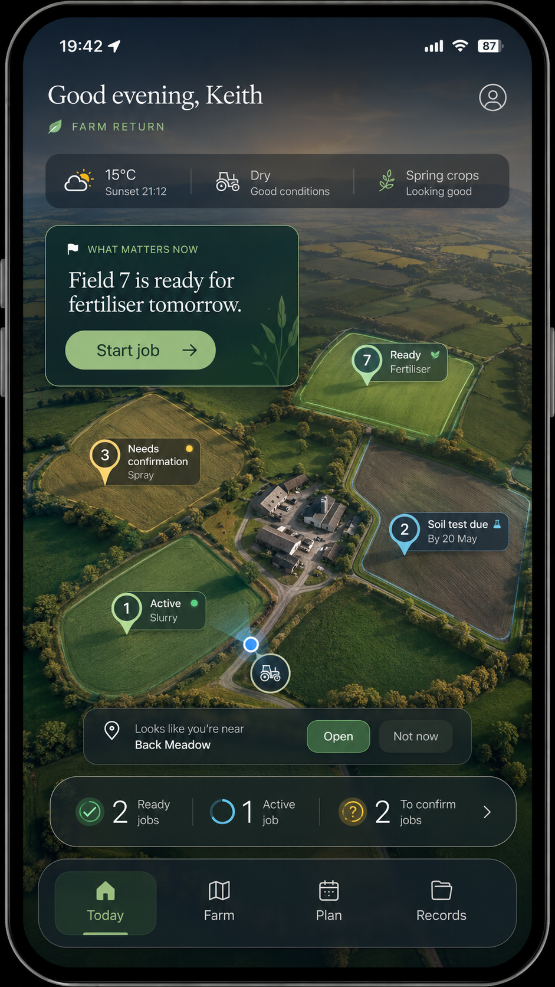
Interaction reference only — Today as a living farm world. Restyle in the approved light visual system.

Field exploration
- Tap a field to zoom into its current state rather than navigating to a generic module.
- Context tabs may include Now, Soil, Activity and Constraints; satellite intelligence is available where real scenes exist.
- Prominent action should reflect the actual current state: Plan job, Start job, Inspect area, Review constraint, etc.
- Scientific detail is progressively disclosed; do not put all farm metrics on the initial field surface.
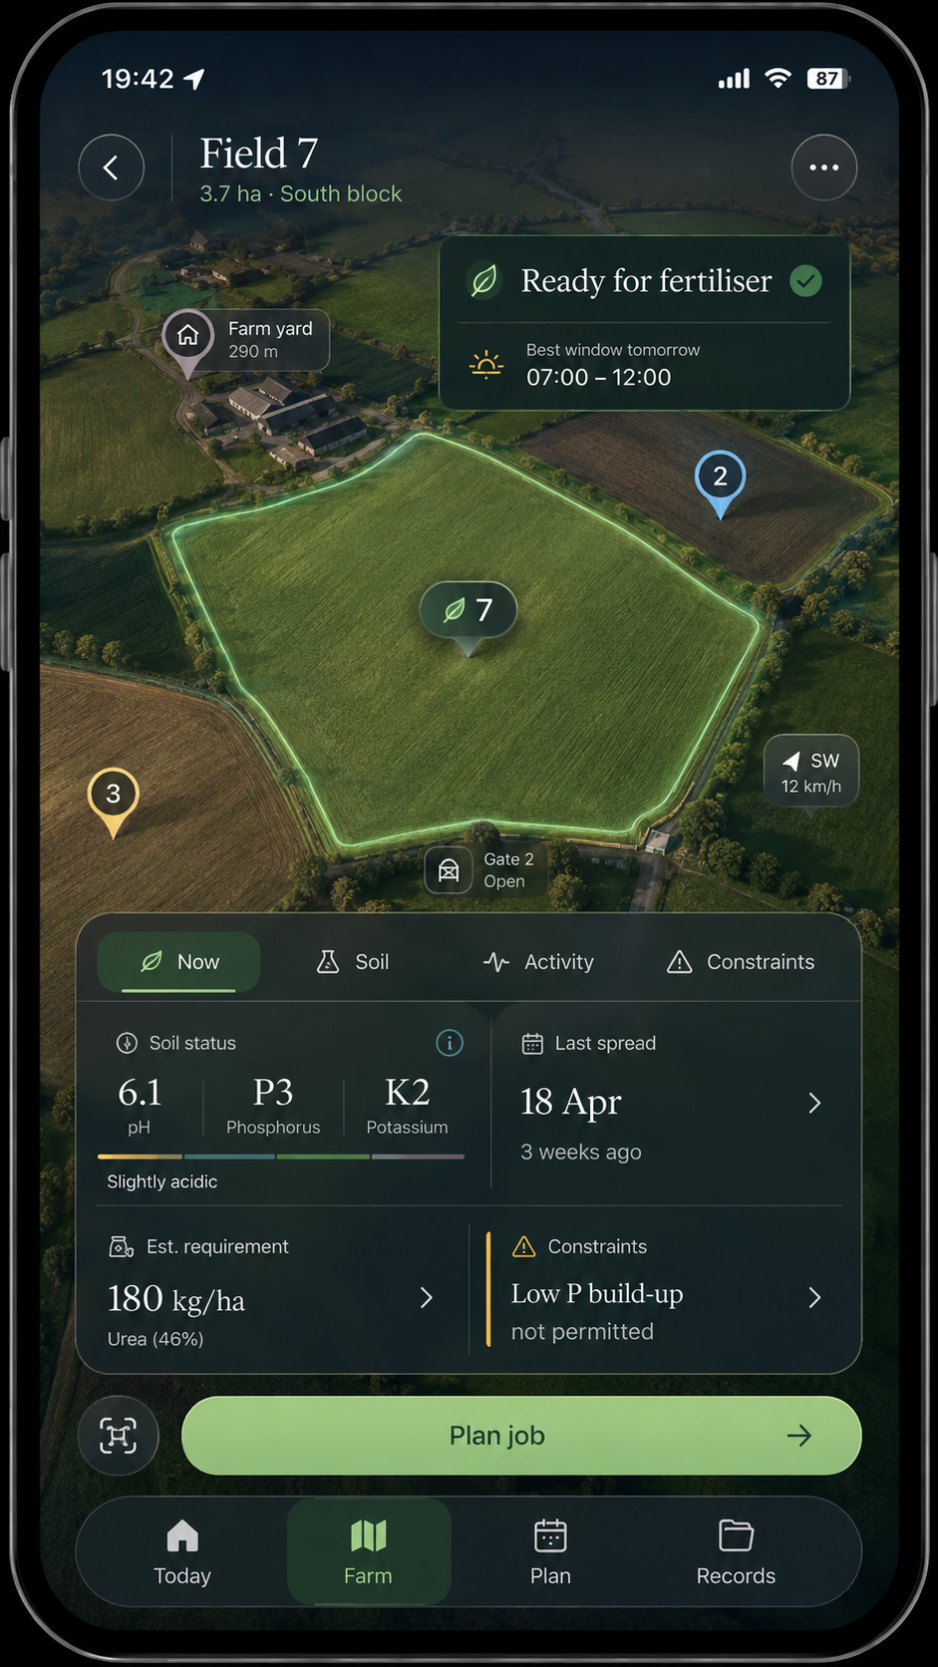
Interaction reference only — selected field as an explorable place. Restyle in the approved light visual system.

GPS Job Mode
Design rule
Starting a physical job should feel like entering an active mode, not opening a form.
- Show job type, field and active state prominently.
- Show elapsed time, GPS/tracking status and area/coverage only where they are genuinely measured or derived.
- Minimise controls to Pause, Finish and essential map controls.
- Do not fabricate machine rate, exact coverage passes or sensor values. Planned/target values must be labelled as such.
- When movement/context suggests completion, Farm Return may prompt the farmer to finish rather than silently completing the job.
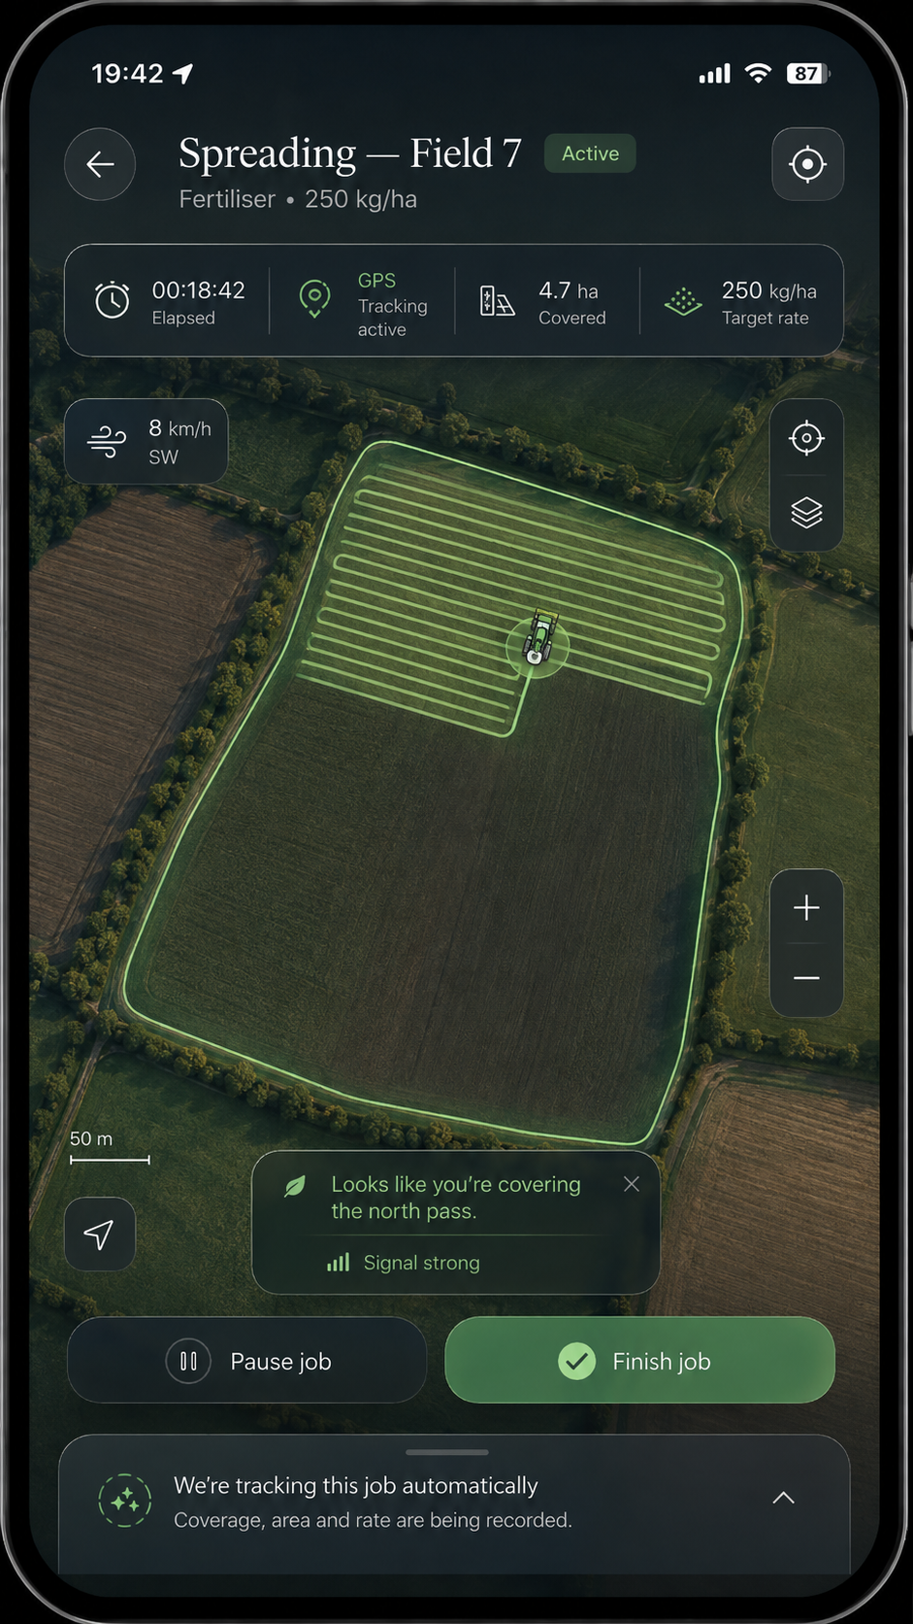
Interaction reference only — focused active-job mode. Restyle in the approved light visual system.

Confirm Actual
- Completion creates a Completed—estimated state first.
- Show Estimated and proposed Actual side by side for the key job values.
- Pre-fill Actual from the best real evidence available, but make it easy to edit.
- The primary action is Confirm actual; secondary actions are Edit and Save later.
- Once confirmed, the activity becomes Completed—actual / confirmed and appears in Records.
- Preserve the estimate/actual difference for later calibration and confidence learning.
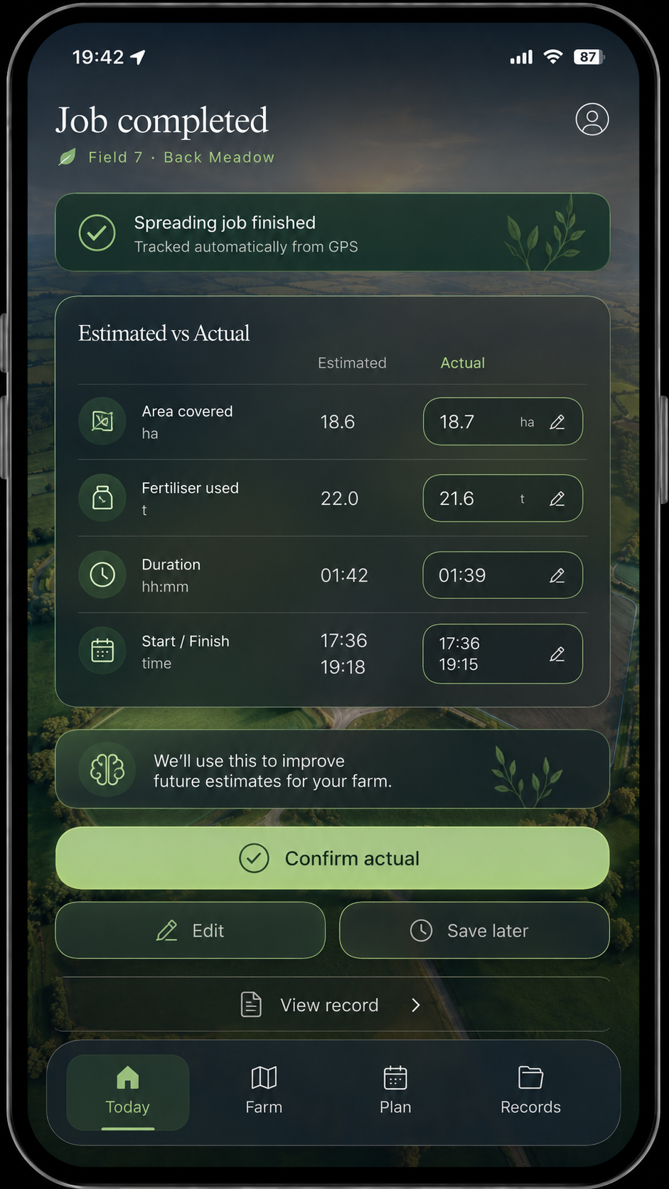
Interaction reference only — Estimated → Actual close-out. Restyle in the approved light visual system.

CORE SUPPORTING SCREENS

9. Plan and Records

Plan
- Organise around Day / Week / Month with strong emphasis on Today, Tomorrow and This week.
- Separate committed planned work from genuine opportunities/suggestions.
- A weather window is useful only if tied to real domain logic and a real action.
- Selecting a planned item should return the user to the relevant farm/field context where possible.
- Avoid a generic calendar-first implementation.

Records
- Default view is a chronological activity timeline, not a spreadsheet register.
- Each item identifies activity, field/group, date/time, core quantity, and provenance/status.
- Clearly distinguish estimated-only, awaiting confirmation and confirmed actual records.
- Opening a record should reveal the connected field/map context, evidence, Estimate/Actual values and related Prompt/decision where available.
- Filters may exist, but they remain secondary to the readable history.

SPECIES-AWARE FARM STATE

10. Livestock world
Livestock must fit the world-first model rather than becoming a separate spreadsheet product. Groups and animals should be anchored to paddocks, sheds or management groups when location/context is known.
- Overview may show animal/group counts spatially on the farm map.
- Primary concepts: group, species, current location, lifecycle/status, recent movement/activity, upcoming action.
- Allow movement between group-level and individual-animal detail depending on the species and farming system.
- Cattle may mix group and individual management; sheep should strongly support batch/group workflows; horses usually require richer individual-animal views.
- The same visual language must support health, movements, breeding and other later livestock workflows without creating a second app inside Farm Return.

Breeding & Births
Product rule
Do not build a cattle-only “pregnancy screen”. Build one species-aware Breeding & Births engine whose terminology, evidence model and group/individual behaviour adapt to the animal.
Species | Primary planning shape | Typical evidence progression | Birth terminology
Cattle | Target calving window; individual or breeding group | Bull exposure / AI service → pregnancy confirmation / scan / vet estimate → actual birth | Calving
Sheep | Target lambing period; strongly group/batch oriented | Ram in/out → pregnancy scan → singles/twins/triplets → actual lambing | Lambing
Horses | Individual mare and desired foaling window | Cover / AI → reproductive scans / vet evidence → actual foaling | Foaling

Breeding logic
- The farmer can start from the desired outcome: e.g. target calving/lambing/foaling period. Farm Return works backwards to estimate the breeding window using species-configured domain logic.
- Once a service/AI/covering or ram/bull exposure is recorded, calculate an estimated birth window and label it as an estimate.
- When stronger evidence arrives — AI record, pregnancy scan, vet gestational estimate, etc. — refine the expected birth window and increase confidence.
- Actual calving/lambing/foaling closes the loop and is preserved as the actual outcome.
- Do not hard-code a single gestation number into the UX. Gestation logic belongs in an authoritative species/domain layer and may account for breed/individual variation where supported.

Breeding screen structure
- Header: Breeding & Births + selected species/group.
- Seasonal/timeline hero: target birth period, estimated breeding window, confirmation/scan period and expected birth period.
- Primary card: “18 cows approaching breeding window”, “126 ewes — ram-in window approaching”, or “Mare Willow — scan due”.
- Group summary: confirmed pregnant / awaiting evidence / empty / unknown; sheep may additionally show scanned litter-size distribution.
- Individual animal detail: service/cover evidence, expected birth window, confidence and upcoming action.
- Ask AI can answer queries such as “Which are due first?”, “Which ewes still need scanning?” or “When should I breed for a March lambing start?” based on real recorded context.

EARLY PRODUCT BOUNDARY

11. Satellite / Vegetation Intelligence
V1 capability
Relative vegetation intelligence: see stronger/weaker parts of a field, compare usable scenes over time, identify persistent underperforming zones and guide ground inspection. It is not an exact biomass or kg DM/ha feature yet.

Core screen
- Header: field name, area, latest usable scene date, source and image-quality/cloud status.
- Layer switch: Satellite / Vegetation / Change / History.
- Vegetation view uses relative language: Lower ← Typical → Higher. Do not label lower vegetation as a diagnosis by itself.
- Tap a zone to reveal relative performance and known contextual farm information; do not claim causal diagnosis unless supported by a real model/evidence.
- Insight card can describe pattern (e.g. Uneven), approximate affected area, and comparison with the field.
- History shows clear and unavailable/cloudy scenes transparently; do not cherry-pick or hide unusable dates.
- Change mode compares valid scenes and may show relative strengthened / stable / lower-response areas.
- Primary action for a persistent anomaly is Inspect area / Log observation, closing the satellite → ground truth loop.
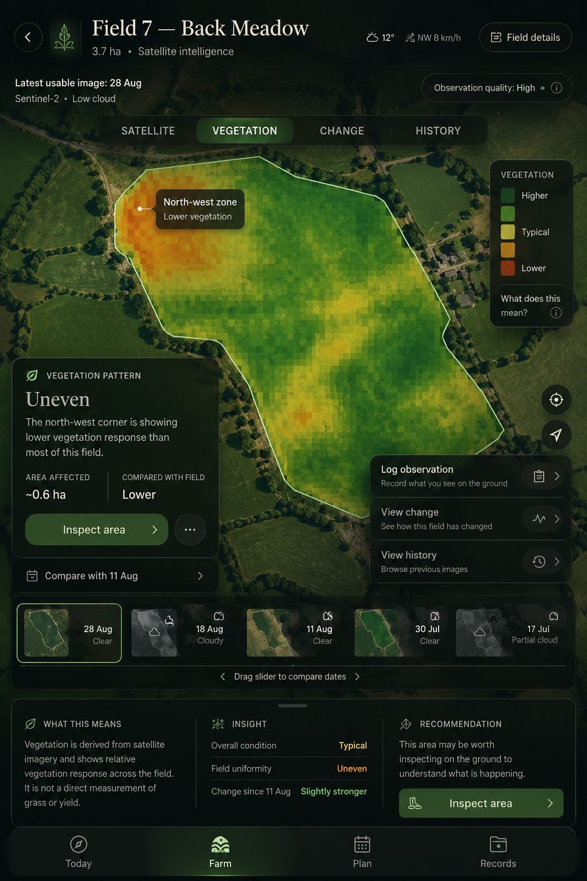
Interaction/logic reference — relative vegetation map, history, explanation and ground inspection. Restyle in the approved light visual system.

Scientific boundaries
Allowed now | Deferred until scientifically validated
Latest usable real scene; relative within-field variation; historical comparison; change detection; approximate affected area; observational Prompt; farmer ground note/photo/voice. | Exact kg DM/ha; tonnes DM; exact grass-growth rate; precise yield forecast; feed wedge values; causal agronomic diagnosis; pseudo-precise fertiliser response.

DATA-HEAVY PATTERNS

12. Scientific detail, Input Planning and Constraints

Soil / scientific detail
- Show real result, unit, source/date and whether a value is measured or estimated.
- Use clear P/K/pH and other agronomic values, trend/history and relevant recommendation without burying the user in raw calculation tables.
- Provide “Why?” and Ask AI access to evidence, assumptions and confidence.
- Regulatory constraints should surface in context, not as surprising failures at the final save step.

Input Planning
- Forecast what the farm needs to buy from mapped land, soil/fertiliser plans, silage/crops, livestock, housing, feed, slurry/organic nutrients and financial assumptions.
- Show needed quantity, secured quantity, timing and the confidence/source of the forecast.
- Surface bulk-buy opportunities as a commercial layer without compromising the correctness of agronomic recommendations.
- Allow farmers to adjust assumptions; preserve the relationship between forecast and eventual actual purchase/use.

Gate / Constraint pattern
- Title the restriction plainly: e.g. “P build-up not permitted”.
- Explain what the restriction affects and what remains permissible.
- Show the real eligibility criteria and which are met/not met when available.
- Offer View details / I understand / Ask AI — not accept/edit/dismiss as if it were a Prompt.
- A constraint may influence or block a planned action, but should retain its own lifecycle and provenance.

CONSISTENCY RULES

13. Scientific Validation, Calculation & Evidence Ledger
System rule
No material recommendation is complete unless Farm Return can show where it came from. The app must be able to produce an evidence chain that an independent Irish agricultural expert can reproduce and audit.

Evidence classification
- Measured Actual — laboratory, scale, sensor, vet, soil test or other direct measurement.
- Farmer Actual — confirmed activity, quantity, price, date, observation or outcome entered/confirmed by the farmer.
- Authoritative External Data — current approved data from trusted Irish/EU sources or licensed providers.
- Derived Estimate — output produced by a defined and versioned calculation/model from known inputs.
- Assumption — an explicit fallback used only because better evidence is unavailable; it must remain visible as an assumption.

Calculation identity and reproducibility
Every material formula or model must have a stable calculation ID and version. Reports must preserve the exact inputs, units, transformations, source references, model version and price/data snapshots used at the time, so an older result can still be reproduced after sources or models change. Historical calculations must never silently rebase onto newer coefficients.
Ledger field | Required content | Example treatment
Calculation ID / version | Stable identity for the formula/model and released version | FR-BEEF-FEED-014 / v1.2
Inputs | Value, unit, evidence type and timestamp | 20 animals; 600 kg measured/confirmed
Source | Authoritative document/dataset/API and source version/date | Approved Teagasc/DAFM/CSO/Met Éireann source record
Method | Formula, lookup, coefficient set or model path | Explicit calculation, not hidden AI reasoning
Output | Value, unit, Estimate/Actual state | 10.0 t concentrate — Estimated
Confidence | High / Medium / Low plus reason | Reduced if feed analysis is missing
Review state | Draft / validated / expert-reviewed / superseded | Model release status

Expert validation framework
- Validate models at the engine/version level rather than requiring an expert to review every farmer report.
- Give the relevant specialist a validation pack containing every formula, coefficient, lookup table, source, assumption, scenario test, boundary condition and known limitation.
- Use domain-appropriate reviewers: ruminant nutrition, soils/nutrients, veterinary/reproduction, grassland, agricultural economics and regulation as applicable.
- Record reviewer identity/role, review date, findings, approval status and model version. Do not claim independent expert validation until it has genuinely occurred.
- A source update can create a review requirement; it must not automatically mutate a released scientific model.

Source hierarchy and freshness
Tier | Preferred source class | Rule
1 | Irish/EU law and regulation; DAFM / Irish Statute Book | Controls compliance logic and overrides non-regulatory guidance.
2 | Irish authoritative technical data: Teagasc, ICBF, DAFM, CSO, Met Éireann, EPA, Bord Bia where applicable | Preferred technical/market/public-data foundation.
3 | Peer-reviewed science | Use where authoritative Irish guidance is absent or a validated model requires it.
4 | Farm-specific evidence | Lab tests, weights, scans, soil tests, invoices, supplier quotes, confirmed jobs and observations.
5 | Explicit assumptions | Fallback only; disclose and downgrade confidence.

Generated Calculation & Evidence Report
- The farmer must be able to generate a human-readable PDF/report for a field, animal/group, plan, recommendation, job, financial forecast or whole-farm view.
- The report should show Result → Inputs → Source → Method/Formula → Output → Confidence → Estimate/Actual status → model/source versions.
- A report should flag stale sources, missing inputs and assumptions rather than disguising them as verified facts.
- Ask AI may explain any calculation in plain language by reading the ledger; it may not independently replace the validated engine with an LLM-generated recommendation.

14. Financial Intelligence
Financial principle
Operational decisions and financial consequences are one system. Farm Return should estimate the cost/return of a plan before it happens, replace assumptions with quotes and Actuals as evidence improves, and preserve the provenance of every important financial value.

Required financial capability
- Whole-farm and enterprise-level profitability for the farm types supported by the product.
- Field/activity costs where attribution is defensible; input, feed, veterinary, contractor, housing and other connected costs.
- Livestock purchase/sale values and expected sale timing where entered or connected to approved market/reference data.
- Estimated versus Actual cost and revenue, including variance and explanation.
- Gross margin / contribution views, cash-flow forecasting and scenario planning.
- Per-head, per-hectare or per-unit-production metrics only where definitions and allocation methods are explicit and scientifically/financially valid.
- Ask AI can change scenario assumptions in natural language, but the financial engine performs the arithmetic and the Evidence Ledger records the result.

Financial provenance
Every price must identify its origin: farmer-entered actual invoice, supplier quote, contracted price, approved external benchmark or explicit assumption. Time-sensitive prices retain their observation/quote date. A later market update must not alter a historical plan or Actual.

15. Feed & Finish Intelligence
Product question
Given these animals, their current state, the target finish/birth/production goal, the feed available and current prices: what feed is required, do I have enough, what realistic strategies exist, and what does each strategy cost?

Core planning flow
- Start from a group/animal state such as animal class, sex, current liveweight, age where relevant, housing date, physiological state and farm-recorded history.
- Allow the farmer to specify an outcome such as target finish date, target liveweight or other scientifically supported goal. Work backwards to the required performance rather than forcing a feed-entry-first workflow.
- Use feed inventory and quality: silage/pit/bales, dry matter, DMD, crude protein and other analysis where scientifically relevant; concentrates/ration composition and price; minerals and other feed inputs.
- Calculate total feed requirement, daily rate where valid, total tonnes/bales, projected depletion/reserve/deficit and estimated total cost.
- Offer realistic scenario comparisons such as forage-led / target-date / faster-finish only when supported by a validated model. Show the trade-off in feed, finish date, cost and projected financial result.
- If a requested target is not supported by the available feed/model evidence, Farm Return must say so rather than manufacturing a plan.

Breed and type refinement
Breed/type must be supported architecturally as an optional refinement rather than a V1 blocking input. Begin with robust animal-class/type assumptions, then allow broader categories and later breed/cross-specific modifiers only when validated evidence exists. Unknown breed must remain usable with clearly stated baseline assumptions. Over time, reliable farm-specific Actual performance may calibrate future estimates without erasing the scientific baseline.

Estimate → Actual learning
The feed plan must retain its original forecast and compare it with actual feed used, actual finishing date, actual weight/performance and actual cost. These differences become farm evidence for later calibration and financial review; they do not justify arbitrary model self-modification.

Cross-species architecture
Design the underlying feed-requirement contract around species, animal class, physiological state, weight, target, environment, feed quality and availability. Validate one deep initial implementation before expanding shallowly. Cattle Feed & Finish can be the first expert-reviewed exemplar; sheep and horses reuse the framework with species-appropriate science and terminology.

16. Trusted Data Update Layer
Connectivity principle
Farm Return should be cloud-connected but offline-capable. Internet connectivity keeps approved data current; it must not allow an AI agent or external webpage to silently rewrite scientific or regulatory logic.

Three update classes
Class | Examples | Update rule
Live / operational | Weather observations/forecast; satellite scene discovery; other approved live feeds | Automated ingestion after schema/licence validation; timestamp every observation.
Reference / market | CSO/market benchmarks, input price indices, approved reference datasets | Automated or scheduled versioned snapshots; retain history.
Scientific / regulatory logic | Nutrient tables, feed coefficients, legislation, breed modifiers, gestation/reproduction logic | Detect change → review → test → expert/owner approval where required → release new version. Never auto-mutate a released model.

Source Registry and monitoring
- Maintain a Source Registry containing source owner, URL/API/dataset identifier, licence/usage status, schema/version, refresh cadence, last successful sync, affected calculations and review status.
- Store immutable raw/versioned snapshots where needed for reproducibility before transforming data into an approved current layer.
- A Source Monitor may detect newly published guidance or regulations and create a review item. It must not interpret and publish new scientific coefficients autonomously.
- Expose data currency in the app/report when it matters: observation time, market-data period, regulation/model version and last scientific review.
- Offline-first behaviour remains mandatory for farm work: active jobs and recent/required farm state continue locally and sync through the durable outbox when connectivity returns.

17. Quote & Procurement Intelligence
Initial commercial model
Request Quote is the farmer-facing purchasing feature. Farm Return calculates a genuine need, the farmer chooses whether to request a quote, approved suppliers quote the farmer, and the farmer pays/transacts directly with the supplier. Farm Return does not hold customer funds in the initial version.

Farmer workflow
- Input Planning or Feed & Finish produces the product, quantity, timing and delivery need from the farm plan.
- The farmer reviews the requirement and explicitly taps Request Quote; Farm Return never sends a commercial enquiry without consent.
- The request carries only the approved minimum farm/delivery context required to price the job. Farmer identity/contact sharing must follow explicit consent and privacy rules.
- One or more approved suppliers return a delivered quote with product, unit price, delivery terms, validity period and total price.
- The farmer may accept/contact the supplier. The commercial contract and payment are directly between farmer and supplier in the initial model.
- A received quote can replace a benchmark assumption in the Financial plan after farmer confirmation; an eventual invoice/actual purchase can replace the quote as Actual.

Economies of scale without a buying-group UX
Farm Return may aggregate anonymised, consent-compatible demand across farms by product, region and delivery window to negotiate stronger supplier pricing or commercial arrangements. The farmer still receives an individual delivered quote. Aggregated demand must not expose identifiable farm information outside the approved workflow.

Supplier commercial model
- Initial preference: a success-based supplier referral/commission fee or another transparent supplier-funded commercial arrangement.
- Avoid charging the farmer simply to request a quote in the initial model unless product strategy is explicitly changed.
- Online/in-app payment, invoicing, financing and order settlement are deferred capabilities. Design contracts so they can be added later without making Farm Return the merchant of record today.

18. States, labels and status language
State | Meaning | UI treatment
Suggested | System proposes something worth considering | Contextual Prompt; low commitment.
Planned | Farmer has accepted/created future work | Visible in Plan and field context.
Window approaching | Timing is becoming relevant | Subtle attention; may notify if appropriate.
Ready | Conditions / timing satisfy the real readiness logic | Clear primary action; green readiness state.
Active | Job is in progress | Focused GPS Job Mode; minimise unrelated UI.
Completed—estimated | Work appears finished but Actual is not confirmed | Amber / needs confirmation.
Completed—actual | Farmer confirmed the real outcome | Stable record / green confirmation.
Constraint | Action is restricted/conditional | Amber/red-orange based on severity; explain why.
Unknown / insufficient evidence | Farm Return cannot support a confident state | Neutral; explicitly say what is missing.

Language rules
- Prefer farmer-facing language over system jargon.
- Do not imply certainty with words such as “will”, “definitely” or exact-looking numbers when the value is estimated.
- Use “Estimated”, “Likely”, “Relative”, “Based on”, “Confidence” and “Source” where they materially improve understanding.
- Avoid generic “Success” toasts for meaningful farm events; show the actual state change instead.

BUILD ORDER

19. Implementation sequence
Phase | Deliverable | Exit criterion
0 | Dev database validation / migrations | RLS script genuinely passes Dev; newer migrations applied and verified, or blocker recorded.
1 | Canonical visual tokens/patterns | Light theme, typography, states, cards, map markers, Ask AI and loading/error states documented and reusable.
2 | Today / Living farm world | Real farm state and genuine Prompts surface without fabricated data.
3 | Farm / Field exploration | Farm → field → state/intelligence/action works with real domain data.
4 | One complete physical-job loop | Real Prompt → Plan/Job → GPS mode → Complete → Confirm Actual → Record works end-to-end.
5 | Plan | Upcoming work/opportunities reflect real state and link back to context.
6 | Records | Timeline and full record detail reflect real provenance and Actual status.
7 | Contextual Ask AI | Every implemented primary screen provides explicit, fail-closed context to AI.
8 | Livestock + Breeding & Births | Species-aware group/individual patterns implemented without cattle-only schema assumptions.
9 | Satellite / vegetation UI | Real scene discovery + honest relative vegetation/change/history; no biomass claims.
10 | Soil / Constraint / Input Planning expansion | Data-heavy patterns reuse the approved design system and real engines.
10 | Scientific Validation + Evidence Ledger | Calculation IDs/versioning, evidence/source registry and report contract exist before new recommendation engines are considered complete.
11 | Financial Intelligence | Connected Estimate/Actual financial model and scenario interface with explicit price provenance.
12 | Feed & Finish | First deeply validated animal/feed planning engine, including feed inventory, scenarios, cost and evidence report; breed/type supported as optional refinement.
13 | Trusted Data Update Layer | Approved source registry, update classes, versioned ingestion and source-change review workflow.
14 | Quote & Procurement | Request Quote from calculated need; supplier-direct transaction; quote can update financial estimate; no Farm Return-held funds.

Do not optimise for
- Maximum number of screens implemented in one session.
- Placeholder content that makes a mock-up look complete.
- A generic component library detached from Farm Return behaviour.
- Adding new backend verticals before the first end-to-end farmer journey works.
- Matching the reference mock-ups pixel-for-pixel where the reference contains illustrative rather than real data.

DEFINITION OF DONE

20. Quality and acceptance gates

Every phase must
- Inspect existing architecture and contracts before implementation.
- Reuse real domain engines and data; no invented scientific values or fake farm records.
- Handle loading, empty, denied-permission, offline and error states intentionally.
- Pass typecheck, lint, tests and build required by the repo.
- Audit mobile layout, tap targets, contrast, readable map overlays and keyboard/screen-reader basics where applicable.
- Test state transitions rather than only static rendering.
- Audit the implementation critically, fix findings and commit only clean work to farm-return-next.
- Never touch main or production unless explicitly instructed later.

First milestone acceptance test
1. Open Today and see real farm state plus at least one genuine Prompt.
2. Open the Prompt and understand why it exists from real supporting evidence.
3. Accept/plan the action and create a real job/activity.
4. Enter GPS Job Mode with the correct farm/field/job context.
5. Finish the job and enter Completed—estimated.
6. Review and confirm/edit Actual values.
7. Find the Completed—actual record in Records.
8. Use Ask AI from at least Today, Field, Prompt, active job or Record and verify it receives only the relevant explicit context.
9. Demonstrate failure behaviour when data/context is absent rather than hallucinating a result.

10. For every material derived number shown in the completed journey, demonstrate a provenance/evidence path or explicitly mark it as a currently unsupported/assumed value.
EXECUTION PROMPT

Appendix A — Copy/paste Claude implementation prompt
Use the following prompt as the next autonomous build instruction. It intentionally prioritises the first complete user journey over backend breadth.
We have now frozen the Farm Return Next Product & UX Specification v1.1. Treat the specification as the product source of truth. Do not invent new product concepts, redesign the navigation, or substitute generic dashboard patterns.
BRANCH / SAFETY
- Work only on farm-return-next.
- Do not touch main or production.
- Reuse the shipped Next architecture and contracts.
- Never fabricate farm data, scientific outputs, satellite values, GPS state or database state.
NORTH STAR
Farm Return should feel like opening a living, explorable farm world rather than a sterile farm-management app. The farmer primarily looks, taps, confirms and adjusts. The system observes, estimates, prompts, explains and learns.
The canonical loop is:
Observe → Estimate → Prompt → Decide → Act → Confirm → Actual → Learn
PRIMARY NAVIGATION
Today / Farm / Plan / Records
GLOBAL ASK AI
Ask AI must be accessible from every primary screen. It must receive only explicit current context that is technically available: farm, field, animal/group, Prompt, job, record, satellite observation or planning context. Fail closed if context is missing. Do not invent farm-specific facts. Keep Ask AI contextual so the user does not lose their place.
VISUAL DIRECTION
- Light, calm, premium agricultural interface.
- Warm off-white / light neutral surfaces and restrained farm greens.
- World/map imagery as a primary interaction surface where appropriate.
- Contextual cards and overlays rather than dense KPI dashboards.
- Serif/display headings may be paired with a clean sans-serif functional layer.
- Use amber only for attention / needs-confirmation and red/orange for genuine restrictions.
- Minimal visual clutter and progressive disclosure.
- The farm is primary; UI chrome is secondary.
INTERACTION TAXONOMY
Prompt = a real decision/action the farmer can meaningfully accept/plan/edit/dismiss/inspect.
Notification = lifecycle/event information derived from real state.
Gate/Constraint = a restriction or eligibility condition; explain what is restricted, why, and what remains permitted. Do not force a Gate into Prompt semantics.
Observation = real evidence such as GPS, telemetry, satellite variation, weather, farmer note/photo/voice or other trusted source.
EFFORTLESS DATA CAPTURE
Prefer infer → pre-fill → confirm/correct over manual forms. Use GPS, weather, plans, previous estimates, telemetry and other trusted data only when real. Preserve provenance and the distinction between Estimate and Actual.
PHASE 0 — DEV DATABASE VALIDATION
1. If real Dev DB access is available, run supabase/validation/decisions_jobs_rls_validation.sql.
2. Only if it genuinely passes, promote the relevant migrations from APPLIED_DEV to VALIDATED_DEV.
3. Apply the newer telemetry, telemetry-retention and notifications migrations to Dev if not already applied, then verify real database state.
4. If DB access is not available, record the blocker clearly and continue only with work that does not require inventing DB state.
PHASE 1 — CANONICAL VISUAL PATTERNS
Document and implement only the reusable Farm Return tokens/patterns required for this build: typography hierarchy, light surfaces, primary green, Ready / Active / Attention / Constraint states, cards, buttons, map markers, bottom navigation, Prompt, Notification, Gate/Constraint, Ask AI, and loading/empty/error/offline states. Do not build a generic design-system project.
PHASE 2 — TODAY / LIVING FARM WORLD
Build Today around the question “What matters on my farm right now?”
- Make the farm/world the primary visual object where real map data allows.
- Surface only real ready work, active jobs, jobs needing confirmation and genuine Prompts.
- Use one strongest “What matters now” action rather than an inbox of cards.
- Use location-aware context only where real GPS permissions/data support it.
- Weather remains ambient unless it materially drives a real action.
PHASE 3 — FARM / FIELD EXPLORATION
Implement Farm → Field → Current state → Intelligence → Activity → Suggested action.
- A selected field should surface only relevant real information such as status, soil, recent activity, planned work, constraints and satellite availability.
- Use progressive disclosure rather than module-heavy dashboards.
- A Gate such as p-build-up eligibility remains a Constraint, not a Prompt.
PHASE 4 — COMPLETE ONE REAL FARM RETURN LOOP
Choose one already-shipped genuine Prompt that cleanly supports a physical farm job. Implement:
real Prompt → farmer accepts/plans → Activity/Job created → GPS Job Mode → job completes → Completed—estimated → farmer confirms/edits Actual → Completed—actual record.
GPS Job Mode:
- feels like entering an active task, not filling a form;
- shows field/job context and real tracking state;
- minimises controls;
- never fabricates coverage, rate, GPS or sensor values;
- distinguishes planned/target values from measured/derived values.
Confirm Actual:
- show Estimated and proposed Actual side by side;
- pre-fill only from real evidence;
- make correction easy;
- save the Estimate/Actual difference and provenance for learning.
PHASE 5 — PLAN
Build Day / Week / Month with emphasis on Today / Tomorrow / This week. Separate planned work from genuine opportunities/prompts. Do not implement a generic calendar-first screen.
PHASE 6 — RECORDS
Build a readable activity timeline rather than a spreadsheet register. Show activity, field/group, date/time, core quantity, provenance, and estimated/confirmed state. Opening a record should reveal connected context and Estimate vs Actual.
PHASE 7 — ASK AI
Wire contextual Ask AI into all implemented primary screens. Explicitly test that it gets the correct current context and fails closed when context is missing.
PHASE 8 — LIVESTOCK + BREEDING & BIRTHS
Do not build a cattle-only pregnancy feature. Use one species-aware Breeding & Births model.
Initial product scope: cattle, sheep and horses.
- Cattle: target calving window; bull exposure / AI; pregnancy scan/vet evidence; expected calving; actual calving.
- Sheep: target lambing period; ram in/out; group/batch management; pregnancy scan including litter-size evidence where recorded; expected lambing; actual lambing.
- Horses: individual mare; cover/AI; reproductive/vet scans; expected foaling; actual foaling.
Allow the farmer to start from a desired birth window and work backwards to an estimated breeding window using authoritative species/domain logic. Do not hard-code a single gestation number in the UI. Refine expected birth windows as stronger evidence arrives; preserve confidence and provenance.
PHASE 9 — SATELLITE / VEGETATION INTELLIGENCE
The early product boundary is relative vegetation intelligence, not biomass estimation.
Allowed:
- real latest usable Sentinel-2 scene;
- relative Lower / Typical / Higher vegetation zones;
- stronger/weaker areas within a field;
- historical comparison and change between valid scenes;
- persistent anomaly worth inspecting;
- approximate affected area where scientifically defensible;
- Inspect area / Log observation workflow.
Not allowed at this stage:
- exact kg DM/ha;
- tonnes DM;
- exact grass-growth rate;
- yield/feed-wedge claims;
- causal agronomic diagnosis without validated evidence.
Show cloud/unusable scenes honestly. A satellite observation should be able to lead to a ground inspection and farmer observation, creating a useful evidence loop.
PHASE 10 — SCIENTIFIC DETAIL / INPUT PLANNING / CONSTRAINTS
Reuse the approved light visual patterns for soil/scientific detail, Input Planning and Gate/Constraint views. Preserve source, date, confidence and Estimate/Actual distinctions. Input Planning should forecast quantities/timing from real connected farm data and surface bulk-buy opportunities without corrupting agronomic recommendations.
QUALITY GATE FOR EVERY PHASE
- inspect existing architecture first;
- reuse shipped domain logic/contracts;
- no invented data or placeholder scientific outputs;
- test real state transitions;
- handle loading/empty/error/offline/permission states;
- audit mobile layout and accessibility;
- run repo typecheck/lint/tests/build;
- perform a critical audit, fix findings, then commit clean work;
- keep an implementation log and explicit blockers.
STOP CONDITION
Do not optimise for maximum code volume. The priority is the first genuinely usable Farm Return Next experience. Once the complete Prompt → Job → GPS → Actual → Record → contextual Ask AI journey is working cleanly and audited, stop and report exactly what is complete, what remains blocked, and which canonical screen should be built next.
SYSTEM-WIDE SCIENTIFIC / FINANCIAL RULES
- No material derived value is complete without a Calculation & Evidence Ledger entry: calculation/model ID and version, input values and units, evidence classification, source and source date/version, method/formula/lookup path, result and unit, confidence, Estimate/Actual state and timestamp.
- Preserve historical reproducibility. New source/model versions must not retroactively change old results.
- Ask AI may explain calculations or request scenario changes, but validated engines perform the calculations. Never use LLM-generated agronomic/financial arithmetic as a substitute for the engine.
- Scientific/regulatory source changes require review/test/release; live/reference data may refresh under versioned ingestion rules.
- Architect for expert-reviewed model releases and generated Calculation & Evidence Reports.
FINANCIAL INTELLIGENCE REQUIREMENT
Financials are a connected product layer, not a later spreadsheet. Track Estimate vs Actual costs/revenues, price provenance, enterprise/whole-farm views, cash-flow/scenario effects and links from operational decisions. A supplier quote or invoice may replace a benchmark only with explicit provenance/confirmation.
FEED & FINISH REQUIREMENT
Feed & Finish is a first-class decision engine. It must eventually support: animals/group state; housing/target date or weight; feed inventory and quality; required performance; scientifically supported feed requirement; total tonnes/bales; reserve/deficit; cost; realistic scenario comparison; and Estimate vs Actual learning. Breed/type is an optional refinement hook, not a blocking V1 input; do not introduce breed modifiers until evidence is validated. If the target is not scientifically supportable, fail closed.
TRUSTED DATA UPDATE LAYER
Use a Source Registry and classify sources as live/operational, reference/market, or scientific/regulatory. Live/reference sources may update through validated, timestamped/versioned ingestion. Scientific/regulatory logic may only change through detected source update → review → test → approval → new model release. Preserve offline-first farm workflows.
REQUEST QUOTE / PROCUREMENT
The early purchasing model is Request Quote, not a Farm Return checkout or direct group-buy marketplace. A farmer reviews a need calculated by Input Planning/Feed & Finish and explicitly requests a quote. Approved suppliers quote the farmer directly. Farmer and supplier transact/pay directly; Farm Return does not initially hold customer funds. Aggregated anonymised demand may support supplier pricing/economies of scale. Farm Return may earn a supplier-funded referral/commission fee. In-app payments are deferred.
PHASE 11 — SCIENTIFIC VALIDATION / EVIDENCE LEDGER
Define calculation IDs/versioning, evidence classes, source registry contract, model validation states, reproducibility rules and generated report structure. Do not claim expert validation until a real reviewer has approved a model version.
PHASE 12 — FINANCIAL INTELLIGENCE
Implement or formalise the connected financial model only from existing/validated domain data. Every material price/cost/revenue must carry provenance and date.
PHASE 13 — FEED & FINISH EXEMPLAR
Build only after the calculation/evidence framework is ready. Prefer one deeply validated Irish cattle use case over shallow cross-species estimates. Support future species and breed/type refinement architecturally without inventing coefficients.
PHASE 14 — TRUSTED SOURCE INGESTION
Implement the controlled data-update layer and source-change review workflow for approved sources; never let the open internet silently rewrite calculations.
PHASE 15 — REQUEST QUOTE
Connect a calculated input/feed need to a consent-based supplier quote request. Keep Farm Return out of the payment flow initially and preserve quote → purchase Actual provenance.

DECISION REGISTER

Appendix B — Product decisions frozen in v1.1
Decision | Frozen position
Visual tone | Light, calm, premium, world-first; current light mock-ups are canonical inspiration.
Navigation | Today / Farm / Plan / Records.
AI | Ask AI accessible on every primary screen; contextual and fail-closed.
Data entry | Infer / pre-fill / confirm where possible; manual entry is fallback, not default.
Prompt taxonomy | Prompt, Notification and Gate/Constraint remain separate.
P build-up eligibility | Gate/Constraint; not a fifth Prompt unless product framing is explicitly revisited.
Satellite early feature | Relative vegetation / underperforming zones / history / change / ground inspection.
Satellite later feature | Calibrated biomass / DM per ha only after scientific validation and ground-truth strategy.
Livestock breeding | Species-aware Breeding & Births supporting cattle, sheep and horses from the product model.
First build milestone | Real Prompt → Job → GPS mode → Confirm Actual → Record → contextual Ask AI.
Scientific evidence | Every material derived value must be traceable and exportable through a Calculation & Evidence Ledger / report.
Expert review | Models are validated/versioned at engine level; no claim of expert validation before genuine review.
Financials | Connected whole-farm/enterprise Estimate → Actual intelligence with explicit price provenance.
Feed & Finish | First-class planning engine linking livestock targets, feed inventory/quality, scenarios, cost and Actual outcomes.
Breed/type | Optional fine-tuning hook now; introduce modifiers only from validated evidence.
Internet/data updates | Trusted Source Registry + versioned ingestion; scientific/regulatory changes require reviewed releases.
Purchasing | Request Quote from calculated need; farmer transacts directly with supplier; supplier-funded fee/commission model preferred initially.
Payments | Farm Return does not initially hold farmer funds; in-app payment may be introduced later.
What should not be discussed again before implementation
The overall app concept, primary navigation, core loop, light visual direction, global Ask AI requirement, early satellite boundary, Prompt/Notification/Gate distinction, and the need for species-aware Breeding & Births are sufficiently settled for the next build phase.
Also frozen at architecture/product level: evidence-ledger requirement, expert-reviewed model release process, financial/feed integration, trusted source-update governance, breed/type as a future validated refinement, and Request Quote with supplier-direct payment in the initial commercial model.

