JDNSUB
Public Domain Date Routines
by Steve Seaquist
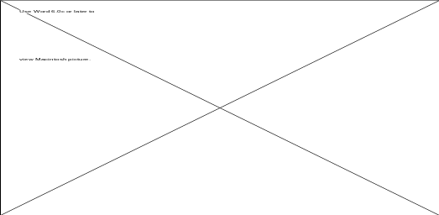
and Contemporary Technology, Inc.,
at the Small Business Administration
Presented at the Orlando UNITE Conference
on Wednesday, 10/04/95, 4:00 PM
JDNSUB - Public Domain Date Routines
Steve Seaquist, President
U-1100 Systems & Applications, Inc.
3126 Brinkley Road, #204
Temple Hills, MD 20748-6329
Abstract
COBOL-85 (UCOB) provides various date conversion functions which were lacking in COBOL-74 (ACOB). JDNSUB makes these capabilities available for the ACOB environment. The integer number of days since December 31, 1600 (Gregorian calendar) is used as an intermediate between YYYYMMDD and YYYYDDD formats. It can also be used as a date compression routine. A listing of the source code will be presented and explained, as well as the procedure used to validate its correctness over the range of 1601 thru 3000 AD.
Acknowledgement
Many thanks to CTI and the Small Business Administration for giving me the opportunity to work extensively with UCS and UDS.
Copyright Notice
©1995 by U-1100 System & Applications, Inc. All rights reserved. Used by permission.
Disclaimer
This paper is not guaranteed to be perfect. If I’ve made a mistake, please point it out so I can correct it.
Trademarks
The folded ribbon logo and USA-1100 are trademarks of U-1100 Systems & Applications, Inc.
UNISYS is a registered trademark of the Unisys Corporation.
Table of Contents
Title, Abstract, etc
1. Introduction
1.1. Why, the Very IDEA!
6. Conclusion
6.1. UCOB Wishlist
6.2. Why’m I Doing All This?
6.3. Final thoughts

1. Introduction
.

1.1. Why, the Very IDEA!

6. Conclusion

6.1. UCOB Wishlist

6.2. Why’m I Doing All This?

6.3. Final thoughts

