Camden County DCA CDBG Survey Results

Dr. Keith Lee & Dr. Joseph Robbins

2023-01-07

# Executive Summary

# Survey Methodology

We followed DCA’s “[Guide to Acceptable Methodology and Sample Survey Form](https://www.dca.ga.gov/sites/default/files/guide_to_acceptable_survey_methodology_0.pdf)” to conduct the LMI study. While DCA prefers a survey of all residents, the study utilized a Qualtrics survey designed for an ARPA needs assessment, embedding specific questions to ascertain household size and household income. Specifically, respondents were asked how many residents lived in the house and a follow up question was asked whereby the respondent would answer if the household income was over or under a specified threshold. This is consistent with the guide linked above (see page 3-4 for DCA’s suggested procedures). The study used the [income limits provided by the U.S. Department of HUD for Camden County, Georgia](https://www.dca.ga.gov/sites/default/files/2021_income_limits.pdf) (see page 6). The “LOW INCOME” row represents the 80% AMI level for Camden County, which is the threshold for those households labeled as “moderate-income.” The LMI thresholds for Camden County are in Table 1.

Camden County LMI Income Limits by Household Size

| Household Size | Threshold |
| --- | --- |
| 1 | $37,050 |
| 2 | $42,350 |
| 3 | $47,650 |
| 4 | $52,900 |
| 5 | $57,150 |
| 6 | $61,400 |
| 7 | $65,600 |
| 8+ | $69,850 |

## Selecting the Survey Method

The survey method selected was mail survey using utility billing. All households in Kingsland, Georgia received a QR code in their utility bill that could be used to access the survey.

## Developing a Questionnare

We developed the survey using input from stakeholders in Camden County, primarily Steven Sainz. The survey questions were embedded into a broader, anonymous ARPA needs assessment survey. Therefore, we did not collect personal information for the study. Further, given the method of collection, multiple responses could have been provided from any given household.

## Selecting the Sample

The universe for the study was residents in Kingsland, Georgia. The sample from the broader survey was pulled from respondents living in map area six or seven (see Figure 1).

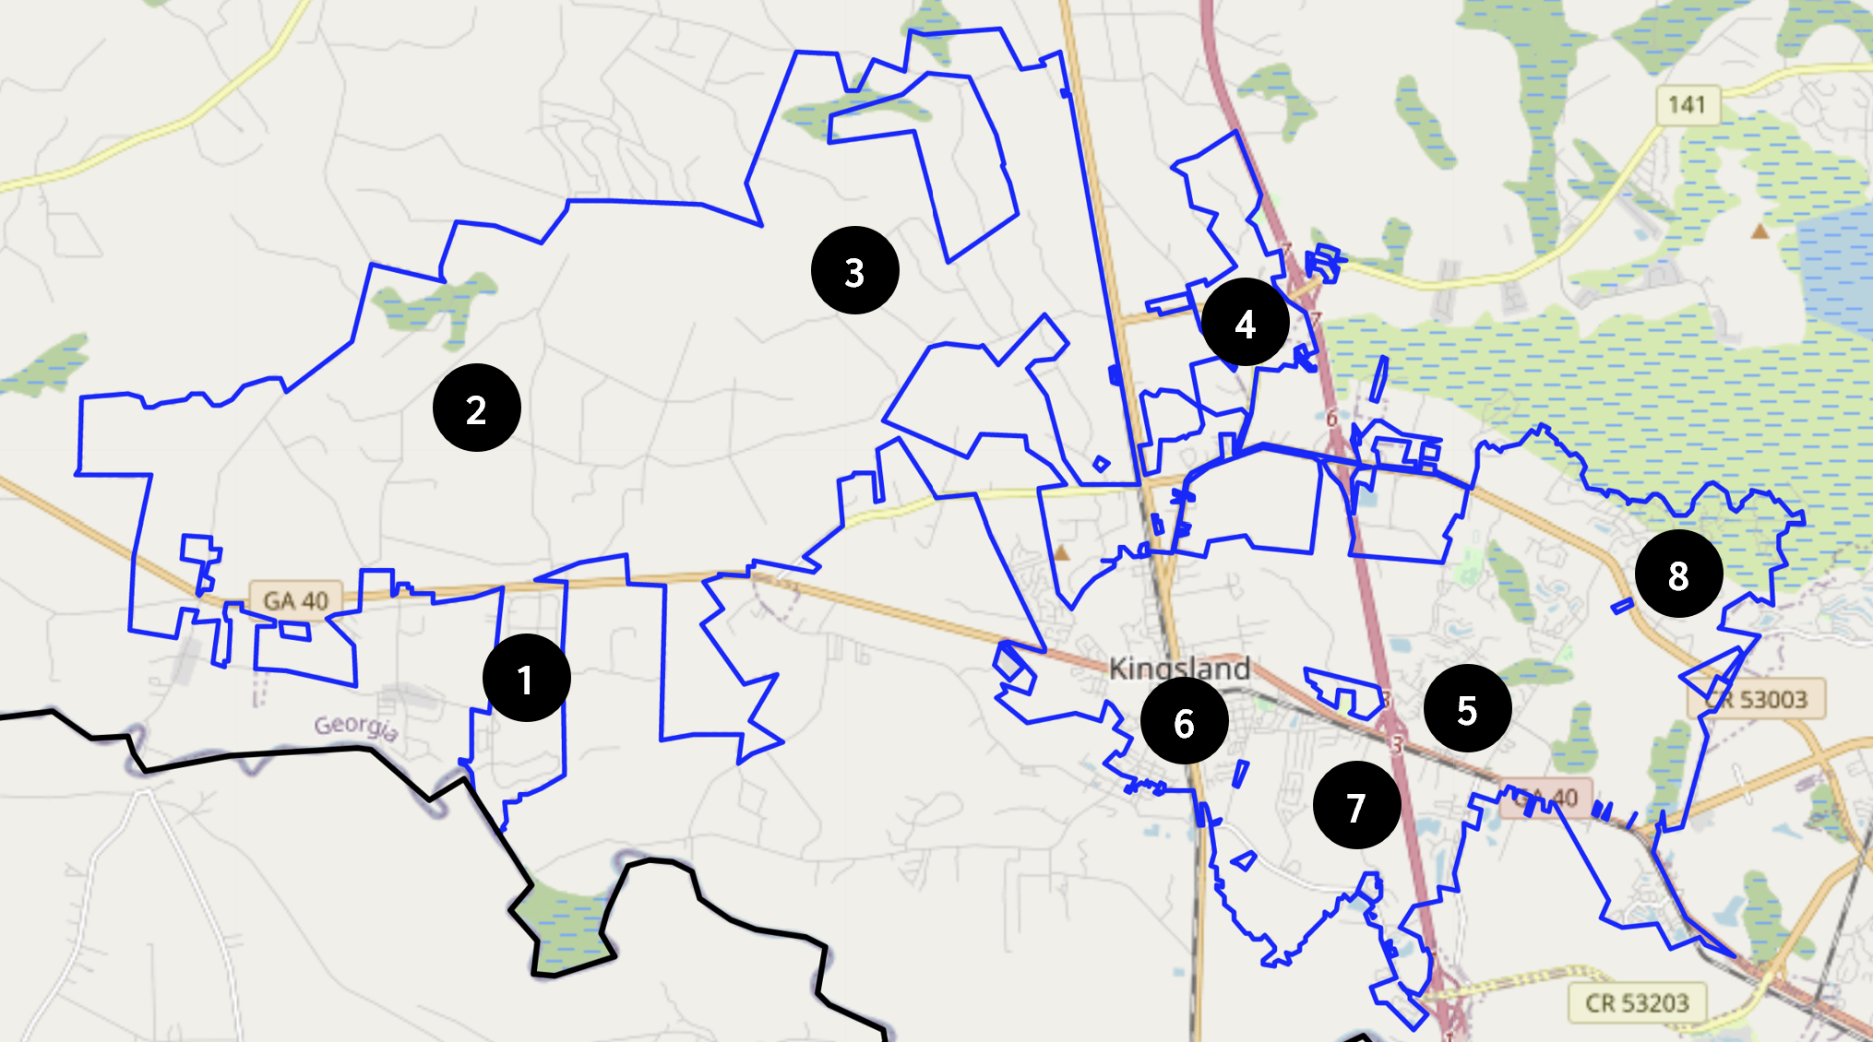

Survey Map Insert

Map areas six and seven were selected based on the affected area for Camden Counties proposed CDBG-DR-Infrastructure project (see Figure 2).

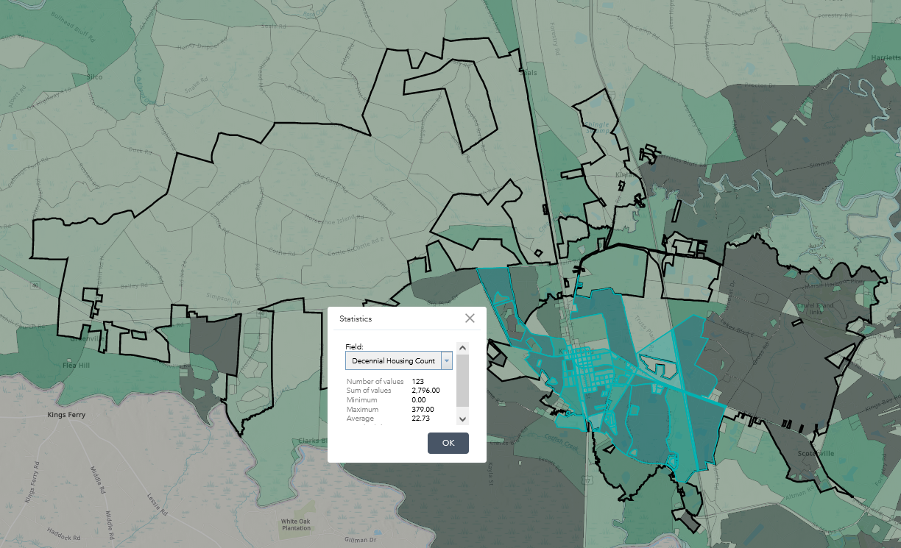

Census Tract in Proposed CDBG-DR-Infrastructure Project Area

There are approximately 2,796 households in areas six and seven (see block contained in Figure @ref(fig:census). Thus, the required sample size for the CDBG per Table 2 (page 6) in DCA’s acceptable survey methodology instructions is 400 respondents. Unfortunately, the survey conducted only received 215 responses.

## Conducting the Survey

As noted above, the survey was publicized through mail inserts.

## Determining the Results

The results have been analyzed and parts A and B of the low- and moderate-income sheet are provided below.

## Documenting Your Effort

Documentation can be found on Github.[1] The raw data is stored as an MS Excel file titled “qualtrics-data.xlsx”.[2] We used R for the data analysis. The .rmd file is titled “dca-cdbg-analysis.Rmd.”[3]

# Low- and moderate-income worksheet

## Part A. Information Contained in Your Survey

1. Enter the estimated total number of families in the target area.  
   **2796**
2. Enter the total number of families interviewed.  
   **215**
3. Enter the total number of low- and moderate- income families interviewed.  
   **72**
4. Enter the total number of persons living in the low- and moderate-income families interviewed.  
   **232**
5. Enter the total number of non-low- and moderate-income families interviewed.  
   **143**
6. Enter the total number of persons living in the non-low- and moderate-income families.  
   **432**

## Part B. Calculations Based on Data Contained in Your Survey

1. Divide Line 4 by Line 3. (This is the average size of the low-mod family you interviewed)  
   **3.22**
2. Divide Line 6 by Line 5. (This is the average size of non-low-mod family you interviewed)  
   **3.02**
3. Divide Line 3 by Line 2. (This is the proportion of families interviewed that have low and moderate incomes)  
   **0.33**
4. Divide Line 5 by Line 2. (This is the proportion of families interviewed that do not have low and moderate incomes)  
   **0.67**
5. Multiply Line 1 by Line 9. (This is the estimate of the total number of low-mod families in your target area)  
   **936.33**
6. Multiply Line 1 by Line 10. (This is the estimate of the total number of non-low-mod families in your target area.)  
   **1860**
7. Multiply Line 7 by Line 11. (This is the estimate of the total number of low-mod persons in your target area.)  
   **3017**
8. Multiply Line 8 by Line 12. (This is the estimate of the total number non-low-mod persons in your target area.)  
   **5618**
9. Add Line 13 and Line 14. (This is the estimate of the total number of persons in your target area)  
   **8635**
10. Divide Line 13 by Line 15, and multiply the resulting decimal by 100. (This is the estimated percentage of persons in your target area who have low and moderate Incomes.)  
    **34.94**

1. 1: <https://github.com/keitheleejr/cc-arpa-cdbg-study>
2. 2: <https://github.com/keitheleejr/cc-arpa-cdbg-study/blob/main/qualtrics-data.xlsx>
3. 3: <https://github.com/keitheleejr/cc-arpa-cdbg-study/blob/main/dca-cdbg-analysis.Rmd>