Camden ARPA / LMI

Start of Block: Block 1

You are being asked to participate in a survey research project entitled “Kingsland Needs Assessment,” which is being conducted by Drs. Joseph Robbins and Keith Lee at Valdosta State University. The purpose of the study is to collect information on the economic impact of COVID-19 and Hurricane Irma on area residents. You will receive no direct benefits from participating in this research study. However, your responses may help us learn more about the community’s recent and ongoing needs. There are no foreseeable risks involved in participating in this study other than those encountered in day-to-day life. Participation should take approximately 10 minutes to complete. This survey is anonymous. No one, including the researcher, will be able to associate your responses with your identity. Your participation is voluntary. You may choose not to take the survey, to stop responding at any time, or to skip any questions that you do not want to answer. Participants must be at least 18 years of age to participate in this study. Your completion of the survey serves as your voluntary agreement to participate in this research project and your certification that you are 18 or older. You may print a copy of this statement for your records.  
  
Questions regarding the purpose or procedures of the research should be directed to Drs. Joseph Robbins (jwrobbins@valdosta.edu) or Keith Lee (keilee@valdosta.edu). This study has been approved by the Valdosta State University Institutional Review Board (IRB) for the Protection of Human Research Participants. The IRB, a university committee established by Federal law, is responsible for protecting the rights and welfare of research participants. If you have concerns or questions about your rights as a research participant, you may contact the IRB Administrator at 229-253-2947 or irb@valdosta.edu.

* Proceed (1)

End of Block: Block 1

Start of Block: Default Question Block

Which number do you live closest to? 

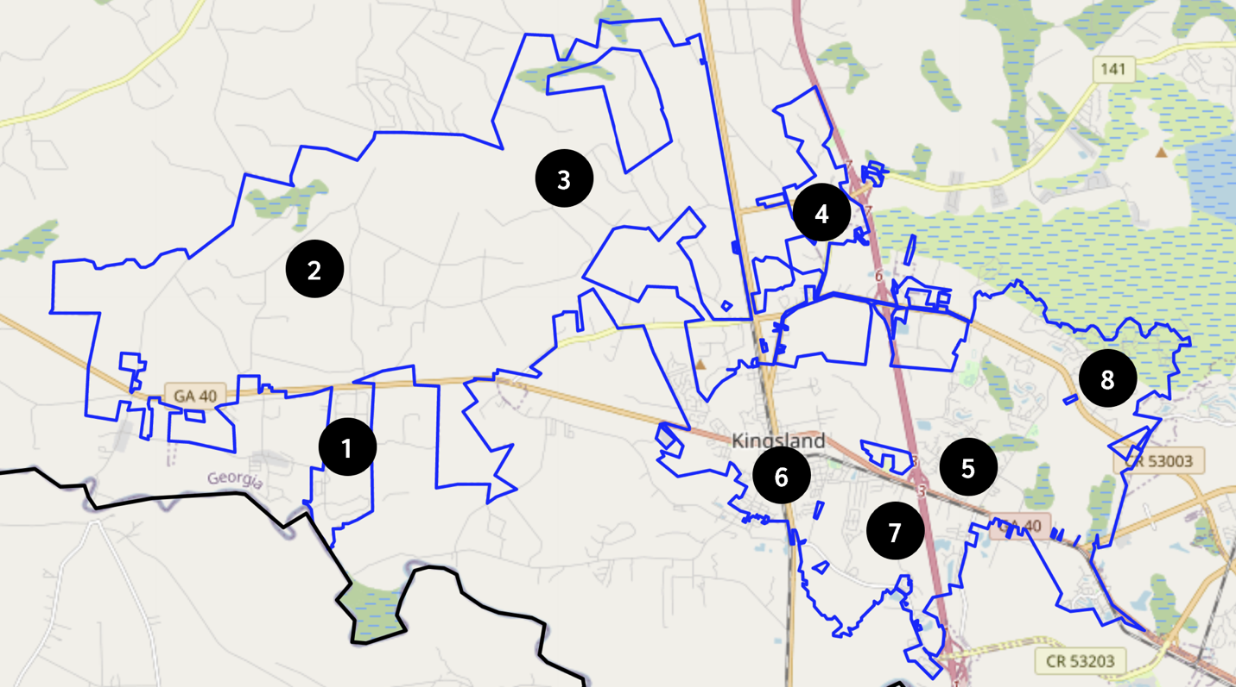

What is the name of the street where you live?

________________________________________________________________

What is your age?

________________________________________________________________

Which option best describes your current housing situation?

* I rent my own house or apartment (1)
* I own my house or apartment (2)
* Other (3)

How many people live in your home?

* 1 (1)
* 2 (2)
* 3 (3)
* 4 (4)
* 5 (5)
* 6 (6)
* 7 (7)
* 8 or more (8)

Are there any individuals living in your household who are younger than 18 years old?

* Yes (1)
* No (2)

Display This Question:

If Are there any individuals living in your household who are younger than 18 years old? = Yes

How many?

________________________________________________________________

Do you live in a single-parent household?

________________________________________________________________

Are there any individuals living in your household who are older than 65 years old?

* Yes (1)
* No (2)

Display This Question:

If Are there any individuals living in your household who are older than 65 years old? = Yes

How many?

________________________________________________________________

Display This Question:

If How many people live in your home? = 1

For 2021, was your gross family income from all sources of those over the age of 18, including those temporarily absent from the unit, greater than or less than the amount listed below?

* Greater Than $37,050 (1)
* Less Than $37,050 (2)

Display This Question:

If How many people live in your home? = 2

For 2021, was your gross family income from all sources of those over the age of 18, including those temporarily absent from the unit, greater than or less than the amount listed below?

* Greater Than $42,350 (1)
* Less Than $42,350 (2)

Display This Question:

If How many people live in your home? = 3

For 2021, was your gross family income from all sources of those over the age of 18, including those temporarily absent from the unit, greater than or less than the amount listed below?

* Greater Than $47,650 (1)
* Less Than $47,650 (2)

Display This Question:

If How many people live in your home? = 4

For 2021, was your gross family income from all sources of those over the age of 18, including those temporarily absent from the unit, greater than or less than the amount listed below?

* Greater Than $52,900 (1)
* Less Than $52,900 (2)

Display This Question:

If How many people live in your home? = 5

For 2021, was your gross family income from all sources of those over the age of 18, including those temporarily absent from the unit, greater than or less than the amount listed below?

* Greater Than $57,150 (1)
* Less Than $57,150 (2)

Display This Question:

If How many people live in your home? = 6

For 2021, was your gross family income from all sources of those over the age of 18, including those temporarily absent from the unit, greater than or less than the amount listed below?

* Greater Than $61,400 (1)
* Less Than $61,400 (2)

Display This Question:

If How many people live in your home? = 7

For 2021, was your gross family income from all sources of those over the age of 18, including those temporarily absent from the unit, greater than or less than the amount listed below?

* Greater Than $65,600 (1)
* Less Than $65,600 (2)

Display This Question:

If How many people live in your home? = 8 or more

For 2021, was your gross family income from all sources of those over the age of 18, including those temporarily absent from the unit, greater than or less than the amount listed below?

* Greater Than $69,850 (1)
* Less Than $69,850 (2)

For 2022, what is the expected gross household income of all adults in your household, including those who are temporarily absent? (Please be as specific as possible as it will determine how funds are allocated to your community)

________________________________________________________________

Was the employment of anyone in your household affected by the COVID pandemic?

* Yes (1)
* No (2)

Display This Question:

If Was the employment of anyone in your household affected by the COVID pandemic? = Yes

Did someone in the household experience a temporary reduction in hours worked?

* Yes (1)
* No (2)

Display This Question:

If Was the employment of anyone in your household affected by the COVID pandemic? = Yes

Did someone in the household experience a permanent reduction in hours worked?

* Yes (1)
* No (2)

Display This Question:

If Was the employment of anyone in your household affected by the COVID pandemic? = Yes

Did someone in the household become temporarily out of work?

* Yes (1)
* No (2)

Display This Question:

If Was the employment of anyone in your household affected by the COVID pandemic? = Yes

Did someone in the household become permanently out of work?

* Yes (1)
* No (2)

If you are still working, are you able to work remotely?

* Yes (1)
* No (2)
* No longer working (3)

How did you find work during COVID?

* I did not look for work (1)
* Department of Labor (2)
* Local job advertisements (3)
* Friends, family, or word of mouth (4)
* Internet-based searches (5)

Do you require child care?

* No, I do not need child care (1)
* Yes, our child care needs are met (2)
* Yes, we have additional child care needs (3)
* Yes, we require child care but do not have it (4)

Display This Question:

If Do you require child care? = Yes, we have additional child care needs

And Do you require child care? = Yes, we require child care but do not have it

Which option best describes your child care needs?

* Full-time child care (1)
* After-school child care (2)
* Other (3)

Display This Question:

If Do you require child care? = Yes, our child care needs are met

And Do you require child care? = Yes, we have additional child care needs

And Do you require child care? = Yes, we require child care but do not have it

How much do you typically spend on child care each month?

________________________________________________________________

Since March 2020, did you access any services or resources from a nonprofit or community organization (for example, church, shelter, food pantry, etc.)?

* Yes (1)
* No (2)

Display This Question:

If Since March 2020, did you access any services or resources from a nonprofit or community organiza... = Yes

Was this the first time you needed resources from nonprofit or community organizations?

* Yes (1)
* No (2)

Over the past two years, which services did you access (choose all that apply)?

* I have not used any services (1)
* Food (2)
* Clothing or household items (3)
* Child care (4)
* Rent or mortgage assistance (5)
* Utilities (6)
* Computer or technology equipment (7)
* Legal aid (8)
* Healthcare (9)
* Medical equipment or supplies (10)
* Mental health services (11)
* Job search or training (12)
* Income assistance (13)
* Transportation (14)
* Other (15)

Display This Question:

If Over the past two years, which services did you access (choose all that apply)? != I have not used any services

List the name(s) of organizations that have provided resources.

________________________________________________________________

________________________________________________________________

________________________________________________________________

________________________________________________________________

________________________________________________________________

Please list any resources you needed but could not access.

________________________________________________________________

________________________________________________________________

________________________________________________________________

________________________________________________________________

________________________________________________________________

Do you have access to the COVID vaccine and/or booster?

* Yes (1)
* No (2)

Do you have internet access?

* Yes (1)
* No (2)

Do you have access to an internet-connected device in your home (for example, computer/laptop, smartphone, or tablet)?

* Yes (1)
* No (2)

Display This Question:

If Do you have access to an internet-connected device in your home (for example, computer/laptop, sm... = No

Do you have access to an internet-connected device outside your home?

* Yes (1)
* No (2)

Display This Question:

If Do you have access to an internet-connected device in your home (for example, computer/laptop, sm... = Yes

Where do you most often access the internet-connected device outside your home (for example, coffee shop, restaurant, friend's house, church, etc.)?

________________________________________________________________

Please select the option that best describes your situation.

* There is always enough food in my home to satisfy the needs of those in the household (1)
* There is mostly enough food in my home to satisfy the needs of those in the household (2)
* There is rarely enough food in my home to satisfy the needs of those in the household (3)
* There is never enough food in my home to satisfy the needs of those in the household (4)

If there was an emergency today and you needed $400, how would you handle the situation?

* Pay with cash, check, or debit card (1)
* Pay with a credit card (2)
* Borrow the money (3)
* Sell or pawn something (4)
* Not able to pay (5)

What would you need to get back on your feet?

________________________________________________________________

________________________________________________________________

________________________________________________________________

________________________________________________________________

________________________________________________________________

End of Block: Default Question Block