**PROBLEM 1 (MATLAB)**

**SCRIPT**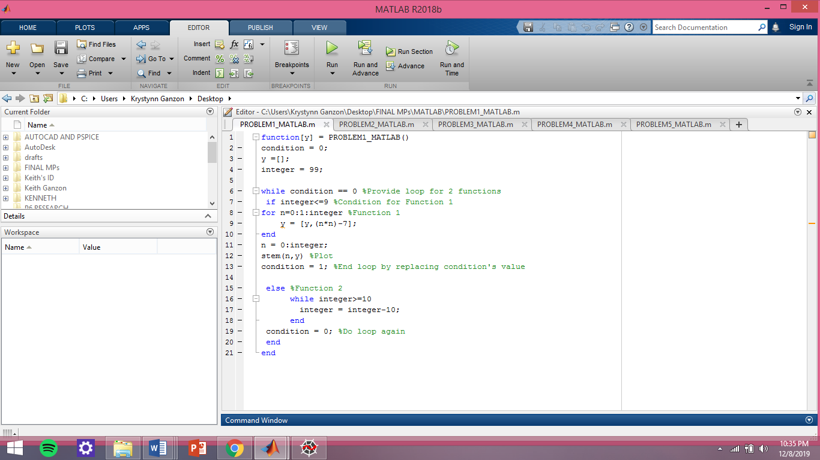

**TEST**

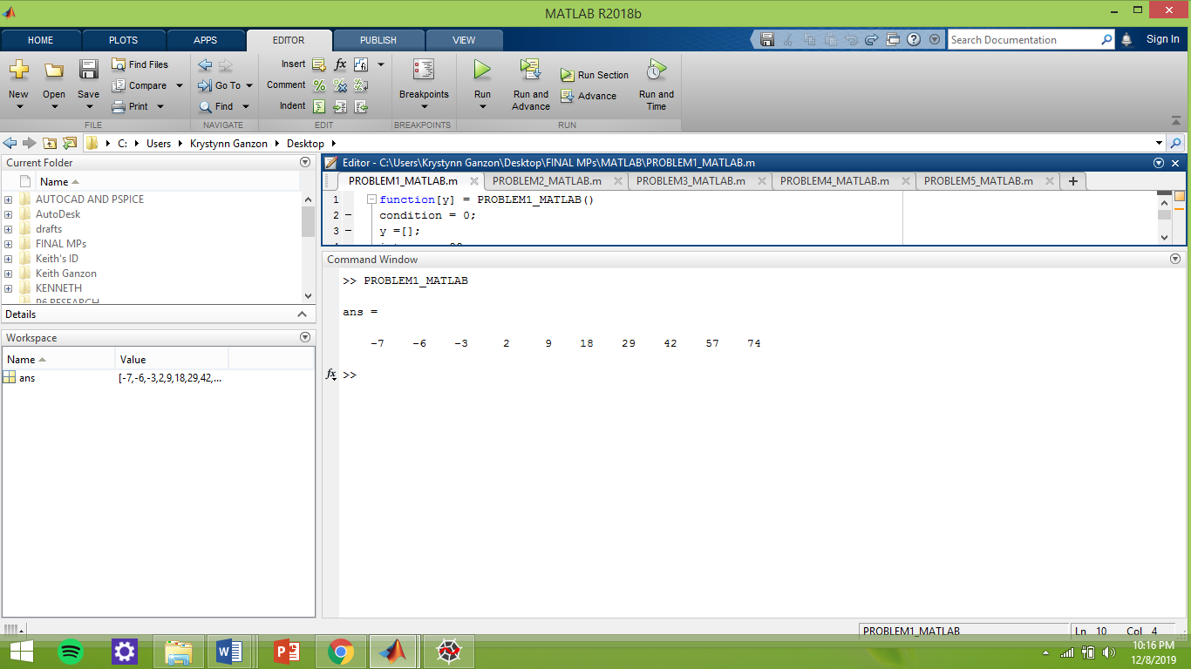

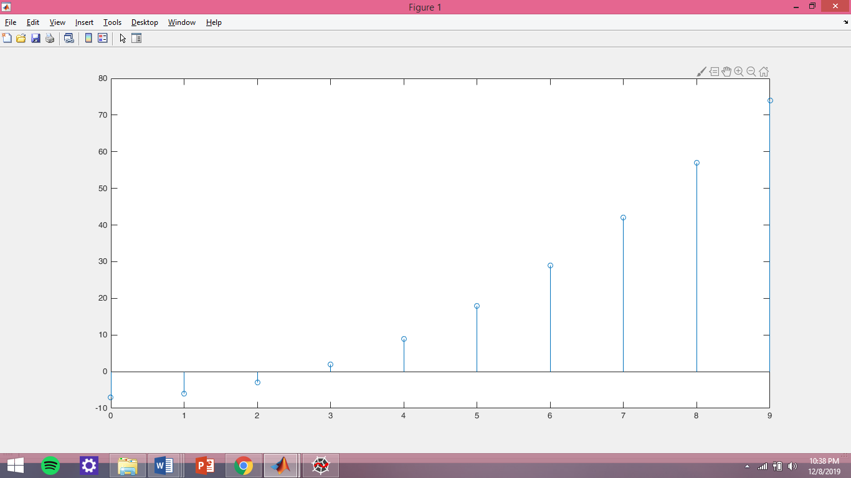

**Describe and comment on the graph f(n):**

Since the second condition would always minus 10 if it is not n <= 9, the only x-axis coordinates

that will be used is 0 to 9. The points goes up as the value of n increases.