**PROBLEM 3 (MATLAB)**

**SCRIPT**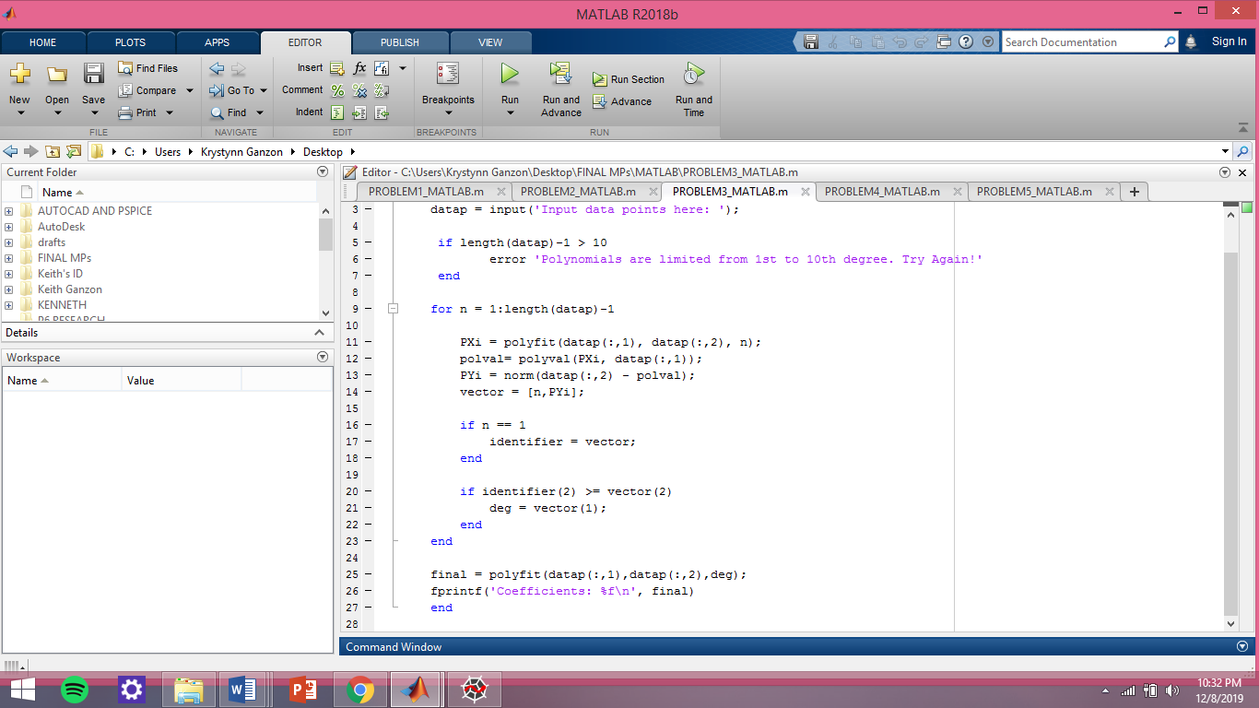

**TEST**

