**PROBLEM 4 (PYTHON)  
SCRIPT**

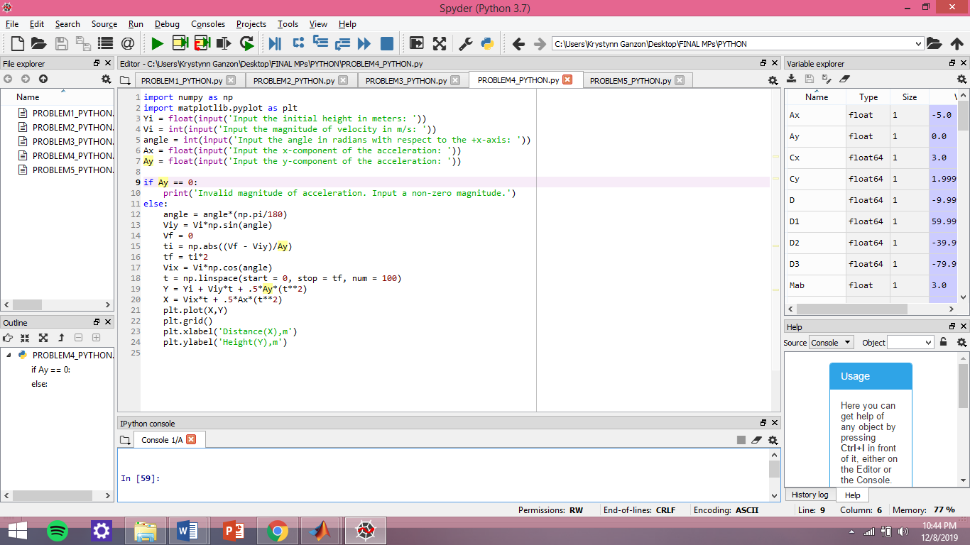 **TEST**

**A. IDEAL MOTION**

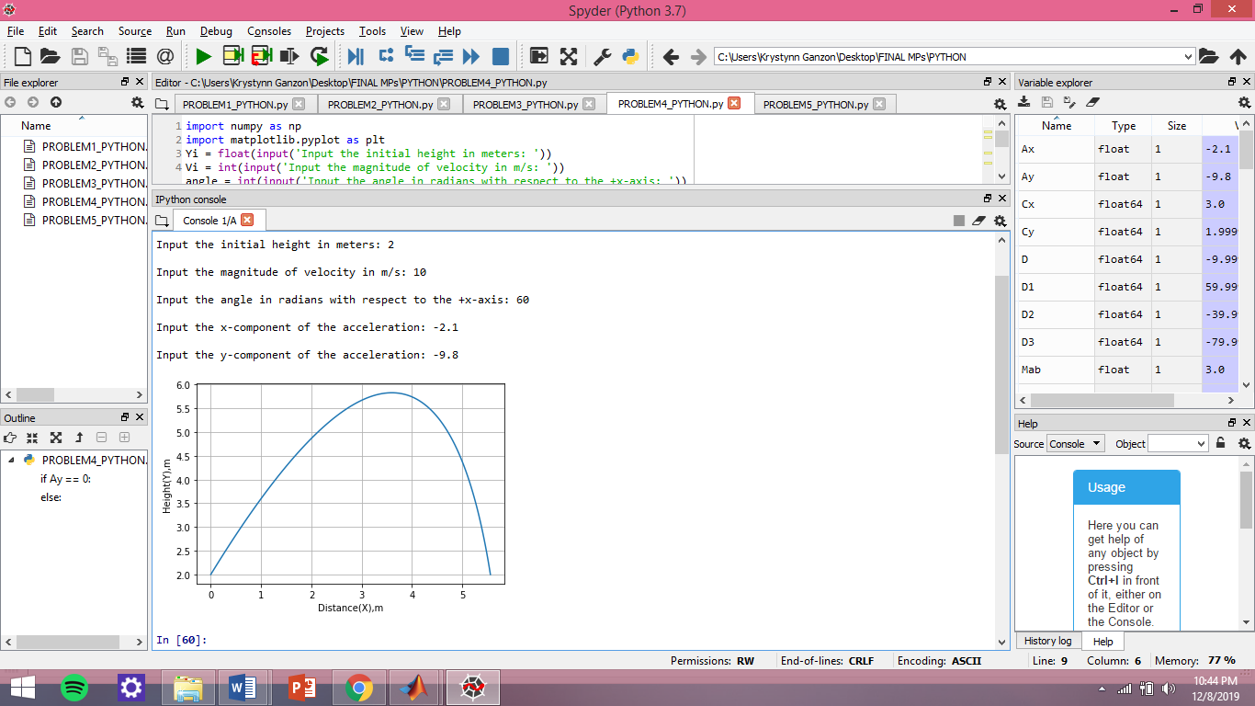

**B. NON IDEAL MOTION**

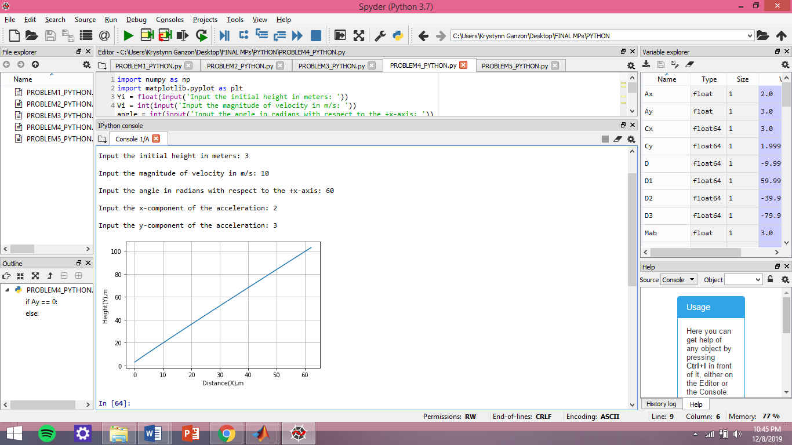

**C. ERROR**

