**PROBLEM 5 (PYTHON)**

**SCRIPT**

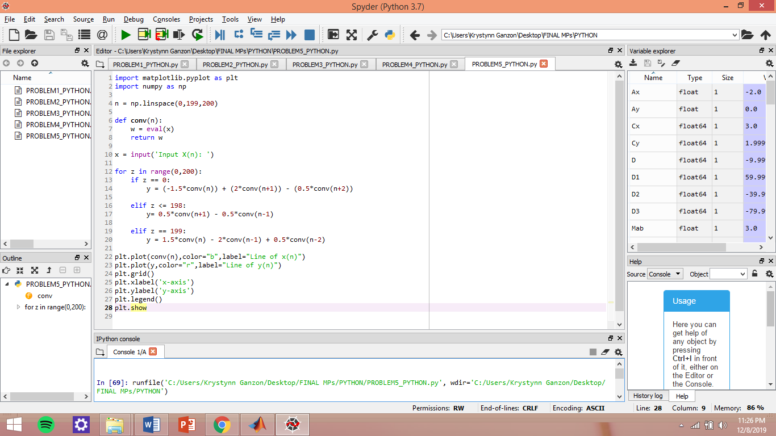

**TEST**

