HW#4

Keith Mitchell

2/20/2020

# Partial code credit to Prof Li (UC Davis), Weiping Zhang(USTC)

## Number 2

### Part 1

#### two-sample Hotelling’s T2 test ——-

# now we perform the two-sample Hotelling T^2-test  
n<-c(18,18)  
p<-2  
xmean1<-c(85,83)  
xmean2<-c(85,87)  
d<-xmean1-xmean2  
S1<-matrix(c(16, 8, 8, 16), nrow=2)  
S2<-matrix(c(16, 8, 8, 16), nrow=2)  
Sp<-((n[1]-1)*S1+(n[2]-1)*S2)/(sum(n)-2)  
t2 <- t(d)%*%solve(sum(1/n)*Sp)%*%d  
t2

## [,1]  
## [1,] 12

alpha<-0.05  
cval <- (sum(n)-2)*p/(sum(n)-p-1)*qf(1-alpha,p,sum(n)-p-1)  
cval

## [1] 6.768921

#### Since T^2 = 12 > 6.76 the null hypothesis is rejected at 5% level of significance.

### Part 2

#### Confidence Region

es<-eigen(sum(1/n)*Sp)  
e1<-es$vec %*% diag(sqrt(es$val))  
r1<-sqrt(cval)  
theta<-seq(0,2*pi,len=250)  
v1<-cbind(r1*cos(theta), r1*sin(theta))  
pts<-t(d-(e1%*%t(v1)))  
plot(pts,type="l",main="Confidence Region for Bivariate Normal",xlab=expression(paste(mu, "(1)")), ylab=expression(paste(mu, "(2)")),asp=1)  
segments(0,d[2],d[1],d[2],lty=2) # highlight the center  
segments(d[1],0,d[1],d[2],lty=2)  
  
th2<-c(0,pi/2,pi,3*pi/2,2*pi) #adding the axis  
v2<-cbind(r1*cos(th2), r1*sin(th2))  
pts2<-t(d-(e1%*%t(v2)))  
segments(pts2[3,1],pts2[3,2],pts2[1,1],pts2[1,2],lty=3)   
segments(pts2[2,1],pts2[2,2],pts2[4,1],pts2[4,2],lty=3)

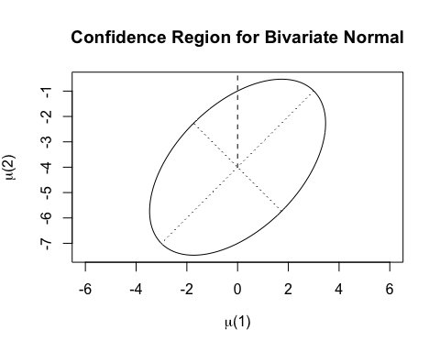

# since we reject the null, we use the simultaneous confidence intervals  
# to check the significant components

### Part 3

#### Simultaneous confidence intervals

wd<-sqrt(cval*diag(Sp)*sum(1/n))  
Cis<-cbind(d-wd,d+wd)  
  
# 95% simultaneous confidence interval  
Cis

## [,1] [,2]  
## [1,] -3.468953 3.4689534  
## [2,] -7.468953 -0.5310466

#plot(Cis[1][1]:0, 1:10, type="l", lty=2)

### Part 4

#### Bonferroni simultaneous confidence intervals

wd.b<- qt(1-alpha/(2*p),n[1]+n[2]-2) *sqrt(diag(Sp)*sum(1/n))  
Cis.b<-cbind(d-wd.b,d+wd.b)  
# 95% Bonferroni simultaneous confidence interval  
Cis.b

## [,1] [,2]  
## [1,] -3.126742 3.1267415  
## [2,] -7.126742 -0.8732585

# both component-wise simultaneous confidence intervals do not contain 0, so they have significant differences.

## Number 3

### Part 1

#### two-sample Hotelling’s T2 test ——-

c <- matrix(c(-1,0,1,-1,0,1), nrow=2)  
tran_c <- t(c)  
s_1 <- matrix(c(16,8,8,8,16,8,8,8,16), nrow=3)  
corrected_s <- c%*%s_1%*%tran_c

# now we perform the two-sample Hotelling T^2-test  
n<-c(18,18)  
p<-2  
xmean1<-c(0,0)  
xmean2<-c(2,2)  
d<-xmean1-xmean2  
S1<-corrected_s  
S2<- corrected_s  
Sp<-((n[1]-1)*S1+(n[2]-1)*S2)/(sum(n)-2)  
t2 <- t(d)%*%solve(sum(1/n)*Sp)%*%d  
t2

## [,1]  
## [1,] 9

alpha<-0.05  
cval <- (sum(n)-2)*p/(sum(n)-p-1)*qf(1-alpha,p,sum(n)-p-1)  
cval

## [1] 6.768921

#### Since T^2 = 9 > 6.76 the null hypothesis is rejected at 5% level of significance.

### Part 2

#### Confidence Region

es<-eigen(sum(1/n)*Sp)  
e1<-es$vec %*% diag(sqrt(es$val))  
r1<-sqrt(cval)  
theta<-seq(0,2*pi,len=250)  
v1<-cbind(r1*cos(theta), r1*sin(theta))  
pts<-t(d-(e1%*%t(v1)))  
plot(pts,type="l",main="Confidence Region for Bivariate Normal",xlab=expression(paste(mu, "(1)")), ylab=expression(paste(mu, "(2)")),asp=1)  
segments(0,d[2],d[1],d[2],lty=2) # highlight the center  
segments(d[1],0,d[1],d[2],lty=2)  
  
th2<-c(0,pi/2,pi,3*pi/2,2*pi) #adding the axis  
v2<-cbind(r1*cos(th2), r1*sin(th2))  
pts2<-t(d-(e1%*%t(v2)))  
segments(pts2[3,1],pts2[3,2],pts2[1,1],pts2[1,2],lty=3)   
segments(pts2[2,1],pts2[2,2],pts2[4,1],pts2[4,2],lty=3)

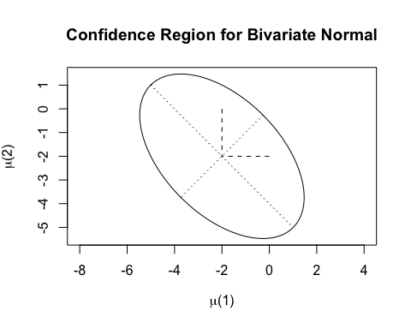

# since we reject the null, we use the simultaneous confidence intervals  
# to check the significant components

### Part 3

#### Simultaneous confidence intervals

wd<-sqrt(cval*diag(Sp)*sum(1/n))  
Cis<-cbind(d-wd,d+wd)  
  
# 95% simultaneous confidence interval  
Cis

## [,1] [,2]  
## [1,] -5.468953 1.468953  
## [2,] -5.468953 1.468953

#plot(Cis[1][1]:0, 1:10, type="l", lty=2)

### Part 4

#### Bonferroni simultaneous confidence intervals

wd.b<- qt(1-alpha/(2*p),n[1]+n[2]-2) *sqrt(diag(Sp)*sum(1/n))  
Cis.b<-cbind(d-wd.b,d+wd.b)  
# 95% Bonferroni simultaneous confidence interval  
Cis.b

## [,1] [,2]  
## [1,] -5.126742 1.126742  
## [2,] -5.126742 1.126742

# both component-wise simultaneous confidence intervals do not contain 0, so they have significant differences.

## Number 4

#### two-sample Hotelling’s T2 test

# now we perform the two-sample Hotelling T^2-test  
n<-c(45,55)  
p<-2  
xmean1<-c(204.4,556.6)  
xmean2<-c(130,355)  
d<-xmean1-xmean2  
S1 <- matrix(c(13825.3, 23823.4, 23823.4, 73107.4), nrow=2)  
S2 <- matrix(c(8632.0, 19616.7, 19616.7, 55964.5), nrow=2)  
  
Sp<-((n[1]-1)*S1+(n[2]-1)*S2)/(sum(n)-2)  
t2 <- t(d)%*%solve(sum(1/n)*Sp)%*%d  
t2

## [,1]  
## [1,] 16.06622

alpha<-0.05  
cval <- (sum(n)-2)*p/(sum(n)-p-1)*qf(1-alpha,p,sum(n)-p-1)  
cval

## [1] 6.244089

#### Since T^2 = 16.06 > 6.24 the null hypothesis is rejected at 5% level of significance.

a <- solve(Sp)%*%d  
a

## [,1]  
## [1,] 0.00170252  
## [2,] 0.00259163

#### Where a is the linear combination of mean components most responsbile for the rejection of the null hypothesis.