Keith Griffin

11/17/20

IT FDN 110 A

Assignment 05

Assignment 05

Introduction

This week I learned more about using lists and dictionaries. That you can insert a list into a dictionary or a dictionary into a list, how to add and delete values from a dictionary and how to display dictionary values with several new functions including value() key() and items() that are useful when using a dictionary with a for loop. I’m realizing that it is getting harder to remember the things that I learned while in the team treehouse course as well and I have been supplementing the material from this class with my python crash course book as well as automate the boring stuff with python.

Questions:

What is the difference between a List and a Dictionary?

Lists are an ordered sequence of objects whereas dictionaries are based on key: value pairs. Each key in a dictionary is attached to one value.

What is the difference between an Index and a Key?

The difference between an index and a key is that the index of a list is a particular position in the list. For example list[0] is the first position in the list where a key is used in a dictionary to access a particular value. A key has a descriptor. For example dict = {“fruit”: “kiwi”} the key is fruit dict[fruit] = “kiwi

How do you read data from a file into a List?

You read data from a file into a list by opening the file in read with open(filename, ‘r’) and then looping through the contents of the file with a for loop.

How do you read data from a file into a Dictionary?

You read data from a file into a dictionary similarly to a list except you assign a key, value pair in the for loop and access the pairs with the .items() function.

What is the programming pattern called “Separations of Concerns?”

Separation of Concerns separate the Processing, Presentation, and Data into discernible sections that make the code easier to read. The proper format is Data -> Processing -> Presentation

How would you use a function to organize your code?

Functions are useful because they allow you to execute your code based on the order that they are called.

For example:

def add(num1, num2):

print(num1+num2)

def sub(num1, num2):

print(num1-num2)

sub(2,2)

add(2,2)

By calling the sub function first, you ensure that it is executed before the add function. You can also call each function as many times as you want with the same or different values to have it execute in any order. Also You can use the variables num1 and num2 in both functions without worrying that the values you input in each function call will override each other because they exist in the scope of the function and aren’t global variables.

Why is a script template useful?

A script template is useful because it makes your code easier to read as well as more professional. You can create script templates in pycharm so that you don’t have to keep recreating them every time you make a new program.

Why is error handling using Try-Except recommended?

Error handing using Try-Except is recommended to make code more user friendly for end users so that when the code has an error, the Try-Except block is able to catch that error and allow the program to continue running as well as tell the user that something went wrong.

What is GitHub, and why is it used?

GitHub is the largest community of developers in the world that holds a public repository for user’s code. The website allows you to upload/share code with the people all over the world so that they can collaborate, use/edit the code.

Code:

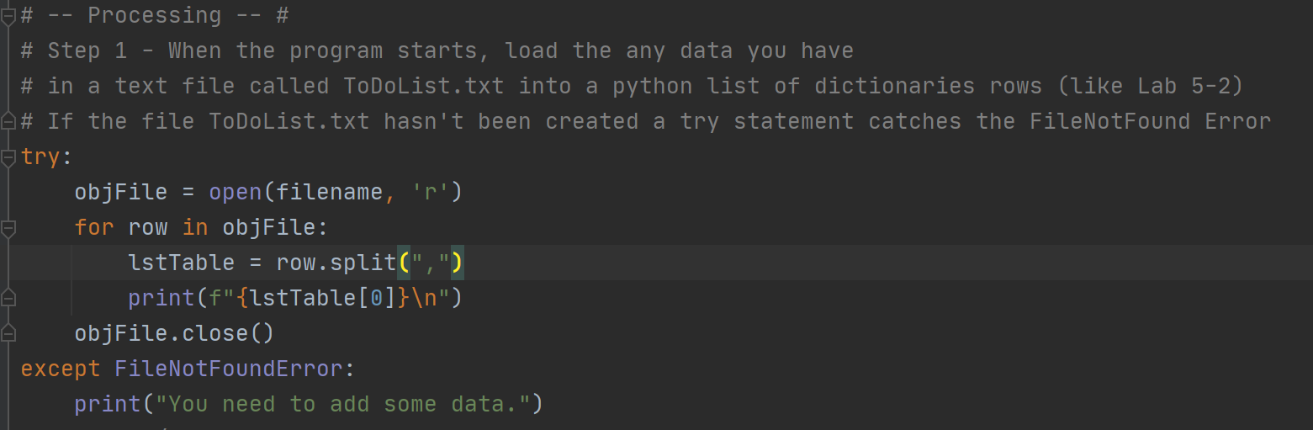

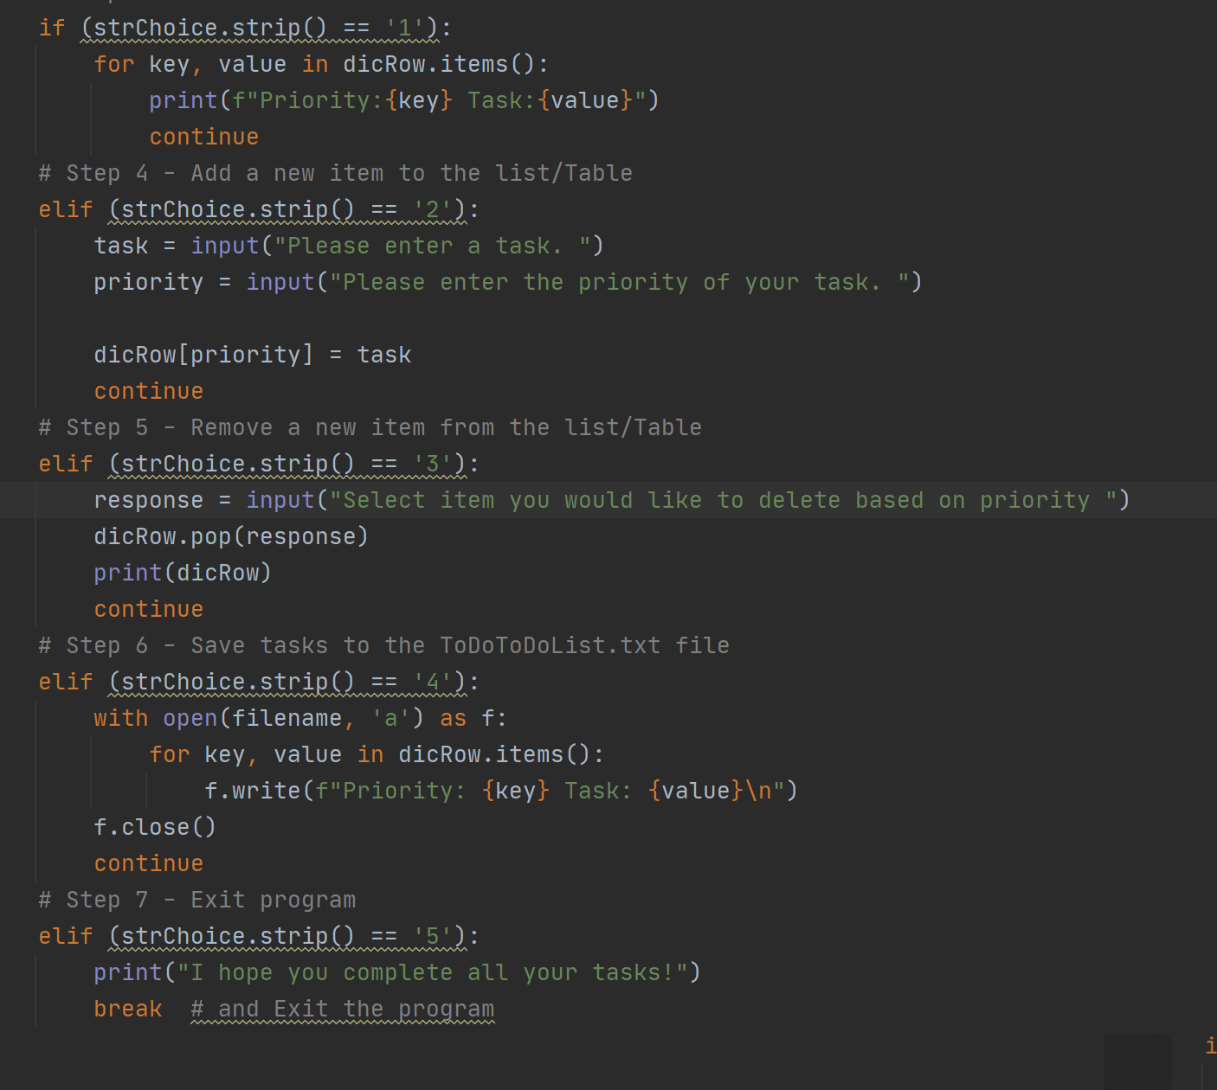

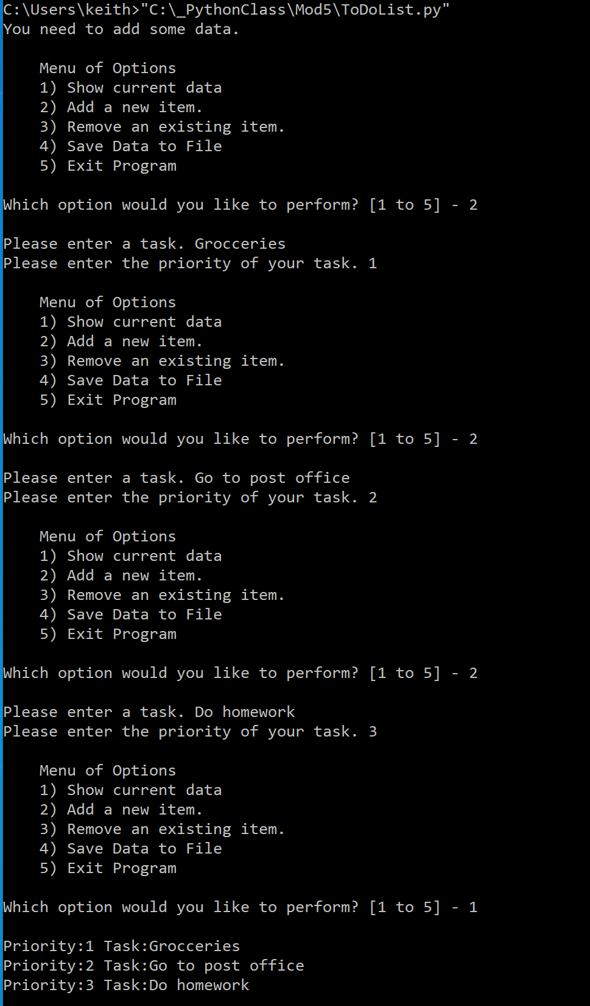

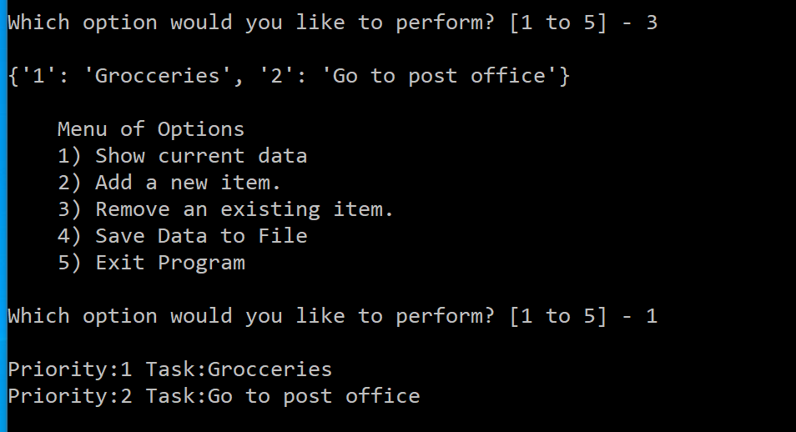

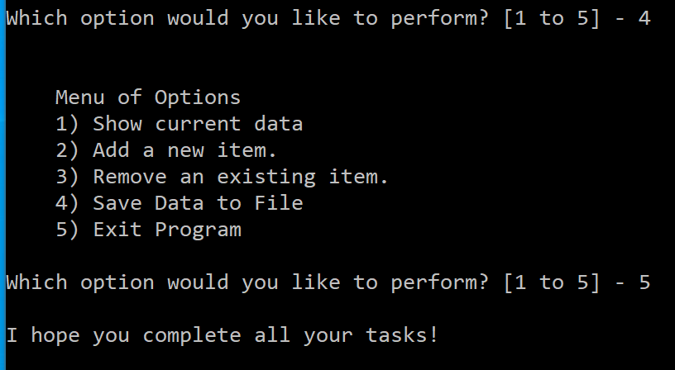

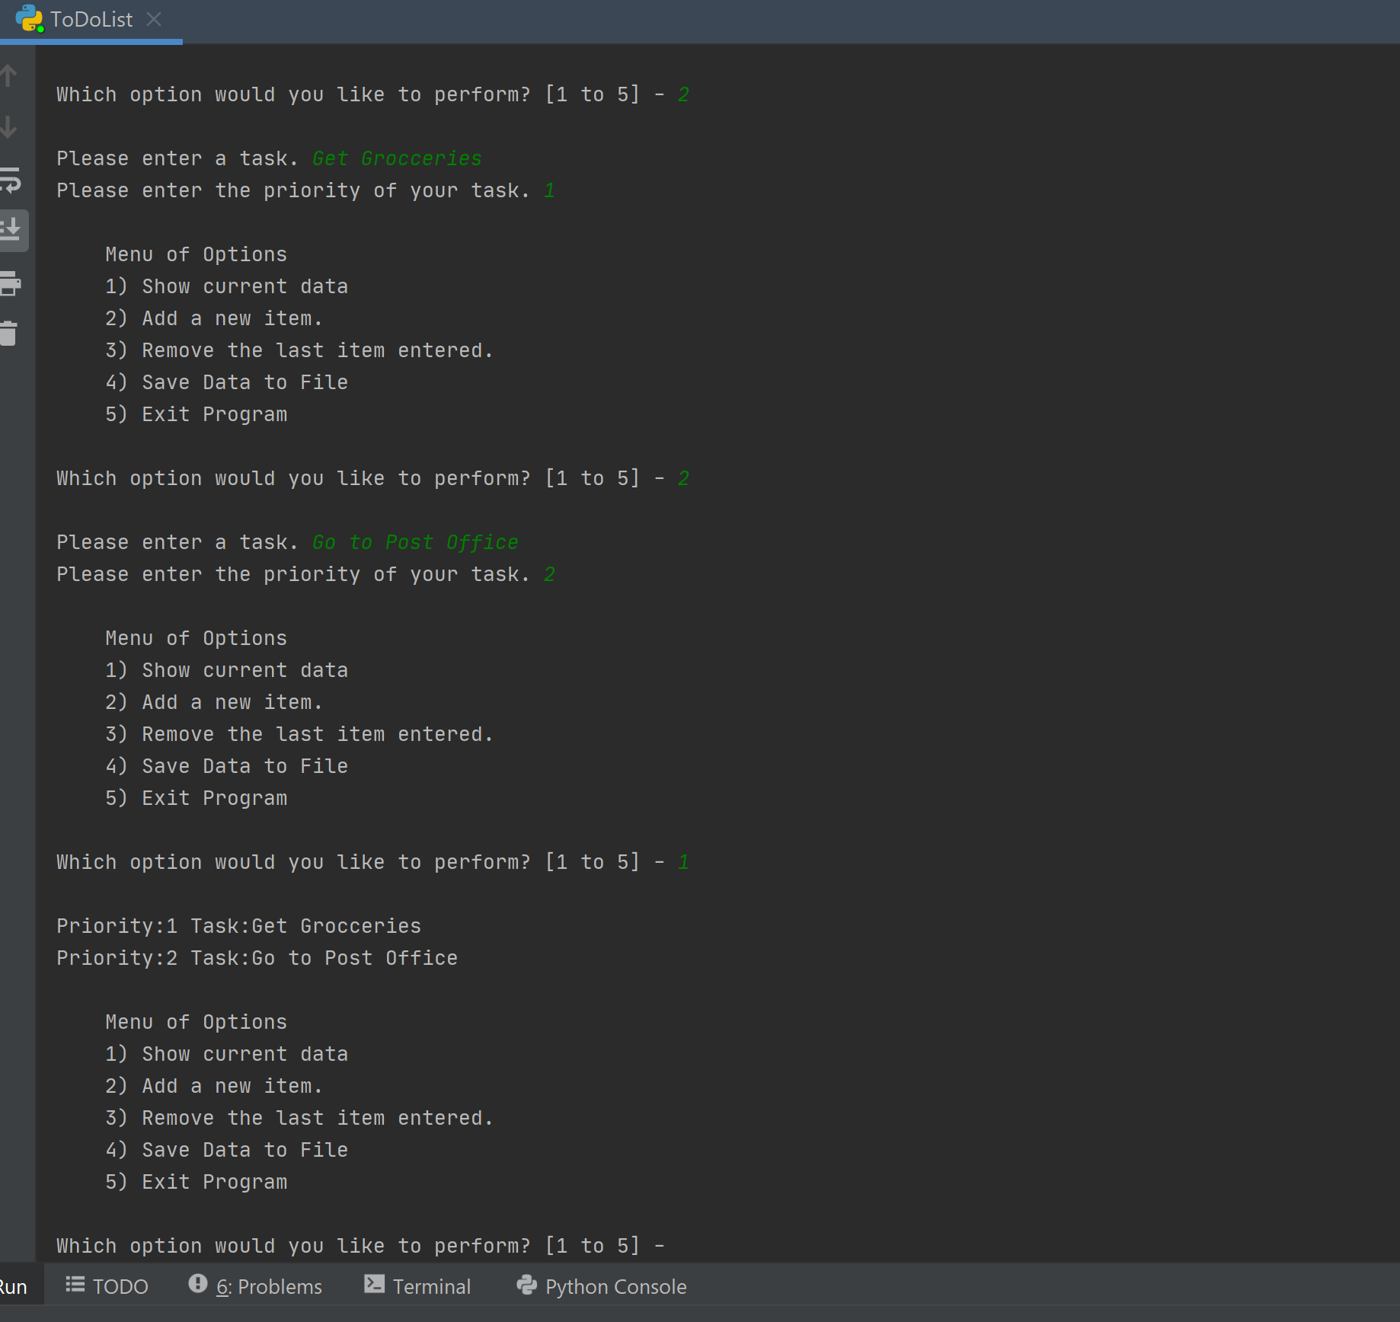

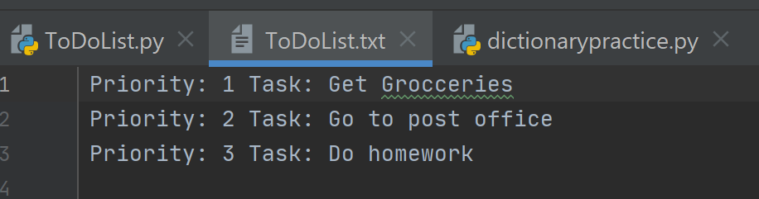

Steps:

1. The first thing that I did to modify the existing code was to create a try-except block that will open and read the toDoList textfile if one has already been created. If the textfile exists, a for loop is used to read the file as a list.

2. The second thing I did was to create a for loop that loops through the dict created from user input and displays it to the user in a neat format. I used the key, value and .item() in the for loop to display the contents of the dict neatly.

3. The third thing that I did was ask for user input on a task and priority for the to do list. The priority was assigned to the dict key and the task was assigned to the dict value. With the dictRow[priority]= task

4. The four thing that I did was to ask the user if they would like to delete an item off the dictionary before saving it to a file. I used the .pop() function to accomplish this.

5. Once the user was done updating their todolist the user can enter 5 and message is printed wishing that the user is able to complete all of his/her tasks.

Conclusion:

Each week has gotten harder for me to make my code successful. I am also not used to filling in code that is already written and prefer to make my own from scratch. This week was the first week that I couldn’t get my code to do exactly what I want it to do. For example, when I display the content of the textfile there are commas where I don’t want to be and when I tried to display the textfiles contents with a \n character the \n character showed up in the print values. I couldn’t figure out how to get rid of it. However after looking at my code again, I was finally able to figure it out and now everything works correctly.