Group Homework: Data Preparation

Wranglers

Saturday, September 26, 2015

## Team Members

* Nisha Balani
* Chanakya Daparthy
* Sri Dakshinya Gudipati
* Sai Aditya Immaneni
* Anusha Vanam
* Keith Williams

# Data Preparation

The data for patent bibliographic data exists in 533 zipped files. The format for the relevant data is pseudo-xml. The following process is used to extract the cleaned data:

### 1. Unzip and Transform Raw ipgbXXXXXXXX_wkXX.xml Files

Each *.zip file is extracted, and the .xml transformed, so that each patent is on a single line. These patent per line files are filtered, so that only patents belonging to our company and its competitors are kept. Shell code:

shopt -s extglob #set shell options  
  
cat >> oppl.txt #create empty text file for appending   
^D  
  
# loop over each zip, extract and transform  
for file in *.zip  
do  
unzip "$file"  
cat *.xml | python ../one-patent-per-line.py | grep -i -E "medtronic|covidien|stryker|boston scientfic|abbott" >> ../oppl.txt  
rm *.!(zip)  
done

### 2. Prepare Each Company Patents for Feature Extraction

The one patent per line text file is split into 4 files: one for the patents belonging to our company, and three for each of our closest competitors:

grep -i -E "<assignee>.*?medtronic.*?</orgname|<assignee>.*?covidien.*?</orgname" oppl.txt > oppl_medtronic.txt  
grep -i -E "<assignee>.*?stryker.*?</orgname" oppl.txt > oppl_stryker.txt  
grep -i -E "<assignee>.*?boston scientific.*?</orgname" oppl_combined.txt > oppl_boston_scientific.txt  
grep -i -E "<assignee>.*?abbott.*?</orgname" oppl_combined.txt > oppl_abbott.txt

### 3. Use Regex to Extract Fields and Write .csv

# Takes as an input a list of .txt files in which each patent is on its own   
# line: an output of one-patent-per-line.py | grep -i "COMPANY" > out.txt  
# Extracts fields for output as a tidy .csv  
  
import sys as sys  
import re as re  
import pandas as pd  
  
def oppl_to_df(company, patent_file):  
 """Takes a wide patent file, and returns a pandas DataFrame  
 Inputs:  
 company: string of company name  
 patent_file: .txt file where each patent owned by company is on a single line  
 Ouput:  
 pandas DataFrame, where rows are patents, and columns are the features:  
 company name  
 patent assignee  
 year granted  
 year applied  
 patent class  
 patent number  
 patent title  
 patent abstract  
 """  
   
 # initialize fields as a dictionary  
 fields = {'company_name' : [],  
 'patent_assignee' : [],  
 'year_granted' : [],  
 'year_applied' : [],  
 'patent_class' : [],  
 'patent_number' : [],  
 'patent_title' : [],  
 'patent_abstract' : []}  
   
 # specify regular expressions  
 assignee_re = '<assignee>.*?</orgname>'  
 pub_ref_re = '<publication-reference>.*?</publication-reference>'  
 date_tags = '<publication-reference>.*<date>|</date>.*'  
 id_tags = '<publication-reference>.*<doc-number>|</doc-number>.*'  
 app_ref_re = '<application-reference.*?</application-reference>'  
 class_re = '</classification-locarno>.*?</main-classification>'  
 title_re = '<invention-title.*?</invention-title>'  
 abstract_re = '<abstract.*?</abstract>'  
   
 for line in patent_file.readlines():  
 # Use regex to find fields,   
 # and append them to appropriate dictionary value  
   
 # attach company name  
 fields['company_name'].append(company)  
   
 # extract patent assignee  
 assignee = re.search(assignee_re, line)  
 if assignee:  
 patent_assignee = re.sub('<assignee>.*<orgname>|</orgname>',   
 '',   
 assignee.group())  
 fields['patent_assignee'].append(patent_assignee)  
 else:  
 fields['patent_assignee'].append('None')  
   
 # extract year granted and patent number,   
 # both in <publication-reference>  
 pub_ref = re.search(pub_ref_re, line)  
 if pub_ref:  
 year_granted = re.sub(date_tags, '', pub_ref.group())  
 patent_number = re.sub(id_tags, '', pub_ref.group())  
 fields['year_granted'].append(year_granted[0:4])  
 fields['patent_number'].append(patent_number)  
 else:  
 fields['year_granted'].append('None')  
 fields['patent_number'].append('None')  
   
 # extract year applied  
 app_ref = re.search(app_ref_re, line)  
 if app_ref:  
 year_applied = re.sub('<application.*<date>|</date>.*',  
 '',  
 app_ref.group())  
 fields['year_applied'].append(year_applied[0:4])  
 else:  
 fields['year_applied'].append('None')  
   
 # extract patent classification  
 classification = re.search(class_re, line)  
 if classification:  
 patent_class = re.sub('</class.*<main-classification>|</main.*',  
 '',  
 classification.group())  
 fields['patent_class'].append(patent_class)  
 else:  
 fields['patent_class'].append('None')  
   
 # extract patent title  
 title = re.search(title_re, line)  
 if title:  
 patent_title = re.sub('<invention.*?>|</invention.*',  
 '',  
 title.group())  
 fields['patent_title'].append(patent_title)  
 else:  
 fields['patent_title'].append('None')  
   
 # extract patent abstract  
 abstract_field = re.search(abstract_re, line)  
 if abstract_field:  
 abstract = re.sub('<abstract.*<p.*?>|</abstract>',  
 '',  
 abstract_field.group())  
 fields['patent_abstract'].append(abstract)  
 else:  
 fields['patent_abstract'].append('None')  
   
 # transform dictionary to pandas DataFrame  
 return pd.DataFrame(fields)  
   
def run():  
 # paths to patent files for each company. Each patent is on a single line.  
 oppl_medtronic = open('../oppl_medtronic.txt')  
 oppl_stryker = open('../oppl_stryker.txt')  
 oppl_bs = open('../oppl_boston_scientific.txt')  
 oppl_abbott = open('../oppl_abbott.txt')  
   
 # define lists of companies, and the patent files for feature extraction loop  
 oppl_files = [oppl_medtronic, oppl_stryker, oppl_bs, oppl_abbott]  
 companies = ['Medtronic', 'Stryker', 'Boston Scientific', 'Abbott']  
   
 # convert each patent file into a tidy pandas data frame  
 dfs = [oppl_to_df(companies[i], oppl_files[i]) for i in range(len(companies))]  
   
 # concatenate the data frames, and write to .csv  
 df_combined = pd.concat(dfs, ignore_index=True)  
 df_combined.to_csv('medtronic_and_competitor_patents_05-15.csv', index=False)  
  
if __name__ == "__main__":  
 run()

# Patent Ratios

The USPTO website was used to query the number of patents per year over the last 10 years for Medtronic and its three closest competitors: Stryker, Boston Scientific, and Abbott. These numbers were compared to the number of patents for each company mined from the patent bibliographic data. All visulizations done in R.

# visualize ratios by year  
plot_ratios <- ggplot(patent_ratios, aes(company_name, count, fill=source_found)) +  
 geom_bar(stat='identity', position='dodge') +  
 facet_grid(.~year_granted, scales="free_y") +  
 labs(list(title = "Patent Counts: Biblio Data vs USPTO",  
 x = "Company Name",  
 y = "Number of Patents")) +  
 theme(axis.text.x = element_text(angle=90, hjust=1, vjust=0.5))  
plot_ratios

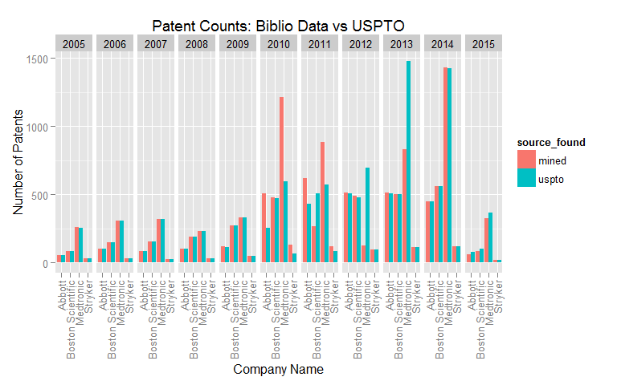

# visualize ratios: total by company  
plot_totals <- ggplot(patent_ratios, aes(company_name, count, fill=source_found)) +  
 geom_bar(stat='identity', position='dodge') +  
 labs(list(title = "Patent Counts: Biblio Data vs USPTO",  
 x = "Company Name",  
 y = "Number of Patents")) +  
 theme(title = element_text(size = 16))  
plot_totals

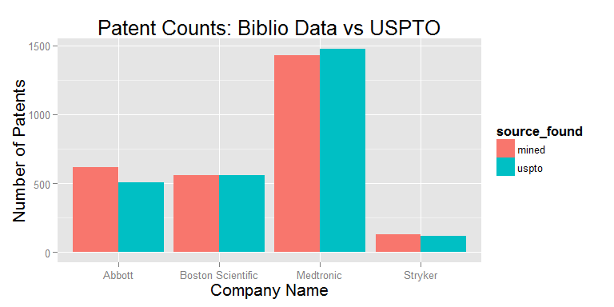

kable(patent_counts, align='c')

|  |  |  |  |
| --- | --- | --- | --- |
| company_name | year_granted | mined | uspto |
| Abbott | 2005 | 54 | 54 |
| Abbott | 2006 | 104 | 101 |
| Abbott | 2007 | 85 | 85 |
| Abbott | 2008 | 101 | 101 |
| Abbott | 2009 | 117 | 115 |
| Abbott | 2010 | 510 | 253 |
| Abbott | 2011 | 619 | 433 |
| Abbott | 2012 | 515 | 505 |
| Abbott | 2013 | 512 | 508 |
| Abbott | 2014 | 450 | 449 |
| Abbott | 2015 | 61 | 76 |
| Boston Scientific | 2005 | 87 | 86 |
| Boston Scientific | 2006 | 146 | 146 |
| Boston Scientific | 2007 | 156 | 156 |
| Boston Scientific | 2008 | 189 | 192 |
| Boston Scientific | 2009 | 275 | 274 |
| Boston Scientific | 2010 | 478 | 474 |
| Boston Scientific | 2011 | 266 | 507 |
| Boston Scientific | 2012 | 488 | 477 |
| Boston Scientific | 2013 | 504 | 504 |
| Boston Scientific | 2014 | 561 | 561 |
| Boston Scientific | 2015 | 83 | 100 |
| Medtronic | 2005 | 260 | 257 |
| Medtronic | 2006 | 310 | 306 |
| Medtronic | 2007 | 320 | 317 |
| Medtronic | 2008 | 229 | 232 |
| Medtronic | 2009 | 333 | 332 |
| Medtronic | 2010 | 1211 | 599 |
| Medtronic | 2011 | 884 | 571 |
| Medtronic | 2012 | 126 | 698 |
| Medtronic | 2013 | 829 | 1476 |
| Medtronic | 2014 | 1430 | 1423 |
| Medtronic | 2015 | 327 | 367 |
| Stryker | 2005 | 33 | 33 |
| Stryker | 2006 | 30 | 30 |
| Stryker | 2007 | 27 | 27 |
| Stryker | 2008 | 31 | 31 |
| Stryker | 2009 | 48 | 48 |
| Stryker | 2010 | 130 | 65 |
| Stryker | 2011 | 119 | 82 |
| Stryker | 2012 | 96 | 94 |
| Stryker | 2013 | 116 | 116 |
| Stryker | 2014 | 118 | 117 |
| Stryker | 2015 | 17 | 21 |

# Visualize Abstracts and Titles for Medtronic

library(wordcloud)  
library(wesanderson)  
  
# filter company equal to Medtronic  
med <- patents %>% filter(company_name == 'Medtronic')  
  
# visualize patent titles  
palette <- wes_palette("Darjeeling", 5, "discrete")  
palette <- palette[5:1]  
wordcloud(med$patent_title, max.words=150, colors=palette)

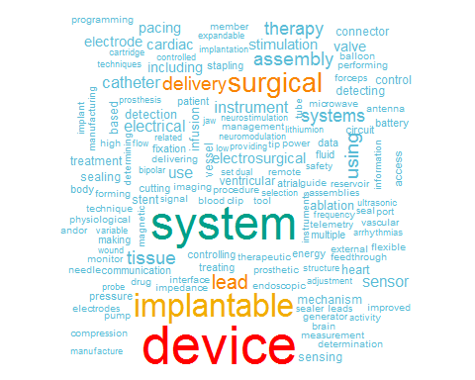

# visualize patent abstracts  
wordcloud(med$patent_abstract, max.words=150, colors=palette)

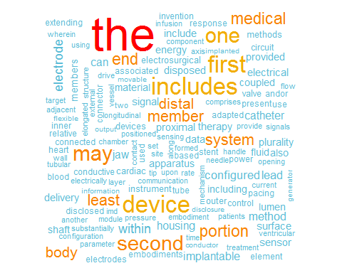

# Other Relevant Data

* Compare patents utilized vs. non utilized (utilization = products implemented)
* Connect patent(s) with products and products to revenue data
  + Product line information
* Revenue information by product (SEC Filings 10K/10Q)
* Macro economic scenario for medical industry
* Patent classification is alpha numeric- dictionary of these codes and translate them to business information
* Medical eco system: Wearable technology (FitBit, Jawbone, Google Lens etc.)