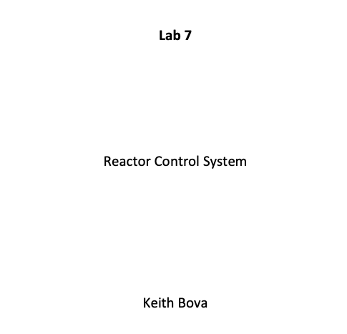

**Introduction:**

The purpose of this lab is to familiarize students with pulse width modulation using the Texas Instruments TM4C123GH6PM microcontroller. Students will continue to gain practice with the temperature module and the digilent 8 led module. The control system follows a structure similar to what might be implemented in a nuclear reactor.

**Body:**

In this control system, the position of the servo motor is controlled by a potentiometer; the position of the potentiometer on its axis should linearly adjust the position of the servo and the lights on the 8 led module. The system needs to display the ambient temperature on the LCD display, and if the temperature gets too high, the system needs to display a message that "scrams" the system.

For example:

| **Potentiometer** | **Servo** | **Leds** |
| --- | --- | --- |
| 100% | +90 deg | 8 lights on |
| 50% | 0 deg | 4 lights on |
| 0% | -90deg | 0 lights on |

**Pseudocode:**

The logic for the program can be implemented as follows:

initializeSystem()

while(True):

currentTemperature = getCurrentTemperature()

if(currentTemperature > threshold):

scramSystem()

displayCurrentTemperatureOnLcdDisplay(currentTemperature)

currentPosition = getCurrentPositionOfPotentiometer()

adjustFuelRodsAkaServoMotor(currentPosition)

displayLightsOnLedModule(currentPosition)

## Source Code:

/* PWM_ADC_servo.c

*

* This program demonstrates the use of the PWM module to generate

* a varying duty cycle PWM output. The program uses a potentiometer

* in a voltage divider circuit to provide a varying amplitude

* signal to the ADC. The digital output is then used to modify

* the compare register, resulting in a changing duty cycle on

* the PWM output.

*

* This program is configured to drive a servo motor where

* the control pulse ranges from 1 - 2 mSec. The ADC output is

* scaled so that the position can be more precisely controlled.

*

* The output signal is M0PWM3 which is output on GPIO PB5

* The PWM source is module 0, generator 1, pwmB

*

* The program uses direct register access mode.

*

* The program uses a sytem clock of 80 Mhz.

*

*

* written by: E.J. Nava, UNM, 11/05/22

*

*/

//****************************************************************

#include <stdint.h>

#include <stdbool.h>

#include <stddef.h>

#include <string.h>

#include <stdio.h>

#include <stdlib.h>

#include <tm4c123gh6pm.h>

#define DELAY_VALUE 0xF9F // 0xF9F = 1 mSec delay at 4 MHz

#define SYSDIV2 4

#define SLAVE_ADDR 0x4F /* 0100 1111 */

/* ************************* Prototypes ****************************** */

void init_SSI0(void);

void SSI0Write(unsigned char data);

void putsSPI0(size_t buflen, char * buffer);

void SysTick_init(void);

void SysTick_mSecDelay(uint32_t delay);

void PWM0_0_init(void);

void init_ADC0(void);

void I2C1_init(void);

char I2C1_byteWrite(int slaveAddr, char data);

char I2C1_burstWrite(int slaveAddr, int byteCount, char* data);

char I2C1_read(int slaveAddr, int byteCount, char* data);

/**********************Global Variables ******************************* */

int result = 0;

char i2c_data[4]; // buffer for date read from or written to I2C

char *i2c_char_p = &i2c_data[0];

void enablePhaseLockLoopByClearingBypass()

{

SYSCTL_RCC2_R &= ~0x00000800; // Enable PLL by clearing BYPASS

}

bool checkIfSystemIsOverheating(const int currentTemperatureInFahrenheit)

{

const int temperatureThreshold = 78;

if(currentTemperatureInFahrenheit > temperatureThreshold)

{

return true;

}

return false;

}

void waitForPhaseLockLoopToLock()

{

while((SYSCTL_RIS_R&0x00000040)==0)

{

}; // Wait for PLL to lock - poll PLLRIS

}

void configureI2C()

{

i2c_data[0] = 0; // select register 0 on TMP3 module

}

void init_SSI0(void)

{

SYSCTL_RCGCSSI_R |= 1; // enable clock to SSI0

SYSCTL_RCGCGPIO_R |= 0x1; // Enable clock to PORT A

/* configure PORTA 2..5 for SSI0 clock, FS, Tx & Rx */

GPIO_PORTA_AMSEL_R = 0; // turn off analog function

GPIO_PORTA_DEN_R |= 0x3C; // make PA2..PA5 digital

GPIO_PORTA_AFSEL_R = 0x3C; // make PA2.. PA5 alternate function

GPIO_PORTA_PCTL_R = 0x00222200; // configure PA2..PA5 as SSI0

/* SPI Master, POL = 0, PHA = 0, SysClk = 80 MHz, 8 bit data */

SSI0_CR1_R = 0; // disable SSI and make it master

SSI0_CC_R = 0; // use system clock

SSI0_CPSR_R = 0x64; // prescaler divided by 100

SSI0_CR0_R = 0x0707; // 800KHz/8 = SSI clock, SPI mode, 8 bit data

SSI0_CR1_R |= 2; // enable SSI0

}

void initializeSystemClockFor80mhz()

{

SYSCTL_RCC2_R |= 0x80000000;

/* Bypass the PLL while initializing it */

SYSCTL_RCC2_R |= 0x00000800;

/* Select the crystal value and oscillator source */

SYSCTL_RCC_R = (SYSCTL_RCC_R & ~0x000007C0) // clear bits 10-6

+ 0x00000540; // 10101 configure for 16Mhz XTL

/* Set for main oscillator source */

SYSCTL_RCC2_R &= ~0x00000070;

/* Activate the PLL by clearing PWRDN */

SYSCTL_RCC2_R &= ~0x00002000;

/* Set the desired system divider */

SYSCTL_RCC2_R |= 0x40000000;

SYSCTL_RCC2_R = (SYSCTL_RCC2_R & ~0x1FC00000) +(SYSDIV2<<22);

/* Wait for the PLL to lock by polling PLLRIS */

while((SYSCTL_RIS_R&0x00000040)==0){};

/* Enable use of the PLL by clearing BYPASS */

SYSCTL_RCC2_R &= ~0x00000800;

}

int convertDegreesCelsiusToDegreesFahrenheit(int inputTemperature)

{

return ((inputTemperature * 9)/ 5) + 32;

}

int getCurrentTemperatureFromSensorInFahrenheit(const char slaveAddress)

{

int raw_temp; // raw temp data in int form

short int a, b, currentTempInDegCelsius; // temperature variables

I2C1_read(slaveAddress, 2, i2c_char_p);

a = (short int) i2c_data[0]; // cast bytes to 16 bits

b = (short int) i2c_data[1];

raw_temp = b | (a << 8); // combine bytes to 9 bit result

currentTempInDegCelsius = raw_temp >> 8; // shift out ls 7 bits of 0 divide by 256 -> 0 Deg C

return convertDegreesCelsiusToDegreesFahrenheit(currentTempInDegCelsius);

}

void displayDecimalNumberOnGpioBoardInBinary(uint8_t decimalToDisplayInBinary)

{

const uint32_t decimalToDisplayInBinaryMod256 = decimalToDisplayInBinary % 256;

GPIO_PORTE_DATA_R = decimalToDisplayInBinary & 0xF; // lower 4 count bits - PE0..PE3

GPIO_PORTD_DATA_R = (decimalToDisplayInBinary & 0xF0) >> 4; // upper 4 count bits - PD0..PD3

}

void initializeGPIOPorts()

{

SYSCTL_RCGCGPIO_R |= 0x38; // activate port D,E & F clocks

GPIO_PORTF_DIR_R |= 0x04; // make PF2 out (built-in blue LED)

GPIO_PORTE_DIR_R |= 0x0F; // make PE0..PE3 out

GPIO_PORTD_DIR_R |= 0x0F; // make PD0..PD3 out

GPIO_PORTF_AFSEL_R &= ~0x04;// disable alt funct on PF2

GPIO_PORTE_AFSEL_R &= ~0x0F;// disable alt funct on PE0..PE3

GPIO_PORTD_AFSEL_R &= ~0x0F;// disable alt funct on PD0..PD3

GPIO_PORTF_DEN_R |= 0x04; // enable digital I/O on PF2

GPIO_PORTE_DEN_R |= 0x0F; // enable digital I/O on PE0..PE3

GPIO_PORTD_DEN_R |= 0x0F; // enable digital I/O on PD0..PD3

// configure PF2 as GPIO (Selectively - others left unchanged)

GPIO_PORTF_PCTL_R = (GPIO_PORTF_PCTL_R&0xFFFFF0FF)+0x00000000;

// configure PE0..PE3 as GPIO (Selectively - others left unchanged)

GPIO_PORTE_PCTL_R = (GPIO_PORTF_PCTL_R&0xFFFF0000)+0x00000000;

// configure PD0..PD3 as GPIO (Selectively - others left unchanged)

GPIO_PORTD_PCTL_R = (GPIO_PORTD_PCTL_R&0xFFFF0000)+0x00000000;

GPIO_PORTF_AMSEL_R = 0; // disable analog functionality on PF

GPIO_PORTE_AMSEL_R = 0; // disable analog functionality on PE

GPIO_PORTD_AMSEL_R = 0; // disable analog functionality on PD

}

uint8_t discreteUniform1400(const uint16_t decimalToConvert){

const uint16_t upperBound = 1400;

const uint16_t stepSize = upperBound / 8;

for(uint8_t i = 0; i < 9; i++)

{

if(decimalToConvert < (stepSize * i))

{

return i - 1;

}

}

return 0;

}

uint8_t convertDecimalToPercentLightBar(const uint16_t decimalNumberToConvert)

{

uint8_t interval = discreteUniform1400(decimalNumberToConvert);

if(0 == interval)

{

return 1;

}

if(1 == interval)

{

return 2;

}

if(2 == interval)

{

return 7;

}

if(3 == interval)

{

return 15;

}

if(4 == interval)

{

return 31;

}

if(5 == interval)

{

return 63;

}

if(6 == interval)

{

return 127;

}

if(7 == interval)

{

return 255;

}

return 0;

}

void I2C1_init(void)

{

SYSCTL_RCGCI2C_R |= 0x02; // enable clock to I2C1

SYSCTL_RCGCGPIO_R |= 0x01; // enable clock to GPIOA

/* PORTA 7, 6 for I2C1 */

GPIO_PORTA_AFSEL_R |= 0xC0; /* PORTA 7, 6 for I2C1 */

GPIO_PORTA_PCTL_R &= ~0xFF000000; /* PORTA 7, 6 for I2C1 */

GPIO_PORTA_PCTL_R |= 0x33000000;

GPIO_PORTA_DEN_R |= 0xC0; /* PORTA 7, 6 as digital pins */

GPIO_PORTA_ODR_R |= 0x80; /* PORTA 7 as open drain */

I2C1_MCR_R = 0x10; /* master mode */

I2C1_MTPR_R = 39; /* 100 kHz @ 80 MHz */

}

/********************************************************************** */

/* Wait until I2C master is not busy and return error code */

/* If there is no error, return 0 */

static int I2C_wait_till_done(void)

{

while(I2C1_MCS_R & 1); /* wait until I2C master is not busy */

return I2C1_MCS_R & 0xE; /* return I2C error code */

}

/********************************************************************** */

/* Write one byte only */

/* byte write: S-(saddr+w)-ACK-maddr-ACK-data-ACK-P */

char I2C1_byteWrite(int slaveAddr, char data)

{

char error;

/* send slave address and starting address */

I2C1_MSA_R = slaveAddr << 1;

I2C1_MDR_R = data;

I2C1_MCS_R = 7; /* S-(saddr+w)-ACK-maddr-ACK */

error = I2C_wait_till_done(); /* wait until write is complete */

if (error) return error;

return 0; /* no error */

}

/********************************************************************** */

/* Use burst write to write multiple bytes to consecutive locations */

/* burst write: S-(saddr+w)-ACK-maddr-ACK-data-ACK-data-ACK-...-data-ACK-P */

char I2C1_burstWrite(int slaveAddr, int byteCount, char* data)

{

char error;

if (byteCount <= 0)

return -1; /* no write was performed */

/* send slave address and starting address */

I2C1_MSA_R = slaveAddr << 1;

I2C1_MDR_R = *data++;

I2C1_MCS_R = 3; /* S-(saddr+w)-ACK-maddr-ACK */

byteCount--; // send first char with start & ACK

error = I2C_wait_till_done(); /* wait until write is complete */

if (error) return error;

/* send remaining data one byte at a time */

while (byteCount > 1)

{

I2C1_MDR_R = *data++; /* write the next byte */

I2C1_MCS_R = 1; /* -data-ACK by slave- */

error = I2C_wait_till_done();

if (error) return error;

byteCount--;

}

/* send last byte and a STOP */

I2C1_MDR_R = *data++; /* write the last byte */

I2C1_MCS_R = 5; /* -data-ACK-P */

error = I2C_wait_till_done();

while(I2C1_MCS_R & 0x40); /* wait until bus is not busy */

if (error) return error;

return 0; /* no error */

}

/********************************************************************** */

/* Read memory */

/* read: S-(saddr+w)-ACK-maddr-ACK-R-(saddr+r)-ACK-data-ACK-data-ACK-...-data-NACK-P */

char I2C1_read(int slaveAddr, int byteCount, char* data)

{

char error;

if (byteCount <= 0)

return -1; /* no read was performed */

/* configure bus from for read, send start with slave addr */

I2C1_MSA_R = (slaveAddr << 1) + 1; /* restart: -R-(saddr+r)-ACK */

if (byteCount == 1) /* if last byte, don't ack */

I2C1_MCS_R = 7; /* -data-NACK-P */

else /* else ack */

I2C1_MCS_R = 0xB; /* -data-ACK- */

error = I2C_wait_till_done();

if (error) return error;

*data++ = I2C1_MDR_R; /* store the data received */

if (--byteCount == 0) /* if single byte read, done */

{

while(I2C1_MCS_R & 0x40); /* wait until bus is not busy */

return 0; /* no error */

}

/* read the rest of the bytes */

while (byteCount > 1)

{

I2C1_MCS_R = 9; /* -data-ACK- */

error = I2C_wait_till_done();

if (error) return error;

byteCount--;

*data++ = I2C1_MDR_R; /* store data received */

}

I2C1_MCS_R = 5; /* -data-NACK-P */

error = I2C_wait_till_done();

*data = I2C1_MDR_R; /* store data received */

while(I2C1_MCS_R & 0x40); /* wait until bus is not busy */

return 0; /* no error */

}

int main(void)

{

//initializeSystemClockFor80mhz();

initializeGPIOPorts();

int currentTemperatureInFahrenheit;

char slaveAddress = SLAVE_ADDR;

uint32_t pw, RCC;

char * bufferp;

int len; // string length

// char i;

char buffer[40] = {"hello world - it's a fine day "};

char * cbuffer = {"this is a command string"}; // buffer for commands

char str[10]; // char string for viewing value

bufferp = &buffer[0];

/* ------------ configure system clock for 80 Mhz operation -------------*/

SYSCTL_RCC2_R |= 0x80000000; // Use RCC2

SYSCTL_RCC2_R |= 0x00000800; // Bypass PLL while initializing it

// Select crystal value and osc source

SYSCTL_RCC_R = (SYSCTL_RCC_R & ~0x000007C0) // clear bits 10-6

+ 0x00000540; // 10101 configure for 16Mhz XTL

SYSCTL_RCC2_R &= ~0x00000070; // Use main oscillator

SYSCTL_RCC2_R &= ~0x00002000; // Activate PLL - clear PWRDN

SYSCTL_RCC2_R |= 0x40000000; // Set system divider

SYSCTL_RCC2_R = (SYSCTL_RCC2_R & ~0x1FC00000) +(SYSDIV2<<22);

while((SYSCTL_RIS_R&0x00000040)==0){}; // Wait for PLL to lock - poll PLLRIS

SYSCTL_RCC2_R &= ~0x00000800; // Enable PLL by clearing BYPASS

SysTick_init(); // initialize SysTick timer

init_SSI0(); // Configure and initialize SSI1 interface

I2C1_init(); // Configure & Initialize I2C1 interface

configureI2C();

/* command TMP3 to read from register 0 for desired temperature format */

I2C1_byteWrite(slaveAddress, i2c_data[0]);

init_ADC0(); // Configure and initialize ADC0

PWM0_0_init(); // Configure and initialize SSI1 interface

/* preliminary display message */

// use the LCDS reset command sequence

SSI0Write(0x1b); // Display reset - write an escape character

cbuffer="[*"; // command sequence for reset

putsSPI0(2, cbuffer);

SysTick_mSecDelay(100); // 10->approximately .1 s

bufferp ="Hello World ! ";

putsSPI0(strlen(bufferp), bufferp);

SysTick_mSecDelay(625); // approximately .625 s

SSI0Write(0x1b); // Display reset - write an escape character

cbuffer="[j"; // command sequence for clear screen

// and reset cursor

putsSPI0(2,cbuffer); // write out string

SysTick_mSecDelay(625); // approximately .625 s

char lcdDisplayMessage[16];

while(1)

{

ADC0_PSSI_R |= 8; /* start a conversion sequence on SS3 */

while((ADC0_RIS_R & 8) == 0) ; /* wait for conversion complete */

result = ADC0_SSFIFO3_R; /* read conversion result */

ADC0_ISC_R = 8; /* clear completion flag */

sprintf(str,"%d",result ); // convert int to ASCII string

SSI0Write(0x1b); // Display reset - write an escape character

cbuffer="[j"; // command sequence for clear screen

// and reset cursor

putsSPI0(2,cbuffer); // write out string

SysTick_mSecDelay(10); // approximately .01 s

currentTemperatureInFahrenheit = getCurrentTemperatureFromSensorInFahrenheit(slaveAddress);

bool systemIsOverheating = checkIfSystemIsOverheating(currentTemperatureInFahrenheit);

sprintf(lcdDisplayMessage,"%df",currentTemperatureInFahrenheit);

if(systemIsOverheating)

{

sprintf(lcdDisplayMessage,"reactor scram");

}

//putsSPI0(strlen(str),str); // write out string

putsSPI0(strlen(lcdDisplayMessage),lcdDisplayMessage); // write out string

//uint8_t statusLightBar = atoi(str);

displayDecimalNumberOnGpioBoardInBinary(convertDecimalToPercentLightBar(result));

SysTick_mSecDelay(100); // delay before reading new temperature

PWM0_1_CMPA_R = 937 + (result + 200);

}

}

void PWM0_0_init(void)

{

/* enable clocks */

SYSCTL_RCGCGPIO_R |= 0x2; // enable clock to GPIOB (M0PWM3 is on PB5)

SYSCTL_RCGCPWM_R |= 1; // enable clock to PWM0

while((SYSCTL_PRPWM_R & 0x1)==0) {}; // wait for PWM0 ready

// use default divider of 64 for PWM clock

/* initialize GPIO pin - PB5 */

GPIO_PORTB_AFSEL_R |= 0x20; // PORTB bit 5

GPIO_PORTB_PCTL_R &= ~0x00F00000; // PORTB bit 5 for M0PWM1

GPIO_PORTB_PCTL_R |= 0x00400000;

GPIO_PORTB_DIR_R |= 0x20; // PORTB bit 5 as output

GPIO_PORTB_DEN_R |= 0x20; // PORTB bit 5 as digital pins

/* Configure PWM0 module, generator 1, pwmB */

// PWM0_1B - PB5 - M0PWM3 pin - Module 0 Generator 1 - pwm1B

PWM0_1_CTL_R = 0x0; // disable PWM0 - entire generator 1 block

PWM0_1_GENB_R = 0x00000083; // high on ZERO, low on CMPA down

PWM0_1_LOAD_R = 24999; // load = 25000 -1

PWM0_1_CTL_R = 0x1; // enable PWM0 Gen 1 - count down mode

PWM0_INVERT_R = 0x8; // invert PWM0 Gen 1 - pwmB MOPWM3

PWM0_ENABLE_R = 0x08; // enable PWM0 Gen 1 - pwmB M0PWM3

}

void SysTick_init(void){

NVIC_ST_CTRL_R = 0; // 1. disable SysTick before configuring

NVIC_ST_RELOAD_R = DELAY_VALUE; // 2. set to desired delay value (1 mSec)

NVIC_ST_CURRENT_R = 0; // 3. clear CURRENT by writing any value

NVIC_ST_CTRL_R &= ~0x00000004; // 4. set clock to POSC/4

NVIC_ST_CTRL_R |= 0x00000001; // 5. enable SysTick timer

}

/* 1 mSec Time delay using busy wait. */

void SysTick_mSecDelay(uint32_t delay){

uint32_t i;

for(i=0; i<delay; i++){

NVIC_ST_RELOAD_R = DELAY_VALUE; // wait one cycle = DELAY_VALUE

NVIC_ST_CURRENT_R = 0;

while((NVIC_ST_CTRL_R & 0x00010000) == 0){ };

}

}

void init_ADC0(void)

{

/* enable clocks */

SYSCTL_RCGCGPIO_R |= 0x10; /* enable clock to GPIOE (AIN9 is on PE4) */

SYSCTL_RCGCADC_R |= 1; /* enable clock to ADC0 */

/* initialize PE4 for AIN0 input */

GPIO_PORTE_AFSEL_R |= 0x10; /* enable alternate function */

GPIO_PORTE_DEN_R &= ~0x10; /* disable digital function */

GPIO_PORTE_AMSEL_R |= 0x10; /* enable analog function */

/* initialize ADC0 */

ADC0_ACTSS_R &= ~8; /* disable SS3 during configuration */

ADC0_EMUX_R &= ~0xF000; /* software trigger conversion */

ADC0_SSMUX3_R = 9; /* get input from channel 9 */

ADC0_SSCTL3_R |= 6; /* take one sample at a time, set flag at 1st sample */

ADC0_ACTSS_R |= 8; /* enable ADC0 sequencer 3 */

}

/* This function writes one byte to a slave device via the SSI0 interface */

void SSI0Write(unsigned char data)

{

while((SSI0_SR_R & 2) == 0); // wait until FIFO not full

SSI0_DR_R = data; // transmit high byte

while(SSI0_SR_R & 0x10); // wait until transmit complete

}

/* --------------------------------------------------------------------------- */

/* This function writes the characters in a string to the SPI 0 interface */

/* The input arguments are a character count and the start address of the buffer */

/* As SS01Write() waits for the FIFO buffer to not be full, no waiting is */

/* Needed in this routine. */

/* --------------------------------------------------------------------------- */

void putsSPI0(size_t buflen, char * buffer) {

char * i;

for (i = buffer; i < (buffer + buflen); i++)

{

SSI0Write(*i); /* write a character */

}

}

**Testing:**

We tested the control system with inspection--checking that the three devices adjusted accordingly with each other, and the program detected a scram when the temperature reached a threshold. The results are shown below:

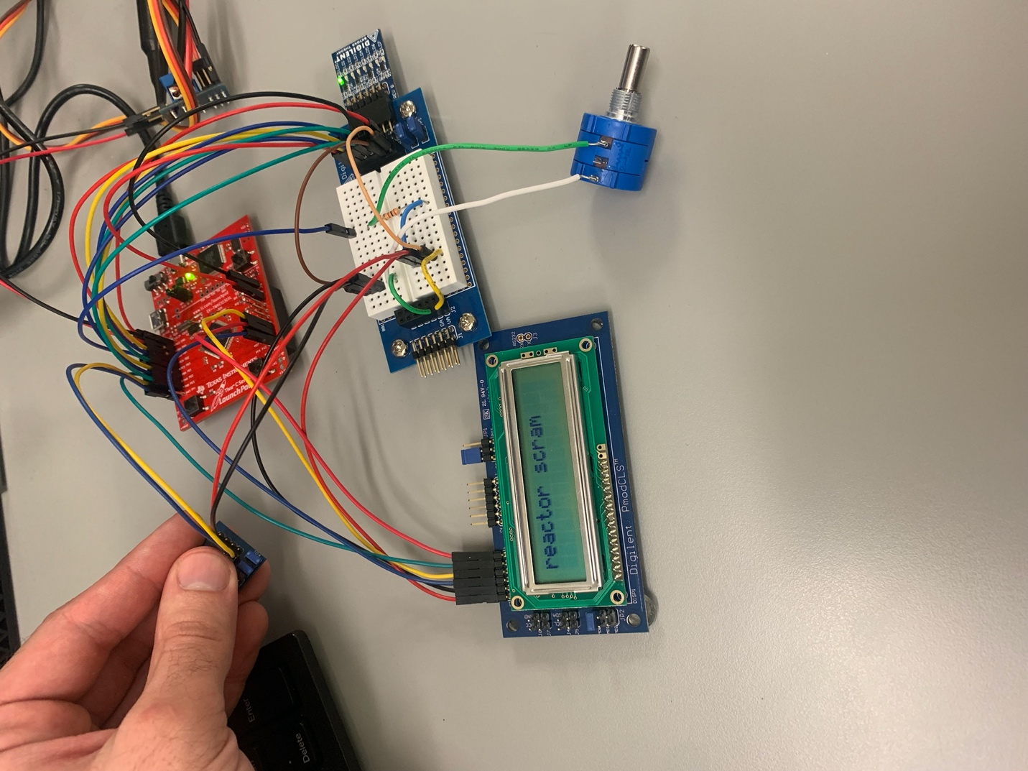

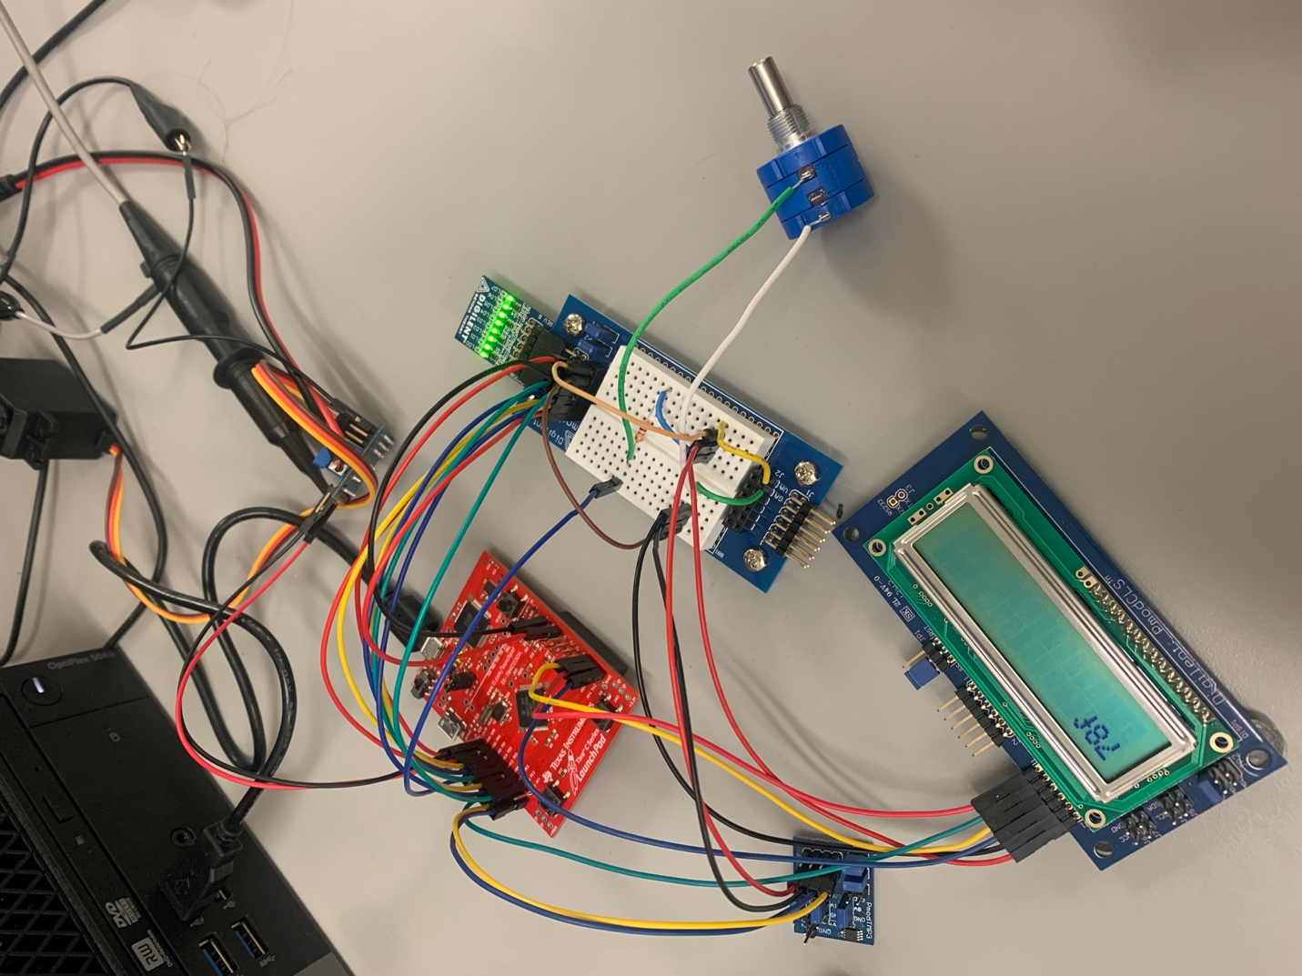

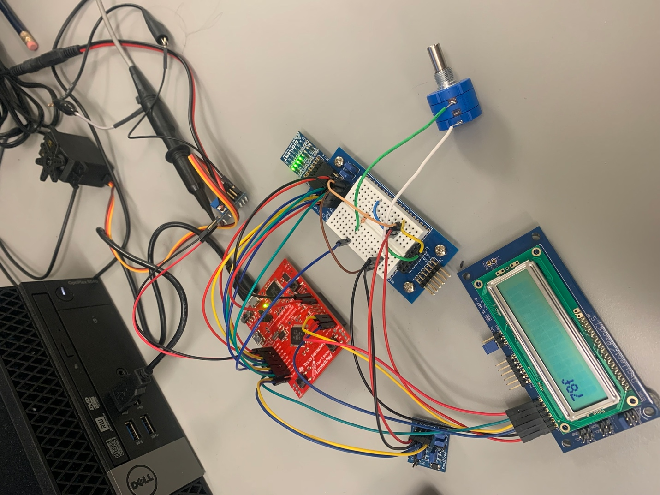

## Conclusion:

Pulse width modulation is useful for controling servo motors. When using pulse width modulation, you need to be careful and check that the input signal will not force the servo beyond its limits.