Applied Data Mining Final Exam

Keith Hickman

# Problem 1

I was unable to find a solution to this problem.

# Problem 2

Choose the best answer. A classification tree generally has (a) high variance. (b) low variance. (c) average variance.

*Answer: (a) a classification tree typically has high variance and low bias.

# Problem 3

Suppose this is the given training set with features, A,B,C,D and label L:

**Create the dataset:

a <- c(1, 2, 1, 3, 0, 4, 1)  
b <- c(2, 3, 2, 1, 0, 1, 1)  
c <- c("m", "m", "p", "p", "a", "m", "m")  
d <- c(1, 1, 0, 1, 0, 1, 0)  
  
p2data <- as.data.frame(cbind(a, b, c, d))  
p2data

## a b c d  
## 1 1 2 m 1  
## 2 2 3 m 1  
## 3 1 2 p 0  
## 4 3 1 p 1  
## 5 0 0 a 0  
## 6 4 1 m 1  
## 7 1 1 m 0

## (a)

The entropy of the Label is: i. minimal ii. maximal iii. neither maximal nor minimal

*Answer: (iii), neither minimal nor maximal.

library(CORElearn)  
attrEval(d ~ ., p2data, estimator="GainRatio")

## a b c   
## 0.2780306 0.1660678 0.1711120

attrEval(d ~ ., p2data, estimator="Gini")

## a b c   
## 0.2993197 0.1564626 0.1326531

attrEval(d ~ ., p2data, estimator="InfGain")

## a b c   
## 0.5916728 0.3059585 0.2359264

Label is binomial, so I’ll use Information Gain, the Gini Index and Gain Ratio. If the variable were continuous, I could use other methods such as Mean Square Error.

Here, it appears that the entropy of the label is neither minimal nor maximal. Values across all three metrics indicated are neither near zero nor close to 1. Not particularly helpful. Variables a and b explain the most variation, however.

## (b)

Using features A,B and treating them as dimension in 2D Euclidean space, the data is: i. linearly separable ii. not linearly separable

library(DMwR2)  
library(rpart.plot)

## Loading required package: rpart

library(e1071)  
library(ggplot2)  
  
  
set.seed(1234)  
  
p2ab <- p2data[,1:2,4]  
ggplot(p2ab,aes(x=b,y=a, color=d)) + geom_point() + guides(color=FALSE)

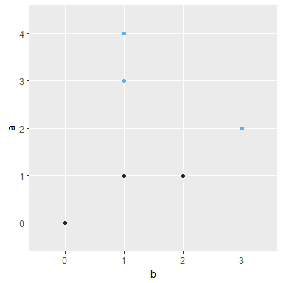

svm_model <- svm(d ~ ., p2data, kernel='linear')  
  
ps <- predict(svm_model, p2data)  
(cm <- table(ps, p2data$d))

##   
## ps 0 1  
## 0 3 1  
## 1 0 3

The data appears to be linearly separable.

## (b)

Give a reasonable separating line for the data. *Answer:  
The separating line would run from $(−.5,3.5)$ to $(3.5,.5)$

## (c)

Give a decision tree for the data:

We’ll use rpartXse to create a tree, and prp to plot the tree.

tree <- rpartXse(d ~ ., p2data)  
prp(tree, type=0, extra=101)

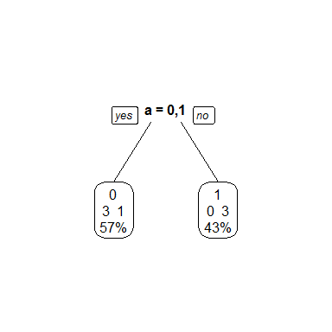

Looks like we could do some post-pruning to improve the purity and accuracy.

# Problem 4

What is the error rate? *Answer: The error rate is 2/5 or 40%, as we misclassified 2 out 5 observations:

2/5

## [1] 0.4

# Problem 5

Fill-in the confusion matrix values $v1$; $v2$; $v3$; $v4$ using the data above: **I was unable to install the caret package previously but got it to work by installing the package mentioned in the namespace error (lubridate).**

library(caret)

## Loading required package: lattice

TID <- c(1, 2, 3, 4, 5)  
Lhat <- (c(1, 1, 0, 1, 0))  
L <- (c(0, 1, 0, 1, 1))  
  
p5data <- as.data.frame(cbind(TID, Lhat, L))  
p5data$Lhat <- as.factor(p5data$Lhat)  
p5data$L <- as.factor(p5data$L)  
p5data

## TID Lhat L  
## 1 1 1 0  
## 2 2 1 1  
## 3 3 0 0  
## 4 4 1 1  
## 5 5 0 1

cm <- confusionMatrix(p5data$L, p5data$Lhat)  
cm

## Confusion Matrix and Statistics  
##   
## Reference  
## Prediction 0 1  
## 0 1 1  
## 1 1 2  
##   
## Accuracy : 0.6   
## 95% CI : (0.1466, 0.9473)  
## No Information Rate : 0.6   
## P-Value [Acc > NIR] : 0.6826   
##   
## Kappa : 0.1667   
## Mcnemar's Test P-Value : 1.0000   
##   
## Sensitivity : 0.5000   
## Specificity : 0.6667   
## Pos Pred Value : 0.5000   
## Neg Pred Value : 0.6667   
## Prevalence : 0.4000   
## Detection Rate : 0.2000   
## Detection Prevalence : 0.4000   
## Balanced Accuracy : 0.5833   
##   
## 'Positive' Class : 0   
##

1. Give the Accuracy: *Answer: our accuracy here is .6 or 60%. This aligns with the rough error rate calcuation.
2. Misclassification Rate *Answer: 40%
3. True Positive Rate *Answer: 50%
4. Specificity *Answer: 66%

# Problem 6:

1. (True or False) The most important stage in the process of data mining is the problem statement. *Answer: True
2. (True or False) A histogram is kind of partition. *Answer: False.
3. (True or False) A histogram is a kind of probability distribution function. *Answer: True.
4. (True or False) Outliers are always noise objects. *Answer: False
5. (True or False) Noise objects can be outliers. *Answer: True
6. Define data mining. *Answer: The analysis of data in search of useful knowledge. The field is broad and diverse, encompassing many tactics, techniques, procedures, and disciplines, including statistics, machine learning, and artificial intelligence.
7. What does over-fitting mean? *Answer: Over-fitting is creating model that only performs well on seen data, and does not handle unseen data well or nearly as well as training data. It means that we have a model whose parameters and algorithms are designed specifically for the data we already possess.
8. What is the main difference between supervised and unsupervised learning? *Answer: Supervised methods are concerned with predictive tasks, whereas unsupervised tasks are concerned with descriptive data mining tasks.

# Problem 7

Consider the following results from a five-fold cross validation:

Fold Error% 1 19.25 2 19.76 3 18.99 4 19.37 5 14.45

error <- c(19.25, 19.76, 18.99, 19.37, 14.45)  
df <- as.data.frame(error)

## (a)

Find the average error ^E

mean(df[,1])

## [1] 18.364

#or   
mean <- mean(error)  
mean

## [1] 18.364

## (b)

^E is a good indicator of the true error E. Explain why/why not?

In this case, $\overset{^}{E}$ is not a good predictor of the true error $E$. As evidenced in the plot below, we have one outlier in the last k-fold validation. The difference between Error 5 in the dataset and the mean is 10x greater than the IQR, meaning we have one outlier. This would indicate that one of our models greatly outperformed the others, and we should further examine that model.

plot(error)

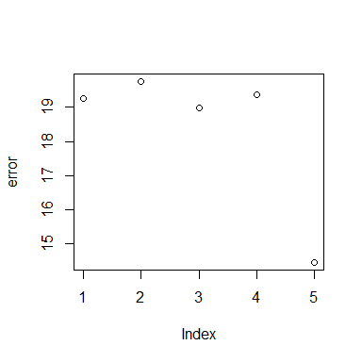

IQR(error)

## [1] 0.38

mean - error[5]

## [1] 3.914

We clearly have an outlier here, and therefore $\overset{^}{E}$ is not an accurate predictor.

# Problem 8

Fill-in the table’s cell with Y (yes), N (no), or U (unknown):

|  |  |
| --- | --- |
| Method | Parametric |
| Linear Reg. | Y |
| knn | N |
| k-means | N |
| decision tree | U |

# Problem 9

In this question, you are asked to use the data set below and K-nearest neighbors to predict $(X1;X2;X3)=(0,0,0)$. Note that X1;X2;X3 are the predictors and Y is the response variable.

x1 <- c(0, 0, 0, 0, -1, 1)  
x2 <- c(3, 0, 1, 1, -1, 1)  
x3 <- c(0, 0, 3, 2, 1, 1)  
Y <- c("Red", "Red", "Red", "Green", "Green", "Red")  
  
p9data <- as.data.frame(cbind(x1, x2, x3, Y))  
p9data

## x1 x2 x3 Y  
## 1 0 3 0 Red  
## 2 0 0 0 Red  
## 3 0 1 3 Red  
## 4 0 1 2 Green  
## 5 -1 -1 1 Green  
## 6 1 1 1 Red

## (a)

Calculate the Euclidean distance between each observation and the test point, X1 = X2 = X3 = 0.

#install.packages("cluster")  
library(cluster)  
di <- diana(p9data[,-4], metric='euclidean', stand=FALSE)  
di3 <- cutree(di, 3)  
(cm <- table(di3, p9data$Y))

##   
## di3 Green Red  
## 1 0 2  
## 2 1 1  
## 3 1 1

100*(1-sum(diag(cm))/sum(cm))

## [1] 83.33333

The Euclidian distance is 83.3

## (b)

What is the prediction for K = 1?

library(class)  
k1 <- knn(p9data[1:3, -4], p9data[4:6,-4],p9data[1:3,4], k = 1)  
table(k1, p9data[1:3, 4])

##   
## k1 Green Red  
## Green 0 0  
## Red 0 3

We’ve got 100% accuracy with k=1.

## (c)

What is the prediction for K = 3?

library(class)  
k3 <- knn(p9data[4:6, -4], p9data[1:3,-4],p9data[4:6,4], k = 3)  
table(k3, p9data[4:6, 4])

##   
## k3 Green Red  
## Green 2 1  
## Red 0 0

Initially, we have fewer correct classifications with k=3, which is likely due to switching the test and train datasets. I re-ran the knn with k=1 with the sme dataset as I did with k=3.

k1b <- knn(p9data[4:6, -4], p9data[1:3,-4],p9data[4:6,4], k = 1)  
table(k1b, p9data[4:6, 4])

##   
## k1b Green Red  
## Green 0 1  
## Red 2 0

K = 1 performed at 33% accuracy, with a Type 2 error rate of 66%. K = 3 outperformed k=1 by 33%.

# Problem 10:

Load the Carseats data as follows and answer the questions below and provide the R code for each question.

library(ISLR)  
attach(Carseats)  
## View(Carseats)  
dim(Carseats)

## [1] 400 11

## (a)

Create a training data set containing a random sample of 200 data points and a test set containing the remaining observations.

rndSample <- sample(1:nrow(Carseats), 200)  
tr <- Carseats[rndSample, ]  
ts <- Carseats[-rndSample, ]

## (b)

Fit a regression tree to the training set. Plot the tree, and interpret the results. What test error rate do you obtain (MSE)?

library(rpart)  
library(rpart.plot)

rt.a1 <- rpart(Sales ~ ., data = Carseats[2:11])  
rt.predictions.a1 <- predict(rt.a1, tr)  
prp(rt.a1,extra=101,box.col="orange",split.box.col="grey")

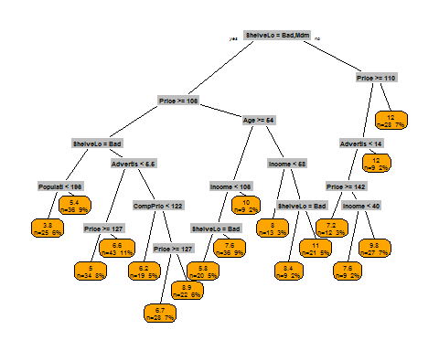

printcp(rt.a1)

##   
## Regression tree:  
## rpart(formula = Sales ~ ., data = Carseats[2:11])  
##   
## Variables actually used in tree construction:  
## [1] Advertising Age CompPrice Income Population Price   
## [7] ShelveLoc   
##   
## Root node error: 3182.3/400 = 7.9557  
##   
## n= 400   
##   
## CP nsplit rel error xerror xstd  
## 1 0.250510 0 1.00000 1.00309 0.069329  
## 2 0.105073 1 0.74949 0.75513 0.051308  
## 3 0.051121 2 0.64442 0.65638 0.044336  
## 4 0.045671 3 0.59330 0.67356 0.045200  
## 5 0.033592 4 0.54763 0.64807 0.045343  
## 6 0.024063 5 0.51403 0.59768 0.042203  
## 7 0.023948 6 0.48997 0.61460 0.041938  
## 8 0.022163 7 0.46602 0.60963 0.040870  
## 9 0.016043 8 0.44386 0.56939 0.040005  
## 10 0.014027 9 0.42782 0.55848 0.038101  
## 11 0.013145 11 0.39976 0.55673 0.038259  
## 12 0.012711 12 0.38662 0.55628 0.038097  
## 13 0.012147 13 0.37391 0.55676 0.037968  
## 14 0.011888 14 0.36176 0.55951 0.038578  
## 15 0.010778 15 0.34987 0.56226 0.038698  
## 16 0.010506 16 0.33909 0.56467 0.039849  
## 17 0.010000 17 0.32859 0.57068 0.040425

mse.a1.rt <- mean(rt.predictions.a1 - Carseats["Sales"])^2

## Warning in mean.default(rt.predictions.a1 - Carseats["Sales"]): argument is  
## not numeric or logical: returning NA

**When I use the training set (code above) get an error message that ‘variable lengths differ (found for ’CompPrice’)’ but was unable to solve using StackOverflow. There aren’t any incomplete cases…can’t figure this one out. Moving forward with the complete Carseats set minus the response variable.**

The overall MSE of our regression tree is 2.614.

We observe that we will probably get the best result with tree 14, which has the lowest estimated relative error at .55577. Alternatively, we could use the 1 - SE rule, which would let us find the tree with the error below .55577 + .039828, or .59559. No other trees have either a relative error or 1-SE error that would perform better than tree 14. We can accordingly obtain the information about the tree using the CP.

1. Train random forests over the training set (mtry = 5, ntree = 500). What test error rate do you obtain (MSE)? Use the importance() function to determine which variables are most important (Three most important variables).

library(randomForest)

## randomForest 4.6-12

## Type rfNews() to see new features/changes/bug fixes.

##   
## Attaching package: 'randomForest'

## The following object is masked from 'package:ggplot2':  
##   
## margin

(rf <- randomForest(Sales ~ .,data=Carseats, ntree = 500, mtry = 5, importance = TRUE))

##   
## Call:  
## randomForest(formula = Sales ~ ., data = Carseats, ntree = 500, mtry = 5, importance = TRUE)   
## Type of random forest: regression  
## Number of trees: 500  
## No. of variables tried at each split: 5  
##   
## Mean of squared residuals: 2.345241  
## % Var explained: 70.52

imp <- importance(rf)  
imp

## %IncMSE IncNodePurity  
## CompPrice 28.5341743 298.93816  
## Income 8.7692794 200.11347  
## Advertising 24.5685910 265.85566  
## Population -0.1562001 133.81778  
## Price 70.6630811 840.91103  
## ShelveLoc 74.0333541 893.05065  
## Age 24.8678366 310.20988  
## Education 2.1057803 106.04341  
## Urban -1.3594701 16.15057  
## US 5.5158558 25.15755

The three most important variables are ShelveLoc, Price, and Advertising based on the %IncMSE variable, which shows how much the MSE increases when those variables are removed from the tree.