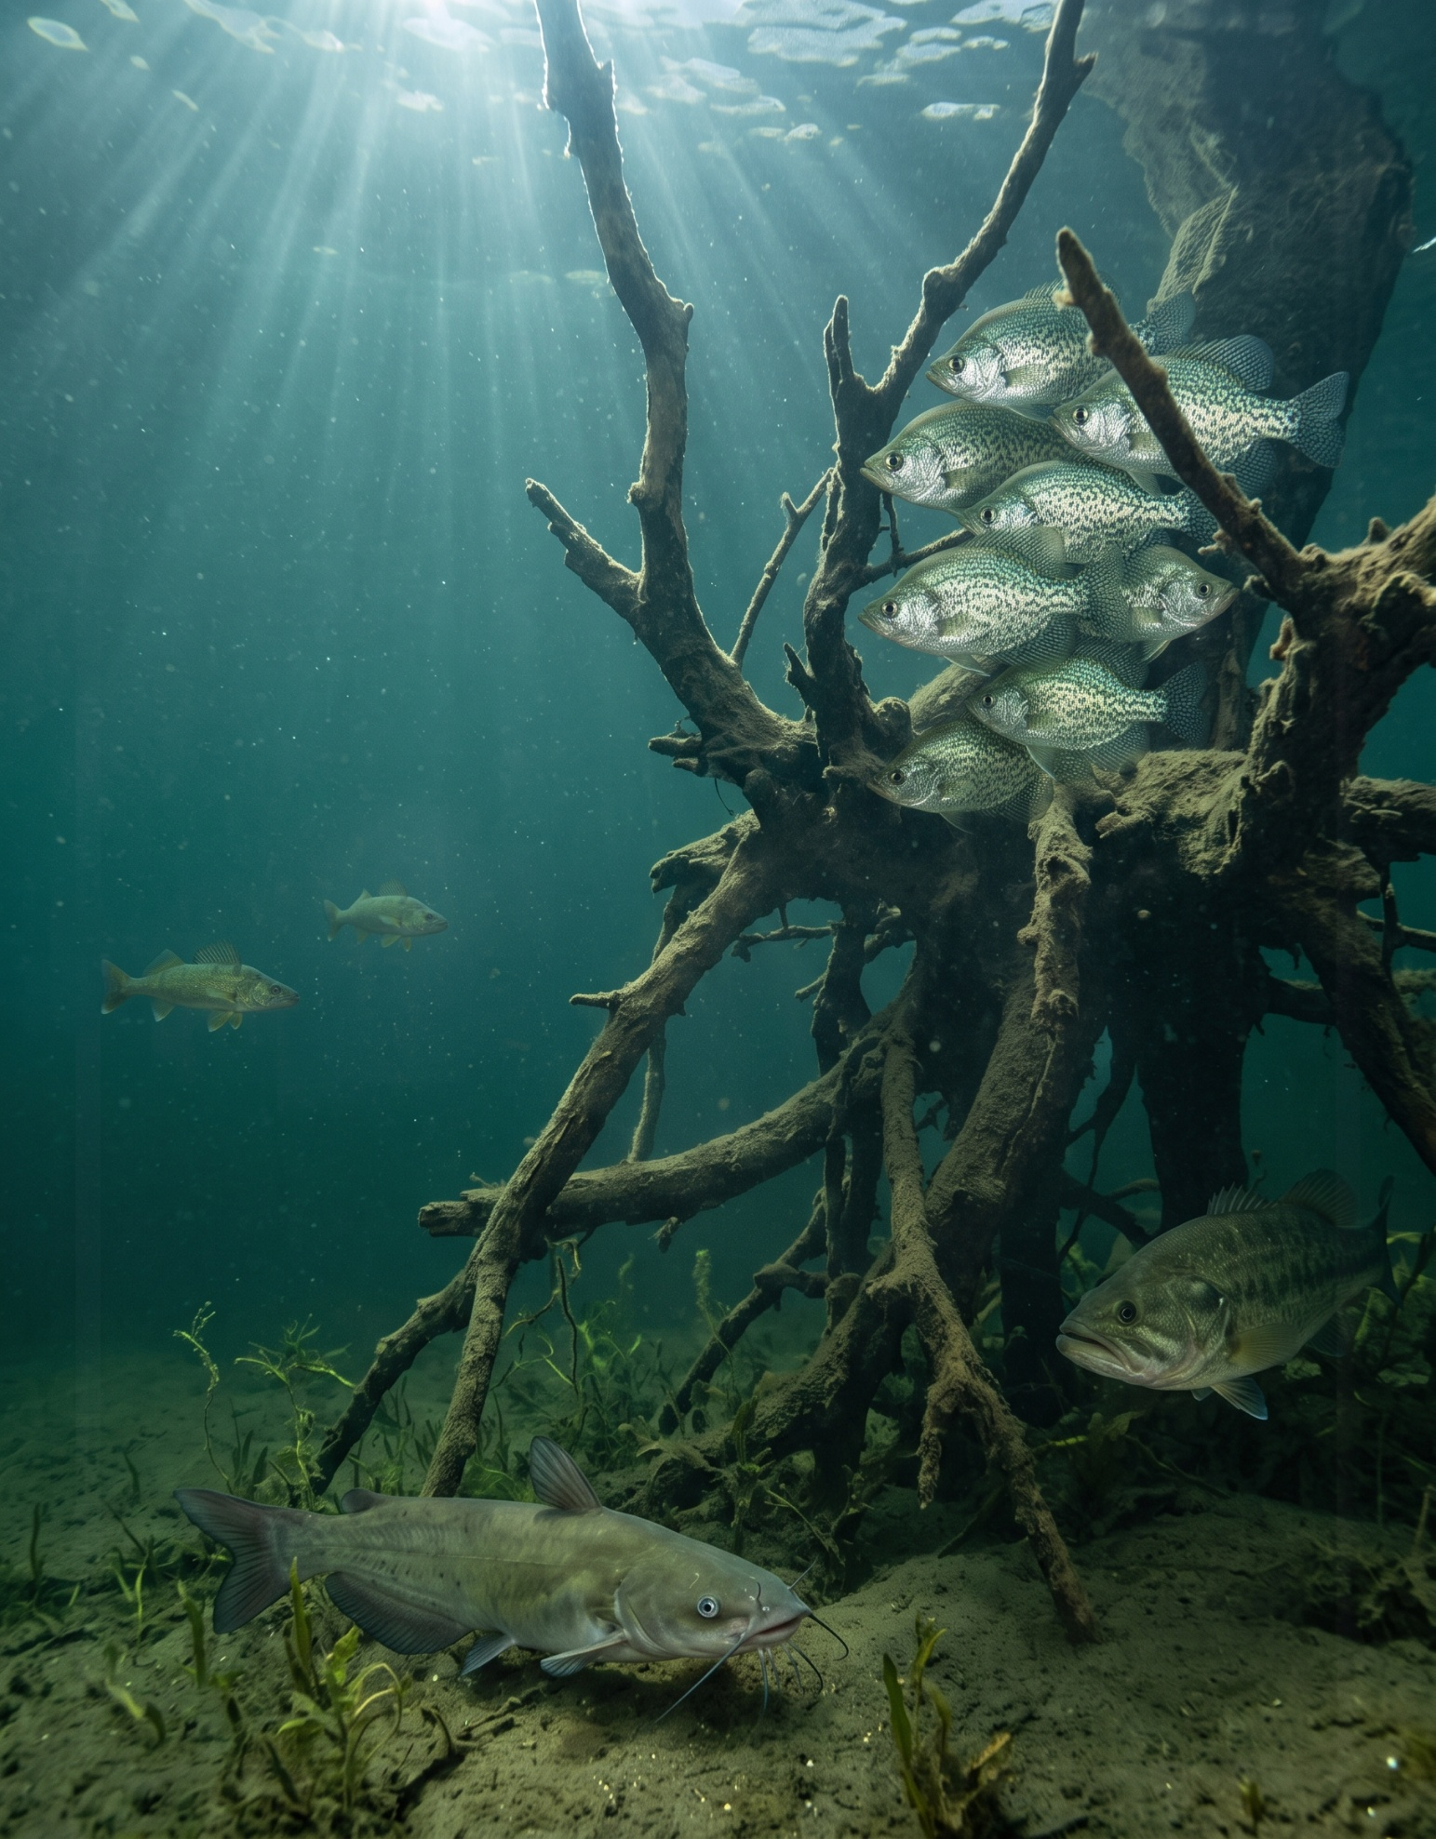
2026 Nebraska Licensed Angler Survey

Preferred Species Analysis
June 2026

Keith Hurley
Fisheries Division – Research Section
Nebraska Game and Parks Commission

1. Chapter 1: Determining Species Groupings 7
1.1. Sample Sizes and Population Estimates by Species 7
1.2. Selection Rules 9
1.3. Proposed Family Groupings 9
1.4. Comparisons Within Proposed Families 10
1.4.1. Bass 10
1.4.2. Panfish 12
1.4.3. Catfish 15
1.4.4. Moronides 18
1.4.5. Esocids 21
1.1. Final Preferred Groups 22
2. Chapter 2: Species-Linked Scale Questions 25
2.1. I am happy with my success fishing for my preferred fish. 25
2.2. I would be satisfied to harvest smaller fish if I could harvest more of my preferred fish. 28
2.3. I support regulations on my preferred fish to increase their size. 31
2.4. I support regulations on my preferred fish to increase their numbers. 34
2.5. If I could catch larger fish, I would be willing to harvest fewer of my preferred fish. 37
2.6. It is becoming harder to catch my preferred fish. 40
2.7. The opportunity to harvest my preferred fish is more important to me than the size of the fish I catch. 44
2.8. I have to travel too far to fish for my preferred fish. 47
2.9. I am satisfied with the size of my preferred fish that I catch in Nebraska. 50
2.10. I am satisfied with the size of my preferred fish that I am allowed to harvest in Nebraska. 53
2.11. I am satisfied with the number of my preferred fish that I catch in Nebraska. 56
2.12. I am satisfied with the number of my preferred fish that I am allowed to harvest in Nebraska. 59
2.13. I do not have enough places to fish for my preferred fish in Nebraska. 62
2.14. Reading Across the Items 66
3. Chapter 3: Survey Question Crosstabs by Preferred Species 67
3.1. Fish Out-Of-State 68
3.2. Boat Out-Of-State 70
3.3. Park Entry Permit 72
3.4. Fishing Tournaments 73
3.5. Waterbody Types 76
3.6. Methods 78
3.7. Techniques 80
3.8. Crowding 82
3.9. Access 84
3.10. Favorite Waterbody Distance 86
3.11. Most-Visited Waterbody Distance 89
3.12. Satisfaction 92
3.13. Live-imaging Sonar Use 95
3.14. Conservation Officer 97
3.15. Guided Trips 98
3.16. Days Fished 100
3.17. Ice Fishing 102
3.18. Angler Motivations 104
3.18.1. Natural environment 104
3.18.2. Physical and psychological 105
3.18.3. Social 105
3.18.4. Fishery resource 106
3.18.5. Motivation scale scores 107
110
3.1. Regulations 111
3.1.1. Comprehension 111
3.1.2. Site-specific 112
3.1.3. Simplification 113
3.1.4. Items outside the three regulation sub-scales 114
3.1.5. Regulation scale scores 115
3.2. Angler Attitudes 117
3.2.1. Catch something 117
3.2.2. Numbers 117
3.2.3. Size 118
3.2.4. Harvest 119
3.2.5. Attitude scale scores 119
3.3. Gender 122
3.4. Age 123
4. Chapter 4: Species Sought 124
4.1. Species Sought 124
4.2. Other Species Sought by Preferred Group 126
4.3. Number of Species Sought 128
5. Chapter 5: Satisfaction 130
5.1. The satisfaction items 130
5.2. Satisfaction by preferred group 132
5.3. Size and numbers: the fish anglers catch 133
5.4. Size and numbers: the fish anglers may harvest 135
5.5. Caught versus allowed 137
5.5.1. Size 137
5.5.2. Number 139
6. Chapter 6: Angler Type Profiles 142
6.1. Choosing the number of profiles 143
6.2. Assignment certainty 145
6.3. Profile means 146
6.4. Profiles on other survey questions 148
6.5. The six profiles 150
6.5.1. Class 1: The harvest-minded, keep-it-simple angler 151
6.5.2. Class 2: The relaxed, catch-optional angler 152
6.5.3. Class 3: The regulation-savvy catch-and-release sport angler 153
6.5.4. Class 4: The all-in enthusiast 154
6.5.5. Class 5: The low-involvement angler 155
6.5.6. Class 6: The conservation-minded purist 156
6.6. Profiles by preferred species 157
6.7. Profile makeup of family-group anglers 159
7. References 166
8. Appendix A - 2025 Nebraska Licensed Angler Survey (Paper Version) 167
9. Appendix B - Statistical Methodology 175
9.1. Analysis sample 175
9.2. Weighting and raking by survey year 175
9.3. Percentage confidence intervals 175
9.4. Mean confidence intervals 176
9.5. Median confidence intervals 176
9.6. Scale scores and the completeness gate 176
9.7. Population expansions 176
9.8. The preferred groups, and why columns do not sum 177
9.9. Comparisons between species 177
9.10. Multiplicity 177
9.11. Effect sizes 178
9.12. How differences are described in the text 178
9.13. Angler type profiles in Chapter 6 179
9.13.1. The model 179
9.13.2. Who was fitted 179
9.13.3. Choosing the number of profiles 179
9.13.4. Models that were fitted but not eligible 180
9.13.5. Assigning respondents to profiles 180
9.13.6. Weights 181
9.13.7. Reporting floor for species rows 181
9.13.8. Comparisons on other survey questions 181
9.13.9. What is not reported 182
9.14. Display precision 182

Fisheries are managed largely one species at a time, through stocking programs, habitat work, and length and creel limits set for particular species, so the anglers affected by a decision are the ones who fish for that species. The overall results of the LAS describe the licensed angler population as a whole and can obscure how anglers who pursue different species compare with one another. Grouping respondents by the species they prefer to fish for provides a view of the survey results that corresponds to the way fisheries are managed, and gives managers a description of the anglers who prefer each species, or group of related species, in terms of who they are, how and where they fish, what motivates them, and how satisfied they are.
This report presents the results of the 2025 Nebraska Licensed Angler Survey (LAS) broken down by the species of fish that respondents prefer to fish for. Details on the design and administration of the LAS can be found in the companion report “Fishing Nebraska 2025-2026 Methodology Report” (BOSR 2026). Information on the responses and returns of the LAS can be found in the companion report “2026 Nebraska Licensed Angler Survey - Respondents and Responses” (Hurley 2026). When LAS returns were examined, it was determined that weighting results by age group and residency was warranted to better represent the Nebraska licensed angler population. In this report, question results that were weighted are notated.

Chapter 1: Determining Species Groupings
This report covers anglers who answered the preferred-species question “Which type of fish do you prefer to fish for in Nebraska?”. Of the 2,822 anglers who responded to the 2025 survey, 907 left that question blank, leaving an analysis sample of 1,915. Tthe Overall column of this report describes anglers who stated a species preference rather than all licensed anglers in the full survey results. The preferred-species distribution table is the exception and it does represent ALL respondents to the 2025 survey.
The 2025 survey offered 23 answer categories for preferred species and responses were not distributed homogenously: 10 categories drew fewer than 30 respondents and Sturgeon drew none. A species-by-species breakdown of the rest of the survey is therefore not recommended across the whole list. In this chapter a set of preferred groups is developed that organizes every later chapter. Related species are combined into a family group only where their anglers cannot be distinguished on the motivations, attitudes and effort questions and additionally a species is also represented by its own column wherever it has enough respondents to be reported on its own. Anglers who prefer no particular type of fish are kept as a group in their own right; they are roughly one in six of the sample and their answers describe a segment of license holders that species-specific management does not directly reach.

Sample Sizes and Population Estimates by Species
Respondents is the raw unweighted count observed in the survey. Effective n is the Kish effective sample size, which is the quantity that governs confidence interval width to account for weighting of survey results (Hurley 2026). These results were weighted with the survey weights summing to the analysis sample. Please consult the survey methodology for details (Hurley 2026). The Total anglers column applies each species percentage to the full weighted 2025 angler population of 234,125. This assumes that leaving the preferred-species question blank is unrelated to which species an angler prefers.

Species | Respondents | Effective n | Weighted respondents | % of angler population | Total anglers
Walleye / Sauger | 499 | 402.3 | 455 ± 41 | 23.8 ± 2.14 | 55,606 ± 5,000
I do not prefer any particular type of fish | 339 | 272.3 | 343 ± 37 | 17.9 ± 1.92 | 41,905 ± 4,504
Largemouth bass | 316 | 261.5 | 347 ± 37 | 18.1 ± 1.93 | 42,371 ± 4,523
Crappie | 181 | 144.2 | 159 ± 27 | 8.3 ± 1.39 | 19,455 ± 3,243
Channel catfish | 151 | 118.9 | 134 ± 24 | 7.0 ± 1.28 | 16,355 ± 2,995
Trout | 90 | 70.2 | 89 ± 20 | 4.6 ± 1.05 | 10,821 ± 2,467
Flathead catfish | 50 | 40.7 | 52 ± 16 | 2.7 ± 0.82 | 6,409 ± 1,917
Bluegill / Sunfish | 43 | 34.5 | 38 ± 13 | 2.0 ± 0.70 | 4,607 ± 1,632
Smallmouth bass | 41 | 34.8 | 49 ± 15 | 2.6 ± 0.79 | 6,030 ± 1,861
White bass | 39 | 29.8 | 41 ± 14 | 2.2 ± 0.73 | 5,073 ± 1,711
Wiper | 35 | 28.6 | 49 ± 15 | 2.5 ± 0.79 | 5,949 ± 1,849
Northern pike | 32 | 26.9 | 38 ± 13 | 2.0 ± 0.70 | 4,675 ± 1,644
Blue catfish | 27 | 22.6 | 32 ± 12 | 1.7 ± 0.65 | 3,955 ± 1,514
Paddlefish | 14 | 11.4 | 22 ± 10 | 1.1 ± 0.53 | 2,666 ± 1,246
Yellow perch | 12 | 11.1 | 9 ± 7 | 0.5 ± 0.35 | 1,126 ± 813
Striped bass | 11 | 8.3 | 13 ± 8 | 0.7 ± 0.42 | 1,632 ± 977
Common carp | 9 | 6.0 | 8 ± 6 | 0.4 ± 0.33 | 997 ± 765
Muskellunge / Tiger musky | 8 | 7.3 | 11 ± 7 | 0.6 ± 0.39 | 1,404 ± 907
Drum | 6 | 5.1 | 8 ± 6 | 0.4 ± 0.32 | 930 ± 739
Bullhead | 4 | 3.5 | 4 ± 5 | 0.2 ± 0.24 | 524 ± 555
Other | 4 | 3.5 | 6 ± 5 | 0.3 ± 0.27 | 699 ± 641
Invasive carp | 4 | 3.8 | 8 ± 6 | 0.4 ± 0.32 | 937 ± 742
Sturgeon | 0 | 0.0 | 0 ± 0 | 0.0 ± 0.00 | 0 ± 0
Three categories account for about 60 percent of the weighted angler population: Walleye / Sauger (24 percent), Largemouth bass (18 percent) and anglers with no particular preference (18 percent). Crappie and Channel catfish follow at 8 and 7 percent, and no other species reaches 5 percent. The practical consequence for managers is that walleye, largemouth bass, crappie and channel catfish programs each speak to a measurable share of the angling public, while preferences for species such as paddlefish, yellow perch, common carp and muskellunge are held by too few surveyed anglers to describe with confidence on a statewide basis; however, those fisheries still may remain locally important and relevant.

Selection Rules
The list of preferred groups used in the rest of this report was produced by the rules below in the stated order. 1) Five candidate families are proposed in the next section; a species that is not in a candidate family is never combined. 2) Every pair of species inside a candidate family is compared on nine outcomes (four motivation scales, four attitude scales, and total days fished) and the p-values are Bonferroni-adjusted across all of the tests in that family. A family group was reported only if none of its adjusted p-values is below 0.05. 4) Both family groups and species needed at least 30 raw respondents to be reported. All species in a candidate family are tested before the size rule is applied, and a species that meets the size rule receives its own column whether or not its family is combined.
Overlapping confidence intervals are weak evidence that two species are similar, and the comparisons for the smaller species are underpowered. A dagger on the n column of a contrast table marks a comparison in which one species has fewer than 30 respondents.
The rules answer a practical question: when a family label such as “catfish” or “bass” is used as a management unit, does it describe one angling constituency or several? Combining species whose anglers behave alike buys precision because the pooled column has narrower confidence intervals than any of its members and in many cases may be managed under combined regulations; combining species whose anglers differ hides the very distinctions a species-specific program depends on. The Bonferroni adjustment leans toward combining, since it is difficult for any single contrast to clear the threshold, so a family that fails the test does so on strong evidence. The reverse does not hold. With as few as 8 respondents in some species, a family that passes may still contain differences the survey is too small to detect, and the family columns should be read as “no measurable difference among these anglers” and not as proof that the species are interchangeable.

Proposed Family Groupings
Candidate families and their member species. Species that are in no candidate family are not listed. Respondents is the raw unweighted count. These results were weighted. Please consult the survey methodology for details (Hurley 2026). Each candidate family with more than one species is shown broken out in the analysis by species alongside the family as a whole. These are the comparisons used to decide whether a family may be combined.

Proposed family | Species | Respondents | Effective n
Bass | Largemouth bass | 316 | 261.5
Bass | Smallmouth bass | 41 | 34.8
Panfish | Crappie | 181 | 144.2
Panfish | Bluegill / Sunfish | 43 | 34.5
Panfish | Yellow perch | 12 | 11.1
Catfish | Channel catfish | 151 | 118.9
Catfish | Blue catfish | 27 | 22.6
Catfish | Flathead catfish | 50 | 40.7
Moronides | Striped bass | 11 | 8.3
Moronides | Wiper | 35 | 28.6
Moronides | White bass | 39 | 29.8
Esocids | Northern pike | 32 | 26.9
Esocids | Muskellunge / Tiger musky | 8 | 7.3

Comparisons Within Proposed Families

Bass
Indicate the importance for each item as a reason why you fish. Values represent mean response ± 95% confidence intervals with sample size given in parenthesis. Answers included (from 1 to 5): Not At All Important, Slightly Important, Moderately Important, Very Important, Extremely Important. These results were weighted. Please consult the survey methodology for details. Rows are the individual species within the family group, followed by the family group as a whole. The family row is computed on the same respondents as the species rows above it, so it is their weighted combination rather than a separate sample.
Species | Physical and psychological | Natural environment | Social | Fishery resource
Largemouth bass | 3.393 ± 0.098 (288) | 3.753 ± 0.096 (291) | 3.643 ± 0.101 (286) | 2.477 ± 0.076 (288)
Smallmouth bass | 3.326 ± 0.284 (37) | 3.716 ± 0.307 (37) | 3.418 ± 0.275 (37) | 2.513 ± 0.255 (36)
All Bass | 3.385 ± 0.092 (325) | 3.749 ± 0.092 (328) | 3.615 ± 0.096 (323) | 2.481 ± 0.073 (324)
Indicate how much you agree with each of the following statements about fishing. Values represent mean response ± 95% confidence intervals with sample size given in parenthesis. Answers included (from 1 to 5): Strongly Disagree, Disagree, Neutral, Agree, Strongly Agree. These results were weighted. Please consult the survey methodology for details. Items marked with a dagger (†) are reverse coded so that all items in this question scale in the same direction. Their response values were inverted (1=5, 2=4, 4=2, 5=1) before computing scale means and medians.
Species | Catch something | Numbers | Size | Harvest
Largemouth bass | 2.729 ± 0.116 (286) | 3.024 ± 0.097 (279) | 3.496 ± 0.099 (285) | 1.700 ± 0.086 (279)
Smallmouth bass | 2.666 ± 0.264 (35) | 3.275 ± 0.220 (36) | 3.521 ± 0.257 (36) | 1.612 ± 0.216 (35)
All Bass | 2.721 ± 0.107 (321) | 3.055 ± 0.090 (315) | 3.499 ± 0.093 (321) | 1.689 ± 0.080 (314)
Total days fished in Nebraska during 2025. Values represent mean response ± 95% confidence intervals with sample size given in parenthesis. Values represent lower 95% median confidence limit, median response, and upper 95% median confidence limit with sample size given in parenthesis. These results were weighted. Please consult the survey methodology for details.
Species | Mean days fished | Median days fished
Largemouth bass | 37.1 ± 4.33 (298) | 22.0/28.0/32.0 (298)
Smallmouth bass | 44.9 ± 17.17 (39) | 17.0/19.3/39.0 (39)
All Bass | 38.1 ± 4.35 (337) | 20.0/26.0/31.0 (337)
In the following table, each row compares two species on the named outcome. Difference is the weighted mean of the second species minus the first, with a 95% confidence interval while g is Hedges’ g computed on effective sample sizes. Family p multiplies the unadjusted p-value by the number of tests in the whole family (species pairs times nine outcomes) and is capped at 1. A dagger on n marks a comparison in which one species has fewer than 30 respondents.
Outcome | Comparison | n | Difference | g | p | Family p
Physical and psychological | Largemouth bass vs. Smallmouth bass | 288 / 37 | -0.067 (-0.373, 0.238) | -0.09 | 0.664 | 1.000
Natural environment | Largemouth bass vs. Smallmouth bass | 291 / 37 | -0.038 (-0.368, 0.293) | -0.05 | 0.822 | 1.000
Social | Largemouth bass vs. Smallmouth bass | 286 / 37 | -0.225 (-0.523, 0.073) | -0.28 | 0.139 | 1.000
Fishery resource | Largemouth bass vs. Smallmouth bass | 288 / 36 | 0.036 (-0.245, 0.316) | 0.06 | 0.803 | 1.000
Catch something | Largemouth bass vs. Smallmouth bass | 286 / 35 | -0.063 (-0.352, 0.226) | -0.07 | 0.668 | 1.000
Numbers | Largemouth bass vs. Smallmouth bass | 279 / 36 | 0.251 (0.006, 0.496) | 0.34 | 0.044 | 0.399
Size | Largemouth bass vs. Smallmouth bass | 285 / 36 | 0.025 (-0.248, 0.299) | 0.03 | 0.855 | 1.000
Harvest | Largemouth bass vs. Smallmouth bass | 279 / 35 | -0.089 (-0.313, 0.136) | -0.13 | 0.438 | 1.000
Days fished | Largemouth bass vs. Smallmouth bass | 298 / 39 | 7.8 (-10.7, 26.3) | 0.21 | 0.407 | 1.000
None of the 9 largemouth-versus-smallmouth contrasts approached the adjusted threshold (smallest adjusted Family p = 0.399). Smallmouth anglers sample size was low (41 respondents) so the comparison has limited power; however, the point estimates for the two species sit close together on every motivation and attitude scale and on days fished. During analysis in this report, the Bass family was combined, and Largemouth bass and Smallmouth bass each keep a species column because both exceed the minimum sample size of 30.

Panfish
Indicate the importance for each item as a reason why you fish. Values represent mean response ± 95% confidence intervals with sample size given in parenthesis. Answers included (from 1 to 5): Not At All Important, Slightly Important, Moderately Important, Very Important, Extremely Important. These results were weighted. Please consult the survey methodology for details. Rows are the individual species within the family group, followed by the family group as a whole. The family row is computed on the same respondents as the species rows above it, so it is their weighted combination rather than a separate sample.
Species | Physical and psychological | Natural environment | Social | Fishery resource
Crappie | 3.281 ± 0.136 (153) | 3.690 ± 0.134 (155) | 3.561 ± 0.145 (156) | 2.510 ± 0.098 (158)
Bluegill / Sunfish | 3.424 ± 0.348 (34) | 3.811 ± 0.319 (37) | 3.612 ± 0.310 (36) | 2.409 ± 0.314 (37)
Yellow perch | 3.093 ± 0.519 (12) | 3.175 ± 0.727 (12) | 3.602 ± 0.525 (12) | 2.495 ± 0.301 (12)
All Panfish | 3.296 ± 0.125 (199) | 3.685 ± 0.127 (204) | 3.572 ± 0.128 (204) | 2.491 ± 0.095 (207)
Indicate how much you agree with each of the following statements about fishing. Values represent mean response ± 95% confidence intervals with sample size given in parenthesis. Answers included (from 1 to 5): Strongly Disagree, Disagree, Neutral, Agree, Strongly Agree. These results were weighted. Please consult the survey methodology for details. Items marked with a dagger (†) are reverse coded so that all items in this question scale in the same direction. Their response values were inverted (1=5, 2=4, 4=2, 5=1) before computing scale means and medians.
Species | Catch something | Numbers | Size | Harvest
Crappie | 2.934 ± 0.143 (162) | 3.125 ± 0.129 (162) | 3.123 ± 0.139 (162) | 2.346 ± 0.155 (158)
Bluegill / Sunfish | 2.693 ± 0.294 (37) | 2.830 ± 0.290 (36) | 2.759 ± 0.254 (36) | 2.106 ± 0.343 (37)
Yellow perch | 3.308 ± 0.717 (10) | 3.352 ± 0.584 (9) | 2.471 ± 0.514 (9) | 2.626 ± 0.730 (10)
All Panfish | 2.909 ± 0.129 (209) | 3.086 ± 0.117 (207) | 3.035 ± 0.123 (207) | 2.317 ± 0.140 (205)
Total days fished in Nebraska during 2025. Values represent mean response ± 95% confidence intervals with sample size given in parenthesis. Values represent lower 95% median confidence limit, median response, and upper 95% median confidence limit with sample size given in parenthesis. These results were weighted. Please consult the survey methodology for details.
Species | Mean days fished | Median days fished
Crappie | 32.4 ± 6.26 (175) | 16.0/19.0/26.0 (175)
Bluegill / Sunfish | 23.5 ± 10.33 (41) | 4.0/11.0/22.0 (41)
Yellow perch | 23.8 ± 19.50 (12) | 4.5/8.1/30.5 (12)
All Panfish | 30.4 ± 5.29 (228) | 13.0/16.0/22.5 (228)
In the following table, each row compares two species on the named outcome. Difference is the weighted mean of the second species minus the first, with a 95% confidence interval while g is Hedges’ g computed on effective sample sizes. Family p multiplies the unadjusted p-value by the number of tests in the whole family (species pairs times nine outcomes) and is capped at 1. A dagger on n marks a comparison in which one species has fewer than 30 respondents.
Outcome | Comparison | n | Difference | g | p | Family p
Physical and psychological | Crappie vs. Bluegill / Sunfish | 153 / 34 | 0.143 (-0.244, 0.530) | 0.18 | 0.466 | 1.000
Physical and psychological | Crappie vs. Yellow perch | 153 / 12† | -0.188 (-0.733, 0.357) | -0.24 | 0.497 | 1.000
Physical and psychological | Bluegill / Sunfish vs. Yellow perch | 34 / 12† | -0.331 (-0.990, 0.327) | -0.36 | 0.316 | 1.000
Natural environment | Crappie vs. Bluegill / Sunfish | 155 / 37 | 0.120 (-0.232, 0.473) | 0.15 | 0.501 | 1.000
Natural environment | Crappie vs. Yellow perch | 155 / 12† | -0.515 (-1.270, 0.239) | -0.64 | 0.180 | 1.000
Natural environment | Bluegill / Sunfish vs. Yellow perch | 37 / 12† | -0.636 (-1.467, 0.196) | -0.63 | 0.131 | 1.000
Social | Crappie vs. Bluegill / Sunfish | 156 / 36 | 0.051 (-0.330, 0.432) | 0.06 | 0.793 | 1.000
Social | Crappie vs. Yellow perch | 156 / 12† | 0.042 (-0.523, 0.606) | 0.05 | 0.884 | 1.000
Social | Bluegill / Sunfish vs. Yellow perch | 36 / 12† | -0.009 (-0.675, 0.656) | -0.01 | 0.978 | 1.000
Fishery resource | Crappie vs. Bluegill / Sunfish | 158 / 37 | -0.101 (-0.475, 0.273) | -0.16 | 0.595 | 1.000
Fishery resource | Crappie vs. Yellow perch | 158 / 12† | -0.015 (-0.317, 0.286) | -0.03 | 0.920 | 1.000
Fishery resource | Bluegill / Sunfish vs. Yellow perch | 37 / 12† | 0.086 (-0.385, 0.556) | 0.11 | 0.716 | 1.000
Catch something | Crappie vs. Bluegill / Sunfish | 162 / 37 | -0.241 (-0.563, 0.082) | -0.29 | 0.142 | 1.000
Catch something | Crappie vs. Yellow perch | 162 / 10† | 0.374 (-0.406, 1.155) | 0.44 | 0.345 | 1.000
Catch something | Bluegill / Sunfish vs. Yellow perch | 37 / 10† | 0.615 (-0.228, 1.458) | 0.67 | 0.149 | 1.000
Numbers | Crappie vs. Bluegill / Sunfish | 162 / 36 | -0.295 (-0.598, 0.008) | -0.39 | 0.056 | 1.000
Numbers | Crappie vs. Yellow perch | 162 / 9† | 0.226 (-0.359, 0.811) | 0.30 | 0.446 | 1.000
Numbers | Bluegill / Sunfish vs. Yellow perch | 36 / 9† | 0.522 (-0.130, 1.173) | 0.63 | 0.114 | 1.000
Size | Crappie vs. Bluegill / Sunfish | 162 / 36 | -0.363 (-0.654, -0.073) | -0.46 | 0.015 | 0.393
Size | Crappie vs. Yellow perch | 162 / 9† | -0.652 (-1.242, -0.061) | -0.81 | 0.031 | 0.830
Size | Bluegill / Sunfish vs. Yellow perch | 36 / 9† | -0.288 (-0.929, 0.352) | -0.40 | 0.369 | 1.000
Harvest | Crappie vs. Bluegill / Sunfish | 158 / 37 | -0.240 (-0.623, 0.143) | -0.27 | 0.219 | 1.000
Harvest | Crappie vs. Yellow perch | 158 / 10† | 0.280 (-0.518, 1.077) | 0.31 | 0.490 | 1.000
Harvest | Bluegill / Sunfish vs. Yellow perch | 37 / 10† | 0.519 (-0.362, 1.401) | 0.51 | 0.242 | 1.000
Days fished | Crappie vs. Bluegill / Sunfish | 175 / 41 | -8.9 (-20.7, 3.0) | -0.24 | 0.142 | 1.000
Days fished | Crappie vs. Yellow perch | 175 / 12† | -8.6 (-26.7, 9.5) | -0.23 | 0.350 | 1.000
Days fished | Bluegill / Sunfish vs. Yellow perch | 41 / 12† | 0.3 (-19.5, 20.1) | 0.01 | 0.977 | 1.000
Crappie, Bluegill / Sunfish and Yellow perch produced no adjusted difference in 27 contrasts (smallest adjusted Family p = 0.393). Yellow perch contributes only 12 respondents and is the least informative member; its inclusion rests on the absence of contrary evidence rather than on a precise estimate. Crappie dominates the family numerically (181 of 236 respondents), so the Panfish column will largely reflect crappie anglers. The separate Crappie and Bluegill / Sunfish columns let the reader check whether that matters for any given question.

Catfish
Indicate the importance for each item as a reason why you fish. Values represent mean response ± 95% confidence intervals with sample size given in parenthesis. Answers included (from 1 to 5): Not At All Important, Slightly Important, Moderately Important, Very Important, Extremely Important. These results were weighted. Please consult the survey methodology for details. Rows are the individual species within the family group, followed by the family group as a whole. The family row is computed on the same respondents as the species rows above it, so it is their weighted combination rather than a separate sample.
Species | Physical and psychological | Natural environment | Social | Fishery resource
Channel catfish | 3.307 ± 0.140 (133) | 3.665 ± 0.153 (131) | 3.565 ± 0.154 (130) | 2.637 ± 0.133 (129)
Blue catfish | 3.517 ± 0.325 (23) | 3.826 ± 0.265 (22) | 3.677 ± 0.388 (23) | 2.885 ± 0.325 (23)
Flathead catfish | 3.486 ± 0.245 (48) | 3.768 ± 0.285 (48) | 3.572 ± 0.272 (46) | 2.673 ± 0.185 (48)
All Catfish | 3.385 ± 0.116 (204) | 3.716 ± 0.124 (201) | 3.584 ± 0.129 (199) | 2.684 ± 0.105 (200)
Indicate how much you agree with each of the following statements about fishing. Values represent mean response ± 95% confidence intervals with sample size given in parenthesis. Answers included (from 1 to 5): Strongly Disagree, Disagree, Neutral, Agree, Strongly Agree. These results were weighted. Please consult the survey methodology for details. Items marked with a dagger (†) are reverse coded so that all items in this question scale in the same direction. Their response values were inverted (1=5, 2=4, 4=2, 5=1) before computing scale means and medians.
Species | Catch something | Numbers | Size | Harvest
Channel catfish | 2.712 ± 0.162 (132) | 3.152 ± 0.159 (129) | 3.245 ± 0.156 (132) | 2.440 ± 0.165 (125)
Blue catfish | 2.882 ± 0.380 (22) | 3.549 ± 0.385 (22) | 3.558 ± 0.442 (22) | 2.056 ± 0.373 (23)
Flathead catfish | 2.580 ± 0.293 (47) | 3.070 ± 0.287 (45) | 3.613 ± 0.292 (46) | 2.128 ± 0.297 (46)
All Catfish | 2.703 ± 0.135 (201) | 3.191 ± 0.135 (196) | 3.385 ± 0.137 (200) | 2.299 ± 0.139 (194)
Total days fished in Nebraska during 2025. Values represent mean response ± 95% confidence intervals with sample size given in parenthesis. Values represent lower 95% median confidence limit, median response, and upper 95% median confidence limit with sample size given in parenthesis. These results were weighted. Please consult the survey methodology for details.
Species | Mean days fished | Median days fished
Channel catfish | 34.1 ± 5.99 (144) | 18.0/25.0/29.0 (144)
Blue catfish | 44.5 ± 16.67 (26) | 18.5/25.8/59.0 (26)
Flathead catfish | 32.4 ± 10.37 (50) | 13.0/17.9/31.5 (50)
All Catfish | 35.2 ± 5.08 (220) | 20.0/23.0/28.0 (220)
In the following table, each row compares two species on the named outcome. Difference is the weighted mean of the second species minus the first, with a 95% confidence interval while g is Hedges’ g computed on effective sample sizes. Family p multiplies the unadjusted p-value by the number of tests in the whole family (species pairs times nine outcomes) and is capped at 1. A dagger on n marks a comparison in which one species has fewer than 30 respondents.
Outcome | Comparison | n | Difference | g | p | Family p
Physical and psychological | Channel catfish vs. Blue catfish | 133 / 23† | 0.209 (-0.145, 0.564) | 0.28 | 0.245 | 1.000
Physical and psychological | Channel catfish vs. Flathead catfish | 133 / 48 | 0.179 (-0.101, 0.459) | 0.24 | 0.209 | 1.000
Physical and psychological | Blue catfish vs. Flathead catfish | 23 / 48† | -0.030 (-0.444, 0.383) | -0.04 | 0.884 | 1.000
Natural environment | Channel catfish vs. Blue catfish | 131 / 22† | 0.161 (-0.145, 0.468) | 0.21 | 0.300 | 1.000
Natural environment | Channel catfish vs. Flathead catfish | 131 / 48 | 0.103 (-0.228, 0.435) | 0.12 | 0.538 | 1.000
Natural environment | Blue catfish vs. Flathead catfish | 22 / 48† | -0.058 (-0.459, 0.343) | -0.07 | 0.774 | 1.000
Social | Channel catfish vs. Blue catfish | 130 / 23† | 0.112 (-0.320, 0.545) | 0.14 | 0.609 | 1.000
Social | Channel catfish vs. Flathead catfish | 130 / 46 | 0.007 (-0.300, 0.314) | 0.01 | 0.963 | 1.000
Social | Blue catfish vs. Flathead catfish | 23 / 46† | -0.105 (-0.591, 0.381) | -0.12 | 0.668 | 1.000
Fishery resource | Channel catfish vs. Blue catfish | 129 / 23† | 0.248 (-0.114, 0.610) | 0.35 | 0.179 | 1.000
Fishery resource | Channel catfish vs. Flathead catfish | 129 / 48 | 0.036 (-0.185, 0.256) | 0.05 | 0.749 | 1.000
Fishery resource | Blue catfish vs. Flathead catfish | 23 / 48† | -0.212 (-0.595, 0.171) | -0.32 | 0.274 | 1.000
Catch something | Channel catfish vs. Blue catfish | 132 / 22† | 0.170 (-0.257, 0.597) | 0.20 | 0.432 | 1.000
Catch something | Channel catfish vs. Flathead catfish | 132 / 47 | -0.132 (-0.464, 0.200) | -0.15 | 0.434 | 1.000
Catch something | Blue catfish vs. Flathead catfish | 22 / 47† | -0.302 (-0.801, 0.197) | -0.33 | 0.231 | 1.000
Numbers | Channel catfish vs. Blue catfish | 129 / 22† | 0.398 (-0.037, 0.832) | 0.48 | 0.072 | 1.000
Numbers | Channel catfish vs. Flathead catfish | 129 / 45 | -0.082 (-0.401, 0.237) | -0.10 | 0.612 | 1.000
Numbers | Blue catfish vs. Flathead catfish | 22 / 45† | -0.480 (-0.976, 0.016) | -0.54 | 0.058 | 1.000
Size | Channel catfish vs. Blue catfish | 132 / 22† | 0.313 (-0.161, 0.786) | 0.37 | 0.194 | 1.000
Size | Channel catfish vs. Flathead catfish | 132 / 46 | 0.368 (0.037, 0.698) | 0.43 | 0.029 | 0.795
Size | Blue catfish vs. Flathead catfish | 22 / 46† | 0.055 (-0.479, 0.589) | 0.06 | 0.837 | 1.000
Harvest | Channel catfish vs. Blue catfish | 125 / 23† | -0.384 (-0.795, 0.027) | -0.46 | 0.067 | 1.000
Harvest | Channel catfish vs. Flathead catfish | 125 / 46 | -0.312 (-0.651, 0.027) | -0.36 | 0.071 | 1.000
Harvest | Blue catfish vs. Flathead catfish | 23 / 46† | 0.072 (-0.415, 0.559) | 0.08 | 0.769 | 1.000
Days fished | Channel catfish vs. Blue catfish | 144 / 26† | 10.5 (-8.5, 29.4) | 0.31 | 0.277 | 1.000
Days fished | Channel catfish vs. Flathead catfish | 144 / 50 | -1.7 (-14.6, 11.2) | -0.05 | 0.795 | 1.000
Days fished | Blue catfish vs. Flathead catfish | 26 / 50† | -12.2 (-33.5, 9.1) | -0.33 | 0.258 | 1.000
The three catfish species were the most homogeneous family tested (smallest adjusted Family p = 0.795 across 27 contrasts). Channel, blue and flathead catfish anglers report similar motivations, attitudes and effort which supports combining catfish as a single family for program-level purposes. Blue catfish (27 respondents) falls below the size floor and appears only within the family column while Channel catfish and Flathead catfish are also reported separately.

Moronides
Indicate the importance for each item as a reason why you fish. Values represent mean response ± 95% confidence intervals with sample size given in parenthesis. Answers included (from 1 to 5): Not At All Important, Slightly Important, Moderately Important, Very Important, Extremely Important. These results were weighted. Please consult the survey methodology for details. Rows are the individual species within the family group, followed by the family group as a whole. The family row is computed on the same respondents as the species rows above it, so it is their weighted combination rather than a separate sample.
Species | Physical and psychological | Natural environment | Social | Fishery resource
Striped bass | 3.429 ± 0.477 (8) | 3.885 ± 0.461 (8) | 3.667 ± 0.692 (8) | 2.471 ± 0.322 (7)
Wiper | 3.543 ± 0.263 (34) | 4.101 ± 0.258 (35) | 3.944 ± 0.330 (34) | 3.033 ± 0.252 (35)
White bass | 3.320 ± 0.390 (36) | 3.668 ± 0.280 (35) | 3.557 ± 0.323 (35) | 2.493 ± 0.197 (37)
All Moronides | 3.443 ± 0.216 (78) | 3.910 ± 0.186 (78) | 3.766 ± 0.226 (77) | 2.772 ± 0.168 (79)
Indicate how much you agree with each of the following statements about fishing. Values represent mean response ± 95% confidence intervals with sample size given in parenthesis. Answers included (from 1 to 5): Strongly Disagree, Disagree, Neutral, Agree, Strongly Agree. These results were weighted. Please consult the survey methodology for details. Items marked with a dagger (†) are reverse coded so that all items in this question scale in the same direction. Their response values were inverted (1=5, 2=4, 4=2, 5=1) before computing scale means and medians.
Species | Catch something | Numbers | Size | Harvest
Striped bass | 2.762 ± 0.882 (8) | 3.345 ± 0.566 (8) | 3.480 ± 0.744 (8) | 1.827 ± 0.882 (8)
Wiper | 2.661 ± 0.302 (31) | 3.342 ± 0.227 (31) | 4.018 ± 0.295 (31) | 1.961 ± 0.292 (30)
White bass | 2.669 ± 0.276 (34) | 3.139 ± 0.232 (34) | 3.226 ± 0.229 (34) | 2.831 ± 0.217 (33)
All Moronides | 2.673 ± 0.206 (73) | 3.260 ± 0.160 (73) | 3.649 ± 0.212 (73) | 2.293 ± 0.223 (71)
Total days fished in Nebraska during 2025. Values represent mean response ± 95% confidence intervals with sample size given in parenthesis. Values represent lower 95% median confidence limit, median response, and upper 95% median confidence limit with sample size given in parenthesis. These results were weighted. Please consult the survey methodology for details.
Species | Mean days fished | Median days fished
Striped bass | 26.9 ± 9.40 (11) | 18.0/19.7/37.0 (11)
Wiper | 26.9 ± 13.42 (35) | 7.0/10.1/27.0 (35)
White bass | 20.7 ± 8.70 (39) | 9.0/13.2/17.0 (39)
All Moronides | 24.4 ± 7.23 (85) | 10.0/14.0/18.0 (85)
In the following table, each row compares two species on the named outcome. Difference is the weighted mean of the second species minus the first, with a 95% confidence interval while g is Hedges’ g computed on effective sample sizes. Family p multiplies the unadjusted p-value by the number of tests in the whole family (species pairs times nine outcomes) and is capped at 1. A dagger on n marks a comparison in which one species has fewer than 30 respondents.
Outcome | Comparison | n | Difference | g | p | Family p
Physical and psychological | Striped bass vs. Wiper | 8 / 34† | 0.113 (-0.316, 0.543) | 0.16 | 0.596 | 1.000
Physical and psychological | Striped bass vs. White bass | 8 / 36† | -0.109 (-0.662, 0.444) | -0.11 | 0.693 | 1.000
Physical and psychological | Wiper vs. White bass | 34 / 36 | -0.222 (-0.712, 0.267) | -0.25 | 0.368 | 1.000
Natural environment | Striped bass vs. Wiper | 8 / 35† | 0.216 (-0.223, 0.654) | 0.31 | 0.326 | 1.000
Natural environment | Striped bass vs. White bass | 8 / 35† | -0.217 (-0.670, 0.236) | -0.30 | 0.339 | 1.000
Natural environment | Wiper vs. White bass | 35 / 35 | -0.433 (-0.809, -0.056) | -0.59 | 0.025 | 0.677
Social | Striped bass vs. Wiper | 8 / 34† | 0.278 (-0.418, 0.973) | 0.30 | 0.424 | 1.000
Social | Striped bass vs. White bass | 8 / 35† | -0.109 (-0.820, 0.602) | -0.13 | 0.758 | 1.000
Social | Wiper vs. White bass | 34 / 35 | -0.387 (-0.897, 0.123) | -0.44 | 0.135 | 1.000
Fishery resource | Striped bass vs. Wiper | 7 / 35† | 0.561 (0.180, 0.943) | 0.84 | 0.005 | 0.134
Fishery resource | Striped bass vs. White bass | 7 / 37† | 0.022 (-0.302, 0.346) | 0.04 | 0.891 | 1.000
Fishery resource | Wiper vs. White bass | 35 / 37 | -0.539 (-0.836, -0.243) | -0.86 | <0.001 | 0.015
Catch something | Striped bass vs. Wiper | 8 / 31† | -0.101 (-1.000, 0.797) | -0.12 | 0.821 | 1.000
Catch something | Striped bass vs. White bass | 8 / 34† | -0.093 (-0.978, 0.793) | -0.11 | 0.833 | 1.000
Catch something | Wiper vs. White bass | 31 / 34 | 0.008 (-0.371, 0.388) | 0.01 | 0.965 | 1.000
Numbers | Striped bass vs. Wiper | 8 / 31† | -0.003 (-0.656, 0.649) | -0.01 | 0.992 | 1.000
Numbers | Striped bass vs. White bass | 8 / 34† | -0.207 (-0.861, 0.448) | -0.33 | 0.527 | 1.000
Numbers | Wiper vs. White bass | 31 / 34 | -0.203 (-0.496, 0.089) | -0.34 | 0.169 | 1.000
Size | Striped bass vs. Wiper | 8 / 31† | 0.538 (-0.377, 1.453) | 0.66 | 0.241 | 1.000
Size | Striped bass vs. White bass | 8 / 34† | -0.254 (-1.142, 0.633) | -0.37 | 0.565 | 1.000
Size | Wiper vs. White bass | 31 / 34 | -0.793 (-1.179, -0.406) | -1.15 | <0.001 | 0.003
Harvest | Striped bass vs. Wiper | 8 / 30† | 0.134 (-0.672, 0.940) | 0.16 | 0.738 | 1.000
Harvest | Striped bass vs. White bass | 8 / 33† | 1.003 (0.225, 1.781) | 1.42 | 0.013 | 0.346
Harvest | Wiper vs. White bass | 30 / 33 | 0.869 (0.546, 1.192) | 1.32 | <0.001 | <0.001
Days fished | Striped bass vs. Wiper | 11 / 35† | -0.1 (-14.6, 14.4) | 0.00 | 0.993 | 1.000
Days fished | Striped bass vs. White bass | 11 / 39† | -6.2 (-18.2, 5.8) | -0.27 | 0.306 | 1.000
Days fished | Wiper vs. White bass | 35 / 39 | -6.1 (-20.6, 8.4) | -0.20 | 0.402 | 1.000
Striped bass, Wiper, and White bass were not combined into a family group. Wiper and White bass anglers differ on 3 of the nine outcomes after adjustment where wiper anglers place more importance on the fishery resource motivations (adjusted p = 0.015), agree more strongly with the size-of-fish attitude items (0.003), and agree less with the harvest items (<0.001). The pattern is of wiper anglers as a size-oriented, release-inclined group and white bass anglers as a more harvest-oriented one and combining them is inappropriate. Wiper and White bass each exceed the sample size minimum and receive their own columns while Striped bass (11 respondents) does not appear in either species or a combined family column.

Esocids
Indicate the importance for each item as a reason why you fish. Values represent mean response ± 95% confidence intervals with sample size given in parenthesis. Answers included (from 1 to 5): Not At All Important, Slightly Important, Moderately Important, Very Important, Extremely Important. These results were weighted. Please consult the survey methodology for details. Rows are the individual species within the family group, followed by the family group as a whole. The family row is computed on the same respondents as the species rows above it, so it is their weighted combination rather than a separate sample.
Species | Physical and psychological | Natural environment | Social | Fishery resource
Northern pike | 3.441 ± 0.226 (30) | 3.770 ± 0.320 (30) | 3.674 ± 0.310 (29) | 2.617 ± 0.214 (31)
Muskellunge / Tiger musky | 4.240 ± 0.345 (8) | 4.124 ± 0.578 (8) | 3.944 ± 0.546 (8) | 3.200 ± 0.226 (8)
All Esocids | 3.635 ± 0.225 (38) | 3.855 ± 0.285 (38) | 3.744 ± 0.273 (37) | 2.753 ± 0.193 (39)
Indicate how much you agree with each of the following statements about fishing. Values represent mean response ± 95% confidence intervals with sample size given in parenthesis. Answers included (from 1 to 5): Strongly Disagree, Disagree, Neutral, Agree, Strongly Agree. These results were weighted. Please consult the survey methodology for details. Items marked with a dagger (†) are reverse coded so that all items in this question scale in the same direction. Their response values were inverted (1=5, 2=4, 4=2, 5=1) before computing scale means and medians.
Species | Catch something | Numbers | Size | Harvest
Northern pike | 3.145 ± 0.339 (29) | 3.186 ± 0.282 (29) | 3.766 ± 0.295 (29) | 1.898 ± 0.373 (27)
Muskellunge / Tiger musky | 3.405 ± 0.612 (8) | 3.483 ± 0.251 (8) | 4.712 ± 0.259 (8) | 1.645 ± 0.425 (8)
All Esocids | 3.208 ± 0.299 (37) | 3.257 ± 0.228 (37) | 3.995 ± 0.273 (37) | 1.830 ± 0.302 (35)
Total days fished in Nebraska during 2025. Values represent mean response ± 95% confidence intervals with sample size given in parenthesis. Values represent lower 95% median confidence limit, median response, and upper 95% median confidence limit with sample size given in parenthesis. These results were weighted. Please consult the survey methodology for details.
Species | Mean days fished | Median days fished
Northern pike | 19.5 ± 8.24 (30) | 5.0/12.0/20.0 (30)
Muskellunge / Tiger musky | 63.8 ± 50.49 (8) | 3.0/22.7/138.0 (8)
All Esocids | 29.9 ± 14.65 (38) | 5.0/13.4/26.0 (38)
In the following table, each row compares two species on the named outcome. Difference is the weighted mean of the second species minus the first, with a 95% confidence interval while g is Hedges’ g computed on effective sample sizes. Family p multiplies the unadjusted p-value by the number of tests in the whole family (species pairs times nine outcomes) and is capped at 1. A dagger on n marks a comparison in which one species has fewer than 30 respondents.
Outcome | Comparison | n | Difference | g | p | Family p
Physical and psychological | Northern pike vs. Muskellunge / Tiger musky | 30 / 8† | 0.799 (0.361, 1.237) | 1.39 | <0.001 | 0.006
Natural environment | Northern pike vs. Muskellunge / Tiger musky | 30 / 8† | 0.354 (-0.347, 1.056) | 0.42 | 0.313 | 1.000
Social | Northern pike vs. Muskellunge / Tiger musky | 29 / 8† | 0.269 (-0.404, 0.943) | 0.33 | 0.422 | 1.000
Fishery resource | Northern pike vs. Muskellunge / Tiger musky | 31 / 8† | 0.583 (0.256, 0.910) | 1.09 | <0.001 | 0.008
Catch something | Northern pike vs. Muskellunge / Tiger musky | 29 / 8† | 0.260 (-0.444, 0.964) | 0.30 | 0.458 | 1.000
Numbers | Northern pike vs. Muskellunge / Tiger musky | 29 / 8† | 0.297 (-0.072, 0.665) | 0.44 | 0.111 | 0.997
Size | Northern pike vs. Muskellunge / Tiger musky | 29 / 8† | 0.945 (0.533, 1.358) | 1.35 | <0.001 | <0.001
Harvest | Northern pike vs. Muskellunge / Tiger musky | 27 / 8† | -0.253 (-0.838, 0.331) | -0.29 | 0.384 | 1.000
Days fished | Northern pike vs. Muskellunge / Tiger musky | 30 / 8† | 44.3 (-11.5, 100.1) | 1.18 | 0.116 | 1.000
Northern pike and Muskellunge / Tiger musky were not combined into a family group. Muskellunge anglers score higher on the physical and psychological motivations (adjusted p = 0.006), the fishery resource motivations (0.008) and the size-of-fish attitudes (<0.001). With only 8 muskellunge respondents these estimates are imprecise but the differences are large enough to clear the adjusted threshold representing a strong test that suggests a small, highly engaged, size-focused muskellunge constituency that pike anglers do not describe well. Northern pike (32 respondents) receives its own column while Muskellunge / Tiger musky does not meet the minimum sample size of 30 and appears in no species or family group columns.

Final Preferred Groups
Three family groups were chosen for inclusion in further analysis: Bass, Panfish, Catfish. The following table lists each family group and its components along with estimates of family angler group sizes in the population of 2025 Nebraska licensed anglers. Responses for a particular family group may also be used for individual species calculations.
Family Group | Components | Respondents | Effective n | % of angler population | Total anglers
Bass |  | 357 | 296.1 | 20.7 ± 2.03 | 48,401 ± 4,758
 | Largemouth bass | 316 | 261.5 | 18.1 ± 1.93 | 42,371 ± 4,523
 | Smallmouth bass | 41 | 34.8 | 2.6 ± 0.79 | 6,030 ± 1,861
Panfish |  | 236 | 189.1 | 10.8 ± 1.55 | 25,188 ± 3,641
 | Crappie | 181 | 144.2 | 8.3 ± 1.39 | 19,455 ± 3,243
 | Bluegill / Sunfish | 43 | 34.5 | 2.0 ± 0.70 | 4,607 ± 1,632
 | Yellow perch | 12 | 11.1 | 0.5 ± 0.35 | 1,126 ± 813
Catfish |  | 228 | 180.7 | 11.4 ± 1.60 | 26,719 ± 3,736
 | Channel catfish | 151 | 118.9 | 7.0 ± 1.28 | 16,355 ± 2,995
 | Flathead catfish | 50 | 40.7 | 2.7 ± 0.82 | 6,409 ± 1,917
 | Blue catfish | 27 | 22.6 | 1.7 ± 0.65 | 3,955 ± 1,514
Twelve individual responses (generally species) were also selected for inclusion in further analysis. These responses were chosen with a minimum sample size of 30 respondents and are referred to as species groups moving forward.
 | Species | Respondents | Effective n | % of angler population | Total anglers
 | Walleye / Sauger | 499 | 402.3 | 23.8 ± 2.14 | 55,606 ± 5,000
 | No preference | 339 | 272.3 | 17.9 ± 1.92 | 41,905 ± 4,504
 | Largemouth bass | 316 | 261.5 | 18.1 ± 1.93 | 42,371 ± 4,523
 | Smallmouth bass | 41 | 34.8 | 2.6 ± 0.79 | 6,030 ± 1,861
 | Crappie | 181 | 144.2 | 8.3 ± 1.39 | 19,455 ± 3,243
 | Bluegill / Sunfish | 43 | 34.5 | 2.0 ± 0.70 | 4,607 ± 1,632
 | Channel catfish | 151 | 118.9 | 7.0 ± 1.28 | 16,355 ± 2,995
 | Flathead catfish | 50 | 40.7 | 2.7 ± 0.82 | 6,409 ± 1,917
 | Wiper | 35 | 28.6 | 2.5 ± 0.79 | 5,949 ± 1,849
 | White bass | 39 | 29.8 | 2.2 ± 0.73 | 5,073 ± 1,711
 | Trout | 90 | 70.2 | 4.6 ± 1.05 | 10,821 ± 2,467
 | Northern pike | 32 | 26.9 | 2.0 ± 0.70 | 4,675 ± 1,644
Nine individual responses fell below the 30-respondent threshold. These preferred species groups were not included in further analysis in this report.
Species | Respondents
Paddlefish | 14
Striped bass | 11
Common carp | 9
Muskellunge / Tiger musky | 8
Drum | 6
Bullhead | 4
Other | 4
Invasive carp | 4
Sturgeon | 0
The family columns are the appropriate reference for program-level questions, where the aim is to characterize catfish or panfish anglers as a whole; they carry the largest samples and the narrowest confidence intervals. The species columns nested beneath them show whether the family average conceals variation worth acting on: where a species column departs from its family, the family figure is a blend and should be quoted with that in mind. Wiper, White bass and Northern pike stand alone because the evidence in this chapter says their anglers should not be merged with their relatives. Because a respondent can appear in both a family column and a species column, columns are not additive across the results and a difference between a species and its own family is damped by the respondents they share and should not be over-read.

Chapter 2: Species-Linked Scale Questions
A list of questions specifically referencing a respondants choice in the preferred fish question were asked in the 2024 and 2025 licensed angler surveys. The initial instructions for the list were worded “Thinking about the one type of fish that you prefer to fish for, how much do you agree or disagree with the following about your fishing in Nebraska during 2025?”. Each item is reported in its own table. Rows are the preferred groups (family and species) selected in Chapter 1, Family rows include the respondents in their species rows, so rows overlap and must not be totaled. Of the analysis sample of 1,915 anglers, 1,567 answered at least one item in this battery.
The thirteen statements were not classified, aggregated, and summarized into any subscales; therefore, analysis of each item stands alone. Topics covered included: satisfaction, regulations, size versus number versus harvest attitudes, fishery access, and current fishery status. Each item is presented with its table, a stacked-percentage figure, a figure of group means ordered from lowest to highest, and a comparison with 2018 for any group whose values have non-overlapping confidence intervals (multi-survey plots are only shown for those items with such differences – lack of a multi-survey plot indicates no significant change from 2018 data likely exists). Means are printed to one decimal, as in the tables, and to two only where two groups would otherwise print as equal.
The list was routed away from anglers who chose the answer that they do not prefer any particular type of fish, so respondents in the No preference row were not asked these items; the few who answered anyway are reported as they stand rather than dropped.

I am happy with my success fishing for my preferred fish.
Cells are the weighted percentage of the row group giving that response, with a 95% confidence interval. Mean scores the five responses from 1 (Strongly Disagree) to 5 (Strongly Agree). N is the raw unweighted number of respondents in the row group who answered the item. These results were weighted. Please consult the survey methodology for details (Hurley 2026).
Preferred species | Strongly Disagree | Disagree | Neutral | Agree | Strongly Agree | Mean ± CI | N
Overall | 8.1 ± 1.52 | 19.9 ± 2.23 | 29.1 ± 2.53 | 34.3 ± 2.65 | 8.7 ± 1.57 | 3.2 ± 0.06 | 1,555
Walleye / Sauger | 9.9 ± 3.02 | 30.3 ± 4.64 | 31.4 ± 4.68 | 24.8 ± 4.36 | 3.5 ± 1.86 | 2.8 ± 0.10 | 468
Bass | 7.9 ± 3.14 | 17.8 ± 4.46 | 28.2 ± 5.25 | 38.1 ± 5.66 | 8.1 ± 3.18 | 3.2 ± 0.13 | 341
Largemouth bass | 7.3 ± 3.23 | 18.3 ± 4.80 | 27.4 ± 5.53 | 38.9 ± 6.05 | 8.0 ± 3.37 | 3.2 ± 0.13 | 302
Smallmouth bass | 11.7 ± 10.96 | 14.3 ± 11.94 | 33.6 ± 16.12 | 31.8 ± 15.90 | 8.7 ± 9.60 | 3.1 ± 0.38 | 39
Panfish | 8.7 ± 4.11 | 18.3 ± 5.63 | 28.6 ± 6.57 | 36.9 ± 7.02 | 7.4 ± 3.82 | 3.2 ± 0.16 | 226
Crappie | 6.3 ± 4.05 | 19.0 ± 6.54 | 30.0 ± 7.62 | 39.1 ± 8.12 | 5.5 ± 3.80 | 3.2 ± 0.17 | 174
Bluegill / Sunfish | 15.3 ± 12.39 | 11.4 ± 10.97 | 22.0 ± 14.27 | 34.9 ± 16.43 | 16.4 ± 12.77 | 3.3 ± 0.44 | 40
Catfish | 5.9 ± 3.50 | 18.5 ± 5.76 | 27.4 ± 6.61 | 35.0 ± 7.07 | 13.2 ± 5.03 | 3.3 ± 0.16 | 220
Channel catfish | 1.8 ± 2.43 | 13.4 ± 6.23 | 27.4 ± 8.15 | 41.2 ± 9.00 | 16.1 ± 6.73 | 3.6 ± 0.18 | 146
Flathead catfish | 13.0 ± 10.42 | 22.6 ± 12.96 | 28.1 ± 13.93 | 25.4 ± 13.49 | 10.8 ± 9.61 | 3.0 ± 0.37 | 49
Wiper | 16.2 ± 13.49 | 4.8 ± 7.83 | 22.7 ± 15.35 | 51.5 ± 18.30 | 4.8 ± 7.80 | 3.2 ± 0.42 | 35
White bass | 5.9 ± 8.58 | 11.0 ± 11.42 | 20.9 ± 14.81 | 35.0 ± 17.37 | 27.2 ± 16.20 | 3.7 ± 0.42 | 38
Trout | 3.1 ± 4.15 | 7.9 ± 6.44 | 31.2 ± 11.04 | 42.6 ± 11.79 | 15.2 ± 8.55 | 3.6 ± 0.23 | 87
Northern pike | 7.8 ± 10.23 | 25.0 ± 16.56 | 15.8 ± 13.94 | 39.0 ± 18.65 | 12.5 ± 12.66 | 3.2 ± 0.45 | 31
No preference | 0.0 ± 0.00 | 13.0 ± 10.44 | 45.2 ± 15.47 | 34.1 ± 14.73 | 7.7 ± 8.30 | 3.4 ± 0.25 | 50
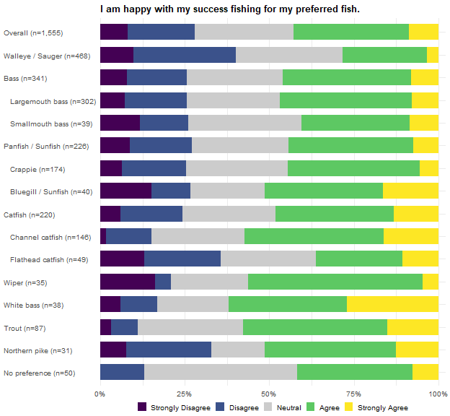
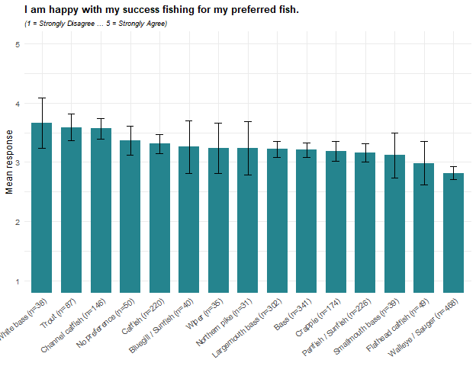
White bass, Trout, and Channel catfish anglers report the highest satisfaction, averaging 3.7, 3.6, and 3.6 on the five-point scale, with 62%, 58%, and 57% agreeing or strongly agreeing and no more than 17% disagreeing. Walleye / Sauger anglers, the largest single preferred group in the survey, report the lowest satisfaction, averaging 2.8, and are the only group where more anglers disagree (40%) than agree (28%); Flathead catfish anglers, at 3.0, divide evenly (36% each way). The gap between Walleye / Sauger and the three highest groups is roughly three-quarters of a point or more. Within families the widest contrast is among catfish, where Channel catfish anglers (3.6) are considerably more satisfied than Flathead catfish anglers (3.0); the two bass species and the two panfish species each fall within about a tenth of a point of each other.
Within 2025, one further pattern stands out: anglers with no single preferred species report above-average satisfaction (3.4, against 3.2) and the largest neutral share of any group (45%), and neutral responses are common across the board (roughly three in ten anglers in most groups take neither side.

I would be satisfied to harvest smaller fish if I could harvest more of my preferred fish.
Cells are the weighted percentage of the row group giving that response, with a 95% confidence interval. Mean scores the five responses from 1 (Strongly Disagree) to 5 (Strongly Agree). N is the raw unweighted number of respondents in the row group who answered the item. These results were weighted. Please consult the survey
Preferred species | Strongly Disagree | Disagree | Neutral | Agree | Strongly Agree | Mean ± CI | N
Overall | 10.5 ± 1.74 | 27.2 ± 2.52 | 38.0 ± 2.75 | 19.9 ± 2.26 | 4.3 ± 1.15 | 2.8 ± 0.06 | 1,507
Walleye / Sauger | 10.3 ± 3.10 | 24.8 ± 4.40 | 39.2 ± 4.98 | 23.3 ± 4.31 | 2.4 ± 1.57 | 2.8 ± 0.10 | 458
Bass | 11.7 ± 3.83 | 28.1 ± 5.35 | 38.9 ± 5.80 | 19.1 ± 4.68 | 2.2 ± 1.73 | 2.7 ± 0.12 | 326
Largemouth bass | 13.1 ± 4.27 | 27.6 ± 5.65 | 40.6 ± 6.21 | 16.2 ± 4.66 | 2.5 ± 1.96 | 2.7 ± 0.12 | 290
Smallmouth bass | 1.6 ± 4.39 | 31.9 ± 16.44 | 26.2 ± 15.52 | 40.4 ± 17.31 | 0.0 ± 0.00 | 3.1 ± 0.31 | 36
Panfish | 11.2 ± 4.71 | 27.1 ± 6.63 | 40.0 ± 7.31 | 19.3 ± 5.89 | 2.3 ± 2.22 | 2.7 ± 0.14 | 215
Crappie | 9.4 ± 4.95 | 28.1 ± 7.63 | 39.9 ± 8.31 | 20.8 ± 6.89 | 1.8 ± 2.26 | 2.8 ± 0.16 | 167
Bluegill / Sunfish | 19.5 ± 14.44 | 19.7 ± 14.49 | 47.7 ± 18.22 | 13.1 ± 12.32 | 0.0 ± 0.00 | 2.5 ± 0.35 | 36
Catfish | 11.2 ± 4.75 | 22.2 ± 6.27 | 41.7 ± 7.44 | 17.2 ± 5.69 | 7.8 ± 4.05 | 2.9 ± 0.16 | 212
Channel catfish | 6.0 ± 4.44 | 24.2 ± 7.99 | 51.4 ± 9.33 | 14.5 ± 6.57 | 3.9 ± 3.63 | 2.9 ± 0.16 | 140
Flathead catfish | 25.2 ± 13.78 | 26.1 ± 13.93 | 22.0 ± 13.16 | 14.1 ± 11.04 | 12.7 ± 10.55 | 2.6 ± 0.42 | 46
Wiper | 7.5 ± 9.83 | 50.1 ± 18.65 | 11.2 ± 11.77 | 14.0 ± 12.96 | 17.2 ± 14.07 | 2.8 ± 0.47 | 33
White bass | 1.3 ± 4.09 | 32.1 ± 17.00 | 35.8 ± 17.46 | 22.5 ± 15.21 | 8.4 ± 10.10 | 3.0 ± 0.35 | 38
Trout | 13.0 ± 8.06 | 33.3 ± 11.30 | 39.1 ± 11.70 | 12.2 ± 7.86 | 2.4 ± 3.64 | 2.6 ± 0.23 | 86
Northern pike | 12.9 ± 12.80 | 46.3 ± 19.07 | 32.8 ± 17.95 | 6.7 ± 9.56 | 1.4 ± 4.46 | 2.4 ± 0.32 | 31
No preference | 3.1 ± 5.37 | 18.6 ± 12.09 | 57.9 ± 15.35 | 19.1 ± 12.22 | 1.3 ± 3.56 | 3.0 ± 0.23 | 50
methodology for details (Hurley 2026).
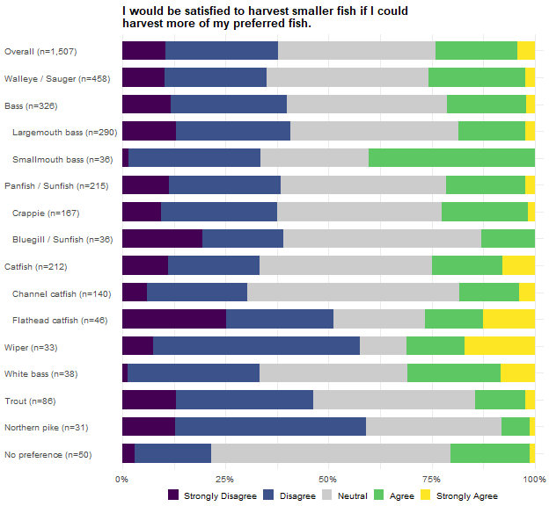
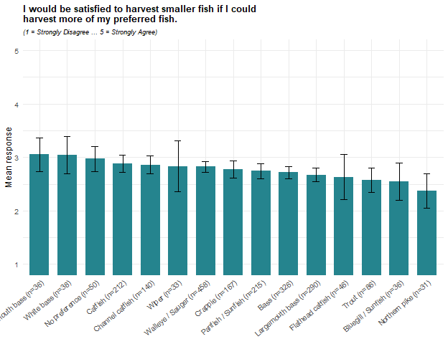
Willingness to harvest smaller fish in exchange for more of them is low overall, averaging 2.8, with 38% disagreeing and 24% agreeing. Smallmouth bass and White bass anglers report the highest agreement (3.05 each), and Smallmouth bass anglers are the only group where more agree (40%) than disagree (33%). Northern pike anglers report the lowest (2.4), with 59% disagreeing and only 8% agreeing; Wiper anglers (58% disagree, 31% agree) and Flathead catfish anglers (51% disagree, 27% agree) also disagree far more often than they agree. The bass family shows the widest within-family spread, with Smallmouth bass anglers (3.1) well above Largemouth bass anglers (2.7).
What separates some groups is how many take no side: 58% of anglers with no single preferred species, 51% of Channel catfish anglers and 48% of Bluegill / Sunfish anglers are neutral, against 11% of Wiper anglers, so similar averages can reflect very different response patterns.

I support regulations on my preferred fish to increase their size.
Cells are the weighted percentage of the row group giving that response, with a 95% confidence interval. Mean scores the five responses from 1 (Strongly Disagree) to 5 (Strongly Agree). N is the raw unweighted number of respondents in the row group who answered the item. These results were weighted. Please consult the survey methodology for details (Hurley 2026).
Preferred species | Strongly Disagree | Disagree | Neutral | Agree | Strongly Agree | Mean ± CI | N
Overall | 2.2 ± 0.83 | 10.0 ± 1.68 | 22.1 ± 2.33 | 41.8 ± 2.76 | 23.8 ± 2.39 | 3.8 ± 0.06 | 1,541
Walleye / Sauger | 2.7 ± 1.63 | 10.7 ± 3.11 | 24.7 ± 4.35 | 46.1 ± 5.02 | 15.9 ± 3.69 | 3.6 ± 0.10 | 469
Bass | 2.6 ± 1.85 | 6.6 ± 2.91 | 19.0 ± 4.60 | 40.8 ± 5.77 | 31.0 ± 5.43 | 3.9 ± 0.12 | 336
Largemouth bass | 2.4 ± 1.90 | 7.5 ± 3.30 | 17.9 ± 4.79 | 40.7 ± 6.14 | 31.4 ± 5.80 | 3.9 ± 0.12 | 297
Smallmouth bass | 3.9 ± 6.60 | 0.0 ± 0.00 | 26.7 ± 15.10 | 41.1 ± 16.80 | 28.3 ± 15.38 | 3.9 ± 0.32 | 39
Panfish | 2.2 ± 2.14 | 9.8 ± 4.36 | 22.9 ± 6.17 | 44.2 ± 7.29 | 21.0 ± 5.98 | 3.7 ± 0.14 | 222
Crappie | 2.0 ± 2.33 | 9.3 ± 4.84 | 23.4 ± 7.07 | 43.6 ± 8.28 | 21.8 ± 6.89 | 3.7 ± 0.16 | 173
Bluegill / Sunfish | 1.6 ± 4.45 | 9.5 ± 10.49 | 23.8 ± 15.24 | 43.5 ± 17.73 | 21.6 ± 14.71 | 3.7 ± 0.34 | 37
Catfish | 2.2 ± 2.20 | 9.5 ± 4.38 | 28.2 ± 6.71 | 34.8 ± 7.10 | 25.2 ± 6.47 | 3.7 ± 0.15 | 218
Channel catfish | 2.0 ± 2.57 | 6.4 ± 4.49 | 31.3 ± 8.53 | 39.7 ± 9.00 | 20.6 ± 7.45 | 3.7 ± 0.17 | 144
Flathead catfish | 4.1 ± 6.17 | 12.5 ± 10.25 | 28.4 ± 13.96 | 25.6 ± 13.53 | 29.3 ± 14.10 | 3.6 ± 0.36 | 49
Wiper | 1.8 ± 4.92 | 3.0 ± 6.27 | 8.2 ± 10.05 | 38.4 ± 17.81 | 48.6 ± 18.30 | 4.3 ± 0.32 | 35
White bass | 0.0 ± 0.00 | 8.8 ± 10.32 | 19.6 ± 14.45 | 48.8 ± 18.21 | 22.8 ± 15.29 | 3.9 ± 0.32 | 38
Trout | 1.8 ± 3.17 | 15.5 ± 8.73 | 20.4 ± 9.73 | 49.3 ± 12.06 | 13.0 ± 8.13 | 3.6 ± 0.23 | 85
Northern pike | 0.0 ± 0.00 | 14.4 ± 13.42 | 8.7 ± 10.76 | 34.5 ± 18.18 | 42.4 ± 18.90 | 4.1 ± 0.40 | 31
No preference | 1.3 ± 3.62 | 1.3 ± 3.62 | 35.5 ± 15.02 | 42.4 ± 15.51 | 19.4 ± 12.42 | 3.8 ± 0.26 | 49
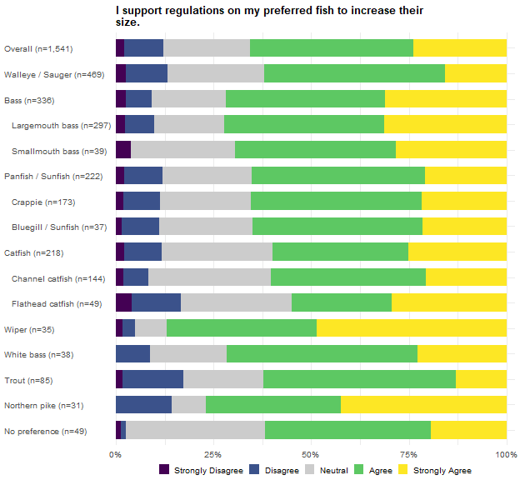
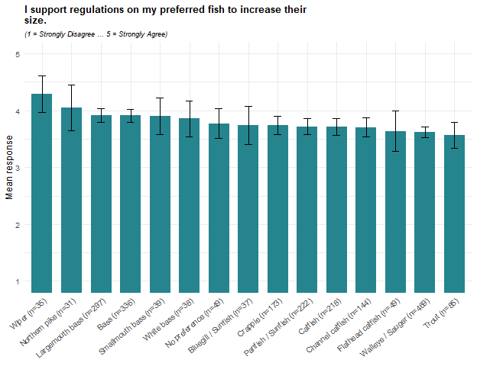
Support for regulations to increase the size of the preferred fish is high in every group, averaging 3.8 overall, with 66% agreeing and 12% disagreeing. Wiper anglers report the highest support (4.3; 87% agree, 5% disagree), followed by Northern pike anglers (4.1; 77% agree). Trout anglers report the lowest (3.6), alongside Walleye / Sauger (3.6) and Flathead catfish anglers (3.6), though even in these groups more than half agree.
What distinguishes the groups in 2025 is the firmness of the support: in every group, supporters outnumber opponents by at least three to one, and Wiper and Northern pike anglers are the least likely to take neither side (8% and 9% neutral), while 35% of anglers with no single preferred species and 31% of Channel catfish anglers do.

I support regulations on my preferred fish to increase their numbers.
Cells are the weighted percentage of the row group giving that response, with a 95% confidence interval. Mean scores the five responses from 1 (Strongly Disagree) to 5 (Strongly Agree). N is the raw unweighted number of respondents in the row group who answered the item. These results were weighted. Please consult the survey methodology for details (Hurley 2026).
Preferred species | Strongly Disagree | Disagree | Neutral | Agree | Strongly Agree | Mean ± CI | N
Overall | 2.9 ± 0.94 | 3.9 ± 1.09 | 20.4 ± 2.26 | 46.5 ± 2.80 | 26.3 ± 2.47 | 3.9 ± 0.05 | 1,533
Walleye / Sauger | 3.0 ± 1.73 | 3.8 ± 1.93 | 17.6 ± 3.85 | 52.5 ± 5.05 | 23.1 ± 4.26 | 3.9 ± 0.09 | 466
Bass | 1.6 ± 1.50 | 3.3 ± 2.12 | 20.1 ± 4.72 | 45.5 ± 5.87 | 29.4 ± 5.37 | 4.0 ± 0.10 | 333
Largemouth bass | 1.9 ± 1.70 | 3.8 ± 2.40 | 18.6 ± 4.87 | 46.7 ± 6.25 | 29.1 ± 5.69 | 4.0 ± 0.11 | 295
Smallmouth bass | 0.0 ± 0.00 | 0.0 ± 0.00 | 30.8 ± 15.91 | 37.7 ± 16.69 | 31.5 ± 16.00 | 4.0 ± 0.27 | 38
Panfish | 4.0 ± 2.89 | 5.4 ± 3.30 | 19.9 ± 5.85 | 52.8 ± 7.32 | 17.9 ± 5.62 | 3.8 ± 0.14 | 223
Crappie | 4.0 ± 3.30 | 5.1 ± 3.69 | 21.4 ± 6.87 | 53.3 ± 8.36 | 16.1 ± 6.16 | 3.7 ± 0.16 | 172
Bluegill / Sunfish | 3.1 ± 6.02 | 4.6 ± 7.31 | 17.3 ± 13.21 | 48.5 ± 17.46 | 26.5 ± 15.43 | 3.9 ± 0.33 | 39
Catfish | 1.8 ± 1.96 | 5.9 ± 3.51 | 27.0 ± 6.61 | 33.7 ± 7.04 | 31.6 ± 6.93 | 3.9 ± 0.15 | 218
Channel catfish | 1.2 ± 1.99 | 6.2 ± 4.41 | 33.3 ± 8.62 | 30.0 ± 8.38 | 29.2 ± 8.31 | 3.8 ± 0.18 | 146
Flathead catfish | 4.2 ± 6.35 | 7.7 ± 8.42 | 18.3 ± 12.19 | 41.7 ± 15.55 | 28.1 ± 14.17 | 3.8 ± 0.33 | 47
Wiper | 8.6 ± 10.61 | 0.0 ± 0.00 | 10.9 ± 11.83 | 30.1 ± 17.40 | 50.5 ± 18.97 | 4.1 ± 0.44 | 33
White bass | 0.0 ± 0.00 | 2.7 ± 5.94 | 21.2 ± 14.90 | 48.4 ± 18.21 | 27.6 ± 16.28 | 4.0 ± 0.28 | 38
Trout | 2.3 ± 3.61 | 1.8 ± 3.17 | 30.3 ± 11.09 | 41.9 ± 11.91 | 23.8 ± 10.27 | 3.8 ± 0.21 | 85
Northern pike | 0.0 ± 0.00 | 11.7 ± 12.51 | 7.3 ± 10.12 | 55.3 ± 19.33 | 25.7 ± 16.99 | 3.9 ± 0.35 | 30
No preference | 0.0 ± 0.00 | 0.0 ± 0.00 | 28.4 ± 14.15 | 49.5 ± 15.69 | 22.1 ± 13.02 | 3.9 ± 0.22 | 49
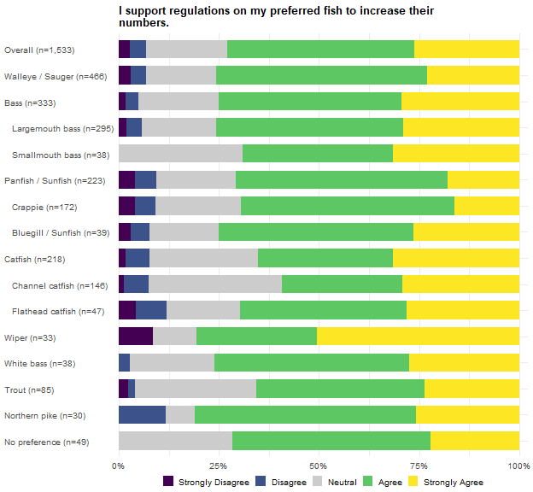
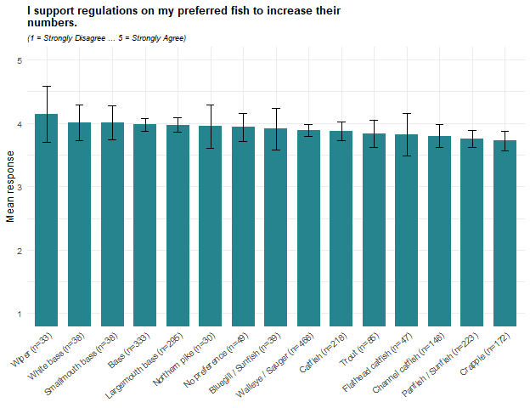
Support for regulations to increase the numbers of the preferred fish is high in every group, averaging 3.9 overall, with 73% agreeing and 7% disagreeing. The spread across groups is narrow: Wiper anglers report the highest support (4.1; 81% agree), while Crappie (3.7) and Panfish anglers (3.8) report the lowest, though 69% and 71% of them agree. Set against the previous item, most groups support numbers-focused regulation more strongly than size-focused regulation; Wiper and Northern pike anglers are the exceptions, backing size rules somewhat more strongly, and Crappie and Panfish anglers rate the two about equally. That tilt toward numbers over size may indicate that, for most anglers, catching fish at all matters more than catching bigger ones.
Among both Smallmouth bass anglers and anglers with no single preferred species, the share who disagree is 0% (after rounding) against 12% of Northern pike and Flathead catfish anglers, so the differences in averages reflect differences in how strongly anglers agree more than any split between supporters and opponents.

If I could catch larger fish, I would be willing to harvest fewer of my preferred fish.
Cells are the weighted percentage of the row group giving that response, with a 95% confidence interval. Mean scores the five responses from 1 (Strongly Disagree) to 5 (Strongly Agree). N is the raw unweighted number of respondents in the row group who answered the item. These results were weighted. Please consult the survey methodology for details (Hurley 2026).
Preferred species | Strongly Disagree | Disagree | Neutral | Agree | Strongly Agree | Mean ± CI | N
Overall | 2.6 ± 0.89 | 11.0 ± 1.75 | 34.6 ± 2.67 | 32.8 ± 2.64 | 19.0 ± 2.20 | 3.5 ± 0.06 | 1,533
Walleye / Sauger | 2.3 ± 1.52 | 13.3 ± 3.44 | 41.5 ± 4.98 | 32.9 ± 4.75 | 9.9 ± 3.02 | 3.3 ± 0.09 | 466
Bass | 2.1 ± 1.70 | 4.1 ± 2.33 | 30.3 ± 5.43 | 35.8 ± 5.67 | 27.7 ± 5.29 | 3.8 ± 0.11 | 331
Largemouth bass | 2.1 ± 1.82 | 4.2 ± 2.51 | 30.7 ± 5.81 | 35.3 ± 6.02 | 27.8 ± 5.64 | 3.8 ± 0.12 | 292
Smallmouth bass | 1.9 ± 4.69 | 3.3 ± 6.14 | 27.7 ± 15.27 | 39.6 ± 16.70 | 27.4 ± 15.23 | 3.9 ± 0.31 | 39
Panfish | 4.4 ± 3.01 | 9.1 ± 4.21 | 30.9 ± 6.75 | 42.0 ± 7.22 | 13.5 ± 5.00 | 3.5 ± 0.14 | 224
Crappie | 2.8 ± 2.76 | 9.5 ± 4.89 | 28.0 ± 7.49 | 45.8 ± 8.32 | 13.9 ± 5.78 | 3.6 ± 0.16 | 173
Bluegill / Sunfish | 8.1 ± 9.51 | 6.1 ± 8.37 | 48.7 ± 17.46 | 29.1 ± 15.87 | 8.1 ± 9.51 | 3.2 ± 0.34 | 39
Catfish | 2.7 ± 2.42 | 13.3 ± 5.04 | 34.6 ± 7.07 | 27.1 ± 6.61 | 22.3 ± 6.18 | 3.5 ± 0.16 | 219
Channel catfish | 0.8 ± 1.63 | 7.8 ± 4.91 | 43.7 ± 9.07 | 28.6 ± 8.26 | 19.1 ± 7.19 | 3.6 ± 0.17 | 146
Flathead catfish | 9.2 ± 9.03 | 16.1 ± 11.47 | 22.7 ± 13.08 | 24.3 ± 13.40 | 27.7 ± 13.97 | 3.5 ± 0.40 | 48
Wiper | 3.3 ± 6.92 | 0.0 ± 0.00 | 14.5 ± 13.57 | 35.0 ± 18.37 | 47.1 ± 19.22 | 4.2 ± 0.36 | 32
White bass | 1.3 ± 4.09 | 14.3 ± 12.75 | 55.7 ± 18.09 | 17.3 ± 13.77 | 11.4 ± 11.59 | 3.2 ± 0.32 | 38
Trout | 0.0 ± 0.00 | 18.4 ± 9.28 | 32.1 ± 11.18 | 31.3 ± 11.11 | 18.1 ± 9.23 | 3.5 ± 0.24 | 86
Northern pike | 0.0 ± 0.00 | 27.4 ± 17.06 | 16.2 ± 14.10 | 25.6 ± 16.68 | 30.8 ± 17.66 | 3.6 ± 0.45 | 31
No preference | 0.0 ± 0.00 | 9.1 ± 9.11 | 39.8 ± 15.52 | 34.2 ± 15.04 | 17.0 ± 11.90 | 3.6 ± 0.28 | 48
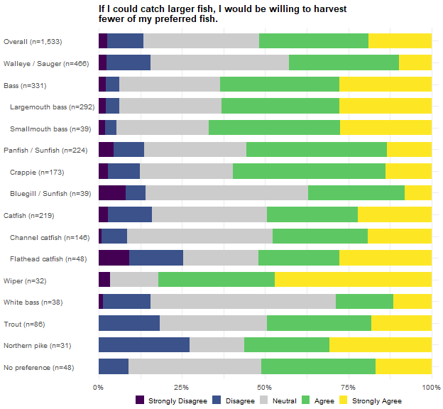
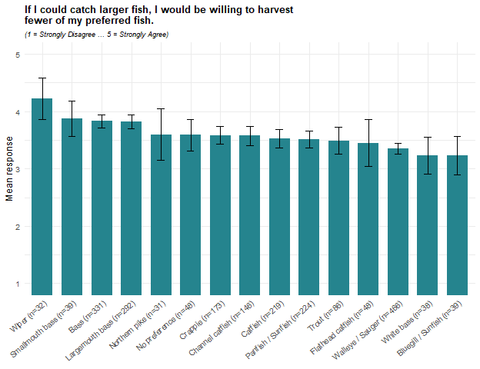
Willingness to harvest fewer fish in exchange for catching larger fish averages 3.5 overall, with 52% agreeing and 14% disagreeing. Wiper anglers report the highest willingness (4.2; 82% agree, 3% disagree), followed by the bass groups (Smallmouth bass 3.9, Largemouth bass 3.8; 63% to 67% agree). Bluegill / Sunfish and White bass anglers report the lowest (3.2 each), though for both the difference is mostly neutral rather than opposed responses: 49% and 56% of them take neither side, and 37% and 29% agree.
The 2025 pattern is internally consistent with the harvest-versus-size question two items later: the groups most willing to sacrifice numbers for size here, Wiper and both bass species, are the same ones that lean toward size over harvest opportunity there, while Walleye / Sauger anglers, among the least willing here, lean toward harvest opportunity. No group falls below neutral on average, so the differences are in degree of willingness, not direction.

It is becoming harder to catch my preferred fish.
Cells are the weighted percentage of the row group giving that response, with a 95% confidence interval. Mean scores the five responses from 1 (Strongly Disagree) to 5 (Strongly Agree). N is the raw unweighted number of respondents in the row group who answered the item. These results were weighted. Please consult the survey methodology for details (Hurley 2026).
Preferred species | Strongly Disagree | Disagree | Neutral | Agree | Strongly Agree | Mean ± CI | N
Overall | 3.1 ± 0.98 | 17.1 ± 2.12 | 35.1 ± 2.68 | 32.7 ± 2.64 | 12.0 ± 1.83 | 3.3 ± 0.06 | 1,528
Walleye / Sauger | 0.8 ± 0.89 | 11.2 ± 3.20 | 32.0 ± 4.74 | 41.5 ± 5.00 | 14.5 ± 3.58 | 3.6 ± 0.09 | 462
Bass | 3.5 ± 2.16 | 19.2 ± 4.63 | 37.4 ± 5.68 | 30.3 ± 5.40 | 9.5 ± 3.45 | 3.2 ± 0.12 | 335
Largemouth bass | 3.8 ± 2.39 | 17.3 ± 4.72 | 36.9 ± 6.03 | 33.0 ± 5.87 | 9.1 ± 3.60 | 3.3 ± 0.12 | 297
Smallmouth bass | 1.5 ± 4.18 | 33.1 ± 16.22 | 41.2 ± 16.96 | 11.6 ± 11.04 | 12.6 ± 11.42 | 3.0 ± 0.35 | 38
Panfish | 4.7 ± 3.11 | 19.1 ± 5.76 | 36.0 ± 7.03 | 27.4 ± 6.54 | 12.6 ± 4.87 | 3.2 ± 0.15 | 223
Crappie | 2.8 ± 2.76 | 17.5 ± 6.35 | 35.8 ± 8.00 | 30.7 ± 7.70 | 13.2 ± 5.66 | 3.3 ± 0.17 | 173
Bluegill / Sunfish | 14.6 ± 12.33 | 31.3 ± 16.20 | 37.8 ± 16.94 | 7.8 ± 9.39 | 8.4 ± 9.70 | 2.6 ± 0.38 | 39
Catfish | 4.7 ± 3.15 | 19.5 ± 5.92 | 38.2 ± 7.25 | 24.3 ± 6.40 | 13.3 ± 5.07 | 3.2 ± 0.16 | 217
Channel catfish | 6.0 ± 4.35 | 26.7 ± 8.11 | 34.4 ± 8.72 | 28.8 ± 8.31 | 4.1 ± 3.63 | 3.0 ± 0.18 | 145
Flathead catfish | 4.1 ± 6.23 | 11.1 ± 9.82 | 40.8 ± 15.35 | 15.1 ± 11.20 | 28.8 ± 14.14 | 3.5 ± 0.36 | 48
Wiper | 3.3 ± 6.92 | 8.3 ± 10.61 | 60.8 ± 18.80 | 14.7 ± 13.64 | 12.8 ± 12.89 | 3.3 ± 0.35 | 32
White bass | 3.8 ± 7.01 | 30.8 ± 16.82 | 25.9 ± 15.96 | 33.5 ± 17.20 | 5.9 ± 8.59 | 3.1 ± 0.37 | 38
Trout | 2.3 ± 3.60 | 23.2 ± 10.21 | 28.3 ± 10.90 | 37.7 ± 11.72 | 8.5 ± 6.76 | 3.3 ± 0.24 | 84
Northern pike | 0.0 ± 0.00 | 25.0 ± 16.57 | 14.9 ± 13.60 | 46.6 ± 19.08 | 13.5 ± 13.06 | 3.5 ± 0.39 | 31
No preference | 3.8 ± 6.00 | 20.0 ± 12.57 | 46.3 ± 15.65 | 18.6 ± 12.20 | 11.4 ± 9.96 | 3.1 ± 0.31 | 49
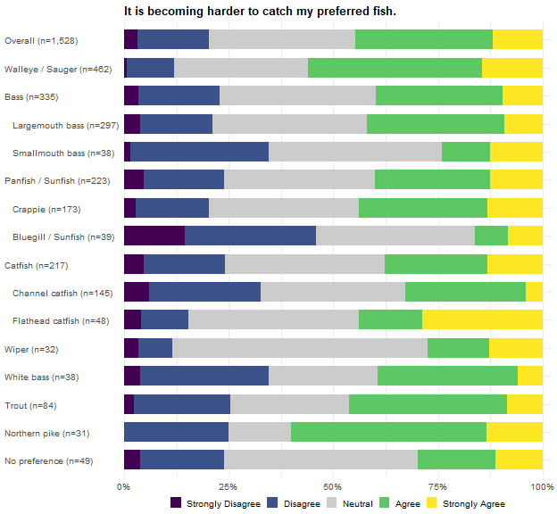
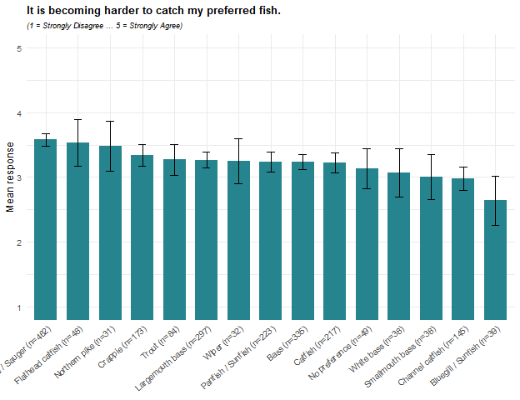
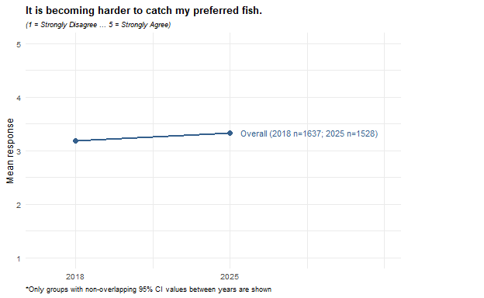
Agreement that the preferred fish is becoming harder to catch averages 3.3 overall, with 45% agreeing and 20% disagreeing. Walleye / Sauger anglers report the highest agreement (3.6; 56% agree), followed by Flathead catfish (3.5) and Northern pike anglers (3.5; 60% agree, the highest agree share of any group). Bluegill / Sunfish anglers report the lowest (2.6; 46% disagree, 16% agree) and are joined below the scale midpoint only by Channel catfish anglers (2.98, just under it). The within-family spreads are wide for panfish (Bluegill / Sunfish 2.6, Crappie 3.3) and catfish (Channel catfish 3.0, Flathead catfish 3.5).
Agreement that the preferred fish has become harder to catch rose modestly across all anglers between 2018 and 2025, from 3.2 to 3.3. It is one of only two items in this battery, along with the places-to-fish item at the end, where the change across all anglers is what stands out between years. No individual preferred group’s change was large enough to appear in the figure above, which suggests a broad, shallow drift toward agreement rather than a sharp movement concentrated in any one group.

The opportunity to harvest my preferred fish is more important to me than the size of the fish I catch.
Cells are the weighted percentage of the row group giving that response, with a 95% confidence interval. Mean scores the five responses from 1 (Strongly Disagree) to 5 (Strongly Agree). N is the raw unweighted number of respondents in the row group who answered the item. These results were weighted. Please consult the survey methodology for details (Hurley 2026).
Preferred species | Strongly Disagree | Disagree | Neutral | Agree | Strongly Agree | Mean ± CI | N
Overall | 9.9 ± 1.67 | 20.1 ± 2.25 | 34.3 ± 2.66 | 29.9 ± 2.57 | 5.7 ± 1.31 | 3.0 ± 0.06 | 1,534
Walleye / Sauger | 4.8 ± 2.16 | 15.9 ± 3.70 | 35.8 ± 4.85 | 36.1 ± 4.86 | 7.4 ± 2.65 | 3.3 ± 0.10 | 466
Bass | 16.7 ± 4.40 | 24.2 ± 5.05 | 35.2 ± 5.63 | 20.5 ± 4.75 | 3.3 ± 2.12 | 2.7 ± 0.13 | 333
Largemouth bass | 16.3 ± 4.62 | 23.0 ± 5.26 | 35.4 ± 5.98 | 21.5 ± 5.13 | 3.8 ± 2.38 | 2.7 ± 0.14 | 297
Smallmouth bass | 19.7 ± 14.05 | 33.6 ± 16.67 | 33.6 ± 16.67 | 13.0 ± 11.88 | 0.0 ± 0.00 | 2.4 ± 0.33 | 36
Panfish | 8.9 ± 4.16 | 23.6 ± 6.21 | 30.7 ± 6.74 | 31.3 ± 6.78 | 5.5 ± 3.32 | 3.0 ± 0.15 | 224
Crappie | 8.6 ± 4.67 | 22.6 ± 6.99 | 29.3 ± 7.60 | 34.4 ± 7.93 | 5.1 ± 3.67 | 3.0 ± 0.18 | 173
Bluegill / Sunfish | 11.3 ± 11.07 | 27.3 ± 15.56 | 37.0 ± 16.86 | 17.2 ± 13.20 | 7.2 ± 9.01 | 2.8 ± 0.37 | 39
Catfish | 6.4 ± 3.63 | 21.0 ± 6.05 | 38.8 ± 7.23 | 27.1 ± 6.59 | 6.7 ± 3.70 | 3.1 ± 0.15 | 220
Channel catfish | 4.3 ± 3.70 | 17.9 ± 7.00 | 43.2 ± 9.06 | 28.5 ± 8.25 | 6.1 ± 4.37 | 3.1 ± 0.17 | 146
Flathead catfish | 12.6 ± 10.28 | 26.1 ± 13.60 | 35.6 ± 14.83 | 17.1 ± 11.66 | 8.6 ± 8.70 | 2.8 ± 0.35 | 49
Wiper | 43.3 ± 18.80 | 16.2 ± 13.97 | 15.4 ± 13.70 | 21.0 ± 15.47 | 4.0 ± 7.48 | 2.3 ± 0.50 | 33
White bass | 4.0 ± 7.15 | 27.0 ± 16.18 | 37.4 ± 17.62 | 30.3 ± 16.74 | 1.3 ± 4.09 | 3.0 ± 0.32 | 38
Trout | 5.8 ± 5.65 | 13.2 ± 8.19 | 37.2 ± 11.69 | 36.8 ± 11.67 | 7.0 ± 6.18 | 3.3 ± 0.24 | 84
Northern pike | 9.9 ± 11.41 | 19.2 ± 15.08 | 24.4 ± 16.43 | 45.1 ± 19.03 | 1.4 ± 4.46 | 3.1 ± 0.40 | 31
No preference | 5.6 ± 7.20 | 22.4 ± 13.08 | 49.8 ± 15.70 | 21.0 ± 12.77 | 1.3 ± 3.62 | 2.9 ± 0.26 | 49
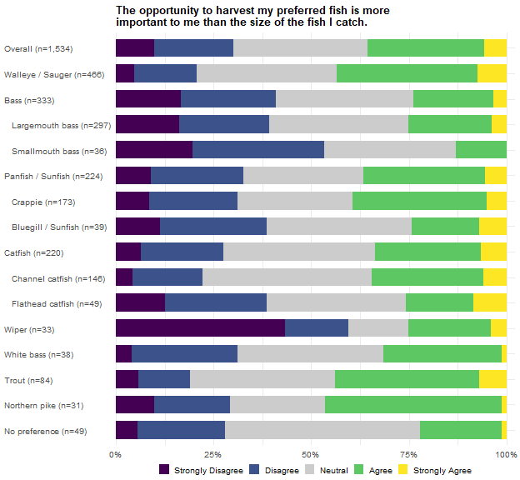
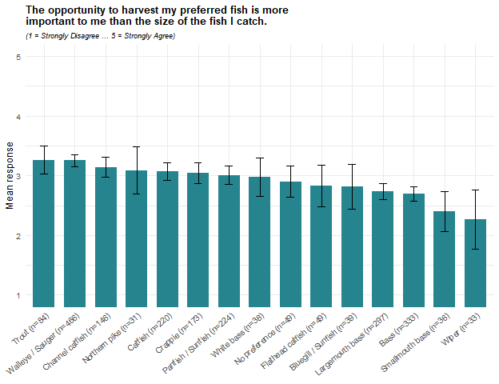
Views on whether harvest opportunity matters more than fish size are divided, averaging 3.0 overall, with 36% agreeing and 30% disagreeing. Trout (3.3) and Walleye / Sauger anglers (3.3) lean furthest toward harvest opportunity. Wiper anglers lean furthest toward size (2.3; 60% disagree, 25% agree), followed by Smallmouth bass anglers (2.4; 53% disagree, 13% agree) and the bass family as a whole (2.7; 41% disagree, 24% agree).
Within 2025, half of the anglers with no single preferred species (50%) take neither side, the largest neutral share of any group, against 15% of Wiper anglers. The two averages differ for different reasons: the Wiper average sits at the size end of the range (2.3) because a majority disagree (60%), while the no-preference average (2.9) sits near the overall (3.0), with the group split between disagreeing (28%) and agreeing (22%).

I have to travel too far to fish for my preferred fish.
Cells are the weighted percentage of the row group giving that response, with a 95% confidence interval. Mean scores the five responses from 1 (Strongly Disagree) to 5 (Strongly Agree). N is the raw unweighted number of respondents in the row group who answered the item. These results were weighted. Please consult the survey methodology for details (Hurley 2026).
Preferred species | Strongly Disagree | Disagree | Neutral | Agree | Strongly Agree | Mean ± CI | N
Overall | 11.1 ± 1.77 | 32.1 ± 2.63 | 32.0 ± 2.63 | 17.1 ± 2.12 | 7.8 ± 1.51 | 2.8 ± 0.06 | 1,519
Walleye / Sauger | 6.8 ± 2.56 | 26.4 ± 4.49 | 35.1 ± 4.86 | 20.3 ± 4.10 | 11.4 ± 3.24 | 3.0 ± 0.11 | 459
Bass | 14.6 ± 4.14 | 38.0 ± 5.70 | 33.1 ± 5.52 | 9.5 ± 3.43 | 4.8 ± 2.50 | 2.5 ± 0.12 | 336
Largemouth bass | 14.1 ± 4.35 | 39.6 ± 6.10 | 34.5 ± 5.93 | 8.5 ± 3.48 | 3.3 ± 2.23 | 2.5 ± 0.12 | 298
Smallmouth bass | 18.0 ± 13.22 | 27.1 ± 15.31 | 23.7 ± 14.65 | 16.1 ± 12.66 | 15.2 ± 12.36 | 2.8 ± 0.45 | 38
Panfish | 14.1 ± 5.13 | 37.8 ± 7.15 | 27.3 ± 6.57 | 14.3 ± 5.17 | 6.5 ± 3.63 | 2.6 ± 0.16 | 220
Crappie | 11.5 ± 5.37 | 38.5 ± 8.20 | 29.4 ± 7.68 | 14.6 ± 5.96 | 6.0 ± 4.00 | 2.7 ± 0.18 | 170
Bluegill / Sunfish | 29.6 ± 16.13 | 45.5 ± 17.60 | 12.7 ± 11.76 | 8.9 ± 10.07 | 3.3 ± 6.33 | 2.1 ± 0.36 | 38
Catfish | 16.7 ± 5.60 | 41.5 ± 7.39 | 27.0 ± 6.66 | 9.5 ± 4.39 | 5.4 ± 3.39 | 2.5 ± 0.16 | 215
Channel catfish | 17.7 ± 7.06 | 37.4 ± 8.95 | 31.8 ± 8.61 | 10.0 ± 5.55 | 3.1 ± 3.21 | 2.4 ± 0.18 | 143
Flathead catfish | 13.2 ± 10.65 | 55.0 ± 15.66 | 16.4 ± 11.67 | 10.3 ± 9.56 | 5.1 ± 6.91 | 2.4 ± 0.32 | 47
Wiper | 10.0 ± 11.38 | 8.0 ± 10.28 | 27.0 ± 16.85 | 43.6 ± 18.82 | 11.4 ± 12.05 | 3.4 ± 0.42 | 33
White bass | 4.6 ± 7.65 | 30.4 ± 16.76 | 30.6 ± 16.78 | 18.5 ± 14.15 | 15.9 ± 13.31 | 3.1 ± 0.41 | 38
Trout | 6.5 ± 5.92 | 26.6 ± 10.64 | 27.7 ± 10.77 | 31.2 ± 11.15 | 8.0 ± 6.53 | 3.1 ± 0.26 | 85
Northern pike | 11.4 ± 12.30 | 16.5 ± 14.37 | 33.6 ± 18.27 | 25.5 ± 16.86 | 13.0 ± 13.01 | 3.1 ± 0.45 | 30
No preference | 3.8 ± 6.10 | 16.7 ± 11.83 | 57.5 ± 15.67 | 15.6 ± 11.50 | 6.3 ± 7.72 | 3.0 ± 0.27 | 48
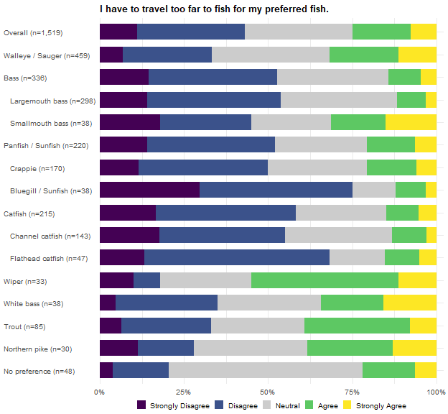
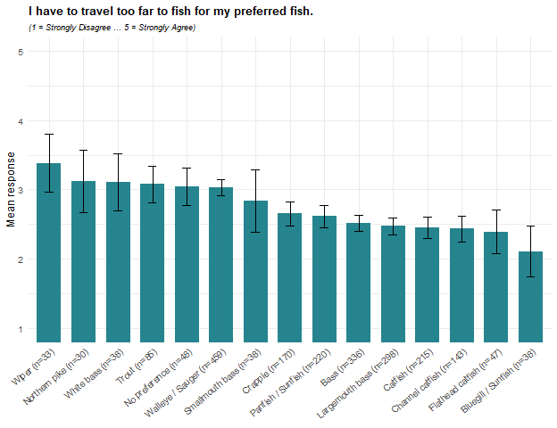
Agreement that the angler has to travel too far to fish for the preferred fish averages 2.8 overall, with 43% disagreeing and 25% agreeing. Wiper anglers report the highest agreement (3.4; 55% agree, 18% disagree), with the widest margin of agreement over disagreement of any group; Northern pike (3.1), White bass (3.1), and Trout anglers (3.1) follow. Bluegill / Sunfish anglers report the lowest (2.1; 75% disagree, 12% agree), followed by Flathead catfish (2.4), Channel catfish (2.4), Catfish anglers as a whole (2.5), and Largemouth bass anglers (2.5).
The travel pattern partly lines up with the places-to-fish item at the end of this list: Northern pike, Wiper, and Trout anglers sit at or near the top of both, while Bluegill / Sunfish and Channel catfish anglers sit at or near the bottom of both, suggesting that travel distance and the perceived shortage of places to fish may be two readings of the same underlying access picture for these species. Flathead catfish anglers are the exception, near the bottom on travel (2.4) but second from the top on places to fish (3.3).

I am satisfied with the size of my preferred fish that I catch in Nebraska.
Cells are the weighted percentage of the row group giving that response, with a 95% confidence interval. Mean scores the five responses from 1 (Strongly Disagree) to 5 (Strongly Agree). N is the raw unweighted number of respondents in the row group who answered the item. These results were weighted. Please consult the survey methodology for details (Hurley 2026).
Preferred species | Strongly Disagree | Disagree | Neutral | Agree | Strongly Agree | Mean ± CI | N
Overall | 5.0 ± 1.22 | 15.8 ± 2.05 | 33.3 ± 2.65 | 40.4 ± 2.75 | 5.5 ± 1.28 | 3.3 ± 0.05 | 1,533
Walleye / Sauger | 5.3 ± 2.28 | 15.5 ± 3.67 | 35.3 ± 4.84 | 41.0 ± 4.99 | 2.9 ± 1.71 | 3.2 ± 0.09 | 464
Bass | 6.4 ± 2.87 | 21.0 ± 4.78 | 33.9 ± 5.55 | 35.9 ± 5.63 | 2.8 ± 1.95 | 3.1 ± 0.11 | 336
Largemouth bass | 6.4 ± 3.05 | 23.2 ± 5.27 | 35.3 ± 5.96 | 31.9 ± 5.81 | 3.2 ± 2.21 | 3.0 ± 0.12 | 298
Smallmouth bass | 6.2 ± 8.29 | 5.4 ± 7.81 | 23.6 ± 14.62 | 64.8 ± 16.45 | 0.0 ± 0.00 | 3.5 ± 0.29 | 38
Panfish | 6.1 ± 3.50 | 19.1 ± 5.76 | 29.4 ± 6.68 | 40.6 ± 7.19 | 4.8 ± 3.13 | 3.2 ± 0.15 | 223
Crappie | 7.5 ± 4.42 | 18.3 ± 6.49 | 28.9 ± 7.61 | 42.5 ± 8.30 | 2.8 ± 2.76 | 3.1 ± 0.17 | 171
Bluegill / Sunfish | 0.0 ± 0.00 | 19.2 ± 13.61 | 29.4 ± 15.73 | 36.4 ± 16.61 | 15.0 ± 12.33 | 3.5 ± 0.33 | 40
Catfish | 3.1 ± 2.57 | 13.5 ± 5.07 | 31.6 ± 6.91 | 41.8 ± 7.33 | 10.0 ± 4.45 | 3.4 ± 0.14 | 219
Channel catfish | 0.5 ± 1.34 | 19.6 ± 7.29 | 25.0 ± 7.94 | 41.5 ± 9.03 | 13.4 ± 6.24 | 3.5 ± 0.18 | 145
Flathead catfish | 5.7 ± 7.24 | 6.4 ± 7.62 | 38.7 ± 15.21 | 42.6 ± 15.44 | 6.7 ± 7.80 | 3.4 ± 0.29 | 48
Wiper | 3.3 ± 6.76 | 3.3 ± 6.76 | 13.6 ± 13.02 | 51.2 ± 18.97 | 28.6 ± 17.16 | 4.0 ± 0.35 | 33
White bass | 1.3 ± 4.09 | 6.1 ± 8.73 | 44.1 ± 18.09 | 25.9 ± 15.95 | 22.6 ± 15.23 | 3.6 ± 0.34 | 38
Trout | 0.0 ± 0.00 | 10.5 ± 7.39 | 41.3 ± 11.88 | 44.2 ± 11.99 | 4.1 ± 4.76 | 3.4 ± 0.18 | 85
Northern pike | 8.7 ± 10.78 | 28.6 ± 17.29 | 20.2 ± 15.35 | 42.5 ± 18.91 | 0.0 ± 0.00 | 3.0 ± 0.39 | 31
No preference | 5.4 ± 7.17 | 8.8 ± 8.99 | 49.9 ± 15.85 | 33.2 ± 14.93 | 2.7 ± 5.16 | 3.2 ± 0.27 | 48
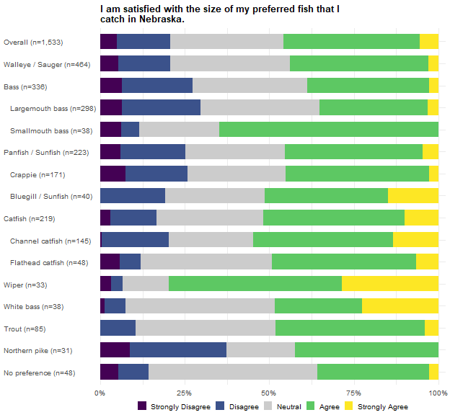
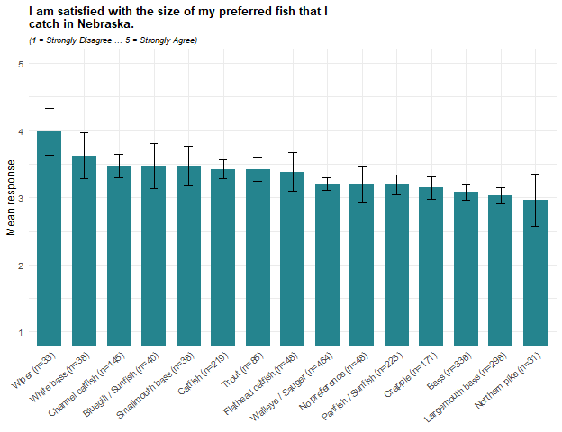
Satisfaction with the size of the preferred fish caught averages 3.3 overall, with 46% agreeing and 21% disagreeing. Wiper anglers report the highest satisfaction (4.0; 80% agree, 7% disagree), followed by White bass anglers (3.6). Northern pike anglers report the lowest (2.96), the only group averaging below the scale midpoint, followed by Largemouth bass anglers (3.02).
Within 2025, how the groups arrive at their averages differs as much as the averages themselves: Northern pike anglers split into opposing camps (43% agree, 37% disagree, only a fifth neutral), while half of the anglers with no single preferred species (50%), 44% of White bass anglers, and four in ten Trout anglers (41%) take no side at all.

I am satisfied with the size of my preferred fish that I am allowed to harvest in Nebraska.
Cells are the weighted percentage of the row group giving that response, with a 95% confidence interval. Mean scores the five responses from 1 (Strongly Disagree) to 5 (Strongly Agree). N is the raw unweighted number of respondents in the row group who answered the item. These results were weighted. Please consult the survey methodology for details (Hurley 2026).
Preferred species | Strongly Disagree | Disagree | Neutral | Agree | Strongly Agree | Mean ± CI | N
Overall | 2.2 ± 0.83 | 7.5 ± 1.48 | 34.5 ± 2.68 | 48.5 ± 2.81 | 7.3 ± 1.46 | 3.5 ± 0.05 | 1,524
Walleye / Sauger | 1.4 ± 1.18 | 9.4 ± 2.95 | 29.7 ± 4.63 | 54.1 ± 5.05 | 5.4 ± 2.30 | 3.5 ± 0.08 | 464
Bass | 3.0 ± 2.02 | 5.0 ± 2.58 | 38.0 ± 5.73 | 47.4 ± 5.89 | 6.5 ± 2.92 | 3.5 ± 0.10 | 333
Largemouth bass | 3.2 ± 2.21 | 5.7 ± 2.91 | 38.5 ± 6.09 | 45.8 ± 6.24 | 6.7 ± 3.14 | 3.5 ± 0.10 | 296
Smallmouth bass | 1.6 ± 4.40 | 0.0 ± 0.00 | 34.2 ± 16.69 | 59.2 ± 17.29 | 5.0 ± 7.65 | 3.7 ± 0.23 | 37
Panfish | 0.0 ± 0.00 | 7.2 ± 3.79 | 30.9 ± 6.78 | 52.9 ± 7.32 | 9.0 ± 4.20 | 3.6 ± 0.11 | 222
Crappie | 0.0 ± 0.00 | 7.4 ± 4.37 | 32.0 ± 7.81 | 54.5 ± 8.34 | 6.2 ± 4.02 | 3.6 ± 0.12 | 172
Bluegill / Sunfish | 0.0 ± 0.00 | 3.2 ± 6.23 | 27.5 ± 15.73 | 44.0 ± 17.48 | 25.2 ± 15.28 | 3.9 ± 0.28 | 38
Catfish | 2.5 ± 2.34 | 4.1 ± 2.96 | 41.3 ± 7.35 | 43.9 ± 7.41 | 8.2 ± 4.09 | 3.5 ± 0.12 | 217
Channel catfish | 0.0 ± 0.00 | 4.9 ± 3.96 | 42.4 ± 9.03 | 43.9 ± 9.07 | 8.8 ± 5.17 | 3.6 ± 0.13 | 146
Flathead catfish | 7.5 ± 8.31 | 4.4 ± 6.43 | 37.4 ± 15.23 | 40.4 ± 15.45 | 10.3 ± 9.58 | 3.4 ± 0.31 | 47
Wiper | 5.3 ± 8.48 | 5.6 ± 8.72 | 45.7 ± 18.90 | 39.2 ± 18.53 | 4.2 ± 7.59 | 3.3 ± 0.32 | 33
White bass | 1.3 ± 4.09 | 3.4 ± 6.59 | 32.0 ± 17.00 | 44.9 ± 18.12 | 18.4 ± 14.12 | 3.8 ± 0.30 | 38
Trout | 1.9 ± 3.37 | 12.7 ± 8.26 | 19.0 ± 9.74 | 59.2 ± 12.19 | 7.2 ± 6.40 | 3.6 ± 0.22 | 81
Northern pike | 9.0 ± 10.93 | 30.7 ± 17.64 | 22.1 ± 15.86 | 33.2 ± 18.01 | 5.1 ± 8.39 | 2.9 ± 0.42 | 31
No preference | 3.6 ± 5.81 | 8.9 ± 8.93 | 51.5 ± 15.69 | 34.8 ± 14.95 | 1.3 ± 3.61 | 3.2 ± 0.24 | 49
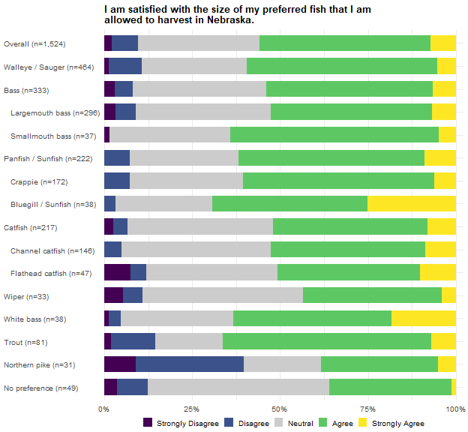
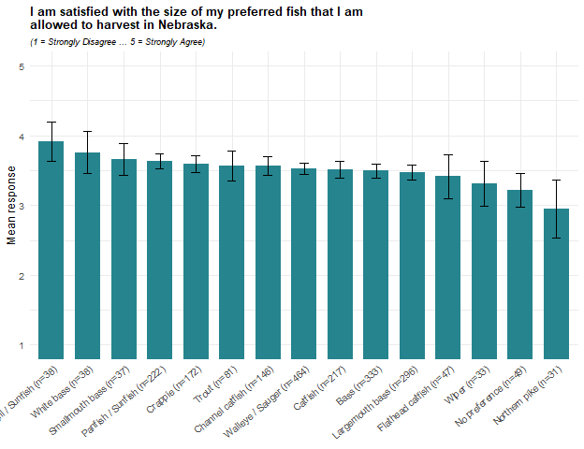
Satisfaction with the size of the preferred fish that may be harvested averages 3.5 overall, with 56% agreeing and 10% disagreeing. Bluegill / Sunfish anglers report the highest satisfaction (3.9; 69% agree, 3% disagree), followed by White bass anglers (3.8) and Smallmouth bass anglers (3.7). Northern pike anglers report the lowest (2.9; 38% agree, 40% disagree) and are the only group where disagreement is at least as common as agreement; anglers with no single preferred species (3.2) and Wiper anglers (3.3) follow.
Compared with the previous item, nearly every group rates the size they are allowed to harvest at least as favorably as the size they actually catch; Wiper anglers are the one clear exception, rating the size they catch (4.0) above the size they are allowed to keep (3.3), while Northern pike anglers rate the two about equally (2.96 caught, 2.95 allowed), which may hint that where Wiper anglers have a complaint, it is with the rules rather than the fish.

I am satisfied with the number of my preferred fish that I catch in Nebraska.
Cells are the weighted percentage of the row group giving that response, with a 95% confidence interval. Mean scores the five responses from 1 (Strongly Disagree) to 5 (Strongly Agree). N is the raw unweighted number of respondents in the row group who answered the item. These results were weighted. Please consult the survey methodology for details (Hurley 2026).
Preferred species | Strongly Disagree | Disagree | Neutral | Agree | Strongly Agree | Mean ± CI | N
Overall | 6.2 ± 1.35 | 21.2 ± 2.30 | 26.7 ± 2.48 | 40.1 ± 2.75 | 5.9 ± 1.32 | 3.2 ± 0.06 | 1,533
Walleye / Sauger | 8.2 ± 2.76 | 23.9 ± 4.30 | 27.8 ± 4.52 | 36.3 ± 4.85 | 3.9 ± 1.96 | 3.0 ± 0.10 | 468
Bass | 5.4 ± 2.66 | 20.0 ± 4.71 | 28.3 ± 5.30 | 42.3 ± 5.82 | 4.1 ± 2.32 | 3.2 ± 0.12 | 334
Largemouth bass | 4.8 ± 2.67 | 19.4 ± 4.94 | 31.0 ± 5.78 | 40.2 ± 6.13 | 4.6 ± 2.62 | 3.2 ± 0.12 | 297
Smallmouth bass | 9.9 ± 10.52 | 24.5 ± 15.13 | 7.9 ± 9.51 | 57.6 ± 17.38 | 0.0 ± 0.00 | 3.1 ± 0.39 | 37
Panfish | 6.3 ± 3.56 | 18.8 ± 5.73 | 20.2 ± 5.88 | 48.8 ± 7.32 | 5.8 ± 3.43 | 3.3 ± 0.15 | 223
Crappie | 4.3 ± 3.40 | 21.1 ± 6.84 | 22.2 ± 6.96 | 48.7 ± 8.38 | 3.6 ± 3.14 | 3.3 ± 0.16 | 172
Bluegill / Sunfish | 8.9 ± 9.93 | 11.4 ± 11.04 | 9.8 ± 10.33 | 52.3 ± 17.37 | 17.6 ± 13.26 | 3.6 ± 0.41 | 39
Catfish | 5.8 ± 3.47 | 22.2 ± 6.17 | 26.4 ± 6.55 | 36.7 ± 7.16 | 8.9 ± 4.24 | 3.2 ± 0.16 | 219
Channel catfish | 2.8 ± 3.02 | 14.4 ± 6.42 | 30.0 ± 8.37 | 41.3 ± 9.00 | 11.5 ± 5.83 | 3.4 ± 0.18 | 146
Flathead catfish | 13.9 ± 10.79 | 36.2 ± 15.01 | 11.5 ± 9.98 | 31.7 ± 14.54 | 6.7 ± 7.80 | 2.8 ± 0.38 | 48
Wiper | 4.4 ± 7.82 | 12.0 ± 12.33 | 23.3 ± 16.04 | 55.8 ± 18.84 | 4.4 ± 7.81 | 3.4 ± 0.35 | 33
White bass | 2.6 ± 5.75 | 20.4 ± 14.68 | 27.4 ± 16.24 | 34.2 ± 17.28 | 15.5 ± 13.18 | 3.4 ± 0.38 | 38
Trout | 2.7 ± 3.98 | 14.9 ± 8.74 | 27.9 ± 11.02 | 50.2 ± 12.28 | 4.3 ± 4.96 | 3.4 ± 0.22 | 83
Northern pike | 8.7 ± 10.78 | 30.6 ± 17.62 | 12.9 ± 12.82 | 26.5 ± 16.87 | 21.3 ± 15.67 | 3.2 ± 0.50 | 31
No preference | 3.6 ± 5.81 | 11.3 ± 9.95 | 46.4 ± 15.66 | 32.2 ± 14.67 | 6.5 ± 7.73 | 3.3 ± 0.27 | 49
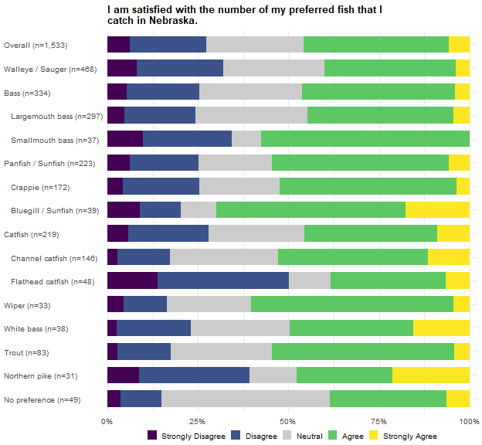
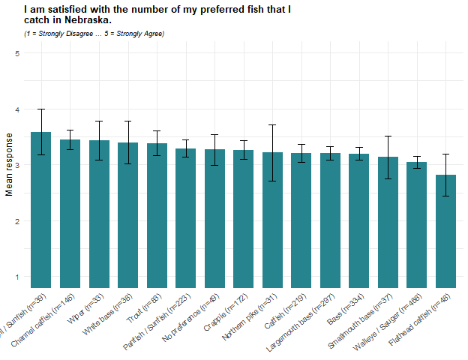
Satisfaction with the number of the preferred fish caught averages 3.2 overall, with 46% agreeing and 27% disagreeing. Bluegill / Sunfish anglers report the highest satisfaction (3.6; 70% agree, 20% disagree), followed by Channel catfish and Wiper anglers (3.4 each). Flathead catfish anglers report the lowest (2.8; 50% disagree, 38% agree), the only group averaging below the scale midpoint, followed by Walleye / Sauger anglers (3.04).
The 2025 ranking partly mirrors the overall fishing-success item at the top of this chapter: Channel catfish, White bass, and Trout anglers are in the upper part of both, and Walleye / Sauger and Flathead catfish anglers are near the bottom of both. That may indicate that when anglers judge their overall success, the number of fish caught weighs into their satisfaction.

I am satisfied with the number of my preferred fish that I am allowed to harvest in Nebraska.
Cells are the weighted percentage of the row group giving that response, with a 95% confidence interval. Mean scores the five responses from 1 (Strongly Disagree) to 5 (Strongly Agree). N is the raw unweighted number of respondents in the row group who answered the item. These results were weighted. Please consult the survey methodology for details (Hurley 2026).
Preferred species | Strongly Disagree | Disagree | Neutral | Agree | Strongly Agree | Mean ± CI | N
Overall | 2.2 ± 0.82 | 8.0 ± 1.53 | 33.6 ± 2.66 | 48.4 ± 2.81 | 7.8 ± 1.51 | 3.5 ± 0.05 | 1,525
Walleye / Sauger | 1.6 ± 1.25 | 9.0 ± 2.91 | 32.0 ± 4.73 | 50.7 ± 5.07 | 6.7 ± 2.54 | 3.5 ± 0.08 | 463
Bass | 2.0 ± 1.64 | 4.7 ± 2.51 | 39.1 ± 5.77 | 48.1 ± 5.91 | 6.1 ± 2.84 | 3.5 ± 0.09 | 331
Largemouth bass | 2.0 ± 1.76 | 5.2 ± 2.79 | 40.5 ± 6.17 | 46.0 ± 6.26 | 6.3 ± 3.05 | 3.5 ± 0.10 | 294
Smallmouth bass | 1.6 ± 4.38 | 1.2 ± 3.82 | 28.6 ± 15.89 | 63.7 ± 16.90 | 4.9 ± 7.62 | 3.7 ± 0.23 | 37
Panfish | 3.1 ± 2.55 | 5.6 ± 3.35 | 23.0 ± 6.16 | 55.4 ± 7.28 | 12.9 ± 4.91 | 3.7 ± 0.13 | 223
Crappie | 2.9 ± 2.82 | 6.1 ± 3.99 | 21.3 ± 6.85 | 59.7 ± 8.21 | 10.0 ± 5.03 | 3.7 ± 0.14 | 172
Bluegill / Sunfish | 0.0 ± 0.00 | 4.8 ± 7.41 | 28.9 ± 15.77 | 39.8 ± 17.02 | 26.6 ± 15.37 | 3.9 ± 0.30 | 39
Catfish | 1.4 ± 1.73 | 5.4 ± 3.38 | 38.4 ± 7.24 | 46.7 ± 7.43 | 8.1 ± 4.07 | 3.5 ± 0.12 | 218
Channel catfish | 0.4 ± 1.16 | 5.4 ± 4.14 | 36.1 ± 8.78 | 49.3 ± 9.14 | 8.7 ± 5.16 | 3.6 ± 0.14 | 146
Flathead catfish | 4.6 ± 6.54 | 6.5 ± 7.69 | 41.3 ± 15.37 | 41.0 ± 15.36 | 6.7 ± 7.80 | 3.4 ± 0.28 | 48
Wiper | 6.6 ± 9.39 | 12.2 ± 12.41 | 46.0 ± 18.91 | 25.1 ± 16.45 | 10.2 ± 11.46 | 3.2 ± 0.38 | 33
White bass | 1.3 ± 4.09 | 7.0 ± 9.30 | 29.6 ± 16.62 | 45.4 ± 18.14 | 16.8 ± 13.61 | 3.7 ± 0.32 | 38
Trout | 3.4 ± 4.43 | 13.8 ± 8.48 | 19.9 ± 9.80 | 55.5 ± 12.20 | 7.5 ± 6.45 | 3.5 ± 0.23 | 83
Northern pike | 9.0 ± 10.93 | 20.7 ± 15.51 | 22.9 ± 16.07 | 40.9 ± 18.81 | 6.5 ± 9.39 | 3.2 ± 0.42 | 31
No preference | 0.0 ± 0.00 | 2.7 ± 5.07 | 54.9 ± 15.62 | 36.0 ± 15.07 | 6.5 ± 7.73 | 3.5 ± 0.21 | 49
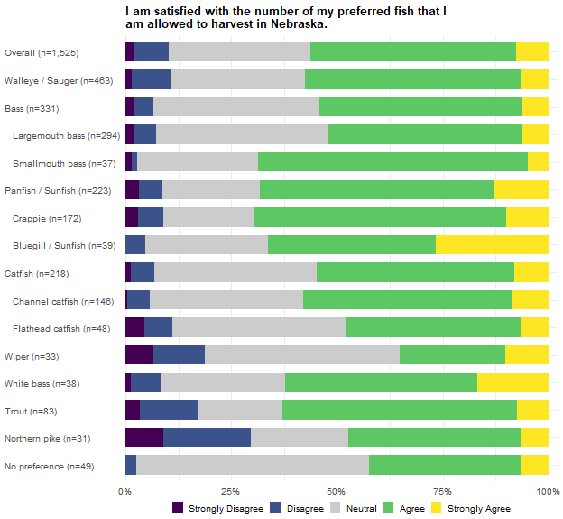
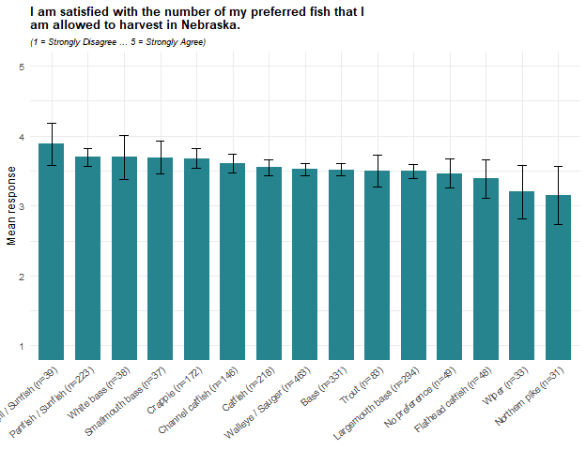
Satisfaction with the number of the preferred fish that may be harvested averages 3.5 overall, with 56% agreeing and 10% disagreeing. Bluegill / Sunfish anglers report the highest satisfaction (3.9; 66% agree, 5% disagree), followed by Panfish, Smallmouth bass, White bass, and Crappie anglers (3.7 each). Northern pike anglers report the lowest (3.15; 47% agree, 30% disagree), followed by Wiper anglers (3.20), 46% of whom take neither side.
Compared with the number caught in the previous item, every group rates the number it is allowed to harvest at least as favorably except Wiper anglers (3.2 allowed, against 3.4 caught) and, marginally, Northern pike anglers (3.15 allowed, against 3.21 caught); Wiper anglers also rate the size they may keep below the size they catch, so their lower ratings for what may be kept appear on both size and number.

I do not have enough places to fish for my preferred fish in Nebraska.
Cells are the weighted percentage of the row group giving that response, with a 95% confidence interval. Mean scores the five responses from 1 (Strongly Disagree) to 5 (Strongly Agree). N is the raw unweighted number of respondents in the row group who answered the item. These results were weighted. Please consult the survey methodology for details (Hurley 2026).
Preferred species | Strongly Disagree | Disagree | Neutral | Agree | Strongly Agree | Mean ± CI | N
Overall | 7.8 ± 1.51 | 26.2 ± 2.48 | 29.9 ± 2.58 | 24.1 ± 2.41 | 12.0 ± 1.83 | 3.1 ± 0.06 | 1,524
Walleye / Sauger | 5.0 ± 2.21 | 26.5 ± 4.46 | 28.2 ± 4.54 | 24.4 ± 4.34 | 15.9 ± 3.69 | 3.2 ± 0.12 | 467
Bass | 9.1 ± 3.40 | 29.7 ± 5.38 | 28.8 ± 5.33 | 23.5 ± 4.99 | 8.9 ± 3.36 | 2.9 ± 0.13 | 334
Largemouth bass | 8.8 ± 3.54 | 31.3 ± 5.79 | 29.4 ± 5.69 | 23.6 ± 5.31 | 6.9 ± 3.17 | 2.9 ± 0.13 | 297
Smallmouth bass | 11.6 ± 11.27 | 17.8 ± 13.44 | 24.1 ± 15.04 | 22.5 ± 14.68 | 23.9 ± 14.99 | 3.3 ± 0.46 | 37
Panfish | 8.6 ± 4.10 | 31.3 ± 6.78 | 28.5 ± 6.60 | 21.3 ± 5.99 | 10.2 ± 4.43 | 2.9 ± 0.17 | 224
Crappie | 5.9 ± 3.93 | 31.8 ± 7.78 | 30.7 ± 7.70 | 21.8 ± 6.89 | 9.8 ± 4.97 | 3.0 ± 0.18 | 173
Bluegill / Sunfish | 23.3 ± 14.76 | 32.4 ± 16.35 | 19.9 ± 13.96 | 14.9 ± 12.44 | 9.5 ± 10.25 | 2.5 ± 0.44 | 39
Catfish | 12.1 ± 4.88 | 29.4 ± 6.82 | 33.4 ± 7.06 | 12.3 ± 4.91 | 12.8 ± 5.00 | 2.8 ± 0.18 | 216
Channel catfish | 14.1 ± 6.36 | 29.9 ± 8.37 | 39.4 ± 8.93 | 10.9 ± 5.70 | 5.7 ± 4.23 | 2.6 ± 0.19 | 146
Flathead catfish | 8.0 ± 8.58 | 21.6 ± 12.99 | 25.5 ± 13.76 | 17.9 ± 12.11 | 26.9 ± 14.00 | 3.3 ± 0.41 | 47
Wiper | 4.6 ± 8.24 | 11.3 ± 12.43 | 45.2 ± 19.50 | 24.3 ± 16.80 | 14.5 ± 13.80 | 3.3 ± 0.39 | 31
White bass | 15.4 ± 13.73 | 11.1 ± 11.94 | 41.8 ± 18.76 | 30.3 ± 17.48 | 1.4 ± 4.45 | 2.9 ± 0.39 | 35
Trout | 6.8 ± 6.22 | 20.2 ± 9.91 | 19.0 ± 9.68 | 45.2 ± 12.28 | 8.9 ± 7.01 | 3.3 ± 0.27 | 82
Northern pike | 1.4 ± 4.46 | 27.0 ± 16.98 | 9.5 ± 11.21 | 42.7 ± 18.92 | 19.4 ± 15.14 | 3.5 ± 0.43 | 31
No preference | 7.0 ± 8.12 | 16.4 ± 11.75 | 58.2 ± 15.67 | 15.2 ± 11.41 | 3.2 ± 5.57 | 2.9 ± 0.27 | 48
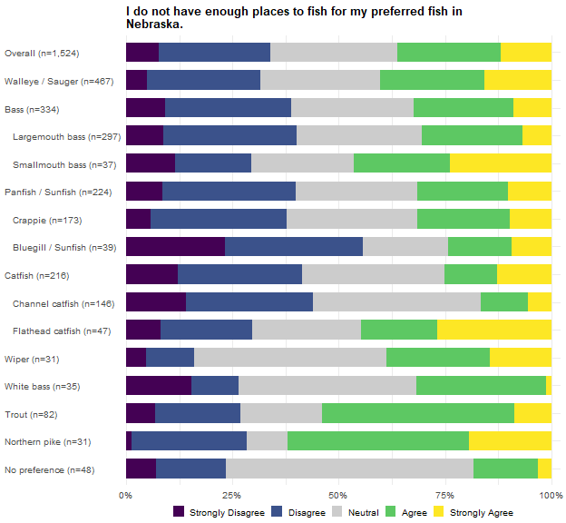
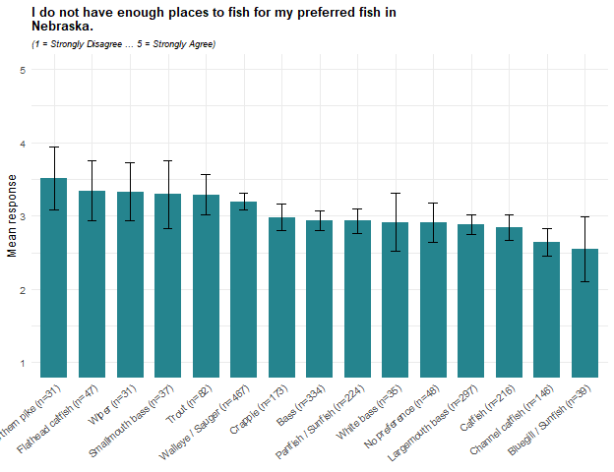
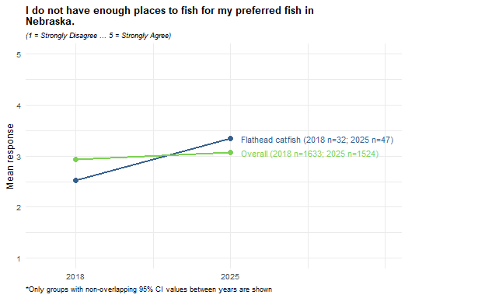
Agreement that there are not enough places to fish for the preferred fish averages 3.1 overall, with 36% agreeing and 34% disagreeing. Northern pike anglers report the highest agreement (3.5; 62% agree, 28% disagree), followed by Flathead catfish (3.3), Wiper (3.3), Trout, and Smallmouth bass anglers (3.3 each). Bluegill / Sunfish anglers report the lowest (2.5; 56% disagree, 24% agree), followed by Channel catfish anglers (2.6).
Flathead catfish anglers’ agreement rose sharply between 2018 and 2025, from 2.5 to 3.3, the only group whose change appears in any of the 2018-2025 figures for this battery. Agreement across all anglers also crept upward between the two years, from 2.9 to 3.1, another instance, like the difficulty-of-catching item earlier, where the shift shows up broadly rather than only within individual preferred groups.

Reading Across the Items
When evaluating differences in this section, differences are stated based on non-overlapping confidence intervals rather than direct statistical tests. Support for regulation is the most uniform result in the list of items. Every preferred group’s mean sits on the agree side for regulations to increase the size of its preferred fish (group means 3.6 to 4.3, overall 3.8) and for regulations to increase their numbers (3.7 to 4.1, overall 3.9). Overall, number regulations draw more support than size regulations and the only group to separate from the overall on either item is Wiper which was above it on size regulations.
The trade-off items are less generous. Willingness to accept smaller fish in exchange for more of them (2.8) is, with traveling too far, one of the two lowest-scoring statements in the list, while willingness to harvest fewer fish for larger ones scores 3.5. Anglers want more and bigger fish, and will give up harvest to gain size more readily than they will give up size to gain harvest. These two results fit together: support for regulation aimed at more fish runs slightly ahead of support for regulation aimed at larger fish, yet when anglers are asked to trade one for the other they lean toward size.
Walleye / Sauger anglers, the largest group, are the only group below the overall on satisfaction with fishing success (2.8 against 3.2 overall and below the neutral point) and the only group above it on saying their preferred fish is becoming harder to catch (3.6). They are above the overall on traveling too far (3.0) and are the only group above it on ranking harvest opportunity ahead of size (3.3). On none of the four size and number satisfaction items do they separate from the overall. For a group of this size, a success-satisfaction mean below the neutral point is the most consequential single figure in the chapter.
Wiper anglers are the list’s size-oriented outlier. They are the only group above the overall on support for size regulations (4.3) and on satisfaction with the size of fish they catch (4.0), above it on willingness to harvest fewer fish for larger ones (4.2) and on traveling too far (3.4), and below it on ranking harvest opportunity ahead of size (2.3). Their rating of the size they are allowed to harvest (3.3) does not separate from the overall. Read with Chapter 1, where Wiper anglers separated from White bass anglers on exactly these attitudes, this is a constituency that strongly supports size regulation and rates what the rules let it keep below what it catches. The group has 35 respondents in this battery so its intervals are wide yet still separating from the overall.
Northern pike anglers are below the overall on satisfaction with the size they are allowed to harvest (2.9 against 3.5) and are the only group below it on willingness to trade size for numbers (2.4). Their means on size regulations (4.1) and on not having enough places to fish (3.5) are among the highest observed, but on 31 respondents neither clears a significant difference from the overall by examination of confidence intervals. What is supported is a size-focused reading: a group unwilling to give up size and dissatisfied with the size the rules let it keep.
Bass anglers, the second-largest preferred group, favor size over harvest: above the overall on harvesting fewer fish for larger ones (3.8) and below it on ranking harvest ahead of size (2.7). They are also below the overall on traveling too far (2.5 against 2.8). Bluegill / Sunfish anglers are the battery’s least constrained constituency: above the overall on satisfaction with the size (3.9) and number (3.9) they are allowed to harvest, and below it on traveling too far (2.1), on lacking places to fish (2.5) and on finding their fish harder to catch (2.6). White bass, Trout and Channel catfish anglers are above the overall on satisfaction with fishing success (3.7, 3.6 and 3.6) without separating on any of the regulation items.
Anglers with no single preferred fish separate from the overall on one item only, below it on satisfaction with the size they are allowed to harvest (3.2), and, as the item paragraphs note, carry the largest neutral shares. Their results deserves a caution of their own because the statements presuppose a preferred fish, only 50 of the 339 anglers in this group answered the first item, so the row describes a small, self-selected subset of them rather than the group as a whole.

Chapter 3: Survey Question Crosstabs by Preferred Species
This chapter crosstabs the remaining survey questions by preferred group. Two conventions for the sample size are used. Where every response column of a table shares one sample size, a single N column reports it. Where each column carries its own sample size (an item with its own non-response, a scale score with its completeness gate not met, or an indicator computed on its own subset), the count appears inside each cell after the confidence interval. N is the raw unweighted respondent count in both cases.
In the text of this chapter, a difference between a preferred group and the overall estimate is described only when the group’s 95% confidence interval lies entirely outside the Overall interval. That test is conservative: modest differences, and most differences involving small groups, will fail it, so an unmentioned group is not shown to be the same - it is merely not shown to differ.

Fish Out-Of-State
Did you fish in a state other than Nebraska during 2025? Cells are the weighted percentage of the row group giving that response, with a 95% confidence interval. N is the raw unweighted number of respondents in the row group who answered the question. These results were weighted. Please consult the survey methodology for details.
Preferred species | Yes | No | N
Overall | 44.1 ± 2.51 | 55.9 ± 2.51 | 1,884
Walleye / Sauger | 49.9 ± 4.89 | 50.1 ± 4.89 | 497
Bass | 42.5 ± 5.67 | 57.5 ± 5.67 | 352
Largemouth bass | 41.3 ± 6.01 | 58.7 ± 6.01 | 312
Smallmouth bass | 51.6 ± 16.85 | 48.4 ± 16.85 | 40
Panfish | 43.6 ± 7.17 | 56.4 ± 7.17 | 229
Crappie | 44.0 ± 8.24 | 56.0 ± 8.24 | 175
Bluegill / Sunfish | 37.6 ± 16.37 | 62.4 ± 16.37 | 42
Catfish | 39.1 ± 7.20 | 60.9 ± 7.20 | 223
Channel catfish | 36.1 ± 8.76 | 63.9 ± 8.76 | 147
Flathead catfish | 43.7 ± 15.36 | 56.3 ± 15.36 | 49
Wiper | 69.8 ± 17.04 | 30.2 ± 17.04 | 34
White bass | 18.2 ± 13.84 | 81.8 ± 13.84 | 39
Trout | 48.6 ± 11.69 | 51.4 ± 11.69 | 90
Northern pike | 71.4 ± 17.08 | 28.6 ± 17.08 | 32
No preference | 32.5 ± 5.63 | 67.5 ± 5.63 | 330
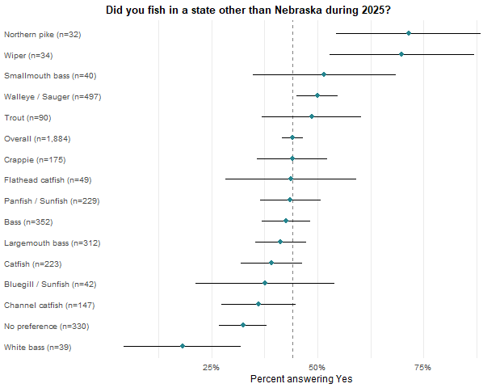
Just under half of anglers (44%) also fished outside Nebraska in 2025. Northern pike (71%) and Wiper (70%) anglers did so at rates above the overall, consistent with the travel distances they report later in this chapter, while White bass (18%) and No preference (32%) anglers fell below it.

Boat Out-Of-State
Did you take a boat or other personal watercraft with you when fishing in a state other than Nebraska during 2025? Cells are the weighted percentage of the row group giving that response, with a 95% confidence interval. N is the raw unweighted number of respondents in the row group who answered the question. Only respondents who fished out of state are included in this calculation. These results were weighted. Please consult the survey methodology for details.
Preferred species | Yes | No | N
Overall | 55.2 ± 3.99 | 44.8 ± 3.99 | 744
Walleye / Sauger | 70.3 ± 6.45 | 29.7 ± 6.45 | 234
Bass | 52.6 ± 9.03 | 47.4 ± 9.03 | 139
Largemouth bass | 54.0 ± 9.71 | 46.0 ± 9.71 | 120
Smallmouth bass | 44.7 ± 24.22 | 55.3 ± 24.22 | 19
Panfish | 48.2 ± 11.49 | 51.8 ± 11.49 | 91
Crappie | 50.5 ± 13.22 | 49.5 ± 13.22 | 69
Bluegill / Sunfish | 40.9 ± 27.74 | 59.1 ± 27.74 | 16
Catfish | 49.5 ± 12.65 | 50.5 ± 12.65 | 72
Channel catfish | 45.8 ± 15.93 | 54.2 ± 15.93 | 46
Flathead catfish | 47.2 ± 25.20 | 52.8 ± 25.20 | 17
Wiper | 73.3 ± 20.64 | 26.7 ± 20.64 | 20
White bass | 7.9 ± 21.18 | 92.1 ± 21.18 | 8
Trout | 40.5 ± 19.12 | 59.5 ± 19.12 | 32
Northern pike | 58.9 ± 22.58 | 41.1 ± 22.58 | 22
No preference | 39.1 ± 11.07 | 60.9 ± 11.07 | 95
Among anglers who fished out of state, 55% took a boat with them. Walleye / Sauger anglers (70%) sit above the overall rate and anglers with no preferred type (39%) below it. White bass anglers’ rate (8%) is also below, though it rests on only 8 respondents.
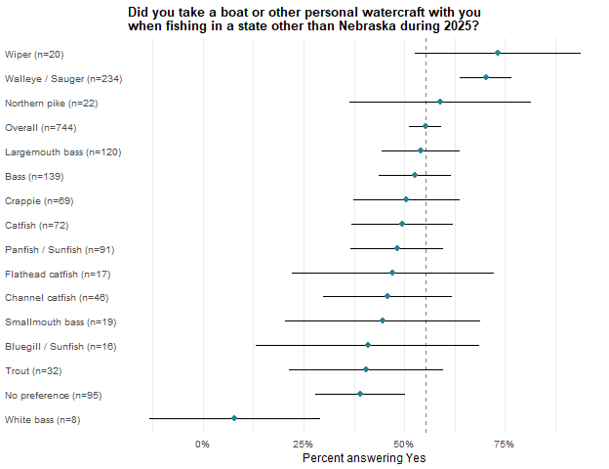

Park Entry Permit
Did you fish at a water body that required a Nebraska Park Entry Permit during 2025? Cells are the weighted percentage of the row group giving that response, with a 95% confidence interval. N is the raw unweighted number of respondents in the row group who answered the question. These results were weighted. Please consult the survey methodology for details.
Preferred species | No | Yes | N
Overall | 31.0 ± 2.33 | 69.0 ± 2.33 | 1,898
Walleye / Sauger | 18.3 ± 3.80 | 81.7 ± 3.80 | 493
Bass | 36.6 ± 5.51 | 63.4 ± 5.51 | 353
Largemouth bass | 38.6 ± 5.92 | 61.4 ± 5.92 | 313
Smallmouth bass | 22.3 ± 13.96 | 77.7 ± 13.96 | 40
Panfish | 33.2 ± 6.71 | 66.8 ± 6.71 | 236
Crappie | 33.9 ± 7.73 | 66.1 ± 7.73 | 181
Bluegill / Sunfish | 30.0 ± 15.30 | 70.0 ± 15.30 | 43
Catfish | 32.5 ± 6.88 | 67.5 ± 6.88 | 225
Channel catfish | 33.6 ± 8.53 | 66.4 ± 8.53 | 150
Flathead catfish | 34.7 ± 14.74 | 65.3 ± 14.74 | 49
Wiper | 12.1 ± 11.93 | 87.9 ± 11.93 | 35
White bass | 30.2 ± 16.48 | 69.8 ± 16.48 | 39
Trout | 31.4 ± 10.86 | 68.6 ± 10.86 | 90
Northern pike | 35.3 ± 18.08 | 64.7 ± 18.08 | 32
No preference | 39.2 ± 5.83 | 60.8 ± 5.83 | 335
69% of anglers held a park entry permit. Wiper (88%) and Walleye / Sauger (82%) anglers exceed the overall rate and No preference anglers (61%) fall below it, a separation that tracks the boat-oriented groups in the Methods section later in this chapter.

Fishing Tournaments
Percent of respondents who participated in at least one fishing tournament (derived from How many fishing tournaments (either requiring an entry fee or awarding prizes/money) held in Nebraska did you participate in during 2025?). Cells are the weighted percentage of the row group giving that response, with a 95% confidence interval. N is the raw unweighted number of respondents in the row group who answered the question. These results were weighted. Please consult the survey methodology for details.
Preferred species | No Tournaments | Fished Tournaments | N
Overall | 97.0 ± 0.86 | 3.0 ± 0.86 | 1,908
Walleye / Sauger | 94.4 ± 2.25 | 5.6 ± 2.25 | 497
Bass | 96.1 ± 2.21 | 3.9 ± 2.21 | 355
Largemouth bass | 97.6 ± 1.88 | 2.4 ± 1.88 | 314
Smallmouth bass | 85.9 ± 11.58 | 14.1 ± 11.58 | 41
Panfish | 97.4 ± 2.25 | 2.6 ± 2.25 | 236
Crappie | 97.0 ± 2.77 | 3.0 ± 2.77 | 181
Bluegill / Sunfish | 98.6 ± 3.90 | 1.4 ± 3.90 | 43
Catfish | 97.2 ± 2.42 | 2.8 ± 2.42 | 227
Channel catfish | 95.4 ± 3.79 | 4.6 ± 3.79 | 150
Flathead catfish | 100.0 ± 0.00 | 0.0 ± 0.00 | 50
Wiper | 100.0 ± 0.00 | 0.0 ± 0.00 | 35
White bass | 100.0 ± 0.00 | 0.0 ± 0.00 | 39
Trout | 98.3 ± 3.03 | 1.7 ± 3.03 | 89
Northern pike | 98.6 ± 4.38 | 1.4 ± 4.38 | 32
No preference | 100.0 ± 0.00 | 0.0 ± 0.00 | 338

Tournament fishing is rare with only 3% of anglers in 2025 fishing at least one tournament and no group sits above the overall rate. Flathead catfish, Wiper, White bass and No preference anglers reported no tournament participation at all. Among the anglers who did fish tournaments, the mean was 3.7 tournaments; Panfish anglers averaged 1.1 which was below the overall mean. An important consideration is that tournament participation WAS NOT identified as a tournament targeting the chosen preferred group.
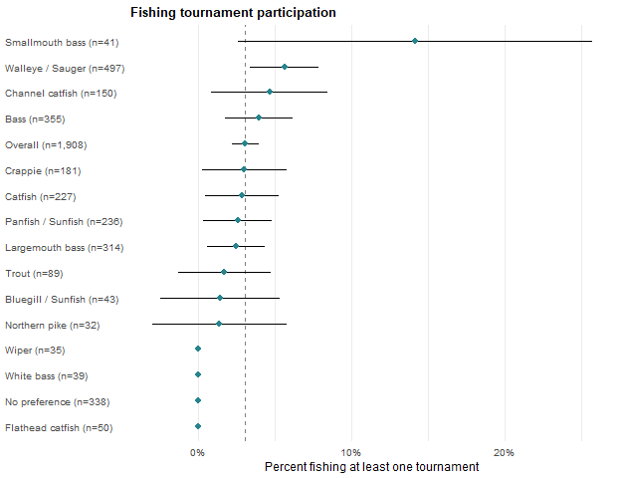

How many fishing tournaments (either requiring an entry fee or awarding prizes/money) held in Nebraska did you participate in during 2025? Cells are the weighted mean for the row group with a 95% confidence interval, followed by the raw unweighted number of respondents contributing to that cell. Only respondents who participated in at least one tournament are included in this calculation. These results were weighted. Please consult the survey methodology for details.
Preferred species | Mean tournaments fished
Overall | 3.7 ± 1.19 (49)
Walleye / Sauger | 3.2 ± 1.35 (23)
Bass | 4.5 ± 2.41 (11)
Largemouth bass | 5.5 ± 3.45 (6)
Smallmouth bass | 3.3 ± 2.97 (5)
Panfish | 1.1 ± 0.32 (5)
Crappie | 1.1 ± 0.36 (4)
Bluegill / Sunfish | 1.0 ± 0.00 (1)
Catfish | 4.3 ± 4.93 (5)
Channel catfish | 4.3 ± 4.93 (5)
Flathead catfish
Wiper
White bass
Trout | 4.0 ± 0.00 (1)
Northern pike | 1.0 ± 0.00 (1)
No preference

Waterbody Types
In what types of water bodies did you fish in Nebraska during 2025? Cells are the weighted percentage of the row group that selected each option, with a 95% confidence interval. Respondents could select more than one option, so a row does not sum to 100 percent. N is the raw unweighted number of respondents in the row group who answered the question. These results were weighted. Please consult the survey methodology for details.
Preferred species | Lakes and Reservoirs | Ponds and sandpits | Other streams, rivers, and canals | Missouri River | Platte River | Sandhill lakes | N
Overall | 86.2 ± 1.76 | 44.6 ± 2.53 | 20.9 ± 2.07 | 15.8 ± 1.85 | 9.6 ± 1.50 | 9.5 ± 1.49 | 1,858
Walleye / Sauger | 93.1 ± 2.52 | 32.1 ± 4.65 | 16.1 ± 3.66 | 17.1 ± 3.75 | 6.9 ± 2.53 | 13.4 ± 3.39 | 480
Bass | 88.5 ± 3.65 | 63.6 ± 5.51 | 15.9 ± 4.19 | 11.3 ± 3.63 | 8.3 ± 3.16 | 7.1 ± 2.94 | 353
Largemouth bass | 88.3 ± 3.92 | 65.5 ± 5.80 | 15.9 ± 4.46 | 9.0 ± 3.50 | 9.0 ± 3.49 | 6.7 ± 3.06 | 312
Smallmouth bass | 90.0 ± 9.97 | 50.6 ± 16.62 | 16.2 ± 12.25 | 27.1 ± 14.78 | 3.7 ± 6.26 | 9.3 ± 9.67 | 41
Panfish | 87.5 ± 4.75 | 42.0 ± 7.10 | 19.3 ± 5.68 | 9.3 ± 4.17 | 6.6 ± 3.57 | 9.3 ± 4.17 | 231
Crappie | 87.9 ± 5.39 | 38.5 ± 8.04 | 19.6 ± 6.56 | 9.1 ± 4.75 | 4.8 ± 3.52 | 8.2 ± 4.53 | 176
Bluegill / Sunfish | 88.0 ± 10.84 | 51.0 ± 16.69 | 20.4 ± 13.45 | 12.3 ± 10.98 | 15.8 ± 12.17 | 7.5 ± 8.79 | 43
Catfish | 79.4 ± 6.00 | 42.9 ± 7.35 | 37.0 ± 7.16 | 27.5 ± 6.63 | 23.5 ± 6.29 | 6.3 ± 3.60 | 219
Channel catfish | 77.5 ± 7.64 | 46.8 ± 9.13 | 34.4 ± 8.69 | 17.9 ± 7.01 | 21.0 ± 7.45 | 6.1 ± 4.38 | 145
Flathead catfish | 76.1 ± 13.49 | 39.2 ± 15.44 | 47.1 ± 15.78 | 44.2 ± 15.70 | 24.9 ± 13.68 | 5.9 ± 7.45 | 47
Wiper | 98.9 ± 3.82 | 27.2 ± 16.45 | 26.1 ± 16.22 | 4.6 ± 7.75 | 15.8 ± 13.50 | 24.5 ± 15.90 | 34
White bass | 100.0 ± 0.00 | 27.4 ± 16.13 | 1.3 ± 4.14 | 6.4 ± 8.87 | 3.8 ± 6.88 | 5.1 ± 7.94 | 38
Trout | 67.6 ± 11.00 | 50.0 ± 11.75 | 38.4 ± 11.43 | 5.6 ± 5.40 | 10.5 ± 7.21 | 9.5 ± 6.88 | 89
Northern pike | 87.0 ± 12.70 | 26.2 ± 16.62 | 8.8 ± 10.74 | 14.2 ± 13.22 | 0.0 ± 0.00 | 34.8 ± 18.02 | 32
No preference | 82.5 ± 4.62 | 49.2 ± 6.08 | 19.8 ± 4.85 | 16.2 ± 4.49 | 8.5 ± 3.39 | 5.5 ± 2.78 | 322
Lakes and reservoirs are the dominant water type for every group (86% overall), but the remaining types carry distinct group signatures. Bass anglers use ponds and sandpits most (64% against 45% overall), while Walleye / Sauger anglers use them least (32%) and are heaviest on lakes and reservoirs (93%). Northern pike anglers are the only group above the overall on Sandhill lakes (35% against 9%). Catfish anglers separate upward on the rivers: the Missouri (27% against 16% overall, and 44% among Flathead catfish anglers), the Platte (23% against 10%) and other streams, rivers and canals (37%). Trout anglers fall below the overall on lakes and reservoirs (68%) and sit above it on other streams, rivers and canals (38% against 21%). It is important to note the survey did not distinguish waterbody types used while pursuing the chosen preferred species but rather the respondents 2025 angling in general.

Methods
Which methods of fishing did you use during 2025? Cells are the weighted percentage of the row group that selected each option, with a 95% confidence interval. Respondents could select more than one option, so a row does not sum to 100 percent. N is the raw unweighted number of respondents in the row group who answered the question. These results were weighted. Please consult the survey methodology for details.
Preferred species | Bank/wading | Motorized boat | Kayak/Canoe | Ice fishing | Wading | Other Non-motorized boat | Other | Float tube | N
Overall | 78.9 ± 2.07 | 51.1 ± 2.54 | 17.7 ± 1.94 | 17.7 ± 1.94 | 13.0 ± 1.71 | 3.7 ± 0.96 | 2.4 ± 0.78 | 1.3 ± 0.57 | 1,865
Walleye / Sauger | 61.4 ± 4.82 | 78.3 ± 4.08 | 12.7 ± 3.29 | 26.3 ± 4.36 | 14.8 ± 3.52 | 1.7 ± 1.30 | 1.2 ± 1.06 | 0.2 ± 0.48 | 485
Bass | 88.8 ± 3.62 | 44.7 ± 5.70 | 26.4 ± 5.05 | 10.4 ± 3.50 | 10.2 ± 3.47 | 3.8 ± 2.20 | 1.7 ± 1.48 | 1.5 ± 1.39 | 353
Largemouth bass | 88.5 ± 3.89 | 46.2 ± 6.08 | 25.6 ± 5.32 | 10.6 ± 3.76 | 8.8 ± 3.46 | 3.3 ± 2.18 | 1.9 ± 1.68 | 1.7 ± 1.58 | 312
Smallmouth bass | 90.4 ± 9.78 | 33.9 ± 15.74 | 31.7 ± 15.48 | 8.8 ± 9.40 | 20.0 ± 13.30 | 7.3 ± 8.66 | 0.0 ± 0.00 | 0.0 ± 0.00 | 41
Panfish | 84.9 ± 5.17 | 44.3 ± 7.16 | 22.2 ± 5.99 | 32.6 ± 6.76 | 9.0 ± 4.13 | 3.6 ± 2.68 | 3.0 ± 2.44 | 0.3 ± 0.83 | 230
Crappie | 86.6 ± 5.64 | 50.8 ± 8.29 | 23.0 ± 6.98 | 34.0 ± 7.85 | 9.5 ± 4.87 | 2.6 ± 2.62 | 3.4 ± 3.00 | 0.4 ± 1.09 | 175
Bluegill / Sunfish | 84.8 ± 11.98 | 19.7 ± 13.27 | 21.2 ± 13.64 | 22.1 ± 13.84 | 9.2 ± 9.65 | 8.6 ± 9.38 | 1.8 ± 4.47 | 0.0 ± 0.00 | 43
Catfish | 90.5 ± 4.35 | 42.4 ± 7.32 | 14.0 ± 5.14 | 13.2 ± 5.02 | 11.5 ± 4.72 | 4.6 ± 3.12 | 3.3 ± 2.64 | 0.7 ± 1.23 | 220
Channel catfish | 90.9 ± 5.26 | 42.4 ± 9.02 | 14.0 ± 6.33 | 12.7 ± 6.08 | 13.3 ± 6.19 | 2.1 ± 2.62 | 2.9 ± 3.06 | 1.1 ± 1.92 | 146
Flathead catfish | 86.8 ± 10.69 | 42.3 ± 15.62 | 11.0 ± 9.89 | 14.4 ± 11.09 | 7.0 ± 8.06 | 10.7 ± 9.78 | 1.4 ± 3.71 | 0.0 ± 0.00 | 47
Wiper | 61.1 ± 18.01 | 66.4 ± 17.46 | 29.1 ± 16.78 | 11.7 ± 11.87 | 28.6 ± 16.71 | 3.1 ± 6.36 | 0.0 ± 0.00 | 2.3 ± 5.55 | 34
White bass | 72.6 ± 16.00 | 67.6 ± 16.80 | 3.8 ± 6.82 | 5.2 ± 7.95 | 9.4 ± 10.46 | 5.7 ± 8.31 | 0.0 ± 0.00 | 1.6 ± 4.54 | 39
Trout | 83.5 ± 8.81 | 27.9 ± 10.64 | 13.7 ± 8.17 | 10.8 ± 7.37 | 41.4 ± 11.69 | 3.0 ± 4.06 | 2.3 ± 3.58 | 3.2 ± 4.18 | 87
Northern pike | 66.8 ± 17.81 | 64.7 ± 18.08 | 16.8 ± 14.14 | 32.7 ± 17.74 | 28.7 ± 17.11 | 11.4 ± 12.03 | 0.0 ± 0.00 | 3.8 ± 7.27 | 32
No preference | 86.7 ± 4.11 | 33.2 ± 5.71 | 15.9 ± 4.43 | 11.7 ± 3.89 | 7.4 ± 3.18 | 4.6 ± 2.55 | 3.1 ± 2.11 | 1.1 ± 1.28 | 325
Bank or wading fishing is the most common method (79% overall), led by Catfish anglers (90%); Walleye / Sauger anglers are the one group below the overall on it (61%) and far above on motorized boats (78% against 51% overall), where Bluegill / Sunfish (20%), Trout (28%) and No preference (33%) anglers fall below. Only Trout anglers were above the overall on wading (41% against 13%), and Bass anglers separate upward on kayaks and canoes (26% against 18%). Ice fishing separates Crappie (34%), Panfish (33%) and Walleye / Sauger (26%) anglers upward and Bass, White bass and No preference anglers downward, agreeing in direction with the ice-fishing question later in this chapter. It is important to note the survey did not distinguish methods used while pursuing the chosen preferred species but rather the respondents 2025 angling in general.

Techniques
What techniques did you use during 2025? Cells are the weighted percentage of the row group that selected each option, with a 95% confidence interval. Respondents could select more than one option, so a row does not sum to 100 percent. N is the raw unweighted number of respondents in the row group who answered the question. These results were weighted. Please consult the survey methodology for details.
Preferred species | Rod & reel | Fly-fishing | Set lines/limb lines | Archery | Snagging | Other | Surface spear | Underwater spear | N
Overall | 97.8 ± 0.74 | 9.4 ± 1.48 | 5.3 ± 1.14 | 3.7 ± 0.96 | 2.4 ± 0.78 | 0.8 ± 0.45 | 0.4 ± 0.31 | 0.2 ± 0.23 | 1,865
Walleye / Sauger | 99.5 ± 0.69 | 5.7 ± 2.30 | 5.0 ± 2.16 | 3.9 ± 1.91 | 2.1 ± 1.43 | 0.0 ± 0.00 | 0.2 ± 0.39 | 0.8 ± 0.87 | 484
Bass | 98.9 ± 1.20 | 10.7 ± 3.55 | 4.4 ± 2.35 | 3.2 ± 2.03 | 0.5 ± 0.78 | 0.5 ± 0.78 | 0.0 ± 0.00 | 0.0 ± 0.00 | 352
Largemouth bass | 99.3 ± 1.04 | 10.0 ± 3.66 | 4.5 ± 2.53 | 3.7 ± 2.31 | 0.5 ± 0.89 | 0.5 ± 0.89 | 0.0 ± 0.00 | 0.0 ± 0.00 | 311
Smallmouth bass | 96.3 ± 6.26 | 15.7 ± 12.10 | 3.7 ± 6.26 | 0.0 ± 0.00 | 0.0 ± 0.00 | 0.0 ± 0.00 | 0.0 ± 0.00 | 0.0 ± 0.00 | 41
Panfish | 99.7 ± 0.73 | 10.6 ± 4.43 | 6.4 ± 3.52 | 3.7 ± 2.73 | 2.4 ± 2.22 | 0.8 ± 1.29 | 1.0 ± 1.42 | 0.3 ± 0.73 | 231
Crappie | 99.7 ± 0.95 | 11.9 ± 5.35 | 7.9 ± 4.46 | 2.3 ± 2.46 | 3.2 ± 2.89 | 1.1 ± 1.68 | 1.3 ± 1.86 | 0.3 ± 0.95 | 176
Bluegill / Sunfish | 100.0 ± 0.00 | 7.8 ± 8.97 | 0.0 ± 0.00 | 10.7 ± 10.32 | 0.0 ± 0.00 | 0.0 ± 0.00 | 0.0 ± 0.00 | 0.0 ± 0.00 | 43
Catfish | 98.9 ± 1.52 | 3.1 ± 2.57 | 9.2 ± 4.29 | 2.0 ± 2.07 | 4.0 ± 2.92 | 1.5 ± 1.82 | 0.7 ± 1.23 | 0.0 ± 0.00 | 219
Channel catfish | 98.8 ± 1.99 | 2.3 ± 2.72 | 8.8 ± 5.20 | 3.2 ± 3.23 | 4.6 ± 3.82 | 2.1 ± 2.62 | 1.1 ± 1.93 | 0.0 ± 0.00 | 145
Flathead catfish | 98.6 ± 3.71 | 3.7 ± 5.95 | 13.2 ± 10.71 | 0.0 ± 0.00 | 5.2 ± 7.03 | 1.1 ± 3.23 | 0.0 ± 0.00 | 0.0 ± 0.00 | 47
Wiper | 100.0 ± 0.00 | 15.9 ± 13.51 | 0.0 ± 0.00 | 0.0 ± 0.00 | 2.3 ± 5.55 | 0.0 ± 0.00 | 0.0 ± 0.00 | 0.0 ± 0.00 | 34
White bass | 100.0 ± 0.00 | 5.7 ± 8.31 | 5.7 ± 8.31 | 0.0 ± 0.00 | 9.2 ± 10.39 | 0.0 ± 0.00 | 0.0 ± 0.00 | 0.0 ± 0.00 | 39
Trout | 88.6 ± 7.46 | 43.9 ± 11.66 | 0.6 ± 1.80 | 3.3 ± 4.21 | 1.7 ± 3.01 | 0.0 ± 0.00 | 0.0 ± 0.00 | 0.0 ± 0.00 | 89
Northern pike | 92.7 ± 9.86 | 5.0 ± 8.24 | 18.5 ± 14.70 | 8.1 ± 10.32 | 3.8 ± 7.27 | 0.0 ± 0.00 | 0.0 ± 0.00 | 0.0 ± 0.00 | 32
No preference | 98.9 ± 1.26 | 6.0 ± 2.87 | 4.8 ± 2.60 | 2.6 ± 1.92 | 1.6 ± 1.51 | 0.9 ± 1.12 | 0.3 ± 0.70 | 0.0 ± 0.00 | 325
Rod and reel is near-universal (98% overall); Trout anglers are the only group below the overall on it (89%), while 44% of them fly-fish against 9% overall, the largest technique separation observed. Catfish anglers fall below the overall on fly-fishing (3%). No other technique lifts any group above its overall rate. It is important to note the survey did not distinguish techniques used while pursuing the chosen preferred species but rather the respondents 2025 angling in general.

Crowding
In 2025, how often were your fishing experiences negatively affected by the number of people at your fishing locations? Cells are the weighted percentage of the row group giving that response, with a 95% confidence interval. N is the raw unweighted number of respondents in the row group who answered the question. These results were weighted. Please consult the survey methodology for details.
Preferred species | Never | Rarely | Sometimes | Often | Always | N
Overall | 30.0 ± 2.33 | 34.5 ± 2.41 | 28.4 ± 2.29 | 6.0 ± 1.21 | 1.1 ± 0.54 | 1,869
Walleye / Sauger | 26.9 ± 4.39 | 35.0 ± 4.73 | 28.1 ± 4.45 | 8.4 ± 2.75 | 1.6 ± 1.23 | 485
Bass | 32.4 ± 5.36 | 30.7 ± 5.29 | 29.6 ± 5.23 | 6.6 ± 2.84 | 0.7 ± 0.95 | 353
Largemouth bass | 34.1 ± 5.78 | 28.7 ± 5.52 | 31.0 ± 5.64 | 5.4 ± 2.75 | 0.8 ± 1.08 | 312
Smallmouth bass | 20.5 ± 13.42 | 44.8 ± 16.53 | 20.0 ± 13.29 | 14.7 ± 11.78 | 0.0 ± 0.00 | 41
Panfish | 34.8 ± 6.84 | 31.7 ± 6.68 | 26.3 ± 6.32 | 6.2 ± 3.47 | 1.0 ± 1.42 | 232
Crappie | 32.7 ± 7.73 | 32.2 ± 7.70 | 27.4 ± 7.35 | 6.5 ± 4.06 | 1.3 ± 1.85 | 177
Bluegill / Sunfish | 41.4 ± 16.44 | 32.8 ± 15.67 | 21.0 ± 13.59 | 4.8 ± 7.15 | 0.0 ± 0.00 | 43
Catfish | 27.6 ± 6.63 | 33.9 ± 7.01 | 29.0 ± 6.72 | 7.8 ± 3.98 | 1.6 ± 1.87 | 220
Channel catfish | 28.9 ± 8.25 | 36.6 ± 8.76 | 27.0 ± 8.08 | 4.9 ± 3.93 | 2.6 ± 2.91 | 147
Flathead catfish | 23.9 ± 13.48 | 20.6 ± 12.78 | 38.6 ± 15.40 | 16.9 ± 11.86 | 0.0 ± 0.00 | 47
Wiper | 32.0 ± 17.24 | 41.3 ± 18.19 | 21.8 ± 15.27 | 4.9 ± 7.98 | 0.0 ± 0.00 | 34
White bass | 35.0 ± 17.12 | 27.2 ± 15.98 | 32.0 ± 16.74 | 2.5 ± 5.62 | 3.3 ± 6.38 | 39
Trout | 25.3 ± 10.28 | 50.9 ± 11.83 | 14.1 ± 8.24 | 9.8 ± 7.03 | 0.0 ± 0.00 | 88
Northern pike | 16.1 ± 13.90 | 52.8 ± 18.88 | 26.1 ± 16.60 | 0.0 ± 0.00 | 5.0 ± 8.24 | 32
No preference | 33.8 ± 5.72 | 34.8 ± 5.76 | 28.8 ± 5.48 | 1.7 ± 1.58 | 0.9 ± 1.11 | 326

Crowding perceptions barely differ by preferred species with 30% of anglers never feeling crowded and 6% that often did and no group separates from the overall on the Never response.
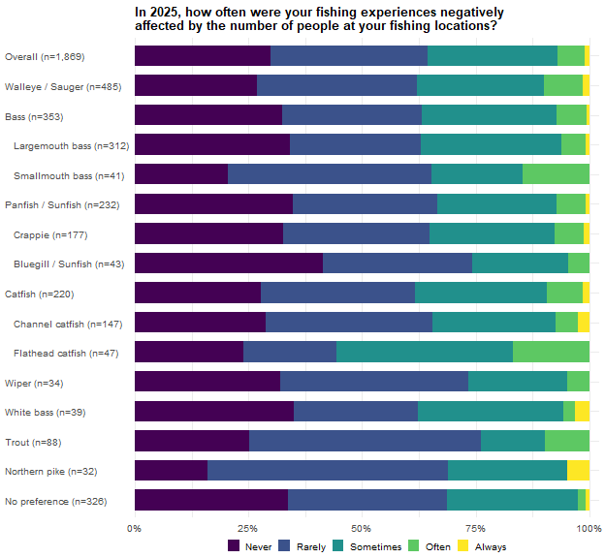

Access
During 2025, did you use the following areas when fishing or launching watercraft to fish? Cells are the weighted percentage of the row group falling in that category with a 95% confidence interval, followed by the raw unweighted number of respondents in that column’s sample. Columns overlap and must not be totaled. These results were weighted. Please consult the survey methodology for details.
Preferred species | Public lands and access | Private lands and access | Both Public and Private lands and access | Only Used Public lands and access | Only Used Private lands and access
Overall | 89.3 ± 1.71 (1,553) | 28.6 ± 2.50 (1,553) | 27.5 ± 2.59 (1,417) | 69.1 ± 2.68 (1,417) | 3.3 ± 1.04 (1,417)
Walleye / Sauger | 94.7 ± 2.47 (391) | 27.2 ± 4.91 (391) | 25.2 ± 4.87 (378) | 72.1 ± 5.03 (378) | 2.7 ± 1.82 (378)
Bass | 92.1 ± 3.31 (304) | 35.9 ± 5.89 (304) | 33.8 ± 5.98 (286) | 62.4 ± 6.12 (286) | 3.7 ± 2.39 (286)
Largemouth bass | 92.4 ± 3.49 (266) | 37.0 ± 6.35 (266) | 35.0 ± 6.44 (251) | 61.4 ± 6.57 (251) | 3.7 ± 2.54 (251)
Smallmouth bass | 90.7 ± 10.00 (38) | 28.8 ± 15.61 (38) | 26.3 ± 15.77 (35) | 69.6 ± 16.49 (35) | 4.1 ± 7.13 (35)
Panfish | 84.6 ± 5.91 (177) | 29.8 ± 7.49 (177) | 28.0 ± 7.80 (158) | 66.7 ± 8.19 (158) | 5.3 ± 3.91 (158)
Crappie | 83.2 ± 7.02 (135) | 31.5 ± 8.73 (135) | 29.4 ± 9.10 (120) | 64.5 ± 9.56 (120) | 6.1 ± 4.78 (120)
Bluegill / Sunfish | 92.8 ± 9.77 (33) | 16.9 ± 14.13 (33) | 16.2 ± 14.38 (31) | 82.1 ± 14.97 (31) | 1.7 ± 5.08 (31)
Catfish | 81.9 ± 6.12 (190) | 33.5 ± 7.50 (190) | 33.1 ± 8.15 (159) | 61.4 ± 8.43 (159) | 5.5 ± 3.96 (159)
Channel catfish | 82.1 ± 7.62 (123) | 32.4 ± 9.30 (123) | 35.0 ± 10.50 (100) | 61.8 ± 10.69 (100) | 3.2 ± 3.86 (100)
Flathead catfish | 76.5 ± 13.79 (44) | 32.8 ± 15.28 (44) | 23.8 ± 14.91 (38) | 62.9 ± 16.93 (38) | 13.4 ± 11.93 (38)
Wiper | 88.9 ± 11.84 (32) | 16.6 ± 14.02 (32) | 17.3 ± 14.97 (29) | 81.5 ± 15.38 (29) | 1.2 ± 4.36 (29)
White bass | 82.3 ± 14.09 (37) | 26.9 ± 16.36 (37) | 32.7 ± 18.81 (31) | 67.3 ± 18.81 (31) | 0.0 ± 0.00 (31)
Trout | 90.9 ± 7.47 (72) | 31.1 ± 12.02 (72) | 26.7 ± 11.72 (69) | 67.7 ± 12.38 (69) | 5.6 ± 6.07 (69)
Northern pike | 87.6 ± 13.23 (28) | 11.7 ± 12.91 (28) | 9.5 ± 12.46 (25) | 87.1 ± 14.29 (25) | 3.5 ± 7.80 (25)
No preference | 86.4 ± 4.53 (270) | 22.4 ± 5.51 (270) | 23.2 ± 5.97 (235) | 74.6 ± 6.16 (235) | 2.2 ± 2.08 (235)

Walleye / Sauger anglers reported greater use of public lands and access sites (95%) than Overall. Northern pike anglers stood out for lower use of private areas (12%) and, among those who used either area type, greater reliance on public areas alone (87%) and less use of both public and private areas (9%). No other family or species differed from the overall by inspection of confidence intervals.

Favorite Waterbody Distance
About how far is the one-way distance from your residence to your favorite Nebraska water body? Cells are the weighted percentage of the row group giving that response, with a 95% confidence interval. N is the raw unweighted number of respondents in the row group who answered the question. These results were weighted. Please consult the survey methodology for details.
Preferred species | 10 or fewer miles | 11 to 20 miles | 21 to 40 miles | 41 to 60 miles | 61 to 100 miles | 101 to 250 miles | 251 to 500 miles | Over 500 miles | N
Overall | 18.2 ± 1.96 | 14.4 ± 1.78 | 15.9 ± 1.86 | 12.8 ± 1.70 | 11.0 ± 1.59 | 17.6 ± 1.93 | 7.4 ± 1.33 | 2.6 ± 0.81 | 1,873
Walleye / Sauger | 8.7 ± 2.77 | 7.2 ± 2.55 | 14.5 ± 3.47 | 12.5 ± 3.26 | 13.8 ± 3.39 | 30.4 ± 4.54 | 11.6 ± 3.16 | 1.3 ± 1.13 | 491
Bass | 29.4 ± 5.24 | 16.8 ± 4.29 | 15.2 ± 4.13 | 10.8 ± 3.57 | 8.6 ± 3.23 | 12.5 ± 3.80 | 5.0 ± 2.51 | 1.6 ± 1.44 | 350
Largemouth bass | 31.2 ± 5.67 | 14.6 ± 4.32 | 15.6 ± 4.44 | 12.2 ± 4.01 | 9.3 ± 3.56 | 10.5 ± 3.76 | 4.9 ± 2.64 | 1.6 ± 1.52 | 309
Smallmouth bass | 17.0 ± 12.48 | 31.9 ± 15.49 | 12.7 ± 11.09 | 1.1 ± 3.39 | 3.7 ± 6.26 | 25.9 ± 14.57 | 5.9 ± 7.85 | 1.8 ± 4.44 | 41
Panfish | 19.5 ± 5.68 | 22.0 ± 5.94 | 17.5 ± 5.45 | 19.9 ± 5.73 | 6.4 ± 3.50 | 10.7 ± 4.43 | 1.4 ± 1.68 | 2.6 ± 2.28 | 233
Crappie | 18.5 ± 6.37 | 24.2 ± 7.02 | 15.7 ± 5.96 | 20.8 ± 6.66 | 8.2 ± 4.50 | 10.3 ± 4.99 | 1.1 ± 1.70 | 1.1 ± 1.74 | 179
Bluegill / Sunfish | 28.7 ± 15.32 | 18.3 ± 13.11 | 22.7 ± 14.20 | 13.2 ± 11.46 | 0.0 ± 0.00 | 7.0 ± 8.62 | 3.0 ± 5.81 | 7.1 ± 8.69 | 42
Catfish | 21.0 ± 6.00 | 20.4 ± 5.94 | 22.8 ± 6.18 | 10.7 ± 4.55 | 14.7 ± 5.21 | 8.9 ± 4.20 | 1.5 ± 1.80 | 0.0 ± 0.00 | 223
Channel catfish | 20.2 ± 7.33 | 23.9 ± 7.79 | 21.0 ± 7.44 | 9.7 ± 5.40 | 13.5 ± 6.25 | 9.2 ± 5.27 | 2.5 ± 2.86 | 0.0 ± 0.00 | 146
Flathead catfish | 19.9 ± 12.26 | 13.1 ± 10.37 | 16.0 ± 11.26 | 19.7 ± 12.23 | 20.3 ± 12.36 | 11.0 ± 9.62 | 0.0 ± 0.00 | 0.0 ± 0.00 | 50
Wiper | 5.5 ± 8.34 | 3.7 ± 6.94 | 4.4 ± 7.53 | 9.8 ± 10.87 | 15.9 ± 13.40 | 14.2 ± 12.79 | 44.6 ± 18.20 | 1.8 ± 4.92 | 35
White bass | 7.1 ± 9.21 | 6.2 ± 8.67 | 8.1 ± 9.81 | 16.1 ± 13.19 | 16.0 ± 13.16 | 37.2 ± 17.35 | 3.5 ± 6.63 | 5.7 ± 8.31 | 39
Trout | 13.0 ± 7.93 | 7.4 ± 6.18 | 19.4 ± 9.34 | 12.6 ± 7.84 | 16.4 ± 8.74 | 18.7 ± 9.21 | 4.9 ± 5.11 | 7.6 ± 6.25 | 88
Northern pike | 17.1 ± 14.24 | 8.1 ± 10.32 | 1.4 ± 4.38 | 7.5 ± 9.99 | 9.0 ± 10.85 | 32.0 ± 17.64 | 22.5 ± 15.80 | 2.3 ± 5.72 | 32
No preference | 20.3 ± 4.89 | 18.9 ± 4.77 | 17.9 ± 4.66 | 15.5 ± 4.40 | 6.8 ± 3.07 | 13.4 ± 4.15 | 4.1 ± 2.41 | 3.1 ± 2.10 | 322

Distance in miles to the favorite water body, using the midpoint of the band each respondent selected. Cells are the lower 95% confidence limit, the weighted median, and the upper 95% confidence limit, followed by the raw unweighted number of respondents. Median confidence limits come from the inherited 1,000-replicate weighted bootstrap. These results were weighted. Please consult the survey methodology for details.
Preferred species | Median one-way miles
Overall | 30/50/50 (1,873)
Walleye / Sauger | 80/80/80 (491)
Bass | 16/30/30 (350)
Largemouth bass | 16/30/30 (309)
Smallmouth bass | 16/30/80 (41)
Panfish | 30/30/30 (233)
Crappie | 30/30/30 (179)
Bluegill / Sunfish | 16/30/30 (42)
Catfish | 30/30/30 (223)
Channel catfish | 16/30/30 (146)
Flathead catfish | 30/37/50 (50)
Wiper | 80/176/376 (35)
White bass | 50/80/176 (39)
Trout | 40/50/80 (88)
Northern pike | 65/176/176 (32)
No preference | 30/30/30 (322)

The median one-way distance to the favorite water body is roughly 50 miles, computed on band midpoints. Walleye / Sauger anglers’ median is 80 miles, and the Wiper and Northern pike medians fall in the 101-to-250-mile band indicating the favorite waters of these three groups are a substantial drive. No group’s median separates below the overall. It is important to note the survey did not distinguish miles driven when pursuing the chosen preferred species but rather the respondents 2025 angling in general.
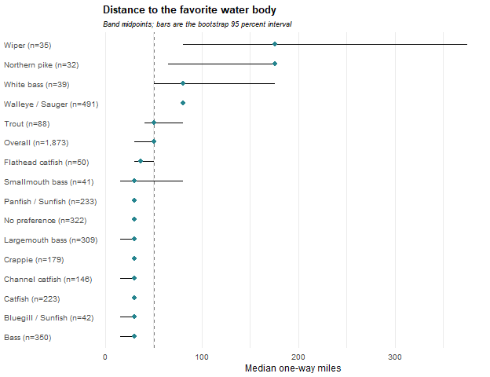

Most-Visited Waterbody Distance
About how far is the one-way distance from your residence to your most visited Nebraska water body? Cells are the weighted percentage of the row group giving that response with a 95% confidence interval. N is the raw unweighted number of respondents in the row group who answered the question. These results were weighted. Please consult the survey methodology for details.
Preferred species | 10 or fewer miles | 11 to 20 miles | 21 to 40 miles | 41 to 60 miles | 61 to 100 miles | 101 to 250 miles | 251 to 500 miles | Over 500 miles | N
Overall | 27.4 ± 2.26 | 19.3 ± 2.00 | 15.2 ± 1.82 | 11.3 ± 1.61 | 8.9 ± 1.45 | 10.5 ± 1.55 | 4.7 ± 1.07 | 2.7 ± 0.82 | 1,877
Walleye / Sauger | 17.2 ± 3.72 | 13.1 ± 3.32 | 16.5 ± 3.66 | 12.7 ± 3.28 | 12.7 ± 3.28 | 20.2 ± 3.95 | 6.2 ± 2.37 | 1.5 ± 1.20 | 491
Bass | 40.5 ± 5.66 | 18.8 ± 4.50 | 16.4 ± 4.27 | 7.7 ± 3.08 | 8.4 ± 3.20 | 4.8 ± 2.47 | 1.3 ± 1.32 | 2.1 ± 1.65 | 348
Largemouth bass | 41.4 ± 6.04 | 16.5 ± 4.55 | 17.9 ± 4.70 | 8.4 ± 3.40 | 8.7 ± 3.46 | 3.5 ± 2.27 | 1.5 ± 1.50 | 2.1 ± 1.76 | 308
Smallmouth bass | 33.6 ± 15.92 | 35.3 ± 16.10 | 6.0 ± 7.99 | 3.1 ± 5.83 | 6.2 ± 8.10 | 14.0 ± 11.70 | 0.0 ± 0.00 | 1.9 ± 4.58 | 40
Panfish | 25.6 ± 6.25 | 32.9 ± 6.73 | 15.6 ± 5.20 | 14.4 ± 5.04 | 2.9 ± 2.42 | 5.3 ± 3.21 | 0.6 ± 1.10 | 2.6 ± 2.28 | 233
Crappie | 23.2 ± 6.94 | 37.1 ± 7.94 | 14.5 ± 5.79 | 14.9 ± 5.86 | 3.5 ± 3.01 | 4.8 ± 3.51 | 0.8 ± 1.43 | 1.1 ± 1.75 | 178
Bluegill / Sunfish | 37.0 ± 16.11 | 22.1 ± 13.84 | 17.3 ± 12.63 | 10.0 ± 10.03 | 1.4 ± 3.90 | 5.4 ± 7.53 | 0.0 ± 0.00 | 6.9 ± 8.44 | 43
Catfish | 28.7 ± 6.62 | 28.8 ± 6.62 | 16.3 ± 5.41 | 10.2 ± 4.42 | 7.9 ± 3.94 | 5.9 ± 3.45 | 2.3 ± 2.21 | 0.0 ± 0.00 | 226
Channel catfish | 27.0 ± 8.03 | 25.7 ± 7.90 | 19.7 ± 7.19 | 10.4 ± 5.52 | 6.7 ± 4.54 | 6.7 ± 4.52 | 3.8 ± 3.47 | 0.0 ± 0.00 | 149
Flathead catfish | 31.0 ± 14.21 | 25.1 ± 13.33 | 10.6 ± 9.47 | 15.8 ± 11.21 | 12.7 ± 10.23 | 4.7 ± 6.53 | 0.0 ± 0.00 | 0.0 ± 0.00 | 50
Wiper | 17.2 ± 13.81 | 8.9 ± 10.42 | 7.1 ± 9.39 | 3.0 ± 6.27 | 9.2 ± 10.58 | 8.2 ± 10.05 | 44.6 ± 18.20 | 1.8 ± 4.92 | 35
White bass | 12.5 ± 12.00 | 18.7 ± 14.18 | 17.6 ± 13.84 | 10.5 ± 11.12 | 2.5 ± 5.72 | 28.8 ± 16.46 | 3.6 ± 6.77 | 5.8 ± 8.48 | 38
Trout | 20.8 ± 9.59 | 17.4 ± 8.94 | 15.0 ± 8.42 | 11.6 ± 7.55 | 15.8 ± 8.60 | 10.7 ± 7.31 | 1.2 ± 2.56 | 7.6 ± 6.25 | 88
Northern pike | 18.7 ± 14.92 | 14.6 ± 13.52 | 1.4 ± 4.46 | 13.5 ± 13.08 | 10.0 ± 11.49 | 19.7 ± 15.21 | 19.6 ± 15.19 | 2.4 ± 5.82 | 31
No preference | 34.7 ± 5.75 | 18.3 ± 4.67 | 14.5 ± 4.26 | 15.1 ± 4.33 | 6.0 ± 2.86 | 7.0 ± 3.08 | 1.8 ± 1.61 | 2.5 ± 1.88 | 328

Distance in miles to the most-visited water body, using the midpoint of the band each respondent selected. Cells are the lower 95% confidence limit, the weighted median, and the upper 95% confidence limit, followed by the raw unweighted number of respondents. Median confidence limits come from the inherited 1,000-replicate weighted bootstrap. These results were weighted. Please consult the survey methodology for details.
Preferred species | Median one-way miles
Overall | 30/30/30 (1,877)
Walleye / Sauger | 30/50/50 (491)
Bass | 16/16/16 (348)
Largemouth bass | 16/16/16 (308)
Smallmouth bass | 16/16/16 (40)
Panfish | 16/16/16 (233)
Crappie | 16/16/16 (178)
Bluegill / Sunfish | 5/16/30 (43)
Catfish | 16/16/16 (226)
Channel catfish | 16/16/30 (149)
Flathead catfish | 16/16/30 (50)
Wiper | 50/176/376 (35)
White bass | 30/49/176 (38)
Trout | 30/30/50 (88)
Northern pike | 50/79/176 (31)
No preference | 16/16/30 (328)

The water fished most often is closer (median 30 miles overall) for some species and the split is sharp as the Bass, Panfish and Catfish family medians fall to 16 miles, while the Wiper median stays in the 101-to-250-mile band and Northern pike anglers’ is 79 miles. It is important to note the survey did not distinguish miles driven when pursuing the chosen preferred species but rather the respondents 2025 angling in general.

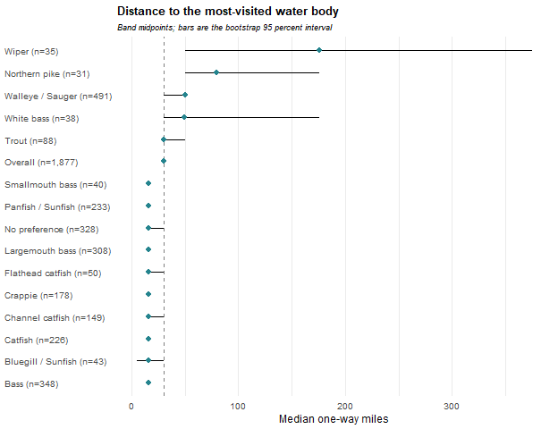

Satisfaction
How satisfied were you with your fishing experiences in Nebraska during 2025? Cells are the weighted percentage of the row group giving that response, with a 95% confidence interval. N is the raw unweighted number of respondents in the row group who answered the question. Mean scores the five responses from 1 (Very satisfied) to 5 (Very dissatisfied). These results were weighted. Please consult the survey methodology for details.
Preferred species | Very satisfied | Somewhat satisfied | Neutral | Somewhat dissatisfied | Very dissatisfied | Mean ± CI | N
Overall | 28.7 ± 2.30 | 34.6 ± 2.41 | 22.4 ± 2.12 | 10.6 ± 1.56 | 3.7 ± 0.95 | 2.3 ± 0.06 | 1,871
Walleye / Sauger | 19.8 ± 3.95 | 34.6 ± 4.71 | 25.2 ± 4.30 | 14.3 ± 3.47 | 6.0 ± 2.36 | 2.5 ± 0.11 | 486
Bass | 24.3 ± 4.92 | 41.2 ± 5.64 | 22.0 ± 4.74 | 10.1 ± 3.45 | 2.4 ± 1.76 | 2.3 ± 0.12 | 353
Largemouth bass | 24.6 ± 5.25 | 40.6 ± 5.99 | 22.6 ± 5.10 | 9.9 ± 3.64 | 2.4 ± 1.86 | 2.2 ± 0.12 | 312
Smallmouth bass | 22.7 ± 13.93 | 45.1 ± 16.54 | 17.7 ± 12.69 | 11.7 ± 10.70 | 2.8 ± 5.48 | 2.3 ± 0.34 | 41
Panfish | 30.7 ± 6.63 | 36.8 ± 6.93 | 16.0 ± 5.27 | 10.9 ± 4.48 | 5.5 ± 3.28 | 2.2 ± 0.17 | 232
Crappie | 26.4 ± 7.27 | 38.6 ± 8.03 | 17.0 ± 6.19 | 12.4 ± 5.43 | 5.7 ± 3.82 | 2.3 ± 0.19 | 177
Bluegill / Sunfish | 53.1 ± 16.66 | 28.1 ± 15.00 | 9.5 ± 9.77 | 3.2 ± 5.85 | 6.2 ± 8.05 | 1.8 ± 0.38 | 43
Catfish | 31.3 ± 6.88 | 32.6 ± 6.95 | 22.3 ± 6.17 | 10.0 ± 4.44 | 3.7 ± 2.82 | 2.2 ± 0.16 | 220
Channel catfish | 35.2 ± 8.73 | 32.3 ± 8.54 | 22.2 ± 7.59 | 8.4 ± 5.07 | 1.9 ± 2.51 | 2.1 ± 0.19 | 146
Flathead catfish | 25.0 ± 13.69 | 34.9 ± 15.07 | 27.8 ± 14.16 | 7.3 ± 8.23 | 5.1 ± 6.94 | 2.3 ± 0.34 | 47
Wiper | 52.2 ± 18.29 | 27.8 ± 16.42 | 16.9 ± 13.73 | 0.0 ± 0.00 | 3.0 ± 6.27 | 1.7 ± 0.35 | 35
White bass | 37.5 ± 17.37 | 42.4 ± 17.74 | 12.9 ± 12.04 | 3.9 ± 6.97 | 3.3 ± 6.38 | 1.9 ± 0.35 | 39
Trout | 44.8 ± 11.69 | 31.5 ± 10.92 | 21.3 ± 9.62 | 1.7 ± 3.01 | 0.8 ± 2.05 | 1.8 ± 0.21 | 89
Northern pike | 21.4 ± 15.50 | 39.5 ± 18.49 | 17.0 ± 14.22 | 14.2 ± 13.20 | 7.9 ± 10.20 | 2.5 ± 0.45 | 32
No preference | 32.3 ± 5.66 | 28.6 ± 5.47 | 28.1 ± 5.44 | 9.4 ± 3.54 | 1.6 ± 1.53 | 2.2 ± 0.13 | 325

Mean satisfaction here is scored from 1 (Very satisfied) to 5 (Very dissatisfied), so lower is better. Walleye / Sauger anglers are the only group less satisfied than the overall (2.5 against 2.3), while Wiper (1.7), Bluegill / Sunfish (1.8) and Trout (1.8) anglers are more satisfied. Walleye / Sauger anglers are also the lowest on the preferred-fish success item in Chapter 2.
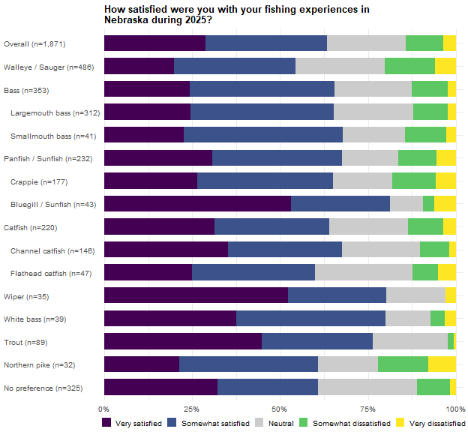
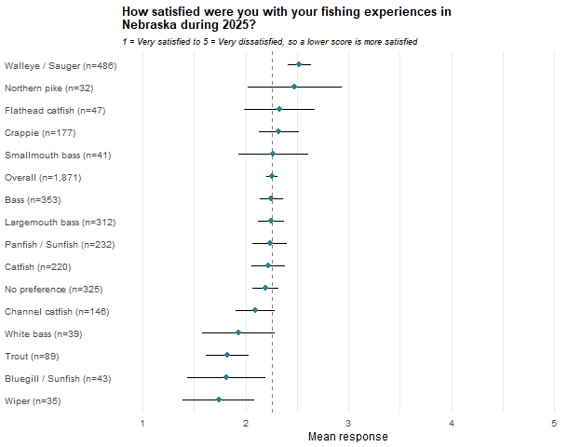

Live-imaging Sonar Use
Did you use LiveScope, MegaLive, ActiveTarget, or a similar live-imaging sonar system in 2025? Cells are the weighted percentage of the row group giving that response, with a 95% confidence interval. N is the raw unweighted number of respondents in the row group who answered the question. These results were weighted. Please consult the survey methodology for details.
Preferred species | Yes | No | N
Overall | 14.5 ± 1.78 | 85.5 ± 1.78 | 1,878
Walleye / Sauger | 24.5 ± 4.24 | 75.5 ± 4.24 | 490
Bass | 10.8 ± 3.55 | 89.2 ± 3.55 | 354
Largemouth bass | 11.0 ± 3.81 | 89.0 ± 3.81 | 313
Smallmouth bass | 9.6 ± 9.80 | 90.4 ± 9.80 | 41
Panfish | 19.2 ± 5.68 | 80.8 ± 5.68 | 231
Crappie | 22.7 ± 6.94 | 77.3 ± 6.94 | 176
Bluegill / Sunfish | 6.4 ± 8.14 | 93.6 ± 8.14 | 43
Catfish | 7.0 ± 3.75 | 93.0 ± 3.75 | 223
Channel catfish | 7.6 ± 4.80 | 92.4 ± 4.80 | 148
Flathead catfish | 7.4 ± 8.21 | 92.6 ± 8.21 | 48
Wiper | 35.2 ± 17.50 | 64.8 ± 17.50 | 35
White bass | 15.5 ± 12.99 | 84.5 ± 12.99 | 39
Trout | 7.3 ± 6.11 | 92.7 ± 6.11 | 89
Northern pike | 12.4 ± 12.69 | 87.6 ± 12.69 | 30
No preference | 6.9 ± 3.06 | 93.1 ± 3.06 | 329

Wiper (35%) and Walleye / Sauger (24%) anglers sit well above the overall mean for live-imaging sonar use while Catfish (7%) and No preference (7%) anglers sit below it. Live-sonar use concentrates in the boat-borne, open-water groups and species.
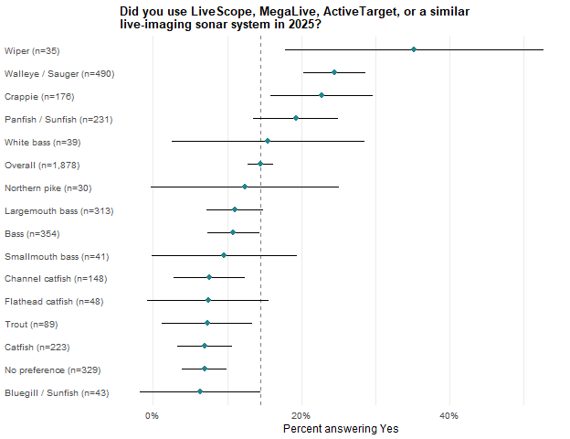

Conservation Officer
Were you checked by a Nebraska conservation officer wearing a sidearm while fishing during 2025? Cells are the weighted percentage of the row group giving that response, with a 95% confidence interval. N is the raw unweighted number of respondents in the row group who answered the question. These results were weighted. Please consult the survey methodology for details.
Preferred species | No | Yes | N
Overall | 81.5 ± 1.97 | 18.5 ± 1.97 | 1,879
Walleye / Sauger | 72.2 ± 4.42 | 27.8 ± 4.42 | 489
Bass | 83.8 ± 4.22 | 16.2 ± 4.22 | 353
Largemouth bass | 83.4 ± 4.54 | 16.6 ± 4.54 | 312
Smallmouth bass | 86.7 ± 11.28 | 13.3 ± 11.28 | 41
Panfish | 82.5 ± 5.45 | 17.5 ± 5.45 | 233
Crappie | 80.4 ± 6.49 | 19.6 ± 6.49 | 180
Bluegill / Sunfish | 91.7 ± 9.42 | 8.3 ± 9.42 | 41
Catfish | 81.3 ± 5.75 | 18.7 ± 5.75 | 222
Channel catfish | 83.2 ± 6.79 | 16.8 ± 6.79 | 147
Flathead catfish | 81.9 ± 11.93 | 18.1 ± 11.93 | 49
Wiper | 83.9 ± 13.45 | 16.1 ± 13.45 | 35
White bass | 80.3 ± 14.29 | 19.7 ± 14.29 | 39
Trout | 88.5 ± 7.52 | 11.5 ± 7.52 | 88
Northern pike | 83.2 ± 14.15 | 16.8 ± 14.15 | 32
No preference | 88.1 ± 3.91 | 11.9 ± 3.91 | 328
Walleye / Sauger anglers are the only group above the overall (28%, against 19% overall) and No preference anglers the only group below it (12%) which appears to be consistent with the two groups’ effort and boat usage observed as well.

Guided Trips
In 2025, how many times did you hire a fishing guide in and outside Nebraska. Cells are the weighted percentage of the row group falling in that category with a 95% confidence interval, followed by the raw unweighted number of respondents in that column’s sample. Columns overlap and must not be totaled. These results were weighted. Please consult the survey methodology for details.
Preferred species | Hired a guide | Hired in Nebraska | Only hired in Nebraska | Hired outside Nebraska | Only hired outside Nebraska | Hired both in and outside
Overall | 8.1 ± 1.38 (1,891) | 2.3 ± 0.76 (1,891) | 1.7 ± 0.66 (1,891) | 6.4 ± 1.24 (1,891) | 5.8 ± 1.18 (1,891) | 0.6 ± 0.39 (1,891)
Walleye / Sauger | 14.0 ± 3.41 (491) | 6.4 ± 2.42 (491) | 4.9 ± 2.12 (491) | 9.1 ± 2.83 (491) | 7.5 ± 2.60 (491) | 1.5 ± 1.21 (491)
Bass | 5.7 ± 2.64 (355) | 0.8 ± 1.03 (355) | 0.5 ± 0.84 (355) | 5.1 ± 2.52 (355) | 4.8 ± 2.45 (355) | 0.3 ± 0.61 (355)
Largemouth bass | 6.5 ± 2.98 (315) | 0.9 ± 1.17 (315) | 0.6 ± 0.95 (315) | 5.8 ± 2.84 (315) | 5.5 ± 2.77 (315) | 0.3 ± 0.69 (315)
Smallmouth bass | 0.0 ± 0.00 (40) | 0.0 ± 0.00 (40) | 0.0 ± 0.00 (40) | 0.0 ± 0.00 (40) | 0.0 ± 0.00 (40) | 0.0 ± 0.00 (40)
Panfish | 9.0 ± 4.09 (235) | 1.3 ± 1.59 (235) | 1.3 ± 1.59 (235) | 7.8 ± 3.82 (235) | 7.8 ± 3.82 (235) | 0.0 ± 0.00 (235)
Crappie | 9.2 ± 4.74 (180) | 0.9 ± 1.57 (180) | 0.9 ± 1.57 (180) | 8.3 ± 4.52 (180) | 8.3 ± 4.52 (180) | 0.0 ± 0.00 (180)
Bluegill / Sunfish | 4.3 ± 6.79 (43) | 2.9 ± 5.64 (43) | 2.9 ± 5.64 (43) | 1.4 ± 3.89 (43) | 1.4 ± 3.89 (43) | 0.0 ± 0.00 (43)
Catfish | 6.2 ± 3.55 (225) | 1.6 ± 1.82 (225) | 0.0 ± 0.00 (225) | 6.2 ± 3.55 (225) | 4.7 ± 3.10 (225) | 1.6 ± 1.82 (225)
Channel catfish | 5.1 ± 3.99 (149) | 2.5 ± 2.85 (149) | 0.0 ± 0.00 (149) | 5.1 ± 3.99 (149) | 2.6 ± 2.87 (149) | 2.5 ± 2.85 (149)
Flathead catfish | 2.8 ± 5.07 (50) | 0.0 ± 0.00 (50) | 0.0 ± 0.00 (50) | 2.8 ± 5.07 (50) | 2.8 ± 5.07 (50) | 0.0 ± 0.00 (50)
Wiper | 9.3 ± 10.62 (35) | 5.9 ± 8.65 (35) | 5.9 ± 8.65 (35) | 3.3 ± 6.59 (35) | 3.3 ± 6.59 (35) | 0.0 ± 0.00 (35)
White bass | 7.7 ± 9.56 (39) | 1.3 ± 3.99 (39) | 1.3 ± 3.99 (39) | 6.4 ± 8.81 (39) | 6.4 ± 8.81 (39) | 0.0 ± 0.00 (39)
Trout | 6.2 ± 5.74 (87) | 0.0 ± 0.00 (87) | 0.0 ± 0.00 (87) | 6.2 ± 5.74 (87) | 6.2 ± 5.74 (87) | 0.0 ± 0.00 (87)
Northern pike | 10.9 ± 11.80 (32) | 0.0 ± 0.00 (32) | 0.0 ± 0.00 (32) | 10.9 ± 11.80 (32) | 10.9 ± 11.80 (32) | 0.0 ± 0.00 (32)
No preference | 4.6 ± 2.52 (333) | 0.4 ± 0.79 (333) | 0.4 ± 0.79 (333) | 4.2 ± 2.40 (333) | 4.2 ± 2.40 (333) | 0.0 ± 0.00 (333)
Number of guided trips taken, among anglers who hired a guide in the universe named by each column. Cells are the weighted mean for the row group with a 95% confidence interval, followed by the raw unweighted number of respondents contributing to that cell. These results were weighted. Please consult the survey methodology for details.
Preferred species | Hired a guide | Hired in Nebraska | Only hired in Nebraska | Hired outside Nebraska | Only hired outside Nebraska | Hired both in and outside
Overall | 1.5 ± 0.24 (165) | 1.2 ± 0.15 (49) | 1.1 ± 0.14 (37) | 1.5 ± 0.26 (128) | 1.3 ± 0.16 (116) | 4.8 ± 1.91 (12)
Walleye / Sauger | 1.6 ± 0.26 (74) | 1.3 ± 0.21 (35) | 1.2 ± 0.20 (26) | 1.6 ± 0.30 (48) | 1.5 ± 0.31 (39) | 3.4 ± 0.92 (9)
Bass | 1.2 ± 0.41 (22) | 1.0 ± 0.00 (4) | 1.0 ± 0.00 (3) | 1.2 ± 0.35 (19) | 1.1 ± 0.12 (18) | 5.0 ± 0.00 (1)
Largemouth bass | 1.2 ± 0.41 (22) | 1.0 ± 0.00 (4) | 1.0 ± 0.00 (3) | 1.2 ± 0.35 (19) | 1.1 ± 0.12 (18) | 5.0 ± 0.00 (1)
Smallmouth bass
Panfish | 1.6 ± 0.51 (23) | 1.0 ± 0.00 (2) | 1.0 ± 0.00 (2) | 1.7 ± 0.56 (21) | 1.7 ± 0.56 (21)
Crappie | 1.5 ± 0.54 (19) | 1.0 ± 0.00 (1) | 1.0 ± 0.00 (1) | 1.6 ± 0.57 (18) | 1.6 ± 0.57 (18)
Bluegill / Sunfish | 1.0 ± 0.00 (2) | 1.0 ± 0.00 (1) | 1.0 ± 0.00 (1) | 1.0 ± 0.00 (1) | 1.0 ± 0.00 (1)
Catfish | 2.8 ± 2.23 (10) | 1.0 ± 0.00 (2) |  | 2.6 ± 2.02 (10) | 1.3 ± 0.52 (8) | 7.5 ± 5.54 (2)
Channel catfish | 4.2 ± 4.02 (5) | 1.0 ± 0.00 (2) |  | 3.7 ± 3.67 (5) | 1.0 ± 0.00 (3) | 7.5 ± 5.54 (2)
Flathead catfish | 1.0 ± 0.00 (1) |  |  | 1.0 ± 0.00 (1) | 1.0 ± 0.00 (1)
Wiper | 1.0 ± 0.00 (4) | 1.0 ± 0.00 (2) | 1.0 ± 0.00 (2) | 1.0 ± 0.00 (2) | 1.0 ± 0.00 (2)
White bass | 1.2 ± 0.35 (5) | 1.0 ± 0.00 (1) | 1.0 ± 0.00 (1) | 1.2 ± 0.42 (4) | 1.2 ± 0.42 (4)
Trout | 1.0 ± 0.00 (6) |  |  | 1.0 ± 0.00 (6) | 1.0 ± 0.00 (6)
Northern pike | 1.0 ± 0.00 (3) |  |  | 1.0 ± 0.00 (3) | 1.0 ± 0.00 (3)
No preference | 1.1 ± 0.31 (12) | 1.0 ± 0.00 (1) | 1.0 ± 0.00 (1) | 1.2 ± 0.34 (11) | 1.2 ± 0.34 (11)
Hiring a guide is uncommon (8% of anglers), and Walleye / Sauger anglers (14%) are the only group above the overall rate. The trip-count means in the second table rest on few respondents per column and their variance should be included in their interpretation.

Days Fished
For each month, indicate about how many DAYS you fished in Nebraska during 2025. Total days fished across all months. Mean cells are the weighted mean for the row group with a 95% confidence interval, followed by the raw unweighted number of respondents contributing to that cell. Median cells are the lower 95% confidence limit, the weighted median, and the upper 95% confidence limit, followed by the raw unweighted number of respondents. Median confidence limits come from the inherited 1,000-replicate weighted bootstrap. These results were weighted. Please consult the survey methodology for details.
Preferred species | Mean days fished | Median days fished
Overall | 30.2 ± 1.78 (1,834) | 16.0/17.0/19.0 (1,834)
Walleye / Sauger | 31.7 ± 3.65 (479) | 18.0/21.0/24.0 (479)
Bass | 38.1 ± 4.35 (337) | 20.0/26.0/31.0 (337)
Largemouth bass | 37.1 ± 4.33 (298) | 22.0/28.0/32.0 (298)
Smallmouth bass | 44.9 ± 17.17 (39) | 17.0/19.3/39.0 (39)
Panfish | 30.4 ± 5.29 (228) | 13.0/16.0/22.5 (228)
Crappie | 32.4 ± 6.26 (175) | 16.0/19.0/26.0 (175)
Bluegill / Sunfish | 23.5 ± 10.33 (41) | 4.0/11.0/22.0 (41)
Catfish | 35.2 ± 5.08 (220) | 20.0/23.0/28.0 (220)
Channel catfish | 34.1 ± 5.99 (144) | 18.0/25.0/29.0 (144)
Flathead catfish | 32.4 ± 10.37 (50) | 13.0/17.9/31.5 (50)
Wiper | 26.9 ± 13.42 (35) | 7.0/10.1/27.0 (35)
White bass | 20.7 ± 8.70 (39) | 9.0/13.2/17.0 (39)
Trout | 23.8 ± 6.60 (84) | 6.0/9.0/16.0 (84)
Northern pike | 19.5 ± 8.24 (30) | 5.0/12.0/20.0 (30)
No preference | 19.9 ± 3.12 (323) | 8.0/10.0/13.0 (323)

Bass anglers are above the overall on both mean (38) and median (26) and Catfish anglers on the median (23). Northern pike anglers mean (19) and No preference anglers mean (20) and median (10) indicating they fished the least. Effort concentrates in the bass and catfish constituencies, and the No preference group’s low effort marks it as the most casual segment of the license base.
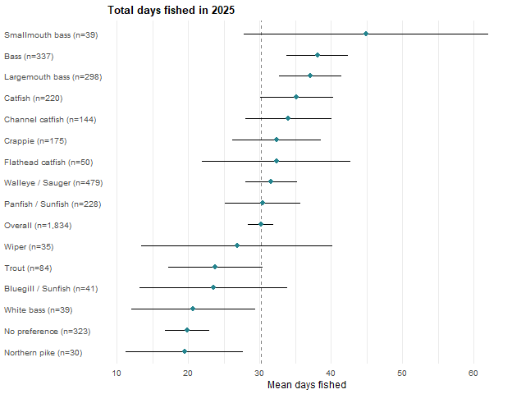

Ice Fishing
Did you ice fish in Nebraska during 2025? Cells are the weighted percentage of the row group giving that response with a 95% confidence interval. N is the raw unweighted number of respondents in the row group who answered the question. These results were weighted. Please consult the survey methodology for details.
Preferred species | Yes | No | N
Overall | 17.8 ± 1.96 | 82.2 ± 1.96 | 1,845
Walleye / Sauger | 27.4 ± 4.42 | 72.6 ± 4.42 | 486
Bass | 11.8 ± 3.73 | 88.2 ± 3.73 | 346
Largemouth bass | 11.8 ± 3.98 | 88.2 ± 3.98 | 306
Smallmouth bass | 11.4 ± 10.72 | 88.6 ± 10.72 | 40
Panfish | 32.1 ± 6.78 | 67.9 ± 6.78 | 227
Crappie | 34.1 ± 7.86 | 65.9 ± 7.86 | 175
Bluegill / Sunfish | 20.3 ± 13.90 | 79.7 ± 13.90 | 40
Catfish | 14.5 ± 5.30 | 85.5 ± 5.30 | 214
Channel catfish | 13.6 ± 6.40 | 86.4 ± 6.40 | 140
Flathead catfish | 20.1 ± 12.42 | 79.9 ± 12.42 | 49
Wiper | 12.6 ± 12.16 | 87.4 ± 12.16 | 35
White bass | 5.4 ± 8.23 | 94.6 ± 8.23 | 38
Trout | 8.7 ± 6.87 | 91.3 ± 6.87 | 84
Northern pike | 41.1 ± 18.82 | 58.9 ± 18.82 | 31
No preference | 9.8 ± 3.60 | 90.2 ± 3.60 | 325

Northern pike (41%), Crappie (34%), Panfish (32%) and Walleye / Sauger (27%) anglers do so above the overall rate; White bass (5%), Trout (9%), No preference (10%) and Largemouth bass (12%) anglers fall below it.
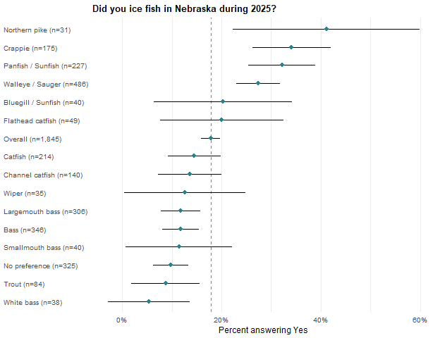

Angler Motivations
Indicate the importance for each item as a reason why you fish. Items are grouped by the relevant motivation sub-scale. Cells are the weighted mean for the row group with a 95% confidence interval followed by the raw unweighted number of respondents contributing to that cell. These results were weighted. Please consult the survey methodology for details.

Natural environment
Preferred species | To be outdoors | To experience natural surroundings | To experience new and different things | To be close to the water
Overall | 4.2 ± 0.04 (1,790) | 4.1 ± 0.05 (1,754) | 3.1 ± 0.06 (1,747) | 3.3 ± 0.07 (1,753)
Walleye / Sauger | 4.1 ± 0.08 (469) | 3.9 ± 0.09 (463) | 2.9 ± 0.12 (461) | 3.3 ± 0.12 (456)
Bass | 4.3 ± 0.09 (338) | 4.2 ± 0.10 (333) | 3.2 ± 0.14 (332) | 3.3 ± 0.15 (335)
Largemouth bass | 4.3 ± 0.09 (300) | 4.2 ± 0.11 (296) | 3.2 ± 0.15 (295) | 3.3 ± 0.16 (298)
Smallmouth bass | 4.1 ± 0.30 (38) | 4.2 ± 0.30 (37) | 3.4 ± 0.41 (37) | 3.2 ± 0.42 (37)
Panfish | 4.2 ± 0.12 (217) | 4.1 ± 0.14 (211) | 3.1 ± 0.20 (208) | 3.2 ± 0.20 (210)
Crappie | 4.2 ± 0.14 (168) | 4.2 ± 0.14 (162) | 3.1 ± 0.22 (159) | 3.2 ± 0.22 (161)
Bluegill / Sunfish | 4.5 ± 0.22 (37) | 4.2 ± 0.36 (37) | 3.3 ± 0.52 (37) | 3.3 ± 0.47 (37)
Catfish | 4.2 ± 0.14 (207) | 4.1 ± 0.15 (203) | 3.2 ± 0.19 (204) | 3.4 ± 0.18 (204)
Channel catfish | 4.2 ± 0.17 (136) | 4.1 ± 0.18 (133) | 3.0 ± 0.23 (133) | 3.5 ± 0.22 (133)
Flathead catfish | 4.2 ± 0.33 (48) | 4.2 ± 0.32 (48) | 3.3 ± 0.43 (48) | 3.4 ± 0.40 (48)
Wiper | 4.5 ± 0.28 (35) | 4.3 ± 0.31 (35) | 3.5 ± 0.42 (35) | 4.1 ± 0.35 (35)
White bass | 4.2 ± 0.27 (37) | 4.0 ± 0.29 (35) | 3.2 ± 0.49 (37) | 3.3 ± 0.38 (37)
Trout | 4.1 ± 0.26 (82) | 4.2 ± 0.20 (81) | 3.2 ± 0.33 (80) | 3.4 ± 0.27 (80)
Northern pike | 4.3 ± 0.29 (31) | 4.1 ± 0.32 (31) | 3.3 ± 0.52 (30) | 3.3 ± 0.44 (31)
No preference | 4.1 ± 0.11 (317) | 4.0 ± 0.12 (310) | 3.0 ± 0.16 (307) | 3.0 ± 0.16 (312)

Physical and psychological
Preferred species | For the challenge or sport | For relaxation | To experience adventure and excitement | For physical exercise
Overall | 3.2 ± 0.06 (1,752) | 4.0 ± 0.05 (1,775) | 3.4 ± 0.06 (1,753) | 2.5 ± 0.07 (1,751)
Walleye / Sauger | 3.3 ± 0.12 (466) | 3.9 ± 0.10 (468) | 3.3 ± 0.12 (461) | 2.4 ± 0.13 (460)
Bass | 3.4 ± 0.13 (330) | 4.1 ± 0.11 (335) | 3.5 ± 0.13 (333) | 2.5 ± 0.14 (331)
Largemouth bass | 3.5 ± 0.14 (293) | 4.2 ± 0.11 (298) | 3.5 ± 0.14 (296) | 2.4 ± 0.16 (294)
Smallmouth bass | 3.2 ± 0.41 (37) | 3.9 ± 0.39 (37) | 3.6 ± 0.37 (37) | 2.6 ± 0.36 (37)
Panfish | 3.2 ± 0.18 (208) | 4.0 ± 0.14 (213) | 3.4 ± 0.19 (208) | 2.6 ± 0.19 (210)
Crappie | 3.3 ± 0.19 (161) | 4.0 ± 0.16 (164) | 3.3 ± 0.20 (160) | 2.5 ± 0.22 (161)
Bluegill / Sunfish | 3.0 ± 0.51 (35) | 4.0 ± 0.30 (37) | 3.7 ± 0.48 (36) | 2.9 ± 0.45 (37)
Catfish | 3.3 ± 0.19 (207) | 4.2 ± 0.13 (208) | 3.5 ± 0.18 (205) | 2.6 ± 0.17 (204)
Channel catfish | 3.2 ± 0.22 (136) | 4.1 ± 0.17 (137) | 3.4 ± 0.22 (134) | 2.6 ± 0.22 (133)
Flathead catfish | 3.6 ± 0.42 (48) | 4.3 ± 0.24 (48) | 3.5 ± 0.39 (48) | 2.5 ± 0.34 (48)
Wiper | 3.9 ± 0.42 (34) | 3.8 ± 0.32 (35) | 3.7 ± 0.40 (35) | 2.8 ± 0.34 (35)
White bass | 3.0 ± 0.51 (37) | 3.8 ± 0.40 (37) | 3.6 ± 0.49 (36) | 2.9 ± 0.57 (37)
Trout | 3.2 ± 0.27 (80) | 3.9 ± 0.23 (81) | 3.3 ± 0.25 (80) | 2.9 ± 0.32 (79)
Northern pike | 3.3 ± 0.51 (30) | 4.0 ± 0.30 (31) | 3.5 ± 0.49 (31) | 2.7 ± 0.51 (31)
No preference | 2.6 ± 0.16 (307) | 3.9 ± 0.13 (311) | 3.1 ± 0.16 (311) | 2.4 ± 0.15 (309)

Social
Preferred species | To be with friends | To get away from other people | To get away from the daily routine | For family recreation
Overall | 3.5 ± 0.06 (1,754) | 3.5 ± 0.07 (1,756) | 3.8 ± 0.06 (1,756) | 3.7 ± 0.06 (1,771)
Walleye / Sauger | 3.6 ± 0.12 (466) | 3.4 ± 0.13 (461) | 3.7 ± 0.11 (461) | 3.8 ± 0.12 (466)
Bass | 3.5 ± 0.15 (332) | 3.6 ± 0.15 (329) | 3.9 ± 0.12 (331) | 3.5 ± 0.16 (332)
Largemouth bass | 3.5 ± 0.16 (295) | 3.6 ± 0.16 (292) | 3.9 ± 0.13 (294) | 3.6 ± 0.16 (295)
Smallmouth bass | 3.2 ± 0.43 (37) | 3.9 ± 0.41 (37) | 3.9 ± 0.35 (37) | 2.8 ± 0.49 (37)
Panfish | 3.6 ± 0.19 (207) | 3.3 ± 0.21 (214) | 3.7 ± 0.17 (211) | 3.7 ± 0.20 (214)
Crappie | 3.5 ± 0.22 (159) | 3.4 ± 0.23 (165) | 3.7 ± 0.20 (162) | 3.6 ± 0.23 (165)
Bluegill / Sunfish | 3.7 ± 0.45 (36) | 3.1 ± 0.59 (37) | 3.7 ± 0.35 (37) | 3.9 ± 0.44 (37)
Catfish | 3.4 ± 0.19 (203) | 3.6 ± 0.21 (205) | 3.8 ± 0.18 (205) | 3.6 ± 0.20 (208)
Channel catfish | 3.5 ± 0.23 (133) | 3.4 ± 0.25 (134) | 3.8 ± 0.21 (135) | 3.6 ± 0.24 (137)
Flathead catfish | 3.1 ± 0.36 (47) | 3.8 ± 0.42 (48) | 3.8 ± 0.40 (47) | 3.7 ± 0.39 (48)
Wiper | 3.9 ± 0.44 (35) | 4.1 ± 0.40 (34) | 3.9 ± 0.43 (35) | 3.8 ± 0.49 (35)
White bass | 3.7 ± 0.44 (35) | 3.2 ± 0.54 (37) | 3.6 ± 0.45 (37) | 3.9 ± 0.39 (37)
Trout | 3.5 ± 0.27 (81) | 3.5 ± 0.32 (79) | 3.6 ± 0.33 (80) | 3.4 ± 0.28 (80)
Northern pike | 3.6 ± 0.41 (29) | 3.7 ± 0.43 (31) | 4.0 ± 0.39 (31) | 3.6 ± 0.40 (31)
No preference | 3.5 ± 0.15 (312) | 3.3 ± 0.18 (312) | 3.5 ± 0.15 (312) | 3.7 ± 0.15 (315)

Fishery resource
Preferred species | To compete for prizes or money | To obtain fish for eating | To catch a trophy fish | For the fun of catching fish
Overall | 1.2 ± 0.03 (1,747) | 2.4 ± 0.07 (1,763) | 2.3 ± 0.07 (1,747) | 4.2 ± 0.05 (1,771)
Walleye / Sauger | 1.2 ± 0.06 (457) | 3.0 ± 0.13 (467) | 2.4 ± 0.13 (462) | 4.1 ± 0.09 (462)
Bass | 1.2 ± 0.09 (331) | 1.8 ± 0.13 (329) | 2.5 ± 0.16 (333) | 4.4 ± 0.09 (333)
Largemouth bass | 1.2 ± 0.10 (294) | 1.8 ± 0.14 (293) | 2.5 ± 0.17 (296) | 4.4 ± 0.10 (296)
Smallmouth bass | 1.2 ± 0.22 (37) | 1.9 ± 0.44 (36) | 2.6 ± 0.51 (37) | 4.3 ± 0.28 (37)
Panfish | 1.2 ± 0.09 (211) | 2.7 ± 0.21 (210) | 1.9 ± 0.18 (210) | 4.2 ± 0.13 (215)
Crappie | 1.1 ± 0.08 (162) | 2.7 ± 0.23 (161) | 2.0 ± 0.21 (161) | 4.2 ± 0.15 (165)
Bluegill / Sunfish | 1.4 ± 0.38 (37) | 2.5 ± 0.55 (37) | 1.5 ± 0.43 (37) | 4.3 ± 0.29 (38)
Catfish | 1.2 ± 0.08 (203) | 2.6 ± 0.20 (208) | 2.6 ± 0.24 (203) | 4.3 ± 0.13 (209)
Channel catfish | 1.2 ± 0.10 (132) | 2.8 ± 0.25 (137) | 2.4 ± 0.29 (132) | 4.2 ± 0.15 (138)
Flathead catfish | 1.0 ± 0.06 (48) | 2.4 ± 0.41 (48) | 2.8 ± 0.49 (48) | 4.5 ± 0.23 (48)
Wiper | 1.8 ± 0.44 (35) | 2.4 ± 0.41 (35) | 3.6 ± 0.51 (35) | 4.4 ± 0.33 (35)
White bass | 1.1 ± 0.14 (37) | 3.1 ± 0.42 (37) | 1.6 ± 0.38 (37) | 4.2 ± 0.27 (37)
Trout | 1.1 ± 0.12 (78) | 2.3 ± 0.27 (79) | 1.9 ± 0.33 (79) | 4.0 ± 0.24 (80)
Northern pike | 1.1 ± 0.22 (31) | 1.9 ± 0.45 (31) | 3.0 ± 0.53 (31) | 4.4 ± 0.30 (31)
No preference | 1.1 ± 0.04 (311) | 2.1 ± 0.16 (312) | 1.6 ± 0.14 (306) | 4.0 ± 0.12 (317)

Motivation scale scores
Each scale score is the mean of its items, computed only for respondents who answered every item in that scale. Cells are the weighted mean for the row group with a 95% confidence interval, followed by the raw unweighted number of respondents contributing to that cell. These results were weighted. Please consult the survey methodology for details.
Preferred species | Physical and psychological | Natural environment | Social | Fishery resource
Overall | 3.3 ± 0.04 (1,712) | 3.7 ± 0.04 (1,710) | 3.6 ± 0.04 (1,710) | 2.5 ± 0.03 (1,715)
Walleye / Sauger | 3.2 ± 0.08 (455) | 3.6 ± 0.08 (445) | 3.6 ± 0.08 (450) | 2.7 ± 0.07 (453)
Bass | 3.4 ± 0.09 (325) | 3.7 ± 0.09 (328) | 3.6 ± 0.10 (323) | 2.5 ± 0.07 (324)
Largemouth bass | 3.4 ± 0.10 (288) | 3.8 ± 0.10 (291) | 3.6 ± 0.10 (286) | 2.5 ± 0.08 (288)
Smallmouth bass | 3.3 ± 0.28 (37) | 3.7 ± 0.31 (37) | 3.4 ± 0.28 (37) | 2.5 ± 0.25 (36)
Panfish | 3.3 ± 0.12 (199) | 3.7 ± 0.13 (204) | 3.6 ± 0.13 (204) | 2.5 ± 0.10 (207)
Crappie | 3.3 ± 0.14 (153) | 3.7 ± 0.13 (155) | 3.6 ± 0.15 (156) | 2.5 ± 0.10 (158)
Bluegill / Sunfish | 3.4 ± 0.35 (34) | 3.8 ± 0.32 (37) | 3.6 ± 0.31 (36) | 2.4 ± 0.31 (37)
Catfish | 3.4 ± 0.12 (204) | 3.7 ± 0.12 (201) | 3.6 ± 0.13 (199) | 2.7 ± 0.11 (200)
Channel catfish | 3.3 ± 0.14 (133) | 3.7 ± 0.15 (131) | 3.6 ± 0.15 (130) | 2.6 ± 0.13 (129)
Flathead catfish | 3.5 ± 0.24 (48) | 3.8 ± 0.28 (48) | 3.6 ± 0.27 (46) | 2.7 ± 0.19 (48)
Wiper | 3.5 ± 0.26 (34) | 4.1 ± 0.26 (35) | 3.9 ± 0.33 (34) | 3.0 ± 0.25 (35)
White bass | 3.3 ± 0.39 (36) | 3.7 ± 0.28 (35) | 3.6 ± 0.32 (35) | 2.5 ± 0.20 (37)
Trout | 3.3 ± 0.20 (79) | 3.7 ± 0.22 (79) | 3.5 ± 0.20 (79) | 2.3 ± 0.16 (76)
Northern pike | 3.4 ± 0.23 (30) | 3.8 ± 0.32 (30) | 3.7 ± 0.31 (29) | 2.6 ± 0.21 (31)
No preference | 3.0 ± 0.11 (298) | 3.5 ± 0.11 (302) | 3.5 ± 0.11 (304) | 2.2 ± 0.08 (302)

Group separations concentrate in the fishery resource scale: Wiper (3.0), Walleye / Sauger (2.7) and Catfish (2.7) anglers sit above the overall and No preference anglers below it (2.2). Wiper anglers are also above on the natural environment scale (4.1), and No preference anglers below the overall on the natural environment and physical and psychological scales. No group separates on the social scale in either direction indicating the companionship motive is shared across species preferences.
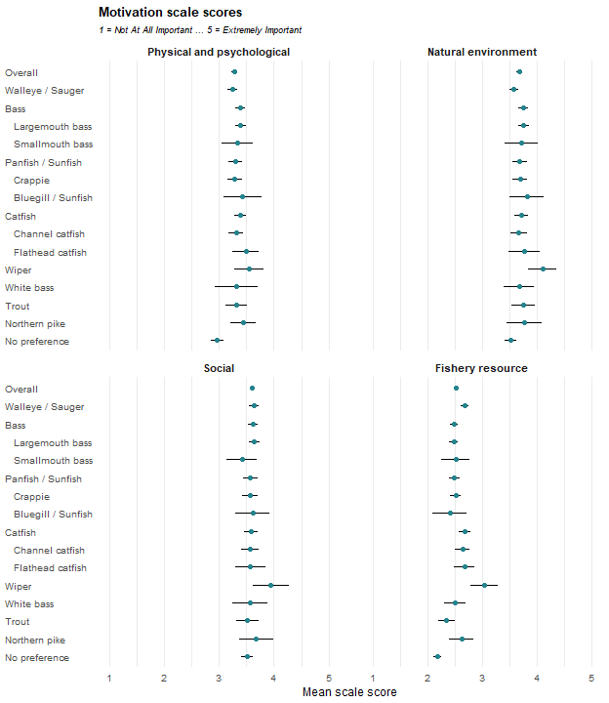

The same items also form a two-part split between catch-oriented and non-catch-oriented motivations, reported below on the same basis. Cells are the weighted mean for the row group with a 95% confidence interval, followed by the raw unweighted number of respondents contributing to that cell. These results were weighted. Please consult the survey methodology for details.
Preferred species | Non-catch Motivations | Catch Motivations
Overall | 3.5 ± 0.04 (1,667) | 3.0 ± 0.03 (1,664)
Walleye / Sauger | 3.5 ± 0.08 (437) | 3.1 ± 0.06 (445)
Bass | 3.6 ± 0.08 (316) | 3.0 ± 0.07 (320)
Largemouth bass | 3.6 ± 0.09 (279) | 3.0 ± 0.07 (284)
Smallmouth bass | 3.6 ± 0.26 (37) | 2.9 ± 0.25 (36)
Panfish | 3.6 ± 0.12 (197) | 3.0 ± 0.10 (197)
Crappie | 3.6 ± 0.13 (149) | 3.0 ± 0.10 (151)
Bluegill / Sunfish | 3.7 ± 0.29 (36) | 2.9 ± 0.31 (34)
Catfish | 3.6 ± 0.11 (199) | 3.1 ± 0.10 (194)
Channel catfish | 3.5 ± 0.14 (130) | 3.0 ± 0.12 (125)
Flathead catfish | 3.6 ± 0.25 (47) | 3.1 ± 0.20 (46)
Wiper | 3.9 ± 0.23 (34) | 3.4 ± 0.25 (34)
White bass | 3.5 ± 0.31 (34) | 2.9 ± 0.21 (35)
Trout | 3.6 ± 0.18 (78) | 2.8 ± 0.15 (76)
Northern pike | 3.7 ± 0.30 (30) | 3.2 ± 0.25 (27)
No preference | 3.4 ± 0.10 (291) | 2.6 ± 0.08 (287)

Wiper anglers stood out on both catch-oriented (3.4) and non-catch-oriented motivations (3.9), exceeding the overall on both scales. Walleye / Sauger anglers also scored above the overall on catch motivations (3.1), while Trout anglers (2.8) and anglers with no species preference (2.6) scored below it. No other family or species separated from the overall on either scale by non-overlapping confidence intervals. Non-catch motivations scored higher than catch motivations within every preferred-species group although Wiper and Northern pike did not have non-overlapping confidence intervals.

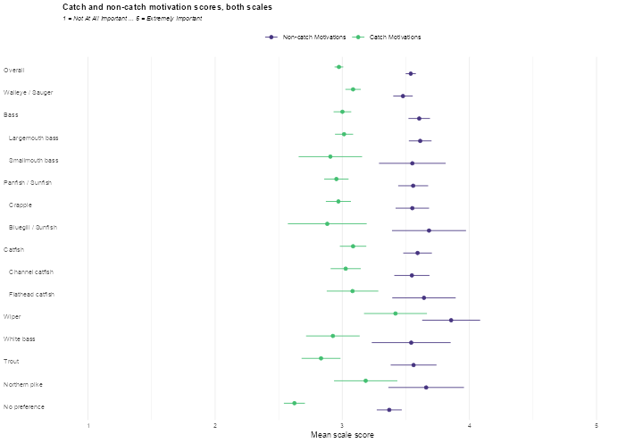

Regulations
How much do you agree or disagree with each of the following items regarding fishing regulations? Items are grouped by the relevant regulation sub-scale. Cells are the weighted mean for the row group with a 95% confidence interval followed by the raw unweighted number of respondents contributing to that cell. These results were weighted. Please consult the survey methodology for details.

Comprehension
Preferred species | Nebraska's mix of statewide and site-specific regulations is easy for me to understand. | Fishing regulations are clear enough that I rarely worry about accidentally breaking them. | I feel confident that I understand Nebraska's fishing regulations.
Overall | 3.3 ± 0.06 (1,690) | 3.5 ± 0.06 (1,699) | 3.9 ± 0.06 (1,697)
Walleye / Sauger | 3.3 ± 0.11 (449) | 3.3 ± 0.12 (453) | 3.8 ± 0.11 (454)
Bass | 3.5 ± 0.13 (317) | 3.8 ± 0.12 (321) | 4.0 ± 0.11 (321)
Largemouth bass | 3.4 ± 0.14 (283) | 3.8 ± 0.13 (286) | 4.0 ± 0.12 (286)
Smallmouth bass | 3.6 ± 0.35 (34) | 4.1 ± 0.28 (35) | 4.2 ± 0.19 (35)
Panfish | 3.4 ± 0.17 (211) | 3.7 ± 0.17 (212) | 3.9 ± 0.16 (210)
Crappie | 3.4 ± 0.20 (166) | 3.7 ± 0.19 (167) | 3.9 ± 0.18 (165)
Bluegill / Sunfish | 3.4 ± 0.39 (36) | 3.9 ± 0.41 (36) | 4.1 ± 0.33 (36)
Catfish | 3.3 ± 0.17 (200) | 3.7 ± 0.18 (200) | 4.0 ± 0.16 (201)
Channel catfish | 3.3 ± 0.21 (129) | 3.7 ± 0.23 (130) | 3.9 ± 0.20 (131)
Flathead catfish | 3.3 ± 0.37 (47) | 3.6 ± 0.42 (47) | 4.2 ± 0.32 (47)
Wiper | 3.6 ± 0.36 (34) | 3.2 ± 0.42 (34) | 4.0 ± 0.35 (34)
White bass | 3.0 ± 0.34 (33) | 3.7 ± 0.41 (33) | 3.8 ± 0.39 (33)
Trout | 3.2 ± 0.29 (77) | 3.4 ± 0.32 (77) | 3.8 ± 0.25 (77)
Northern pike | 4.0 ± 0.41 (30) | 3.4 ± 0.58 (29) | 4.0 ± 0.40 (29)
No preference | 3.3 ± 0.13 (286) | 3.5 ± 0.15 (287) | 3.7 ± 0.14 (285)

Site-specific

Preferred species | I trust fisheries' managers to decide when site-specific regulations are necessary. | Site-specific regulations are important because different waters need different management approaches. | Creating special fishing opportunities at certain waters is worth having lake-specific regulations.
Overall | 3.7 ± 0.05 (1,694) | 4.0 ± 0.05 (1,691) | 3.9 ± 0.05 (1,682)
Walleye / Sauger | 3.5 ± 0.11 (452) | 4.0 ± 0.09 (450) | 3.8 ± 0.10 (446)
Bass | 3.8 ± 0.11 (320) | 4.1 ± 0.11 (319) | 4.0 ± 0.11 (319)
Largemouth bass | 3.8 ± 0.12 (285) | 4.0 ± 0.11 (285) | 4.0 ± 0.12 (285)
Smallmouth bass | 4.0 ± 0.27 (35) | 4.3 ± 0.23 (34) | 4.4 ± 0.24 (34)
Panfish | 3.8 ± 0.15 (210) | 4.1 ± 0.13 (209) | 4.0 ± 0.14 (209)
Crappie | 3.8 ± 0.16 (166) | 4.1 ± 0.15 (165) | 4.0 ± 0.15 (165)
Bluegill / Sunfish | 4.1 ± 0.38 (35) | 4.1 ± 0.33 (35) | 4.0 ± 0.34 (35)
Catfish | 3.7 ± 0.16 (200) | 4.1 ± 0.14 (200) | 3.9 ± 0.16 (201)
Channel catfish | 3.7 ± 0.20 (130) | 4.1 ± 0.17 (130) | 4.0 ± 0.19 (131)
Flathead catfish | 3.6 ± 0.30 (47) | 4.0 ± 0.30 (47) | 3.8 ± 0.33 (47)
Wiper | 3.7 ± 0.40 (34) | 4.0 ± 0.43 (34) | 4.1 ± 0.39 (33)
White bass | 3.5 ± 0.32 (33) | 3.7 ± 0.33 (33) | 3.4 ± 0.31 (33)
Trout | 3.6 ± 0.27 (78) | 4.0 ± 0.21 (78) | 3.6 ± 0.26 (76)
Northern pike | 3.7 ± 0.47 (29) | 4.1 ± 0.30 (29) | 4.1 ± 0.36 (29)
No preference | 3.7 ± 0.13 (287) | 3.9 ± 0.12 (288) | 3.8 ± 0.12 (285)

Simplification

Preferred species | Site-specific rules make fishing regulations unnecessarily complicated. | Simplified, uniform regulations are more likely to be obeyed by anglers. | Fisheries' managers should avoid site-specific regulations to avoid confusing anglers. | It is better to have uniform statewide regulations, even if that means they aren't always effective everywhere. | I would rather have one set of regulations everywhere, even if it limits unique fishing opportunities.
Overall | 3.0 ± 0.06 (1,713) | 3.7 ± 0.06 (1,712) | 3.0 ± 0.06 (1,696) | 2.9 ± 0.06 (1,689) | 2.8 ± 0.06 (1,692)
Walleye / Sauger | 3.1 ± 0.11 (454) | 3.7 ± 0.11 (454) | 3.1 ± 0.11 (454) | 2.8 ± 0.11 (450) | 2.7 ± 0.12 (452)
Bass | 2.8 ± 0.14 (321) | 3.8 ± 0.12 (319) | 2.9 ± 0.13 (318) | 3.1 ± 0.13 (319) | 2.7 ± 0.14 (320)
Largemouth bass | 2.8 ± 0.15 (286) | 3.8 ± 0.13 (284) | 2.9 ± 0.14 (285) | 3.1 ± 0.15 (285) | 2.8 ± 0.15 (285)
Smallmouth bass | 2.6 ± 0.37 (35) | 3.8 ± 0.32 (35) | 2.8 ± 0.37 (33) | 2.9 ± 0.31 (34) | 2.2 ± 0.35 (35)
Panfish | 3.0 ± 0.19 (214) | 3.7 ± 0.17 (213) | 3.0 ± 0.18 (209) | 2.9 ± 0.18 (209) | 2.7 ± 0.18 (209)
Crappie | 3.0 ± 0.22 (168) | 3.7 ± 0.19 (167) | 3.0 ± 0.20 (164) | 2.9 ± 0.21 (165) | 2.7 ± 0.20 (164)
Bluegill / Sunfish | 3.0 ± 0.46 (36) | 3.6 ± 0.43 (36) | 2.9 ± 0.40 (35) | 2.7 ± 0.40 (35) | 2.9 ± 0.46 (36)
Catfish | 3.0 ± 0.18 (200) | 3.7 ± 0.17 (203) | 3.1 ± 0.15 (202) | 3.2 ± 0.19 (200) | 2.9 ± 0.19 (200)
Channel catfish | 3.0 ± 0.23 (130) | 3.7 ± 0.20 (132) | 3.1 ± 0.19 (131) | 3.1 ± 0.24 (130) | 2.8 ± 0.24 (130)
Flathead catfish | 3.1 ± 0.40 (47) | 3.8 ± 0.37 (47) | 3.2 ± 0.33 (47) | 3.5 ± 0.36 (47) | 3.1 ± 0.37 (47)
Wiper | 3.1 ± 0.38 (34) | 4.0 ± 0.40 (34) | 2.8 ± 0.42 (34) | 2.7 ± 0.40 (33) | 2.7 ± 0.49 (34)
White bass | 2.9 ± 0.40 (33) | 3.8 ± 0.35 (33) | 3.0 ± 0.39 (33) | 3.1 ± 0.38 (33) | 3.1 ± 0.43 (33)
Trout | 3.1 ± 0.30 (79) | 3.9 ± 0.25 (77) | 3.3 ± 0.29 (77) | 2.7 ± 0.31 (77) | 3.0 ± 0.34 (77)
Northern pike | 2.6 ± 0.50 (31) | 3.4 ± 0.50 (31) | 2.8 ± 0.51 (30) | 2.4 ± 0.51 (29) | 2.2 ± 0.51 (29)
No preference | 3.1 ± 0.14 (294) | 3.8 ± 0.13 (295) | 3.0 ± 0.13 (286) | 3.1 ± 0.14 (286) | 2.9 ± 0.14 (287)

Items outside the three regulation sub-scales
These items are part of the list but belong to no sub-scale. Cells are the weighted mean for the row group with a 95% confidence interval, followed by the raw unweighted number of respondents contributing to that cell.
Preferred species | Anglers are willing to follow complex regulations to produce high-quality fisheries.
Overall | 3.2 ± 0.06 (1,705)
Walleye / Sauger | 3.2 ± 0.10 (454)
Bass | 3.2 ± 0.14 (320)
Largemouth bass | 3.1 ± 0.15 (286)
Smallmouth bass | 3.7 ± 0.34 (34)
Panfish | 3.1 ± 0.17 (211)
Crappie | 3.2 ± 0.19 (166)
Bluegill / Sunfish | 2.8 ± 0.38 (35)
Catfish | 3.3 ± 0.16 (202)
Channel catfish | 3.2 ± 0.20 (131)
Flathead catfish | 3.3 ± 0.35 (47)
Wiper | 3.6 ± 0.36 (34)
White bass | 3.2 ± 0.41 (33)
Trout | 2.8 ± 0.27 (77)
Northern pike | 3.2 ± 0.50 (30)
No preference | 3.2 ± 0.12 (291)

Regulation scale scores
Each scale score is the mean of its items, computed only for respondents who answered every item in that scale. Cells are the weighted mean for the row group with a 95% confidence interval followed by the raw unweighted number of respondents contributing to that cell. These results were weighted. Please consult the survey methodology for details.
Preferred species | Comprehension | Site-specific | Simplification
Overall | 3.6 ± 0.05 (1,680) | 3.9 ± 0.05 (1,679) | 3.1 ± 0.04 (1,666)
Walleye / Sauger | 3.5 ± 0.09 (449) | 3.8 ± 0.09 (445) | 3.1 ± 0.08 (446)
Bass | 3.7 ± 0.10 (316) | 4.0 ± 0.10 (319) | 3.1 ± 0.10 (316)
Largemouth bass | 3.7 ± 0.11 (282) | 3.9 ± 0.11 (285) | 3.1 ± 0.10 (283)
Smallmouth bass | 4.0 ± 0.23 (34) | 4.2 ± 0.21 (34) | 2.9 ± 0.25 (33)
Panfish | 3.6 ± 0.14 (210) | 4.0 ± 0.13 (209) | 3.0 ± 0.13 (206)
Crappie | 3.6 ± 0.16 (165) | 4.0 ± 0.14 (165) | 3.0 ± 0.15 (162)
Bluegill / Sunfish | 3.8 ± 0.35 (36) | 4.1 ± 0.33 (35) | 3.0 ± 0.30 (35)
Catfish | 3.7 ± 0.15 (198) | 3.9 ± 0.13 (200) | 3.1 ± 0.13 (197)
Channel catfish | 3.6 ± 0.19 (128) | 3.9 ± 0.16 (130) | 3.1 ± 0.16 (128)
Flathead catfish | 3.7 ± 0.32 (47) | 3.8 ± 0.25 (47) | 3.3 ± 0.24 (47)
Wiper | 3.6 ± 0.31 (34) | 4.0 ± 0.36 (33) | 3.1 ± 0.29 (33)
White bass | 3.5 ± 0.31 (33) | 3.5 ± 0.29 (33) | 3.2 ± 0.22 (33)
Trout | 3.4 ± 0.26 (76) | 3.7 ± 0.21 (76) | 3.2 ± 0.20 (76)
Northern pike | 3.8 ± 0.39 (29) | 4.0 ± 0.28 (29) | 2.7 ± 0.38 (29)
No preference | 3.5 ± 0.12 (282) | 3.8 ± 0.11 (284) | 3.2 ± 0.10 (280)

The regulation scales separate few groups. On the Comprehension scale (3.6 overall), Bass (3.7) and especially Smallmouth bass (4.0) anglers sit above the overall and Smallmouth bass anglers are the one group above it on the Site-specific scale (4.2 against 3.9). On the Simplification scale, the preference for uniform statewide regulations (3.1 overall), Northern pike anglers are the only group below the overall (2.7), consistent with a group fishing a small set of specialized waters.
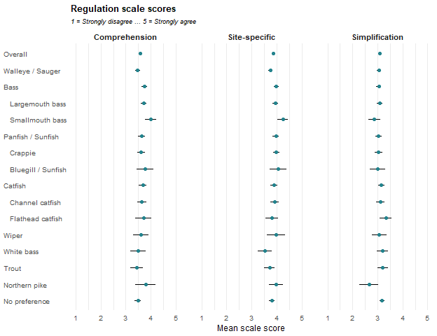

Angler Attitudes
Indicate how much you agree with each of the following statements about fishing. Items are grouped by the relevant attitude sub-scale. Item means are computed on the responses as recorded and are not reverse-adjusted; a dagger marks an item as reverse-coded. Cells are the weighted mean for the row group with a 95% confidence interval followed by the raw unweighted number of respondents contributing to that cell. These results were weighted. Please consult the survey methodology for details.

Catch something

Preferred species | A fishing trip can be successful even if no fish are caught. † | If I thought I wouldn’t catch any fish, I would not go fishing. | When I go fishing, I’m just as happy if I don’t catch a fish. † | When I go fishing, I am not satisfied unless I catch at least something.
Overall | 3.8 ± 0.06 (1,733) | 2.7 ± 0.07 (1,716) | 3.0 ± 0.06 (1,718) | 3.2 ± 0.06 (1,715)
Walleye / Sauger | 3.6 ± 0.11 (460) | 2.9 ± 0.13 (456) | 2.6 ± 0.10 (456) | 3.4 ± 0.10 (457)
Bass | 3.8 ± 0.12 (329) | 2.6 ± 0.15 (323) | 3.0 ± 0.13 (325) | 3.1 ± 0.13 (324)
Largemouth bass | 3.8 ± 0.13 (293) | 2.7 ± 0.16 (287) | 3.0 ± 0.14 (289) | 3.1 ± 0.14 (289)
Smallmouth bass | 3.9 ± 0.32 (36) | 2.4 ± 0.38 (36) | 2.8 ± 0.33 (36) | 3.0 ± 0.37 (35)
Panfish | 3.7 ± 0.16 (212) | 2.9 ± 0.19 (211) | 2.9 ± 0.15 (211) | 3.3 ± 0.17 (211)
Crappie | 3.6 ± 0.18 (165) | 2.9 ± 0.21 (164) | 2.9 ± 0.17 (164) | 3.3 ± 0.19 (164)
Bluegill / Sunfish | 4.0 ± 0.29 (37) | 2.8 ± 0.45 (37) | 3.1 ± 0.37 (37) | 3.1 ± 0.38 (37)
Catfish | 3.9 ± 0.16 (205) | 2.6 ± 0.20 (205) | 3.1 ± 0.17 (203) | 3.2 ± 0.17 (202)
Channel catfish | 3.9 ± 0.19 (134) | 2.7 ± 0.24 (134) | 3.0 ± 0.21 (133) | 3.1 ± 0.20 (133)
Flathead catfish | 3.8 ± 0.32 (47) | 2.5 ± 0.42 (47) | 3.4 ± 0.33 (47) | 3.0 ± 0.40 (47)
Wiper | 4.2 ± 0.35 (31) | 3.5 ± 0.44 (31) | 3.1 ± 0.36 (31) | 2.5 ± 0.51 (31)
White bass | 4.1 ± 0.36 (34) | 2.8 ± 0.38 (34) | 3.1 ± 0.34 (34) | 3.0 ± 0.37 (34)
Trout | 3.9 ± 0.26 (79) | 2.6 ± 0.28 (78) | 3.3 ± 0.23 (78) | 3.0 ± 0.26 (78)
Northern pike | 3.3 ± 0.47 (29) | 2.9 ± 0.54 (29) | 2.6 ± 0.37 (29) | 3.6 ± 0.33 (29)
No preference | 3.9 ± 0.12 (300) | 2.6 ± 0.16 (298) | 3.2 ± 0.14 (299) | 3.0 ± 0.14 (297)

Numbers

Preferred species | I'm happiest with a fishing trip if I catch at least the limit. | The more fish I catch, the happier I am. | A successful fishing trip is one in which many fish are caught. | A full stringer is the best indicator of a good fishing trip.
Overall | 3.0 ± 0.05 (1,707) | 3.5 ± 0.06 (1,698) | 3.3 ± 0.05 (1,715) | 2.6 ± 0.06 (1,717)
Walleye / Sauger | 3.1 ± 0.10 (452) | 3.5 ± 0.10 (449) | 3.4 ± 0.09 (458) | 2.8 ± 0.10 (457)
Bass | 2.9 ± 0.12 (322) | 3.6 ± 0.13 (321) | 3.3 ± 0.12 (324) | 2.4 ± 0.13 (326)
Largemouth bass | 2.8 ± 0.13 (286) | 3.6 ± 0.14 (285) | 3.3 ± 0.12 (288) | 2.4 ± 0.13 (290)
Smallmouth bass | 3.2 ± 0.27 (36) | 4.1 ± 0.28 (36) | 3.5 ± 0.33 (36) | 2.4 ± 0.44 (36)
Panfish | 2.9 ± 0.16 (212) | 3.4 ± 0.16 (208) | 3.3 ± 0.14 (210) | 2.7 ± 0.15 (211)
Crappie | 2.9 ± 0.18 (165) | 3.4 ± 0.18 (162) | 3.4 ± 0.16 (164) | 2.8 ± 0.17 (164)
Bluegill / Sunfish | 2.5 ± 0.37 (37) | 3.2 ± 0.44 (37) | 3.1 ± 0.36 (36) | 2.4 ± 0.33 (37)
Catfish | 3.2 ± 0.17 (202) | 3.5 ± 0.17 (202) | 3.3 ± 0.17 (202) | 2.8 ± 0.18 (203)
Channel catfish | 3.1 ± 0.20 (131) | 3.5 ± 0.21 (132) | 3.2 ± 0.19 (134) | 2.8 ± 0.20 (134)
Flathead catfish | 3.2 ± 0.40 (47) | 3.5 ± 0.38 (46) | 3.1 ± 0.39 (46) | 2.5 ± 0.41 (47)
Wiper | 3.6 ± 0.35 (31) | 3.9 ± 0.31 (31) | 3.4 ± 0.29 (31) | 2.4 ± 0.35 (31)
White bass | 3.2 ± 0.40 (34) | 3.5 ± 0.43 (34) | 3.0 ± 0.32 (34) | 2.9 ± 0.28 (34)
Trout | 2.7 ± 0.23 (78) | 3.1 ± 0.27 (79) | 3.1 ± 0.22 (79) | 2.4 ± 0.22 (78)
Northern pike | 3.0 ± 0.46 (29) | 3.7 ± 0.39 (29) | 3.7 ± 0.30 (29) | 2.3 ± 0.45 (29)
No preference | 2.8 ± 0.12 (295) | 3.3 ± 0.15 (293) | 3.1 ± 0.13 (296) | 2.5 ± 0.13 (296)

Size

Preferred species | The bigger the fish I catch, the better the fishing trip. | I am the happiest with a fishing trip if I catch a challenging game fish. | I would rather catch one or two big fish than ten smaller fish. | I like to fish where I know I have a chance to catch a trophy fish.
Overall | 3.4 ± 0.06 (1,719) | 3.3 ± 0.06 (1,717) | 3.2 ± 0.05 (1,713) | 3.3 ± 0.06 (1,715)
Walleye / Sauger | 3.3 ± 0.10 (456) | 3.4 ± 0.10 (457) | 3.0 ± 0.09 (457) | 3.3 ± 0.10 (457)
Bass | 3.6 ± 0.12 (326) | 3.5 ± 0.12 (325) | 3.3 ± 0.12 (323) | 3.5 ± 0.12 (324)
Largemouth bass | 3.6 ± 0.12 (290) | 3.5 ± 0.13 (289) | 3.3 ± 0.13 (287) | 3.5 ± 0.13 (288)
Smallmouth bass | 3.9 ± 0.32 (36) | 3.5 ± 0.30 (36) | 3.2 ± 0.41 (36) | 3.4 ± 0.33 (36)
Panfish | 3.2 ± 0.15 (211) | 3.1 ± 0.17 (211) | 2.9 ± 0.15 (209) | 2.8 ± 0.17 (210)
Crappie | 3.3 ± 0.18 (164) | 3.2 ± 0.19 (164) | 3.0 ± 0.17 (163) | 2.9 ± 0.19 (164)
Bluegill / Sunfish | 3.1 ± 0.28 (37) | 2.8 ± 0.41 (37) | 2.7 ± 0.35 (36) | 2.5 ± 0.45 (37)
Catfish | 3.5 ± 0.18 (203) | 3.4 ± 0.17 (205) | 3.4 ± 0.16 (205) | 3.3 ± 0.18 (202)
Channel catfish | 3.3 ± 0.22 (132) | 3.4 ± 0.19 (134) | 3.2 ± 0.18 (134) | 3.1 ± 0.20 (134)
Flathead catfish | 3.8 ± 0.32 (47) | 3.3 ± 0.38 (47) | 3.8 ± 0.33 (47) | 3.5 ± 0.45 (46)
Wiper | 4.2 ± 0.32 (31) | 4.1 ± 0.31 (31) | 3.6 ± 0.44 (31) | 4.1 ± 0.35 (31)
White bass | 3.5 ± 0.40 (34) | 3.0 ± 0.35 (34) | 3.3 ± 0.30 (34) | 3.1 ± 0.33 (34)
Trout | 3.1 ± 0.26 (79) | 3.2 ± 0.23 (78) | 3.4 ± 0.24 (78) | 3.2 ± 0.25 (79)
Northern pike | 3.5 ± 0.37 (29) | 4.0 ± 0.37 (29) | 3.5 ± 0.45 (29) | 4.1 ± 0.31 (29)
No preference | 3.2 ± 0.13 (298) | 3.0 ± 0.13 (296) | 2.9 ± 0.14 (296) | 2.8 ± 0.13 (297)

Harvest

Preferred species | I want to keep all the fish I catch. | I'm just as happy if I release all the fish I catch. † | I usually eat the fish I catch. | I’m just as happy if I don't keep the fish I catch. †
Overall | 1.9 ± 0.05 (1,715) | 4.0 ± 0.06 (1,691) | 2.8 ± 0.07 (1,714) | 3.9 ± 0.05 (1,709)
Walleye / Sauger | 2.0 ± 0.08 (454) | 3.5 ± 0.10 (452) | 3.5 ± 0.12 (457) | 3.5 ± 0.10 (454)
Bass | 1.6 ± 0.10 (325) | 4.5 ± 0.09 (319) | 1.9 ± 0.13 (324) | 4.3 ± 0.10 (325)
Largemouth bass | 1.6 ± 0.10 (290) | 4.4 ± 0.09 (283) | 1.9 ± 0.14 (288) | 4.3 ± 0.11 (289)
Smallmouth bass | 1.4 ± 0.21 (35) | 4.6 ± 0.23 (36) | 1.8 ± 0.35 (36) | 4.3 ± 0.31 (36)
Panfish | 1.9 ± 0.14 (209) | 3.8 ± 0.17 (209) | 3.0 ± 0.21 (211) | 3.8 ± 0.16 (211)
Crappie | 1.9 ± 0.15 (162) | 3.7 ± 0.19 (162) | 3.1 ± 0.23 (164) | 3.8 ± 0.18 (164)
Bluegill / Sunfish | 1.8 ± 0.32 (37) | 4.1 ± 0.41 (37) | 2.6 ± 0.52 (37) | 3.8 ± 0.36 (37)
Catfish | 1.9 ± 0.14 (205) | 3.8 ± 0.18 (200) | 3.0 ± 0.21 (202) | 3.8 ± 0.16 (202)
Channel catfish | 2.1 ± 0.18 (134) | 3.7 ± 0.21 (130) | 3.2 ± 0.26 (131) | 3.8 ± 0.19 (132)
Flathead catfish | 1.6 ± 0.25 (47) | 4.0 ± 0.37 (46) | 2.6 ± 0.44 (47) | 3.8 ± 0.36 (47)
Wiper | 1.8 ± 0.39 (31) | 4.5 ± 0.35 (30) | 2.8 ± 0.45 (31) | 4.2 ± 0.30 (31)
White bass | 2.3 ± 0.38 (34) | 3.3 ± 0.31 (33) | 3.5 ± 0.45 (34) | 3.4 ± 0.38 (34)
Trout | 1.9 ± 0.26 (79) | 3.9 ± 0.27 (73) | 2.7 ± 0.30 (78) | 4.0 ± 0.23 (78)
Northern pike | 1.6 ± 0.29 (29) | 4.4 ± 0.40 (29) | 2.0 ± 0.46 (29) | 4.0 ± 0.43 (27)
No preference | 1.9 ± 0.12 (297) | 4.2 ± 0.11 (294) | 2.6 ± 0.16 (296) | 4.1 ± 0.12 (295)

Attitude scale scores

Each scale score is the mean of its items, computed only for respondents who answered every item in that scale. Reverse-coded items are reversed before the scale score is formed. Cells are the weighted mean for the row group with a 95% confidence interval, followed by the raw unweighted number of respondents contributing to that cell. Reverse-scored items: E1a, E1k, E1f, E1l. These results were weighted. Please consult the survey methodology for details.
Preferred species | Catch something | Numbers | Size | Harvest
Overall | 2.8 ± 0.05 (1,704) | 3.1 ± 0.04 (1,670) | 3.3 ± 0.04 (1,695) | 2.2 ± 0.05 (1,653)
Walleye / Sauger | 3.0 ± 0.08 (456) | 3.2 ± 0.08 (443) | 3.3 ± 0.07 (452) | 2.6 ± 0.08 (441)
Bass | 2.7 ± 0.11 (321) | 3.1 ± 0.09 (315) | 3.5 ± 0.09 (321) | 1.7 ± 0.08 (314)
Largemouth bass | 2.7 ± 0.12 (286) | 3.0 ± 0.10 (279) | 3.5 ± 0.10 (285) | 1.7 ± 0.09 (279)
Smallmouth bass | 2.7 ± 0.26 (35) | 3.3 ± 0.22 (36) | 3.5 ± 0.26 (36) | 1.6 ± 0.22 (35)
Panfish | 2.9 ± 0.13 (209) | 3.1 ± 0.12 (207) | 3.0 ± 0.12 (207) | 2.3 ± 0.14 (205)
Crappie | 2.9 ± 0.14 (162) | 3.1 ± 0.13 (162) | 3.1 ± 0.14 (162) | 2.3 ± 0.15 (158)
Bluegill / Sunfish | 2.7 ± 0.29 (37) | 2.8 ± 0.29 (36) | 2.8 ± 0.25 (36) | 2.1 ± 0.34 (37)
Catfish | 2.7 ± 0.14 (201) | 3.2 ± 0.13 (196) | 3.4 ± 0.14 (200) | 2.3 ± 0.14 (194)
Channel catfish | 2.7 ± 0.16 (132) | 3.2 ± 0.16 (129) | 3.2 ± 0.16 (132) | 2.4 ± 0.16 (125)
Flathead catfish | 2.6 ± 0.29 (47) | 3.1 ± 0.29 (45) | 3.6 ± 0.29 (46) | 2.1 ± 0.30 (46)
Wiper | 2.7 ± 0.30 (31) | 3.3 ± 0.23 (31) | 4.0 ± 0.30 (31) | 2.0 ± 0.29 (30)
White bass | 2.7 ± 0.28 (34) | 3.1 ± 0.23 (34) | 3.2 ± 0.23 (34) | 2.8 ± 0.22 (33)
Trout | 2.6 ± 0.21 (77) | 2.8 ± 0.17 (77) | 3.2 ± 0.19 (77) | 2.2 ± 0.23 (72)
Northern pike | 3.1 ± 0.34 (29) | 3.2 ± 0.28 (29) | 3.8 ± 0.29 (29) | 1.9 ± 0.37 (27)
No preference | 2.6 ± 0.11 (296) | 2.9 ± 0.10 (286) | 3.0 ± 0.10 (293) | 2.0 ± 0.10 (285)

The four attitude scales reprise the evidence behind Chapter 1’s groupings. Walleye / Sauger anglers are the only group above the overall on catching something (3.0 against 2.8) and on numbers of fish (3.2 against 3.1). No preference anglers fall below on both, and Trout anglers on numbers. On size of fish, Wiper (4.0) and Northern pike (3.8) anglers sit highest and Bass anglers also above the overall (3.5), with Panfish and particularly Bluegill / Sunfish anglers (2.8) below. On harvesting, White bass (2.8), Walleye / Sauger (2.6) and Channel catfish (2.4) anglers are above the overall and Bass anglers well below it (1.7). Bass anglers are the most release-oriented constituency in the survey, and Walleye and White bass anglers the most harvest-oriented.
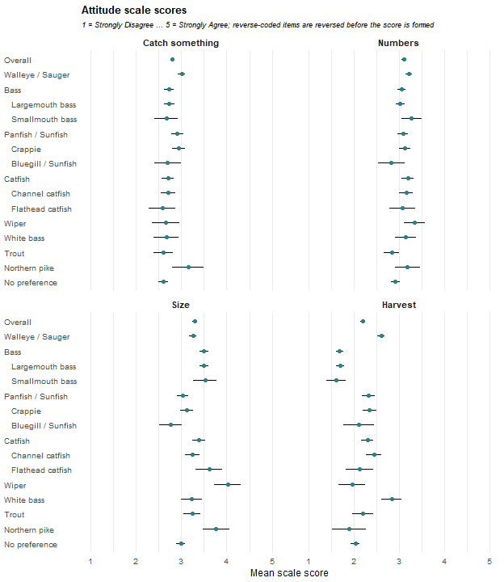

Gender
What is your gender? Cells are the weighted percentage of the row group giving that response with a 95% confidence interval. N is the raw unweighted number of respondents in the row group who answered the question. These results were weighted. Please consult the survey methodology for details. Percentages are weighted, as they are throughout this report.
Preferred species | Male | Female | N
Overall | 80.5 ± 2.06 | 19.5 ± 2.06 | 1,801
Walleye / Sauger | 82.8 ± 3.77 | 17.2 ± 3.77 | 479
Bass | 85.3 ± 4.16 | 14.7 ± 4.16 | 336
Largemouth bass | 84.9 ± 4.46 | 15.1 ± 4.46 | 299
Smallmouth bass | 88.2 ± 11.36 | 11.8 ± 11.36 | 37
Panfish | 80.3 ± 5.87 | 19.7 ± 5.87 | 220
Crappie | 82.2 ± 6.44 | 17.8 ± 6.44 | 170
Bluegill / Sunfish | 69.6 ± 15.88 | 30.4 ± 15.88 | 40
Catfish | 83.3 ± 5.67 | 16.7 ± 5.67 | 210
Channel catfish | 81.5 ± 7.35 | 18.5 ± 7.35 | 136
Flathead catfish | 88.8 ± 9.77 | 11.2 ± 9.77 | 49
Wiper | 95.0 ± 8.08 | 5.0 ± 8.08 | 34
White bass | 64.6 ± 18.36 | 35.4 ± 18.36 | 35
Trout | 84.5 ± 8.89 | 15.5 ± 8.89 | 83
Northern pike | 89.2 ± 11.85 | 10.8 ± 11.85 | 31
No preference | 68.5 ± 5.74 | 31.5 ± 5.74 | 315
The share of female anglers is above the overall among No preference anglers (32%) and below it among Wiper anglers (5%). No other group separates from the overall mean.

Age
Respondent age group. Cells are the weighted percentage of the row group giving that response with a 95% confidence interval. N is the raw unweighted number of respondents in the row group who answered the question. The final column is the weighted mean age in years, taken from the reported age rather than from the bands, and computed on the same respondents as the percentages. These results were weighted. Please consult the survey methodology for details. Percentages and the mean are weighted, as they are throughout this report.
Preferred species | 16-24 | 25-34 | 35-44 | 45-54 | 55-64 | 65 and older | Mean age ± CI | N
Overall | 11.9 ± 1.69 | 17.7 ± 1.99 | 20.2 ± 2.09 | 18.4 ± 2.02 | 13.8 ± 1.80 | 18.0 ± 2.00 | 46.0 ± 0.88 | 1,777
Walleye / Sauger | 4.1 ± 1.99 | 12.4 ± 3.31 | 21.4 ± 4.11 | 20.1 ± 4.02 | 18.7 ± 3.91 | 23.3 ± 4.24 | 50.7 ± 1.57 | 474
Bass | 15.2 ± 4.25 | 21.4 ± 4.86 | 22.0 ± 4.91 | 19.2 ± 4.66 | 10.9 ± 3.69 | 11.3 ± 3.74 | 42.3 ± 1.85 | 331
Largemouth bass | 13.2 ± 4.26 | 21.7 ± 5.18 | 22.9 ± 5.28 | 19.8 ± 5.01 | 10.8 ± 3.89 | 11.6 ± 4.03 | 42.8 ± 1.94 | 294
Smallmouth bass | 29.5 ± 16.06 | 19.4 ± 13.94 | 15.4 ± 12.70 | 15.1 ± 12.62 | 12.1 ± 11.50 | 8.4 ± 9.79 | 38.3 ± 5.85 | 37
Panfish | 4.5 ± 3.08 | 17.9 ± 5.71 | 13.2 ± 5.05 | 23.3 ± 6.30 | 17.3 ± 5.64 | 23.8 ± 6.35 | 50.7 ± 2.46 | 216
Crappie | 3.3 ± 3.04 | 20.5 ± 6.89 | 14.8 ± 6.06 | 20.2 ± 6.85 | 18.8 ± 6.66 | 22.4 ± 7.11 | 50.1 ± 2.82 | 166
Bluegill / Sunfish | 10.5 ± 10.60 | 10.8 ± 10.72 | 6.4 ± 8.47 | 33.1 ± 16.25 | 7.6 ± 9.15 | 31.5 ± 16.04 | 52.1 ± 6.03 | 40
Catfish | 13.9 ± 5.28 | 14.2 ± 5.34 | 22.7 ± 6.40 | 14.3 ± 5.35 | 16.5 ± 5.68 | 18.4 ± 5.93 | 46.4 ± 2.60 | 207
Channel catfish | 9.5 ± 5.60 | 12.1 ± 6.23 | 23.2 ± 8.06 | 11.5 ± 6.09 | 19.0 ± 7.49 | 24.7 ± 8.25 | 49.6 ± 3.26 | 133
Flathead catfish | 17.5 ± 11.80 | 14.4 ± 10.90 | 23.4 ± 13.14 | 22.5 ± 12.95 | 12.1 ± 10.11 | 10.1 ± 9.33 | 43.3 ± 4.90 | 49
Wiper | 8.9 ± 10.58 | 41.6 ± 18.37 | 9.3 ± 10.85 | 25.5 ± 16.25 | 5.3 ± 8.31 | 9.5 ± 10.91 | 39.0 ± 5.32 | 34
White bass | 13.4 ± 13.07 | 26.3 ± 16.90 | 8.3 ± 10.61 | 22.1 ± 15.93 | 11.3 ± 12.15 | 18.6 ± 14.93 | 43.9 ± 7.09 | 35
Trout | 12.4 ± 8.21 | 22.5 ± 10.38 | 13.1 ± 8.38 | 11.5 ± 7.93 | 10.2 ± 7.54 | 30.3 ± 11.43 | 48.7 ± 4.74 | 81
Northern pike | 27.5 ± 17.31 | 7.9 ± 10.48 | 25.2 ± 16.85 | 16.3 ± 14.31 | 15.9 ± 14.19 | 7.2 ± 10.03 | 40.7 ± 6.48 | 30
No preference | 18.3 ± 4.80 | 15.6 ± 4.50 | 22.2 ± 5.16 | 16.7 ± 4.63 | 10.6 ± 3.81 | 16.6 ± 4.62 | 44.0 ± 2.14 | 312
Walleye / Sauger and Panfish anglers are older than the overall (both about 51), while Bass (42), Smallmouth bass (38) and Wiper (39) anglers are younger. The age gradient is worth holding alongside the effort and attitude differences above when deciding whether a group contrast reflects the species or the cohort that pursues it.

Chapter 4: Species Sought
This chapter reports which species anglers tried to catch in 2025, as distinct from the species they prefer. Of the 1,915 anglers in the analysis sample, 1,764 answered the species-sought question and 151 did not; the percentages below are of those who answered. An angler could say they tried to catch any number of species, so every list in this chapter overlaps and must not be totaled.

Species Sought
Please indicate whether or not you tried to catch each of the following types of fish in Nebraska waters during 2025. Respondents is the raw unweighted number of anglers who said they tried to catch the species in 2025. The percentage is of anglers who answered the species-sought question, with a 95 percent confidence interval. Total anglers applies that percentage to the full weighted 2025 angler population. Rows overlap, because an angler can try to catch many species, and must not be totaled. These results were weighted. Please consult the survey methodology for details.
Species sought | Respondents | % of angler population | Total anglers
Largemouth bass | 998 | 59.8 ± 2.56 | 140,054 ± 6,004
Crappie | 1,042 | 59.5 ± 2.57 | 139,221 ± 6,012
Bluegill / Sunfish | 938 | 55.2 ± 2.60 | 129,160 ± 6,090
Walleye / Sauger | 926 | 53.3 ± 2.61 | 124,839 ± 6,109
Channel catfish | 822 | 48.0 ± 2.61 | 112,369 ± 6,118
Smallmouth bass | 599 | 37.6 ± 2.53 | 88,091 ± 5,932
Flathead catfish | 438 | 27.8 ± 2.34 | 65,049 ± 5,486
White bass | 499 | 27.5 ± 2.34 | 64,484 ± 5,471
Trout | 446 | 26.9 ± 2.32 | 63,086 ± 5,433
Blue catfish | 409 | 26.5 ± 2.31 | 62,094 ± 5,406
Northern pike | 389 | 24.2 ± 2.24 | 56,720 ± 5,247
Yellow perch | 390 | 23.6 ± 2.22 | 55,211 ± 5,199
Wiper | 403 | 22.7 ± 2.19 | 53,231 ± 5,133
Striped bass | 306 | 20.0 ± 2.09 | 46,789 ± 4,897
Common carp | 238 | 15.2 ± 1.88 | 35,587 ± 4,397
Drum | 193 | 12.2 ± 1.71 | 28,633 ± 4,012
Muskellunge / Tiger musky | 168 | 11.9 ± 1.69 | 27,847 ± 3,964
Bullhead | 176 | 11.3 ± 1.66 | 26,565 ± 3,884
Invasive carp | 98 | 7.1 ± 1.34 | 16,549 ± 3,139
Paddlefish | 50 | 3.5 ± 0.96 | 8,167 ± 2,247
Sturgeon | 38 | 2.3 ± 0.78 | 5,380 ± 1,835
Fished for anything | 727 | 43.7 ± 2.59 | 102,407 ± 6,075
Other | 49 | 3.5 ± 0.96 | 8,214 ± 2,253
Total anglers applies each percentage to the full weighted 2025 angler population of 234,125, as the preferred-species table in Chapter 1 does. This assumes that leaving the species-sought question or the preferred-species question blank is unrelated to which species an angler tries to catch.
Five species are each sought by about half of anglers or more: Largemouth bass (60 percent), Crappie (59), Bluegill / Sunfish (55), Walleye / Sauger (53) and Channel catfish (48). Smallmouth bass follows at 38 percent, and no other species reaches 30 percent. At the other end, Sturgeon, Paddlefish and the Other answer are each sought by fewer than 4 percent of anglers. In population terms, each of the five leading species is pursued by more than 110,000 anglers. A further 44 percent said they fished for anything.
What anglers seek is much broader than what they prefer. At least twice as many anglers tried to catch each of the five leading species as name it as their preferred fish: Walleye / Sauger is preferred by 24 percent and sought by 53, Largemouth bass 18 and 60, Crappie 8 and 59, Channel catfish 7 and 48, and Bluegill / Sunfish 2 and 55. The preferred-species table in Chapter 1 therefore understates how many anglers a program for any of these species reaches, and the species in the long tail, such as Sturgeon and Paddlefish, are rarely sought by anyone.

Other Species Sought by Preferred Group
For each preferred group, the table lists the three species, other than the group’s own family, that the largest share of its anglers tried to catch. The table gives the groups only. Across all anglers (1,764 respondents) the three are Largemouth bass (60 percent), Crappie (59 percent), Bluegill / Sunfish (55 percent), the first three named species in the population table above. Walleye / Sauger anglers most often also sought Crappie (63 percent), White bass (46 percent), Channel catfish (43 percent). The three are shown whatever their confidence intervals.
The lists are alike from group to group. Only 7 species appear in any of the 15 group lists, and five of them (Largemouth bass, Crappie, Walleye / Sauger, Bluegill / Sunfish and Channel catfish) fill 43 of the 45 places. Largemouth bass is listed by 11 groups, Crappie by 10, Walleye / Sauger by 9, Bluegill / Sunfish by 8 and Channel catfish by 5. Two features of the lists come from the family exclusion rather than from angler behavior. Largemouth bass heads the lists of the Panfish / Sunfish, Crappie and Bluegill / Sunfish groups because the other panfish are excluded for them, and White bass appears only once, in second place for Walleye / Sauger anglers, because it is excluded for every Moronides group. Smallmouth bass appears once, in third place for Wiper anglers.
Read together, the lists suggest that anglers who prefer different species are, for the most part, also fishing for the same handful of widely sought species, so the preferred groups are not separate constituencies in what they pursue. The order within a list should be read cautiously. In 10 of the 15 groups the interval for the first species reaches the interval for the third, and the groups with few respondents have wide intervals, so a second or third place is often not firmly established.
Please indicate whether or not you tried to catch each of the following types of fish in Nebraska waters during 2025. Cells give the three species most often sought, other than the group’s own family, as the weighted percentage of the row group who said they tried to catch the species, with a 95 percent confidence interval. A group’s own family is every species in the same Chapter 1 candidate family as its preferred species (Wiper and White bass exclude all three of Striped bass, Wiper and White bass). The Overall ranking, which excludes nothing, is given in the text. Answers of fishing for anything and Other are not ranked. N is the raw unweighted number of respondents in the row group who answered the question. These results were weighted. Please consult the survey methodology for details.
Preferred species | N | Rank 1 | Rank 2 | Rank 3
Walleye / Sauger | 464 | Crappie: 62.9 ± 4.90 | White bass: 46.1 ± 5.06 | Channel catfish: 43.3 ± 5.03
Bass | 333 | Bluegill / Sunfish: 69.8 ± 5.41 | Crappie: 69.4 ± 5.44 | Walleye / Sauger: 45.0 ± 5.87
Largemouth bass | 294 | Crappie: 71.5 ± 5.68 | Bluegill / Sunfish: 70.6 ± 5.72 | Walleye / Sauger: 42.9 ± 6.22
Smallmouth bass | 39 | Bluegill / Sunfish: 64.0 ± 16.32 | Walleye / Sauger: 59.5 ± 16.69 | Crappie: 55.2 ± 16.91
Panfish / Sunfish | 220 | Largemouth bass: 63.0 ± 7.12 | Walleye / Sauger: 48.6 ± 7.37 | Channel catfish: 42.0 ± 7.28
Crappie | 168 | Largemouth bass: 66.3 ± 8.00 | Walleye / Sauger: 56.5 ± 8.39 | Channel catfish: 45.5 ± 8.43
Bluegill / Sunfish | 40 | Largemouth bass: 49.7 ± 17.27 | Channel catfish: 35.2 ± 16.49 | Walleye / Sauger: 23.3 ± 14.59
Catfish | 210 | Bluegill / Sunfish: 60.4 ± 7.41 | Crappie: 57.9 ± 7.48 | Largemouth bass: 56.6 ± 7.51
Channel catfish | 139 | Bluegill / Sunfish: 57.4 ± 9.25 | Largemouth bass: 57.0 ± 9.26 | Crappie: 53.0 ± 9.33
Flathead catfish | 46 | Bluegill / Sunfish: 61.0 ± 15.59 | Crappie: 60.4 ± 15.63 | Largemouth bass: 51.5 ± 15.98
Wiper | 35 | Largemouth bass: 71.6 ± 16.51 | Walleye / Sauger: 54.5 ± 18.24 | Smallmouth bass: 54.1 ± 18.25
White bass | 38 | Walleye / Sauger: 48.2 ± 18.24 | Crappie: 47.4 ± 18.23 | Largemouth bass: 46.9 ± 18.22
Trout | 80 | Largemouth bass: 53.6 ± 12.45 | Bluegill / Sunfish: 51.8 ± 12.47 | Crappie: 35.3 ± 11.93
Northern pike | 30 | Largemouth bass: 69.9 ± 17.86 | Walleye / Sauger: 65.4 ± 18.52 | Crappie: 62.4 ± 18.87
No preference | 298 | Bluegill / Sunfish: 48.8 ± 6.32 | Largemouth bass: 47.5 ± 6.31 | Channel catfish: 45.6 ± 6.30

Number of Species Sought
Each angler’s count is the number of named species they tried to catch other than their own preferred species. The table gives the groups only. Across all anglers (1,764 respondents) the weighted mean is 5.0 ± 0.21 species and the median is 4.0 (95 percent interval 4.0 to 5.0); the screen below is applied against that mean. As in Chapters 3 and 5, a group is described as differing from the overall only when its 95 percent confidence interval lies entirely outside the Overall interval. By that screen two groups seek fewer other species than anglers overall, Bluegill / Sunfish (2.8) and Trout (3.4), and one seeks more, Flathead catfish (6.6), although the Flathead catfish interval clears the Overall interval only narrowly. No other group separates, so the other groups are not shown to differ, not shown to be alike.
Bluegill / Sunfish and Trout anglers, who are among the smaller groups (40 and 80 respondents) and have wide intervals, appear to concentrate their fishing on fewer species, which is consistent with the distinct profile of Trout anglers in Chapter 3. Flathead catfish anglers, with 46 respondents, spread over more. The two ends of the range are far apart, with Bluegill / Sunfish anglers averaging 2.8 other species and Flathead catfish anglers 6.6, but the groups at both ends are small, so the size of that gap is imprecise. Because every count excludes the angler’s own preferred species, these differences describe how widely anglers fish beyond their favorite, not how many species they fish in total.
Please indicate whether or not you tried to catch each of the following types of fish in Nebraska waters during 2025. Cells summarize the number of named species each angler tried to catch, not counting the angler’s own preferred species or the answers of fishing for anything and Other. The mean has a 95 percent confidence interval; the median has the 1,000-replicate weighted bootstrap 95 percent confidence limits. N is the raw unweighted number of respondents in the row group who answered the question. These results were weighted. Please consult the survey methodology for details.
Preferred species | N | Mean ± 95% CI | Median | Median 95% CI
Walleye / Sauger | 464 | 5.1 ± 0.40 | 5.0 | 4.0 to 5.0
Bass | 333 | 5.3 ± 0.44 | 5.0 | 4.0 to 5.0
Largemouth bass | 294 | 5.2 ± 0.47 | 5.0 | 4.0 to 5.0
Smallmouth bass | 39 | 5.7 ± 1.32 | 5.0 | 4.0 to 7.0
Panfish / Sunfish | 220 | 4.6 ± 0.51 | 4.0 | 3.5 to 5.0
Crappie | 168 | 5.1 ± 0.59 | 5.0 | 4.0 to 5.0
Bluegill / Sunfish | 40 | 2.8 ± 0.82 | 2.0 | 1.5 to 3.0
Catfish | 210 | 5.6 ± 0.60 | 5.0 | 4.0 to 6.0
Channel catfish | 139 | 4.8 ± 0.71 | 4.0 | 3.0 to 5.0
Flathead catfish | 46 | 6.6 ± 1.37 | 5.5 | 4.5 to 8.0
Wiper | 35 | 6.2 ± 1.66 | 4.0 | 4.0 to 6.0
White bass | 38 | 5.4 ± 1.61 | 5.0 | 2.5 to 6.0
Trout | 80 | 3.4 ± 1.00 | 2.0 | 1.5 to 3.0
Northern pike | 30 | 5.8 ± 1.37 | 5.0 | 3.5 to 7.0
No preference | 298 | 4.4 ± 0.52 | 4.0 | 3.0 to 4.0

Chapter 5: Satisfaction
Managers and administrators often want to know how satisfied anglers are but one satisfaction score does not always clear convey entire picture and may mask important distinctions. The 2025 survey asked about satisfaction in several ways and this chapter is organized around what each can tell us. One item asks about the season as a whole. Another asks about success at catching the angler’s preferred fish. Four more examine pairs of questions aimed at satisfaction with the size or the number of the preferred fish, for the fish the angler catches or the fish the angler is allowed to harvest. The pairs are there to answer two questions. Is an unhappy group short of large fish or of many fish? And is the complaint about what the water produces or about what the rules let anglers keep? This chapter reports the six items together by preferred group, then compares size with numbers within each angler, first for the catch and then for the harvest, and finally compares what each angler catches with what the same angler is allowed to keep. As in Chapter 3, a group is described as different from the overall only when its interval lies entirely outside the Overall confidence interval. A within-angler group difference is described only when the interval around that difference excludes zero.
The general satisfaction question about 2025 angling is reverse-coded here to align directionality between all questions. Chapter 3 reports this question on its recorded scale, where 1 is Very satisfied. The two are the same estimate with the same confidence interval however the values in Chapter 3 and 4 do not match – however the interpretations derived are appropriate.

The satisfaction items
The six items are listed below with the short names used in the rest of the chapter. Each is scored so that a higher mean means a more satisfied angler.
The six items, with the question text as it appears in the instrument, the short name used in the tables that follow, and the chapter that reports the item in full. N is the raw unweighted number of respondents in the analysis sample who answered the item; the mean is weighted with a 95% confidence interval. These results were weighted. Please consult the survey methodology for details.
Item | Question text | Short name | Also in | N | Overall mean ± CI
A9 | How satisfied were you with your fishing experiences in Nebraska during 2025? | Season overall | Chapter 3 | 1,871 | 3.7 ± 0.06
D4a | I am happy with my success fishing for my preferred fish. | Success | Chapter 2 | 1,555 | 3.2 ± 0.06
D4i | I am satisfied with the size of my preferred fish that I catch in Nebraska. | Size caught | Chapter 2 | 1,533 | 3.3 ± 0.05
D4j | I am satisfied with the size of my preferred fish that I am allowed to harvest in Nebraska. | Size harvestable | Chapter 2 | 1,524 | 3.5 ± 0.05
D4k | I am satisfied with the number of my preferred fish that I catch in Nebraska. | Number caught | Chapter 2 | 1,533 | 3.2 ± 0.06
D4l | I am satisfied with the number of my preferred fish that I am allowed to harvest in Nebraska. | Number harvestable | Chapter 2 | 1,525 | 3.5 ± 0.05
Anglers rate the season as a whole highest (3.7) and their preferred fish lower. Success (3.2) and the number caught (3.2) are the lowest of the five preferred-fish items, and their intervals overlap. The season item is worded differently from the other items so the distance between it and the rest is only a rough guide. The four size and number items share their wording and among those the comparison is cleaner. Anglers rate what the rules allow them to keep above what they catch, for size (3.5 harvestable against 3.3 caught) and for number (3.5 against 3.2), and the intervals do not overlap in either pair. On average, the harvest side draws less complaint than the catch side.

Satisfaction by preferred group
Results for all six items are displayed across the preferred groups. Cells are the weighted mean for the row group with a 95% confidence interval followed by the raw unweighted number of respondents contributing to that cell. Rows are the preferred groups from Chapter 1 with individual species indented beneath the family group that contains them. Family rows include the respondents in their species rows, so rows overlap and must not be totaled. These results were weighted. Please consult the survey methodology for details.
Preferred species | Season overall | Success | Size caught | Size harvestable | Number caught | Number harvestable
Overall | 3.7 ± 0.06 (1,871) | 3.2 ± 0.06 (1,555) | 3.3 ± 0.05 (1,533) | 3.5 ± 0.05 (1,524) | 3.2 ± 0.06 (1,533) | 3.5 ± 0.05 (1,525)
Walleye / Sauger | 3.5 ± 0.11 (486) | 2.8 ± 0.10 (468) | 3.2 ± 0.09 (464) | 3.5 ± 0.08 (464) | 3.0 ± 0.10 (468) | 3.5 ± 0.08 (463)
Bass | 3.7 ± 0.12 (353) | 3.2 ± 0.13 (341) | 3.1 ± 0.11 (336) | 3.5 ± 0.10 (333) | 3.2 ± 0.12 (334) | 3.5 ± 0.09 (331)
Largemouth bass | 3.8 ± 0.12 (312) | 3.2 ± 0.13 (302) | 3.0 ± 0.12 (298) | 3.5 ± 0.10 (296) | 3.2 ± 0.12 (297) | 3.5 ± 0.10 (294)
Smallmouth bass | 3.7 ± 0.34 (41) | 3.1 ± 0.38 (39) | 3.5 ± 0.29 (38) | 3.7 ± 0.23 (37) | 3.1 ± 0.39 (37) | 3.7 ± 0.23 (37)
Panfish | 3.8 ± 0.17 (232) | 3.2 ± 0.16 (226) | 3.2 ± 0.15 (223) | 3.6 ± 0.11 (222) | 3.3 ± 0.15 (223) | 3.7 ± 0.13 (223)
Crappie | 3.7 ± 0.19 (177) | 3.2 ± 0.17 (174) | 3.1 ± 0.17 (171) | 3.6 ± 0.12 (172) | 3.3 ± 0.16 (172) | 3.7 ± 0.14 (172)
Bluegill / Sunfish | 4.2 ± 0.38 (43) | 3.3 ± 0.44 (40) | 3.5 ± 0.33 (40) | 3.9 ± 0.28 (38) | 3.6 ± 0.41 (39) | 3.9 ± 0.30 (39)
Catfish | 3.8 ± 0.16 (220) | 3.3 ± 0.16 (220) | 3.4 ± 0.14 (219) | 3.5 ± 0.12 (217) | 3.2 ± 0.16 (219) | 3.5 ± 0.12 (218)
Channel catfish | 3.9 ± 0.19 (146) | 3.6 ± 0.18 (146) | 3.5 ± 0.18 (145) | 3.6 ± 0.13 (146) | 3.4 ± 0.18 (146) | 3.6 ± 0.14 (146)
Flathead catfish | 3.7 ± 0.34 (47) | 3.0 ± 0.37 (49) | 3.4 ± 0.29 (48) | 3.4 ± 0.31 (47) | 2.8 ± 0.38 (48) | 3.4 ± 0.28 (48)
Wiper | 4.3 ± 0.35 (35) | 3.2 ± 0.42 (35) | 4.0 ± 0.35 (33) | 3.3 ± 0.32 (33) | 3.4 ± 0.35 (33) | 3.2 ± 0.38 (33)
White bass | 4.1 ± 0.35 (39) | 3.7 ± 0.42 (38) | 3.6 ± 0.34 (38) | 3.8 ± 0.30 (38) | 3.4 ± 0.38 (38) | 3.7 ± 0.32 (38)
Trout | 4.2 ± 0.21 (89) | 3.6 ± 0.23 (87) | 3.4 ± 0.18 (85) | 3.6 ± 0.22 (81) | 3.4 ± 0.22 (83) | 3.5 ± 0.23 (83)
Northern pike | 3.5 ± 0.45 (32) | 3.2 ± 0.45 (31) | 3.0 ± 0.39 (31) | 2.9 ± 0.42 (31) | 3.2 ± 0.50 (31) | 3.2 ± 0.42 (31)
No preference | 3.8 ± 0.13 (325) | 3.4 ± 0.25 (50) | 3.2 ± 0.27 (48) | 3.2 ± 0.24 (49) | 3.3 ± 0.27 (49) | 3.5 ± 0.21 (49)
Walleye / Sauger anglers are the only group below the overall satisfaction score on the season (3.5 against 3.7) and on success (2.8 against 3.2). They do not separate from the overall on any of the four size and number items, so the particular cause of their lower satisfaction cannot be determined. The next section looks at it directly. On the positive side, Wiper (4.3), Bluegill / Sunfish (4.2) and Trout (4.2) anglers rate the season above the overall value. Trout (3.6), Channel catfish (3.6) and White bass (3.7) anglers are above it on success, and Channel catfish anglers are also above on the number caught (3.4). Wiper anglers alone are above on the size caught (4.0).
The remaining separations are specific to one item. Bass anglers, and Largemouth bass anglers in particular, are below the overall on the size caught (3.1 and 3.0 against 3.3). Chapter 3 shows the same anglers above the overall on the size-of-fish attitude scale, so this is a group that cares about size and is less satisfied with the size it catches. On the size allowed to harvest, Northern pike (2.9) and No preference anglers (3.2) are below the overall (3.5), and Bluegill / Sunfish anglers are above it (3.9). Panfish (3.7) and Bluegill / Sunfish (3.9) anglers are above the overall on the number allowed. Most cells have no flag at all. That does not show those groups are typical, because the smaller groups have wide intervals and a real difference could sit inside one.

Size and numbers: the fish anglers catch
Preferred species | Size caught | Number caught | Difference ± CI | N
Overall | 3.3 ± 0.05 | 3.2 ± 0.06 | 0.07 ± 0.06 | 1,521
Walleye / Sauger | 3.2 ± 0.09 | 3.0 ± 0.11 | 0.16 ± 0.10 | 464
Bass | 3.1 ± 0.11 | 3.2 ± 0.12 | -0.12 ± 0.11 | 332
Largemouth bass | 3.0 ± 0.12 | 3.2 ± 0.12 | -0.18 ± 0.12 | 296
Smallmouth bass | 3.5 ± 0.31 | 3.1 ± 0.39 | 0.32 ± 0.33 | 36
Panfish | 3.2 ± 0.15 | 3.3 ± 0.15 | -0.10 ± 0.15 | 221
Crappie | 3.1 ± 0.17 | 3.3 ± 0.16 | -0.12 ± 0.16 | 170
Bluegill / Sunfish | 3.5 ± 0.34 | 3.6 ± 0.41 | -0.09 ± 0.40 | 39
Catfish | 3.4 ± 0.14 | 3.2 ± 0.16 | 0.21 ± 0.14 | 218
Channel catfish | 3.5 ± 0.18 | 3.4 ± 0.18 | 0.03 ± 0.15 | 145
Flathead catfish | 3.4 ± 0.29 | 2.8 ± 0.38 | 0.57 ± 0.32 | 48
Wiper | 4.0 ± 0.35 | 3.4 ± 0.35 | 0.55 ± 0.29 | 33
White bass | 3.6 ± 0.34 | 3.4 ± 0.38 | 0.23 ± 0.38 | 38
Trout | 3.4 ± 0.19 | 3.4 ± 0.22 | 0.07 ± 0.24 | 81
Northern pike | 3.0 ± 0.39 | 3.2 ± 0.50 | -0.25 ± 0.30 | 31
No preference | 3.2 ± 0.27 | 3.3 ± 0.28 | -0.09 ± 0.24 | 48
Each angler answered one item on the size of the preferred fish caught and one on the number caught, so the two answers can be compared within the angler. A positive difference means the angler is happier with size than with numbers. Both mean columns and the difference between the two, by respondent, are presented for respondents that answered both questions. This allows the difference to represent a direct, paired comparison. Confidence intervals are 95%. Family rows include the respondents in their species rows, so rows overlap and must not be totaled.
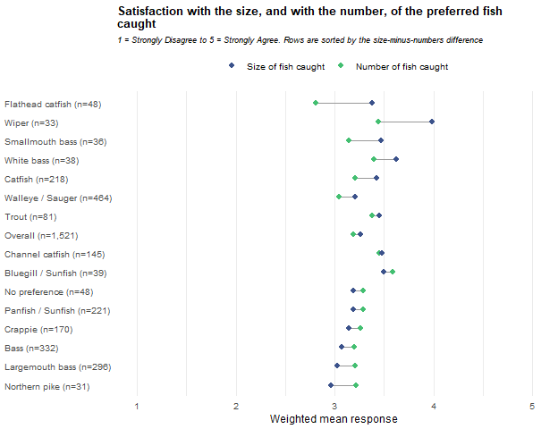
Across all anglers the difference is small (0.07 ± 0.06). The interval only just clears zero, so the average angler is about equally content with size and numbers. The groups are where the separation shows up.
The difference’s confidence interval does not include zero for a number of groups while for 9 groups the interval includes zero. Four groups rate size satisfaction above numbers: Wiper (0.55), Flathead catfish (0.57), Catfish as a family (0.21) and Walleye / Sauger (0.16). For these anglers the weaker satisfaction of the catch is how many fish they are catching, not how large they are. That agrees with Chapter 2, where Flathead catfish anglers had the lowest satisfaction with the number caught of any group, and with Chapter 3, where Walleye / Sauger anglers score above the overall on the numbers attitude. It also explains the result in the previous section about walleye where the season satisfaction and walleye/sauger success ratings are low. Among the catch items it is the number of walleye/sauger the anglers were less satisfied with that their size.
Two groups go the other way, Bass (-0.12) and Largemouth bass (-0.18) – keeping in mind that the Bass group is comprised of largely the Largemouth bass anglers. Bass anglers are comparatively content with how many fish they catch and less so with how large they are, which matches their size-focused attitudes.

Size and numbers: the fish anglers may harvest
Preferred species | Size harvestable | Number harvestable | Difference ± CI | N
Overall | 3.5 ± 0.05 | 3.5 ± 0.05 | 0.00 ± 0.04 | 1,518
Walleye / Sauger | 3.5 ± 0.08 | 3.5 ± 0.08 | 0.01 ± 0.08 | 462
Bass | 3.5 ± 0.10 | 3.5 ± 0.09 | -0.02 ± 0.08 | 330
Largemouth bass | 3.5 ± 0.10 | 3.5 ± 0.10 | -0.02 ± 0.09 | 294
Smallmouth bass | 3.7 ± 0.23 | 3.7 ± 0.24 | -0.03 ± 0.12 | 36
Panfish | 3.6 ± 0.11 | 3.7 ± 0.13 | -0.06 ± 0.12 | 221
Crappie | 3.6 ± 0.12 | 3.7 ± 0.14 | -0.09 ± 0.14 | 171
Bluegill / Sunfish | 3.9 ± 0.28 | 3.9 ± 0.30 | 0.03 ± 0.24 | 38
Catfish | 3.5 ± 0.12 | 3.5 ± 0.12 | -0.04 ± 0.11 | 217
Channel catfish | 3.6 ± 0.13 | 3.6 ± 0.14 | -0.04 ± 0.14 | 146
Flathead catfish | 3.4 ± 0.31 | 3.4 ± 0.28 | 0.04 ± 0.22 | 47
Wiper | 3.3 ± 0.32 | 3.2 ± 0.38 | 0.11 ± 0.35 | 33
White bass | 3.8 ± 0.30 | 3.7 ± 0.32 | 0.06 ± 0.17 | 38
Trout | 3.6 ± 0.22 | 3.5 ± 0.23 | 0.05 ± 0.22 | 81
Northern pike | 2.9 ± 0.42 | 3.2 ± 0.42 | -0.20 ± 0.25 | 31
No preference | 3.2 ± 0.24 | 3.5 ± 0.21 | -0.25 ± 0.24 | 49
The same comparison follows for the fish an angler is allowed to keep. These two items describe the regulations rather than the actual catch so a difference here says something about regulation and not about the fishery. Both mean columns and the difference between the two, by respondent, are presented for respondents that answered both questions. This allows the difference to represent a direct, paired comparison. Confidence intervals are 95%. Family rows include the respondents in their species rows, so rows overlap and must not be totaled.
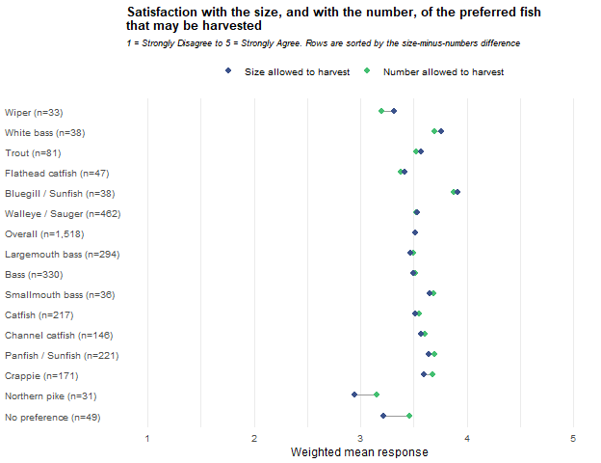
The difference interval lies above zero for none of the groups and below zero for the No preference group. For the remaining 14 groups the interval includes zero. The average angler is as satisfied with the size allowed as with the number allowed by regulation. This does not indicate if they are satisfied or dissatisfied but rather that there is no relative difference between the two objectives. One group is flagged, No preference (-0.25 ± 0.24, 49 respondents), who are happier with the number allowed. With 15 groups compared and no adjustment, one flagged group is about what chance alone would produce, so this result should carry little weight.
The contrast with the previous section is useful. The groups that leaned toward size or toward numbers on the catch (walleye, catfish, Wiper and bass anglers) show no lean on the harvest items. Their differences are about what the fishery delivers, not about how the rules balance size against number. For management considerations that separates the two readings: the catch differences look like a signal about fishery performance, while satisfaction with the harvest rules is fairly even across groups on this comparison.
Even fairness between size and number does not mean every group is equally content with the rules. The next section sets what anglers catch against what they may keep, and there one group, Wiper, stands apart from the rest.

Caught versus allowed
This section compares each angler’s rating of the fish caught with the same angler’s rating of the fish that may be harvested, once for size and once for number. A negative difference means the angler is happier with what the rules allow than with what the water gives.

Size
Preferred species | Size caught | Size harvestable | Difference ± CI | N
Overall | 3.3 ± 0.05 | 3.5 ± 0.05 | -0.25 ± 0.05 | 1,514
Walleye / Sauger | 3.2 ± 0.09 | 3.5 ± 0.08 | -0.32 ± 0.09 | 460
Bass | 3.1 ± 0.11 | 3.5 ± 0.10 | -0.42 ± 0.11 | 331
Largemouth bass | 3.0 ± 0.12 | 3.5 ± 0.10 | -0.45 ± 0.12 | 295
Smallmouth bass | 3.5 ± 0.31 | 3.7 ± 0.23 | -0.20 ± 0.36 | 36
Panfish | 3.2 ± 0.15 | 3.6 ± 0.11 | -0.45 ± 0.14 | 221
Crappie | 3.1 ± 0.17 | 3.6 ± 0.12 | -0.45 ± 0.16 | 171
Bluegill / Sunfish | 3.5 ± 0.35 | 3.9 ± 0.28 | -0.42 ± 0.29 | 38
Catfish | 3.4 ± 0.14 | 3.5 ± 0.12 | -0.09 ± 0.13 | 216
Channel catfish | 3.5 ± 0.18 | 3.6 ± 0.13 | -0.10 ± 0.14 | 145
Flathead catfish | 3.4 ± 0.29 | 3.4 ± 0.31 | -0.04 ± 0.35 | 47
Wiper | 4.0 ± 0.35 | 3.3 ± 0.32 | 0.67 ± 0.40 | 33
White bass | 3.6 ± 0.34 | 3.8 ± 0.30 | -0.13 ± 0.19 | 38
Trout | 3.4 ± 0.19 | 3.6 ± 0.22 | -0.12 ± 0.18 | 80
Northern pike | 3.0 ± 0.39 | 2.9 ± 0.42 | 0.02 ± 0.44 | 31
No preference | 3.2 ± 0.27 | 3.2 ± 0.24 | -0.03 ± 0.17 | 48
Two questions ask about the size of the preferred fish, one for the fish caught and one for the fish that may be harvested. The difference reported is size caught minus size harvestable. Both mean columns and the difference are computed on the same respondents who answered both items, so the difference is a paired comparison and equals the difference of the two means shown. Intervals are 95% and are not adjusted for the number of groups compared.
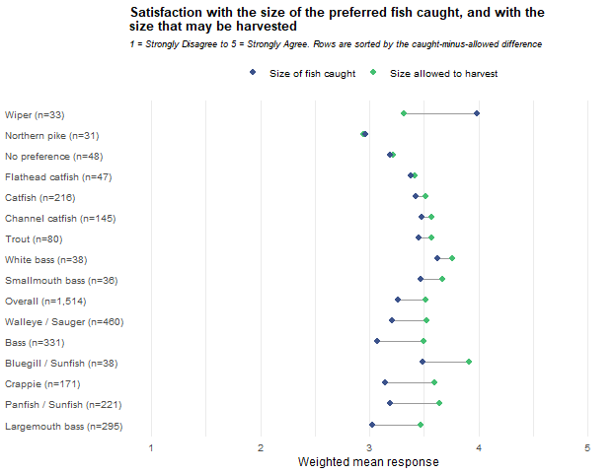

Number
Preferred species | Number caught | Number harvestable | Difference ± CI | N
Overall | 3.2 ± 0.06 | 3.5 ± 0.05 | -0.33 ± 0.05 | 1,521
Walleye / Sauger | 3.0 ± 0.11 | 3.5 ± 0.08 | -0.47 ± 0.10 | 463
Bass | 3.2 ± 0.12 | 3.5 ± 0.09 | -0.32 ± 0.11 | 330
Largemouth bass | 3.2 ± 0.12 | 3.5 ± 0.10 | -0.29 ± 0.11 | 294
Smallmouth bass | 3.1 ± 0.39 | 3.7 ± 0.24 | -0.57 ± 0.36 | 36
Panfish | 3.3 ± 0.15 | 3.7 ± 0.13 | -0.40 ± 0.14 | 222
Crappie | 3.3 ± 0.16 | 3.7 ± 0.14 | -0.41 ± 0.15 | 171
Bluegill / Sunfish | 3.6 ± 0.41 | 3.9 ± 0.30 | -0.30 ± 0.38 | 39
Catfish | 3.2 ± 0.16 | 3.5 ± 0.12 | -0.34 ± 0.15 | 217
Channel catfish | 3.4 ± 0.18 | 3.6 ± 0.14 | -0.16 ± 0.15 | 146
Flathead catfish | 2.8 ± 0.38 | 3.4 ± 0.28 | -0.58 ± 0.35 | 47
Wiper | 3.4 ± 0.35 | 3.2 ± 0.38 | 0.24 ± 0.45 | 33
White bass | 3.4 ± 0.38 | 3.7 ± 0.32 | -0.30 ± 0.23 | 38
Trout | 3.4 ± 0.22 | 3.5 ± 0.23 | -0.11 ± 0.24 | 83
Northern pike | 3.2 ± 0.50 | 3.2 ± 0.42 | 0.06 ± 0.56 | 31
No preference | 3.3 ± 0.27 | 3.5 ± 0.21 | -0.20 ± 0.18 | 49
Two questions repeat the comparison for the number of fish. The difference is number caught minus number harvestable. Both mean columns and the difference are computed on the same respondents who answered both items, so the difference is a paired comparison and equals the difference of the two means shown. Intervals are 95% and are not adjusted for the number of groups compared.
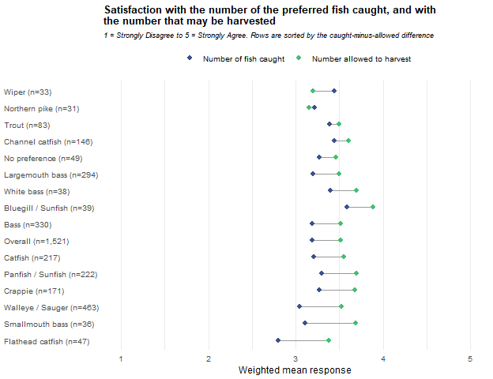
Across all anglers the allowed side is rated above the catch side, for size (-0.25 ± 0.05) and for number (-0.33 ± 0.05). The pattern is broad rather than driven by a few groups. On size, 6 groups are flagged (Walleye / Sauger, Bass, Largemouth bass, Panfish, Crappie and Bluegill / Sunfish) and every one goes the same way. On number, 11 of the 15 groups are flagged and again none goes the other way. A consistent finding is that the harvest rules draw less complaint than the catch does
The size of the gap depends on the group in a way that matches the catch results above. Walleye / Sauger anglers have a larger gap on number (-0.47) than on size (-0.32), which fits their shortfall in numbers caught. Bass anglers show the reverse, a larger gap on size (-0.42) than on number (-0.32), which fits their lower satisfaction with the size they catch. Catfish anglers are not flagged on size (-0.09 ± 0.13) but are on number (-0.34 ± 0.15), so their gap is a numbers gap only.
Wiper anglers are the exception, and only on size. They rate the size they catch above the size they may keep (0.67 ± 0.40, 33 respondents), and they are the only group with a positive size difference. On number they are not separated from zero (0.24 ± 0.45). The result sits comfortably with the rest of the Wiper profile. They are the group most satisfied with the size of fish they catch (4.0), the most supportive of regulations to increase size and the most willing to harvest fewer fish for larger ones (both in Chapter 2). Their rating of the size they may keep is lower, at 3.3.
Two cautions apply. The Wiper estimate rests on 33 respondents, and although its interval stays above zero (the lower end is 0.27), the size of the gap is less certain than its direction. And these are 30 comparisons (15 groups, two items) with no adjustment, so a handful of flagged groups could appear by chance alone. The number flagged here is far larger than that, which is why the overall pattern can be trusted, and Wiper stands out because every other flagged group points the other way.

Chapter 6: Angler Type Profiles
Chapters 1 to 5 divided every question in the survey by the fish anglers prefer to catch. That is a natural approach for species management but a species column is a mixture of people: some anglers who prefer walleye keep fish for the freezer, while others fish for the challenge and release what they catch. Aggregating anglers solely by choice of preferred species can mask other differences among anglers. This chapter turns things around and groups anglers by what they want from fishing rather than by what they fish for using the eleven attitude, motivation and regulation scale scores from the survey respondents.
This analysis attempts to answer two questions. First, what distinct angler types are there among anglers who stated a species preference? The model described below finds 6 profiles, and each is described with the scale scores that set it apart and a sketch of the angler it depicts. Second, how are those profiles spread across the preferred-species groups? The short answer is that every family group contains all 6 types in proportions that vary from group to group, more for some than for others. Managing for a species therefore means serving a mix of angler types, and the cards spell out what that mix looks like group by group.
The profiles are built from stated attitudes and motivations rather than from observed behavior and the labels and personas attached to them are interpretive summaries rather than measured categories. Also, preferred-species groups were dropped from reporting when their effective sample size fell below 30 (rather than the minimum sample size). This change was meant to eliminate reporting profiling by subdividing groups already low on sample size and potentially examining artifacts as meaningful results.
This chapter groups anglers into profiles using a latent profile analysis of eleven scale scores also reported in Chapter 3: the four angler-attitude scales, the four motivation scales, and the three regulation scales. One model is fitted to the whole report’s sample, so the profiles are defined once and are used universally in every preferred-species group; the tables below report how each group’s respondents are distributed across them. The model is fitted without the survey weights. Every percentage and mean reported from it is weighted, with intervals built on the Kish effective N and raw unweighted counts are displayed.
Of all 1,915 survey respondents, 1,718 (89.7%) answered at least 7 of the eleven scales and were included in the model fitting. Scales that a fitted respondent left blank are handled within the model rather than using imputed. The other 197 respondents are reported as Unassigned rather than dropped. Profiles are numbered 1 to 6 in the order the estimation produced them therefore the numbers are labels and carry no meaning.

Choosing the number of profiles
Separate models with 1 to 6 profiles were fitted under two within-profile variance structures: equal, in which every profile shares one variance per scale, and varying, in which each profile has its own. The equal structure was extended to 8 profiles as models continued to converge. When using BIC, lower values indicate better fit. Relative entropy runs from 0 to 1, with 1 meaning every respondent is assigned with certainty. The lowest mean assigned probability is the average membership probability among the respondents assigned to a profile, for the profile where that average is smallest. OpenMx status 0 or 1 indicates the estimation converged. All values in this table are unweighted model quantities. The model used in the rest of this chapter is the one with the lowest BIC among models that converged, whose smallest profile holds at least 5% of fitted respondents, and whose relative entropy is at least 0.60. The use of a 5% floor was subjective and meant to keep the number of profiles to an interpretable level. The model selected was the 6-profile equal-variance model.
Variances | Profiles | Parameters | Log-likelihood | BIC | Relative entropy | Smallest profile n (%) | Lowest mean assigned probability | OpenMx status | Eligible
Equal | 1 | 22 | -22,120.2 | 44,404.4 | — | 1,718 (100.0%) | — | 0 | Yes
Equal | 2 | 34 | -21,292.3 | 42,837.9 | 0.707 | 805 (46.9%) | 0.912 | 0 | Yes
Equal | 3 | 46 | -20,881.1 | 42,104.8 | 0.724 | 394 (22.9%) | 0.851 | 0 | Yes
Equal | 4 | 58 | -20,507.0 | 41,446.1 | 0.761 | 303 (17.6%) | 0.853 | 0 | Yes
Equal | 5 | 70 | -20,285.6 | 41,092.5 | 0.750 | 262 (15.3%) | 0.799 | 0 | Yes
Equal | 6 | 82 | -20,179.0 | 40,968.9 | 0.747 | 120 (7.0%) | 0.759 | 0 | Yes (selected)
Equal | 7 | 94 | -20,037.2 | 40,774.7 | 0.766 | 71 (4.1%) | 0.776 | 0 | No: smallest profile below 5%
Equal | 8 | 106 | -19,964.0 | 40,717.5 | 0.769 | 57 (3.3%) | 0.788 | 0 | No: smallest profile below 5%
Varying | 1 | 22 | -22,120.2 | 44,404.4 | — | 1,718 (100.0%) | — | 0 | Yes
Varying | 2 | 45 | -21,223.0 | 42,781.2 | 0.723 | 754 (43.9%) | 0.908 | 0 | Yes
Varying | 3 | 68 | -20,774.8 | 42,056.2 | 0.746 | 436 (25.4%) | 0.867 | 0 | Yes
Varying | 4 | 91 | -20,430.3 | 41,538.5 | 0.771 | 297 (17.3%) | 0.848 | 0 | Yes
Varying | 5 | 114 | -19,229.3 | 39,307.8 | 0.836 | 244 (14.2%) | 0.859 | 6 | No: not converged
Varying | 6 | 137 | -18,863.0 | 38,746.6 | 0.822 | 228 (13.3%) | 0.800 | 6 | No: not converged
The four models with a lower BIC than the selected model are not eligible. The 7- and 8-profile equal-variance models converged, but their smallest profiles hold 4.1 and 3.3 percent of fitted respondents. BIC is lower at every larger equal-variance model fitted, so the selected model is the largest eligible equal-variance model rather than the point at which BIC stops decreasing. The 5- and 6-profile varying-variance models did not converge.

Assignment certainty
Each fitted respondent is assigned to the profile with the highest estimated membership probability. The table below shows how certain those assignments are by the number of scales the respondent answered. The values are unweighted model quantities for the 1,718 fitted respondents.
Scales answered (of 11) | Respondents (n) | Mean probability of assigned profile | Assigned with probability below 0.70
11 | 1,373 | 0.839 | 23.5%
10 | 209 | 0.799 | 32.1%
7-9 | 136 | 0.722 | 44.9%

The vast majority of respondents used in fitting answered all questions used in the model. As less items were answered, uncertainty rose in assignments; however, the preponderance of respondents had above a 0.0 probability for their membership assignment.

Profile means
The two figures below show the weighted mean of each scale for the respondents assigned to each profile with 95% confidence intervals. These are weighted means of the assigned respondents to adjust for population size and not the unweighted means the model estimated for each profile. The first figure places the profiles side by side across the eleven scales.
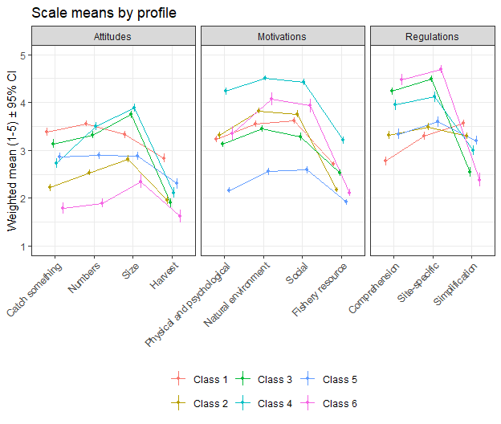
The second figure shows one panel per scale with the profiles along the horizontal axis. The Overall weighted mean for every respondent who answered that scale is shown as a dashed line.
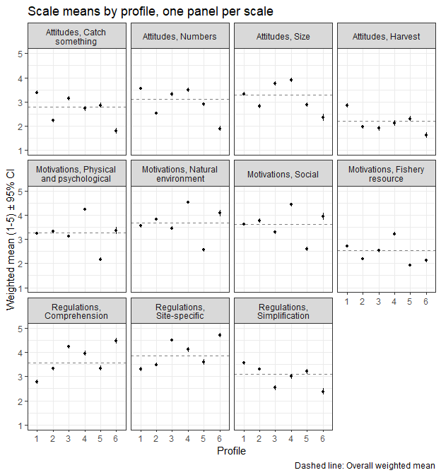

The values behind both figures are below. The Overall column is computed on every respondent in the group who answered the scale, including Unassigned respondents. Cells are the weighted mean for the row group with a 95% confidence interval followed by the raw unweighted number of respondents contributing to that cell. These results were weighted. Please consult the survey methodology for details.
 |  |  |  |  |  |  |  | 
Domain | Scale | Overall | Class 1 | Class 2 | Class 3 | Class 4 | Class 5 | Class 6
Attitudes | Catch something | 2.8 ± 0.05 (1,704) | 3.4 ± 0.08 (355) | 2.2 ± 0.07 (344) | 3.1 ± 0.09 (291) | 2.7 ± 0.10 (280) | 2.9 ± 0.09 (307) | 1.8 ± 0.12 (116)
Attitudes | Numbers | 3.1 ± 0.04 (1,670) | 3.6 ± 0.06 (350) | 2.5 ± 0.06 (339) | 3.3 ± 0.08 (286) | 3.5 ± 0.08 (274) | 2.9 ± 0.08 (298) | 1.9 ± 0.10 (116)
Attitudes | Size | 3.3 ± 0.04 (1,695) | 3.3 ± 0.08 (358) | 2.8 ± 0.07 (341) | 3.7 ± 0.08 (286) | 3.9 ± 0.09 (280) | 2.9 ± 0.08 (305) | 2.4 ± 0.14 (117)
Attitudes | Harvest | 2.2 ± 0.05 (1,653) | 2.8 ± 0.09 (347) | 2.0 ± 0.09 (334) | 1.9 ± 0.09 (282) | 2.1 ± 0.11 (267) | 2.3 ± 0.11 (296) | 1.6 ± 0.13 (118)
Motivations | Physical and psychological | 3.3 ± 0.04 (1,712) | 3.2 ± 0.06 (350) | 3.3 ± 0.07 (333) | 3.1 ± 0.06 (281) | 4.2 ± 0.07 (277) | 2.2 ± 0.07 (299) | 3.4 ± 0.14 (111)
Motivations | Natural environment | 3.7 ± 0.04 (1,710) | 3.5 ± 0.07 (343) | 3.8 ± 0.06 (329) | 3.5 ± 0.07 (284) | 4.5 ± 0.06 (281) | 2.6 ± 0.07 (295) | 4.1 ± 0.13 (117)
Motivations | Social | 3.6 ± 0.04 (1,710) | 3.6 ± 0.06 (348) | 3.8 ± 0.08 (332) | 3.3 ± 0.08 (284) | 4.4 ± 0.07 (274) | 2.6 ± 0.08 (293) | 3.9 ± 0.15 (116)
Motivations | Fishery resource | 2.5 ± 0.03 (1,715) | 2.7 ± 0.05 (349) | 2.2 ± 0.05 (326) | 2.5 ± 0.06 (284) | 3.2 ± 0.08 (279) | 1.9 ± 0.06 (295) | 2.1 ± 0.08 (118)
Regulations | Comprehension | 3.6 ± 0.05 (1,680) | 2.8 ± 0.09 (353) | 3.3 ± 0.08 (337) | 4.2 ± 0.08 (281) | 4.0 ± 0.11 (277) | 3.3 ± 0.10 (302) | 4.5 ± 0.11 (117)
Regulations | Site-specific | 3.9 ± 0.05 (1,679) | 3.3 ± 0.08 (350) | 3.5 ± 0.08 (335) | 4.5 ± 0.07 (283) | 4.1 ± 0.10 (282) | 3.6 ± 0.10 (303) | 4.7 ± 0.09 (117)
Regulations | Simplification | 3.1 ± 0.04 (1,666) | 3.6 ± 0.07 (350) | 3.3 ± 0.07 (338) | 2.5 ± 0.10 (278) | 3.0 ± 0.10 (278) | 3.2 ± 0.10 (300) | 2.4 ± 0.14 (113)

Profiles on other survey questions
The table below compares the profiles on their responses to other survey questions. Each question was gated the same as in Chapter 3 so N differs by row. Unassigned respondents are counted in Overall only and have no column of their own. The river and stream row combines three Chapter 3 waterbody types and includes a respondent who fished the Missouri River, the Platte River, or other streams, rivers, and canals. Percentage and mean cells show the weighted value with a 95% confidence interval, followed by N (unweighted raw count). Median cells show the lower limit, the weighted median and the upper limit, followed by N (unweighted raw count. Satisfaction is scored from 1, Very satisfied, to 5, Very dissatisfied. These results were weighted. Please consult the survey methodology for details.
Measure | Overall | Class 1 | Class 2 | Class 3 | Class 4 | Class 5 | Class 6
Days fished in 2025, mean | 30.2 ± 1.78 (1,834) | 28.6 ± 3.28 (357) | 26.8 ± 3.89 (336) | 35.6 ± 4.57 (286) | 45.4 ± 5.86 (280) | 17.4 ± 3.06 (302) | 21.1 ± 3.99 (120)
Days fished in 2025, median | 16.0/17.0/19.0 (1,834) | 17.0/19.0/22.0 (357) | 10.5/14.0/18.0 (336) | 20.0/24.0/30.0 (286) | 27.0/31.0/36.5 (280) | 6.0/7.0/10.0 (302) | 9.0/13.0/19.0 (120)
Fished at least one tournament, % | 3.0 ± 0.86 (1,908) | 3.4 ± 2.08 (360) | 1.3 ± 1.32 (346) | 4.0 ± 2.49 (291) | 5.3 ± 2.85 (286) | 2.3 ± 1.90 (309) | 0.6 ± 1.52 (120)
Hired a fishing guide, % | 8.1 ± 1.38 (1,891) | 11.6 ± 3.67 (361) | 5.3 ± 2.67 (341) | 13.9 ± 4.43 (287) | 8.1 ± 3.48 (286) | 5.5 ± 2.90 (308) | 4.6 ± 4.12 (120)
Fished from a motorized boat, % | 51.1 ± 2.54 (1,865) | 57.4 ± 5.68 (359) | 49.1 ± 6.00 (336) | 58.4 ± 6.33 (286) | 57.1 ± 6.37 (280) | 43.6 ± 6.35 (302) | 40.6 ± 9.74 (118)
Fished from a kayak or canoe, % | 17.7 ± 1.94 (1,865) | 16.8 ± 4.29 (359) | 20.3 ± 4.83 (336) | 22.5 ± 5.36 (286) | 24.2 ± 5.51 (280) | 8.4 ± 3.56 (302) | 17.4 ± 7.52 (118)
Ice fished, % | 17.7 ± 1.94 (1,865) | 21.2 ± 4.69 (359) | 12.3 ± 3.94 (336) | 20.5 ± 5.18 (286) | 24.3 ± 5.52 (280) | 9.4 ± 3.73 (302) | 18.1 ± 7.65 (118)
Fished the Missouri River, Platte River, or other streams and rivers, % | 36.0 ± 2.44 (1,858) | 37.1 ± 5.56 (357) | 33.9 ± 5.68 (335) | 35.7 ± 6.16 (286) | 47.4 ± 6.46 (277) | 25.4 ± 5.59 (301) | 29.0 ± 9.01 (118)
Fished a water requiring a Park Entry Permit, % | 69.0 ± 2.33 (1,898) | 68.3 ± 5.33 (361) | 68.0 ± 5.53 (345) | 71.2 ± 5.79 (289) | 77.0 ± 5.37 (285) | 55.7 ± 6.32 (307) | 71.4 ± 8.90 (120)
Used private areas to fish or launch, % | 28.6 ± 2.50 (1,553) | 28.2 ± 5.75 (287) | 29.0 ± 5.99 (276) | 35.0 ± 6.53 (249) | 28.7 ± 6.22 (244) | 28.2 ± 6.45 (242) | 27.4 ± 9.62 (99)
Fished outside Nebraska, % | 44.1 ± 2.51 (1,884) | 47.5 ± 5.79 (352) | 41.3 ± 5.87 (342) | 50.2 ± 6.43 (286) | 54.9 ± 6.36 (284) | 28.9 ± 5.76 (307) | 34.3 ± 9.34 (120)
One-way miles to most visited water, median | 30/30/30 (1,877) | 30/30/30 (360) | 30/30/50 (342) | 16/16/30 (288) | 16/30/30 (282) | 16/30/30 (309) | 16/16/16 (117)
Overall fishing satisfaction, mean (1 = Very satisfied, 5 = Very dissatisfied) | 2.3 ± 0.06 (1,871) | 2.6 ± 0.13 (359) | 2.1 ± 0.12 (336) | 2.3 ± 0.14 (287) | 2.2 ± 0.15 (285) | 2.4 ± 0.13 (305) | 1.7 ± 0.19 (118)
Used live-imaging sonar, % | 14.5 ± 1.78 (1,878) | 15.5 ± 4.17 (357) | 12.6 ± 3.96 (339) | 16.1 ± 4.72 (286) | 21.4 ± 5.25 (282) | 7.7 ± 3.40 (307) | 11.4 ± 6.31 (118)
Female, % | 19.5 ± 2.06 (1,801) | 18.2 ± 4.42 (362) | 28.2 ± 5.33 (346) | 12.7 ± 4.24 (291) | 14.5 ± 4.49 (286) | 19.1 ± 4.99 (308) | 28.1 ± 8.92 (118)
Age, mean | 46.0 ± 0.88 (1,777) | 46.9 ± 1.80 (358) | 48.5 ± 1.96 (337) | 44.6 ± 2.05 (292) | 39.2 ± 1.94 (286) | 52.4 ± 2.33 (302) | 48.4 ± 3.10 (117)

The six profiles
The six profiles are listed below with the icon that marks each profile’s column in the tables of this chapter. Shares are weighted percentages of respondents; N is the number of respondents assigned to the profile. Appendix B reports profile sizes as unweighted shares of the respondents fitted.
 | Profile | Label | Share of respondents | N
 | Class 1 | The harvest-minded, keep-it-simple angler | 18.3% | 362
 | Class 2 | The relaxed, catch-optional angler | 16.7% | 347
 | Class 3 | The regulation-savvy catch-and-release sport angler | 15.9% | 292
 | Class 4 | The all-in enthusiast | 18.2% | 286
 | Class 5 | The low-involvement angler | 13.4% | 311
 | Class 6 | The conservation-minded purist | 6.0% | 120
The paragraphs below describe each profile by the scales on which it differs most from the Overall mean. Means are the weighted means in the profile means table; the figure after each mean is its distance from the Overall mean in standard deviations of the Overall weighted distribution (SD). Two scale names need a note: the Fishery resource motivation scale is made up of catch outcomes (competing for prizes, obtaining fish to eat, catching a trophy, the fun of catching), and the Simplification regulation scale measures agreement with uniform statewide or regional regulations. The other regulation scales, Comprehension and Site-specific, are described in the text as comprehension of the rules and support for site-specific rules. Species shares are the row percentages from the profiles-by-preferred-species table at the end of this chapter with their confidence intervals. The label and the picture in each paragraph are an interpretive summary of the eleven scale scores and represent a possible interpretation of the profile.
The second paragraph for each profile compares it with the Overall column on the other survey questions in the table above. The values quoted are from that table and its confidence intervals show that several of the differences described are small relative to their precision. Where a family group makes up at least 5 percentage points more of a profile than of all assigned respondents, the paragraph names it, unless its row is below the effective-N floor and therefore not shown, because questions that vary by species may partly reflect that mix rather than the profile itself.

Class 1: The harvest-minded, keep-it-simple angler
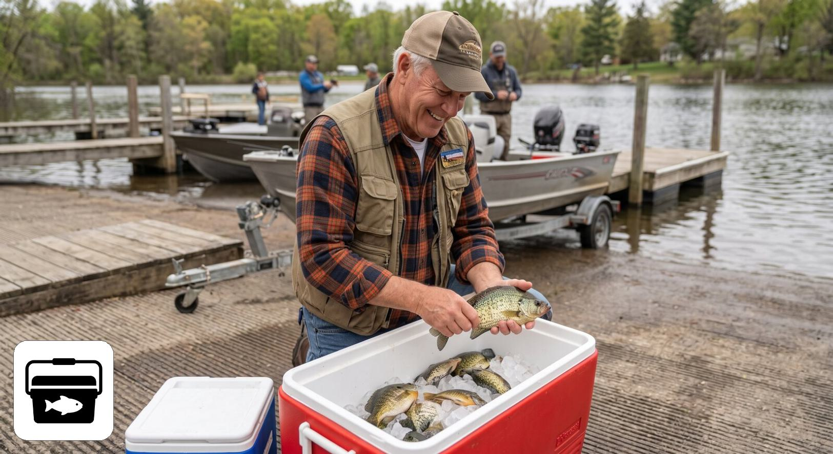
Class 1: The harvest-minded, keep-it-simple angler
Class 1 holds 18.3% of respondents (n = 362). It has the highest harvest score of any profile (2.8, +0.75 SD) and is above average on needing to catch something (3.4) and on catching many fish (3.6). Size matters no more than average (3.3), and its motivations sit near the Overall means. What sets it apart is regulations: it reports the least comprehension of the rules (2.8, -0.87 SD), the least support for site-specific rules (3.3), and the strongest preference for uniform statewide rules (3.6, +0.59 SD). Picture someone who fishes for a meal, measures a trip by what goes in the cooler, and finds a patchwork of lake-specific rules confusing. Class 1 makes up 26.3% ± 4.3 of Walleye / Sauger, 25.2% ± 7.1 of Crappie and 23.0% ± 6.0 of Panfish anglers, against 18.3% overall.
On the other survey questions, Class 1 fishes about as often as anglers overall (mean days 28.6, against 30.2 overall). It is more likely than average to have hired a guide (11.6%, against 8.1% overall), to have ice fished (21.2%, against 17.7% overall) and to have fished from a motorized boat (57.4%, against 51.1% overall). It reports the lowest overall satisfaction of any profile (mean 2.6, against 2.3 overall, where higher means less satisfied). Its species mix leans toward Walleye / Sauger (34.1% of the profile, against 24.3% of all assigned respondents), so differences on questions that vary by species may partly reflect that mix rather than the profile itself.

Class 2: The relaxed, catch-optional angler
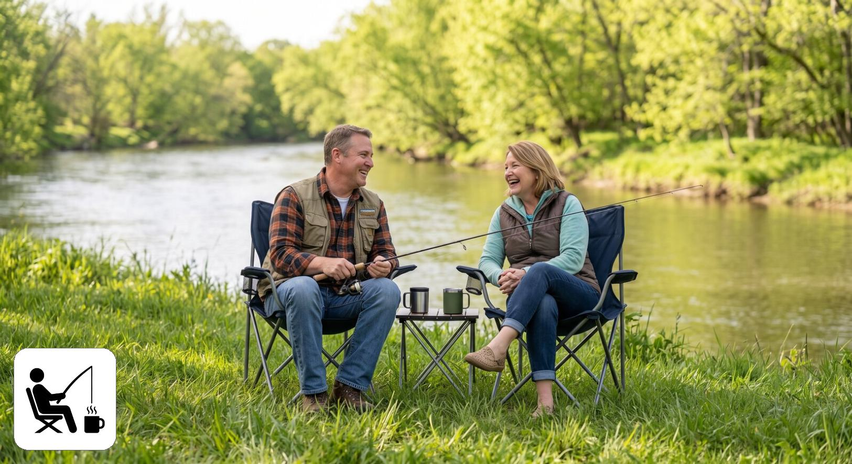
Class 2: The relaxed, catch-optional angler
Class 2 holds 16.7% of respondents (n = 347). It is below average on all four catch attitudes: catch something 2.2, numbers 2.5, size 2.8, harvest 2.0. Its lowest motivation is the fishery resource (2.2, -0.52 SD), while the natural environment (3.8) and social (3.8) motivations run slightly above average. Its regulation scores are middling, with a slight lean toward uniform rules (3.3). Picture someone who goes for the day out, the company and the water, and for whom a fishless trip is not a failed trip. Class 2 makes up 25.2% ± 5.2 of No preference and 22.6% ± 9.8 of Trout anglers, against 16.7% overall.
On the other survey questions, Class 2 fishes less often than average (median days 14.0, against 17.0 overall) and seldom fishes tournaments (1.3%, against 3.0% overall). It ice fishes less often than average (12.3%, against 17.7% overall) and is more satisfied than average (mean 2.1, against 2.3 overall). Together with Class 6 it has the highest share of women of any profile (28.2%, and 28.1% in Class 6, against 19.5% overall). Its species mix leans toward No preference (27.0% of the profile, against 17.7% of all assigned respondents), so differences on questions that vary by species may partly reflect that mix rather than the profile itself.

Class 3: The regulation-savvy catch-and-release sport angler
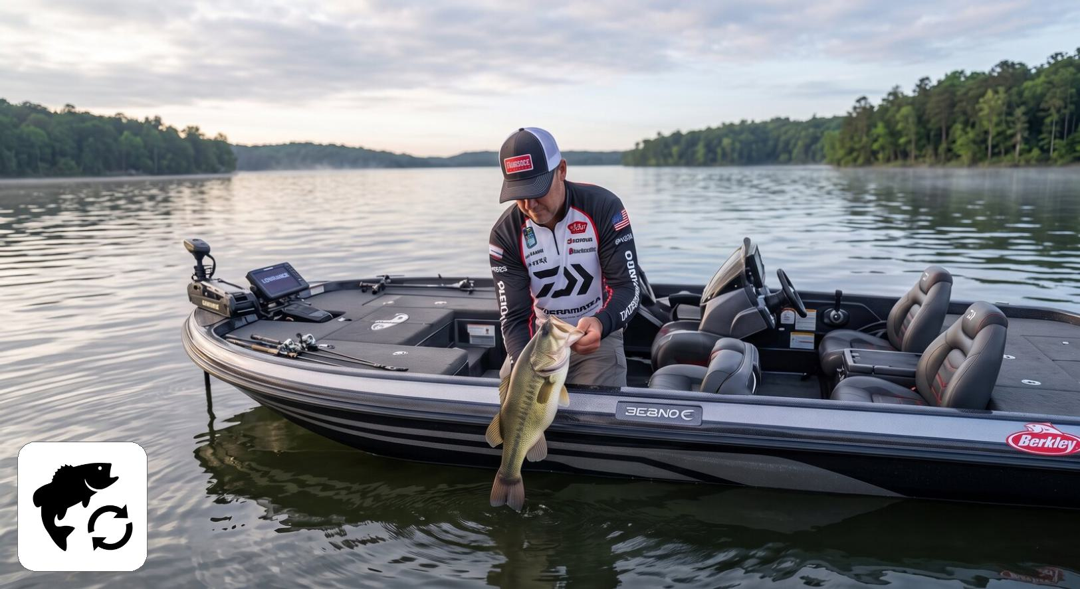
Class 3: The regulation-savvy catch-and-release sport angler
Class 3 holds 15.9% of respondents (n = 292). It is above average on size (3.7, +0.56 SD) and on needing a catch (3.1), but below average on harvest (1.9): it wants a fish on the line, preferably a good one, and then lets it go. Its motivations are at or slightly below average (social 3.3, -0.39 SD). It is strongly engaged with regulations, with high comprehension (4.2, +0.71 SD), high support for site-specific rules (4.5, +0.76 SD), and a low preference for uniform rules (2.5, -0.68 SD). Picture an angler, often a bass angler, who reads the regulations and values rules tailored to each lake. Class 3 makes up 23.0% ± 4.8 of Bass, 24.0% ± 5.2 of Largemouth bass and 24.1% ± 13.1 of Flathead catfish anglers, against 15.9% overall.
On the other survey questions, Class 3 fishes more often than average (mean days 35.6, against 30.2 overall; median 24.0, against 17.0 overall). It has the highest rate of hiring a guide of any profile (13.9%, against 8.1% overall) and the highest use of private areas (35.0%, against 28.6% overall); its tournament participation is close to the overall rate (4.0%, against 3.0% overall). Its median distance to its most visited water is 16 miles, against 30 overall, and it has the lowest share of women of any profile (12.7%, against 19.5% overall). Its species mix leans toward Bass (30.0% of the profile, against 21.0% of all assigned respondents), so differences on questions that vary by species may partly reflect that mix rather than the profile itself.

Class 4: The all-in enthusiast
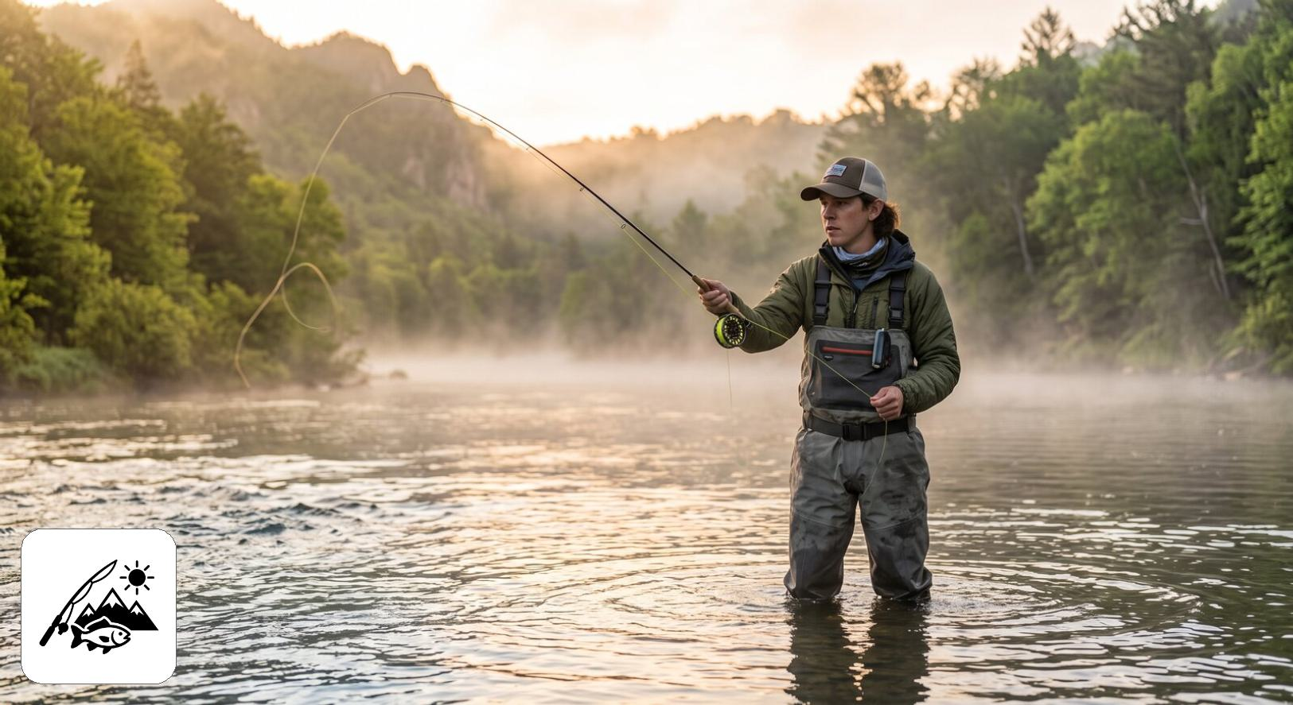
Class 4: The all-in enthusiast
Class 4 holds 18.2% of respondents (n = 286). It has the highest score of any profile on all four motivations: physical and psychological (4.2, +1.15 SD), natural environment (4.5, +1.04 SD), social (4.4, +0.98 SD), and fishery resource (3.2, +1.05 SD). It is also the most size-oriented profile (3.9, +0.74 SD) and is above average on numbers (3.5), with average scores on needing a catch (2.7) and on harvest (2.1). Its support for site-specific rules is above average (4.1). The fishery resource scale, on which no other profile scores as high, includes competing for prizes or money. Picture the angler for whom fishing is a central hobby: every reason to go matters, trophies and tournament competition included. Class 4 makes up 33.8% ± 15.7 of Smallmouth bass anglers, against 18.2% overall.
On the other survey questions, Class 4 is the most active profile and the one most likely to fish tournaments (5.3%, against 3.0% overall), although tournament anglers remain a small share of it. It has the highest mean days fished (45.4, against 30.2 overall) and median days fished (31.0, against 17.0 overall), and the highest rates of any profile for using a kayak or canoe (24.2%, against 17.7% overall), ice fishing (24.3%, against 17.7% overall), fishing rivers and streams (47.4%, against 36.0% overall), fishing waters that require a Park Entry Permit (77.0%, against 69.0% overall), fishing outside Nebraska (54.9%, against 44.1% overall) and using live-imaging sonar (21.4%, against 14.5% overall). It is also the youngest profile (mean age 39.2, against 46.0 overall).

Class 5: The low-involvement angler
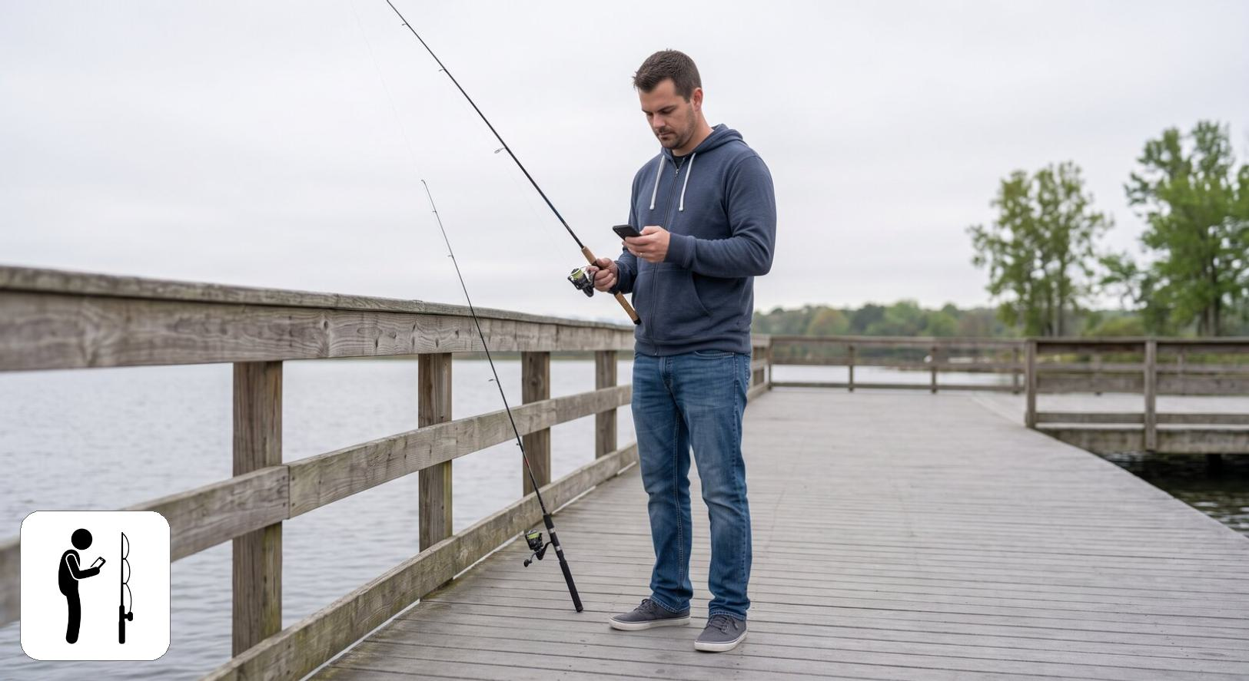
Class 5: The low-involvement angler
Class 5 holds 13.4% of respondents (n = 311). It has the lowest score of any profile on all four motivations: physical and psychological (2.2, -1.33 SD), natural environment (2.6, -1.37 SD), social (2.6, -1.22 SD), and fishery resource (1.9, -0.92 SD). It is near average on needing a catch (2.9) and on harvest (2.3), below average on numbers (2.9, -0.27 SD) and size (2.9, -0.50 SD), and close to average on the three regulation scales. Picture a license holder for whom fishing is incidental rather than a pursuit in its own right. Uniformly low importance ratings can also reflect how a respondent uses the rating scale. Class 5 makes up 19.7% ± 4.7 of No preference anglers, against 13.4% overall.
On the other survey questions, Class 5 is the least active profile. It has the lowest mean days fished (17.4, against 30.2 overall) and median days fished (7.0, against 17.0 overall), and the lowest rates of any profile for using a kayak or canoe (8.4%, against 17.7% overall), ice fishing (9.4%, against 17.7% overall), fishing rivers and streams (25.4%, against 36.0% overall), fishing waters that require a Park Entry Permit (55.7%, against 69.0% overall), fishing outside Nebraska (28.9%, against 44.1% overall) and using live-imaging sonar (7.7%, against 14.5% overall). It is the oldest profile (mean age 52.4, against 46.0 overall). Its species mix leans toward No preference (26.3% of the profile, against 17.7% of all assigned respondents), so differences on questions that vary by species may partly reflect that mix rather than the profile itself.

Class 6: The conservation-minded purist
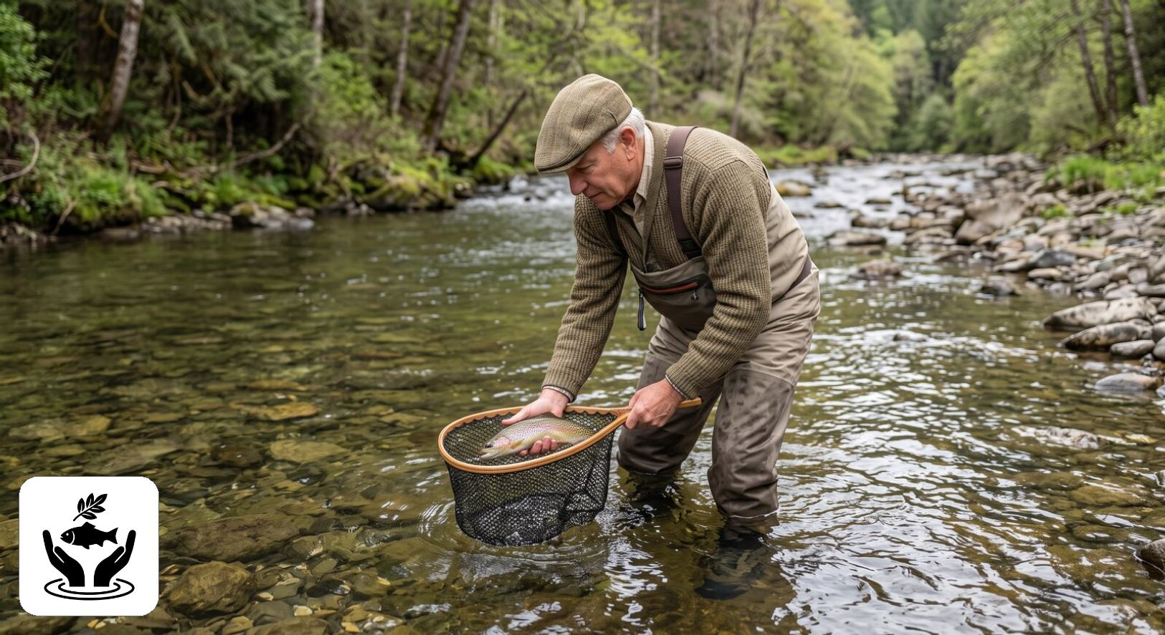
Class 6: The conservation-minded purist
Class 6 holds 6.0% of respondents (n = 120), the smallest profile. It has the lowest score of any profile on all four catch attitudes: catch something 1.8, numbers 1.9 (-1.58 SD), size 2.4, harvest 1.6; catching and keeping fish are close to irrelevant to it. It is motivated by the natural environment (4.1) and by social reasons (3.9) but not by the fishery resource (2.1). It has the highest comprehension of the rules (4.5) and support for site-specific rules (4.7) of any profile, and the lowest preference for uniform rules (2.4). Picture someone who values the experience and well-managed waters over the catch. Class 6 makes up 1.7% ± 1.3 of Walleye / Sauger anglers, its smallest share of any displayed family group; its largest share of any displayed row is 13.8% ± 11.5 of Bluegill / Sunfish anglers.
On the other survey questions, Class 6 fishes less often than average (median days 13.0, against 17.0 overall) and has the lowest rates of any profile for fishing tournaments (0.6%, against 3.0% overall), hiring a guide (4.6%, against 8.1% overall) and fishing from a motorized boat (40.6%, against 51.1% overall). Its median distance to its most visited water is 16 miles, against 30 overall. It reports the highest overall satisfaction of any profile (mean 1.7, against 2.3 overall, where lower means more satisfied), and, with Class 2, the highest share of women (28.1%, against 19.5% overall). With 120 respondents it is the smallest profile, and most of its intervals in the table are correspondingly wide. Its species mix leans toward No preference (28.2% of the profile, against 17.7% of all assigned respondents), Panfish (17.9% of the profile, against 10.7% of all assigned respondents), and Bass (26.5% of the profile, against 21.0% of all assigned respondents), so differences on questions that vary by species may partly reflect that mix rather than the profile itself.

Profiles by preferred species
The table below gives, for each preferred-species group, the weighted percentage of its respondents assigned to each profile with Unassigned as a column so that each row sums to 100. Preferred-species groups below the effective-N floor of 30 are not shown (3 rows): Wiper (35 respondents, effective N 28.6); White bass (39 respondents, effective N 29.8); Northern pike (32 respondents, effective N 26.9). Their respondents are included in the model fit and in the Overall row. This is the only chapter of the report that withholds preferred-species groups; the effective-N floor was set before the model was fitted. Cells are the weighted percentage of the row group giving that response, with a 95% percent confidence interval. N is the raw unweighted number of respondents in the row group who answered the question. These results were weighted. Please consult the survey methodology for details.
Preferred species | Class 1 | Class 2 | Class 3 | Class 4 | Class 5 | Class 6 | Unassigned | N
Overall | 18.3 ± 1.94 | 16.7 ± 1.87 | 15.9 ± 1.83 | 18.2 ± 1.94 | 13.4 ± 1.71 | 6.0 ± 1.19 | 11.6 ± 1.60 | 1,915
Walleye / Sauger | 26.3 ± 4.30 | 15.4 ± 3.53 | 18.3 ± 3.78 | 15.1 ± 3.50 | 13.7 ± 3.36 | 1.7 ± 1.28 | 9.5 ± 2.87 | 499
Bass | 12.5 ± 3.77 | 17.3 ± 4.30 | 23.0 ± 4.80 | 19.7 ± 4.53 | 9.8 ± 3.39 | 7.7 ± 3.03 | 10.0 ± 3.41 | 357
Largemouth bass | 13.7 ± 4.17 | 18.1 ± 4.67 | 24.0 ± 5.18 | 17.8 ± 4.63 | 9.0 ± 3.47 | 7.8 ± 3.26 | 9.6 ± 3.57 | 316
Smallmouth bass | 4.4 ± 6.79 | 11.4 ± 10.56 | 16.1 ± 12.22 | 33.8 ± 15.72 | 15.4 ± 12.01 | 6.5 ± 8.18 | 12.5 ± 10.99 | 41
Panfish | 23.0 ± 6.00 | 10.4 ± 4.36 | 11.6 ± 4.56 | 17.1 ± 5.36 | 16.1 ± 5.24 | 10.0 ± 4.27 | 11.8 ± 4.59 | 236
Crappie | 25.2 ± 7.09 | 10.1 ± 4.91 | 12.9 ± 5.48 | 17.2 ± 6.15 | 15.2 ± 5.86 | 9.7 ± 4.82 | 9.8 ± 4.85 | 181
Bluegill / Sunfish | 13.0 ± 11.23 | 11.0 ± 10.43 | 5.7 ± 7.74 | 19.5 ± 13.23 | 17.8 ± 12.77 | 13.8 ± 11.51 | 19.1 ± 13.13 | 43
Catfish | 16.6 ± 5.43 | 15.6 ± 5.29 | 14.4 ± 5.12 | 21.4 ± 5.98 | 13.1 ± 4.91 | 6.1 ± 3.48 | 12.8 ± 4.87 | 228
Channel catfish | 19.3 ± 7.09 | 15.3 ± 6.47 | 9.1 ± 5.16 | 19.4 ± 7.11 | 15.1 ± 6.44 | 6.7 ± 4.50 | 15.1 ± 6.44 | 151
Flathead catfish | 15.9 ± 11.25 | 18.0 ± 11.80 | 24.1 ± 13.14 | 15.5 ± 11.11 | 11.5 ± 9.80 | 8.2 ± 8.43 | 6.8 ± 7.74 | 50
Trout | 21.2 ± 9.57 | 22.6 ± 9.78 | 9.8 ± 6.97 | 13.4 ± 7.97 | 7.4 ± 6.14 | 8.5 ± 6.54 | 17.0 ± 8.78 | 90
No preference | 10.8 ± 3.69 | 25.2 ± 5.16 | 11.0 ± 3.72 | 11.2 ± 3.75 | 19.7 ± 4.72 | 9.4 ± 3.47 | 12.6 ± 3.95 | 339
The figure below shows the profile makeup of each family group against the Overall share of each profile. Unassigned respondents, between 9.5 and 17.0 percent of each family group, are not shown, so the bars in a panel sum to less than 100.
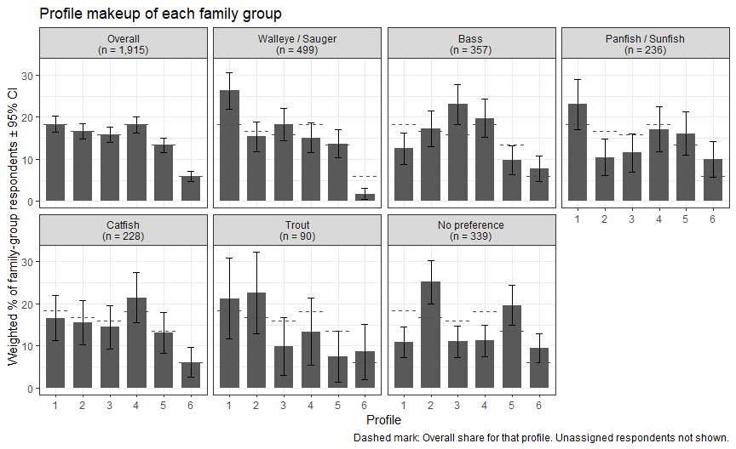

Profile makeup of family-group anglers
Every family group contains anglers of all six profiles. No family group is dominated by a single profile; the largest share of any profile in any family group is Class 1 among Walleye / Sauger anglers (26.3% ± 4.3). Managing for any one species therefore means serving a mix of angler types, and the differences described in the cards below are differences of emphasis rather than of kind. Each card shows one family group’s weighted percentage in each profile with 95% confidence intervals on a common scale. The icons along the bottom mark the profiles and the dashed mark is the Overall share of that profile. The text beside each card also gives the group’s mean on the attitude, motivation and regulation scales used to fit the profiles (1 to 5 value scales) with the difference from the Overall mean in standard deviations (SD); the largest such difference for any family group is 0.59 SD.
Walleye / Sauger
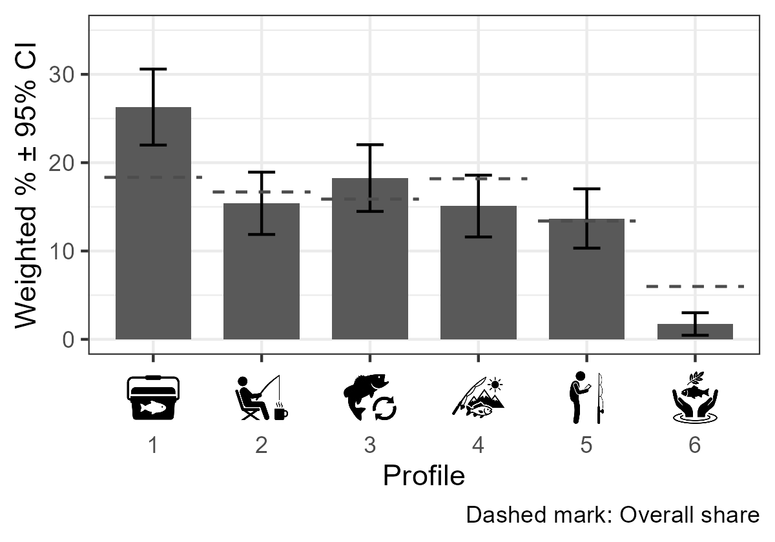 | Walleye / Sauger anglers, the largest family group (n = 499), lean toward Class 1, the harvest-minded, keep-it-simple angler (26.3% ± 4.3 against 18.3% overall), and include very few Class 6 purists (1.7% ± 1.3 against 6.0% overall). Their attitude scores agree: keeping fish matters more to them than to any other family group (2.6, +0.48 SD), and needing a catch is above average (3.0, +0.24 SD). Together with Catfish anglers they score highest on the fishery resource motivation (2.7, +0.24 SD), while the natural environment is slightly below average (3.6, -0.12 SD). Harvest opportunity and catch results are the levers most likely to matter to this group. Their comprehension of the rules (3.5, -0.11 SD) is slightly below average, so plain-language communication of lake-specific length and bag limits also has a role.
Bass
Bass anglers (n = 357) sit at the opposite end from Walleye / Sauger anglers on harvest. Class 3, the regulation-savvy catch-and-release angler, is their largest profile (23.0% ± 4.8 against 15.9% overall), and Class 1 is less common among them (12.5% ± 3.8 against 18.3% overall). Keeping fish matters least to them of any family group (1.7, -0.59 SD), and the size of the fish matters more than average (3.5, +0.26 SD). Their motivations are close to average, with the physical and psychological rewards (3.4, +0.13 SD) and the natural environment (3.7, +0.10 SD) slightly above. They also report above-average comprehension of the rules (3.7, +0.19 SD) and support for site-specific rules (4.0, +0.15 SD). Bass anglers look like a receptive audience for size-focused management, including special length limits and catch-and-release rules for individual waters. |  | 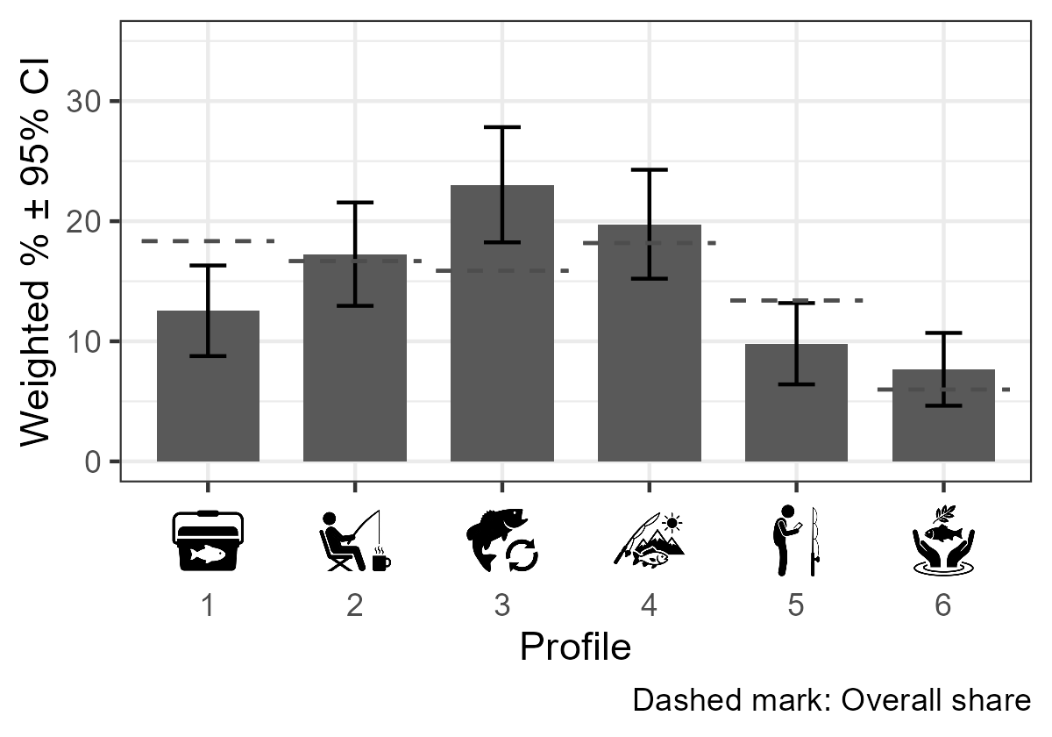
Panfish
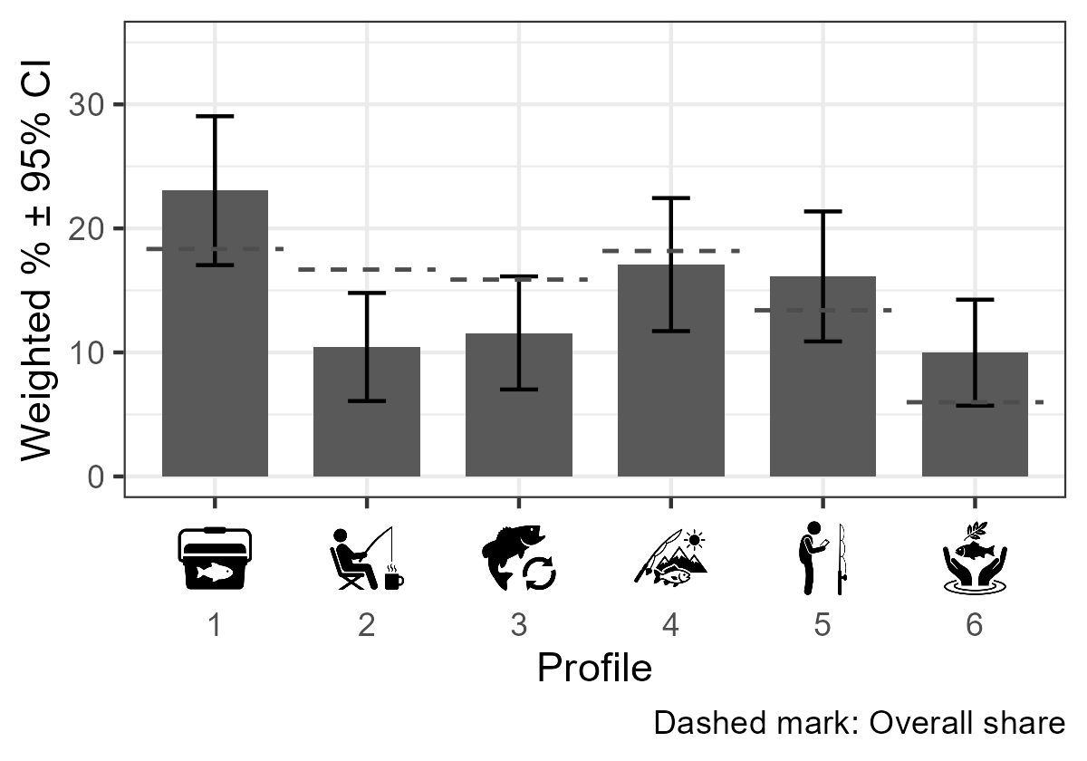 | Panfish anglers (n = 236) combine two contrasting profiles: Class 1 harvest-minded anglers (23.0% ± 6.0 against 18.3% overall) and Class 6 conservation-minded purists (10.0% ± 4.3 against 6.0% overall) are both more common than overall, while Class 2 is less common (10.4% ± 4.4 against 16.7% overall). Their attitudes lean toward keeping fish (2.3, +0.15 SD) and needing a catch (2.9, +0.13 SD), while the size of the fish matters less than average (3.0, -0.32 SD). All four motivations are within 0.1 SD of the Overall means, so this group differs in what it wants from the catch rather than in why it fishes. Panfish management may need to balance harvest opportunity for the larger group with the experience-focused values of the smaller one.
Catfish
Catfish anglers (n = 228) are the closest to the angler population as a whole: no profile's share among them differs from its Overall share by 5 percentage points or more. Of the 11 scales, only the fishery resource motivation is 0.15 SD or more from the Overall mean (2.7, +0.24 SD), and the rest are all within 0.15 SD. Catfish anglers are therefore much like Nebraska anglers generally, with a somewhat stronger interest in what they catch, so catfish management is in effect management for the general angler. |  | 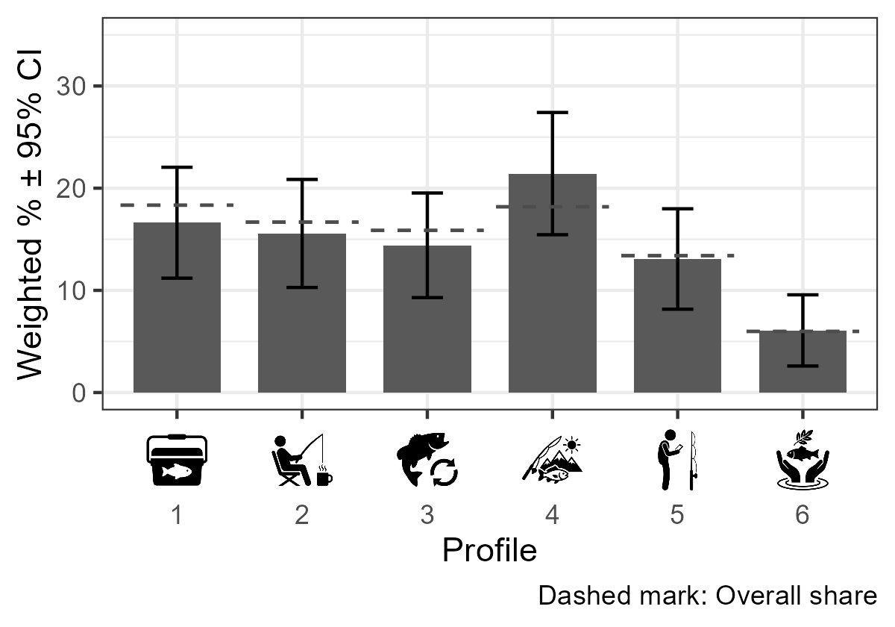
Trout
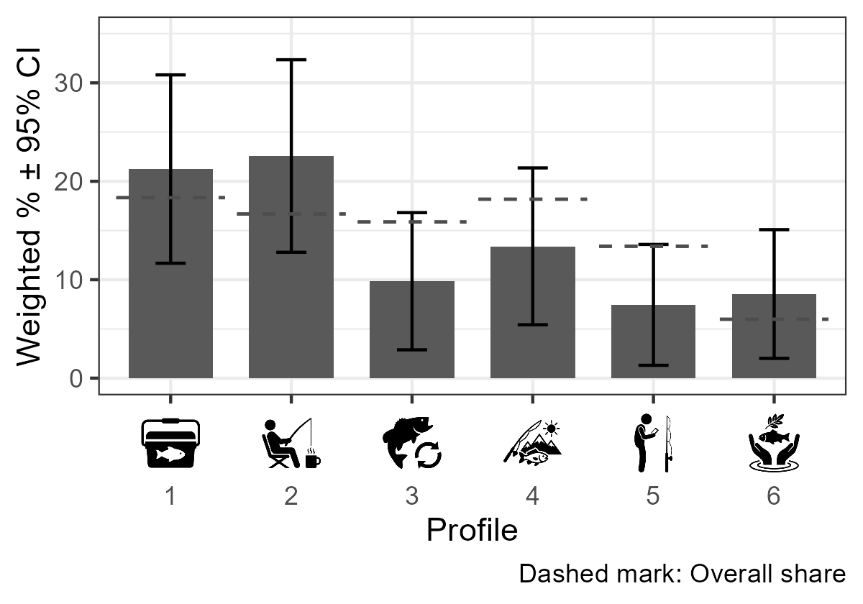 | Trout anglers lean toward Class 2, the relaxed, catch-optional angler (22.6% ± 9.8 against 16.7% overall), with fewer Class 3 anglers (9.8% ± 7.0 against 15.9% overall); with 90 respondents these intervals, and the scale means below, are imprecise. They score below average on needing a catch (2.6, -0.24 SD), on catching numbers of fish (2.8, -0.35 SD) and on the fishery resource motivation (2.3, -0.27 SD), and slightly above average on the natural environment (3.7, +0.10 SD). The pattern is only suggestive at this sample size, but it fits a stocked fishery valued for the outing, where access, the timing of stockings and a pleasant setting may matter more than catch rates or trophy potential.
No preference
Anglers with no preferred species (n = 339) are the group most weighted toward the less committed profiles: Class 2 (25.2% ± 5.2 against 16.7% overall) and Class 5, the low-involvement angler (19.7% ± 4.7 against 13.4% overall), are both more common than overall, and Class 1 is less common (10.8% ± 3.7 against 18.3% overall). They score below the Overall mean on every attitude and every motivation. The fishery resource motivation is lowest of any family group (2.2, -0.52 SD), and the physical and psychological rewards (3.0, -0.37 SD) and the importance of size (3.0, -0.38 SD) are also low. These anglers are a natural focus for recruitment, retention and reactivation efforts, where convenience, easy access and general information are more likely to reach them than species-specific management. |  | 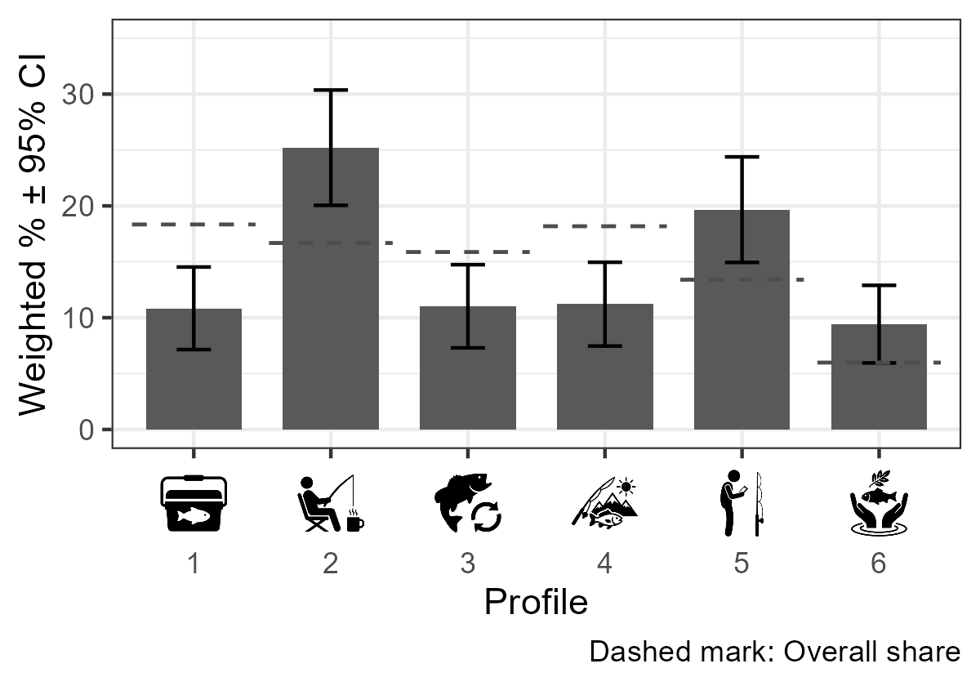
These implications are interpretive. The profiles are built from attitude, motivation and regulation scales, not from behavior, and the shares are associations: preferring a species does not place an angler in a profile, nor the reverse. Differences of less than about 5 percentage points are within the precision of these estimates for most family groups, and the Trout group, the smallest family group, has intervals that reach ±9.8 points.

References
Bureau of Sociological Research. 2026. Fishing Nebraska 2025-2026 Methodology Report. University of Nebraska-Lincoln.
Hurley, Keith. 2026. 2026 Nebraska Licensed Angler Survey - Respondents and Responses. Nebraska Game and Parks Commission.

Appendix A - 2025 Nebraska Licensed Angler Survey (Paper Version)
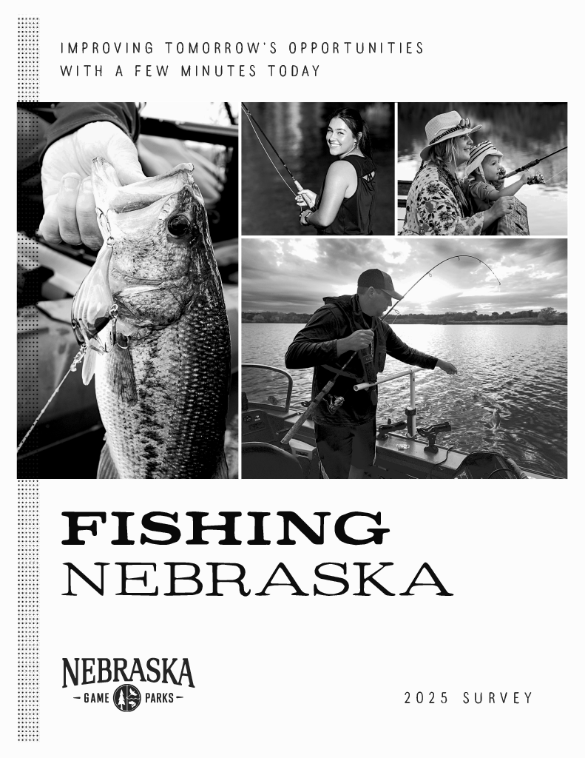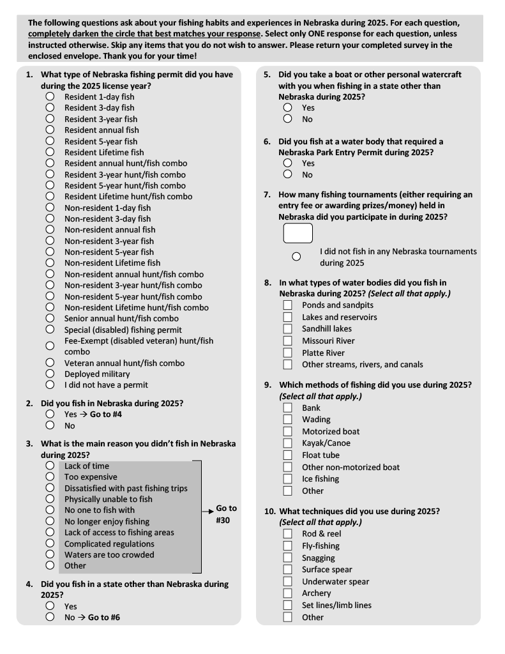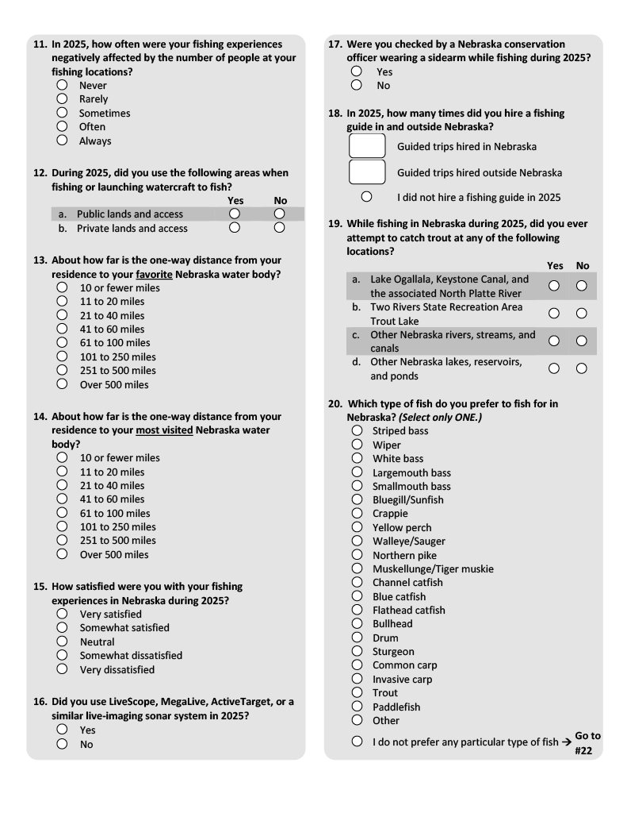
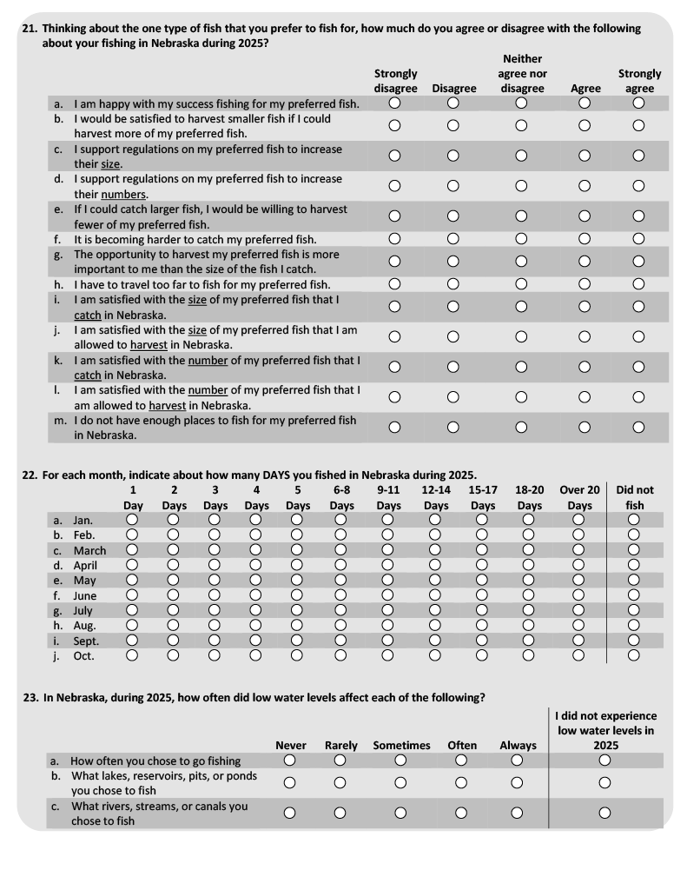
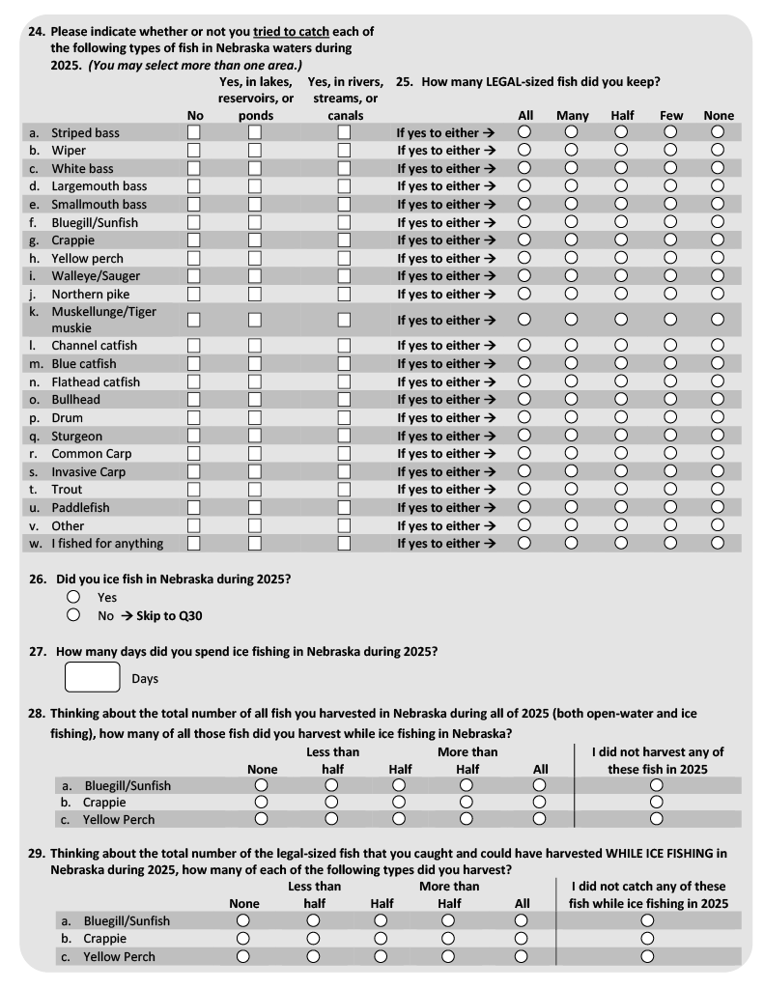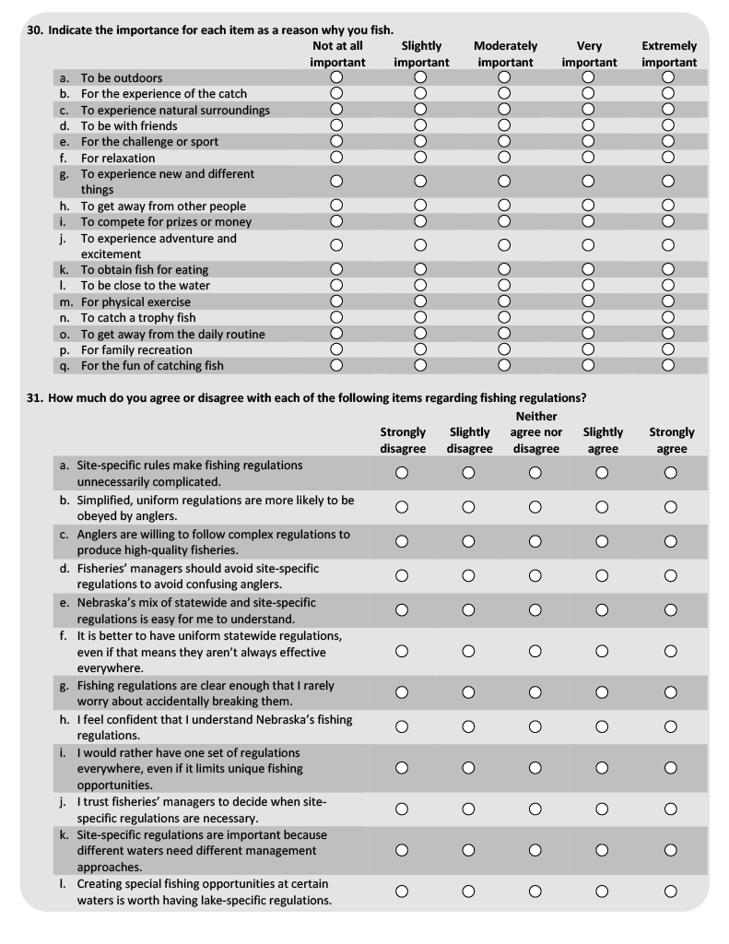
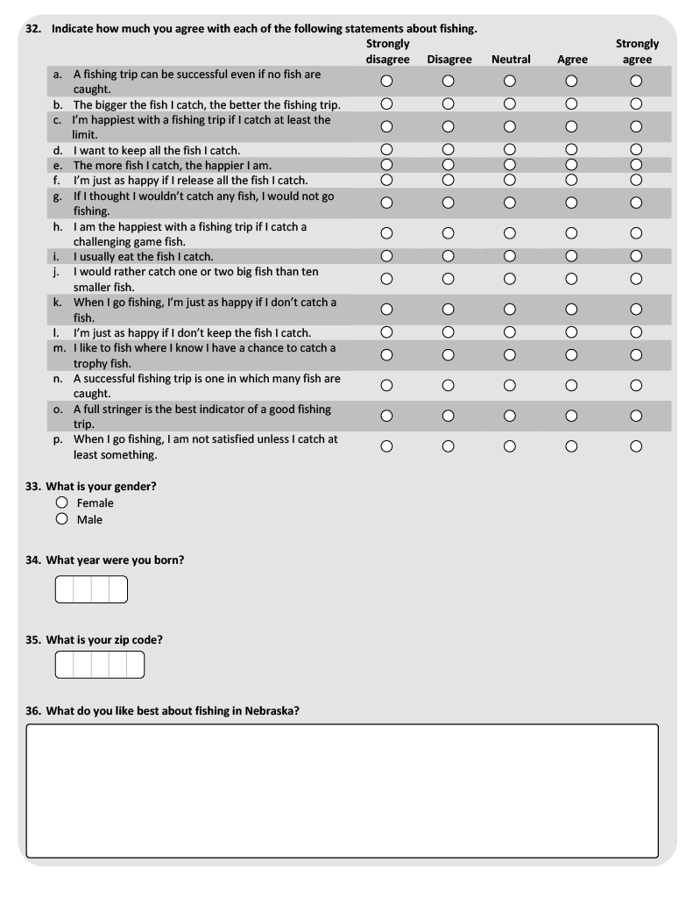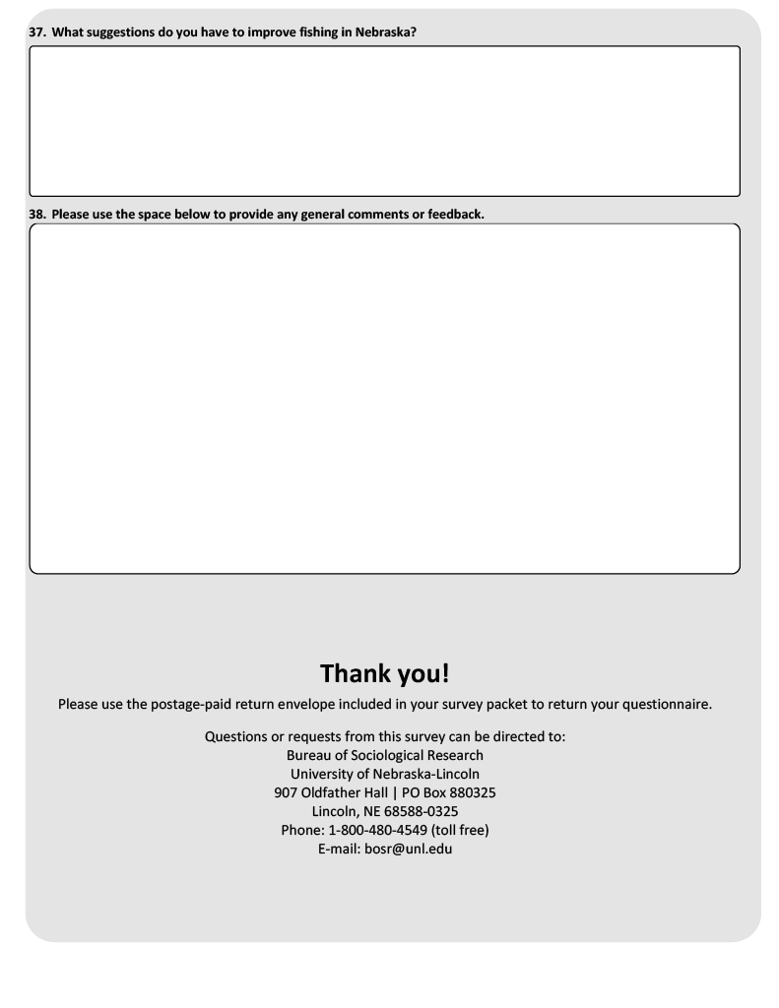

Appendix B - Statistical Methodology

Analysis sample
This report is restricted to respondents who answered the preferred-species question. Of the 2,822 anglers who responded to the 2025 survey, 907 left that question blank and are excluded from the report entirely rather than merely from the species columns. The analysis sample is therefore 1,915 respondents.
A second, narrower exclusion applies only to the preferred groups. Sixety respondents in the analysis sample prefer a species that has no preferred-group column, either because it is in no candidate family or because it and its family did not meet the selection rules in Chapter 1. They remain in the Overall column of every table but receive no preferred-group column of their own. The two exclusions are distinct and are reported separately in Chapter 1.
Because of the first restriction, the Overall column of this report estimates a different population than the Overall column of the 2025 Licensed Angler Survey Crosstabs report - anglers who stated a species preference, rather than all licensed anglers. The two reports will therefore not agree in that column, and no attempt has been made to reconcile them.

Weighting and raking by survey year
Every respondent record carries a pre-calculated weight that is computed during data aggregation and stored with the survey data. All percentages and means in this report are weighted using that stored value; sample sizes (N) shown in parentheses are always raw, unweighted respondent counts and not weighted N’s. Calculated weights for the 2025 sum to population size values and not sample size values and displaying the weighted N’s would be difficult for readers to interpret. Full detail on how the 2025 raking weights themselves were constructed can be found in Hurley (2026).

Percentage confidence intervals
Percentage use a normal-approximation (Wald) interval:
$$CI=1.96×\sqrt{\frac{p(1-p)}{effN}}×100$$
where $p$ is the weighted proportion and $effN$ is the Kish effective sample size, not the raw respondent count or the raw sum of weights:
$$effN=\frac{(∑w)^{2}}{∑w^{2}}$$
This matters because the 2025 weights sum to the angler population (roughly 234,000 across all 2025 respondents, a mean weight around 83), not to the number of respondents. A formula that treated the sum of weights as the sample size would inherit that population scale and give intervals roughly 9 times too narrow. The Kish effective sample size avoids this in two ways: it is unchanged if every weight is multiplied by a constant, so the population scale drops out; and it is smaller than the respondent count, reflecting the design effect of unequal weighting.

Mean confidence intervals
Mean tables compute a weighted mean and a weighted standard deviation, then a standard error using the same Kish effective sample size ($effN$) used by the percentage formula above, rather than the raw respondent count:
$$SE=\frac{SD_{w}}{\sqrt{effN}}, CI=1.96×SE$$
This mirrors the percentage CI fix for the same underlying reason: using $effN$ keeps mean CIs on the same design-effect-corrected basis as percentage CIs. The sample size (N) displayed alongside each mean is still the raw, unweighted respondent count; only the internal SE calculation changed.

Median confidence intervals
Median tables report a weighted median together with a genuine 95% confidence interval for that median computed by weighted bootstrap. Respondents are resampled with replacement with selection probability proportional to the precalculated weight values 1,000 times; the (unweighted) median is computed for each resample; and the 2.5th and 97.5th percentiles of those 1,000 bootstrap medians form the reported CI bounds. A fixed random seed (7361) is set before each grouped computation so results are reproducible from one render to the next. This method was chosen because there is no simple closed-form confidence interval for a weighted median under arbitrary, non-integer survey weights.

Scale scores and the completeness gate
The motivation, attitude and regulation scale scores are rebuilt from the raw item responses at render time while applying the reversals for items as appropiate. Each scale table is restricted to respondents who answered every item in that sub-scale. The gate is applied per scale, so each scale carries its own sample size; across the eleven scales used here the analysis sample ranges from 1,653 to 1,715 respondents. This is a design-time choice rather than a discretionary exclusion and the resulting sample size is printed beside every estimate.

Population expansions
The species table in Chapter 1 reports a population expansion, obtained by applying each weighted percentage to the full weighted 2025 angler population of 234,125. That column therefore sums to the full angler population. The weights carried by the 1,915 respondents in the analysis sample themselves total only 171,760, or about 73 percent of the population, because the respondents who skipped the preferred-species question carry weight too.
Expanding to the full population rather than to the 171,760 represented by the analysis sample assumes that skipping the preferred-species question is unrelated to which species an angler prefers. That assumption cannot be tested with these data, since no preference was recorded for the respondents who skipped the question. Readers who prefer not to make it should scale the expansion column by 0.734.

The preferred groups, and why columns do not sum
The preferred groups are not a single-level partition. A family that Chapter 1 combined appears both as a family column and as one column per constituent species that met the minimum size, so a respondent who prefers largemouth bass is counted in both the Bass column and the Largemouth bass column. A family that was not combined has no family column and only its species that met the minimum size appear.

Comparisons between species
Chapter 1 compares species within a family using design-based two-sample comparisons on survey weights rescaled to sum to the number of respondents in the pair being compared:
$$w_{norm}=w×\frac{n}{∑w}$$
The rescaling is presentational. Like the Kish effective sample size, the linearized standard errors do not change when every weight is multiplied by a constant, so raw and rescaled weights give identical standard errors and degrees of freedom. The sum-of-weights problem described under percentage confidence intervals does not arise here.
No omnibus test is reported. Each row of a comparison table is a single two-species contrast. An overall F-test across the species in a family was considered and dropped and with it any model $R^{2}$ or $η^{2}$, because the split-or-combine decisions were made from the species estimates directly.

Multiplicity
The Bonferroni adjustment is applied across every test in a family with the number of species pairs multiplied by the nine outcomes. A two-species family therefore carries 9 tests and a three-species family 27. The unadjusted p-value for each test is multiplied by the family’s test count and capped at 1, and both the unadjusted p and the family-adjusted p are printed.
Bonferroni was chosen over Holm for simplicity of exposition. The two rest on identical assumptions and Bonferroni is uniformly the more conservative of the two, so any comparison Bonferroni separates, Holm would separate as well. Tukey’s HSD was not used as it is not valid here given the unequal group sizes and the weighted design.
The family-adjusted p-values are used for one decision. A family is combined only if none of its adjusted p-values is below 0.05. The comparisons for the smaller species are underpowered and overlapping confidence intervals are weak evidence that two species are similar. Failing to separate two species is not evidence that they are alike.

Effect sizes
Every comparison reports the weighted difference in means with a 95% confidence interval, and Hedges’ g, a standardized difference computed by pooling the two weighted standard deviations on the effective sample sizes and applying the usual small-sample correction. Both are shown because several species in this survey are represented by very few respondents where a comparison that separates nothing is not evidence that the species behave alike; the interval is simply too wide to distinguish the two possibilities. The difference and g together let the reader tell those cases apart.

How differences are described in the text
The narrative in Chapters 3 and 5 describes a preferred group as different from the Overall estimate only when the group’s 95% confidence interval lies entirely outside the Overall 95% interval: the lower limit of the group is above the upper limit of Overall, or the upper limit of the group is below the lower limit of Overall. The intervals are those printed in the tables, the Kish effective-N interval for percentages and means and the bootstrap percentile interval for medians. A group whose interval overlaps the Overall interval is not described as different, and a group that goes unmentioned is not thereby shown to be atypical. Within-angler differences in Chapter 5 (size against numbers, and caught against allowed) are described as different from zero only when the 95% interval around the paired difference excludes zero. The rule is not applied everywhere - The Chapter 1 narrative reports the Bonferroni-adjusted family tests described above.
This screen is not a hypothesis test and carries no p-value. For a single comparison it is more conservative than a two-sided test at the 5 percent level, because it requires the two intervals not to touch rather than the difference to exceed its own standard error; how much more conservative depends on how wide the group interval is relative to the Overall interval. It is not adjusted for the number of comparisons. Each table screens 15 groups, so some flagged comparisons could arise by chance. The comparisons are also not independent: every group is part of the Overall it is compared with, and a family group contains the respondents in its own species rows.
A percentage of 0 or 100 has a Wald interval of zero width, so the screen carries no information for such a cell. The text reports those cells descriptively, as groups in which no respondent gave the response, and not as screened differences.

Angler type profiles in Chapter 6

The model
Chapter 6 groups anglers using a latent profile analysis, a finite mixture model in which each respondent is assumed to belong to one of a number of unobserved profiles and, within a profile, each indicator is normally distributed. The indicators are the eleven scale scores reported in Chapter 3: the four angler-attitude scales, the four motivation scales, and the three regulation scales. Within each profile the eleven indicators are treated as uncorrelated, so each profile is described by eleven means and a set of variances.
Models were fitted with the tidySEM package (version 0.2.12), function mx_profiles(), which estimates by maximum likelihood in OpenMx (version 2.22.11). tidySEM obtains starting values from a k-means partition, refines them by simulated annealing, and then runs gradient-based optimization. A fixed random seed (5813) is set before each model so the fits are reproducible. Starting values come from a single k-means run, and the sensitivity of the solution to other starting values has not been examined.

Who was fitted
Of the 1,915 respondents in the analysis sample, 1,718 (89.7 percent) answered at least 7 of the eleven scales and were included in the fit. The threshold was set before fitting. Where a fitted respondent is missing some scales, the model uses the scales that were answered (full-information maximum likelihood); no values are imputed. The remaining 197 respondents (78 who answered between 1 and 6 scales and 119 who answered none) are reported as Unassigned. They are not dropped: they remain in every Chapter 6 row, and Unassigned appears as its own column, so each row’s percentages are of all respondents in that row.
Each scale score carries the completeness gate described under Scale scores and the completeness gate above, so the scores entering the model are the same values summarized in the Chapter 6 profile figures and profile means table.

Choosing the number of profiles
Two within-profile variance structures were fitted: one in which every profile shares the same variance for a given indicator (equal), and one in which each profile has its own variances (varying). Under both structures, models with 1 to 6 profiles were fitted. The equal structure was then extended to 7 and 8 profiles because the Bayesian information criterion (BIC) was still decreasing at 6.
The number of profiles was chosen by a stated convention rather than a statistical test: among all fitted models, the one with the lowest BIC, restricted to models in which the smallest profile holds at least 5 percent of fitted respondents and the relative entropy is at least 0.60. Only fits that OpenMx reports as converged (status code 0 or 1) are eligible. BIC is computed as
$$BIC=-2logL+pln(n)$$
with p the number of estimated parameters and n = 1,718. OpenMx’s default summary reports a different, degrees-of-freedom-adjusted BIC; it was not used. Relative entropy summarizes how distinctly respondents are assigned:
E=1-i​j​-pijlnpijnlnk
where p-hat(ij) is respondent i’s estimated probability of belonging to profile j and k is the number of profiles. It runs from 0 to 1, with 1 indicating that every respondent is assigned with certainty.
The selected model has 6 profiles with equal variances: BIC 40,968.9, relative entropy 0.747, smallest profile 120 respondents (7.0 percent of those fitted). The full table of fitted models is given in Chapter 6.

Models that were fitted but not eligible
Four fits had a lower BIC than the selected model and were excluded under the convention above. The 7- and 8-profile equal-variance models (BIC 40,774.7 and 40,717.5) converged, but their smallest profiles hold 4.1 and 3.3 percent of fitted respondents, below the 5 percent floor. Because BIC continued to decrease through 8 profiles, the selected model is the largest equal-variance model that satisfies the floor rather than the point at which BIC stops improving.
The 5- and 6-profile varying-variance models (BIC 39,307.8 and 38,746.6) did not converge. Inspection showed the cause. In each, one profile (271 and 277 respondents) contains only respondents whose Site-specific regulation score is exactly 5, the top of the scale, among those who answered it (267 of 267 and 273 of 273). That profile’s variance on the indicator shrinks toward zero (estimates of 5.5e-06 and 3.6e-07). Because the normal likelihood increases without limit as a variance approaches zero, the lower BIC of these two models reflects that collapse rather than a better description of the data. A further optimization attempt was not made, since it would search the same unbounded region. Placing a lower bound on the variances was considered and not adopted, because it would change the model specification. Both fits are excluded.

Assigning respondents to profiles
Each fitted respondent is assigned to the profile with the highest estimated membership probability. Assignment is not certain: the average probability of the assigned profile among its members is at least 0.759 for every profile. Certainty also depends on how many scales a respondent answered. Mean assigned-profile probability is 0.839 for respondents who answered all eleven scales (1,373 respondents), 0.799 for respondents who answered ten (209 respondents), 0.722 for respondents who answered seven to nine (136 respondents); the share assigned with probability below 0.70 is 23.5, 32.1, 44.9 percent respectively. The profile numbers are arbitrary labels produced by the estimation and carry no order.

Weights
The model is fitted without the survey weights: each fitted respondent contributes equally to the estimated profiles. Everything reported from the model is then weighted in the same way as the rest of this report. The share of each profile in each row is a weighted percentage with the Kish effective-N confidence interval, and the profile means in the Chapter 6 figures and profile means table are weighted means with the Kish effective-N confidence interval, computed from the assigned respondents. These weighted means are therefore not the same quantities as the unweighted means the model estimated for each profile. Whether the fitting software can carry survey weights into the estimation was not verified. The model diagnostics and the assignment-certainty table are unweighted model quantities.

Reporting floor for species rows
Chapter 6 is the only chapter of this report that withholds rows. Before the model was fitted, a floor of 30 on the Kish effective sample size was set for species rows, adopting the effective-sample-size element of the National Center for Health Statistics data presentation standards for proportions (Parker JD, Talih M, Malec DJ, et al. National Center for Health Statistics Data Presentation Standards for Proportions. Vital and Health Statistics, Series 2, No. 175. 2017). Only that element is adopted: the NCHS standard also calls for a raw sample size of at least 30 and for Korn-Graubard confidence intervals with width criteria, while this report’s intervals are Wald intervals on the Kish effective N, as described above, and no width criterion is applied.
Three rows fall below the floor and are not shown in the Chapter 6 tables: Wiper (35 respondents, effective N 28.6); White bass (39 respondents, effective N 29.8); Northern pike (32 respondents, effective N 26.9). The floor applies to reporting only; these respondents are included in the model fit and in the Overall row. Wiper, White bass, and Northern pike are species whose family was not combined and have no family row, so their respondents appear in no displayed Chapter 6 species row. Where a profile has no respondents in a displayed row, the percentage is 0 and the Wald interval has zero width; this is a property of the interval formula, not a measurement of certainty.

Comparisons on other survey questions
The Chapter 6 table of profiles on other survey questions uses the same estimators as Chapter 3: weighted percentages and means with Kish effective-N intervals, and weighted medians with the bootstrap interval described above. Each question keeps its Chapter 3 universe, and the Overall column reproduces the Overall row of the corresponding Chapter 3 table. Unassigned respondents are counted in Overall only. One row is constructed for this chapter: a respondent counts as fishing rivers and streams if they reported the Missouri River, the Platte River, or other streams, rivers, and canals, among respondents who answered the waterbody question.
These comparisons treat each respondent’s assigned profile as known. Because assignment is uncertain, some respondents are counted in a profile they may not belong to, which tends to make the profiles look more alike on these questions than they are; the differences shown are therefore more likely understated than overstated. The profile paragraphs name a family group when it makes up at least 5 percentage points more of a profile than of all assigned respondents, as a reminder that species preference and profile membership are related; a group whose row is below the reporting floor is not named. No adjustment for species mix is made.

What is not reported
No significance test is reported in Chapter 6, and the profile shares in different rows are not formally compared. As in other chapters, the species rows overlap and must not be totalled.

Display precision
Scale means and their confidence intervals are printed to three decimal places in Chapter 1, rather than the one decimal place used in the 2025 Crosstabs report. At one decimal place a scale-mean interval of roughly plus or minus 0.04 rounds to zero, which would make the species comparisons unreadable. This is a rounding change in presentation only; the underlying values are identical to those the inherited functions produce.
For the same reason, the paired difference columns in Chapter 5 carry two decimal places rather than the one used for the means beside them. The overall difference between satisfaction with size and satisfaction with numbers is 0.07, which one decimal place would print as 0.1 next to an interval of 0.06.

