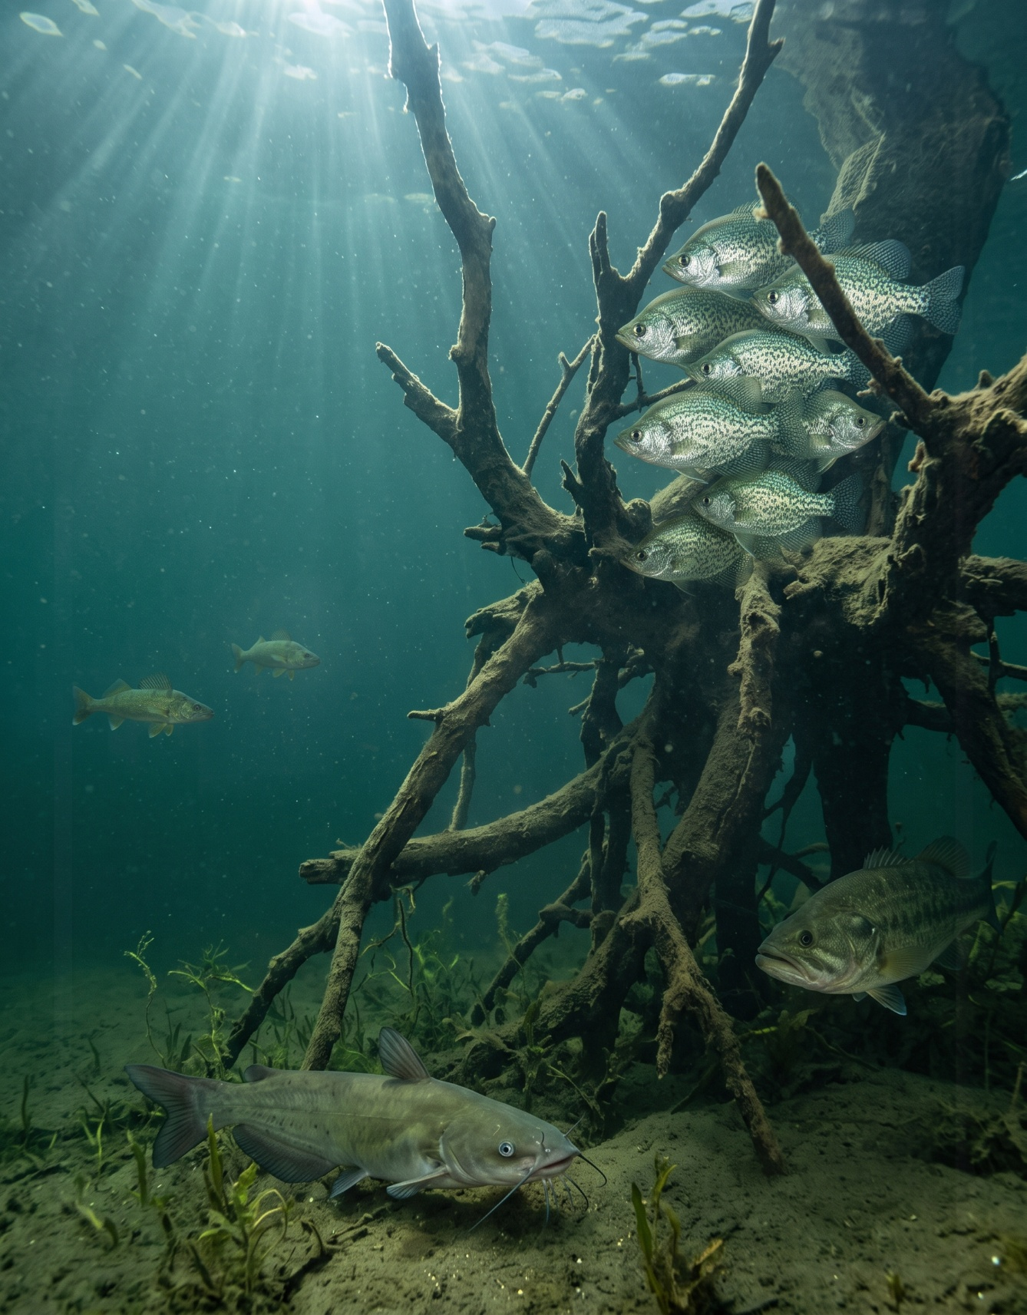
2026 Nebraska Licensed Angler Survey
Preferred Species
June 2026

Keith Hurley
Fisheries Division – Research Section
Nebraska Game and Parks Commission

1. Chapter 1: Determining Species Groupings 6
1.1. Question Text 6
1.2. Sample Sizes and Population Estimates by Species 6
1.3. Selection Rules 8
1.4. Proposed Family Groupings 8
1.5. Comparisons Within Proposed Families 9
1.5.1. Bass 9
1.5.2. Panfish / Sunfish 11
1.5.3. Catfish 14
1.5.4. Moronides 17
1.5.5. Esocids 20
1.6. Group Selection Results 22
1.7. Final Preferred Groups 23
2. Chapter 2: Species-Linked Scale Questions 26
2.1. I am happy with my success fishing for my preferred fish. 26
2.2. I would be satisfied to harvest smaller fish if I could harvest more of my preferred fish. 30
2.3. I support regulations on my preferred fish to increase their size. 34
2.4. I support regulations on my preferred fish to increase their numbers. 38
2.5. If I could catch larger fish, I would be willing to harvest fewer of my preferred fish. 42
2.6. It is becoming harder to catch my preferred fish. 46
2.7. The opportunity to harvest my preferred fish is more important to me than the size of the fish I catch. 50
2.8. I have to travel too far to fish for my preferred fish. 54
2.9. I am satisfied with the size of my preferred fish that I catch in Nebraska. 58
2.10. I am satisfied with the size of my preferred fish that I am allowed to harvest in Nebraska. 62
2.11. I am satisfied with the number of my preferred fish that I catch in Nebraska. 66
2.12. I am satisfied with the number of my preferred fish that I am allowed to harvest in Nebraska. 70
2.13. I do not have enough places to fish for my preferred fish in Nebraska. 74
2.14. Reading Across the Items 78
3. Chapter 3: Crosstabs by Preferred Species 79
3.1. Fish Out-Of-State 81
3.2. Boat Out-Of-State 84
3.3. Park Entry Permit 87
3.4. Fishing Tournaments 88
3.5. Waterbody Types 91
3.6. Methods 93
3.7. Techniques 96
3.8. Crowding 98
3.9. Access 101
3.10. Favorite Waterbody Distance 103
3.11. Most-Visited Waterbody Distance 108
3.12. Satisfaction 113
3.13. Live-imaging Sonar Use 117
3.14. Conservation Officer 120
3.15. Guided Trips 121
3.16. Days Fished 124
3.17. Ice Fishing 127
3.18. Angler Motivations 130
3.18.1. Natural environment 131
3.18.2. Physical and psychological 131
3.18.3. Social 132
3.18.4. Fishery resource 133
3.18.5. Motivation scale scores 134
3.19. Regulations 138
3.19.1. Comprehension 139
3.19.2. Site-specific 139
3.19.3. Simplification 141
3.19.4. Items outside the three regulation sub-scales 143
3.19.5. Regulation scale scores 143
3.20. Angler Attitudes 146
3.20.1. Catch something 147
3.20.2. Numbers 147
3.20.3. Size 148
3.20.4. Harvest 149
3.20.5. Attitude scale scores 150
3.21. Gender 153
3.22. Age 154
4. Chapter 4: Satisfaction 156
4.1. The satisfaction items 157
4.2. Satisfaction by preferred group 158
4.3. Size and numbers: the fish anglers catch 159
4.4. Size and numbers: the fish anglers may harvest 162
4.5. Caught versus allowed 165
4.5.1. Size 165
4.5.2. Number 168
5. Chapter 5: Angler Type Profiles 171
5.1. Choosing the number of profiles 172
5.2. Assignment certainty 174
5.3. Profile means 175
5.4. Profiles on other survey questions 177
5.5. The six profiles 181
5.5.1. Class 1: The harvest-minded, keep-it-simple angler 182
5.5.2. Class 2: The relaxed, catch-optional angler 183
5.5.3. Class 3: The regulation-savvy catch-and-release sport angler 184
5.5.4. Class 4: The all-in enthusiast 185
5.5.5. Class 5: The low-involvement angler 186
5.5.6. Class 6: The conservation-minded purist 187
5.6. Profiles by preferred species 188
5.7. Profile makeup of family-group anglers 190
6. Appendix A - 2025 Nebraska Licensed Angler Survey (Paper Version) 197
7. Appendix B - Statistical Methodology 198
7.1. Analysis sample 198
7.2. Weighting and raking by survey year 198
7.3. Percentage confidence intervals 198
7.4. Mean confidence intervals 199
7.5. Median confidence intervals 199
7.6. Reverse-coded item markers (dagger, †) 199
7.7. Scale scores and the completeness gate 199
7.8. Population expansions 200
7.9. The preferred groups, and why columns do not sum 200
7.10. Comparisons between species 200
7.11. Multiplicity 201
7.12. Effect sizes 201
7.13. How differences are described in the text 201
7.14. Satisfaction comparisons in Chapter 4 202
7.15. Angler type profiles in Chapter 5 203
7.15.1. The model 203
7.15.2. Who was fitted 203
7.15.3. Choosing the number of profiles 204
7.15.4. Models that were fitted but not eligible 204
7.15.5. Assigning respondents to profiles 205
7.15.6. Weights 205
7.15.7. Reporting floor for species rows 205
7.15.8. Comparisons on other survey questions 206
7.15.9. What is not reported 206
7.16. Display precision 206

Chapter 1: Determining Species Groupings
This report covers only anglers who answered the preferred-species question during the 2025 licensed angler survey. Of the 2,822 anglers who responded to the survey, 907 left that question blank, leaving an maximum overall sample size of 1,915. Because of that restriction, the Overall column of this report describes anglers who stated a species preference rather than all licensed anglers, and it will therefore not match the Overall column of the 2025 Crosstabs report. Likewise, not all results or estimates may fully match other survey reports due to the preferred-species question restriction.
The 2025 questionnaire offered 23 answer categories for preferred species (select one response only), and anglers responses concentrated in a few of them: 10 categories drew fewer than 30 respondents and Sturgeon drew none. A species-by-species breakdown of the rest of the survey is therefore not presented for the entire list of species. This chapter builds the set of preferred groups (both species and family aggregates) that organizes every later chapter. Family groups are used during analysis when angler responses for the constituent cannot be distinguished on motivations, attitudes, and effort. Individual species (regardless of family reporting) are also included when they have enough respondents to support analysis. Anglers who prefer no particular type of fish are kept as a group in their own right rather than set aside: they are roughly one in six of the sample, and their answers describe a segment of license holders that species-specific management does not reach directly.

Question Text
Which type of fish do you prefer to fish for in Nebraska?

Sample Sizes and Population Estimates by Species
Insert weighted statement here, Respondents is the raw unweighted count. Effective n is the Kish effective sample size, (sum w)^2 / sum(w^2), which is the quantity that governs confidence interval width. Weighted respondents rescales the survey weights to sum to the analysis sample. These results were weighted. Please consult the survey methodology for details.
Species | Respondents | Effective n | Weighted respondents | % of angler population | Total anglers
Walleye / Sauger | 499 | 402.3 | 455 ± 41 | 23.8 ± 2.14 | 55,606 ± 5,000
I do not prefer any particular type of fish | 339 | 272.3 | 343 ± 37 | 17.9 ± 1.92 | 41,905 ± 4,504
Largemouth bass | 316 | 261.5 | 347 ± 37 | 18.1 ± 1.93 | 42,371 ± 4,523
Crappie | 181 | 144.2 | 159 ± 27 | 8.3 ± 1.39 | 19,455 ± 3,243
Channel catfish | 151 | 118.9 | 134 ± 24 | 7.0 ± 1.28 | 16,355 ± 2,995
Trout | 90 | 70.2 | 89 ± 20 | 4.6 ± 1.05 | 10,821 ± 2,467
Flathead catfish | 50 | 40.7 | 52 ± 16 | 2.7 ± 0.82 | 6,409 ± 1,917
Bluegill / Sunfish | 43 | 34.5 | 38 ± 13 | 2.0 ± 0.70 | 4,607 ± 1,632
Smallmouth bass | 41 | 34.8 | 49 ± 15 | 2.6 ± 0.79 | 6,030 ± 1,861
White bass | 39 | 29.8 | 41 ± 14 | 2.2 ± 0.73 | 5,073 ± 1,711
Wiper | 35 | 28.6 | 49 ± 15 | 2.5 ± 0.79 | 5,949 ± 1,849
Northern pike | 32 | 26.9 | 38 ± 13 | 2.0 ± 0.70 | 4,675 ± 1,644
Blue catfish | 27 | 22.6 | 32 ± 12 | 1.7 ± 0.65 | 3,955 ± 1,514
Paddlefish | 14 | 11.4 | 22 ± 10 | 1.1 ± 0.53 | 2,666 ± 1,246
Yellow perch | 12 | 11.1 | 9 ± 7 | 0.5 ± 0.35 | 1,126 ± 813
Striped bass | 11 | 8.3 | 13 ± 8 | 0.7 ± 0.42 | 1,632 ± 977
Common carp | 9 | 6.0 | 8 ± 6 | 0.4 ± 0.33 | 997 ± 765
Muskellunge / Tiger musky | 8 | 7.3 | 11 ± 7 | 0.6 ± 0.39 | 1,404 ± 907
Drum | 6 | 5.1 | 8 ± 6 | 0.4 ± 0.32 | 930 ± 739
Bullhead | 4 | 3.5 | 4 ± 5 | 0.2 ± 0.24 | 524 ± 555
Other | 4 | 3.5 | 6 ± 5 | 0.3 ± 0.27 | 699 ± 641
Invasive carp | 4 | 3.8 | 8 ± 6 | 0.4 ± 0.32 | 937 ± 742
Sturgeon | 0 | 0.0 | 0 ± 0 | 0.0 ± 0.00 | 0 ± 0
Total anglers applies each species percentage to the full weighted 2025 angler population of 234,125, so the column sums to that population. This assumes that leaving the preferred-species question blank is unrelated to which species an angler prefers. The weights carried by the 1,915 respondents in the analysis sample themselves total 171,760.
Three categories account for about 60 percent of the weighted angler population: Walleye / Sauger (24 percent), Largemouth bass (18 percent) and anglers with no particular preference (18 percent). Crappie and Channel catfish follow at 8 and 7 percent, and no other species reaches 5 percent. The practical consequence for managers is that walleye, largemouth bass, crappie and channel catfish programs each speak to a measurable share of the angling public, while preferences for species such as paddlefish, yellow perch, common carp and muskellunge are held by too few surveyed anglers to describe with confidence, however locally important those fisheries may be.

Selection Rules
The list of preferred groups used in the rest of this report is produced by the rules below, applied in this order. (1) Five candidate families are proposed in the next section; a species that is not in a candidate family is never combined. (2) Every pair of species inside a candidate family is compared on nine outcomes (four motivation scales, four attitude scales, and days fished), and the p-values are Bonferroni-adjusted across all of the tests in that family. A family may be combined only if none of its adjusted p-values is below 0.05. (3) Walleye / Sauger, Trout and No preference are single-member groups; they are not tested. (4) A group or species needs at least 30 raw respondents to receive a column. All species in a candidate family are tested before the size rule is applied, and a species that meets the size rule receives its own column whether or not its family is combined.
Overlapping confidence intervals are weak evidence that two species are similar, and the comparisons for the smaller species are underpowered. A dagger on the n column of a contrast table marks a comparison in which one species has fewer than 30 respondents.
The rules answer a practical question: when a family label such as “catfish” or “bass” is used as a management unit, does it describe one angling constituency or several? Combining species whose anglers behave alike buys precision, because the pooled column has narrower confidence intervals than any of its members; combining species whose anglers differ hides the very distinctions a species-specific program depends on. The Bonferroni adjustment leans toward combining, since it is difficult for any single contrast to clear the threshold, so a family that fails the test does so on strong evidence. The reverse does not hold. With as few as 8 respondents in some species, a family that passes may still contain differences the survey is too small to detect, and the family columns should be read as “no measurable difference among these anglers”, not as proof that the species are interchangeable.

Proposed Family Groupings
Candidate families and their member species. Species that are in no candidate family are not listed. Respondents is the raw unweighted count. These results were weighted. Please consult the survey methodology for details.
Proposed family | Species | Respondents | Effective n
Bass | Largemouth bass | 316 | 261.5
Bass | Smallmouth bass | 41 | 34.8
Panfish / Sunfish | Crappie | 181 | 144.2
Panfish / Sunfish | Bluegill / Sunfish | 43 | 34.5
Panfish / Sunfish | Yellow perch | 12 | 11.1
Catfish | Channel catfish | 151 | 118.9
Catfish | Blue catfish | 27 | 22.6
Catfish | Flathead catfish | 50 | 40.7
Moronides | Striped bass | 11 | 8.3
Moronides | Wiper | 35 | 28.6
Moronides | White bass | 39 | 29.8
Esocids | Northern pike | 32 | 26.9
Esocids | Muskellunge / Tiger musky | 8 | 7.3

Comparisons Within Proposed Families
Each candidate family with more than one species is shown broken out by species alongside the family as a whole. These are the comparisons used to decide whether a family may be combined.

Bass
Indicate the importance for each item as a reason why you fish. Values represent mean response ± 95% confidence intervals with sample size given in parenthesis. Answers included (from 1 to 5): Not At All Important, Slightly Important, Moderately Important, Very Important, Extremely Important. These results were weighted. Please consult the survey methodology for details. Rows are the individual species within the family group, followed by the family group as a whole. The family row is computed on the same respondents as the species rows above it, so it is their weighted combination rather than a separate sample.
Species | Physical and psychological | Natural environment | Social | Fishery resource
Largemouth bass | 3.393 ± 0.098 (288) | 3.753 ± 0.096 (291) | 3.643 ± 0.101 (286) | 2.477 ± 0.076 (288)
Smallmouth bass | 3.326 ± 0.284 (37) | 3.716 ± 0.307 (37) | 3.418 ± 0.275 (37) | 2.513 ± 0.255 (36)
All Bass | 3.385 ± 0.092 (325) | 3.749 ± 0.092 (328) | 3.615 ± 0.096 (323) | 2.481 ± 0.073 (324)
Indicate how much you agree with each of the following statements about fishing. Values represent mean response ± 95% confidence intervals with sample size given in parenthesis. Answers included (from 1 to 5): Strongly Disagree, Disagree, Neutral, Agree, Strongly Agree. These results were weighted. Please consult the survey methodology for details. Items marked with a dagger (†) are reverse coded so that all items in this question scale in the same direction. Their response values were inverted (1=5, 2=4, 4=2, 5=1) before computing scale means and medians.
Species | Catch something | Numbers | Size | Harvest
Largemouth bass | 2.729 ± 0.116 (286) | 3.024 ± 0.097 (279) | 3.496 ± 0.099 (285) | 1.700 ± 0.086 (279)
Smallmouth bass | 2.666 ± 0.264 (35) | 3.275 ± 0.220 (36) | 3.521 ± 0.257 (36) | 1.612 ± 0.216 (35)
All Bass | 2.721 ± 0.107 (321) | 3.055 ± 0.090 (315) | 3.499 ± 0.093 (321) | 1.689 ± 0.080 (314)
Total days fished in Nebraska during 2025. Values represent mean response ± 95% confidence intervals with sample size given in parenthesis. Values represent lower 95% median confidence limit, median response, and upper 95% median confidence limit with sample size given in parenthesis. These results were weighted. Please consult the survey methodology for details.
Species | Mean days fished | Median days fished
Largemouth bass | 37.1 ± 4.33 (298) | 22.0/28.0/32.0 (298)
Smallmouth bass | 44.9 ± 17.17 (39) | 17.0/19.3/39.0 (39)
All Bass | 38.1 ± 4.35 (337) | 20.0/26.0/31.0 (337)
Each row compares two species on the outcome named. Difference is the weighted mean of the second species minus the first, with a 95% confidence interval; it is a design-based comparison on weights rescaled to the sample size. g is Hedges’ g computed on effective sample sizes. Family p multiplies the unadjusted p-value by the number of tests in the whole family (species pairs times nine outcomes) and is capped at 1. A dagger on n marks a comparison in which one species has fewer than 30 respondents.
Outcome | Comparison | n | Difference | g | p | Family p
Physical and psychological | Largemouth bass vs. Smallmouth bass | 288 / 37 | -0.067 (-0.373, 0.238) | -0.09 | 0.664 | 1.000
Natural environment | Largemouth bass vs. Smallmouth bass | 291 / 37 | -0.038 (-0.368, 0.293) | -0.05 | 0.822 | 1.000
Social | Largemouth bass vs. Smallmouth bass | 286 / 37 | -0.225 (-0.523, 0.073) | -0.28 | 0.139 | 1.000
Fishery resource | Largemouth bass vs. Smallmouth bass | 288 / 36 | 0.036 (-0.245, 0.316) | 0.06 | 0.803 | 1.000
Catch something | Largemouth bass vs. Smallmouth bass | 286 / 35 | -0.063 (-0.352, 0.226) | -0.07 | 0.668 | 1.000
Numbers | Largemouth bass vs. Smallmouth bass | 279 / 36 | 0.251 (0.006, 0.496) | 0.34 | 0.044 | 0.399
Size | Largemouth bass vs. Smallmouth bass | 285 / 36 | 0.025 (-0.248, 0.299) | 0.03 | 0.855 | 1.000
Harvest | Largemouth bass vs. Smallmouth bass | 279 / 35 | -0.089 (-0.313, 0.136) | -0.13 | 0.438 | 1.000
Days fished, same species comparisons. The columns are defined as in the contrast table above.
Comparison | n | Difference in days | g | p | Family p
Largemouth bass vs. Smallmouth bass | 298 / 39 | 7.8 (-10.7, 26.3) | 0.21 | 0.407 | 1.000
None of the 9 largemouth-versus-smallmouth contrasts approached the adjusted threshold (smallest adjusted p = 0.399). Smallmouth anglers are few (41 respondents), so the comparison has limited power, but the point estimates for the two species sit close together on every motivation and attitude scale and on days fished. The Bass family is combined, and Largemouth bass and Smallmouth bass each keep a species column because both exceed the size floor.

Panfish / Sunfish
Indicate the importance for each item as a reason why you fish. Values represent mean response ± 95% confidence intervals with sample size given in parenthesis. Answers included (from 1 to 5): Not At All Important, Slightly Important, Moderately Important, Very Important, Extremely Important. These results were weighted. Please consult the survey methodology for details. Rows are the individual species within the family group, followed by the family group as a whole. The family row is computed on the same respondents as the species rows above it, so it is their weighted combination rather than a separate sample.
Species | Physical and psychological | Natural environment | Social | Fishery resource
Crappie | 3.281 ± 0.136 (153) | 3.690 ± 0.134 (155) | 3.561 ± 0.145 (156) | 2.510 ± 0.098 (158)
Bluegill / Sunfish | 3.424 ± 0.348 (34) | 3.811 ± 0.319 (37) | 3.612 ± 0.310 (36) | 2.409 ± 0.314 (37)
Yellow perch | 3.093 ± 0.519 (12) | 3.175 ± 0.727 (12) | 3.602 ± 0.525 (12) | 2.495 ± 0.301 (12)
All Panfish / Sunfish | 3.296 ± 0.125 (199) | 3.685 ± 0.127 (204) | 3.572 ± 0.128 (204) | 2.491 ± 0.095 (207)
Indicate how much you agree with each of the following statements about fishing. Values represent mean response ± 95% confidence intervals with sample size given in parenthesis. Answers included (from 1 to 5): Strongly Disagree, Disagree, Neutral, Agree, Strongly Agree. These results were weighted. Please consult the survey methodology for details. Items marked with a dagger (†) are reverse coded so that all items in this question scale in the same direction. Their response values were inverted (1=5, 2=4, 4=2, 5=1) before computing scale means and medians.
Species | Catch something | Numbers | Size | Harvest
Crappie | 2.934 ± 0.143 (162) | 3.125 ± 0.129 (162) | 3.123 ± 0.139 (162) | 2.346 ± 0.155 (158)
Bluegill / Sunfish | 2.693 ± 0.294 (37) | 2.830 ± 0.290 (36) | 2.759 ± 0.254 (36) | 2.106 ± 0.343 (37)
Yellow perch | 3.308 ± 0.717 (10) | 3.352 ± 0.584 (9) | 2.471 ± 0.514 (9) | 2.626 ± 0.730 (10)
All Panfish / Sunfish | 2.909 ± 0.129 (209) | 3.086 ± 0.117 (207) | 3.035 ± 0.123 (207) | 2.317 ± 0.140 (205)
Total days fished in Nebraska during 2025. Values represent mean response ± 95% confidence intervals with sample size given in parenthesis. Values represent lower 95% median confidence limit, median response, and upper 95% median confidence limit with sample size given in parenthesis. These results were weighted. Please consult the survey methodology for details.
Species | Mean days fished | Median days fished
Crappie | 32.4 ± 6.26 (175) | 16.0/19.0/26.0 (175)
Bluegill / Sunfish | 23.5 ± 10.33 (41) | 4.0/11.0/22.0 (41)
Yellow perch | 23.8 ± 19.50 (12) | 4.5/8.1/30.5 (12)
All Panfish / Sunfish | 30.4 ± 5.29 (228) | 13.0/16.0/22.5 (228)
Each row compares two species on the outcome named. Difference is the weighted mean of the second species minus the first, with a 95% confidence interval; it is a design-based comparison on weights rescaled to the sample size. g is Hedges’ g computed on effective sample sizes. Family p multiplies the unadjusted p-value by the number of tests in the whole family (species pairs times nine outcomes) and is capped at 1. A dagger on n marks a comparison in which one species has fewer than 30 respondents.
Outcome | Comparison | n | Difference | g | p | Family p
Physical and psychological | Crappie vs. Bluegill / Sunfish | 153 / 34 | 0.143 (-0.244, 0.530) | 0.18 | 0.466 | 1.000
Physical and psychological | Crappie vs. Yellow perch | 153 / 12† | -0.188 (-0.733, 0.357) | -0.24 | 0.497 | 1.000
Physical and psychological | Bluegill / Sunfish vs. Yellow perch | 34 / 12† | -0.331 (-0.990, 0.327) | -0.36 | 0.316 | 1.000
Natural environment | Crappie vs. Bluegill / Sunfish | 155 / 37 | 0.120 (-0.232, 0.473) | 0.15 | 0.501 | 1.000
Natural environment | Crappie vs. Yellow perch | 155 / 12† | -0.515 (-1.270, 0.239) | -0.64 | 0.180 | 1.000
Natural environment | Bluegill / Sunfish vs. Yellow perch | 37 / 12† | -0.636 (-1.467, 0.196) | -0.63 | 0.131 | 1.000
Social | Crappie vs. Bluegill / Sunfish | 156 / 36 | 0.051 (-0.330, 0.432) | 0.06 | 0.793 | 1.000
Social | Crappie vs. Yellow perch | 156 / 12† | 0.042 (-0.523, 0.606) | 0.05 | 0.884 | 1.000
Social | Bluegill / Sunfish vs. Yellow perch | 36 / 12† | -0.009 (-0.675, 0.656) | -0.01 | 0.978 | 1.000
Fishery resource | Crappie vs. Bluegill / Sunfish | 158 / 37 | -0.101 (-0.475, 0.273) | -0.16 | 0.595 | 1.000
Fishery resource | Crappie vs. Yellow perch | 158 / 12† | -0.015 (-0.317, 0.286) | -0.03 | 0.920 | 1.000
Fishery resource | Bluegill / Sunfish vs. Yellow perch | 37 / 12† | 0.086 (-0.385, 0.556) | 0.11 | 0.716 | 1.000
Catch something | Crappie vs. Bluegill / Sunfish | 162 / 37 | -0.241 (-0.563, 0.082) | -0.29 | 0.142 | 1.000
Catch something | Crappie vs. Yellow perch | 162 / 10† | 0.374 (-0.406, 1.155) | 0.44 | 0.345 | 1.000
Catch something | Bluegill / Sunfish vs. Yellow perch | 37 / 10† | 0.615 (-0.228, 1.458) | 0.67 | 0.149 | 1.000
Numbers | Crappie vs. Bluegill / Sunfish | 162 / 36 | -0.295 (-0.598, 0.008) | -0.39 | 0.056 | 1.000
Numbers | Crappie vs. Yellow perch | 162 / 9† | 0.226 (-0.359, 0.811) | 0.30 | 0.446 | 1.000
Numbers | Bluegill / Sunfish vs. Yellow perch | 36 / 9† | 0.522 (-0.130, 1.173) | 0.63 | 0.114 | 1.000
Size | Crappie vs. Bluegill / Sunfish | 162 / 36 | -0.363 (-0.654, -0.073) | -0.46 | 0.015 | 0.393
Size | Crappie vs. Yellow perch | 162 / 9† | -0.652 (-1.242, -0.061) | -0.81 | 0.031 | 0.830
Size | Bluegill / Sunfish vs. Yellow perch | 36 / 9† | -0.288 (-0.929, 0.352) | -0.40 | 0.369 | 1.000
Harvest | Crappie vs. Bluegill / Sunfish | 158 / 37 | -0.240 (-0.623, 0.143) | -0.27 | 0.219 | 1.000
Harvest | Crappie vs. Yellow perch | 158 / 10† | 0.280 (-0.518, 1.077) | 0.31 | 0.490 | 1.000
Harvest | Bluegill / Sunfish vs. Yellow perch | 37 / 10† | 0.519 (-0.362, 1.401) | 0.51 | 0.242 | 1.000
Days fished, same species comparisons. The columns are defined as in the contrast table above.
Comparison | n | Difference in days | g | p | Family p
Crappie vs. Bluegill / Sunfish | 175 / 41 | -8.9 (-20.7, 3.0) | -0.24 | 0.142 | 1.000
Crappie vs. Yellow perch | 175 / 12† | -8.6 (-26.7, 9.5) | -0.23 | 0.350 | 1.000
Bluegill / Sunfish vs. Yellow perch | 41 / 12† | 0.3 (-19.5, 20.1) | 0.01 | 0.977 | 1.000
Crappie, Bluegill / Sunfish and Yellow perch produced no adjusted difference in 27 contrasts (smallest adjusted p = 0.393). Yellow perch contributes only 12 respondents and is the least informative member; its inclusion rests on the absence of contrary evidence rather than on a precise estimate. Crappie dominates the family numerically (181 of 236 respondents), so the Panfish / Sunfish column will largely reflect crappie anglers. The separate Crappie and Bluegill / Sunfish columns let the reader check whether that matters for any given question.

Catfish
Indicate the importance for each item as a reason why you fish. Values represent mean response ± 95% confidence intervals with sample size given in parenthesis. Answers included (from 1 to 5): Not At All Important, Slightly Important, Moderately Important, Very Important, Extremely Important. These results were weighted. Please consult the survey methodology for details. Rows are the individual species within the family group, followed by the family group as a whole. The family row is computed on the same respondents as the species rows above it, so it is their weighted combination rather than a separate sample.
Species | Physical and psychological | Natural environment | Social | Fishery resource
Channel catfish | 3.307 ± 0.140 (133) | 3.665 ± 0.153 (131) | 3.565 ± 0.154 (130) | 2.637 ± 0.133 (129)
Blue catfish | 3.517 ± 0.325 (23) | 3.826 ± 0.265 (22) | 3.677 ± 0.388 (23) | 2.885 ± 0.325 (23)
Flathead catfish | 3.486 ± 0.245 (48) | 3.768 ± 0.285 (48) | 3.572 ± 0.272 (46) | 2.673 ± 0.185 (48)
All Catfish | 3.385 ± 0.116 (204) | 3.716 ± 0.124 (201) | 3.584 ± 0.129 (199) | 2.684 ± 0.105 (200)
Indicate how much you agree with each of the following statements about fishing. Values represent mean response ± 95% confidence intervals with sample size given in parenthesis. Answers included (from 1 to 5): Strongly Disagree, Disagree, Neutral, Agree, Strongly Agree. These results were weighted. Please consult the survey methodology for details. Items marked with a dagger (†) are reverse coded so that all items in this question scale in the same direction. Their response values were inverted (1=5, 2=4, 4=2, 5=1) before computing scale means and medians.
Species | Catch something | Numbers | Size | Harvest
Channel catfish | 2.712 ± 0.162 (132) | 3.152 ± 0.159 (129) | 3.245 ± 0.156 (132) | 2.440 ± 0.165 (125)
Blue catfish | 2.882 ± 0.380 (22) | 3.549 ± 0.385 (22) | 3.558 ± 0.442 (22) | 2.056 ± 0.373 (23)
Flathead catfish | 2.580 ± 0.293 (47) | 3.070 ± 0.287 (45) | 3.613 ± 0.292 (46) | 2.128 ± 0.297 (46)
All Catfish | 2.703 ± 0.135 (201) | 3.191 ± 0.135 (196) | 3.385 ± 0.137 (200) | 2.299 ± 0.139 (194)
Total days fished in Nebraska during 2025. Values represent mean response ± 95% confidence intervals with sample size given in parenthesis. Values represent lower 95% median confidence limit, median response, and upper 95% median confidence limit with sample size given in parenthesis. These results were weighted. Please consult the survey methodology for details.
Species | Mean days fished | Median days fished
Channel catfish | 34.1 ± 5.99 (144) | 18.0/25.0/29.0 (144)
Blue catfish | 44.5 ± 16.67 (26) | 18.5/25.8/59.0 (26)
Flathead catfish | 32.4 ± 10.37 (50) | 13.0/17.9/31.5 (50)
All Catfish | 35.2 ± 5.08 (220) | 20.0/23.0/28.0 (220)
Each row compares two species on the outcome named. Difference is the weighted mean of the second species minus the first, with a 95% confidence interval; it is a design-based comparison on weights rescaled to the sample size. g is Hedges’ g computed on effective sample sizes. Family p multiplies the unadjusted p-value by the number of tests in the whole family (species pairs times nine outcomes) and is capped at 1. A dagger on n marks a comparison in which one species has fewer than 30 respondents.
Outcome | Comparison | n | Difference | g | p | Family p
Physical and psychological | Channel catfish vs. Blue catfish | 133 / 23† | 0.209 (-0.145, 0.564) | 0.28 | 0.245 | 1.000
Physical and psychological | Channel catfish vs. Flathead catfish | 133 / 48 | 0.179 (-0.101, 0.459) | 0.24 | 0.209 | 1.000
Physical and psychological | Blue catfish vs. Flathead catfish | 23 / 48† | -0.030 (-0.444, 0.383) | -0.04 | 0.884 | 1.000
Natural environment | Channel catfish vs. Blue catfish | 131 / 22† | 0.161 (-0.145, 0.468) | 0.21 | 0.300 | 1.000
Natural environment | Channel catfish vs. Flathead catfish | 131 / 48 | 0.103 (-0.228, 0.435) | 0.12 | 0.538 | 1.000
Natural environment | Blue catfish vs. Flathead catfish | 22 / 48† | -0.058 (-0.459, 0.343) | -0.07 | 0.774 | 1.000
Social | Channel catfish vs. Blue catfish | 130 / 23† | 0.112 (-0.320, 0.545) | 0.14 | 0.609 | 1.000
Social | Channel catfish vs. Flathead catfish | 130 / 46 | 0.007 (-0.300, 0.314) | 0.01 | 0.963 | 1.000
Social | Blue catfish vs. Flathead catfish | 23 / 46† | -0.105 (-0.591, 0.381) | -0.12 | 0.668 | 1.000
Fishery resource | Channel catfish vs. Blue catfish | 129 / 23† | 0.248 (-0.114, 0.610) | 0.35 | 0.179 | 1.000
Fishery resource | Channel catfish vs. Flathead catfish | 129 / 48 | 0.036 (-0.185, 0.256) | 0.05 | 0.749 | 1.000
Fishery resource | Blue catfish vs. Flathead catfish | 23 / 48† | -0.212 (-0.595, 0.171) | -0.32 | 0.274 | 1.000
Catch something | Channel catfish vs. Blue catfish | 132 / 22† | 0.170 (-0.257, 0.597) | 0.20 | 0.432 | 1.000
Catch something | Channel catfish vs. Flathead catfish | 132 / 47 | -0.132 (-0.464, 0.200) | -0.15 | 0.434 | 1.000
Catch something | Blue catfish vs. Flathead catfish | 22 / 47† | -0.302 (-0.801, 0.197) | -0.33 | 0.231 | 1.000
Numbers | Channel catfish vs. Blue catfish | 129 / 22† | 0.398 (-0.037, 0.832) | 0.48 | 0.072 | 1.000
Numbers | Channel catfish vs. Flathead catfish | 129 / 45 | -0.082 (-0.401, 0.237) | -0.10 | 0.612 | 1.000
Numbers | Blue catfish vs. Flathead catfish | 22 / 45† | -0.480 (-0.976, 0.016) | -0.54 | 0.058 | 1.000
Size | Channel catfish vs. Blue catfish | 132 / 22† | 0.313 (-0.161, 0.786) | 0.37 | 0.194 | 1.000
Size | Channel catfish vs. Flathead catfish | 132 / 46 | 0.368 (0.037, 0.698) | 0.43 | 0.029 | 0.795
Size | Blue catfish vs. Flathead catfish | 22 / 46† | 0.055 (-0.479, 0.589) | 0.06 | 0.837 | 1.000
Harvest | Channel catfish vs. Blue catfish | 125 / 23† | -0.384 (-0.795, 0.027) | -0.46 | 0.067 | 1.000
Harvest | Channel catfish vs. Flathead catfish | 125 / 46 | -0.312 (-0.651, 0.027) | -0.36 | 0.071 | 1.000
Harvest | Blue catfish vs. Flathead catfish | 23 / 46† | 0.072 (-0.415, 0.559) | 0.08 | 0.769 | 1.000
Days fished, same species comparisons. The columns are defined as in the contrast table above.
Comparison | n | Difference in days | g | p | Family p
Channel catfish vs. Blue catfish | 144 / 26† | 10.5 (-8.5, 29.4) | 0.31 | 0.277 | 1.000
Channel catfish vs. Flathead catfish | 144 / 50 | -1.7 (-14.6, 11.2) | -0.05 | 0.795 | 1.000
Blue catfish vs. Flathead catfish | 26 / 50† | -12.2 (-33.5, 9.1) | -0.33 | 0.258 | 1.000
The three catfish species were the most homogeneous family tested (smallest adjusted p = 0.795 across 27 contrasts). Channel, blue and flathead catfish anglers report similar motivations, attitudes and effort, which supports treating catfish as a single constituency for program-level purposes. Blue catfish (27 respondents) falls below the size floor and appears only within the family column; Channel catfish and Flathead catfish are also reported separately.

Moronides
Indicate the importance for each item as a reason why you fish. Values represent mean response ± 95% confidence intervals with sample size given in parenthesis. Answers included (from 1 to 5): Not At All Important, Slightly Important, Moderately Important, Very Important, Extremely Important. These results were weighted. Please consult the survey methodology for details. Rows are the individual species within the family group, followed by the family group as a whole. The family row is computed on the same respondents as the species rows above it, so it is their weighted combination rather than a separate sample.
Species | Physical and psychological | Natural environment | Social | Fishery resource
Striped bass | 3.429 ± 0.477 (8) | 3.885 ± 0.461 (8) | 3.667 ± 0.692 (8) | 2.471 ± 0.322 (7)
Wiper | 3.543 ± 0.263 (34) | 4.101 ± 0.258 (35) | 3.944 ± 0.330 (34) | 3.033 ± 0.252 (35)
White bass | 3.320 ± 0.390 (36) | 3.668 ± 0.280 (35) | 3.557 ± 0.323 (35) | 2.493 ± 0.197 (37)
All Moronides | 3.443 ± 0.216 (78) | 3.910 ± 0.186 (78) | 3.766 ± 0.226 (77) | 2.772 ± 0.168 (79)
Indicate how much you agree with each of the following statements about fishing. Values represent mean response ± 95% confidence intervals with sample size given in parenthesis. Answers included (from 1 to 5): Strongly Disagree, Disagree, Neutral, Agree, Strongly Agree. These results were weighted. Please consult the survey methodology for details. Items marked with a dagger (†) are reverse coded so that all items in this question scale in the same direction. Their response values were inverted (1=5, 2=4, 4=2, 5=1) before computing scale means and medians.
Species | Catch something | Numbers | Size | Harvest
Striped bass | 2.762 ± 0.882 (8) | 3.345 ± 0.566 (8) | 3.480 ± 0.744 (8) | 1.827 ± 0.882 (8)
Wiper | 2.661 ± 0.302 (31) | 3.342 ± 0.227 (31) | 4.018 ± 0.295 (31) | 1.961 ± 0.292 (30)
White bass | 2.669 ± 0.276 (34) | 3.139 ± 0.232 (34) | 3.226 ± 0.229 (34) | 2.831 ± 0.217 (33)
All Moronides | 2.673 ± 0.206 (73) | 3.260 ± 0.160 (73) | 3.649 ± 0.212 (73) | 2.293 ± 0.223 (71)
Total days fished in Nebraska during 2025. Values represent mean response ± 95% confidence intervals with sample size given in parenthesis. Values represent lower 95% median confidence limit, median response, and upper 95% median confidence limit with sample size given in parenthesis. These results were weighted. Please consult the survey methodology for details.
Species | Mean days fished | Median days fished
Striped bass | 26.9 ± 9.40 (11) | 18.0/19.7/37.0 (11)
Wiper | 26.9 ± 13.42 (35) | 7.0/10.1/27.0 (35)
White bass | 20.7 ± 8.70 (39) | 9.0/13.2/17.0 (39)
All Moronides | 24.4 ± 7.23 (85) | 10.0/14.0/18.0 (85)
Each row compares two species on the outcome named. Difference is the weighted mean of the second species minus the first, with a 95% confidence interval; it is a design-based comparison on weights rescaled to the sample size. g is Hedges’ g computed on effective sample sizes. Family p multiplies the unadjusted p-value by the number of tests in the whole family (species pairs times nine outcomes) and is capped at 1. A dagger on n marks a comparison in which one species has fewer than 30 respondents.
Outcome | Comparison | n | Difference | g | p | Family p
Physical and psychological | Striped bass vs. Wiper | 8 / 34† | 0.113 (-0.316, 0.543) | 0.16 | 0.596 | 1.000
Physical and psychological | Striped bass vs. White bass | 8 / 36† | -0.109 (-0.662, 0.444) | -0.11 | 0.693 | 1.000
Physical and psychological | Wiper vs. White bass | 34 / 36 | -0.222 (-0.712, 0.267) | -0.25 | 0.368 | 1.000
Natural environment | Striped bass vs. Wiper | 8 / 35† | 0.216 (-0.223, 0.654) | 0.31 | 0.326 | 1.000
Natural environment | Striped bass vs. White bass | 8 / 35† | -0.217 (-0.670, 0.236) | -0.30 | 0.339 | 1.000
Natural environment | Wiper vs. White bass | 35 / 35 | -0.433 (-0.809, -0.056) | -0.59 | 0.025 | 0.677
Social | Striped bass vs. Wiper | 8 / 34† | 0.278 (-0.418, 0.973) | 0.30 | 0.424 | 1.000
Social | Striped bass vs. White bass | 8 / 35† | -0.109 (-0.820, 0.602) | -0.13 | 0.758 | 1.000
Social | Wiper vs. White bass | 34 / 35 | -0.387 (-0.897, 0.123) | -0.44 | 0.135 | 1.000
Fishery resource | Striped bass vs. Wiper | 7 / 35† | 0.561 (0.180, 0.943) | 0.84 | 0.005 | 0.134
Fishery resource | Striped bass vs. White bass | 7 / 37† | 0.022 (-0.302, 0.346) | 0.04 | 0.891 | 1.000
Fishery resource | Wiper vs. White bass | 35 / 37 | -0.539 (-0.836, -0.243) | -0.86 | <0.001 | 0.015
Catch something | Striped bass vs. Wiper | 8 / 31† | -0.101 (-1.000, 0.797) | -0.12 | 0.821 | 1.000
Catch something | Striped bass vs. White bass | 8 / 34† | -0.093 (-0.978, 0.793) | -0.11 | 0.833 | 1.000
Catch something | Wiper vs. White bass | 31 / 34 | 0.008 (-0.371, 0.388) | 0.01 | 0.965 | 1.000
Numbers | Striped bass vs. Wiper | 8 / 31† | -0.003 (-0.656, 0.649) | -0.01 | 0.992 | 1.000
Numbers | Striped bass vs. White bass | 8 / 34† | -0.207 (-0.861, 0.448) | -0.33 | 0.527 | 1.000
Numbers | Wiper vs. White bass | 31 / 34 | -0.203 (-0.496, 0.089) | -0.34 | 0.169 | 1.000
Size | Striped bass vs. Wiper | 8 / 31† | 0.538 (-0.377, 1.453) | 0.66 | 0.241 | 1.000
Size | Striped bass vs. White bass | 8 / 34† | -0.254 (-1.142, 0.633) | -0.37 | 0.565 | 1.000
Size | Wiper vs. White bass | 31 / 34 | -0.793 (-1.179, -0.406) | -1.15 | <0.001 | 0.003
Harvest | Striped bass vs. Wiper | 8 / 30† | 0.134 (-0.672, 0.940) | 0.16 | 0.738 | 1.000
Harvest | Striped bass vs. White bass | 8 / 33† | 1.003 (0.225, 1.781) | 1.42 | 0.013 | 0.346
Harvest | Wiper vs. White bass | 30 / 33 | 0.869 (0.546, 1.192) | 1.32 | <0.001 | <0.001
Days fished, same species comparisons. The columns are defined as in the contrast table above.
Comparison | n | Difference in days | g | p | Family p
Striped bass vs. Wiper | 11 / 35† | -0.1 (-14.6, 14.4) | 0.00 | 0.993 | 1.000
Striped bass vs. White bass | 11 / 39† | -6.2 (-18.2, 5.8) | -0.27 | 0.306 | 1.000
Wiper vs. White bass | 35 / 39 | -6.1 (-20.6, 8.4) | -0.20 | 0.402 | 1.000
Striped bass, Wiper and White bass were not combined. Wiper and White bass anglers differ on 3 of the nine outcomes after adjustment: wiper anglers place more importance on the fishery resource motivations (adjusted p = 0.015), agree more strongly with the size-of-fish attitude items (0.003), and agree less with the harvest items (<0.001). The pattern is of wiper anglers as a size-oriented, release-inclined group and white bass anglers as a more harvest-oriented one, a distinction a combined Moronid column would erase. Wiper and White bass each exceed the size floor and receive their own columns; Striped bass (11 respondents) does not, and appears in no column.

Esocids
Indicate the importance for each item as a reason why you fish. Values represent mean response ± 95% confidence intervals with sample size given in parenthesis. Answers included (from 1 to 5): Not At All Important, Slightly Important, Moderately Important, Very Important, Extremely Important. These results were weighted. Please consult the survey methodology for details. Rows are the individual species within the family group, followed by the family group as a whole. The family row is computed on the same respondents as the species rows above it, so it is their weighted combination rather than a separate sample.
Species | Physical and psychological | Natural environment | Social | Fishery resource
Northern pike | 3.441 ± 0.226 (30) | 3.770 ± 0.320 (30) | 3.674 ± 0.310 (29) | 2.617 ± 0.214 (31)
Muskellunge / Tiger musky | 4.240 ± 0.345 (8) | 4.124 ± 0.578 (8) | 3.944 ± 0.546 (8) | 3.200 ± 0.226 (8)
All Esocids | 3.635 ± 0.225 (38) | 3.855 ± 0.285 (38) | 3.744 ± 0.273 (37) | 2.753 ± 0.193 (39)
Indicate how much you agree with each of the following statements about fishing. Values represent mean response ± 95% confidence intervals with sample size given in parenthesis. Answers included (from 1 to 5): Strongly Disagree, Disagree, Neutral, Agree, Strongly Agree. These results were weighted. Please consult the survey methodology for details. Items marked with a dagger (†) are reverse coded so that all items in this question scale in the same direction. Their response values were inverted (1=5, 2=4, 4=2, 5=1) before computing scale means and medians.
Species | Catch something | Numbers | Size | Harvest
Northern pike | 3.145 ± 0.339 (29) | 3.186 ± 0.282 (29) | 3.766 ± 0.295 (29) | 1.898 ± 0.373 (27)
Muskellunge / Tiger musky | 3.405 ± 0.612 (8) | 3.483 ± 0.251 (8) | 4.712 ± 0.259 (8) | 1.645 ± 0.425 (8)
All Esocids | 3.208 ± 0.299 (37) | 3.257 ± 0.228 (37) | 3.995 ± 0.273 (37) | 1.830 ± 0.302 (35)
Total days fished in Nebraska during 2025. Values represent mean response ± 95% confidence intervals with sample size given in parenthesis. Values represent lower 95% median confidence limit, median response, and upper 95% median confidence limit with sample size given in parenthesis. These results were weighted. Please consult the survey methodology for details.
Species | Mean days fished | Median days fished
Northern pike | 19.5 ± 8.24 (30) | 5.0/12.0/20.0 (30)
Muskellunge / Tiger musky | 63.8 ± 50.49 (8) | 3.0/22.7/138.0 (8)
All Esocids | 29.9 ± 14.65 (38) | 5.0/13.4/26.0 (38)
Each row compares two species on the outcome named. Difference is the weighted mean of the second species minus the first, with a 95% confidence interval; it is a design-based comparison on weights rescaled to the sample size. g is Hedges’ g computed on effective sample sizes. Family p multiplies the unadjusted p-value by the number of tests in the whole family (species pairs times nine outcomes) and is capped at 1. A dagger on n marks a comparison in which one species has fewer than 30 respondents.
Outcome | Comparison | n | Difference | g | p | Family p
Physical and psychological | Northern pike vs. Muskellunge / Tiger musky | 30 / 8† | 0.799 (0.361, 1.237) | 1.39 | <0.001 | 0.006
Natural environment | Northern pike vs. Muskellunge / Tiger musky | 30 / 8† | 0.354 (-0.347, 1.056) | 0.42 | 0.313 | 1.000
Social | Northern pike vs. Muskellunge / Tiger musky | 29 / 8† | 0.269 (-0.404, 0.943) | 0.33 | 0.422 | 1.000
Fishery resource | Northern pike vs. Muskellunge / Tiger musky | 31 / 8† | 0.583 (0.256, 0.910) | 1.09 | <0.001 | 0.008
Catch something | Northern pike vs. Muskellunge / Tiger musky | 29 / 8† | 0.260 (-0.444, 0.964) | 0.30 | 0.458 | 1.000
Numbers | Northern pike vs. Muskellunge / Tiger musky | 29 / 8† | 0.297 (-0.072, 0.665) | 0.44 | 0.111 | 0.997
Size | Northern pike vs. Muskellunge / Tiger musky | 29 / 8† | 0.945 (0.533, 1.358) | 1.35 | <0.001 | <0.001
Harvest | Northern pike vs. Muskellunge / Tiger musky | 27 / 8† | -0.253 (-0.838, 0.331) | -0.29 | 0.384 | 1.000
Days fished, same species comparisons. The columns are defined as in the contrast table above.
Comparison | n | Difference in days | g | p | Family p
Northern pike vs. Muskellunge / Tiger musky | 30 / 8† | 44.3 (-11.5, 100.1) | 1.18 | 0.116 | 1.000
Northern pike and Muskellunge / Tiger musky were not combined. Muskellunge anglers score higher on the physical and psychological motivations (adjusted p = 0.006), the fishery resource motivations (0.008) and the size-of-fish attitudes (<0.001). With only 8 muskellunge respondents these estimates are imprecise, but the differences are large enough to clear the adjusted threshold regardless, and they point the same way: a small, highly engaged, size-focused muskellunge constituency that pike anglers do not describe well. Northern pike (32 respondents) receives its own column; Muskellunge / Tiger musky does not meet the size floor and appears in no column.

Group Selection Results
Test results and size rule for every candidate group. Tests is the number of species pairs times nine outcomes. Differences counts the tests with a family p below 0.05. Family column is Yes only when the group may be combined and has at least 30 respondents.
Group | Species tested | Tests | Differences (family p < 0.05) | Smallest family p | May combine | Respondents | n >= 30 | Family column
Walleye / Sauger | 1 (no test) | — | — | — | Yes | 499 | Yes | Yes
Bass | 2 | 9 | 0 | 0.399 | Yes | 357 | Yes | Yes
Panfish / Sunfish | 3 | 27 | 0 | 0.393 | Yes | 236 | Yes | Yes
Catfish | 3 | 27 | 0 | 0.795 | Yes | 228 | Yes | Yes
Moronides | 3 | 27 | 3 | <0.001 | No | 85 | Yes | No
Trout | 1 (no test) | — | — | — | Yes | 90 | Yes | Yes
Esocids | 2 | 9 | 3 | <0.001 | No | 40 | Yes | No
No preference | 1 (no test) | — | — | — | Yes | 339 | Yes | Yes
Size rule for each species in a candidate family. A species column is independent of whether its family is combined.
Proposed family | Species | Respondents | n >= 30 | Species column
Bass | Largemouth bass | 316 | Yes | Yes
Bass | Smallmouth bass | 41 | Yes | Yes
Panfish / Sunfish | Crappie | 181 | No | No
Panfish / Sunfish | Bluegill / Sunfish | 43 | Yes | Yes
Panfish / Sunfish | Yellow perch | 12 | No | No
Catfish | Channel catfish | 151 | No | No
Catfish | Blue catfish | 27 | No | No
Catfish | Flathead catfish | 50 | Yes | Yes
Moronides | Striped bass | 11 | No | No
Moronides | Wiper | 35 | Yes | Yes
Moronides | White bass | 39 | Yes | Yes
Esocids | Northern pike | 32 | Yes | Yes
Esocids | Muskellunge / Tiger musky | 8 | Yes | Yes
Of the 5 candidate families, 3 were combined: Bass (9 tests), Panfish / Sunfish (27 tests), Catfish (27 tests), with smallest Bonferroni-adjusted p-values of 0.399, 0.393, 0.795. The 2 that were not, Moronides (3 of 27 contrasts below 0.05, smallest <0.001) and Esocids (3 of 9, smallest <0.001), failed for a similar reason: in each, one member (Wiper, Muskellunge) is more size-focused and places more importance on fishery resource motivations than its relative. Wiper (35 respondents), White bass (39) and Northern pike (32) meet the 30-respondent minimum and stand alone. Striped bass (11) and Muskellunge / Tiger musky (8) do not, and because their families were not combined they appear in no column; their respondents remain in the Overall column only. Blue catfish (27) and Yellow perch (12) also fall below the minimum but are carried within the Catfish and Panfish / Sunfish family columns. The final banner has 15 columns: 6 family columns and 9 species columns.

Final Preferred Groups
There are 15 preferred groups: 6 family groups, 6 species reported alongside the family group that contains them, and 3 species whose family was not combined. Every table in the chapters that follow uses these columns. Respondents outside every column keep their place in the Overall column of every table.
Family columns contain the species columns listed beneath them, so a respondent who prefers largemouth bass is counted in both the Bass column and the Largemouth bass column. Preferred-group columns therefore overlap and do not sum to the analysis sample. Percentages are of the analysis sample. These results were weighted. Please consult the survey methodology for details.
Preferred group | Level | Respondents | Effective n | % of angler population | Total anglers
Walleye / Sauger | Family group | 499 | 402.3 | 23.8 ± 2.14 | 55,606 ± 5,000
Bass | Family group | 357 | 296.1 | 20.7 ± 2.03 | 48,401 ± 4,758
Largemouth bass | Species within family | 316 | 261.5 | 18.1 ± 1.93 | 42,371 ± 4,523
Smallmouth bass | Species within family | 41 | 34.8 | 2.6 ± 0.79 | 6,030 ± 1,861
Panfish / Sunfish | Family group | 236 | 189.1 | 10.8 ± 1.55 | 25,188 ± 3,641
Crappie | Species within family | 181 | 144.2 | 8.3 ± 1.39 | 19,455 ± 3,243
Bluegill / Sunfish | Species within family | 43 | 34.5 | 2.0 ± 0.70 | 4,607 ± 1,632
Catfish | Family group | 228 | 180.7 | 11.4 ± 1.60 | 26,719 ± 3,736
Channel catfish | Species within family | 151 | 118.9 | 7.0 ± 1.28 | 16,355 ± 2,995
Flathead catfish | Species within family | 50 | 40.7 | 2.7 ± 0.82 | 6,409 ± 1,917
Wiper | Species (family not combined) | 35 | 28.6 | 2.5 ± 0.79 | 5,949 ± 1,849
White bass | Species (family not combined) | 39 | 29.8 | 2.2 ± 0.73 | 5,073 ± 1,711
Trout | Family group | 90 | 70.2 | 4.6 ± 1.05 | 10,821 ± 2,467
Northern pike | Species (family not combined) | 32 | 26.9 | 2.0 ± 0.70 | 4,675 ± 1,644
No preference | Family group | 339 | 272.3 | 17.9 ± 1.92 | 41,905 ± 4,504
Preferred species outside every preferred group. These 60 respondents remain in the Overall column of every table but receive no preferred-group column.
Outside every preferred group | Respondents
Paddlefish | 14
Striped bass | 11
Common carp | 9
Muskellunge / Tiger musky | 8
Drum | 6
Bullhead | 4
Other | 4
Invasive carp | 4
Sturgeon | 0
Total | 60
The preferred groups cover 1,855 distinct respondents of the 1,915 in the analysis sample; 60 do not appear in any preferred-group column. Because family columns contain their own species columns, the respondent counts in the table above add to more than 1,855 and should not be totalled.
The family columns are the appropriate reference for program-level questions, where the aim is to characterise catfish or panfish anglers as a whole; they carry the largest samples and the narrowest confidence intervals. The species columns nested beneath them show whether the family average conceals variation worth acting on: where a species column departs from its family, the family figure is a blend and should be quoted with that in mind. Wiper, White bass and Northern pike stand alone because the evidence in this chapter says their anglers should not be merged with their relatives. Because a respondent can appear in both a family column and a species column, columns are not additive across the banner, and a difference between a species and its own family is damped by the respondents they share and should not be over-read.

Chapter 2: Species-Linked Scale Questions
Thinking about the one type of fish that you prefer to fish for, how much do you agree or disagree with the following about your fishing in Nebraska during 2025?
Each item is reported in its own table. Rows are the preferred groups from Chapter 1, with individual species indented beneath the family group that contains them; family rows include the respondents in their species rows, so rows overlap and must not be totalled. Of the analysis sample of 1,915 anglers, 1,567 answered at least one item in this battery.
This battery diverges from the 2025 Crosstabs report by more than the rest of the report does. Leaving the preferred-species question blank did not keep respondents out of the battery in the delivered data: across all 2,822 respondents to the 2025 survey, 2,149 answered at least one item in this battery, of whom 582 left the preferred-species question blank. Those respondents are outside this report’s universe, so the Overall row here rests on fewer respondents than the corresponding Crosstabs report table.
The thirteen statements fall into three themes. Five ask about satisfaction: with fishing success (D4a) and with the size and number of fish caught and the size and number allowed to be harvested (D4i to D4l); Chapter 4 returns to those five, together with the season item (A9), as a set. Five ask about regulation and the trade-off between size and harvest: support for regulations that increase size (D4c) or numbers (D4d), willingness to take smaller fish for more of them (D4b) or fewer fish for larger ones (D4e), and whether harvest opportunity matters more than size (D4g). Three ask about the fishery and access to it: whether the preferred fish is becoming harder to catch (D4f), whether the angler travels too far (D4h) and whether there are enough places to fish (D4m). Each item is presented with its table, a stacked-percentage figure, a figure of group means ordered from lowest to highest, and a comparison with 2018 for any group whose change is large enough to show. Apart from Flathead catfish on the places-to-fish item, no group’s change between 2018 and 2025 was large enough to show on any item, so the item paragraphs mention 2018 only where the change across all anglers shows (the difficulty-of-catching and places-to-fish items). Means are printed to one decimal, as in the tables, and to two only where two groups would otherwise print as equal. The closing section of the chapter reads across the items by preferred group.
The battery was routed away from anglers who chose the answer that they do not prefer any particular type of fish, so respondents in the No preference row were not asked these items; the few who answered anyway are reported as they stand rather than dropped.

I am happy with my success fishing for my preferred fish.
Cells are the weighted percentage of the row group giving that response, with a 95 percent confidence interval. Mean scores the five responses from 1 (Strongly Disagree) to 5 (Strongly Agree). N is the raw unweighted number of respondents in the row group who answered the item. These results were weighted. Please consult the survey methodology for details.
Preferred species | Strongly Disagree | Disagree | Neutral | Agree | Strongly Agree | Mean ± CI | N
Overall | 8.1 ± 1.52 | 19.9 ± 2.23 | 29.1 ± 2.53 | 34.3 ± 2.65 | 8.7 ± 1.57 | 3.2 ± 0.06 | 1,555
Walleye / Sauger | 9.9 ± 3.02 | 30.3 ± 4.64 | 31.4 ± 4.68 | 24.8 ± 4.36 | 3.5 ± 1.86 | 2.8 ± 0.10 | 468
Bass | 7.9 ± 3.14 | 17.8 ± 4.46 | 28.2 ± 5.25 | 38.1 ± 5.66 | 8.1 ± 3.18 | 3.2 ± 0.13 | 341
Largemouth bass | 7.3 ± 3.23 | 18.3 ± 4.80 | 27.4 ± 5.53 | 38.9 ± 6.05 | 8.0 ± 3.37 | 3.2 ± 0.13 | 302
Smallmouth bass | 11.7 ± 10.96 | 14.3 ± 11.94 | 33.6 ± 16.12 | 31.8 ± 15.90 | 8.7 ± 9.60 | 3.1 ± 0.38 | 39
Panfish / Sunfish | 8.7 ± 4.11 | 18.3 ± 5.63 | 28.6 ± 6.57 | 36.9 ± 7.02 | 7.4 ± 3.82 | 3.2 ± 0.16 | 226
Crappie | 6.3 ± 4.05 | 19.0 ± 6.54 | 30.0 ± 7.62 | 39.1 ± 8.12 | 5.5 ± 3.80 | 3.2 ± 0.17 | 174
Bluegill / Sunfish | 15.3 ± 12.39 | 11.4 ± 10.97 | 22.0 ± 14.27 | 34.9 ± 16.43 | 16.4 ± 12.77 | 3.3 ± 0.44 | 40
Catfish | 5.9 ± 3.50 | 18.5 ± 5.76 | 27.4 ± 6.61 | 35.0 ± 7.07 | 13.2 ± 5.03 | 3.3 ± 0.16 | 220
Channel catfish | 1.8 ± 2.43 | 13.4 ± 6.23 | 27.4 ± 8.15 | 41.2 ± 9.00 | 16.1 ± 6.73 | 3.6 ± 0.18 | 146
Flathead catfish | 13.0 ± 10.42 | 22.6 ± 12.96 | 28.1 ± 13.93 | 25.4 ± 13.49 | 10.8 ± 9.61 | 3.0 ± 0.37 | 49
Wiper | 16.2 ± 13.49 | 4.8 ± 7.83 | 22.7 ± 15.35 | 51.5 ± 18.30 | 4.8 ± 7.80 | 3.2 ± 0.42 | 35
White bass | 5.9 ± 8.58 | 11.0 ± 11.42 | 20.9 ± 14.81 | 35.0 ± 17.37 | 27.2 ± 16.20 | 3.7 ± 0.42 | 38
Trout | 3.1 ± 4.15 | 7.9 ± 6.44 | 31.2 ± 11.04 | 42.6 ± 11.79 | 15.2 ± 8.55 | 3.6 ± 0.23 | 87
Northern pike | 7.8 ± 10.23 | 25.0 ± 16.56 | 15.8 ± 13.94 | 39.0 ± 18.65 | 12.5 ± 12.66 | 3.2 ± 0.45 | 31
No preference | 0.0 ± 0.00 | 13.0 ± 10.44 | 45.2 ± 15.47 | 34.1 ± 14.73 | 7.7 ± 8.30 | 3.4 ± 0.25 | 50
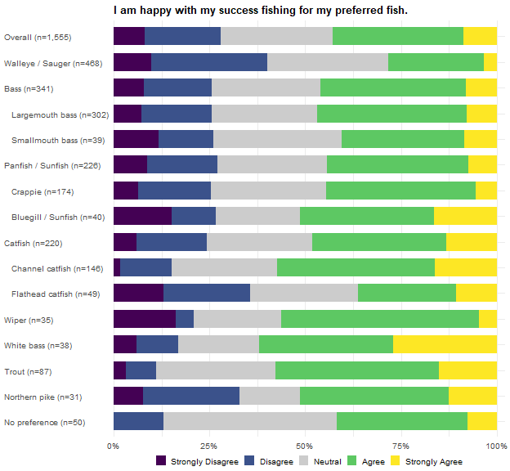
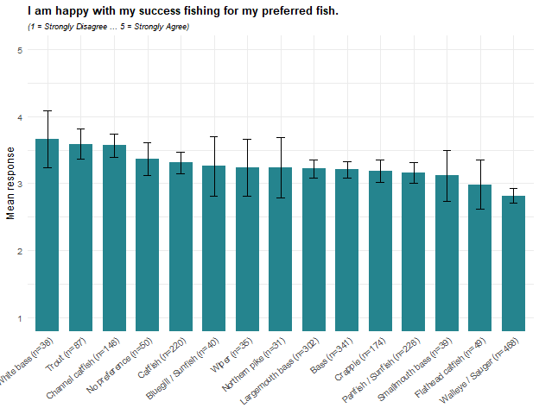
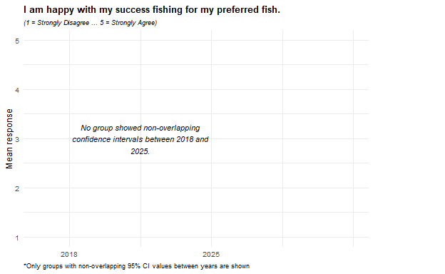
For this item, White bass, Trout, and Channel catfish anglers report the highest satisfaction, averaging 3.7, 3.6, and 3.6 on the five-point scale, with 62%, 58%, and 57% agreeing or strongly agreeing and no more than 17% disagreeing. Walleye / Sauger anglers, the largest single preferred group in the survey, report the lowest satisfaction, averaging 2.8, and are the only group where more anglers disagree (40%) than agree (28%); Flathead catfish anglers, at 3.0, divide evenly (36% each way). The gap between Walleye / Sauger and the three highest groups is roughly three-quarters of a point or more, and may point to a difference in how reliably each species can be caught rather than a difference in how much anglers enjoy the pursuit itself. Within families the widest contrast is among catfish, where Channel catfish anglers (3.6) are considerably more satisfied than Flathead catfish anglers (3.0); the two bass species and the two panfish species each fall within about a tenth of a point of each other.
Within 2025, one further pattern stands out: anglers with no single preferred species report above-average satisfaction (3.4, against 3.2 overall, on only 50 respondents, because the statements presuppose a preferred fish) and the largest neutral share of any group (45%), and neutral responses are common across the board (roughly three in ten anglers in most groups take neither side), so the group differences described above rest on the balance between agreement and disagreement rather than on lopsided views within any group.

I would be satisfied to harvest smaller fish if I could harvest more of my preferred fish.
Cells are the weighted percentage of the row group giving that response, with a 95 percent confidence interval. Mean scores the five responses from 1 (Strongly Disagree) to 5 (Strongly Agree). N is the raw unweighted number of respondents in the row group who answered the item. These results were weighted. Please consult the survey methodology for details.
Preferred species | Strongly Disagree | Disagree | Neutral | Agree | Strongly Agree | Mean ± CI | N
Overall | 10.5 ± 1.74 | 27.2 ± 2.52 | 38.0 ± 2.75 | 19.9 ± 2.26 | 4.3 ± 1.15 | 2.8 ± 0.06 | 1,507
Walleye / Sauger | 10.3 ± 3.10 | 24.8 ± 4.40 | 39.2 ± 4.98 | 23.3 ± 4.31 | 2.4 ± 1.57 | 2.8 ± 0.10 | 458
Bass | 11.7 ± 3.83 | 28.1 ± 5.35 | 38.9 ± 5.80 | 19.1 ± 4.68 | 2.2 ± 1.73 | 2.7 ± 0.12 | 326
Largemouth bass | 13.1 ± 4.27 | 27.6 ± 5.65 | 40.6 ± 6.21 | 16.2 ± 4.66 | 2.5 ± 1.96 | 2.7 ± 0.12 | 290
Smallmouth bass | 1.6 ± 4.39 | 31.9 ± 16.44 | 26.2 ± 15.52 | 40.4 ± 17.31 | 0.0 ± 0.00 | 3.1 ± 0.31 | 36
Panfish / Sunfish | 11.2 ± 4.71 | 27.1 ± 6.63 | 40.0 ± 7.31 | 19.3 ± 5.89 | 2.3 ± 2.22 | 2.7 ± 0.14 | 215
Crappie | 9.4 ± 4.95 | 28.1 ± 7.63 | 39.9 ± 8.31 | 20.8 ± 6.89 | 1.8 ± 2.26 | 2.8 ± 0.16 | 167
Bluegill / Sunfish | 19.5 ± 14.44 | 19.7 ± 14.49 | 47.7 ± 18.22 | 13.1 ± 12.32 | 0.0 ± 0.00 | 2.5 ± 0.35 | 36
Catfish | 11.2 ± 4.75 | 22.2 ± 6.27 | 41.7 ± 7.44 | 17.2 ± 5.69 | 7.8 ± 4.05 | 2.9 ± 0.16 | 212
Channel catfish | 6.0 ± 4.44 | 24.2 ± 7.99 | 51.4 ± 9.33 | 14.5 ± 6.57 | 3.9 ± 3.63 | 2.9 ± 0.16 | 140
Flathead catfish | 25.2 ± 13.78 | 26.1 ± 13.93 | 22.0 ± 13.16 | 14.1 ± 11.04 | 12.7 ± 10.55 | 2.6 ± 0.42 | 46
Wiper | 7.5 ± 9.83 | 50.1 ± 18.65 | 11.2 ± 11.77 | 14.0 ± 12.96 | 17.2 ± 14.07 | 2.8 ± 0.47 | 33
White bass | 1.3 ± 4.09 | 32.1 ± 17.00 | 35.8 ± 17.46 | 22.5 ± 15.21 | 8.4 ± 10.10 | 3.0 ± 0.35 | 38
Trout | 13.0 ± 8.06 | 33.3 ± 11.30 | 39.1 ± 11.70 | 12.2 ± 7.86 | 2.4 ± 3.64 | 2.6 ± 0.23 | 86
Northern pike | 12.9 ± 12.80 | 46.3 ± 19.07 | 32.8 ± 17.95 | 6.7 ± 9.56 | 1.4 ± 4.46 | 2.4 ± 0.32 | 31
No preference | 3.1 ± 5.37 | 18.6 ± 12.09 | 57.9 ± 15.35 | 19.1 ± 12.22 | 1.3 ± 3.56 | 3.0 ± 0.23 | 50
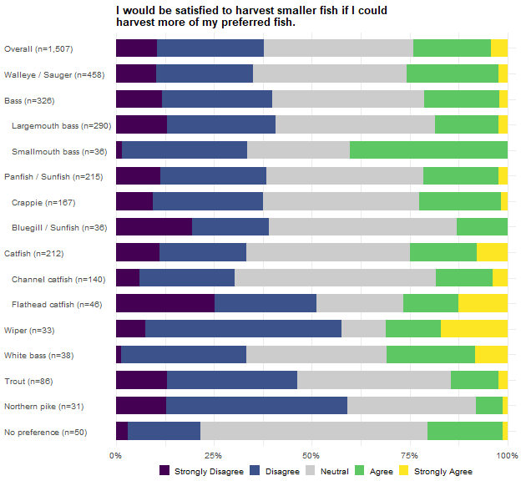
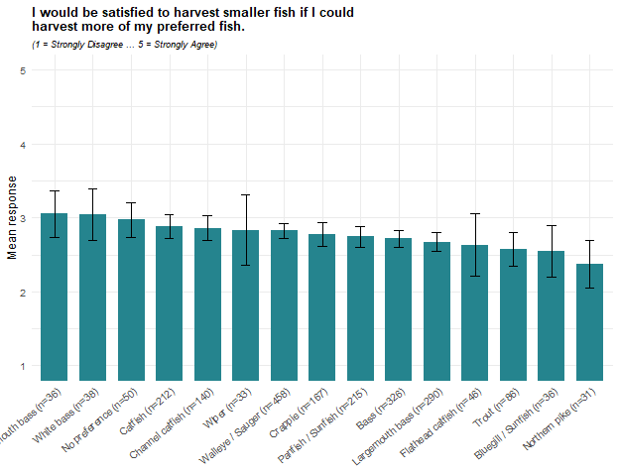
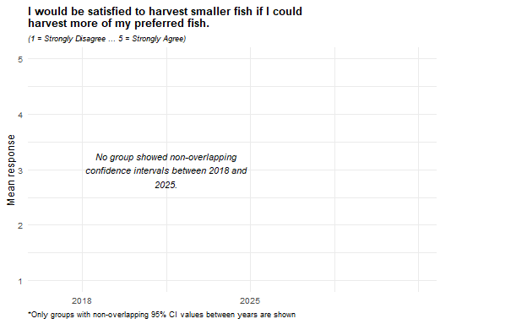
Willingness to harvest smaller fish in exchange for more of them is low overall, averaging 2.8, with 38% disagreeing and 24% agreeing. Smallmouth bass and White bass anglers report the highest agreement (3.05 each), and Smallmouth bass anglers are the only group where more agree (40%) than disagree (33%). Northern pike anglers report the lowest (2.4), with 59% disagreeing and only 8% agreeing; Wiper anglers (58% disagree, 31% agree) and Flathead catfish anglers (51% disagree, 27% agree) also disagree far more often than they agree. The bass family shows the widest within-family spread, with Smallmouth bass anglers (3.1) well above Largemouth bass anglers (2.7).
Within 2025, what separates some groups is how many take no side: 58% of anglers with no single preferred species, 51% of Channel catfish anglers and 48% of Bluegill / Sunfish anglers are neutral, against 11% of Wiper anglers, so a middling average can reflect very different response patterns.

I support regulations on my preferred fish to increase their size.
Cells are the weighted percentage of the row group giving that response, with a 95 percent confidence interval. Mean scores the five responses from 1 (Strongly Disagree) to 5 (Strongly Agree). N is the raw unweighted number of respondents in the row group who answered the item. These results were weighted. Please consult the survey methodology for details.
Preferred species | Strongly Disagree | Disagree | Neutral | Agree | Strongly Agree | Mean ± CI | N
Overall | 2.2 ± 0.83 | 10.0 ± 1.68 | 22.1 ± 2.33 | 41.8 ± 2.76 | 23.8 ± 2.39 | 3.8 ± 0.06 | 1,541
Walleye / Sauger | 2.7 ± 1.63 | 10.7 ± 3.11 | 24.7 ± 4.35 | 46.1 ± 5.02 | 15.9 ± 3.69 | 3.6 ± 0.10 | 469
Bass | 2.6 ± 1.85 | 6.6 ± 2.91 | 19.0 ± 4.60 | 40.8 ± 5.77 | 31.0 ± 5.43 | 3.9 ± 0.12 | 336
Largemouth bass | 2.4 ± 1.90 | 7.5 ± 3.30 | 17.9 ± 4.79 | 40.7 ± 6.14 | 31.4 ± 5.80 | 3.9 ± 0.12 | 297
Smallmouth bass | 3.9 ± 6.60 | 0.0 ± 0.00 | 26.7 ± 15.10 | 41.1 ± 16.80 | 28.3 ± 15.38 | 3.9 ± 0.32 | 39
Panfish / Sunfish | 2.2 ± 2.14 | 9.8 ± 4.36 | 22.9 ± 6.17 | 44.2 ± 7.29 | 21.0 ± 5.98 | 3.7 ± 0.14 | 222
Crappie | 2.0 ± 2.33 | 9.3 ± 4.84 | 23.4 ± 7.07 | 43.6 ± 8.28 | 21.8 ± 6.89 | 3.7 ± 0.16 | 173
Bluegill / Sunfish | 1.6 ± 4.45 | 9.5 ± 10.49 | 23.8 ± 15.24 | 43.5 ± 17.73 | 21.6 ± 14.71 | 3.7 ± 0.34 | 37
Catfish | 2.2 ± 2.20 | 9.5 ± 4.38 | 28.2 ± 6.71 | 34.8 ± 7.10 | 25.2 ± 6.47 | 3.7 ± 0.15 | 218
Channel catfish | 2.0 ± 2.57 | 6.4 ± 4.49 | 31.3 ± 8.53 | 39.7 ± 9.00 | 20.6 ± 7.45 | 3.7 ± 0.17 | 144
Flathead catfish | 4.1 ± 6.17 | 12.5 ± 10.25 | 28.4 ± 13.96 | 25.6 ± 13.53 | 29.3 ± 14.10 | 3.6 ± 0.36 | 49
Wiper | 1.8 ± 4.92 | 3.0 ± 6.27 | 8.2 ± 10.05 | 38.4 ± 17.81 | 48.6 ± 18.30 | 4.3 ± 0.32 | 35
White bass | 0.0 ± 0.00 | 8.8 ± 10.32 | 19.6 ± 14.45 | 48.8 ± 18.21 | 22.8 ± 15.29 | 3.9 ± 0.32 | 38
Trout | 1.8 ± 3.17 | 15.5 ± 8.73 | 20.4 ± 9.73 | 49.3 ± 12.06 | 13.0 ± 8.13 | 3.6 ± 0.23 | 85
Northern pike | 0.0 ± 0.00 | 14.4 ± 13.42 | 8.7 ± 10.76 | 34.5 ± 18.18 | 42.4 ± 18.90 | 4.1 ± 0.40 | 31
No preference | 1.3 ± 3.62 | 1.3 ± 3.62 | 35.5 ± 15.02 | 42.4 ± 15.51 | 19.4 ± 12.42 | 3.8 ± 0.26 | 49
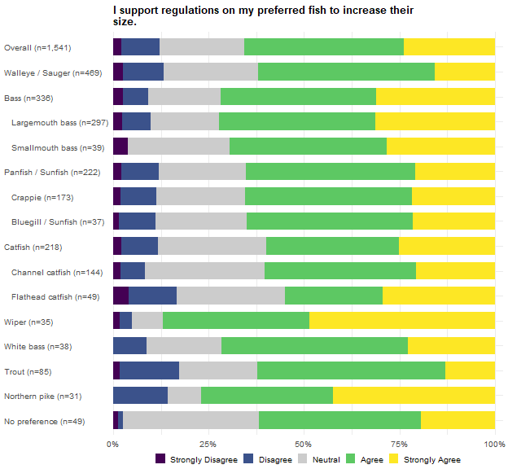
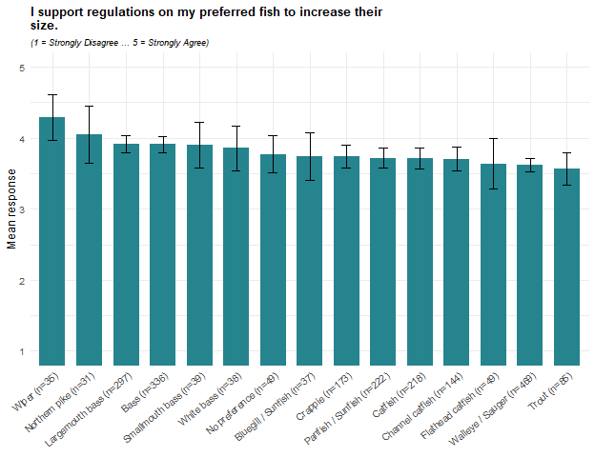
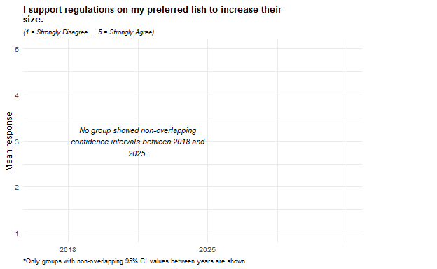
Support for regulations to increase the size of the preferred fish is high in every group, averaging 3.8 overall, with 66% agreeing and 12% disagreeing. Wiper anglers report the highest support (4.3; 87% agree, 5% disagree), followed by Northern pike anglers (4.1; 77% agree). Trout anglers report the lowest (3.6), alongside Walleye / Sauger (3.6) and Flathead catfish anglers (3.6), though even in these groups more than half agree.
What distinguishes the groups in 2025 is the firmness of the support: in every group, supporters outnumber opponents by at least three to one, and Wiper and Northern pike anglers are the least likely to take neither side (8% and 9% neutral), while 35% of anglers with no single preferred species and 31% of Channel catfish anglers do.

I support regulations on my preferred fish to increase their numbers.
Cells are the weighted percentage of the row group giving that response, with a 95 percent confidence interval. Mean scores the five responses from 1 (Strongly Disagree) to 5 (Strongly Agree). N is the raw unweighted number of respondents in the row group who answered the item. These results were weighted. Please consult the survey methodology for details.
Preferred species | Strongly Disagree | Disagree | Neutral | Agree | Strongly Agree | Mean ± CI | N
Overall | 2.9 ± 0.94 | 3.9 ± 1.09 | 20.4 ± 2.26 | 46.5 ± 2.80 | 26.3 ± 2.47 | 3.9 ± 0.05 | 1,533
Walleye / Sauger | 3.0 ± 1.73 | 3.8 ± 1.93 | 17.6 ± 3.85 | 52.5 ± 5.05 | 23.1 ± 4.26 | 3.9 ± 0.09 | 466
Bass | 1.6 ± 1.50 | 3.3 ± 2.12 | 20.1 ± 4.72 | 45.5 ± 5.87 | 29.4 ± 5.37 | 4.0 ± 0.10 | 333
Largemouth bass | 1.9 ± 1.70 | 3.8 ± 2.40 | 18.6 ± 4.87 | 46.7 ± 6.25 | 29.1 ± 5.69 | 4.0 ± 0.11 | 295
Smallmouth bass | 0.0 ± 0.00 | 0.0 ± 0.00 | 30.8 ± 15.91 | 37.7 ± 16.69 | 31.5 ± 16.00 | 4.0 ± 0.27 | 38
Panfish / Sunfish | 4.0 ± 2.89 | 5.4 ± 3.30 | 19.9 ± 5.85 | 52.8 ± 7.32 | 17.9 ± 5.62 | 3.8 ± 0.14 | 223
Crappie | 4.0 ± 3.30 | 5.1 ± 3.69 | 21.4 ± 6.87 | 53.3 ± 8.36 | 16.1 ± 6.16 | 3.7 ± 0.16 | 172
Bluegill / Sunfish | 3.1 ± 6.02 | 4.6 ± 7.31 | 17.3 ± 13.21 | 48.5 ± 17.46 | 26.5 ± 15.43 | 3.9 ± 0.33 | 39
Catfish | 1.8 ± 1.96 | 5.9 ± 3.51 | 27.0 ± 6.61 | 33.7 ± 7.04 | 31.6 ± 6.93 | 3.9 ± 0.15 | 218
Channel catfish | 1.2 ± 1.99 | 6.2 ± 4.41 | 33.3 ± 8.62 | 30.0 ± 8.38 | 29.2 ± 8.31 | 3.8 ± 0.18 | 146
Flathead catfish | 4.2 ± 6.35 | 7.7 ± 8.42 | 18.3 ± 12.19 | 41.7 ± 15.55 | 28.1 ± 14.17 | 3.8 ± 0.33 | 47
Wiper | 8.6 ± 10.61 | 0.0 ± 0.00 | 10.9 ± 11.83 | 30.1 ± 17.40 | 50.5 ± 18.97 | 4.1 ± 0.44 | 33
White bass | 0.0 ± 0.00 | 2.7 ± 5.94 | 21.2 ± 14.90 | 48.4 ± 18.21 | 27.6 ± 16.28 | 4.0 ± 0.28 | 38
Trout | 2.3 ± 3.61 | 1.8 ± 3.17 | 30.3 ± 11.09 | 41.9 ± 11.91 | 23.8 ± 10.27 | 3.8 ± 0.21 | 85
Northern pike | 0.0 ± 0.00 | 11.7 ± 12.51 | 7.3 ± 10.12 | 55.3 ± 19.33 | 25.7 ± 16.99 | 3.9 ± 0.35 | 30
No preference | 0.0 ± 0.00 | 0.0 ± 0.00 | 28.4 ± 14.15 | 49.5 ± 15.69 | 22.1 ± 13.02 | 3.9 ± 0.22 | 49
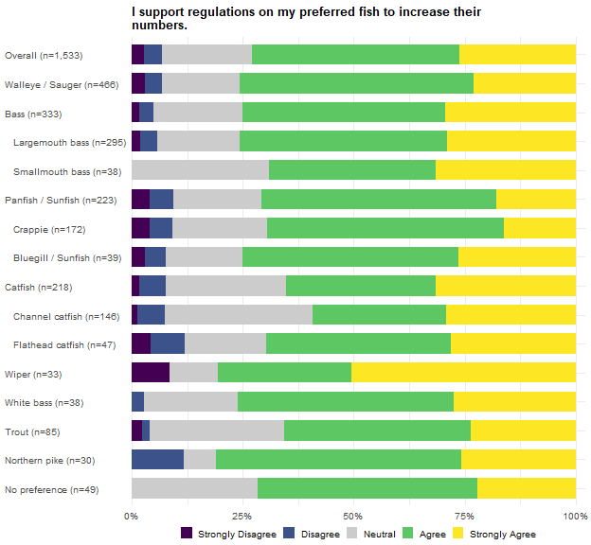
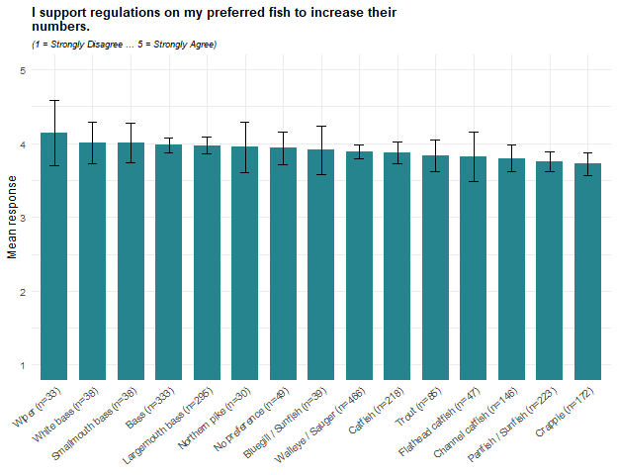
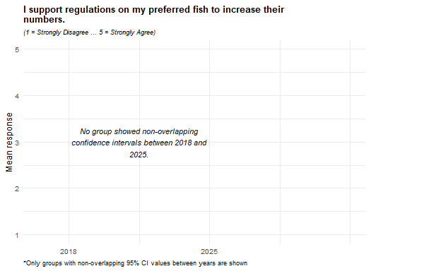
Support for regulations to increase the numbers of the preferred fish is high in every group, averaging 3.9 overall, with 73% agreeing and 7% disagreeing. The spread across groups is narrow: Wiper anglers report the highest support (4.1; 81% agree), while Crappie (3.7) and Panfish / Sunfish anglers (3.8) report the lowest, though 69% and 71% of them agree. Set against the previous item, most groups support numbers-focused regulation more strongly than size-focused regulation; Wiper and Northern pike anglers are the exceptions, backing size rules somewhat more strongly, and Crappie and Panfish / Sunfish anglers rate the two about equally. That tilt toward numbers over size may indicate that, for most anglers, catching fish at all matters more than catching bigger ones.
Within 2025, the share who disagree is 0% after rounding among both Smallmouth bass anglers and anglers with no single preferred species, against 12% of Northern pike and Flathead catfish anglers, so the differences in averages reflect differences in how strongly anglers agree more than any split between supporters and opponents.

If I could catch larger fish, I would be willing to harvest fewer of my preferred fish.
Cells are the weighted percentage of the row group giving that response, with a 95 percent confidence interval. Mean scores the five responses from 1 (Strongly Disagree) to 5 (Strongly Agree). N is the raw unweighted number of respondents in the row group who answered the item. These results were weighted. Please consult the survey methodology for details.
Preferred species | Strongly Disagree | Disagree | Neutral | Agree | Strongly Agree | Mean ± CI | N
Overall | 2.6 ± 0.89 | 11.0 ± 1.75 | 34.6 ± 2.67 | 32.8 ± 2.64 | 19.0 ± 2.20 | 3.5 ± 0.06 | 1,533
Walleye / Sauger | 2.3 ± 1.52 | 13.3 ± 3.44 | 41.5 ± 4.98 | 32.9 ± 4.75 | 9.9 ± 3.02 | 3.3 ± 0.09 | 466
Bass | 2.1 ± 1.70 | 4.1 ± 2.33 | 30.3 ± 5.43 | 35.8 ± 5.67 | 27.7 ± 5.29 | 3.8 ± 0.11 | 331
Largemouth bass | 2.1 ± 1.82 | 4.2 ± 2.51 | 30.7 ± 5.81 | 35.3 ± 6.02 | 27.8 ± 5.64 | 3.8 ± 0.12 | 292
Smallmouth bass | 1.9 ± 4.69 | 3.3 ± 6.14 | 27.7 ± 15.27 | 39.6 ± 16.70 | 27.4 ± 15.23 | 3.9 ± 0.31 | 39
Panfish / Sunfish | 4.4 ± 3.01 | 9.1 ± 4.21 | 30.9 ± 6.75 | 42.0 ± 7.22 | 13.5 ± 5.00 | 3.5 ± 0.14 | 224
Crappie | 2.8 ± 2.76 | 9.5 ± 4.89 | 28.0 ± 7.49 | 45.8 ± 8.32 | 13.9 ± 5.78 | 3.6 ± 0.16 | 173
Bluegill / Sunfish | 8.1 ± 9.51 | 6.1 ± 8.37 | 48.7 ± 17.46 | 29.1 ± 15.87 | 8.1 ± 9.51 | 3.2 ± 0.34 | 39
Catfish | 2.7 ± 2.42 | 13.3 ± 5.04 | 34.6 ± 7.07 | 27.1 ± 6.61 | 22.3 ± 6.18 | 3.5 ± 0.16 | 219
Channel catfish | 0.8 ± 1.63 | 7.8 ± 4.91 | 43.7 ± 9.07 | 28.6 ± 8.26 | 19.1 ± 7.19 | 3.6 ± 0.17 | 146
Flathead catfish | 9.2 ± 9.03 | 16.1 ± 11.47 | 22.7 ± 13.08 | 24.3 ± 13.40 | 27.7 ± 13.97 | 3.5 ± 0.40 | 48
Wiper | 3.3 ± 6.92 | 0.0 ± 0.00 | 14.5 ± 13.57 | 35.0 ± 18.37 | 47.1 ± 19.22 | 4.2 ± 0.36 | 32
White bass | 1.3 ± 4.09 | 14.3 ± 12.75 | 55.7 ± 18.09 | 17.3 ± 13.77 | 11.4 ± 11.59 | 3.2 ± 0.32 | 38
Trout | 0.0 ± 0.00 | 18.4 ± 9.28 | 32.1 ± 11.18 | 31.3 ± 11.11 | 18.1 ± 9.23 | 3.5 ± 0.24 | 86
Northern pike | 0.0 ± 0.00 | 27.4 ± 17.06 | 16.2 ± 14.10 | 25.6 ± 16.68 | 30.8 ± 17.66 | 3.6 ± 0.45 | 31
No preference | 0.0 ± 0.00 | 9.1 ± 9.11 | 39.8 ± 15.52 | 34.2 ± 15.04 | 17.0 ± 11.90 | 3.6 ± 0.28 | 48
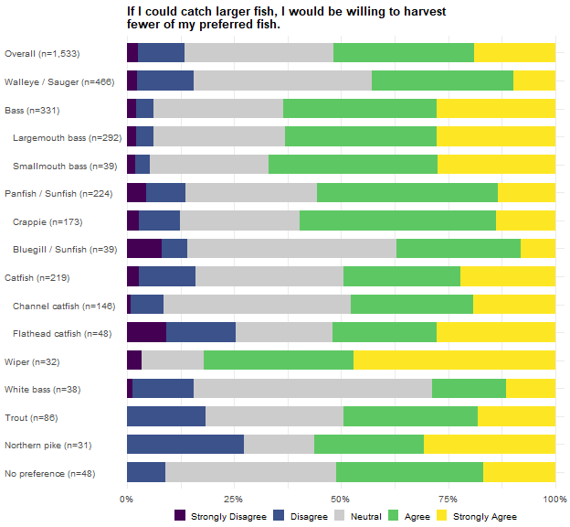
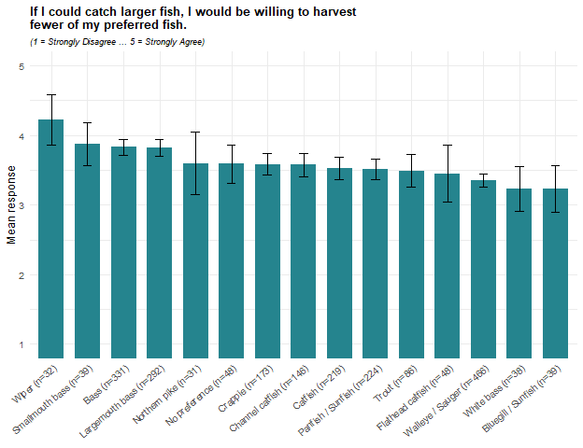
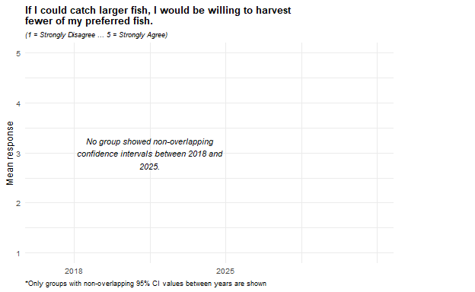
Willingness to harvest fewer fish in exchange for larger fish averages 3.5 overall, with 52% agreeing and 14% disagreeing. Wiper anglers report the highest willingness (4.2; 82% agree, 3% disagree), followed by the bass groups (Smallmouth bass 3.9, Largemouth bass 3.8; 63% to 67% agree). Bluegill / Sunfish and White bass anglers report the lowest (3.2 each), though for both the difference is mostly neutral rather than opposed responses: 49% and 56% of them take neither side, and 37% and 29% agree.
The 2025 pattern is internally consistent with the harvest-versus-size question two items later: the groups most willing to sacrifice numbers for size here, Wiper and both bass species, are the same ones that lean toward size over harvest opportunity there, while Walleye / Sauger anglers, among the least willing here, lean toward harvest opportunity. No group falls below neutral on average, so the differences are in degree of willingness, not direction.

It is becoming harder to catch my preferred fish.
Cells are the weighted percentage of the row group giving that response, with a 95 percent confidence interval. Mean scores the five responses from 1 (Strongly Disagree) to 5 (Strongly Agree). N is the raw unweighted number of respondents in the row group who answered the item. These results were weighted. Please consult the survey methodology for details.
Preferred species | Strongly Disagree | Disagree | Neutral | Agree | Strongly Agree | Mean ± CI | N
Overall | 3.1 ± 0.98 | 17.1 ± 2.12 | 35.1 ± 2.68 | 32.7 ± 2.64 | 12.0 ± 1.83 | 3.3 ± 0.06 | 1,528
Walleye / Sauger | 0.8 ± 0.89 | 11.2 ± 3.20 | 32.0 ± 4.74 | 41.5 ± 5.00 | 14.5 ± 3.58 | 3.6 ± 0.09 | 462
Bass | 3.5 ± 2.16 | 19.2 ± 4.63 | 37.4 ± 5.68 | 30.3 ± 5.40 | 9.5 ± 3.45 | 3.2 ± 0.12 | 335
Largemouth bass | 3.8 ± 2.39 | 17.3 ± 4.72 | 36.9 ± 6.03 | 33.0 ± 5.87 | 9.1 ± 3.60 | 3.3 ± 0.12 | 297
Smallmouth bass | 1.5 ± 4.18 | 33.1 ± 16.22 | 41.2 ± 16.96 | 11.6 ± 11.04 | 12.6 ± 11.42 | 3.0 ± 0.35 | 38
Panfish / Sunfish | 4.7 ± 3.11 | 19.1 ± 5.76 | 36.0 ± 7.03 | 27.4 ± 6.54 | 12.6 ± 4.87 | 3.2 ± 0.15 | 223
Crappie | 2.8 ± 2.76 | 17.5 ± 6.35 | 35.8 ± 8.00 | 30.7 ± 7.70 | 13.2 ± 5.66 | 3.3 ± 0.17 | 173
Bluegill / Sunfish | 14.6 ± 12.33 | 31.3 ± 16.20 | 37.8 ± 16.94 | 7.8 ± 9.39 | 8.4 ± 9.70 | 2.6 ± 0.38 | 39
Catfish | 4.7 ± 3.15 | 19.5 ± 5.92 | 38.2 ± 7.25 | 24.3 ± 6.40 | 13.3 ± 5.07 | 3.2 ± 0.16 | 217
Channel catfish | 6.0 ± 4.35 | 26.7 ± 8.11 | 34.4 ± 8.72 | 28.8 ± 8.31 | 4.1 ± 3.63 | 3.0 ± 0.18 | 145
Flathead catfish | 4.1 ± 6.23 | 11.1 ± 9.82 | 40.8 ± 15.35 | 15.1 ± 11.20 | 28.8 ± 14.14 | 3.5 ± 0.36 | 48
Wiper | 3.3 ± 6.92 | 8.3 ± 10.61 | 60.8 ± 18.80 | 14.7 ± 13.64 | 12.8 ± 12.89 | 3.3 ± 0.35 | 32
White bass | 3.8 ± 7.01 | 30.8 ± 16.82 | 25.9 ± 15.96 | 33.5 ± 17.20 | 5.9 ± 8.59 | 3.1 ± 0.37 | 38
Trout | 2.3 ± 3.60 | 23.2 ± 10.21 | 28.3 ± 10.90 | 37.7 ± 11.72 | 8.5 ± 6.76 | 3.3 ± 0.24 | 84
Northern pike | 0.0 ± 0.00 | 25.0 ± 16.57 | 14.9 ± 13.60 | 46.6 ± 19.08 | 13.5 ± 13.06 | 3.5 ± 0.39 | 31
No preference | 3.8 ± 6.00 | 20.0 ± 12.57 | 46.3 ± 15.65 | 18.6 ± 12.20 | 11.4 ± 9.96 | 3.1 ± 0.31 | 49
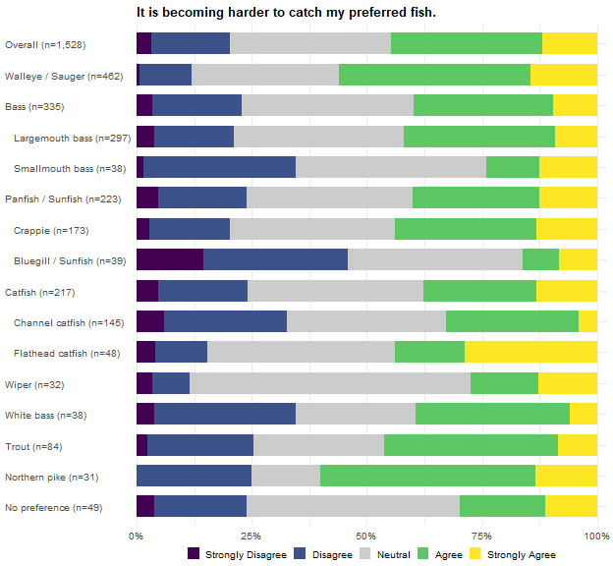
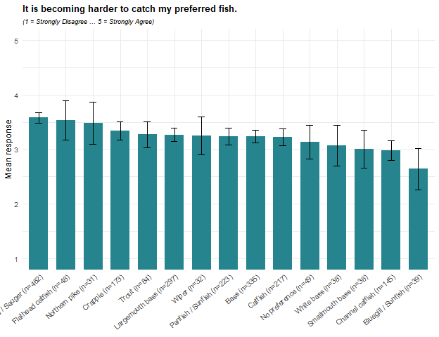
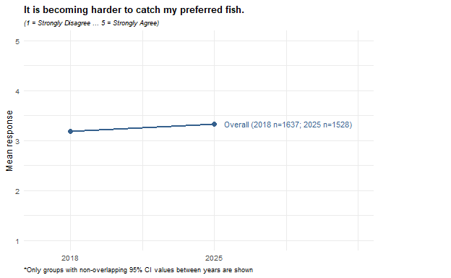
Agreement that the preferred fish is becoming harder to catch averages 3.3 overall, with 45% agreeing and 20% disagreeing. Walleye / Sauger anglers report the highest agreement (3.6; 56% agree), followed by Flathead catfish (3.5) and Northern pike anglers (3.5; 60% agree, the highest agree share of any group). Bluegill / Sunfish anglers report the lowest (2.6; 46% disagree, 16% agree) and are joined below the scale midpoint only by Channel catfish anglers (2.98, just under it). The within-family spreads are wide for panfish (Bluegill / Sunfish 2.6, Crappie 3.3) and catfish (Channel catfish 3.0, Flathead catfish 3.5).
Agreement that the preferred fish has become harder to catch rose modestly across all anglers between 2018 and 2025, from 3.2 to 3.3. It is one of only two items in this battery, along with the places-to-fish item at the end, where the change across all anglers is what stands out between years. No individual preferred group’s change was large enough to appear in the figure above, which suggests a broad, shallow drift toward agreement rather than a sharp movement concentrated in any one group.

The opportunity to harvest my preferred fish is more important to me than the size of the fish I catch.
Cells are the weighted percentage of the row group giving that response, with a 95 percent confidence interval. Mean scores the five responses from 1 (Strongly Disagree) to 5 (Strongly Agree). N is the raw unweighted number of respondents in the row group who answered the item. These results were weighted. Please consult the survey methodology for details.
Preferred species | Strongly Disagree | Disagree | Neutral | Agree | Strongly Agree | Mean ± CI | N
Overall | 9.9 ± 1.67 | 20.1 ± 2.25 | 34.3 ± 2.66 | 29.9 ± 2.57 | 5.7 ± 1.31 | 3.0 ± 0.06 | 1,534
Walleye / Sauger | 4.8 ± 2.16 | 15.9 ± 3.70 | 35.8 ± 4.85 | 36.1 ± 4.86 | 7.4 ± 2.65 | 3.3 ± 0.10 | 466
Bass | 16.7 ± 4.40 | 24.2 ± 5.05 | 35.2 ± 5.63 | 20.5 ± 4.75 | 3.3 ± 2.12 | 2.7 ± 0.13 | 333
Largemouth bass | 16.3 ± 4.62 | 23.0 ± 5.26 | 35.4 ± 5.98 | 21.5 ± 5.13 | 3.8 ± 2.38 | 2.7 ± 0.14 | 297
Smallmouth bass | 19.7 ± 14.05 | 33.6 ± 16.67 | 33.6 ± 16.67 | 13.0 ± 11.88 | 0.0 ± 0.00 | 2.4 ± 0.33 | 36
Panfish / Sunfish | 8.9 ± 4.16 | 23.6 ± 6.21 | 30.7 ± 6.74 | 31.3 ± 6.78 | 5.5 ± 3.32 | 3.0 ± 0.15 | 224
Crappie | 8.6 ± 4.67 | 22.6 ± 6.99 | 29.3 ± 7.60 | 34.4 ± 7.93 | 5.1 ± 3.67 | 3.0 ± 0.18 | 173
Bluegill / Sunfish | 11.3 ± 11.07 | 27.3 ± 15.56 | 37.0 ± 16.86 | 17.2 ± 13.20 | 7.2 ± 9.01 | 2.8 ± 0.37 | 39
Catfish | 6.4 ± 3.63 | 21.0 ± 6.05 | 38.8 ± 7.23 | 27.1 ± 6.59 | 6.7 ± 3.70 | 3.1 ± 0.15 | 220
Channel catfish | 4.3 ± 3.70 | 17.9 ± 7.00 | 43.2 ± 9.06 | 28.5 ± 8.25 | 6.1 ± 4.37 | 3.1 ± 0.17 | 146
Flathead catfish | 12.6 ± 10.28 | 26.1 ± 13.60 | 35.6 ± 14.83 | 17.1 ± 11.66 | 8.6 ± 8.70 | 2.8 ± 0.35 | 49
Wiper | 43.3 ± 18.80 | 16.2 ± 13.97 | 15.4 ± 13.70 | 21.0 ± 15.47 | 4.0 ± 7.48 | 2.3 ± 0.50 | 33
White bass | 4.0 ± 7.15 | 27.0 ± 16.18 | 37.4 ± 17.62 | 30.3 ± 16.74 | 1.3 ± 4.09 | 3.0 ± 0.32 | 38
Trout | 5.8 ± 5.65 | 13.2 ± 8.19 | 37.2 ± 11.69 | 36.8 ± 11.67 | 7.0 ± 6.18 | 3.3 ± 0.24 | 84
Northern pike | 9.9 ± 11.41 | 19.2 ± 15.08 | 24.4 ± 16.43 | 45.1 ± 19.03 | 1.4 ± 4.46 | 3.1 ± 0.40 | 31
No preference | 5.6 ± 7.20 | 22.4 ± 13.08 | 49.8 ± 15.70 | 21.0 ± 12.77 | 1.3 ± 3.62 | 2.9 ± 0.26 | 49
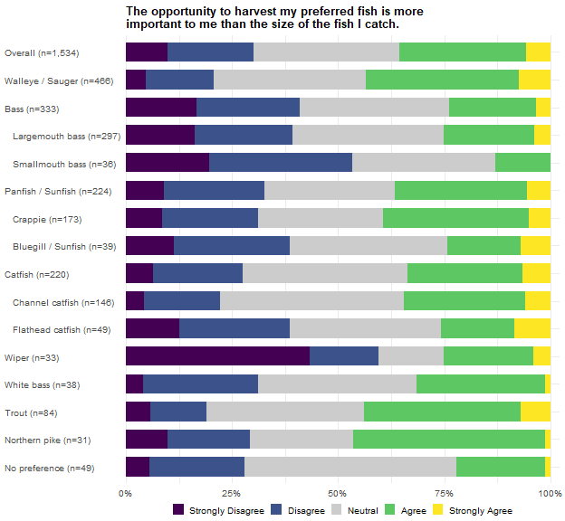
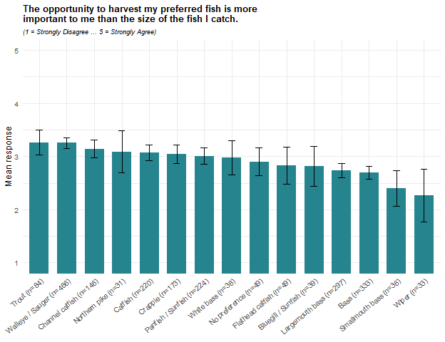
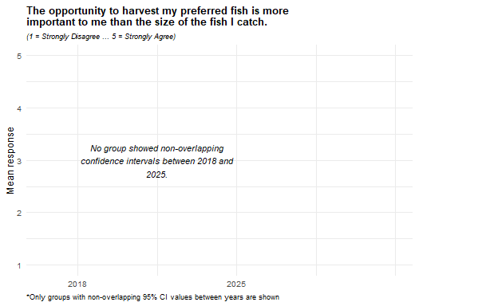
Views on whether harvest opportunity matters more than fish size are divided, averaging 3.0 overall, with 36% agreeing and 30% disagreeing. Trout (3.3) and Walleye / Sauger anglers (3.3) lean furthest toward harvest opportunity. Wiper anglers lean furthest toward size (2.3; 60% disagree, 25% agree), followed by Smallmouth bass anglers (2.4; 53% disagree, 13% agree) and the bass family as a whole (2.7; 41% disagree, 24% agree).
Within 2025, half of the anglers with no single preferred species (50%) take neither side, the largest neutral share of any group, against 15% of Wiper anglers. The two averages differ for different reasons: the Wiper average sits at the size end of the range (2.3) because a majority disagree (60%), while the no-preference average (2.9) sits near the overall (3.0), with the group split between disagreeing (28%) and agreeing (22%).

I have to travel too far to fish for my preferred fish.
Cells are the weighted percentage of the row group giving that response, with a 95 percent confidence interval. Mean scores the five responses from 1 (Strongly Disagree) to 5 (Strongly Agree). N is the raw unweighted number of respondents in the row group who answered the item. These results were weighted. Please consult the survey methodology for details.
Preferred species | Strongly Disagree | Disagree | Neutral | Agree | Strongly Agree | Mean ± CI | N
Overall | 11.1 ± 1.77 | 32.1 ± 2.63 | 32.0 ± 2.63 | 17.1 ± 2.12 | 7.8 ± 1.51 | 2.8 ± 0.06 | 1,519
Walleye / Sauger | 6.8 ± 2.56 | 26.4 ± 4.49 | 35.1 ± 4.86 | 20.3 ± 4.10 | 11.4 ± 3.24 | 3.0 ± 0.11 | 459
Bass | 14.6 ± 4.14 | 38.0 ± 5.70 | 33.1 ± 5.52 | 9.5 ± 3.43 | 4.8 ± 2.50 | 2.5 ± 0.12 | 336
Largemouth bass | 14.1 ± 4.35 | 39.6 ± 6.10 | 34.5 ± 5.93 | 8.5 ± 3.48 | 3.3 ± 2.23 | 2.5 ± 0.12 | 298
Smallmouth bass | 18.0 ± 13.22 | 27.1 ± 15.31 | 23.7 ± 14.65 | 16.1 ± 12.66 | 15.2 ± 12.36 | 2.8 ± 0.45 | 38
Panfish / Sunfish | 14.1 ± 5.13 | 37.8 ± 7.15 | 27.3 ± 6.57 | 14.3 ± 5.17 | 6.5 ± 3.63 | 2.6 ± 0.16 | 220
Crappie | 11.5 ± 5.37 | 38.5 ± 8.20 | 29.4 ± 7.68 | 14.6 ± 5.96 | 6.0 ± 4.00 | 2.7 ± 0.18 | 170
Bluegill / Sunfish | 29.6 ± 16.13 | 45.5 ± 17.60 | 12.7 ± 11.76 | 8.9 ± 10.07 | 3.3 ± 6.33 | 2.1 ± 0.36 | 38
Catfish | 16.7 ± 5.60 | 41.5 ± 7.39 | 27.0 ± 6.66 | 9.5 ± 4.39 | 5.4 ± 3.39 | 2.5 ± 0.16 | 215
Channel catfish | 17.7 ± 7.06 | 37.4 ± 8.95 | 31.8 ± 8.61 | 10.0 ± 5.55 | 3.1 ± 3.21 | 2.4 ± 0.18 | 143
Flathead catfish | 13.2 ± 10.65 | 55.0 ± 15.66 | 16.4 ± 11.67 | 10.3 ± 9.56 | 5.1 ± 6.91 | 2.4 ± 0.32 | 47
Wiper | 10.0 ± 11.38 | 8.0 ± 10.28 | 27.0 ± 16.85 | 43.6 ± 18.82 | 11.4 ± 12.05 | 3.4 ± 0.42 | 33
White bass | 4.6 ± 7.65 | 30.4 ± 16.76 | 30.6 ± 16.78 | 18.5 ± 14.15 | 15.9 ± 13.31 | 3.1 ± 0.41 | 38
Trout | 6.5 ± 5.92 | 26.6 ± 10.64 | 27.7 ± 10.77 | 31.2 ± 11.15 | 8.0 ± 6.53 | 3.1 ± 0.26 | 85
Northern pike | 11.4 ± 12.30 | 16.5 ± 14.37 | 33.6 ± 18.27 | 25.5 ± 16.86 | 13.0 ± 13.01 | 3.1 ± 0.45 | 30
No preference | 3.8 ± 6.10 | 16.7 ± 11.83 | 57.5 ± 15.67 | 15.6 ± 11.50 | 6.3 ± 7.72 | 3.0 ± 0.27 | 48
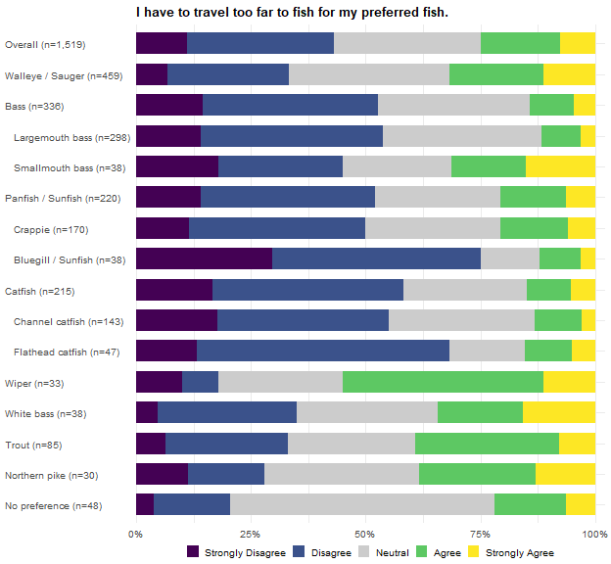
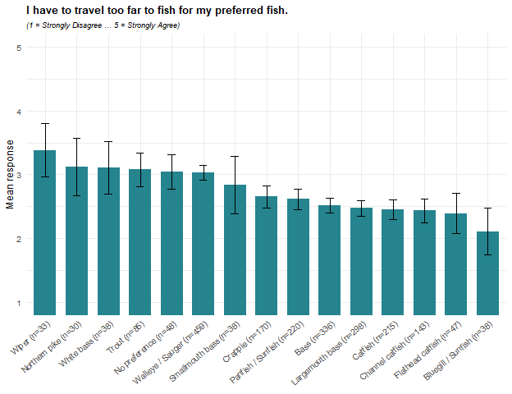
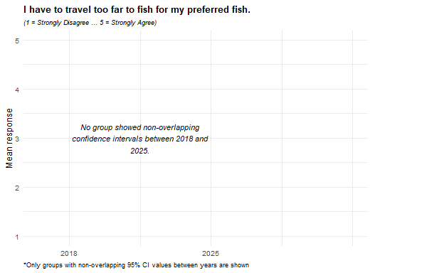
Agreement that the angler has to travel too far to fish for the preferred fish averages 2.8 overall, with 43% disagreeing and 25% agreeing. Wiper anglers report the highest agreement (3.4; 55% agree, 18% disagree), with the widest margin of agreement over disagreement of any group; Northern pike (3.1), White bass (3.1), and Trout anglers (3.1) follow. Bluegill / Sunfish anglers report the lowest (2.1; 75% disagree, 12% agree), followed by Flathead catfish (2.4), Channel catfish (2.4), Catfish anglers as a whole (2.5), and Largemouth bass anglers (2.5).
The travel pattern partly lines up with the places-to-fish item at the end of this battery: Northern pike, Wiper, and Trout anglers sit at or near the top of both, while Bluegill / Sunfish and Channel catfish anglers sit at or near the bottom of both, suggesting that travel distance and the perceived shortage of places to fish may be two readings of the same underlying access picture for these species. Flathead catfish anglers are the exception, near the bottom on travel (2.4) but second from the top on places to fish (3.3).

I am satisfied with the size of my preferred fish that I catch in Nebraska.
Cells are the weighted percentage of the row group giving that response, with a 95 percent confidence interval. Mean scores the five responses from 1 (Strongly Disagree) to 5 (Strongly Agree). N is the raw unweighted number of respondents in the row group who answered the item. These results were weighted. Please consult the survey methodology for details.
Preferred species | Strongly Disagree | Disagree | Neutral | Agree | Strongly Agree | Mean ± CI | N
Overall | 5.0 ± 1.22 | 15.8 ± 2.05 | 33.3 ± 2.65 | 40.4 ± 2.75 | 5.5 ± 1.28 | 3.3 ± 0.05 | 1,533
Walleye / Sauger | 5.3 ± 2.28 | 15.5 ± 3.67 | 35.3 ± 4.84 | 41.0 ± 4.99 | 2.9 ± 1.71 | 3.2 ± 0.09 | 464
Bass | 6.4 ± 2.87 | 21.0 ± 4.78 | 33.9 ± 5.55 | 35.9 ± 5.63 | 2.8 ± 1.95 | 3.1 ± 0.11 | 336
Largemouth bass | 6.4 ± 3.05 | 23.2 ± 5.27 | 35.3 ± 5.96 | 31.9 ± 5.81 | 3.2 ± 2.21 | 3.0 ± 0.12 | 298
Smallmouth bass | 6.2 ± 8.29 | 5.4 ± 7.81 | 23.6 ± 14.62 | 64.8 ± 16.45 | 0.0 ± 0.00 | 3.5 ± 0.29 | 38
Panfish / Sunfish | 6.1 ± 3.50 | 19.1 ± 5.76 | 29.4 ± 6.68 | 40.6 ± 7.19 | 4.8 ± 3.13 | 3.2 ± 0.15 | 223
Crappie | 7.5 ± 4.42 | 18.3 ± 6.49 | 28.9 ± 7.61 | 42.5 ± 8.30 | 2.8 ± 2.76 | 3.1 ± 0.17 | 171
Bluegill / Sunfish | 0.0 ± 0.00 | 19.2 ± 13.61 | 29.4 ± 15.73 | 36.4 ± 16.61 | 15.0 ± 12.33 | 3.5 ± 0.33 | 40
Catfish | 3.1 ± 2.57 | 13.5 ± 5.07 | 31.6 ± 6.91 | 41.8 ± 7.33 | 10.0 ± 4.45 | 3.4 ± 0.14 | 219
Channel catfish | 0.5 ± 1.34 | 19.6 ± 7.29 | 25.0 ± 7.94 | 41.5 ± 9.03 | 13.4 ± 6.24 | 3.5 ± 0.18 | 145
Flathead catfish | 5.7 ± 7.24 | 6.4 ± 7.62 | 38.7 ± 15.21 | 42.6 ± 15.44 | 6.7 ± 7.80 | 3.4 ± 0.29 | 48
Wiper | 3.3 ± 6.76 | 3.3 ± 6.76 | 13.6 ± 13.02 | 51.2 ± 18.97 | 28.6 ± 17.16 | 4.0 ± 0.35 | 33
White bass | 1.3 ± 4.09 | 6.1 ± 8.73 | 44.1 ± 18.09 | 25.9 ± 15.95 | 22.6 ± 15.23 | 3.6 ± 0.34 | 38
Trout | 0.0 ± 0.00 | 10.5 ± 7.39 | 41.3 ± 11.88 | 44.2 ± 11.99 | 4.1 ± 4.76 | 3.4 ± 0.18 | 85
Northern pike | 8.7 ± 10.78 | 28.6 ± 17.29 | 20.2 ± 15.35 | 42.5 ± 18.91 | 0.0 ± 0.00 | 3.0 ± 0.39 | 31
No preference | 5.4 ± 7.17 | 8.8 ± 8.99 | 49.9 ± 15.85 | 33.2 ± 14.93 | 2.7 ± 5.16 | 3.2 ± 0.27 | 48
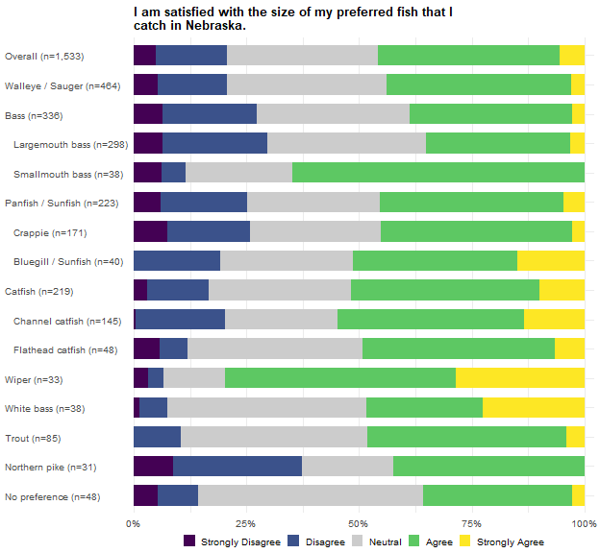
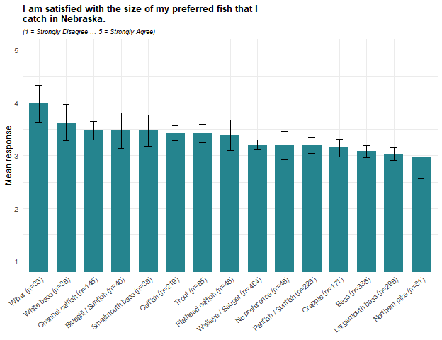
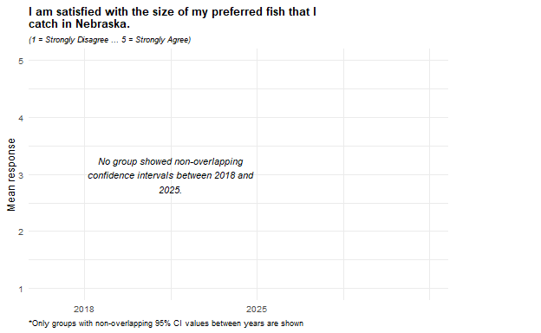
Satisfaction with the size of the preferred fish caught averages 3.3 overall, with 46% agreeing and 21% disagreeing. Wiper anglers report the highest satisfaction (4.0; 80% agree, 7% disagree), followed by White bass anglers (3.6). Northern pike anglers report the lowest (2.96), the only group averaging below the scale midpoint, followed by Largemouth bass anglers (3.02).
Within 2025, how the groups arrive at their averages differs as much as the averages themselves: Northern pike anglers split into opposing camps (43% agree, 37% disagree, only a fifth neutral), while half of the anglers with no single preferred species (50%), 44% of White bass anglers, and four in ten Trout anglers (41%) take no side at all.

I am satisfied with the size of my preferred fish that I am allowed to harvest in Nebraska.
Cells are the weighted percentage of the row group giving that response, with a 95 percent confidence interval. Mean scores the five responses from 1 (Strongly Disagree) to 5 (Strongly Agree). N is the raw unweighted number of respondents in the row group who answered the item. These results were weighted. Please consult the survey methodology for details.
Preferred species | Strongly Disagree | Disagree | Neutral | Agree | Strongly Agree | Mean ± CI | N
Overall | 2.2 ± 0.83 | 7.5 ± 1.48 | 34.5 ± 2.68 | 48.5 ± 2.81 | 7.3 ± 1.46 | 3.5 ± 0.05 | 1,524
Walleye / Sauger | 1.4 ± 1.18 | 9.4 ± 2.95 | 29.7 ± 4.63 | 54.1 ± 5.05 | 5.4 ± 2.30 | 3.5 ± 0.08 | 464
Bass | 3.0 ± 2.02 | 5.0 ± 2.58 | 38.0 ± 5.73 | 47.4 ± 5.89 | 6.5 ± 2.92 | 3.5 ± 0.10 | 333
Largemouth bass | 3.2 ± 2.21 | 5.7 ± 2.91 | 38.5 ± 6.09 | 45.8 ± 6.24 | 6.7 ± 3.14 | 3.5 ± 0.10 | 296
Smallmouth bass | 1.6 ± 4.40 | 0.0 ± 0.00 | 34.2 ± 16.69 | 59.2 ± 17.29 | 5.0 ± 7.65 | 3.7 ± 0.23 | 37
Panfish / Sunfish | 0.0 ± 0.00 | 7.2 ± 3.79 | 30.9 ± 6.78 | 52.9 ± 7.32 | 9.0 ± 4.20 | 3.6 ± 0.11 | 222
Crappie | 0.0 ± 0.00 | 7.4 ± 4.37 | 32.0 ± 7.81 | 54.5 ± 8.34 | 6.2 ± 4.02 | 3.6 ± 0.12 | 172
Bluegill / Sunfish | 0.0 ± 0.00 | 3.2 ± 6.23 | 27.5 ± 15.73 | 44.0 ± 17.48 | 25.2 ± 15.28 | 3.9 ± 0.28 | 38
Catfish | 2.5 ± 2.34 | 4.1 ± 2.96 | 41.3 ± 7.35 | 43.9 ± 7.41 | 8.2 ± 4.09 | 3.5 ± 0.12 | 217
Channel catfish | 0.0 ± 0.00 | 4.9 ± 3.96 | 42.4 ± 9.03 | 43.9 ± 9.07 | 8.8 ± 5.17 | 3.6 ± 0.13 | 146
Flathead catfish | 7.5 ± 8.31 | 4.4 ± 6.43 | 37.4 ± 15.23 | 40.4 ± 15.45 | 10.3 ± 9.58 | 3.4 ± 0.31 | 47
Wiper | 5.3 ± 8.48 | 5.6 ± 8.72 | 45.7 ± 18.90 | 39.2 ± 18.53 | 4.2 ± 7.59 | 3.3 ± 0.32 | 33
White bass | 1.3 ± 4.09 | 3.4 ± 6.59 | 32.0 ± 17.00 | 44.9 ± 18.12 | 18.4 ± 14.12 | 3.8 ± 0.30 | 38
Trout | 1.9 ± 3.37 | 12.7 ± 8.26 | 19.0 ± 9.74 | 59.2 ± 12.19 | 7.2 ± 6.40 | 3.6 ± 0.22 | 81
Northern pike | 9.0 ± 10.93 | 30.7 ± 17.64 | 22.1 ± 15.86 | 33.2 ± 18.01 | 5.1 ± 8.39 | 2.9 ± 0.42 | 31
No preference | 3.6 ± 5.81 | 8.9 ± 8.93 | 51.5 ± 15.69 | 34.8 ± 14.95 | 1.3 ± 3.61 | 3.2 ± 0.24 | 49
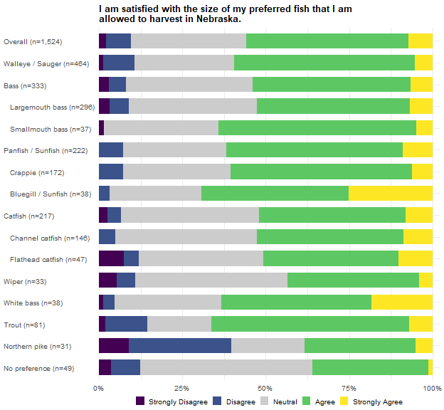
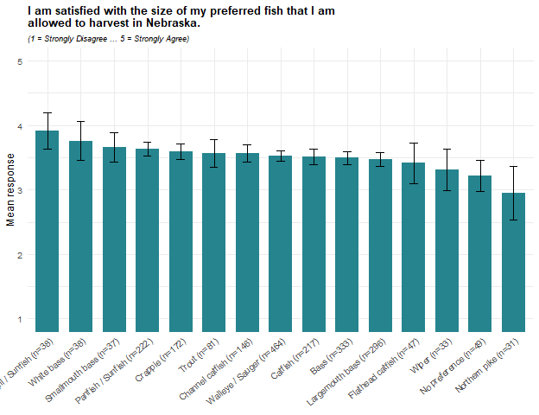
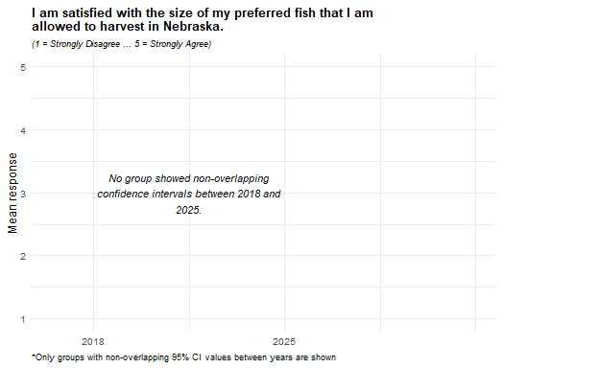
Satisfaction with the size of the preferred fish that may be harvested averages 3.5 overall, with 56% agreeing and 10% disagreeing. Bluegill / Sunfish anglers report the highest satisfaction (3.9; 69% agree, 3% disagree), followed by White bass anglers (3.8) and Smallmouth bass anglers (3.7). Northern pike anglers report the lowest (2.9; 38% agree, 40% disagree) and are the only group where disagreement is at least as common as agreement; anglers with no single preferred species (3.2) and Wiper anglers (3.3) follow.
Compared with the previous item, nearly every group rates the size they are allowed to harvest at least as favorably as the size they actually catch; Wiper anglers are the one clear exception, rating the size they catch (4.0) above the size they are allowed to keep (3.3), while Northern pike anglers rate the two about equally (2.96 caught, 2.95 allowed), which may hint that where Wiper anglers have a complaint, it is with the rules rather than the fish.

I am satisfied with the number of my preferred fish that I catch in Nebraska.
Cells are the weighted percentage of the row group giving that response, with a 95 percent confidence interval. Mean scores the five responses from 1 (Strongly Disagree) to 5 (Strongly Agree). N is the raw unweighted number of respondents in the row group who answered the item. These results were weighted. Please consult the survey methodology for details.
Preferred species | Strongly Disagree | Disagree | Neutral | Agree | Strongly Agree | Mean ± CI | N
Overall | 6.2 ± 1.35 | 21.2 ± 2.30 | 26.7 ± 2.48 | 40.1 ± 2.75 | 5.9 ± 1.32 | 3.2 ± 0.06 | 1,533
Walleye / Sauger | 8.2 ± 2.76 | 23.9 ± 4.30 | 27.8 ± 4.52 | 36.3 ± 4.85 | 3.9 ± 1.96 | 3.0 ± 0.10 | 468
Bass | 5.4 ± 2.66 | 20.0 ± 4.71 | 28.3 ± 5.30 | 42.3 ± 5.82 | 4.1 ± 2.32 | 3.2 ± 0.12 | 334
Largemouth bass | 4.8 ± 2.67 | 19.4 ± 4.94 | 31.0 ± 5.78 | 40.2 ± 6.13 | 4.6 ± 2.62 | 3.2 ± 0.12 | 297
Smallmouth bass | 9.9 ± 10.52 | 24.5 ± 15.13 | 7.9 ± 9.51 | 57.6 ± 17.38 | 0.0 ± 0.00 | 3.1 ± 0.39 | 37
Panfish / Sunfish | 6.3 ± 3.56 | 18.8 ± 5.73 | 20.2 ± 5.88 | 48.8 ± 7.32 | 5.8 ± 3.43 | 3.3 ± 0.15 | 223
Crappie | 4.3 ± 3.40 | 21.1 ± 6.84 | 22.2 ± 6.96 | 48.7 ± 8.38 | 3.6 ± 3.14 | 3.3 ± 0.16 | 172
Bluegill / Sunfish | 8.9 ± 9.93 | 11.4 ± 11.04 | 9.8 ± 10.33 | 52.3 ± 17.37 | 17.6 ± 13.26 | 3.6 ± 0.41 | 39
Catfish | 5.8 ± 3.47 | 22.2 ± 6.17 | 26.4 ± 6.55 | 36.7 ± 7.16 | 8.9 ± 4.24 | 3.2 ± 0.16 | 219
Channel catfish | 2.8 ± 3.02 | 14.4 ± 6.42 | 30.0 ± 8.37 | 41.3 ± 9.00 | 11.5 ± 5.83 | 3.4 ± 0.18 | 146
Flathead catfish | 13.9 ± 10.79 | 36.2 ± 15.01 | 11.5 ± 9.98 | 31.7 ± 14.54 | 6.7 ± 7.80 | 2.8 ± 0.38 | 48
Wiper | 4.4 ± 7.82 | 12.0 ± 12.33 | 23.3 ± 16.04 | 55.8 ± 18.84 | 4.4 ± 7.81 | 3.4 ± 0.35 | 33
White bass | 2.6 ± 5.75 | 20.4 ± 14.68 | 27.4 ± 16.24 | 34.2 ± 17.28 | 15.5 ± 13.18 | 3.4 ± 0.38 | 38
Trout | 2.7 ± 3.98 | 14.9 ± 8.74 | 27.9 ± 11.02 | 50.2 ± 12.28 | 4.3 ± 4.96 | 3.4 ± 0.22 | 83
Northern pike | 8.7 ± 10.78 | 30.6 ± 17.62 | 12.9 ± 12.82 | 26.5 ± 16.87 | 21.3 ± 15.67 | 3.2 ± 0.50 | 31
No preference | 3.6 ± 5.81 | 11.3 ± 9.95 | 46.4 ± 15.66 | 32.2 ± 14.67 | 6.5 ± 7.73 | 3.3 ± 0.27 | 49
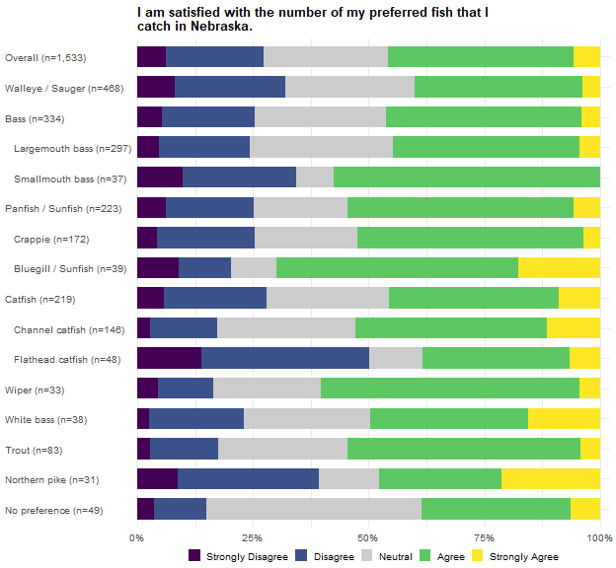
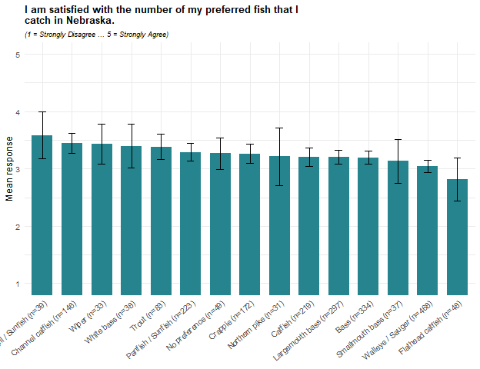
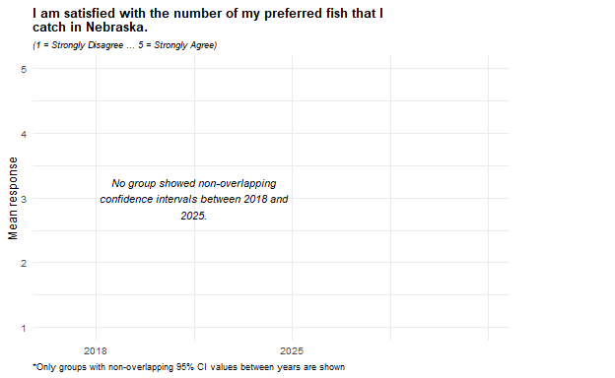
Satisfaction with the number of the preferred fish caught averages 3.2 overall, with 46% agreeing and 27% disagreeing. Bluegill / Sunfish anglers report the highest satisfaction (3.6; 70% agree, 20% disagree), followed by Channel catfish and Wiper anglers (3.4 each). Flathead catfish anglers report the lowest (2.8; 50% disagree, 38% agree), the only group averaging below the scale midpoint, followed by Walleye / Sauger anglers (3.04).
The 2025 ranking partly mirrors the overall fishing-success item at the top of this battery: Channel catfish, White bass, and Trout anglers are in the upper part of both, and Walleye / Sauger and Flathead catfish anglers are near the bottom of both. That may indicate that when anglers judge their overall success, the number of fish caught weighs at least as heavily as their size.

I am satisfied with the number of my preferred fish that I am allowed to harvest in Nebraska.
Cells are the weighted percentage of the row group giving that response, with a 95 percent confidence interval. Mean scores the five responses from 1 (Strongly Disagree) to 5 (Strongly Agree). N is the raw unweighted number of respondents in the row group who answered the item. These results were weighted. Please consult the survey methodology for details.
Preferred species | Strongly Disagree | Disagree | Neutral | Agree | Strongly Agree | Mean ± CI | N
Overall | 2.2 ± 0.82 | 8.0 ± 1.53 | 33.6 ± 2.66 | 48.4 ± 2.81 | 7.8 ± 1.51 | 3.5 ± 0.05 | 1,525
Walleye / Sauger | 1.6 ± 1.25 | 9.0 ± 2.91 | 32.0 ± 4.73 | 50.7 ± 5.07 | 6.7 ± 2.54 | 3.5 ± 0.08 | 463
Bass | 2.0 ± 1.64 | 4.7 ± 2.51 | 39.1 ± 5.77 | 48.1 ± 5.91 | 6.1 ± 2.84 | 3.5 ± 0.09 | 331
Largemouth bass | 2.0 ± 1.76 | 5.2 ± 2.79 | 40.5 ± 6.17 | 46.0 ± 6.26 | 6.3 ± 3.05 | 3.5 ± 0.10 | 294
Smallmouth bass | 1.6 ± 4.38 | 1.2 ± 3.82 | 28.6 ± 15.89 | 63.7 ± 16.90 | 4.9 ± 7.62 | 3.7 ± 0.23 | 37
Panfish / Sunfish | 3.1 ± 2.55 | 5.6 ± 3.35 | 23.0 ± 6.16 | 55.4 ± 7.28 | 12.9 ± 4.91 | 3.7 ± 0.13 | 223
Crappie | 2.9 ± 2.82 | 6.1 ± 3.99 | 21.3 ± 6.85 | 59.7 ± 8.21 | 10.0 ± 5.03 | 3.7 ± 0.14 | 172
Bluegill / Sunfish | 0.0 ± 0.00 | 4.8 ± 7.41 | 28.9 ± 15.77 | 39.8 ± 17.02 | 26.6 ± 15.37 | 3.9 ± 0.30 | 39
Catfish | 1.4 ± 1.73 | 5.4 ± 3.38 | 38.4 ± 7.24 | 46.7 ± 7.43 | 8.1 ± 4.07 | 3.5 ± 0.12 | 218
Channel catfish | 0.4 ± 1.16 | 5.4 ± 4.14 | 36.1 ± 8.78 | 49.3 ± 9.14 | 8.7 ± 5.16 | 3.6 ± 0.14 | 146
Flathead catfish | 4.6 ± 6.54 | 6.5 ± 7.69 | 41.3 ± 15.37 | 41.0 ± 15.36 | 6.7 ± 7.80 | 3.4 ± 0.28 | 48
Wiper | 6.6 ± 9.39 | 12.2 ± 12.41 | 46.0 ± 18.91 | 25.1 ± 16.45 | 10.2 ± 11.46 | 3.2 ± 0.38 | 33
White bass | 1.3 ± 4.09 | 7.0 ± 9.30 | 29.6 ± 16.62 | 45.4 ± 18.14 | 16.8 ± 13.61 | 3.7 ± 0.32 | 38
Trout | 3.4 ± 4.43 | 13.8 ± 8.48 | 19.9 ± 9.80 | 55.5 ± 12.20 | 7.5 ± 6.45 | 3.5 ± 0.23 | 83
Northern pike | 9.0 ± 10.93 | 20.7 ± 15.51 | 22.9 ± 16.07 | 40.9 ± 18.81 | 6.5 ± 9.39 | 3.2 ± 0.42 | 31
No preference | 0.0 ± 0.00 | 2.7 ± 5.07 | 54.9 ± 15.62 | 36.0 ± 15.07 | 6.5 ± 7.73 | 3.5 ± 0.21 | 49
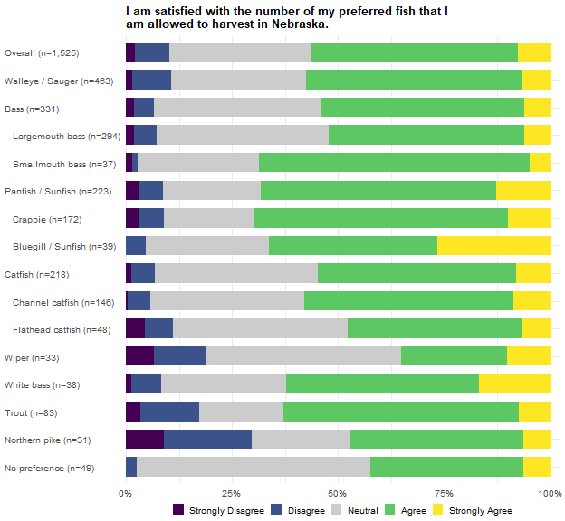
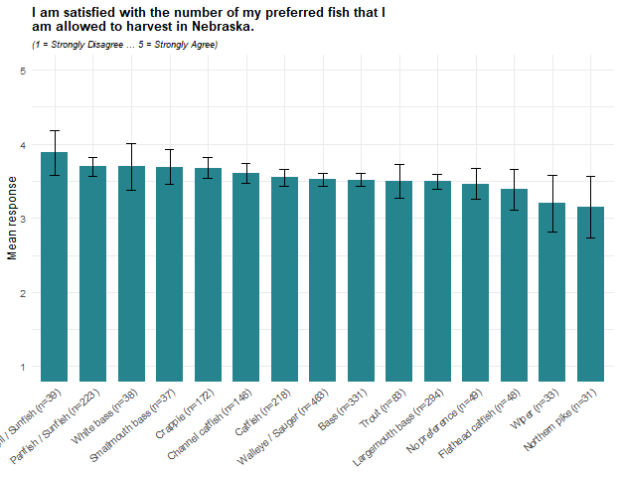
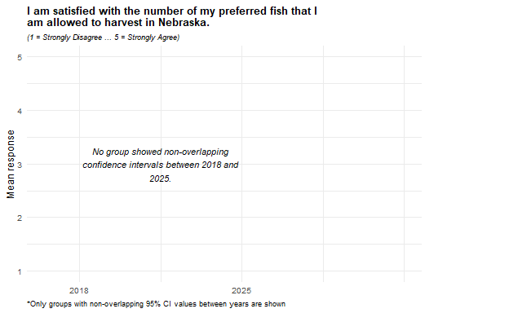
Satisfaction with the number of the preferred fish that may be harvested averages 3.5 overall, with 56% agreeing and 10% disagreeing. Bluegill / Sunfish anglers report the highest satisfaction (3.9; 66% agree, 5% disagree), followed by Panfish / Sunfish, Smallmouth bass, White bass, and Crappie anglers (3.7 each). Northern pike anglers report the lowest (3.15; 47% agree, 30% disagree), followed by Wiper anglers (3.20), 46% of whom take neither side.
Compared with the number caught in the previous item, every group rates the number it is allowed to harvest at least as favorably except Wiper anglers (3.2 allowed, against 3.4 caught) and, marginally, Northern pike anglers (3.15 allowed, against 3.21 caught); Wiper anglers also rate the size they may keep below the size they catch, so their lower ratings for what may be kept appear on both size and number.

I do not have enough places to fish for my preferred fish in Nebraska.
Cells are the weighted percentage of the row group giving that response, with a 95 percent confidence interval. Mean scores the five responses from 1 (Strongly Disagree) to 5 (Strongly Agree). N is the raw unweighted number of respondents in the row group who answered the item. These results were weighted. Please consult the survey methodology for details.
Preferred species | Strongly Disagree | Disagree | Neutral | Agree | Strongly Agree | Mean ± CI | N
Overall | 7.8 ± 1.51 | 26.2 ± 2.48 | 29.9 ± 2.58 | 24.1 ± 2.41 | 12.0 ± 1.83 | 3.1 ± 0.06 | 1,524
Walleye / Sauger | 5.0 ± 2.21 | 26.5 ± 4.46 | 28.2 ± 4.54 | 24.4 ± 4.34 | 15.9 ± 3.69 | 3.2 ± 0.12 | 467
Bass | 9.1 ± 3.40 | 29.7 ± 5.38 | 28.8 ± 5.33 | 23.5 ± 4.99 | 8.9 ± 3.36 | 2.9 ± 0.13 | 334
Largemouth bass | 8.8 ± 3.54 | 31.3 ± 5.79 | 29.4 ± 5.69 | 23.6 ± 5.31 | 6.9 ± 3.17 | 2.9 ± 0.13 | 297
Smallmouth bass | 11.6 ± 11.27 | 17.8 ± 13.44 | 24.1 ± 15.04 | 22.5 ± 14.68 | 23.9 ± 14.99 | 3.3 ± 0.46 | 37
Panfish / Sunfish | 8.6 ± 4.10 | 31.3 ± 6.78 | 28.5 ± 6.60 | 21.3 ± 5.99 | 10.2 ± 4.43 | 2.9 ± 0.17 | 224
Crappie | 5.9 ± 3.93 | 31.8 ± 7.78 | 30.7 ± 7.70 | 21.8 ± 6.89 | 9.8 ± 4.97 | 3.0 ± 0.18 | 173
Bluegill / Sunfish | 23.3 ± 14.76 | 32.4 ± 16.35 | 19.9 ± 13.96 | 14.9 ± 12.44 | 9.5 ± 10.25 | 2.5 ± 0.44 | 39
Catfish | 12.1 ± 4.88 | 29.4 ± 6.82 | 33.4 ± 7.06 | 12.3 ± 4.91 | 12.8 ± 5.00 | 2.8 ± 0.18 | 216
Channel catfish | 14.1 ± 6.36 | 29.9 ± 8.37 | 39.4 ± 8.93 | 10.9 ± 5.70 | 5.7 ± 4.23 | 2.6 ± 0.19 | 146
Flathead catfish | 8.0 ± 8.58 | 21.6 ± 12.99 | 25.5 ± 13.76 | 17.9 ± 12.11 | 26.9 ± 14.00 | 3.3 ± 0.41 | 47
Wiper | 4.6 ± 8.24 | 11.3 ± 12.43 | 45.2 ± 19.50 | 24.3 ± 16.80 | 14.5 ± 13.80 | 3.3 ± 0.39 | 31
White bass | 15.4 ± 13.73 | 11.1 ± 11.94 | 41.8 ± 18.76 | 30.3 ± 17.48 | 1.4 ± 4.45 | 2.9 ± 0.39 | 35
Trout | 6.8 ± 6.22 | 20.2 ± 9.91 | 19.0 ± 9.68 | 45.2 ± 12.28 | 8.9 ± 7.01 | 3.3 ± 0.27 | 82
Northern pike | 1.4 ± 4.46 | 27.0 ± 16.98 | 9.5 ± 11.21 | 42.7 ± 18.92 | 19.4 ± 15.14 | 3.5 ± 0.43 | 31
No preference | 7.0 ± 8.12 | 16.4 ± 11.75 | 58.2 ± 15.67 | 15.2 ± 11.41 | 3.2 ± 5.57 | 2.9 ± 0.27 | 48
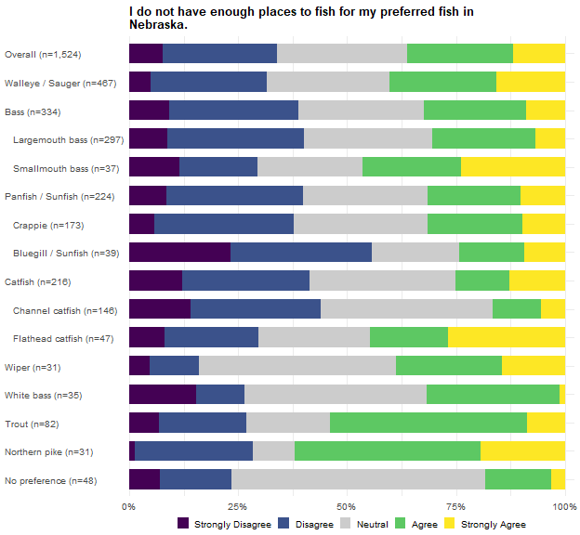
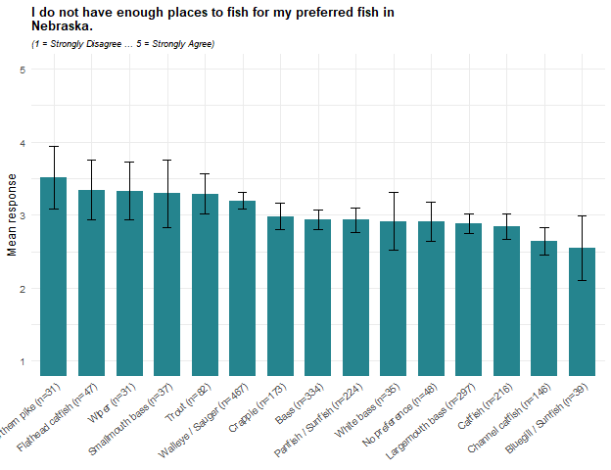
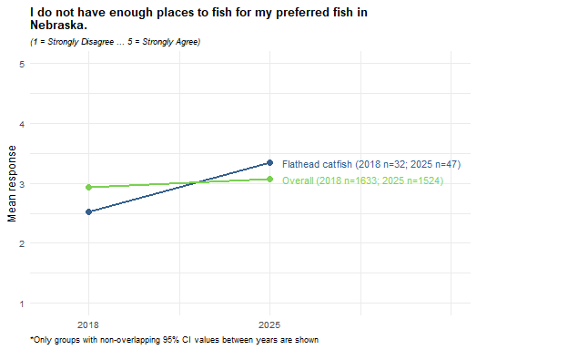
Agreement that there are not enough places to fish for the preferred fish averages 3.1 overall, with 36% agreeing and 34% disagreeing. Northern pike anglers report the highest agreement (3.5; 62% agree, 28% disagree), followed by Flathead catfish (3.3), Wiper (3.3), Trout, and Smallmouth bass anglers (3.3 each). Bluegill / Sunfish anglers report the lowest (2.5; 56% disagree, 24% agree), followed by Channel catfish anglers (2.6).
Flathead catfish anglers’ agreement rose sharply between 2018 and 2025, from 2.5 to 3.3, the only group whose change appears in any of the 2018-2025 figures for this battery. Agreement across all anglers also crept upward between the two years, from 2.9 to 3.1, another instance, like the difficulty-of-catching item earlier, where the shift shows up broadly rather than only within individual preferred groups.

Reading Across the Items
This section reads across the thirteen items by preferred group, under the same rule as Chapters 3 and 4: a group is described as differing from the overall only when its 95 percent confidence interval lies entirely outside the Overall interval. The per-item paragraphs above describe the printed means without that screen.
Support for regulation is the most uniform result in the battery. Every preferred group’s mean sits on the agree side for regulations to increase the size of its preferred fish (group means 3.6 to 4.3, overall 3.8) and for regulations to increase their numbers (3.7 to 4.1, overall 3.9). Overall, number regulations draw more support than size regulations, with the two intervals apart, and the only group to separate from the overall on either item is Wiper, above it on size regulations. The trade-off items are less generous. Willingness to accept smaller fish in exchange for more of them (2.8) is, with traveling too far, one of the two lowest-scoring statements in the battery, while willingness to harvest fewer fish for larger ones scores 3.5, again with the intervals apart. Anglers want more and bigger fish, and will give up harvest to gain size more readily than they will give up size to gain harvest. These two results fit together: support for regulation aimed at more fish runs slightly ahead of support for regulation aimed at larger fish, yet when anglers are asked to trade one for the other they lean toward size.
Walleye / Sauger anglers, the largest preferred group, are the only group below the overall on satisfaction with fishing success (2.8 against 3.2 overall, and below the neutral point) and the only group above it on saying their preferred fish is becoming harder to catch (3.6). They are above the overall on traveling too far (3.0) and are the only group above it on ranking harvest opportunity ahead of size (3.3). On none of the four size and number satisfaction items do they separate from the overall, so the discontent is with catch rates and access rather than with harvest rules; the paired comparison in Chapter 4 places it more precisely, in the number of fish caught. For a group of this size, a success-satisfaction mean below the neutral point is the most consequential single figure in the chapter.
Wiper anglers are the battery’s size-oriented outlier. They are the only group above the overall on support for size regulations (4.3) and on satisfaction with the size of fish they catch (4.0), above it on willingness to harvest fewer fish for larger ones (4.2) and on traveling too far (3.4), and below it on ranking harvest opportunity ahead of size (2.3). Their rating of the size they are allowed to harvest (3.3) does not separate from the overall by this screen, but the sharper paired comparison in Chapter 4 shows them to be the only group that rates the size it catches above the size it may keep. Read with Chapter 1, where Wiper anglers separated from White bass anglers on exactly these attitudes, this is a constituency that strongly supports size regulation and rates what the rules let it keep below what it catches. The group has 35 respondents in this battery, so its intervals are wide.
Northern pike anglers are below the overall on satisfaction with the size they are allowed to harvest (2.9 against 3.5) and are the only group below it on willingness to trade size for numbers (2.4). Their means on size regulations (4.1) and on not having enough places to fish (3.5) are among the highest printed, but on 31 respondents neither clears the interval screen. What the screen does support is a size-focused reading: a group unwilling to give up size and dissatisfied with the size the rules let it keep.
Bass anglers, the second-largest preferred group, favor size over harvest: above the overall on harvesting fewer fish for larger ones (3.8) and below it on ranking harvest ahead of size (2.7). They are also below the overall on traveling too far (2.5 against 2.8). Bluegill / Sunfish anglers are the battery’s least constrained constituency: above the overall on satisfaction with the size (3.9) and number (3.9) they are allowed to harvest, and below it on traveling too far (2.1), on lacking places to fish (2.5) and on finding their fish harder to catch (2.6), on 40 respondents. White bass, Trout and Channel catfish anglers are above the overall on satisfaction with fishing success (3.7, 3.6 and 3.6) without separating on any of the regulation items.
Anglers with no single preferred fish separate from the overall on one item only, below it on satisfaction with the size they are allowed to harvest (3.2), and, as the item paragraphs note, carry the largest neutral shares. Their row deserves a caution of its own: because the statements presuppose a preferred fish, only 50 of the 339 anglers in this group answered the first item, so the row describes a small, self-selected subset of them rather than the group as a whole.

Chapter 3: Crosstabs by Preferred Species
This chapter crosstabs the remaining survey questions by preferred group. Questions appear in the order they are reported in the 2025 Crosstabs report, and each question keeps the universe and the derived variables that report uses; only the columns of the original crosstabs (residency, gender, and age) are replaced by the preferred groups. Rows are the preferred groups from Chapter 1, with individual species indented beneath the family group that contains them. Family rows include the respondents in their species rows, so rows overlap and must not be totalled.
Two conventions for the sample size are used. Where every response column of a table shares one denominator, a single N column reports it. Where each column carries its own universe (a battery item with its own missingness, a scale score with its completeness gate, or an indicator computed on its own subset), the count appears inside each cell after the confidence interval. N is the raw unweighted respondent count in both cases.
In the text of this chapter, a difference between a preferred group and the overall estimate is described only when the group’s 95 percent confidence interval lies entirely outside the Overall interval. That screen is conservative: modest differences, and most differences involving small groups, will fail it, so an unmentioned group is not shown to be typical; it is merely not shown to differ.

Fish Out-Of-State
Just under half of anglers (44%) also fished outside Nebraska in 2025. Northern pike (71%) and Wiper (70%) anglers did so at rates above the overall, consistent with the travel distances they report later in this chapter, while White bass (18%) and No preference (32%) anglers fell below it.
Did you fish in a state other than Nebraska during 2025? Cells are the weighted percentage of the row group giving that response, with a 95 percent confidence interval. N is the raw unweighted number of respondents in the row group who answered the question. These results were weighted. Please consult the survey methodology for details.
Preferred species | Yes | No | N
Overall | 44.1 ± 2.51 | 55.9 ± 2.51 | 1,884
Walleye / Sauger | 49.9 ± 4.89 | 50.1 ± 4.89 | 497
Bass | 42.5 ± 5.67 | 57.5 ± 5.67 | 352
Largemouth bass | 41.3 ± 6.01 | 58.7 ± 6.01 | 312
Smallmouth bass | 51.6 ± 16.85 | 48.4 ± 16.85 | 40
Panfish / Sunfish | 43.6 ± 7.17 | 56.4 ± 7.17 | 229
Crappie | 44.0 ± 8.24 | 56.0 ± 8.24 | 175
Bluegill / Sunfish | 37.6 ± 16.37 | 62.4 ± 16.37 | 42
Catfish | 39.1 ± 7.20 | 60.9 ± 7.20 | 223
Channel catfish | 36.1 ± 8.76 | 63.9 ± 8.76 | 147
Flathead catfish | 43.7 ± 15.36 | 56.3 ± 15.36 | 49
Wiper | 69.8 ± 17.04 | 30.2 ± 17.04 | 34
White bass | 18.2 ± 13.84 | 81.8 ± 13.84 | 39
Trout | 48.6 ± 11.69 | 51.4 ± 11.69 | 90
Northern pike | 71.4 ± 17.08 | 28.6 ± 17.08 | 32
No preference | 32.5 ± 5.63 | 67.5 ± 5.63 | 330
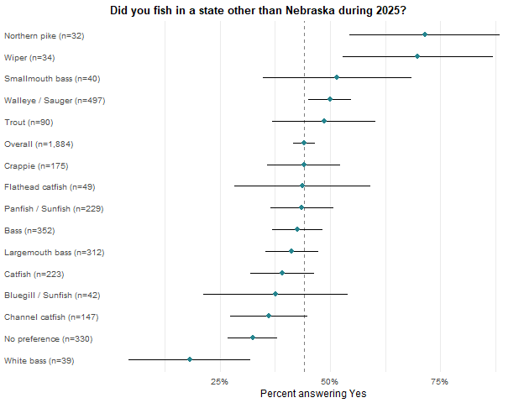

Boat Out-Of-State
Among anglers who fished out of state, 55% took a boat with them. Walleye / Sauger anglers (70%) sit above the overall rate and anglers with no preferred type (39%) below it. White bass anglers’ rate (8%) is also below, though it rests on only 8 respondents.
Did you take a boat or other personal watercraft with you when fishing in a state other than Nebraska during 2025? Cells are the weighted percentage of the row group giving that response, with a 95 percent confidence interval. N is the raw unweighted number of respondents in the row group who answered the question. Only respondents who fished out of state are included in this calculation. These results were weighted. Please consult the survey methodology for details.
Preferred species | Yes | No | N
Overall | 55.2 ± 3.99 | 44.8 ± 3.99 | 744
Walleye / Sauger | 70.3 ± 6.45 | 29.7 ± 6.45 | 234
Bass | 52.6 ± 9.03 | 47.4 ± 9.03 | 139
Largemouth bass | 54.0 ± 9.71 | 46.0 ± 9.71 | 120
Smallmouth bass | 44.7 ± 24.22 | 55.3 ± 24.22 | 19
Panfish / Sunfish | 48.2 ± 11.49 | 51.8 ± 11.49 | 91
Crappie | 50.5 ± 13.22 | 49.5 ± 13.22 | 69
Bluegill / Sunfish | 40.9 ± 27.74 | 59.1 ± 27.74 | 16
Catfish | 49.5 ± 12.65 | 50.5 ± 12.65 | 72
Channel catfish | 45.8 ± 15.93 | 54.2 ± 15.93 | 46
Flathead catfish | 47.2 ± 25.20 | 52.8 ± 25.20 | 17
Wiper | 73.3 ± 20.64 | 26.7 ± 20.64 | 20
White bass | 7.9 ± 21.18 | 92.1 ± 21.18 | 8
Trout | 40.5 ± 19.12 | 59.5 ± 19.12 | 32
Northern pike | 58.9 ± 22.58 | 41.1 ± 22.58 | 22
No preference | 39.1 ± 11.07 | 60.9 ± 11.07 | 95
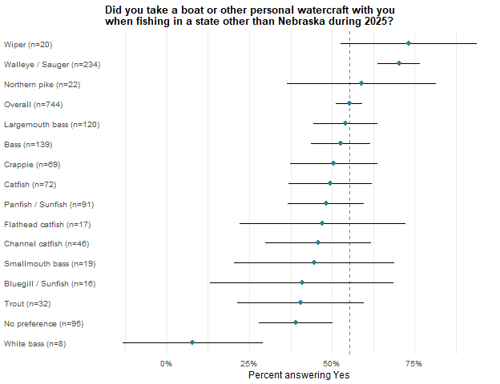

Park Entry Permit
69% of anglers held a park entry permit. Wiper (88%) and Walleye / Sauger (82%) anglers exceed the overall rate and No preference anglers (61%) fall below it, a separation that tracks the boat-oriented groups in the Methods section later in this chapter.
Did you fish at a water body that required a Nebraska Park Entry Permit during 2025? Cells are the weighted percentage of the row group giving that response, with a 95 percent confidence interval. N is the raw unweighted number of respondents in the row group who answered the question. These results were weighted. Please consult the survey methodology for details.
Preferred species | No | Yes | N
Overall | 31.0 ± 2.33 | 69.0 ± 2.33 | 1,898
Walleye / Sauger | 18.3 ± 3.80 | 81.7 ± 3.80 | 493
Bass | 36.6 ± 5.51 | 63.4 ± 5.51 | 353
Largemouth bass | 38.6 ± 5.92 | 61.4 ± 5.92 | 313
Smallmouth bass | 22.3 ± 13.96 | 77.7 ± 13.96 | 40
Panfish / Sunfish | 33.2 ± 6.71 | 66.8 ± 6.71 | 236
Crappie | 33.9 ± 7.73 | 66.1 ± 7.73 | 181
Bluegill / Sunfish | 30.0 ± 15.30 | 70.0 ± 15.30 | 43
Catfish | 32.5 ± 6.88 | 67.5 ± 6.88 | 225
Channel catfish | 33.6 ± 8.53 | 66.4 ± 8.53 | 150
Flathead catfish | 34.7 ± 14.74 | 65.3 ± 14.74 | 49
Wiper | 12.1 ± 11.93 | 87.9 ± 11.93 | 35
White bass | 30.2 ± 16.48 | 69.8 ± 16.48 | 39
Trout | 31.4 ± 10.86 | 68.6 ± 10.86 | 90
Northern pike | 35.3 ± 18.08 | 64.7 ± 18.08 | 32
No preference | 39.2 ± 5.83 | 60.8 ± 5.83 | 335

Fishing Tournaments
Tournament fishing is rare: 3% of anglers fished at least one tournament, and no group sits above the overall rate by the interval screen. Flathead catfish, Wiper, White bass and No preference anglers reported no tournament participation at all. Among the anglers who did fish tournaments, the mean was 3.7 tournaments; Panfish / Sunfish anglers averaged 1.1, below the overall mean.
Percent of respondents who participated in at least one fishing tournament (derived from How many fishing tournaments (either requiring an entry fee or awarding prizes/money) held in Nebraska did you participate in during 2025?). Cells are the weighted percentage of the row group giving that response, with a 95 percent confidence interval. N is the raw unweighted number of respondents in the row group who answered the question. These results were weighted. Please consult the survey methodology for details.
Preferred species | No Tournaments | Fished Tournaments | N
Overall | 97.0 ± 0.86 | 3.0 ± 0.86 | 1,908
Walleye / Sauger | 94.4 ± 2.25 | 5.6 ± 2.25 | 497
Bass | 96.1 ± 2.21 | 3.9 ± 2.21 | 355
Largemouth bass | 97.6 ± 1.88 | 2.4 ± 1.88 | 314
Smallmouth bass | 85.9 ± 11.58 | 14.1 ± 11.58 | 41
Panfish / Sunfish | 97.4 ± 2.25 | 2.6 ± 2.25 | 236
Crappie | 97.0 ± 2.77 | 3.0 ± 2.77 | 181
Bluegill / Sunfish | 98.6 ± 3.90 | 1.4 ± 3.90 | 43
Catfish | 97.2 ± 2.42 | 2.8 ± 2.42 | 227
Channel catfish | 95.4 ± 3.79 | 4.6 ± 3.79 | 150
Flathead catfish | 100.0 ± 0.00 | 0.0 ± 0.00 | 50
Wiper | 100.0 ± 0.00 | 0.0 ± 0.00 | 35
White bass | 100.0 ± 0.00 | 0.0 ± 0.00 | 39
Trout | 98.3 ± 3.03 | 1.7 ± 3.03 | 89
Northern pike | 98.6 ± 4.38 | 1.4 ± 4.38 | 32
No preference | 100.0 ± 0.00 | 0.0 ± 0.00 | 338
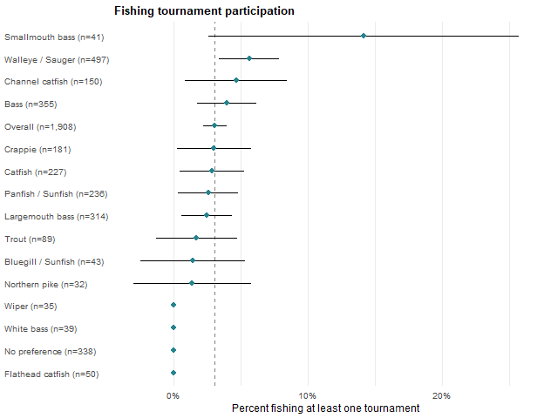
How many fishing tournaments (either requiring an entry fee or awarding prizes/money) held in Nebraska did you participate in during 2025? Cells are the weighted mean for the row group with a 95 percent confidence interval, followed by the raw unweighted number of respondents contributing to that cell. Only respondents who participated in at least one tournament are included in this calculation. These results were weighted. Please consult the survey methodology for details.
Preferred species | Mean tournaments fished
Overall | 3.7 ± 1.19 (49)
Walleye / Sauger | 3.2 ± 1.35 (23)
Bass | 4.5 ± 2.41 (11)
Largemouth bass | 5.5 ± 3.45 (6)
Smallmouth bass | 3.3 ± 2.97 (5)
Panfish / Sunfish | 1.1 ± 0.32 (5)
Crappie | 1.1 ± 0.36 (4)
Bluegill / Sunfish | 1.0 ± 0.00 (1)
Catfish | 4.3 ± 4.93 (5)
Channel catfish | 4.3 ± 4.93 (5)
Flathead catfish
Wiper
White bass
Trout | 4.0 ± 0.00 (1)
Northern pike | 1.0 ± 0.00 (1)
No preference

Waterbody Types
Lakes and reservoirs are the dominant water type for every group (86% overall), but the remaining types carry distinct group signatures. Bass anglers use ponds and sandpits most (64% against 45% overall), while Walleye / Sauger anglers use them least (32%) and are heaviest on lakes and reservoirs (93%). Northern pike anglers are the only group above the overall on Sandhill lakes (35% against 9%). Catfish anglers separate upward on the rivers: the Missouri (27% against 16% overall, and 44% among Flathead catfish anglers), the Platte (23% against 10%) and other streams, rivers and canals (37%). Trout anglers fall below the overall on lakes and reservoirs (68%) and sit above it on other streams, rivers and canals (38% against 21%).
In what types of water bodies did you fish in Nebraska during 2025? Cells are the weighted percentage of the row group that selected each option, with a 95 percent confidence interval. Respondents could select more than one option, so a row does not sum to 100 percent. N is the raw unweighted number of respondents in the row group who answered the question. These results were weighted. Please consult the survey methodology for details.
Preferred species | Lakes and Reservoirs | Ponds and sandpits | Other streams, rivers, and canals | Missouri River | Platte River | Sandhill lakes | N
Overall | 86.2 ± 1.76 | 44.6 ± 2.53 | 20.9 ± 2.07 | 15.8 ± 1.85 | 9.6 ± 1.50 | 9.5 ± 1.49 | 1,858
Walleye / Sauger | 93.1 ± 2.52 | 32.1 ± 4.65 | 16.1 ± 3.66 | 17.1 ± 3.75 | 6.9 ± 2.53 | 13.4 ± 3.39 | 480
Bass | 88.5 ± 3.65 | 63.6 ± 5.51 | 15.9 ± 4.19 | 11.3 ± 3.63 | 8.3 ± 3.16 | 7.1 ± 2.94 | 353
Largemouth bass | 88.3 ± 3.92 | 65.5 ± 5.80 | 15.9 ± 4.46 | 9.0 ± 3.50 | 9.0 ± 3.49 | 6.7 ± 3.06 | 312
Smallmouth bass | 90.0 ± 9.97 | 50.6 ± 16.62 | 16.2 ± 12.25 | 27.1 ± 14.78 | 3.7 ± 6.26 | 9.3 ± 9.67 | 41
Panfish / Sunfish | 87.5 ± 4.75 | 42.0 ± 7.10 | 19.3 ± 5.68 | 9.3 ± 4.17 | 6.6 ± 3.57 | 9.3 ± 4.17 | 231
Crappie | 87.9 ± 5.39 | 38.5 ± 8.04 | 19.6 ± 6.56 | 9.1 ± 4.75 | 4.8 ± 3.52 | 8.2 ± 4.53 | 176
Bluegill / Sunfish | 88.0 ± 10.84 | 51.0 ± 16.69 | 20.4 ± 13.45 | 12.3 ± 10.98 | 15.8 ± 12.17 | 7.5 ± 8.79 | 43
Catfish | 79.4 ± 6.00 | 42.9 ± 7.35 | 37.0 ± 7.16 | 27.5 ± 6.63 | 23.5 ± 6.29 | 6.3 ± 3.60 | 219
Channel catfish | 77.5 ± 7.64 | 46.8 ± 9.13 | 34.4 ± 8.69 | 17.9 ± 7.01 | 21.0 ± 7.45 | 6.1 ± 4.38 | 145
Flathead catfish | 76.1 ± 13.49 | 39.2 ± 15.44 | 47.1 ± 15.78 | 44.2 ± 15.70 | 24.9 ± 13.68 | 5.9 ± 7.45 | 47
Wiper | 98.9 ± 3.82 | 27.2 ± 16.45 | 26.1 ± 16.22 | 4.6 ± 7.75 | 15.8 ± 13.50 | 24.5 ± 15.90 | 34
White bass | 100.0 ± 0.00 | 27.4 ± 16.13 | 1.3 ± 4.14 | 6.4 ± 8.87 | 3.8 ± 6.88 | 5.1 ± 7.94 | 38
Trout | 67.6 ± 11.00 | 50.0 ± 11.75 | 38.4 ± 11.43 | 5.6 ± 5.40 | 10.5 ± 7.21 | 9.5 ± 6.88 | 89
Northern pike | 87.0 ± 12.70 | 26.2 ± 16.62 | 8.8 ± 10.74 | 14.2 ± 13.22 | 0.0 ± 0.00 | 34.8 ± 18.02 | 32
No preference | 82.5 ± 4.62 | 49.2 ± 6.08 | 19.8 ± 4.85 | 16.2 ± 4.49 | 8.5 ± 3.39 | 5.5 ± 2.78 | 322

Methods
Bank or wading fishing is the most common method (79% overall), led by Catfish anglers (90%); Walleye / Sauger anglers are the one group below the overall on it (61%) and far above on motorized boats (78% against 51% overall), where Bluegill / Sunfish (20%), Trout (28%) and No preference (33%) anglers fall below. Trout anglers stand alone above the overall on wading (41% against 13%), and Bass anglers separate upward on kayaks and canoes (26% against 18%). Ice fishing separates Crappie (34%), Panfish / Sunfish (33%) and Walleye / Sauger (26%) anglers upward and Bass, White bass and No preference anglers downward, agreeing in direction with the ice-fishing question later in this chapter.
Which methods of fishing did you use during 2025? Cells are the weighted percentage of the row group that selected each option, with a 95 percent confidence interval. Respondents could select more than one option, so a row does not sum to 100 percent. N is the raw unweighted number of respondents in the row group who answered the question. These results were weighted. Please consult the survey methodology for details.
Preferred species | Bank/wading | Motorized boat | Kayak/Canoe | Ice fishing | Wading | Other Non-motorized boat | Other | Float tube | N
Overall | 78.9 ± 2.07 | 51.1 ± 2.54 | 17.7 ± 1.94 | 17.7 ± 1.94 | 13.0 ± 1.71 | 3.7 ± 0.96 | 2.4 ± 0.78 | 1.3 ± 0.57 | 1,865
Walleye / Sauger | 61.4 ± 4.82 | 78.3 ± 4.08 | 12.7 ± 3.29 | 26.3 ± 4.36 | 14.8 ± 3.52 | 1.7 ± 1.30 | 1.2 ± 1.06 | 0.2 ± 0.48 | 485
Bass | 88.8 ± 3.62 | 44.7 ± 5.70 | 26.4 ± 5.05 | 10.4 ± 3.50 | 10.2 ± 3.47 | 3.8 ± 2.20 | 1.7 ± 1.48 | 1.5 ± 1.39 | 353
Largemouth bass | 88.5 ± 3.89 | 46.2 ± 6.08 | 25.6 ± 5.32 | 10.6 ± 3.76 | 8.8 ± 3.46 | 3.3 ± 2.18 | 1.9 ± 1.68 | 1.7 ± 1.58 | 312
Smallmouth bass | 90.4 ± 9.78 | 33.9 ± 15.74 | 31.7 ± 15.48 | 8.8 ± 9.40 | 20.0 ± 13.30 | 7.3 ± 8.66 | 0.0 ± 0.00 | 0.0 ± 0.00 | 41
Panfish / Sunfish | 84.9 ± 5.17 | 44.3 ± 7.16 | 22.2 ± 5.99 | 32.6 ± 6.76 | 9.0 ± 4.13 | 3.6 ± 2.68 | 3.0 ± 2.44 | 0.3 ± 0.83 | 230
Crappie | 86.6 ± 5.64 | 50.8 ± 8.29 | 23.0 ± 6.98 | 34.0 ± 7.85 | 9.5 ± 4.87 | 2.6 ± 2.62 | 3.4 ± 3.00 | 0.4 ± 1.09 | 175
Bluegill / Sunfish | 84.8 ± 11.98 | 19.7 ± 13.27 | 21.2 ± 13.64 | 22.1 ± 13.84 | 9.2 ± 9.65 | 8.6 ± 9.38 | 1.8 ± 4.47 | 0.0 ± 0.00 | 43
Catfish | 90.5 ± 4.35 | 42.4 ± 7.32 | 14.0 ± 5.14 | 13.2 ± 5.02 | 11.5 ± 4.72 | 4.6 ± 3.12 | 3.3 ± 2.64 | 0.7 ± 1.23 | 220
Channel catfish | 90.9 ± 5.26 | 42.4 ± 9.02 | 14.0 ± 6.33 | 12.7 ± 6.08 | 13.3 ± 6.19 | 2.1 ± 2.62 | 2.9 ± 3.06 | 1.1 ± 1.92 | 146
Flathead catfish | 86.8 ± 10.69 | 42.3 ± 15.62 | 11.0 ± 9.89 | 14.4 ± 11.09 | 7.0 ± 8.06 | 10.7 ± 9.78 | 1.4 ± 3.71 | 0.0 ± 0.00 | 47
Wiper | 61.1 ± 18.01 | 66.4 ± 17.46 | 29.1 ± 16.78 | 11.7 ± 11.87 | 28.6 ± 16.71 | 3.1 ± 6.36 | 0.0 ± 0.00 | 2.3 ± 5.55 | 34
White bass | 72.6 ± 16.00 | 67.6 ± 16.80 | 3.8 ± 6.82 | 5.2 ± 7.95 | 9.4 ± 10.46 | 5.7 ± 8.31 | 0.0 ± 0.00 | 1.6 ± 4.54 | 39
Trout | 83.5 ± 8.81 | 27.9 ± 10.64 | 13.7 ± 8.17 | 10.8 ± 7.37 | 41.4 ± 11.69 | 3.0 ± 4.06 | 2.3 ± 3.58 | 3.2 ± 4.18 | 87
Northern pike | 66.8 ± 17.81 | 64.7 ± 18.08 | 16.8 ± 14.14 | 32.7 ± 17.74 | 28.7 ± 17.11 | 11.4 ± 12.03 | 0.0 ± 0.00 | 3.8 ± 7.27 | 32
No preference | 86.7 ± 4.11 | 33.2 ± 5.71 | 15.9 ± 4.43 | 11.7 ± 3.89 | 7.4 ± 3.18 | 4.6 ± 2.55 | 3.1 ± 2.11 | 1.1 ± 1.28 | 325

Techniques
Rod and reel is near-universal (98% overall); Trout anglers are the only group below the overall on it (89%), while 44% of them fly-fish against 9% overall, the largest technique separation in the table. Catfish anglers fall below the overall on fly-fishing (3%). No other technique lifts any group above its overall rate by the interval screen.
What techniques did you use during 2025? Cells are the weighted percentage of the row group that selected each option, with a 95 percent confidence interval. Respondents could select more than one option, so a row does not sum to 100 percent. N is the raw unweighted number of respondents in the row group who answered the question. These results were weighted. Please consult the survey methodology for details.
Preferred species | Rod & reel | Fly-fishing | Set lines/limb lines | Archery | Snagging | Other | Surface spear | Underwater spear | N
Overall | 97.8 ± 0.74 | 9.4 ± 1.48 | 5.3 ± 1.14 | 3.7 ± 0.96 | 2.4 ± 0.78 | 0.8 ± 0.45 | 0.4 ± 0.31 | 0.2 ± 0.23 | 1,865
Walleye / Sauger | 99.5 ± 0.69 | 5.7 ± 2.30 | 5.0 ± 2.16 | 3.9 ± 1.91 | 2.1 ± 1.43 | 0.0 ± 0.00 | 0.2 ± 0.39 | 0.8 ± 0.87 | 484
Bass | 98.9 ± 1.20 | 10.7 ± 3.55 | 4.4 ± 2.35 | 3.2 ± 2.03 | 0.5 ± 0.78 | 0.5 ± 0.78 | 0.0 ± 0.00 | 0.0 ± 0.00 | 352
Largemouth bass | 99.3 ± 1.04 | 10.0 ± 3.66 | 4.5 ± 2.53 | 3.7 ± 2.31 | 0.5 ± 0.89 | 0.5 ± 0.89 | 0.0 ± 0.00 | 0.0 ± 0.00 | 311
Smallmouth bass | 96.3 ± 6.26 | 15.7 ± 12.10 | 3.7 ± 6.26 | 0.0 ± 0.00 | 0.0 ± 0.00 | 0.0 ± 0.00 | 0.0 ± 0.00 | 0.0 ± 0.00 | 41
Panfish / Sunfish | 99.7 ± 0.73 | 10.6 ± 4.43 | 6.4 ± 3.52 | 3.7 ± 2.73 | 2.4 ± 2.22 | 0.8 ± 1.29 | 1.0 ± 1.42 | 0.3 ± 0.73 | 231
Crappie | 99.7 ± 0.95 | 11.9 ± 5.35 | 7.9 ± 4.46 | 2.3 ± 2.46 | 3.2 ± 2.89 | 1.1 ± 1.68 | 1.3 ± 1.86 | 0.3 ± 0.95 | 176
Bluegill / Sunfish | 100.0 ± 0.00 | 7.8 ± 8.97 | 0.0 ± 0.00 | 10.7 ± 10.32 | 0.0 ± 0.00 | 0.0 ± 0.00 | 0.0 ± 0.00 | 0.0 ± 0.00 | 43
Catfish | 98.9 ± 1.52 | 3.1 ± 2.57 | 9.2 ± 4.29 | 2.0 ± 2.07 | 4.0 ± 2.92 | 1.5 ± 1.82 | 0.7 ± 1.23 | 0.0 ± 0.00 | 219
Channel catfish | 98.8 ± 1.99 | 2.3 ± 2.72 | 8.8 ± 5.20 | 3.2 ± 3.23 | 4.6 ± 3.82 | 2.1 ± 2.62 | 1.1 ± 1.93 | 0.0 ± 0.00 | 145
Flathead catfish | 98.6 ± 3.71 | 3.7 ± 5.95 | 13.2 ± 10.71 | 0.0 ± 0.00 | 5.2 ± 7.03 | 1.1 ± 3.23 | 0.0 ± 0.00 | 0.0 ± 0.00 | 47
Wiper | 100.0 ± 0.00 | 15.9 ± 13.51 | 0.0 ± 0.00 | 0.0 ± 0.00 | 2.3 ± 5.55 | 0.0 ± 0.00 | 0.0 ± 0.00 | 0.0 ± 0.00 | 34
White bass | 100.0 ± 0.00 | 5.7 ± 8.31 | 5.7 ± 8.31 | 0.0 ± 0.00 | 9.2 ± 10.39 | 0.0 ± 0.00 | 0.0 ± 0.00 | 0.0 ± 0.00 | 39
Trout | 88.6 ± 7.46 | 43.9 ± 11.66 | 0.6 ± 1.80 | 3.3 ± 4.21 | 1.7 ± 3.01 | 0.0 ± 0.00 | 0.0 ± 0.00 | 0.0 ± 0.00 | 89
Northern pike | 92.7 ± 9.86 | 5.0 ± 8.24 | 18.5 ± 14.70 | 8.1 ± 10.32 | 3.8 ± 7.27 | 0.0 ± 0.00 | 0.0 ± 0.00 | 0.0 ± 0.00 | 32
No preference | 98.9 ± 1.26 | 6.0 ± 2.87 | 4.8 ± 2.60 | 2.6 ± 1.92 | 1.6 ± 1.51 | 0.9 ± 1.12 | 0.3 ± 0.70 | 0.0 ± 0.00 | 325

Crowding
Crowding perceptions barely differ by preferred species: 30% of anglers never feel crowded and 6% often do, and no group separates from the overall on the Never response. No preference anglers report feeling crowded Often less than the overall (2%), and no Northern pike angler chose Often, though the latter rests on 32 respondents.
In 2025, how often were your fishing experiences negatively affected by the number of people at your fishing locations? Cells are the weighted percentage of the row group giving that response, with a 95 percent confidence interval. N is the raw unweighted number of respondents in the row group who answered the question. These results were weighted. Please consult the survey methodology for details.
Preferred species | Never | Rarely | Sometimes | Often | Always | N
Overall | 30.0 ± 2.33 | 34.5 ± 2.41 | 28.4 ± 2.29 | 6.0 ± 1.21 | 1.1 ± 0.54 | 1,869
Walleye / Sauger | 26.9 ± 4.39 | 35.0 ± 4.73 | 28.1 ± 4.45 | 8.4 ± 2.75 | 1.6 ± 1.23 | 485
Bass | 32.4 ± 5.36 | 30.7 ± 5.29 | 29.6 ± 5.23 | 6.6 ± 2.84 | 0.7 ± 0.95 | 353
Largemouth bass | 34.1 ± 5.78 | 28.7 ± 5.52 | 31.0 ± 5.64 | 5.4 ± 2.75 | 0.8 ± 1.08 | 312
Smallmouth bass | 20.5 ± 13.42 | 44.8 ± 16.53 | 20.0 ± 13.29 | 14.7 ± 11.78 | 0.0 ± 0.00 | 41
Panfish / Sunfish | 34.8 ± 6.84 | 31.7 ± 6.68 | 26.3 ± 6.32 | 6.2 ± 3.47 | 1.0 ± 1.42 | 232
Crappie | 32.7 ± 7.73 | 32.2 ± 7.70 | 27.4 ± 7.35 | 6.5 ± 4.06 | 1.3 ± 1.85 | 177
Bluegill / Sunfish | 41.4 ± 16.44 | 32.8 ± 15.67 | 21.0 ± 13.59 | 4.8 ± 7.15 | 0.0 ± 0.00 | 43
Catfish | 27.6 ± 6.63 | 33.9 ± 7.01 | 29.0 ± 6.72 | 7.8 ± 3.98 | 1.6 ± 1.87 | 220
Channel catfish | 28.9 ± 8.25 | 36.6 ± 8.76 | 27.0 ± 8.08 | 4.9 ± 3.93 | 2.6 ± 2.91 | 147
Flathead catfish | 23.9 ± 13.48 | 20.6 ± 12.78 | 38.6 ± 15.40 | 16.9 ± 11.86 | 0.0 ± 0.00 | 47
Wiper | 32.0 ± 17.24 | 41.3 ± 18.19 | 21.8 ± 15.27 | 4.9 ± 7.98 | 0.0 ± 0.00 | 34
White bass | 35.0 ± 17.12 | 27.2 ± 15.98 | 32.0 ± 16.74 | 2.5 ± 5.62 | 3.3 ± 6.38 | 39
Trout | 25.3 ± 10.28 | 50.9 ± 11.83 | 14.1 ± 8.24 | 9.8 ± 7.03 | 0.0 ± 0.00 | 88
Northern pike | 16.1 ± 13.90 | 52.8 ± 18.88 | 26.1 ± 16.60 | 0.0 ± 0.00 | 5.0 ± 8.24 | 32
No preference | 33.8 ± 5.72 | 34.8 ± 5.76 | 28.8 ± 5.48 | 1.7 ± 1.58 | 0.9 ± 1.11 | 326
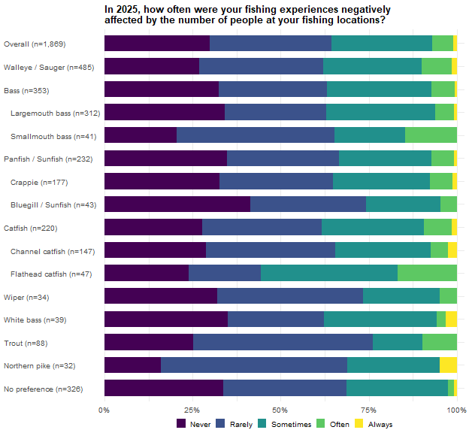

Access
Of the anglers who fished at least one of the two area types, 69% fished public areas only and 28% fished both. Northern pike anglers are the one departure: 87% public-only and 9% both, on 25 respondents, with little private-water access in this group.
During 2025, did you use the following areas when fishing or launching watercraft to fish? Each column is a separate indicator computed on its own universe: cells are the weighted percentage of the row group falling in that category, with a 95 percent confidence interval, followed by the raw unweighted number of respondents in that column’s universe. Columns overlap and must not be totalled. The first two columns are computed on everyone who answered the question; the last three are computed on respondents who used at least one of the two area types, matching the 2025 Crosstabs report. These results were weighted. Please consult the survey methodology for details.
Preferred species | Public lands and access | Private lands and access | Both Public and Private lands and access | Only Used Public lands and access | Only Used Private lands and access
Overall | 89.3 ± 1.71 (1,553) | 28.6 ± 2.50 (1,553) | 27.5 ± 2.59 (1,417) | 69.1 ± 2.68 (1,417) | 3.3 ± 1.04 (1,417)
Walleye / Sauger | 94.7 ± 2.47 (391) | 27.2 ± 4.91 (391) | 25.2 ± 4.87 (378) | 72.1 ± 5.03 (378) | 2.7 ± 1.82 (378)
Bass | 92.1 ± 3.31 (304) | 35.9 ± 5.89 (304) | 33.8 ± 5.98 (286) | 62.4 ± 6.12 (286) | 3.7 ± 2.39 (286)
Largemouth bass | 92.4 ± 3.49 (266) | 37.0 ± 6.35 (266) | 35.0 ± 6.44 (251) | 61.4 ± 6.57 (251) | 3.7 ± 2.54 (251)
Smallmouth bass | 90.7 ± 10.00 (38) | 28.8 ± 15.61 (38) | 26.3 ± 15.77 (35) | 69.6 ± 16.49 (35) | 4.1 ± 7.13 (35)
Panfish / Sunfish | 84.6 ± 5.91 (177) | 29.8 ± 7.49 (177) | 28.0 ± 7.80 (158) | 66.7 ± 8.19 (158) | 5.3 ± 3.91 (158)
Crappie | 83.2 ± 7.02 (135) | 31.5 ± 8.73 (135) | 29.4 ± 9.10 (120) | 64.5 ± 9.56 (120) | 6.1 ± 4.78 (120)
Bluegill / Sunfish | 92.8 ± 9.77 (33) | 16.9 ± 14.13 (33) | 16.2 ± 14.38 (31) | 82.1 ± 14.97 (31) | 1.7 ± 5.08 (31)
Catfish | 81.9 ± 6.12 (190) | 33.5 ± 7.50 (190) | 33.1 ± 8.15 (159) | 61.4 ± 8.43 (159) | 5.5 ± 3.96 (159)
Channel catfish | 82.1 ± 7.62 (123) | 32.4 ± 9.30 (123) | 35.0 ± 10.50 (100) | 61.8 ± 10.69 (100) | 3.2 ± 3.86 (100)
Flathead catfish | 76.5 ± 13.79 (44) | 32.8 ± 15.28 (44) | 23.8 ± 14.91 (38) | 62.9 ± 16.93 (38) | 13.4 ± 11.93 (38)
Wiper | 88.9 ± 11.84 (32) | 16.6 ± 14.02 (32) | 17.3 ± 14.97 (29) | 81.5 ± 15.38 (29) | 1.2 ± 4.36 (29)
White bass | 82.3 ± 14.09 (37) | 26.9 ± 16.36 (37) | 32.7 ± 18.81 (31) | 67.3 ± 18.81 (31) | 0.0 ± 0.00 (31)
Trout | 90.9 ± 7.47 (72) | 31.1 ± 12.02 (72) | 26.7 ± 11.72 (69) | 67.7 ± 12.38 (69) | 5.6 ± 6.07 (69)
Northern pike | 87.6 ± 13.23 (28) | 11.7 ± 12.91 (28) | 9.5 ± 12.46 (25) | 87.1 ± 14.29 (25) | 3.5 ± 7.80 (25)
No preference | 86.4 ± 4.53 (270) | 22.4 ± 5.51 (270) | 23.2 ± 5.97 (235) | 74.6 ± 6.16 (235) | 2.2 ± 2.08 (235)

Favorite Waterbody Distance
The median one-way distance to the favorite water body is roughly 50 miles, computed on band midpoints. Walleye / Sauger anglers’ median is 80 miles, and the Wiper and Northern pike medians fall in the 101-to-250-mile band: the favorite waters of these three groups are a substantial drive. No group’s median separates below the overall.
About how far is the one-way distance from your residence to your favorite Nebraska water body? Cells are the weighted percentage of the row group giving that response, with a 95 percent confidence interval. N is the raw unweighted number of respondents in the row group who answered the question. These results were weighted. Please consult the survey methodology for details.
Preferred species | 10 or fewer miles | 11 to 20 miles | 21 to 40 miles | 41 to 60 miles | 61 to 100 miles | 101 to 250 miles | 251 to 500 miles | Over 500 miles | N
Overall | 18.2 ± 1.96 | 14.4 ± 1.78 | 15.9 ± 1.86 | 12.8 ± 1.70 | 11.0 ± 1.59 | 17.6 ± 1.93 | 7.4 ± 1.33 | 2.6 ± 0.81 | 1,873
Walleye / Sauger | 8.7 ± 2.77 | 7.2 ± 2.55 | 14.5 ± 3.47 | 12.5 ± 3.26 | 13.8 ± 3.39 | 30.4 ± 4.54 | 11.6 ± 3.16 | 1.3 ± 1.13 | 491
Bass | 29.4 ± 5.24 | 16.8 ± 4.29 | 15.2 ± 4.13 | 10.8 ± 3.57 | 8.6 ± 3.23 | 12.5 ± 3.80 | 5.0 ± 2.51 | 1.6 ± 1.44 | 350
Largemouth bass | 31.2 ± 5.67 | 14.6 ± 4.32 | 15.6 ± 4.44 | 12.2 ± 4.01 | 9.3 ± 3.56 | 10.5 ± 3.76 | 4.9 ± 2.64 | 1.6 ± 1.52 | 309
Smallmouth bass | 17.0 ± 12.48 | 31.9 ± 15.49 | 12.7 ± 11.09 | 1.1 ± 3.39 | 3.7 ± 6.26 | 25.9 ± 14.57 | 5.9 ± 7.85 | 1.8 ± 4.44 | 41
Panfish / Sunfish | 19.5 ± 5.68 | 22.0 ± 5.94 | 17.5 ± 5.45 | 19.9 ± 5.73 | 6.4 ± 3.50 | 10.7 ± 4.43 | 1.4 ± 1.68 | 2.6 ± 2.28 | 233
Crappie | 18.5 ± 6.37 | 24.2 ± 7.02 | 15.7 ± 5.96 | 20.8 ± 6.66 | 8.2 ± 4.50 | 10.3 ± 4.99 | 1.1 ± 1.70 | 1.1 ± 1.74 | 179
Bluegill / Sunfish | 28.7 ± 15.32 | 18.3 ± 13.11 | 22.7 ± 14.20 | 13.2 ± 11.46 | 0.0 ± 0.00 | 7.0 ± 8.62 | 3.0 ± 5.81 | 7.1 ± 8.69 | 42
Catfish | 21.0 ± 6.00 | 20.4 ± 5.94 | 22.8 ± 6.18 | 10.7 ± 4.55 | 14.7 ± 5.21 | 8.9 ± 4.20 | 1.5 ± 1.80 | 0.0 ± 0.00 | 223
Channel catfish | 20.2 ± 7.33 | 23.9 ± 7.79 | 21.0 ± 7.44 | 9.7 ± 5.40 | 13.5 ± 6.25 | 9.2 ± 5.27 | 2.5 ± 2.86 | 0.0 ± 0.00 | 146
Flathead catfish | 19.9 ± 12.26 | 13.1 ± 10.37 | 16.0 ± 11.26 | 19.7 ± 12.23 | 20.3 ± 12.36 | 11.0 ± 9.62 | 0.0 ± 0.00 | 0.0 ± 0.00 | 50
Wiper | 5.5 ± 8.34 | 3.7 ± 6.94 | 4.4 ± 7.53 | 9.8 ± 10.87 | 15.9 ± 13.40 | 14.2 ± 12.79 | 44.6 ± 18.20 | 1.8 ± 4.92 | 35
White bass | 7.1 ± 9.21 | 6.2 ± 8.67 | 8.1 ± 9.81 | 16.1 ± 13.19 | 16.0 ± 13.16 | 37.2 ± 17.35 | 3.5 ± 6.63 | 5.7 ± 8.31 | 39
Trout | 13.0 ± 7.93 | 7.4 ± 6.18 | 19.4 ± 9.34 | 12.6 ± 7.84 | 16.4 ± 8.74 | 18.7 ± 9.21 | 4.9 ± 5.11 | 7.6 ± 6.25 | 88
Northern pike | 17.1 ± 14.24 | 8.1 ± 10.32 | 1.4 ± 4.38 | 7.5 ± 9.99 | 9.0 ± 10.85 | 32.0 ± 17.64 | 22.5 ± 15.80 | 2.3 ± 5.72 | 32
No preference | 20.3 ± 4.89 | 18.9 ± 4.77 | 17.9 ± 4.66 | 15.5 ± 4.40 | 6.8 ± 3.07 | 13.4 ± 4.15 | 4.1 ± 2.41 | 3.1 ± 2.10 | 322

Distance in miles to the favorite water body, using the midpoint of the band each respondent selected. Cells are the lower 95 percent confidence limit, the weighted median, and the upper 95 percent confidence limit, followed by the raw unweighted number of respondents. Median confidence limits come from the inherited 1,000-replicate weighted bootstrap. These results were weighted. Please consult the survey methodology for details.
Preferred species | Median one-way miles
Overall | 30/50/50 (1,873)
Walleye / Sauger | 80/80/80 (491)
Bass | 16/30/30 (350)
Largemouth bass | 16/30/30 (309)
Smallmouth bass | 16/30/80 (41)
Panfish / Sunfish | 30/30/30 (233)
Crappie | 30/30/30 (179)
Bluegill / Sunfish | 16/30/30 (42)
Catfish | 30/30/30 (223)
Channel catfish | 16/30/30 (146)
Flathead catfish | 30/37/50 (50)
Wiper | 80/176/376 (35)
White bass | 50/80/176 (39)
Trout | 40/50/80 (88)
Northern pike | 65/176/176 (32)
No preference | 30/30/30 (322)
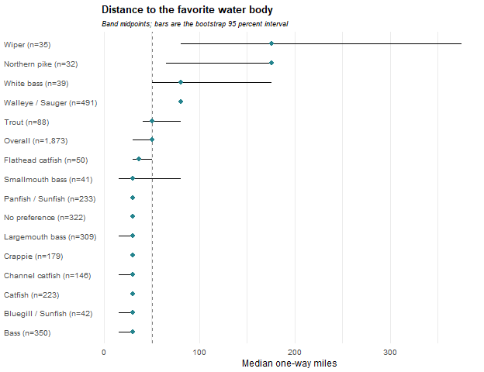

Most-Visited Waterbody Distance
The water fished most often is closer (median 30 miles overall), and the split is sharp: the Bass, Panfish / Sunfish and Catfish family medians fall to 16 miles, while the Wiper median stays in the 101-to-250-mile band and Northern pike anglers’ is 79 miles. The banner separates local-water constituencies from traveling ones.
About how far is the one-way distance from your residence to your most visited Nebraska water body? Cells are the weighted percentage of the row group giving that response, with a 95 percent confidence interval. N is the raw unweighted number of respondents in the row group who answered the question. These results were weighted. Please consult the survey methodology for details.
Preferred species | 10 or fewer miles | 11 to 20 miles | 21 to 40 miles | 41 to 60 miles | 61 to 100 miles | 101 to 250 miles | 251 to 500 miles | Over 500 miles | N
Overall | 27.4 ± 2.26 | 19.3 ± 2.00 | 15.2 ± 1.82 | 11.3 ± 1.61 | 8.9 ± 1.45 | 10.5 ± 1.55 | 4.7 ± 1.07 | 2.7 ± 0.82 | 1,877
Walleye / Sauger | 17.2 ± 3.72 | 13.1 ± 3.32 | 16.5 ± 3.66 | 12.7 ± 3.28 | 12.7 ± 3.28 | 20.2 ± 3.95 | 6.2 ± 2.37 | 1.5 ± 1.20 | 491
Bass | 40.5 ± 5.66 | 18.8 ± 4.50 | 16.4 ± 4.27 | 7.7 ± 3.08 | 8.4 ± 3.20 | 4.8 ± 2.47 | 1.3 ± 1.32 | 2.1 ± 1.65 | 348
Largemouth bass | 41.4 ± 6.04 | 16.5 ± 4.55 | 17.9 ± 4.70 | 8.4 ± 3.40 | 8.7 ± 3.46 | 3.5 ± 2.27 | 1.5 ± 1.50 | 2.1 ± 1.76 | 308
Smallmouth bass | 33.6 ± 15.92 | 35.3 ± 16.10 | 6.0 ± 7.99 | 3.1 ± 5.83 | 6.2 ± 8.10 | 14.0 ± 11.70 | 0.0 ± 0.00 | 1.9 ± 4.58 | 40
Panfish / Sunfish | 25.6 ± 6.25 | 32.9 ± 6.73 | 15.6 ± 5.20 | 14.4 ± 5.04 | 2.9 ± 2.42 | 5.3 ± 3.21 | 0.6 ± 1.10 | 2.6 ± 2.28 | 233
Crappie | 23.2 ± 6.94 | 37.1 ± 7.94 | 14.5 ± 5.79 | 14.9 ± 5.86 | 3.5 ± 3.01 | 4.8 ± 3.51 | 0.8 ± 1.43 | 1.1 ± 1.75 | 178
Bluegill / Sunfish | 37.0 ± 16.11 | 22.1 ± 13.84 | 17.3 ± 12.63 | 10.0 ± 10.03 | 1.4 ± 3.90 | 5.4 ± 7.53 | 0.0 ± 0.00 | 6.9 ± 8.44 | 43
Catfish | 28.7 ± 6.62 | 28.8 ± 6.62 | 16.3 ± 5.41 | 10.2 ± 4.42 | 7.9 ± 3.94 | 5.9 ± 3.45 | 2.3 ± 2.21 | 0.0 ± 0.00 | 226
Channel catfish | 27.0 ± 8.03 | 25.7 ± 7.90 | 19.7 ± 7.19 | 10.4 ± 5.52 | 6.7 ± 4.54 | 6.7 ± 4.52 | 3.8 ± 3.47 | 0.0 ± 0.00 | 149
Flathead catfish | 31.0 ± 14.21 | 25.1 ± 13.33 | 10.6 ± 9.47 | 15.8 ± 11.21 | 12.7 ± 10.23 | 4.7 ± 6.53 | 0.0 ± 0.00 | 0.0 ± 0.00 | 50
Wiper | 17.2 ± 13.81 | 8.9 ± 10.42 | 7.1 ± 9.39 | 3.0 ± 6.27 | 9.2 ± 10.58 | 8.2 ± 10.05 | 44.6 ± 18.20 | 1.8 ± 4.92 | 35
White bass | 12.5 ± 12.00 | 18.7 ± 14.18 | 17.6 ± 13.84 | 10.5 ± 11.12 | 2.5 ± 5.72 | 28.8 ± 16.46 | 3.6 ± 6.77 | 5.8 ± 8.48 | 38
Trout | 20.8 ± 9.59 | 17.4 ± 8.94 | 15.0 ± 8.42 | 11.6 ± 7.55 | 15.8 ± 8.60 | 10.7 ± 7.31 | 1.2 ± 2.56 | 7.6 ± 6.25 | 88
Northern pike | 18.7 ± 14.92 | 14.6 ± 13.52 | 1.4 ± 4.46 | 13.5 ± 13.08 | 10.0 ± 11.49 | 19.7 ± 15.21 | 19.6 ± 15.19 | 2.4 ± 5.82 | 31
No preference | 34.7 ± 5.75 | 18.3 ± 4.67 | 14.5 ± 4.26 | 15.1 ± 4.33 | 6.0 ± 2.86 | 7.0 ± 3.08 | 1.8 ± 1.61 | 2.5 ± 1.88 | 328

Distance in miles to the most-visited water body, using the midpoint of the band each respondent selected. Cells are the lower 95 percent confidence limit, the weighted median, and the upper 95 percent confidence limit, followed by the raw unweighted number of respondents. Median confidence limits come from the inherited 1,000-replicate weighted bootstrap. These results were weighted. Please consult the survey methodology for details.
Preferred species | Median one-way miles
Overall | 30/30/30 (1,877)
Walleye / Sauger | 30/50/50 (491)
Bass | 16/16/16 (348)
Largemouth bass | 16/16/16 (308)
Smallmouth bass | 16/16/16 (40)
Panfish / Sunfish | 16/16/16 (233)
Crappie | 16/16/16 (178)
Bluegill / Sunfish | 5/16/30 (43)
Catfish | 16/16/16 (226)
Channel catfish | 16/16/30 (149)
Flathead catfish | 16/16/30 (50)
Wiper | 50/176/376 (35)
White bass | 30/49/176 (38)
Trout | 30/30/50 (88)
Northern pike | 50/79/176 (31)
No preference | 16/16/30 (328)
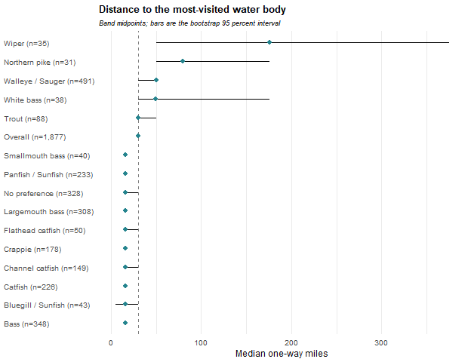

Satisfaction
Mean satisfaction here is scored from 1 (Very satisfied) to 5 (Very dissatisfied), so lower is better. Walleye / Sauger anglers are the only group less satisfied than the overall (2.5 against 2.3), while Wiper (1.7), Bluegill / Sunfish (1.8) and Trout (1.8) anglers are more satisfied. Walleye / Sauger anglers are also the lowest on the preferred-fish success item in Chapter 2, and Chapter 4 examines the satisfaction items as a set.
How satisfied were you with your fishing experiences in Nebraska during 2025? Cells are the weighted percentage of the row group giving that response, with a 95 percent confidence interval. N is the raw unweighted number of respondents in the row group who answered the question. Mean scores the five responses from 1 (Very satisfied) to 5 (Very dissatisfied). These results were weighted. Please consult the survey methodology for details.
Preferred species | Very satisfied | Somewhat satisfied | Neutral | Somewhat dissatisfied | Very dissatisfied | Mean ± CI | N
Overall | 28.7 ± 2.30 | 34.6 ± 2.41 | 22.4 ± 2.12 | 10.6 ± 1.56 | 3.7 ± 0.95 | 2.3 ± 0.06 | 1,871
Walleye / Sauger | 19.8 ± 3.95 | 34.6 ± 4.71 | 25.2 ± 4.30 | 14.3 ± 3.47 | 6.0 ± 2.36 | 2.5 ± 0.11 | 486
Bass | 24.3 ± 4.92 | 41.2 ± 5.64 | 22.0 ± 4.74 | 10.1 ± 3.45 | 2.4 ± 1.76 | 2.3 ± 0.12 | 353
Largemouth bass | 24.6 ± 5.25 | 40.6 ± 5.99 | 22.6 ± 5.10 | 9.9 ± 3.64 | 2.4 ± 1.86 | 2.2 ± 0.12 | 312
Smallmouth bass | 22.7 ± 13.93 | 45.1 ± 16.54 | 17.7 ± 12.69 | 11.7 ± 10.70 | 2.8 ± 5.48 | 2.3 ± 0.34 | 41
Panfish / Sunfish | 30.7 ± 6.63 | 36.8 ± 6.93 | 16.0 ± 5.27 | 10.9 ± 4.48 | 5.5 ± 3.28 | 2.2 ± 0.17 | 232
Crappie | 26.4 ± 7.27 | 38.6 ± 8.03 | 17.0 ± 6.19 | 12.4 ± 5.43 | 5.7 ± 3.82 | 2.3 ± 0.19 | 177
Bluegill / Sunfish | 53.1 ± 16.66 | 28.1 ± 15.00 | 9.5 ± 9.77 | 3.2 ± 5.85 | 6.2 ± 8.05 | 1.8 ± 0.38 | 43
Catfish | 31.3 ± 6.88 | 32.6 ± 6.95 | 22.3 ± 6.17 | 10.0 ± 4.44 | 3.7 ± 2.82 | 2.2 ± 0.16 | 220
Channel catfish | 35.2 ± 8.73 | 32.3 ± 8.54 | 22.2 ± 7.59 | 8.4 ± 5.07 | 1.9 ± 2.51 | 2.1 ± 0.19 | 146
Flathead catfish | 25.0 ± 13.69 | 34.9 ± 15.07 | 27.8 ± 14.16 | 7.3 ± 8.23 | 5.1 ± 6.94 | 2.3 ± 0.34 | 47
Wiper | 52.2 ± 18.29 | 27.8 ± 16.42 | 16.9 ± 13.73 | 0.0 ± 0.00 | 3.0 ± 6.27 | 1.7 ± 0.35 | 35
White bass | 37.5 ± 17.37 | 42.4 ± 17.74 | 12.9 ± 12.04 | 3.9 ± 6.97 | 3.3 ± 6.38 | 1.9 ± 0.35 | 39
Trout | 44.8 ± 11.69 | 31.5 ± 10.92 | 21.3 ± 9.62 | 1.7 ± 3.01 | 0.8 ± 2.05 | 1.8 ± 0.21 | 89
Northern pike | 21.4 ± 15.50 | 39.5 ± 18.49 | 17.0 ± 14.22 | 14.2 ± 13.20 | 7.9 ± 10.20 | 2.5 ± 0.45 | 32
No preference | 32.3 ± 5.66 | 28.6 ± 5.47 | 28.1 ± 5.44 | 9.4 ± 3.54 | 1.6 ± 1.53 | 2.2 ± 0.13 | 325
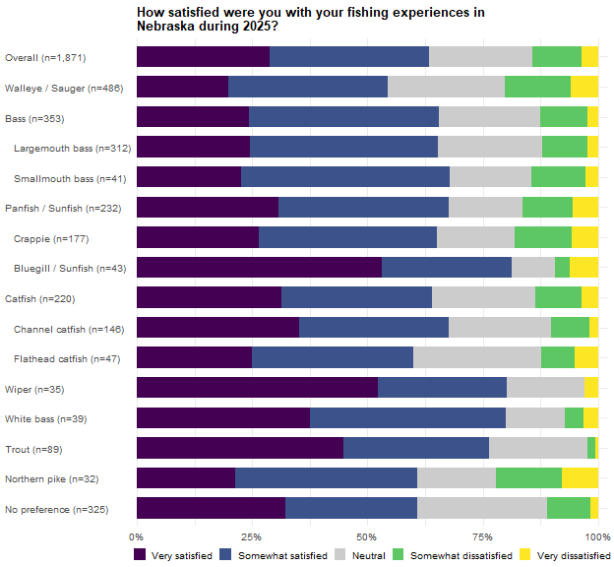
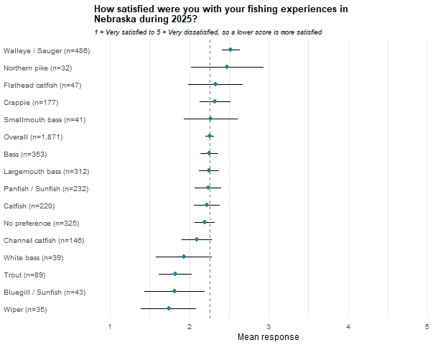

Live-imaging Sonar Use
14% of anglers used live-imaging sonar in 2025. Wiper (35%) and Walleye / Sauger (24%) anglers sit well above the overall; Catfish (7%) and No preference (7%) anglers sit below it. Uptake concentrates in the boat-borne, open-water groups.
Did you use LiveScope, MegaLive, ActiveTarget, or a similar live-imaging sonar system in 2025? Cells are the weighted percentage of the row group giving that response, with a 95 percent confidence interval. N is the raw unweighted number of respondents in the row group who answered the question. These results were weighted. Please consult the survey methodology for details.
Preferred species | Yes | No | N
Overall | 14.5 ± 1.78 | 85.5 ± 1.78 | 1,878
Walleye / Sauger | 24.5 ± 4.24 | 75.5 ± 4.24 | 490
Bass | 10.8 ± 3.55 | 89.2 ± 3.55 | 354
Largemouth bass | 11.0 ± 3.81 | 89.0 ± 3.81 | 313
Smallmouth bass | 9.6 ± 9.80 | 90.4 ± 9.80 | 41
Panfish / Sunfish | 19.2 ± 5.68 | 80.8 ± 5.68 | 231
Crappie | 22.7 ± 6.94 | 77.3 ± 6.94 | 176
Bluegill / Sunfish | 6.4 ± 8.14 | 93.6 ± 8.14 | 43
Catfish | 7.0 ± 3.75 | 93.0 ± 3.75 | 223
Channel catfish | 7.6 ± 4.80 | 92.4 ± 4.80 | 148
Flathead catfish | 7.4 ± 8.21 | 92.6 ± 8.21 | 48
Wiper | 35.2 ± 17.50 | 64.8 ± 17.50 | 35
White bass | 15.5 ± 12.99 | 84.5 ± 12.99 | 39
Trout | 7.3 ± 6.11 | 92.7 ± 6.11 | 89
Northern pike | 12.4 ± 12.69 | 87.6 ± 12.69 | 30
No preference | 6.9 ± 3.06 | 93.1 ± 3.06 | 329
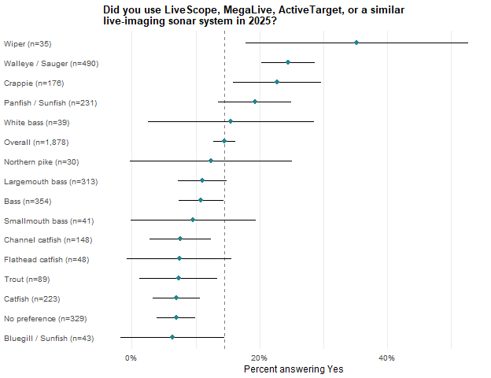

Conservation Officer
19% of anglers encountered a conservation officer while fishing. Walleye / Sauger anglers are the only group above the overall (28%, against 19% overall) and No preference anglers the only group below it (12%), consistent with the two groups’ effort and boat use elsewhere in this chapter.
Were you checked by a Nebraska conservation officer wearing a sidearm while fishing during 2025? Cells are the weighted percentage of the row group giving that response, with a 95 percent confidence interval. N is the raw unweighted number of respondents in the row group who answered the question. These results were weighted. Please consult the survey methodology for details.
Preferred species | No | Yes | N
Overall | 81.5 ± 1.97 | 18.5 ± 1.97 | 1,879
Walleye / Sauger | 72.2 ± 4.42 | 27.8 ± 4.42 | 489
Bass | 83.8 ± 4.22 | 16.2 ± 4.22 | 353
Largemouth bass | 83.4 ± 4.54 | 16.6 ± 4.54 | 312
Smallmouth bass | 86.7 ± 11.28 | 13.3 ± 11.28 | 41
Panfish / Sunfish | 82.5 ± 5.45 | 17.5 ± 5.45 | 233
Crappie | 80.4 ± 6.49 | 19.6 ± 6.49 | 180
Bluegill / Sunfish | 91.7 ± 9.42 | 8.3 ± 9.42 | 41
Catfish | 81.3 ± 5.75 | 18.7 ± 5.75 | 222
Channel catfish | 83.2 ± 6.79 | 16.8 ± 6.79 | 147
Flathead catfish | 81.9 ± 11.93 | 18.1 ± 11.93 | 49
Wiper | 83.9 ± 13.45 | 16.1 ± 13.45 | 35
White bass | 80.3 ± 14.29 | 19.7 ± 14.29 | 39
Trout | 88.5 ± 7.52 | 11.5 ± 7.52 | 88
Northern pike | 83.2 ± 14.15 | 16.8 ± 14.15 | 32
No preference | 88.1 ± 3.91 | 11.9 ± 3.91 | 328

Guided Trips
Hiring a guide is uncommon (8% of anglers), and Walleye / Sauger anglers (14%) are the only group above the overall rate. The trip-count means in the second table rest on few respondents per column and should be read with their intervals in view.
In 2025, how many times did you hire a fishing guide in and outside Nebraska? Each column is a separate indicator computed on its own universe: cells are the weighted percentage of the row group falling in that category, with a 95 percent confidence interval, followed by the raw unweighted number of respondents in that column’s universe. Columns overlap and must not be totalled. These results were weighted. Please consult the survey methodology for details.
Preferred species | Hired a guide | Hired in Nebraska | Only hired in Nebraska | Hired outside Nebraska | Only hired outside Nebraska | Hired both in and outside
Overall | 8.1 ± 1.38 (1,891) | 2.3 ± 0.76 (1,891) | 1.7 ± 0.66 (1,891) | 6.4 ± 1.24 (1,891) | 5.8 ± 1.18 (1,891) | 0.6 ± 0.39 (1,891)
Walleye / Sauger | 14.0 ± 3.41 (491) | 6.4 ± 2.42 (491) | 4.9 ± 2.12 (491) | 9.1 ± 2.83 (491) | 7.5 ± 2.60 (491) | 1.5 ± 1.21 (491)
Bass | 5.7 ± 2.64 (355) | 0.8 ± 1.03 (355) | 0.5 ± 0.84 (355) | 5.1 ± 2.52 (355) | 4.8 ± 2.45 (355) | 0.3 ± 0.61 (355)
Largemouth bass | 6.5 ± 2.98 (315) | 0.9 ± 1.17 (315) | 0.6 ± 0.95 (315) | 5.8 ± 2.84 (315) | 5.5 ± 2.77 (315) | 0.3 ± 0.69 (315)
Smallmouth bass | 0.0 ± 0.00 (40) | 0.0 ± 0.00 (40) | 0.0 ± 0.00 (40) | 0.0 ± 0.00 (40) | 0.0 ± 0.00 (40) | 0.0 ± 0.00 (40)
Panfish / Sunfish | 9.0 ± 4.09 (235) | 1.3 ± 1.59 (235) | 1.3 ± 1.59 (235) | 7.8 ± 3.82 (235) | 7.8 ± 3.82 (235) | 0.0 ± 0.00 (235)
Crappie | 9.2 ± 4.74 (180) | 0.9 ± 1.57 (180) | 0.9 ± 1.57 (180) | 8.3 ± 4.52 (180) | 8.3 ± 4.52 (180) | 0.0 ± 0.00 (180)
Bluegill / Sunfish | 4.3 ± 6.79 (43) | 2.9 ± 5.64 (43) | 2.9 ± 5.64 (43) | 1.4 ± 3.89 (43) | 1.4 ± 3.89 (43) | 0.0 ± 0.00 (43)
Catfish | 6.2 ± 3.55 (225) | 1.6 ± 1.82 (225) | 0.0 ± 0.00 (225) | 6.2 ± 3.55 (225) | 4.7 ± 3.10 (225) | 1.6 ± 1.82 (225)
Channel catfish | 5.1 ± 3.99 (149) | 2.5 ± 2.85 (149) | 0.0 ± 0.00 (149) | 5.1 ± 3.99 (149) | 2.6 ± 2.87 (149) | 2.5 ± 2.85 (149)
Flathead catfish | 2.8 ± 5.07 (50) | 0.0 ± 0.00 (50) | 0.0 ± 0.00 (50) | 2.8 ± 5.07 (50) | 2.8 ± 5.07 (50) | 0.0 ± 0.00 (50)
Wiper | 9.3 ± 10.62 (35) | 5.9 ± 8.65 (35) | 5.9 ± 8.65 (35) | 3.3 ± 6.59 (35) | 3.3 ± 6.59 (35) | 0.0 ± 0.00 (35)
White bass | 7.7 ± 9.56 (39) | 1.3 ± 3.99 (39) | 1.3 ± 3.99 (39) | 6.4 ± 8.81 (39) | 6.4 ± 8.81 (39) | 0.0 ± 0.00 (39)
Trout | 6.2 ± 5.74 (87) | 0.0 ± 0.00 (87) | 0.0 ± 0.00 (87) | 6.2 ± 5.74 (87) | 6.2 ± 5.74 (87) | 0.0 ± 0.00 (87)
Northern pike | 10.9 ± 11.80 (32) | 0.0 ± 0.00 (32) | 0.0 ± 0.00 (32) | 10.9 ± 11.80 (32) | 10.9 ± 11.80 (32) | 0.0 ± 0.00 (32)
No preference | 4.6 ± 2.52 (333) | 0.4 ± 0.79 (333) | 0.4 ± 0.79 (333) | 4.2 ± 2.40 (333) | 4.2 ± 2.40 (333) | 0.0 ± 0.00 (333)
Number of guided trips taken, among anglers who hired a guide in the universe named by each column. Cells are the weighted mean for the row group with a 95 percent confidence interval, followed by the raw unweighted number of respondents contributing to that cell. These results were weighted. Please consult the survey methodology for details.
Preferred species | Hired a guide | Hired in Nebraska | Only hired in Nebraska | Hired outside Nebraska | Only hired outside Nebraska | Hired both in and outside
Overall | 1.5 ± 0.24 (165) | 1.2 ± 0.15 (49) | 1.1 ± 0.14 (37) | 1.5 ± 0.26 (128) | 1.3 ± 0.16 (116) | 4.8 ± 1.91 (12)
Walleye / Sauger | 1.6 ± 0.26 (74) | 1.3 ± 0.21 (35) | 1.2 ± 0.20 (26) | 1.6 ± 0.30 (48) | 1.5 ± 0.31 (39) | 3.4 ± 0.92 (9)
Bass | 1.2 ± 0.41 (22) | 1.0 ± 0.00 (4) | 1.0 ± 0.00 (3) | 1.2 ± 0.35 (19) | 1.1 ± 0.12 (18) | 5.0 ± 0.00 (1)
Largemouth bass | 1.2 ± 0.41 (22) | 1.0 ± 0.00 (4) | 1.0 ± 0.00 (3) | 1.2 ± 0.35 (19) | 1.1 ± 0.12 (18) | 5.0 ± 0.00 (1)
Smallmouth bass
Panfish / Sunfish | 1.6 ± 0.51 (23) | 1.0 ± 0.00 (2) | 1.0 ± 0.00 (2) | 1.7 ± 0.56 (21) | 1.7 ± 0.56 (21)
Crappie | 1.5 ± 0.54 (19) | 1.0 ± 0.00 (1) | 1.0 ± 0.00 (1) | 1.6 ± 0.57 (18) | 1.6 ± 0.57 (18)
Bluegill / Sunfish | 1.0 ± 0.00 (2) | 1.0 ± 0.00 (1) | 1.0 ± 0.00 (1) | 1.0 ± 0.00 (1) | 1.0 ± 0.00 (1)
Catfish | 2.8 ± 2.23 (10) | 1.0 ± 0.00 (2) |  | 2.6 ± 2.02 (10) | 1.3 ± 0.52 (8) | 7.5 ± 5.54 (2)
Channel catfish | 4.2 ± 4.02 (5) | 1.0 ± 0.00 (2) |  | 3.7 ± 3.67 (5) | 1.0 ± 0.00 (3) | 7.5 ± 5.54 (2)
Flathead catfish | 1.0 ± 0.00 (1) |  |  | 1.0 ± 0.00 (1) | 1.0 ± 0.00 (1)
Wiper | 1.0 ± 0.00 (4) | 1.0 ± 0.00 (2) | 1.0 ± 0.00 (2) | 1.0 ± 0.00 (2) | 1.0 ± 0.00 (2)
White bass | 1.2 ± 0.35 (5) | 1.0 ± 0.00 (1) | 1.0 ± 0.00 (1) | 1.2 ± 0.42 (4) | 1.2 ± 0.42 (4)
Trout | 1.0 ± 0.00 (6) |  |  | 1.0 ± 0.00 (6) | 1.0 ± 0.00 (6)
Northern pike | 1.0 ± 0.00 (3) |  |  | 1.0 ± 0.00 (3) | 1.0 ± 0.00 (3)
No preference | 1.1 ± 0.31 (12) | 1.0 ± 0.00 (1) | 1.0 ± 0.00 (1) | 1.2 ± 0.34 (11) | 1.2 ± 0.34 (11)

Days Fished
Anglers fished a mean of 30 days in 2025, with a median of 17. Bass anglers are above the overall on both (mean 38, median 26) and Catfish anglers on the median (23); Northern pike anglers (mean 19) and No preference anglers (mean 20, median 10) fished the least. Effort concentrates in the bass and catfish constituencies, and the No preference group’s low effort marks it as the most casual segment of the license base.
For each month, indicate about how many DAYS you fished in Nebraska during 2025. Total days fished across all months. Cells are the weighted mean for the row group with a 95 percent confidence interval, followed by the raw unweighted number of respondents contributing to that cell. Cells are the lower 95 percent confidence limit, the weighted median, and the upper 95 percent confidence limit, followed by the raw unweighted number of respondents. Median confidence limits come from the inherited 1,000-replicate weighted bootstrap. These results were weighted. Please consult the survey methodology for details.
Preferred species | Mean days fished | Median days fished
Overall | 30.2 ± 1.78 (1,834) | 16.0/17.0/19.0 (1,834)
Walleye / Sauger | 31.7 ± 3.65 (479) | 18.0/21.0/24.0 (479)
Bass | 38.1 ± 4.35 (337) | 20.0/26.0/31.0 (337)
Largemouth bass | 37.1 ± 4.33 (298) | 22.0/28.0/32.0 (298)
Smallmouth bass | 44.9 ± 17.17 (39) | 17.0/19.3/39.0 (39)
Panfish / Sunfish | 30.4 ± 5.29 (228) | 13.0/16.0/22.5 (228)
Crappie | 32.4 ± 6.26 (175) | 16.0/19.0/26.0 (175)
Bluegill / Sunfish | 23.5 ± 10.33 (41) | 4.0/11.0/22.0 (41)
Catfish | 35.2 ± 5.08 (220) | 20.0/23.0/28.0 (220)
Channel catfish | 34.1 ± 5.99 (144) | 18.0/25.0/29.0 (144)
Flathead catfish | 32.4 ± 10.37 (50) | 13.0/17.9/31.5 (50)
Wiper | 26.9 ± 13.42 (35) | 7.0/10.1/27.0 (35)
White bass | 20.7 ± 8.70 (39) | 9.0/13.2/17.0 (39)
Trout | 23.8 ± 6.60 (84) | 6.0/9.0/16.0 (84)
Northern pike | 19.5 ± 8.24 (30) | 5.0/12.0/20.0 (30)
No preference | 19.9 ± 3.12 (323) | 8.0/10.0/13.0 (323)
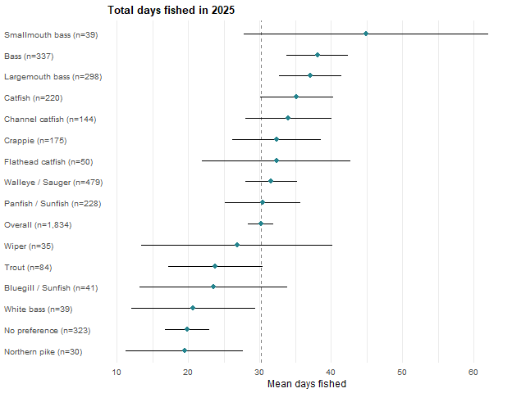

Ice Fishing
18% of anglers ice fish. Northern pike (41%), Crappie (34%), Panfish / Sunfish (32%) and Walleye / Sauger (27%) anglers do so above the overall rate; White bass (5%), Trout (9%), No preference (10%) and Largemouth bass (12%) anglers fall below it. The ordering agrees in direction with the ice-fishing method in the Methods section, which is a separate item with a slightly different set of respondents, and maps onto the species reachable through the ice.
Did you ice fish in Nebraska during 2025? Cells are the weighted percentage of the row group giving that response, with a 95 percent confidence interval. N is the raw unweighted number of respondents in the row group who answered the question. These results were weighted. Please consult the survey methodology for details.
Preferred species | Yes | No | N
Overall | 17.8 ± 1.96 | 82.2 ± 1.96 | 1,845
Walleye / Sauger | 27.4 ± 4.42 | 72.6 ± 4.42 | 486
Bass | 11.8 ± 3.73 | 88.2 ± 3.73 | 346
Largemouth bass | 11.8 ± 3.98 | 88.2 ± 3.98 | 306
Smallmouth bass | 11.4 ± 10.72 | 88.6 ± 10.72 | 40
Panfish / Sunfish | 32.1 ± 6.78 | 67.9 ± 6.78 | 227
Crappie | 34.1 ± 7.86 | 65.9 ± 7.86 | 175
Bluegill / Sunfish | 20.3 ± 13.90 | 79.7 ± 13.90 | 40
Catfish | 14.5 ± 5.30 | 85.5 ± 5.30 | 214
Channel catfish | 13.6 ± 6.40 | 86.4 ± 6.40 | 140
Flathead catfish | 20.1 ± 12.42 | 79.9 ± 12.42 | 49
Wiper | 12.6 ± 12.16 | 87.4 ± 12.16 | 35
White bass | 5.4 ± 8.23 | 94.6 ± 8.23 | 38
Trout | 8.7 ± 6.87 | 91.3 ± 6.87 | 84
Northern pike | 41.1 ± 18.82 | 58.9 ± 18.82 | 31
No preference | 9.8 ± 3.60 | 90.2 ± 3.60 | 325
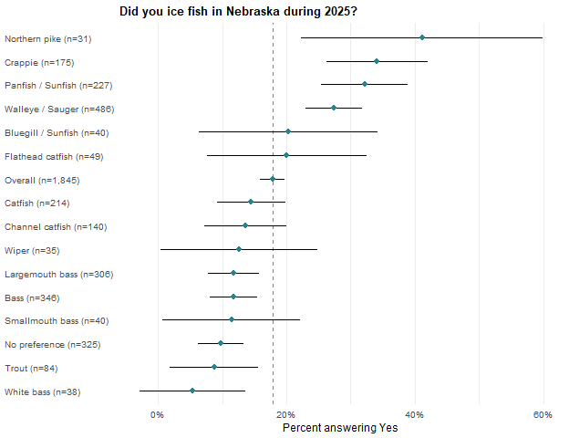

Angler Motivations
Across the four motivation sub-scales, the natural environment (3.7 overall) and social (3.6) scales rate highest and the fishery resource scale lowest (2.5). The group separations concentrate in the fishery resource scale: Wiper (3.0), Walleye / Sauger (2.7) and Catfish (2.7) anglers sit above the overall and No preference anglers below it (2.2). Wiper anglers are also above on the natural environment scale (4.1), and No preference anglers below the overall on the natural environment and physical and psychological scales. No group separates on the social scale in either direction: the companionship motive is shared across species preferences.
Indicate the importance for each item as a reason why you fish. Items are grouped by the motivation sub-scale they belong to in Scales.csv; the grouping organizes the tables and does not change any value. Cells are the weighted mean for the row group with a 95 percent confidence interval, followed by the raw unweighted number of respondents contributing to that cell. These results were weighted. Please consult the survey methodology for details.

Natural environment
Preferred species | To be outdoors | To experience natural surroundings | To experience new and different things | To be close to the water
Overall | 4.2 ± 0.04 (1,790) | 4.1 ± 0.05 (1,754) | 3.1 ± 0.06 (1,747) | 3.3 ± 0.07 (1,753)
Walleye / Sauger | 4.1 ± 0.08 (469) | 3.9 ± 0.09 (463) | 2.9 ± 0.12 (461) | 3.3 ± 0.12 (456)
Bass | 4.3 ± 0.09 (338) | 4.2 ± 0.10 (333) | 3.2 ± 0.14 (332) | 3.3 ± 0.15 (335)
Largemouth bass | 4.3 ± 0.09 (300) | 4.2 ± 0.11 (296) | 3.2 ± 0.15 (295) | 3.3 ± 0.16 (298)
Smallmouth bass | 4.1 ± 0.30 (38) | 4.2 ± 0.30 (37) | 3.4 ± 0.41 (37) | 3.2 ± 0.42 (37)
Panfish / Sunfish | 4.2 ± 0.12 (217) | 4.1 ± 0.14 (211) | 3.1 ± 0.20 (208) | 3.2 ± 0.20 (210)
Crappie | 4.2 ± 0.14 (168) | 4.2 ± 0.14 (162) | 3.1 ± 0.22 (159) | 3.2 ± 0.22 (161)
Bluegill / Sunfish | 4.5 ± 0.22 (37) | 4.2 ± 0.36 (37) | 3.3 ± 0.52 (37) | 3.3 ± 0.47 (37)
Catfish | 4.2 ± 0.14 (207) | 4.1 ± 0.15 (203) | 3.2 ± 0.19 (204) | 3.4 ± 0.18 (204)
Channel catfish | 4.2 ± 0.17 (136) | 4.1 ± 0.18 (133) | 3.0 ± 0.23 (133) | 3.5 ± 0.22 (133)
Flathead catfish | 4.2 ± 0.33 (48) | 4.2 ± 0.32 (48) | 3.3 ± 0.43 (48) | 3.4 ± 0.40 (48)
Wiper | 4.5 ± 0.28 (35) | 4.3 ± 0.31 (35) | 3.5 ± 0.42 (35) | 4.1 ± 0.35 (35)
White bass | 4.2 ± 0.27 (37) | 4.0 ± 0.29 (35) | 3.2 ± 0.49 (37) | 3.3 ± 0.38 (37)
Trout | 4.1 ± 0.26 (82) | 4.2 ± 0.20 (81) | 3.2 ± 0.33 (80) | 3.4 ± 0.27 (80)
Northern pike | 4.3 ± 0.29 (31) | 4.1 ± 0.32 (31) | 3.3 ± 0.52 (30) | 3.3 ± 0.44 (31)
No preference | 4.1 ± 0.11 (317) | 4.0 ± 0.12 (310) | 3.0 ± 0.16 (307) | 3.0 ± 0.16 (312)

Physical and psychological
Preferred species | For the challenge or sport | For relaxation | To experience adventure and excitement | For physical exercise
Overall | 3.2 ± 0.06 (1,752) | 4.0 ± 0.05 (1,775) | 3.4 ± 0.06 (1,753) | 2.5 ± 0.07 (1,751)
Walleye / Sauger | 3.3 ± 0.12 (466) | 3.9 ± 0.10 (468) | 3.3 ± 0.12 (461) | 2.4 ± 0.13 (460)
Bass | 3.4 ± 0.13 (330) | 4.1 ± 0.11 (335) | 3.5 ± 0.13 (333) | 2.5 ± 0.14 (331)
Largemouth bass | 3.5 ± 0.14 (293) | 4.2 ± 0.11 (298) | 3.5 ± 0.14 (296) | 2.4 ± 0.16 (294)
Smallmouth bass | 3.2 ± 0.41 (37) | 3.9 ± 0.39 (37) | 3.6 ± 0.37 (37) | 2.6 ± 0.36 (37)
Panfish / Sunfish | 3.2 ± 0.18 (208) | 4.0 ± 0.14 (213) | 3.4 ± 0.19 (208) | 2.6 ± 0.19 (210)
Crappie | 3.3 ± 0.19 (161) | 4.0 ± 0.16 (164) | 3.3 ± 0.20 (160) | 2.5 ± 0.22 (161)
Bluegill / Sunfish | 3.0 ± 0.51 (35) | 4.0 ± 0.30 (37) | 3.7 ± 0.48 (36) | 2.9 ± 0.45 (37)
Catfish | 3.3 ± 0.19 (207) | 4.2 ± 0.13 (208) | 3.5 ± 0.18 (205) | 2.6 ± 0.17 (204)
Channel catfish | 3.2 ± 0.22 (136) | 4.1 ± 0.17 (137) | 3.4 ± 0.22 (134) | 2.6 ± 0.22 (133)
Flathead catfish | 3.6 ± 0.42 (48) | 4.3 ± 0.24 (48) | 3.5 ± 0.39 (48) | 2.5 ± 0.34 (48)
Wiper | 3.9 ± 0.42 (34) | 3.8 ± 0.32 (35) | 3.7 ± 0.40 (35) | 2.8 ± 0.34 (35)
White bass | 3.0 ± 0.51 (37) | 3.8 ± 0.40 (37) | 3.6 ± 0.49 (36) | 2.9 ± 0.57 (37)
Trout | 3.2 ± 0.27 (80) | 3.9 ± 0.23 (81) | 3.3 ± 0.25 (80) | 2.9 ± 0.32 (79)
Northern pike | 3.3 ± 0.51 (30) | 4.0 ± 0.30 (31) | 3.5 ± 0.49 (31) | 2.7 ± 0.51 (31)
No preference | 2.6 ± 0.16 (307) | 3.9 ± 0.13 (311) | 3.1 ± 0.16 (311) | 2.4 ± 0.15 (309)

Social
Preferred species | To be with friends | To get away from other people | To get away from the daily routine | For family recreation
Overall | 3.5 ± 0.06 (1,754) | 3.5 ± 0.07 (1,756) | 3.8 ± 0.06 (1,756) | 3.7 ± 0.06 (1,771)
Walleye / Sauger | 3.6 ± 0.12 (466) | 3.4 ± 0.13 (461) | 3.7 ± 0.11 (461) | 3.8 ± 0.12 (466)
Bass | 3.5 ± 0.15 (332) | 3.6 ± 0.15 (329) | 3.9 ± 0.12 (331) | 3.5 ± 0.16 (332)
Largemouth bass | 3.5 ± 0.16 (295) | 3.6 ± 0.16 (292) | 3.9 ± 0.13 (294) | 3.6 ± 0.16 (295)
Smallmouth bass | 3.2 ± 0.43 (37) | 3.9 ± 0.41 (37) | 3.9 ± 0.35 (37) | 2.8 ± 0.49 (37)
Panfish / Sunfish | 3.6 ± 0.19 (207) | 3.3 ± 0.21 (214) | 3.7 ± 0.17 (211) | 3.7 ± 0.20 (214)
Crappie | 3.5 ± 0.22 (159) | 3.4 ± 0.23 (165) | 3.7 ± 0.20 (162) | 3.6 ± 0.23 (165)
Bluegill / Sunfish | 3.7 ± 0.45 (36) | 3.1 ± 0.59 (37) | 3.7 ± 0.35 (37) | 3.9 ± 0.44 (37)
Catfish | 3.4 ± 0.19 (203) | 3.6 ± 0.21 (205) | 3.8 ± 0.18 (205) | 3.6 ± 0.20 (208)
Channel catfish | 3.5 ± 0.23 (133) | 3.4 ± 0.25 (134) | 3.8 ± 0.21 (135) | 3.6 ± 0.24 (137)
Flathead catfish | 3.1 ± 0.36 (47) | 3.8 ± 0.42 (48) | 3.8 ± 0.40 (47) | 3.7 ± 0.39 (48)
Wiper | 3.9 ± 0.44 (35) | 4.1 ± 0.40 (34) | 3.9 ± 0.43 (35) | 3.8 ± 0.49 (35)
White bass | 3.7 ± 0.44 (35) | 3.2 ± 0.54 (37) | 3.6 ± 0.45 (37) | 3.9 ± 0.39 (37)
Trout | 3.5 ± 0.27 (81) | 3.5 ± 0.32 (79) | 3.6 ± 0.33 (80) | 3.4 ± 0.28 (80)
Northern pike | 3.6 ± 0.41 (29) | 3.7 ± 0.43 (31) | 4.0 ± 0.39 (31) | 3.6 ± 0.40 (31)
No preference | 3.5 ± 0.15 (312) | 3.3 ± 0.18 (312) | 3.5 ± 0.15 (312) | 3.7 ± 0.15 (315)

Fishery resource
Preferred species | To compete for prizes or money | To obtain fish for eating | To catch a trophy fish | For the fun of catching fish
Overall | 1.2 ± 0.03 (1,747) | 2.4 ± 0.07 (1,763) | 2.3 ± 0.07 (1,747) | 4.2 ± 0.05 (1,771)
Walleye / Sauger | 1.2 ± 0.06 (457) | 3.0 ± 0.13 (467) | 2.4 ± 0.13 (462) | 4.1 ± 0.09 (462)
Bass | 1.2 ± 0.09 (331) | 1.8 ± 0.13 (329) | 2.5 ± 0.16 (333) | 4.4 ± 0.09 (333)
Largemouth bass | 1.2 ± 0.10 (294) | 1.8 ± 0.14 (293) | 2.5 ± 0.17 (296) | 4.4 ± 0.10 (296)
Smallmouth bass | 1.2 ± 0.22 (37) | 1.9 ± 0.44 (36) | 2.6 ± 0.51 (37) | 4.3 ± 0.28 (37)
Panfish / Sunfish | 1.2 ± 0.09 (211) | 2.7 ± 0.21 (210) | 1.9 ± 0.18 (210) | 4.2 ± 0.13 (215)
Crappie | 1.1 ± 0.08 (162) | 2.7 ± 0.23 (161) | 2.0 ± 0.21 (161) | 4.2 ± 0.15 (165)
Bluegill / Sunfish | 1.4 ± 0.38 (37) | 2.5 ± 0.55 (37) | 1.5 ± 0.43 (37) | 4.3 ± 0.29 (38)
Catfish | 1.2 ± 0.08 (203) | 2.6 ± 0.20 (208) | 2.6 ± 0.24 (203) | 4.3 ± 0.13 (209)
Channel catfish | 1.2 ± 0.10 (132) | 2.8 ± 0.25 (137) | 2.4 ± 0.29 (132) | 4.2 ± 0.15 (138)
Flathead catfish | 1.0 ± 0.06 (48) | 2.4 ± 0.41 (48) | 2.8 ± 0.49 (48) | 4.5 ± 0.23 (48)
Wiper | 1.8 ± 0.44 (35) | 2.4 ± 0.41 (35) | 3.6 ± 0.51 (35) | 4.4 ± 0.33 (35)
White bass | 1.1 ± 0.14 (37) | 3.1 ± 0.42 (37) | 1.6 ± 0.38 (37) | 4.2 ± 0.27 (37)
Trout | 1.1 ± 0.12 (78) | 2.3 ± 0.27 (79) | 1.9 ± 0.33 (79) | 4.0 ± 0.24 (80)
Northern pike | 1.1 ± 0.22 (31) | 1.9 ± 0.45 (31) | 3.0 ± 0.53 (31) | 4.4 ± 0.30 (31)
No preference | 1.1 ± 0.04 (311) | 2.1 ± 0.16 (312) | 1.6 ± 0.14 (306) | 4.0 ± 0.12 (317)

Motivation scale scores
Each scale score is the mean of its items, computed only for respondents who answered every item in that scale. Cells are the weighted mean for the row group with a 95 percent confidence interval, followed by the raw unweighted number of respondents contributing to that cell. These results were weighted. Please consult the survey methodology for details.
Preferred species | Physical and psychological | Natural environment | Social | Fishery resource
Overall | 3.3 ± 0.04 (1,712) | 3.7 ± 0.04 (1,710) | 3.6 ± 0.04 (1,710) | 2.5 ± 0.03 (1,715)
Walleye / Sauger | 3.2 ± 0.08 (455) | 3.6 ± 0.08 (445) | 3.6 ± 0.08 (450) | 2.7 ± 0.07 (453)
Bass | 3.4 ± 0.09 (325) | 3.7 ± 0.09 (328) | 3.6 ± 0.10 (323) | 2.5 ± 0.07 (324)
Largemouth bass | 3.4 ± 0.10 (288) | 3.8 ± 0.10 (291) | 3.6 ± 0.10 (286) | 2.5 ± 0.08 (288)
Smallmouth bass | 3.3 ± 0.28 (37) | 3.7 ± 0.31 (37) | 3.4 ± 0.28 (37) | 2.5 ± 0.25 (36)
Panfish / Sunfish | 3.3 ± 0.12 (199) | 3.7 ± 0.13 (204) | 3.6 ± 0.13 (204) | 2.5 ± 0.10 (207)
Crappie | 3.3 ± 0.14 (153) | 3.7 ± 0.13 (155) | 3.6 ± 0.15 (156) | 2.5 ± 0.10 (158)
Bluegill / Sunfish | 3.4 ± 0.35 (34) | 3.8 ± 0.32 (37) | 3.6 ± 0.31 (36) | 2.4 ± 0.31 (37)
Catfish | 3.4 ± 0.12 (204) | 3.7 ± 0.12 (201) | 3.6 ± 0.13 (199) | 2.7 ± 0.11 (200)
Channel catfish | 3.3 ± 0.14 (133) | 3.7 ± 0.15 (131) | 3.6 ± 0.15 (130) | 2.6 ± 0.13 (129)
Flathead catfish | 3.5 ± 0.24 (48) | 3.8 ± 0.28 (48) | 3.6 ± 0.27 (46) | 2.7 ± 0.19 (48)
Wiper | 3.5 ± 0.26 (34) | 4.1 ± 0.26 (35) | 3.9 ± 0.33 (34) | 3.0 ± 0.25 (35)
White bass | 3.3 ± 0.39 (36) | 3.7 ± 0.28 (35) | 3.6 ± 0.32 (35) | 2.5 ± 0.20 (37)
Trout | 3.3 ± 0.20 (79) | 3.7 ± 0.22 (79) | 3.5 ± 0.20 (79) | 2.3 ± 0.16 (76)
Northern pike | 3.4 ± 0.23 (30) | 3.8 ± 0.32 (30) | 3.7 ± 0.31 (29) | 2.6 ± 0.21 (31)
No preference | 3.0 ± 0.11 (298) | 3.5 ± 0.11 (302) | 3.5 ± 0.11 (304) | 2.2 ± 0.08 (302)
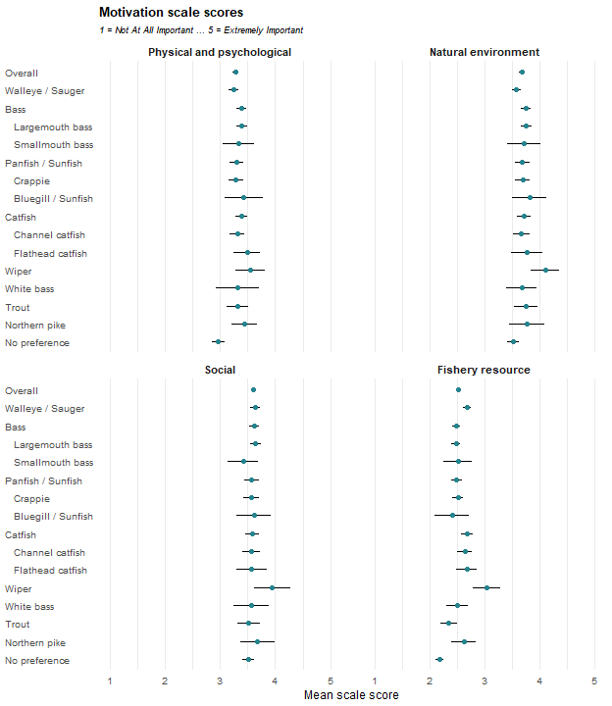
The same items also form a two-part split between catch-oriented and non-catch-oriented motivations, reported below on the same basis. Cells are the weighted mean for the row group with a 95 percent confidence interval, followed by the raw unweighted number of respondents contributing to that cell. These results were weighted. Please consult the survey methodology for details.
Preferred species | Non-catch Motivations | Catch Motivations
Overall | 3.5 ± 0.04 (1,667) | 3.0 ± 0.03 (1,664)
Walleye / Sauger | 3.5 ± 0.08 (437) | 3.1 ± 0.06 (445)
Bass | 3.6 ± 0.08 (316) | 3.0 ± 0.07 (320)
Largemouth bass | 3.6 ± 0.09 (279) | 3.0 ± 0.07 (284)
Smallmouth bass | 3.6 ± 0.26 (37) | 2.9 ± 0.25 (36)
Panfish / Sunfish | 3.6 ± 0.12 (197) | 3.0 ± 0.10 (197)
Crappie | 3.6 ± 0.13 (149) | 3.0 ± 0.10 (151)
Bluegill / Sunfish | 3.7 ± 0.29 (36) | 2.9 ± 0.31 (34)
Catfish | 3.6 ± 0.11 (199) | 3.1 ± 0.10 (194)
Channel catfish | 3.5 ± 0.14 (130) | 3.0 ± 0.12 (125)
Flathead catfish | 3.6 ± 0.25 (47) | 3.1 ± 0.20 (46)
Wiper | 3.9 ± 0.23 (34) | 3.4 ± 0.25 (34)
White bass | 3.5 ± 0.31 (34) | 2.9 ± 0.21 (35)
Trout | 3.6 ± 0.18 (78) | 2.8 ± 0.15 (76)
Northern pike | 3.7 ± 0.30 (30) | 3.2 ± 0.25 (27)
No preference | 3.4 ± 0.10 (291) | 2.6 ± 0.08 (287)

Regulations
The regulation scales separate few groups. On the Comprehension scale (3.6 overall), Bass (3.7) and especially Smallmouth bass (4.0) anglers sit above the overall, and Smallmouth bass anglers are the one group above it on the Site-specific scale (4.2 against 3.9). On the Simplification scale, the preference for uniform statewide regulations (3.1 overall), Northern pike anglers are the only group below the overall (2.7), consistent with a group fishing a small set of specialized waters.
How much do you agree or disagree with each of the following items regarding fishing regulations? Items are grouped by the regulation sub-scale they belong to in Scales.csv. Item means are computed on the responses as recorded and are not reverse-adjusted, matching the 2025 Crosstabs report. None of the three sub-scales reported here contains a reverse-coded item; the reversals the codebook records for this battery belong to a separate bipolar orientation scale that this report does not use. Cells are the weighted mean for the row group with a 95 percent confidence interval, followed by the raw unweighted number of respondents contributing to that cell. These results were weighted. Please consult the survey methodology for details.

Comprehension
Preferred species | Nebraska's mix of statewide and site-specific regulations is easy for me to understand. | Fishing regulations are clear enough that I rarely worry about accidentally breaking them. | I feel confident that I understand Nebraska's fishing regulations.
Overall | 3.3 ± 0.06 (1,690) | 3.5 ± 0.06 (1,699) | 3.9 ± 0.06 (1,697)
Walleye / Sauger | 3.3 ± 0.11 (449) | 3.3 ± 0.12 (453) | 3.8 ± 0.11 (454)
Bass | 3.5 ± 0.13 (317) | 3.8 ± 0.12 (321) | 4.0 ± 0.11 (321)
Largemouth bass | 3.4 ± 0.14 (283) | 3.8 ± 0.13 (286) | 4.0 ± 0.12 (286)
Smallmouth bass | 3.6 ± 0.35 (34) | 4.1 ± 0.28 (35) | 4.2 ± 0.19 (35)
Panfish / Sunfish | 3.4 ± 0.17 (211) | 3.7 ± 0.17 (212) | 3.9 ± 0.16 (210)
Crappie | 3.4 ± 0.20 (166) | 3.7 ± 0.19 (167) | 3.9 ± 0.18 (165)
Bluegill / Sunfish | 3.4 ± 0.39 (36) | 3.9 ± 0.41 (36) | 4.1 ± 0.33 (36)
Catfish | 3.3 ± 0.17 (200) | 3.7 ± 0.18 (200) | 4.0 ± 0.16 (201)
Channel catfish | 3.3 ± 0.21 (129) | 3.7 ± 0.23 (130) | 3.9 ± 0.20 (131)
Flathead catfish | 3.3 ± 0.37 (47) | 3.6 ± 0.42 (47) | 4.2 ± 0.32 (47)
Wiper | 3.6 ± 0.36 (34) | 3.2 ± 0.42 (34) | 4.0 ± 0.35 (34)
White bass | 3.0 ± 0.34 (33) | 3.7 ± 0.41 (33) | 3.8 ± 0.39 (33)
Trout | 3.2 ± 0.29 (77) | 3.4 ± 0.32 (77) | 3.8 ± 0.25 (77)
Northern pike | 4.0 ± 0.41 (30) | 3.4 ± 0.58 (29) | 4.0 ± 0.40 (29)
No preference | 3.3 ± 0.13 (286) | 3.5 ± 0.15 (287) | 3.7 ± 0.14 (285)

Site-specific
Preferred species | I trust fisheries' managers to decide when site-specific regulations are necessary. | Site-specific regulations are important because different waters need different management approaches. | Creating special fishing opportunities at certain waters is worth having lake-specific regulations.
Overall | 3.7 ± 0.05 (1,694) | 4.0 ± 0.05 (1,691) | 3.9 ± 0.05 (1,682)
Walleye / Sauger | 3.5 ± 0.11 (452) | 4.0 ± 0.09 (450) | 3.8 ± 0.10 (446)
Bass | 3.8 ± 0.11 (320) | 4.1 ± 0.11 (319) | 4.0 ± 0.11 (319)
Largemouth bass | 3.8 ± 0.12 (285) | 4.0 ± 0.11 (285) | 4.0 ± 0.12 (285)
Smallmouth bass | 4.0 ± 0.27 (35) | 4.3 ± 0.23 (34) | 4.4 ± 0.24 (34)
Panfish / Sunfish | 3.8 ± 0.15 (210) | 4.1 ± 0.13 (209) | 4.0 ± 0.14 (209)
Crappie | 3.8 ± 0.16 (166) | 4.1 ± 0.15 (165) | 4.0 ± 0.15 (165)
Bluegill / Sunfish | 4.1 ± 0.38 (35) | 4.1 ± 0.33 (35) | 4.0 ± 0.34 (35)
Catfish | 3.7 ± 0.16 (200) | 4.1 ± 0.14 (200) | 3.9 ± 0.16 (201)
Channel catfish | 3.7 ± 0.20 (130) | 4.1 ± 0.17 (130) | 4.0 ± 0.19 (131)
Flathead catfish | 3.6 ± 0.30 (47) | 4.0 ± 0.30 (47) | 3.8 ± 0.33 (47)
Wiper | 3.7 ± 0.40 (34) | 4.0 ± 0.43 (34) | 4.1 ± 0.39 (33)
White bass | 3.5 ± 0.32 (33) | 3.7 ± 0.33 (33) | 3.4 ± 0.31 (33)
Trout | 3.6 ± 0.27 (78) | 4.0 ± 0.21 (78) | 3.6 ± 0.26 (76)
Northern pike | 3.7 ± 0.47 (29) | 4.1 ± 0.30 (29) | 4.1 ± 0.36 (29)
No preference | 3.7 ± 0.13 (287) | 3.9 ± 0.12 (288) | 3.8 ± 0.12 (285)

Simplification
Preferred species | Site-specific rules make fishing regulations unnecessarily complicated. | Simplified, uniform regulations are more likely to be obeyed by anglers. | Fisheries' managers should avoid site-specific regulations to avoid confusing anglers. | It is better to have uniform statewide regulations, even if that means they aren't always effective everywhere. | I would rather have one set of regulations everywhere, even if it limits unique fishing opportunities.
Overall | 3.0 ± 0.06 (1,713) | 3.7 ± 0.06 (1,712) | 3.0 ± 0.06 (1,696) | 2.9 ± 0.06 (1,689) | 2.8 ± 0.06 (1,692)
Walleye / Sauger | 3.1 ± 0.11 (454) | 3.7 ± 0.11 (454) | 3.1 ± 0.11 (454) | 2.8 ± 0.11 (450) | 2.7 ± 0.12 (452)
Bass | 2.8 ± 0.14 (321) | 3.8 ± 0.12 (319) | 2.9 ± 0.13 (318) | 3.1 ± 0.13 (319) | 2.7 ± 0.14 (320)
Largemouth bass | 2.8 ± 0.15 (286) | 3.8 ± 0.13 (284) | 2.9 ± 0.14 (285) | 3.1 ± 0.15 (285) | 2.8 ± 0.15 (285)
Smallmouth bass | 2.6 ± 0.37 (35) | 3.8 ± 0.32 (35) | 2.8 ± 0.37 (33) | 2.9 ± 0.31 (34) | 2.2 ± 0.35 (35)
Panfish / Sunfish | 3.0 ± 0.19 (214) | 3.7 ± 0.17 (213) | 3.0 ± 0.18 (209) | 2.9 ± 0.18 (209) | 2.7 ± 0.18 (209)
Crappie | 3.0 ± 0.22 (168) | 3.7 ± 0.19 (167) | 3.0 ± 0.20 (164) | 2.9 ± 0.21 (165) | 2.7 ± 0.20 (164)
Bluegill / Sunfish | 3.0 ± 0.46 (36) | 3.6 ± 0.43 (36) | 2.9 ± 0.40 (35) | 2.7 ± 0.40 (35) | 2.9 ± 0.46 (36)
Catfish | 3.0 ± 0.18 (200) | 3.7 ± 0.17 (203) | 3.1 ± 0.15 (202) | 3.2 ± 0.19 (200) | 2.9 ± 0.19 (200)
Channel catfish | 3.0 ± 0.23 (130) | 3.7 ± 0.20 (132) | 3.1 ± 0.19 (131) | 3.1 ± 0.24 (130) | 2.8 ± 0.24 (130)
Flathead catfish | 3.1 ± 0.40 (47) | 3.8 ± 0.37 (47) | 3.2 ± 0.33 (47) | 3.5 ± 0.36 (47) | 3.1 ± 0.37 (47)
Wiper | 3.1 ± 0.38 (34) | 4.0 ± 0.40 (34) | 2.8 ± 0.42 (34) | 2.7 ± 0.40 (33) | 2.7 ± 0.49 (34)
White bass | 2.9 ± 0.40 (33) | 3.8 ± 0.35 (33) | 3.0 ± 0.39 (33) | 3.1 ± 0.38 (33) | 3.1 ± 0.43 (33)
Trout | 3.1 ± 0.30 (79) | 3.9 ± 0.25 (77) | 3.3 ± 0.29 (77) | 2.7 ± 0.31 (77) | 3.0 ± 0.34 (77)
Northern pike | 2.6 ± 0.50 (31) | 3.4 ± 0.50 (31) | 2.8 ± 0.51 (30) | 2.4 ± 0.51 (29) | 2.2 ± 0.51 (29)
No preference | 3.1 ± 0.14 (294) | 3.8 ± 0.13 (295) | 3.0 ± 0.13 (286) | 3.1 ± 0.14 (286) | 2.9 ± 0.14 (287)

Items outside the three regulation sub-scales
These items are part of the battery but belong to no sub-scale of the Regulations scale. Cells are the weighted mean for the row group with a 95 percent confidence interval, followed by the raw unweighted number of respondents contributing to that cell.
Preferred species | Anglers are willing to follow complex regulations to produce high-quality fisheries.
Overall | 3.2 ± 0.06 (1,705)
Walleye / Sauger | 3.2 ± 0.10 (454)
Bass | 3.2 ± 0.14 (320)
Largemouth bass | 3.1 ± 0.15 (286)
Smallmouth bass | 3.7 ± 0.34 (34)
Panfish / Sunfish | 3.1 ± 0.17 (211)
Crappie | 3.2 ± 0.19 (166)
Bluegill / Sunfish | 2.8 ± 0.38 (35)
Catfish | 3.3 ± 0.16 (202)
Channel catfish | 3.2 ± 0.20 (131)
Flathead catfish | 3.3 ± 0.35 (47)
Wiper | 3.6 ± 0.36 (34)
White bass | 3.2 ± 0.41 (33)
Trout | 2.8 ± 0.27 (77)
Northern pike | 3.2 ± 0.50 (30)
No preference | 3.2 ± 0.12 (291)

Regulation scale scores
Each scale score is the mean of its items, computed only for respondents who answered every item in that scale. Cells are the weighted mean for the row group with a 95 percent confidence interval, followed by the raw unweighted number of respondents contributing to that cell. These results were weighted. Please consult the survey methodology for details.
Preferred species | Comprehension | Site-specific | Simplification
Overall | 3.6 ± 0.05 (1,680) | 3.9 ± 0.05 (1,679) | 3.1 ± 0.04 (1,666)
Walleye / Sauger | 3.5 ± 0.09 (449) | 3.8 ± 0.09 (445) | 3.1 ± 0.08 (446)
Bass | 3.7 ± 0.10 (316) | 4.0 ± 0.10 (319) | 3.1 ± 0.10 (316)
Largemouth bass | 3.7 ± 0.11 (282) | 3.9 ± 0.11 (285) | 3.1 ± 0.10 (283)
Smallmouth bass | 4.0 ± 0.23 (34) | 4.2 ± 0.21 (34) | 2.9 ± 0.25 (33)
Panfish / Sunfish | 3.6 ± 0.14 (210) | 4.0 ± 0.13 (209) | 3.0 ± 0.13 (206)
Crappie | 3.6 ± 0.16 (165) | 4.0 ± 0.14 (165) | 3.0 ± 0.15 (162)
Bluegill / Sunfish | 3.8 ± 0.35 (36) | 4.1 ± 0.33 (35) | 3.0 ± 0.30 (35)
Catfish | 3.7 ± 0.15 (198) | 3.9 ± 0.13 (200) | 3.1 ± 0.13 (197)
Channel catfish | 3.6 ± 0.19 (128) | 3.9 ± 0.16 (130) | 3.1 ± 0.16 (128)
Flathead catfish | 3.7 ± 0.32 (47) | 3.8 ± 0.25 (47) | 3.3 ± 0.24 (47)
Wiper | 3.6 ± 0.31 (34) | 4.0 ± 0.36 (33) | 3.1 ± 0.29 (33)
White bass | 3.5 ± 0.31 (33) | 3.5 ± 0.29 (33) | 3.2 ± 0.22 (33)
Trout | 3.4 ± 0.26 (76) | 3.7 ± 0.21 (76) | 3.2 ± 0.20 (76)
Northern pike | 3.8 ± 0.39 (29) | 4.0 ± 0.28 (29) | 2.7 ± 0.38 (29)
No preference | 3.5 ± 0.12 (282) | 3.8 ± 0.11 (284) | 3.2 ± 0.10 (280)
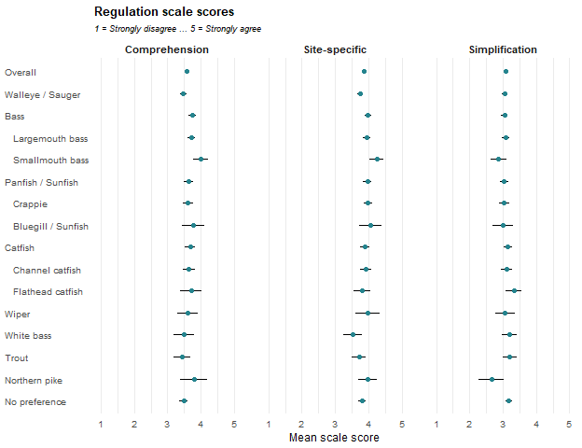

Angler Attitudes
The four attitude scales reprise the evidence behind Chapter 1’s groupings. Walleye / Sauger anglers are the only group above the overall on catching something (3.0 against 2.8) and on numbers of fish (3.2 against 3.1); No preference anglers fall below on both, and Trout anglers on numbers. On size of fish, Wiper (4.0) and Northern pike (3.8) anglers sit highest and Bass anglers also above the overall (3.5), with Panfish / Sunfish and particularly Bluegill / Sunfish anglers (2.8) below. On harvesting, White bass (2.8), Walleye / Sauger (2.6) and Channel catfish (2.4) anglers are above the overall and Bass anglers well below it (1.7): bass anglers are the most release-oriented constituency in the survey, and walleye and white bass anglers the most harvest-oriented.
Indicate how much you agree with each of the following statements about fishing. Items are grouped by the attitude sub-scale they belong to in Scales.csv. Item means are computed on the responses as recorded and are not reverse-adjusted; a dagger marks an item the codebook flags as reverse-coded. Cells are the weighted mean for the row group with a 95 percent confidence interval, followed by the raw unweighted number of respondents contributing to that cell. Reverse-scored items: E1a, E1k, E1f, E1l. These results were weighted. Please consult the survey methodology for details.

Catch something
Preferred species | A fishing trip can be successful even if no fish are caught. † | If I thought I wouldn’t catch any fish, I would not go fishing. | When I go fishing, I’m just as happy if I don’t catch a fish. † | When I go fishing, I am not satisfied unless I catch at least something.
Overall | 3.8 ± 0.06 (1,733) | 2.7 ± 0.07 (1,716) | 3.0 ± 0.06 (1,718) | 3.2 ± 0.06 (1,715)
Walleye / Sauger | 3.6 ± 0.11 (460) | 2.9 ± 0.13 (456) | 2.6 ± 0.10 (456) | 3.4 ± 0.10 (457)
Bass | 3.8 ± 0.12 (329) | 2.6 ± 0.15 (323) | 3.0 ± 0.13 (325) | 3.1 ± 0.13 (324)
Largemouth bass | 3.8 ± 0.13 (293) | 2.7 ± 0.16 (287) | 3.0 ± 0.14 (289) | 3.1 ± 0.14 (289)
Smallmouth bass | 3.9 ± 0.32 (36) | 2.4 ± 0.38 (36) | 2.8 ± 0.33 (36) | 3.0 ± 0.37 (35)
Panfish / Sunfish | 3.7 ± 0.16 (212) | 2.9 ± 0.19 (211) | 2.9 ± 0.15 (211) | 3.3 ± 0.17 (211)
Crappie | 3.6 ± 0.18 (165) | 2.9 ± 0.21 (164) | 2.9 ± 0.17 (164) | 3.3 ± 0.19 (164)
Bluegill / Sunfish | 4.0 ± 0.29 (37) | 2.8 ± 0.45 (37) | 3.1 ± 0.37 (37) | 3.1 ± 0.38 (37)
Catfish | 3.9 ± 0.16 (205) | 2.6 ± 0.20 (205) | 3.1 ± 0.17 (203) | 3.2 ± 0.17 (202)
Channel catfish | 3.9 ± 0.19 (134) | 2.7 ± 0.24 (134) | 3.0 ± 0.21 (133) | 3.1 ± 0.20 (133)
Flathead catfish | 3.8 ± 0.32 (47) | 2.5 ± 0.42 (47) | 3.4 ± 0.33 (47) | 3.0 ± 0.40 (47)
Wiper | 4.2 ± 0.35 (31) | 3.5 ± 0.44 (31) | 3.1 ± 0.36 (31) | 2.5 ± 0.51 (31)
White bass | 4.1 ± 0.36 (34) | 2.8 ± 0.38 (34) | 3.1 ± 0.34 (34) | 3.0 ± 0.37 (34)
Trout | 3.9 ± 0.26 (79) | 2.6 ± 0.28 (78) | 3.3 ± 0.23 (78) | 3.0 ± 0.26 (78)
Northern pike | 3.3 ± 0.47 (29) | 2.9 ± 0.54 (29) | 2.6 ± 0.37 (29) | 3.6 ± 0.33 (29)
No preference | 3.9 ± 0.12 (300) | 2.6 ± 0.16 (298) | 3.2 ± 0.14 (299) | 3.0 ± 0.14 (297)

Numbers
Preferred species | I'm happiest with a fishing trip if I catch at least the limit. | The more fish I catch, the happier I am. | A successful fishing trip is one in which many fish are caught. | A full stringer is the best indicator of a good fishing trip.
Overall | 3.0 ± 0.05 (1,707) | 3.5 ± 0.06 (1,698) | 3.3 ± 0.05 (1,715) | 2.6 ± 0.06 (1,717)
Walleye / Sauger | 3.1 ± 0.10 (452) | 3.5 ± 0.10 (449) | 3.4 ± 0.09 (458) | 2.8 ± 0.10 (457)
Bass | 2.9 ± 0.12 (322) | 3.6 ± 0.13 (321) | 3.3 ± 0.12 (324) | 2.4 ± 0.13 (326)
Largemouth bass | 2.8 ± 0.13 (286) | 3.6 ± 0.14 (285) | 3.3 ± 0.12 (288) | 2.4 ± 0.13 (290)
Smallmouth bass | 3.2 ± 0.27 (36) | 4.1 ± 0.28 (36) | 3.5 ± 0.33 (36) | 2.4 ± 0.44 (36)
Panfish / Sunfish | 2.9 ± 0.16 (212) | 3.4 ± 0.16 (208) | 3.3 ± 0.14 (210) | 2.7 ± 0.15 (211)
Crappie | 2.9 ± 0.18 (165) | 3.4 ± 0.18 (162) | 3.4 ± 0.16 (164) | 2.8 ± 0.17 (164)
Bluegill / Sunfish | 2.5 ± 0.37 (37) | 3.2 ± 0.44 (37) | 3.1 ± 0.36 (36) | 2.4 ± 0.33 (37)
Catfish | 3.2 ± 0.17 (202) | 3.5 ± 0.17 (202) | 3.3 ± 0.17 (202) | 2.8 ± 0.18 (203)
Channel catfish | 3.1 ± 0.20 (131) | 3.5 ± 0.21 (132) | 3.2 ± 0.19 (134) | 2.8 ± 0.20 (134)
Flathead catfish | 3.2 ± 0.40 (47) | 3.5 ± 0.38 (46) | 3.1 ± 0.39 (46) | 2.5 ± 0.41 (47)
Wiper | 3.6 ± 0.35 (31) | 3.9 ± 0.31 (31) | 3.4 ± 0.29 (31) | 2.4 ± 0.35 (31)
White bass | 3.2 ± 0.40 (34) | 3.5 ± 0.43 (34) | 3.0 ± 0.32 (34) | 2.9 ± 0.28 (34)
Trout | 2.7 ± 0.23 (78) | 3.1 ± 0.27 (79) | 3.1 ± 0.22 (79) | 2.4 ± 0.22 (78)
Northern pike | 3.0 ± 0.46 (29) | 3.7 ± 0.39 (29) | 3.7 ± 0.30 (29) | 2.3 ± 0.45 (29)
No preference | 2.8 ± 0.12 (295) | 3.3 ± 0.15 (293) | 3.1 ± 0.13 (296) | 2.5 ± 0.13 (296)

Size
Preferred species | The bigger the fish I catch, the better the fishing trip. | I am the happiest with a fishing trip if I catch a challenging game fish. | I would rather catch one or two big fish than ten smaller fish. | I like to fish where I know I have a chance to catch a trophy fish.
Overall | 3.4 ± 0.06 (1,719) | 3.3 ± 0.06 (1,717) | 3.2 ± 0.05 (1,713) | 3.3 ± 0.06 (1,715)
Walleye / Sauger | 3.3 ± 0.10 (456) | 3.4 ± 0.10 (457) | 3.0 ± 0.09 (457) | 3.3 ± 0.10 (457)
Bass | 3.6 ± 0.12 (326) | 3.5 ± 0.12 (325) | 3.3 ± 0.12 (323) | 3.5 ± 0.12 (324)
Largemouth bass | 3.6 ± 0.12 (290) | 3.5 ± 0.13 (289) | 3.3 ± 0.13 (287) | 3.5 ± 0.13 (288)
Smallmouth bass | 3.9 ± 0.32 (36) | 3.5 ± 0.30 (36) | 3.2 ± 0.41 (36) | 3.4 ± 0.33 (36)
Panfish / Sunfish | 3.2 ± 0.15 (211) | 3.1 ± 0.17 (211) | 2.9 ± 0.15 (209) | 2.8 ± 0.17 (210)
Crappie | 3.3 ± 0.18 (164) | 3.2 ± 0.19 (164) | 3.0 ± 0.17 (163) | 2.9 ± 0.19 (164)
Bluegill / Sunfish | 3.1 ± 0.28 (37) | 2.8 ± 0.41 (37) | 2.7 ± 0.35 (36) | 2.5 ± 0.45 (37)
Catfish | 3.5 ± 0.18 (203) | 3.4 ± 0.17 (205) | 3.4 ± 0.16 (205) | 3.3 ± 0.18 (202)
Channel catfish | 3.3 ± 0.22 (132) | 3.4 ± 0.19 (134) | 3.2 ± 0.18 (134) | 3.1 ± 0.20 (134)
Flathead catfish | 3.8 ± 0.32 (47) | 3.3 ± 0.38 (47) | 3.8 ± 0.33 (47) | 3.5 ± 0.45 (46)
Wiper | 4.2 ± 0.32 (31) | 4.1 ± 0.31 (31) | 3.6 ± 0.44 (31) | 4.1 ± 0.35 (31)
White bass | 3.5 ± 0.40 (34) | 3.0 ± 0.35 (34) | 3.3 ± 0.30 (34) | 3.1 ± 0.33 (34)
Trout | 3.1 ± 0.26 (79) | 3.2 ± 0.23 (78) | 3.4 ± 0.24 (78) | 3.2 ± 0.25 (79)
Northern pike | 3.5 ± 0.37 (29) | 4.0 ± 0.37 (29) | 3.5 ± 0.45 (29) | 4.1 ± 0.31 (29)
No preference | 3.2 ± 0.13 (298) | 3.0 ± 0.13 (296) | 2.9 ± 0.14 (296) | 2.8 ± 0.13 (297)

Harvest
Preferred species | I want to keep all the fish I catch. | I'm just as happy if I release all the fish I catch. † | I usually eat the fish I catch. | I’m just as happy if I don't keep the fish I catch. †
Overall | 1.9 ± 0.05 (1,715) | 4.0 ± 0.06 (1,691) | 2.8 ± 0.07 (1,714) | 3.9 ± 0.05 (1,709)
Walleye / Sauger | 2.0 ± 0.08 (454) | 3.5 ± 0.10 (452) | 3.5 ± 0.12 (457) | 3.5 ± 0.10 (454)
Bass | 1.6 ± 0.10 (325) | 4.5 ± 0.09 (319) | 1.9 ± 0.13 (324) | 4.3 ± 0.10 (325)
Largemouth bass | 1.6 ± 0.10 (290) | 4.4 ± 0.09 (283) | 1.9 ± 0.14 (288) | 4.3 ± 0.11 (289)
Smallmouth bass | 1.4 ± 0.21 (35) | 4.6 ± 0.23 (36) | 1.8 ± 0.35 (36) | 4.3 ± 0.31 (36)
Panfish / Sunfish | 1.9 ± 0.14 (209) | 3.8 ± 0.17 (209) | 3.0 ± 0.21 (211) | 3.8 ± 0.16 (211)
Crappie | 1.9 ± 0.15 (162) | 3.7 ± 0.19 (162) | 3.1 ± 0.23 (164) | 3.8 ± 0.18 (164)
Bluegill / Sunfish | 1.8 ± 0.32 (37) | 4.1 ± 0.41 (37) | 2.6 ± 0.52 (37) | 3.8 ± 0.36 (37)
Catfish | 1.9 ± 0.14 (205) | 3.8 ± 0.18 (200) | 3.0 ± 0.21 (202) | 3.8 ± 0.16 (202)
Channel catfish | 2.1 ± 0.18 (134) | 3.7 ± 0.21 (130) | 3.2 ± 0.26 (131) | 3.8 ± 0.19 (132)
Flathead catfish | 1.6 ± 0.25 (47) | 4.0 ± 0.37 (46) | 2.6 ± 0.44 (47) | 3.8 ± 0.36 (47)
Wiper | 1.8 ± 0.39 (31) | 4.5 ± 0.35 (30) | 2.8 ± 0.45 (31) | 4.2 ± 0.30 (31)
White bass | 2.3 ± 0.38 (34) | 3.3 ± 0.31 (33) | 3.5 ± 0.45 (34) | 3.4 ± 0.38 (34)
Trout | 1.9 ± 0.26 (79) | 3.9 ± 0.27 (73) | 2.7 ± 0.30 (78) | 4.0 ± 0.23 (78)
Northern pike | 1.6 ± 0.29 (29) | 4.4 ± 0.40 (29) | 2.0 ± 0.46 (29) | 4.0 ± 0.43 (27)
No preference | 1.9 ± 0.12 (297) | 4.2 ± 0.11 (294) | 2.6 ± 0.16 (296) | 4.1 ± 0.12 (295)

Attitude scale scores
Each scale score is the mean of its items, computed only for respondents who answered every item in that scale. Reverse-coded items are reversed before the scale score is formed. Cells are the weighted mean for the row group with a 95 percent confidence interval, followed by the raw unweighted number of respondents contributing to that cell. Reverse-scored items: E1a, E1k, E1f, E1l. These results were weighted. Please consult the survey methodology for details.
Preferred species | Catch something | Numbers | Size | Harvest
Overall | 2.8 ± 0.05 (1,704) | 3.1 ± 0.04 (1,670) | 3.3 ± 0.04 (1,695) | 2.2 ± 0.05 (1,653)
Walleye / Sauger | 3.0 ± 0.08 (456) | 3.2 ± 0.08 (443) | 3.3 ± 0.07 (452) | 2.6 ± 0.08 (441)
Bass | 2.7 ± 0.11 (321) | 3.1 ± 0.09 (315) | 3.5 ± 0.09 (321) | 1.7 ± 0.08 (314)
Largemouth bass | 2.7 ± 0.12 (286) | 3.0 ± 0.10 (279) | 3.5 ± 0.10 (285) | 1.7 ± 0.09 (279)
Smallmouth bass | 2.7 ± 0.26 (35) | 3.3 ± 0.22 (36) | 3.5 ± 0.26 (36) | 1.6 ± 0.22 (35)
Panfish / Sunfish | 2.9 ± 0.13 (209) | 3.1 ± 0.12 (207) | 3.0 ± 0.12 (207) | 2.3 ± 0.14 (205)
Crappie | 2.9 ± 0.14 (162) | 3.1 ± 0.13 (162) | 3.1 ± 0.14 (162) | 2.3 ± 0.15 (158)
Bluegill / Sunfish | 2.7 ± 0.29 (37) | 2.8 ± 0.29 (36) | 2.8 ± 0.25 (36) | 2.1 ± 0.34 (37)
Catfish | 2.7 ± 0.14 (201) | 3.2 ± 0.13 (196) | 3.4 ± 0.14 (200) | 2.3 ± 0.14 (194)
Channel catfish | 2.7 ± 0.16 (132) | 3.2 ± 0.16 (129) | 3.2 ± 0.16 (132) | 2.4 ± 0.16 (125)
Flathead catfish | 2.6 ± 0.29 (47) | 3.1 ± 0.29 (45) | 3.6 ± 0.29 (46) | 2.1 ± 0.30 (46)
Wiper | 2.7 ± 0.30 (31) | 3.3 ± 0.23 (31) | 4.0 ± 0.30 (31) | 2.0 ± 0.29 (30)
White bass | 2.7 ± 0.28 (34) | 3.1 ± 0.23 (34) | 3.2 ± 0.23 (34) | 2.8 ± 0.22 (33)
Trout | 2.6 ± 0.21 (77) | 2.8 ± 0.17 (77) | 3.2 ± 0.19 (77) | 2.2 ± 0.23 (72)
Northern pike | 3.1 ± 0.34 (29) | 3.2 ± 0.28 (29) | 3.8 ± 0.29 (29) | 1.9 ± 0.37 (27)
No preference | 2.6 ± 0.11 (296) | 2.9 ± 0.10 (286) | 3.0 ± 0.10 (293) | 2.0 ± 0.10 (285)
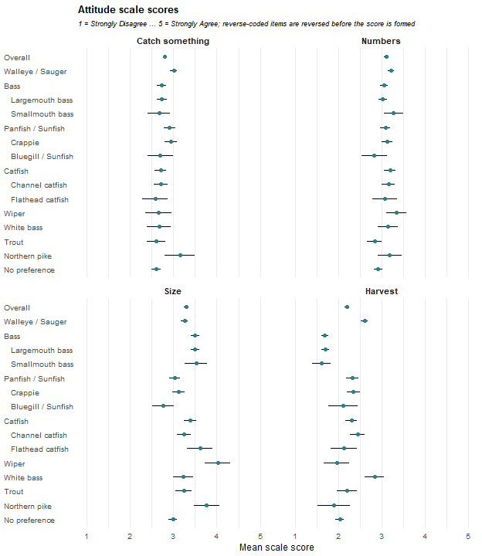

Gender
20% of anglers who answered are female. The share is above the overall among No preference anglers (32%) and below it among Wiper anglers (5%); no other group separates. Group differences elsewhere in this report are therefore partly demographic as well as behavioral.
What is your gender? Cells are the weighted percentage of the row group giving that response, with a 95 percent confidence interval. N is the raw unweighted number of respondents in the row group who answered the question. These results were weighted. Please consult the survey methodology for details. Percentages are weighted, as they are throughout this report.
Preferred species | Male | Female | N
Overall | 80.5 ± 2.06 | 19.5 ± 2.06 | 1,801
Walleye / Sauger | 82.8 ± 3.77 | 17.2 ± 3.77 | 479
Bass | 85.3 ± 4.16 | 14.7 ± 4.16 | 336
Largemouth bass | 84.9 ± 4.46 | 15.1 ± 4.46 | 299
Smallmouth bass | 88.2 ± 11.36 | 11.8 ± 11.36 | 37
Panfish / Sunfish | 80.3 ± 5.87 | 19.7 ± 5.87 | 220
Crappie | 82.2 ± 6.44 | 17.8 ± 6.44 | 170
Bluegill / Sunfish | 69.6 ± 15.88 | 30.4 ± 15.88 | 40
Catfish | 83.3 ± 5.67 | 16.7 ± 5.67 | 210
Channel catfish | 81.5 ± 7.35 | 18.5 ± 7.35 | 136
Flathead catfish | 88.8 ± 9.77 | 11.2 ± 9.77 | 49
Wiper | 95.0 ± 8.08 | 5.0 ± 8.08 | 34
White bass | 64.6 ± 18.36 | 35.4 ± 18.36 | 35
Trout | 84.5 ± 8.89 | 15.5 ± 8.89 | 83
Northern pike | 89.2 ± 11.85 | 10.8 ± 11.85 | 31
No preference | 68.5 ± 5.74 | 31.5 ± 5.74 | 315

Age
The weighted mean age is 46 years. Walleye / Sauger and Panfish / Sunfish anglers are older than the overall (both about 51), while Bass (42), Smallmouth bass (38) and Wiper (39) anglers are younger. The age gradient is worth holding alongside the effort and attitude differences above when deciding whether a group contrast reflects the species or the cohort that pursues it.
Respondent age group. Cells are the weighted percentage of the row group giving that response, with a 95 percent confidence interval. N is the raw unweighted number of respondents in the row group who answered the question. The final column is the weighted mean age in years, taken from the reported age rather than from the bands, and computed on the same respondents as the percentages. These results were weighted. Please consult the survey methodology for details. Percentages and the mean are weighted, as they are throughout this report.
Preferred species | 16-24 | 25-34 | 35-44 | 45-54 | 55-64 | 65 and older | Mean age ± CI | N
Overall | 11.9 ± 1.69 | 17.7 ± 1.99 | 20.2 ± 2.09 | 18.4 ± 2.02 | 13.8 ± 1.80 | 18.0 ± 2.00 | 46.0 ± 0.88 | 1,777
Walleye / Sauger | 4.1 ± 1.99 | 12.4 ± 3.31 | 21.4 ± 4.11 | 20.1 ± 4.02 | 18.7 ± 3.91 | 23.3 ± 4.24 | 50.7 ± 1.57 | 474
Bass | 15.2 ± 4.25 | 21.4 ± 4.86 | 22.0 ± 4.91 | 19.2 ± 4.66 | 10.9 ± 3.69 | 11.3 ± 3.74 | 42.3 ± 1.85 | 331
Largemouth bass | 13.2 ± 4.26 | 21.7 ± 5.18 | 22.9 ± 5.28 | 19.8 ± 5.01 | 10.8 ± 3.89 | 11.6 ± 4.03 | 42.8 ± 1.94 | 294
Smallmouth bass | 29.5 ± 16.06 | 19.4 ± 13.94 | 15.4 ± 12.70 | 15.1 ± 12.62 | 12.1 ± 11.50 | 8.4 ± 9.79 | 38.3 ± 5.85 | 37
Panfish / Sunfish | 4.5 ± 3.08 | 17.9 ± 5.71 | 13.2 ± 5.05 | 23.3 ± 6.30 | 17.3 ± 5.64 | 23.8 ± 6.35 | 50.7 ± 2.46 | 216
Crappie | 3.3 ± 3.04 | 20.5 ± 6.89 | 14.8 ± 6.06 | 20.2 ± 6.85 | 18.8 ± 6.66 | 22.4 ± 7.11 | 50.1 ± 2.82 | 166
Bluegill / Sunfish | 10.5 ± 10.60 | 10.8 ± 10.72 | 6.4 ± 8.47 | 33.1 ± 16.25 | 7.6 ± 9.15 | 31.5 ± 16.04 | 52.1 ± 6.03 | 40
Catfish | 13.9 ± 5.28 | 14.2 ± 5.34 | 22.7 ± 6.40 | 14.3 ± 5.35 | 16.5 ± 5.68 | 18.4 ± 5.93 | 46.4 ± 2.60 | 207
Channel catfish | 9.5 ± 5.60 | 12.1 ± 6.23 | 23.2 ± 8.06 | 11.5 ± 6.09 | 19.0 ± 7.49 | 24.7 ± 8.25 | 49.6 ± 3.26 | 133
Flathead catfish | 17.5 ± 11.80 | 14.4 ± 10.90 | 23.4 ± 13.14 | 22.5 ± 12.95 | 12.1 ± 10.11 | 10.1 ± 9.33 | 43.3 ± 4.90 | 49
Wiper | 8.9 ± 10.58 | 41.6 ± 18.37 | 9.3 ± 10.85 | 25.5 ± 16.25 | 5.3 ± 8.31 | 9.5 ± 10.91 | 39.0 ± 5.32 | 34
White bass | 13.4 ± 13.07 | 26.3 ± 16.90 | 8.3 ± 10.61 | 22.1 ± 15.93 | 11.3 ± 12.15 | 18.6 ± 14.93 | 43.9 ± 7.09 | 35
Trout | 12.4 ± 8.21 | 22.5 ± 10.38 | 13.1 ± 8.38 | 11.5 ± 7.93 | 10.2 ± 7.54 | 30.3 ± 11.43 | 48.7 ± 4.74 | 81
Northern pike | 27.5 ± 17.31 | 7.9 ± 10.48 | 25.2 ± 16.85 | 16.3 ± 14.31 | 15.9 ± 14.19 | 7.2 ± 10.03 | 40.7 ± 6.48 | 30
No preference | 18.3 ± 4.80 | 15.6 ± 4.50 | 22.2 ± 5.16 | 16.7 ± 4.63 | 10.6 ± 3.81 | 16.6 ± 4.62 | 44.0 ± 2.14 | 312

Chapter 4: Satisfaction
Managers usually want to know how satisfied anglers are, but one satisfaction score does not say what is behind it. The survey therefore asks about satisfaction in several ways, and this chapter is organized around what each way can tell apart. One item (A9) asks about the season as a whole. Another (D4a) asks about success at catching the angler’s preferred fish. Four more (D4i to D4l) form a two-by-two: satisfaction with the size or the number of the preferred fish, for the fish the angler catches or the fish the angler is allowed to harvest. The pairs are there to answer two questions. Is an unhappy group short of large fish or of many fish? And is the complaint about what the water produces or about what the rules let anglers keep? The chapter reports the six items together by preferred group, then compares size with numbers within each angler, first for the catch and then for the harvest, and finally compares what each angler catches with what the same angler is allowed to keep. As in Chapter 3, a group is described as different from the overall only when its interval lies entirely outside the Overall interval. A within-angler difference is described only when the interval around that difference excludes zero.
The survey measures satisfaction in two places that this report has so far kept apart. A9 asks how satisfied the angler was with fishing in Nebraska during 2025 and is reported in Chapter 3. Five items in the D4 battery ask about the one type of fish the angler prefers to fish for and are reported one at a time in Chapter 2. This chapter puts all six in one place, pointing the same direction, across the same preferred groups. No cell is computed differently here: the same summary functions, the same universe, and the same row set are used, so a value in this chapter and its counterpart in Chapter 2 or 3 are the same number.
A9 appears here as 6 minus the recorded response, so that every item in this chapter runs the same way and a higher score is always more satisfied. Chapter 3 reports A9 on its recorded scale, where 1 is Very satisfied. The two are the same estimate with the same confidence interval: the overall 2.3 plus or minus 0.06 in Chapter 3 is 3.7 plus or minus 0.06 here.
Rows are the preferred groups from Chapter 1, with individual species indented beneath the family group that contains them. Family rows include the respondents in their species rows, so rows overlap and must not be totalled.

The satisfaction items
The six items are listed below with the short names used in the rest of the chapter. Each is scored so that a higher mean means a more satisfied angler.
The six items, with the question text as it appears in the instrument, the short name used in the tables that follow, and the chapter that reports the item in full. N is the raw unweighted number of respondents in the analysis sample who answered the item; the mean is weighted, with a 95 percent confidence interval. These results were weighted. Please consult the survey methodology for details.
Item | Question text | Short name | Also in | N | Overall mean ± CI
A9 | How satisfied were you with your fishing experiences in Nebraska during 2025? | Season overall | Chapter 3 | 1,871 | 3.7 ± 0.06
D4a | I am happy with my success fishing for my preferred fish. | Success | Chapter 2 | 1,555 | 3.2 ± 0.06
D4i | I am satisfied with the size of my preferred fish that I catch in Nebraska. | Size caught | Chapter 2 | 1,533 | 3.3 ± 0.05
D4j | I am satisfied with the size of my preferred fish that I am allowed to harvest in Nebraska. | Size harvestable | Chapter 2 | 1,524 | 3.5 ± 0.05
D4k | I am satisfied with the number of my preferred fish that I catch in Nebraska. | Number caught | Chapter 2 | 1,533 | 3.2 ± 0.06
D4l | I am satisfied with the number of my preferred fish that I am allowed to harvest in Nebraska. | Number harvestable | Chapter 2 | 1,525 | 3.5 ± 0.05
Anglers rate the season as a whole highest (3.7) and their preferred fish lower. Success (3.2) and the number caught (3.2) are the lowest of the five preferred-fish items, and their intervals overlap. The season item is worded differently from the D4 items, so the distance between it and the rest is only a rough guide. The four size and number items share their wording, and among those the comparison is cleaner. Anglers rate what the rules allow them to keep above what they catch, for size (3.5 harvestable against 3.3 caught) and for number (3.5 against 3.2), and the intervals do not overlap in either pair. On average, then, the harvest side draws less complaint than the catch side.

Satisfaction by preferred group
The table sets the six items side by side for every preferred group. Higher is more satisfied on every item.
All six items across the preferred groups. Cells are the weighted mean for the row group with a 95 percent confidence interval, followed by the raw unweighted number of respondents contributing to that cell. Rows are the preferred groups from Chapter 1, with individual species indented beneath the family group that contains them. Family rows include the respondents in their species rows, so rows overlap and must not be totalled. These results were weighted. Please consult the survey methodology for details.
Preferred species | Season overall | Success | Size caught | Size harvestable | Number caught | Number harvestable
Overall | 3.7 ± 0.06 (1,871) | 3.2 ± 0.06 (1,555) | 3.3 ± 0.05 (1,533) | 3.5 ± 0.05 (1,524) | 3.2 ± 0.06 (1,533) | 3.5 ± 0.05 (1,525)
Walleye / Sauger | 3.5 ± 0.11 (486) | 2.8 ± 0.10 (468) | 3.2 ± 0.09 (464) | 3.5 ± 0.08 (464) | 3.0 ± 0.10 (468) | 3.5 ± 0.08 (463)
Bass | 3.7 ± 0.12 (353) | 3.2 ± 0.13 (341) | 3.1 ± 0.11 (336) | 3.5 ± 0.10 (333) | 3.2 ± 0.12 (334) | 3.5 ± 0.09 (331)
Largemouth bass | 3.8 ± 0.12 (312) | 3.2 ± 0.13 (302) | 3.0 ± 0.12 (298) | 3.5 ± 0.10 (296) | 3.2 ± 0.12 (297) | 3.5 ± 0.10 (294)
Smallmouth bass | 3.7 ± 0.34 (41) | 3.1 ± 0.38 (39) | 3.5 ± 0.29 (38) | 3.7 ± 0.23 (37) | 3.1 ± 0.39 (37) | 3.7 ± 0.23 (37)
Panfish / Sunfish | 3.8 ± 0.17 (232) | 3.2 ± 0.16 (226) | 3.2 ± 0.15 (223) | 3.6 ± 0.11 (222) | 3.3 ± 0.15 (223) | 3.7 ± 0.13 (223)
Crappie | 3.7 ± 0.19 (177) | 3.2 ± 0.17 (174) | 3.1 ± 0.17 (171) | 3.6 ± 0.12 (172) | 3.3 ± 0.16 (172) | 3.7 ± 0.14 (172)
Bluegill / Sunfish | 4.2 ± 0.38 (43) | 3.3 ± 0.44 (40) | 3.5 ± 0.33 (40) | 3.9 ± 0.28 (38) | 3.6 ± 0.41 (39) | 3.9 ± 0.30 (39)
Catfish | 3.8 ± 0.16 (220) | 3.3 ± 0.16 (220) | 3.4 ± 0.14 (219) | 3.5 ± 0.12 (217) | 3.2 ± 0.16 (219) | 3.5 ± 0.12 (218)
Channel catfish | 3.9 ± 0.19 (146) | 3.6 ± 0.18 (146) | 3.5 ± 0.18 (145) | 3.6 ± 0.13 (146) | 3.4 ± 0.18 (146) | 3.6 ± 0.14 (146)
Flathead catfish | 3.7 ± 0.34 (47) | 3.0 ± 0.37 (49) | 3.4 ± 0.29 (48) | 3.4 ± 0.31 (47) | 2.8 ± 0.38 (48) | 3.4 ± 0.28 (48)
Wiper | 4.3 ± 0.35 (35) | 3.2 ± 0.42 (35) | 4.0 ± 0.35 (33) | 3.3 ± 0.32 (33) | 3.4 ± 0.35 (33) | 3.2 ± 0.38 (33)
White bass | 4.1 ± 0.35 (39) | 3.7 ± 0.42 (38) | 3.6 ± 0.34 (38) | 3.8 ± 0.30 (38) | 3.4 ± 0.38 (38) | 3.7 ± 0.32 (38)
Trout | 4.2 ± 0.21 (89) | 3.6 ± 0.23 (87) | 3.4 ± 0.18 (85) | 3.6 ± 0.22 (81) | 3.4 ± 0.22 (83) | 3.5 ± 0.23 (83)
Northern pike | 3.5 ± 0.45 (32) | 3.2 ± 0.45 (31) | 3.0 ± 0.39 (31) | 2.9 ± 0.42 (31) | 3.2 ± 0.50 (31) | 3.2 ± 0.42 (31)
No preference | 3.8 ± 0.13 (325) | 3.4 ± 0.25 (50) | 3.2 ± 0.27 (48) | 3.2 ± 0.24 (49) | 3.3 ± 0.27 (49) | 3.5 ± 0.21 (49)
Walleye / Sauger anglers are the only group below the overall on the season (3.5 against 3.7) and on success (2.8 against 3.2). They do not separate from the overall on any of the four size and number items, so this screen cannot place the shortfall in one of them. The next section looks at it directly. On the positive side, Wiper (4.3), Bluegill / Sunfish (4.2) and Trout (4.2) anglers rate the season above the overall. Trout (3.6), Channel catfish (3.6) and White bass (3.7) anglers are above it on success, and Channel catfish anglers are also above on the number caught (3.4). Wiper anglers alone are above on the size caught (4.0).
The remaining separations are specific to one item. Bass anglers, and Largemouth bass anglers in particular, are below the overall on the size caught (3.1 and 3.0 against 3.3). Chapter 3 shows the same anglers above the overall on the size-of-fish attitude scale, so this is a group that cares about size and is less satisfied with the size it catches. On the size allowed to harvest, Northern pike (2.9) and No preference anglers (3.2) are below the overall (3.5), and Bluegill / Sunfish anglers are above it (3.9). Panfish / Sunfish (3.7) and Bluegill / Sunfish (3.9) anglers are above the overall on the number allowed. Most cells have no flag at all. That does not show those groups are typical, because the smaller groups have wide intervals and a real difference could sit inside one.

Size and numbers: the fish anglers catch
Each angler answered one item on the size of the preferred fish caught and one on the number caught, so the two answers can be compared within the angler. A positive difference means the angler is happier with size than with numbers.
D4i and D4k ask the same question about the same fish, one about the size caught and one about the number caught, so the two can be compared within an angler rather than across anglers. Both mean columns and the difference are computed on the same respondents, those who answered both items, so the difference is a paired comparison and equals the difference of the two means shown. Intervals are 95 percent and are built exactly as every other mean interval in this report. They are not adjusted for the number of groups compared. Rows are the preferred groups from Chapter 1, with individual species indented beneath the family group that contains them. Family rows include the respondents in their species rows, so rows overlap and must not be totalled.
Preferred species | Size caught | Number caught | Difference ± CI | N
Overall | 3.3 ± 0.05 | 3.2 ± 0.06 | 0.07 ± 0.06 | 1,521
Walleye / Sauger | 3.2 ± 0.09 | 3.0 ± 0.11 | 0.16 ± 0.10 | 464
Bass | 3.1 ± 0.11 | 3.2 ± 0.12 | -0.12 ± 0.11 | 332
Largemouth bass | 3.0 ± 0.12 | 3.2 ± 0.12 | -0.18 ± 0.12 | 296
Smallmouth bass | 3.5 ± 0.31 | 3.1 ± 0.39 | 0.32 ± 0.33 | 36
Panfish / Sunfish | 3.2 ± 0.15 | 3.3 ± 0.15 | -0.10 ± 0.15 | 221
Crappie | 3.1 ± 0.17 | 3.3 ± 0.16 | -0.12 ± 0.16 | 170
Bluegill / Sunfish | 3.5 ± 0.34 | 3.6 ± 0.41 | -0.09 ± 0.40 | 39
Catfish | 3.4 ± 0.14 | 3.2 ± 0.16 | 0.21 ± 0.14 | 218
Channel catfish | 3.5 ± 0.18 | 3.4 ± 0.18 | 0.03 ± 0.15 | 145
Flathead catfish | 3.4 ± 0.29 | 2.8 ± 0.38 | 0.57 ± 0.32 | 48
Wiper | 4.0 ± 0.35 | 3.4 ± 0.35 | 0.55 ± 0.29 | 33
White bass | 3.6 ± 0.34 | 3.4 ± 0.38 | 0.23 ± 0.38 | 38
Trout | 3.4 ± 0.19 | 3.4 ± 0.22 | 0.07 ± 0.24 | 81
Northern pike | 3.0 ± 0.39 | 3.2 ± 0.50 | -0.25 ± 0.30 | 31
No preference | 3.2 ± 0.27 | 3.3 ± 0.28 | -0.09 ± 0.24 | 48
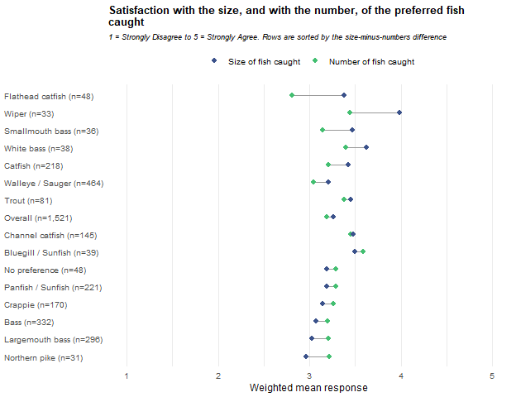
Reading the difference column against its own interval, and without any adjustment for the number of groups compared: the interval lies above zero, with size rated higher than numbers, for Flathead catfish, Wiper, Catfish, Walleye / Sauger; it lies below zero, with numbers rated higher than size, for Largemouth bass, Bass. For the remaining 9 groups the interval includes zero. Overall the difference is 0.07 ± 0.06.
Across all anglers the difference is small (0.07 ± 0.06). The interval only just clears zero, so the average angler is about equally content with size and numbers. The groups are where the separation shows up.
Four groups rate size above numbers: Wiper (0.55), Flathead catfish (0.57), Catfish as a family (0.21) and Walleye / Sauger (0.16). For these anglers the weaker side of the catch is how many fish they get, not how large they are. That agrees with Chapter 2, where Flathead catfish anglers had the lowest satisfaction with the number caught of any group, and with Chapter 3, where Walleye / Sauger anglers score above the overall on the numbers attitude. It also gives the walleye result in the previous section somewhere to land: the season and success ratings are low, and among the catch items it is the number of fish that trails. Two groups go the other way, Bass (-0.12) and Largemouth bass (-0.18). Bass anglers are comparatively content with how many fish they catch and less so with how large, which matches their size-focused attitudes.
The Wiper and Flathead catfish differences are the largest, but they rest on 33 and 48 respondents and their intervals are about ± 0.29 and ± 0.32. The direction is more dependable than the size. Channel catfish anglers, the larger part of the catfish family, are not flagged (0.03 ± 0.15), so the family result leans on Flathead catfish. None of these intervals is adjusted for the number of groups compared.

Size and numbers: the fish anglers may harvest
The same comparison follows for the fish an angler is allowed to keep. These items describe the rules rather than the catch, so a difference here says something about regulation and not about the fishery.
D4j and D4l repeat the comparison for the fish an angler is allowed to keep rather than the fish caught. Both mean columns and the difference are computed on the same respondents, those who answered both items, so the difference is a paired comparison and equals the difference of the two means shown. Intervals are 95 percent and are built exactly as every other mean interval in this report. They are not adjusted for the number of groups compared. Rows are the preferred groups from Chapter 1, with individual species indented beneath the family group that contains them. Family rows include the respondents in their species rows, so rows overlap and must not be totalled.
Preferred species | Size harvestable | Number harvestable | Difference ± CI | N
Overall | 3.5 ± 0.05 | 3.5 ± 0.05 | 0.00 ± 0.04 | 1,518
Walleye / Sauger | 3.5 ± 0.08 | 3.5 ± 0.08 | 0.01 ± 0.08 | 462
Bass | 3.5 ± 0.10 | 3.5 ± 0.09 | -0.02 ± 0.08 | 330
Largemouth bass | 3.5 ± 0.10 | 3.5 ± 0.10 | -0.02 ± 0.09 | 294
Smallmouth bass | 3.7 ± 0.23 | 3.7 ± 0.24 | -0.03 ± 0.12 | 36
Panfish / Sunfish | 3.6 ± 0.11 | 3.7 ± 0.13 | -0.06 ± 0.12 | 221
Crappie | 3.6 ± 0.12 | 3.7 ± 0.14 | -0.09 ± 0.14 | 171
Bluegill / Sunfish | 3.9 ± 0.28 | 3.9 ± 0.30 | 0.03 ± 0.24 | 38
Catfish | 3.5 ± 0.12 | 3.5 ± 0.12 | -0.04 ± 0.11 | 217
Channel catfish | 3.6 ± 0.13 | 3.6 ± 0.14 | -0.04 ± 0.14 | 146
Flathead catfish | 3.4 ± 0.31 | 3.4 ± 0.28 | 0.04 ± 0.22 | 47
Wiper | 3.3 ± 0.32 | 3.2 ± 0.38 | 0.11 ± 0.35 | 33
White bass | 3.8 ± 0.30 | 3.7 ± 0.32 | 0.06 ± 0.17 | 38
Trout | 3.6 ± 0.22 | 3.5 ± 0.23 | 0.05 ± 0.22 | 81
Northern pike | 2.9 ± 0.42 | 3.2 ± 0.42 | -0.20 ± 0.25 | 31
No preference | 3.2 ± 0.24 | 3.5 ± 0.21 | -0.25 ± 0.24 | 49
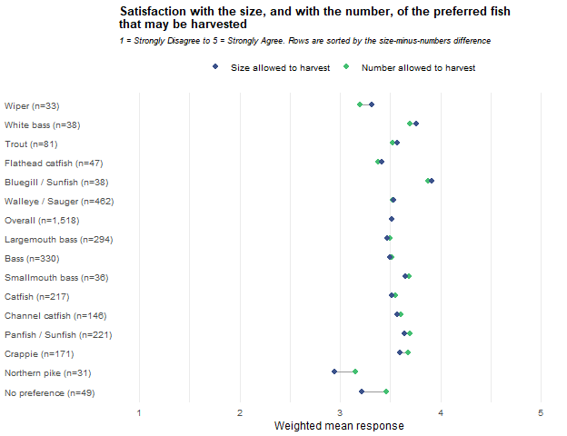
On the same reading: the interval lies above zero for none, and below zero for No preference. For the remaining 14 groups the interval includes zero. Overall the difference is 0.00 ± 0.04.
The overall difference is 0.00 ± 0.04, so the average angler is as satisfied with the size allowed as with the number allowed. One group is flagged, No preference (-0.25 ± 0.24, 49 respondents), who are happier with the number allowed. With 15 groups compared and no adjustment, one flagged group is about what chance alone would produce, so this result should carry little weight.
The contrast with the previous section is the useful part. The groups that leaned toward size or toward numbers on the catch (walleye, catfish, Wiper and bass anglers) show no lean on the harvest items. Their differences are about what the fishery delivers, not about how the rules balance size against number. For management that separates the two readings: the catch differences look like a signal about fishery performance, while satisfaction with the harvest rules is fairly even across groups on this comparison.
Even fairness between size and number does not mean every group is equally content with the rules. The next section sets what anglers catch against what they may keep, and there one group, Wiper, stands apart from the rest.

Caught versus allowed
This section compares each angler’s rating of the fish caught with the same angler’s rating of the fish that may be harvested, once for size and once for number. A negative difference means the angler is happier with what the rules allow than with what the water gives.

Size
D4i and D4j ask about the size of the preferred fish, one for the fish caught and one for the fish that may be harvested. The difference is size caught minus size harvestable. Both mean columns and the difference are computed on the same respondents, those who answered both items, so the difference is a paired comparison and equals the difference of the two means shown. Intervals are 95 percent and are built exactly as every other mean interval in this report. They are not adjusted for the number of groups compared. Rows are the preferred groups from Chapter 1, with individual species indented beneath the family group that contains them. Family rows include the respondents in their species rows, so rows overlap and must not be totalled.
Preferred species | Size caught | Size harvestable | Difference ± CI | N
Overall | 3.3 ± 0.05 | 3.5 ± 0.05 | -0.25 ± 0.05 | 1,514
Walleye / Sauger | 3.2 ± 0.09 | 3.5 ± 0.08 | -0.32 ± 0.09 | 460
Bass | 3.1 ± 0.11 | 3.5 ± 0.10 | -0.42 ± 0.11 | 331
Largemouth bass | 3.0 ± 0.12 | 3.5 ± 0.10 | -0.45 ± 0.12 | 295
Smallmouth bass | 3.5 ± 0.31 | 3.7 ± 0.23 | -0.20 ± 0.36 | 36
Panfish / Sunfish | 3.2 ± 0.15 | 3.6 ± 0.11 | -0.45 ± 0.14 | 221
Crappie | 3.1 ± 0.17 | 3.6 ± 0.12 | -0.45 ± 0.16 | 171
Bluegill / Sunfish | 3.5 ± 0.35 | 3.9 ± 0.28 | -0.42 ± 0.29 | 38
Catfish | 3.4 ± 0.14 | 3.5 ± 0.12 | -0.09 ± 0.13 | 216
Channel catfish | 3.5 ± 0.18 | 3.6 ± 0.13 | -0.10 ± 0.14 | 145
Flathead catfish | 3.4 ± 0.29 | 3.4 ± 0.31 | -0.04 ± 0.35 | 47
Wiper | 4.0 ± 0.35 | 3.3 ± 0.32 | 0.67 ± 0.40 | 33
White bass | 3.6 ± 0.34 | 3.8 ± 0.30 | -0.13 ± 0.19 | 38
Trout | 3.4 ± 0.19 | 3.6 ± 0.22 | -0.12 ± 0.18 | 80
Northern pike | 3.0 ± 0.39 | 2.9 ± 0.42 | 0.02 ± 0.44 | 31
No preference | 3.2 ± 0.27 | 3.2 ± 0.24 | -0.03 ± 0.17 | 48
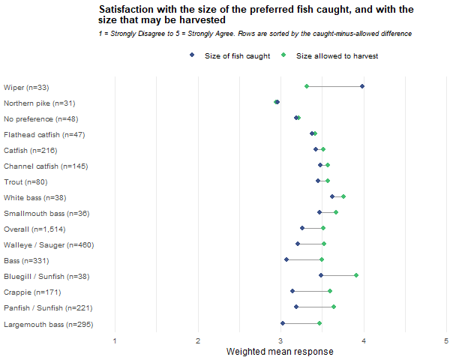

Number
D4k and D4l repeat the comparison for the number of fish. The difference is number caught minus number harvestable. Both mean columns and the difference are computed on the same respondents, those who answered both items, so the difference is a paired comparison and equals the difference of the two means shown. Intervals are 95 percent and are built exactly as every other mean interval in this report. They are not adjusted for the number of groups compared. Rows are the preferred groups from Chapter 1, with individual species indented beneath the family group that contains them. Family rows include the respondents in their species rows, so rows overlap and must not be totalled.
Preferred species | Number caught | Number harvestable | Difference ± CI | N
Overall | 3.2 ± 0.06 | 3.5 ± 0.05 | -0.33 ± 0.05 | 1,521
Walleye / Sauger | 3.0 ± 0.11 | 3.5 ± 0.08 | -0.47 ± 0.10 | 463
Bass | 3.2 ± 0.12 | 3.5 ± 0.09 | -0.32 ± 0.11 | 330
Largemouth bass | 3.2 ± 0.12 | 3.5 ± 0.10 | -0.29 ± 0.11 | 294
Smallmouth bass | 3.1 ± 0.39 | 3.7 ± 0.24 | -0.57 ± 0.36 | 36
Panfish / Sunfish | 3.3 ± 0.15 | 3.7 ± 0.13 | -0.40 ± 0.14 | 222
Crappie | 3.3 ± 0.16 | 3.7 ± 0.14 | -0.41 ± 0.15 | 171
Bluegill / Sunfish | 3.6 ± 0.41 | 3.9 ± 0.30 | -0.30 ± 0.38 | 39
Catfish | 3.2 ± 0.16 | 3.5 ± 0.12 | -0.34 ± 0.15 | 217
Channel catfish | 3.4 ± 0.18 | 3.6 ± 0.14 | -0.16 ± 0.15 | 146
Flathead catfish | 2.8 ± 0.38 | 3.4 ± 0.28 | -0.58 ± 0.35 | 47
Wiper | 3.4 ± 0.35 | 3.2 ± 0.38 | 0.24 ± 0.45 | 33
White bass | 3.4 ± 0.38 | 3.7 ± 0.32 | -0.30 ± 0.23 | 38
Trout | 3.4 ± 0.22 | 3.5 ± 0.23 | -0.11 ± 0.24 | 83
Northern pike | 3.2 ± 0.50 | 3.2 ± 0.42 | 0.06 ± 0.56 | 31
No preference | 3.3 ± 0.27 | 3.5 ± 0.21 | -0.20 ± 0.18 | 49
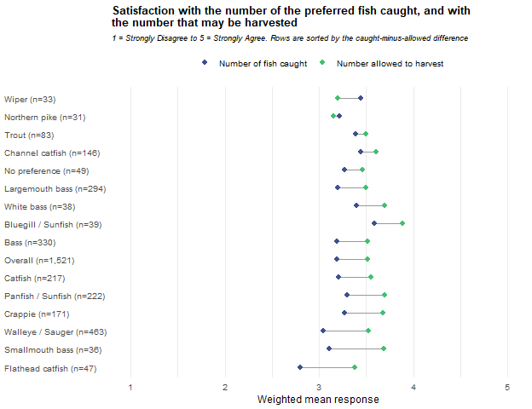
Across all anglers the allowed side is rated above the catch side, for size (-0.25 ± 0.05) and for number (-0.33 ± 0.05). The pattern is broad rather than driven by a few groups. On size, 6 groups are flagged (Walleye / Sauger, Bass, Largemouth bass, Panfish / Sunfish, Crappie and Bluegill / Sunfish) and every one goes the same way. On number, 11 of the 15 groups are flagged, and again none goes the other way. For most of the survey the harvest rules draw less complaint than the catch does, which is the reading that has run through this chapter: where groups are less satisfied, the shortfall is more often in the catch than in the harvest rules.
The size of the gap depends on the group in a way that matches the catch results above. Walleye / Sauger anglers have a larger gap on number (-0.47) than on size (-0.32), which fits their shortfall in numbers caught. Bass anglers show the reverse, a larger gap on size (-0.42) than on number (-0.32), which fits their lower satisfaction with the size they catch. Catfish anglers are not flagged on size (-0.09 ± 0.13) but are on number (-0.34 ± 0.15), so their gap is a numbers gap only.
Wiper anglers are the exception, and only on size. They rate the size they catch above the size they may keep (0.67 ± 0.40, 33 respondents), and they are the only group with a positive size difference. On number they are not separated from zero (0.24 ± 0.45). The result sits comfortably with the rest of the Wiper profile. They are the group most satisfied with the size of fish they catch (4.0), the most supportive of regulations to increase size and the most willing to harvest fewer fish for larger ones (both in Chapter 2). Their rating of the size they may keep is lower, at 3.3. What falls short for this group is the size that can be taken home, which points toward length limits more than the fishery. Treat that as a lead to confirm, for the reasons given below.
Two cautions apply. The Wiper estimate rests on 33 respondents, and although its interval stays above zero (the lower end is 0.27), the size of the gap is less certain than its direction. And these are 30 comparisons (15 groups, two items) with no adjustment, so a handful of flagged groups could appear by chance alone. The number flagged here is far larger than that, which is why the overall pattern can be trusted, and Wiper stands out because every other flagged group points the other way.

Chapter 5: Angler Type Profiles
Chapters 1 to 4 divided every question in the survey by the fish anglers prefer to catch. That is a natural cut for species management, but a species column is a mixture of people: some anglers who prefer walleye keep fish for the freezer, while others fish for the challenge and release what they catch. This chapter turns the lens around and groups anglers by what they want from fishing rather than by what they fish for, using the eleven attitude, motivation and regulation scale scores reported in Chapter 3.
The chapter answers two questions. First, what distinct angler types are there among anglers who state a species preference? The model described below finds 6 profiles, and each is described with the scale scores that set it apart and a sketch of the angler it depicts. Second, how are those types spread across the preferred-species groups? The profiles-by-species table and the family-group cards at the end of the chapter answer that, and the short answer is that every family group contains all 6 types in proportions that vary from group to group, more for some than for others. Managing for a species therefore means serving a mix of angler types, and the cards spell out what that mix looks like group by group.
The profiles are built from stated attitudes and motivations, not from observed behavior, and the labels and personas attached to them are interpretive summaries rather than measured categories. The model and its diagnostics come first, then the profile descriptions, and then the crosstabs by preferred species. This is also the only chapter of the report that withholds table rows: a preferred-species row is dropped from a table when its effective sample size falls below 30.
This chapter groups anglers into profiles using a latent profile analysis of eleven scale scores reported in Chapter 3: the four angler-attitude scales, the four motivation scales, and the three regulation scales. One model is fitted to the whole report universe, so the profiles are defined once and are the same in every preferred-species row; the tables below report how each row’s respondents are distributed across them. The model is fitted without the survey weights. Every percentage and mean reported from it is weighted, with intervals built on the Kish effective N and raw unweighted counts displayed, as in Chapters 1 to 4.
1,718 of the 1,915 respondents in this report’s universe (89.7%) answered at least 7 of the eleven scales and were included in the fit. Scales that a fitted respondent left blank are handled within the model rather than imputed. The other 197 respondents are reported as Unassigned rather than dropped. Profiles are numbered 1 to 6 in the order the estimation produced them; the numbers are labels and carry no order.

Choosing the number of profiles
Models with 1 to 6 profiles were fitted under two within-profile variance structures: equal, in which every profile shares one variance per scale, and varying, in which each profile has its own. The equal structure was extended to 8 profiles. The model used in the rest of this chapter is the one with the lowest BIC among models that converged, whose smallest profile holds at least 5 percent of fitted respondents, and whose relative entropy is at least 0.60. That is the 6-profile equal-variance model. BIC is minus twice the log-likelihood plus the number of estimated parameters times the natural log of the number of fitted respondents; lower values indicate better fit. Relative entropy runs from 0 to 1, with 1 meaning every respondent is assigned with certainty. The lowest mean assigned probability is the average membership probability among the respondents assigned to a profile, for the profile where that average is smallest. OpenMx status 0 or 1 indicates the estimation converged. All values in this table are unweighted model quantities.
Variances | Profiles | Parameters | Log-likelihood | BIC | Relative entropy | Smallest profile n (%) | Lowest mean assigned probability | OpenMx status | Eligible
Equal | 1 | 22 | -22,120.2 | 44,404.4 | — | 1,718 (100.0%) | — | 0 | Yes
Equal | 2 | 34 | -21,292.3 | 42,837.9 | 0.707 | 805 (46.9%) | 0.912 | 0 | Yes
Equal | 3 | 46 | -20,881.1 | 42,104.8 | 0.724 | 394 (22.9%) | 0.851 | 0 | Yes
Equal | 4 | 58 | -20,507.0 | 41,446.1 | 0.761 | 303 (17.6%) | 0.853 | 0 | Yes
Equal | 5 | 70 | -20,285.6 | 41,092.5 | 0.750 | 262 (15.3%) | 0.799 | 0 | Yes
Equal | 6 | 82 | -20,179.0 | 40,968.9 | 0.747 | 120 (7.0%) | 0.759 | 0 | Yes (selected)
Equal | 7 | 94 | -20,037.2 | 40,774.7 | 0.766 | 71 (4.1%) | 0.776 | 0 | No: smallest profile below 5%
Equal | 8 | 106 | -19,964.0 | 40,717.5 | 0.769 | 57 (3.3%) | 0.788 | 0 | No: smallest profile below 5%
Varying | 1 | 22 | -22,120.2 | 44,404.4 | — | 1,718 (100.0%) | — | 0 | Yes
Varying | 2 | 45 | -21,223.0 | 42,781.2 | 0.723 | 754 (43.9%) | 0.908 | 0 | Yes
Varying | 3 | 68 | -20,774.8 | 42,056.2 | 0.746 | 436 (25.4%) | 0.867 | 0 | Yes
Varying | 4 | 91 | -20,430.3 | 41,538.5 | 0.771 | 297 (17.3%) | 0.848 | 0 | Yes
Varying | 5 | 114 | -19,229.3 | 39,307.8 | 0.836 | 244 (14.2%) | 0.859 | 6 | No: not converged (status 6)
Varying | 6 | 137 | -18,863.0 | 38,746.6 | 0.822 | 228 (13.3%) | 0.800 | 6 | No: not converged (status 6)
Four models with a lower BIC than the selected model are not eligible. The 7- and 8-profile equal-variance models converged, but their smallest profiles hold 4.1 and 3.3 percent of fitted respondents. BIC is lower at every larger equal-variance model fitted, so the selected model is the largest eligible equal-variance model rather than the point at which BIC stops decreasing. The 5- and 6-profile varying-variance models did not converge (OpenMx status 6). In each, one profile (271 and 277 respondents) contains only respondents at the scale maximum of 5 on the Site-specific regulation scale among those who answered it (267 of 267 and 273 of 273), and that profile’s estimated variance on the scale is effectively zero (5.5e-06 and 3.6e-07).

Assignment certainty
Each fitted respondent is assigned to the profile with the highest estimated membership probability. The table below shows how certain those assignments are, by the number of scales the respondent answered. The values are unweighted model quantities for the 1,718 fitted respondents.
Scales answered (of 11) | Respondents (n) | Mean probability of assigned profile | Assigned with probability below 0.70
11 | 1,373 | 0.839 | 23.5%
10 | 209 | 0.799 | 32.1%
7-9 | 136 | 0.722 | 44.9%

Profile means
The two figures below show the weighted mean of each scale for the respondents assigned to each profile, with 95 percent confidence intervals. These are weighted means of the assigned respondents, not the unweighted means the model estimated for each profile. The first figure places the profiles side by side across the eleven scales.
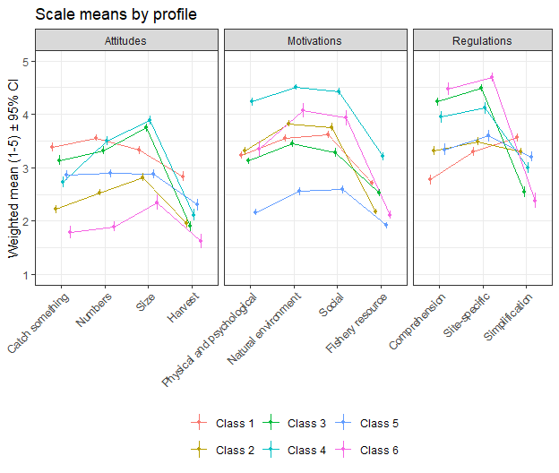
The second figure shows one panel per scale, with the profiles along the horizontal axis and the Overall weighted mean for every respondent who answered that scale as a dashed line.
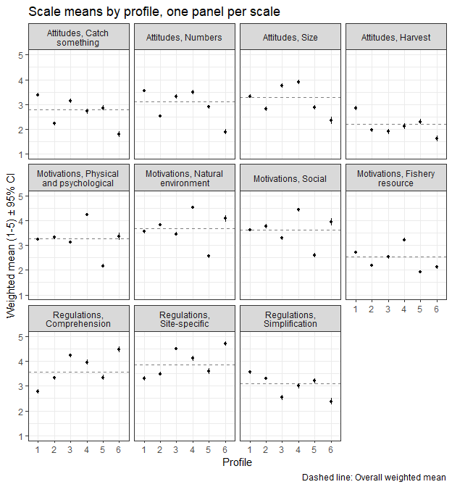

The values behind both figures are below. The Overall column is computed on every respondent in the universe who answered the scale, including Unassigned respondents, and equals the Overall row of the Chapter 3 scale tables. Cells are the weighted mean for the row group with a 95 percent confidence interval, followed by the raw unweighted number of respondents contributing to that cell. These results were weighted. Please consult the survey methodology for details.
 |  |  |  |  |  |  |  | 
Domain | Scale | Overall | Class 1 | Class 2 | Class 3 | Class 4 | Class 5 | Class 6
Attitudes | Catch something | 2.8 ± 0.05 (1,704) | 3.4 ± 0.08 (355) | 2.2 ± 0.07 (344) | 3.1 ± 0.09 (291) | 2.7 ± 0.10 (280) | 2.9 ± 0.09 (307) | 1.8 ± 0.12 (116)
Attitudes | Numbers | 3.1 ± 0.04 (1,670) | 3.6 ± 0.06 (350) | 2.5 ± 0.06 (339) | 3.3 ± 0.08 (286) | 3.5 ± 0.08 (274) | 2.9 ± 0.08 (298) | 1.9 ± 0.10 (116)
Attitudes | Size | 3.3 ± 0.04 (1,695) | 3.3 ± 0.08 (358) | 2.8 ± 0.07 (341) | 3.7 ± 0.08 (286) | 3.9 ± 0.09 (280) | 2.9 ± 0.08 (305) | 2.4 ± 0.14 (117)
Attitudes | Harvest | 2.2 ± 0.05 (1,653) | 2.8 ± 0.09 (347) | 2.0 ± 0.09 (334) | 1.9 ± 0.09 (282) | 2.1 ± 0.11 (267) | 2.3 ± 0.11 (296) | 1.6 ± 0.13 (118)
Motivations | Physical and psychological | 3.3 ± 0.04 (1,712) | 3.2 ± 0.06 (350) | 3.3 ± 0.07 (333) | 3.1 ± 0.06 (281) | 4.2 ± 0.07 (277) | 2.2 ± 0.07 (299) | 3.4 ± 0.14 (111)
Motivations | Natural environment | 3.7 ± 0.04 (1,710) | 3.5 ± 0.07 (343) | 3.8 ± 0.06 (329) | 3.5 ± 0.07 (284) | 4.5 ± 0.06 (281) | 2.6 ± 0.07 (295) | 4.1 ± 0.13 (117)
Motivations | Social | 3.6 ± 0.04 (1,710) | 3.6 ± 0.06 (348) | 3.8 ± 0.08 (332) | 3.3 ± 0.08 (284) | 4.4 ± 0.07 (274) | 2.6 ± 0.08 (293) | 3.9 ± 0.15 (116)
Motivations | Fishery resource | 2.5 ± 0.03 (1,715) | 2.7 ± 0.05 (349) | 2.2 ± 0.05 (326) | 2.5 ± 0.06 (284) | 3.2 ± 0.08 (279) | 1.9 ± 0.06 (295) | 2.1 ± 0.08 (118)
Regulations | Comprehension | 3.6 ± 0.05 (1,680) | 2.8 ± 0.09 (353) | 3.3 ± 0.08 (337) | 4.2 ± 0.08 (281) | 4.0 ± 0.11 (277) | 3.3 ± 0.10 (302) | 4.5 ± 0.11 (117)
Regulations | Site-specific | 3.9 ± 0.05 (1,679) | 3.3 ± 0.08 (350) | 3.5 ± 0.08 (335) | 4.5 ± 0.07 (283) | 4.1 ± 0.10 (282) | 3.6 ± 0.10 (303) | 4.7 ± 0.09 (117)
Regulations | Simplification | 3.1 ± 0.04 (1,666) | 3.6 ± 0.07 (350) | 3.3 ± 0.07 (338) | 2.5 ± 0.10 (278) | 3.0 ± 0.10 (278) | 3.2 ± 0.10 (300) | 2.4 ± 0.14 (113)

Profiles on other survey questions
The table below compares the profiles on other survey questions. Each question keeps the universe it has in Chapter 3, so N differs by row, and the Overall column equals the Overall row of the corresponding Chapter 3 table. Unassigned respondents are counted in Overall only and have no column of their own. The river and stream row counts a respondent who fished the Missouri River, the Platte River, or other streams, rivers, and canals; it combines three Chapter 3 waterbody types and has no single Chapter 3 counterpart. Percentage and mean cells show the weighted value with a 95 percent confidence interval, followed by N. Median cells show the lower limit, the weighted median and the upper limit, followed by N, as in Chapter 3. Satisfaction is scored from 1, Very satisfied, to 5, Very dissatisfied, as in Chapter 3. These results were weighted. Please consult the survey methodology for details.
Measure | Overall | Class 1 | Class 2 | Class 3 | Class 4 | Class 5 | Class 6
Days fished in 2025, mean | 30.2 ± 1.78 (1,834) | 28.6 ± 3.28 (357) | 26.8 ± 3.89 (336) | 35.6 ± 4.57 (286) | 45.4 ± 5.86 (280) | 17.4 ± 3.06 (302) | 21.1 ± 3.99 (120)
Days fished in 2025, median | 16.0/17.0/19.0 (1,834) | 17.0/19.0/22.0 (357) | 10.5/14.0/18.0 (336) | 20.0/24.0/30.0 (286) | 27.0/31.0/36.5 (280) | 6.0/7.0/10.0 (302) | 9.0/13.0/19.0 (120)
Fished at least one tournament, % | 3.0 ± 0.86 (1,908) | 3.4 ± 2.08 (360) | 1.3 ± 1.32 (346) | 4.0 ± 2.49 (291) | 5.3 ± 2.85 (286) | 2.3 ± 1.90 (309) | 0.6 ± 1.52 (120)
Hired a fishing guide, % | 8.1 ± 1.38 (1,891) | 11.6 ± 3.67 (361) | 5.3 ± 2.67 (341) | 13.9 ± 4.43 (287) | 8.1 ± 3.48 (286) | 5.5 ± 2.90 (308) | 4.6 ± 4.12 (120)
Fished from a motorized boat, % | 51.1 ± 2.54 (1,865) | 57.4 ± 5.68 (359) | 49.1 ± 6.00 (336) | 58.4 ± 6.33 (286) | 57.1 ± 6.37 (280) | 43.6 ± 6.35 (302) | 40.6 ± 9.74 (118)
Fished from a kayak or canoe, % | 17.7 ± 1.94 (1,865) | 16.8 ± 4.29 (359) | 20.3 ± 4.83 (336) | 22.5 ± 5.36 (286) | 24.2 ± 5.51 (280) | 8.4 ± 3.56 (302) | 17.4 ± 7.52 (118)
Ice fished, % | 17.7 ± 1.94 (1,865) | 21.2 ± 4.69 (359) | 12.3 ± 3.94 (336) | 20.5 ± 5.18 (286) | 24.3 ± 5.52 (280) | 9.4 ± 3.73 (302) | 18.1 ± 7.65 (118)
Fished the Missouri River, Platte River, or other streams and rivers, % | 36.0 ± 2.44 (1,858) | 37.1 ± 5.56 (357) | 33.9 ± 5.68 (335) | 35.7 ± 6.16 (286) | 47.4 ± 6.46 (277) | 25.4 ± 5.59 (301) | 29.0 ± 9.01 (118)
Fished a water requiring a Park Entry Permit, % | 69.0 ± 2.33 (1,898) | 68.3 ± 5.33 (361) | 68.0 ± 5.53 (345) | 71.2 ± 5.79 (289) | 77.0 ± 5.37 (285) | 55.7 ± 6.32 (307) | 71.4 ± 8.90 (120)
Used private areas to fish or launch, % | 28.6 ± 2.50 (1,553) | 28.2 ± 5.75 (287) | 29.0 ± 5.99 (276) | 35.0 ± 6.53 (249) | 28.7 ± 6.22 (244) | 28.2 ± 6.45 (242) | 27.4 ± 9.62 (99)
Fished outside Nebraska, % | 44.1 ± 2.51 (1,884) | 47.5 ± 5.79 (352) | 41.3 ± 5.87 (342) | 50.2 ± 6.43 (286) | 54.9 ± 6.36 (284) | 28.9 ± 5.76 (307) | 34.3 ± 9.34 (120)
One-way miles to most visited water, median | 30/30/30 (1,877) | 30/30/30 (360) | 30/30/50 (342) | 16/16/30 (288) | 16/30/30 (282) | 16/30/30 (309) | 16/16/16 (117)
Overall fishing satisfaction, mean (1 = Very satisfied, 5 = Very dissatisfied) | 2.3 ± 0.06 (1,871) | 2.6 ± 0.13 (359) | 2.1 ± 0.12 (336) | 2.3 ± 0.14 (287) | 2.2 ± 0.15 (285) | 2.4 ± 0.13 (305) | 1.7 ± 0.19 (118)
Used live-imaging sonar, % | 14.5 ± 1.78 (1,878) | 15.5 ± 4.17 (357) | 12.6 ± 3.96 (339) | 16.1 ± 4.72 (286) | 21.4 ± 5.25 (282) | 7.7 ± 3.40 (307) | 11.4 ± 6.31 (118)
Female, % | 19.5 ± 2.06 (1,801) | 18.2 ± 4.42 (362) | 28.2 ± 5.33 (346) | 12.7 ± 4.24 (291) | 14.5 ± 4.49 (286) | 19.1 ± 4.99 (308) | 28.1 ± 8.92 (118)
Age, mean | 46.0 ± 0.88 (1,777) | 46.9 ± 1.80 (358) | 48.5 ± 1.96 (337) | 44.6 ± 2.05 (292) | 39.2 ± 1.94 (286) | 52.4 ± 2.33 (302) | 48.4 ± 3.10 (117)

The six profiles
The six profiles are listed below with the icon that marks each profile’s column in the tables of this chapter. Shares are weighted percentages of respondents; N is the number of respondents assigned to the profile. Weighted shares and raw counts can rank the profiles differently because respondents carry different weights; Appendix B reports profile sizes as unweighted shares of the respondents fitted.
 | Profile | Label | Share of respondents | N
 | Class 1 | The harvest-minded, keep-it-simple angler | 18.3% | 362
 | Class 2 | The relaxed, catch-optional angler | 16.7% | 347
 | Class 3 | The regulation-savvy catch-and-release sport angler | 15.9% | 292
 | Class 4 | The all-in enthusiast | 18.2% | 286
 | Class 5 | The low-involvement angler | 13.4% | 311
 | Class 6 | The conservation-minded purist | 6.0% | 120
The paragraphs below describe each profile by the scales on which it differs most from the Overall mean. Means are the weighted means in the profile means table; the figure after each mean is its distance from the Overall mean in standard deviations of the Overall weighted distribution (SD). Two scale names need a note: the Fishery resource motivation scale is made up of catch outcomes (competing for prizes, obtaining fish to eat, catching a trophy, the fun of catching), and the Simplification regulation scale measures agreement with uniform statewide regulations. The other regulation scales, Comprehension and Site-specific, are described in the text as comprehension of the rules and support for site-specific rules. Species shares are the row percentages from the profiles-by-preferred-species table at the end of this chapter, with their confidence intervals. The label and the closing picture in each paragraph are an interpretive summary of the eleven scale scores. They are not measured directly, and traits beyond those scales, such as how often or how an angler fishes, are not established by these data.
The second paragraph for each profile compares it with the Overall column on the other survey questions in the table above; the values quoted are from that table, and its confidence intervals show that several of the differences described are small relative to their precision. Where a family group makes up at least 5 percentage points more of a profile than of all assigned respondents, the paragraph names it, unless its row is below the effective-N floor and therefore not shown, because questions that vary by species may partly reflect that mix rather than the profile itself.

Class 1: The harvest-minded, keep-it-simple angler
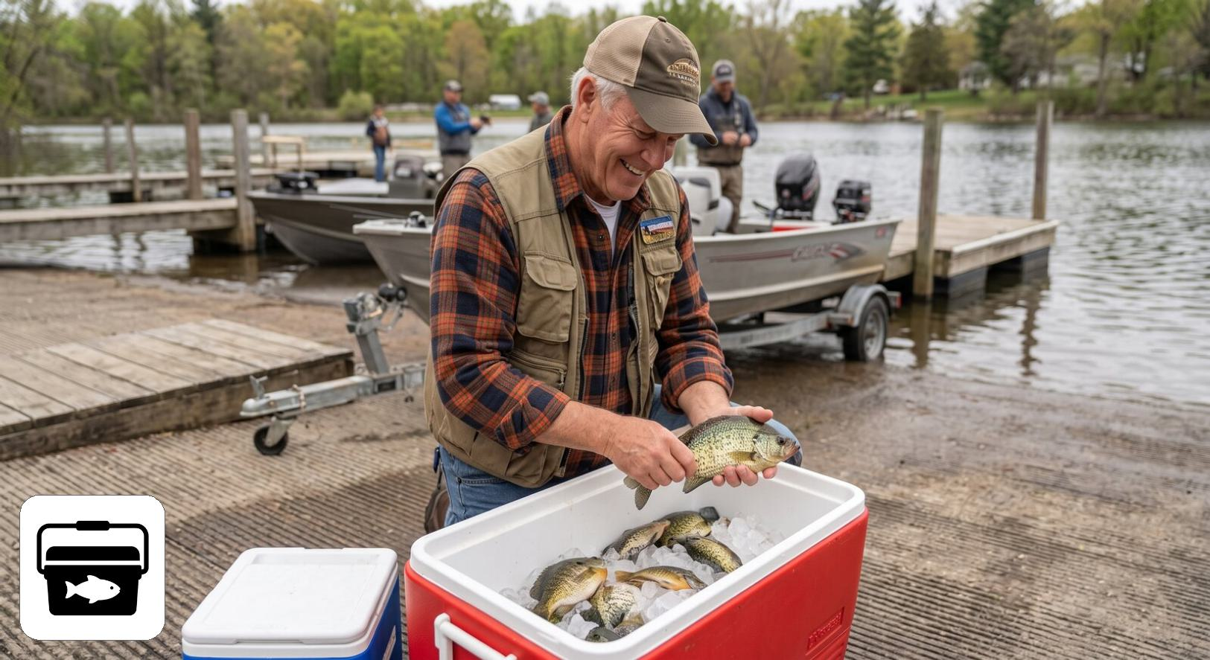
Class 1: The harvest-minded, keep-it-simple angler
Class 1 holds 18.3% of respondents (n = 362). It has the highest harvest score of any profile (2.8, +0.75 SD) and is above average on needing to catch something (3.4) and on catching many fish (3.6). Size matters no more than average (3.3), and its motivations sit near the Overall means. What sets it apart is regulations: it reports the least comprehension of the rules (2.8, -0.87 SD), the least support for site-specific rules (3.3), and the strongest preference for uniform statewide rules (3.6, +0.59 SD). Picture someone who fishes for a meal, measures a trip by what goes in the cooler, and finds a patchwork of lake-specific rules confusing. Class 1 makes up 26.3% ± 4.3 of Walleye / Sauger, 25.2% ± 7.1 of Crappie and 23.0% ± 6.0 of Panfish / Sunfish anglers, against 18.3% overall.
On the other survey questions, Class 1 fishes about as often as anglers overall (mean days 28.6, against 30.2 overall). It is more likely than average to have hired a guide (11.6%, against 8.1% overall), to have ice fished (21.2%, against 17.7% overall) and to have fished from a motorized boat (57.4%, against 51.1% overall). It reports the lowest overall satisfaction of any profile (mean 2.6, against 2.3 overall, where higher means less satisfied). Its species mix leans toward Walleye / Sauger (34.1% of the profile, against 24.3% of all assigned respondents), so differences on questions that vary by species may partly reflect that mix rather than the profile itself.

Class 2: The relaxed, catch-optional angler
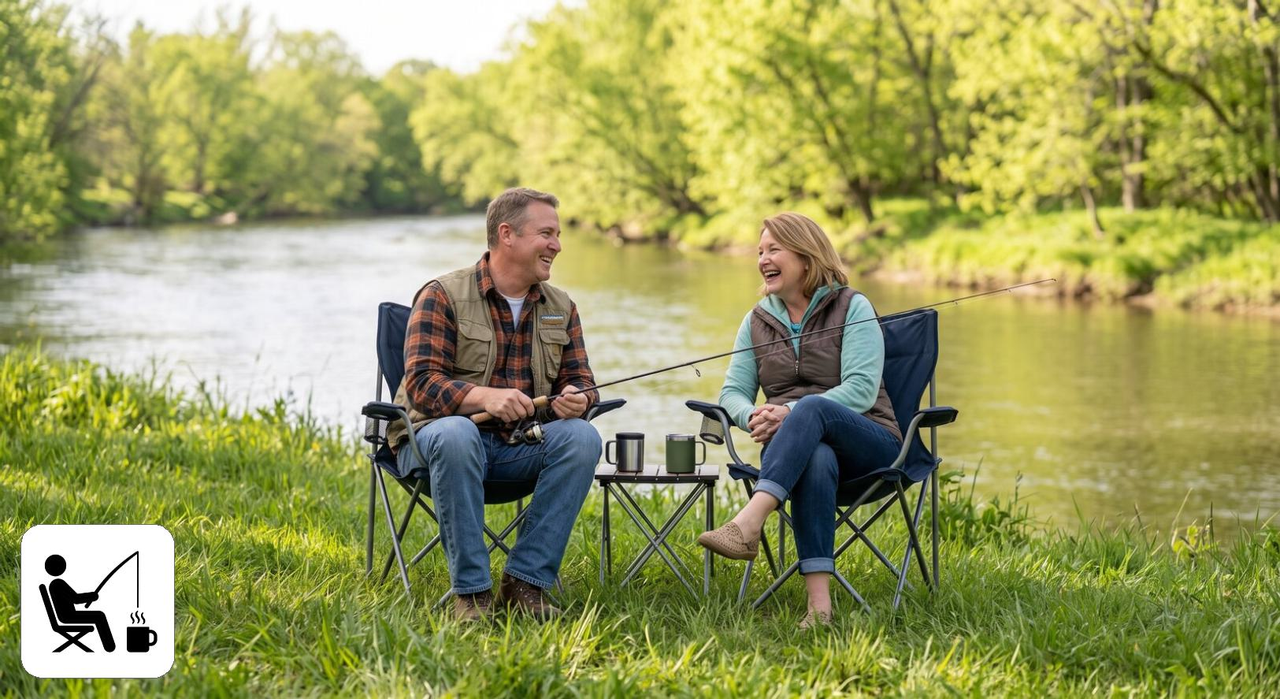
Class 2: The relaxed, catch-optional angler
Class 2 holds 16.7% of respondents (n = 347). It is below average on all four catch attitudes: catch something 2.2, numbers 2.5, size 2.8, harvest 2.0. Its lowest motivation is the fishery resource (2.2, -0.52 SD), while the natural environment (3.8) and social (3.8) motivations run slightly above average. Its regulation scores are middling, with a slight lean toward uniform rules (3.3). Picture someone who goes for the day out, the company and the water, and for whom a fishless trip is not a failed trip. Class 2 makes up 25.2% ± 5.2 of No preference and 22.6% ± 9.8 of Trout anglers, against 16.7% overall.
On the other survey questions, Class 2 fishes less often than average (median days 14.0, against 17.0 overall) and seldom fishes tournaments (1.3%, against 3.0% overall). It ice fishes less often than average (12.3%, against 17.7% overall) and is more satisfied than average (mean 2.1, against 2.3 overall). Together with Class 6 it has the highest share of women of any profile (28.2%, and 28.1% in Class 6, against 19.5% overall). Its species mix leans toward No preference (27.0% of the profile, against 17.7% of all assigned respondents), so differences on questions that vary by species may partly reflect that mix rather than the profile itself.

Class 3: The regulation-savvy catch-and-release sport angler
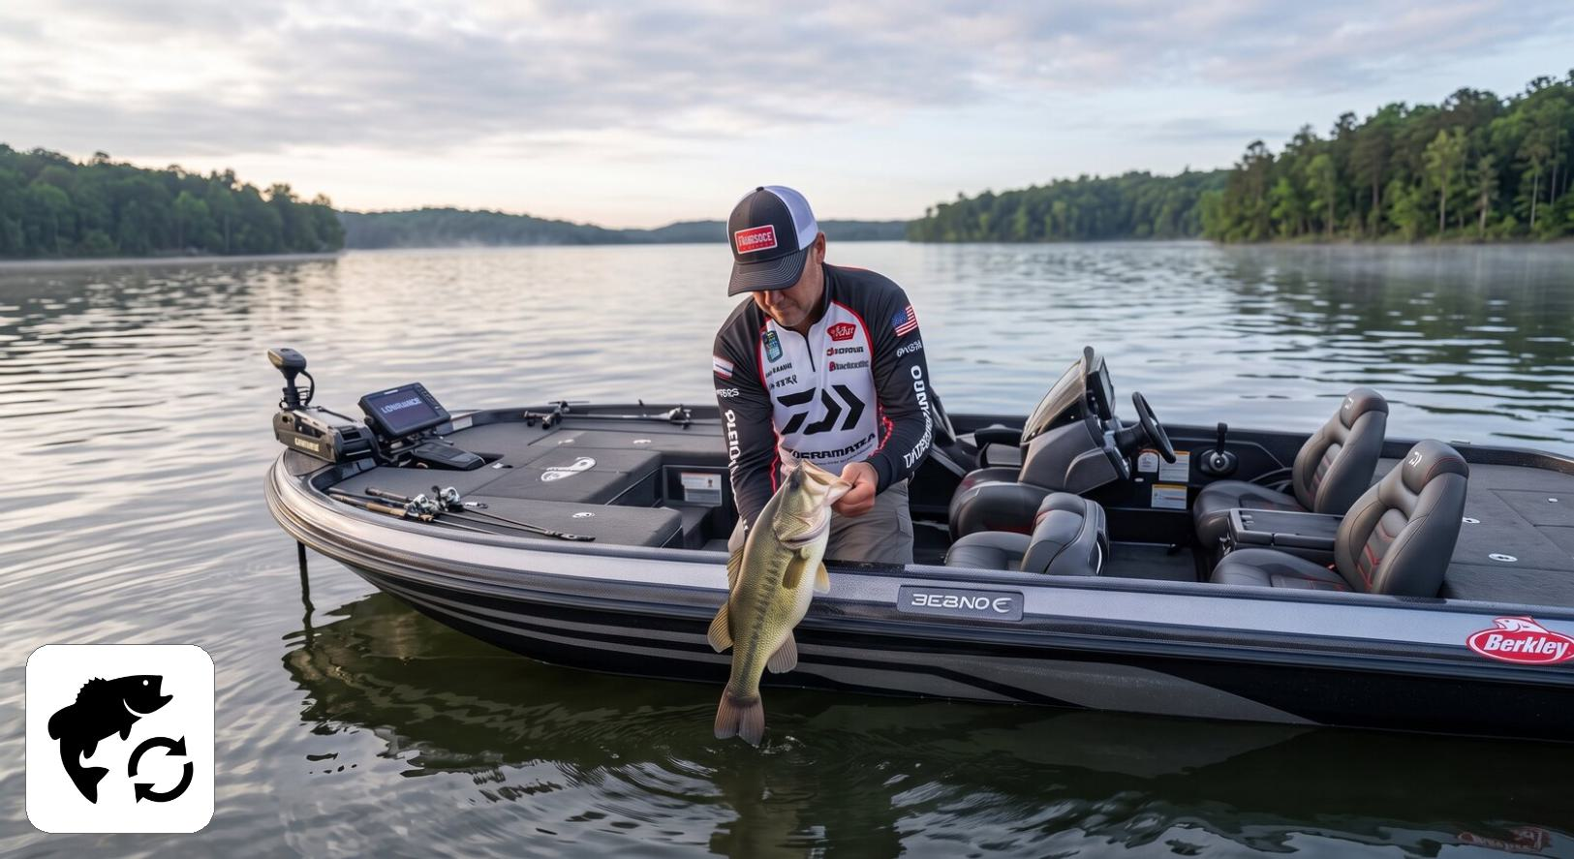
Class 3: The regulation-savvy catch-and-release sport angler
Class 3 holds 15.9% of respondents (n = 292). It is above average on size (3.7, +0.56 SD) and on needing a catch (3.1), but below average on harvest (1.9): it wants a fish on the line, preferably a good one, and then lets it go. Its motivations are at or slightly below average (social 3.3, -0.39 SD). It is strongly engaged with regulations, with high comprehension (4.2, +0.71 SD), high support for site-specific rules (4.5, +0.76 SD), and a low preference for uniform rules (2.5, -0.68 SD). Picture an angler, often a bass angler, who reads the regulations and values rules tailored to each lake. Class 3 makes up 23.0% ± 4.8 of Bass, 24.0% ± 5.2 of Largemouth bass and 24.1% ± 13.1 of Flathead catfish anglers, against 15.9% overall.
On the other survey questions, Class 3 fishes more often than average (mean days 35.6, against 30.2 overall; median 24.0, against 17.0 overall). It has the highest rate of hiring a guide of any profile (13.9%, against 8.1% overall) and the highest use of private areas (35.0%, against 28.6% overall); its tournament participation is close to the overall rate (4.0%, against 3.0% overall). Its median distance to its most visited water is 16 miles, against 30 overall, and it has the lowest share of women of any profile (12.7%, against 19.5% overall). Its species mix leans toward Bass (30.0% of the profile, against 21.0% of all assigned respondents), so differences on questions that vary by species may partly reflect that mix rather than the profile itself.

Class 4: The all-in enthusiast
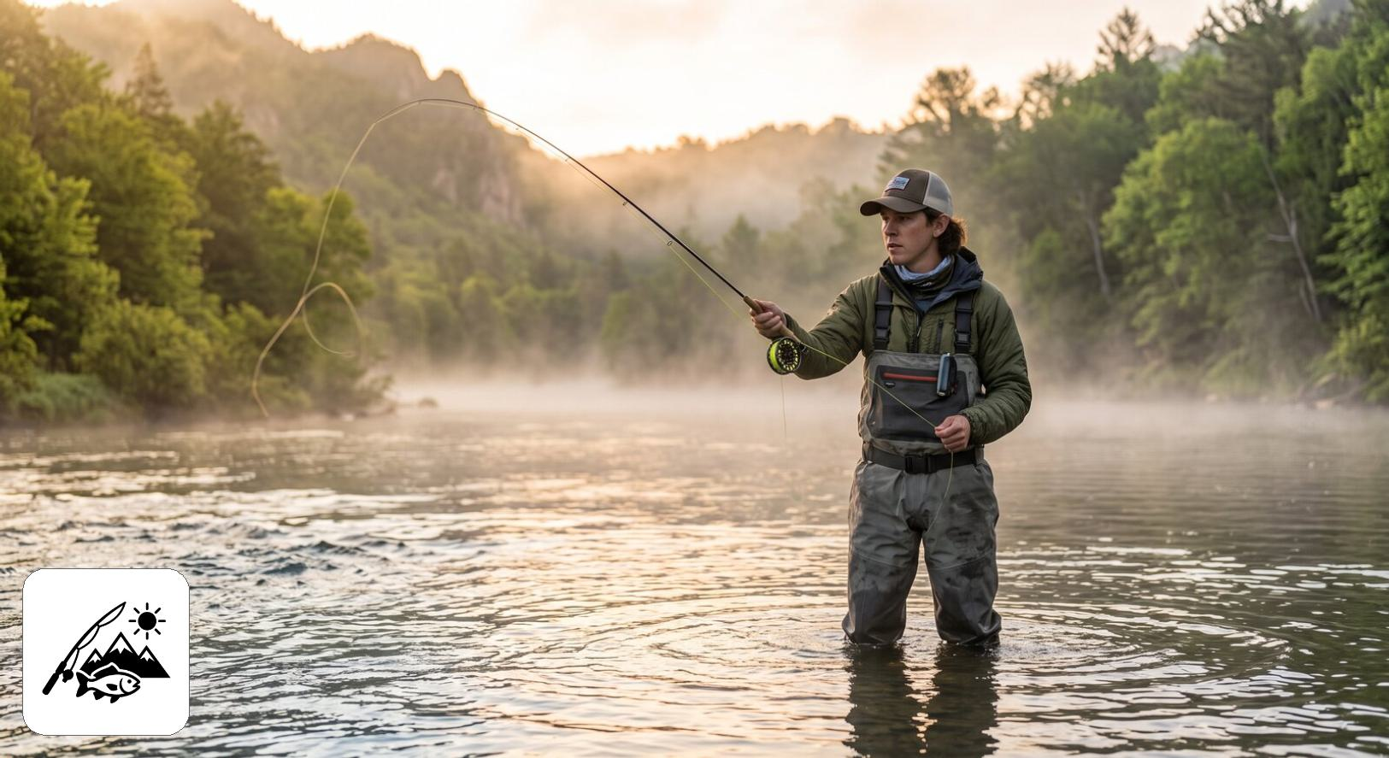
Class 4: The all-in enthusiast
Class 4 holds 18.2% of respondents (n = 286). It has the highest score of any profile on all four motivations: physical and psychological (4.2, +1.15 SD), natural environment (4.5, +1.04 SD), social (4.4, +0.98 SD), and fishery resource (3.2, +1.05 SD). It is also the most size-oriented profile (3.9, +0.74 SD) and is above average on numbers (3.5), with average scores on needing a catch (2.7) and on harvest (2.1). Its support for site-specific rules is above average (4.1). The fishery resource scale, on which no other profile scores as high, includes competing for prizes or money. Picture the angler for whom fishing is a central hobby: every reason to go matters, trophies and tournament competition included. Class 4 makes up 33.8% ± 15.7 of Smallmouth bass anglers, against 18.2% overall.
On the other survey questions, Class 4 is the most active profile and the one most likely to fish tournaments (5.3%, against 3.0% overall), although tournament anglers remain a small share of it. It has the highest mean days fished (45.4, against 30.2 overall) and median days fished (31.0, against 17.0 overall), and the highest rates of any profile for using a kayak or canoe (24.2%, against 17.7% overall), ice fishing (24.3%, against 17.7% overall), fishing rivers and streams (47.4%, against 36.0% overall), fishing waters that require a Park Entry Permit (77.0%, against 69.0% overall), fishing outside Nebraska (54.9%, against 44.1% overall) and using live-imaging sonar (21.4%, against 14.5% overall). It is also the youngest profile (mean age 39.2, against 46.0 overall).

Class 5: The low-involvement angler
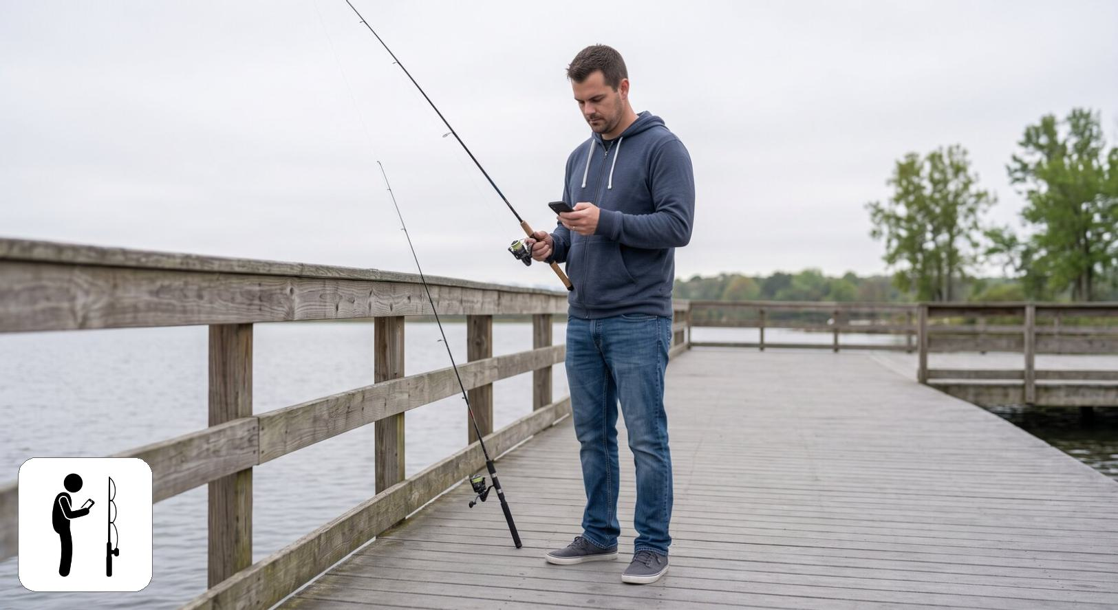
Class 5: The low-involvement angler
Class 5 holds 13.4% of respondents (n = 311). It has the lowest score of any profile on all four motivations: physical and psychological (2.2, -1.33 SD), natural environment (2.6, -1.37 SD), social (2.6, -1.22 SD), and fishery resource (1.9, -0.92 SD). It is near average on needing a catch (2.9) and on harvest (2.3), below average on numbers (2.9, -0.27 SD) and size (2.9, -0.50 SD), and close to average on the three regulation scales. Picture a license holder for whom fishing is incidental rather than a pursuit in its own right. Uniformly low importance ratings can also reflect how a respondent uses the rating scale. Class 5 makes up 19.7% ± 4.7 of No preference anglers, against 13.4% overall.
On the other survey questions, Class 5 is the least active profile. It has the lowest mean days fished (17.4, against 30.2 overall) and median days fished (7.0, against 17.0 overall), and the lowest rates of any profile for using a kayak or canoe (8.4%, against 17.7% overall), ice fishing (9.4%, against 17.7% overall), fishing rivers and streams (25.4%, against 36.0% overall), fishing waters that require a Park Entry Permit (55.7%, against 69.0% overall), fishing outside Nebraska (28.9%, against 44.1% overall) and using live-imaging sonar (7.7%, against 14.5% overall). It is the oldest profile (mean age 52.4, against 46.0 overall). Its species mix leans toward No preference (26.3% of the profile, against 17.7% of all assigned respondents), so differences on questions that vary by species may partly reflect that mix rather than the profile itself.

Class 6: The conservation-minded purist
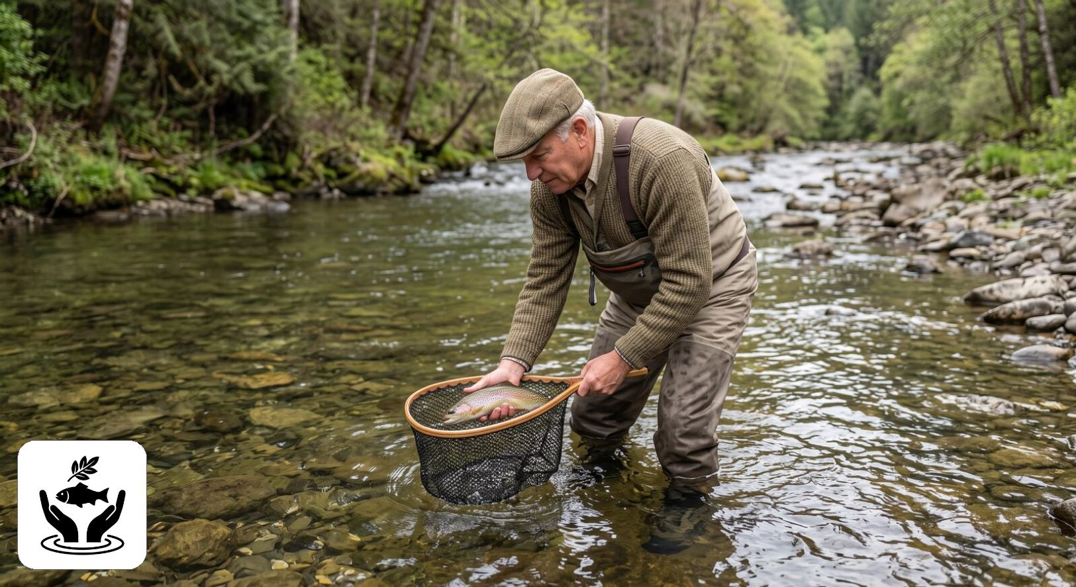
Class 6: The conservation-minded purist
Class 6 holds 6.0% of respondents (n = 120), the smallest profile. It has the lowest score of any profile on all four catch attitudes: catch something 1.8, numbers 1.9 (-1.58 SD), size 2.4, harvest 1.6; catching and keeping fish are close to irrelevant to it. It is motivated by the natural environment (4.1) and by social reasons (3.9) but not by the fishery resource (2.1). It has the highest comprehension of the rules (4.5) and support for site-specific rules (4.7) of any profile, and the lowest preference for uniform rules (2.4). Picture someone who values the experience and well-managed waters over the catch. Class 6 makes up 1.7% ± 1.3 of Walleye / Sauger anglers, its smallest share of any displayed family group; its largest share of any displayed row is 13.8% ± 11.5 of Bluegill / Sunfish anglers.
On the other survey questions, Class 6 fishes less often than average (median days 13.0, against 17.0 overall) and has the lowest rates of any profile for fishing tournaments (0.6%, against 3.0% overall), hiring a guide (4.6%, against 8.1% overall) and fishing from a motorized boat (40.6%, against 51.1% overall). Its median distance to its most visited water is 16 miles, against 30 overall. It reports the highest overall satisfaction of any profile (mean 1.7, against 2.3 overall, where lower means more satisfied), and, with Class 2, the highest share of women (28.1%, against 19.5% overall). With 120 respondents it is the smallest profile, and most of its intervals in the table are correspondingly wide. Its species mix leans toward No preference (28.2% of the profile, against 17.7% of all assigned respondents), Panfish / Sunfish (17.9% of the profile, against 10.7% of all assigned respondents), and Bass (26.5% of the profile, against 21.0% of all assigned respondents), so differences on questions that vary by species may partly reflect that mix rather than the profile itself.

Profiles by preferred species
The table below gives, for each preferred-species row, the weighted percentage of its respondents assigned to each profile, with Unassigned as a column so that each row sums to 100. The rows overlap, as elsewhere in this report, and must not be totalled. Where a row has no respondents in a profile, the percentage is 0.0 and the interval has zero width. Preferred-species rows below the effective-N floor of 30 are not shown (3 rows): Wiper (35 respondents, effective N 28.6); White bass (39 respondents, effective N 29.8); Northern pike (32 respondents, effective N 26.9). Their respondents are included in the model fit and in the Overall row. This is the only chapter of the report that withholds rows; the effective-N floor was set before the model was fitted. Cells are the weighted percentage of the row group giving that response, with a 95 percent confidence interval. N is the raw unweighted number of respondents in the row group who answered the question. These results were weighted. Please consult the survey methodology for details.
Preferred species | Class 1 | Class 2 | Class 3 | Class 4 | Class 5 | Class 6 | Unassigned | N
Overall | 18.3 ± 1.94 | 16.7 ± 1.87 | 15.9 ± 1.83 | 18.2 ± 1.94 | 13.4 ± 1.71 | 6.0 ± 1.19 | 11.6 ± 1.60 | 1,915
Walleye / Sauger | 26.3 ± 4.30 | 15.4 ± 3.53 | 18.3 ± 3.78 | 15.1 ± 3.50 | 13.7 ± 3.36 | 1.7 ± 1.28 | 9.5 ± 2.87 | 499
Bass | 12.5 ± 3.77 | 17.3 ± 4.30 | 23.0 ± 4.80 | 19.7 ± 4.53 | 9.8 ± 3.39 | 7.7 ± 3.03 | 10.0 ± 3.41 | 357
Largemouth bass | 13.7 ± 4.17 | 18.1 ± 4.67 | 24.0 ± 5.18 | 17.8 ± 4.63 | 9.0 ± 3.47 | 7.8 ± 3.26 | 9.6 ± 3.57 | 316
Smallmouth bass | 4.4 ± 6.79 | 11.4 ± 10.56 | 16.1 ± 12.22 | 33.8 ± 15.72 | 15.4 ± 12.01 | 6.5 ± 8.18 | 12.5 ± 10.99 | 41
Panfish / Sunfish | 23.0 ± 6.00 | 10.4 ± 4.36 | 11.6 ± 4.56 | 17.1 ± 5.36 | 16.1 ± 5.24 | 10.0 ± 4.27 | 11.8 ± 4.59 | 236
Crappie | 25.2 ± 7.09 | 10.1 ± 4.91 | 12.9 ± 5.48 | 17.2 ± 6.15 | 15.2 ± 5.86 | 9.7 ± 4.82 | 9.8 ± 4.85 | 181
Bluegill / Sunfish | 13.0 ± 11.23 | 11.0 ± 10.43 | 5.7 ± 7.74 | 19.5 ± 13.23 | 17.8 ± 12.77 | 13.8 ± 11.51 | 19.1 ± 13.13 | 43
Catfish | 16.6 ± 5.43 | 15.6 ± 5.29 | 14.4 ± 5.12 | 21.4 ± 5.98 | 13.1 ± 4.91 | 6.1 ± 3.48 | 12.8 ± 4.87 | 228
Channel catfish | 19.3 ± 7.09 | 15.3 ± 6.47 | 9.1 ± 5.16 | 19.4 ± 7.11 | 15.1 ± 6.44 | 6.7 ± 4.50 | 15.1 ± 6.44 | 151
Flathead catfish | 15.9 ± 11.25 | 18.0 ± 11.80 | 24.1 ± 13.14 | 15.5 ± 11.11 | 11.5 ± 9.80 | 8.2 ± 8.43 | 6.8 ± 7.74 | 50
Trout | 21.2 ± 9.57 | 22.6 ± 9.78 | 9.8 ± 6.97 | 13.4 ± 7.97 | 7.4 ± 6.14 | 8.5 ± 6.54 | 17.0 ± 8.78 | 90
No preference | 10.8 ± 3.69 | 25.2 ± 5.16 | 11.0 ± 3.72 | 11.2 ± 3.75 | 19.7 ± 4.72 | 9.4 ± 3.47 | 12.6 ± 3.95 | 339
The figure below shows the profile makeup of each family group against the Overall share of each profile. Unassigned respondents, between 9.5 and 17.0 percent of each family group, are not shown, so the bars in a panel sum to less than 100. Wiper, White bass, and Northern pike are reported as individual species because their families were not combined, and are not in the figure.
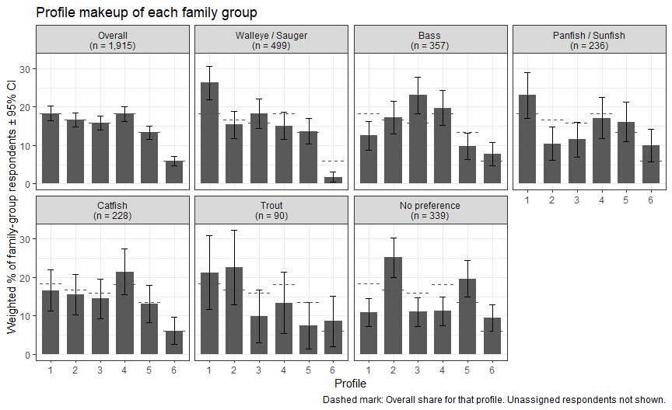

Profile makeup of family-group anglers
Every family group contains anglers of all six profiles. No family group is dominated by a single profile; the largest share of any profile in any family group is Class 1 among Walleye / Sauger anglers (26.3% ± 4.3). Managing for any one species therefore means serving a mix of angler types, and the differences described in the cards below are differences of emphasis rather than of kind. Each card shows one family group’s weighted percentage in each profile, with 95 percent confidence intervals, on a common scale; the icons along the bottom mark the profiles, and the dashed mark is the Overall share of that profile. The text beside each card also gives the group’s mean on the attitude, motivation and regulation scales used to fit the profiles (1 to 5 scales), with the difference from the Overall mean in standard deviations (SD); the largest such difference for any family group is 0.59 SD.
Walleye / Sauger
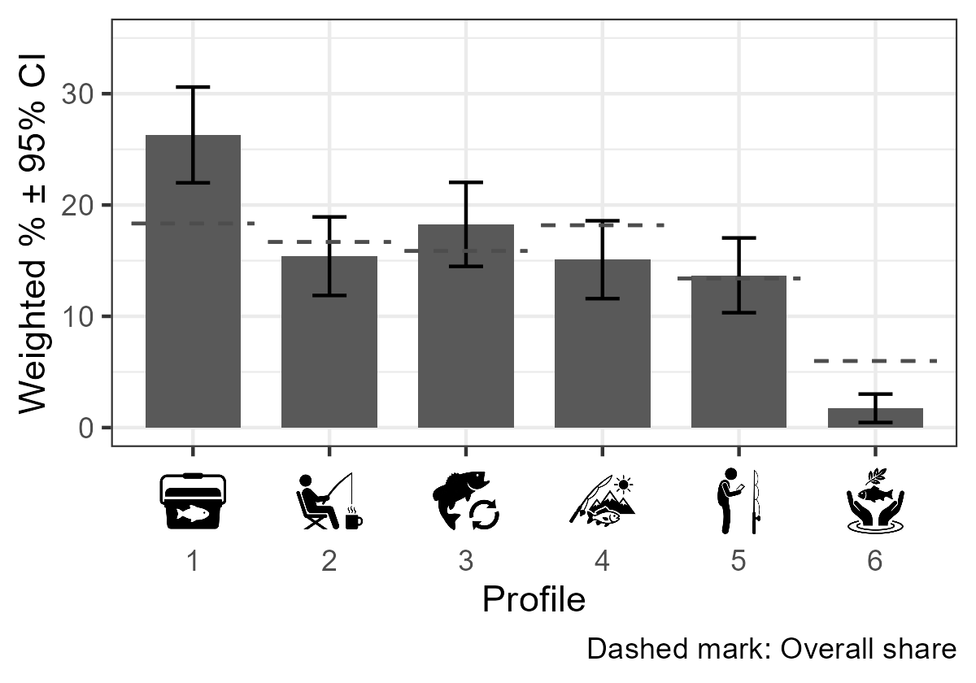 | Walleye / Sauger anglers, the largest family group (n = 499), lean toward Class 1, the harvest-minded, keep-it-simple angler (26.3% ± 4.3 against 18.3% overall), and include very few Class 6 purists (1.7% ± 1.3 against 6.0% overall). Their attitude scores agree: keeping fish matters more to them than to any other family group (2.6, +0.48 SD), and needing a catch is above average (3.0, +0.24 SD). Together with Catfish anglers they score highest on the fishery resource motivation (2.7, +0.24 SD), while the natural environment is slightly below average (3.6, -0.12 SD). Harvest opportunity and catch results are the levers most likely to matter to this group. Their comprehension of the rules (3.5, -0.11 SD) is slightly below average, so plain-language communication of lake-specific length and bag limits also has a role.
Bass
Bass anglers (n = 357) sit at the opposite end from Walleye / Sauger anglers on harvest. Class 3, the regulation-savvy catch-and-release angler, is their largest profile (23.0% ± 4.8 against 15.9% overall), and Class 1 is less common among them (12.5% ± 3.8 against 18.3% overall). Keeping fish matters least to them of any family group (1.7, -0.59 SD), and the size of the fish matters more than average (3.5, +0.26 SD). Their motivations are close to average, with the physical and psychological rewards (3.4, +0.13 SD) and the natural environment (3.7, +0.10 SD) slightly above. They also report above-average comprehension of the rules (3.7, +0.19 SD) and support for site-specific rules (4.0, +0.15 SD). Bass anglers look like a receptive audience for size-focused management, including special length limits and catch-and-release rules for individual waters. |  | 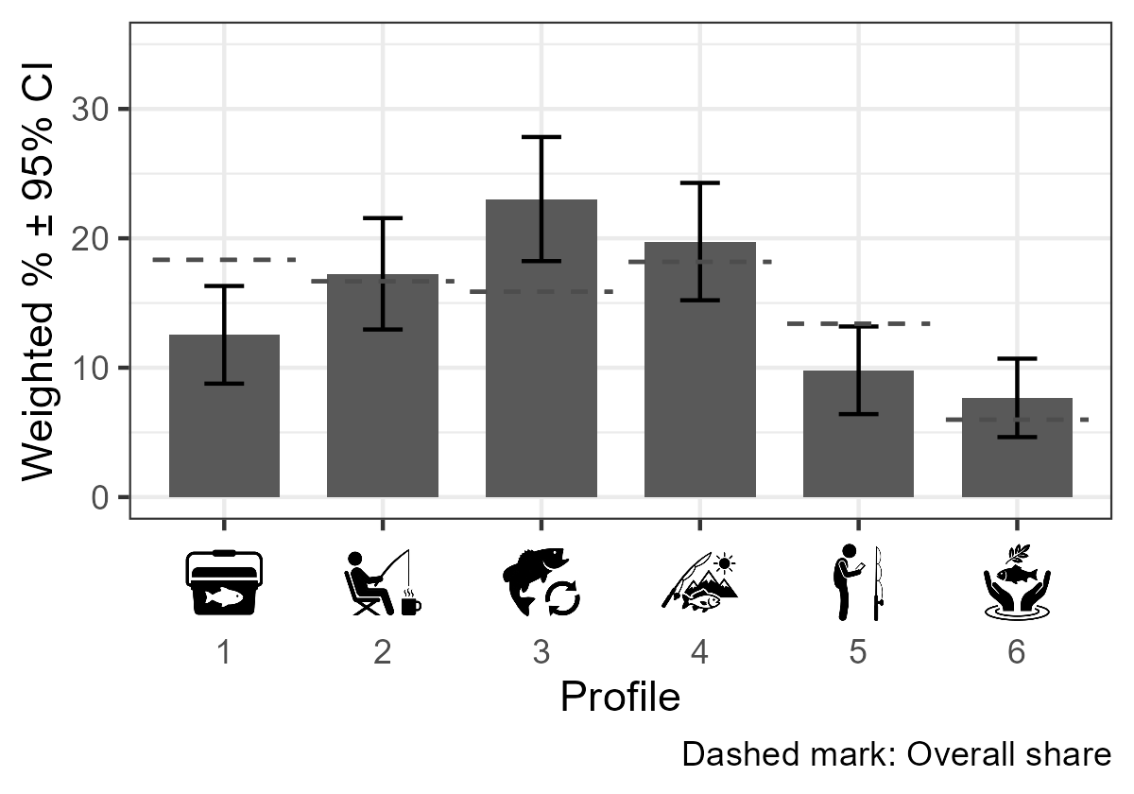
Panfish / Sunfish
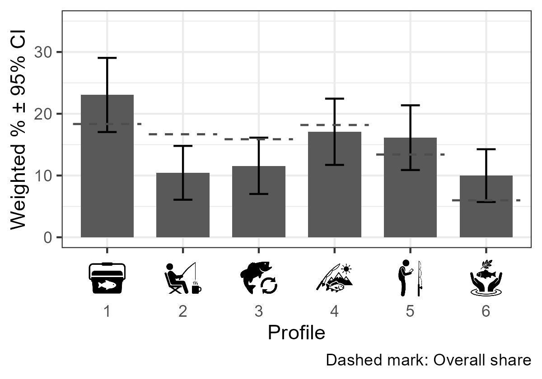 | Panfish / Sunfish anglers (n = 236) combine two contrasting profiles: Class 1 harvest-minded anglers (23.0% ± 6.0 against 18.3% overall) and Class 6 conservation-minded purists (10.0% ± 4.3 against 6.0% overall) are both more common than overall, while Class 2 is less common (10.4% ± 4.4 against 16.7% overall). Their attitudes lean toward keeping fish (2.3, +0.15 SD) and needing a catch (2.9, +0.13 SD), while the size of the fish matters less than average (3.0, -0.32 SD). All four motivations are within 0.1 SD of the Overall means, so this group differs in what it wants from the catch rather than in why it fishes. Panfish management may need to balance harvest opportunity for the larger group with the experience-focused values of the smaller one.
Catfish
Catfish anglers (n = 228) are the closest to the angler population as a whole: no profile's share among them differs from its Overall share by 5 percentage points or more. Of the 11 scales, only the fishery resource motivation is 0.15 SD or more from the Overall mean (2.7, +0.24 SD), and the rest are all within 0.15 SD. Catfish anglers are therefore much like Nebraska anglers generally, with a somewhat stronger interest in what they catch, so catfish management is in effect management for the general angler. |  | 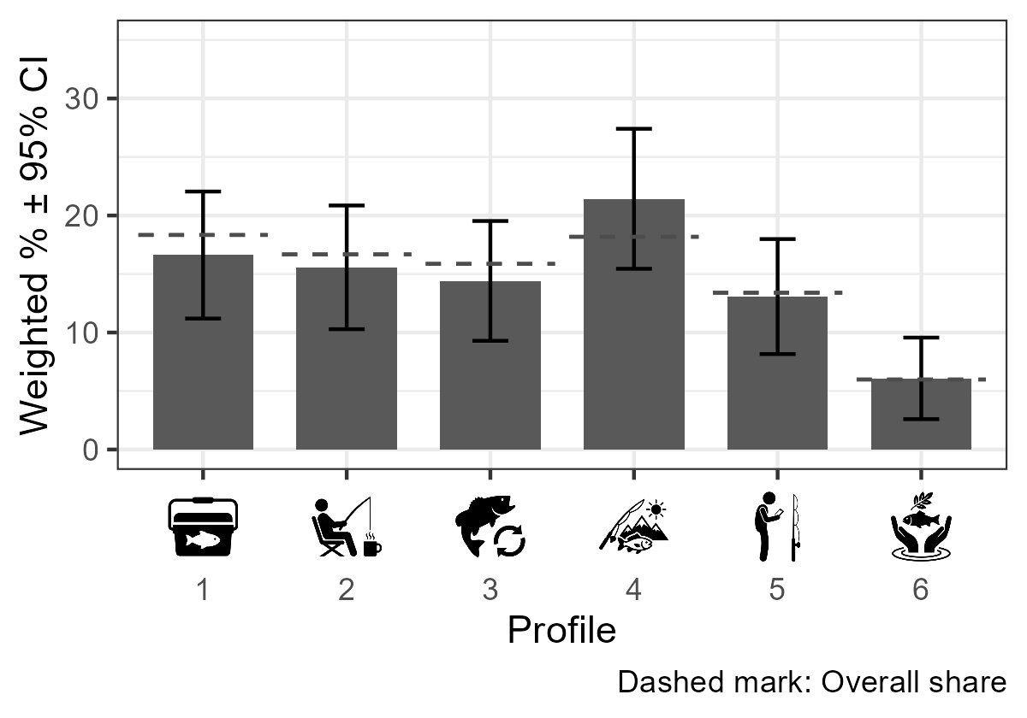
Trout
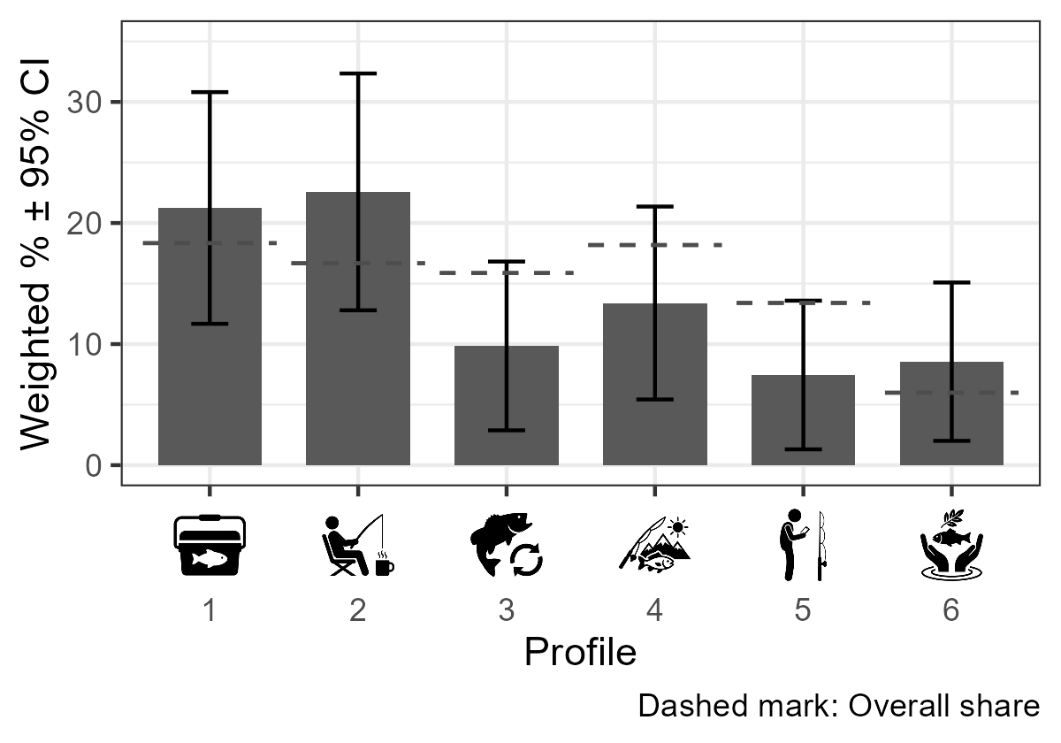 | Trout anglers lean toward Class 2, the relaxed, catch-optional angler (22.6% ± 9.8 against 16.7% overall), with fewer Class 3 anglers (9.8% ± 7.0 against 15.9% overall); with 90 respondents these intervals, and the scale means below, are imprecise. They score below average on needing a catch (2.6, -0.24 SD), on catching numbers of fish (2.8, -0.35 SD) and on the fishery resource motivation (2.3, -0.27 SD), and slightly above average on the natural environment (3.7, +0.10 SD). The pattern is only suggestive at this sample size, but it fits a stocked fishery valued for the outing, where access, the timing of stockings and a pleasant setting may matter more than catch rates or trophy potential.
No preference
Anglers with no preferred species (n = 339) are the group most weighted toward the less committed profiles: Class 2 (25.2% ± 5.2 against 16.7% overall) and Class 5, the low-involvement angler (19.7% ± 4.7 against 13.4% overall), are both more common than overall, and Class 1 is less common (10.8% ± 3.7 against 18.3% overall). They score below the Overall mean on every attitude and every motivation. The fishery resource motivation is lowest of any family group (2.2, -0.52 SD), and the physical and psychological rewards (3.0, -0.37 SD) and the importance of size (3.0, -0.38 SD) are also low. These anglers are a natural focus for recruitment, retention and reactivation efforts, where convenience, easy access and general information are more likely to reach them than species-specific management. |  | 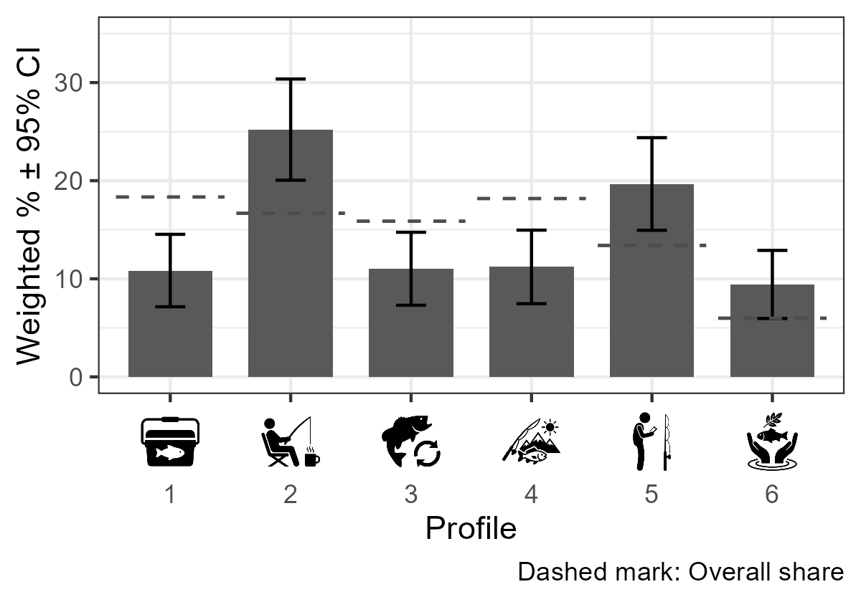
These implications are interpretive. The profiles are built from attitude, motivation and regulation scales, not from behavior, and the shares are associations: preferring a species does not place an angler in a profile, nor the reverse. Differences of less than about 5 percentage points are within the precision of these estimates for most family groups, and the Trout group, the smallest family group, has intervals that reach ±9.8 points.

Appendix A - 2025 Nebraska Licensed Angler Survey (Paper Version)

Appendix B - Statistical Methodology

Analysis sample
This report is restricted to respondents who answered the preferred-species question. Of the 2,822 anglers who responded to the 2025 survey, 907 left that question blank and are excluded from the report entirely rather than merely from the species columns. The analysis sample is therefore 1,915 respondents.
A second, narrower exclusion applies only to the preferred groups. 60 respondents in the analysis sample prefer a species that has no preferred-group column, either because it is in no candidate family or because it and its family did not meet the selection rules in Chapter 1. They remain in the Overall column of every table but receive no preferred-group column of their own. The two exclusions are distinct and are reported separately in Chapter 1.
Because of the first restriction, the Overall column of this report estimates a different population than the Overall column of the 2025 Crosstabs report: anglers who stated a species preference, rather than all licensed anglers. The two reports will therefore not agree in that column, and no attempt has been made to reconcile them. The one exception is the preferred-species distribution itself, which is computed on respondents to that question in both reports and does match exactly.

Weighting and raking by survey year
Every respondent record carries a pre-calculated weight that is computed during data aggregation and stored with the survey data. All percentages and means in this report are weighted using that stored value; sample sizes (N) shown in parentheses are always raw, unweighted respondent counts and not weighted Ns. Calculated weights for the 2025 sum to population size values and not sample size values and displaying the weighted N’s would be difficult for readers to interpret. Full detail on how the 2025 raking weights themselves were constructed can be found in Hurley (2026).

Percentage confidence intervals
Percentage tables (base.summary.percent.selectOne / base.summary.percent.selectAll in BaseFunctions_2025_UPDATED.R) use a normal-approximation (Wald) interval:
$$CI=1.96×\sqrt{\frac{p(1-p)}{effN}}×100$$
where $p$ is the weighted proportion and $effN$ is the Kish effective sample size, not the raw respondent count or the raw sum of weights:
$$effN=\frac{(∑w)^{2}}{∑w^{2}}$$
This matters because the 2025 weights sum to the angler population (roughly 234,000 across all 2025 respondents, a mean weight around 83), not to the number of respondents. A formula that treated the sum of weights as the sample size would inherit that population scale and give intervals roughly 9 times too narrow. The Kish effective sample size avoids this in two ways: it is unchanged if every weight is multiplied by a constant, so the population scale drops out; and it is smaller than the respondent count, reflecting the design effect of unequal weighting.

Mean confidence intervals
Mean tables (base.summary.means) compute a weighted mean and a weighted standard deviation, then a standard error using the same Kish effective sample size ($effN$) used by the percentage formula above, rather than the raw respondent count:
$$SE=\frac{SD_{w}}{\sqrt{effN}}, CI=1.96×SE$$
This mirrors the percentage CI fix for the same underlying reason: using $effN$ keeps mean CIs on the same design-effect-corrected basis as percentage CIs. The sample size (N) displayed alongside each mean is still the raw, unweighted respondent count; only the internal SE calculation changed.

Median confidence intervals
Median tables report a weighted median together with a genuine 95% confidence interval for that median, computed by weighted bootstrap: respondents are resampled with replacement, with selection probability proportional to the precalculated weight values, 1,000 times; the (unweighted) median is computed for each resample; and the 2.5th and 97.5th percentiles of those 1,000 bootstrap medians form the reported CI bounds. A fixed random seed (7361) is set before each grouped computation so results are reproducible from one render to the next. This method was chosen because there is no simple closed-form confidence interval for a weighted median under arbitrary, non-integer survey weights.

Reverse-coded item markers (dagger, †)
Some questions in this report mark individual items with a dagger and a caption explaining that dagger-marked items “are reverse coded… before computing scale means.” That marking is only meaningful when a table actually being shown reflects a reversed value. That is true for the Angler Attitudes (E1) tables: attitude_catch and attitude_harvest, both shown in this report, genuinely reverse items E1a, E1k, E1f, and E1l when computing those subscale and item means.

Scale scores and the completeness gate
The motivation, attitude and regulation scale scores are rebuilt from the raw item responses at render time, applying the reversals flagged in Scales.csv. Each scale table is restricted to respondents who answered every item in that sub-scale, matching the 2025 Crosstabs report. The gate is applied per scale, so each scale carries its own sample size; across the eleven scales used here the analysis sample ranges from 1,653 to 1,715 respondents. This is an inherited listwise requirement rather than a discretionary exclusion, and the resulting sample size is printed beside every estimate.

Population expansions
The species table in Chapter 1 reports a population expansion, obtained by applying each weighted percentage to the full weighted 2025 angler population of 234,125. That column therefore sums to the full angler population. The weights carried by the 1,915 respondents in the analysis sample themselves total only 171,760, or about 73 percent of the population, because the respondents who skipped the preferred-species question carry weight too.
Expanding to the full population rather than to the 171,760 represented by the analysis sample assumes that skipping the preferred-species question is unrelated to which species an angler prefers. That assumption cannot be tested with these data, since no preference was recorded for the respondents who skipped the question. Readers who prefer not to make it should scale the expansion column by 0.734.

The preferred groups, and why columns do not sum
The preferred groups are not a partition. A family that Chapter 1 combined appears both as a family column and as one column per constituent species that met the minimum size, so a respondent who prefers largemouth bass is counted in both the Bass column and the Largemouth bass column. A family that was not combined has no family column, and only its species that met the minimum size appear, each as a column of its own.
The columns are chosen by rule, not by hand. A candidate family is combined only if none of its within-family tests has a family-adjusted p-value below 0.05. A column, whether for a family or a species, requires at least 30 raw respondents; the size rule is applied after testing, so every species in a candidate family is tested even if it later falls below the minimum. The hand-typed column list is checked against these rules at every render and the render stops if they disagree.
Two consequences follow. Preferred-group column counts sum to 2,637 against 1,855 distinct respondents, so they must never be totalled. And because each column is computed on its own respondents and uses its own denominator, the percentages within any single column remain correct; only addition across columns is invalid.

Comparisons between species
Chapter 1 compares species within a family using design-based two-sample comparisons (svyttest from the survey package) on a design object built with the survey weights rescaled to sum to the number of respondents in the pair being compared:
$$w_{norm}=w×\frac{n}{∑w}$$
The rescaling is presentational. Like the Kish effective sample size, the linearized standard errors that survey computes do not change when every weight is multiplied by a constant, so raw and rescaled weights give identical standard errors and degrees of freedom. The sum-of-weights problem described under percentage confidence intervals does not arise here.
No omnibus test is reported. Each row of a comparison table is a single two-species contrast. An overall F-test across the species in a family was considered and dropped, and with it any model $R^{2}$ or $η^{2}$, because the split-or-combine decisions were made from the species estimates directly.

Multiplicity
The Bonferroni adjustment is applied across every test in a family: the number of species pairs multiplied by the nine outcomes. A two-species family therefore carries 9 tests and a three-species family 27. The unadjusted p-value for each test is multiplied by the family’s test count and capped at 1, and both the unadjusted p and the family-adjusted p are printed.
Bonferroni was chosen over Holm for simplicity of exposition. The two rest on identical assumptions and Bonferroni is uniformly the more conservative of the two, so any comparison Bonferroni separates, Holm would separate as well. Tukey’s HSD was not used: it is not valid here given the unequal group sizes and the weighted design. Benjamini-Hochberg was not used because false-discovery control is suited to screening rather than to the go/no-go grouping decisions this chapter supports.
The family-adjusted p-values are used for one decision: a family is combined only if none of its adjusted p-values is below 0.05. The comparisons for the smaller species are underpowered, and overlapping confidence intervals are weak evidence that two species are similar, so failing to separate two species is not evidence that they are alike. Comparisons in which one species has fewer than 30 respondents are marked with a dagger in the contrast tables.

Effect sizes
Every comparison reports the weighted difference in means with a 95% confidence interval, and Hedges’ g, a standardized difference computed by pooling the two weighted standard deviations on the effective sample sizes and applying the usual small-sample correction. Both are shown because several species in this survey are represented by very few respondents, where a comparison that separates nothing is not evidence that the species behave alike; the interval is simply too wide to distinguish the two possibilities. The difference, its interval, and g together let the reader tell those cases apart.

How differences are described in the text
The narrative in Chapters 3 and 4 describes a preferred group as different from the Overall estimate only when the group’s 95 percent confidence interval lies entirely outside the Overall 95 percent interval: the lower limit of the group is above the upper limit of Overall, or the upper limit of the group is below the lower limit of Overall. The intervals are those printed in the tables, the Kish effective-N interval for percentages and means and the bootstrap percentile interval for medians. A group whose interval overlaps the Overall interval is not described as different, and a group that goes unmentioned is not thereby shown to be typical. Within-angler differences in Chapter 4 (size against numbers, and caught against allowed) are described as different from zero only when the 95 percent interval around the paired difference excludes zero.
This screen is not a hypothesis test and carries no p-value. For a single comparison it is more conservative than a two-sided test at the 5 percent level, because it requires the two intervals not to touch rather than the difference to exceed its own standard error; how much more conservative depends on how wide the group interval is relative to the Overall interval. It is not adjusted for the number of comparisons. Each table screens 15 groups, and Chapter 3 screens many outcomes, so some flagged comparisons could arise by chance. The comparisons are also not independent: every group is part of the Overall it is compared with, and a family row contains the respondents in its own species rows.
A percentage of 0 or 100 has a Wald interval of zero width, so the screen carries no information for such a cell. The text reports those cells descriptively, as groups in which no respondent gave the response, and not as screened differences.
The rule is not applied everywhere. The Chapter 1 narrative reports the Bonferroni-adjusted family tests described above. The Chapter 2 per-item paragraphs describe group means and their ordering as printed in the item tables and apply no interval screen; the interval for any group is in the table. Their means and percentages are computed from the same objects as the item tables, and the ordering and direction they state (which group is highest or lowest, which groups are the only ones above or below a point, and that no group’s 2018 to 2025 change shows in the slope figure) are checked when the report is built. The closing section of Chapter 2, Reading Across the Items, applies the interval screen above. Chapter 5 is described in its own section below. In Chapters 1 to 4 every value quoted in the narrative is computed from the same objects as the tables, and each claim is checked when the report is built, against the interval rule where one applies and otherwise against the ordering or direction it states, so the build stops if the data no longer support a statement.

Satisfaction comparisons in Chapter 4
Chapter 4 reports no new estimator. Its group means are the weighted means described above, with the same Kish effective-N confidence intervals, and its rows are the same preferred groups used in Chapters 2 and 3.
One variable is transformed. A9 is recorded from 1, Very satisfied, to 5, Very dissatisfied, while every D4 item runs from 1, Strongly Disagree, to 5, Strongly Agree. Chapter 4 reports A9 as 6 minus the recorded response so that all six items point the same way. Subtraction from a constant shifts and reflects the scale without changing its spread, so the confidence interval is unchanged: the overall A9 mean of 2.3 plus or minus 0.06 in Chapter 3 appears as 3.7 plus or minus 0.06 in Chapter 4.
The size-and-numbers comparisons are paired. For each respondent who answered both items of a pair, the difference between the two responses is computed first, and the group figure is the weighted mean of those differences with the usual interval. Restricting to respondents who answered both items means the two means printed beside the difference describe the same people, so the difference column equals the difference of the columns. Pairing removes between-angler variation in how the scale is used, which is why a difference of a few hundredths of a scale point can carry a narrower interval than either mean.
Chapter 4 also compares what each angler catches with what the same angler is allowed to harvest, for size (D4i and D4j) and for number (D4k and D4l). The method is the paired method above. The difference is the caught item minus the harvestable item, so a negative value means the harvestable item is rated higher. It is computed for every row of the table, Overall and the 15 preferred groups, for both pairs: 30 group comparisons, none adjusted for multiplicity. The size comparison was added after the Chapter 2 item paragraphs suggested a difference for one group, Wiper. It is reported for every group so that the group is read against the others and not alone.
No significance test is reported in Chapter 4, and no adjustment for multiple comparisons is applied. Each interval is a 95 percent interval for its own group taken alone. 15 groups are shown for each pair, and the groups overlap, since a family row contains the respondents in its own species rows; reading every interval at once is therefore a weaker exercise than reading any one of them, and a group whose interval just excludes zero should be read with that in mind.

Angler type profiles in Chapter 5

The model
Chapter 5 groups anglers using a latent profile analysis, a finite mixture model in which each respondent is assumed to belong to one of a number of unobserved profiles and, within a profile, each indicator is normally distributed. The indicators are the eleven scale scores reported in Chapter 3: the four angler-attitude scales, the four motivation scales, and the three regulation scales. Within each profile the eleven indicators are treated as uncorrelated, so each profile is described by eleven means and a set of variances.
Models were fitted with the tidySEM package (version 0.2.12), function mx_profiles(), which estimates by maximum likelihood in OpenMx (version 2.22.11). tidySEM obtains starting values from a k-means partition, refines them by simulated annealing, and then runs gradient-based optimization. A fixed random seed (5813) is set before each model so the fits are reproducible. Starting values come from a single k-means run, and the sensitivity of the solution to other starting values has not been examined.

Who was fitted
Of the 1,915 respondents in the analysis sample, 1,718 (89.7 percent) answered at least 7 of the eleven scales and were included in the fit. The threshold was set before fitting. Where a fitted respondent is missing some scales, the model uses the scales that were answered (full-information maximum likelihood); no values are imputed. The remaining 197 respondents (78 who answered between 1 and 6 scales and 119 who answered none) are reported as Unassigned. They are not dropped: they remain in every Chapter 5 row, and Unassigned appears as its own column, so each row’s percentages are of all respondents in that row.
Each scale score carries the completeness gate described under Scale scores and the completeness gate above, so the scores entering the model are the same values summarized in the Chapter 5 profile figures and profile means table.

Choosing the number of profiles
Two within-profile variance structures were fitted: one in which every profile shares the same variance for a given indicator (equal), and one in which each profile has its own variances (varying). Under both structures, models with 1 to 6 profiles were fitted. The equal structure was then extended to 7 and 8 profiles because the Bayesian information criterion (BIC) was still decreasing at 6.
The number of profiles was chosen by a stated convention rather than a statistical test: among all fitted models, the one with the lowest BIC, restricted to models in which the smallest profile holds at least 5 percent of fitted respondents and the relative entropy is at least 0.60. Only fits that OpenMx reports as converged (status code 0 or 1) are eligible. BIC is computed as
$$BIC=-2logL+pln(n)$$
with p the number of estimated parameters and n = 1,718. OpenMx’s default summary reports a different, degrees-of-freedom-adjusted BIC; it was not used. Relative entropy summarizes how distinctly respondents are assigned:
E=1-i​j​-pijlnpijnlnk
where p-hat(ij) is respondent i’s estimated probability of belonging to profile j and k is the number of profiles. It runs from 0 to 1, with 1 indicating that every respondent is assigned with certainty.
The selected model has 6 profiles with equal variances: BIC 40,968.9, relative entropy 0.747, smallest profile 120 respondents (7.0 percent of those fitted). The full table of fitted models is given in Chapter 5.

Models that were fitted but not eligible
Four fits had a lower BIC than the selected model and were excluded under the convention above. The 7- and 8-profile equal-variance models (BIC 40,774.7 and 40,717.5) converged, but their smallest profiles hold 4.1 and 3.3 percent of fitted respondents, below the 5 percent floor. Because BIC continued to decrease through 8 profiles, the selected model is the largest equal-variance model that satisfies the floor rather than the point at which BIC stops improving.
The 5- and 6-profile varying-variance models (BIC 39,307.8 and 38,746.6) did not converge (OpenMx status code 6: first-order optimality conditions not met). Inspection showed the cause. In each, one profile (271 and 277 respondents) contains only respondents whose Site-specific regulation score is exactly 5, the top of the scale, among those who answered it (267 of 267 and 273 of 273). That profile’s variance on the indicator shrinks toward zero (estimates of 5.5e-06 and 3.6e-07). Because the normal likelihood increases without limit as a variance approaches zero, the lower BIC of these two models reflects that collapse rather than a better description of the data. A further optimization attempt was not made, since it would search the same unbounded region. Placing a lower bound on the variances was considered and not adopted, because it would change the model specification. Both fits are excluded.

Assigning respondents to profiles
Each fitted respondent is assigned to the profile with the highest estimated membership probability. Assignment is not certain: the average probability of the assigned profile among its members is at least 0.759 for every profile. Certainty also depends on how many scales a respondent answered. Mean assigned-profile probability is 0.839 for respondents who answered all eleven scales (1,373 respondents), 0.799 for respondents who answered ten (209 respondents), 0.722 for respondents who answered seven to nine (136 respondents); the share assigned with probability below 0.70 is 23.5, 32.1, 44.9 percent respectively. The profile numbers are arbitrary labels produced by the estimation and carry no order.

Weights
The model is fitted without the survey weights: each fitted respondent contributes equally to the estimated profiles. Everything reported from the model is then weighted in the same way as the rest of this report. The share of each profile in each row is a weighted percentage with the Kish effective-N confidence interval, and the profile means in the Chapter 5 figures and profile means table are weighted means with the Kish effective-N confidence interval, computed from the assigned respondents. These weighted means are therefore not the same quantities as the unweighted means the model estimated for each profile. Whether the fitting software can carry survey weights into the estimation was not verified. The model diagnostics and the assignment-certainty table are unweighted model quantities.

Reporting floor for species rows
Chapter 5 is the only chapter of this report that withholds rows. Before the model was fitted, a floor of 30 on the Kish effective sample size was set for species rows, adopting the effective-sample-size element of the National Center for Health Statistics data presentation standards for proportions (Parker JD, Talih M, Malec DJ, et al. National Center for Health Statistics Data Presentation Standards for Proportions. Vital and Health Statistics, Series 2, No. 175. 2017). Only that element is adopted: the NCHS standard also calls for a raw sample size of at least 30 and for Korn-Graubard confidence intervals with width criteria, while this report’s intervals are Wald intervals on the Kish effective N, as described above, and no width criterion is applied.
Three rows fall below the floor and are not shown in the Chapter 5 tables: Wiper (35 respondents, effective N 28.6); White bass (39 respondents, effective N 29.8); Northern pike (32 respondents, effective N 26.9). The floor applies to reporting only; these respondents are included in the model fit and in the Overall row. Wiper, White bass, and Northern pike are species whose family was not combined and have no family row, so their respondents appear in no displayed Chapter 5 species row. Where a profile has no respondents in a displayed row, the percentage is 0 and the Wald interval has zero width; this is a property of the interval formula, not a measurement of certainty.

Comparisons on other survey questions
The Chapter 5 table of profiles on other survey questions uses the same estimators as Chapter 3: weighted percentages and means with Kish effective-N intervals, and weighted medians with the bootstrap interval described above. Each question keeps its Chapter 3 universe, and the Overall column reproduces the Overall row of the corresponding Chapter 3 table. Unassigned respondents are counted in Overall only. One row is constructed for this chapter: a respondent counts as fishing rivers and streams if they reported the Missouri River, the Platte River, or other streams, rivers, and canals, among respondents who answered the waterbody question.
These comparisons treat each respondent’s assigned profile as known. Because assignment is uncertain, some respondents are counted in a profile they may not belong to, which tends to make the profiles look more alike on these questions than they are; the differences shown are therefore more likely understated than overstated. The profile paragraphs name a family group when it makes up at least 5 percentage points more of a profile than of all assigned respondents, as a reminder that species preference and profile membership are related; a group whose row is below the reporting floor is not named. No adjustment for species mix is made.

What is not reported
No significance test is reported in Chapter 5, and the profile shares in different rows are not formally compared. As in other chapters, the species rows overlap and must not be totalled.

Display precision
Scale means and their confidence intervals are printed to three decimal places in Chapter 1, rather than the one decimal place used in the 2025 Crosstabs report. At one decimal place a scale-mean interval of roughly plus or minus 0.04 rounds to zero, which would make the species comparisons unreadable. This is a rounding change in presentation only; the underlying values are identical to those the inherited functions produce.
For the same reason, the paired difference columns in Chapter 4 carry two decimal places rather than the one used for the means beside them. The overall difference between satisfaction with size and satisfaction with numbers is 0.07, which one decimal place would print as 0.1 next to an interval of 0.06.
## Report Took : 152.85 sec elapsed

