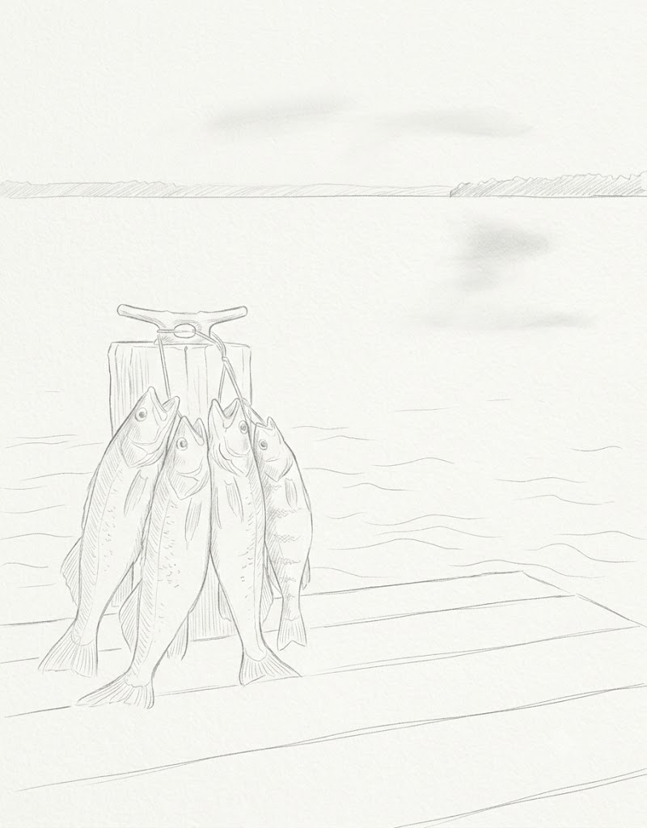
Keith Hurley
Fisheries Division – Research Section
Nebraska Game and Parks Commission

June 2026

2026 Nebraska Licensed Angler Survey
Site-Specific Versus Simplified Regulations
Table of Contents
1. Introduction 2
2. Methods 3
3. Results 3
3.1. Dimensionality and the three-scale solution 3
3.2. Reliability 6
3.3. Two correlated scales versus a single bipolar composite 7
4. Discussion 8
4.1. Interaction of comprehension and policy scales 8
4.2. Fishing avidity and species preference 10
4.3. Standalone Item C 11
4.4. Population sizes of the quadrants 13
4.5. Limitations 14
5. Implications 14
5.1. Fisheries regulations 14
5.2. Scale development. 15
6. Appendex A 15
7. References 25

Introduction
The use of harvest regulations is one of the most-commonly used tools in the management of sport fisheries. Harvest regulations can be applied to fisheries over a region-wide or state-wide scale, or they can be applied to specific waterbodies or fisheries in a site-specific manner. While site-specific regulations are often more effective at addressing local concerns, region-wide and state-wide regulations can provide consistency and broader management benefits. Fisheries managers, adminstrators, and the general public often disagree on the best mix of wide-scale and site-specific regulations due to percieved complexity, compliance, enforcement, and other social issues. The 2025 Statwide License Angler Survey (LAS) included a series of questions that were designed to assess angler attitudes toward the use of harvest regulations, particularly among different spatial scales (see Appendix A for the full list of questions).
These questions were designed to cover a range of opinions and attitudes towards regulations. As the questions are new and under their first iteration of use, no a priori scale structure was imposed on the questions. The following report describes the development of a scale structure for the regulation questions, the reliability of the resulting scales, and the relationship of the scale results to other survey parameters.

Methods
Logistic implementation of the 2025 LAS is described in Bosr (2026). Analysis of survey returns, response bias, and weighting stratigies are found in Hurley (2026). The twelve regulation items (Items A–L) were administered as a single block of 5-point statements with responses of: 1 = Strongly disagree, 2 = Slightly disagree, 3 = Neither agree nor disagree, 4 = Slightly agree, and 5 = Strongly agree (Appendix A). The questions were written as balanced between three scale constructs including multi-directionality. However, this analysis treats the list of items without an a priori scale structure. Any reversal of answer directionality was determined by survey responses and the scale development analysis.
Analyses used 2,382 of 2,822 2025 LAS respondents (84.4%) who answered all twelve items. Per-item nonresponse was modest and uniform (11–13%), consistent with incidental item skipping rather than structured non-response. All correlational and factor-analytic steps used polychoric correlations due to the ordinal nature of the items. Item and scale structure was explored unweighted on the rationale that measurement structure is a property of the instrument rather than of the survey response composition. Appriopiate per-respondant survey weighting suggested by Hurley (2026) was used only for the population-level estimates and comparisons (post-stratified on age group and residency).

Results

Dimensionality and the three-scale solution
Before extraction, the correlation matrix was checked for factorability. The Kaiser–Meyer–Olkin measure of sampling adequacy was 0.85, with all per-item values ≥ 0.77. By Kaiser’s (1974) conventional benchmarks (< 0.50 unacceptable, 0.70–0.79 middling, 0.80–0.89 meritorious, ≥ 0.90 marvelous), the items are comfortably in the meritorious range. Bartlett’s test of sphericity rejected the hypothesis that the items represent an identity-matrix (χ²(66) = 14,553, p < .001). These results confirm that sufficient common variance exists to factor.
Horn’s parallel analysis (which retains factors whose eigenvalues exceed those from random data of equivalent dimensions) indicated 3 factors in the items (Figure 1). The polychoric inter-item correlations (Figure 2) show the same three blocks visually and that the two policy blocks split by direction: the simplification items correlate positively among themselves and negatively with the site-specific items.
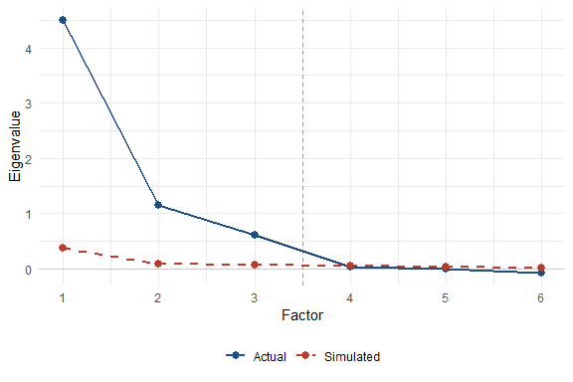
Figure 1: Figure 1. Horn’s parallel analysis scree plot. Actual factor eigenvalues (solid line) exceed mean eigenvalues from 100 random datasets of equivalent dimensions (dashed line) for the first three factors, supporting retention of a 3-factor solution.
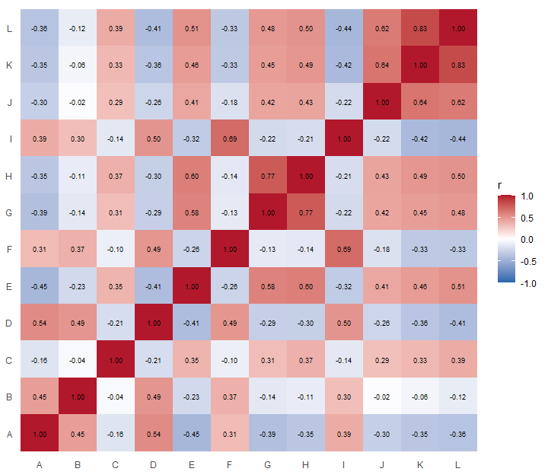
Figure 2: Figure 2. Polychoric inter-item correlations among the twelve regulation items.
A three-factor model was also estimated by maximum likelihood with oblique rotation. The rotated pattern (Table 1) is simple and interpretable. Eleven of twelve items load saliently (|loading| ≥ .40) on exactly one factor with no consequential cross-loadings. The factors correspond to regulation comprehension and confidence (comprehension; Items E, G, H), site-specific support (site-specific; Items J, K, L), and simplification preference (simplification; Items A, B, D, F, I).
Item | Statement | Comprehension | Site-specific | Simplification | h²
E | Nebraska's mix of statewide and site-specific regulations is easy for me to understand. | 0.56 |  |  | 0.54
G | Fishing regulations are clear enough that I rarely worry about accidentally breaking them. | 0.85 |  |  | 0.74
H | I feel confident that I understand Nebraska's fishing regulations. | 0.83 |  |  | 0.76
J | I trust fisheries' managers to decide when site-specific regulations are necessary. |  | 0.63 |  | 0.49
K | Site-specific regulations are important because different waters need different management approaches. |  | 0.91 |  | 0.86
L | Creating special fishing opportunities at certain waters is worth having lake-specific regulations. |  | 0.82 |  | 0.81
A | Site-specific rules make fishing regulations unnecessarily complicated. | -0.32 |  | 0.50 | 0.43
B | Simplified, uniform regulations are more likely to be obeyed by anglers. |  |  | 0.65 | 0.40
D | Fisheries' managers should avoid site-specific regulations to avoid confusing anglers. |  |  | 0.68 | 0.56
F | It is better to have uniform statewide regulations, even if that means they aren't always effective everywhere. |  |  | 0.73 | 0.57
I | I would rather have one set of regulations everywhere, even if it limits unique fishing opportunities. |  |  | 0.67 | 0.58
Table 1. Oblimin-rotated factor loadings from maximum-likelihood extraction on the polychoric correlation matrix (loadings < .30 suppressed; Item C excluded — see text); h² = communality. TLI = 0.897, RMSEA = 0.097.
Item C - “Anglers are willing to follow complex regulations to produce high-quality fisheries” — failed to relate with any factor (no loading ≥ .30; largest polychoric correlation = 0.39). It instead appears to tap the idea of complience that the remaining items do not. Retaining it would degrade rather than improve any of the other scales. Item C was excluded from all scale scores and is reported only at the item level.
The three-factor model accounted for 58% of the variance of the items. Overall approximate fit was acceptable for an exploratory solution (TLI = 0.897, RMSEA = 0.097), with the residual misfit attributable largely to the orphan item and a minor secondary loading on Item A.

Reliability
Internal consistency was estimated with Cronbach’s α and McDonald’s ω (Table 2). Conventionally, α ≥ .70 is considered acceptable and ≥ .80 good (Nunnally & Bernstein, 1994); ω is reported alongside because it does not assume tau-equivalence and is the preferred coefficient for congeneric items (McDonald, 1999; McNeish, 2018). All three scales meet or approach the “good” threshold, and no item deletion would materially raise any coefficient, so all items were retained.
Scale | Items | Cronbach alpha | McDonald omega
Comprehension | 3 | 0.810 | 0.853
Site-specific | 3 | 0.832 | 0.880
Simplification | 5 | 0.773 | 0.809
Table 2. Internal-consistency reliability for the three derived scales.

Two correlated scales versus a single bipolar composite
Because the simplified and site-specific items are negatively related, a natural question is whether the eight policy items measure one bipolar dimension (simplification at one pole, site-specificity at the other) or two distinct but correlated dimensions. The three-factor EFA structure established in the previous section is suggested by this analysis; the confirmatory analysis here addresses a narrower question specifically about the two policy-orientation factors — whether the simplification and site-specific items, which load on separate EFA factors, nonetheless reduce to a single, more-easily understood bipolar dimension. This was tested with confirmatory factor analysis on the eight policy items, using the WLSMV estimator appropriate for ordinal indicators, comparing a one-factor model against a two-factor correlated model (Table 3).
Model | CFI | TLI | RMSEA | SRMR
1-factor (bipolar) | 0.816 | 0.743 | 0.288 | 0.150
2-factor (correlated) | 0.946 | 0.920 | 0.161 | 0.077
Table 3. CFA fit for competing structures of the eight policy items (WLSMV, robust/scaled indices).
Against standard cutoffs (good fit: CFI/TLI ≥ .95, RMSEA ≤ .06, SRMR ≤ .08; acceptable: CFI/TLI ≥ .90, RMSEA ≤ .08; Hu & Bentler, 1999), the one-factor model fits poorly (CFI = 0.82, RMSEA = 0.29), whereas the two-factor model is far better (CFI = 0.95, RMSEA = 0.16). A robust scaled chi-square difference test strongly favors two factors (Δχ²(1) = 985, p < .001). The two-factor model estimates the latent correlation between the two policy factors at -0.52—substantial, but well short of the −1 that a true single bipolar axis would require (the two poles share only about 27% of their variance).
The practical difference between a two-scale and single-scale approach to the support of the different regulation complexity levels is visible when respondents are scored both ways (Figure 3). Under the two-scale framing the data do not collapse onto the diagonal that a pure bipolar dimension implies; a large group scores high on both scales. The single reversed composite, though internally consistent (α = 0.8), averages these respondents toward the middle and conceals that pattern.
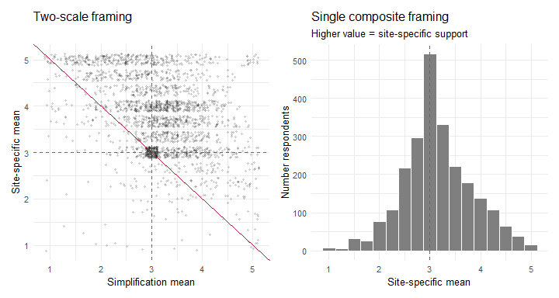
Figure 3: Figure 3. Two-scale framing (left) versus single reversed composite (right). Red line marks where a strictly bipolar dimension would place respondents.
The evidence supports retaining two policy scales (site-specific and simplification) rather than a single composite. Beyond the statistical case, the two-scale representation preserves the most interesting group, the anglers who simultaneously value local tailoring and worry about complexity, who are otherwise erased. The composite scale can remain available for occasions that call for a single summary number, with the caveat that it compresses a genuinely two-dimensional attitude.

Discussion

Interaction of comprehension and policy scales
To connect the comprehension scale to the policy debate, respondents were split at the scale midpoints (3.0) into four quadrants: Site-specific only, Simplification only, Wants both (high on both), and Neither (low on both). A multinomial logistic regression predicting quadrant membership from comprehension (Table 4, Figure 4) shows a strong, monotonic gradient (likelihood-ratio χ²(3) = 538.5, p < .001).
Contrast | Odds Ratio
Statewide only vs Wants both | 0.38 [0.32, 0.44]
Neither vs Wants both | 0.54 [0.46, 0.64]
Site-specific only vs Wants both | 1.94 [1.71, 2.19]
Table 4. Odds ratios for a one-point increase in comprehension, relative to the “Wants both” reference group.
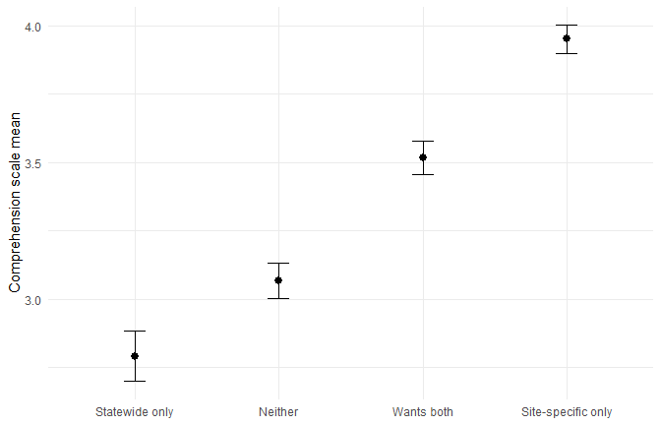
Figure 4: Figure 4. Mean comprehension by policy quadrant. Error bars represent 95% confidence interval.
Each one-point rise in comprehension nearly doubles the odds of being “Site-specific only” rather than “Wants both” (OR = 1.94) and sharply lowers the odds of being “Statewide only” (OR = 0.38). For fishery managers, the actionable finding is that support for more complex, locally tailored regulations rises with anglers’ confidence that they understand the rules. Investments that make regulations easier to find, read, and apply are therefore not merely a customer-service function but may plausibly expand the constituency comfortable with the site-specific management that biologists often need.

Fishing avidity and species preference
A reasonable consideration is that the comprehension–policy link is a by-product of how much or for what people fish. Adding fishing avidity (log of total days fished in 2025) and target-species preference to the model leaves the comprehension effect essentially unchanged (Table 5): the adjusted odds ratios match the unadjusted ones to two decimals, and comprehension remains the dominant term (LR χ²(3) = 530.5, p < .001).
Contrast | Odds ratio - original | Odds ration - adjusted
Statewide only vs Wants both | 0.38 | 0.37
Neither vs Wants both | 0.54 | 0.54
Site-specific only vs Wants both | 1.94 | 1.94
Table 5. Comprehension odds ratios before and after adjusting for avidity and species preference.
The two covariates behave differently from one another. Fishing avidity is not associated with policy quadrant in the multinomial model (LR χ²(3) = 5.3, p = 0.15): how often an angler fishes does not predict where they stand. However Species preference is associated (LR χ²(21) = 60.5, p < .001), though the practical differences are modest; most groups fall within a few points of one another (Figure 5). The clearest departure is among trout anglers, who lean toward simplified regulations more than other groups (Figure 5). This pattern is worth noting for managers given the site-specific nature of much of Nebraska’s trout management.
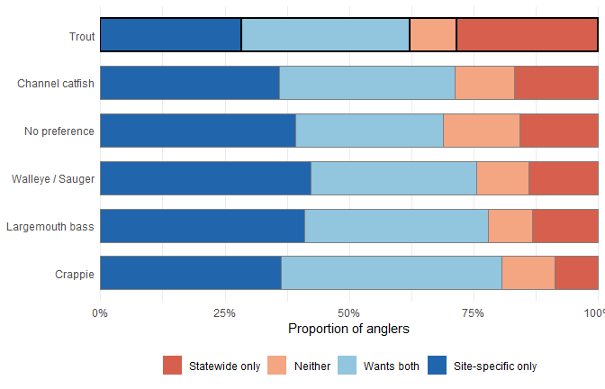
Figure 5: Figure 5. Policy quadrant membership by target species preference (anglers with missing or unspecified species preference excluded), sorted by proportion in the Statewide-only quadrant. Trout anglers (outlined) show the strongest lean toward simplifed regulations.
Demographically, the “wants both” segment is unremarkable. It does not differ from other anglers in residency (χ²(1) = 0.36, p = 0.55; Cramér’s V = 0.013) or gender (χ²(1) = 0.51, p = 0.48; V = 0.015), and is only trivially older (median 62 vs 58 years; Wilcoxon p = 0.003, rank-biserial r = -0.07). Because the “wants both” segment is demographically unremarkable, the appetite for both flexibility and simplicity should be understood as a mainstream attitude rather than a position of any demographic subgroup. Coupled with the comprehension scale relationships, support of this group for site-specific regulations also appears to be mallable with education and enforcement actions.

Standalone Item C
Item C (“Anglers are willing to follow complex regulations to produce high-quality fisheries”) was excluded from the scales because it failed to load cleanly on any factor. While it doesn’t factor into the three scales presented, its responses are still worth examining outside of scale developement because it speaks to a stated behavioral willingness rather than a policy preference.
quadrant | n | Mean | 95% CI
Site-specific only | 869 | 3.45 | 3.45 ± 0.07
Wants both | 845 | 3.27 | 3.27 ± 0.07
Neither | 287 | 2.98 | 2.98 ± 0.08
Statewide only | 381 | 2.73 | 2.73 ± 0.10
Table 7. Mean agreement with Item C by policy quadrant.
Agreement with Item C is unevenly distributed across the quadrants (Kruskal-Wallis χ²(3) = 156.3, p < .001; Figure 7). It is highest among the Site-specific only group (3.45) and lowest among the Statewide only group (2.73). Consistent with this, Item C correlates positively with both the comprehension scale (Spearman ρ = 0.34) and the site-specific scale (ρ = 0.34), and weakly negatively with simplification (ρ = -0.15).
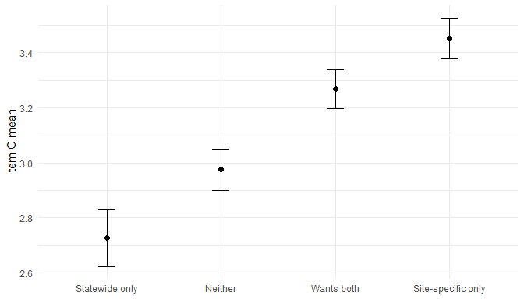
Figure 6: Figure 7. Mean agreement with Item C by policy quadrant. Error bars represent 95% confidence intervals.
This dual association explains why Item C resisted assignment to a single factor: it draws simultaneously on feeling competent with the rules and on valuing locally tailored management, the two constructs that the exploratory analysis kept distinct. Item C functions less like a scale indicator than like a downstream attitude the scales help account for. For fishery managers, the implication is direct and encouraging. The anglers most willing to comply with complex, site-specific rules in pursuit of better fishing are those who understand the regulations and already endorse tailored management. This reinforces the earlier conclusion that improving regulatory comprehension is a plausible route not only to broader acceptance of site-specific regulation but to greater willingness to follow it. However, this is a single item and repeated measures on future application of this instrument may be needed to confirm this construct.

Population sizes of the quadrants
Finally, the quadrants were projected to the licensed-angler population using the survey respondant weights (post-stratified on age group and residency; Hurley 2026). A design-based estimator (Taylor-linearized standard errors) yields the weighted prevalences and 95% confidence intervals in Table 6 and Figure 6. Weighting shifts the estimates only slightly relative to the raw sample, indicating that attitude composition is not strongly confounded with the age or residency margins used in weighting.
Quadrant | Unweighted % | Weighted %
Site-specific only | 36.5 ± 1.9 | 38.4 ± 2.2
Wants both | 35.5 ± 1.9 | 34.4 ± 2.1
Statewide only | 16.0 ± 1.5 | 14.9 ± 1.6
Neither | 12.0 ± 1.3 | 12.4 ± 1.5
Table 6. Unweighted and weighted (raked) quadrant prevalence with design-based 95% confidence intervals.
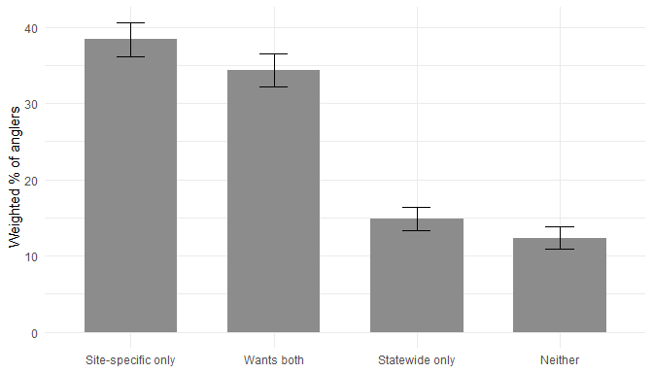
Figure 7: Figure 6. Weighted population prevalence of the four policy quadrants (design-based 95% CIs).
Roughly 38% of Nebraska anglers endorse site-specific regulation without favoring statewide regulation, while a comparable 34% want both simplicity and local tailoring. Only about 15% prefer statewide regulations alone. For decision-makers, the message is that outright opposition to site-specific regulation is a minority position, but another group of anglers hold the more nuanced “both” view which suggests that communication emphasizing why particular waters carry particular regulations, paired with genuine effort to keep the overall system comprehendible, and adaquate education and enforcement actions are likely to resonate more broadly than either pure simplification or unexplained complexity.

Limitations
Some limitations could apply to these results. The scales derived in this study including comprehension, site-specific preference, simplification preference, and their combinations were measured in a single cross-sectional effort. It is possible that the associations found can be purely correlative here and should taken as informative but not as causational. Higher comprehension may foster openness to complexity, or anglers predisposed toward site-specific management may simply invest more in learning the rules, or both may be true. Anglers may share a common driver such as engagement or experience or education and this analysis cannot differentiate among them. These results also rely on stated versus realized preferences. Any given respondant may score highly on site-specific or simplified scales, yet when faced with a concrete regulation implimentation may exhibit a different realized response driven by situation specfic parameters. Results presented reflect population analysis of generalized, stated opinions and preferences The analysis also rests on a single survey year (2025) and angler population sampling so the scale structure and prevalence estimates should be treated as provisional or potentially transitional, Confirmatory cross-validation in a future survey efforts would be needed to establish measurement over time and confirm the three-factor solution is stable rather than sample-specific.

Implications

Fisheries regulations
From a broad persepective, 2025 LAS respondants expressed more support for site-specific approaches over simplified, regional approaches to regulating fisheries. However, the smaller, no inconsequential amount of respondents that did favor simplified regulations indicates that that discontent may be expressed regardless of approach used. The tipping point for policy application appears to lie with a sizable portion of respondants who are willing to support either approach. The critical consideration to move respondants towards site-specific regulations appears to be the ability to comprehend both the regulations themselves and the logic behind them as well as trust in the managers that set the recommendations. With proper educational and outreach efforts, this large, middle-group of respondants will likely lend the support needed for any regulation change or implementation.

Scale development.
The simplification preference scale warrants attention in future survey iterations: all five of its items are negatively worded (reversed), meaning angler agreement consistently signals preference for simpler, statewide rules. While the scale performs reliably (ω = ), all-same-direction item blocks are susceptible to acquiescence bias — a tendency to agree with statements regardless of content. Future development should introduce positively worded counterparts to create a more balanced item pool. Additionally, additional questions to complement Item C could help create a useful fourth scale looking at perception of angler behaviors.
While they score well on factor loading and consistance, the comprehension and site-specific scales are also relatively narrow at three items. Broadening it with additional items tapping angler confidence with specific regulatory formats and additional site-specific examples may improve not on cosmetic balance but also content coverage providing a more stable platform for longitudinal monitoring.

Appendex A
How much do you agree or disagree with each of the following items regarding fishing regulations? Values represent mean response +- 95% confidence intervals with sample size given in parenthesis. Answers included (from 1 to 5): Strongly Disagree, Disagree, Neutral, Agree, Strongly Agree. Items marked with a dagger (†) are reverse coded so that all items in this question scale in the same direction. Their response values were inverted (1=5, 2=4, 4=2, 5=1) before computing scale means and medians. These results were weighted. Please consult the survey methodology for details.
Item | Statement | Response | Overall | Resident | Non-Resident | Male | Female
A | Site-specific rules make fishing regulations unnecessarily complicated. † | Strongly disagree | 14.3+-0.15 (336) | 14.6+-0.17 (300) | 13.7+-0.42 (29) | 13.9+-0.17 (263) | 16.2+-0.37 (72)
A |  | Slightly disagree | 14.4+-0.15 (328) | 13.9+-0.16 (285) | 18.9+-0.48 (37) | 14+-0.17 (261) | 14.8+-0.36 (62)
A |  | Neither agree nor disagree | 37.9+-0.21 (979) | 37.8+-0.23 (857) | 41+-0.6 (103) | 36.9+-0.23 (779) | 42.5+-0.5 (194)
A |  | Slightly agree | 23+-0.18 (586) | 22.9+-0.2 (514) | 19.9+-0.49 (54) | 24+-0.21 (497) | 19.2+-0.39 (88)
A |  | Strongly agree | 10.4+-0.13 (269) | 10.8+-0.15 (242) | 6.6+-0.3 (18) | 11.2+-0.15 (225) | 7.3+-0.26 (43)
B | Simplified, uniform regulations are more likely to be obeyed by anglers. † | Strongly disagree | 4.2+-0.09 (98) | 4+-0.09 (85) | 6.2+-0.29 (13) | 4.3+-0.1 (80) | 3.7+-0.19 (17)
B |  | Slightly disagree | 6.4+-0.11 (158) | 5.6+-0.11 (127) | 11.2+-0.39 (28) | 6.4+-0.12 (128) | 5.3+-0.22 (26)
B |  | Neither agree nor disagree | 27.2+-0.19 (697) | 27.2+-0.21 (611) | 28.9+-0.55 (69) | 26.2+-0.21 (554) | 32.1+-0.47 (141)
B |  | Slightly agree | 34.6+-0.21 (857) | 34.8+-0.22 (762) | 32.6+-0.57 (79) | 34.5+-0.23 (697) | 34.9+-0.48 (157)
B |  | Strongly agree | 27.7+-0.19 (687) | 28.4+-0.21 (611) | 21.1+-0.5 (54) | 28.6+-0.22 (563) | 24+-0.43 (122)
C | Anglers are willing to follow complex regulations to produce high-quality fisheries. | Strongly disagree | 7.2+-0.11 (169) | 7.8+-0.13 (156) | 3.2+-0.21 (9) | 7.5+-0.13 (140) | 5.8+-0.23 (27)
C |  | Slightly disagree | 14.8+-0.15 (374) | 15.1+-0.17 (333) | 14.2+-0.43 (36) | 15.5+-0.18 (314) | 11.5+-0.32 (57)
C |  | Neither agree nor disagree | 39.6+-0.21 (1006) | 39.3+-0.23 (886) | 41.4+-0.6 (98) | 38.1+-0.23 (785) | 46.4+-0.5 (216)
C |  | Slightly agree | 25.8+-0.19 (634) | 25.8+-0.21 (560) | 25.7+-0.54 (58) | 26.7+-0.21 (534) | 22.1+-0.41 (97)
C |  | Strongly agree | 12.5+-0.14 (309) | 12+-0.15 (258) | 15.5+-0.44 (40) | 12.2+-0.16 (242) | 14.1+-0.35 (67)
D | Fisheries' managers should avoid site-specific regulations to avoid confusing anglers. † | Strongly disagree | 10.9+-0.14 (264) | 11.2+-0.15 (235) | 10.9+-0.38 (28) | 11+-0.15 (213) | 10.7+-0.31 (50)
D |  | Slightly disagree | 14.9+-0.16 (350) | 14.7+-0.17 (304) | 17+-0.46 (37) | 15.7+-0.18 (302) | 10.9+-0.31 (44)
D |  | Neither agree nor disagree | 44.6+-0.22 (1118) | 44.6+-0.23 (989) | 45.2+-0.61 (104) | 42.4+-0.24 (873) | 54.5+-0.5 (241)
D |  | Slightly agree | 20.3+-0.18 (498) | 20+-0.19 (433) | 21.1+-0.5 (53) | 21+-0.2 (413) | 17+-0.38 (82)
D |  | Strongly agree | 9.2+-0.13 (242) | 9.6+-0.14 (215) | 5.8+-0.29 (18) | 9.8+-0.14 (202) | 6.9+-0.25 (40)
E | Nebraska's mix of statewide and site-specific regulations is easy for me to understand. | Strongly disagree | 5.6+-0.1 (146) | 6+-0.11 (134) | 2.6+-0.2 (7) | 6+-0.12 (122) | 4+-0.2 (23)
E |  | Slightly disagree | 14+-0.15 (376) | 15.1+-0.17 (351) | 5+-0.27 (15) | 14.6+-0.17 (315) | 11.6+-0.32 (59)
E |  | Neither agree nor disagree | 38.6+-0.21 (990) | 37.4+-0.23 (845) | 47.6+-0.61 (124) | 38.4+-0.24 (804) | 39.9+-0.49 (183)
E |  | Slightly agree | 26.2+-0.19 (610) | 26.3+-0.21 (544) | 26.5+-0.54 (55) | 25.4+-0.21 (486) | 28.9+-0.45 (121)
E |  | Strongly agree | 15.6+-0.16 (348) | 15.2+-0.17 (299) | 18.3+-0.48 (39) | 15.6+-0.18 (274) | 15.7+-0.36 (72)
F | It is better to have uniform statewide regulations, even if that means they aren't always effective everywhere. † | Strongly disagree | 11.7+-0.14 (273) | 11.7+-0.15 (233) | 12.5+-0.41 (34) | 12+-0.16 (230) | 9.8+-0.3 (41)
F |  | Slightly disagree | 19.5+-0.17 (459) | 19+-0.18 (400) | 22.8+-0.52 (48) | 19.6+-0.19 (380) | 18.8+-0.39 (77)
F |  | Neither agree nor disagree | 37.9+-0.21 (934) | 37.7+-0.23 (827) | 38.7+-0.6 (90) | 37.3+-0.23 (741) | 41.2+-0.49 (191)
F |  | Slightly agree | 21.2+-0.18 (556) | 21.8+-0.19 (501) | 17.2+-0.46 (43) | 21.2+-0.2 (452) | 21.2+-0.41 (102)
F |  | Strongly agree | 9.8+-0.13 (248) | 9.8+-0.14 (213) | 8.8+-0.35 (24) | 9.8+-0.14 (197) | 9+-0.29 (48)
G | Fishing regulations are clear enough that I rarely worry about accidentally breaking them. | Strongly disagree | 5+-0.1 (128) | 4.9+-0.1 (111) | 2.9+-0.21 (7) | 5.4+-0.11 (110) | 3.4+-0.18 (17)
G |  | Slightly disagree | 15.4+-0.16 (387) | 15.5+-0.17 (345) | 16.6+-0.46 (37) | 16+-0.18 (325) | 13.4+-0.34 (61)
G |  | Neither agree nor disagree | 25.3+-0.19 (648) | 24.4+-0.2 (559) | 32.1+-0.57 (76) | 24.8+-0.21 (515) | 27.7+-0.45 (130)
G |  | Slightly agree | 31.2+-0.2 (768) | 32.1+-0.22 (687) | 25.4+-0.53 (63) | 30.6+-0.22 (613) | 33.8+-0.47 (151)
G |  | Strongly agree | 23.1+-0.18 (553) | 23.2+-0.2 (484) | 23+-0.52 (57) | 23.3+-0.2 (446) | 21.8+-0.41 (104)
H | I feel confident that I understand Nebraska's fishing regulations. | Strongly disagree | 2.5+-0.07 (67) | 2.5+-0.07 (59) | 0.6+-0.09 (2) | 2.2+-0.07 (52) | 3.7+-0.19 (15)
H |  | Slightly disagree | 9.7+-0.13 (242) | 9.7+-0.14 (214) | 10.2+-0.37 (24) | 10+-0.15 (203) | 8.4+-0.28 (39)
H |  | Neither agree nor disagree | 23.3+-0.18 (594) | 22+-0.2 (504) | 30.4+-0.56 (74) | 23+-0.2 (474) | 24.8+-0.43 (118)
H |  | Slightly agree | 33.9+-0.21 (845) | 34.9+-0.22 (759) | 28.8+-0.56 (70) | 33.1+-0.23 (676) | 37.2+-0.48 (165)
H |  | Strongly agree | 30.8+-0.2 (730) | 31+-0.22 (644) | 30.1+-0.56 (71) | 31.7+-0.23 (600) | 25.9+-0.44 (125)
I | I would rather have one set of regulations everywhere, even if it limits unique fishing opportunities. † | Strongly disagree | 15.8+-0.16 (361) | 15.7+-0.17 (311) | 16.6+-0.46 (43) | 16.8+-0.18 (310) | 11.2+-0.32 (49)
I |  | Slightly disagree | 21.2+-0.18 (492) | 22+-0.2 (451) | 18.4+-0.48 (36) | 20.7+-0.2 (394) | 23.5+-0.43 (96)
I |  | Neither agree nor disagree | 36+-0.21 (901) | 35.2+-0.22 (782) | 40.7+-0.61 (95) | 35.7+-0.23 (721) | 38+-0.49 (177)
I |  | Slightly agree | 18+-0.17 (473) | 17.9+-0.18 (415) | 17.8+-0.47 (45) | 17.4+-0.18 (379) | 20.4+-0.41 (92)
I |  | Strongly agree | 8.9+-0.12 (249) | 9.2+-0.14 (221) | 6.5+-0.31 (19) | 9.4+-0.14 (203) | 6.8+-0.25 (44)
J | I trust fisheries' managers to decide when site-specific regulations are necessary. | Strongly disagree | 3.5+-0.08 (89) | 3.7+-0.09 (81) | 1.5+-0.15 (4) | 3.8+-0.09 (76) | 1.9+-0.14 (12)
J |  | Slightly disagree | 7+-0.11 (179) | 7.5+-0.12 (164) | 4.7+-0.26 (13) | 7.7+-0.13 (158) | 4.3+-0.2 (19)
J |  | Neither agree nor disagree | 33.3+-0.21 (850) | 32.9+-0.22 (744) | 33.9+-0.59 (84) | 33.3+-0.23 (678) | 33.3+-0.47 (169)
J |  | Slightly agree | 34.4+-0.21 (822) | 34.7+-0.22 (729) | 32.8+-0.58 (74) | 33.3+-0.23 (656) | 38.7+-0.49 (163)
J |  | Strongly agree | 21.8+-0.18 (536) | 21.2+-0.19 (463) | 27.2+-0.55 (63) | 21.9+-0.2 (438) | 21.8+-0.42 (96)
K | Site-specific regulations are important because different waters need different management approaches. | Strongly disagree | 1.3+-0.05 (38) | 1.3+-0.05 (32) | 1.1+-0.13 (4) | 1.4+-0.06 (33) | 0.8+-0.09 (5)
K |  | Slightly disagree | 3.5+-0.08 (90) | 3.7+-0.09 (84) | 2.7+-0.2 (6) | 4+-0.09 (80) | 1.2+-0.11 (9)
K |  | Neither agree nor disagree | 26.4+-0.19 (657) | 25.6+-0.21 (568) | 28.3+-0.56 (67) | 26+-0.21 (517) | 28.3+-0.45 (137)
K |  | Slightly agree | 35.3+-0.21 (892) | 35.7+-0.23 (789) | 34.7+-0.59 (88) | 35+-0.23 (732) | 36.3+-0.48 (156)
K |  | Strongly agree | 33.5+-0.21 (796) | 33.7+-0.22 (706) | 33.3+-0.58 (72) | 33.6+-0.23 (642) | 33.4+-0.48 (151)
L | Creating special fishing opportunities at certain waters is worth having lake-specific regulations. | Strongly disagree | 1.8+-0.06 (51) | 1.9+-0.06 (45) | 1.1+-0.13 (4) | 1.9+-0.07 (45) | 1.1+-0.11 (6)
L |  | Slightly disagree | 4.4+-0.09 (111) | 4.4+-0.1 (98) | 4.8+-0.27 (13) | 5.1+-0.11 (104) | 1.3+-0.11 (7)
L |  | Neither agree nor disagree | 31.1+-0.2 (797) | 29.9+-0.22 (685) | 35.9+-0.6 (84) | 30.3+-0.22 (620) | 34.7+-0.48 (174)
L |  | Slightly agree | 32.1+-0.2 (813) | 32.9+-0.22 (725) | 28.2+-0.56 (74) | 30.6+-0.22 (648) | 38+-0.49 (160)
L |  | Strongly agree | 30.6+-0.2 (689) | 30.9+-0.22 (614) | 30+-0.57 (62) | 32+-0.23 (578) | 24.8+-0.44 (109)
How much do you agree or disagree with each of the following items regarding fishing regulations? Values represent mean response +- 95% confidence intervals with sample size given in parenthesis. Answers included (from 1 to 5): Strongly Disagree, Disagree, Neutral, Agree, Strongly Agree. Items marked with a dagger (†) are reverse coded so that all items in this question scale in the same direction. Their response values were inverted (1=5, 2=4, 4=2, 5=1) before computing scale means and medians. These results were weighted. Please consult the survey methodology for details.
Item | Statement | Response | 16-24 | 25-34 | 35-44 | 45-54 | 55-64 | 65 and older
A | Site-specific rules make fishing regulations unnecessarily complicated. † | Strongly disagree | 15.8+-0.5 (19) | 15.3+-0.4 (31) | 16.8+-0.38 (50) | 13.3+-0.35 (51) | 16.7+-0.43 (78) | 10.2+-0.27 (102)
A |  | Slightly disagree | 24.8+-0.59 (29) | 16.9+-0.42 (32) | 10.8+-0.32 (33) | 16.2+-0.38 (62) | 11.4+-0.37 (55) | 11.2+-0.28 (112)
A |  | Neither agree nor disagree | 27.7+-0.62 (34) | 32.8+-0.53 (65) | 43.4+-0.5 (129) | 37.2+-0.49 (148) | 37.2+-0.56 (178) | 42.1+-0.44 (410)
A |  | Slightly agree | 22.4+-0.57 (28) | 22.5+-0.47 (42) | 20.1+-0.41 (60) | 23.5+-0.43 (90) | 25.3+-0.5 (115) | 24.6+-0.39 (244)
A |  | Strongly agree | 9.3+-0.4 (12) | 12.5+-0.37 (26) | 8.9+-0.29 (27) | 9.8+-0.3 (41) | 9.4+-0.34 (47) | 11.9+-0.29 (111)
B | Simplified, uniform regulations are more likely to be obeyed by anglers. † | Strongly disagree | 1.6+-0.17 (2) | 3.1+-0.2 (6) | 5.7+-0.23 (17) | 6.1+-0.24 (23) | 4.9+-0.25 (21) | 2.9+-0.15 (28)
B |  | Slightly disagree | 5.9+-0.32 (7) | 3.9+-0.22 (8) | 8.8+-0.29 (26) | 4.8+-0.22 (18) | 8.3+-0.32 (39) | 5.6+-0.2 (55)
B |  | Neither agree nor disagree | 25.6+-0.6 (31) | 22.8+-0.47 (45) | 24.2+-0.43 (74) | 30.7+-0.47 (122) | 32.5+-0.54 (149) | 28+-0.4 (270)
B |  | Slightly agree | 34.4+-0.65 (41) | 36.2+-0.54 (70) | 35+-0.48 (105) | 36.6+-0.49 (143) | 29.1+-0.52 (142) | 34.5+-0.42 (342)
B |  | Strongly agree | 32.5+-0.64 (41) | 34+-0.53 (66) | 26.3+-0.45 (78) | 21.8+-0.42 (86) | 25.1+-0.5 (121) | 29.1+-0.41 (287)
C | Anglers are willing to follow complex regulations to produce high-quality fisheries. | Strongly disagree | 7.9+-0.37 (10) | 9.8+-0.33 (20) | 4.6+-0.21 (14) | 10.5+-0.31 (39) | 4.8+-0.25 (22) | 6.2+-0.22 (62)
C |  | Slightly disagree | 11.4+-0.44 (14) | 13.6+-0.38 (26) | 15.7+-0.37 (48) | 16.9+-0.38 (66) | 13.7+-0.4 (63) | 14.8+-0.32 (148)
C |  | Neither agree nor disagree | 35.7+-0.67 (41) | 36.9+-0.54 (71) | 42.3+-0.5 (127) | 34.6+-0.49 (139) | 44+-0.57 (207) | 42.8+-0.44 (409)
C |  | Slightly agree | 30.6+-0.64 (37) | 28.1+-0.5 (55) | 24+-0.43 (72) | 25.8+-0.45 (101) | 24.2+-0.49 (116) | 24.3+-0.38 (243)
C |  | Strongly agree | 14.4+-0.49 (18) | 11.7+-0.36 (23) | 13.4+-0.34 (40) | 12.2+-0.33 (47) | 13.4+-0.39 (64) | 11.9+-0.29 (116)
D | Fisheries' managers should avoid site-specific regulations to avoid confusing anglers. † | Strongly disagree | 10.7+-0.43 (13) | 8.5+-0.31 (17) | 11.5+-0.32 (33) | 14+-0.36 (54) | 12.7+-0.39 (55) | 9.2+-0.26 (91)
D |  | Slightly disagree | 15.9+-0.51 (19) | 17.4+-0.43 (33) | 13.9+-0.35 (41) | 16.2+-0.38 (61) | 14+-0.4 (66) | 12.4+-0.3 (122)
D |  | Neither agree nor disagree | 37.9+-0.68 (44) | 45.7+-0.56 (87) | 48.2+-0.51 (145) | 41.3+-0.51 (160) | 47.1+-0.58 (222) | 45.5+-0.45 (447)
D |  | Slightly agree | 25.6+-0.61 (31) | 19.7+-0.45 (39) | 18.6+-0.39 (56) | 19.7+-0.41 (78) | 18.3+-0.45 (86) | 21.3+-0.37 (200)
D |  | Strongly agree | 9.9+-0.42 (12) | 8.7+-0.32 (18) | 7.8+-0.27 (24) | 8.8+-0.29 (35) | 7.9+-0.31 (38) | 11.5+-0.29 (111)
E | Nebraska's mix of statewide and site-specific regulations is easy for me to understand. | Strongly disagree | 4.1+-0.27 (5) | 6.1+-0.27 (13) | 5+-0.22 (15) | 5.9+-0.24 (22) | 5.7+-0.27 (27) | 6.1+-0.22 (62)
E |  | Slightly disagree | 9.5+-0.41 (12) | 10.8+-0.35 (20) | 13.6+-0.35 (41) | 14.6+-0.36 (59) | 14.7+-0.41 (69) | 17.2+-0.34 (168)
E |  | Neither agree nor disagree | 31.6+-0.65 (37) | 37.9+-0.54 (74) | 35.7+-0.49 (107) | 37.1+-0.5 (147) | 40.2+-0.57 (186) | 44.9+-0.45 (429)
E |  | Slightly agree | 26+-0.61 (31) | 31.1+-0.52 (60) | 27.9+-0.45 (85) | 27+-0.46 (103) | 25.4+-0.51 (115) | 20.5+-0.36 (203)
E |  | Strongly agree | 28.8+-0.63 (35) | 14.1+-0.39 (28) | 17.8+-0.39 (52) | 15.4+-0.37 (57) | 13.9+-0.4 (65) | 11.2+-0.28 (111)
F | It is better to have uniform statewide regulations, even if that means they aren't always effective everywhere. † | Strongly disagree | 12.3+-0.46 (15) | 12.8+-0.38 (26) | 13.2+-0.34 (38) | 11.4+-0.33 (44) | 11.5+-0.37 (53) | 9.7+-0.27 (94)
F |  | Slightly disagree | 17.6+-0.53 (22) | 24.1+-0.48 (45) | 20.3+-0.41 (59) | 19.8+-0.41 (75) | 17.3+-0.44 (81) | 17.3+-0.34 (170)
F |  | Neither agree nor disagree | 35.2+-0.66 (42) | 37.5+-0.54 (72) | 38.6+-0.49 (116) | 38.2+-0.5 (146) | 39.4+-0.57 (179) | 38.2+-0.44 (368)
F |  | Slightly agree | 22.7+-0.58 (26) | 18.3+-0.44 (36) | 18.7+-0.4 (58) | 20.2+-0.41 (82) | 22.7+-0.49 (109) | 24.2+-0.38 (237)
F |  | Strongly agree | 12.3+-0.46 (15) | 7.3+-0.29 (15) | 9.2+-0.29 (28) | 10.4+-0.31 (39) | 9.1+-0.33 (42) | 10.7+-0.28 (106)
G | Fishing regulations are clear enough that I rarely worry about accidentally breaking them. | Strongly disagree | 1.6+-0.18 (2) | 6.7+-0.28 (13) | 5.9+-0.24 (18) | 4.9+-0.22 (20) | 3.7+-0.22 (18) | 5.3+-0.2 (54)
G |  | Slightly disagree | 10.9+-0.43 (14) | 18.8+-0.44 (34) | 15.2+-0.36 (45) | 15.9+-0.37 (64) | 15.8+-0.42 (76) | 15+-0.32 (149)
G |  | Neither agree nor disagree | 20.2+-0.56 (23) | 20.9+-0.46 (41) | 25+-0.44 (75) | 26.2+-0.45 (105) | 25.9+-0.51 (119) | 29.2+-0.41 (276)
G |  | Slightly agree | 32.2+-0.65 (38) | 29.3+-0.51 (57) | 32.6+-0.47 (98) | 34.3+-0.49 (132) | 30.6+-0.54 (144) | 28.8+-0.4 (287)
G |  | Strongly agree | 35.1+-0.67 (42) | 24.3+-0.48 (49) | 21.3+-0.41 (64) | 18.7+-0.4 (70) | 24+-0.5 (109) | 21.8+-0.37 (215)
H | I feel confident that I understand Nebraska's fishing regulations. | Strongly disagree | 3.3+-0.25 (4) | 0.4+-0.07 (1) | 2.1+-0.15 (7) | 3.3+-0.18 (12) | 2.1+-0.17 (10) | 3.4+-0.16 (33)
H |  | Slightly disagree | 3.5+-0.26 (4) | 11+-0.35 (22) | 10.2+-0.31 (29) | 12.1+-0.33 (50) | 11+-0.36 (50) | 8.6+-0.25 (85)
H |  | Neither agree nor disagree | 19.8+-0.55 (23) | 22.6+-0.47 (43) | 23.4+-0.43 (69) | 21.1+-0.42 (85) | 22.6+-0.49 (105) | 27.4+-0.4 (261)
H |  | Slightly agree | 29.4+-0.63 (36) | 35.1+-0.54 (67) | 34.4+-0.48 (106) | 35.7+-0.49 (137) | 33.2+-0.55 (158) | 32.9+-0.42 (326)
H |  | Strongly agree | 44+-0.69 (53) | 30.9+-0.52 (60) | 29.9+-0.46 (89) | 27.8+-0.46 (106) | 31.1+-0.54 (142) | 27.8+-0.4 (273)
I | I would rather have one set of regulations everywhere, even if it limits unique fishing opportunities. † | Strongly disagree | 15+-0.5 (18) | 16+-0.41 (31) | 20.7+-0.41 (61) | 15.7+-0.37 (61) | 16.9+-0.44 (74) | 11.6+-0.29 (112)
I |  | Slightly disagree | 30.7+-0.65 (37) | 23.3+-0.48 (44) | 23.4+-0.43 (69) | 20.8+-0.42 (80) | 17.2+-0.44 (82) | 17.4+-0.34 (175)
I |  | Neither agree nor disagree | 33.8+-0.66 (39) | 37.2+-0.54 (72) | 33.2+-0.48 (100) | 33.5+-0.48 (132) | 40.9+-0.57 (190) | 37.2+-0.43 (356)
I |  | Slightly agree | 13.6+-0.48 (16) | 15.8+-0.41 (31) | 15.7+-0.37 (48) | 21+-0.42 (82) | 18+-0.45 (85) | 20.7+-0.36 (206)
I |  | Strongly agree | 6.9+-0.36 (8) | 7.7+-0.3 (16) | 7+-0.26 (22) | 8.9+-0.29 (34) | 7+-0.3 (33) | 13+-0.3 (130)
J | I trust fisheries' managers to decide when site-specific regulations are necessary. | Strongly disagree | 1.7+-0.18 (2) | 1.8+-0.15 (4) | 4.1+-0.2 (12) | 4.3+-0.21 (16) | 3+-0.2 (14) | 3.7+-0.17 (37)
J |  | Slightly disagree | 3.3+-0.25 (4) | 7.2+-0.29 (15) | 6.8+-0.26 (21) | 9.2+-0.3 (37) | 8.4+-0.32 (38) | 6+-0.21 (59)
J |  | Neither agree nor disagree | 24.4+-0.6 (29) | 32.9+-0.53 (63) | 31.7+-0.47 (95) | 33.8+-0.48 (133) | 33.1+-0.55 (152) | 38.3+-0.44 (367)
J |  | Slightly agree | 42.7+-0.69 (50) | 38.4+-0.55 (74) | 36.2+-0.49 (107) | 31.3+-0.47 (124) | 33.9+-0.55 (162) | 29.9+-0.41 (298)
J |  | Strongly agree | 28+-0.63 (33) | 19.6+-0.45 (38) | 21.2+-0.41 (64) | 21.4+-0.42 (80) | 21.6+-0.48 (100) | 22.1+-0.37 (216)
K | Site-specific regulations are important because different waters need different management approaches. | Strongly disagree |  |  | 1.2+-0.11 (4) | 2.1+-0.15 (8) | 1.4+-0.14 (6) | 2.1+-0.13 (19)
K |  | Slightly disagree | 1.7+-0.18 (2) | 2.5+-0.18 (5) | 3.7+-0.19 (11) | 4+-0.2 (16) | 4.1+-0.23 (15) | 3.7+-0.17 (38)
K |  | Neither agree nor disagree | 23.3+-0.59 (27) | 25.6+-0.49 (49) | 27.9+-0.45 (85) | 26.9+-0.46 (106) | 24.5+-0.5 (118) | 27.8+-0.4 (262)
K |  | Slightly agree | 31.5+-0.65 (37) | 36.6+-0.54 (72) | 31.8+-0.47 (94) | 34.4+-0.49 (134) | 38.6+-0.57 (179) | 36.7+-0.43 (362)
K |  | Strongly agree | 43.6+-0.7 (52) | 35.2+-0.54 (68) | 35.3+-0.48 (106) | 32.7+-0.48 (124) | 31.5+-0.54 (147) | 29.7+-0.41 (295)
L | Creating special fishing opportunities at certain waters is worth having lake-specific regulations. | Strongly disagree | 0.8+-0.13 (1) |  | 1.7+-0.13 (5) | 2.6+-0.16 (10) | 1.4+-0.14 (6) | 2.9+-0.15 (27)
L |  | Slightly disagree | 3.3+-0.25 (4) | 6.1+-0.27 (12) | 1.9+-0.14 (6) | 5.2+-0.23 (21) | 5.4+-0.26 (22) | 4.6+-0.19 (45)
L |  | Neither agree nor disagree | 26.5+-0.62 (30) | 25.3+-0.49 (48) | 34.3+-0.48 (102) | 28.9+-0.47 (116) | 32.9+-0.55 (159) | 34.4+-0.43 (329)
L |  | Slightly agree | 24.1+-0.6 (29) | 32.2+-0.53 (63) | 30.8+-0.47 (93) | 32.2+-0.48 (125) | 34.7+-0.55 (160) | 34.1+-0.43 (332)
L |  | Strongly agree | 45.2+-0.7 (54) | 36.3+-0.54 (69) | 31.4+-0.47 (94) | 31.1+-0.48 (116) | 25.5+-0.51 (117) | 24+-0.38 (236)
How much do you agree or disagree with each of the following items regarding fishing regulations? Values represent mean response +- 95% confidence intervals with sample size given in parenthesis. Answers included (from 1 to 5): Strongly Disagree, Disagree, Neutral, Agree, Strongly Agree. Items marked with a dagger (†) are reverse coded so that all items in this question scale in the same direction. Their response values were inverted (1=5, 2=4, 4=2, 5=1) before computing scale means and medians. These results were weighted. Please consult the survey methodology for details.
Item | Statement | Overall | Resident | Non-Resident | Male | Female
A | Site-specific rules make fishing regulations unnecessarily complicated. † | 3+-0.05 (2498) | 3+-0.05 (2198) | 2.9+-0.14 (241) | 3+-0.05 (2025) | 2.9+-0.1 (459)
B | Simplified, uniform regulations are more likely to be obeyed by anglers. † | 3.8+-0.04 (2497) | 3.8+-0.04 (2196) | 3.5+-0.14 (243) | 3.8+-0.05 (2022) | 3.7+-0.09 (463)
C | Anglers are willing to follow complex regulations to produce high-quality fisheries. | 3.2+-0.04 (2492) | 3.2+-0.05 (2193) | 3.4+-0.13 (241) | 3.2+-0.05 (2015) | 3.3+-0.09 (464)
D | Fisheries' managers should avoid site-specific regulations to avoid confusing anglers. † | 3+-0.04 (2472) | 3+-0.05 (2176) | 2.9+-0.13 (240) | 3+-0.05 (2003) | 3+-0.09 (457)
E | Nebraska's mix of statewide and site-specific regulations is easy for me to understand. | 3.3+-0.04 (2470) | 3.3+-0.05 (2173) | 3.5+-0.12 (240) | 3.3+-0.05 (2001) | 3.4+-0.09 (458)
F | It is better to have uniform statewide regulations, even if that means they aren't always effective everywhere. † | 3+-0.04 (2470) | 3+-0.05 (2174) | 2.9+-0.14 (239) | 3+-0.05 (2000) | 3+-0.1 (459)
G | Fishing regulations are clear enough that I rarely worry about accidentally breaking them. | 3.5+-0.05 (2484) | 3.5+-0.05 (2186) | 3.5+-0.14 (240) | 3.5+-0.05 (2009) | 3.6+-0.1 (463)
H | I feel confident that I understand Nebraska's fishing regulations. | 3.8+-0.04 (2478) | 3.8+-0.04 (2180) | 3.8+-0.13 (241) | 3.8+-0.05 (2005) | 3.7+-0.1 (462)
I | I would rather have one set of regulations everywhere, even if it limits unique fishing opportunities. † | 2.8+-0.05 (2476) | 2.8+-0.05 (2180) | 2.8+-0.14 (238) | 2.8+-0.05 (2007) | 2.9+-0.1 (458)
J | I trust fisheries' managers to decide when site-specific regulations are necessary. | 3.6+-0.04 (2476) | 3.6+-0.04 (2181) | 3.8+-0.12 (238) | 3.6+-0.04 (2006) | 3.7+-0.08 (459)
K | Site-specific regulations are important because different waters need different management approaches. | 4+-0.04 (2473) | 4+-0.04 (2179) | 4+-0.12 (237) | 4+-0.04 (2004) | 4+-0.08 (458)
L | Creating special fishing opportunities at certain waters is worth having lake-specific regulations. | 3.9+-0.04 (2461) | 3.9+-0.04 (2167) | 3.8+-0.12 (237) | 3.9+-0.04 (1995) | 3.8+-0.08 (456)
How much do you agree or disagree with each of the following items regarding fishing regulations? Values represent mean response +- 95% confidence intervals with sample size given in parenthesis. Answers included (from 1 to 5): Strongly Disagree, Disagree, Neutral, Agree, Strongly Agree. Items marked with a dagger (†) are reverse coded so that all items in this question scale in the same direction. Their response values were inverted (1=5, 2=4, 4=2, 5=1) before computing scale means and medians. These results were weighted. Please consult the survey methodology for details.
Item | Statement | 16-24 | 25-34 | 35-44 | 45-54 | 55-64 | 65 and older
A | Site-specific rules make fishing regulations unnecessarily complicated. † | 2.8+-0.21 (122) | 3+-0.17 (196) | 2.9+-0.13 (299) | 3+-0.11 (392) | 3+-0.11 (473) | 3.2+-0.07 (979)
B | Simplified, uniform regulations are more likely to be obeyed by anglers. † | 3.9+-0.17 (122) | 3.9+-0.14 (195) | 3.7+-0.13 (300) | 3.6+-0.11 (392) | 3.6+-0.1 (472) | 3.8+-0.06 (982)
C | Anglers are willing to follow complex regulations to produce high-quality fisheries. | 3.3+-0.2 (120) | 3.2+-0.16 (195) | 3.3+-0.12 (301) | 3.1+-0.11 (392) | 3.3+-0.09 (472) | 3.2+-0.06 (978)
D | Fisheries' managers should avoid site-specific regulations to avoid confusing anglers. † | 3.1+-0.2 (119) | 3+-0.14 (194) | 3+-0.12 (299) | 2.9+-0.11 (388) | 2.9+-0.1 (467) | 3.1+-0.07 (971)
E | Nebraska's mix of statewide and site-specific regulations is easy for me to understand. | 3.7+-0.2 (120) | 3.4+-0.15 (195) | 3.4+-0.12 (300) | 3.3+-0.11 (388) | 3.3+-0.1 (462) | 3.1+-0.06 (973)
F | It is better to have uniform statewide regulations, even if that means they aren't always effective everywhere. † | 3.1+-0.21 (120) | 2.8+-0.15 (194) | 2.9+-0.13 (299) | 3+-0.11 (386) | 3+-0.1 (464) | 3.1+-0.07 (975)
G | Fishing regulations are clear enough that I rarely worry about accidentally breaking them. | 3.9+-0.19 (119) | 3.5+-0.17 (194) | 3.5+-0.13 (300) | 3.5+-0.11 (391) | 3.6+-0.1 (466) | 3.5+-0.07 (981)
H | I feel confident that I understand Nebraska's fishing regulations. | 4.1+-0.18 (120) | 3.8+-0.14 (193) | 3.8+-0.12 (300) | 3.7+-0.11 (390) | 3.8+-0.1 (465) | 3.7+-0.07 (978)
I | I would rather have one set of regulations everywhere, even if it limits unique fishing opportunities. † | 2.7+-0.2 (118) | 2.8+-0.16 (194) | 2.6+-0.13 (300) | 2.9+-0.12 (389) | 2.8+-0.1 (464) | 3.1+-0.07 (979)
J | I trust fisheries' managers to decide when site-specific regulations are necessary. | 3.9+-0.16 (118) | 3.7+-0.13 (194) | 3.6+-0.12 (299) | 3.6+-0.1 (390) | 3.6+-0.09 (466) | 3.6+-0.06 (977)
K | Site-specific regulations are important because different waters need different management approaches. | 4.2+-0.15 (118) | 4+-0.12 (194) | 4+-0.11 (300) | 3.9+-0.1 (388) | 3.9+-0.08 (465) | 3.9+-0.06 (976)
L | Creating special fishing opportunities at certain waters is worth having lake-specific regulations. | 4.1+-0.17 (118) | 4+-0.13 (192) | 3.9+-0.11 (300) | 3.8+-0.1 (388) | 3.8+-0.09 (464) | 3.7+-0.06 (969)

References
Bureau of Sociological Research. 2026. Fishing Nebraska 2025-2026 Methodology Report. University of Nebraska-Lincoln.
Hu, L. T., & Bentler, P. M. (1999). Cutoff criteria for fit indexes in covariance structure analysis: Conventional criteria versus new alternatives. Structural Equation Modeling, 6(1), 1–55.
Hurley, Keith. 2026. 2026 Nebraska Licensed Angler Survey - Respondents and Responses. Nebraska Game and Parks Commission.
Kaiser, H. F. (1974). An index of factorial simplicity. Psychometrika, 39(1), 31–36.
McDonald, R. P. (1999). Test theory: A unified treatment. Lawrence Erlbaum Associates.
McNeish, D. (2018). Thanks coefficient alpha, we’ll take it from here. Psychological Methods, 23(3), 412–433.
Nunnally, J. C., & Bernstein, I. H. (1994). Psychometric theory (3rd ed.). McGraw-Hill.

