
Keith Hurley
Fisheries Division – Research Section
Nebraska Game and Parks Commission

June 2026
2026 Nebraska Licensed Angler Survey
Respondents and Responses
The 2025 Nebraska Licensed Angler Survey (NLAS) was designed by Nebraska Game and Parks Commission Fisheries Division staff and was administered under contract with the University of Nebraska – Lincoln Bureau of Sociological Research (BOSR). BOSR conducted all logistics, distributions, and data entry before returning the 2025 NLAS dataset to the NGPC. A complete explanation of BOSR efforts can be found in the Fishing Nebraska 2025-2026 Methodology Report (BOSR 2026). Further analysis was conducted by the NGPC Fisheries Research Section and can be found in this and companion reports.

Survey Subsample
Subsample selection began with 234,125 permits allowing fishing during 2025. These permits were purchased by 221,830 people with 8,524 people having purchased multiple licenses. Permit buyers under 19 were removed due to legal consent issues while license holders >80 years old were removed to account for “endless” permit types (i.e., lifetime permits). The resulting licensed angler population used for subsample selection was 220,627 permit holders.
Subsample selection was stratified by residency type of permit with 86.8% (184,821) of holders classified as resident and 13.2% (28,064) identified as non-resident. Individuals holding multiple permits were classified by their initial permit purchased. A survey subsample was drawn from the unique permit holders and stratified by residency resulting in 10,000 permit holders (4.5% of licensed anglers) selected for inclusion in the 2025 Licensed Angler Survey efforts including 8647 residents 1353 non-residents. Demographic distributions were similar for the license and subsample datasets for age, gender, residency and rural/urban variables (Figure 1).
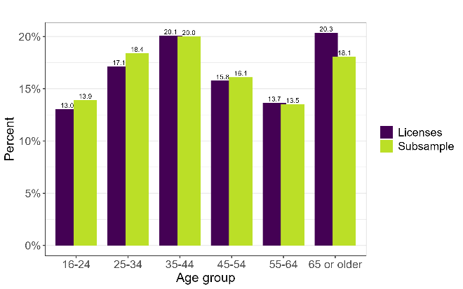 | 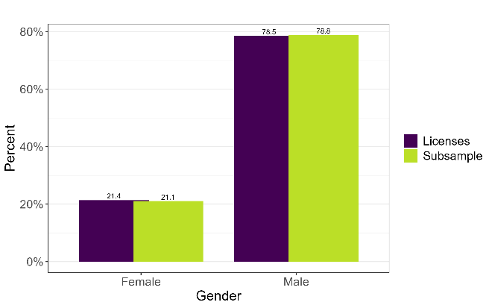
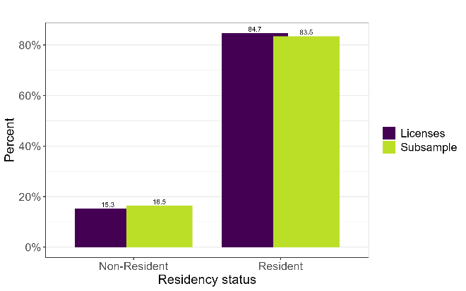
Figure 1 Distribution of demographic variables in the license and subsample datasets.

Survey Distribution
The survey was distributed using a multi-mode methodology including mailed paper surveys which included a link to an online survey option as well as email and text indentations that included a link to an online survey option. Responses were tracked by invitation to ensure reminders and follow-up surveys were only sent to non-respondents and to evaluate returns by mode. All potential survey participants received all mail packets, email invitations, and postcard reminders while potential survey participants were divided into one of two schedules to stagger text invitations and allow for evaluation of the confounding invitation modes. Figure 2 displays the timeline of survey distributions.
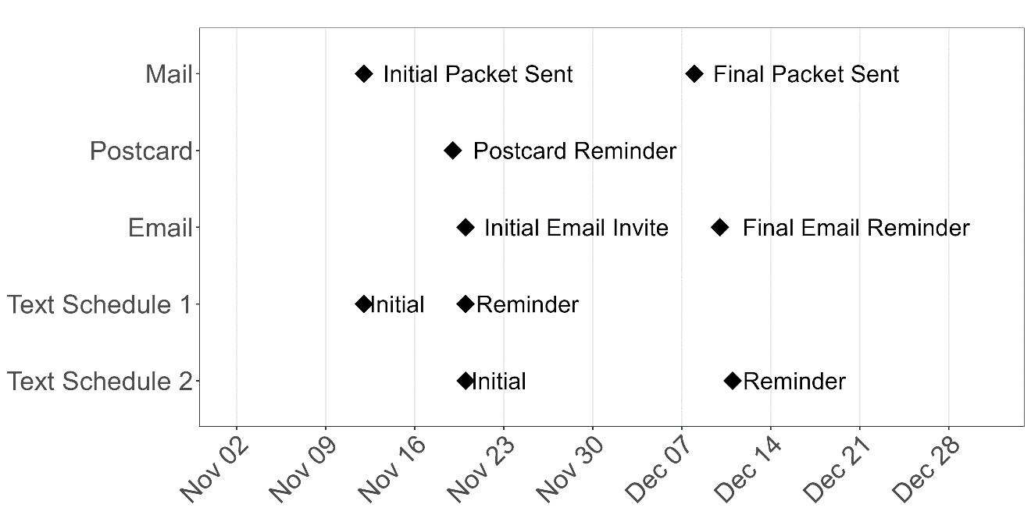
Figure 2 Timeline of survey distribution efforts.

Ineligible Recipients
From the subsample of 10,000 survey recipients, 361 were determined to be ineligible due to bad addressing, vacant housing units, deceased, etc. Additionally, one recipient was not mailed a survey. Of the 6,849 recipients with an email address, 308 were identified as ineligible due to bad address data. During text distributions, 437 recipients out of 9,717 were deemed ineligible due to bad phone number data (Table 1). These revised survey recipient numbers were used when mode-specific response rates were calculated in this report.
Mode | Potential Recipients | Ineligible | Recipients | Ineligible Rate
Mail | 9,999 | 367 | 9,632 | 3.7%
Email | 6,849 | 308 | 6,541 | 4.5%
Text (Overall) | 9,717 | 437 | 9,280 | 4.5%
Text (Schedule 1) | 4,869 | 206 | 4,663 | 4.2%
Text (Schedule 2) | 4,848 | 231 | 4,617 | 4.8%
Table 1 Ineligible recipients identified during the 2025 licensed angler survey. Reasons for ineligibility vary with all ineligible recipients identified as unable to receive a survey invitation through the appropriate mode.
The mail mode recipients were the only group below 4% ineligible rates with both email and text rates at 4.5% (Table 1). Mail surveys were the mode able to engage the largest segment of our angler population due to higher quality addressing data in the licensed angler database. While email and text ineligible rates are similar, it should be noted that approximately 41% more recipients have usable phone numbers compared to email addresses in the licensed angler database. From a population perspective, the text mode appears to have a higher potential engagement rate of Nebraska licensed anglers than does the email mode.
When ineligible for individual recipients was compared across all modes, only two individuals were identified as fully ineligible across all modes of contact. However, a minimum of 56 recipients (0.6%) were identified as only accessible through a single mode. These findings indicate the importance of continued use of the multi-mode approach to survey dissemination.

Ineligible For | N
All three modes (Mail + Email + Text) | 2
Mail + Email only | 10
Mail + Text only | 34
Email + Text only | 12
Mail only | 321
Email only | 284
Text only | 389
Table 2 Ineligible recipient counts by mode of contact.
An important caveat to these figures is that ineligibility in this context refers to known undeliverable mail/email/text communications. True rates of undeliverable communications may be higher. In addition, it is unknown if the mail/email/text communications with deliverable addressing actually resulted in a connection with the intended recipient. Therefore, ineligible rates and response should be considered a minimum value and number of recipients likewise a maximum estimate.

Survey Responses

A total of 2672 responses of the 2025 licensed angler survey were received by BOSR. Using the American Association for Public Opinion Research’s (AAPOR) standard definition of Response Rate 2, BOSR reported a 26.8% response rate. This is slightly lower yet similar to response rates observed in previous statewide angler surveys ???.
Mode | Number Of Responses | Percent Of Responses
Paper via mail | 1,746 | 65.3%
Online via mail | 238 | 8.9%
Email Message | 306 | 11.5%
Text Message | 382 | 14.3%
Table 3 Response modes for the statewide angler survey.

For the first time, text message invitations were used during survey administration and likely contributed to sustaining survey response rates in a general climate of decreased survey participation and saturation in society. In addition, this was also the first statewide angler survey that observed measurable use (8.9%) of online survey web links distributed in traditional paper survey mailings (Table 2).
Some inferences about effectiveness of different modes can be drawn from the differing distribution timelines. For example, respondents in schedule 1 were initially invited with mail and text invitations. When looking at the schedule 1 responses before November 20 (when the same respondents received an initial email invitation), a response rate of 5.4% was seen (Table 4). When Schedule 2 text distributions were undertaken recipients have had mail and email invitations and response was 2.8% (Table 4). When the schedule 2 final text invitation was sent it those recipients have had the option of two full mail distributions and two email invitations and no further schedule 2 text responses were seen. These results seem to indicate some amount of interplay between the text and email modes in the competition for respondents.
When schedule 1 text invitations were released, they saw a 3.5% response rate while schedule 2 text invitations were released at the same time as the initial email reminders, response rates were 2.8% and 2.9% respectively (Table 4). While some interaction between text and email modes was present, it was not entirely compensatory. Inclusion of both text and email modes in future survey efforts is recommended.
 | Invitations | Round 1 | Round 2
Text -Schedule 1 | 4,663 | 164 (3.5%) | 89 (1.9%)
Text – Schedule 2 | 4,617 | 129 (2.8%) | 0 (0%)
Text - Combined | 9,280 | 293 (3.2%) | 89 (1.0%)
Email | 6,541 | 190 (2.9%) | 116 (1.8%)
Mail | 9,632 | 1142 (11.9%) | 813 (8.4%)
Table 4 Survey response rates by mode of invitation.
Response rates ranged from 6.8% to 50.1% and were continuously skewed higher as age increased (Table 5). The electronic modes showed both consistency among age groups and no particular trends or skewness by age. Response rates were constantly the smallest for the youngest age groups regardless of mode indicating a particular lack of desire to participate by the youngest anglers.
Response Rate (%) | 18-30 Years old | 31-40 Years old | 41-50 Years old | 51-60 Years old | 61-70 Years old | 70+ Years old
Mail | 6.8 | 10.4 | 14.8 | 25.6 | 37.9 | 50.1
Email | 3.3 | 3.9 | 5.2 | 5.5 | 7 | 4.3
Text | 3.9 | 3.3 | 3.5 | 5.6 | 5 | 4.1
Table 5 Response rates by mode and age group.
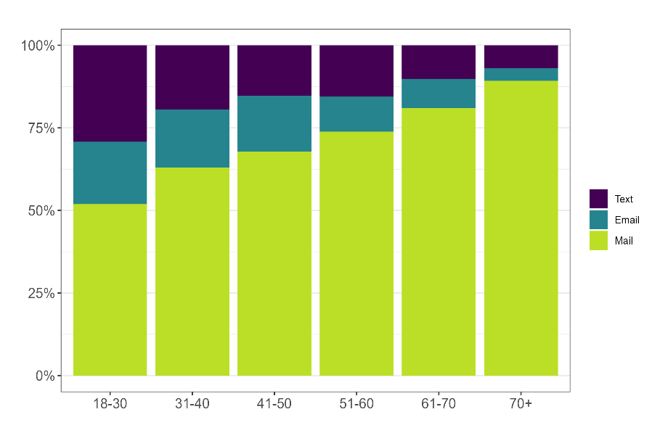
Table 6 Response proportions by age group.
While responses by younger age groups included larger proportions of electronic modes, over 50% of responses for all age groups were from traditional mailed surveys (Table 6). Future survey efforts should continue to include printed, mailed surveys as a primary mode of delivery.

Response Bias
While a 26.2% response rate is respectable in the current survey, political, and social environments, it does allow for the presence of response bias. Of particular concern is a non-response bias that could shift response outcomes or magnitudes. A few descriptive characteristics are available in the licensed angler data that can help identify if such bias may be present.
Age
Age distributions of responders and non-responders of the survey sample are significantly different (Figure 3) according to an independent samples t-test (t=35.317, p<2.2e-16, df=4737). Mean age of responders was 12.91 years higher for respondents than non-responders.
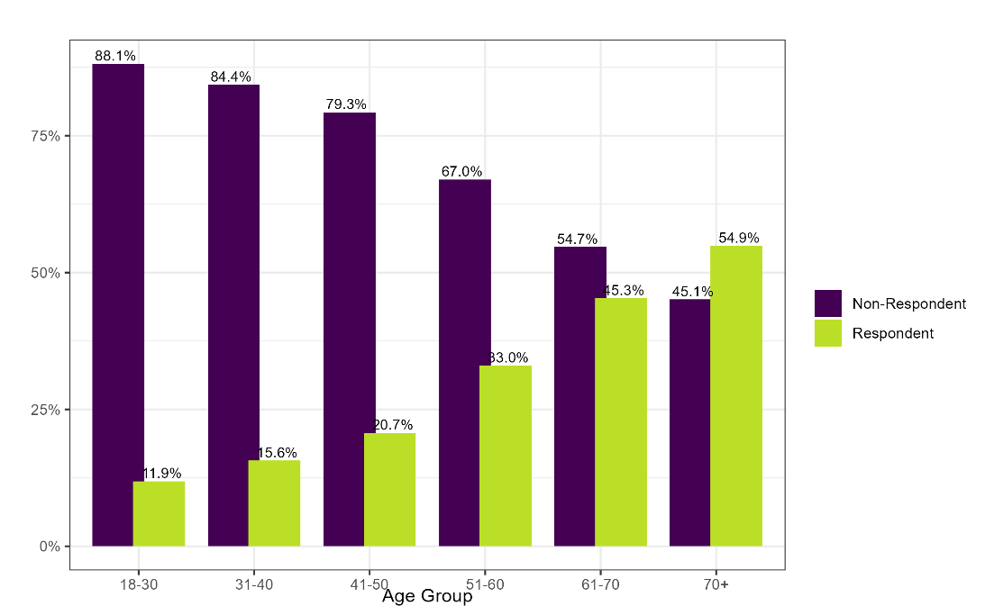
Figure 3 Response rates of by age group. Error bars represent 95% confidence intervals.

When looking at the average days fished by respondents, significant differences (Kruskal-Wallis: χ²=92.91, p<0.001, df=5) exist between age groups with a consistent decline across ages in a reverse relationship to the response rates (Table 6). Differences were also observed for both fishing motivation (Figure 5) and attitude (Figure 6) scales in both rank order and magnitude difference between subscale measures. These age-related differences in survey results coupled with significant differences in response by age groups indicate the need to weight survey results by age groups for any analysis extrapolating the survey results to the overall angler population either through percentage of responses, means and medians, or creation and extrapolation of estimates.
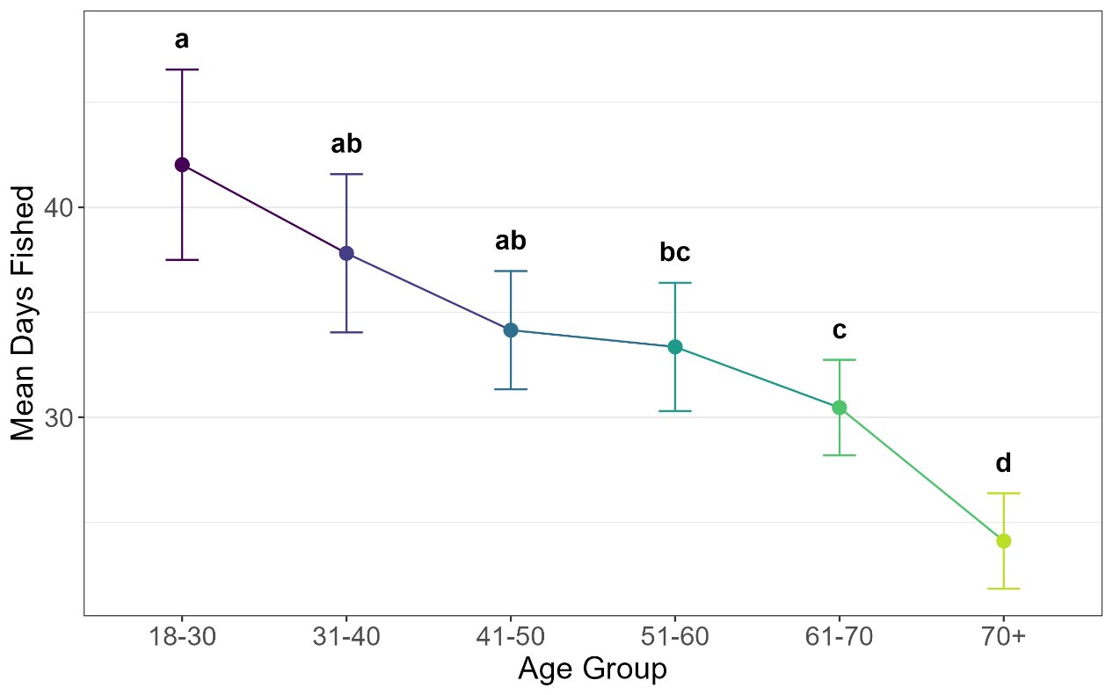
Figure 4 Mean days fish by age group. Means sharing a letter are not significantly different as tested with a Dunn test with Bonferroni correction at alpha=0.05. Error bars represent 95% confidence intervals.

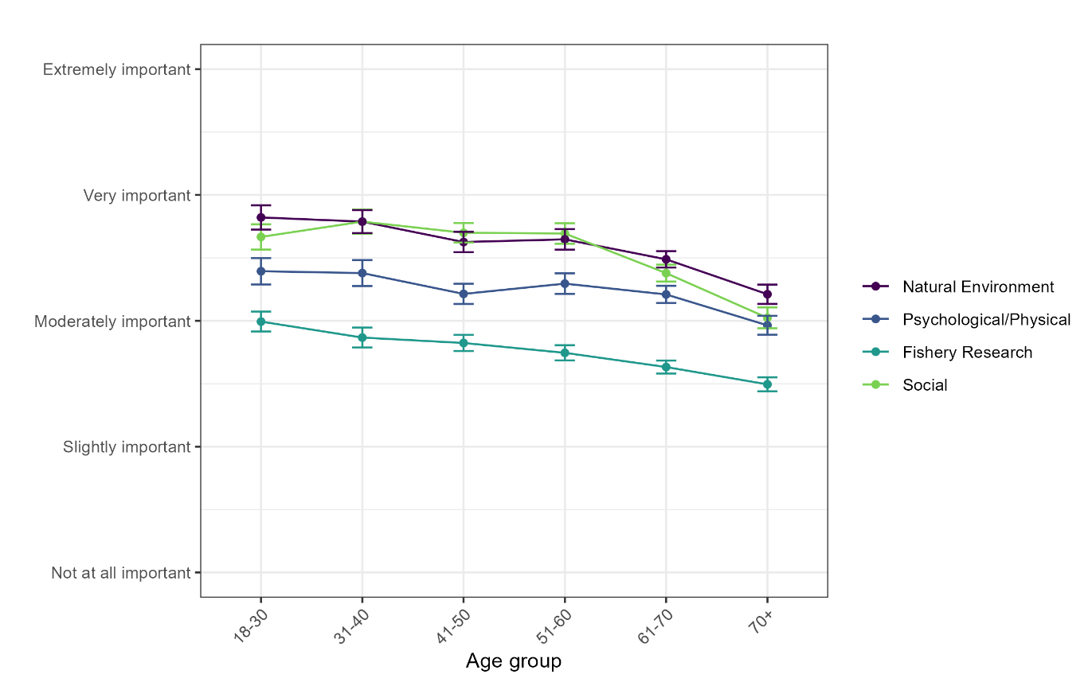
Figure 5 Mean response values for fishing motivations subscales across age groups. Error bars represent 95% confidence intervals.
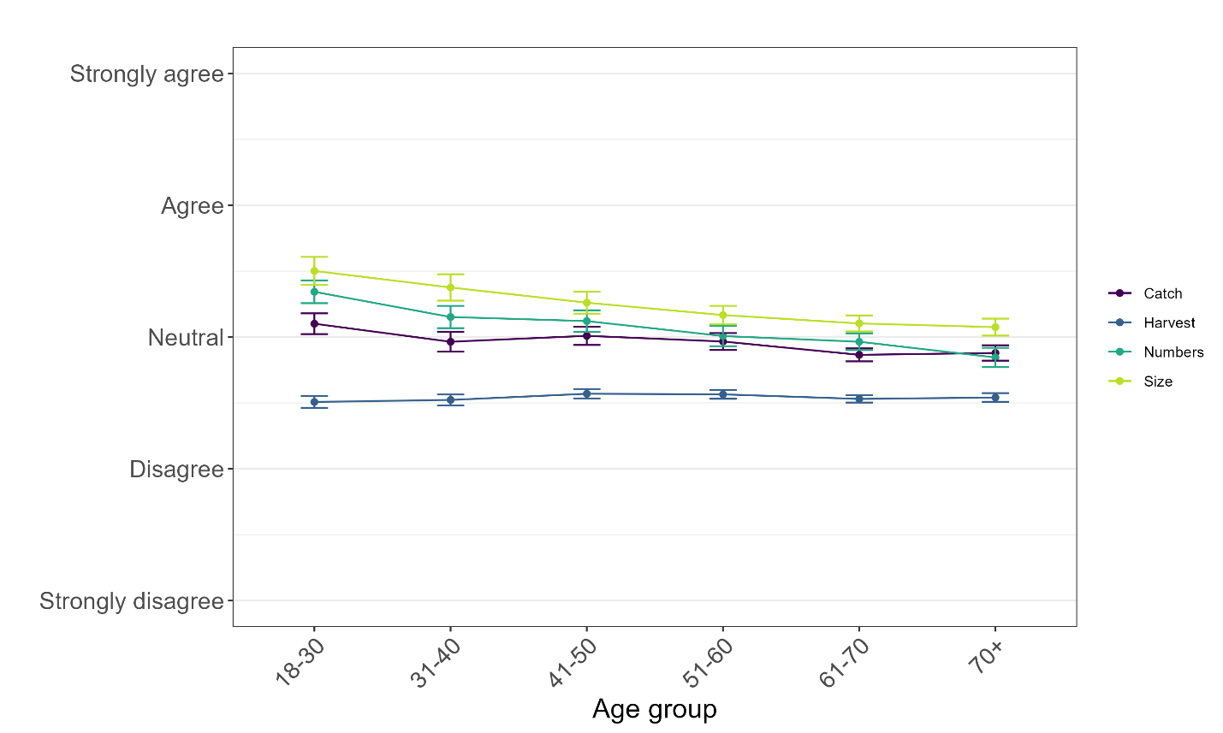
Figure 6 Mean response values for fishing attitude subscales across age groups. Error bars represent 95% confidence intervals.
Gender
Gender between respondents and non-respondents (Figure 3) was not significantly different according to a chi-square test (χ²=2.0138, p<1.5587e-01, df=1). Weighting of responses by gender was not necessary.
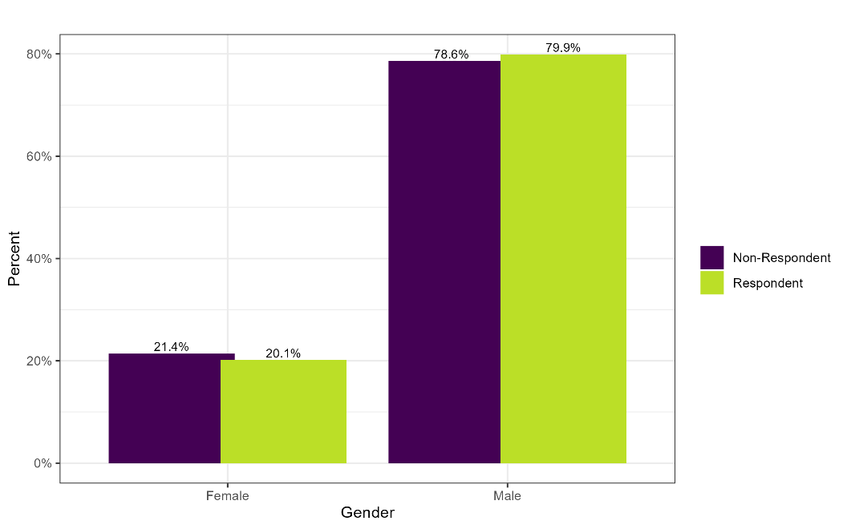
Figure 7 Response rate by gender.
Residency
Initial subsample selection was stratified by residency status to ensure both populations were represented in the subsample. However, according to a chi-square test of residency by response outcome, a significantly different response rate occurred between residents and non-residents (Figure 4) favoring resident license holders (χ²=57.3647, p<3.62e-14, df=1).
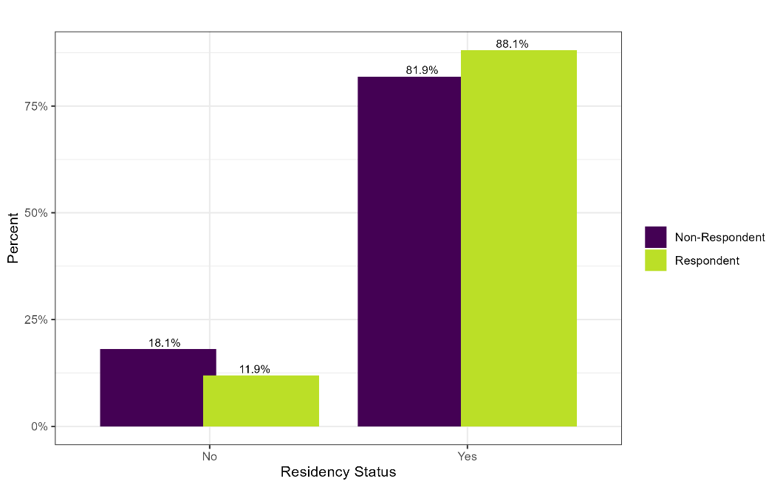
Figure 8 Response rates by residency status. Error bars represent 95% confidence intervals.
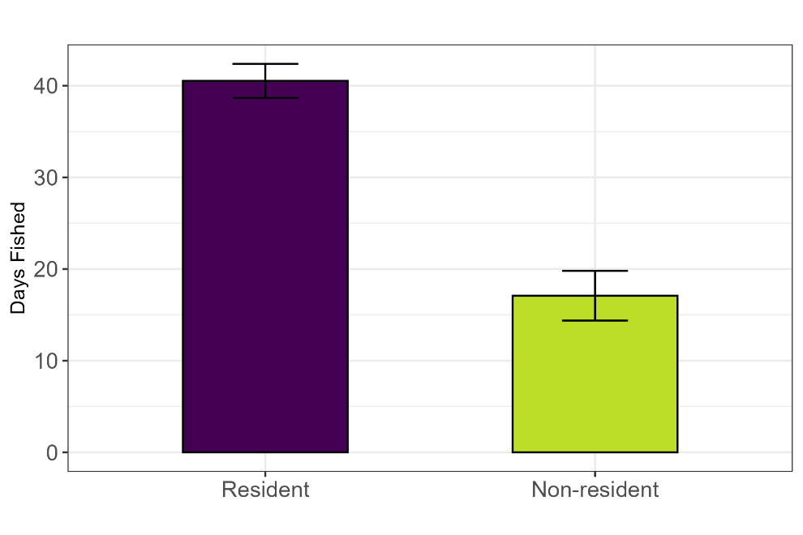
Figure 9 Days fished during 2025 for resident and non-resident anglers. Error bars represent 95% confidence intervals.
No substantial differences in rank order or difference intervals were noticed between the motivation and attitude subscales (Figure 10 and Figure 11). Motivation subscales were higher for all categories for non-residents than residents. Number of days fished were statistically different between resident and non-resident respondents. These differences combined with the statistically different response rates suggests the possibility of substantial non-response bias and survey analysis should be weighted by residency in addition to age group.

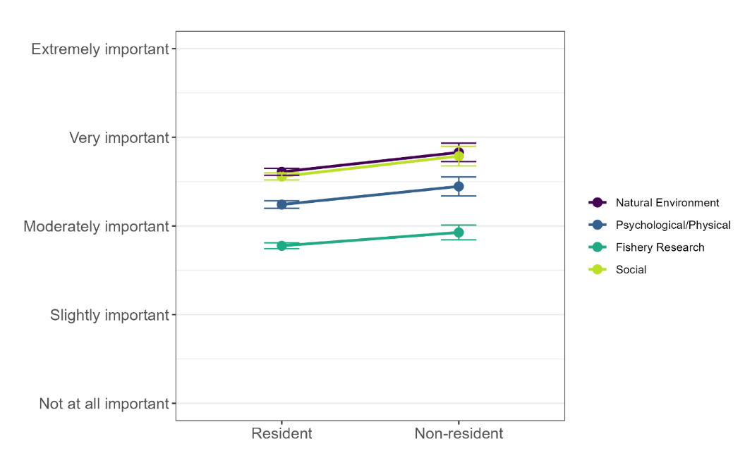
Figure 10 Mean response values for fishing motivation subscales across age groups. Error bars represent 95% confidence intervals.
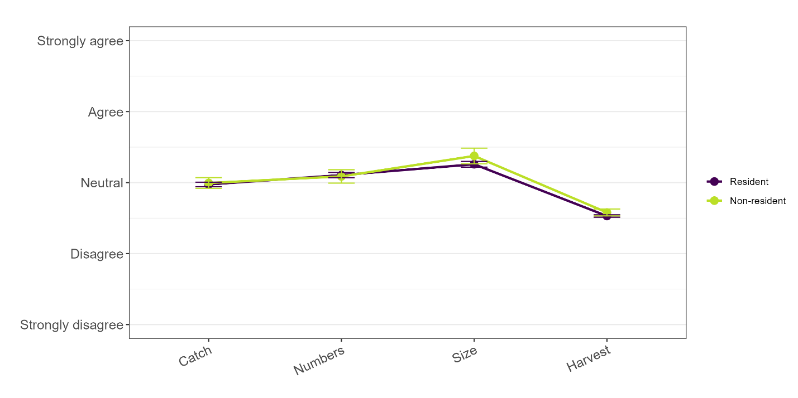
Figure 11 Mean response values for fishing attitude subscales across age groups. Error bars represent 95% confidence intervals.
Urban/Rural
Subsample and respondents were classified into either urban or rural status according to zip codes. Cities of over 10,000 people or cities adjacent to or surrounded by those cities were classified as urban and included (in order of population): Omaha, Lincoln, Bellevue, Grand Island, Kearney, Fremont, Hastings, Norfolk, North Platte, Columbus, Papillion, La Vista, Scottsbluff, South Sioux City, Beatrice, Lexington, Alliance, Offutt Air Force Base, and Elkhorn. No significant differences (χ²=1.4718, p<2.25e-01, df=1) exist for response rates based on urban/rural status. No weighting of analysis is needed for urban/rural status.
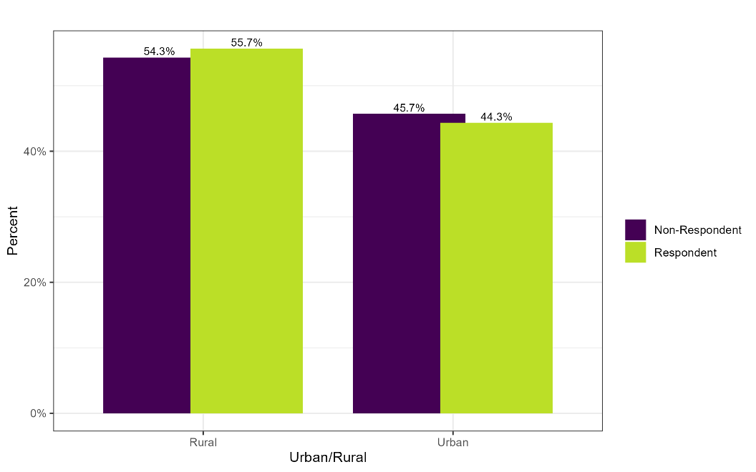

Analysis Weighting
With significant differences in response rates for age groups and residency status combined with observed differences between some basic survey questions, the potential for substantial influences of response bias exists. Permanent weighting factors were statistically raked for each respondent according to their distributions in the subsample and responses and weights developed were attached to the survey dataset. Survey results and analysis were weighted for both factors.

