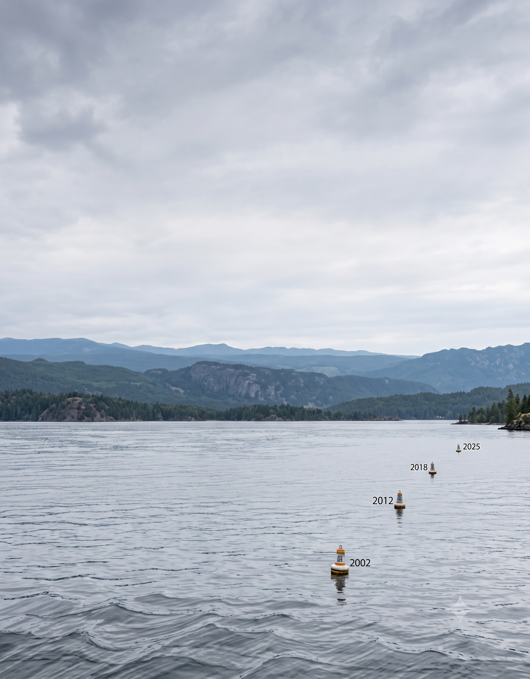
Keith Hurley
Fisheries Division – Research Section
Nebraska Game and Parks Commission

July 2026

Nebraska Licensed Angler Survey Trends Over A Quarter Century
Table of Contents
1. Summary 3
2. Longitudinal Results 8
2.1. Fished in Nebraska 8
2.2. Reasons for Not Fishing 9
2.3. Waterbody Types 10
2.4. Fishing Methods 12
2.5. Fishing Techniques 13
2.6. Distance to Waterbody 14
2.7. Satisfaction 15
2.8. State Park Entry Permits 17
2.9. Conservation Officer Contact 18
2.10. Most-Preferred Species 19
2.11. Most Sought Species 22
2.12. Fish Harvest and Release 25
2.13. Days Fished 32
2.14. Angler Motivations 45
2.15. Angler Attitudes 52

Summary
Nebraska has surveyed licensed anglers four times over two decades. This report tracks the questions asked across those surveys so we can see how angler behavior, preferences, and attitudes have or have not shifted. A few percentage-point movements between any two surveys are normal. Major shifts or changes in ranking across surveys may indicate societal changes or shifts important for consideration in fisheries management.
The share of license holders who did not fish in Nebraska fell from about 17% (2002) to under 10% (2025). Including this questions is more for context than indicative of angler behavior. During the 2002 and 2012 survey distribution, recepients were chosen from the previous years’ licensed angler list due to the capabilities of the permit system in place. Answers of no during those years are a mix of anglers who were licensed but chose not to fish and truely lapsed anglers (did not by a license in the survey year). Beginning in the 2018 survey, the year covered by the survey was presented to current license holders. However, a decrease in fishing participation among licensed anglers was seen indicating more people bought licenses that they did not use. In the 2025 survey we also have a confounding effect of multi-year permits which presents anglers that are licensed due to a purchase during a previous year that may or may not fish. Those that did not are not truly “lapsed” from an license standpoint but do represent decreased participation. Among those who fished during each survey, the typical angler reported about 18–19 days on the water per year, stable across all four surveys (with a temporary rise to ~23 days in 2018).
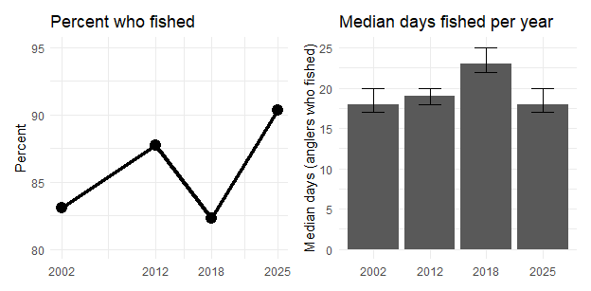
Bank fishing and wading remain the backbone of Nebraska angling (roughly three-quarters of anglers) with little change. Use of a motorized boat, however, has declined steadily — from about 67% (2002) to 52% (2025) — while kayaks and canoes have emerged as a distinct and growing mode (~15–17% in the two most recent surveys).
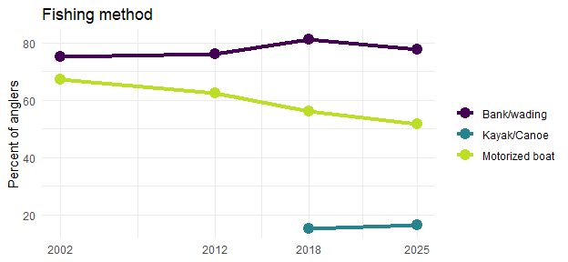
Most anglers fish close to home with their most-visited waterbody about 30 miles or less from home. While the last two surveys have shown a slight increase in the percentage of anglers fishing closer to home, the 2025 respondants showed similar travel distances to the 2002 survey with a slightly larger percentage of anglers traveling 100 or more miles to their most-visited waters. This could also indicate some anglers fished fewer but farther trips at the expense of more numerous local trips.
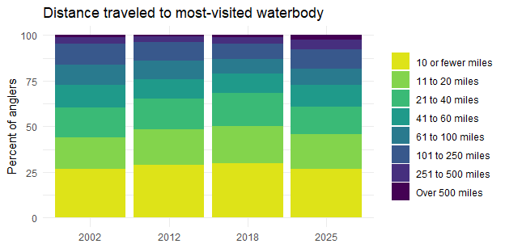
Walleye remains the single most-preferred species but its share has slipped from about 31% (2002) to 24% (2025). Largemouth bass remains second while channel catfish preference has declined. The largest change is the rise of anglers who do not prefer any particular species, up from 10% to 18%, and is now one of the most common responses. Angler preference is becoming less concentrated on a few flagship species.
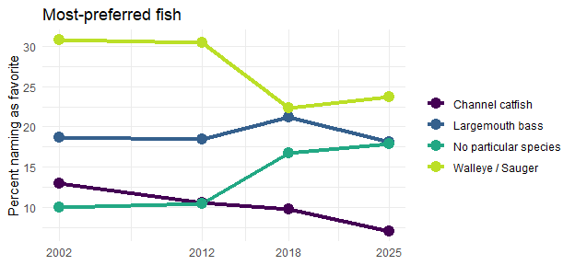
Satisfaction improved between 2002 and 2012 and has held since. The share who are “very satisfied” has climbed every survey (16% to 28%) while dissatisfaction has fallen from about a quarter of anglers to roughly 15%.
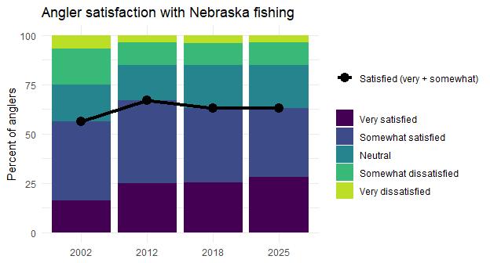
When examining the components to Nebraska anglers’ attitudes of a successful trip, rank order of the four attitudes has not changed over the four surveys. Anglers’ orientation towards size of fish and catching something have remained relatively constant. The importance of numbers of fish caught has increased in the last two surveys yet remains lower than the importance of size of fish. The clearest movement is a modest, steady decline in harvest-oriented attitudes of Nebraska anglers.
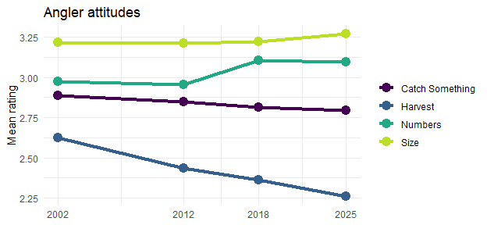
The declining harvest orientation is reflected in what anglers actually do with their catch. When anglers who sought a species were asked how much of their catch they kept, harvest has declined steadily for almost every species across the four surveys. Anglers of traditional harvest species such as crappie, channel catfish, bluegill, and walleye have shifted from keeping roughly half of their catch toward keeping only a few with trout anglers showing the largest decline. Harvest among the release-oriented largemouth bass anglers continues to fall. Voluntary release is rising broadly outside of the traditional trophy fisheries, which affects assumptions about exploitation rates and how harvest-oriented regulations will function.
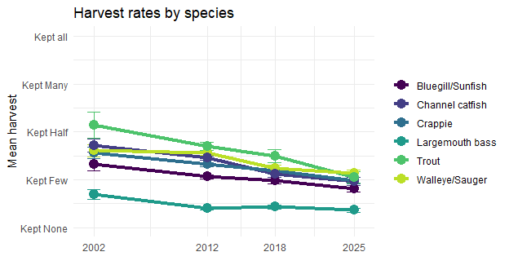
When asked about four different motivations for fishing, anglers rate social motivations and natural environment motivations as most important. During the 2018 survey natural environment motivations overtook social motivations for the top ranking and the that rank order remained during the 2025 survey. Motivations tied strictly to the fishery resource itself (the importance of the catch and keeping fish) rank last among motivational factors and fall significantly lower on the scale. For a large share of anglers, the quality of the overall outdoor experience and social motivations are as important as the catch. All scale scores were higher for all scales than in previous survey and likely represents a survey artifect and attention should remain on rank order and relative differences within years and not examined for relative differences in scale scores between years.
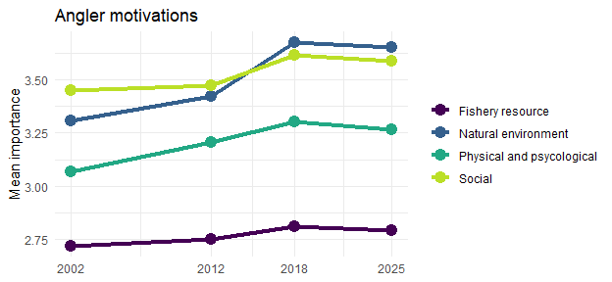
Over the past two decades, Nebraska’s licensed anglers have become more active, consistently satisfied, less reliant on motorized boats, broader in the species they pursue, and less focused on harvest. The implications for management is that anglers value access and a quality overall experience across diverse species and settings. Management should continue to provide access to a diversity of waters and opportunites alongside the traditional draw of premier species. Continued attention to shore and small-craft access, dependable fishing close to home, and the broader experience will serve the largest segments of the angling public.

Longitudinal Results

Fished in Nebraska
Did you fish in Nebraska during 2025? Values represent percentage of respondents +- 95% confidence intervals with sample size given in parenthesis.
Response | 2002 |  |  |  | 2012 |  |  |  | 2018 |  |  |  | 2025
Response | Value | CI | N |  | Value | CI | N |  | Value | CI | N |  | Value | CI | N
No | 16.9 | 1.97 | 234 |  | 12.2 | 0.71 | 1,002 |  | 17.7 | 1.55 | 578 |  | 9.6 | 1.24 | 348
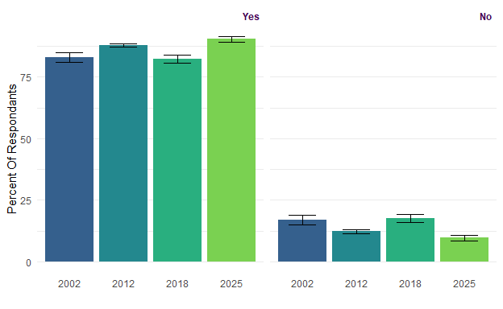

Reasons for Not Fishing
What is the main reason you didn’t fish in Nebraska during 2025? Values represent percentage of respondents +- 95% confidence intervals with sample size given in parenthesis.
Response | 2002 |  |  |  | 2012 |  |  |  | 2018 |  |  |  | 2025
Response | Value | CI | N |  | Value | CI | N |  | Value | CI | N |  | Value | CI | N
Lack of time | 58.7 | 6.46 | 131 |  | 52.5 | 3.14 | 509 |  | 54.2 | 4.91 | 259 |  | 50.5 | 5.98 | 158
Dissatisfied with past fishing trips | 8.1 | 3.58 | 18 |  | 7.9 | 1.70 | 77 |  | 5.4 | 2.23 | 31 |  | 6.3 | 2.90 | 22
No one to fish with | 3.1 | 2.29 | 7 |  | 5.2 | 1.39 | 50 |  | 4.5 | 2.04 | 32 |  | 3.8 | 2.30 | 17
Lack of access to fishing areas | 4.0 | 2.58 | 9 |  | 3.8 | 1.21 | 37 |  | 3.9 | 1.90 | 23 |  | 3.6 | 2.23 | 13
Too expensive | 6.7 | 3.29 | 15 |  | 2.3 | 0.94 | 22 |  | 6.6 | 2.44 | 28 |  | 2.3 | 1.78 | 5
Physically unable to fish | 2.7 | 2.12 | 6 |  | 3.7 | 1.19 | 36 |  | 5.4 | 2.23 | 43 |  | 6.6 | 2.97 | 29
No longer enjoy fishing | 1.3 | 1.51 | 3 |  | 2.8 | 1.04 | 27 |  | 1.4 | 1.18 | 11 |  | 2.4 | 1.83 | 10
Other | 15.2 | 4.72 | 34 |  | 7.3 | 1.64 | 71 |  | 15.9 | 3.61 | 93 |  | 22.1 | 4.96 | 71
Complicated regulations |  |  |  |  | 1.0 | 0.64 | 10 |  | 1.9 | 1.33 | 8 |  | 1.4 | 1.39 | 6
Waters are too crowded |  |  |  |  | 13.5 | 2.15 | 131 |  | 0.9 | 0.91 | 4 |  | 1.0 | 1.20 | 4
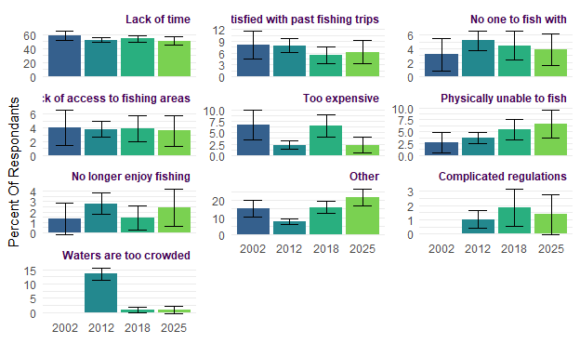

Waterbody Types
In what types of water bodies did you fish in Nebraska during 2025? Values represent percentage of respondents +- 95% confidence intervals with sample size given in parenthesis.
Response | 2002 |  |  |  | 2012 |  |  |  | 2018 |  |  |  | 2025
Response | Value | CI | N |  | Value | CI | N |  | Value | CI | N |  | Value | CI | N
City park ponds | 9.2 | 1.67 | 105 |  | 16.4 | 0.85 | 1,183
Lakes and Reservoirs |  |  |  |  |  |  |  |  | 85.2 | 1.59 | 2,033 |  | 85.2 | 1.58 | 2,065
Missouri River | 16.6 | 2.16 | 190 |  | 17.1 | 0.87 | 1,233 |  | 15.3 | 1.61 | 356 |  | 15.9 | 1.63 | 370
Open fields and waters lakes/ponds |  |  |  |  | 20.0 | 0.92 | 1,444
Open fields and waters rivers/streams |  |  |  |  | 7.2 | 0.60 | 517
Other public lakes, reservoirs, and ponds | 80.4 | 2.30 | 919 |  | 73.8 | 1.01 | 5,325
Other streams, rivers, and canals | 24.0 | 2.48 | 274 |  | 16.8 | 0.86 | 1,213 |  | 21.8 | 1.85 | 483 |  | 20.2 | 1.79 | 451
Platte River | 10.1 | 1.74 | 115 |  | 9.8 | 0.69 | 705 |  | 10.3 | 1.36 | 232 |  | 9.4 | 1.30 | 204
Ponds and sandpits |  |  |  |  |  |  |  |  | 52.1 | 2.23 | 1,193 |  | 44.3 | 2.21 | 1,046
Private ponds and sandpits | 41.0 | 2.85 | 469 |  | 37.4 | 1.12 | 2,698
Public sandpits | 11.4 | 1.84 | 130 |  | 8.9 | 0.66 | 643
Sandhill lakes | 17.5 | 2.20 | 200 |  | 11.8 | 0.74 | 853 |  | 11.7 | 1.44 | 278 |  | 9.3 | 1.29 | 220
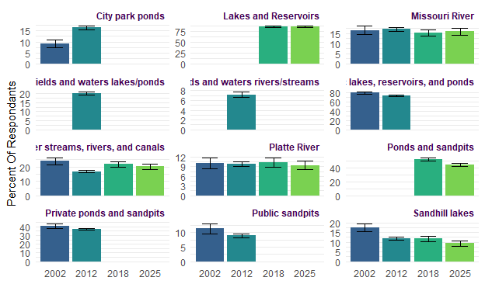

Fishing Methods
Which methods of fishing did you use during 2025? Values represent percentage of respondents +- 95% confidence intervals with sample size given in parenthesis.
Response | 2002 |  |  |  | 2012 |  |  |  | 2018 |  |  |  | 2025
Response | Value | CI | N |  | Value | CI | N |  | Value | CI | N |  | Value | CI | N
Bank/wading | 75.1 | 2.48 | 875 |  | 76.0 | 0.98 | 5,507 |  | 81.3 | 1.73 | 1,937 |  | 77.7 | 1.85 | 1,885
Float tube | 3.3 | 1.03 | 39 |  | 3.5 | 0.42 | 251 |  | 1.7 | 0.57 | 45 |  | 1.4 | 0.53 | 36
Ice fishing | 17.7 | 2.19 | 206 |  | 14.6 | 0.81 | 1,057 |  | 20.7 | 1.80 | 447 |  | 16.9 | 1.66 | 382
Kayak/Canoe |  |  |  |  |  |  |  |  | 15.2 | 1.59 | 293 |  | 16.5 | 1.65 | 351
Motorized boat | 67.0 | 2.70 | 781 |  | 62.5 | 1.11 | 4,527 |  | 56.1 | 2.20 | 1,387 |  | 51.6 | 2.22 | 1,296
Other | 2.8 | 0.95 | 33 |  | 1.4 | 0.27 | 102 |  | 1.8 | 0.58 | 40 |  | 2.6 | 0.71 | 51
Other Non-motorized boat | 12.6 | 1.91 | 147 |  | 12.5 | 0.76 | 907 |  | 4.7 | 0.94 | 107 |  | 3.7 | 0.84 | 85
Wading |  |  |  |  | 14.3 | 0.81 | 1,035 |  | 14.2 | 1.55 | 322 |  | 11.9 | 1.44 | 273
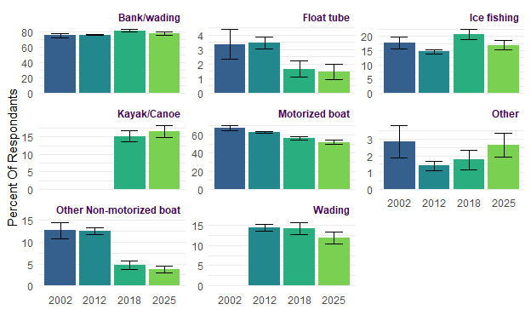

Fishing Techniques
What techniques did you use during 2025? Values represent percentage of respondents +- 95% confidence intervals with sample size given in parenthesis.
Response | 2002 |  |  |  | 2012 |  |  |  | 2018 |  |  |  | 2025
Response | Value | CI | N |  | Value | CI | N |  | Value | CI | N |  | Value | CI | N
Archery | 3.3 | 1.02 | 38 |  | 4.9 | 0.50 | 352 |  | 6.2 | 1.07 | 103 |  | 3.4 | 0.80 | 64
Fly-fishing | 8.7 | 1.61 | 101 |  | 9.9 | 0.69 | 716 |  | 8.1 | 1.21 | 208 |  | 8.6 | 1.24 | 191
Other | 0.9 | 0.55 | 11 |  | 0.9 | 0.22 | 64 |  | 0.9 | 0.41 | 17 |  | 1.0 | 0.44 | 21
Rod & reel | 98.9 | 0.60 | 1,154 |  | 98.4 | 0.29 | 7,122 |  | 98.8 | 0.47 | 2,443 |  | 97.9 | 0.64 | 2,431
Set lines/limb lines | 8.5 | 1.60 | 99 |  | 6.7 | 0.58 | 488 |  | 6.5 | 1.10 | 143 |  | 5.2 | 0.99 | 113
Snagging | 1.8 | 0.76 | 21 |  | 2.6 | 0.37 | 188 |  | 2.3 | 0.67 | 48 |  | 2.2 | 0.66 | 46
Surface spear | 1.6 | 0.73 | 19 |  | 0.6 | 0.18 | 43 |  | 0.3 | 0.26 | 6 |  | 0.3 | 0.25 | 7
Underwater spear | 1.0 | 0.58 | 12 |  | 0.4 | 0.14 | 28 |  | 0.4 | 0.28 | 9 |  | 0.2 | 0.19 | 6
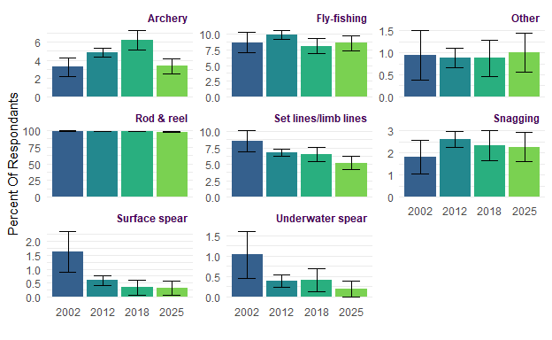

Distance to Waterbody
About how far is the one-way distance from your residence to your favorite Nebraska water body? Values represent lower 95% median confidence limit, median response, and upper 95% median confidence limit with sample size given in parenthesis Answers included: 10 or less miles, 11 to 20 miles, 21 to 40 miles, 41 to 60 miles, 61 to 100 miles, 101 to 250 miles, 251 to 500 miles, and Over 500 miles.
 | 2002 |  |  |  | 2012 |  |  |  | 2018 |  |  |  | 2025
 | Value | CI | N |  | Value | CI | N |  | Value | CI | N |  | Value | CI | N
 | 50.5 | 50.5/375.5 | 1137 |  | 50.5 | 50.5/375.5 | 7181 |  | 30.5 | 30.5/375.5 | 2518 |  | 50.5 | 50.5/375.5 | 2470
About how far is the one-way distance from your residence to your most visited Nebraska water body? Values represent percentage of respondents +- 95% confidence intervals with sample size given in parenthesis. Answers included: 10 or less miles, 11 to 20 miles, 21 to 40 miles, 41 to 60 miles, 61 to 100 miles, 101 to 250 miles, 251 to 500 miles, and Over 500 miles.
 | 2002 |  |  |  | 2012 |  |  |  | 2018 |  |  |  | 2025
 | Value | CI | N |  | Value | CI | N |  | Value | CI | N |  | Value | CI | N
 | 30.5 | 30.5/175.5 | 1161 |  | 30.5 | 30.5/175.5 | 7236 |  | 30.5 | 30.5/175.5 | 2551 |  | 30.5 | 30.5/375.5 | 2489

Satisfaction
How satisfied were you with your fishing experiences in Nebraska during 2025? Values represent percentage of respondents +- 95% confidence intervals with sample size given in parenthesis. Answers included (from 1 to 5): Very Satisfied, Somewhat Satisfied, Neutral, Somewhat Dissatisfied, and Very Dissatisfied.
Response | 2002 |  |  |  | 2012 |  |  |  | 2018 |  |  |  | 2025
Response | Value | CI | N |  | Value | CI | N |  | Value | CI | N |  | Value | CI | N
Very satisfied | 16.4 | 2.13 | 190 |  | 25.0 | 1.00 | 1,810 |  | 25.4 | 1.94 | 608 |  | 28.1 | 2.00 | 678
Somewhat satisfied | 39.8 | 2.82 | 461 |  | 42.2 | 1.14 | 3,054 |  | 37.7 | 2.16 | 923 |  | 34.8 | 2.12 | 872
Neutral | 18.6 | 2.24 | 215 |  | 17.6 | 0.88 | 1,275 |  | 21.6 | 1.83 | 535 |  | 22.0 | 1.84 | 528
Somewhat dissatisfied | 18.4 | 2.23 | 213 |  | 11.4 | 0.73 | 829 |  | 11.1 | 1.40 | 280 |  | 11.4 | 1.41 | 291
Very dissatisfied | 6.7 | 1.44 | 78 |  | 3.8 | 0.44 | 276 |  | 4.2 | 0.90 | 113 |  | 3.7 | 0.84 | 102
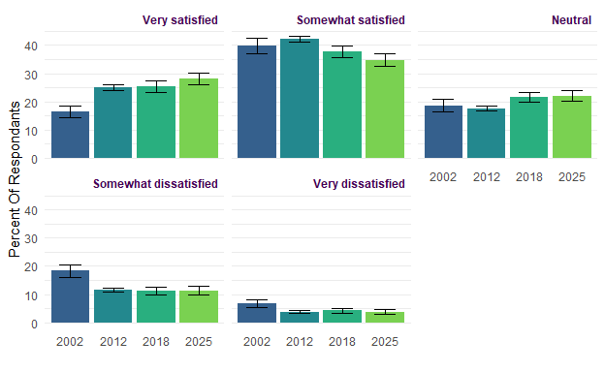

How satisfied were you with your fishing experiences in Nebraska during 2025? Values represent mean response +- 95% confidence intervals with sample size given in parenthesis. Answers included (from 1 to 5): Very Satisfied, Somewhat Satisfied, Neutral, Somewhat Dissatisfied, and Very Dissatisfied.
 | 2002 |  |  |  | 2012 |  |  |  | 2018 |  |  |  | 2025
 | Value | CI | N |  | Value | CI | N |  | Value | CI | N |  | Value | CI | N
 | 2.6 | 0.07 | 1,157 |  | 2.3 | 0.02 | 7,244 |  | 2.3 | 0.04 | 2,459 |  | 2.3 | 0.04 | 2,471

State Park Entry Permits
Did you fish at a water body that required a Nebraska Park Entry Permit during 2025? Values represent mean response +- 95% confidence intervals with sample size given in parenthesis.
Response | 2002 |  |  |  | 2012 |  |  |  | 2018 |  |  |  | 2025
Response | Value | CI | N |  | Value | CI | N |  | Value | CI | N |  | Value | CI | N
No | 26.9 | 2.56 | 311 |  | 27.6 | 1.03 | 1,980 |  | 31.4 | 1.98 | 925 |  | 33.5 | 2.05 | 898
Yes | 73.1 | 2.56 | 845 |  | 72.4 | 1.03 | 5,194 |  | 68.6 | 1.98 | 1,766 |  | 66.5 | 2.05 | 1,691
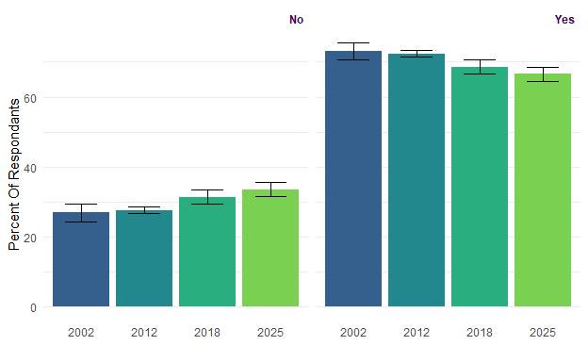

Conservation Officer Contact
Were you checked by a Nebraska conservation officer wearing a sidearm while fishing during 2025? Values represent percentage of respondents +- 95% confidence intervals with sample size given in parenthesis.
Response | 2002 |  |  |  | 2012 |  |  |  | 2018 |  |  |  | 2025
Response | Value | CI | N |  | Value | CI | N |  | Value | CI | N |  | Value | CI | N
No | 80.9 | 2.12 | 1,066 |  | 85.3 | 0.78 | 6,838 |  | 84 | 1.62 | 2,110 |  | 82.1 | 1.7 | 2,062
Yes | 19.1 | 2.12 | 251 |  | 14.7 | 0.78 | 1,180 |  | 16 | 1.62 | 386 |  | 17.9 | 1.7 | 423
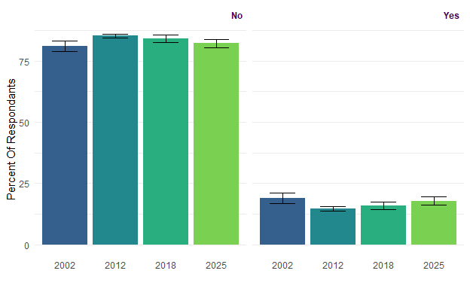

Most-Preferred Species
Which type of fish do you prefer to fish for in Nebraska? Values represent percentage of respondents +- 95% confidence intervals with sample size given in parenthesis.
Response | 2002 |  |  |  | 2012 |  |  |  | 2018 |  |  |  | 2025
Response | Value | CI | N |  | Value | CI | N |  | Value | CI | N |  | Value | CI | N
Striped bass | 0.3 | 0.37 | 3 |  | 0.1 | 0.09 | 9 |  | 0.4 | 0.32 | 7 |  | 0.7 | 0.42 | 11
Wiper | 1.3 | 0.74 | 12 |  | 1.3 | 0.27 | 84 |  | 1.0 | 0.52 | 14 |  | 2.5 | 0.79 | 35
White bass | 3.7 | 1.23 | 34 |  | 2.5 | 0.38 | 161 |  | 2.5 | 0.81 | 48 |  | 2.2 | 0.73 | 39
Largemouth bass | 18.7 | 2.53 | 171 |  | 18.5 | 0.94 | 1,208 |  | 21.2 | 2.14 | 344 |  | 18.1 | 1.93 | 316
Smallmouth bass | 1.2 | 0.71 | 11 |  | 1.1 | 0.26 | 75 |  | 1.2 | 0.56 | 23 |  | 2.6 | 0.79 | 41
Bluegill / Sunfish | 2.6 | 1.04 | 24 |  | 2.2 | 0.36 | 144 |  | 3.2 | 0.92 | 62 |  | 2.0 | 0.70 | 43
Crappie | 6.8 | 1.63 | 62 |  | 9.0 | 0.69 | 586 |  | 10.0 | 1.57 | 183 |  | 8.3 | 1.39 | 181
Yellow perch | 1.4 | 0.77 | 13 |  | 1.2 | 0.27 | 80 |  | 1.4 | 0.61 | 27 |  | 0.5 | 0.35 | 12
Walleye / Sauger | 30.9 | 2.99 | 282 |  | 30.4 | 1.11 | 1,991 |  | 22.4 | 2.18 | 426 |  | 23.8 | 2.14 | 499
Northern pike | 2.7 | 1.06 | 25 |  | 2.5 | 0.38 | 162 |  | 2.1 | 0.74 | 37 |  | 2.0 | 0.70 | 32
Muskellunge / Tiger musky |  |  |  |  | 0.3 | 0.14 | 21 |  | 0.6 | 0.40 | 9 |  | 0.6 | 0.39 | 8
Channel catfish | 12.9 | 2.17 | 118 |  | 10.6 | 0.74 | 691 |  | 9.8 | 1.56 | 177 |  | 7.0 | 1.28 | 151
Blue catfish | 0.3 | 0.37 | 3 |  | 0.7 | 0.21 | 48 |  | 0.8 | 0.46 | 14 |  | 1.7 | 0.65 | 27
Flathead catfish | 1.8 | 0.85 | 16 |  | 2.3 | 0.36 | 149 |  | 1.7 | 0.67 | 32 |  | 2.7 | 0.82 | 50
Bullhead | 0.2 | 0.30 | 2 |  | 0.3 | 0.13 | 20 |  | 0.3 | 0.27 | 4 |  | 0.2 | 0.24 | 4
Drum | 0.1 | 0.21 | 1 |  | 0.2 | 0.11 | 14 |  |  |  |  |  | 0.4 | 0.32 | 6
Sturgeon |  |  |  |  | 0.0 | 0.03 | 1 |  | 0.1 | 0.16 | 1
Common carp | 0.5 | 0.48 | 5 |  | 0.3 | 0.13 | 20 |  | 0.2 | 0.23 | 5 |  | 0.4 | 0.33 | 9
Trout | 4.0 | 1.28 | 37 |  | 5.1 | 0.53 | 331 |  | 3.5 | 0.97 | 70 |  | 4.6 | 1.05 | 90
Paddlefish | 0.4 | 0.43 | 4 |  | 0.7 | 0.21 | 49 |  | 0.7 | 0.43 | 11 |  | 1.1 | 0.53 | 14
I do not prefer any particular type of fish | 10.0 | 1.94 | 91 |  | 10.5 | 0.74 | 686 |  | 16.7 | 1.95 | 292 |  | 17.9 | 1.92 | 339
Other |  |  |  |  | 0.1 | 0.07 | 5 |  | 0.2 | 0.26 | 4 |  | 0.3 | 0.27 | 4
Invasive carp |  |  |  |  | 0.1 | 0.09 | 9 |  | 0.2 | 0.23 | 2 |  | 0.4 | 0.32 | 4
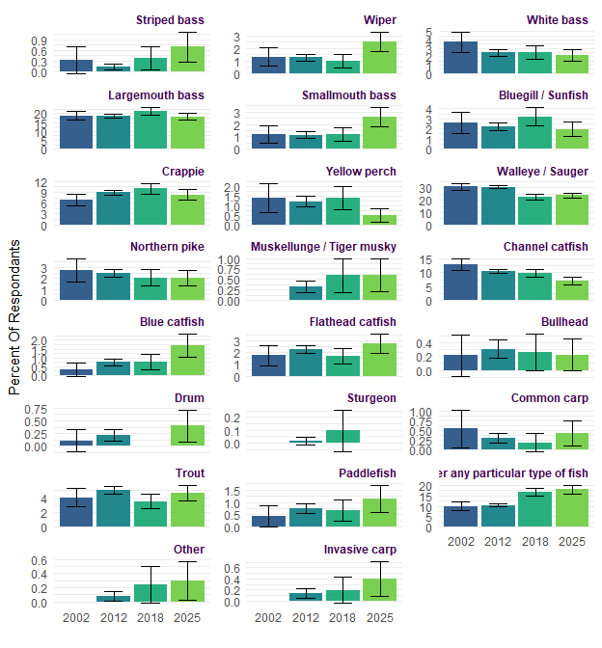
Which type of fish do you prefer to fish for in Nebraska? Values represent rank order of responses.
Response | 2002 | 2012 | 2018 | 2025
Walleye / Sauger | 1 (30.9%) | 1 (30.4%) | 1 (22.4%) | 1 (23.8%)
Largemouth bass | 2 (18.7%) | 2 (18.5%) | 2 (21.2%) | 2 (18.1%)
Channel catfish | 3 (12.9%) | 3 (10.6%) | 5 (9.8%) | 5 (7%)
I do not prefer any particular type of fish | 4 (10%) | 4 (10.5%) | 3 (16.7%) | 3 (17.9%)
Crappie | 5 (6.8%) | 5 (9%) | 4 (10%) | 4 (8.3%)
Trout | 6 (4%) | 6 (5.1%) | 6 (3.5%) | 6 (4.6%)
White bass | 7 (3.7%) | 8 (2.5%) | 8 (2.5%) | 10 (2.2%)
Northern pike | 8 (2.7%) | 7 (2.5%) | 9 (2.1%) | 11 (2%)
Bluegill / Sunfish | 9 (2.6%) | 10 (2.2%) | 7 (3.2%) | 12 (2%)
Flathead catfish | 10 (1.8%) | 9 (2.3%) | 10 (1.7%) | 7 (2.7%)
Yellow perch | 11 (1.4%) | 12 (1.2%) | 11 (1.4%) | 17 (0.5%)
Wiper | 12 (1.3%) | 11 (1.3%) | 13 (1%) | 9 (2.5%)
Smallmouth bass | 13 (1.2%) | 13 (1.1%) | 12 (1.2%) | 8 (2.6%)
Common carp | 14 (0.5%) | 18 (0.3%) | 21 (0.2%) | 18 (0.4%)
Paddlefish | 15 (0.4%) | 14 (0.7%) | 15 (0.7%) | 14 (1.1%)
Striped bass | 16 (0.3%) | 20 (0.1%) | 17 (0.4%) | 15 (0.7%)
Blue catfish | 17 (0.3%) | 15 (0.7%) | 14 (0.8%) | 13 (1.7%)
Bullhead | 18 (0.2%) | 17 (0.3%) | 18 (0.3%) | 22 (0.2%)
Drum | 19 (0.1%) | 19 (0.2%) |  | 20 (0.4%)
Muskellunge / Tiger musky |  | 16 (0.3%) | 16 (0.6%) | 16 (0.6%)
Sturgeon |  | 23 (0%) | 22 (0.1%)
Other |  | 22 (0.1%) | 19 (0.2%) | 21 (0.3%)
Invasive carp |  | 21 (0.1%) | 20 (0.2%) | 19 (0.4%)

Most Sought Species
Please indicate whether or not you tried to catch each of the following types of fish in Nebraska waters during 2025. Values represent percentage of respondents +- 95% confidence intervals with sample size given in parenthesis.
Response | 2002 |  |  |  | 2012 |  |  |  | 2018 |  |  |  | 2025
Response | Value | CI | N |  | Value | CI | N |  | Value | CI | N |  | Value | CI | N
Blue catfish | 9.7 | 1.71 | 112 |  | 13.3 | 0.78 | 963 |  | 26.3 | 1.98 | 591 |  | 26.9 | 2.03 | 558
Bluegill / Sunfish | 34.2 | 2.74 | 394 |  | 44.9 | 1.15 | 3,251 |  | 59.8 | 2.20 | 1,355 |  | 55.5 | 2.28 | 1,243
Bullhead | 4.9 | 1.25 | 57 |  | 7.5 | 0.61 | 542 |  | 15.7 | 1.63 | 346 |  | 11.0 | 1.43 | 233
Channel catfish | 39.6 | 2.82 | 456 |  | 45.0 | 1.15 | 3,255 |  | 53.0 | 2.24 | 1,238 |  | 48.5 | 2.29 | 1,102
Common Carp | 9.0 | 1.65 | 104 |  | 8.7 | 0.65 | 630 |  | 14.4 | 1.57 | 317 |  | 14.3 | 1.60 | 295
Crappie | 46.4 | 2.88 | 535 |  | 55.3 | 1.15 | 4,005 |  | 63.4 | 2.16 | 1,509 |  | 60.4 | 2.24 | 1,398
Drum | 3.5 | 1.06 | 40 |  | 6.0 | 0.55 | 436 |  | 10.9 | 1.40 | 260 |  | 11.3 | 1.45 | 239
Flathead catfish | 14.1 | 2.01 | 162 |  | 17.5 | 0.88 | 1,266 |  | 28.8 | 2.03 | 631 |  | 27.7 | 2.05 | 590
I fished for anything | 18.9 | 2.26 | 218 |  | 8.6 | 0.65 | 626 |  | 43.3 | 2.22 | 951 |  | 40.3 | 2.25 | 864
Invasive Carp |  |  |  |  | 1.5 | 0.28 | 110 |  | 3.9 | 0.87 | 72 |  | 6.5 | 1.13 | 117
Largemouth bass | 45.8 | 2.88 | 528 |  | 51.9 | 1.15 | 3,758 |  | 63.4 | 2.16 | 1,464 |  | 58.9 | 2.25 | 1,285
Muskellunge / Tiger musky | 4.4 | 1.19 | 51 |  | 3.1 | 0.40 | 226 |  | 8.8 | 1.27 | 186 |  | 10.6 | 1.41 | 197
Northern pike | 15.6 | 2.10 | 180 |  | 19.1 | 0.91 | 1,384 |  | 26.4 | 1.98 | 594 |  | 23.4 | 1.94 | 496
Other | 1.7 | 0.75 | 20 |  | 16.0 | 0.84 | 1,157 |  | 3.5 | 0.83 | 76 |  | 3.3 | 0.81 | 58
Paddlefish | 3.6 | 1.07 | 41 |  | 2.7 | 0.37 | 195 |  | 2.8 | 0.73 | 60 |  | 3.2 | 0.81 | 61
Smallmouth bass | 16.1 | 2.12 | 186 |  | 18.5 | 0.89 | 1,340 |  | 32.8 | 2.11 | 739 |  | 37.0 | 2.21 | 768
Striped bass | 8.8 | 1.63 | 101 |  | 7.8 | 0.62 | 561 |  | 17.5 | 1.70 | 400 |  | 19.0 | 1.80 | 385
Sturgeon | 1.6 | 0.72 | 18 |  | 1.1 | 0.24 | 79 |  | 2.6 | 0.71 | 57 |  | 2.1 | 0.66 | 46
Trout | 13.5 | 1.97 | 155 |  | 19.3 | 0.91 | 1,399 |  | 23.2 | 1.89 | 547 |  | 25.2 | 1.99 | 541
Walleye / Sauger | 45.1 | 2.87 | 519 |  | 50.1 | 1.15 | 3,627 |  | 50.6 | 2.24 | 1,225 |  | 53.9 | 2.28 | 1,230
White bass | 23.4 | 2.44 | 269 |  | 26.0 | 1.01 | 1,880 |  | 30.6 | 2.07 | 752 |  | 27.2 | 2.04 | 647
Wiper | 16.2 | 2.13 | 187 |  | 16.6 | 0.86 | 1,203 |  | 20.7 | 1.82 | 498 |  | 22.2 | 1.90 | 509
Yellow perch | 14.4 | 2.03 | 166 |  | 16.2 | 0.85 | 1,173 |  | 22.0 | 1.86 | 525 |  | 23.0 | 1.93 | 507

Please indicate whether or not you tried to catch each of the following types of fish in Nebraska waters during 2025. Values represent rank order of responses.
Response | 2002 | 2012 | 2018 | 2025
Crappie | 1 (46.4%) | 1 (55.3%) | 2 (63.4%) | 1 (60.4%)
Largemouth bass | 2 (45.8%) | 2 (51.9%) | 1 (63.4%) | 2 (58.9%)
Walleye / Sauger | 3 (45.1%) | 3 (50.1%) | 5 (50.6%) | 4 (53.9%)
Channel catfish | 4 (39.6%) | 4 (45%) | 4 (53%) | 5 (48.5%)
Bluegill / Sunfish | 5 (34.2%) | 5 (44.9%) | 3 (59.8%) | 3 (55.5%)
White bass | 6 (23.4%) | 6 (26%) | 8 (30.6%) | 9 (27.2%)
I fished for anything | 7 (18.9%) | 16 (8.6%) | 6 (43.3%) | 6 (40.3%)
Wiper | 8 (16.2%) | 11 (16.6%) | 14 (20.7%) | 14 (22.2%)
Smallmouth bass | 9 (16.1%) | 9 (18.5%) | 7 (32.8%) | 7 (37%)
Northern pike | 10 (15.6%) | 8 (19.1%) | 10 (26.4%) | 12 (23.4%)
Yellow perch | 11 (14.4%) | 12 (16.2%) | 13 (22%) | 13 (23%)
Flathead catfish | 12 (14.1%) | 10 (17.5%) | 9 (28.8%) | 8 (27.7%)
Trout | 13 (13.5%) | 7 (19.3%) | 12 (23.2%) | 11 (25.2%)
Blue catfish | 14 (9.7%) | 14 (13.3%) | 11 (26.3%) | 10 (26.9%)
Common Carp | 15 (9%) | 15 (8.7%) | 17 (14.4%) | 16 (14.3%)
Striped bass | 16 (8.8%) | 17 (7.8%) | 15 (17.5%) | 15 (19%)
Bullhead | 17 (4.9%) | 18 (7.5%) | 16 (15.7%) | 18 (11%)
Muskellunge / Tiger musky | 18 (4.4%) | 20 (3.1%) | 19 (8.8%) | 19 (10.6%)
Paddlefish | 19 (3.6%) | 21 (2.7%) | 22 (2.8%) | 22 (3.2%)
Drum | 20 (3.5%) | 19 (6%) | 18 (10.9%) | 17 (11.3%)
Other | 21 (1.7%) | 13 (16%) | 21 (3.5%) | 21 (3.3%)
Sturgeon | 22 (1.6%) | 23 (1.1%) | 23 (2.6%) | 23 (2.1%)
Invasive Carp |  | 22 (1.5%) | 20 (3.9%) | 20 (6.5%)

Fish Harvest and Release
How many LEGAL-sized fish did you keep? Values represent percentage of respondents +- 95% confidence intervals with sample size given in parenthesis.
Species | Response | 2002 |  |  |  | 2012 |  |  |  | 2018 |  |  |  | 2025
Species | Response | Value | CI | N |  | Value | CI | N |  | Value | CI | N |  | Value | CI | N
Striped bass | Kept All | 6.7 | 5.65 | 5 |  | 7.2 | 2.48 | 30 |  | 6.3 | 2.74 | 28 |  | 5.4 | 2.66 | 24
Striped bass | Kept Many | 8.0 | 6.14 | 6 |  | 7.7 | 2.55 | 32 |  | 2.7 | 1.82 | 11 |  | 4.8 | 2.51 | 16
Striped bass | Kept Half | 5.3 | 5.09 | 4 |  | 6.7 | 2.40 | 28 |  | 7.3 | 2.95 | 22 |  | 3.2 | 2.06 | 12
Striped bass | Kept A Few | 26.7 | 10.01 | 20 |  | 22.1 | 3.98 | 92 |  | 18.0 | 4.34 | 72 |  | 17.5 | 4.48 | 66
Striped bass | Kept None | 53.3 | 11.29 | 40 |  | 56.4 | 4.76 | 235 |  | 65.7 | 5.36 | 234 |  | 69.2 | 5.44 | 222
Wiper | Kept All | 9.9 | 4.62 | 16 |  | 10.0 | 1.90 | 96 |  | 6.2 | 2.43 | 33 |  | 5.3 | 2.32 | 31
Wiper | Kept Many | 8.7 | 4.35 | 14 |  | 5.5 | 1.45 | 53 |  | 3.8 | 1.94 | 19 |  | 5.9 | 2.44 | 28
Wiper | Kept Half | 8.1 | 4.21 | 13 |  | 7.3 | 1.65 | 70 |  | 6.9 | 2.56 | 31 |  | 4.8 | 2.21 | 23
Wiper | Kept A Few | 33.5 | 7.29 | 54 |  | 27.7 | 2.83 | 266 |  | 21.0 | 4.12 | 99 |  | 25.9 | 4.53 | 123
Wiper | Kept None | 39.8 | 7.56 | 64 |  | 49.4 | 3.16 | 474 |  | 62.0 | 4.90 | 277 |  | 58.1 | 5.10 | 245
White bass | Kept All | 11.7 | 4.08 | 28 |  | 9.6 | 1.41 | 162 |  | 8.5 | 2.28 | 68 |  | 6.5 | 2.24 | 45
White bass | Kept Many | 18.8 | 4.96 | 45 |  | 17.1 | 1.80 | 288 |  | 8.7 | 2.29 | 63 |  | 8.6 | 2.56 | 49
White bass | Kept Half | 14.2 | 4.43 | 34 |  | 15.8 | 1.74 | 265 |  | 13.0 | 2.73 | 96 |  | 7.9 | 2.46 | 45
White bass | Kept A Few | 30.1 | 5.82 | 72 |  | 31.4 | 2.22 | 527 |  | 27.0 | 3.62 | 197 |  | 27.8 | 4.09 | 167
White bass | Kept None | 25.1 | 5.50 | 60 |  | 26.1 | 2.10 | 438 |  | 42.8 | 4.03 | 283 |  | 49.2 | 4.56 | 275
Largemouth bass | Kept All | 5.1 | 1.99 | 24 |  | 2.2 | 0.50 | 71 |  | 3.2 | 1.05 | 51 |  | 2.6 | 1.02 | 31
Largemouth bass | Kept Many | 5.7 | 2.10 | 27 |  | 2.2 | 0.50 | 71 |  | 2.2 | 0.87 | 28 |  | 2.1 | 0.92 | 23
Largemouth bass | Kept Half | 4.2 | 1.82 | 20 |  | 3.3 | 0.62 | 108 |  | 4.0 | 1.16 | 57 |  | 3.2 | 1.14 | 35
Largemouth bass | Kept A Few | 22.5 | 3.77 | 106 |  | 18.2 | 1.33 | 591 |  | 15.3 | 2.14 | 233 |  | 13.1 | 2.18 | 165
Largemouth bass | Kept None | 62.4 | 4.37 | 294 |  | 74.1 | 1.51 | 2,403 |  | 75.3 | 2.56 | 1,013 |  | 79.0 | 2.63 | 905
Smallmouth bass | Kept All | 9.7 | 4.68 | 15 |  | 4.1 | 1.16 | 46 |  | 3.3 | 1.50 | 28 |  | 2.0 | 1.16 | 18
Smallmouth bass | Kept Many | 4.5 | 3.29 | 7 |  | 2.5 | 0.91 | 28 |  | 2.1 | 1.20 | 15 |  | 1.9 | 1.14 | 14
Smallmouth bass | Kept Half | 5.8 | 3.70 | 9 |  | 4.0 | 1.15 | 45 |  | 3.7 | 1.57 | 27 |  | 2.6 | 1.31 | 16
Smallmouth bass | Kept A Few | 21.4 | 6.48 | 33 |  | 17.8 | 2.24 | 200 |  | 17.4 | 3.17 | 130 |  | 11.7 | 2.67 | 93
Smallmouth bass | Kept None | 58.4 | 7.78 | 90 |  | 71.6 | 2.64 | 804 |  | 73.6 | 3.70 | 485 |  | 81.9 | 3.20 | 545
Bluegill/Sunfish | Kept All | 7.6 | 2.72 | 28 |  | 5.3 | 0.80 | 161 |  | 6.1 | 1.48 | 90 |  | 4.8 | 1.41 | 60
Bluegill/Sunfish | Kept Many | 15.5 | 3.71 | 57 |  | 11.2 | 1.12 | 339 |  | 9.0 | 1.77 | 117 |  | 7.1 | 1.69 | 79
Bluegill/Sunfish | Kept Half | 12.8 | 3.42 | 47 |  | 11.4 | 1.13 | 347 |  | 10.9 | 1.92 | 149 |  | 9.5 | 1.93 | 107
Bluegill/Sunfish | Kept A Few | 28.9 | 4.64 | 106 |  | 28.5 | 1.60 | 867 |  | 24.9 | 2.67 | 326 |  | 21.2 | 2.69 | 249
Bluegill/Sunfish | Kept None | 35.1 | 4.88 | 129 |  | 43.6 | 1.76 | 1,326 |  | 49.1 | 3.08 | 596 |  | 57.4 | 3.26 | 612
Crappie | Kept All | 9.7 | 2.69 | 45 |  | 8.3 | 0.90 | 297 |  | 8.2 | 1.62 | 129 |  | 5.5 | 1.42 | 88
Crappie | Kept Many | 18.3 | 3.51 | 85 |  | 13.6 | 1.12 | 488 |  | 11.2 | 1.86 | 152 |  | 10.3 | 1.90 | 123
Crappie | Kept Half | 16.6 | 3.38 | 77 |  | 13.0 | 1.10 | 466 |  | 12.6 | 1.95 | 180 |  | 10.3 | 1.90 | 141
Crappie | Kept A Few | 29.0 | 4.13 | 135 |  | 31.9 | 1.52 | 1,145 |  | 26.2 | 2.59 | 382 |  | 23.8 | 2.66 | 302
Crappie | Kept None | 26.5 | 4.01 | 123 |  | 33.3 | 1.54 | 1,196 |  | 41.8 | 2.90 | 559 |  | 50.1 | 3.12 | 584
Yellow perch | Kept All | 15.9 | 6.24 | 21 |  | 9.8 | 1.82 | 101 |  | 8.0 | 2.65 | 46 |  | 7.3 | 2.66 | 36
Yellow perch | Kept Many | 14.4 | 5.99 | 19 |  | 15.3 | 2.20 | 157 |  | 8.8 | 2.77 | 43 |  | 7.5 | 2.70 | 33
Yellow perch | Kept Half | 15.9 | 6.24 | 21 |  | 12.1 | 2.00 | 125 |  | 10.3 | 2.95 | 48 |  | 4.9 | 2.20 | 30
Yellow perch | Kept A Few | 34.8 | 8.13 | 46 |  | 35.0 | 2.91 | 360 |  | 26.4 | 4.29 | 136 |  | 23.4 | 4.33 | 115
Yellow perch | Kept None | 18.9 | 6.68 | 25 |  | 27.8 | 2.74 | 286 |  | 46.5 | 4.86 | 216 |  | 56.9 | 5.06 | 244
Walleye/Sauger | Kept All | 16.0 | 3.42 | 71 |  | 14.5 | 1.27 | 427 |  | 13.2 | 2.17 | 170 |  | 10.1 | 2.00 | 127
Walleye/Sauger | Kept Many | 11.3 | 2.95 | 50 |  | 12.4 | 1.19 | 366 |  | 7.3 | 1.67 | 87 |  | 8.0 | 1.80 | 91
Walleye/Sauger | Kept Half | 12.6 | 3.09 | 56 |  | 12.4 | 1.19 | 364 |  | 10.4 | 1.96 | 127 |  | 11.4 | 2.11 | 129
Walleye/Sauger | Kept A Few | 37.2 | 4.50 | 165 |  | 36.4 | 1.74 | 1,070 |  | 27.7 | 2.87 | 331 |  | 25.5 | 2.89 | 282
Walleye/Sauger | Kept None | 22.8 | 3.91 | 101 |  | 24.3 | 1.55 | 716 |  | 41.4 | 3.16 | 445 |  | 45.0 | 3.30 | 467
Northern pike | Kept All | 9.3 | 4.63 | 14 |  | 6.2 | 1.41 | 70 |  | 4.7 | 1.96 | 32 |  | 3.8 | 1.98 | 20
Northern pike | Kept Many | 4.6 | 3.35 | 7 |  | 5.9 | 1.37 | 66 |  | 2.3 | 1.37 | 9 |  | 2.0 | 1.45 | 11
Northern pike | Kept Half | 7.3 | 4.15 | 11 |  | 6.2 | 1.41 | 70 |  | 6.0 | 2.20 | 34 |  | 3.5 | 1.90 | 16
Northern pike | Kept A Few | 31.8 | 7.43 | 48 |  | 26.6 | 2.58 | 299 |  | 14.8 | 3.28 | 94 |  | 9.5 | 3.03 | 56
Northern pike | Kept None | 47.0 | 7.96 | 71 |  | 55.1 | 2.91 | 620 |  | 72.1 | 4.14 | 386 |  | 81.1 | 4.03 | 348
Muskellunge/Tiger muskie | Kept All | 2.6 | 5.09 | 1 |  |  |  |  |  | 2.3 | 2.46 | 6 |  | 1.2 | 1.78 | 2
Muskellunge/Tiger muskie | Kept Many | 5.3 | 7.10 | 2 |  | 1.4 | 1.95 | 2 |  |  |  |  |  | 0.2 | 0.81 | 1
Muskellunge/Tiger muskie | Kept Half | 2.6 | 5.09 | 1 |  | 2.1 | 2.38 | 3 |  | 0.9 | 1.52 | 1 |  | 0.9 | 1.50 | 1
Muskellunge/Tiger muskie | Kept A Few | 15.8 | 11.59 | 6 |  | 4.3 | 3.33 | 6 |  | 5.4 | 3.73 | 9 |  | 0.3 | 0.93 | 1
Muskellunge/Tiger muskie | Kept None | 73.7 | 14.00 | 28 |  | 92.2 | 4.43 | 130 |  | 91.5 | 4.61 | 160 |  | 97.3 | 2.61 | 168
Channel catfish | Kept All | 14.6 | 3.45 | 59 |  | 12.2 | 1.17 | 367 |  | 9.2 | 1.88 | 120 |  | 7.9 | 1.89 | 89
Channel catfish | Kept Many | 17.9 | 3.74 | 72 |  | 14.1 | 1.24 | 422 |  | 9.1 | 1.87 | 106 |  | 7.5 | 1.85 | 77
Channel catfish | Kept Half | 15.1 | 3.50 | 61 |  | 10.9 | 1.11 | 326 |  | 9.7 | 1.93 | 122 |  | 8.8 | 2.00 | 97
Channel catfish | Kept A Few | 28.8 | 4.42 | 116 |  | 32.1 | 1.67 | 962 |  | 28.9 | 2.95 | 343 |  | 24.7 | 3.03 | 238
Channel catfish | Kept None | 23.6 | 4.14 | 95 |  | 30.7 | 1.65 | 922 |  | 43.1 | 3.23 | 465 |  | 51.1 | 3.52 | 478
Blue catfish | Kept All | 14.6 | 7.34 | 13 |  | 14.0 | 2.50 | 104 |  | 8.8 | 2.65 | 53 |  | 7.4 | 2.59 | 39
Blue catfish | Kept Many | 11.2 | 6.56 | 10 |  | 8.9 | 2.05 | 66 |  | 3.6 | 1.74 | 21 |  | 3.6 | 1.84 | 22
Blue catfish | Kept Half | 4.5 | 4.30 | 4 |  | 5.5 | 1.64 | 41 |  | 4.9 | 2.01 | 30 |  | 3.9 | 1.92 | 24
Blue catfish | Kept A Few | 27.0 | 9.22 | 24 |  | 20.2 | 2.89 | 150 |  | 22.2 | 3.88 | 128 |  | 18.2 | 3.83 | 90
Blue catfish | Kept None | 42.7 | 10.28 | 38 |  | 51.3 | 3.60 | 381 |  | 60.6 | 4.57 | 316 |  | 66.9 | 4.66 | 305
Flathead catfish | Kept All | 18.9 | 6.68 | 25 |  | 12.6 | 2.02 | 130 |  | 8.0 | 2.47 | 52 |  | 6.3 | 2.31 | 39
Flathead catfish | Kept Many | 12.9 | 5.71 | 17 |  | 9.8 | 1.81 | 101 |  | 5.5 | 2.08 | 31 |  | 5.2 | 2.11 | 31
Flathead catfish | Kept Half | 8.3 | 4.72 | 11 |  | 7.1 | 1.56 | 73 |  | 5.4 | 2.06 | 33 |  | 4.4 | 1.96 | 29
Flathead catfish | Kept A Few | 21.2 | 6.97 | 28 |  | 23.8 | 2.60 | 246 |  | 18.6 | 3.53 | 126 |  | 17.1 | 3.58 | 86
Flathead catfish | Kept None | 38.6 | 8.31 | 51 |  | 46.8 | 3.04 | 484 |  | 62.4 | 4.40 | 343 |  | 67.0 | 4.48 | 338
Bullhead | Kept All | 22.4 | 11.68 | 11 |  | 12.4 | 2.92 | 61 |  | 8.1 | 3.38 | 34 |  | 7.8 | 4.15 | 19
Bullhead | Kept Many | 4.1 | 5.54 | 2 |  | 5.9 | 2.09 | 29 |  | 5.0 | 2.70 | 17 |  | 3.4 | 2.79 | 6
Bullhead | Kept Half | 4.1 | 5.54 | 2 |  | 7.8 | 2.37 | 38 |  | 4.0 | 2.44 | 13 |  | 2.1 | 2.23 | 6
Bullhead | Kept A Few | 28.6 | 12.65 | 14 |  | 21.0 | 3.61 | 103 |  | 16.5 | 4.61 | 54 |  | 10.6 | 4.75 | 27
Bullhead | Kept None | 40.8 | 13.76 | 20 |  | 52.9 | 4.42 | 259 |  | 66.4 | 5.87 | 199 |  | 76.1 | 6.59 | 142
Drum | Kept All | 14.3 | 11.59 | 5 |  | 11.3 | 3.11 | 45 |  | 7.9 | 3.84 | 19 |  | 4.3 | 3.03 | 15
Drum | Kept Many | 11.4 | 10.54 | 4 |  | 10.3 | 2.99 | 41 |  | 6.6 | 3.54 | 13 |  | 5.3 | 3.34 | 11
Drum | Kept Half | 5.7 | 7.69 | 2 |  | 8.5 | 2.75 | 34 |  | 6.5 | 3.53 | 15 |  | 3.3 | 2.65 | 7
Drum | Kept A Few | 22.9 | 13.91 | 8 |  | 21.4 | 4.03 | 85 |  | 26.1 | 6.27 | 70 |  | 17.7 | 5.69 | 40
Drum | Kept None | 45.7 | 16.50 | 16 |  | 48.5 | 4.91 | 193 |  | 53.0 | 7.13 | 119 |  | 69.3 | 6.87 | 144
Sturgeon | Kept All | 23.5 | 20.16 | 4 |  | 1.4 | 2.78 | 1 |  | 4.2 | 6.07 | 3
Sturgeon | Kept Many | 11.8 | 15.32 | 2
Sturgeon | Kept Half | 5.9 | 11.19 | 1 |  |  |  |  |  | 1.0 | 3.03 | 1 |  | 7.0 | 8.54 | 2
Sturgeon | Kept A Few | 11.8 | 15.32 | 2 |  | 12.9 | 7.84 | 9 |  | 9.1 | 8.67 | 5 |  | 1.6 | 4.25 | 1
Sturgeon | Kept None | 47.1 | 23.73 | 8 |  | 85.7 | 8.20 | 60 |  | 85.7 | 10.57 | 44 |  | 91.4 | 9.41 | 38
Common Carp | Kept All | 18.2 | 8.06 | 16 |  | 19.9 | 3.28 | 113 |  | 9.9 | 3.99 | 29 |  | 9.2 | 3.86 | 25
Common Carp | Kept Many | 8.0 | 5.65 | 7 |  | 5.8 | 1.92 | 33 |  | 2.4 | 2.02 | 5 |  | 3.1 | 2.32 | 11
Common Carp | Kept Half | 9.1 | 6.01 | 8 |  | 2.6 | 1.32 | 15 |  | 4.3 | 2.72 | 12 |  | 1.6 | 1.67 | 5
Common Carp | Kept A Few | 18.2 | 8.06 | 16 |  | 15.3 | 2.96 | 87 |  | 16.8 | 5.00 | 53 |  | 13.0 | 4.48 | 36
Common Carp | Kept None | 46.6 | 10.42 | 41 |  | 56.4 | 4.07 | 321 |  | 66.6 | 6.30 | 184 |  | 73.1 | 5.92 | 190
Invasive Carp | Kept All |  |  |  |  | 34.3 | 9.21 | 35 |  | 17.0 | 10.33 | 8 |  | 29.2 | 9.29 | 33
Invasive Carp | Kept Many |  |  |  |  | 2.0 | 2.69 | 2 |  | 5.4 | 6.23 | 2 |  | 2.8 | 3.38 | 4
Invasive Carp | Kept Half |  |  |  |  | 2.0 | 2.69 | 2 |  |  |  |  |  | 0.8 | 1.85 | 1
Invasive Carp | Kept A Few |  |  |  |  | 10.8 | 6.02 | 11 |  | 11.0 | 8.60 | 10 |  | 8.4 | 5.67 | 9
Invasive Carp | Kept None |  |  |  |  | 51.0 | 9.70 | 52 |  | 66.5 | 12.97 | 43 |  | 58.7 | 10.06 | 62
Trout | Kept All | 37.3 | 8.19 | 50 |  | 24.3 | 2.37 | 306 |  | 22.4 | 4.03 | 116 |  | 13.6 | 3.41 | 78
Trout | Kept Many | 6.0 | 4.01 | 8 |  | 9.9 | 1.65 | 125 |  | 7.4 | 2.53 | 38 |  | 5.3 | 2.23 | 26
Trout | Kept Half | 9.0 | 4.83 | 12 |  | 7.6 | 1.47 | 96 |  | 6.4 | 2.36 | 34 |  | 7.4 | 2.60 | 37
Trout | Kept A Few | 29.1 | 7.69 | 39 |  | 27.8 | 2.47 | 350 |  | 25.1 | 4.19 | 138 |  | 20.0 | 3.98 | 100
Trout | Kept None | 18.7 | 6.60 | 25 |  | 30.3 | 2.54 | 382 |  | 38.7 | 4.70 | 195 |  | 53.8 | 4.96 | 242
Paddlefish | Kept All | 21.4 | 15.20 | 6 |  | 30.1 | 7.52 | 43 |  | 10.5 | 9.26 | 7 |  | 18.2 | 11.60 | 6
Paddlefish | Kept Many | 3.6 | 6.87 | 1 |  | 1.4 | 1.92 | 2 |  | 2.2 | 4.40 | 1
Paddlefish | Kept Half | 10.7 | 11.46 | 3 |  | 2.8 | 2.70 | 4 |  | 3.0 | 5.17 | 1 |  | 4.2 | 6.04 | 3
Paddlefish | Kept A Few | 7.1 | 9.54 | 2 |  | 24.5 | 7.05 | 35 |  | 21.7 | 12.43 | 9 |  | 12.6 | 9.99 | 7
Paddlefish | Kept None | 57.1 | 18.33 | 16 |  | 41.3 | 8.07 | 59 |  | 62.6 | 14.60 | 33 |  | 65.0 | 14.34 | 36
How many LEGAL-sized fish did you keep? Values represent mean response +- 95% confidence intervals with sample size given in parenthesis. Answers included (from 1 to 5): Kept All, Kept Many, Kept Half, Kept A Few, Kept None.
Response | 2002 |  |  |  | 2012 |  |  |  | 2018 |  |  |  | 2025
Response | Value | CI | N |  | Value | CI | N |  | Value | CI | N |  | Value | CI | N
Blue catfish | 3.7 | 0.31 | 89 |  | 3.9 | 0.11 | 742 |  | 4.2 | 0.10 | 548 |  | 4.3 | 0.11 | 480
Bluegill/Sunfish | 3.7 | 0.13 | 367 |  | 3.9 | 0.04 | 3,040 |  | 4.0 | 0.07 | 1,278 |  | 4.2 | 0.07 | 1,107
Bullhead | 3.6 | 0.44 | 49 |  | 4.0 | 0.12 | 490 |  | 4.3 | 0.14 | 317 |  | 4.4 | 0.17 | 200
Channel catfish | 3.3 | 0.14 | 403 |  | 3.6 | 0.05 | 2,999 |  | 3.9 | 0.08 | 1,156 |  | 4.0 | 0.08 | 979
Common Carp | 3.7 | 0.32 | 88 |  | 3.8 | 0.13 | 569 |  | 4.3 | 0.15 | 283 |  | 4.4 | 0.15 | 267
Crappie | 3.4 | 0.12 | 465 |  | 3.7 | 0.04 | 3,592 |  | 3.8 | 0.07 | 1,402 |  | 4.0 | 0.07 | 1,238
Drum | 3.7 | 0.49 | 35 |  | 3.9 | 0.14 | 398 |  | 4.1 | 0.16 | 236 |  | 4.4 | 0.14 | 217
Flathead catfish | 3.5 | 0.27 | 132 |  | 3.8 | 0.09 | 1,034 |  | 4.2 | 0.10 | 585 |  | 4.3 | 0.10 | 523
Invasive Carp |  |  |  |  | 3.4 | 0.36 | 102 |  | 4.0 | 0.38 | 63 |  | 3.6 | 0.34 | 109
Largemouth bass | 4.3 | 0.10 | 471 |  | 4.6 | 0.03 | 3,244 |  | 4.6 | 0.05 | 1,382 |  | 4.6 | 0.05 | 1,159
Muskellunge/Tiger muskie | 4.5 | 0.31 | 38 |  | 4.9 | 0.08 | 141 |  | 4.8 | 0.10 | 176 |  | 4.9 | 0.07 | 173
Northern pike | 4.0 | 0.20 | 151 |  | 4.2 | 0.07 | 1,125 |  | 4.5 | 0.09 | 555 |  | 4.6 | 0.09 | 451
Paddlefish | 3.8 | 0.61 | 28 |  | 3.5 | 0.28 | 143 |  | 4.2 | 0.35 | 51 |  | 4.1 | 0.41 | 52
Smallmouth bass | 4.1 | 0.20 | 154 |  | 4.5 | 0.06 | 1,123 |  | 4.6 | 0.07 | 685 |  | 4.7 | 0.06 | 686
Striped bass | 4.1 | 0.28 | 75 |  | 4.1 | 0.12 | 417 |  | 4.3 | 0.12 | 367 |  | 4.4 | 0.12 | 340
Sturgeon | 3.5 | 0.80 | 17 |  | 4.8 | 0.13 | 70 |  | 4.7 | 0.23 | 53 |  | 4.8 | 0.16 | 41
Trout | 2.9 | 0.27 | 134 |  | 3.3 | 0.09 | 1,259 |  | 3.5 | 0.14 | 521 |  | 4.0 | 0.13 | 483
Walleye/Sauger | 3.4 | 0.13 | 443 |  | 3.4 | 0.05 | 2,943 |  | 3.8 | 0.08 | 1,160 |  | 3.9 | 0.08 | 1,096
White bass | 3.4 | 0.17 | 239 |  | 3.5 | 0.06 | 1,680 |  | 3.9 | 0.09 | 707 |  | 4.0 | 0.10 | 581
Wiper | 3.8 | 0.20 | 161 |  | 4.0 | 0.08 | 959 |  | 4.3 | 0.10 | 459 |  | 4.3 | 0.10 | 450
Yellow perch | 3.3 | 0.23 | 132 |  | 3.6 | 0.08 | 1,029 |  | 3.9 | 0.11 | 489 |  | 4.2 | 0.11 | 458

Days Fished
For each month, indicate about how many DAYS you fished in Nebraska during 2025. Values represent percentage of respondents +- 95% confidence intervals with sample size given in parenthesis.
January
Response | 2002 |  |  |  | 2012 |  |  |  | 2018 |  |  |  | 2025
Response | Value | CI | N |  | Value | CI | N |  | Value | CI | N |  | Value | CI | N
0 | 73.2 | 3.11 | 571 |  | 82.1 | 0.92 | 5,474 |  | 74.7 | 2.12 | 1,587 |  | 74.2 | 2.16 | 1,508
1 | 2.8 | 1.16 | 22 |  | 3.3 | 0.43 | 217 |  | 3.1 | 0.84 | 58 |  | 4.1 | 0.99 | 76
2 | 7.2 | 1.81 | 56 |  | 4.5 | 0.50 | 297 |  | 4.4 | 1.00 | 89 |  | 4.1 | 0.98 | 74
3 | 4.9 | 1.51 | 38 |  | 3.0 | 0.41 | 199 |  | 3.9 | 0.94 | 79 |  | 3.7 | 0.94 | 75
4 | 2.9 | 1.19 | 23 |  | 1.8 | 0.32 | 123 |  | 2.7 | 0.78 | 47 |  | 2.3 | 0.74 | 42
5 | 2.1 | 0.99 | 16 |  | 1.6 | 0.30 | 108 |  | 3.2 | 0.86 | 60 |  | 3.3 | 0.89 | 61
7 | 5.0 | 1.53 | 39 |  | 2.1 | 0.34 | 140 |  | 3.4 | 0.88 | 64 |  | 4.3 | 1.00 | 78
10 | 1.4 | 0.83 | 11 |  | 0.9 | 0.22 | 58 |  | 2.5 | 0.76 | 47 |  | 1.6 | 0.62 | 32
13 | 0.3 | 0.35 | 2 |  | 0.4 | 0.16 | 28 |  | 1.2 | 0.53 | 19 |  | 0.9 | 0.47 | 17
16 |  |  |  |  | 0.2 | 0.09 | 10 |  | 0.6 | 0.39 | 12 |  | 0.3 | 0.29 | 6
19 | 0.3 | 0.35 | 2 |  | 0.0 | 0.04 | 2 |  | 0.1 | 0.18 | 2 |  | 0.5 | 0.35 | 6
21 |  |  |  |  | 0.1 | 0.08 | 8 |  | 0.2 | 0.20 | 4 |  | 0.6 | 0.37 | 11

For each month, indicate about how many DAYS you fished in Nebraska during 2025. Values represent percentage of respondents +- 95% confidence intervals with sample size given in parenthesis.
February
Response | 2002 |  |  |  | 2012 |  |  |  | 2018 |  |  |  | 2025
Response | Value | CI | N |  | Value | CI | N |  | Value | CI | N |  | Value | CI | N
0 | 74.2 | 3.09 | 570 |  | 83.7 | 0.89 | 5,566 |  | 76.8 | 2.06 | 1,614 |  | 77.7 | 2.08 | 1,545
1 | 3.9 | 1.37 | 30 |  | 2.7 | 0.39 | 181 |  | 3.0 | 0.83 | 56 |  | 3.2 | 0.88 | 57
2 | 6.6 | 1.76 | 51 |  | 4.4 | 0.49 | 291 |  | 4.5 | 1.01 | 91 |  | 5.0 | 1.09 | 88
3 | 3.8 | 1.35 | 29 |  | 2.5 | 0.37 | 165 |  | 3.1 | 0.84 | 61 |  | 2.8 | 0.83 | 52
4 | 3.6 | 1.33 | 28 |  | 2.0 | 0.34 | 135 |  | 2.6 | 0.78 | 50 |  | 2.5 | 0.78 | 50
5 | 1.8 | 0.95 | 14 |  | 1.3 | 0.27 | 87 |  | 2.6 | 0.78 | 48 |  | 2.0 | 0.69 | 35
7 | 4.2 | 1.41 | 32 |  | 1.9 | 0.33 | 126 |  | 3.3 | 0.87 | 63 |  | 3.9 | 0.97 | 66
10 | 1.0 | 0.72 | 8 |  | 0.8 | 0.22 | 56 |  | 2.4 | 0.75 | 43 |  | 1.1 | 0.51 | 21
13 | 0.4 | 0.44 | 3 |  | 0.3 | 0.12 | 18 |  | 1.0 | 0.48 | 15 |  | 0.9 | 0.47 | 14
16 |  |  |  |  | 0.2 | 0.10 | 11 |  | 0.4 | 0.32 | 8 |  | 0.2 | 0.22 | 3
19 | 0.4 | 0.44 | 3 |  | 0.0 | 0.05 | 3 |  | 0.1 | 0.18 | 2 |  | 0.4 | 0.30 | 4
21 |  |  |  |  | 0.1 | 0.09 | 9 |  | 0.2 | 0.20 | 3 |  | 0.4 | 0.32 | 7

For each month, indicate about how many DAYS you fished in Nebraska during 2025. Values represent percentage of respondents +- 95% confidence intervals with sample size given in parenthesis.
March
Response | 2002 |  |  |  | 2012 |  |  |  | 2018 |  |  |  | 2025
Response | Value | CI | N |  | Value | CI | N |  | Value | CI | N |  | Value | CI | N
0 | 62.5 | 3.43 | 479 |  | 67.6 | 1.12 | 4,527 |  | 66.1 | 2.31 | 1,380 |  | 64.5 | 2.39 | 1,293
1 | 5.0 | 1.54 | 38 |  | 4.3 | 0.49 | 291 |  | 4.1 | 0.97 | 82 |  | 4.0 | 0.98 | 78
2 | 9.3 | 2.05 | 71 |  | 7.7 | 0.64 | 515 |  | 6.5 | 1.21 | 138 |  | 7.2 | 1.29 | 137
3 | 4.6 | 1.48 | 35 |  | 5.4 | 0.54 | 363 |  | 5.5 | 1.12 | 109 |  | 5.2 | 1.11 | 103
4 | 5.1 | 1.55 | 39 |  | 4.0 | 0.47 | 269 |  | 4.3 | 1.00 | 80 |  | 5.2 | 1.11 | 95
5 | 3.4 | 1.28 | 26 |  | 3.3 | 0.43 | 222 |  | 4.1 | 0.97 | 79 |  | 3.4 | 0.91 | 64
7 | 6.4 | 1.73 | 49 |  | 4.4 | 0.49 | 298 |  | 4.6 | 1.02 | 98 |  | 5.4 | 1.13 | 91
10 | 1.3 | 0.80 | 10 |  | 1.8 | 0.32 | 121 |  | 2.0 | 0.68 | 35 |  | 2.0 | 0.69 | 37
13 | 1.4 | 0.84 | 11 |  | 0.7 | 0.20 | 49 |  | 1.3 | 0.55 | 24 |  | 1.3 | 0.56 | 22
16 | 0.7 | 0.57 | 5 |  | 0.4 | 0.15 | 25 |  | 0.8 | 0.45 | 16 |  | 0.4 | 0.32 | 7
19 | 0.4 | 0.44 | 3 |  | 0.1 | 0.07 | 6 |  | 0.3 | 0.26 | 5 |  | 0.8 | 0.45 | 11
21 | 0.1 | 0.26 | 1 |  | 0.2 | 0.11 | 15 |  | 0.2 | 0.24 | 6 |  | 0.6 | 0.39 | 10

For each month, indicate about how many DAYS you fished in Nebraska during 2025. Values represent percentage of respondents +- 95% confidence intervals with sample size given in parenthesis.
April
Response | 2002 |  |  |  | 2012 |  |  |  | 2018 |  |  |  | 2025
Response | Value | CI | N |  | Value | CI | N |  | Value | CI | N |  | Value | CI | N
0 | 32.5 | 3.18 | 272 |  | 38.1 | 1.15 | 2,603 |  | 38.4 | 2.32 | 829 |  | 39.9 | 2.39 | 781
1 | 7.4 | 1.78 | 62 |  | 7.1 | 0.61 | 484 |  | 6.9 | 1.21 | 134 |  | 6.1 | 1.17 | 136
2 | 11.8 | 2.19 | 99 |  | 11.9 | 0.77 | 813 |  | 10.4 | 1.46 | 229 |  | 10.0 | 1.46 | 210
3 | 9.4 | 1.98 | 79 |  | 9.4 | 0.69 | 640 |  | 8.2 | 1.31 | 189 |  | 8.9 | 1.39 | 198
4 | 10.4 | 2.07 | 87 |  | 7.7 | 0.63 | 529 |  | 8.2 | 1.30 | 174 |  | 6.7 | 1.22 | 150
5 | 6.2 | 1.64 | 52 |  | 7.3 | 0.62 | 501 |  | 6.9 | 1.21 | 159 |  | 7.1 | 1.25 | 157
7 | 10.4 | 2.07 | 87 |  | 9.3 | 0.69 | 633 |  | 9.4 | 1.39 | 203 |  | 9.1 | 1.40 | 181
10 | 5.1 | 1.50 | 43 |  | 4.4 | 0.49 | 300 |  | 4.7 | 1.00 | 100 |  | 5.6 | 1.12 | 104
13 | 3.0 | 1.15 | 25 |  | 2.5 | 0.37 | 170 |  | 3.1 | 0.82 | 65 |  | 3.1 | 0.84 | 55
16 | 1.8 | 0.90 | 15 |  | 1.2 | 0.26 | 81 |  | 2.1 | 0.68 | 41 |  | 1.1 | 0.50 | 25
19 | 1.2 | 0.74 | 10 |  | 0.5 | 0.17 | 35 |  | 0.5 | 0.33 | 11 |  | 1.2 | 0.53 | 18
21 | 0.6 | 0.52 | 5 |  | 0.7 | 0.20 | 47 |  | 1.3 | 0.53 | 25 |  | 1.3 | 0.56 | 24

For each month, indicate about how many DAYS you fished in Nebraska during 2025. Values represent percentage of respondents +- 95% confidence intervals with sample size given in parenthesis.
May
Response | 2002 |  |  |  | 2012 |  |  |  | 2018 |  |  |  | 2025
Response | Value | CI | N |  | Value | CI | N |  | Value | CI | N |  | Value | CI | N
0 | 10.2 | 1.89 | 100 |  | 17.1 | 0.88 | 1,189 |  | 18.1 | 1.77 | 429 |  | 22.2 | 1.98 | 453
1 | 8.5 | 1.74 | 83 |  | 7.6 | 0.62 | 532 |  | 6.5 | 1.14 | 152 |  | 7.2 | 1.23 | 153
2 | 13.8 | 2.16 | 136 |  | 12.9 | 0.79 | 900 |  | 11.1 | 1.45 | 259 |  | 10.9 | 1.48 | 246
3 | 12.2 | 2.05 | 120 |  | 11.3 | 0.74 | 786 |  | 10.9 | 1.43 | 245 |  | 9.9 | 1.42 | 238
4 | 11.2 | 1.97 | 110 |  | 9.8 | 0.70 | 686 |  | 9.3 | 1.34 | 211 |  | 8.1 | 1.30 | 184
5 | 8.4 | 1.73 | 82 |  | 9.5 | 0.69 | 659 |  | 8.7 | 1.30 | 212 |  | 9.9 | 1.42 | 205
7 | 16.1 | 2.30 | 158 |  | 14.9 | 0.84 | 1,042 |  | 14.2 | 1.61 | 330 |  | 11.4 | 1.51 | 257
10 | 9.3 | 1.81 | 91 |  | 7.3 | 0.61 | 506 |  | 8.5 | 1.29 | 197 |  | 7.6 | 1.26 | 174
13 | 4.6 | 1.31 | 45 |  | 4.7 | 0.50 | 330 |  | 6.1 | 1.10 | 134 |  | 5.7 | 1.10 | 110
16 | 2.6 | 1.00 | 26 |  | 2.7 | 0.38 | 185 |  | 2.7 | 0.75 | 60 |  | 2.7 | 0.77 | 56
19 | 1.9 | 0.86 | 19 |  | 1.0 | 0.24 | 71 |  | 2.3 | 0.68 | 47 |  | 2.1 | 0.68 | 40
21 | 1.2 | 0.69 | 12 |  | 1.2 | 0.26 | 85 |  | 1.6 | 0.57 | 32 |  | 2.1 | 0.68 | 41

For each month, indicate about how many DAYS you fished in Nebraska during 2025. Values represent percentage of respondents +- 95% confidence intervals with sample size given in parenthesis.
June
Response | 2002 |  |  |  | 2012 |  |  |  | 2018 |  |  |  | 2025
Response | Value | CI | N |  | Value | CI | N |  | Value | CI | N |  | Value | CI | N
0 | 9.3 | 1.77 | 95 |  | 13.6 | 0.80 | 958 |  | 13.2 | 1.54 | 326 |  | 16.4 | 1.74 | 338
1 | 7.4 | 1.60 | 76 |  | 7.5 | 0.61 | 526 |  | 7.0 | 1.16 | 170 |  | 8.1 | 1.28 | 168
2 | 11.7 | 1.97 | 120 |  | 12.8 | 0.78 | 897 |  | 9.7 | 1.35 | 228 |  | 10.1 | 1.42 | 244
3 | 10.1 | 1.85 | 104 |  | 10.4 | 0.71 | 732 |  | 11.0 | 1.42 | 262 |  | 10.3 | 1.43 | 246
4 | 11.6 | 1.96 | 119 |  | 10.3 | 0.71 | 728 |  | 9.2 | 1.32 | 223 |  | 8.7 | 1.32 | 207
5 | 9.0 | 1.75 | 92 |  | 9.0 | 0.67 | 634 |  | 9.7 | 1.35 | 226 |  | 9.7 | 1.39 | 214
7 | 16.8 | 2.29 | 172 |  | 15.9 | 0.85 | 1,119 |  | 14.3 | 1.59 | 335 |  | 13.3 | 1.60 | 291
10 | 9.9 | 1.83 | 102 |  | 8.8 | 0.66 | 616 |  | 10.8 | 1.41 | 245 |  | 8.9 | 1.34 | 204
13 | 6.7 | 1.53 | 69 |  | 5.7 | 0.54 | 398 |  | 6.9 | 1.15 | 167 |  | 5.2 | 1.05 | 104
16 | 3.8 | 1.17 | 39 |  | 2.7 | 0.38 | 192 |  | 3.3 | 0.81 | 75 |  | 3.7 | 0.88 | 77
19 | 1.9 | 0.82 | 19 |  | 1.6 | 0.30 | 116 |  | 2.3 | 0.68 | 53 |  | 2.2 | 0.69 | 47
21 | 1.9 | 0.82 | 19 |  | 1.7 | 0.30 | 119 |  | 2.6 | 0.72 | 52 |  | 3.3 | 0.84 | 67

For each month, indicate about how many DAYS you fished in Nebraska during 2025. Values represent percentage of respondents +- 95% confidence intervals with sample size given in parenthesis.
July
Response | 2002 |  |  |  | 2012 |  |  |  | 2018 |  |  |  | 2025
Response | Value | CI | N |  | Value | CI | N |  | Value | CI | N |  | Value | CI | N
0 | 11.4 | 1.97 | 114 |  | 22.0 | 0.97 | 1,535 |  | 16.8 | 1.72 | 424 |  | 19.2 | 1.86 | 430
1 | 10.2 | 1.88 | 102 |  | 8.8 | 0.67 | 618 |  | 7.1 | 1.18 | 159 |  | 8.3 | 1.30 | 174
2 | 10.7 | 1.92 | 107 |  | 11.8 | 0.76 | 826 |  | 10.3 | 1.40 | 240 |  | 10.0 | 1.42 | 231
3 | 10.3 | 1.89 | 103 |  | 9.5 | 0.69 | 662 |  | 9.7 | 1.36 | 226 |  | 10.2 | 1.43 | 230
4 | 11.0 | 1.94 | 110 |  | 9.2 | 0.68 | 641 |  | 9.8 | 1.37 | 225 |  | 9.6 | 1.39 | 211
5 | 9.9 | 1.85 | 99 |  | 8.7 | 0.66 | 610 |  | 10.2 | 1.39 | 233 |  | 8.9 | 1.35 | 200
7 | 16.1 | 2.28 | 161 |  | 13.0 | 0.79 | 910 |  | 13.8 | 1.59 | 306 |  | 13.1 | 1.59 | 273
10 | 8.6 | 1.74 | 86 |  | 7.1 | 0.60 | 493 |  | 9.4 | 1.34 | 202 |  | 7.9 | 1.28 | 174
13 | 5.1 | 1.36 | 51 |  | 4.6 | 0.49 | 324 |  | 5.9 | 1.08 | 134 |  | 4.7 | 1.01 | 91
16 | 3.7 | 1.17 | 37 |  | 2.1 | 0.34 | 149 |  | 3.1 | 0.80 | 72 |  | 1.9 | 0.65 | 44
19 | 1.3 | 0.70 | 13 |  | 1.4 | 0.27 | 97 |  | 1.8 | 0.60 | 38 |  | 2.5 | 0.74 | 50
21 | 1.6 | 0.78 | 16 |  | 1.8 | 0.31 | 123 |  | 2.3 | 0.69 | 47 |  | 3.7 | 0.89 | 67

For each month, indicate about how many DAYS you fished in Nebraska during 2025. Values represent percentage of respondents +- 95% confidence intervals with sample size given in parenthesis.
August
Response | 2002 |  |  |  | 2012 |  |  |  | 2018 |  |  |  | 2025
Response | Value | CI | N |  | Value | CI | N |  | Value | CI | N |  | Value | CI | N
0 | 19.4 | 2.53 | 181 |  | 31.2 | 1.09 | 2,156 |  | 24.4 | 1.99 | 575 |  | 27.7 | 2.14 | 571
1 | 9.9 | 1.92 | 93 |  | 9.2 | 0.68 | 633 |  | 8.3 | 1.28 | 181 |  | 7.9 | 1.29 | 179
2 | 11.3 | 2.03 | 106 |  | 11.4 | 0.75 | 787 |  | 9.5 | 1.36 | 229 |  | 9.8 | 1.42 | 217
3 | 10.3 | 1.95 | 96 |  | 8.6 | 0.66 | 591 |  | 9.5 | 1.36 | 217 |  | 9.3 | 1.39 | 204
4 | 9.1 | 1.84 | 85 |  | 8.2 | 0.65 | 566 |  | 9.0 | 1.33 | 207 |  | 8.5 | 1.34 | 196
5 | 9.2 | 1.85 | 86 |  | 7.3 | 0.61 | 501 |  | 9.4 | 1.35 | 207 |  | 7.7 | 1.28 | 169
7 | 14.8 | 2.27 | 138 |  | 10.7 | 0.73 | 737 |  | 11.5 | 1.48 | 251 |  | 11.4 | 1.52 | 238
10 | 6.8 | 1.62 | 64 |  | 5.6 | 0.54 | 388 |  | 7.3 | 1.21 | 162 |  | 5.9 | 1.12 | 122
13 | 4.2 | 1.28 | 39 |  | 3.6 | 0.44 | 246 |  | 5.2 | 1.03 | 113 |  | 4.2 | 0.96 | 81
16 | 2.8 | 1.05 | 26 |  | 1.9 | 0.32 | 130 |  | 2.5 | 0.73 | 61 |  | 2.3 | 0.72 | 47
19 | 0.7 | 0.55 | 7 |  | 1.0 | 0.24 | 71 |  | 1.4 | 0.55 | 30 |  | 2.4 | 0.73 | 43
21 | 1.5 | 0.78 | 14 |  | 1.5 | 0.28 | 102 |  | 1.8 | 0.62 | 39 |  | 2.9 | 0.80 | 56

For each month, indicate about how many DAYS you fished in Nebraska during 2025. Values represent percentage of respondents +- 95% confidence intervals with sample size given in parenthesis.
September
Response | 2002 |  |  |  | 2012 |  |  |  | 2018 |  |  |  | 2025
Response | Value | CI | N |  | Value | CI | N |  | Value | CI | N |  | Value | CI | N
0 | 35.4 | 3.19 | 305 |  | 45.1 | 1.18 | 3,073 |  | 41.4 | 2.33 | 888 |  | 39.7 | 2.36 | 806
1 | 10.2 | 2.02 | 88 |  | 8.0 | 0.65 | 549 |  | 6.9 | 1.20 | 137 |  | 7.3 | 1.26 | 161
2 | 11.4 | 2.12 | 98 |  | 10.7 | 0.73 | 727 |  | 9.5 | 1.39 | 205 |  | 10.3 | 1.46 | 216
3 | 6.8 | 1.69 | 59 |  | 7.6 | 0.63 | 516 |  | 7.6 | 1.26 | 185 |  | 7.7 | 1.28 | 178
4 | 7.5 | 1.76 | 65 |  | 6.5 | 0.58 | 440 |  | 7.1 | 1.22 | 165 |  | 7.3 | 1.26 | 155
5 | 8.1 | 1.82 | 70 |  | 5.9 | 0.56 | 399 |  | 6.4 | 1.15 | 145 |  | 7.4 | 1.26 | 160
7 | 10.1 | 2.01 | 87 |  | 7.4 | 0.62 | 508 |  | 8.2 | 1.30 | 184 |  | 8.0 | 1.31 | 167
10 | 4.3 | 1.35 | 37 |  | 4.0 | 0.47 | 273 |  | 5.0 | 1.03 | 115 |  | 4.5 | 1.00 | 95
13 | 3.2 | 1.18 | 28 |  | 2.4 | 0.36 | 161 |  | 4.0 | 0.93 | 84 |  | 2.7 | 0.78 | 56
16 | 1.3 | 0.75 | 11 |  | 1.1 | 0.25 | 74 |  | 1.9 | 0.65 | 41 |  | 2.2 | 0.71 | 44
19 | 0.5 | 0.45 | 4 |  | 0.6 | 0.18 | 40 |  | 1.0 | 0.46 | 27 |  | 1.4 | 0.57 | 25
21 | 1.2 | 0.71 | 10 |  | 0.9 | 0.22 | 60 |  | 0.9 | 0.44 | 18 |  | 1.6 | 0.60 | 30

For each month, indicate about how many DAYS you fished in Nebraska during 2025. Values represent percentage of respondents +- 95% confidence intervals with sample size given in parenthesis.
October
Response | 2002 |  |  |  | 2012 |  |  |  | 2018 |  |  |  | 2025
Response | Value | CI | N |  | Value | CI | N |  | Value | CI | N |  | Value | CI | N
0 | 58.0 | 3.44 | 458 |  | 62.7 | 1.16 | 4,215 |  | 61.3 | 2.34 | 1,271 |  | 58.1 | 2.41 | 1,149
1 | 7.6 | 1.85 | 60 |  | 7.0 | 0.61 | 468 |  | 5.6 | 1.11 | 126 |  | 6.8 | 1.23 | 140
2 | 8.4 | 1.93 | 66 |  | 7.5 | 0.63 | 504 |  | 5.6 | 1.10 | 132 |  | 7.3 | 1.27 | 162
3 | 7.1 | 1.79 | 56 |  | 5.1 | 0.53 | 344 |  | 4.7 | 1.02 | 102 |  | 5.5 | 1.12 | 128
4 | 6.0 | 1.65 | 47 |  | 4.3 | 0.48 | 288 |  | 4.9 | 1.04 | 104 |  | 4.2 | 0.98 | 82
5 | 3.4 | 1.27 | 27 |  | 3.9 | 0.46 | 264 |  | 5.0 | 1.04 | 110 |  | 4.5 | 1.02 | 98
7 | 4.9 | 1.51 | 39 |  | 4.9 | 0.52 | 328 |  | 5.4 | 1.08 | 114 |  | 5.6 | 1.12 | 117
10 | 1.6 | 0.89 | 13 |  | 1.9 | 0.33 | 129 |  | 3.2 | 0.85 | 69 |  | 3.3 | 0.87 | 66
13 | 1.5 | 0.85 | 12 |  | 1.2 | 0.26 | 82 |  | 2.0 | 0.68 | 41 |  | 1.7 | 0.64 | 32
16 | 0.4 | 0.43 | 3 |  | 0.7 | 0.20 | 47 |  | 1.6 | 0.61 | 32 |  | 0.9 | 0.45 | 20
19 | 0.6 | 0.55 | 5 |  | 0.3 | 0.14 | 22 |  | 0.4 | 0.29 | 8 |  | 1.0 | 0.49 | 16
21 | 0.4 | 0.43 | 3 |  | 0.4 | 0.16 | 30 |  | 0.3 | 0.27 | 10 |  | 1.1 | 0.50 | 20

For each month, indicate about how many DAYS you fished in Nebraska during 2025. This table represents all respondants to this question including those who did not fish during the given time period. Values represent lower 95% median confidence limit, median response, and upper 95% median confidence limit with sample size given in parenthesis Answers included: Did Not Fish, 1, 2, 3, 4, 5, 6-8, 9-11, 12-14, 15-17, 18-20, and Over 20.
Response | 2002 |  |  |  | 2012 |  |  |  | 2018 |  |  |  | 2025
Response | Value | CI | N |  | Value | CI | N |  | Value | CI | N |  | Value | CI | N
January | 0 | 0/7 | 780 |  | 0 | 0/5 | 6664 |  | 0 | 0/7 | 2068 |  | 0 | 0/7 | 1986
February | 0 | 0/7 | 768 |  | 0 | 0/4 | 6648 |  | 0 | 0/7 | 2054 |  | 0 | 0/7 | 1942
March | 0 | 0/7 | 767 |  | 0 | 0/7 | 6701 |  | 0 | 0/7 | 2052 |  | 0 | 0/10 | 1948
April | 2 | 2/13 | 836 |  | 2 | 2/10 | 6836 |  | 2 | 2/13 | 2159 |  | 2 | 2/13 | 2039
May | 4 | 4/16 | 982 |  | 4 | 4/13 | 6971 |  | 4 | 4/16 | 2308 |  | 3 | 3/16 | 2157
June | 4 | 4/16 | 1026 |  | 4 | 4/16 | 7035 |  | 4 | 4/16 | 2362 |  | 4 | 4/19 | 2207
July | 4 | 4/16 | 999 |  | 3 | 3/16 | 6988 |  | 4 | 4/16 | 2306 |  | 4 | 4/19 | 2175
August | 3 | 3/13.7499999999999 | 935 |  | 2 | 2/13 | 6908 |  | 3 | 3/16 | 2272 |  | 3 | 3/19 | 2123
September | 2 | 2/13 | 862 |  | 1 | 1/10 | 6820 |  | 2 | 2/13 | 2194 |  | 2 | 2/16 | 2093
October | 0 | 0/7 | 789 |  | 0 | 0/7 | 6721 |  | 0 | 0/10 | 2119 |  | 0 | 0/10 | 2030

For each month, indicate about how many DAYS you fished in Nebraska during 2025. Only respondants that fished at least once during the time period were included in this breakdown. Values represent lower 95% median confidence limit, median response, and upper 95% median confidence limit with sample size given in parenthesis Answers included: Did Not Fish, 1, 2, 3, 4, 5, 6-8, 9-11, 12-14, 15-17, 18-20, and Over 20.
Response | 2002 |  |  |  | 2012 |  |  |  | 2018 |  |  |  | 2025
Response | Value | CI | N |  | Value | CI | N |  | Value | CI | N |  | Value | CI | N
January | 3 | 3/10 | 209 |  | 3 | 3/10 | 1190 |  | 4 | 4/13 | 481 |  | 4 | 4/16 | 478
February | 3 | 3/10 | 198 |  | 3 | 3/10 | 1082 |  | 4 | 4/13 | 440 |  | 4 | 4/13 | 397
March | 3 | 3/13 | 288 |  | 3 | 3/10 | 2174 |  | 4 | 4/13 | 672 |  | 4 | 4/16 | 655
April | 4 | 4/16 | 564 |  | 4 | 4/13 | 4233 |  | 4 | 4/16 | 1330 |  | 4 | 4/16 | 1258
May | 4 | 4/16 | 882 |  | 4 | 4/16 | 5782 |  | 5 | 5/16 | 1879 |  | 5 | 5/19 | 1704
June | 5 | 5/16 | 931 |  | 5 | 5/16 | 6077 |  | 5 | 5/19 | 2036 |  | 5 | 5/19 | 1869
July | 5 | 5/16 | 885 |  | 4 | 4/16 | 5453 |  | 5 | 5/16 | 1882 |  | 5 | 5/19 | 1745
August | 4 | 4/16 | 754 |  | 4 | 4/16 | 4752 |  | 5 | 5/16 | 1697 |  | 5 | 5/19 | 1552
September | 4 | 4/13 | 557 |  | 4 | 4/13 | 3747 |  | 4 | 4/16 | 1306 |  | 4 | 4/16 | 1287
October | 3 | 3/13 | 331 |  | 3 | 3/13 | 2506 |  | 4 | 4/16 | 848 |  | 4 | 4/16 | 881
Total (Jan-Oct) | 18 | 18/86 | 1146 |  | 19 | 19/85 | 7200 |  | 23 | 23/101 | 2367 |  | 18 | 18/102.107371978849 | 2357

For each month, indicate about how many DAYS you fished in Nebraska during 2025. Only respondants that fished at least once during the time period were included in this breakdown. Values represent lower 95% median confidence limit, median response, and upper 95% median confidence limit with sample size given in parenthesis Answers included: Did Not Fish, 1, 2, 3, 4, 5, 6-8, 9-11, 12-14, 15-17, 18-20, and Over 20.

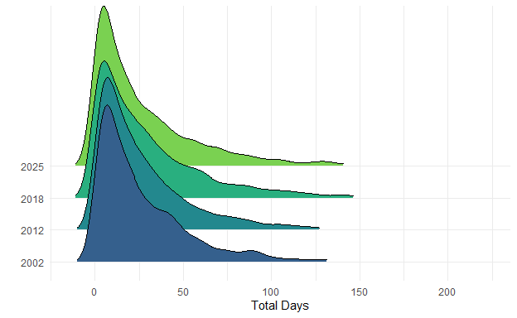

Angler Motivations
Indicate the importance for each item as a reason why you fish. Values represent mean response +- 95% confidence intervals with sample size given in parenthesis. Answers included (from 1 to 5): Not At All Important, Slightly Important, Moderately Important, Very Important, Extremely Important.
Response | 2002 |  |  |  | 2012 |  |  |  | 2018 |  |  |  | 2025
Response | Value | CI | N |  | Value | CI | N |  | Value | CI | N |  | Value | CI | N
For family recreation | 3.6 | 0.07 | 1,113 |  | 3.6 | 0.03 | 8,075 |  | 3.8 | 0.04 | 2,775 |  | 3.6 | 0.05 | 2,571
For physical exercise | 2.1 | 0.07 | 1,086 |  | 2.3 | 0.03 | 8,031 |  | 2.4 | 0.05 | 2,742 |  | 2.5 | 0.05 | 2,544
For relaxation | 4.0 | 0.06 | 1,124 |  | 4.0 | 0.02 | 8,112 |  | 4.0 | 0.03 | 2,788 |  | 4.0 | 0.04 | 2,582
For the challenge or sport | 3.2 | 0.07 | 1,107 |  | 3.3 | 0.03 | 8,054 |  | 3.4 | 0.05 | 2,755 |  | 3.2 | 0.05 | 2,546
For the experience of the catch | 3.6 | 0.06 | 1,108 |  | 3.7 | 0.02 | 8,076 |  | 3.9 | 0.04 | 2,780 |  | 3.9 | 0.04 | 2,577
For the fun of catching fish | 4.1 | 0.05 | 1,140 |  | 4.1 | 0.02 | 8,121 |  | 4.2 | 0.03 | 2,813 |  | 4.2 | 0.04 | 2,590
To be close to the water | 2.9 | 0.07 | 1,098 |  | 3.1 | 0.03 | 8,058 |  | 3.3 | 0.05 | 2,759 |  | 3.3 | 0.05 | 2,543
To be outdoors | 4.0 | 0.05 | 1,138 |  | 4.2 | 0.02 | 8,132 |  | 4.3 | 0.03 | 2,820 |  | 4.2 | 0.03 | 2,608
To be with friends | 3.3 | 0.07 | 1,104 |  | 3.4 | 0.03 | 8,101 |  | 3.6 | 0.04 | 2,768 |  | 3.5 | 0.05 | 2,562
To catch a trophy fish | 2.3 | 0.08 | 1,082 |  | 2.2 | 0.03 | 8,015 |  | 2.2 | 0.05 | 2,748 |  | 2.2 | 0.05 | 2,532
To compete for prizes or money | 1.2 | 0.04 | 1,076 |  | 1.2 | 0.01 | 8,011 |  | 1.2 | 0.02 | 2,753 |  | 1.2 | 0.03 | 2,536
To experience adventure and excitement | 3.0 | 0.07 | 1,084 |  | 3.2 | 0.03 | 8,030 |  | 3.4 | 0.04 | 2,758 |  | 3.4 | 0.05 | 2,545
To experience natural surroundings | 3.7 | 0.06 | 1,104 |  | 3.8 | 0.02 | 8,073 |  | 4.1 | 0.03 | 2,776 |  | 4.1 | 0.03 | 2,559
To experience new and different things | 2.6 | 0.07 | 1,080 |  | 2.7 | 0.03 | 8,038 |  | 3.1 | 0.04 | 2,760 |  | 3.1 | 0.05 | 2,543
To get away from other people | 3.1 | 0.08 | 1,098 |  | 3.1 | 0.03 | 8,059 |  | 3.3 | 0.05 | 2,772 |  | 3.4 | 0.05 | 2,551
To get away from the daily routine | 3.8 | 0.06 | 1,110 |  | 3.8 | 0.02 | 8,108 |  | 3.8 | 0.04 | 2,780 |  | 3.7 | 0.04 | 2,548
To obtain fish for eating | 2.6 | 0.07 | 1,119 |  | 2.6 | 0.03 | 8,108 |  | 2.6 | 0.05 | 2,763 |  | 2.5 | 0.05 | 2,559
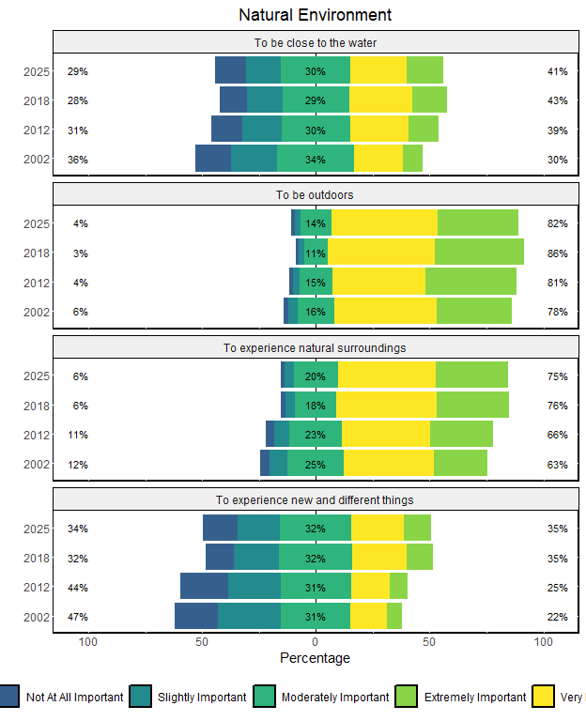
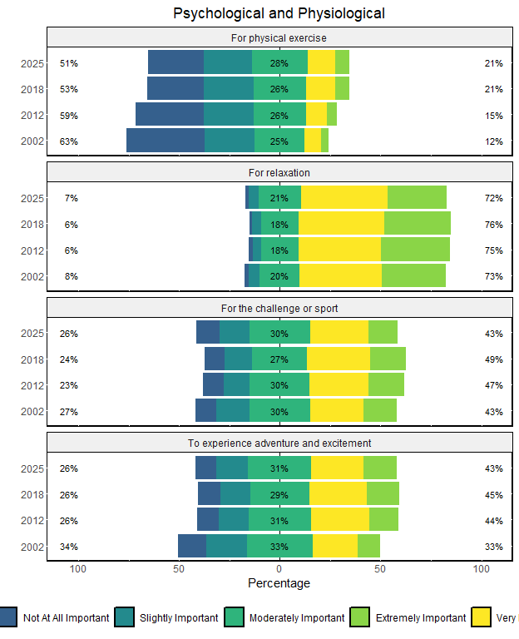
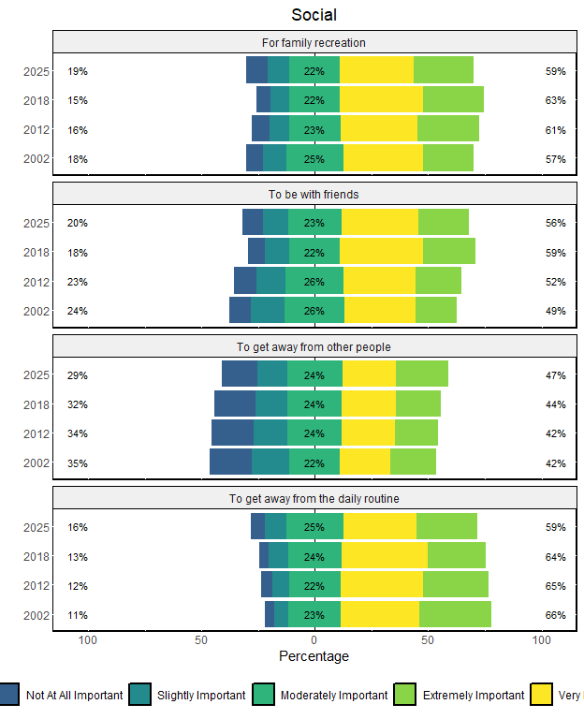
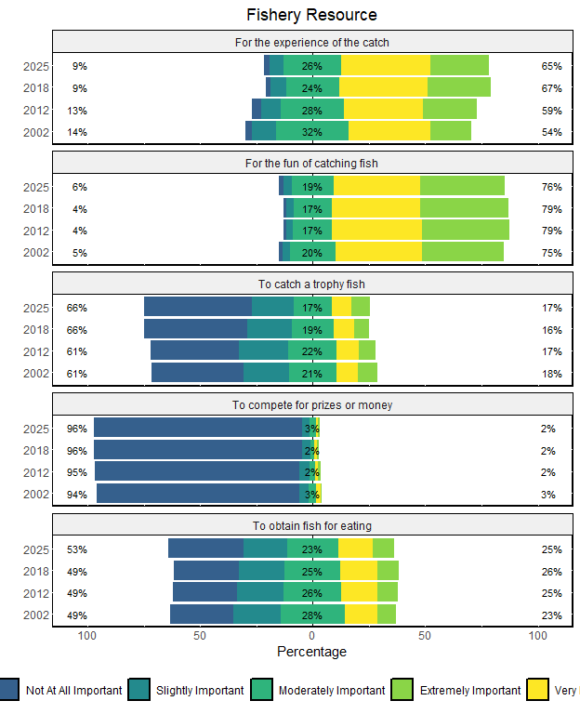

Indicate the importance for each item as a reason why you fish. Values represent mean response +- 95% confidence intervals with sample size given in parenthesis. Answers included (from 1 to 5): Not At All Important, Slightly Important, Moderately Important, Very Important, Extremely Important.
Response | 2002 |  |  |  | 2012 |  |  |  | 2018 |  |  |  | 2025
Response | Value | CI | N |  | Value | CI | N |  | Value | CI | N |  | Value | CI | N
Fishery resource | 2.7 | 0.04 | 1,049 |  | 2.8 | 0.01 | 7,940 |  | 2.8 | 0.02 | 2,656 |  | 2.8 | 0.03 | 2,453
Natural environment | 3.3 | 0.05 | 1,058 |  | 3.4 | 0.02 | 7,978 |  | 3.7 | 0.03 | 2,694 |  | 3.6 | 0.03 | 2,468
Physical and psycological | 3.1 | 0.05 | 1,053 |  | 3.2 | 0.02 | 7,955 |  | 3.3 | 0.03 | 2,653 |  | 3.3 | 0.03 | 2,469
Social | 3.5 | 0.05 | 1,063 |  | 3.5 | 0.02 | 7,987 |  | 3.6 | 0.03 | 2,689 |  | 3.6 | 0.03 | 2,466
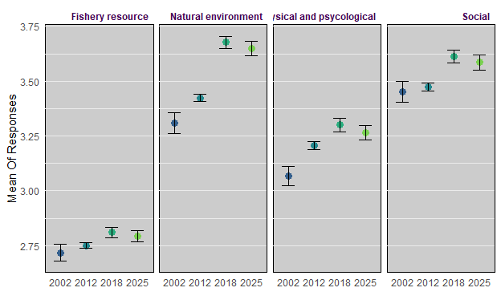

Indicate the importance for each item as a reason why you fish. Values represent mean response +- 95% confidence intervals with sample size given in parenthesis. Answers included (from 1 to 5): Not At All Important, Slightly Important, Moderately Important, Very Important, Extremely Important.
Response | 2002 |  |  |  | 2012 |  |  |  | 2018 |  |  |  | 2025
Response | Value | CI | N |  | Value | CI | N |  | Value | CI | N |  | Value | CI | N
Catch Motivations | 2.9 | 0.04 | 1,032 |  | 2.9 | 0.01 | 7,908 |  | 3.0 | 0.02 | 2,599 |  | 3.0 | 0.03 | 2,391
Non-catch Motivations | 3.3 | 0.04 | 1,027 |  | 3.4 | 0.02 | 7,893 |  | 3.5 | 0.03 | 2,580 |  | 3.5 | 0.03 | 2,377

Indicate the importance for each item as a reason why you fish. Values represent mean response +- 95% confidence intervals with sample size given in parenthesis. Answers included (from 1 to 5): Not At All Important, Slightly Important, Moderately Important, Very Important, Extremely Important.
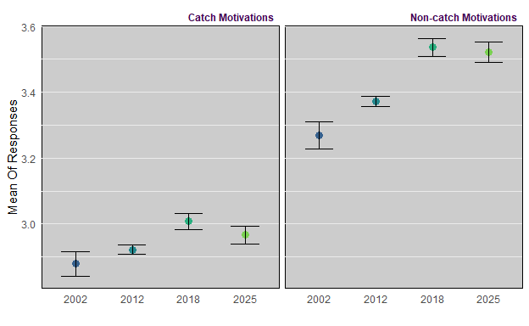

Angler Attitudes
Indicate how much you agree with each of the following statements about fishing. Values represent mean response +- 95% confidence intervals with sample size given in parenthesis. Answers included (from 1 to 5): Strongly Disagree, Disagree, Neutral, Agree, Strongly Agree.
Response | 2002 |  |  |  | 2012 |  |  |  | 2018 |  |  |  | 2025
Response | Value | CI | N |  | Value | CI | N |  | Value | CI | N |  | Value | CI | N
A fishing trip can be successful even if no fish are caught. | 3.7 | 0.06 | 1,357 |  | 3.7 | 0.02 | 8,153 |  | 3.8 | 0.04 | 2,790 |  | 3.8 | 0.04 | 2,538
A full stringer is the best indicator of a good fishing trip. | 2.7 | 0.05 | 1,346 |  | 2.6 | 0.02 | 8,136 |  | 2.7 | 0.04 | 2,765 |  | 2.7 | 0.04 | 2,526
A successful fishing trip is one in which many fish are caught. | 3.1 | 0.06 | 1,347 |  | 3.1 | 0.02 | 8,137 |  | 3.2 | 0.04 | 2,762 |  | 3.3 | 0.04 | 2,520
I'm happiest with a fishing trip if I catch at least the limit. | 2.9 | 0.06 | 1,338 |  | 2.8 | 0.02 | 8,119 |  | 3.0 | 0.04 | 2,743 |  | 3.0 | 0.04 | 2,506
I'm just as happy if I release all the fish I catch. | 3.4 | 0.06 | 1,346 |  | 3.7 | 0.02 | 8,112 |  | 3.8 | 0.04 | 2,720 |  | 3.9 | 0.04 | 2,477
I am the happiest with a fishing trip if I catch a challenging game fish. | 3.4 | 0.05 | 1,339 |  | 3.4 | 0.02 | 8,108 |  | 3.3 | 0.04 | 2,760 |  | 3.3 | 0.04 | 2,522
I like to fish where I know I have a chance to catch a trophy fish. | 3.2 | 0.06 | 1,347 |  | 3.2 | 0.02 | 8,109 |  | 3.1 | 0.04 | 2,750 |  | 3.2 | 0.04 | 2,518
I usually eat the fish I catch. | 3.3 | 0.07 | 1,351 |  | 3.2 | 0.03 | 8,131 |  | 3.0 | 0.05 | 2,747 |  | 2.9 | 0.05 | 2,513
I want to keep all the fish I catch. | 2.0 | 0.05 | 1,342 |  | 1.9 | 0.02 | 8,131 |  | 1.9 | 0.04 | 2,754 |  | 1.9 | 0.04 | 2,519
I would rather catch one or two big fish than ten smaller fish. | 3.1 | 0.06 | 1,349 |  | 3.1 | 0.02 | 8,115 |  | 3.1 | 0.04 | 2,758 |  | 3.2 | 0.04 | 2,512
I’m just as happy if I don't keep the fish I catch. | 3.4 | 0.06 | 1,333 |  | 3.7 | 0.02 | 8,108 |  | 3.7 | 0.04 | 2,766 |  | 3.8 | 0.04 | 2,511
If I thought I wouldn’t catch any fish, I would not go fishing. | 2.8 | 0.07 | 1,335 |  | 2.8 | 0.03 | 8,002 |  | 2.8 | 0.05 | 2,754 |  | 2.7 | 0.05 | 2,521
The bigger the fish I catch, the better the fishing trip. | 3.2 | 0.06 | 1,347 |  | 3.2 | 0.02 | 8,121 |  | 3.3 | 0.04 | 2,766 |  | 3.4 | 0.04 | 2,524
The more fish I catch, the happier I am. | 3.2 | 0.06 | 1,347 |  | 3.3 | 0.02 | 8,121 |  | 3.5 | 0.04 | 2,750 |  | 3.4 | 0.04 | 2,485
When I go fishing, I am not satisfied unless I catch at least something. | 3.2 | 0.06 | 1,354 |  | 3.2 | 0.02 | 8,117 |  | 3.2 | 0.04 | 2,764 |  | 3.2 | 0.04 | 2,524
When I go fishing, I’m just as happy if I don’t catch a fish. | 2.8 | 0.06 | 1,347 |  | 2.9 | 0.02 | 8,128 |  | 2.9 | 0.04 | 2,765 |  | 2.9 | 0.04 | 2,525
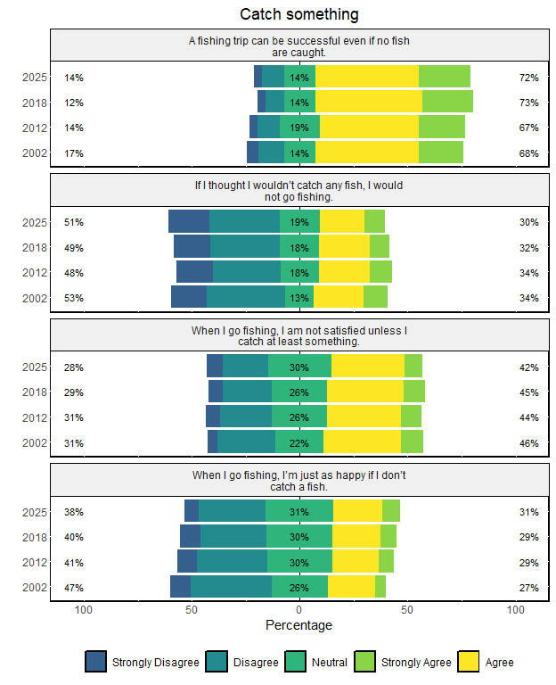
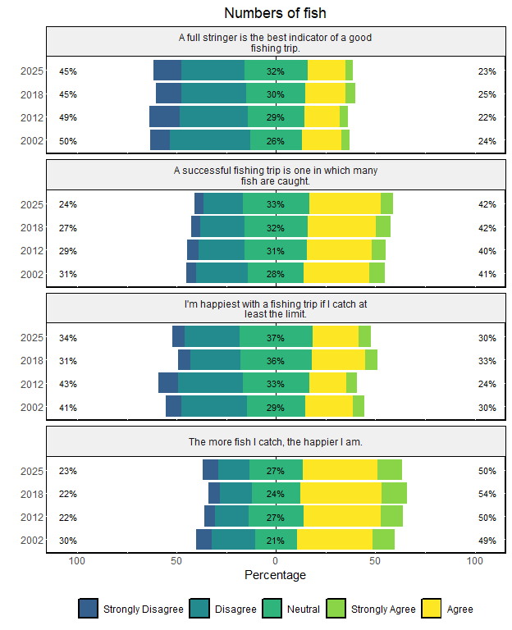
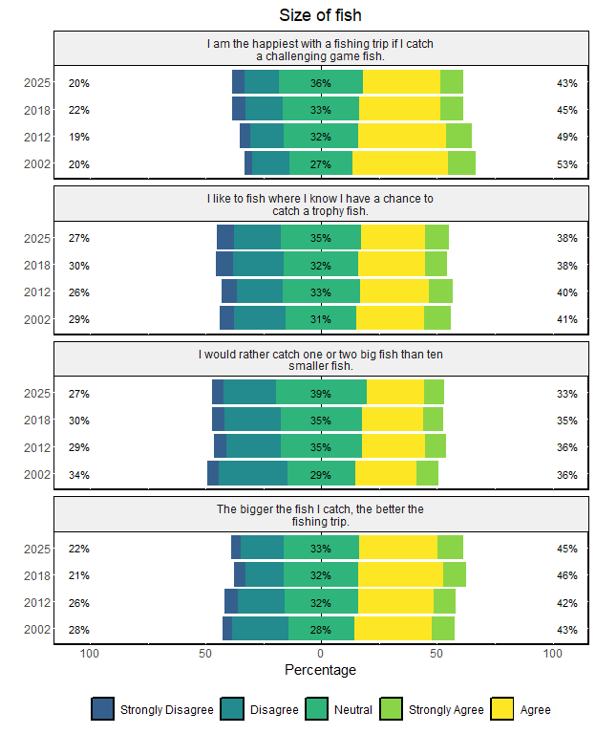
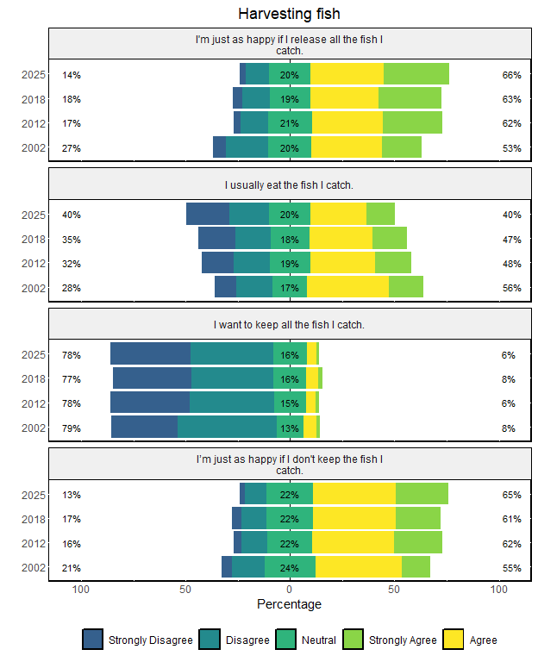

Indicate how much you agree with each of the following statements about fishing. Values represent mean response +- 95% confidence intervals with sample size given in parenthesis. Answers included (from 1 to 5): Strongly Disagree, Disagree, Neutral, Agree, Strongly Agree.
Response | 2002 |  |  |  | 2012 |  |  |  | 2018 |  |  |  | 2025
Response | Value | CI | N |  | Value | CI | N |  | Value | CI | N |  | Value | CI | N
Catch Something | 2.9 | 0.05 | 1,317 |  | 2.8 | 0.02 | 7,921 |  | 2.8 | 0.03 | 2,716 |  | 2.8 | 0.03 | 2,497
Harvest | 2.6 | 0.05 | 1,305 |  | 2.4 | 0.02 | 7,998 |  | 2.4 | 0.03 | 2,649 |  | 2.3 | 0.03 | 2,418
Numbers | 3.0 | 0.04 | 1,316 |  | 3.0 | 0.02 | 8,043 |  | 3.1 | 0.03 | 2,689 |  | 3.1 | 0.03 | 2,442
Size | 3.2 | 0.04 | 1,315 |  | 3.2 | 0.02 | 8,009 |  | 3.2 | 0.03 | 2,705 |  | 3.3 | 0.03 | 2,481


