
COURSE: COMPUTER SCIENCE
SEMESTER: II
COURSE UNIT: Cryptography and Cyber Security
FACILITATOR: MR.MUCHAKE BRIAN
NAME:KIRABIRA KEITH 23/2/306/D/387
ASSIGNMENT: NETWORK SCANNING AND ANALYSIS USING NMAP
Introduction
Network security is an important aspect of modern computing systems. Organizations and individuals need to understand their networks to protect them from attacks. One of the most powerful tools used for network discovery and security auditing is Nmap (Network Mapper).
Task 1: Installation and Setup
Explain what Nmap is and its purpose.
Nmap(Network Mapper) is a network scanning tool designed to discover hosts and services on a computer network. It works by sending specially crafted packets to target systems and analyzing their responses.

Main purposes of Nmap include:
- Host discovery – identifying active devices on a network
- Port scanning – detecting open, closed, or filtered ports
- Service detection – identifying applications running on ports
- Operating system detection – determining the OS of a target machine
- Security auditing – identifying vulnerabilities and misconfigurations

Nmap is widely used in cybersecurity for:
- Network inventory
- Monitoring system uptime
- Penetration testing
- Vulnerability assessment
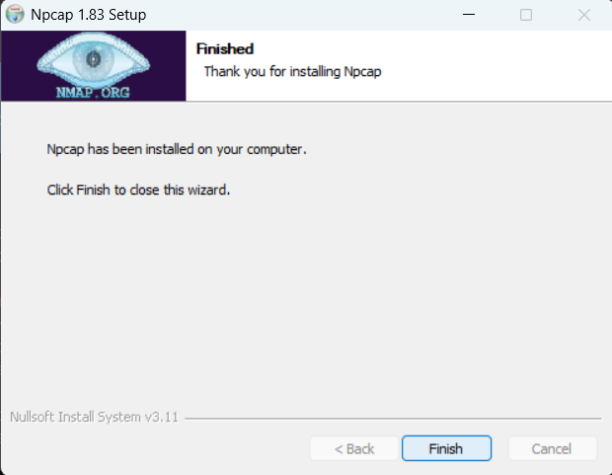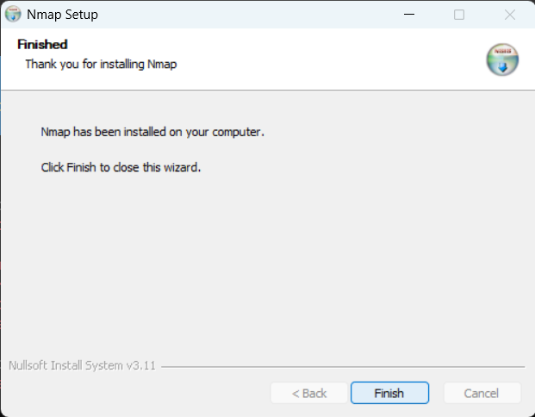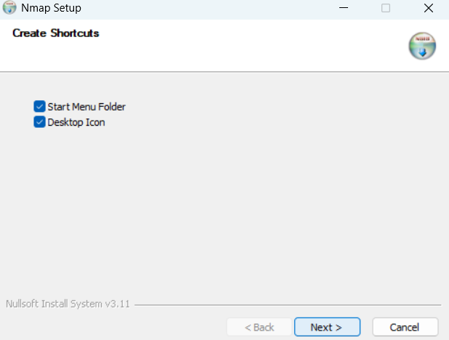

Methodology: The command nmap -v was used to verify the installation. Analysis: Nmap was successfully installed. Nmap works by sending raw IP packets to a host and analyzing responses to create a map of the network.

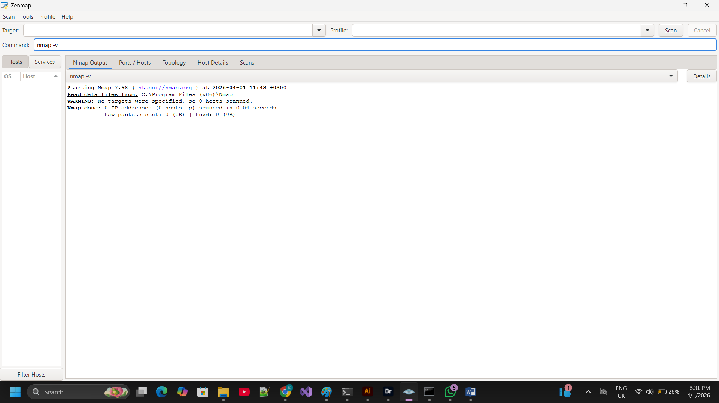

Task 2: Host Discovery (15 Marks)

Methodology

The goal was to identify active devices on the subnet. The command nmap -sn 192.168.137.159/24 was used. The -sn flag (Ping Scan) disables port scanning to focus strictly on host availability using ICMP and ARP requests.

Results & Analysis

The scan discovered two active hosts on the 192.168.137.0/24 subnet:

192.168.137.1 (Umar.mshome.net): Identified as the network gateway.

192.168.137.159 (USER-EFQ6UCVS0S.mshome.net): Identified as the local workstation.

Analysis: The /24 notation instructed Nmap to scan 256 addresses. The speed of discovery (5.67 seconds) indicates a healthy local connection.

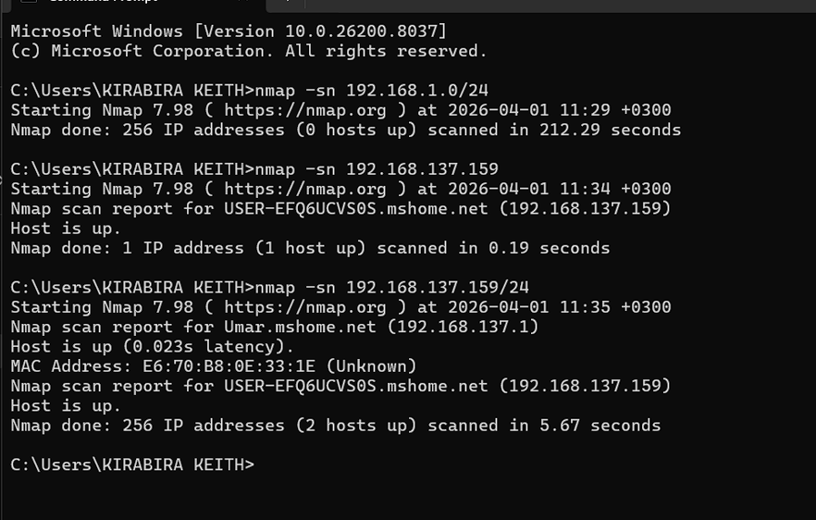

Task 3: Port Scanning
Run 'nmap ' and 'nmap -p 1-1000 '. Identify open ports.
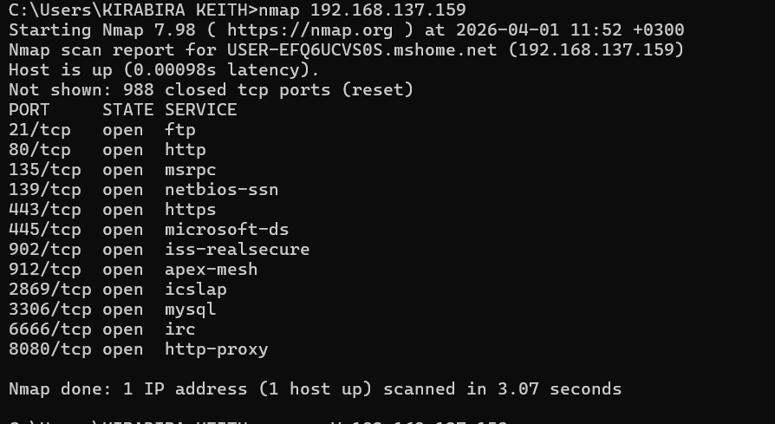

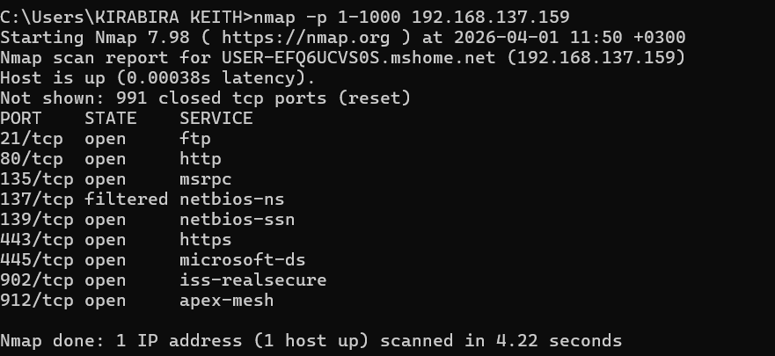
Methodology
Two commands were used: nmap 192.168.137.159 and nmap -p 1-1000 192.168.137.159.

Two variations of port scanning were performed:

nmap 192.168.137.159: Scanned the top 1,000 most common ports.

nmap -p 1-1000 192.168.137.159: Explicitly scanned every port from 1 to 1,000.

Results

The scan identified 12 open ports. Key findings include:

Port 80/443 (HTTP/HTTPS): Standard web services.

Port 3306 (MySQL): Database services (Maria DB).

Port 21 (FTP): File transfer services.

Analysis: The -p 1-1000 scan revealed that port 137 was "filtered," meaning a firewall (Windows Defender) was actively dropping packets for that specific service.

Task 4: Service Detection
Run 'nmap -sV ' and identify running services.
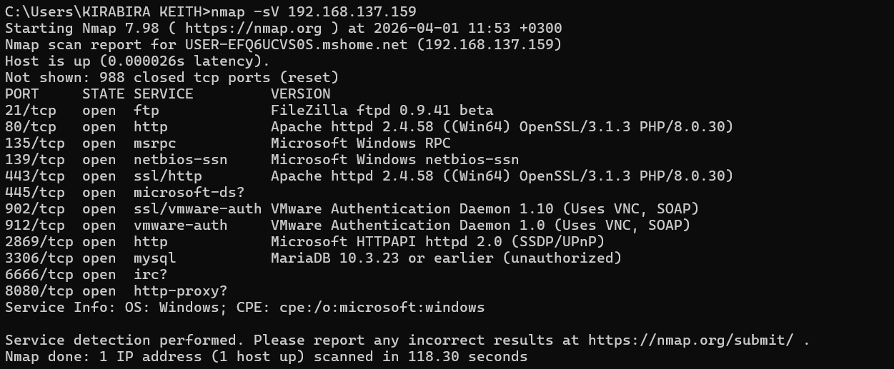
Methodology
The command nmap -sV 192.168.137.159 was used to determine the specific software versions running on the open ports.
Results & Analysis
Web Server: Apache httpd 2.4.58 (running PHP 8.0.30).
Database: MariaDB 10.3.23 (found on port 3306).
FTP Server: FileZilla ftpd 0.9.41 beta.
Analysis: Identifying these versions is critical. For example, knowing the exact Apache version allows an administrator to check if the server is vulnerable to known exploits.

Task 5: OS Detection
Run 'nmap -O ' and identify the operating system
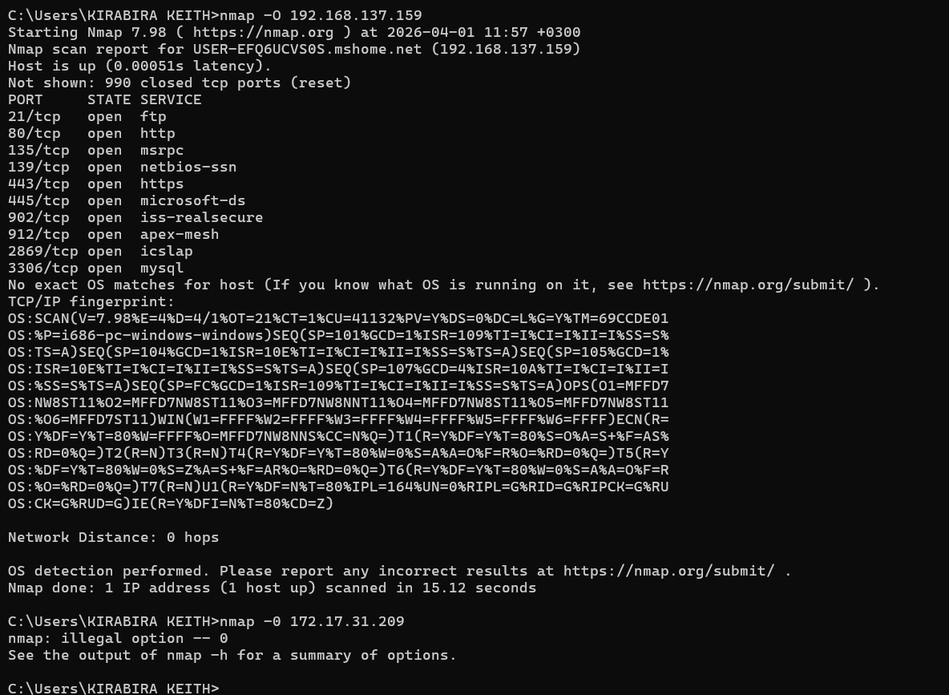
Methodology
The command nmap -O 192.168.137.159 was executed to perform TCP/IP fingerprinting to guess the Operating System.
Results & Analysis
Nmap provided a detailed TCP/IP fingerprint. While an exact build of Windows wasn't "matched" with 100% certainty, the Service Info correctly identified the family: OS: Windows; CPE: cpe:/o:microsoft:windows.

Task 6: Advanced Scans
Run advanced scans such as SYN (-sS), UDP (-sU), and Aggressive (-A). Compare results.
nmap -sS 192.168.137.159
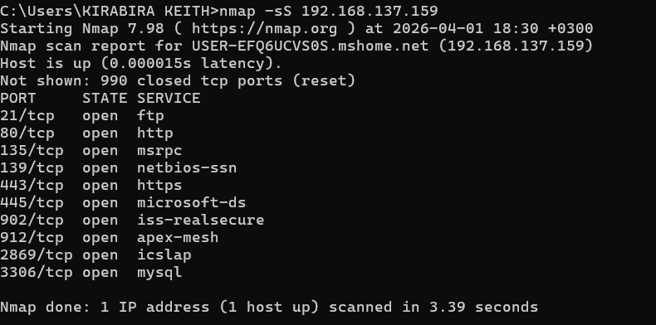

nmap -sU 192.168.137.159
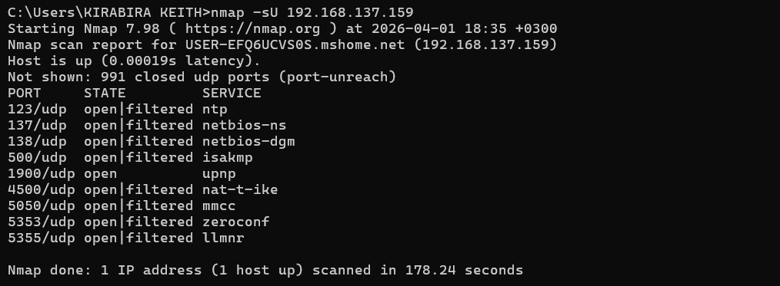
nmap -A 192.168.137.159
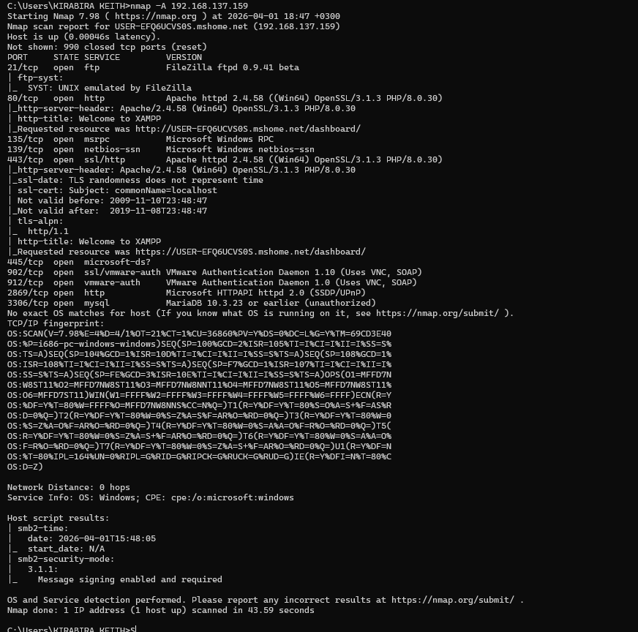
Methodology
Three types of scans were compared:
- SYN Scan (-sS): Fast and "half-open," as it doesn't complete the TCP handshake.
- UDP Scan (-sU): Discovered services like NTP (123) and UPnP (1900).
- Aggressive Scan (-A): Combined version detection, OS detection, and traceroute.
Analysis: The UDP scan is essential because services like DNS and DHCP do not use TCP. The Aggressive scan revealed that SMBv3 signing is enabled on the host, which is a positive security configuration.

Comparison Table
Scan Type | Command Flag | Key Observation
SYN Stealth | -sS | Fast (3.39s). Identified 10 TCP ports without full connection.
UDP Scan | -sU | Slow (178s). Found NTP (123) and UPnP (1900) which TCP missed.
Aggressive | -A | Comprehensive. Combined OS, Version, and SMB security info.

Task 7: Vulnerability Scan
Run 'nmap --script vuln ' and identify vulnerabilities.
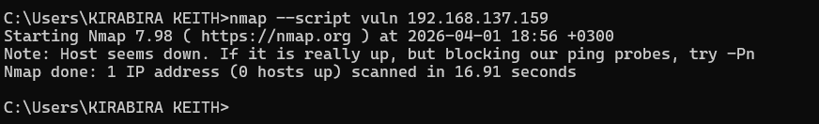
Methodology:
The command nmap --script vuln 192.168.137.159 was used.
Analysis: The host initially appeared "down" during this scan. This is a common security response where the Windows Firewall detects a high volume of script probes and temporarily blocks the scanning IP to prevent a potential attack.

Task 8: Other Essential Nmap Commands
Command: nmap -T4 -F 192.168.137.159
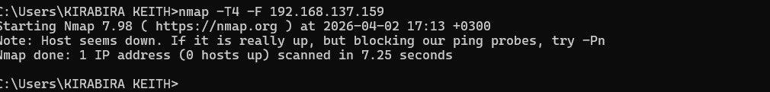
Speeds up the execution by adjusting parallel probes and timeouts. -F limits the scan to the top 100 most common ports instead of 1,000.

Command: nmap -oN nmap_report.txt 192.168.137.159
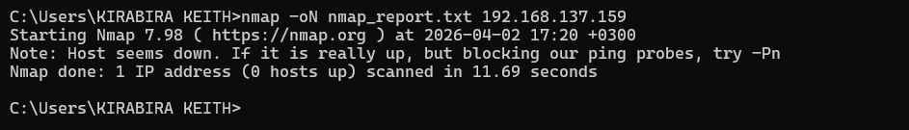
The -oN flag saves the output in "Normal" format into a file named nmap_report.txt in your current folder.

Command: nmap -Pn 192.168.137.159
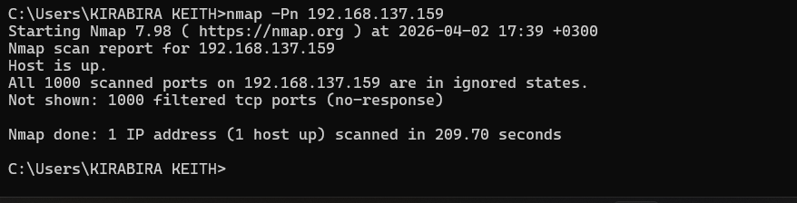
The -Pn flag tells Nmap to skip the initial "ping" check and assume the host is active. This is exactly what was needed when task 7 scan initially failed.

Conclusion
The assignment helped me to use Nmap for network reconnaissance. By discovering open ports and identifying service versions, I learned how to assess a machine's security posture. The discovery of an open database and web server highlights the importance of using firewalls to restrict access to only authorized users.

