Capstone Project Report
Hong Kong Parking Vacancy Prediction
Group Number: 4
Group Members: Lee Ki Yick (Keith) · Chin Ka Wang (Kelvin)

1. Project Details

1.1 Project Title
Hong Kong Parking Vacancy Prediction (Product name: 「咪再兜」— “stop circling for parking”).

1.2 Project Objectives
The project objectives are:
- Define a clear research question around forward-looking parking vacancy prediction (30–60 minutes ahead).
- Build a reproducible ETL pipeline from official open APIs into a queryable database.
- Establish a strong, interpretable historical baseline and compare Machine Learning models against it.
- Conduct EDA and visualization across Hong Kong districts to reveal vacancy structure by time and place.
- Deliver a usable GenAI product that turns predictions into natural-language, voice-friendly recommendations for drivers.

1.3 Research Question
Can we predict whether a car park will have private-car vacancies (classification) and the number of vacancies (regression) 30–60 minutes ahead, using official real-time data and time/location features—and outperform a same-weekday–same-hour historical average baseline?

2. Dataset Description

2.1 Introduction to the Dataset
The primary data source is the Transport Department / data.gov.hk Carpark Information and Vacancy API, which provides near real-time private-car vacancy counts, park metadata (name, district, coordinates), and fee fields where available. Complementary weather snapshots come from the Hong Kong Observatory Weather API (temperature, humidity, and related regional observations). Product-side APIs (DeepSeek Chat, Google Maps Geocoding / Maps JavaScript, Google Speech Recognition, and Microsoft Edge Text-to-Speech) are used for the interactive agent, not as training labels.
Geographic scope evolved from an early Kwun Tong / Sha Tin pilot to a territory-wide coverage of roughly 18 Hong Kong districts and about 587–592 car parks in the working inventory. The modelling and product focus is car-park vacancy for private cars; on-street metered spaces are out of scope.

2.2 Dataset Characteristics
Characteristic | Approximate value
Car parks (metadata inventory) | ~587–592 parks across ~18 districts
Historical baseline window | 365 days (≈ 34.9k snapshots; ~238k aggregated baseline rows; ~511 parks in baseline build)
Live / local vacancy snapshots (SQLite backup) | ~39k vacancy records; ~69 weather records (growing with collection)
Collection cadence | About every 10 minutes
Target variables | vacancy count (regression); has_vacancy = vacancy > 0 (classification)
Key features | hour / half-hour slot, day of week, weekend flag, park_id, district, temperature
Class balance note | Many parks often have vacancy > 0; binary F1 is high but still useful as a gate for ranking

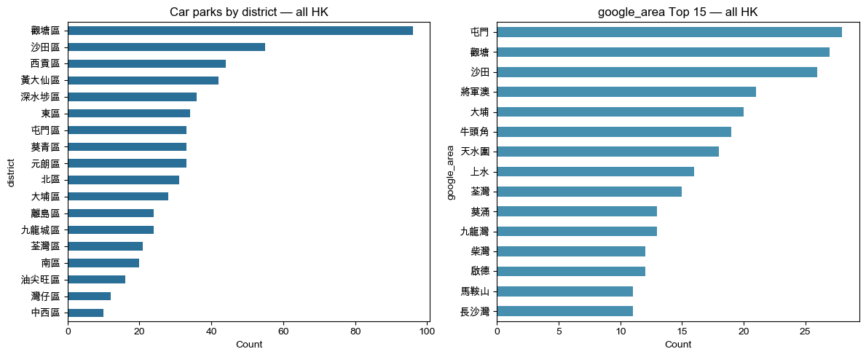
Figure 1. Car-park counts by administrative district (left) and top Google area clusters (right). Kwun Tong and Sha Tin have the densest coverage in the inventory.

2.3 Data Preprocessing
- Filter private-car vacancy fields; treat negative / missing vacancy as unavailable for modelling and ranking.
- Join park metadata (district, coordinates, names) to vacancy snapshots on park_id.
- Derive temporal features in Hong Kong time (hour, half-hour slot, day of week, weekend).
- Build capacity proxies from observed max vacancy / baseline means where official “space” coverage is sparse (~5%).
- Aggregate a 365-day historical ZIP into a compact vacancy_baselines.parquet summary (park × half-hour × DOW means) for scalable scoring.
- Optional shrinkage toward broader priors when a specific slot has few observations (mirrors production app logic).
- Time-based train/test split (70/30) to avoid future leakage when evaluating Gradient Boosting models.

3. Methodology

3.1 Research Approach
We treat parking vacancy as a structured spatiotemporal prediction problem rather than a pure “current map” lookup. The approach combines (i) continuous ETL from official APIs, (ii) a strong historical baseline as the scientific control, (iii) Gradient Boosting models for lift beyond averages, and (iv) a GenAI agent that translates scores into driver-facing answers. The rationale is practical: drivers need forward-looking guidance, and any ML claim must beat an interpretable same-hour baseline built from a full year of history.
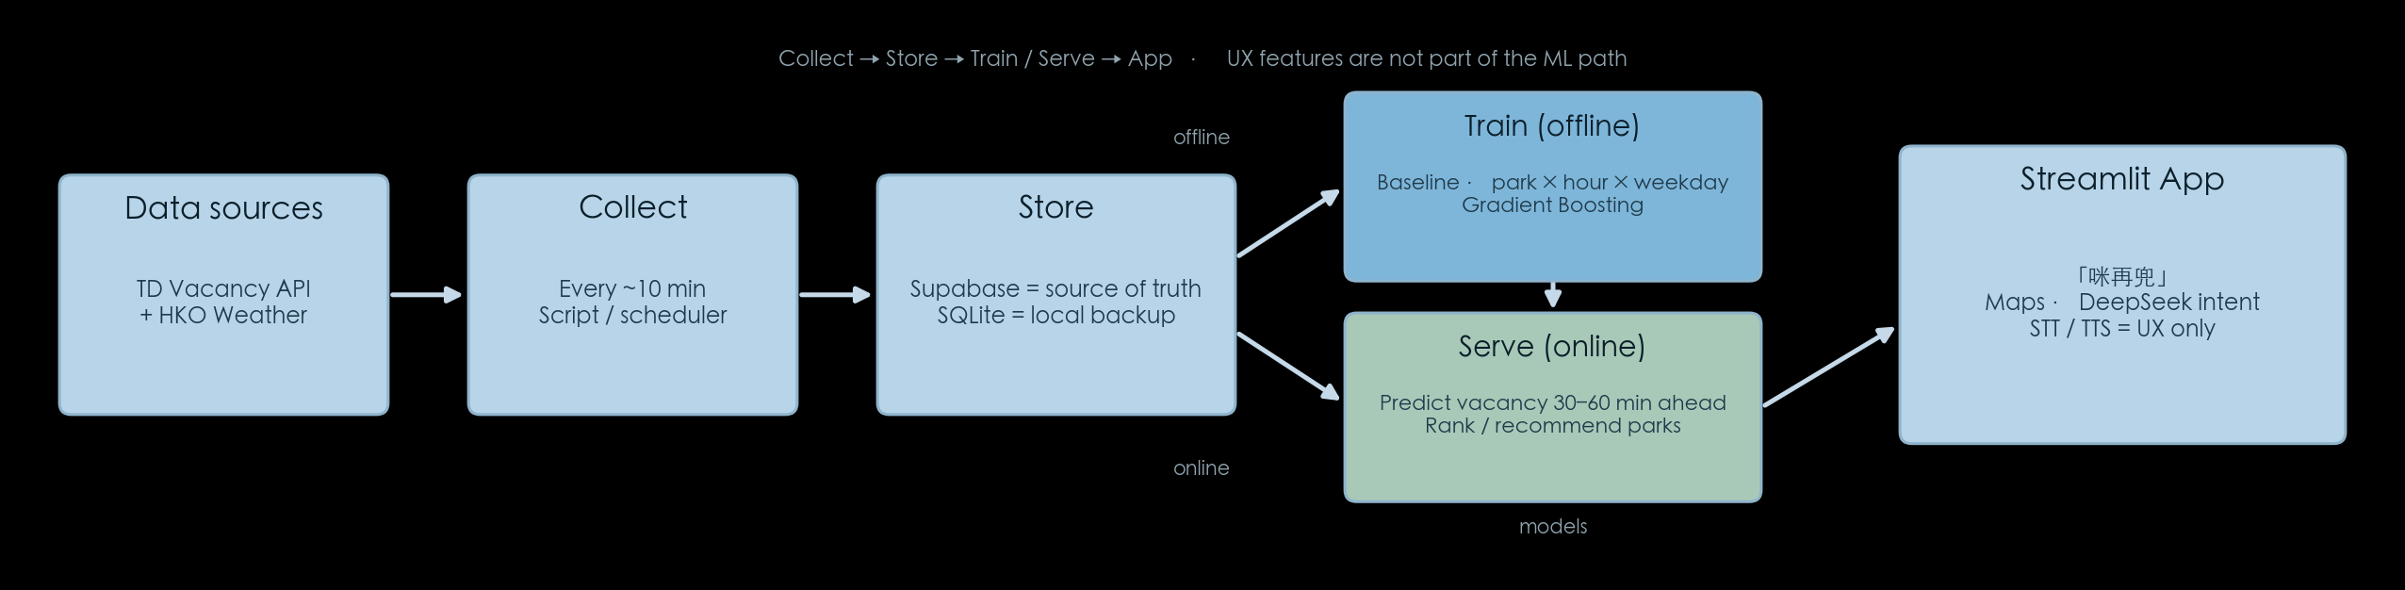
Figure 2. System pipeline from the project PowerPoint: Collect → Store → Train / Serve → Streamlit app 「咪再兜」(Maps + DeepSeek intent; STT/TTS as UX only).

3.2 Data Collection & ETL
Collection scripts and notebooks (collect.ipynb / scripts/collect_to_supabase.py) poll the Transport Department vacancy API and HKO weather endpoints approximately every 10 minutes. Records are transformed into normalized tables—carparks, vacancy_records, weather_records—and written to local SQLite (parking.db) as well as mirrored to Supabase Postgres for cloud reads by the Streamlit app. Historical ZIP imports are summarized into baseline parquet files to avoid saturating free-tier cloud disk with raw history.

3.3 Analytical Techniques
Baseline model.
For each park, half-hour slot, and weekday, we compute the mean private-car vacancy from up to 365 days of history. This baseline is strong and interpretable: it already encodes weekly seasonality and park-specific capacity behaviour.
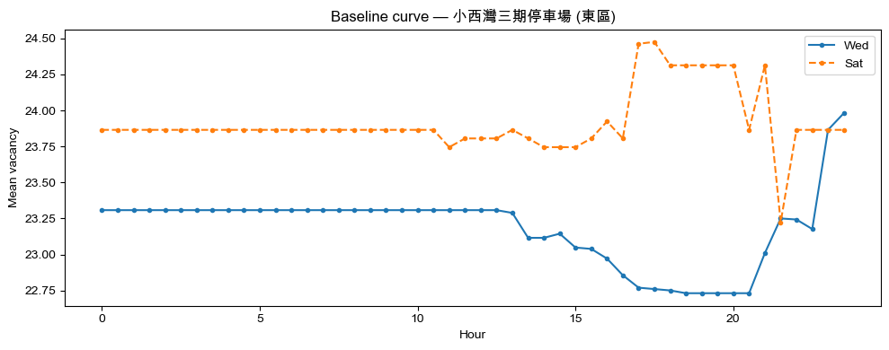
Figure 3. Example park-level baseline curve comparing weekday vs weekend mean vacancy across hours of day.
Machine Learning models.
We train a Gradient Boosting Regressor to predict vacancy count and a Gradient Boosting Classifier to predict has_vacancy (vacancy > 0). Features include hour, day of week, weekend flag, encoded park/district identifiers, and temperature when available. Evaluation uses a chronological 70/30 train/test split. Primary metrics are MAE for regression and F1 for classification, with explicit comparison to the historical baseline MAE.
Product / Generative AI layer.
The Streamlit app 「咪再兜」 uses DeepSeek to parse Cantonese/Chinese natural-language intent (place, time, and query type such as “how easy to park here” vs “where nearby is easier”). Google Geocoding locates the place; nearby parks are scored with live vacancy plus baseline/ML predictions; Speech Recognition and Edge TTS support hands-busy driving scenarios. This GenAI layer does not replace the models—it packages predictions into usable guidance.

4. Analysis and Discussion

4.1 Exploratory Insights
EDA across all Hong Kong districts shows that vacancy is structured, not random. Capacity-weighted vacancy-rate heatmaps by district × hour reveal tighter midday conditions and freer nights in many areas, with Central Business District districts (Central & Western, Yau Tsim Mong, Wan Chai) often showing lower average vacancy rates than parts of the New Territories and Islands. These patterns motivate including time and location features and explain why a same-hour baseline is already competitive—and why ML can still add lift by combining park identity with context features.
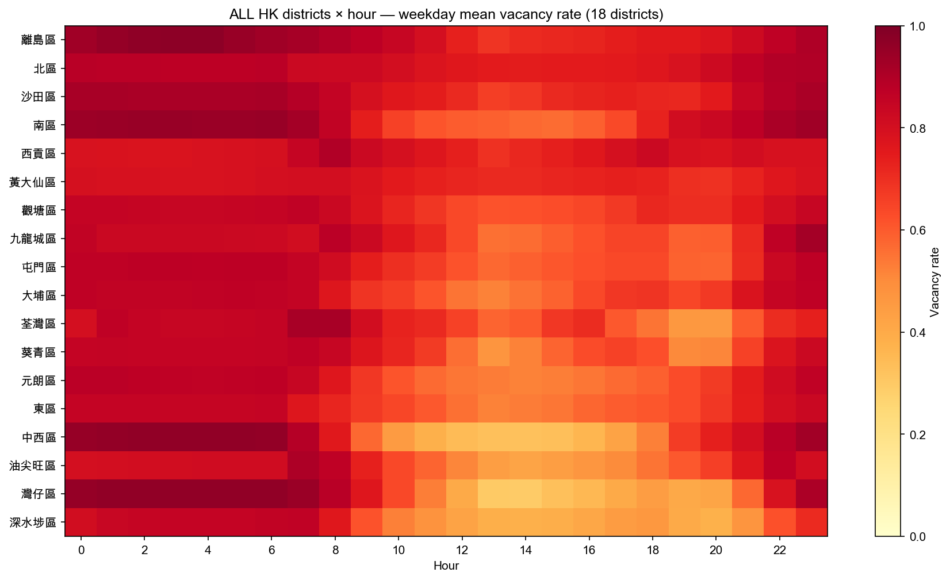
Figure 4. Territory-wide weekday mean vacancy-rate heatmap (district × hour). Structured diurnal and district differences are visible.
Live-vs-baseline spot checks (one park per district) show that historical means usually track live vacancy directionally, while large facilities can deviate substantially at a given moment—exactly the regime where forward-looking prediction and nearby ranking help drivers decide.
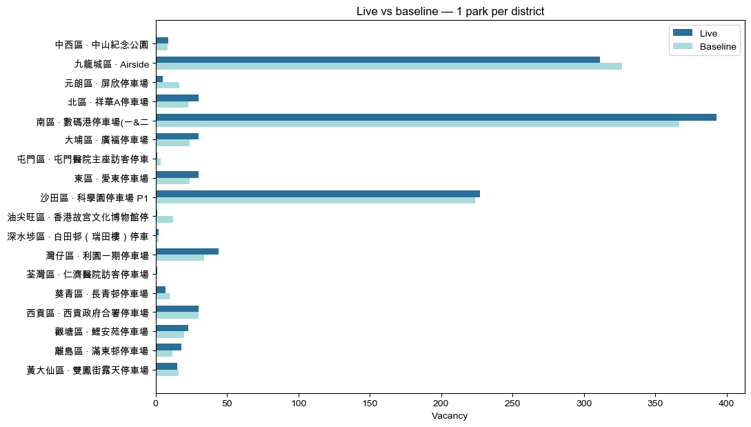
Figure 5. Live private-car vacancy versus same-slot baseline for one representative park per district.

4.2 Model Results
On the time-based holdout, Gradient Boosting outperforms the same-hour historical baseline on vacancy-count prediction: regression MAE improves from approximately 17.8 vacancies to 10.40. Classification of whether a park has any private-car vacancy achieves an F1 of about 0.957. Including temperature yielded a modest MAE improvement relative to a no-weather variant (~10.73 → 10.40) in early experiments, suggesting weather is a useful but still under-exploited signal.
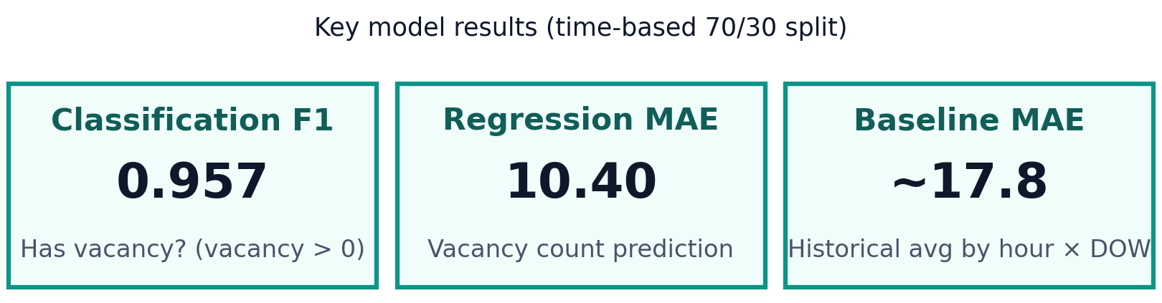
Figure 6. Key model results from the PowerPoint (time-based 70/30 split): Classification F1 ≈ 0.957; Regression MAE = 10.40; Baseline MAE ≈ 17.8.
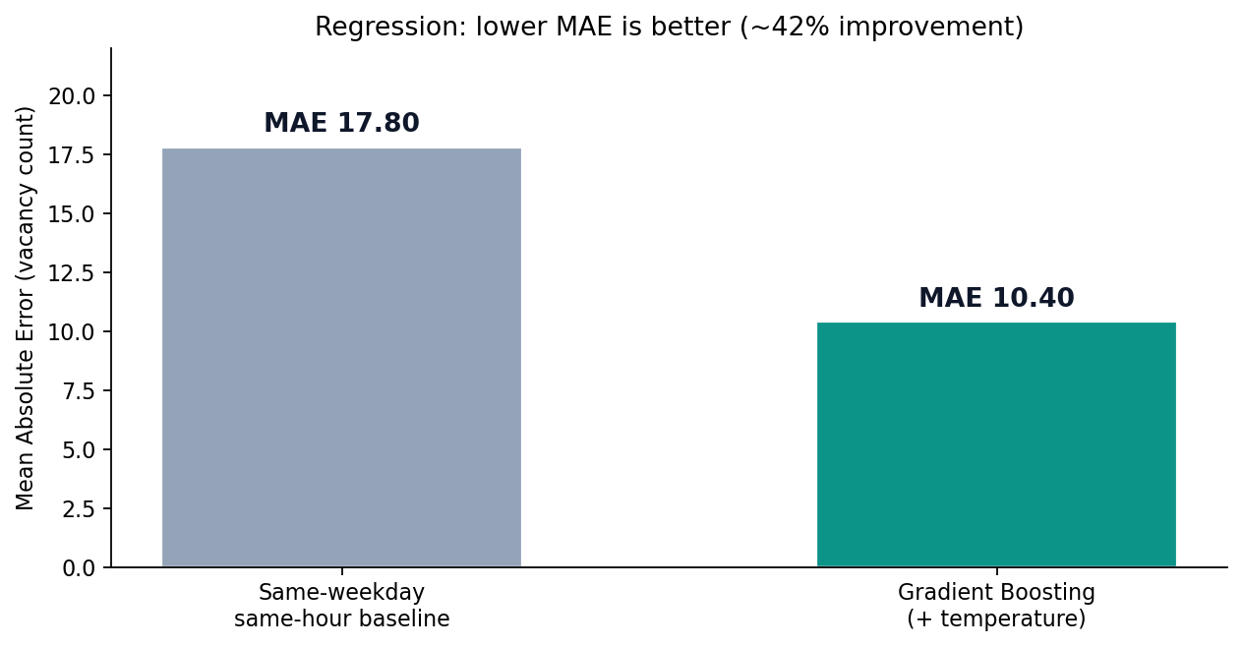
Figure 7. Regression MAE comparison from the PowerPoint: Gradient Boosting versus same-hour historical baseline.
Beyond scalar metrics, district-level mean predicted vacancy rankings (e.g., Friday 19:00) illustrate how the system supports routing decisions: drivers need not only a yes/no vacancy flag, but a comparative view of where spaces are likelier to be available at a chosen future time.
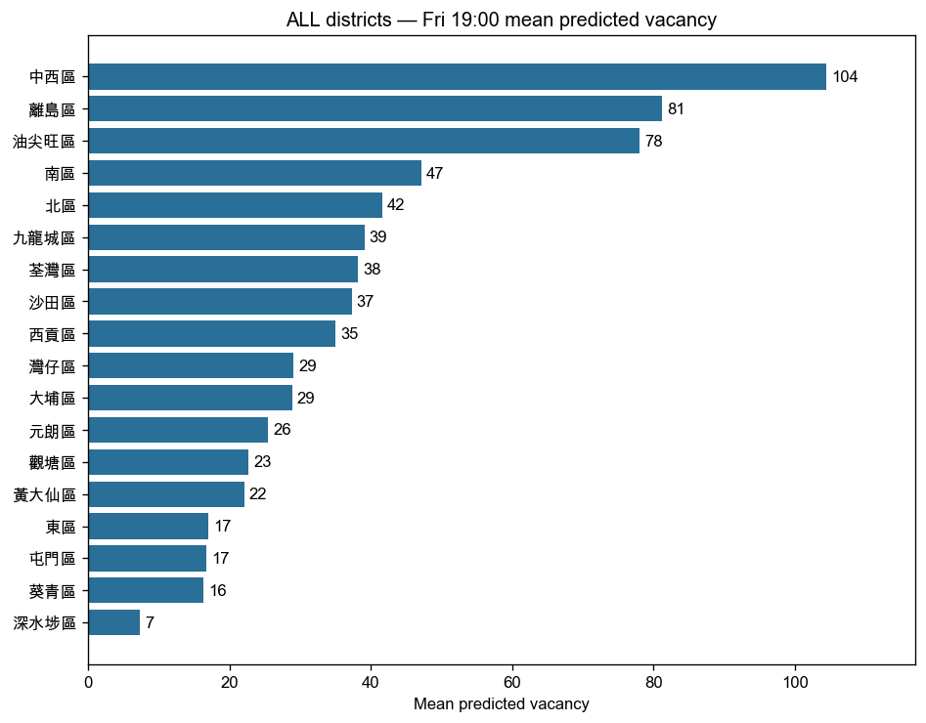
Figure 8. Example Friday 19:00 mean predicted vacancy ranking across all districts.

4.3 Potential Reasons for Observed Patterns
- Weekly and hourly seasonality dominate parking demand (commuting, shopping, dining).
- District land-use mix (CBD offices vs residential New Territories) shifts when parks fill and empty.
- Park-specific capacity and access rules create large level differences that park_id features capture.
- Short-horizon weather effects exist but need longer variation (rain, warnings) to dominate time features.
- High binary F1 partly reflects that many parks often retain some vacancy; ranking and count MAE remain the harder practical problems.

4.4 Product Demonstration Evidence
The product screenshots below are taken from the live Streamlit Cloud demo (https://hk-parking-vacancy-prediction.streamlit.app/). They show the full loop from home screen → natural-language query → AI intent parsing → ranked nearby car parks → map → day-ahead vacancy trend. The demo query is 「啟德附近下星期五下晝兩點半邊度比較易泊車？」 (Near Kai Tak, where is it easier to park next Friday at 2:30 p.m.?). DeepSeek parses this into place ≈ Kai Tak, Kowloon, Hong Kong, date = Friday 13 Nov 2026, and time = 2:30 p.m. The UI then returns the top 10 nearby parks (default when count is unspecified), with distance and fee fields (fee shown as 未提供 when open data has no rule for the selected period), a colour-coded map, and a Friday all-day predicted-vacancy trend for the leading parks.
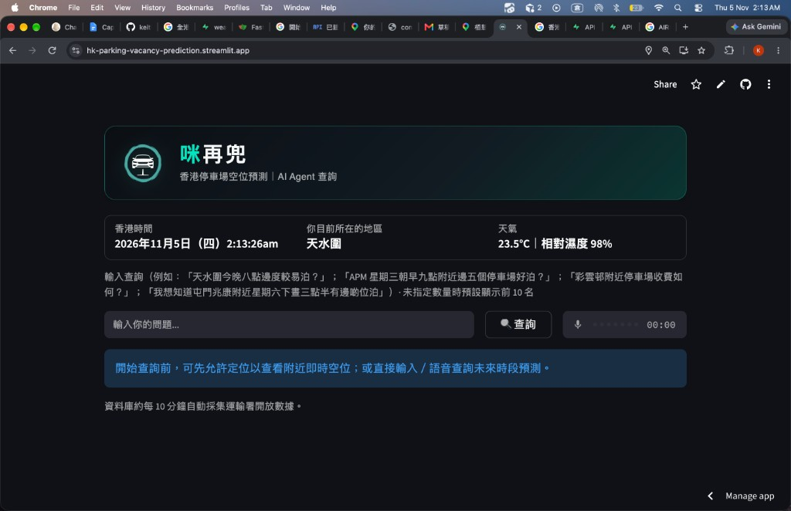
Figure 9. 「咪再兜」 home screen (live Streamlit demo).
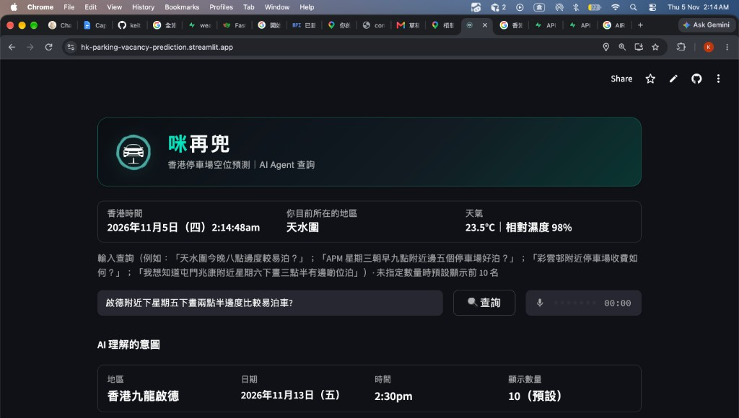
Figure 10. Natural-language query and AI intent panel (Kai Tak · next Friday 2:30 p.m.).
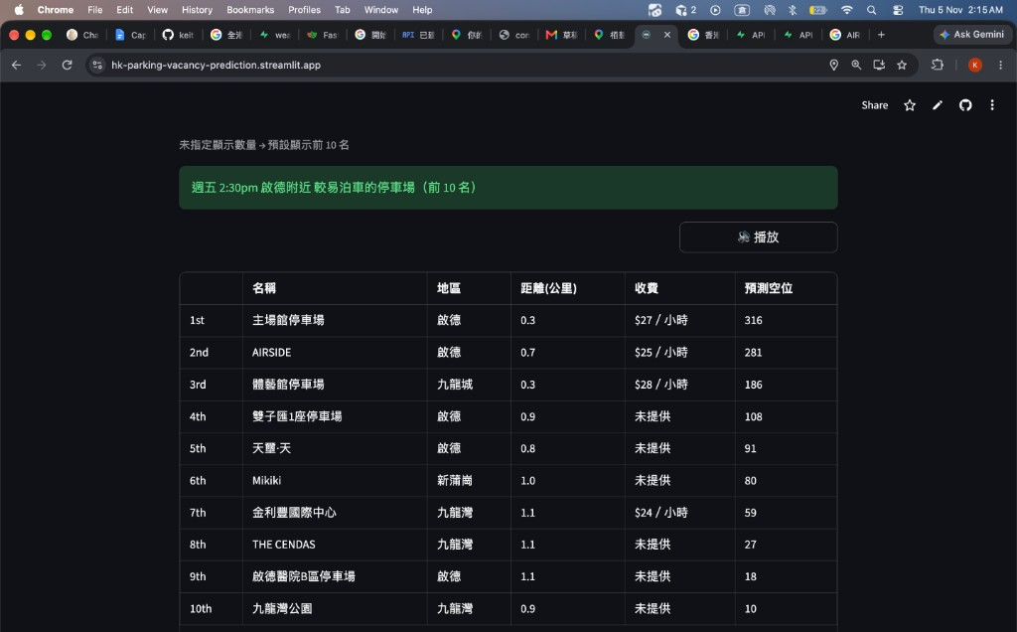
Figure 11. Ranked nearby car parks for Friday 2:30 p.m. near Kai Tak (top 10; distance in km; predicted vacancy).
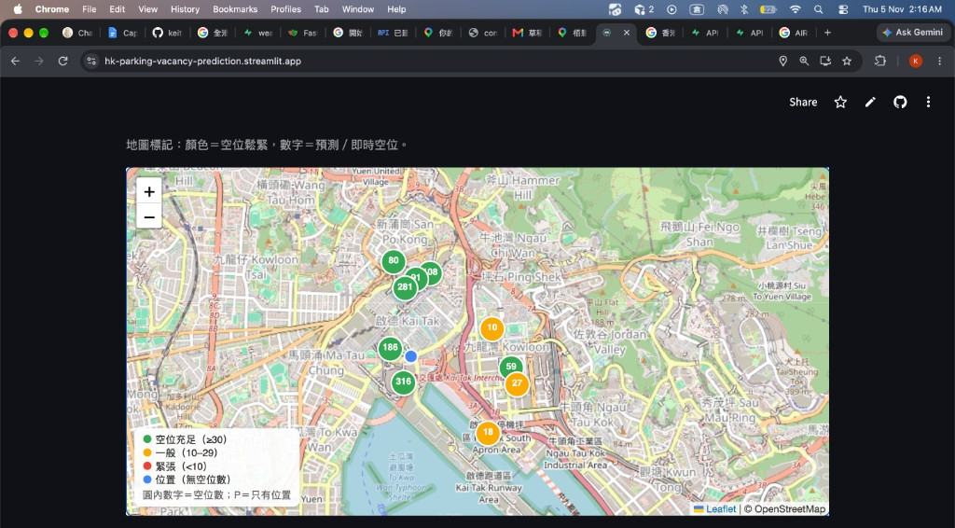
Figure 12. Map view for the same Kai Tak query (colour = vacancy tightness; number = predicted vacancy).
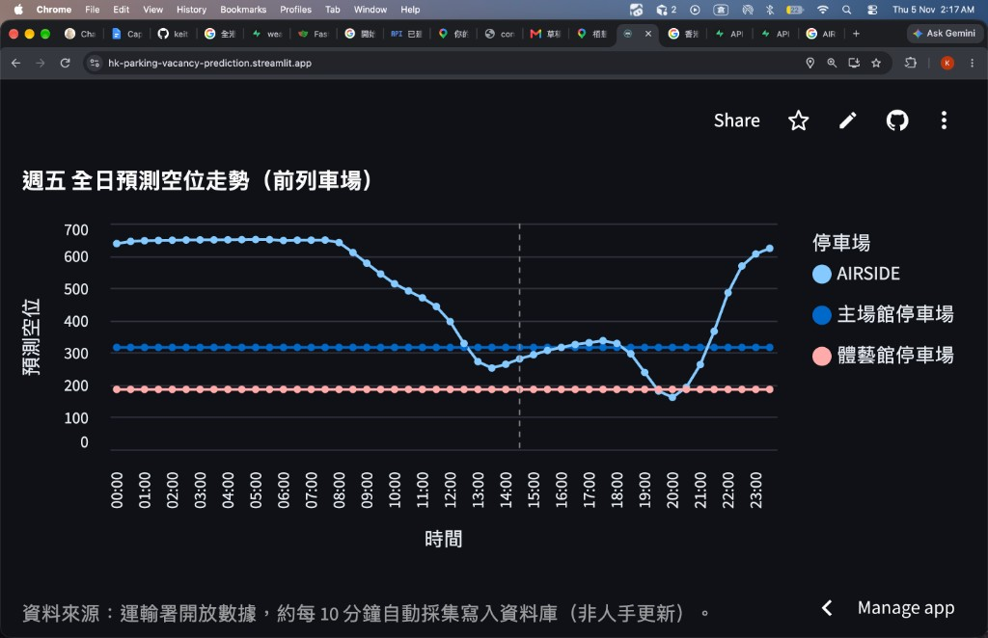
Figure 13. Friday all-day predicted vacancy trend for leading parks near Kai Tak (vertical marker at 14:30).
Live app URL: https://hk-parking-vacancy-prediction.streamlit.app/
GitHub repository: https://github.com/keithlky1992/hk-parking-vacancy-prediction
Scan the QR code below to open 「咪再兜」 on Streamlit Cloud and try the same natural-language queries.

Figure 14. QR code for the live Streamlit app (https://hk-parking-vacancy-prediction.streamlit.app/).

5. Challenges and Limitations

5.1 Challenges Faced
- Early live collection depended on a continuously running machine; sleep/gaps created missing timestamps.
- Cloud free-tier disk limits constrained importing full raw historical vacancy into Supabase.
- Official capacity (“space”) fields are sparse, requiring proxy capacity for rate-based EDA.
- Integrating many APIs (TD, HKO, Supabase, DeepSeek, Google, Speech, TTS) increased operational complexity.
- Balancing scientific evaluation (baseline vs ML) with a polished bilingual driving-oriented UX under a short Capstone timeline.

5.2 Limitations of Approach / Dataset
- Scope covers car parks only—not on-street meters—so results must not be claimed as “all parking in HK.”
- Early ML training windows were short before the 365-day baseline expansion; some metrics reflect limited diversity.
- Weather signals were collected but remain underused beyond temperature in the reported models.
- High classification F1 does not imply equally precise count forecasts for every park size.
- Speech and LLM components introduce external service dependency and latency.

5.3 Potential Areas for Improvement
- Move collection to cloud cron / Edge Functions for true 24×7 reliability.
- Persist trained model artifacts to storage and automate retraining.
- Add rainfall, warning signals, public holidays, and special-event flags.
- Introduce multi-class vacancy levels (low / medium / high) alongside regression.
- Deeper error analysis by district, hour, and park capacity band.

6. Future Work
Ideas considered but not fully implemented—mainly due to time, cloud-disk, and operational constraints—include: scheduled cloud collection; richer weather and holiday feature sets; storing and versioning trained Gradient Boosting models; vacancy-level classification; stronger LLM-generated suggestion copy grounded in model confidence; and systematic residual analysis. The current product already ships a working agent with baseline scoring; these items are the natural next engineering milestones after Capstone submission.

7. Conclusion
This Capstone project set out to predict Hong Kong private-car parking vacancy 30–60 minutes ahead and to prove that Machine Learning can beat a strong same-hour historical baseline while packaging results into a usable driver product. We delivered an end-to-end data science stack—API ETL, SQL/Postgres storage, EDA, baseline and Gradient Boosting models, and a Generative AI Streamlit agent—aligned with the course technical skills checklist (Python, SQL, ETL, APIs, EDA, visualization, ML, and GenAI).
Key takeaways: (1) parking vacancy in Hong Kong has learnable structure by district and hour; (2) a year-long same-park × hour × weekday baseline is a fair and necessary control; (3) Gradient Boosting improved regression MAE from ~17.8 to 10.40 and reached ~0.957 classification F1 on the reported split; (4) GenAI is most valuable when it orchestrates maps, voice, and ranked predictions rather than inventing vacancies. Together, these results affirm the research question and provide a practical foundation for continued data collection and model hardening.

8. References
- Transport Department / data.gov.hk — Carpark Vacancy Data API.
- Hong Kong Observatory — Weather information APIs.
- Supabase — Postgres backend used for carparks, vacancy_records, and weather_records.
- DeepSeek — Chat API for natural-language intent parsing and agent replies.
- Google Maps Platform — Geocoding and Maps JavaScript APIs.
- Google Speech Recognition API; Microsoft Edge Text-to-Speech (Cantonese output).
- scikit-learn — Gradient Boosting Regressor / Classifier.
- Streamlit — Product deployment (https://hk-parking-vacancy-prediction.streamlit.app/).
- Project repository: https://github.com/keithlky1992/hk-parking-vacancy-prediction (explore_api_en.ipynb / explore_api_zh.ipynb, app.py, parking_db.py, scripts/).

9. Distribution of Work
Member | Primary responsibilities
Lee Ki Yick (Keith) | Product/app (Streamlit「咪再兜」), GenAI agent wiring (DeepSeek/Maps/Speech/TTS), cloud data layer (Supabase), demo & presentation narrative
Chin Ka Wang (Kelvin) | Data collection & ETL design, baseline/ML modelling & evaluation, EDA notebooks and charts, methodology documentation
Shared | Research question framing, report/presentation content, figure selection, final deliverable packaging

Note: Exact effort shares were collaborative; the table summarises primary ownership for assessment clarity.

Appendix A. Technical Skills Checklist Mapping
Course skill | How this project uses it
Python programming | ETL scripts, notebooks, Streamlit app, modelling utilities
SQL & database management | SQLite + Supabase Postgres schemas and queries
ETL processes | Scheduled ~10-min collect/join of vacancy + weather
API integration | TD, HKO, Supabase, DeepSeek, Google Maps, Speech, Edge TTS
EDA | District/hour heatmaps, baseline curves, live-vs-baseline checks
Data visualization | Matplotlib charts embedded in notebooks, slides, and this report
Statistical / ML modelling | Historical baseline; Gradient Boosting regression & classification
Generative AI | DeepSeek intent + natural-language recommendations; voice I/O

Appendix B. How to Reproduce
- Clone the GitHub repository (https://github.com/keithlky1992/hk-parking-vacancy-prediction) and create a Python environment from requirements.txt.
- Configure .env with SUPABASE_URL / keys (and other API keys required by the app).
- Run scripts/build_vacancy_baselines.py to regenerate baseline summaries if needed.
- Run streamlit run app.py locally, or open the deployed Streamlit Cloud URL.
- Use explore_api_en.ipynb (or explore_api_zh.ipynb) for EDA aligned with the app scoring logic.
- Optional: scripts/collect_to_supabase.py for continued ~10-minute collection.
— End of Final Report (References, Distribution of Work, and Appendix excluded from the 20-page body limit per Capstone Guideline) —

