Quest 02: ‘The Warlock Canticle’.
Answer each of the questions below to the best of your ability. Please be sure to put your answers in red font. Unlike lab assignments, each Quest should reflect each student’s independent work. You are welcome to study previous course materials with other students, but you should not share answers or directly assist other students in completing the Quest.

Question 1.
This question is loosely based on the following paper: Shure, D.J, Mooreside, P.D., & Ogle, S.M. (1998). Rainfall effects on plant-herbivore processes in an upland oak forest. Ecology, 79, 604-617.
In this study of leaf damage caused by insects in an upland oak forest, the following variables are available for a number of trees:
- TreeType = ‘white’ oak, ‘chestnut’ oak, or red ‘maple’
- Age = ‘sapling’ or ‘mature’
- Elevation = altitude in meters where the tree is located
- Nitrogen = leaf concentrations of Nitrogen as a percent of leaf mass
- Damage = a continuous measure of the leaf damage (percent of leaf area damaged) caused by insects
Provide the Model A/C comparison to be used to answer the following questions. Be sure to specify any new variables that you create.
1. Do trees at higher elevations tend to have more leaf damage caused by insects?
- Model A: [Your Answer Here.]
- Model C: [Your Answer Here.]
2. There might be an ideal elevation at which trees are best at defending themselves against insect damage. Is there an elevation at which insect damage approaches an asymptote? (That is, is there a curvilinear relationship between elevation and insect damage?)
- Model A: [Your Answer Here.]
- Model C: [Your Answer Here.]
3. A researcher believes that the ideal elevation to reduce insect damage is 200 meters. Thus, assuming that there is a curvilinear relationship, the slope relating elevation to insect damage should be essentially 0 at elevation = 200 meters. How could you answer this question using a model comparison? (Note that answering this question will require creating a new variable.)
- Model A: [Your Answer Here.]
- Model C: [Your Answer Here.]
4. Now assume that there is only a linear relationship between elevation and leaf damage, does this relationship depend on the concentration of Nitrogen in the leaf?
- Model A: [Your Answer Here.]
- Model C: [Your Answer Here.]

5. Ignoring the previous variables, are the oaks more susceptible to insect damage than maples? First you will need to specify a set of contrast codes to answer this question. Design your codes so that one code is explicitly comparing the oaks (on average) to red maples.
- Codes
Code Label ↓ | White Oaks | Red Maples | Chestnut Oaks
[Your Answer Here.] | [Your Answer Here.] | [Your Answer Here.] | [Your Answer Here.]
[Your Answer Here.] | [Your Answer Here.] | [Your Answer Here.] | [Your Answer Here.]

- Model A: [Your Answer Here.]
- Model C: [Your Answer Here.]

6. Finally, assume that you want to see if resistance to insect damage depends on both tree type and nitrogen concentration. What models would you need to compare to test for the Tree Type x Nitrogen interaction?
- Model A: [Your Answer Here.]
- Model C: [Your Answer Here.]
7. Ignoring Nitrogen levels, does the difference in susceptibility to insect damage between oaks and maples depend on the age of the trees?
- Model A: [Your Answer Here.]
- Model C: [Your Answer Here.]
8. Considering the six groups defined by Tree Type crossed with Age. What models would you need to compare for the omnibus test among the six groups? That is, are there any significant mean differences in leaf damage across all six groups?
- Model A: [Your Answer Here.]
- Model C: [Your Answer Here.]
9. Do an omnibus test of whether the relationship between Nitrogen and insect damage is the same within each of the six groups in the 2 (Age = sapling or mature) x 3 (Tree Type = white oak, chestnut oak or red maple) design.
- Model A: [Your Answer Here.]
- Model C: [Your Answer Here.]

Question 2. Identify Different Types of Variables and Designs:
1. Consider an experiment in which participants were assigned to three different levels of Stress (Low, Medium, and High) and three different levels of Skill (Novice, Intermediate, Expert). In the table below, create an orthogonal set of contrast codes for the effect of Stress, the effect of Skill and their interaction:
Code Label ↓ | Low_Nov | Low_Int | Low_exp | Med_Nov | Med_Int | Med_Exp | High_Nov | High_Int | High_Exp
λ1 | [Answer] | [Answer] | [Answer] | [Answer] | [Answer] | [Answer] | [Answer] | [Answer] | [Answer]
λ2 | [Answer] | [Answer] | [Answer] | [Answer] | [Answer] | [Answer] | [Answer] | [Answer] | [Answer]
λ3 | [Answer] | [Answer] | [Answer] | [Answer] | [Answer] | [Answer] | [Answer] | [Answer] | [Answer]
λ4 | [Answer] | [Answer] | [Answer] | [Answer] | [Answer] | [Answer] | [Answer] | [Answer] | [Answer]
λ5 | [Answer] | [Answer] | [Answer] | [Answer] | [Answer] | [Answer] | [Answer] | [Answer] | [Answer]
λ6 | [Answer] | [Answer] | [Answer] | [Answer] | [Answer] | [Answer] | [Answer] | [Answer] | [Answer]
λ7 | [Answer] | [Answer] | [Answer] | [Answer] | [Answer] | [Answer] | [Answer] | [Answer] | [Answer]
λ8 | [Answer] | [Answer] | [Answer] | [Answer] | [Answer] | [Answer] | [Answer] | [Answer] | [Answer]

2. Assume that there was a statistically significant interaction in the experimental design above. Given this statistically significant interaction, you need to run post-hoc tests to determine how the effects of the two variables depend on each other. Describe your strategy for conducting the post-hoc tests, be sure to specify the number of post-hoc tests you will conduct.
- [Your Answer Here.]

3. In a case-control study of the association between smoking and lung cancer, n = 1325 smokers and n = 1479 non-smokers were followed for ten years. Measurements were taken at 0, 5, and 10 years from the start of the study. The primary dependent measure of interest is the presence of lung cancer as identified in a diagnostic test. For each of the variables below, identify whether it is a between-subjects factor or a within-subject factor.
- Time (assessments at 0, 5, and 10 years): [Your Answer Here.]
- Group (Case versus Control): [Your Answer Here.]
- Age at the start of the study: [Your Answer Here.]

4. In a physical activity epidemiology study, schools are randomly assigned to receive two different physical education interventions, either Control schools that continued their standard practices or Experimental schools that received an autonomy-supportive-climate intervention. For each of the variables below, identify whether it is a between-schools factor or a within-school factor:
- Average class size: [Your Answer Here.]
- Group (Experimental versus Control): [Your Answer Here.]
- Type (Public or Private school): [Your Answer Here.]

5. In a physical therapy study, participants with Parkinson’s disease were asked to maintain their balance on either a firm surface or a foam surface, with either their eyes open or their eyes closed. Additionally, researchers collected the participants’ levels of impairment using the Unified Parkinson’s Disease Rating Scale (UPDRS). For each of the variables below, identify whether it is a between-subject factor or a within-school subject:
- Surface (Firm versus Foam): [Your Answer Here.]
- Vision (Eyes-Open versus Eyes-Closed): [Your Answer Here.]
- UPDRS scores (a continuous measure of impairment): [Your Answer Here.]

Question 3. ANOVA Tables:
1. In study of 150 people, complete the following ANOVA table:
Source | SSE | df | MSE | F_obs | PRE
Model | 374012 | 1 | [Answer] | [Answer] | [Answer]
Error(Residuals) | 3988068 | [Answer] | [Answer]
Total | 4362081 | [Answer]

2. The ANOVA table below corresponds to a study in which people were randomly assigned to different running Groups (Interval training, Mixed training, and Long-distance training) as a function of their previous Experience with long distance running (<1 year, 2-5 years, and >5 years). The variance explained in their 10-km run times is given below. Note that an equal number of participants (n = 30) were in each training group (N = 90):
Source | SSE | df | MSE | F_obs | PRE
Reduced (Full Model) | 312 | [Answer] | [Answer] | [Answer] | [Answer]
Group | 18 | [Answer] | [Answer] | [Answer] | [Answer]
-- X1 | 8 | [Answer] | [Answer] | [Answer] | [Answer]
-- X2 | 10 | [Answer] | [Answer] | [Answer] | [Answer]
Experience | 260 | [Answer] | [Answer] | [Answer] | [Answer]
-- X3 | 201 | [Answer] | [Answer] | [Answer] | [Answer]
-- X4 | 59 | [Answer] | [Answer] | [Answer] | [Answer]
Group x Experience | 34 | [Answer] | [Answer] | [Answer] | [Answer]
-- X5 | 11 | [Answer] | [Answer] | [Answer] | [Answer]
-- X6 | 3 | [Answer] | [Answer] | [Answer] | [Answer]
-- X7 | 18 | [Answer] | [Answer] | [Answer] | [Answer]
-- X8 | 2 | [Answer] | [Answer] | [Answer] | [Answer]
Error (Residuals) | 2375 | [Answer] | [Answer]
Total | 2687 | [Answer]

3. The ANOVA table below comes from a training study in which human participants were randomly assigned to either a maltodextrose supplement, a fixed-dose whey protein supplement, or a graded-dose of whey protein supplementation (increasing over time). The dependent variable was the muscle fiber count, which was measured at four different time-points throughout the experiment (obtained from muscle biopsies). Fibers were counted separately for fast-twitch and slow-twitch fibers. As such, there was one between-subjects factor of Group, and two within-subject factors of Time and Fiber Type:
Source | SSE | df | MSE | F_obs | PRE
Group | 605 | 2 | [Answer] | [Answer] | [Answer]
Error(Between) | 14115 | 28 | [Answer]
Total Between-Subjects | 14720 | 29 | [Answer]
Time | 1889 | 3 | [Answer] | [Answer] | [Answer]
Time x Group | 910 | [Answer] | [Answer] | [Answer] | [Answer]
Error (Time) | 22572 | 84 | [Answer]
Fiber Type | 1294 | 1 | [Answer] | [Answer] | [Answer]
Fiber Type x Group | 684 | [Answer] | [Answer] | [Answer] | [Answer]
Error(Fiber Type) | 45090 | 28 | [Answer]
Time x Fiber Type | 1118 | 3 | [Answer] | [Answer] | [Answer]
Time x Fiber Type x Group | 1626 | [Answer] | [Answer] | [Answer] | [Answer]
Error(Time x Fiber Type) | 24971 | 84 | [Answer]
Total Within-Subjects | 100154 | 93
Total | 114874 | 123
* Note that the sums of squared errors for individual contrasts have been omitted. Only omnibus sums of squares are presented.

Question 4. Regression Assumptions:
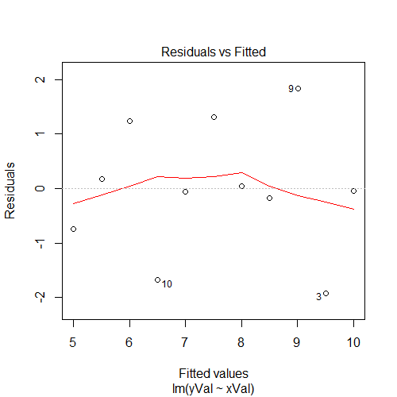
1. The plot above shows residuals (i.e., a model’s errors) versus fitted values (i.e., a model’s predictions).
- What assumption/s of a general linear model is this plot meant to address? [Your Answer Here.]
- Do you think these assumption/s are violated? Why or why not? [Your Answer Here.]
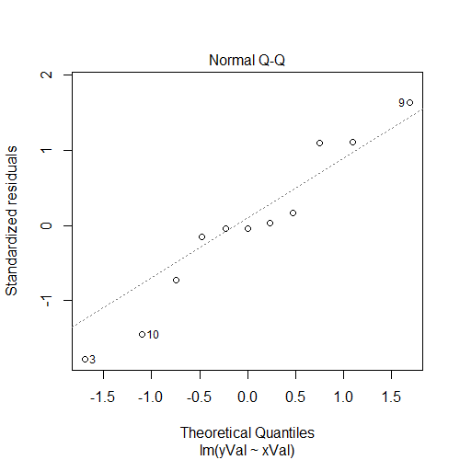
2. The Normal Quantile-Quantile plot above shows standardized residuals (i.e., a model’s errors) versus their theoretical quantiles under a normal distribution.
- What assumption of a general linear model is this plot meant to address? [Your Answer Here.]
- Do you think this assumption is violated? Why or why not? [Your Answer Here.]

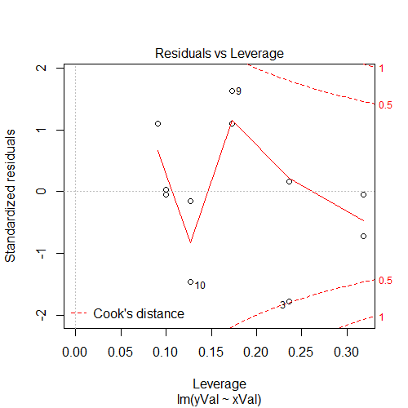
3. The residuals versus leverage plot above shows standardized residuals (i.e., a model’s errors) versus the “leverage” that each data point exerts on the model and the Cook’s distance for each data point.
- In your own words, describe what “leverage” means. Why is it important to check for the leverage of individual data points? [Your Answer Here.]

- In your own words, describe what “Cook’s distance” means. Why is it important to check for the leverage of individual data points? [Your Answer Here.]

Question 5. Interpreting a Regression Output:
Using the altitude dataset that we have used before in class, we get the following output from R when we regress the DECREASE in a person’s VO2max onto the ALTITUDE at which the test was conducted (in km), that person’s baseline VO2max (BVO2, in mL/kg/min), the interaction of those two terms:
Coefficients:
Estimate Std. Error t value Pr(>|t|)
(Intercept) 8.51588 3.01436 2.825 0.005697 **
alt_km -0.11323 1.00029 -0.113 0.910097
BVO2 -0.10874 0.05266 -2.065 0.041512 *
alt_km:BVO2 -0.07448 0.01849 -4.027 0.000109 ***
---
Signif. codes: 0 ‘***’ 0.001 ‘**’ 0.01 ‘*’ 0.05 ‘.’ 0.1 ‘ ’ 1

Residual standard error: 2.432 on 101 degrees of freedom
Multiple R-squared: 0.8488, Adjusted R-squared: 0.8443
F-statistic: 189 on 3 and 101 DF, p-value: < 2.2e-16
1. How should we interpret the simple effect of altitude (in km)? Note that your answer should incorporate the statistical significance of the effect (assume that α = 0.01), the direction of the effect, and the magnitude of the effect.
- [Your Answer Here.]

2. How should we interpret the simple effect of Baseline VO2_max (in mL/kg/min)? Note that your answer should incorporate the statistical significance of the effect (assume that α = 0.01), the direction of the effect, and the magnitude of the effect.
- [Your Answer Here.]

3. How should we interpret the interaction of these two terms? Note that your answer should incorporate the statistical significance of the effect (assume that α = 0.01), the direction of the effect, and the magnitude of the effect.
- [Your Answer Here.]

4. Statistical “significance” is an important consideration in a statistical analysis, and it requires an accurate interpretation of the p-value. In your own words, provide a technically accurate definition of the p-value:
- [Your Answer Here.]

5. Finally, what would happen to our statistical power to detect an effect if we changed α from 0.01 to 0.05? Defend your answer by briefly explaining the relationship between α and statistical power.
- [Your Answer Here.]

