Quest 01: ‘Release the Kraken’.
Answer each of the questions below to the best of your ability. Please be sure to put your answers in red font. Unlike lab assignments, each Quest should reflect each student’s independent work. You are welcome to study previous course materials with other students, but you should not share answers or directly assist other students in completing the Quest.
Question 1
This example is taken from a study by Hodge et al. (2018), “Family Leisure Functioning: A Cross-National Study,” who were interested in the association between family leisure (involvement and satisfaction) and family outcomes (cohesion, adaptability, and satisfaction with family life). This truncated version of the real dataset will allow us to explore hypotheses like the original authors were interested in. We will specifically focus on five variables:
INV a measure of family involvement in leisure
SAT a measure of satisfaction with family leisure
COH a measure of family’s self-reported cohesion
ADP a measure of family’s self-reported adaptability
SFL a measure of family’s self-reported satisfaction with family life
Use these variables to answer the following model comparison questions. For each scenario, specify the MODEL A and C you would use to answer each question. You may have to compute new variables from the above variables. If so, please clearly indicate how those are computed.
- Is the average level of family cohesion statistically different from 0?
  - MODEL A: Your answer here
  - MODEL C: Your answer here

- Is there a relationship between satisfaction with family life and involvement in leisure activities?
  - MODEL A: Your answer here
  - MODEL C: Your answer here

- Is the relationship between satisfaction with family life and involvement in leisure activities stronger than 0.30?
  - MODEL A: Your answer here
  - MODEL C: Your answer here

- The family adaptability and cohesion scale measures COH on a scale from 1-5. We want to see if the average cohesion value is different from zero, after controlling for satisfaction with family leisure. (Hint: COH is your dependent variable and SAT is your independent variable. You will need to “center” SAT around a specific value to correctly answer this question.)
  - MODEL A: Your answer here
  - MODEL C: Your answer here

Question 2.
In the table below, calculate the mean, median, and the standard deviation of the variable ‘X’. Next, use these numbers to calculate the errors (“residuals”), squared errors, and the sum of squared errors.
X | Errors $(x_{i}-\overline{x})$ | Squared Errors ${(x_{i}-\overline{x})}^{2}$
28 | Your answer here. | Your answer here.
37 | Your answer here. | Your answer here.
15 | Your answer here. | Your answer here.
48 | Your answer here. | Your answer here.
20 | Your answer here. | Your answer here.
10 | Your answer here. | Your answer here.

- Mean of X = Your answer here.

- Median of X = Your answer here.

- Standard Deviation of X = Your answer here.

- Sum of Errors, $\sum{(x_{i}-\overline{x})}$ = Your answer here.

- Sum of Squared Errors, ${\sum{\left(x_{i}-\overline{x}\right)}}^{2}$ = Your answer here.

Question 3.
Statistical tests require a comparison between models, either implicitly or explicitly. For instance, there is a relationship between diastolic (DIA) and systolic (SYS) blood pressure. A researcher fits two different models. In Model C, we assume that SYS and DIA are independent of each other. In this unconditional model, the best estimate of SYS will be the mean SYS value.

Model C: $SYS_{i}=121.2+ϵ_{i}$

Alternatively, we can fit a model that allows for a relationship between SYS and DIA blood pressure. Based on ordinary least-squares estimation, the betting fitting slope and intercept for the data presented in the table below are:

Model A: $SYS_{i}=-7.1+1.7(DIA_{i})+ϵ_{i}$

Use the models to calculate the predictions, $\hat{y}$, of Model A and Model C. Using these predictions, enter the residuals errors for each prediction into the table below.

Sub_ID | DIA (x) | SYS (y) | Model C Error, $y_{i}-\hat{y_{i_{c}}}$ | Model A Error, $y_{i}-{\hat{y}}_{i_{a}}$
S001 | 75 | 135 | Your answer here. | Your answer here.
S002 | 62 | 100 | Your answer here. | Your answer here.
S003 | 80 | 115 | Your answer here. | Your answer here.
S004 | 85 | 142 | Your answer here. | Your answer here.
S005 | 70 | 95 | Your answer here. | Your answer here.
S006 | 90 | 140 | Your answer here. | Your answer here.

Given the information above, calculate:
- The Sum of Squared Errors for Model C, SSE(C): Your answer here.

- The Sum of Squared Errors for Model A, SSE(A): Your answer here.

- The Proportional Reduction in Error (PRE) for this model comparison: Your answer here.

- How many parameters are being estimated in Model A: Your answer here.

- How many parameters are being estimated in Model C: Your answer here.

- Given the PRE, PA, and PC you calculated above, what would be the F-observed for this model comparison? Your answer here.

- Although it is not explicitly written in Model C above, what numeric value is the slope for DIA being tested against in the Model A to Model C comparison? (That is, if our estimated slope is statistically significant, what value is it statistically different from?) Your answer here.

Question 4.
The following are based on data from 16 distinct animal species to show the relationship between body weight (in kg) and heart rate (in bpm). The following variables are in the dataset:
BW The average body weight for animals of that species (in kg)
HR The average resting heart rate for animals of that species (in beats per minute)
Because these animals, from the blue whale to the shew, differ so massively in size, the effect is not linear (as shown on the left). By taking the natural-log of each of these variables, the relationship becomes more linear (as shown on the right).
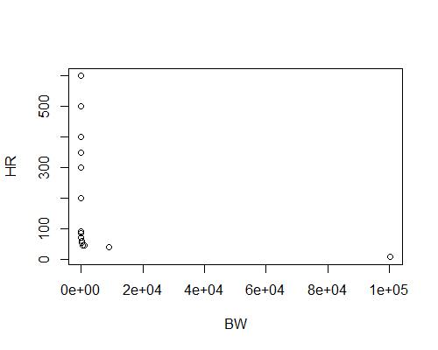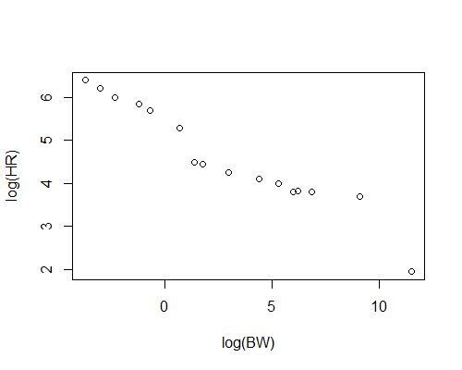
Using these variables, we constructed linear models to see if there was a statistical relationship between HR and BW across species. The details of one such output are provided with an incomplete ANOVA table below. Fill in the ANOVA table and answer the relevant questions.
- In this model log-transformed HR was being predicted by log-transformed BW. Using the Sums of Squared Errors Provided, fill in the ANOVA table below:
ANOVA Summary Table.
Source | SSE | df | MSE | F-observed | p-value
Reduced, Model A | 20.1614 | Your answer here | Your answer here | Your answer here | <0.001
Error, Model A | 1.3891 | Your answer here | Your answer here
Total | 21.5505 | Your answer here

- We also get the parameters listed below for the slope and intercept. In order to get the p-values associated with each of these parameters, we use the following MODEL A:
$$HR_{i}=β_{0}+β_{1}\left(BW_{i}\right)+ε_{i}$$
Table of Parameter Estimates.
Variable | df | Estimate | Standard Error | t-observed | p-value
Intercept | 1 | 5.35 | 0.094 | 56.84 | <0.001
BW | 1 | -0.26 | 0.018 | -14.26 | <0.001

However, the MODEL C in each comparison is different.

  - What is the MODEL C for the test of the intercept? Your answer here

  - What is the MODEL C for the test of the slope? Your answer here

- Finally, provide a one sentence interpretation of the intercept and a one sentence interpretation of the slope: Your answer here

