# Lab 01: Introduction to the Course.

Make sure that have Jamovi installed on your computer. Jamovi is an open-source statistical software program. Jamovi provides a very helpful graphical user interface that allows you to manage, visualize, and analyze data using the programming language R, but through menus rather than writing code.

## Question 1.

Although the base installation of Jamovi has almost everything we need, we will need expand our repertoire with a few additional modules. Go to the modules tab as shown below and then click on “jamovi library” to download these modules from the web.

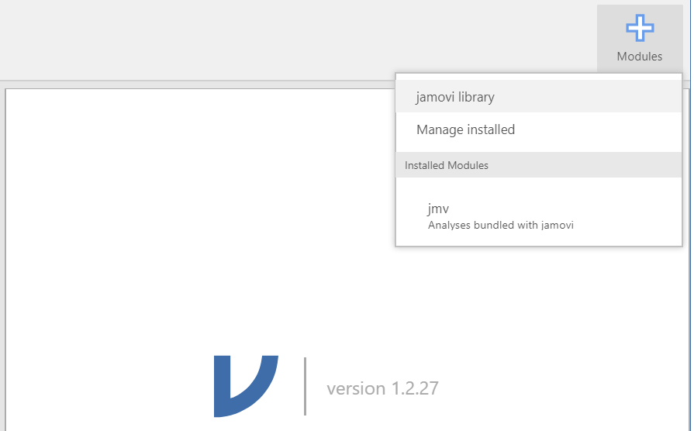

We will want to add the following modules. Tick the appropriate box when each installation is complete:

|  |  |
| --- | --- |
| **Module** | **Done?** |
| **Scatr** – a module for different types of scatterplots and other exploratory charts. |  |
| **Jpower** – power analysis tools for common research designs. |  |
| **r-datasets** – this module provides a lot of different example datasets from R. |  |

Question 2

In the final week of the course, we have built in a flexible week to allow us more time if we need to revisit or expand our discussion of certain topics. However, we can also use that time to cover advanced topics if there is sufficient interest/consensus from the class. We will also re-visit this decision midway through the semester as you have a better sense of how the class is going and what you might be interested in covering. For the time being however, what would you like to do in the last week of class?

(E.g., “nothing – I want more time to work on final notebooks”, “advanced topics – I want to learn more about power analysis”, or any other fine answer.)