# Lab 04: Statistical Inferences about Parameter Values.

As always, indicate your answers using a different color font or shading to clearly separate your answers from the questions. When you are finished, save the file as "lab04_FIRST_LAST" using **your** first name and **your** last name, and then upload the file as a Word Document or .pdf on Canvas.

Start by opening the data_800m.csv datafile in Jamovi. These data resemble real data taken from a study of two sets of high-level athletes (collegiate Nordic Skiers and Soccer players) and similarly aged Controls who were engaged in recreational sports.

## Question 1.

1A. Create a **histogram** showing the distribution of VO2max across all athletes (ignoring group). Turn on the **density** plot, so that it is overlain on the histogram. Insert the plot below:

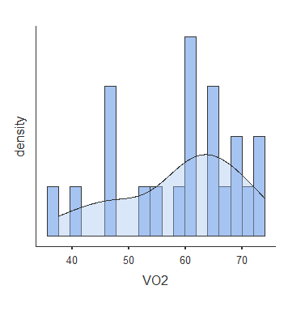

1B. Generate a table of descriptive statistics. Be sure to include the number of observations, the mean, and the standard deviation. We will also want to turn on the **Shapiro-Wilk** test for normality. Insert that table below:

| Descriptives | | | |
| --- | --- | --- | --- |
|  |  |  |  |
|  | | **VO2** | |
| N |  | 21 |  |
| Mean |  | 59.0 |  |
| Standard deviation |  | 10.5 |  |
| Shapiro-Wilk W |  | 0.941 |  |
| Shapiro-Wilk p |  | 0.230 |  |
|  | | | |

1C. Next, let’s conduct a **one sample t-test** for the mean VO2max we observed in this sample. Report the mean and the standard deviation for VO2 max, and report the results of the t-test formatted in the way you might report these results in a scientific paper?

We observed a mean VO2max of 59 mL/kg/min (SD=10.5) and this was statistically different from zero, t(20)=25.7, p<0.001.

1D. Provide a written explanation of what this t-test is telling you. Be sure to explain what the null hypothesis is in this situation, whether you would reject the null hypothesis or not, and what you conclude.

The null hypothesis assumes that the true mean VO2max = 0. In this case, we would reject the null hypothesis (p<0.001) meaning that the true mean is unlikely to be 0.

1E. A typical VO2 max for healthy young men is between 35-40 mL/kg/min. Let’s take the middle value and say that the average VO2 max for health young men is 37.5 mL/kg/min. Replace the test value of 0 with a test value of 37.5. Report the results of this new t-test formatted in the way you might report these results in a scientific paper. Provide a new written explanation of what **this** t-test is telling you (similar to what you did in answer 1D).

We observed a mean VO2max of 59 mL/kg/min (SD=10.5) and this was statistically different from the average value of 37.5 mL/kg/min, t(20)=9.38, p<0.001. We reject the null hypothesis that these athletes came from the “typical” population who have a mean VO2max of 37.5.

1F. Finally, turn on the Q-Q Normal plot and compare the distribution of the residuals to the results of your Shapiro-Wilk Test from above. Insert the plot below.

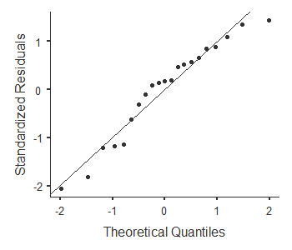

Question 2

Next, use the data_ALTITUDE.csv data set from the class folder. In this question, we want to explore the Change in VO2 max when participants were taken to different altitudes. We want to know if the change in VO2 max was reliably different from 0.

2A. Create a **histogram** showing the distribution of the Change in VO2max. Turn on the **density** plot, so that it is overlain on the histogram. Insert the plot below:

2B. Generate a table of descriptive statistics. Be sure to include the number of observations, the mean, and the standard deviation. We will also want to turn on the **Shapiro-Wilk** test for normality. Insert that table below:

2C. **By hand, calculate the t-observed** for the change in VO2 max in this sample using the mean change, the standard deviation, and sample size from your table.

2D. Next, let’s conduct a **one sample t-test** for the mean Change in VO2max we observed in this sample. Does your calculation of the t-value by hand agree with what you got from Jamovi? (*Hint, it should, or something when wrong somewhere!*)

2E. Provide a written explanation of what this t-test is telling you, report the t-test as you would in a scientific paper, state what you decide about the null hypothesis, and what you conclude.

2F. Next, in the “one sample t-test” tab, turn on the **mean difference** and the **95% Confidence Interval**. What are the upper and lower limits for this confidence interval? What does this confidence interval tell you about the expected decrease in VO2 max when someone is taken to higher altitudes?

Question 3

Finally, create a new data tab in Jamovi. Create a variable called “rolls” and give in the values 1-20 in the rows. Next, create a variable called “outcomes”. Roll a six-sided die twenty times and enter your results in the “outcomes” column. If you don’t have access to a die, do your best to randomly pick a number (1-6) for each outcome).

3A. Create a **histogram** showing the distribution dice rolls. Turn on the **density** plot, so that it overlain on the histogram. Insert the plot below.

3B. Generate a table of descriptive statistics. Be sure to include the number of observations, the mean, and the standard deviation. We will also want to turn on the **Shapiro-Wilk** test for normality. Insert that table below:

3C. Next, let’s conduct a **one sample t-test for the average die roll** you observed in your sample. Report the mean and the standard deviation for the die and provide a written explanation of what this t-test is telling you.

3D. Note that the **expected value for a fair die is 3.5** (the average of the numbers 1-6). Replace the test value of 0 with a test value of 3.5. Report the results of this new t-test formatted in the way you might report these results in a scientific paper. Provide a new written explanation of what **this** t-test is telling you (e.g. do you think your die is fair? if you made up the numbers yourself, did you do a good job of making them up randomly?).

3E. Finally, turn on the Q-Q Normal plot and compare the distribution of the residuals to the results of your Shapiro-Wilk Test from above. Insert the plot below.