# Lab 08B: Practice with Post-Hoc Tests

As always, indicate your answers using a different color font or shading to clearly separate your answers from the questions. When you are finished, save the file as "lab08_FIRST_LAST" using **your** first name and **your** last name, and then upload the file as a Word Document or .pdf on Canvas.

Below, you will be presented with a series of hypothetical ANOVAs. You will be shown a figure of the fully factorial design and a summary of a fictious analysis that indicates which main-effects and interactions were statistically significant. You will then be asked to design a strategy for post-hoc testing in each situation.

## Question 1: Time x Sex Interaction in a Hormone Supplement Study.

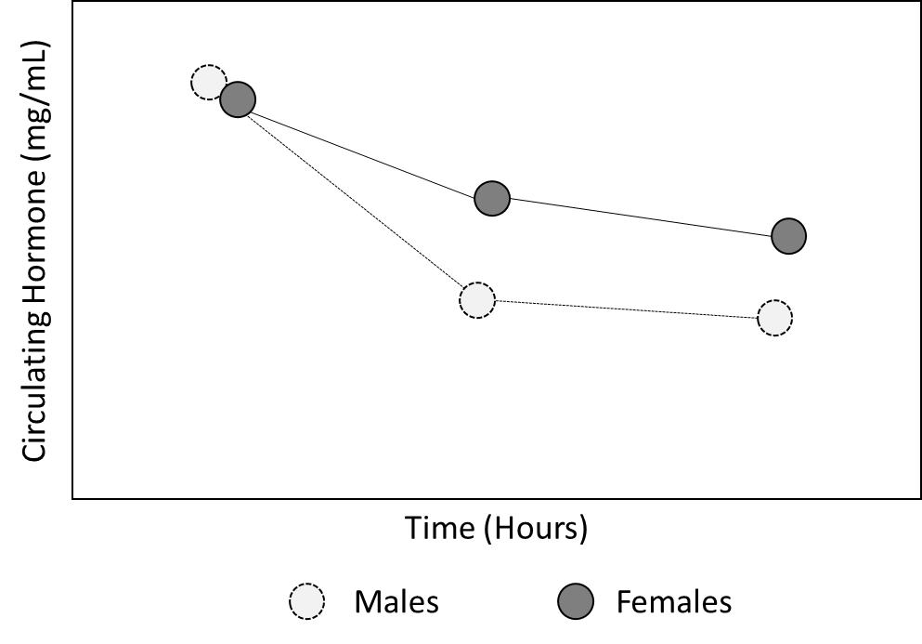

In this study, participants received a hormone supplement. To see how much of the hormone was absorbed, the levels or the hormone circulating in the blood were measured several times following injection. There was a main-effect of time, no statistically significant main-effect of sex, and a statistically significant Time x Sex Interaction.

1A. Describe the post-hoc tests you would conduct in this study (if any). Explain all post-hoc comparisons you would make:

1B. Assume that you are going to use a Bonferroni correction for multiple comparisons. Based on the number of post-hoc t-tests you describe in Part A, what would the corrected alpha level be?

1C. Note that some statistical programs apply the correction to the p-value rather than the alpha level. Assume the original p-value was 0.01, what is the equivalent Bonferroni corrected p-value in this scenario?

## Question 2: Camp Experiences and Recidivism in Juvenile Offenders

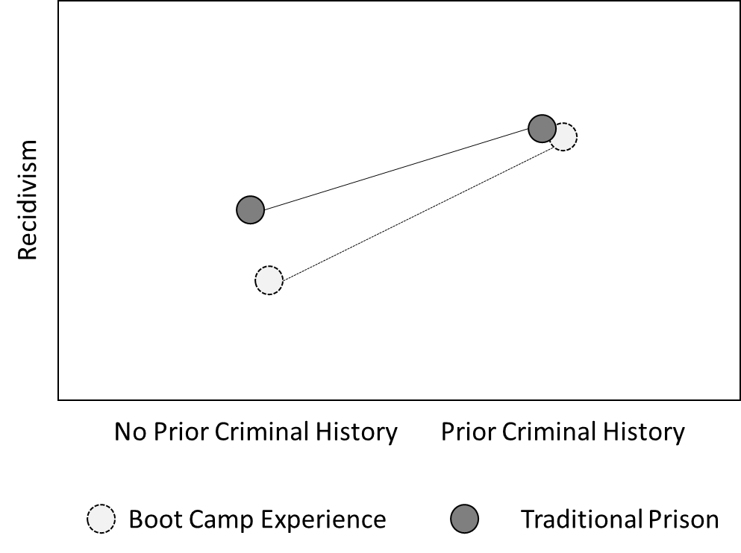

In this study, juvenile criminals were sentenced to either a traditional juvenile detention center or an experimental boot camp focused on building accountability, social connectedness, and life skills. There was a main-effect of past criminal history, but no statistically significant main-effect of sentence type. There was, however, a statistically significant History x Sentence Type interaction on the likelihood of recidivism (i.e., committing another offense in the following year).

1A. Describe the post-hoc tests you would conduct in this study (if any). Explain all post-hoc comparisons you would make:

1B. Assume that you are going to use a Bonferroni correction for multiple comparisons. Based on the number of post-hoc t-tests you describe in Part A, what would the corrected alpha level be?

1C. Note that some statistical programs apply the correction to the p-value rather than the alpha level. Assume the original p-value was 0.03, what is the equivalent Bonferroni corrected p-value in this scenario?

## Question 3: Protein Synthesis Inhibitors affect Learning the Morris Water Maze in Wild- Type Rodents.

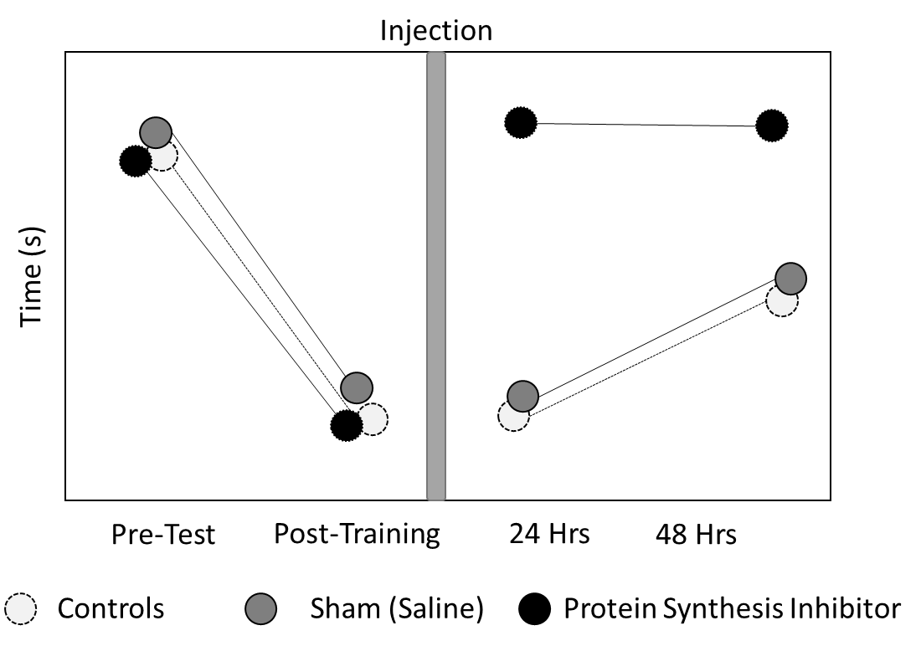

In this study, there was a main-effect of Time, a main-effect of Treatment, and a statistically significant Time x Treatment Interaction. (Note that faster/lower times indicate better performance in this task.)

1A. Describe the post-hoc tests you would conduct in this study (if any). Explain all post-hoc comparisons you would make:

1B. Assume that you are going to use a Bonferroni correction for multiple comparisons. Based on the number of post-hoc t-tests you describe in Part A, what would the corrected alpha level be?

1C. Note that some statistical programs apply the correction to the p-value rather than the alpha level. Assume the original p-value was 0.002, what is the equivalent Bonferroni corrected p-value in this scenario?

## Question 4: Effects of a commercial “brain supplement” on cognitive performance.

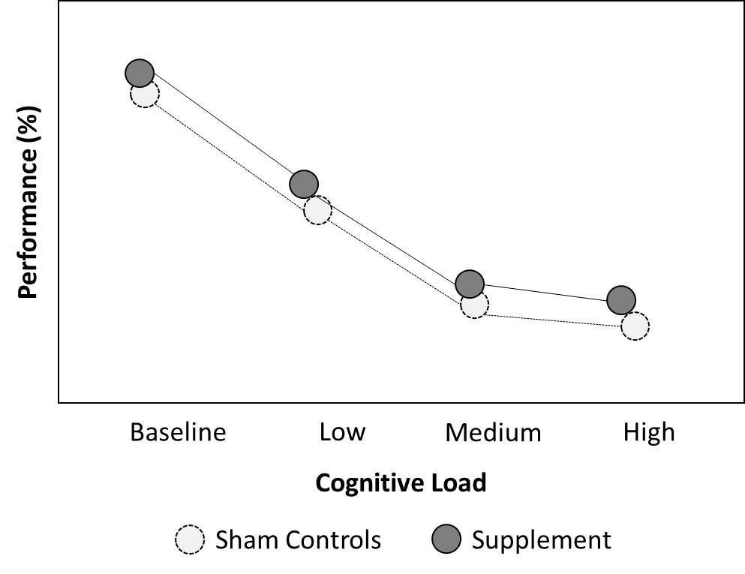

In this study, there was a main-effect of Cognitive Load, but no statistically significant main-effect of Supplement nor a Load x Supplement Interaction.

1A. Describe the post-hoc tests you would conduct in this study (if any). Explain all post-hoc comparisons you would make:

1B. Assume that you are going to use a Bonferroni correction for multiple comparisons. Based on the number of post-hoc t-tests you describe in Part A, what would the corrected alpha level be?

1C. Note that some statistical programs apply the correction to the p-value rather than the alpha level. Assume the original p-value was 0.025, what is the equivalent Bonferroni corrected p-value in this scenario?