Inspection Report

Asset: - Chamaeleon Emergency enLighten

Fault_id: 0

Fault: No fault

Remedy: No remedy

Comment:





Asset: - 2.3kg ABE Powder Type Portable Fire Extinguisher

Fault_id: 0

Fault: No fault

Remedy: No action required

Comment:





Asset: - Entrance door

Fault_id: 0

Fault: No fault

Remedy: No remedy required

Comment:





Asset: - None

Fault_id: 0

Fault:

Remedy:

Comment:



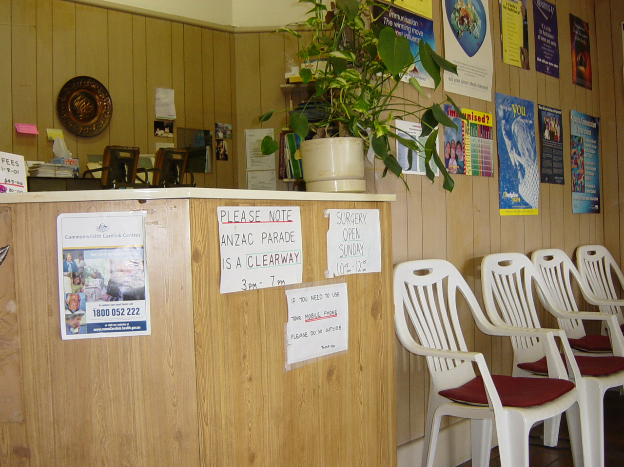

Asset: - None

Fault_id: 0

Fault:

Remedy:

Comment: test test



