EE 596 HOMEWORK 2 REPORT
COLOR CLUSTERING AND SKIN FINDING
Name:

1. Introduction
Briefly explain the method, especially any parts that you designed.
2. Skin Finding Results
- Name: face28
Original Image NB Skin-Labeled Image (r,g) NB Skin (RGB)
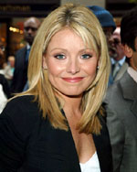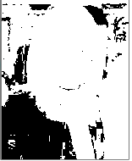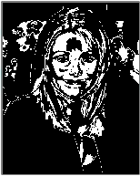
Naïve Bayes Jaccard (r,g) : 0.19 Naïve Bayes Jaccard (RGB): 0.27
Random Forest Jaccard (r,g) Random Forest Jaccard (RGB)

Name: face1
Original Image NB Skin-Labeled Image (r,g) NB Skin (RGB)
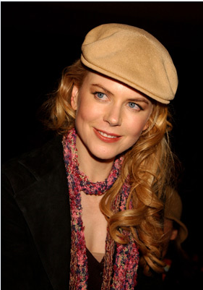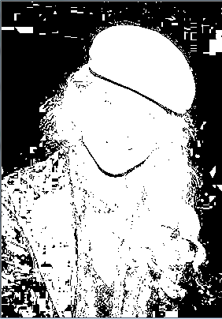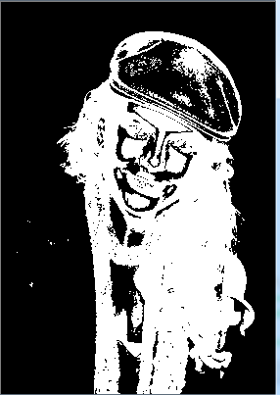
Naïve Bayes Jaccard (r,g): 0.19 Naïve Bayes Jaccard (RGB): 0.18
Random Forest Jaccard (r,g) Random Forest Jaccard (RGB)

(3) Name: face4
Original Image NB Skin-Labeled Image (r,g) NB Skin (RGB)
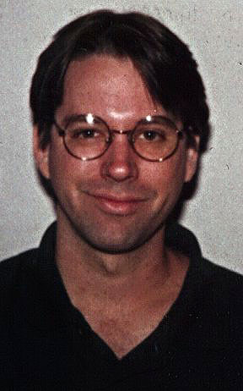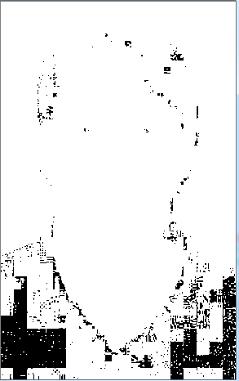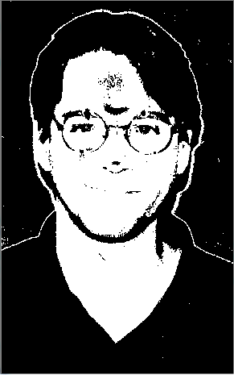
Naïve Bayes Jaccard (r,g) : 0.32 Naïve Bayes Jaccard (RGB): 0.80
Random Forest Jaccard (r,g) Random Forest Jaccard (RGB)

(4) Name: face5
Original Image NB Skin-Labeled Image (r,g) NB Skin (RGB)
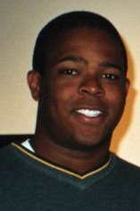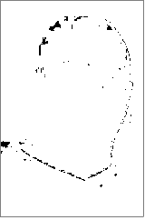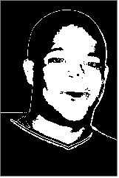

Naïve Bayes Jaccard (r,g) : 0.33 Naïve Bayes Jaccard (RGB): 0.61
Random Forest Jaccard (r,g) Random Forest Jaccard (RGB)

(5) Name: face8
Original Image NB Skin-Labeled Image (r,g) NB Skin (RGB)
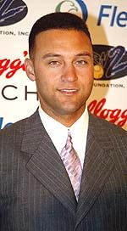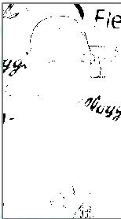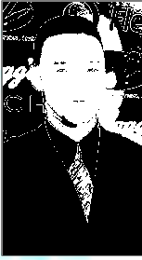
Naïve Bayes Jaccard (r,g) : 0.16 Naïve Bayes Jaccard (RGB): 0.55
Random Forest Jaccard (r,g) Random Forest Jaccard (RGB)
(6) Name: face10
Original Image NB Skin-Labeled Image (r,g) NB Skin (RGB)
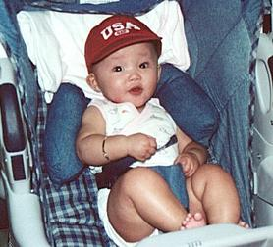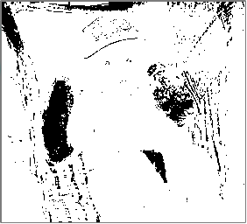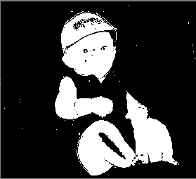
Naïve Bayes Jaccard (r,g) : 0.20 Naïve Bayes Jaccard (RGB): 0.71
Random Forest Jaccard (r,g) Random Forest Jaccard (RGB)

(7) Name: face23
Original Image NB Skin-Labeled Image (r,g) NB Skin (RGB)
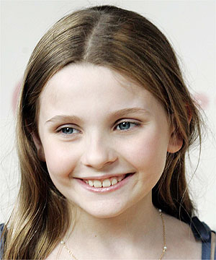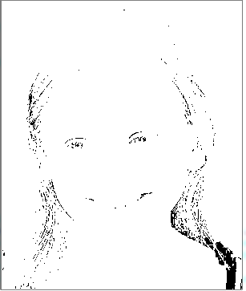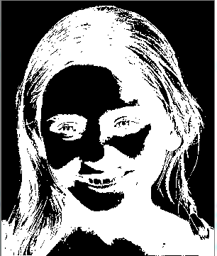
Naïve Bayes Jaccard (r,g) Naïve Bayes Jaccard (RGB): 0.31
Random Forest Jaccard (r,g) Random Forest Jaccard (RGB)

3. Discussion on Results and Limitations

