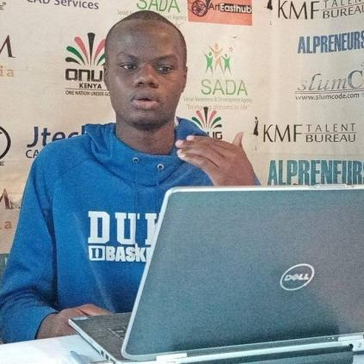­

Summary

Specializing in front end development 7 years and counting. Experienced with all stages of the development cycle for dynamic web projects. Well-versed in numerous programming languages including HTML5, PHP, OOP, JavaScript, CSS, MySQL, Python, Ruby, SASS. Strong background in project management and customer relations.

Skills

|  |  |
| --- | --- |
| * Project management * Attention to detail * Strong decision maker * Complex problem solver * Team player | * Creative design * Innovative * Service-focused * Work independently * Working knowledge of HTML5, CSS3, SASS, Bootstrap, Java-script, Python, Ruby, SQL, MySQL, JQuery, PHP |

Experience

**GRAPHIC WEB DESIGNER** since 01/2018

**NAIROBI, KENYA**

* Cooperate with designers to create clean interfaces and simple, intuitive interactions and experiences.
* Develop project concepts and maintain optimal workflow.
* Work with senior developer to manage large, complex design projects for corporate clients.
* Complete detailed programming and development tasks for front end public and internal websites as well as challenging back-end server code.
* Carry out quality assurance tests to discover errors and optimize usability.

Education

**Moringa,** Ng’ong Rd at Ng’ong Lane Plaza

Certificate in Graphic Design

+254768290857

Keithjames9261@gmail.com

Linkedin link here…

Porfolio link here…

KEITH OWINO