UIRI Inventory Management System
Database Design & System Architecture
Version 2.0 - Professional Revision

Uganda Industrial Research Institute (UIRI)
Prepared by: Systems Development Team
Date: July 2026

1. Introduction
This document outlines the revised database design and system architecture for the UIRI Inventory Management System (IMS). It integrates the Data Dictionary, logical Entity-Relationship Diagram (ERD), and System Use Cases to provide a comprehensive view of the system's data structures and interactions.
The database is designed to handle multi-branch inventory tracking, procurement workflows, stock movements, and strict role-based access control (RBAC).

2. System Architecture & Use Cases
The UIRI IMS caters to various actors including Administrators, Storekeepers, Department Heads, and standard Staff. The following diagram illustrates the core use cases and interactions within the system:
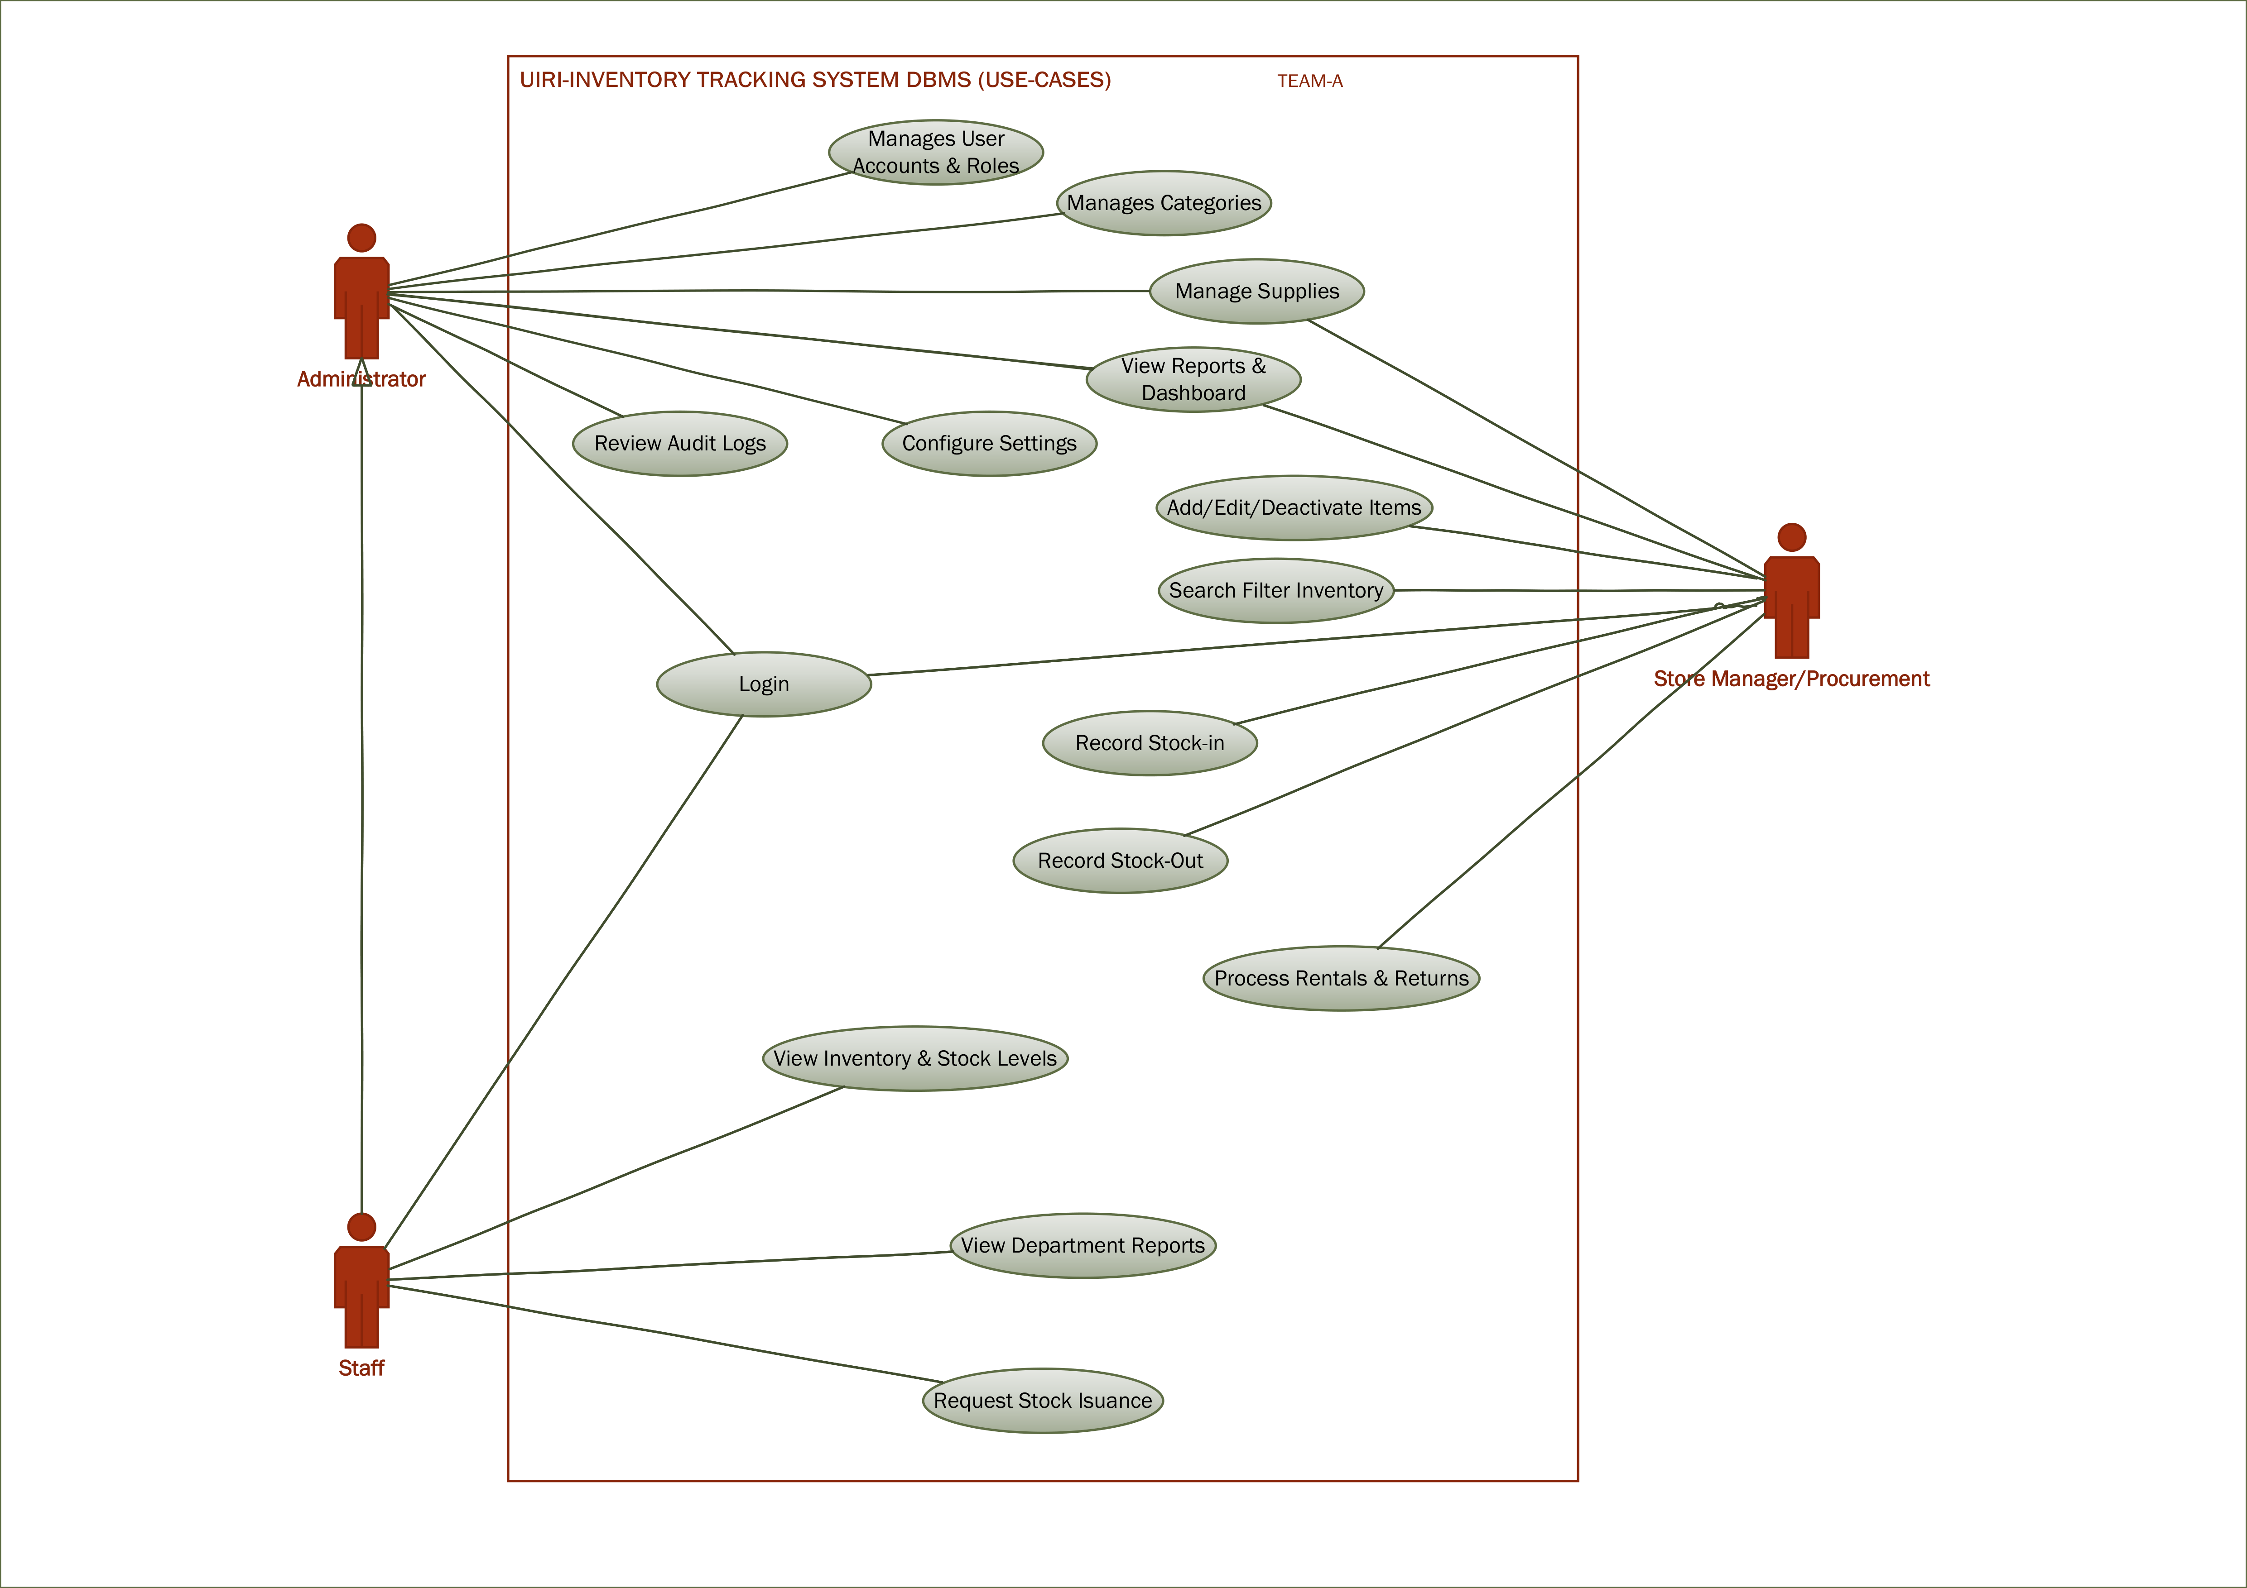
Figure 1: UIRI IMS System Use Cases

3. Logical Database Design (ERD)
The logical ERD represents the conceptual structure of the UIRI IMS database. It is segmented into distinct domains: Organization & Access, Catalog & Inventory Master, Stock Operations, Procurement, and Equipment Maintenance.

Figure 2: Conceptual Entity-Relationship Diagram

4. Data Dictionary (Core Entities)
The following section details the core entities within the system, replacing the legacy Data Dictionary with an updated understanding of the schema.

4.1 Users & Authentication (users)
Manages system access and role assignment.
Column Name | Data Type | Constraints | Description
id | INT | PK, AI | Unique identifier
username | VARCHAR(50) | UNIQUE, NOT NULL | Login name
role_id | INT | FK | References roles(id)
branch_id | INT | FK | References branches(id)
password_hash | VARCHAR(255) | NOT NULL | Bcrypt hashed password

4.2 Inventory Master (items)
Core catalog of all items tracked across branches.
Column Name | Data Type | Constraints | Description
id | INT | PK, AI | Unique identifier
item_code | VARCHAR(50) | UNIQUE, NOT NULL | SKU or Barcode
name | VARCHAR(100) | NOT NULL | Item name
category_id | INT | FK | References categories(id)
minimum_stock | INT | DEFAULT 0 | Reorder threshold

4.3 Stock Transactions (stock_transactions)
Immutable ledger of all stock movements (IN/OUT/ADJ).
Column Name | Data Type | Constraints | Description
id | INT | PK, AI | Unique identifier
item_id | INT | FK, NOT NULL | References items(id)
branch_id | INT | FK, NOT NULL | References branches(id)
transaction_type | ENUM | NOT NULL | 'IN', 'OUT', or 'ADJUSTMENT'
quantity | DECIMAL | NOT NULL | Amount moved
user_id | INT | FK, NOT NULL | User who performed action

5. Conclusion
The revised architecture implements strong data integrity via foreign key constraints, optimizes reporting through structured categorical entities, and ensures accountability via the comprehensive stock_transactions ledger and audit logs.

