

UGANDA INDUSTRIAL RESEARCH INSTITUTE
Namanve Industrial and Business Park, Mukono District, Uganda
PROGRESS REPORT
  - DESIGN AND DEVELOPMENT OF A WEB BASED
  - INVENTORY MANAGEMENT SYSTEM
  - FOR UGANDA INDUSTRIAL RESEARCH INSTITUTE (UIRI)
  - NAKAWA AND NAMANVE CAMPUSES

Name | Registration Number | Project Responsibility
Keith Paul Kato | 24/U/26593/EVE | Lead reporting, database design and documentation coordination
Komukama Tracy | 24/U/06151/EXT | Requirements review, user needs analysis and supporting documentation
Atuhiire Deo Kamate | 24/U/14365/PS | System analysis, testing support and validation of database design decisions

Programme | Bachelor of Science in Computer Science
Institution | Makerere University, Kampala
Host Organisation | Uganda Industrial Research Institute (UIRI)
Department | Information and Communications Technology (ICT)
Field Supervisor | Mr. William Kakooza, IT Engineer at UIRI
Submitted to | ICT Team, UIRI Namanve
Reporting Period | June-July 2026
Preparation Date | 19 July 2026

Project Team and Report Control
This progress report records the current implementation status of the UIRI Inventory Management System. It links the approved proposal, requirements specification, database design, source code, deployment evidence, updated workplan and live database snapshot as at 19 July 2026.
Name | Registration Number | Project Responsibility
Keith Paul Kato | 24/U/26593/EVE | Lead reporting, database design and documentation coordination
Komukama Tracy | 24/U/06151/EXT | Requirements review, user needs analysis and supporting documentation
Atuhiire Deo Kamate | 24/U/14365/PS | System analysis, testing support and validation of database design decisions
Table 1: Project Team and Assigned Contributions

Item | Description
Document Title | Progress Report for the UIRI Inventory Management System
Document Version | 1.1
Document Basis | Project brief, proposal, SRS, database design, system design diagrams, source code, deployed application, updated workplan and live database snapshot
Main Purpose | To report the current state of analysis, design, database implementation, coding, testing evidence, challenges and remaining work
Current Project Status | Working PHP/MySQL and Alwaysdata-deployed prototype with implemented database, inventory, stock, reports, dashboard, audit, session-security and table-UX improvements
Table 3: Document Control

Table of Contents
Project Team and Report Control i
List of Tables iii
Abbreviations and Acronyms iv
Executive Summary v
1.0 Introduction and Background 1
2.0 Objectives and Progress Status 1
3.0 Methodology and Technical Approach 2
4.0 Progress Against Deliverables 2
5.0 Database Design and Implementation Progress 2
5.1 Live Database Snapshot 3
5.2 Implemented Schema Groups 3
5.3 Implementation Changes from Preliminary Design 3
6.0 Functional Progress Against the Project Brief 4
7.0 Testing and Validation Evidence 4
8.0 Challenges, Changes and Mitigation 5
9.0 Remaining Work Plan 5
10.0 Conclusion 6
11.0 References 6
Appendix A: Live Database Snapshot 7
Appendix B: Updated Workplan and Implementation Visual Evidence 14

List of Tables
Table 1: Project Team and Assigned Contributions
Table 2: Report Summary Details
Table 3: Document Control
Table 4: Objectives and Progress Status
Table 5: Progress Against Deliverables
Table 6: Live Database Snapshot
Table 7: Implemented Schema Groups
Table 8: Implementation Changes from Preliminary Design
Table 9: Functional Progress Against the Project Brief
Table 10: Testing and Validation Evidence
Table 11: Challenges, Changes and Mitigation
Table 12: Remaining Work Plan
Table 13: Live Database Table Counts

Abbreviations and Acronyms
Acronym | Full Form
CRUD | Create, Read, Update and Delete
CSRF | Cross Site Request Forgery
CSV | Comma Separated Values
DBMS | Database Management System
ERD | Entity Relationship Diagram
ICT | Information and Communications Technology
IMS | Inventory Management System
PDO | PHP Data Objects
PHP | PHP: Hypertext Preprocessor
RBAC | Role Based Access Control
SMTP | Simple Mail Transfer Protocol
SQL | Structured Query Language
SRS | Software Requirements Specification
UAT | User Acceptance Testing
UIRI | Uganda Industrial Research Institute
XAMPP | Cross Platform, Apache, MariaDB, PHP and Perl

Abstract
This progress report presents the current state of the internship project titled Design and Development of a Web Based Inventory Management System for Uganda Industrial Research Institute (UIRI). The report follows the approved structure and updates the implementation evidence, live database figures, deployment status, user-interface refinements, security controls and current workplan as at 19 July 2026.
The project has progressed from proposal and requirements analysis into a working PHP/MySQL prototype that is available locally and through the Alwaysdata deployment. The implemented system now supports authentication, role-based access, branch/campus structure, departments and sections, category and supplier management, inventory item records with images, stock movement, requests, dashboards, analytics, reports, audit trails and improved print behaviour for item-level previews.
The live database named uiri_ims currently contains 24 tables, including 2 branches, 39 sections, 111 departments, 70 categories, 1,047 inventory items, 8,481 stock units, 71 stock transactions, 20 inventory requests, 18 users, 348 audit records and 108 login-history records. The current inventory value snapshot is UGX 21,267,553,200.
Progress Note
Current Assessment: The project is now a substantially implemented and deployed prototype. The strongest areas are inventory records, stock movement, dashboard reporting, printable reports, database population, audit evidence and session-security hardening. Remaining work now mainly concerns final user documentation, formal UAT evidence, demonstration records for still-empty workflow tables and final presentation packaging.

1.0 Introduction and Background
Uganda Industrial Research Institute operates in an environment where ICT equipment, laboratory equipment, engineering tools, office supplies, furniture, machinery, consumables and safety equipment must be recorded, monitored and reported accurately. The original project question required a web based Inventory Management System capable of authentication, inventory management, stock management, supplier management, reporting, search, filtering, database design and security.
The preliminary documents identified the main problem as the difficulty of obtaining a reliable and quick picture of what UIRI owns, where items are located, their current condition and how stock has moved over time. The proposal and SRS therefore emphasized centralized records, secure access, current stock visibility, low stock alerts, supplier transaction history and reports for management decision making.
The implementation has followed the approved database and web application direction, using PHP, MySQL/MariaDB and XAMPP. During coding, the physical schema was adjusted to support a practical prototype with branch-specific categories, section and department hierarchy, item-level asset decision fields and reporting views suitable for demonstration.

2.0 Objectives and Progress Status
Objective | Progress Status | Evidence
Study the inventory problem and identify users, records, reports and rules. | Complete | Proposal and SRS define problem, stakeholders, scope, user classes, functional requirements and acceptance criteria.
Design a normalized relational database. | Complete with implementation refinement | Database design exists; SQL schema and live MySQL database contain users, roles, branches, sections, departments, categories, suppliers, inventory_items, stock_transactions and audit tables.
Implement secure authentication and role-based access control. | Implemented | Login, roles, permissions, session controls, password hashing, account lockout, rate limiting, audit logging, no-store session handling and seven-minute idle timeout are present in code and database.
Enable inventory item registration, editing, classification and tracking. | Implemented | Item CRUD, categories, images, supplier link, serial number, asset code, brand/model, status, condition, funding source and storage location fields are implemented.
Support stock receipt, issue, transfer, return and low-stock alerts. | Implemented with active UI refinement | Stock-in, stock-out, stock adjustment, transaction history, transfer workflow, low-stock notifications and scrollable recent-movement tables exist. Return handling remains a future refinement.
Provide supplier management and supplier transaction history. | Implemented | Supplier CRUD is implemented; supplier-based filtering is available in inventory and reports.
Generate dashboard summaries and reports. | Implemented | Dashboard, analytics workspace, printable reports, low-stock report, valuation report, movement report, CSV exports, improved table headers and clearer action controls are implemented.
Enforce validation, password protection, sessions and audit logs. | Implemented | CSRF helper, prepared SQL statements, clean output helper, security headers, login history, rate limits, audit_log, forced landing logout and idle-session expiry are implemented.
Table 4: Objectives and Progress Status

3.0 Methodology and Technical Approach
The project followed an incremental database-driven approach. The first stage involved problem analysis and requirements documentation. The second stage converted requirements into a database design, data dictionary and system design diagrams. The third stage implemented the application using PHP pages, shared configuration and helper functions, MySQL tables and XAMPP for local development.
- Requirements analysis was guided by the ICT Team project question, the system proposal and the SRS.
- Database work used a relational MySQL/MariaDB design with primary keys, foreign keys, indexes and controlled status values.
- Implementation used procedural PHP modules organized into pages, shared includes, upload folders, migrations and SQL seed files.
- Security work used password hashing, prepared statements, session hardening, CSRF tokens, security headers, login history, rate limiting and audit logging.
- Testing evidence was collected from the live uiri_ims database, implemented pages, migrations and source-code inspection.

4.0 Progress Against Deliverables
Deliverable | Current Status | Progress Note
System Proposal | Complete | Located in documentation/proposal and final_report. Defines problem, objectives, scope, methodology and expected deliverables.
System Requirements Specification | Complete | Located in documentation/srs. Defines functional, non-functional, database and acceptance requirements.
Database Design, ERD and Data Dictionary | Complete | Located in documentation/database_design. Current implementation refined some table names and combined some asset/stock fields for prototype delivery.
System Design Diagrams | Complete | Located in documentation/system_design. Includes use case, activity and class design coverage.
Source Code | Substantially complete and deployed | PHP pages, includes, assets, migrations, SQL seed files, upload support, deployment workflow and security/session hardening are present.
Fully Functional Inventory Management System | Working deployed prototype | Core modules run against the live uiri_ims database locally and on Alwaysdata. Final UAT evidence and demonstration data cleanup remain.
User Manual | Pending/In progress | Needs to be written after the final interface inspection and UAT pass.
Final Project Report | In progress | This updated progress report now includes refreshed database figures, workplan evidence and current implementation progress.
Presentation and Demonstration | In progress | System screens, deployment link and database evidence are ready for demonstration; slides and script need final assembly.
Table 5: Progress Against Deliverables

5.0 Database Design and Implementation Progress
The original database design proposed a strongly normalized schema with separate entities for campuses, departments, locations, inventory categories, units of measure, item types, inventory items, suppliers, supplier_items, acquisition_batches, asset_statuses, asset_instances, stock_balances, stock_transactions, requisitions, maintenance_records, audit_logs and report_logs.
The implemented database keeps the same core intention but uses a practical prototype structure. For example, campuses are represented as branches, inventory locations are partly represented through section, department and storage_location fields, while current stock and key asset decision fields are stored directly on inventory_items. This makes the prototype easier to demonstrate while still preserving transaction history through stock_transactions.

5.1 Live Database Snapshot
Database Area | Current Evidence
Database name | uiri_ims
Core table count | 24 tables
Branches/campuses | 2: UIRI Nakawa and UIRI Namanve
Departments and sections/units | 39 sections and 111 departments/units
Categories | 70 category records: 33 for Nakawa and 37 for Namanve
Inventory items | 1,047 active inventory records
Stock units and value | 8,481 units with a current stock value of UGX 21,267,553,200
Stock movement history | 71 stock transactions: 43 stock-in, 24 stock-out, 2 transfer-in and 2 transfer-out
Low-stock exposure | 425 items at or below the minimum stock threshold, including 196 low-stock items and 229 out-of-stock items
Users and roles | 18 users across 6 roles
Audit evidence | 348 audit log entries and 108 login history records
Security evidence | rate_limits table exists; current rate limit count is 0 at snapshot time; settings table now contains 10 records
Table 6: Live Database Snapshot

5.2 Implemented Schema Groups
Schema Group | Implemented Tables | Purpose
Access control | users, roles, permissions, role_permissions, user_permissions, login_history, rate_limits | Controls login, roles, permissions, sign-in monitoring and brute-force protection.
Organizational structure | branches, sections, departments | Represents UIRI Nakawa/Namanve and their departments or units.
Inventory master data | categories, suppliers, inventory_items | Stores item classifications, suppliers and item records with asset and stock fields.
Stock workflow | stock_transactions, inventory_requests, transfers, transfer_items | Records stock movement, request approvals and inter-branch transfer workflow.
Reporting and operations | reports, notifications, settings, audit_log | Supports report metadata, alerts, application settings and accountability logs.
Extended workflow | procurement_requests, purchase_orders, goods_received_notes, equipment_maintenance | Adds procurement and maintenance support beyond the minimum project brief.
Table 7: Implemented Schema Groups

5.3 Implementation Changes from Preliminary Design
Preliminary Design Idea | Current Implementation | Progress Report Interpretation
campuses table | branches table | The naming changed, but the same concept is implemented for Nakawa and Namanve.
Separate locations table | sections, departments and inventory_items.storage_location | The prototype captures organizational placement and storage location without a full location master table.
asset_instances table | asset fields on inventory_items, including asset_code, serial_number, asset_status and asset_condition | Acceptable for prototype; future version should separate individual asset instances for stronger normalization.
stock_balances table | inventory_items.current_stock and stock_transactions history | Current stock is fast to read, while movement history is still preserved. A future stock_balances table can improve multi-location quantities.
report_logs table | audit_log records report generation; reports table exists but has no saved rows yet | Report access is audited, but saved report metadata is still incomplete.
Chart.js graphs | CSS/SVG dashboard visuals and tabular reports | Management visuals are present; dedicated Chart.js graphs remain optional enhancement.
Executive role support | Code references Administrator/Executive, but live roles table currently has six roles and no Executive role | Migration exists; live DB should be aligned before final demonstration if Executive view is required.
Table 8: Implementation Changes from Preliminary Design

6.0 Functional Progress Against the Project Brief
Project Requirement | Current Progress | Evidence From Repository and Database
User authentication and authorization | Implemented | Login, registration, password hashing, roles, permissions, admin user management, profile photos, lockout/rate limiting, login history, forced session clearing on landing and seven-minute idle timeout are implemented.
Inventory management | Implemented | items.php supports item management, categorization, image upload, asset code, serial number, brand/model, condition, storage location, supplier links, details preview and isolated item-detail print output.
Stock management | Implemented with active UI refinement | stock_in.php, stock_out.php, stock_adjustment.php and transactions.php record stock movement and update balances. Recent stock-in/out panels were expanded with clearer table space, multiple rows and scrollable pagination.
Supplier management | Implemented | suppliers.php supports supplier add, edit, status toggle and deletion safeguards; supplier-based filtering is available in inventory and reports; action-column visibility and styled deletion confirmation were improved.
Reporting dashboard | Implemented | dashboard.php and analytics.php provide summary KPIs, stock risk, request queues, movement visuals, supplier exposure, operational status and redesigned table headers with consistent blue/gold table styling.
Monthly and annual reports | Implemented/In progress | reports.php supports date filters, movement report, valuation, low-stock report, print mode and CSV export. Final saved report metadata remains to be populated if required.
Search and filtering | Implemented | Items, reports, transactions, login history and notifications include filters and search fields.
Database design | Implemented | database.sql, migrations and live uiri_ims database are available. Data dictionary exists in documentation.
Security features | Implemented | Input validation, prepared statements, CSRF helper, output escaping, session hardening, seven-minute idle timeout, landing-page logout enforcement, email verification support and audit trails are implemented.
Table 9: Functional Progress Against the Project Brief

7.0 Testing and Validation Evidence
Testing at this progress stage focused on verifying that the database exists, implemented tables can be queried, source modules correspond to the SRS and project brief, and the most recent interface/security corrections behave as intended. The live database was queried again on 19 July 2026 and the report evidence was refreshed from those results.
Test Area | Evidence | Current Result
Database connection | PDO connection to localhost/uiri_ims | Successful
Schema completeness | SHOW TABLES and table counts | 24 tables present
Inventory data | COUNT inventory_items and stock summary | 1,047 items, 8,481 units and UGX 21,267,553,200 current value
Stock transaction history | Grouped stock_transactions by transaction_type | 71 transaction records exist across stock-in, stock-out and transfer movement types
Access control data | Roles, users and permissions tables queried | 6 roles, 18 users and 34 role-permission mappings
Audit trail | audit_log count and login_history count | 348 audit entries and 108 login history records
Report functions | Source inspection of reports.php, dashboard.php and analytics.php | Reports, filters, item/list print paths and CSV export are implemented; item-preview print isolation was corrected
Table 10: Testing and Validation Evidence
Progress Note
Testing Gap: Formal signed user acceptance testing, a browser-by-browser evidence set and the final demonstration checklist still need to be attached before submission. Security timeout behaviour, dashboard visibility, table styling and item-level print isolation have been corrected and should be included in the final UAT checklist.

8.0 Challenges, Changes and Mitigation
Challenge or Change | Effect on Project | Mitigation or Recommendation
Preliminary database design was more normalized than the working prototype. | Some planned entities, such as asset_instances and stock_balances, are not separate live tables. | Document the prototype decision and add these tables in a future refinement if individual asset tracking becomes the main assessment focus.
Real UIRI inventory data may be incomplete or sensitive. | Demonstration data has to be used for some screens and reports. | Continue using realistic dummy/demo records while keeping real institutional data protected.
107 items still lack purchase dates. | Reports on acquisition year, warranty and asset aging are less complete for those records. | Prioritize data cleaning for purchase_date, warranty_date, serial_number, brand_model, asset_condition and storage_location before final reporting.
Transfers and procurement structures exist but live transfer/procurement records are empty. | Demonstration may not show those workflows with real examples. | Seed a small number of approved demonstration transfers and procurement records before presentation.
Final visual inspection and browser evidence are still needed. | Recent UI issues were corrected, but final screenshots must prove table visibility, delete confirmations and print behaviour. | Run a final browser pass across dashboard, suppliers, inventory, stock-in/out, reports and analytics before submission.
Reports table exists but report rows are not saved. | Report generation is audited, but saved report metadata is incomplete. | Either populate reports table on report generation or explain that audit_log currently provides accountability.
Table 11: Challenges, Changes and Mitigation

9.0 Remaining Work Plan
Task | Priority | Expected Output
Complete user manual with login, session timeout, item management, stock in/out, reports and admin workflows. | High | User manual ready for submission.
Run final UAT for authentication, item CRUD, item-level print, list print, stock movement, reports and audit logs. | High | Signed test results, screenshots and issue-resolution notes for final report.
Clean demonstration data by adding missing purchase dates, serial numbers, warranty dates, item images and asset conditions. | High | Stronger report evidence for computers, equipment, asset aging and valuation.
Align final role list and live user accounts before demonstration. | Medium | Consistent role list, users and access evidence before presentation.
Seed transfer, maintenance and procurement demonstration records. | Medium | Complete workflow examples for presentation.
Document prototype schema decisions, including inventory_items.current_stock and deferred asset_instances/stock_balances refinement. | High | Clear database-design explanation for assessors.
Configure SMTP/PHPMailer or prepare fallback demonstration steps. | Medium | Reliable email verification and password reset demo.
Prepare final report, presentation slides and deployment demonstration script. | High | Final submission package and demonstration flow.
Table 12: Remaining Work Plan

10.0 Conclusion
The UIRI Inventory Management System has moved from requirements analysis and database design into a working, deployed, database-backed PHP prototype. The current system satisfies most core project requirements: secure login, role-based navigation, inventory CRUD, supplier management, stock movement, requests, dashboards, analytics, printable reports, audit trails and improved session handling.
The most important academic point to document in the final report is the difference between the preliminary ideal database design and the implemented prototype schema. The implementation remains suitable for demonstration, while the final report should clearly explain the prototype design decisions, completed security hardening, deployment evidence and remaining refinements.

11.0 References
[1] ICT Team, UIRI Namanve, Internship Project Question: Design and Development of an Inventory Management System for Uganda Industrial Research Institute, 2026.
[2] K. P. Kato, K. Tracy and A. D. Kamate, System Proposal: Design and Development of a Web Based Inventory Management System for UIRI, 2026.
[3] K. P. Kato, K. Tracy and A. D. Kamate, Software Requirements Specification for the UIRI Inventory Management System, 2026.
[4] K. P. Kato, K. Tracy and A. D. Kamate, Database Design Document and Data Dictionary for the UIRI Inventory Management System, 2026.
[5] K. P. Kato, K. Tracy and A. D. Kamate, System Design Diagrams for the UIRI Inventory Management System, 2026.
[6] UIRI IMS repository source code, database.sql, migrations, SECURITY_IMPROVEMENTS.md and live uiri_ims database snapshot, accessed 16 July 2026.
[7] T. M. Connolly and C. E. Begg, Database Systems: A Practical Approach to Design, Implementation, and Management, 4th ed., Pearson Education, 2005.
[8] IEEE Computer Society, IEEE Recommended Practice for Software Requirements Specifications, IEEE Std 830-1998, 1998.

Appendix A: Live Database Snapshot
Table | Rows | Table | Rows
audit_log | 348 | branches | 2
categories | 70 | departments | 111
equipment_maintenance | 3 | goods_received_notes | 0
inventory_items | 1,047 | inventory_requests | 20
login_history | 108 | notifications | 11
permissions | 16 | procurement_requests | 0
purchase_orders | 0 | rate_limits | 0
reports | 0 | role_permissions | 34
roles | 6 | sections | 39
settings | 10 | stock_transactions | 71
suppliers | 13 | transfer_items | 0
transfers | 0 | user_permissions | 0
users | 18
Table 13: Live Database Table Counts
Snapshot source: live uiri_ims database queried through MySQL on 19 July 2026. The snapshot should be regenerated before final submission if new records are added.

Appendix B: Updated Workplan and Implementation Visual Evidence
This appendix adds the updated SRS workplan snapshot and selected live-database item visuals prepared for the 19 July 2026 progress review.
Figure B1: Updated SRS workplan snapshot showing refreshed responsibilities, progress and dates as at 19 July 2026.
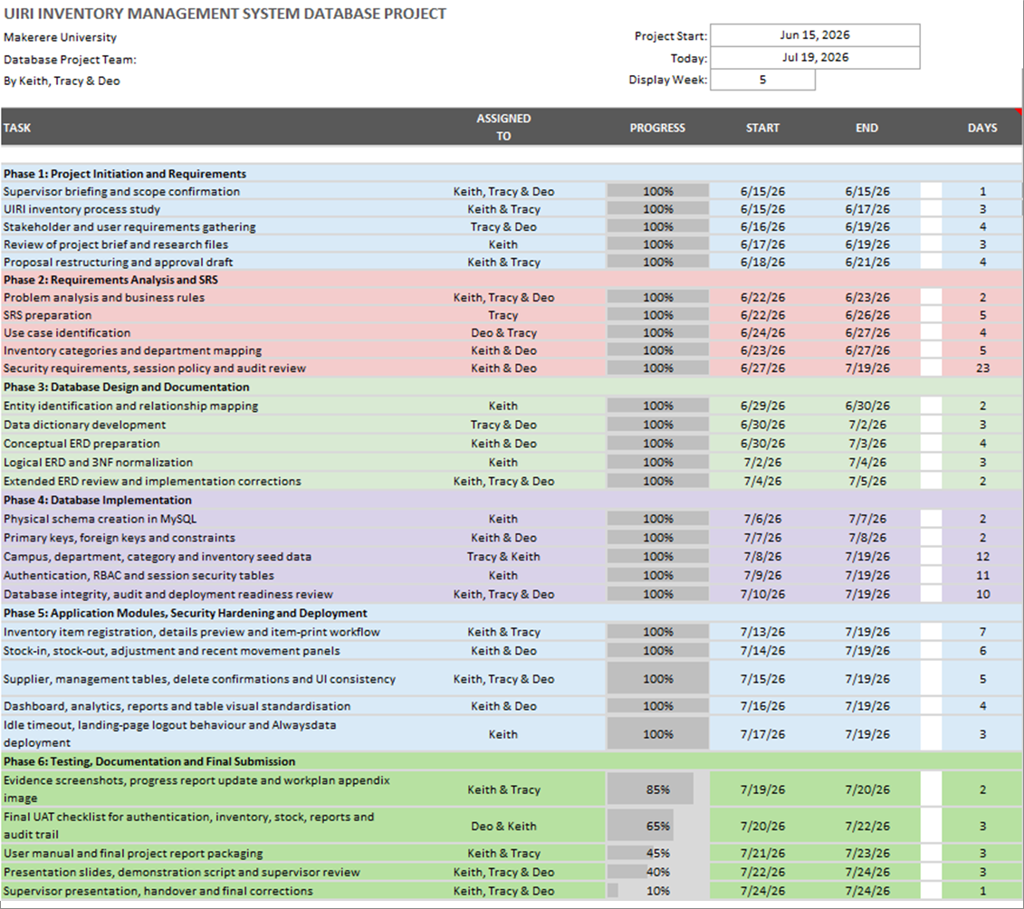

Figure B2: Inventory item evidence - OptiPlex 7050 item visual linked to the item-detail preview and isolated print workflow.


Figure B3: ICT/network equipment evidence from uploaded inventory visuals used to support database-populated asset records.


