

User Manual
UIRI Inventory Management System

Enterprise operating guide for secure inventory, stock movement, reporting, and audit workflows.
Prepared For | Uganda Industrial Research Institute (UIRI)
System Scope | Inventory items, suppliers, stock in/out, requests, reports, analytics, audit trail
Campus Context | UIRI Nakawa and UIRI Namanve
Version | 1.0
Manual Date | 19 July 2026
Classification | Internal operating document

Security Operating Position
Users must re-authenticate after sign-out, session expiry, or returning to the login/landing screen. The current configured idle timeout is 7 minutes, matching the tighter controlled-database posture requested for the system.

This manual is written for day-to-day operators, stock officers, system administrators, and managers who need dependable, auditable use of UIRI IMS.

Contents
Section | Focus
1. Purpose and Governance | Manual scope, record discipline, roles, and expected controls.
2. Secure Access | Login, idle timeout, logout, session expiry, and password practice.
3. Navigation and Dashboard | Branch context, dashboard panels, risk cards, and live signals.
4. Inventory Item Lifecycle | Add, edit, filter, view, and print item-level records.
5. Stock Movement | Receiving stock, issuing stock, adjustments, and transaction evidence.
6. Management Workflows | Suppliers, requests, procurement, maintenance, transfers, users, and settings.
7. Reports, Analytics, and Audit | Printable reports, CSV exports, analytics, and traceability.
8. Daily Operating Controls | Routine quality checks before, during, and after system use.
Appendices | Screenshot register, role matrix, and field guidance.

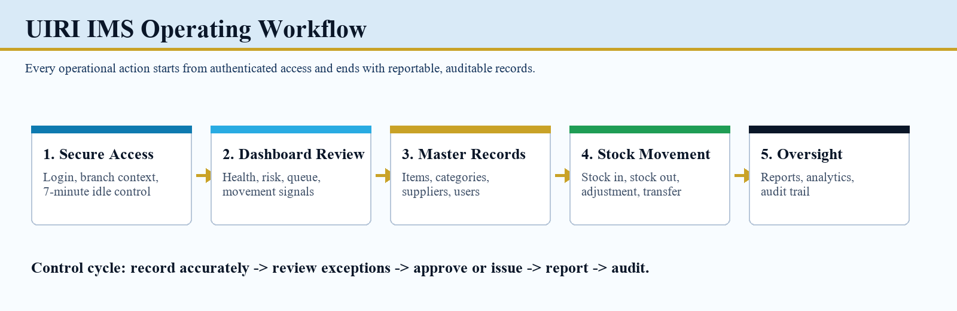
Figure 1. Operating workflow from secure access through audit-ready oversight.

1. Purpose and Governance
UIRI IMS is the controlled inventory platform for recording institutional assets, stock balances, supplier records, stock receipts, issues, requests, reports, and audit evidence across the UIRI campus context.
Operating Principle | Expected Practice
Single source of truth | Inventory and stock movement records should be entered once, verified, and then used for dashboard, reports, and audit decisions.
Branch awareness | Confirm the active branch before reviewing, receiving, or issuing stock. Branch selection changes the operational context of displayed records.
Evidence before action | Use item details, supplier data, purchase information, and current stock before approving requests or issuing stock.
Auditability | Create, update, delete, login, stock movement, and reporting actions must remain traceable to the responsible user account.
Security-first use | Keep sessions short, never share passwords, and log out when leaving the workstation.

Role | Primary Responsibilities
Administrator | User accounts, permissions, branches, settings, audit review, and full system oversight.
Store / Inventory Officer | Inventory item creation, stock-in receipts, stock-out issues, supplier checks, and stock reconciliation.
Campus / Section Manager | Operational review, request tracking, stock risk monitoring, and report interpretation.
Procurement / Maintenance Officer | Supplier records, procurement follow-up, maintenance entries, and asset lifecycle updates.
General User | Submit or monitor permitted requests and maintain responsible use of assigned access.

2. Secure Access
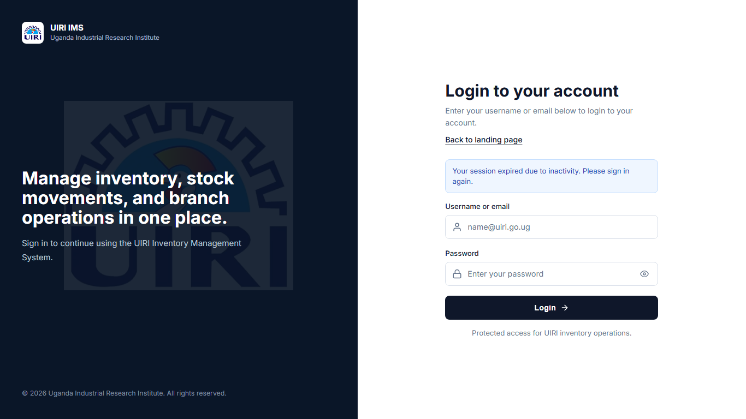
Figure 2. Login screen shown when authentication is required or a session has expired.

2.1 Login and Re-authentication
Step | Action | Expected Result
1 | Open the system URL. | The login screen appears before any protected module is accessible.
2 | Enter the assigned username or email address and password. | The system verifies the account and opens the dashboard for the permitted role.
3 | If the system reports an expired session, sign in again. | A fresh authenticated session is created and protected pages become available.
4 | When work is complete, use the profile or logout control. | The browser returns to the login screen and the previous session is invalidated.

Idle Session Rule
The configured idle threshold is 7 minutes. If the user stops interacting with the system beyond this time, the session is considered inactive and protected pages require a new login.

2.2 Security Conduct
Do | Do Not
Use only your assigned user account. | Do not share passwords or allow another staff member to work under your login.
Lock the workstation when leaving the desk. | Do not leave a logged-in browser unattended in stores, procurement, or office areas.
Report unfamiliar records, unexpected deletions, or failed login patterns. | Do not ignore audit irregularities or repeated session warnings.

3. Navigation and Dashboard
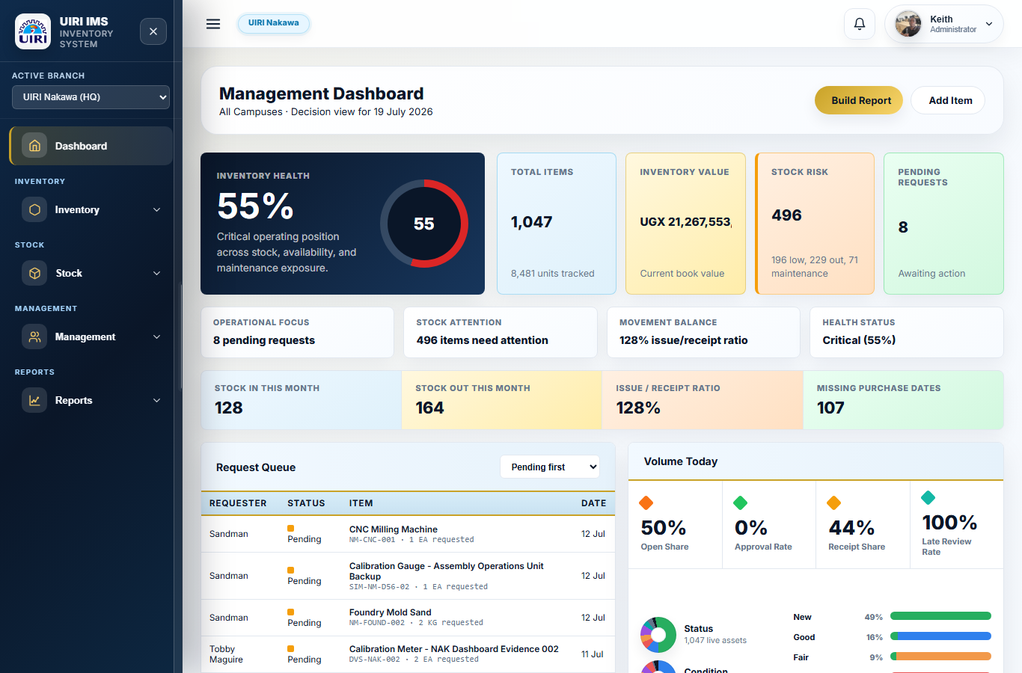
Figure 3. Management dashboard showing branch context, inventory health, risks, pending requests, and movement signals.
Area | How to Use It
Sidebar | Move between Dashboard, Inventory, Stock, Management, and Reports modules. Expanded menu groups show the available pages for the user role.
Active Branch | Confirm whether the working context is UIRI Nakawa, UIRI Namanve, or all campuses before acting on records.
KPI Cards | Review total items, inventory value, stock risk, pending requests, monthly stock in/out, and missing purchase dates.
Operational Tables | Use request queue, priority stock decisions, supplier exposure, and status panels to identify records needing action.
Profile Area | Check the signed-in user and access account actions, including logout.

The dashboard should be the first review point at the start of each working session. It is designed for exception management: the officer should look first for pending approvals, low or out-of-stock items, maintenance exposure, and records with missing purchase evidence.

4. Inventory Item Lifecycle

4.1 Add a New Inventory Item
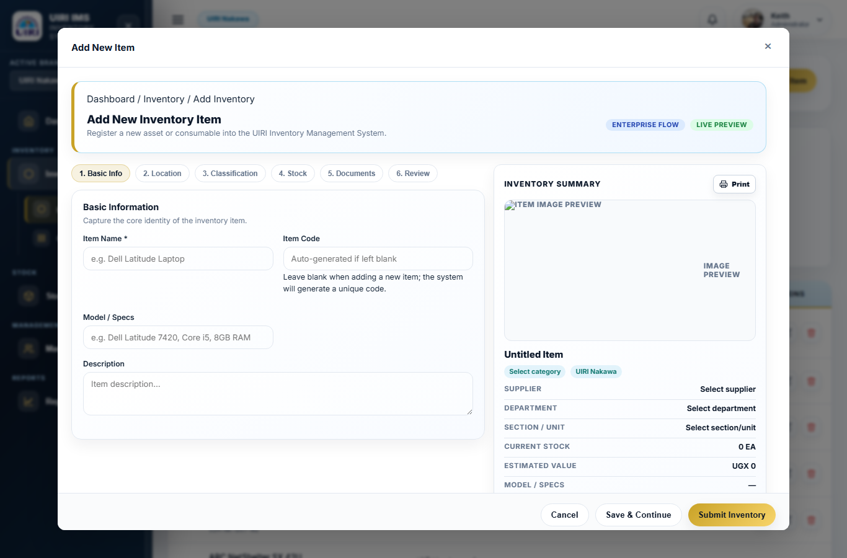
Figure 4. Add Item workflow with progressive sections for basic information, location, classification, stock, documents, and review.

Step | Action | Quality Control
1 | Click Add Item from Inventory Items. | Confirm that the active branch is correct before entering the item.
2 | Complete Basic Info and Location. | Use official item names, department, section/unit, and storage placement.
3 | Complete Classification and Stock. | Select the category, supplier, asset type, condition, current stock, unit, and minimum threshold.
4 | Attach or confirm item image and identifiers. | Capture serial number, asset code, QR/barcode tag, purchase date, and warranty where available.
5 | Review, then submit inventory. | Verify that the preview panel reflects the item exactly before saving.

4.2 Search, Filter, View, and Print Inventory
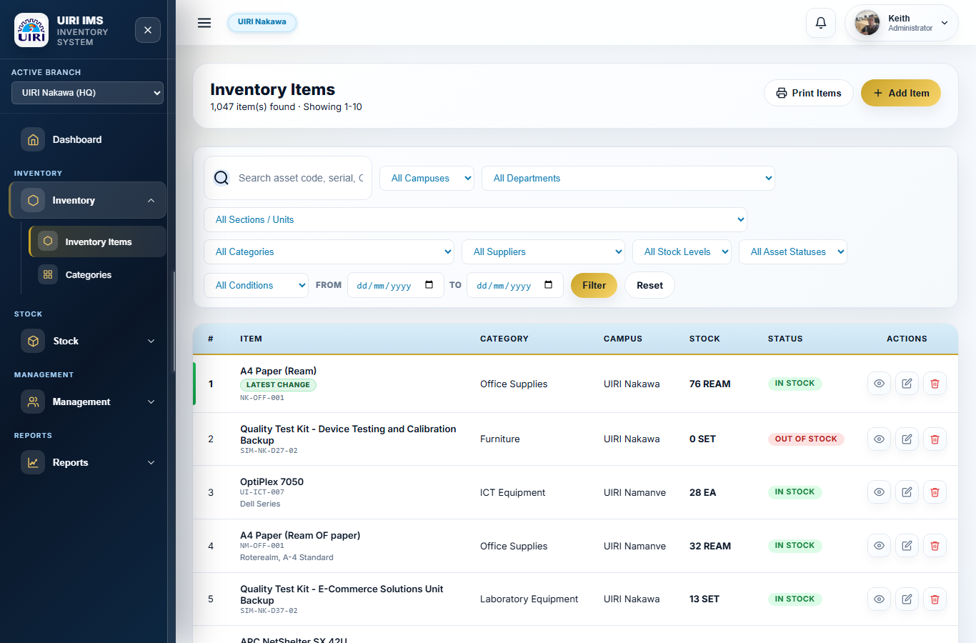
Figure 5. Inventory list with filters, item status badges, and view/edit/delete actions.
Action | Use
Search | Find records by asset code, serial number, item name, category, supplier, or related reference text.
Filters | Limit the list by campus, department, section/unit, category, supplier, stock level, asset status, condition, and purchase date range.
View Details | Open the selected item's full record. This preview is the correct place to print the individual item summary.
Print Details | Print only the item currently open in the item-details preview.
Print Items | Print the list visible on the Inventory Items page. Filters should be applied before printing a filtered list.
Delete | Use only where permitted and confirm the deletion dialog after checking that the record is truly obsolete or duplicated.

Print Discipline
There are two print behaviours. Print Items is for the page list and its active filters. Print Details is for one selected inventory item opened from View Details. Do not use the page-list print when the required evidence is a single asset record.

5. Stock Movement Workflows

5.1 Receive Stock
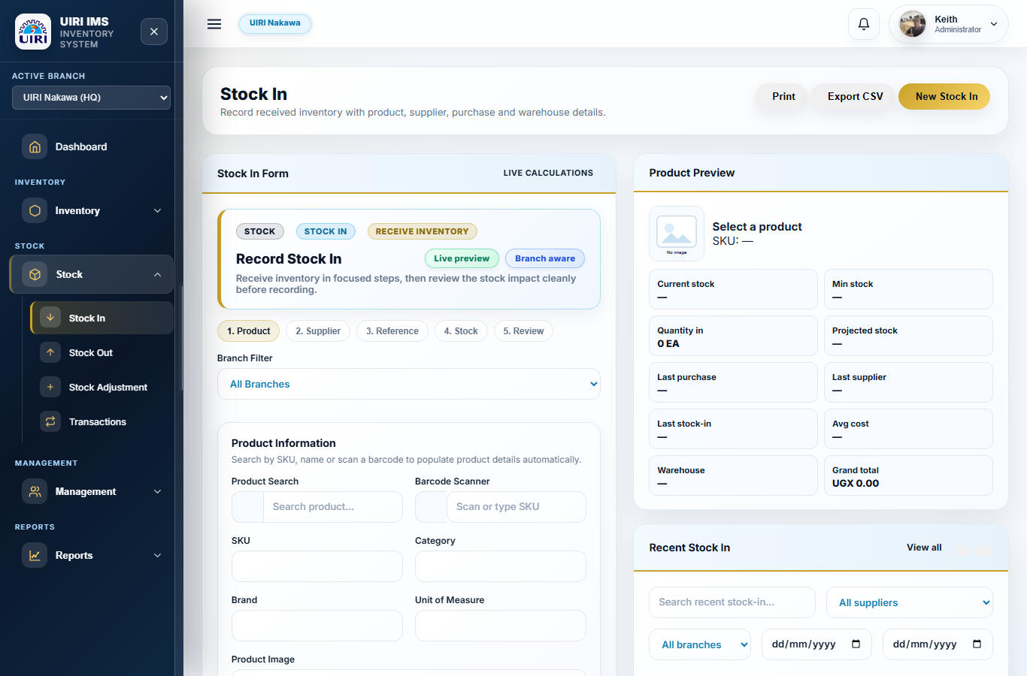
Figure 6. Stock In wizard with product, supplier, reference, stock, and review steps.

Step | Action | Control Check
1 | Select the branch and product. | Confirm item name, SKU, category, current stock, and minimum stock.
2 | Select or confirm supplier. | Supplier information should match the procurement record or delivery documentation.
3 | Enter reference details. | Capture purchase order, invoice number, receiving date, and supporting transaction notes.
4 | Enter quantity and costing. | Check unit cost, tax, discount, total cost, and projected stock before continuing.
5 | Review and save. | The stock-in transaction should increase the item balance and appear in recent stock-in records.

5.2 Issue Stock
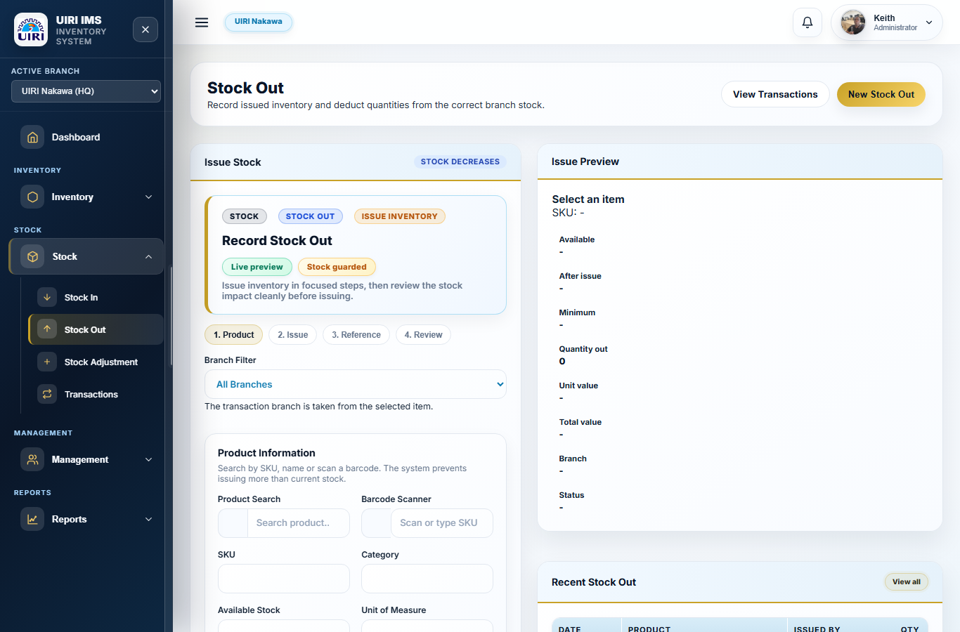
Figure 7. Stock Out wizard for issuing stock from available branch stock.

Step | Action | Control Check
1 | Select the product and branch. | Verify available quantity before recording an issue.
2 | Enter issue quantity and recipient context. | The issue should not exceed the available stock balance.
3 | Capture reference information. | Use request numbers, department, section/unit, and remarks where applicable.
4 | Review the stock impact. | Check after-issue stock, movement reason, and audit trail before saving.
5 | Save transaction. | The stock-out transaction should reduce stock and appear in transactions, reports, and analytics.

5.3 Adjustments and Transfers
Workflow | When to Use | Evidence Required
Stock Adjustment | Correct verified stock count differences, damaged stock, or approved reconciliation changes. | Reason, quantity, item, branch, officer, and approval trail.
Transfer | Move stock or assets between campuses, departments, or sections where the system permits. | Origin, destination, item, quantity, transfer date, and receiving confirmation.
Transactions | Review the full stock movement history. | Date, movement type, item, quantity, user, and branch context.

6. Management Workflows
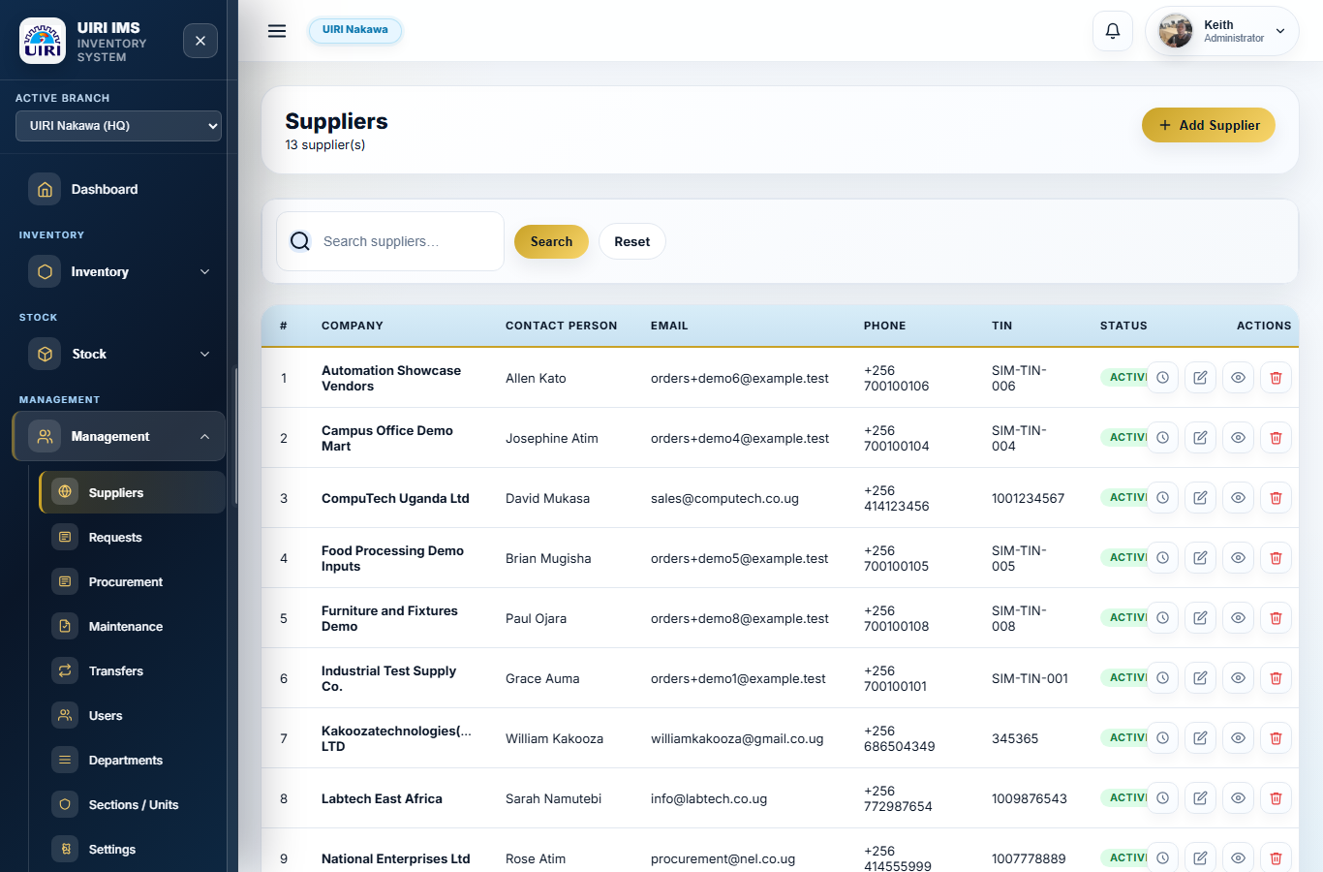
Figure 8. Suppliers table with search, action icons, status indicators, and consistent table styling.
Module | Purpose | Operating Notes
Suppliers | Maintain supplier company, contact, email, phone, TIN, and status. | Use view/edit icons for review and correction. Delete only after verifying that supplier links are no longer required.
Requests | Track internal stock or item requests. | Prioritise pending requests and keep approval, issue, rejection, or cancellation statuses current.
Procurement | Follow procurement-related inventory acquisition steps. | Reference purchase orders, funding source, supplier, and expected receipt dates.
Maintenance | Record equipment condition, service actions, repair status, and maintenance exposure. | Update asset status after inspection, repair, disposal, or recommissioning.
Transfers | Move stock or assigned items across approved organisational locations. | Check origin and destination, then confirm movement evidence.
Users | Create and maintain role-based access. | Use least privilege and deactivate accounts that no longer require system access.
Departments and Sections / Units | Maintain organisational structure used for reporting and assignment. | Keep names consistent with institutional naming to protect report quality.
Settings | Control system-level defaults where permissions allow. | Changes should be deliberate and auditable.

Deletion Confirmation Standard
Delete actions should present a clear confirmation panel before a record is removed. The officer must read the object name and consequence, then proceed only when the deletion is intended.

7. Reports, Analytics, and Audit

7.1 Reports
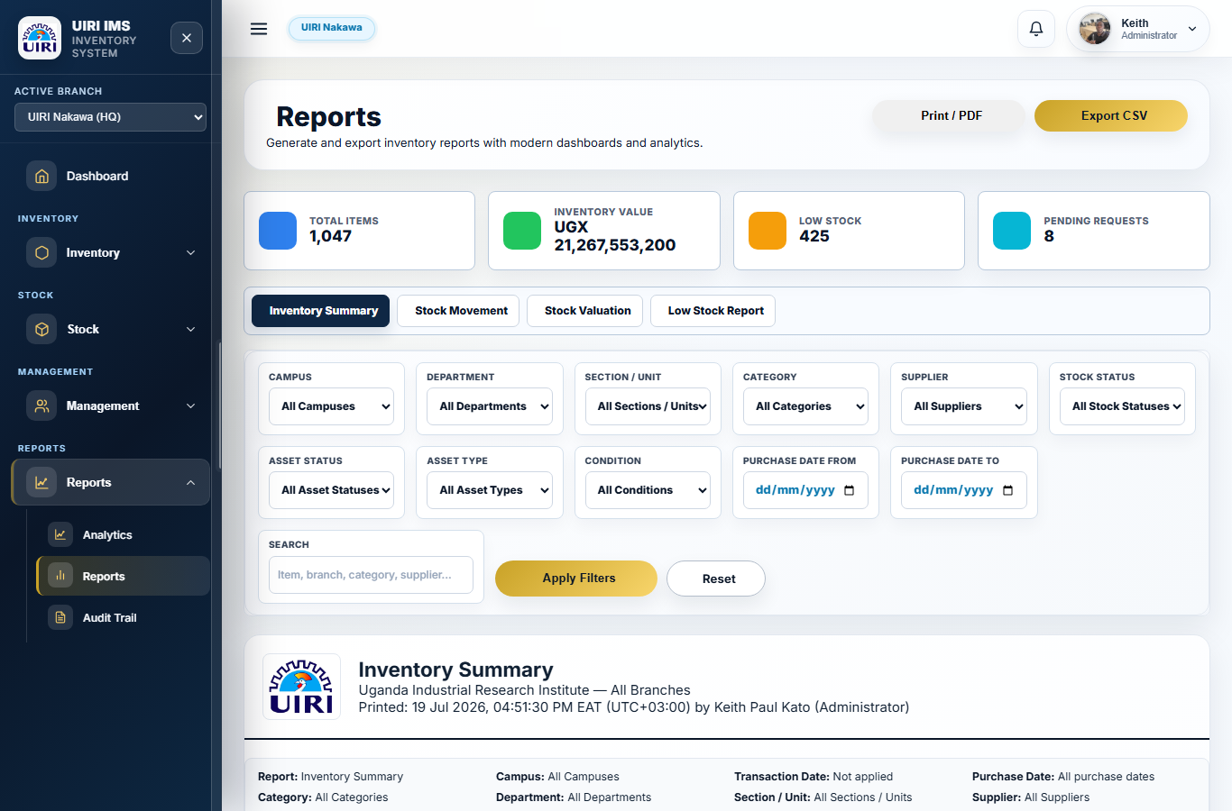
Figure 9. Reports module with filters, report tabs, Print/PDF, and CSV export controls.

Report Type | Primary Use
Inventory Summary | Board or management summary of active inventory state by branch, category, supplier, status, and filtered context.
Stock Movement | Evidence of stock receipts, issues, adjustments, and transaction movement over a selected period.
Stock Valuation | Financial view of inventory value, unit costing, quantity, category, and branch exposure.
Low Stock Report | Exception report for items below minimum threshold or out of stock.
Export CSV | Spreadsheet-ready data extract for further analysis, reconciliation, or appendix evidence.
Print / PDF | Formal printable output of the selected report with filters applied.

7.2 Analytics Command Centre
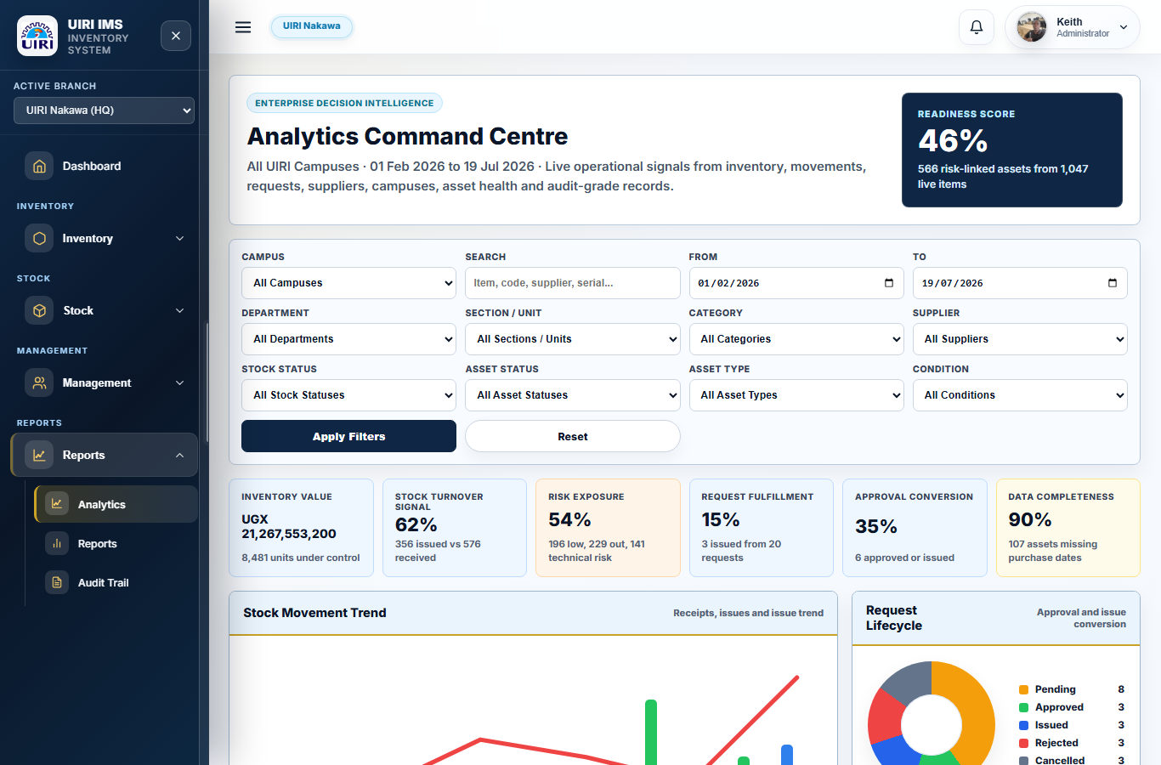
Figure 10. Analytics command centre with readiness score, filters, KPI cards, movement trend, and lifecycle charts.
Signal | Interpretation
Readiness Score | High-level indication of how complete and controlled the inventory records are.
Inventory Value | Book value under control for the selected filters and period.
Risk Exposure | Share of records requiring attention because of low stock, outage, maintenance, or non-working states.
Request Fulfilment | Conversion of inventory requests into issued or completed outcomes.
Data Completeness | Completeness of purchase dates and other evidence fields needed for audit and replacement planning.

7.3 Audit Trail
The audit trail should be reviewed by authorised users to confirm that major actions are attributable, dated, and aligned with business decisions. Pay close attention to account access, deletes, stock movements, and records changed shortly before reporting cycles.

8. Daily Operating Controls
When | Control Activity | Owner
Start of day | Sign in, confirm branch, review dashboard risk cards and pending requests. | Inventory Officer / Manager
Before stock-in | Confirm item, supplier, receipt evidence, quantity, price, purchase date, and storage location. | Inventory Officer
Before stock-out | Confirm available balance, request or issue authority, recipient context, and after-issue stock. | Inventory Officer / Approver
Before deletion | Open record details, check dependencies, read confirmation panel, and delete only when authorised. | Authorised User
Before reporting | Apply filters, confirm date ranges, verify printed summary, and export CSV where required. | Reports User
End of day | Review transactions, check exceptions, export required evidence, and log out. | Responsible Officer

Minimum Appearance and Data Standard
Tables used for operational review should show clear sky-blue headers, a gold divider under the header row, readable action icons, visible pagination, and consistent confirmation dialogs for destructive actions.

Appendix A. Screenshot Register
Figure | System Area | Purpose in the Manual
1 | Workflow Overview | Shows the operating cycle from secure access to audit.
2 | Login | Explains authentication, session expiry, and re-authentication.
3 | Dashboard | Explains management review and operational signals.
4 | Add Item | Shows the item creation workflow.
5 | Inventory Items | Shows list filters, actions, and print distinction.
6 | Stock In | Shows stock receipt workflow.
7 | Stock Out | Shows issue workflow.
8 | Suppliers | Shows supplier management and action controls.
9 | Reports | Shows filters, printed reports, and CSV export.
10 | Analytics | Shows readiness, KPI, and lifecycle analysis.

Appendix B. Key Field Guidance
Field | Guidance
Item Name | Use a clear, official item description that a reviewer can recognise without informal shorthand.
Asset Code | Use the institutional code assigned to the asset. Avoid duplicates.
Serial Number | Record the manufacturer's serial number where available; leave clear evidence when not available.
Category | Choose the most accurate category group to protect dashboard, analytics, and valuation quality.
Campus / Department / Section | Use the exact location hierarchy for assignment, custody, and branch reporting.
Supplier | Select the supplier that provided the item or the approved procurement source.
Purchase Date | Record actual acquisition date where available. Missing dates reduce audit readiness.
Minimum Threshold | Set a realistic control level so low-stock reports reflect operational need.
Asset Status and Condition | Update after maintenance, disposal, issue, repair, or inspection.
Audit Stamp | Confirm that saved actions are attributable to the responsible user.

Figure 11. Inventory summary print of a well documented Item

