Introduction:
Web applications are among the most common targets for cyberattacks, handling sensitive data such as user credentials, payment information, and personal details. According to the OWASP Top 10, injection flaws, cross-site scripting (XSS), and broken authentication account for a significant portion of successful web attacks. This project simulates a real-world web application penetration test using the deliberately vulnerable OWASP Juice Shop application to understand attack vectors and develop effective mitigation strategies.
Project Objectives
The goal of this project is to perform a complete ethical hacking lifecycle against OWASP Juice Shop running in an isolated lab environment. We will demonstrate footprinting, reconnaissance, vulnerability identification, exploitation, and propose technical and process-based hardening recommendations. All testing occurs within student-controlled virtual machines to ensure complete safety and compliance with course requirements.

Target Environment and Tools
Lab Architecture Overview
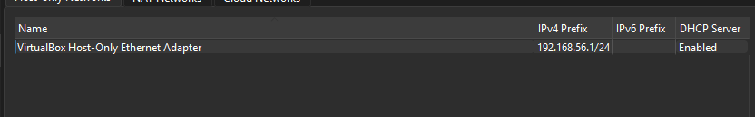
Our lab environment consists of a single Kali Linux virtual machine running both the attacker tools and the OWASP Juice Shop target application. Due to hardware constraints we deployed Juice Shop as a Node.js service within the Kali VM rather than using separate target VMs. The Kali VM operates on a VirtualBox Host Only network (192.168.56.101), ensuring complete isolation from external networks.

In kali adapter 1 is set to host only and adapter 2 is set to NAT to download packages
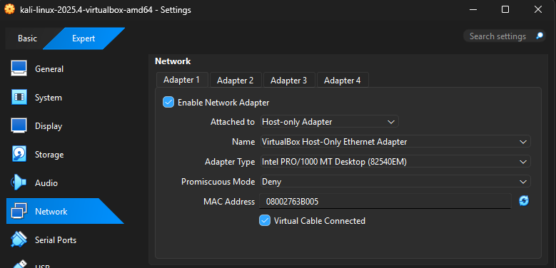
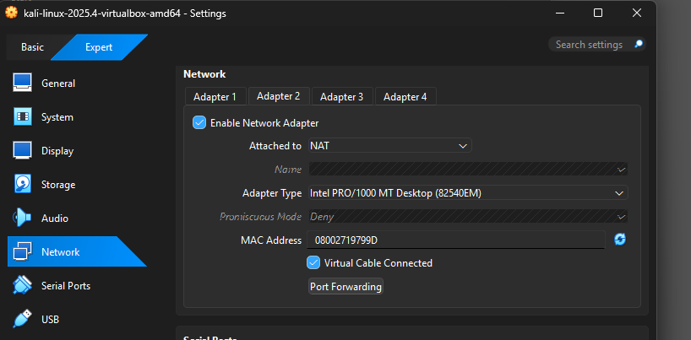

Host IP in Kali 192.168.56.101
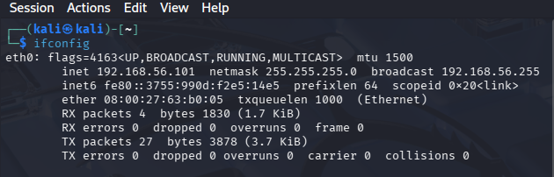

Downloading Juice Shop in Kali
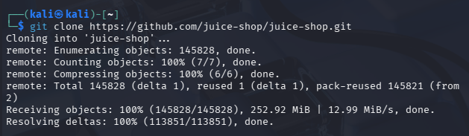

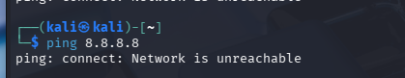
The Host Only network configuration prevents all external connectivity satisfying course safety requirements. A ping test to Google public DNS server (8.8.8.8) confirms no internet access from the lab environment.

Kali VM (attacker) with Juice Shop service as target (localhost:3000) on the same isolated host network.
OWASP Juice Shop runs as a Node.js/Express application within the Kali VM:
- Access: http://localhost:3000
- Technology Stack: Node.js, Express framework, Angular frontend
- Purpose: Deliberately vulnerable e-commerce application for educational penetration testing

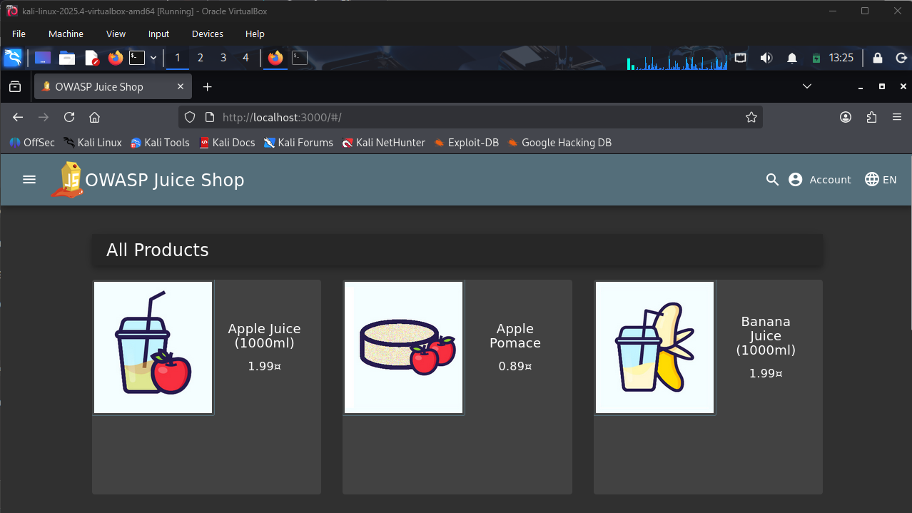

Diagram shows the topology of our isolated lab environment. A single host laptop runs VirtualBox with a host only network (192.168.56.101) connecting an attacker VM (Kali Linux) and a target VM (OWASP Juice Shop, localhost:3000). The host only network has no route to the Internet or any production systems, ensuring all attacks remain confined to virtual machines
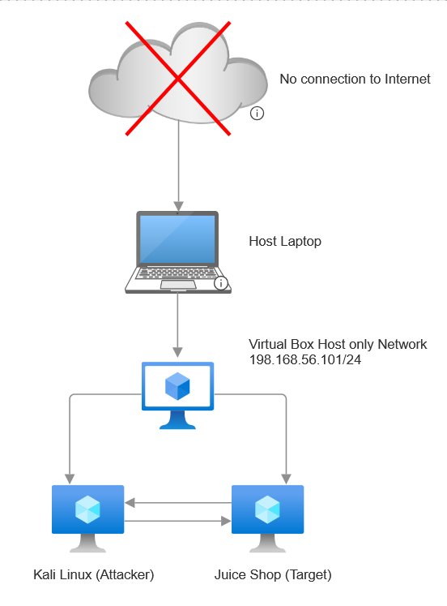

Environment Summary
This controlled lab environment provides a realistic web application penetration testing scenario while maintaining strict isolation from production networks. The single Kali VM with integrated Juice Shop service optimizes resource usage on limited hardware while preserving the complete attack lifecycle from reconnaissance through mitigation recommendations.

