Purchase Invoice Approval Process – Current State, Future State & Options Paper
Author:- Keith Roberts
Version:- 0.1
Date:- April 2026

Contents
1. Overview 2
2. Current State (As-Is) 2
3. Future State (To-Be) 3
4. Options Analysis 3
Option 1 – Excel + Outlook Manual Workflow 3
Option 2 – Odoo Approvals 4
Option 3 – Power Automate + Power Apps + SharePoint 4
Option 4 – Do Nothing 5
5. Recommendation 5

1. Overview
This paper summarises the current state of DEC’s Purchase Invoice approval process, the desired future state, and the available solution options. It is based on the existing process description and discussions to date.

2. Current State (As-Is)
- Invoice received manually via email or PDF
- Normally monthly
- Add to invoice log

- Manually forwarded to budget holder
- Coding (Dept/Appeal/Grant/Project) collected manually
- Second approval via email
- Manual posting into SunSystems
- No audit trail, no visibility of unposted invoices
- Effectively operating on cash basis due to lack of accrual visibility

Figure 1 — Current State Process Overview – Using Adobe/Excel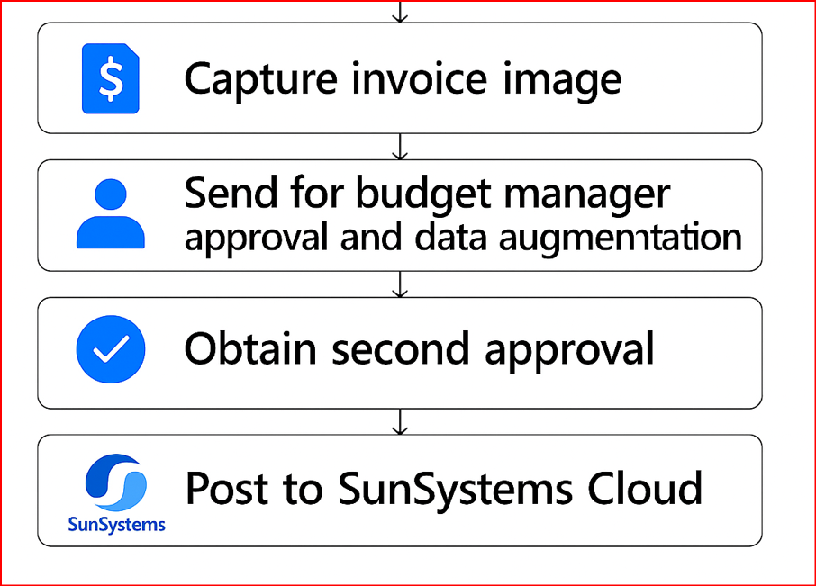

Revised As-Is after issue of documents in Appendix

CURRENT STATE PROCESS — END-TO-END (AS-IS)

1. Invoice Received
Source: Supplier emails invoice to finance@dec.org.uk.
Notes:
- Suppliers frequently send invoices to non-finance staff; those must be forwarded manually to Finance.) [01. Add in...AdobeSign) | Word]
- Invoices should be categorised into “invoices to be distributed” inbox folder. [01. Add in...AdobeSign) | Word]

2. Manually File Invoice in SharePoint
Finance officer manually moves invoices into:
DEC Shared → Finance → Invoices → [Team Subfolder]
Teams include SEC01–05 (and SEC07/SEC08 for devolved nations).[01. Add in...AdobeSign) | Word]

3. Log Invoice in the Excel Invoice Log
Open: Invoice Log.xlsx on SharePoint.
Steps:
- Enter Invoice Number, Date, Due Date, Supplier, Amount.
- Supplier Code is auto-populated if known..docx&action=default&mobileredirect=true) [01. Add in...AdobeSign) | Word]
- Coding columns (Account Code, SEC Code, Appeal, Grant Code) left blank at this stage.
- The log row remains incomplete until coding and signatures are returned.

4. Coding the Invoice (Manually)
Coding depends on team conventions and awareness of past invoices.
Coding fields include:
- Account Code (7-digit nominal code for type of spend)
- SEC Code (team code: SEC01–SEC05 / SEC07 / SEC08)
- Appeal Code (A025–A029 or #ZZ for core)
- Grant/Strategic Project Code (#ZZ or Pxxxx code).docx&action=default&mobileredirect=true) [01. Add in...AdobeSign) | Word]
Split-coded invoices:
- Required when invoice relates to multiple appeals/teams/codes.
- Staff manually add up subtotals for each coding pattern.
- VAT normally added at 20%, unless exempt lines are marked.
- Splits recorded by inserting extra rows in the Invoice Log. [01.1 Split...g Invoices | Word]
This step is high-judgment and often unclear unless familiar with supplier history.

5. Identify Approval Path (Per DFA Policy)
Approvers depend on:
- Team
- Amount
- Budget responsibility
- Delegated financial authority thresholds [DEC Delega...July 2024 | Word]
Example rules:
- < £10,000: Head of Department can approve
- > £10,000: Must be approved by Director
- > £75,000: Director and CEO must approve
- Payment Authorisation: Always Director of Finance (Nick Waring)
This is currently enforced manually through staff knowledge and checking the DFA sheet.

6. Prepare Invoice for Signature (AdobeSign Process)
Finance officer:
- Opens invoice in SharePoint.
- Clicks Sign → Request E-Signatures in AdobeSign.
- Sets signing order based on team and amount.
- Manually inserts:
  - Text fields for coding
  - Signature boxes for budget holders
  - Signature box for payment authorisation
- Sends the AdobeSign request.
SME instructions:
- Digital and Fundraising teams have specific extra approval chains (e.g., Google Ads, Torchbox).
- Programmes team uses a three-step chain (Assistant → Head/PQAL → Director).
.docx&action=default&mobileredirect=true) [01. Add in...AdobeSign) | Word]
This step takes the majority of administrative time.

7. Signature Workflow Happens (AdobeSign)
- Each approver signs or adds coding.
- AdobeSign notifies Finance when completed.
- No integration with any DEC systems.
- Finance must monitor completion manually.

8. Save Down Signed Invoice (Manual, Multi-Step)
AdobeSign returns a multi-page batch PDF.
Finance officer must:
- Extract the signed page(s).
- Save “page 1” (the stamped signature page) and original invoice.
- Recombine using Combine Files → Add Open Files.
- Delete the unused originals.
- Save the final signed invoice into correct SharePoint team folder.
.docx&action=default&mobileredirect=true) [01. Add in...AdobeSign) | Word]
This is the most labour-intensive part of the process.

9. Update Invoice Log (Manually)
- Finance adds coding (from stamp) to columns R–AA.
- Updates Status (e.g., Signed, Ready for Payment).
- This step ties the AdobeSign output back to the spreadsheet.

10. Payment Run (Separate Process)
- Team sends signed invoices to payment run preparer.
- Payment is authorised according to bank mandate rules.
- Not part of SME workshop scope, but connected.
KEY POINTS FROM THE SME DOCUMENTS
This is a fully manual process consisting of:
- Email handling
- SharePoint filing
- Manual Excel logging
- Manual coding
- Manual approval routing
- Manual signature insertion
- Manual file extraction
- Manual update of log
Risk Areas Identified:
- Coding inconsistency (depends on individual familiarity)
- No visibility of invoices “in flight”
- No automated routing based on DFA
- No system-based audit trail
- Manual VAT/split allocations
- Manual AdobeSign configuration (error-prone)
- No integration with SunSystems
- No real-time Power BI visibility
Opportunities directly implied by the documents:
- Automate routing based on DFA + team + spend threshold
- Use Power Apps to collect coding from budget holders
- Replace AdobeSign signature placements
- Use Power Automate for approvals
- Auto-export CSV for SunSystems TransferDesk
- Auto-log approvals + coding into SharePoint List (not Excel)
- Auto-feed Power BI dataset

3. Future State (To-Be)
- Invoices captured automatically via Power App, SharePoint folder, or email‑to‑SharePoint rule
- Structured metadata captured at point of entry (supplier, amount, coding, narrative)
- Two‑stage approval workflow managed by Power Automate
- Audit logs stored centrally in SharePoint/Dataverse
- Automatic creation of CSV or API posting to SunSystems
- Real‑time visibility of approved/unapproved invoices in Power BI
4. Options Analysis
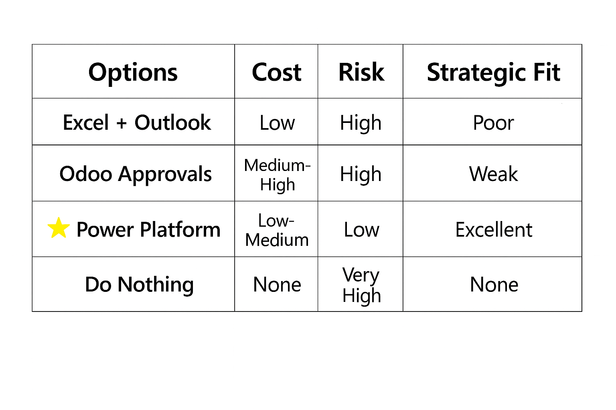
Diagram 3: Options Comparison Diagram

Option 1 – Excel + Outlook Manual Workflow
- Not recommended
- Manual steps, no audit trail
- High error risk, no metadata capture
- No integration with SunSystems

Option 2 – Odoo Approvals
- Technically possible but external to DEC systems
- No native integration with SunSystems
- Creates parallel system and governance risks

Option 3 – Power Automate + Power Apps + SharePoint
- Best alignment with DEC systems
- Full automation and audit trail
- Integration with Power BI and security groups
Diagram 5: Power Automate Flow Diagram

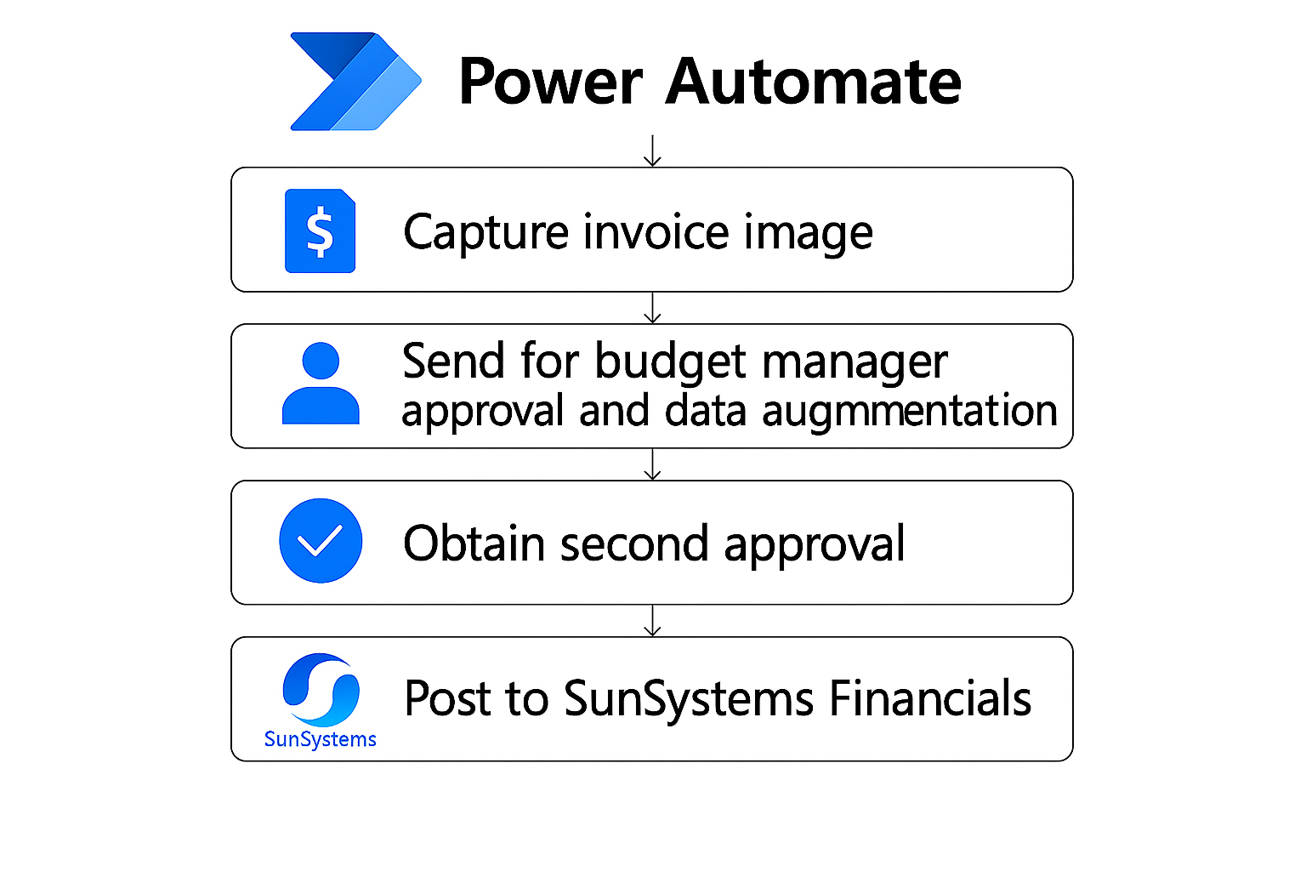

- Option to export CSV for TransferDesk posting to SunSystems
Diagram 6: TransferDesk Integration

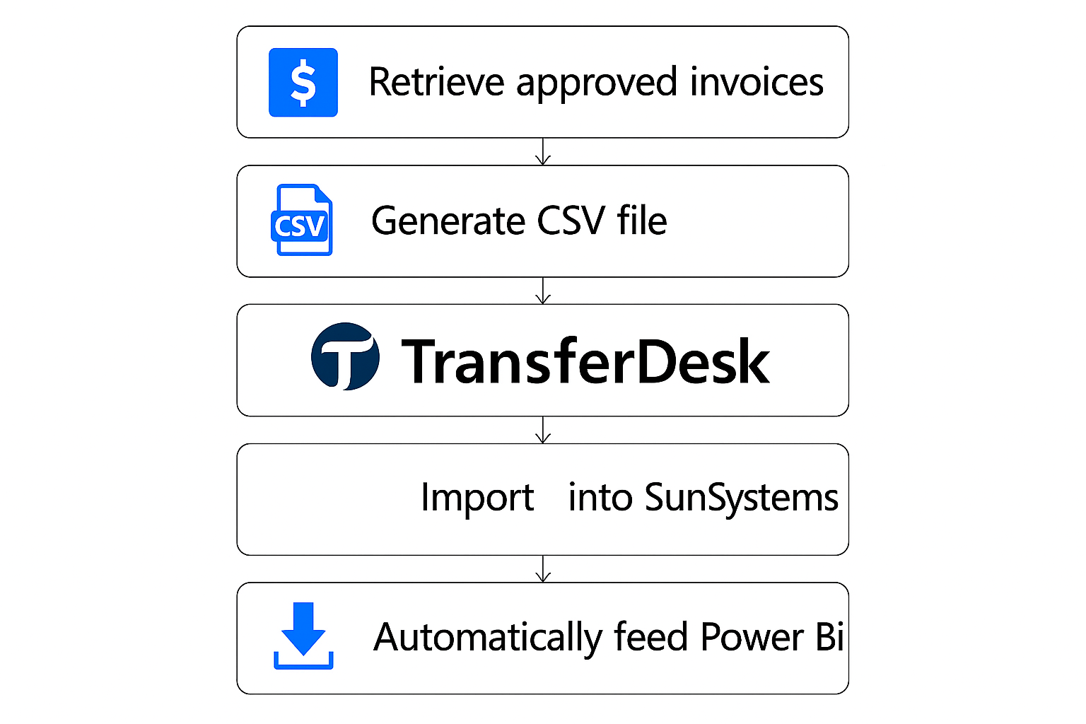

Option 4 – Do Nothing
- Lowest cost but high operational risk
- No improvement to audit or timeliness
- Not scalable and fails to address current issues

5. Recommendation
Based on the analysis, Option 3 (Power Automate + Power Apps + SharePoint) provides the strongest, lowest‑cost, fully auditable workflow. It integrates naturally with DEC’s existing M365 ecosystem and supports either CSV export into SunSystems TransferDesk or API routes if available in future.

Diagram 4: Architecture Diagram
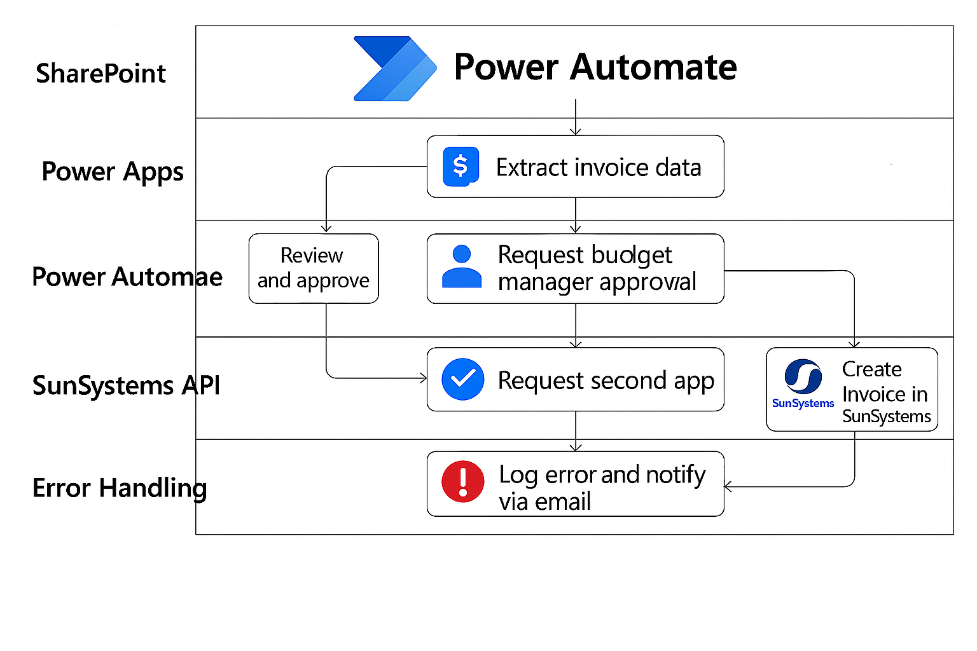

1. Functional Requirements
1.1 Invoice Capture & Intake
ID | Requirement | Source
FR-01 | The system must accept invoices forwarded to the finance@dec.org.uk mailbox. | [01. Add in...AdobeSign) | Word].docx&action=default&mobileredirect=true).docx&action=default&mobileredirect=true)
FR-02 | The system must ingest invoices arriving via non-finance staff (forwarded invoices). | [01. Add in...AdobeSign) | Word].docx&action=default&mobileredirect=true).docx&action=default&mobileredirect=true)
FR-03 | The system must store invoices in a structured folder location per team (SEC01–SEC05, SEC07–08). | [01. Add in...AdobeSign) | Word].docx&action=default&mobileredirect=true)
FR-04 | The system must replace the manual “categorise to inbox subfolder” process. | [01. Add in...AdobeSign) | Word].docx&action=default&mobileredirect=true)
FR-05 | The system must extract or prompt for Supplier, Amount, Date, and Due Date. | [01. Add in...AdobeSign) | Word].docx&action=default&mobileredirect=true).docx&action=default&mobileredirect=true)

1.2 Invoice Logging
ID | Requirement | Source
FR-06 | The system must maintain a register of all invoices (received, pending, approved, posted). | [01. Add in...AdobeSign) | Word].docx&action=default&mobileredirect=true).docx&action=default&mobileredirect=true)
FR-07 | The system must capture Supplier Code automatically where possible (based on a lookup). | [01. Add in...AdobeSign) | Word].docx&action=default&mobileredirect=true)
FR-08 | The system must support invoice splitting into multiple lines where invoices relate to multiple appeals/expenditure codes/teams. | [01.1 Split...g Invoices | Word]
FR-09 | The system must support VAT calculation logic including 20% standard VAT and exceptions (non-VAT lines marked with “*”). | [01.1 Split...g Invoices | Word]
FR-10 | The system must validate split code totals against the invoice gross amount. | [01.1 Split...g Invoices | Word]

1.3 Coding Requirements
ID | Requirement | Source
FR-11 | The system must support coding using Account Codes, SEC Codes, Appeal Codes, and Grant/Strategic Project Codes. | [01. Add in...AdobeSign) | Word].docx&action=default&mobileredirect=true)
FR-12 | The system must allow budget holders to enter coding information. | [01. Add in...AdobeSign) | Word].docx&action=default&mobileredirect=true).docx&action=default&mobileredirect=true)
FR-13 | The system must provide coding options based on structured lists (Nominal codes, Appeals, Grant codes). | [01. Add in...AdobeSign) | Word].docx&action=default&mobileredirect=true)
FR-14 | The system must support #ZZ core-cost coding and strategic project codes starting with “P”. | [01. Add in...AdobeSign) | Word].docx&action=default&mobileredirect=true).docx&action=default&mobileredirect=true)

1.4 Approval Workflow
ID | Requirement | Source
FR-15 | The system must identify the correct approval path based on the team (SEC01–SEC05, SEC07–08). | [01. Add in...AdobeSign) | Word].docx&action=default&mobileredirect=true)
FR-16 | The system must route approvals based on Delegated Financial Authority thresholds. | [DEC Delega...July 2024 | Word]
FR-17 | The system must support two-tier and three-tier approvals depending on invoice type (e.g., SEC03 Google Ads requires Digital & Innovation Manager + Fundraising Director). | [01. Add in...AdobeSign) | Word].docx&action=default&mobileredirect=true)
FR-18 | The system must require CEO approval for invoices above £75k. | [DEC Delega...July 2024 | Word]
FR-19 | The system must support payment authorisation by the Director of Finance & Resources as the final step. | [01. Add in...AdobeSign) | Word].docx&action=default&mobileredirect=true).docx&action=default&mobileredirect=true)
FR-20 | The system must include optional multi-approver chains (e.g., Programmes: Assistant → Head/PQAL → Director). | [01. Add in...AdobeSign) | Word].docx&action=default&mobileredirect=true)

1.5 Document Signing / Approval Evidence
ID | Requirement | Source
FR-21 | The system must provide an auditable digital approval trail replacing AdobeSign. | [01. Add in...AdobeSign) | Word].docx&action=default&mobileredirect=true)
FR-22 | The system must capture coding and signature metadata without needing manual stamp boxes. | [01. Add in...AdobeSign) | Word].docx&action=default&mobileredirect=true)
FR-23 | The system must eliminate manual creation of text/signature boxes. | [01. Add in...AdobeSign) | Word].docx&action=default&mobileredirect=true)
FR-24 | The system must store signed/approved invoices in the correct SharePoint location. | [01. Add in...AdobeSign) | Word].docx&action=default&mobileredirect=true)
FR-25 | The system must support merging multi-page PDFs without requiring manual Adobe editing. | [01. Add in...AdobeSign) | Word].docx&action=default&mobileredirect=true).docx&action=default&mobileredirect=true)

1.6 Integration & Posting
ID | Requirement | Source
FR-26 | The system must export final approval data in CSV format for import into SunSystems via TransferDesk. | (Inferred from current manual posting)
FR-27 | The system must ensure coding lines correspond to SunSystems Analysis codes. | [01. Add in...AdobeSign) | Word].docx&action=default&mobileredirect=true).docx&action=default&mobileredirect=true)
FR-28 | The system must support multiple rows per invoice for split coding (SunSystems requires multiple lines). | [01.1 Split...g Invoices | Word]

2. Non-Functional Requirements
ID | Requirement | Source
NFR-01 | The system must maintain full auditability for Finance team and external auditors. | [01. Add in...AdobeSign) | Word].docx&action=default&mobileredirect=true)
NFR-02 | The system must ensure approvers cannot exceed delegated authority limits. | [DEC Delega...July 2024 | Word]
NFR-03 | The system must support secure access via DEC Microsoft 365 authentication. | (Implied by SharePoint/Adobe use)
NFR-04 | The system must minimise manual calculations (VAT, split codes). | [01.1 Split...g Invoices | Word]
NFR-05 | The system must provide high availability during working hours. | (Implied operational requirement)
NFR-06 | The system must allow audit retrieval of any invoice, signature, and metadata. | [01. Add in...AdobeSign) | Word].docx&action=default&mobileredirect=true)
NFR-07 | The system must reduce risk of fraud by ensuring only authorised approvers can sign. | [01. Add in...AdobeSign) | Word].docx&action=default&mobileredirect=true).docx&action=default&mobileredirect=true).docx&action=default&mobileredirect=true)
NFR-08 | User experience must be simple enough for Directors, Managers, and Assistants. | (Practical SME requirement)
NFR-09 | System must support GDPR requirements for storage of supplier personal data. | (Implied by handling consultant invoices)

3. Data Requirements
ID | Requirement | Source
DR-01 | Invoice metadata: Supplier, Date, Due Date, Invoice No., Amount, VAT, Total. | [01. Add in...AdobeSign) | Word].docx&action=default&mobileredirect=true)
DR-02 | Coding metadata: Account Code, SEC Code, Appeal Code, Grant Code. | [01. Add in...AdobeSign) | Word].docx&action=default&mobileredirect=true)
DR-03 | Approval metadata: Name, Role, Date/Time, DFA level. | [DEC Delega...July 2024 | Word]
DR-04 | Audit metadata: Status (Received, For Approval, Approved, Ready for Payment). | [01. Add in...AdobeSign) | Word].docx&action=default&mobileredirect=true)
DR-05 | Split coding totals and VAT calculations. | [01.1 Split...g Invoices | Word]
DR-06 | PDF signed invoice stored in SharePoint. | [01. Add in...AdobeSign) | Word].docx&action=default&mobileredirect=true)

4. Process Requirements
ID | Requirement | Source
PR-01 | Replace the “Inbox → SharePoint → Excel” triage process with automation. | [01. Add in...AdobeSign) | Word].docx&action=default&mobileredirect=true)
PR-02 | Automate approval routing based on team and DFA thresholds. | [DEC Delega...July 2024 | Word]
PR-03 | Automate extraction of coding data from approvers. | [01. Add in...AdobeSign) | Word].docx&action=default&mobileredirect=true).docx&action=default&mobileredirect=true)
PR-04 | Provide visibility of invoices “in flight” (tracking). | [01. Add in...AdobeSign) | Word].docx&action=default&mobileredirect=true).docx&action=default&mobileredirect=true).docx&action=default&mobileredirect=true)
PR-05 | Integrate posting with SunSystems (via file). | (Implied from manual posting gap)
PR-06 | Replace AdobeSign multi-step extraction/merge workflow. | [01. Add in...AdobeSign) | Word].docx&action=default&mobileredirect=true)

5. Governance & Control Requirements
ID | Requirement | Source
GOV-01 | Enforce Delegated Financial Authority policy automatically. | [DEC Delega...July 2024 | Word]
GOV-02 | Enforce team-specific approval chains (e.g., SEC03 Digital invoices). | [01. Add in...AdobeSign) | Word].docx&action=default&mobileredirect=true)
GOV-03 | Prevent payments without DF&R signoff. | [01. Add in...AdobeSign) | Word].docx&action=default&mobileredirect=true)
GOV-04 | Maintain evidence of approval and coding for auditors. | [01. Add in...AdobeSign) | Word].docx&action=default&mobileredirect=true).docx&action=default&mobileredirect=true)
GOV-05 | Maintain separation of duties (budget approval vs payment approval). | [01. Add in...AdobeSign) | Word].docx&action=default&mobileredirect=true)
GOV-06 | Ensure consistent coding across invoices and prevent miscoding. | [01.1 Split...g Invoices | Word]

Appendix

SME Files
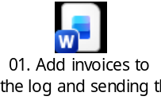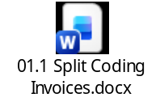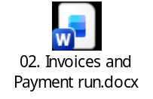

Design and Configuration Document

✅ ✅ STEP 1 — DEFINE YOUR STATUS MODEL (final version)
Based on your discussion + document, I recommend:
Draft
CodingRequired
CodingComplete
ReadyForApproval
InApproval
Approved
Rejected

✅ ✅ What each status means (important)
Status | Owner | Meaning
Draft | Finance | Invoice created
CodingRequired | Coding Admin | Needs coding
CodingComplete | Coding Admin | Coding entered
ReadyForApproval | System | Ready to start approvals
InApproval | System | Approval in progress
Approved | System | Fully approved
Rejected | System | Rejected

✅ ✅ STEP 2 — DEFINE TRANSITIONS (this is the key design)
Now we define who moves from one status to the next and how

✅ 1. Finance creates invoice
Draft → CodingRequired
How:
- Finance fills in metadata
- Sets Status = CodingRequired

✅ 2. Coding Admin works queue
CodingRequired → CodingComplete
How:
- Coding Admin opens list view
- Enters coding:
  - NominalCode
  - Appeal
  - Grant
- Sets:
- Status = CodingComplete

✅ 3. Budget Holder review
CodingComplete → ReadyForApproval
How:
- Budget Holder reviews coding in list
- If OK → sets:
- Status = ReadyForApproval
- If not → returns to:
- CodingRequired

✅ 4. YOUR EXISTING FLOW STARTS
Trigger:
Status = ReadyForApproval ✅

✅ Flow updates:
ReadyForApproval → InApproval ✅

✅ Then:
InApproval → Approved / Rejected ✅

✅ ✅ STEP 3 — IMPLEMENTING THIS IN SHAREPOINT (practical)

🔧 3.1 Create Status column
Column type:
Choice
Values:
Draft
CodingRequired
CodingComplete
ReadyForApproval
InApproval
Approved
Rejected

🔧 3.2 Set default value
Draft

✅ ✅ STEP 4 — CREATE WORK QUEUES (THIS IS WHAT USERS WANTED)

🔹 View 1 — Coding Admin Queue
Filter:
Status = CodingRequired

🔹 View 2 — Budget Holder Queue
Filter:
Status = CodingComplete

🔹 View 3 — Approval Monitoring
Filter:
Status = InApproval

🔹 View 4 — Finance Dashboard
Filter:
All items
Grouped by Status

👉 This replaces:
Emails → Tasks ❌
With:
Queues → Worklists ✅

✅ ✅ STEP 5 — UPDATE YOUR FLOW (minimal change)

✅ Modify trigger
Keep:
Status = ReadyForApproval

✅ First step in flow
Update Status → InApproval ✅

✅ Final step
Approved / Rejected ✅

👉 That part you already built perfectly ✅

✅ ✅ STEP 6 — CONTROL TRANSITIONS (important rule)
You must enforce:
✅ Only correct roles can move to next status

✅ Example governance
Action | Who can do it
Draft → CodingRequired | Finance
CodingRequired → CodingComplete | Coding Admin
CodingComplete → ReadyForApproval | Budget Holder
ReadyForApproval → InApproval | Flow
InApproval → Approved/Rejected | Flow

👉 You don’t need full automation yet — just train users + views

✅ ✅ STEP 7 — OPTIONAL VALIDATION (very useful)
Later, you can enforce rules:

✅ Example
Before allowing:
CodingComplete → ReadyForApproval
Check:
NominalCode NOT empty
Appeal NOT empty
Grant NOT empty

👉 This prevents bad data entering approvals

✅ ✅ WHAT YOU HAVE NOW (BIG IMPROVEMENT)
You’ve moved from:
Event-driven workflow
to:
✅ State-driven process (enterprise standard)

✅ ✅ HOW THIS MATCHES YOUR DOCUMENT
Requirement | Now satisfied
FR12 coding by budget holder | ✅ controlled stage
FR13 structured coding | ✅ enforced
PR04 visibility of invoices | ✅ views
GOV06 consistent coding | ✅ structured process
NFR08 simple UX | ✅ list-based working

✅ ✅ FINAL DESIGN (clean view)
Finance → creates invoice
↓
Coding Admin → adds coding
↓
Budget Holder → confirms coding
↓
Flow → triggers approvals
↓
Director / CEO → approve
↓
Final outcome

✅ ✅ NEXT STEP (what I recommend)
👉 Implement ONLY:
- Status column ✅
- Views ✅
- Manual transitions ✅
- Keep your flow unchanged ✅

Then test:
Can users work entirely from list views without emails?

✅ ✅ After that (phase 2)
We can:
- automate transitions
- restrict who can update status
- introduce Power Apps for better UX

✅ ✅ Summary
🎯 Status transitions = your system backbone
You now have:
✅ Controlled lifecycle
✅ Reduced emails
✅ Clear responsibilities
✅ Audit-friendly process

If you want next, I can help you:
✅ Define a simple “user playbook” (who does what, when)
✅ Add light validation rules
✅ Design a clean Power Apps UI on top

👍 This is a major step up — you’re now designing the process, not just the flow.
Provide your feedback on BizChat
How to restrict status updates by role?How to validate fields before transition?
Drop your files here

