**Name: Tang Zheng Yin Keith**

**Admission Number: 2228002**

**Class: DIT/FT/1B/03**

**ST0503 BACK-END WEB DEVELOPMENT**

**2022/2023 SEMESTER 2**

**ASSIGNMENT 2 DATABASE MODIFICATIONS**

Insert an additional column named “image” in bed_dvd_db.category.

Datatype: VARCHAR(45)

Insert data into image column accordingly.

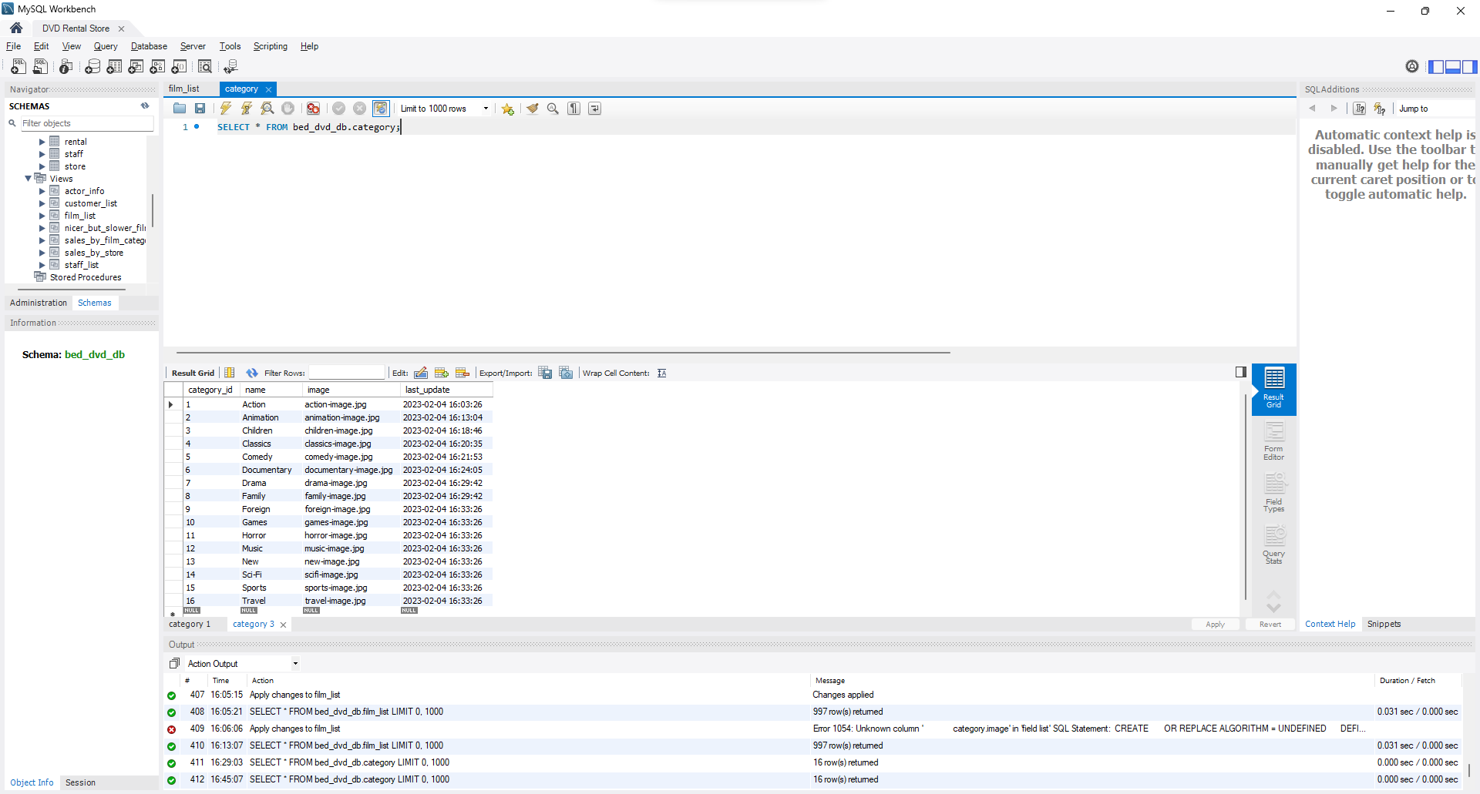

Navigate to “film_list” table, and click the spanner icon.

Insert data into DDL accordingly.

Results of “film_list” table after insertion:

