Distributed Job Scheduler
System Architecture, Database Design & Engineering Decisions
This document explains the reasoning behind the architecture, schema, and reliability mechanisms of the submitted system, and maps each design choice back to the assignment's evaluation criteria.

1. System Architecture
The system is split into four independently-deployable processes that share nothing but the database, which is deliberate: it means the pieces that need to scale out (workers) can be scaled independently of the piece that must stay singular (the scheduler), without code changes.
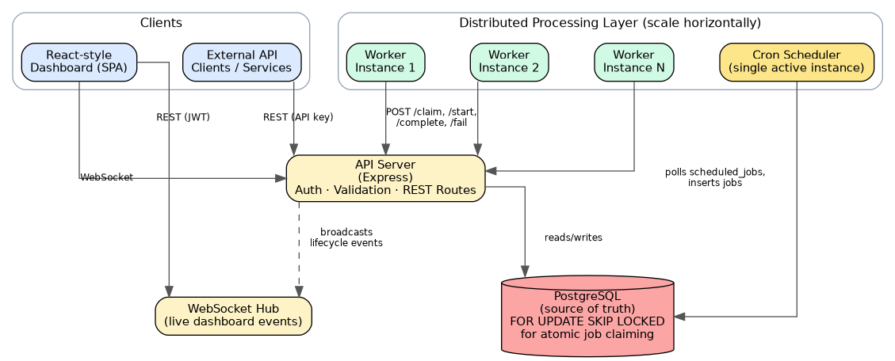

1.1 Components
- API Server (Express) — stateless REST layer. Handles auth, validation, and all reads/writes to Postgres. Being stateless means any number of replicas can sit behind a load balancer with no session affinity required.
- Worker Service — polls its assigned queues, atomically claims jobs, executes them, and reports outcomes back through the API. Multiple worker processes (potentially on different machines) run against the same project concurrently; this is the "distributed" part of the system.
- Cron Scheduler — a single lightweight process that turns recurring-job templates into concrete job rows when they come due. Kept separate from workers so a slow scheduler tick never competes with job execution for a worker's concurrency slots.
- WebSocket Hub — pushes lifecycle events (job created, worker online, replay, etc.) to connected dashboards in real time, so the UI doesn't have to poll aggressively.

1.2 Why this separation, specifically
A tempting shortcut is to embed the worker loop inside the API process (e.g. a setInterval in server.js). That was deliberately avoided for two reasons: first, it makes the API process's resource usage unpredictable (a burst of job execution competes with the event loop that's also serving HTTP requests); second, it makes horizontal scaling ambiguous — scaling API replicas would silently also scale worker concurrency, which are two independent scaling dimensions in a real system (you may want 20 workers but only 2 API replicas).

1.3 Scaling story
Horizontal: run more worker processes — the atomic claim on the database (Section 3) is what makes this safe with zero coordination between workers. Vertical / read scaling: the dashboard's read-heavy aggregate queries (Section 4.4) are the first candidates for a read replica if load grows. The scheduler is intentionally a single active instance; running two would double-fire recurring jobs. A production hardening step (noted as a limitation below) would add a Postgres advisory lock so a second scheduler instance can sit warm as a failover rather than being architecturally forbidden.

2. Database Design
PostgreSQL was chosen specifically for one feature: SELECT ... FOR UPDATE SKIP LOCKED, which is what makes atomic job claiming possible without an external coordination service (Redis locks, Zookeeper, etc). Everything else about the schema follows from modelling the job lifecycle honestly.
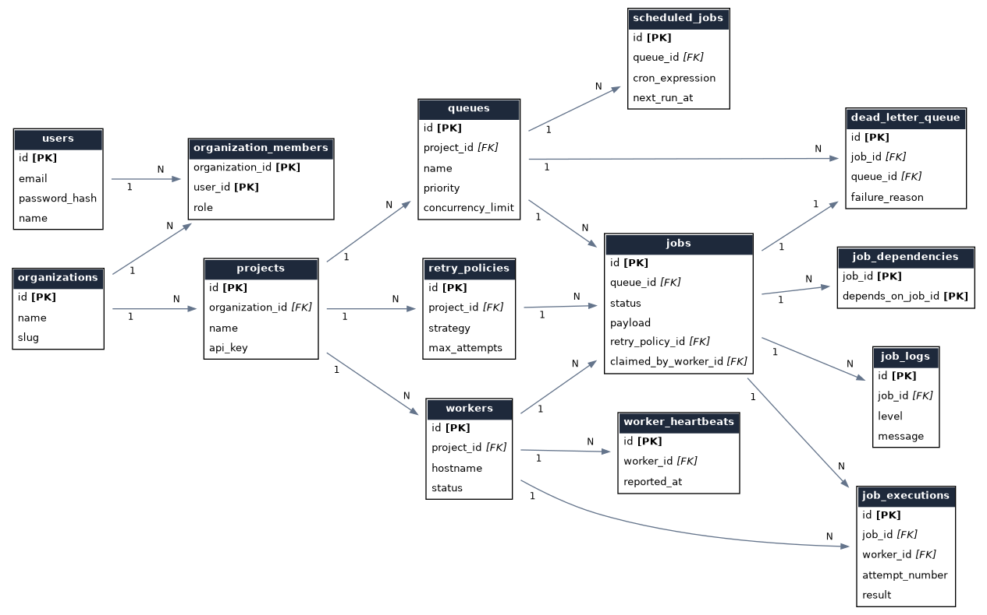

2.1 Normalization
The schema is in Third Normal Form. A few choices that are worth calling out explicitly because they look like denormalization at first glance:
- jobs.attempt_count is a running counter duplicated from the count of job_executions rows for that job. This is intentional denormalization: attempt_count is read on every single claim query (the hottest path in the system), while job_executions is only read when someone inspects history. Recomputing it with a COUNT(*) subquery on every claim would add a join to the hottest query in the system for no benefit — job_executions remains the source of truth and attempt_count is treated as a cache of it, updated in the same transaction that appends the execution row.
- dead_letter_queue stores a payload_snapshot rather than just pointing at jobs.payload. This is intentional: if the job row is later purged by a retention job, the DLQ entry — which exists specifically for post-mortem debugging — must survive that purge.

2.2 Cascade rules, and why each one was chosen
Relationship | On delete | Reasoning
queue → jobs | CASCADE | A queue with no consumer has no meaningful jobs; deleting a queue is an explicit, rare admin action.
job → job_executions/logs | CASCADE | Execution history has no meaning without the job it belongs to.
retry_policy → jobs.retry_policy_id | SET NULL | A retry policy being deleted shouldn't destroy the jobs that reference it; they fall back to the default policy logic.
worker → jobs.claimed_by_worker_id | SET NULL | A deregistered worker's historical jobs remain queryable; only the pointer to the now-gone worker is cleared.
organization → projects/members | CASCADE | Projects cannot exist outside an organization in this model.

2.3 Indexing strategy
The single most important index in the system is:
CREATE INDEX idx_jobs_claim_scan ON jobs (queue_id, status, run_at)
WHERE status IN ('queued', 'scheduled');
This is a partial index — it only indexes rows in a claimable state, which is a small fraction of all jobs once a system has been running for a while (most rows end up 'completed'). That keeps the index small and fast even as the jobs table grows into the millions of rows, because completed/dead-lettered history never bloats the one index the claim query depends on.
Supporting indexes: idx_jobs_status (dashboard aggregate queries group by status), idx_jobs_batch (partial, only non-null batch_id), idx_jobs_cron (partial, only recurring jobs), idx_heartbeats_worker_time (time-series lookups for the worker health panel), and idx_dlq_unreplayed (partial, only rows awaiting triage).

3. Reliability & Concurrency
This section is the crux of the assignment brief. The core guarantee the system provides is: a job is claimed by exactly one worker, even when many workers poll the same queue at the same instant.

3.1 Atomic claiming
UPDATE jobs SET status='claimed', claimed_by_worker_id=$1,
claimed_at=now(), attempt_count = attempt_count + 1
WHERE id = (
SELECT id FROM jobs
WHERE queue_id = $2 AND status IN ('queued','scheduled')
AND run_at <= now()
ORDER BY priority DESC, run_at ASC, created_at ASC
LIMIT $3
FOR UPDATE SKIP LOCKED
)
RETURNING *;
FOR UPDATE locks the candidate rows for the duration of the transaction; SKIP LOCKED tells Postgres that if another concurrent transaction already has a row locked, skip it and move to the next candidate rather than blocking. The net effect: N workers can run this exact query against the same queue at the same millisecond, and Postgres guarantees the row sets they come back with are disjoint. No application-level locking, no distributed lock service, no polling-then-checking race window.

3.2 The concurrency_limit race — a subtlety worth documenting
An earlier version of this implementation checked "how many jobs are currently running against this queue" as a separate query before the claim, to enforce the per-queue concurrency_limit. That is a check-then-act race: two concurrent claim requests can each read "3 of 5 slots used" and both proceed, together exceeding the limit. The fix was to lock the queue row itself (SELECT ... FOR UPDATE, without SKIP LOCKED) for the duration of the claim transaction, so the limit check and the claim happen atomically. This serializes claims per queue — a deliberately narrow scope, since different queues remain fully concurrent with each other. A concurrency test (tests/concurrency.test.js) specifically exercises this: 10 workers firing simultaneous claim requests against a 5-slot queue never collectively claim more than 5 jobs.

3.3 Retry strategy & backoff
Each retry policy specifies a strategy (fixed, linear, or exponential), a base delay, a max delay ceiling, and a max attempt count. On failure, the resolution logic (jobRepository.markFailedAndResolve) locks the job row, computes the next run_at using the policy, and either re-queues the job or — once max attempts is exhausted — moves it to the dead_letter_queue table with a snapshot of its final payload and failure reason for manual triage and replay.
Strategy | Formula (attempt = n) | Use case
fixed | base_delay | External calls with a known, stable recovery time
linear | base_delay × n | Gradual backoff for rate-limited APIs
exponential | base_delay × multiplier^(n-1), capped at max_delay | Unknown/variable outage duration (the general-purpose default)

3.4 Idempotency
Job creation accepts an optional idempotencyKey, enforced by a unique constraint on (queue_id, idempotency_key). Submitting the same key twice returns 409 Conflict rather than silently creating a duplicate job — important for at-least-once callers (e.g. a webhook retrying its own delivery).

3.5 Graceful worker shutdown
On SIGTERM/SIGINT, a worker stops polling for new work immediately, reports itself as draining, waits (bounded by a timeout) for in-flight jobs to finish, and only then deregisters. This avoids the common failure mode where a rolling deploy kills workers mid-job, leaving jobs stuck in 'running' with no process left to complete them.

4. API Design
REST resources are nested to mirror ownership: /projects/:id/queues/:id/jobs. Two auth schemes are supported on the same routes — a JWT bearer token for the human dashboard, and a per-project API key (X-API-Key) for workers and external services — resolved by the same requireAuthOrApiKey middleware so route handlers don't need to know which one authenticated the caller. Validation is centralized through Zod schemas; a failed validation returns 400 with a field-level error breakdown rather than a generic message.

4.1 Error format
{ "error": "human-readable message", "details": { ... optional field errors ... } }

4.2 Bonus features implemented
- Batch job submission (POST /jobs/batch) — up to 1000 jobs sharing a batch_id for grouped tracking.
- Job dependencies (job_dependencies table) — a job is only claimable once all its dependencies are 'completed', enabling simple DAG workflows.
- Recurring jobs via cron expressions, run by a dedicated scheduler process.
- Rate limiting (express-rate-limit) on the whole API to blunt abusive polling.
- RBAC-ready schema (organization_members.role) for multi-user projects.
- Real-time dashboard updates over WebSocket, with polling as an automatic fallback.

5. Testing Strategy
Automated tests (Jest + Supertest) run against a real Postgres test database rather than mocks, because the correctness property that matters most here — no double-claiming under concurrency — is a property of the database's locking behavior, not of application code that a mock could faithfully stand in for.
Suite | What it proves
auth.test.js | Registration, login, duplicate-email rejection, token-gated routes
jobLifecycle.test.js | Create → claim → start → complete; idempotency; cancellation; pause; delayed run_at; full retry → dead-letter path
concurrency.test.js | 10 workers racing for 20 jobs never double-claim; concurrency_limit is never exceeded under concurrent claim requests

6. Known Limitations
- The cron scheduler runs as a single instance with no leader election yet — documented in Section 1.3 as the next hardening step for high availability.
- Dashboard-side authorization does not re-verify organization membership on every nested project route (it trusts the JWT plus the route's project id) — acceptable for the assignment's scope, flagged here rather than silently glossed over.
- Job payloads are stored as JSONB with no schema validation per job type; a production system would likely add per-job-name payload schemas.

