1. 需求：

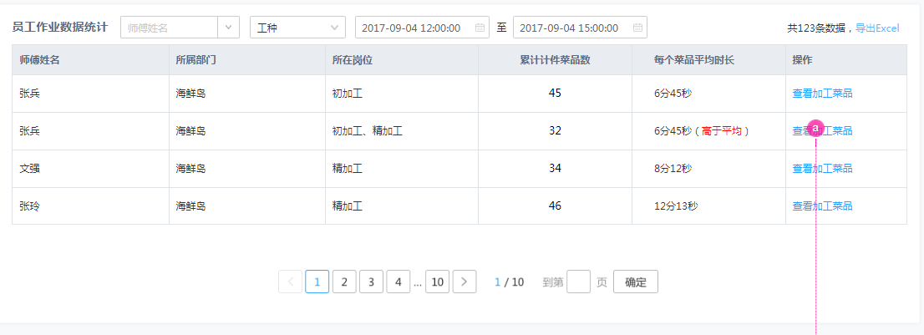

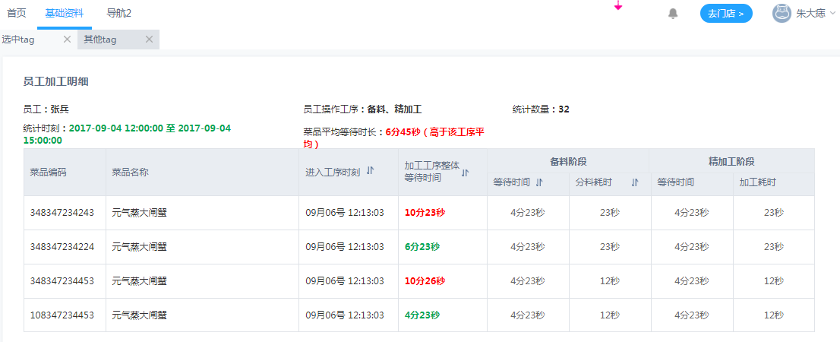

思路：

点开页面🡪请求参数都为空,controller调service,service调dao🡪dao4表联合查询统计

SELECT operator_rfid,warehouse_code,restaurant_code, COUNT(*) FROM rough_produce_order_46

where gmt_create >'2017-09-28 18:55:29' and gmt_create<'2017-10-13' and warehouse_code ='1000513336' and restaurant_code = '3082'

GROUP BY operator_rfid,warehouse_code,restaurant_code

UNION

SELECT operator_rfid,warehouse_code,restaurant_code, COUNT(*) FROM distribute_material_order_46

where gmt_create >'2017-09-28 18:55:29' and gmt_create<'2017-10-13' and warehouse_code ='1000513336' and restaurant_code = '3082'

GROUP BY operator_rfid,warehouse_code,restaurant_code

UNION

SELECT operator_rfid,warehouse_code,restaurant_code, COUNT(*) FROM refined_produce_order_46

where gmt_create >'2017-09-28 18:55:29' and gmt_create<'2017-10-13' and warehouse_code ='1000513336' and restaurant_code = '3082'

GROUP BY operator_rfid,warehouse_code,restaurant_code

UNION

SELECT operator_rfid,warehouse_code,restaurant_code, COUNT(*) FROM cook_produce_order_46

where gmt_create >'2017-09-28 18:55:29' and gmt_create<'2017-10-13' and warehouse_code ='1000513336' and restaurant_code = '3082'

GROUP BY operator_rfid,warehouse_code,restaurant_code

LIMIT 0,5