**万法归宗之语法速成进阶**

**第 4 节 动词时态与语态超精解**

**All of model sentences are from a series of movies of MARVEL**

**时态篇**

**专题思维导图**

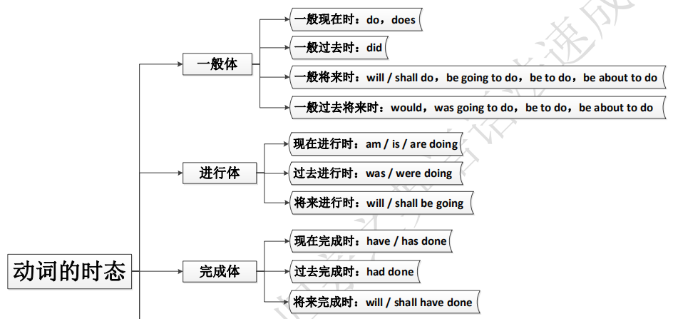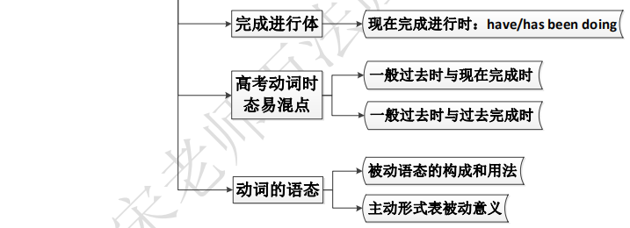

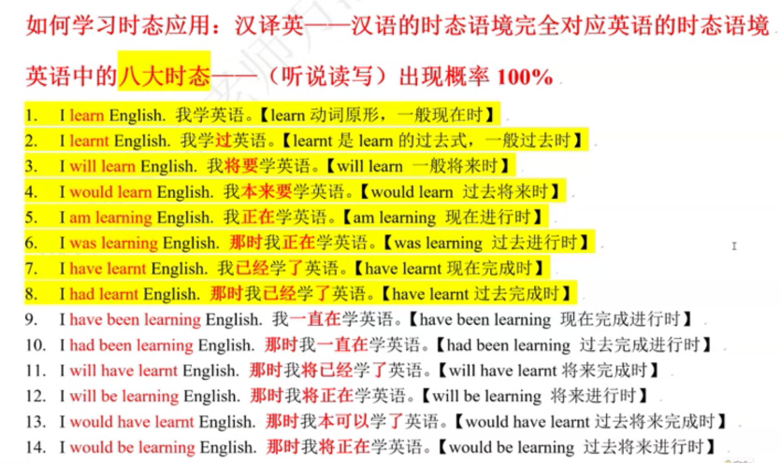

英语中的时态比较复杂，不像汉语用“着、了、过”三个字就把时态的含义表现的淋漓尽致。英语中动词的的时态变化根据时间分为现在、过去、将来和过去将来；根据动作方式分为一般、进行、完成和完

成进行，两种分类结合便产生了十六种时态。

下面以“I do”为例，将十六种时态的构成形式列表如下

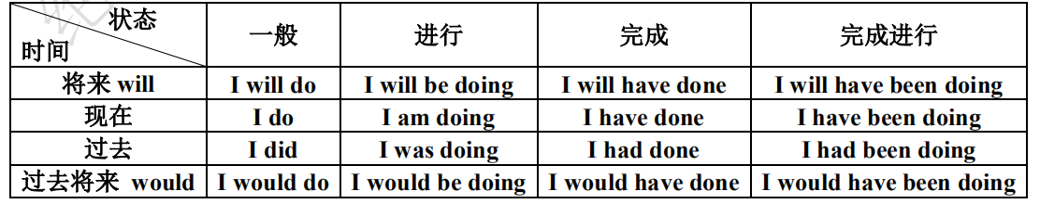

**一、时态的一般体**

**1. 一般现在时**

（1）一般体中的一般现在时、一般过去时分别表示现在、过去的经常性、习惯性动作或状态，常和表重复

性的时间状语 always，usually，often 等连用。

（2）一般现在时还可表示客观真理、科学事实。

（3）一般现在时还可用在 if，unless，even if 引导的条件状语从句中；由 when，before，until (till)，as soon

as，the moment，once 引导的时间状语从句中；由 no matter what/who/which/when/where/how 或 whatever，

whoever，whichever，whenever，wherever，however 引导的让步状语从句中。这时主句往往表示将来（出现

will/shall/can/must）或主句是祈使句。

**Following Iron Man to learn English【一般现在时】**

1. 01:24

I feel like you're driving me to court martial.

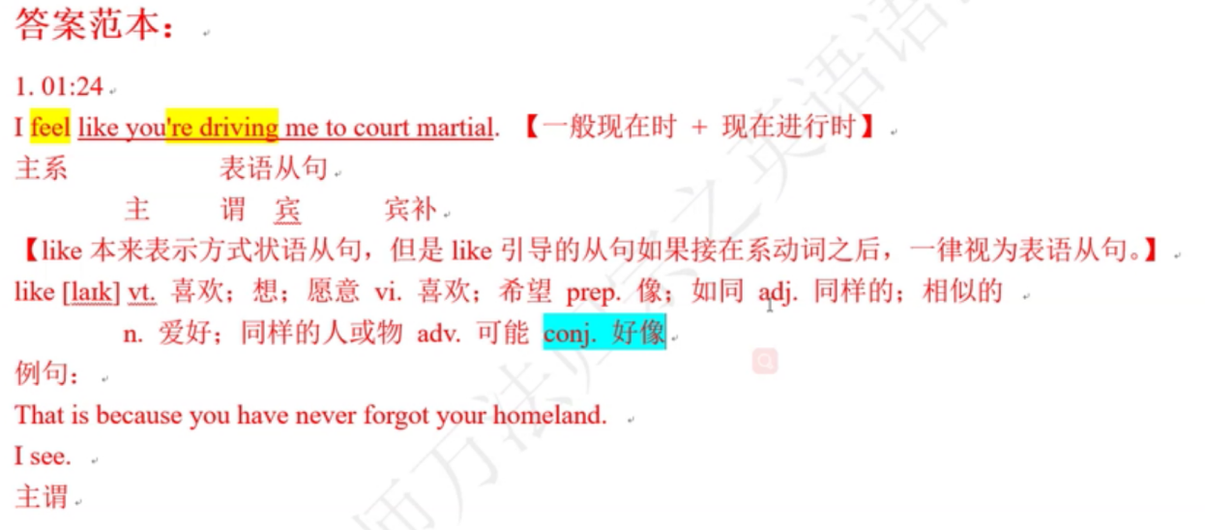

2. 06:31

Tony, you know, the best thing about Tony is also the worst thing--he's always working.

3. 06:49

You are unbelievable!

4. 07:31

Render unto Caesar that which is Caesar's.

5. 08:21

My old man had a philosophy: "Peace means having a bigger stick than the other guy."

6. 14:36

Is it better to be feared or respected?

7. 14:39

And I say, is it too much to ask for both?

8. 27:19

So you're a man who has everything and nothing.

**Following Hulk to learn English【一般现在时】**

9. 36:58

She doesn't know that I'm here.

10. 37:07

They say he's one of the best.

11. 37:44

I don't think there's anybody up there.

12. 41:55

Just tell me if I saw what I think I saw.

13. 48:50

I want to know who jumped the gun!

14. 59:14

Where does she meet these guys?

**Following Thor to learn English【一般现在时】**

15. 03:09

Do me a favor and don't be dead.

16. 13:32

There's nothing you can do without defying Father.

17. 13:39

That's the only way to ensure the safety of our borders.

18. 44:49

Then this is where we say goodbye.

**Following Captain America to learn English【一般现在时】**

19. 01:13

You're the guys from Washington?

20. 01:35

You know we don't have the equipment for a job like this.

21. 05:16

I think that you are a man of great vision.

22. 05:33

What you seek is just a legend.

23. 06:28

You have no need for them to die.

24. 07:40

It's not for the eyes of ordinary men.

25. 07:54

You cannot control the power you hold.

**2. 一般过去时**

（1）一般过去时主要用来表示过去某个时间完成的动作或一度存在的状态，常跟一个表示过去的时间状语

连用，如：then，yesterday，the other day 等。有时省去时间状语，但从上下文语境当中能体会出被省略的

部分。语境中的一般过去时往往表示“刚才，在过去”，暗示现在已“不再这样”。

（2）一般过去时还可以表示过去一段时间经常反复发生的行为或习惯性动作，往往与 used to，would 等连

用。

（3）在时间、条件、方式或让步状语从句中，要用一般过去时态代替过去将来时。

（4）两个或两个以上在过去接连发生的动作用 and 或 but 连接时，要用一般过去时。

（5）叙述某一动作或状态在过去持续了一段时间终止或在过去某段时间发生了若干次时用一般过去式。

**Following Iron Man to learn English【一般过去时】**

1. 01:43

I thought of you as a soldier first.

2. 02:02

March and I had a scheduling conflict.

1. 04:33

At age four, he built his first circuit board.

4. 08:47

Wow, did you ever lose an hour of sleep your whole life?

5. 12:55

For three hours, you got me standing here.

**Following Hulk to learn English【一般过去时】**

6. 36:49

I mean, you know how I felt about you two.

7. 59:04

I used to wonder why she never talked about you.

**Following Thor to learn English【一般过去时】**

8. 02:08

I thought you said it was a subtle aurora!

9. 03:38

Mankind accepted a simple truth, that they were not alone in this universe.

10. 03:48

Some worlds man believed to be home to their gods.

11. 13:59

My father fought his way into Jotunheim, defeated their armies and took their Casket.

12. 14:15

Who led you into the most glorious of battles?

**Following Captain America to learn English【一般过去时】**

13. 01:20

A Russian oil team called it in about 18 hours ago.

14. 08:45

She was a nurse in a TB ward.

15. 10:32

I had him on the ropes.

16. 11:31

What'd you tell her about me?

17. 12:53

Well I did say a few years, didn't I?

18. 23:00

When you brought a 90 pounds modicum asthmatic onto my army base, I let it slide.

**3. 一般将来时**

（1）“will + 动词原形”表示现在看来以后要发生的动作或存在的状态；事物的固有属性或必然趋势。

（2）“be going to + 动词原形”多用在口语中，表示“计划、打算要做某事”，此处，be going to 还可根据现在

的迹象，对未来进行判断。

1. “be about to + 动词原形”表示“立即的将来（immediate future）”，因此，该句型很少与时间状语连用。

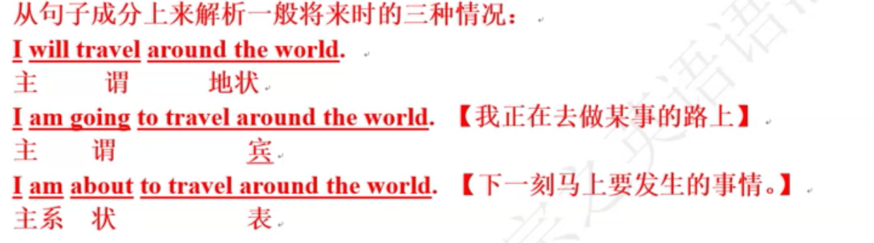

**Following Iron Man to learn English【一般将来时】**

1. 07:23

Worse things have happened, I think we're going to be fine. 【进行时表将来时】

2. 08:08

I guarantee you the day weapons are no longer needed to keep the peace we'll start making bricks and beams for

baby hospitals。

3. 10:09

And there's a car waiting for you outside that will take you anywhere you'd like to go.

4. 10:59

I'll keep you posted.

5. 15:12

I personally guarantee you the bad guys won't even want to come out of their caves.

6. 37:55

Come on, you're going to go see your family again.

7. 44:18

I'll put something in a book, shell I?

8. 01:21

It's about to be blown to kingdom come.

**Following Hulk to learn English【一般将来时】**

9. 22:46

You don't understand! Something really bad is about to happen here!

10. 32:10

Let me emphasise that what I'm about to share with you is tremendously sensitive, both to me personally and the

Army.

11. 58:25

I need to know where they're going.

12. 58:28

She'll be in incredible danger as long as she's with him.

13. 01:08:40

Well, we'll have to try and get it back.

**Following Thor to learn English【一般将来时】**

14. 12:19

We will find the breach in our defenses and it will be sealed.

15. 20:54

We will accept your most gracious offer.

16. 26:58

He'll get what he came for.

17. 44:01

If you take me there now, I'll tell you everything you wish to know.

18. 47:29

They're not going to do that to us.

19. 47:31

I'm going to get everything back.

**Following Captain America to learn English【一般将来时】**

20. 03:59

They'll never find it.

21. 09:47

Together with allied forces, we'll face any threat, no matter the size.

22. 28:39

I can't imagine he'll succeed.

23. 01:47:42

We'll have the band play something slow.

24. 01:27:36

He's going to kill you anyway, Doc.

25. 58:08

One of these days I'm going to have a stick of my own.

26. 11:18

You're about to be the last eligible man in New York.

**4. 过去将来时【特别要领悟语境的含义，因为未来要作为虚拟语气使用】**

表示在过去看来将要发生的动作或存在的状态，用“would/should + 动词原形”，should 仅用于第一人称。

具体运用时，多用于宾语从句或间接引语当中，表示从过去的观点来看将发生的行为或存在的状态。

**Following Iron Man to learn English【过去将来时】**

1. 01:41

I mean, I would apologize, but isn't that what we're going for here?

2. 02:25

Yeah, peace! I love peace. I'd be out of job with peace.

3. 06:20

But if I were Tony, I would tell you how honored I feel and what a joy it is to receive this very prestigious award.

4. 06:52

But they told me that if I presented you with an award, you'd be deeply honored.

5. 08:31

A lot of people, including your professors at Brown would call that being a hero.

6. 13:42

It would be irresponsible not to drink.

7. 17:26

I wouldn't do that if I were you.

8. 44:26

Hey, would it be alright if everyone sat down？

9. 01:55

If I were Iron Man, I'd have this girlfriend who knew my true identity

**Following Hulk to learn English【过去将来时】**

10. 01:09:00

If he was trying to escape, he'd be long gone.

11. 01:17:25

I'd take your hands off him.

**Following Thor to learn English【过去将来时】**

12. 04:27

But humanity would not face this threat alone.

13. 38:16

I had no idea Father would banish him for what he did.

14. 43:35

Well, I wouldn't waste my time!

15. 01:03

I tried to tell him so, but he wouldn't listen.

16. 01:16

Thor would do the same for us.

**Following Captain America to learn English【过去将来时】**

17. 30:01

I guess I just don't know why you would want to join the army.

18. 33:35

Agent Carter, don't you think you would be more comfortable in the booth?

19. 46:05

But without Erskine it would take years.

**二、时态的进行体**

**1. 现在进行时**

（1）表示在说话的瞬间正在进行或发生的动作或者是当前一段时间内的活动情况或现阶段正在进行的动作

（在说话时不一定是正在进行）。在句中往往有 now/just now（就在此时）等时间状语或是像 Look!等提示词

语，有的则是通过上下文暗示某动作正在进行。

（2）与 always/constantly/continually/forever/all the time 等表示时间的副词连用，表示说话人对主语的行为表

示赞叹、赞许、表扬、抱怨、厌恶等情绪，体现出一定的感情色彩。

（3）表示来、去、开始、终结、离开、到达等意义的终止性动词的进行时表示按照计划安排好的将要进行

的动作。

（4）不可以用于进行时态的情况（通常是表示感觉、情感、存在、从属、思维的动词）：

①表示存在状态的动词：be / stay / exist / belong to

②表示心理或情感状态的动词：fear / hate / remember / think / know / believe / want / need / understand /forget / please / respect / prefer / mind / like / hope / wish / agree / appreciate / recognize / mean / care / dislike /love 等。【以上动词需要特别记忆】

③终止性动词不可以用于进行时：accept / allow / complete / hear / notice / end / admit / give / receive / refuse /promise / decide 等。

④感官动词（系动词）：see / look （看上去）/ hear / smell / taste / feel / sound 等。

（5）表示动作的未完性、暂时性。

**Following Iron Man to learn English【现在进行时】**

1. 02:08

You're kidding me with a hand up, right?

2. 11:52

What are you trying to get rid of me for?

3. 12:58

I'm waiting on you now.

4. 13:11

What're you reading?

5. 13:36

We're not drinking, we're working right now.

6. 16:07

Why aren't you wearing those pyjamas I got you?

7. 18:40

And it's keeping the shrapnel from entering your heart.

**Following Hulk to learn English【现在进行时】**

8. 30:26

So if you're taking another crack at him, I want in.

9. 46:38

We're giving you a very low dose only.

10. 01:13:58

But we're not strolling into the park for a picnic, here.

11. 01:22:38

I hate the government just as much as anyone, but you're being a little paranoid, don't you think?

12. 01:24:03

Are you telling me you can make more like him?

**Following Thor to learn English【现在进行时】**

13. 02:41

I am not dying for six college credits!

14. 35:30

I'm so sorry. I swear I'm not doing this on purpose.

15. 44:23

But I'm not talking about the crater, I'm talking about him.

16. 44:28

Listen to what he's saying.

17. 44:29

He's talking about Mjolnir and Thor and Bifrost.

**Following Captain America to learn English【现在进行时】**

18. 23:19

I am looking for qualities beyond the physical.

19. 27:42

No, wait, wait. What am I doing?

20. 09:35

Our brave boys are showing the Axis Powers that the price of freedom is never too high.

21. 30:55

What are we doing here?

22. 01:15:16

Then what are we waiting for?

**2. 过去进行时**

（1）过去进行时主要表示在过去某一时间或某一时刻正在进行的动作，这一特定的时间（时刻）除了上下

文暗示之外，还有时间状语如：at that time / at this time yesterday / at that moment 或 when / while 等引导的状

语从句表示。

（2）与 always / constantly / continually / forever 等频度副词连用时具有一定的感情色彩，一般表示说话人对

所描述的时间里发生事持批评或表扬的态度。表示过去经常发生的动作。

（3）come / go / leave / get / reach / set out / arrive 等一些表示趋向动作的动词用过去进行时可表示从过去某

一时间看将要发生的动作，一般强调按计划、要求、打算进行的动作。如：

（4）was / were doing 常与作并列连词的 when 连用，表示“……正在（正要）……这时突然……”。

（5）在介绍故事时，用过去进行时来描述故事发生的背景。

**Following Iron Man to learn English【过去进行时】**

1. 49:40

I was swapping it up for an upgraded unit.

2. 50:56

Now don't let it touch the sides, that's what I was trying to tell you before.

3. 01:12

I was referring to your company's involvement in this latest atrocity.

4. 01:19

No, sir. They were using human shields.

5. 01:20

—I was just jogging at the canyon.

—I thought you were driving.

6. 01:54

I was thinking maybe we should say it was just Pepper and me alone on the island.

7. 13:07

Guess it had a little more kick than he was looking for.

**Following Hulk to learn English【过去进行时】**

1. 32:56

He thought he was working on radiation resistance.

9. 33:24

You were trying other things.

10. 01:45:26

What if I told you we were putting a team together?

**Following Thor to learn English【过去进行时】**

11. 31:12

What? He was freaking me out!

12. 43:03

Yeah, we were having a good time with it until the Feds showed up.

13. 43:36

Looked like the whole Army was coming when we left.

14. 01:07

My father was trying to teach me something, but I was too stupid to see it.

15. 01:53

I was thinking they're taking me down here to kill me.

**Following Captain America to learn English【过去进行时】**

16. 08:43

I was hoping I could be assigned...

17. 20:01

Thought I was signing up for the U.S. Army.

**3. 将来进行时**

（1）表示将来某一时刻或将来时某一时间段内正在进行的动作，有时由上下文的暗示，有时有 this time

tomorrow，from 10 to 15 next month 等时间状语。

（2）表示按计划或安排将要发生的动作。

**Following Iron Man to learn English【将来进行时】**

1. 49:37

This is what will be keeping me alive for the foreseeable future.

**Following Hulk to learn English【将来进行时】**

2. 01:09:16

If he comes up for air, we'll be waiting.

**Following Thor to learn English【将来进行时】**

3. 27:59

You'd stand giving speeches while Asgard falls.【时间状语从句是从句的时态决定主句的时态，所以这里不会是状语从句。这里while然而=but】

主 谓 宾 主 谓

**Following Captain America to learn English【将来进行时】**

1. 48:14

You'll be leading your own platoon in no time.

4. 过去将来时进行时

**Following Thor to learn English【过去将来进行时】**

1. 14:04

We would just be looking for answers.【适用于虚拟语气和从过去某一时间点对未来的描述】

would的另一重解析，可被视为情态动词would,表示委婉语气，这样来就视为将来进行时了。

**三、时态的完成体**

**1. 现在完成时**

（1）一个动作开始于过去，持续到现在（也许还将持续下去）。表示从过去延续到现在并包括现在在内的

一段时间的状语有：lately，recently，in the last / past few days / years（在过去的这几天/年里），since then，

up to now，so far（至今）等。

（2）一件发生在过去的事情对现在产生的影响，注意这时说话者说话的重心在过去的事情对现在产生的影

响上。常用的状语有 already，just（刚刚），yet，never，before 等。

（3）This / It is the first / second...time + that 从句。that 从句的谓语要用现在完成时。

（4）在条件、时间、让步状语从句中，表示“将来某时”以前已完成的动作。

（5）终止性动词又叫非延续性动词，也叫瞬间动词。终止性动词可以有现在完成时，但不可以接一段时间，若要接一段时间，需要做一些相应的变换。终止性动词在完成时态的否定式中可以接一段时间。如：

（×）He has come to Beijing ~~since last year.~~

（√）He has lived in Beijing since last year.

（×）He has joined the army ~~for 3 years~~.

（√）He has served in the army for 3 years.

（√）He joined the army 3 years ago. He had joined the army 3 years ago.

（√）He has been a solder for 3 years.

（√）It is 3 years since he joined the army.

（√）He has joined the army.

终止性动词可以表示完成时，但是绝对不能加时间段，只能加时间点。

常见的终止性动词有：come，go，get to，reach，arrive at，leave，buy，sell，open，close，get up，join，

take part in，start，return，give，borrow，lend，become，turn，bring，take，die，finish，end，receive，hear

from，marry，break，lose，jump 等。

特别提示：判断英语单词是否为终止性动词时，只需要放在中文语境下看看这个动作是否能持续即可。

**Following Iron Man to learn English【现在完成时】**

1. 05:10

Today, Tony Stark has changed the face of the weapons industry by ensuring freedom and protecting America and

her interests around the globe.

2. 05:31

I've had the unique privilege of serving with a real patriot.

3. 08:05

It's an imperfect world, but it's the only one we've got.

4. 08:37

Tell me, do you plan to report on the millions we've saved by advancing medical technology?

5. 12:40

You're good! I thought I've lost you back there.

6. 18:27

I've seen many wounds like that in my village.

7. 01:56

It's been a while since I was in front of you.

8. 01:56

There's been speculation that I was involved in the events that occurred on a freeway and the rooftop.

**Following Hulk to learn English【现在完成时】**

9. 27:34

It was the most powerful thing I've ever seen.

10. 30:06

I've run into bad situations on crap missions before.

11. 30:14

I've moved on to the next one.

12. 36:43

Stan, I give you my word, whatever you've heard about me, it's not true.

13. 36:55

Have you talked to her?

14. 43:53

I haven't spoken to him in a couple of years.

15. 01:01:54

He's got a heart like a machine.

16. 01:07:07

Has anyone found out if he has next of kin or family?

**Following Thor to learn English【现在完成时】**

17. 11:33

The Jotuns must pay for what they've done!

18. 11:35

They have paid, with their lives.

19. 14:09

My friends, have you forgotten all that we have done together?

20. 16:00

Then tell no one where we have gone until we've returned.

21. 28:26

Thor Odinson, you have betrayed the express command of your king.

**Following Captain America to learn English【现在完成时】**

22. 43:29

And we have learned through local intelligence.

23. 43:32

You have mounted a full scaled incursion into Norway

24. 47:32

The enlistment lines have been around the block since your picture hit the newsstands.

25. 57:40

Then use up what strength they have left, Doctor.

**2. 过去完成时【用于故事描述】**

（1）一件事情发生于过去，而另外一件事情先于它发生（即表示“过去的过去”），那么发生在先的事情的动

词须用过去完成时。这个过去的过去时间可用 before 等介词短语或一个时间状语从句来表示，也可以通过

上下文给出暗示。如：

（2）表示从过去某一时间开始，一直延续到过去的另一时间的动作，常用的时间状语有：by then，by that time，

by the end of，before 2000，by the time 等。

（3）Hardly / Scarcely / Barely had...done...when...；No sooner had...done...than...。when 和 than 从句里用一般过去时，表示“刚刚……就……”。

（4）It was / had been + 一段时间 + since 从句。since 从句中的谓语动词用过去完成时。

（5）That / It was the first / second /...time + that 从句。that 从句中的谓语动词要用过去完成时。

（6）表示愿望、打算一类的词，如：hope，expect，mean，intend，want，think，suppose 等，其过去完成

时表示过去未曾实现的愿望或意图。【只是体现在含义上】

I had hoped to go abroad.

**Following Iron Man to learn English【过去完成时】**

1. 19:03

If I had been that drunk, I wouldn't have been able to stand much less give a lecture on integrated circuits.

**Following Thor to learn English【过去完成时】**

2. 11:48

If the Frost Giants had stolen even one of these relics...

3. 01:09

I suspect that the Asgardians would not take kindly to a king who had murdered his predecessor.

**Following Captain America to learn English【过去完成时】**

4. 32:41

Of course if you had given me a generalized requisition.

**3. 将来完成时**

将来完成时表示到将来某一时间某一动作将会完成，常用的时间状语为：by + 将来的某个时间。

**Following Thor to learn English【将来完成时】**

1. 01:35

When he wakes, I will have saved his life.

2. 01:35

I will have destroyed that race of monsters.

4. 过去将来完成时

**Following Iron Man to learn English【过去将来完成时】**

1. 19:03

If I had been that drunk, I wouldn't have been able to stand much less give a lecture on integrated circuits.

2. 44:56

There's questions that I would've asked him.

3. 44:58

I would've asked him how he felt about what his company did.

**Following Hulk to learn English【过去将来完成时】**

4. 32:59

I would never have told him what the project really was.

**Following Thor to learn English【过去将来完成时】**

5. 01:47

Erik, I wouldn't have asked you to fly out here if I wasn't absolutely sure.

6. 53:35

They would have hauled the wreckage away, they wouldn't have built a city around it.

**Following Captain America to learn English【过去将来完成时】**

7. 52:33

Phillips would have had me stuck in a lab.

**四、完成进行体**

1. 现在完成进行时

现在完成进行时表示一个动作开始与过去，并持续到现在还在进行。完成进行体是完成体和进行体的

组合，因此它具备完成体和进行体的一些因素，如：它具备进行体的“未完成性、暂时性、感情色彩等”特点。

**Following Iron Man to learn English【现在完成进行时】**

1. 57:26

I've been buzzing you. Did you hear the intercom?

2. 58:09

You told me to lay low and that's what I've been doing.

3. 01:28

They've been dealing under the table, I'm going to stop them.

4. 01:34

We've been working our best.

**Following Hulk to learn English【现在完成进行时】**

5. 26:56

He wants to be alone, but see if he's been talking to anybody

6. 01:09:07

And we know he's been talking to somebody.

7. 01:13:43

I got to tell you, I've been wondering if you were even real.

8. 01:26:14

I don't know what you've been ladling into yourself.

**Following Thor to learn English【现在完成进行时】**

9. 01:34

Why, it must have been enforcing Father's last command.

10. 01:53

I've been hearing about the New Mexico situation.

**Following Captain America to learn English【现在完成进行时】**

11. 46:37

Hydra, I'm sure you've been reading our briefings.

**2. 过去完成进行时**

电影原版例句：无

**3. 将来完成进行时**

电影原版例句：无

**4. 过去将来完成进行时**

电影原版例句：无

**动词时态易混点**

1. **一般过去时和现在完成时的用法区别**

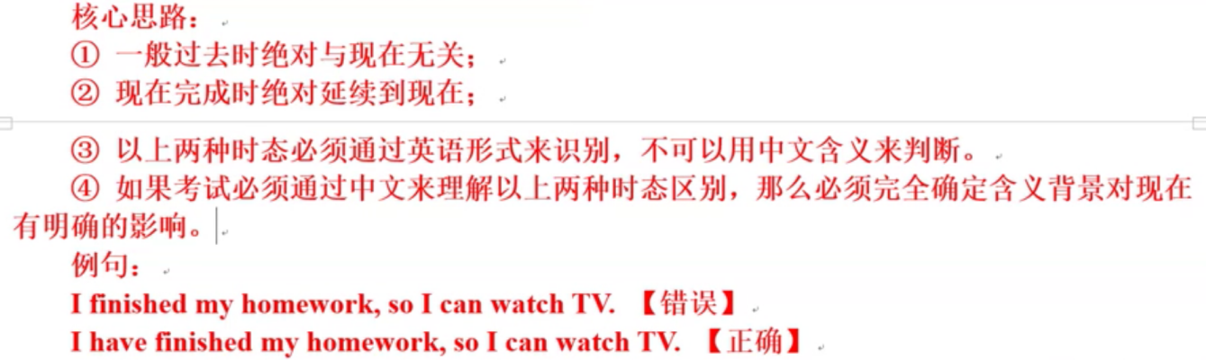

（1）一般过去时所表示的一个或一段过去时间是可以具体确定的，与其他时间没有牵连。它所表示的

事情纯属过去，与现在情况没有联系。现在完成时表示的事情发生在不能具体指出的与现在有联系的过去

某个或某段时间。它所表示的事情与现在情况有关系，是过去事情在现在产生的结果或对现在的影响。

（2）比较下面几组句子，体会两种时态的不同。

He served in the army from 1952 to 1954. （这是过去的一件事）

He has served in the army for 5 years. （现在他仍在军中服役，他仍是军人）

He wrote many plays when he was at college. （写剧本是他过去做的事情）

He has written many plays. （这意味着他是剧作家）

I saw Hero last year. （看《英雄》的时间是去年，与现在无关）

I have seen Hero before. （强调现在知道这部电影的内容。以前看过，但“以前”是表示一个与现在有联

系的过去时间，而不是一个确定的与现在无关的过去时间）

**2. 一般过去时和过去完成时的用法区别**

（1）一般过去时是对现在说话时刻而言的，过去完成时则是对过去某一时刻而言的。两种时态建立的

时间参照点不同，对过去完成时来说，这个时间参照点十分重要，它是过去完成概念赖以建立的基础，也

是和一般过去时相区别的重要标准。

（2）过去完成时的时间状语常用 by 和 before 引导的短语表示，如 by that time，by the end of，before 2000，

by the time 等。

**3. 过去完成时与现在完成时的用法区别**

（1）两种时态都常与表示一段时间的状语连用，但现在完成时表示的是延续到现在或同现在有关的动

作（句中不可以有表示过去特定时间的状语），而过去完成时表示的是在过去某事之前已经完成或延续到过

去某时的动作（句中有表示过去特定时间的状语）。

（2）比较下面的句子

She had been ill for a week before she came back.

（回来发生在过去某一时间，生病发生在过去的过去）

She has been ill for a week.

（现在仍然病着）

**含有不同时态的谚语和名言：背+默写**

1. Failure teaches success.

失败乃成功之母。

2. Love makes the world go around.

爱让世界转动。

3. What are you waiting for? Live life to the fullest.

你还在等什么？活着，就要活得尽可能充实。

4. A book is the same today as if always was and it will never change.

一本好书今天如此，将来如此，永不改变。

5. All work and no play makes Jack a dull boy.

只工作不玩耍聪明的孩子会变傻。

6. We shall never have friends if we expect to find them without fault.

世上找不到十全十美的朋友。

7. If you shut your door to all errors, truth will be shut out.

如果你把所有的错误都关在门外，真理也就被关在门外了。

8. Life has taught me to think, but thinking has not taught me to live.

生活教会了我思考，但思考却没有教会我生活。

9. When the enemy praises you, you should ask yourself what errors you have committed.

当敌人夸奖你的时候，你该想想自己做错了什么。

10. The man who has made up his mind to win will never say “impossible”.

凡是决心取得胜利的人是从来不说“不可能的”。

11. A small leak will sink a great ship.

一个裂缝可以沉掉一艘巨轮。

12. Change will not come if we wait for some other person or some other time. We are the ones we’ve been waiting

for. We are the change that we seek

如果我们等待别人或其它时间，变化将永远不会发生。我们就是我们要等的人，我们就是我们在寻找的变化！

**专项能力强化训练**

**Ⅰ. 常考易混时态对比填空：**

Ⅰ. 用一般现在时或现在进行时填空

1. Look! It (rain) hard. It seldom (rain) during the month of October.

2. Bill Gates (use) this computer, but he (not use) it at present.

**Ⅱ. 用一般现在时或一般将来时填空。**

3. I don’t know when Suzan (return), but when she (return), I (let) you know.

4. We (send) for a doctor if you (be) not better this afternoon.

5. I’m sure the harder you (work), the better progress you (make).

**Ⅲ. 用一般过去时或过去进行时填空。**

6. The fireman (go) towards the fire, which still (smoke).

7. While my father (look) through the evening paper, he suddenly (let) out a cry of surprise.

8. When I (enter) the room, he (not see) me. For he (read) something with great

interest.

9. I (not know) you (wait) for me here.

**Ⅳ. 用一般过去时或过去将来时填空。**

10. In his letter, he (tell) me that he (take) the college entrance examination this year.

11. I (not expect) that so many people (come) to the party.

12. He said that he (not go) with us if he (be) too busy.

13. They promised that they (bring) us all the necessary books as soon as they (have) a

chance.

**Ⅴ. 用一般过去时或现在完成时填空。**

14. – I can’t find my glasses. You (see) them?

– Yes. You (leave) them in the car yesterday.

15. – How you (be) since I (see) you lost?

– Very well, thank you. And you?

16. – I (not see) you for ages! Where you (be)?

– I (be) to Scotland.

17. – I can’t lock the door. I (lose) my key. I (lost) it while I (be) out.

18. We (know) each other since we (be) boys.

19. You (not do) what you (promise) to do.

**Ⅵ. 用一般过去时或过去完成时填空。**

20. The task (be) much harder than we (expect).

21. He (not feel) so well, as he (catch) a bad cold.

22. She (be given) a gold medal for what she (do) for the country

23. I (cannot go) out that might, for I (promise) to wait for Ma Ying at home.

24. He hardly (read) home when it (begin) to rain.

**Ⅶ. 用现在完成时或完成进行时填空。**

25. – I am sorry I (keep) you waiting so long.

– It is all right. I (read) the newspapers.

26. CCTV (broadcast) English programmers ever since 1977.

**Ⅷ. 时态综合比较填空**

27. Please wake me up if I still (sleep) when you (come) home.

28. My sister (learn) English since she (be) a child. She (speak) English very

fluently now.

29. My uncle (come) to see us. He (arrive) here a few days ago. He (start) for

Sydney tomorrow morning.

30. He (break) his leg when he (play) in a football match against another school.

**Ⅸ. 时态短文填空。阅读短文，用所给动词的适当形式填空。**

My friend Bob Jones (have) a motorcycle accident on Highway 41 yesterday. Fortunately, a passing

police officer (see) him (lie) on the side of the road and (call) an ambulance. He

(take) to the nearest hospital. He (be) fine now even though he (have) a broken leg and bruises

all over. His doctor (expect) to release him in two or three days. Bob (tell) me that he

(not speed). He (think) the accident (cause) by the bad condition of the road

**语态篇**

**1. 被动语态的构成和用法**

英语中的语态分主动语态和被动语态两种，是根据主语与谓语之间的关系划分的，如果主语是动作的

执行者，谓语动词就用主动语态，如果主语是动作的承受者，就用被动语态。

**（1）被动语态的构成**

被动语态的构成：be + 及物动词的过去分词，be 本身无词义，但有时态、人称和数的变化。下表是不

同情况下被动语态的形式

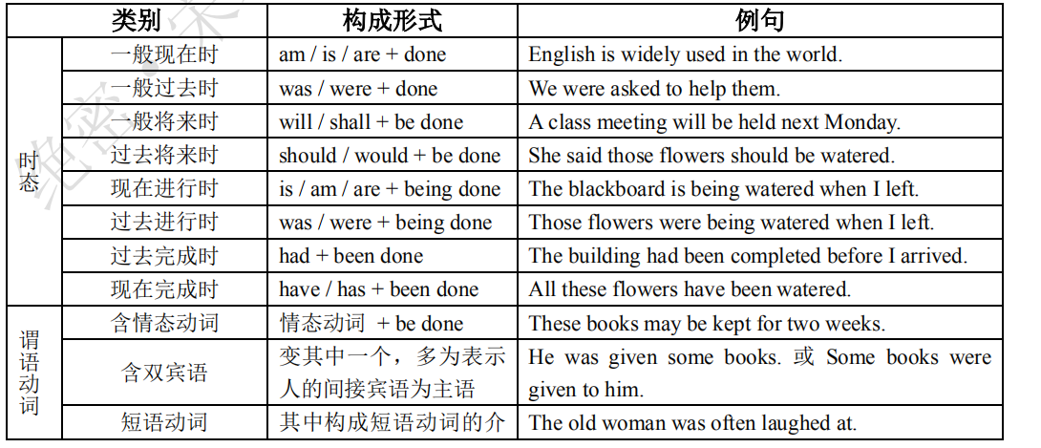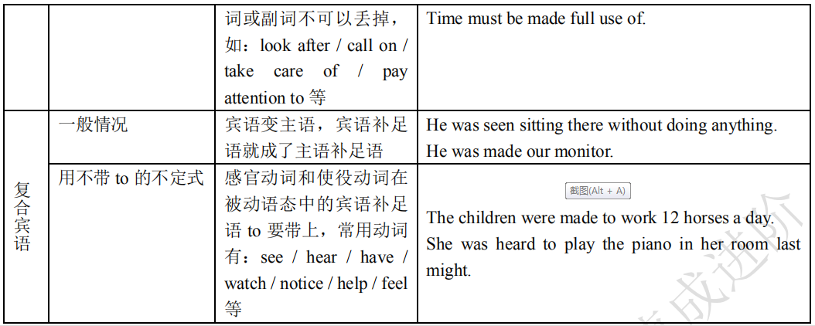

**（2）被动语态的用法**

以下几种情况须用被动语态：

①不知道动作的执行者或没必要指明谁是动作的执行者。如：

Printing was introduced into Europe from China.

印刷术是从中国引入欧洲的。

All the work has been finished by now.

所有的工作现在都已经完成了。

②强调动作的承受者。如：

Health is valued above everything.

健康高于一切。

The injured were allowed home after treatment.

受伤者在治疗后获准回家。

③动作的执行者是无生命的事物时。如：

The window glass was broken by a stone.

窗户玻璃是被石头打碎的。

We were shocked by the news of his death.

我们听到他的死讯极为震惊。

④在文章标题，广告，新闻等中。如：

Girls wanted. 招女工。（广告标题，省略了助动词 are）

The destroyer is reported to have been sunk.

据报道，这艘驱逐舰被击沉了。

注意：当宾语是反身代词、同源宾语、表示地点/处所/团体的名词、不定式、动词的-ing 形式时，句子

不可以用被动语态。

**2. 主动形式表被动意义**

**（1）“系动词 look，sound，feel，smell，taste，appear，seem，go，prove，turn，stay，**

**become，fall，get，grow，keep + 形容词/名词”构成系表结构。如：**

The steel feels cold.

His plan proved (to be) practiced.

It has gone bad.

**（2）表示开始、结束、运动的动词，如：begin，finish，start，open，close，stop，end，**

shut，run，move 等。如

Work began at 7 o’clock this morning.

The shop closes at 6 p.m. every day.

**（3）表示主语的某种属性特征的动词，如 read，write，act，iron，cut，draw，drive，**

**sell，wash，clean，wear，open，cook，lock，shut，dry，eat，drink。这类动词一般不单独使用，常有一个修饰语与之搭配。**如：

This coat dries easily.

这种外衣容易干。

Nylon cleans easily.

尼龙容易洗干净。

Food can keep fresh in a fridge.

食物在冰箱里能保鲜。

Your speech reads well.

你的演说讲得好。

This material has won thin.

这种材料已经磨薄了。

The match won’t catch.

火柴擦不着。

The plan worked out wonderfully.

这个计划制定得很好。

The engine won’t start.

引擎发动不起来。

**（4）少数动词用于进行时，其主动形式表示被动含义，这类动词有：print，cook，fry，**

hang，build，make 等。如：

The books are printing.

这些书正在印刷中。

The meat is cooking.

肉在煮。

**（5）“介词 in，on，under 等 + 名词”构成介词短语表示被动意义。**

表示方位的介词与含动作意义的名词连用，有被动之意，其意义相当于该名词相应的动词的被动形式，

名词前一般不用冠词。常见的有：

under control（受控制） under treatment（在治疗中）

under repair（在修理中） under discussion（在讨论中）

under construction（在施工中） beyond belief（令人难以置信）

beyond one’s reach（鞭长莫及） beyond one’s control（无法控制）

beyond our hope（我们始料不及） for sale（出售）

for rent（出租） in print（在印刷中）

in sight（在视野范围内） on sale（出售）

on show（展出） on trial（受审）

out of control（控制不了） out of sight（超出视线之外）

out of one’s reach（够不着） out of fashion（不流行）

如：

The rumor is beyond belief. (= The rumor can’t be believed.)

谣言不可信。

His honest character is above all praise. (= His honest character cannot be praised enough.)

他诚实的品质最值得赞誉。

Today some treasures are on show. (= Today some treasures are being shown.)

今天有些珍宝正在展出。

**（6）不能用于被动语态的及物动词或动词短语：fit，have，wish，cost，agree with，arrive**

**at / in，shake hands with，succeed in，suffer from，happen to，take part in，walk into，belong**

**to 等。如：**

This key just fits the lock.

这把钥匙刚好适合这把锁。

Your story agrees with what had already been heard.

你说的故事与刚刚听说的相一致

**含有被动语态的谚语和名言：**

1. Rome was not build in a day.

罗马是一天建成的。

2. True friendship is like health, the value of it is seldom known until it is lost.

真正的友谊就像健康一样，它的价值要到失去以后才知道。

3. Life is measured by thought and action, not by time.

衡量生命的尺度是思想和行动，而不是时间长短。

4. A friend without fault will never be found.

没有缺点的朋友永不可得。

5. Everything in this world was declared impossible before it was actually done.

在成功之前，每件事情都被认为是不可能的！

6. A man must not be judged by his appearance, just as the ocean cannot be measured in gallons.

人不可貌相，海水不可斗量。

7. Great works are performed not by strength, but by perseverance.

完成伟大的事业不在于体力，而在于坚韧不拔的毅力。

8. In time of distress true friendship can be proved.

患难见真情。

9. One never notices what has been done; one can only see what remains to be done.

切不要注意已经做了哪些，只应考虑还有哪些有待去做。

10. Miracles can be made, but only by sweating.

唯有努力拼搏，才会有奇迹发生。

11. Everyone wants to be appreciated.

每个人都想被欣赏。

12. Have an aim in life, or your energies will all be wasted.

人生应该树立目标，否则精力会白白浪费。

**专项能力强化训练**

**Ⅰ. 用括号内所给的动词的适当形式填空。**

1. a) Paul doesn’t have to be made . He always works hard.

b) You don’t have to make Paul . He always works hard. (learn)

2. a) What will you next?

b) What will (by you) next? (do)

3. a) She that Mike is sick in bed.

b) It that Mike is sick in bed.

c) Mike to be sick in bed. (say)

4. a) They will the parents-meeting next Monday.

b) The parent-teacher meeting will next Monday. (hold)

5. a) That TV play is worth .

b) That TV play is worthy .

c) That TV play is worthy of . (watch)

6. a) The lady likes to ill of others.

b) Nobody likes to ill of. (speak)

7. a) I noticed an old lady the street just now.

b) An old lady was noticed the street just now. (cross)

8. a) We are to the machine this afternoon.

b) The machine is to this afternoon. (repair)

9. a) We had better not the sports meet.

b) The sports meet had better not . (put off)

10. a) They the question from 5 to 6 o’clock yesterday afternoon.

b) The questions from 5 to 6 o’clock yesterday afternoon. (discuss)

11. 受到责备的应该是你。 It is you who are to (blame).

12. 此屋出租。 The house is to (let).

13. 这小村庄在地图上难以找到。 The small village is difficult to on the map. (find)

**Ⅱ. 短文填空。阅读短文，用所给动词的适当形式填空。**

Our Solar System

Ptolemy, who 1 (live) in ancient times 2 (note for) his theory that the universe 3

(compose of) heavenly bodies which 4 (revolve) around the Earth. In the fifteenth century, Copernicus

5 (theorize) that our solar system 6 (make up of) planets which 7 (revolve) around the sun.

Modern astronomy 8 (base on) this theory. Today, as a result of sophisticated techniques and space

exploration we 9 (know) far more about the universe, especially about our own solar system. The universe

10 (consist of) planets, stars, comets, “black holes” and other phenomena; continuing analysis of lunar rocks

and planetary data 11 (may reveal) when our solar system 12 (form) and what natural materials it

13 (contain). These studies will in turn 14

(lead) to more questions for astronomers to answer.

**作业翻译下列句子**

**Following Iron Man to learn English**

1. 01:30

What, you're not allowed to talk?

2. 07:49

You've been called the Da Vinci of our time.

3. 10:01

You are not authorized to access this area.

4. 11:56

I'm allowed to have plans on my birthday

5. 44:07

We've been approached already by the DOD, FBI, CIA.

6. 52:14

Pepper, I've been called many things.

7. 01:13

Simple farmers and herders from peaceful villages have been driven from their homes.

8. 01:13

Villagers have been forced to take shelter in whatever ways that they can find.

9. 01:14

As you can see, these men are heavily armed and on a mission.

10. 01:14

Around me, a woman begging for news on her husband who was kidnapped by insurgents.

11. 14:09

No, you can't be distracted right now. Listen to me!

12. 01:12:38

When were these taken?

13. 01:14:26

Around me, a woman begging for news on her husband who was kidnapped by insurgents.

14. 01:54:16

That's been handled. He's on vacation.

**Following Hulk to learn English**

15. 01:04:58

Further search for the mysterious ''hulk'' was postponed by powerful thunderstorms in the Smoky Mountain

National Forest.

16. 01:08:48

Local PD have been placed on alert.

17. 01:09:11

The aliases Mr. Green and Mr. Blue have been added to the SHIELD Operations Database.

18. 01:44:58

You know, I hate to say," I told you so," General, but that Super Soldier programme was put on ice for a reason.

19. 01:44:58

You know, I hate to say, "I told you so," General, but that Super Soldier programme was put on ice for a reason.

**Following Thor to learn English**

20. 05:27

And the source of their power was taken from them.

21. 17:09

And you'll be left to die in the cold waste of Jotunheim.

22. 01:16:47

I am bound by honor to our king.

23. 30:39

Yeah, we can tell you're hammered. It's pretty obvious.

**Following Captain America to learn English**

24. 05:10

You should be commended.

25. 08:43

I was hoping I could be assigned...

26. 28:59

It has been given.

27. 20:39

"Wars are fought with weapons but they are won by men."

28. 26:48

This is why you were chosen.

29. 34:21

The subject will be saturated with Vita rays.

30. 43:37

The Red Skull has been indulged long enough.

31. 45:06

You will be punished for your insolence.

32. 45:08

You will be brought before the Fürer and ....

33. 53:36

The rest were killed or captured.

34. 01:06:28

You are deluded, Captain.

35. 01:27:28

Of course, it was encoded.