**万法归宗之语法速成进阶**

**第 6 节 介词短语**

**All of model sentences are from a series of movies of MARVEL**

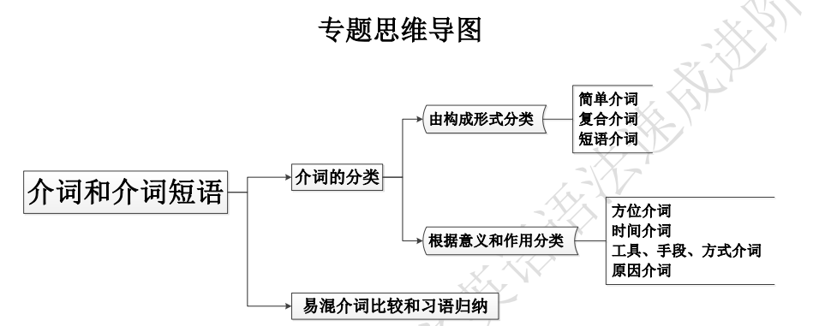

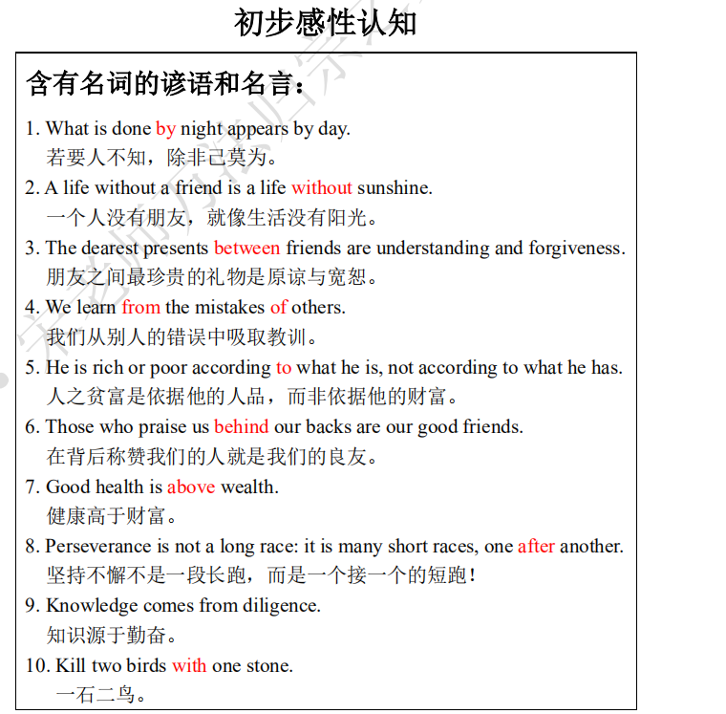

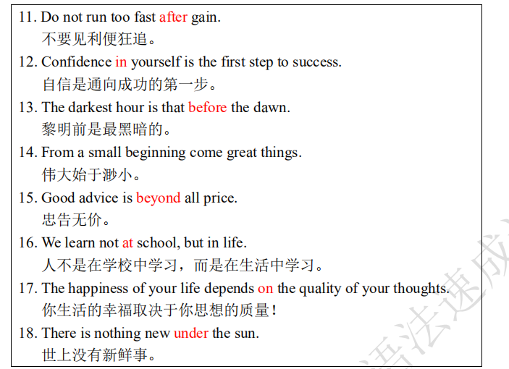

**绪 论**

介词是所有英语课堂上都淡而化之的主题，因为其变化多端，毫无规律可言，所以一直以来都被描述成为“No way, just remember it!”。但根据二八定律，介词的使用规律一样呈现出标准正态分布。

其次，介词只能以短语的形式充当句子成分，这就再次印证了语法七要素四和七的判断标准。

**介词短语核心公式**

**一、介词的位置**

**1. 介词通常位于名词或代词前**

The book is beyond her. 这本书她读不懂。

The man is beneath contempt. 那人为人所不齿。

The retired general lived in a small castle three miles past the village.

那位退役将军住在村庄过去三英里的一座小城堡里。

**2. 在某些结构中，介词可以放在句尾:但依然符合“介词+名词或代词”的完美公式**

① 在“介词+whom/which/what/whose”结构位于句首的疑问句中，介词常可放在句尾

Who is she talking to? 她在同谁谈话？

Which hotel did you stay at? 你住在哪家宾馆？

Which desk did you put the book on? 你把书放在哪个桌子上了？

② 定语从句中位于 that/whom/which 之前的介词也可以放在句尾

在这种情况下，关系代词可以省略。但介词不可放在 that 前面，而必须放在句尾，that 可省略。例如：

She is the teacher (whom,that) I once worked together with.

她是一位教师，与我做过同事。

This is the kind of life (that, which) he is used to.

他已习惯了这种生活。

③ 某些 wh-词引导的名词性从句中，关系代词为介词宾语位于从句句首时，介词应后置

I don’t know what you are driving at. 我不知道你是什么意图。

Money is what he is badly in need of. 他急需的是钱。

I wonder whose room he was in. 我不知道他在谁的房间里。

I don’t know what he looks like. 我不知道他长得什么样。

*④ 动词不定式作状语，需要介词同句中主语构成介宾关系时，介词应后置（一般见不到）

The lake is safe to swim in. 在这个湖里游泳安全。

The table lamp is bright enough to read by. 这个台灯很亮，看书没有问题。

⑤ 动词不定式作定语，需要介词同动词不定式所修饰的名词构成介宾关系时，介词应后置

It is the key to open the box with. 这就是开那个箱子的钥匙。

In those days he even didn’t have any money to buy food with.

在那些日子里，他甚至连购买食物的钱都没有。

They pledged their newly borrowed house for a loan to do business with.

他们以刚购置的房屋作为抵押，弄到一笔贷款来做生意。

**3. 在某些“（不及物）动词+介词”结构中，介词紧跟动词后 ：不及物动词+介词最好视为动词短语做谓语**

在这种结构中，宾语不可放在动词和介词之间，只能放在介词后面。

The thief broke into the house. 盗贼闯进了屋子。

She looked after her brother. 她照看弟弟。

He takes after his mother. 他像他母亲

**二、介词的宾语**

**1. 介词的宾语不仅限于名词和代词，还可以是其他词类或句子等。**

**（1）名词**

The car ran into a wall, and two men were killed.

I shall answer you concerning your request.

The park is home to half of the world’s population of gorillas.

That is a building constructed of wood, metal, concrete, etc.

Human affairs are all subject to changes and disasters.

We walked through the woods under a roof of leafy boughs.

主 谓 地状

介 宾 地状

介 宾 定

介 宾

It was towards sunset on a cool autumn day.

They trudged westward, day and night, over dusty roads and roaring river, under hot suns and cold rains, through green valleys and windy wastelands.

**（2）代词**

She is interested in it.

Wherever he went, he carried the photo with him.

**（3）形容词（非常少见）**

Your plan is far from perfect.

I have advised him in private.

In short, I have done my best.

The bridge is anything but safe.

【特别提示：in, from, but, near, instead of 等后可用形容词作宾语】

**（4）副词（非常少见）**

She came from after.

He shouted from below.

We have trusted her till recently.

I can’t see the tower clearly from here.

They have never seen each other since five years ago.

She received them coldly instead of warmly.

【特别提示：from, since, except, till, until, instead of 等后可用副词作宾语】

**（5）动名词**

He insisted on doing it that way.

She spent the morning in reading.

He entered the room without taking off his hat.

Instead of attempting to save one species at a time, they are trying to save a complete natural environment.

As for being adopted, I have no desire to find my real parents.

【特别提示：in, on, without, instead of 等后可用动名词作宾语】

**（6）不定式（非常少见）**

He did nothing but cry.

I would sooner die than yield.

She could do no otherwise than (to) wait.

He couldn’t do anything except wait for the reply.

He knew better than to trust the hypocrite.

【特别提示：but, besides, except, than 等后可用不定式作宾语】

**（7）介词短语（非常少见）**

She often studies till after midnight.

They came from across the river.

She read till into the night.

The temperature dropped to over zero centigrade.

He suddenly appeared from behind the door.

【特别提示：to, since, from, except, till, until, across 等后可用介词短语作宾语】

**（8）数词**

In nine out of ten he won’t come.

The students walked there in twos and threes.

**（9）疑问词+不定式：说白了就是宾语从句转为非谓语动词短语**

I have informed her of when to start.

That depends on which method to take.

The problem of how to get enough money is difficult to settle.

**（10）疑问词引导从句：其实就是宾语从句做介词的宾语**

He does not care about who will be promoted.

I have no idea as to what he will do there.

That depends on whether he has persistence.

She asked to be informed of which university was the best for her.

The night was dead quiet except that a bird flew from tree to tree occasionally.

I got myself a table at what was said to be the best restaurant in town.

**（11）that 引导的从句**

I would go with you but that I am too busy.

She is not happy notwithstanding that she is rich.

Man differs from other animals in that man can laugh and speak.

2. 介词后的其他结构：介词短语嵌套（名词+形容词）（比较少见）

He is away from home with his children alone. （名词+形容词）

With the sun down, night came on. （名词+副词）

He left home without a cent in his pocket. （名词+介词短语）

His success depends on him/his working hard. （代词+现在分词）

They parted from each other without a word said. （名词+过去分词）

He wandered about without anything to do. （代词+不定式）

She stayed late with a lot of letters to write. （名词+不定式）

The night was beautiful with the moon shining brightly. （名词+现在分词）

The soldiers returned with a man bound up in rope. （名词+过去分词）

He stayed there three years with Jim his only friend. （名词+同位语）

**完全忘记以下内容**

**3. 值得注意的是，除了 in that, except that, save that, but that, notwithstanding that 外，that**

**引导的从句不可直接作介词的宾语，必须在介词和 that 之间加上先行词，一般用 it**

例句如下：

你可以放心，你的需要会被满足的。

You can count on that your needs will be satisfied. [×]

You can count on it that your needs will be satisfied. [√]

你尽管放心，他们会遵守承诺的。

We may depend upon that they will do as they have promised. [×]

We may depend upon it that they will do as they have promised. [√]

**三、介词的句法功能**

**介词与其他词类或成分结合后方能在句子中充当语法成分，构成介词短语。介词短语可**

**以作定语（须后置）、状语、表语、宾语补足语、另一介词的宾语，间或作主语等。**

**Following the Avengers I to learn English**

作业练习要求：准确标出介词短语及其所在句子（短语）成分

**1. about**

① 07:37

This place is about to blow and drop a hundred feet of rock on us.

主 系 表

介 宾

非谓1 非谓2 宾 地状

② 15:07

Coulson, you know that Stark trusts me about as far as he can throw me.

主 谓 宾

主 谓 宾 状

介 比较状语从

③ 20:02

This isn't about the Avengers.

主 系 表

④ 25:25

I'm going to pay for that comment about percentages in some subtle way later, aren't I?

主 谓 宾 状

介 宾 定 方状

介宾 介 宾 时状

⑤ 57:43

Even if Barton didn't tell Loki about the tower, it was still all over the news.

让状从 主 系 状 表

主 谓 直宾 间宾（特殊情况，一般不做宾语）

⑥ 58:23

Yet you're confused about why they didn't want you around.【一般的，介词短语从不做宾语】

主系 表 状

介 宾

状主 谓 宾 宾补

⑦ 01:07:53

You want to think about removing yourself from this environment, Doctor?

主 谓 宾

非谓 宾

介 宾

非谓 宾 宾补

**2. above**

① 41:20

You know, the last time I was in Germany, and saw a man standing above everybody else, we ended up

时状 主系 表

disagreeing.

② 46:10

你觉得你比他们强大么？

You think yourself above them?

主 谓 宾 宾补

③ 01:09:18

Are you above or below angry bees?

系 主 表

**3. after**

① 18:31

So, Fury isn't after the monster?

主 系 表

② 01:03:45

After whatever tortures Fury can concoct, you would appear as a friend, as a balm.

③ 01:12:17

Sorry, kids, you don't get to see my party trick after all.

主 谓 宾 时状

④ 01:15:30

Navigation's recalibrating after the engine failure.

主 谓 时状

⑤ 01:24:09

We started working on the prototype after you sent the Destroyer.【after是连词引导时间状语从句】

主 谓 宾 地状 时状从

**4. against**

① 53:11

他打算率领他们攻打地球

He means to lead them against your people.

主 谓 宾

非谓 宾 宾补

介 宾

② 01:59:16

I will not order a nuclear strike against a civilian population.

主 谓 宾 宾补

介 定 宾

③ 02:00:48

The Tesseract can't fight, but you can't protect against yourself.

主 谓 宾 主 谓 宾

非谓 定 宾补

也可以把protect against 使免受【视为整体--动词短语】

**5. at**

① 04:01

If there was any tampering, sir, it wasn't at this end.

条状 主 系 表

② 11:29

As of right now, we are at war.

时状 主 系 表

介定（of right now=形容词）

as of+状语(right now时间副词)

③ 22:44

At this point, I doubt anything would surprise me.

地状 主 谓 宾从

④ 22:51

直译：在你的公寓里有一份简报正在等你回去

There's a debriefing packet waiting for you back at your apartment.

表 系 主 定

非谓 目状 地状

介 宾 宾补 介 宾

⑤ 01:08:01

You didn't come here because I bat my eyelashes at you.

主 谓 状 原状

主 谓 宾 地状

bat vt. 用球板击球，用球棒击球

eyelash [ˈaɪlæʃ] 睫毛 复数: eyelashes

**6. before**

① 39:54

Kneel before me.

谓 地状

② 01:41:35

You will all fall before me.

主 谓 状 地状

**7. beyond**

① 30:37

We look beyond the Earth to the greater worlds the Tesseract will unveil.

主 系 表

介 宾 地状 定从

② 47:30

This is beyond you, metal man.

主系表

介 宾 同位语

③ 53:43

Loki is beyond reason, but he is of Asgard.

主 系 表 主 系 表

**8. by**

① 20:25

War isn't won by sentiment, Director.【被动语态中的by视为宾语的一部分即可】

主 谓 宾

② 27:40

So, any chance you're driving by LaGuardia?

主 谓 方状

③ 55:34

I don't know about that, but it is powered by the Cube.【被动语态中的by视为宾语的一部分即可】

主 谓 宾 主 谓 宾

④ 56:25

You know, you should come by Stark Tower sometime.

主 谓 宾 地状

或者把come by视为整体 ，从旁走过

⑤ 57:52

It's powered by an arc reactor, a self-sustaining energy source.【被动语态中的by视为宾语的一部分即可】

主 谓 宾 同位语

**9. for**

① 03:02

Is there anything we know for certain?

② 03:20

We prepared for this, Doctor.

③ 06:45

I've come too far for anything else.

④ 13:32

It's for her.

⑤ 16:33

You know, for a man who's supposed to be avoiding stress you picked a hell of a place to settle.

⑥ 17:11

Because that's not going to work out for everyone.

⑦ 24:05

I'm in DC tomorrow, I'm working on the zoning for the next three buildings.

**10. from**

① 02:10

Dr. Selvig read an energy surge from the Tesseract four hours ago.

② 03:25

My calculations are far from complete.

③ 03:48

Well, I see better from a distance.

④ 22:33

He's not from around here.

⑤ 28:00

We're about 40 minutes out from home base, sir.

**11. in**

① 02:15

He wasn't even in the room.

② 02:24

Campus should be clear in the next half-hour.

③ 03:39

Up in his nest, as usual.

④ 07:44

He's right. The portal is collapsing in on itself.

⑤ 00:12:33

I thought General Solohob is in charge of the export business.

**12. of**

① 02:49

Every piece of Phase 2 on a truck and gone.

② 07:32

I kind of think you mean the other thing.

③ 13:58

I'm in the middle of an interrogation.

④ 14:06

Look, you can't pull me out of this right now.

⑤ 16:47

You brought me to the edge of the city.

**13. into**

① 45:46

I remember you tossing me into an abyss.

② 55:20

And I'm a huge fan of the way you lose control and turn into an enormous green rage-monster.

③ 55:38

And I would like to know how Loki used it to turn two of the sharpest men I know into his personal flying

monkeys.

④ 01:11:51

Until you dragged me back into this freak show and put everyone here at risk.

⑤ 02:12:09

If we get into a situation like this again, what happens then?

**14. on**

① 17:14

I'm here on behalf of S.H.I.E.L.D.

② 18:38

He needs you on this.

③ 19:47

We can't depend on him to help, either.

④ 28:48

You know, it's really just a huge honour to have you on board this...

⑤ 42:58

Just get him here. We're low on time.

**15. without**

① 17:47

You've been more than a year without an incident.

② 01:17:53

Even if I clear the rotors, this thing won't re-engage without a jump.

③ 01:50:46

Without him, these things could run wild.

**16. to**

① 04:06

Yeah, the Cube is a doorway to the other end of space, right?

② 15:05

But first, we need you to talk to the big guy.

③ 18:41

Stop lying to me!

④ 20:11

I'm not leaving anything to anyone.

⑤ 53:58

I'll fly you to Portland.

**17. under**

① 45:55

No. The Earth is under my protection, Loki.

② 53:28

Loki has him under some kind of spell, along with one of ours.

**18. with**

① 06:49

I am Loki, of Asgard and I am burdened with glorious purpose.

② 06:58

We have no quarrel with your people.

③ 19:24

You're dealing with forces you can't control.

④ 20:16

These people may be isolated, unbalanced even but I believe with the right push they can be exactly what we need.

⑤ 29:10

With everything that's happening and the things that are about to come to light, people might just need a little

old-fashioned.