**万法归宗之语法速成进阶**

**第 8 节 非谓语动词（进阶）**

**All of model sentences are from a series of movies of MARVEL**

1. **动词不定式的时态和语态**

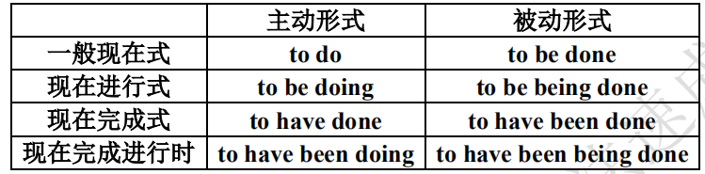

不定式的进行式表示动作正在进行，完成式表示动作发生于谓语动词之前，常用于 pretend，believe，

prove，seem，consider 等词之后。如：

The boy pretended to be working hard when the teacher came in.

She seems to have forgotten her promise.

不定式的被动形式表示不定式的逻辑主语是不定式所表示的动作的承受者。如：

This painting is said to have been drawn by a little girl.

Volunteer workers asked to be sent where they were most needed.

**二、动名词的时态和语态**

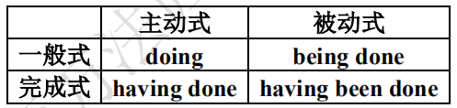

（1）动名词一般式表示的动作发生在谓语动词表示的动作的同时或之后。如：

We all don’t like his walking that way.

She dreams of becoming a teacher.

（2）动名词的完成式表示的动作发生在主句的谓语表示的动作之前。如：

I remember having read the book.

She was praised for having helped the old man.

注意：有时用动名词的一般式来代替完成式。如：

After working for three hours, we began having a break.

Thank you for helping me.

（3）动名词有两种语态，即主动式 doing 和 having done 及其对应的被动式 being done 和 having been

done。如：

Tom feels like being taken to Beijing.

He was excited for having been praised.

（4）动名词的否定式是在动名词的前面加 not 构成。如：

I regret not having told you the truth.

He always has excuses for not going to school

**三、分词的时态语语态**

过去分词只有一种形式，现在分词和动名词的各种形式是完全一样的。

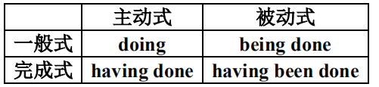

现在分词一般式表示的动作与谓语动词所表示的动作一般同时发生，而完成式所表示的动作则在谓语

动词所表示的动作之前已经完成。现在分词的被动式常表示正在进行的动作。如：

Having written the letter, he went to post it.

Having been translated into Chinese, the book is widely read among young people.

“Can’t you read?” Mary said, angrily pointing to the notice.

The building being built is our new office building.

**Marvel 系列电影原版例句赏析**

《绿巨人》

1. 01:18:42

Oh, you've got to be kidding me!

《钢铁侠 2》

2. 14:12

It was my understanding that I was going to be testifying in a much more comprehensive and detailed manner.

3. 00:48:45

Is that supposed to be smoking?

复仇者联盟 1

4. 16:33

You know, for a man who's supposed to be avoiding stress you picked a hell of a place to settle.

5. 01:07:20

You're supposed to be locating the Tesseract.

6. 01:49:17

There are people inside and they're going to be running right into the line of fire.

雷神 2

7. 14:15

So, I show up to work at the lab/your mom's house, fully expecting you to be moping around in your pajamas,

eating ice cream and obsessing about... you know who.

8. 16:10

It's such a great honor to be working with you.

美国队长 2

9. 01:11:24

Who happens to be sitting on top of the most secure building in the world.

美国队长 3

10. 35:39

You seem to be doing alright so far.

复仇者联盟 1

11. 52:19

It burns you to have come so close.

雷神 2

12. 32:59

The Aether was said to have been destroyed with them, and yet here it is.

美国队长 2

13. 02:03:10

Many of which you seemed to have had a personal hand in telling.

钢铁侠 3

14. 01:11:38

Right, and then you just said it, by name, while denying having said it.

蚁人 1

15. 58:05

And there's not a day that goes by that I don't regret having said yes.

**非谓语动词难点辨析**

1. **动名词与现在分词用法的区别**

动词的-ing 形式按功能可分为动名词和现在分词。动词的-ing 形式何时为动名词，何时为现在分词。首

先，我们要从概念上区分。动词的-ing 形式在起名词作用时，称为动名词；用作形容词或副词时，称为现在

分词。其次，我们要从用法方面区分动词的-ing 形式是动名词还是现在分词。

**（1）动词的-ing 形式用作主语时为动名词，现在分词不可以用作主语。**

**①动名词用作主语.**

Reading French is easier than speaking it. 阅读法文比讲法语容易。

Talking to him is talking to a wall. 和他说话等于对牛弹琴。

Smoking can cause cancer. 吸烟会致癌。

Growing roses is her hobby. 种玫瑰是她的爱好。

**②有时 it 作形式主语，把动名词主语放在句子后面**

It’s nice seeing you again. 再次见到你太好了。

It was tiring driving from morning till night. 从早到晚开车很累人。

It’s a wonder meeting you here. 在这里碰到你真是奇迹。

It was a waste of time reading that book. 看那本书是浪费时间。

**③“There is + no”后可以用动名词作主语**

There was no knowing what he could do. 他能做什么很难说。

There was no arguing with her. 没法和她争论。

**（2）动词的-ing 形式用作宾语时为动名词，现在分词不可以用作宾语。**

**①有许多动词可接动名词作宾语**

I suggested bringing the meeting to an end. 我建议结束会议。

So you prefer living abroad? 这样说你更愿意住在国外？

He kept complaining. 他不停地抱怨。

I finished reading the book last night. 这书我昨晚看完了。

**②有许多带介词的动词固定搭配接动名词作宾语**

He has given up playing football. 他现在不踢足球了。

Prices keep on increasing. 价格不断上涨。

**（3）当动词的-ing 形式用作状语时为现在分词，动名词不可以用作状语。**

现在分词及其短语可以用作状语，表示时间、原因、结果、条件、让步、方式或伴随情况等。其动作

可能发生在谓语之前或之后，也可能与谓语动词的动作同时发生。

Climbing to the top of the tower, we saw a magnificent view.

我们爬到塔顶后，看到了一片壮丽的景象。（表时间）

Living in the country, we had few social engagements.

我们住在乡下，交际的机会很少。（表原因）

Having money, he will buy a bigger car.（表条件）

Knowing the secret, she would not tell me about it..（表让步）

The child fell, striking his head against the door and cutting it.

那孩子跌倒了，头碰在门上碰破了.（表结果）

He stood leaning against the wall. 他靠墙站着.（表方式或伴随情况）

**（4）动名词与现在分词都可以用作表语，当动词的-ing 的作用相当于名词时为动名词。**当

动词的-ing 的作用相当于形容词时，动词的-ing 为现在分词。

**①动名词用作表语**

Her hobby is painting. 她的爱好是绘画。

Her job was tending the sheep. 她的工作是放羊。

The main thing is getting there in time. 首要的事是及时到达那里。

**②现在分词用作表语**

The news is encouraging. 这消息令人鼓舞。

This story is very interesting. 这个故事很有趣。

The day was so charming. 天气真是好极了。

The difference was most striking. 差别很明显。

**（5）动名词与现在分词都可以用作定语**

现在分词表示其所修饰的名词的动作，即: 现在分词与其所修饰的名词在逻辑上具有主谓关系。通常能

改为一个定语从句。动名词则表示其修饰的名词的性质，或用途或功能. 两者在逻辑上无主谓关系。因此，

只能改为一个 for 加动名词的短语。

**①动名词作定语，动名词表性质或用途或功能。**

swimming pool 游泳池 drinking water 饮用水

swimming suit 游泳衣 waiting room 候车室

sleeping bag 睡袋 parking lot 停车场

sleeping pill 安眠药 writing desk 写字桌

sewing machine 缝纫机 writing paper 信纸

operating table 手术室 checking account 活期账户

diving suit 潜水衣 reading room 阅览室

diving board 跳板 playing ground 运动场

washing machine 洗衣机 boxing competition 拳击比赛

washing powder 洗衣粉 speaking contest 演讲比赛

fishing pole 钓鱼杆 fishing line 钓鱼线

**②现在分词作定语**

developing countries 发展中国家 a booming town 日渐繁荣的城镇

growing doubts 越来越大的怀疑 the existing condition 现有条件

the remaining days 剩下的岁月 lasting peace 持久的和平

a falling star 流星 the leading newspapers 主要报纸

the ruling class 统治阶级 living things 有生命的东西

the ageing population 老化的人口 the rising generation 成长的一代

**（6）动名词与现在分词都可以用作补语，但现在分词用作宾语补语时，与前面的宾语构成复合宾语。**

具有这种复合宾语的动词多为表示感觉的动词，如：smell, observe, watch, notice, look at, listen to 等。

另外，有些使役动词如 have, set, get, catch, keep, leave 等可以后面接含有现在分词的复合宾语。还有，作为

宾语补语的现在分词有时前面可有 as，前面的动词多用 regard, consider, describe, see, think of 等。现在分词

用作主语补语，多用在被动结构中，与主语构成复合主语。而动名词作补语对相应的动词却没这些规定。

**①动名词用作补语**

I call this robbing Peter to pay Paul. 我管这叫做拆东墙补西墙。

（robbing 是宾语补语）

This is called turning things upside down. 这叫做把事物颠倒了。

（turning 是主语补语）

**②现在分词用作补语**

We found him waiting to receive us. 我们发现他等着欢迎我们。

We kept the fire burning all the time. 我们使火一直燃烧着。

They described the young man as having initiative and drive.他们说这青年积极肯干。

He was seen going upstairs. 有人看见他上楼。

**2. 分词、不定式作补足语要点辨析**

（1）用于感官动词后的宾语补足语，现在分词一般用其主动式，表示动作正在进行，及物动词的过去

分词表示动作的被动和完成，不及物动词只表完成，只表被动。如：

I saw a thief stealing a purse from a woman.

When I got off the bus, I found my cellphone stolen.

（2）用于感官动词后的宾语补足语，不定式表示动作的全过程或只陈述某一事实。如：

I saw a thief steal a purse from a woman.

（3）with + 名词/代词 + 宾语补足语

在该结构中，现在分词作宾语补足语表示动作与谓语动词同时发生，过去分词表示被动和完成，不定式则表示动作在谓语动词之后发生。

With all lights turned on, the building looks more beautiful.

With the guide leading the way, we set off on foot into the dark night.

With them to help us, we can finish the work ahead of time.

1. **不定式、动名词作宾语要点辨析**

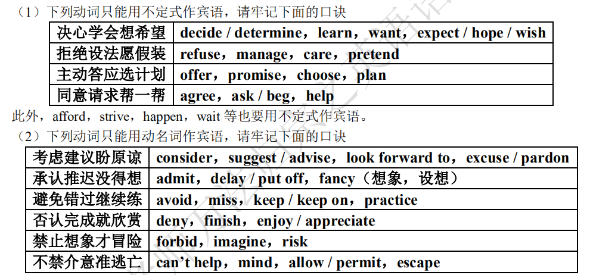

（3）下列动词或词组既可以跟动名词作宾语，也可以跟不定式作宾语，但意义上有区别，要特别注意。

①remember doing sth. 记得过去做过的某事

remember to do sth. 记得要去做某事

如：I remember seeing the film long time ago.

②forget doing sth. 忘记曾做过某事

forget to do sth. 忘记去做某事

如：He must forget to turn off the lights when he left the room.

③regret doing sth. 对过去做过一件事情后悔

regret to do sth. 对还没做或正在做的事情后悔

如：I regret telling you the bad news

我后悔把这个坏消息告诉你。

I regret to say I’m unable to help you.

很抱歉我不能帮助你。

④stop doing sth. 停止正在做的事情

stop to do sth. 停下来，去做另一件事情

如：We stopped to see what happened.

我们停下来去看发生了什么事情。

Let’s stop talking about it.

咱们停止谈论这件事情吧。

⑤try doing sth. 尝试着做某事

try to do sth. 设法做某事

如：I’ll try doing it in a new way.

我想用一种新方法试着做做看。

I once tried to learn Japanese.

我曾试图学日语。

⑥mean doing sth. 意味着，意思是

mean to do sth. 打算想要

如：Giving up the job means missing a good opportunity.

放弃这份工作意味着错了一个好机会。

I mean to help him with it.

我打算帮助他做这件事情。

⑦need，require，want 当“需要”讲时，都应用动名词，但也可以用动词不定式被动语态替换。

如：This pair of shoes needs repairing.

这双鞋需要修理。

The walls of the room want white-washing.

这个房间的墙需要粉刷了。

⑧prefer to do sth. rather than to sth.

prefer doing sth. to doing sth.

表示“喜欢做这件事而不喜欢作那件事”。

如：I prefer working to staying at home.

我愿意工作而不愿意呆在家里。

⑨go on to do sth. 做完一件事，接着去做另一件事

go on doing sth. 继续不停地做某事

如：Go on to do the other exercises after you finish this one.

做完这个练习后，接着做其他的。

Go on doing the exercises after a short rest.

⑩allow doing sth. 允许做某事

allow sb. to do sth. 允许某人做某事

如：We don’t allow smoking here.

我们不允许在此吸烟。

We don’t allow students to go out on school days.

上学期间，我们不允许学生外出。

（4）动词 like，love，prefer 后接不定式或动名词作宾语均可。如表示经常性的行为常用动名词，如表

示具体的行为常用动词不定式。但要注意：如果 like，love，prefer 前有 would / should 时，后面则应该接动

词不定式作宾语。feel like 后接动名词作宾语。

would / should + like / love / prefer + to do sth.

feel like doing sth.

（5）在动词 allow，advise，forbid，permit 后直接跟动名词形式作宾语，如果后面有名词或代词作宾语，

其后用动词不定式作宾语补足语。即：

allow / permit / forbid / advice：①sb. to do sth.；②doing sth.

（6）动词 need，require，want 作“需要”讲时，其后必须用动名词的主动形式或不定式的被动形式作宾

语，表示事情需要做。这时动名词的主动形式表被动意义。be worth 后必须用动名词的主动形式表示被动意

义。be worth 后必须用动名词的主动形式表示被动意义。此外，若动词 need 表示“需要”，require 表示“要求”，want 表示“想要”时，其后必须接名词或代词作宾语，然后接不定式作宾语补足语。即：

①need / want / require（需要）：to be done / doing / sb. to do sth.

②be worth：doing / 名词（钱数或表示价格的名词）

③be worthy：to be done / of (名词/being done)

如：The window needs / requires / wants：to be cleaned / cleaning

窗户需要擦一下。

This place is worth visiting.

This place is worthy to be visited.

This place is worthy of a visit.

This place is worthy being visited.

这个地方值得一去。

**4. 不定式、分词作状语要点辨析**

不定式作状语，主要表示主句的目的、结果、程度、原因等。而分词或分词短语作状语时，可以表示

时间、原因、结果、条件、让步、行为方式、伴随状况等。

It was unbelievable that the fans waited outside the gym for three hours just to have a look at the sports stars.

（目的）

My grandmother lived to see the liberation of China. （结果）

Having been told many times, he still repeated the same mistake. （让步）

The teacher came into the lab, followed by some students. （伴随）

**5. 不定式、动名词和分词作定语要点辨析**

（1）不定式与其所修饰的名词可能是主谓关系或动宾关系：动名词与所修饰词之间不存在逻辑上的关系；现在分词与被修饰的名词是主谓关系；过去分词与被修饰的名词是动宾关系。

He was the last one to leave school yesterday.

昨天他是最后一个离开学校的。

Get him something to eat.

给他拿点东西吃。

She used to study in the reading room.

她过去常常在阅览室里学习。

He rushed into the burning house.

他冲进了正在燃烧的房子。

He lost the bike bought last week.

他把上周买的车子丢了。

（2）不及物动词构成的不定式作定语，要加上适当的介词；有些不及物动词的过去分词也可以作定语，

但只表完成，不具有被动意义。

There is nothing to worry about.

没有什么值得担心的。

The ground is covered with fallen leaves.

地上铺满了落叶。

（3）不定式多表示将来的动作；动名词表示所修饰词的用途；现在分词表示主动、正在进行的动作；

过去分词表示被动或完成的动作。

The building to be built is our office building.

将要建的那座楼是我们的办公楼。

The building being built is our office building.

正在建的那座楼是我们的办公楼。

The building built last year is our office building.

去年建的那座楼是我们的办公楼。

He needs to buy a new writing table.

他需要买一个新的写字台。