**万法归宗之语法速成进阶**

**第 7 节 三大从句超精解高阶**

**All of model sentences are from a series of movies of MARVEL**

**（一）名词性从句**

**主语从句**

主语从句（the subject clause）是指由连词引导，在句中做主语的句子。

1. it 形式主语先行，主语从句后置的情况

**①当主语从句较长时，为了使句子显得平衡，我们常用“It be…that/whether/how”句型把主语从句置后。**

**在非正式问题中，that 往往省略。如：**

**☆句型：It is/was+名词+that 从句**

It was not known whether there was gold left in the mine. 矿里是否还有金子尚不清楚。

It’s not my business how she choose to live. 她选择什么样的生活与我无关。

It is pity (that) you don’t know Russian. 你不懂俄语是件憾事。

可用于此句型的名词还有：shame，wonder，fact，news，honor，question 等。

☆句型：It is/was+adj.+that 从句

It is certain that he will pass the final examination. 他肯定能通过考试。

可用于此句型的形容词还有 uncertain，sure，doubt，clear，better，important，necessary，possible，likely

等，这类主语从句中，谓语动词多用“should+动词原形”或省去 should，只用动词原形。如：

It is necessary that we (should) have a good knowledge of basic English. 我们掌握好英语基础知识是必

要的。

**②当主句谓语动词是被动语态时：It+is/was+过去分词+that 从句；**

It is said/reported/thought/believed...意为“据说/报道/认为/相信……”

It was admitted that she sang well. 她歌唱的很好得到了大家的认可。

It is not yet settled whether I am going to America. 我是否去美国还没决定下来。

It has not been decided that the show shall not be open on Monday. 展览在不在周一展出还未决定。

**③当主句是疑问句或感叹句时**

Is it true that he has been arrested? 他被捕了是不是真的？

How is it you don’t like peaches? 你怎么不喜欢桃子？

How strange it is the children are so quiet! 孩子们这么安静真奇怪啊！

**④当主句的谓语动词是下列动词时：It+不及物动词+that 从句**

appear；come；happen；matter；look；occur；seem；strike；……

It appears that he was very hard up. 他显得手头很紧。

It seems that nobody knew what had happened. 好像没人知道发生了什么。

It seems that he has known the secret. 他似乎已经明白了那个秘密。

**⑤在突出主句的表语时**

It’s a pity (that) you didn’t attend the meeting. 你没参加那个会议真可惜。

It’s still unknown whether he is going or not. 他去还是不去还不知道。

It’s a mystery to her how it all happened. 事情怎样发生的对她来说是个谜。

**⑥在分裂句中（分裂句，也叫断裂句，还叫 It 强调句。）**

It was he who had been wrong. 错的是他（不是别人）。

It was then that the unfortunate incident occurred. 就在那时不幸事故发生了。

**⑦当主语从句以连接词 if/whether、but (that)、as if/though 引导时**

It was not clear to me if/whether she likes the present. 她是否喜欢礼物我尚不清楚。

It is not impossible that such a day may come. 这样的一天到来不是不可能的。

It seems as if you are the first to come. 看来你是第一个到的。

**2. 主语从句必须前置的情况**

当主语从句由强式词“wh-+ever”引导时，必须置于句首。如：

Whoever comes will be welcome. 谁来都欢迎。

Whatever I have is at your service. 我的东西你随便用。

Whichever you want is yours. 你想要什么就拿去好了。

**3. 主语从句句型的转换**

①主语从句→不定式

It is natural that they are together. →It is natural for them to be together.

他们在一起是自然的。

It is stupid that one should be so conceited. →It is stupid to be so conceited.

如此骄傲是愚蠢的。

②主语从句→v-ing 分词短语

It disturbs me greatly that you should drive a car to Chicago in your condition.

→Your driving a car to Chicago in your condition disturbs me greatly.

以你的情况驾车去芝加哥使我非常担心。

It made things all the worse that Bob was discharged by the manager.

→Bob’s being discharged by the manager made things all the worse.

鲍勃被经理解雇使事情变得更糟。

③wh-词引出的主语从句→wh-+动词不定式短语

Who(m) she should turn to is what she wants to know.

→Who to turn to is what she wants to know

她想知道该求助于谁。

④含先行主语 it（形式主语）的主语从句的句型转换。下列含先行主语 it 的主语从句与上述主语从句的

转换方式有所不同。例如：

It’s certain that we’ll forget the address. →We’re certain to forget the address.

我们肯定会忘记那个地址。

It seems that you’ve made a mistake. →You seem to have made a mistake.

你似乎犯了个错误。

It is known that he is a coward. →He is known to be a coward.

大家都知道他是个懦夫。

It is said that he is working in some factory. →He is said to be working in some factory.

据说他在某个工厂工作。

**表语从句**

表语从句（the predicative clause）作表语，置于主句中的连系动词之后。

引导表语从句的连接词也有单纯连词、连接代词、连接限定词、连接副词等。

1. **单纯连词：**

**that（口语中可省略）**

**whether（是否，不论）**

**as（因为，随着，依照，当……时）**

**like（好像）**

**as/though（虽然，尽管）**

**because（因为）**

**lest（唯恐，以免）**

The reason was (that) she was afraid. 理由是她害怕。

My attitude is that students should not cheat in examinations. 我的态度是学生不应该在考试中作弊。

Her first question was whether Rose had arrived. 她的第一个问题是 Rose 是否到了。

The reasons are as (what) follows. 理由如下。

He looks like he will get the job. 他看起来好像会得到那份工作。

It is like she remembered the matter. 她好像记得那件事。

The reason I am here is because I wish to lend a hand. 我之所以到这里来是想帮把手。

I was in mort-al fear lest (that) he should see me. 我非常害怕他会看见我。

**2. 连接代词：whom what which as ……**

She is not who she was thought to be. 她不是人们曾想象中的她。

This is what I want to know. 这就是我想知道的。

What I want to know is what they said at the meeting. 我想知道的是他们在会上说了什么。

The question is which of us should go. 问题是我们中谁该去。

Things are not always as they seem to be. 事情不是总是像表面上的那样。

**3. 连接限定词：whose where why how ……**

The problem is whose name should be put foremost. 问题是谁的名字排在最前面。

I asked him what clothes I should wear. 我问他我该穿什么衣服。

The question is which bus we should take. 问题是我们该乘哪辆公共汽车。

**4. 连接副词：when where why how**

This is where we found it. 这就是我们找到它的地方。

What we want to know is when he will get there by train. 我们想知道的是他坐火车什么时间到那里。

**5. 表语从句句型的转换**

①that 引导的表语从句转换成动词不定式短语

Our plan is that we shall finish the work in two weeks.

→Our plan is to finish the work in two weeks.

What I want is that you will talk to Mr. Green.

→What I want is for you to talk to Mr. Green.

②wh-词引导的表语从句可转换成动词不定式短语。

The question is what we should do next.

→The question is what to do next.

What I want to know is where we shall begin.

→What I want to know is where to begin.

③有时表语从句可以转换成 v-ing 分词短语。

The greatest trouble was that we did not know all the details.

→The greatest trouble was our not knowing all the details.

What upset us was that Helen was leaving for New Zealand.

→What upset us was Helen’s leaving for New Zealand.

**宾语从句**

**1. 表示希望和建议的宾语从句中常用的助动词（就是情态动词表人的主观愿望）：may、**

**might 和 should。**如：

I hope we may have the pleasure of seeing you again. 但愿有幸与你再会。

We hoped that they might have the pleasure of seeing her again. 我们曾希望他们有幸再会。

The teacher suggested that each student should tell a story in English. 老师建议每个学生用英语讲一个故

事。

**2. 宾语从句后置的情况**

①当宾语从句带有宾语补足语时（what 引导的除外），常用 it 做先行宾语，而将宾语从句后置。

We know what they are after to be true. 我们知道他们追求的是正确的。（不后置）

We think it a pity that you didn’t try hard. 我们认为你没有努力试试是件憾事。

He has not made it clear whether she is to go or not. 他没有讲清她去还是不去。

②及物动词 have，like，love，owe，put，take 后不能直接跟 that 宾语从句，而要用 it 作形式宾语，把

真宾语 that 从句置后。如：

Rumour has it that she’s going to resign. 据传闻她要辞职。

We like it that you are here. 我们喜欢你来这儿。

I love it that you give me the feel of happiness. 我爱上你带给我的幸福感觉。

I owe it to you that I am still alive. 多亏了你我才活下来。

Something put it into his head that she was a spy. 他想她是一个间谍。

I take it that you’re not interested. 我猜你不感兴趣。

**3. 宾语从句句型的转换**

①由 wh-词引导的宾语从句常常可以转换成这些词引导的不定式短语。如：

I don’t know whether I should accept or refuse. 我不知道我该接受还是拒绝。

→I don’t know whether to accept or refuse.

I can’t decide what I should do next. 我决定不了下一步该做什么。

→I can’t decide what to do next.

Ask him when he should open it. 问他什么时候我们打开它。

→Ask him when to open it.

I told him how he could find me. 我告诉了他怎样能找到我。

→I told him how to find me.

②有些动词的宾语从句可以转换成 v-ing 分词短语。如：

She denied that she had been there. 她否认她到过那里。

→She denied having been there.

He can’t recall that he said it. 他不记得他说过这事。

→He can’t recall saying it.

We remember that we heard you speak on that subject. 我们记得听过你讲过那个问题。

→We remember having heard you speak on that subject.

③有时动词的宾语从句可转换成复合宾语。如：

We advised that he should accept the offer. 我们建议他应该接受这个提议。

→We advised him to accept the offer.

He noticed that someone was standing at the gate. 他注意到有人站在门口。

→He noticed someone standing at the gate.

Does he think it is necessary? 他认为这是必要的吗？

→Does he think it necessary?

Who found the door was closed? 谁发现这门是关着的？

→Who found the door closed?

④有时动词宾语从句和形容词宾语从句可以转换成其他结构。如：

He insisted that I should stay here. 他坚持我应该呆在这里。

→He insisted on me staying here. (or: He insisted on my staying here.)

He wished that he would visit China again. 他希望他还能来访问中国。

→He expressed his wish to visit China again.

You may be sure that he is honest. 你可以相信他是诚实的。

→You may be sure of his honest.

She is confident that she will pass the examination. 她相信自己能通过考试。

→She is confident of passing the examination.

**名词性从句的其他要点**

**1. 连接词的选择**

从下表可以看出，连接词的选择主要是依据其意义和在从句中的成分而决定的.

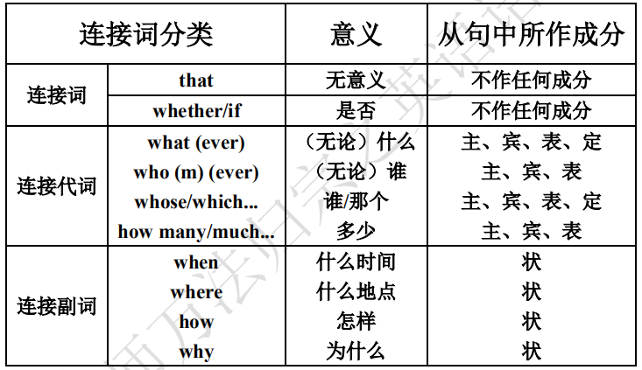

**2. whether 和 if 在名词性从句中的区别**

①引导宾语从句可以通用，但介词后只用 whether。

②引导主语从句时，if 不能用于句首。但 it 作形式主语时，whether 和 if 均可引导主语从句。如：

Whether we will attend the lecture has not been decided.

我们是否将参加那个讲座还没确定。

It’s still uncertain whether/if he is coming.

他是否回来还未确定。

③非肯定主句的宾语从句连接词用 whether/if，肯定住的主句则只能用 that 引导。

sb. doubt/be not sure/be uncertain/be doubtful whether/if...

sb. doesn’t doubt/be sure/be certain/be not doubtful that...

如：I doubt whether/if he will come and help us tomorrow.

We don’t doubt that they can complete the task ahead of time(提早).

**3. 名词性关系从句（认知熟悉即可，不需要可以背诵）**

名词性关系从句实际上是先行词与其后的定语从句的结合。

what 是最常用的引导名词性关系从句的关系代词，此时 what=the thing(s) which/that，有时 what 可以用

作前置定语，如 what help，what funny stories 等。此外，whoever=anyone who；whichever=anyone/anything that

(whichever 也可指人)；whatever=anything that (whichever 和 whatever 也可作定语)。有时 where=the place where

和 when=the time when 也可以用来引导名词性关系从句。

①主语从句。如：

What they need is a good textbook. 他们需要的是一本好课本。

Whichever book he bought would be paid for. 无论他买了哪一本书都要（替他）付款。

②宾语从句。如：

We shall not forget when (=the time when) the meeting will open. 我们不会忘记开会的时间。

She will give whoever (=anyone who) needs helps a warm support. 凡是需要帮助的人，她都会给予热情的

支持。

She walked up to where (=the place where) he stood.

她走到他站着的地方。（作介词宾语）

I can judge by what (=the things that) I know of him.

我可以根据我对他的了解来判断。（作介词宾语）

You can write about whatever topic (=any topic that) you prefer.

你可以写你喜欢的任何题目。（作介词宾语）

③表语从句。如：

This is where our problem lies. 这就是我们的问题所在。

Tomorrow is when it would be most convenient. 明天是最方便的时候。

④同位语从句。如：

I gave the girl a big doll, exactly what she longed to have.

我给了这个女孩一个大洋娃娃，那正是她渴望拥有的东西。

⑤名词性关系从句还可以作宾语补足语。如：

We’ll make him whatever he is fit for. 他适合干什么，我们就培养他干什么。

I’ll call the baby whatever name you like. 你喜欢哪一个名字，我就叫宝贝哪一个名字。

He has made a company what it is today. 他把公司办成了今天这个样子。

**4. 名词性从句的难点**

①wh-ever 与 no matter wh-的用法区别

wh-ever 既可以引导名词性关系从句，又可以引导让步状语从句；而 no matter wh-只能引导让步状语从句。如：

Whatever I said, he wouldn’t listen to me. =No matter what I said, he wouldn’t listen to me.

无论我说什么，他都不会听我的。（让步状语从句）

He would believe whatever I said.

我说什么他都信。（宾语从句）

另外，在 whoever，whatever，whenever，wherever 中，ever 其强调作用，意为“究竟、到底”。如：

Where have you been? 你究竟去了哪里？

②as if/as though（好像，仿佛）, because, why 也可引导表语从句。如：

It looked as if it was going to rain.

That’s because he didn’t work hard enough.

That was why I asked for three days’ leave (n.休假).

注意：because 引导的表语从句，主语不能是 reason 或 cause，而且 since，as 不能引导表语从句。

**5. 宾语补足语从句**

宾语补足语可以由名词、形容词、副词、动词不定式、分词、介词短语等担任，一般语法书都这样阐述。然而宾语补足语也可由从句充当，这一点却被忽视了。做宾语补足语的从句除了具有宾语补足语的特点外，它还不能 that 而必须由 what 引出。如：

His education has made him what he is. 他的教育使他成为了现在这个样子。

You may call the new tool what you like. 你要怎么称呼这个新工具就怎么称呼它好了。

—What has made China what she is today? 是什么使得中国成为今天这样？

—It is reforming and opening-up. 是改革开放。

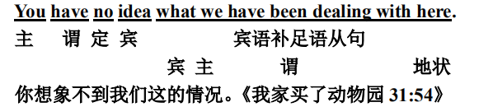

1. **定语从句**

**一、定语从句的其他要点**

**（1）关系副词和关系代词的比较**

引导定语从句的关系代词及关系副词除了起连接先行词和从句的作用外，它们还有一个最重要的作用，

那就是它们分别在定语从句中充当成分。具体地说，关系代词在定语从句中作主语、宾语或表语，而关系

副词在定语从句中作状语。因此，在选择引导词时，最重要的是分析一下定语从句中的成分，若从句中缺

主语、宾语或表语，那么必须用关系代词；若从句中不缺主语、宾语或表语，那么必须用关系副词。

试比较下面的句子：

①Do you still remember the days that/which we spent in Qingdao?

你还记得我们一起在青岛度过的日子吗？

②Do you still remember the days when we spent the summer holidays in Qingdao?

你还记得我们在青岛过暑假的日子吗？

在句①中，定语从句中缺宾语，因此须用关系代词 that/which 来引导从句，而在句②中，定语从句不缺主语，也不缺宾语，因此须用关系副词 when 来引导从句。

**（2）特殊关系代词 than，but 和 where**

如：He gave more money than was needed. 他给的钱比需要的多。

There was no one in my family but was glad to hear the good news.

我家里没有人听到这个好消息不高兴的。

至今绝大多数词典和语法学家还没有承认 than 为关系代词，认为是连接词，引导比较状语从句，其后经常用省略形式。

**（3）定语从句与其他句式的比较**

It is such a heavy box that he can’t lift it. （状语从句）

It is such a heavy box as he can’t lift. （定语从句）

Is this factory the one in which/where we lived three years ago? （定语从句）

Is this factory where we lived three years ago? （表语从句）

As is known to the world, Mark Twain is a great American writer. （定语从句）

It is known to the world that Mark Twain is a great American writer. （主语从句）

That Mark Twain is a great American writer is known to the world. （主语从句）

The reason why he didn’t come was unknown. （同位语从句）

The reason that he gave was not right. （定语从句）

She did all she could to help him. （定语从句）

She is not the girl she used to be. （定语从句）

She did what she could to help him. （宾语从句）

She is not what she used to be. （表语从句）

由以上例句可以看出，分清定语从句与其他复合句的关键是要掌握先行词及其后的关系词，要看其是否在从句中做成分，是否有意义。

（4）注意 way 和 time 后接定语从句的情况

①当先行词是 way 意为“方式、方法”时，引导定语从句的关系词有下列三种形式。如：

What surprise me was not he said but the way (in which/that/不填) he said it.

使我感到惊奇的不是他说了什么，而是他说话的方式。

注意下面两个句子中关系词的不同，试比较：

The way (that/which/不填) he explained to us was quite simple.

他向我们解释的那种方法很简单。

The way (that/in which/不填) he explained the sentence to us was not difficult to understand.

他向我们解释句子的那种方法不难理解。

②先行词是 time 时，若 time 作“次数”讲时，应用关系代词 That 引导定语从句，That 可省略；若 time

作“一段时间”讲时，应用关系副词 when 或介词 at/during + which 引导定语从句。如：

This is the second time (that) the President has visited the country. 这是总统第二次访问那个国家。

I could hardly remember how many times (that) I’ve failed. 我几乎记不清我失败多少次了。

This was at a time when/during which there were no radio, no telephones or no TV sets.

这是一段没有收音机，没有电话，没有电视机的时间.

**\*二、定语从句的转换（写作课部分内容提前学习）**

**1. 用“同位语”缩略的定语从句**

在新闻媒体中，常见用“同位语”来缩略定语从句。也就是把两个名词短语并列，中间用逗号分开，这样，

第二个短语是对第一个短语加以补充说明，这也就是一同谓语的形式缩略了原来的非限制性定语从句。例

如：

Mr. Watkins, a neighbour of mine, never missed the opportunity to tell me the latest news.

(=Mr. Watkins, who is a neighbour of mine, never missed the opportunity to tell me the latest news.)

沃特金斯先生，我的一个邻居，从不放过对我讲述最近消息的机会。

D. H. Lawrence, the author of Sons and Lovers, died in 1930.

(=D. H. Lawrence, who was the author of Sons and Lovers, died in 1930.)

D. H. 劳伦斯，《儿子与情人》的作者，与 1930 年逝世。

**2. 定语从句与其他句型的转换**

有时，一个同样的意思可以用不同的方法来表达，如用同义词、同义词组和短语，有时也可以用不同

的句子结构表示，这就叫句型转换。定语从句也一样，它们可以通过用不同的词、词组、短语、不同的句

子结构表示定语的意思。下面是定语从句与其他一些句型的转换形式。

**（1）与不定式的转换**

It is time we (you, they) started. 该动身了。

→It is time to start.

He was the first that arrived and the last that left. 他来的最早，走的最晚。

→He was the first to arrive and the last to leave.

He had a large family that he must support. 他有一大家子人要他负担。

→He had a large family to support.

**（2）与介词短语的转换**

The student that is from U.S.A. speaks Chinese. 从美国来的那位学生讲中文。

→The students from U.S.A. speaks Chinese.

Milton was the greatest poet that lived in King Charles’s reign. 弥尔顿是查理士王时代的最伟大的诗人。

→Milton was the greatest poet in King Charles’s reign.

He read us a poem which he had composed himself. 他给我们朗诵他自己作的诗。

→He read us a poem of his own composing.

There is no man but has his faults. 人皆有过。

→There is no man without faults.

The book that is on the desk is expensive. 办公桌上的那本书很贵。

→The book on the desk is expensive.

**（3）与形容词短语的转换**

He, who was selfless and anxious to help others, led a simple life and studied perseveringly.

→Selfless and anxious to help others, he led a simple life and studied perseveringly.

他大公无私，热心助人，生活简朴，坚持学习。

They, who are cheerful, efficient and warm-hearted, will do everything to make your journey smooth and comfortable.

→Cheerful, efficient and warm-hearted, they will do everything to make your journey smooth and comfortable.

他们乐观、能干、热情，总会想方设法让你一路上顺利舒适。

She, who was conscientious and eager, took down what was said, carefully not to do miss a word.

→Conscientious and eager, she took down what was said, carefully not to miss a word.

她认真热情，把说的话一字不漏地记了下来。

**（4）与分词短语的转换**

定语从句与分词短语的转换分为与现在分词及其短语的转换和与过去分词及其短语的转换。

**①与现在分词短语的转换**

The train which is arriving at platform 8 is the 17:50 from Crewe.

→The train arriving at platform 8 is the 17:50 from Crewe.

即将在 8 号站台进站的列车是 17:50 从克鲁开来的。

The man who is talking with Mary is my brother. 与玛丽谈话的人是我哥哥。

→The man talking with Mary is my brother.

**②与过去分词短语的转换**

The system which is used in this school is very successful. 这个学校所施行的制度是非常成功的。

→The system used in this school is very successful.

He posted me a dictionary which was compiled by him last year. 他邮给我一部他去年编的词典。

→He posted me a dictionary compiled by him last year.

This was a freighter that was built in China and was fitted entirely with Chinese-made equipment.

→This was a freighter built in China and was fitted entirely with Chinese-made equipment.

这是中国制造的并且完全是中国装备的一搜货轮。

**（5）与状语从句的转换**

He who looks not forward finds himself behind. 不进则退。

→If he does look forward, he will find himself behind. （条件状语从句）

Nothing is hard in this world for anyone who dares to scale the height. 世上无难事，只要肯登攀。

→Nothing is hard in this world for anyone if he dares to scale the height.

Dr. Bethune, who was very tired on his arrival, set to work at once.

→Dr. Bethune set to work at once though he was very tired on his arrival. （让步状语从句）

白求恩大夫虽然到达时很累，但还是立即开始工作

**（6）含定语从句的复合句与并列句的转换**

I will lend you this book, which is both easy and interesting. 我愿借给你这本书，它既浅显又有趣。

→I will lend you this book, and it is both easy and interesting.

I have a friend, whose father is a famous doctor. 我有个朋友，他的父亲是个有名的医生。

→I have a friend, and his father is a famous doctor.

On May 5 we arrived in Beijing, where we stayed a fortnight. 5 月 5 日我们到达北京，在那里停留了两周。

→On May 5 we arrived in Beijing, and we stayed a fortnight.

**3. 定语从句与同位语从句的比较**

定语从句与同位语从句最大的不同点有两个：一是作用不同；二是引导词不同。我们先说第一点：定语从句是用来修饰名词或代词的从句,定语从句起形容词的作用,对先行词或句子起限制作用;同位语从句常跟在中心词后,对名词及其短语进行补充说明.第二点引导定有从句的关联词有关系代词和关系副词两大类;而引出同位语从句的只有连词,当然其连词有单纯连词、连接代词、连接限定词、连接副词。还有，定语从句有限制性和非限制性两种，同位语从句只有一种，是名词性从句中的一种。例如：

The woman who was here just now is Tom’s mother.

刚才在这里的女人是汤姆的母亲。

She gave me a useful book, which was written by her last year.

她给了我一本有用的书，那本书是她去年写的。

Your original question, why he didn’t attend the important meeting, has not yet been answered.

你最先的问题，他为什么不参加那个重要的会议，还没有回答呢。

There is no doubt that (=but) he is the best student in this class.

毫无疑问，他是他班上最好的学生。

显而易见，上面的例句中第一、二句是定语从句（限制性和非限制性），第三、四句为同位语从句。无论从英语字面上看，还是从汉语译文上看，都能辨出他们的不同作用，觉察出它们的引导词的不同，也许，从本专题的内容里你还会悟出定语从句的先行词一般没有约束，而同位语从句的中心词常是 feeling、doubt、question、reason 等词。

**（三）状语从句**

**状语从句中的时态问题及紧缩现象**

**1. 状语从句中的时态问题**

时间状语和条件状语从句中用一般现在时或现在完成时表示将来，主句用将来时或情态动词原形。

如：

I’ll not lend the money to you unless you return it next month.

You can’t get off until the bus has stopped.

**2. 状语从句中的紧缩现象（请试着翻译以下的例句）**

**（1）时间状语从句中常见的紧缩形式。如：**

Don’t speak until spoken to.

在别人跟你说话前不要先发言。

Don’t speak until you are spoken to.

While in Beijing, I paid a visit to the Summer Palace.

I prefer my milk a little sweetened whenever possible.

As a young man, Abraham Lincoln was a storekeeper and a postmaster.

He often makes mistakes when speaking English.

She always sings while doing her work.

1. **条件状语从句中常见的紧缩形式。如：**

Come tomorrow if possible.

We will come tomorrow if it is possible.

If so, you must go back and get it.

I’ll buy a TV set if necessary.

The girl never gave in unless wrong.

Unless repaired, the machine is of no use.

（3）方式状语从句中常见的紧缩形式。如：

Some flowers shut up at night as if (they did this in order) to sleep.

She stood at the gate as if (she was) waiting for someone.

The woman teacher left the classroom silently as though (she was) angry.

The inspector looked round, as if (he was) in search of something.

（4）其他状语从句中常见的紧缩形式。如：

Tough cold, he still wore a shirt.

As he was bind, he couldn’t see anything. =Being blind, he couldn’t see anything.

Fill in the blanks with articles where necessary.

**三大从句系统提升**

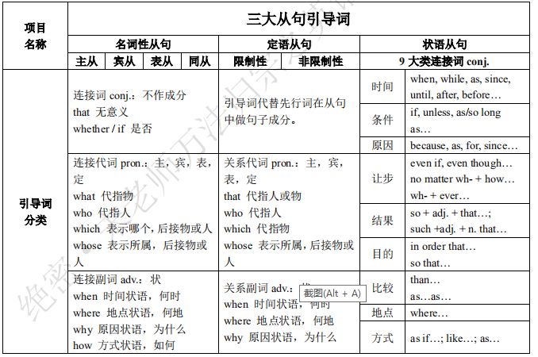

**一招搞定长难句：句子成分解析**

**句式终极流程图 + 句子成分和词类交互式对应**

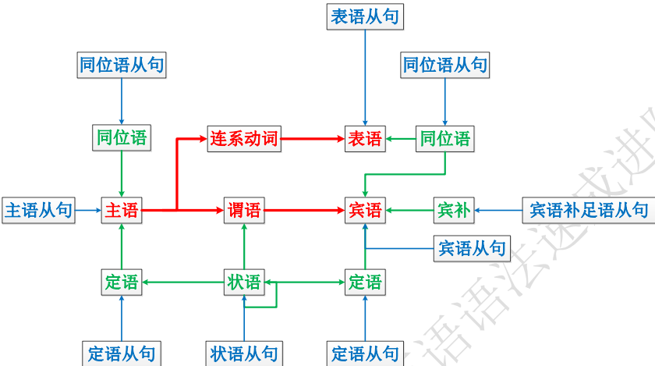

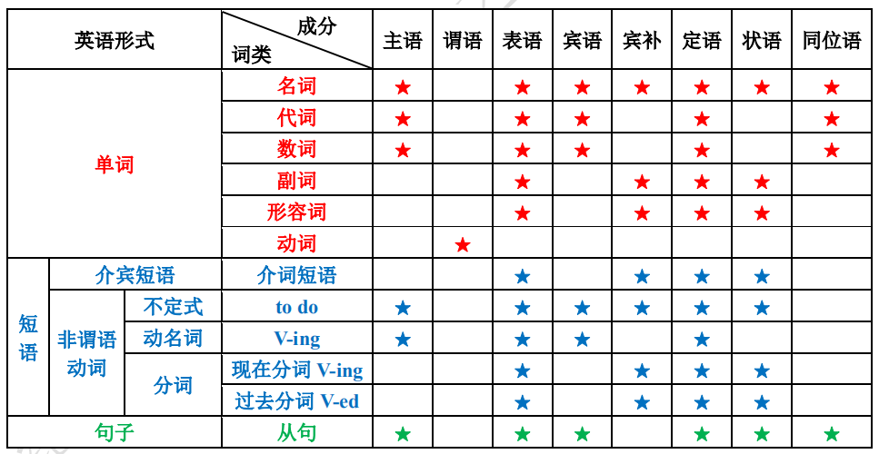

**实战例句解析**

1. 20:16 【Avengers I】

这些人可能习惯各自为政，甚至可能失控，但我相信只要合理用人，他们便会成为我们眼下急需的人。

These people may be isolated, unbalanced even but I believe with the right push they can be exactly what we need.

2. 22:36 【Avengers I】

如果你愿意加入，我们得给你补补课。

There's a lot we'll have to bring you up to speed on if you're in.

3. 22:57 【Avengers I】

关于宇宙魔方我们应该了解些什么，你有任何可以告诉我们的吗？

Is there anything you can tell us about the Tesseract that we ought to know now?

4. 25:25 【Avengers I】

我会补偿刚才对于百分比的发言，贴心地补偿，不是吗？

I'm going to pay for that comment about percentages in some subtle way later, aren't I?

5. 28:14 【Avengers I】

班纳认为伽马射线是解开厄斯金博士原始配方的关键。

Banner thought gamma radiation might hold the key to unlocking Erskine's original formula.

6. 29:10 【Avengers I】

鉴于这些发生的事情和预计未来会发生的事情，人们确实需要一些老传统。

With everything that's happening and the things that are about to come to light, people might just need a little

old-fashioned.

7. 55:38 【Avengers I】

我很想知道到底洛基是怎么用它，把我最优秀的两个手下变成他的飞猴跟班的。

And I would like to know how Loki used it to turn two of the sharpest men I know into his personal flying

monkeys.

8. 58:11 【Avengers I】

我确实应该调查一下，一旦我的破解程序侵入了神盾局的机密档案的话。

I should probably look into that once my decryption programme finishes breaking into all of S.H.I.E.L.D.'s secure Files.

9. 01:30:23 【Avengers I】

这个概念是让一群能力超群的人聚集在一起看看他们是否能发挥更强大的作用。

The idea was to bring together a group of remarkable people to see if they could become something more.

10. 02:09:44 【Avengers I】

尽管这是一起被定义为外星人入侵的毁灭性灾难，但一群名为复仇者联盟的小队的超凡壮举对很多人来说

带来的不仅是宽慰 更是值得庆贺的理由。

Despite the devastation of what has been confirmed as an extraterrestrial attack, the extraordinary heroics of the

group known as the Avengers has been to many a cause not only for comfort, but for celebration.

11. 02:52 【Iron Man III】

如果我的推论没错，大脑修复中枢可被进入，并通过化学手段被重新编码。

If I'm right, we can access the area of the brain that governs repair and chemically recode it.

12. 12:30 【Iron Man III】

我只是说用人的部分可用机器代替人比机器脆弱得多，也是我们最大的弱点。

What I'm saying is that the human element of Human Resources is our biggest point of vulnerability.

13. 15:31 【Iron Man III】

而这里空间充足，也就是说，人类的大脑和 DNA 系统，注定要升级换代。

This is essentially an empty slot, and what this tells us is that our mind, our entire DNA in fact, is destined to be

upgraded.

14. 15:31 【Iron Man III】

而这里空间充足，也就是说人类的大脑和 DNA 系统注定要升级换代。

This is essentially an empty slot, and what this tells us is that our mind, our entire DNA in fact, is destined to be

upgraded.

15. 17:55 【Iron Man III】

可现在不一样了，另有天才执掌高位，她不归托尼管，也不像他那般自大。

But something tells me now there is a new genius on the throne, who doesn't have to answer to Tony anymore and

who has slightly less of an ego.

16. 01:02:36 【Iron Man III】

你遇到过这么个小妞么，仔细看她时发，现她由内向外散发亮橘色的光。

Did you have a chick striking you and you look up and so then she glowing from the inside out, a kind of bright

orange?

17. 01:10:41 【Iron Man III】

在对 AIM 的卫星接收设备进行分析后，我成功定位了曼达林视频的来源地。

Once I factored in available AIM downlink facilities I was able to pinpoint the Mandarin's broadcast signal.

18. 01:15:39 【Iron Man III】

想要什么就拿吧，这些枪都是假的，因为那些混蛋不敢给我真枪。

If you want something, take it, although the guns are all fake because those wankers wouldn't trust me with the real

ones.

19. 01:21:09 【Iron Man III】

但当我俯瞰城市，没人知道我在那里，没人能看到我，甚至都没人在看。

But as I looked out over that city, nobody knew I was there, nobody could see me, no one was even looking.

20. 02:09:07 【Iron Man III】

这真的很有用，把郁积心头的话都说出来，敞开心扉，一吐为快。

There's just something about getting it off my chest and putting it out there in the atmosphere instead of holding

this in.

21. 10:19 【Iron Man III】

你今天肯定是蜂蜜吃多了，不然嘴巴怎么这么甜。

You must think I'm a piece of bread that needs to be buttered so heavily.

22. 12:17 【Iron Man III】

我还记得庆祝哈罗金之战的时候，你兴奋得几乎想要立刻再去下一个国家战斗。

I remember you celebrated the Battle of Harokin so much that you nearly started the second.

23. 13:27 【Iron Man III】

我们约会的前十分钟你都把头埋在只有三个选择的菜单里。

You spent the first ten minutes of our date hiding behind a menu that has three choices on it.

23. 14:15 【Iron Man III】

我去实验室干活，又去了你妈家，满心期待你穿着睡衣到处乱逛，吃着冰激凌犯着某人的花痴…

So, I show up to work at the lab/your mom's house, fully expecting you to be moping around in your pajamas,

eating ice cream and obsessing about...

24. 59:43 【Iron Man III】

但在过去那么多次兵戎相见中，我确实隐隐地希望着，我的弟弟仍然和曾经一样。

But you should know that when we fought each other in the past, I did so with a glimmer of hope that my brother

was still in there somewhere.

25. 01:01:36 【Iron Man III】

你心爱的凡人正被英灵战士重重守卫，你接近半米都会被发现。

Your lovely mortal is being guarded by a legion of Einherjar who will see you coming from miles away.

26. 44:23

因为我们知道，除了外交，高层的交际来往，豪言壮语想要建立一个更美好的世界，往往意味着要将旧

的推翻。

We knew that, despite all the diplomacy and the handshaking and the rhetoric, to build a really better world

sometimes means having to tear the old one down.

27. 44:40

那些因为你有勇气把手放进土里试着创造出更美好的东西，而说你肮脏的人。

Those people that call you dirty because you got the guts to stick your hands in the mud and try to build something better.

28. 58:02

有时候很难相信一个你并不知道真面目的人。

You know, it's kind of hard to trust someone, when you don't know who that someone really is.

29. 1:33:23

不管他曾经是谁，现在的那个人不是你该救的人了。

Look, whoever he used to be and the guy he is now, I don't think he's the kind you save.

30. 2:02:59

他可以说说这个国家接下来要如何保护自身的安全，鉴于他，还有你毁掉了我们的情报部门。

Well, he could explain how this country is expected to maintain its national security now that he and you have laid waste to our intelligence apparatus.