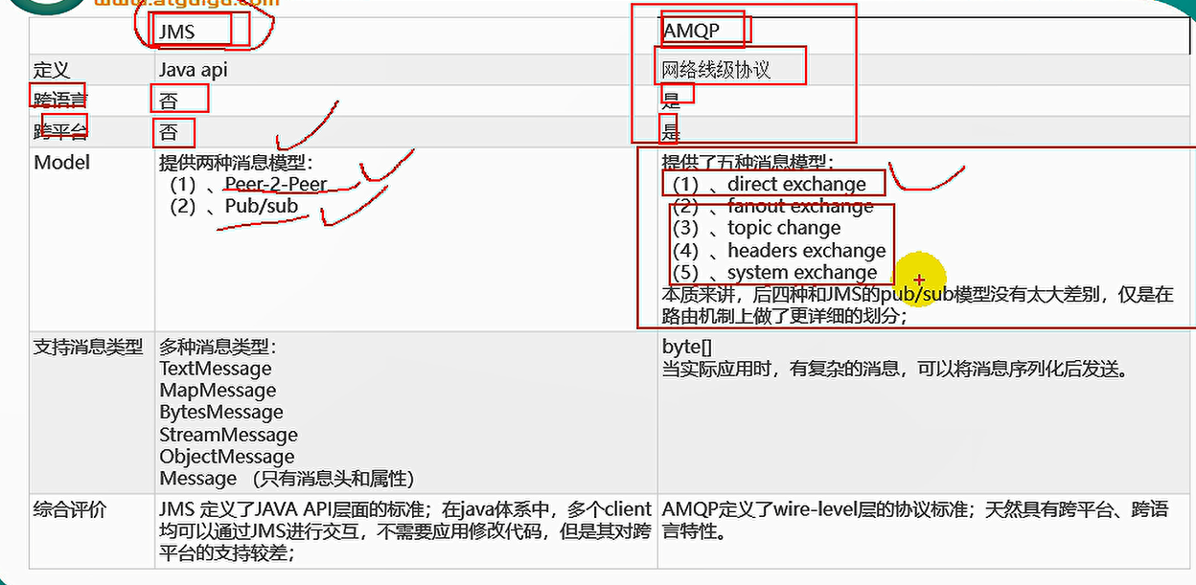

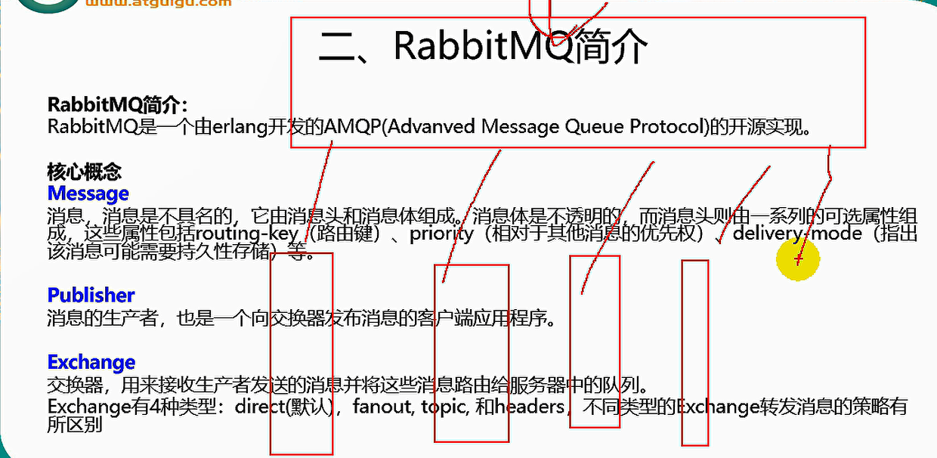

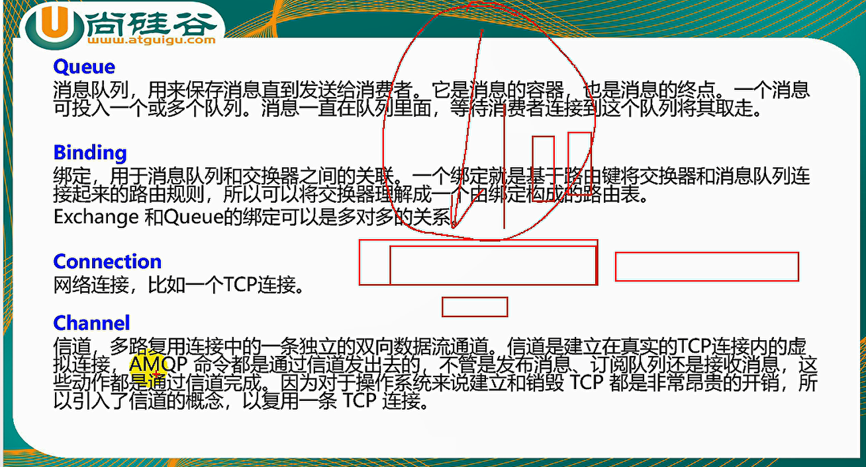

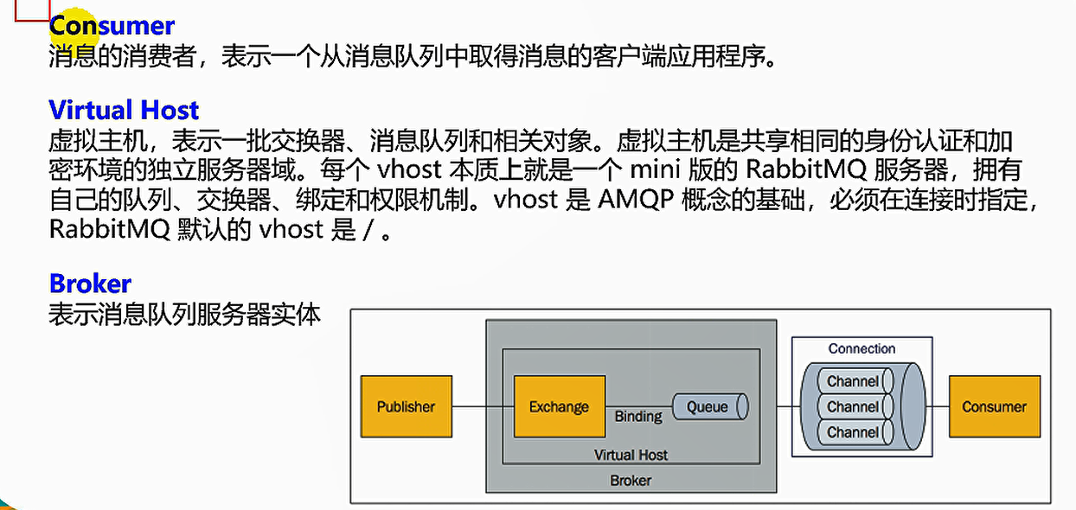

@Autowired  
private RabbitTemplate rabbitTemplate;

convertAndSend 发消息

receiveAndConvert 读消息

messageConverter 可转换消息格式

@EnableRabbit+@RabbitListener(queues = "atguigu.news")可监听消息

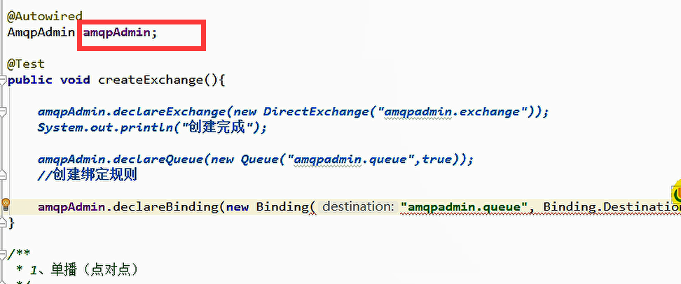

可创建exchange，queue和 绑定规则等