

ISCG 7424

Mobile Software Development

Semester 2, 2018

Assignment 3

Assignment 3

|  |  |
| --- | --- |
| Team Member 1: | Shichang Qi |
| : | 1491947 |
| Team Member 2: | Lei Li |
|  | 1494024 |
| Team Member 3: | Yuyue Wang |
|  | 1497039 |

# 1. Background

## 1.1 Application Aim

This application is aiming to design an Android ball shooting game, which mainly utilizes the knowledge of Box2D, gyroscope and accelerometer, so that the team members could practice coding skills and enhance memory of what learnt from the course.

## 1.2 Derivation of idea

There is a ball shooting game embedded in a mobile application “WeChat”which is shown as below.

There are three differences between our app and the original app that I want to address.

Firstly, the original game was built using JavaScript, while our team is going to use Java.

Secondly, the original game has one difficulty level with four randomly changed background images. But in our app, it is intended to provide to players with about three difficulty modes.

Thirdly, there is no gyroscope used in original game, all the balls are falling and bouncing back with accelerations base on a fixed horizontal phase no matter how players tilt their phones, besides the player has to use the finger to move the shooter, the pro is accurate operation, but the con is that sometimes the finger will block player’s sight, especially when too many balls on the srceen. In our app, the player’s finger will be freed, it is considered to apply gyroscope to the shooter, so the player can only tilt the phone to make the shooter slide left or right on the ground platform.

According to what we are going to implement, our app extends the existing application.

# 2 Target Audience and Likely Market Size

The target audience should be those who have fractured time like commuters, when they are in the bus or subway. In few minutes, players could start three or four times of new game normally.

In the market, such game probably can be popular in a period,especially when there is a good design and comfortable feeling of hitting the ball, and easily becomes a time killer.

# 3 Bulid Time for Initial Version

It can take about two weeks to develop a runnable initial version in which player is provided with one difficulty mode to play. It is easier to add other difficulty modes after one is success.

# 4 Team Contribution

YuyueWang 1497039: game mechanism design, checkpoint 1 chief editor, estimate 1/4 coding work.

LeiLi 1494024: game art work design, checkpoint 2 chief editor, estimate 1/4 coding work.

ShichangQi 1491947: Chief Technology Officer, app structure management, estimate 1/2 coding work.

# Design

## 1.1 Usage of Technologies

**Intent.** Assist in interaction and communication between pages.

**RecyclerView.** Display top score history.

**Multi-threads.** Potentially used in game activity.

**Android.media**. To generate a SoundPool so that sound effects can be stored and used.

**Gyroscope.** Let user to tilt the phone in order to control the cannon.

**Box2D.** Using Box2D in Libgdx to create specific physical laws in different difficulties. For example, in “Moon mode” the acceleration will be set to the gravity of the moon to make the balls falling and bouncing slower.1.2 Screen design.

## 1.2 Initial Screen Design

### 1.2.1 Main Activity

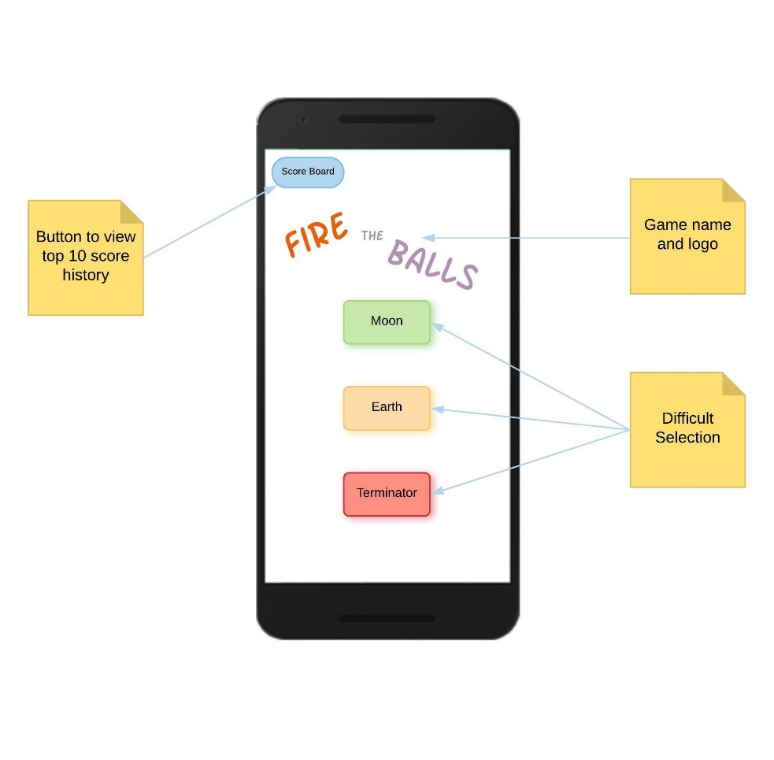

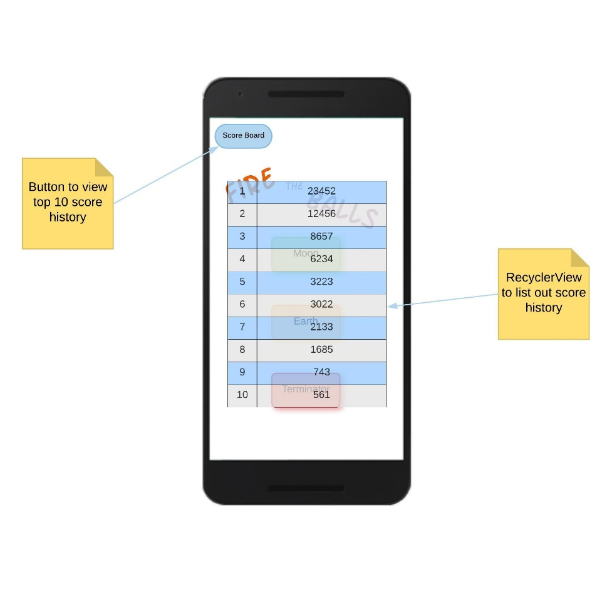

### 1.2.2 Game Activity

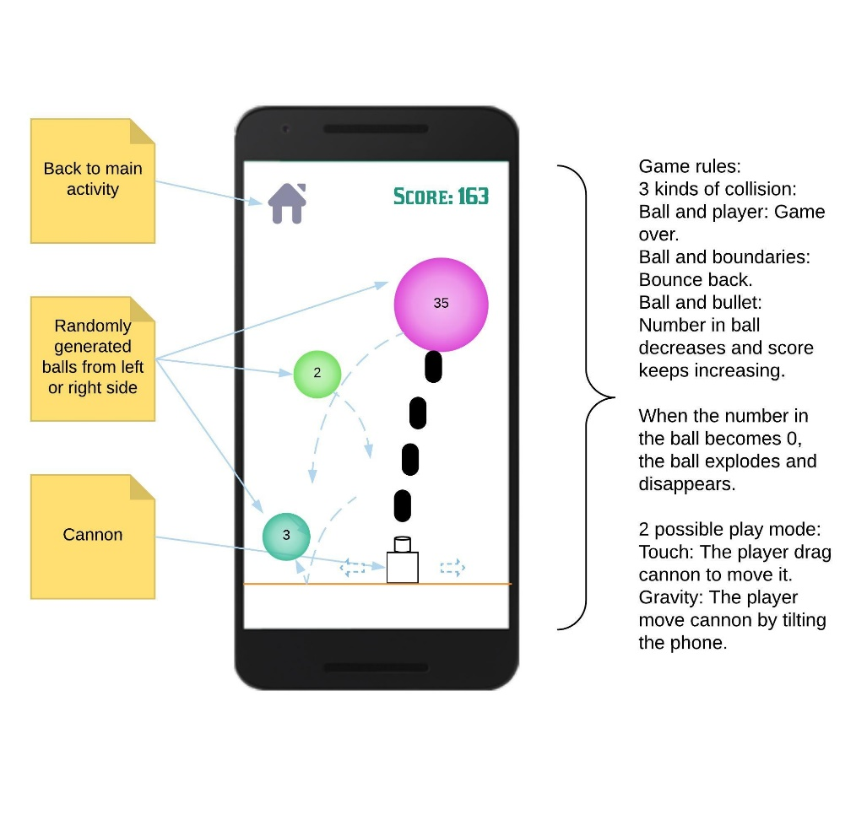

## 1.3 Database and Database Schema

This project is intended to use SQLite to store application data.

In game database schema, one table “score” is going to be implemented for sure, another three tables “info”, “ball” and “bullet” will be added if there is a need to continue previously paused game.

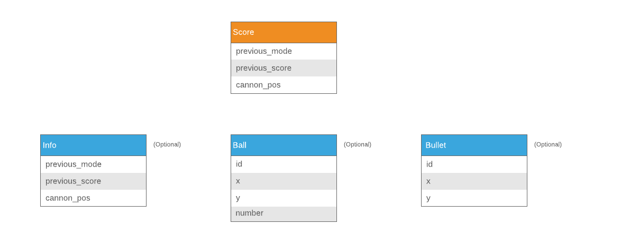

# Work Plan

All team members: **T**

YuyueWang 1497039: **Y**

LeiLi 1494024: **L**

ShichangQi 1491947: **S**

Y: New the project.

S: Define the Classes and write brief comments for each classes.

L: Collect Images and music/sound.

T: Discusses the usage of images and music/sound.

Y: The ball generation related class.

L: The collision related class.

S: Play related class.

L: Add images.

S: Game test run and debug.

T: Discussed game element (Ball speed, Bullet power, Ball number, Player speed,etc...)

Y: Add score and time functionality.

L: Add music and sound effect.

S: Test the game functionality.

L: Play the game and give advice (Good at play games...)

T: Improve other functionality (Depend on the deadline and time limited)

The actual work will be carried out according to the plan, but it won’t be exactly the same as the work plan.