CS 186 - Fall 2024

Exam Prep Section 7

Query Optimization

Query Optimization 1

(Modified from Fall 2017)

For the following question, assume the following:

• Column values are uniformly distributed and independent from one another

• Use System R defaults (1/10) when selectivity estimation is not possible

• Primary key IDs are sequential, starting from 1

• Our optimizer does not consider interesting orders

We have the following schema:

| Table Schema | Records | Pages | Indices |
| --- | --- | --- | --- |
| CREATE TABLE Student (  sid INTEGER PRIMARY KEY,  name VARCHAR(32),  major VARCHAR(64),  semesters_completed INTEGER); | 25,000 | 500 | + Index 1: Clustered (major). There are 130 unique majors  + Index 2: Unclustered (semesters completed). There are 11 unique values in the range [0, 10]. |
| CREATE TABLE Application (  sid INTEGER REFERENCES Student,  cid INTEGER REFERENCES Company,  status TEXT,  (sid, cid) PRIMARY KEY); | 100,000 | 10,000 | + Index 3: Clustered(cid, sid).  + Given: status has 10 unique values |
| CREATE TABLE Company (  cid INTEGER PRIMARY KEY,  open_roles INTEGER); | 500 | 100 | + Index 4: Unclustered(cid)  + Index 5: Clustered(open roles). There are 500 unique values in the range [1, 500] |

Consider the following query:

SELECT Student.name, Company.open_roles, Application.referral

FROM Student, Application, Company

WHERE Student.sid = Application.sid -- (Selectivity 1)

AND Application.cid = Company.cid -- (Selectivity 2)

AND Student.semesters_completed > 6 -- (Selectivity 3) AND (Student.major=’EECS’ OR Company.open_roles <= 50) -- (Selectivity 4) AND NOT Application.status = ’limbo’ -- (Selectivity 5) ORDER BY Company.open_roles;

1. For the following questions, calculate the selectivity of each of the labeled Selectivities above.

(a) Selectivity 1

(b) Selectivity 2

(c) Selectivity 3

(d) Selectivity 4

(e) Selectivity 5

2. For each predicate, which is the first pass of Selinger’s algorithm that uses its selectivity to estimate output size? (Pass 1, 2 or 3?)

(a) Selectivity 1

(b) Selectivity 2

(c) Selectivity 3

(d) Selectivity 4

(e) Selectivity 5

3. Mark the choices for all access plans that would be considered in pass 2 of the Selinger algorithm.

(a) Student ⋈/ Application (800 IOs)

(b) Application ⋈Student (750 IOs)

(c) Student ⋈Company (470 IOs)

(d) Company ⋈Student (525 IOs)

(e) Application ⋈Company (600 IOs)

(f) Company ⋈Application (575 IOs)

4. Which choices from the previous question for all access plans would be chosen at the end of pass 2 of the Selinger algorithm?

5. Which plans would be considered in pass 3?

(a) Company ⋈(Application ⋈Student) (175,000 IOs)

(b) Company ⋈(Student ⋈Application) (150,000 IOs)

(c) Application ⋈*/* (Company ⋈Student) (155,000 IOs)

(d) Application ⋈(Company ⋈Student) (160,000 IOs)

(e) Student ⋈(Company ⋈Application) (215,000 IOs)

(f) (Company ⋈Application) ⋈Student (180,000 IOs)

(g) (Application ⋈Company) ⋈Student (200,000 IOs)

(h) (Application ⋈Student) ⋈Company (194,000 IOs)

(i) (Student ⋈Application) ⋈Company (195,000 IOs)

(j) (Student ⋈Company) ⋈Application (165,000 IOs)

6. Which choice from the previous question for all plans would be chosen at the end of pass 3?

Query Optimization 2

(Modified from Spring 2016)

1. True or False

• When evaluating potential query plans, the set of left deep join plans are always guaranteed to contain the best plan.

• As a heuristic, the System R optimizer avoids cross-products if possible.

• A plan can result in an interesting order if it involves a sort-merge join.

• The System R algorithm is greedy because for each pass, it only keeps the lowest cost plan for each combination of tables.

2. For the following parts assume the following:

• The System R assumptions about uniformity and independence from lecture hold • Primary key IDs are sequential, starting from 1

We have the following schema:

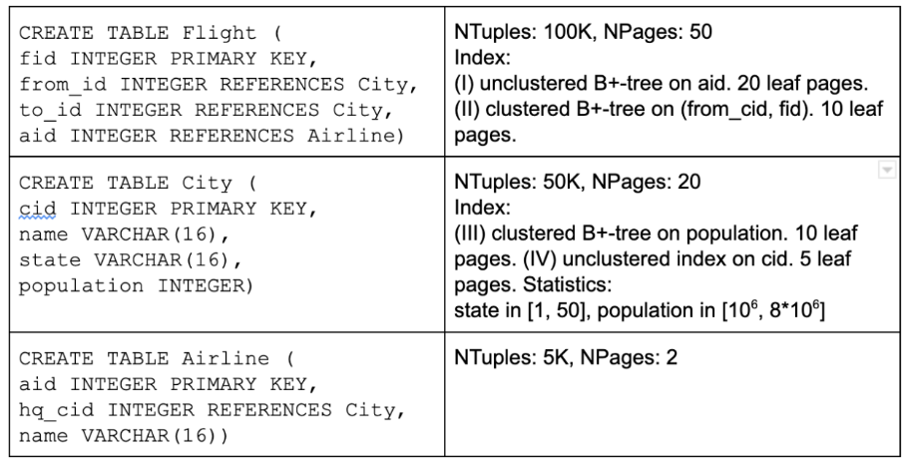

Consider the following query:

SELECT *

FROM Flight F, City C, Airline A

WHERE F.to_id = C.cid

AND F.aid = A.aid

AND F.aid >= 2500

AND C.population > 5e6

AND C.state = ’California’;

Considering each predicate in the WHERE clause separately, what is the selectivity for each?

(a) C.state=’California’

(b) F.to_id = C.cid

(c) F.aid >= 2500

(d) C.population > 5 * 10^6

3. For each blank in the System R DP table for Pass 1. Assume this is before the optimizer discards any rows it isn’t interested in keeping and note that some blanks may be N/A. Additionally, assume B+ trees are height 2.

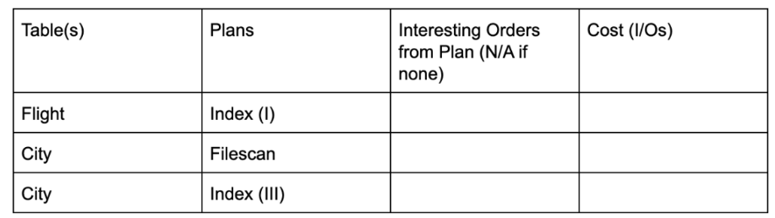4. After Pass 2, which of the following plans could be in the DP table?

(a) City [Index(III)] JOIN Airline [File scan]

(b) City [Index (III)] JOIN Flight [Index (I)]

(c) Flight [Index (II)] JOIN City [Index (III)]

5. Suppose we want to optimize for queries similar to the query above in part 2, which of the following suggestions could reduce I/O cost?

(a) Change Index (III) to be unclustered

(b) Store City as a sorted file on population