CS 186 - Fall 2024

Exam Prep Section 7 (Sol)

Query Optimization

Query Optimization 1

(Modified from Fall 2017)

For the following question, assume the following:

• Column values are uniformly distributed and independent from one another

• Use System R defaults (1/10) when selectivity estimation is not possible

• Primary key IDs are sequential, starting from 1

• Our optimizer does not consider interesting orders

We have the following schema:

| Table Schema | Records | Pages | Indices |
| --- | --- | --- | --- |
| CREATE TABLE Student (  sid INTEGER PRIMARY KEY,  name VARCHAR(32),  major VARCHAR(64),  semesters_completed INTEGER); | 25,000 | 500 | + Index 1: Clustered (major). There are 130 unique majors  + Index 2: Unclustered (semesters completed). There are 11 unique values in the range [0, 10]. |
| CREATE TABLE Application (  sid INTEGER REFERENCES Student,  cid INTEGER REFERENCES Company,  status TEXT,  (sid, cid) PRIMARY KEY); | 100,000 | 10,000 | + Index 3: Clustered(cid, sid).  + Given: status has 10 unique values |
| CREATE TABLE Company (  cid INTEGER PRIMARY KEY,  open_roles INTEGER); | 500 | 100 | + Index 4: Unclustered(cid)  + Index 5: Clustered(open roles). There are 500 unique values in the range [1, 500] |

Consider the following query:

SELECT Student.name, Company.open_roles, Application.referral

FROM Student, Application, Company

WHERE Student.sid = Application.sid -- (Selectivity 1)

AND Application.cid = Company.cid -- (Selectivity 2)

AND Student.semesters_completed > 6 -- (Selectivity 3) AND (Student.major=’EECS’ OR Company.open_roles <= 50) -- (Selectivity 4) AND NOT Application.status = ’limbo’ -- (Selectivity 5) ORDER BY Company.open_roles;

1. For the following questions, calculate the selectivity of each of the labeled Selectivities above.

(a) Selectivity 1

1/max(25000, 25000) = 1/25000. There are exactly 25000 values in Student.sid, and due to the foreign key, there are at most 25000 values of Application.sid.

(b) Selectivity 2

1/max(500, 500) = 1/500. Similarly to Selectivity 1, there are exactly 500 values in Com pany.cid, and due to the foreign key, there are at most 500 values in Application.cid.

(c) Selectivity 3

(10 - 6) / (10 - 0 + 1) = 4/11. We have 11 unique values, assumed to be equally distributed. Therefore we use the equation for less than or equal to which is (high key - value) / (high key - low key + 1).

(d) Selectivity 4

(1/130 + (1/10 + 1/500)) - (1/130 * (1/10 + 1/500)). We can find the selectivity that they are an EECS major by using the equation 1/distinct values. Next, we find the selectivity that open positions are less than or equal to 50 using the equation (v - low key) / (high key - low key + 1) + (1 / number distinct). Lastly we combine these two selectivities using S(p1) + S(p2) - S(p1)S(p2) to determine the selectivity of having one or the other.

(e) Selectivity 5

1 - (1/10) = 9/10. Given 10 unique values, the non-negated predicate has selectivity 1/10, so we can use the equation for NOT which is 1 - selectivity of the predicate. The selectivity of the predicate is 1/10 (because there are 10 unique values).

2. For each predicate, which is the first pass of Selinger’s algorithm that uses its selectivity to estimate output size? (Pass 1, 2 or 3?)

(a) Selectivity 1

(b) Selectivity 2

(c) Selectivity 3

(d) Selectivity 4

(e) Selectivity 5

Solution: Pass 2, Pass 2, Pass 1, Pass 3, Pass 1. C and E are pass 1 because they only involve filtering one table. A and B are pass 2 because they represent a join. Note that (d)—the OR predicate—is over 2 tables that have no associated join predicate, so the selection is postponed along with the cross-product, until after 3-way joins are done.

3. Mark the choices for all access plans that would be considered in pass 2 of the Selinger algorithm.

(a) Student ⋈ Application (800 IOs)

(b) Application ⋈Student (750 IOs)

(c) Student ⋈Company (470 IOs)

(d) Company ⋈Student (525 IOs)

(e) Application ⋈Company (600 IOs)

(f) Company ⋈Application (575 IOs)

A, B, E, and F will be considered because they are not cross products.They are joined on a condition, so some rows can be filtered out, making our intermediate relations smaller.

4. Which choices from the previous question for all access plans would be chosen at the end of pass 2 of the Selinger algorithm?

B and F will be chosen because they have the lower cost for joining the two tables, and we have the assumption that our optimizer does not consider interesting orders. (Even if we did, there are no interesting orders in the other joins.)

5. Which plans would be considered in pass 3?

(a) Company ⋈(Application ⋈Student) (175,000 IOs)

(b) Company ⋈(Student ⋈Application) (150,000 IOs)

(c) Application ⋈*/* (Company ⋈Student) (155,000 IOs)

(d) Application ⋈(Company ⋈Student) (160,000 IOs)

(e) Student ⋈(Company ⋈Application) (215,000 IOs)

(f) (Company ⋈Application) ⋈Student (180,000 IOs)

(g) (Application ⋈Company) ⋈Student (200,000 IOs)

(h) (Application ⋈Student) ⋈Company (194,000 IOs)

(i) (Student ⋈Application) ⋈Company (195,000 IOs)

(j) (Student ⋈Company) ⋈Application (165,000 IOs)

Considers F and H only. A-E can be immediately discarded because they aren’t left-deep. G won’t be considered because we chose (Company *./* Application) in pass 2. Similarly, choice I wouldn’t be considered because we choose Application *./* Student in the previous pass. Choice J wouldn’t be considered because there is no join condition on Student and Company, so this is a cross-join, which we avoid since we have other options.

6. Which choice from the previous question for all plans would be chosen at the end of pass 3? Chooses F. F has the lower I/O cost between F and H.

Query Optimization 2

(Modified from Spring 2016)

1. True or False

• When evaluating potential query plans, the set of left deep join plans are always guaranteed to contain the best plan.

• As a heuristic, the System R optimizer avoids cross-products if possible.

• A plan can result in an interesting order if it involves a sort-merge join.

• The System R algorithm is greedy because for each pass, it only keeps the lowest cost plan for each combination of tables.

False. This is a heuristic that System R uses to shrink the search space.

True.

True. Sort merge join leaves the joined tables in sort order, which may be useful in future passes and/or if the overall query includes an ORDER BY clause.

False. It is not greedy because it keeps track of interesting orders. (Dynamic Programming!)

2. For the following parts assume the following:

• The System R assumptions about uniformity and independence from lecture hold • Primary key IDs are sequential, starting from 1

We have the following schema:

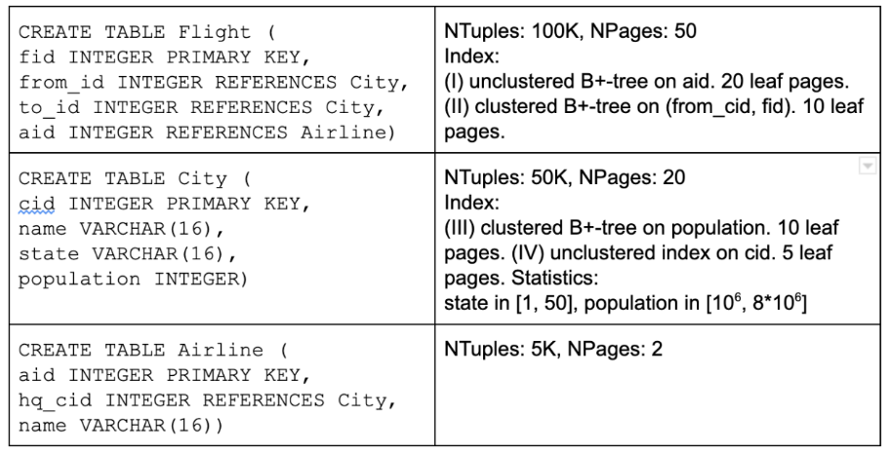

Consider the following query:

SELECT *

FROM Flight F, City C, Airline A

WHERE F.to_id = C.cid

AND F.aid = A.aid

AND F.aid >= 2500

AND C.population > 5e6

AND C.state = ’California’;

Considering each predicate in the WHERE clause separately, what is the selectivity for each?

(a) C.state=’California’

1/50, since there are 50 possible values for state.

(b) F.to_id = C.cid

1/MAX(50000, 50000) = 1/50000, since there are 50000 tuples in the City table, and cid is the primary key of the City table, while to id is a foreign key that references the primary key of City, so there are also 50000 values for it.

(c) F.aid >= 2500

Since we have the assumption that primary key IDs are sequential, starting from 1, we know that the low value for F.aid (which is a primary key) is 1, and the high value is 5000 (since we have 5000 records). Thus, our selectivity is (5000 - 2500)/(5000 - 1 + 1) + 1/5000 = 2501/5000.

(d) C.population > 5 * 10^6

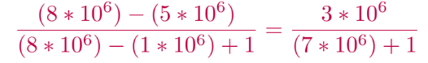

3. For each blank in the System R DP table for Pass 1. Assume this is before the optimizer discards any rows it isn’t interested in keeping and note that some blanks may be N/A. Additionally, assume B+ trees are height 2.

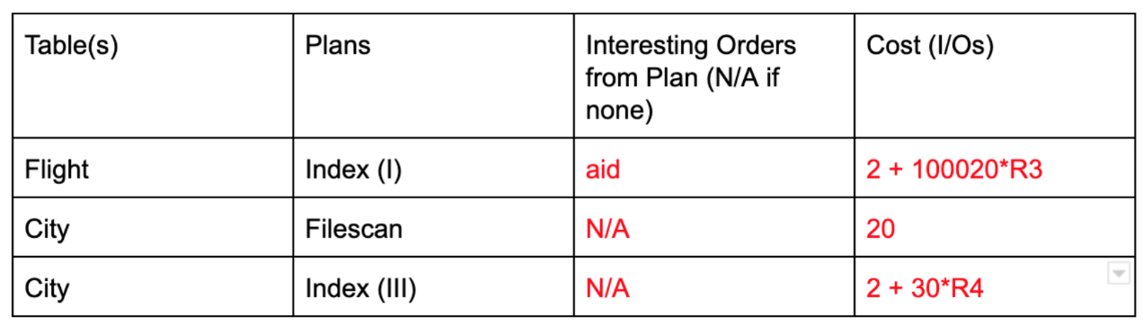Detailed Solution: (Note there is a typo in the exam’s solutions. population is *not* an interesting order for a the Index(III) scan.)

Flight:

Interesting order: aid is an interesting order because it’s used as part of a join condition in F.aid = A.aid,potentially making the algorithm choose an index nested loop join in later passes. Cost: 2 + (100,020) * R3. First we have the R3 selectivity factor due to the F.aid *≤* 2500 clause and that this index is on F.aid. We read in the root page and inner node page with 2 I/Os, which are then cached. Then we only have to read in part of the index that is relevant after applying the selectivity. The index size (number of leaves) is 20 pages, but we read in R3 * 20 pages. Since the index is unclustered, we perform 1 I/O per matching tuple. We have 100K total tuples but only need to consider 100K * R3. This gives us a total of 2 + (100,000 + 20) * R3 I/Os for this index scan. City 1st row:

Interesting order: None because file-scans don’t produce any interesting orders. Cost: File-scans look through all of the pages, so it will take 20 I/Os.

City 2nd row:

Interesting order: None. population isn’t used in any later joins.

Cost: 2 + 30*R4. We have a selectivity factor of R4 since the index is on C.population. For clustered indexes, we perform 1 I/O per matching page of tuples. Therefore in a similar calculation to Flight, we read in R4*10pg portion of the relevant part of the index and R4*20pg worth of relevant pages of matching tuples.

4. After Pass 2, which of the following plans could be in the DP table?

(a) City [Index(III)] JOIN Airline [File scan]

(b) City [Index (III)] JOIN Flight [Index (I)]

(c) Flight [Index (II)] JOIN City [Index (III)]

Solution:

(a) Cannot. Because there is no condition joining City and Airline, this is a cross product, which the Selinger algorithm avoids.

(b) Can. City [Index (III)] is kept from pass 1 because it has the lowest cost of the cities table. Flight [Index (I)] is kept from pass 1 because it has an interesting order.

(c) Cannot. Index (II) would not have been kept as a Single Table Access Method. No interesting order and more expensive than a simple full scan.

5. Suppose we want to optimize for queries similar to the query above in part 2, which of the following suggestions could reduce I/O cost?

(a) Change Index (III) to be unclustered

(b) Store City as a sorted file on population

Solution:

(a) Won’t reduce I/O cost. An unclustered index would not minimize I/O cost, since it’s more random I/O, and we may load a page more than once. Instead of 1 I/O per matching page of tuples, this would increase the cost to 1 I/O per matching tuple.

(b) May reduce I/O cost. Sorted file may provide more efficient range lookups due to the presence of the C.population *>* 5e6 clause.