(32×40×32voxels in this work). The second type is the 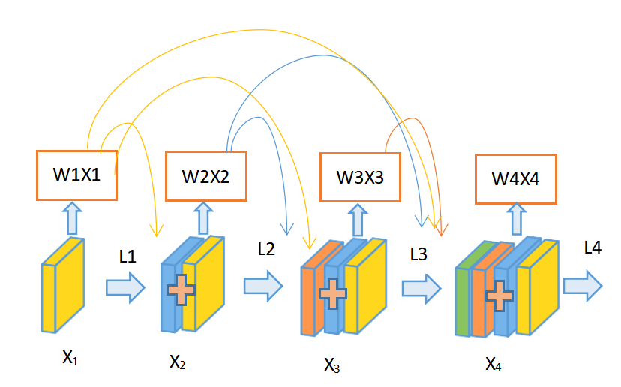convolutional layer which convolves the learned filters with the input image and produce a feature map for each filter. Our CNN is built with 8 convolutional layers, each two convolutional layers followed by one max pooling layers.The sizes of the first 8 convolution filters are 3×3×3, and the filter numbers are set to 35. The third type is the pooling layer which down-samples the input feature map along the spatial dimensions by replacing each non-overlapping block with their maximum. Max pooling is applied for each 2×2×2 region, and Tanh is adopted as the activation function in these layers because of its good performance for CNNs.The forth type of layer is the fully connected layer which consists of a number of input and output neurons.

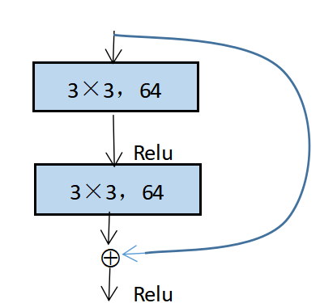

Figure.3.Residual learning:a building block

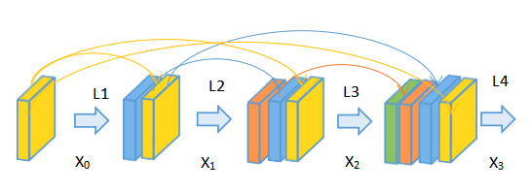

Figure.5.Our ADDW-DenseNet with 4-layer

Figure.4.Constitution of dense connectivity with

4-layer DenseBlock

Pooling2X2X2

L4

Input:

32X40X32

FC/sigmoid

W2X2

W1X1

W4X4

W3X3

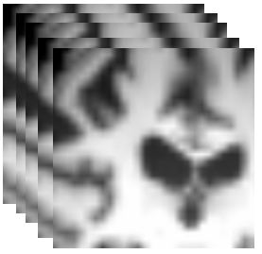

AD/NC

L2

L4

L3

L1

……

X3

X4

X2

X1

35@4X5X4

2Conv 3X3X3

35@8X10X8

2Conv 3X3X3

32X40X32

2Conv 3X3X3

35@16X20X16

2Conv 3X3X3

Figure.6. The architecture of ADDW-DenseNet denoted with the sizes of input,convolution and outpus layers and the numbers and sizes of generated feature maps

5.experience and result

5.1 Experiments

4. Experimental and Results

4.1 Experiment

In this section, we will first introduce the image datasets used in our network and implementation of our proposed method. Then, we will present the extensive experiments to test the proposed method on classifications of AD vs. NC or other group. We will further compare our proposed method with other methods reported in the literature and give the discussion.The size of MRI image after processing is 182 ×218 × 182 voxels.We divide each dimension into four regions,there are 20 pixels overlap between each two adjacent regions.We get an new MRI for size 96 ×120 × 96.In order to quickly converge the network and reduce the training time and the parameters of the model, we reshape the MRI to size 32 ×40 ×32 and feed to network for training.Figure.2.show the MR image we use as input to the network.Ten-fold cross-validation is used in our work to avoid random factors affecting the results. Each time, one fold of the image set is used for testing, another one fold used for validation while the left eight folds were used for training. The validation part is used for early stopping the training process to obtain the model weights with the optimized performance.

The proposed classification method is implemented with the Keras library in Python3.6 based on tensorflow. The experiments are conducted on PC with GPU NVIDIA GTX1080 in the environment ofUbuntu14.04-x64 . For training our network, the initial weights for whole network is uniform, which is default in Keras. Sgd optimizer is adopted with a low learning rate of 1 × 10-3, the momentum is set to 0.9. The batch size is set to 64, and the model begins to be stable after 25~30 epochs.To avoid overfitting problem, dropout, L1 and L2 regulation are adopted in our network (Srivastava et al. 2014). To prove the validity of our model, we do a lot of comparative experiments with our dataset , such as the basic CNN, the simple ResNet, and the DenseNet.

4.2 result

The proposed algorithm was tested on the classifications of AD vs. NC, sMCI vs. NC,cMCI vs. NC,sMCI vs. cMCI based on MRI biomarkers of 432 subject from ADNI datasets. The datasets that we used in the experiments is conducted as illustrated in the above section. Accuracy (ACC), Sensitivity (SEN), Specificity (SPE) are used to evaluate the classification performance.TP, FP, TN, and FN are the numbers of true positives, false positives, true negatives, and false negatives, respectively. We also report the area under receiver operating characteristic (ROC) curve (AUC). The AUC value is an important index to measure the overall-performance of classification methods, and the performance of classification methods can be judged directly by the value of AUC .The three metrics are calculated by the following formulas:







4.2.1Comparison with others methods on the same datasets in 10-fold cross validation We used different models and a lot of experiments to prove the validity of our experiment.The first model is a commonly convolutional neural network(CNN), which composed of eight convolutional layers, maxpooling and L1 and L2 regulation are adopted in the CNN network；The second one is a Resnet network ; The third group is the densenet network. In order to have a clear contrast with our model, we uses an plus to connect each layer in Denesnet instead of adhesion of each layer to all previous layers . We will show you more detail in the table.Table.2. (a,b,c d) show the comparisons of the thier classification performa- nces for AD vs. NC,cMCI vs. NC,sMCI vs.NC, sMCI vs. cMCI with different model and using the same datasets. Figure.7. (a,b,c ,d)compare the ROC (receiver operating characteristic) curves of different model for classifica- tion.From the result we found that our model better than the other three model ,and have a better classification performance.The result also show that the performances of MRI by DenseNet better than CNN and ResNet.

Table.2.a Comparison of classification performances on AD vs.NC

|  |
| --- |
| AD vs.NC ACC% SEN% SPE% AUC% |
| CNN 84.15 82.04 84.51 87.49  ResNet 90.69 93.55 88.87 95.14  Densenet 95.82 96.00 84.82 97.12  Ours 97.15 97.10 97.95 98.12 |

Table.2.b Comparison of classification performances on cMCI vs.NC

|  |
| --- |
| cMCI vs.NC ACC% SEN% SPE% AUC% |
| CNN 81.32 80.71 82.32 84.42  ResNet 88.12 87.09 88.43 91.66  DenseNet 89.63 85.62 93.50 93.55  Ours 88.82 87.56 88.84 93.61 |

Table.2.c Comparison of classification performances on sMCI vs.NC

|  |
| --- |
| sMCI vs.NC ACC% SEN% SPE% AUC% |
| CNN 76.60 75.71 76.93 81.83  ResNet 79.72 79.21 80.35 83.45  DenseNEt 83.77 84.24 85.30 87.89  Ours 86.32 87.87 85.15 88.40 |

Table.2.a Comparison of classification performances on sMCI vs.cMCI

|  |
| --- |
| sMCI vs.cMCI ACC% SEN% SPE% AUC% |
| CNN 73.37 73.95 73.21 78.72  ResNet 75.98 74.10 77.27 80.64  DenseNet 78.33 80.71 72.78 84.89  Ours 81.06 80.70 82.21 87.26 |

1. (b)

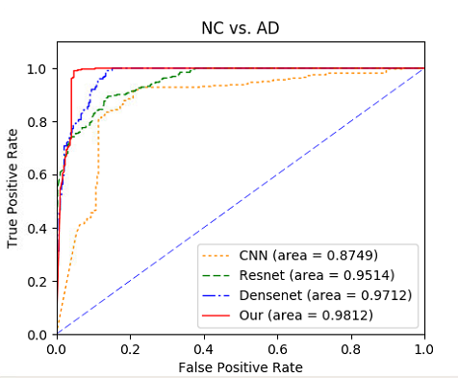

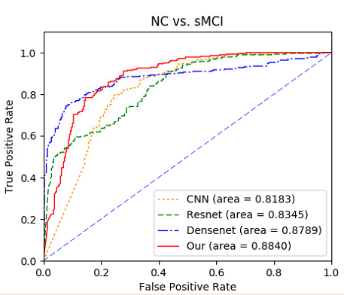

(b)

(d)

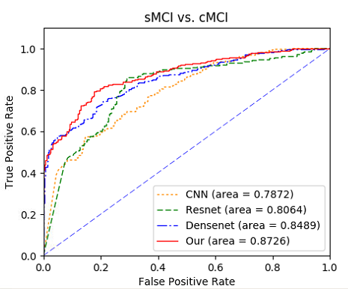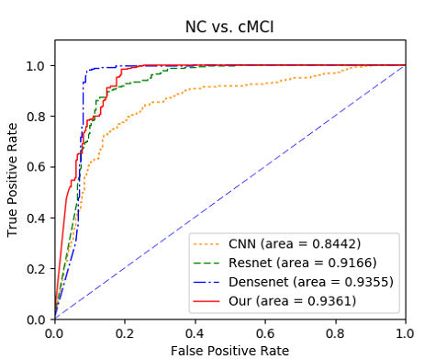 (c) (d)

Figure.7. ROC curves of MRI,PET and Multi-modality for classifications of (a)AD vs.NC;(b)cMCI vs.NC;

(c)sMCI vs.NC;(d)cMCI vs.NC

4.2.2Comparison with Existing Methods

The second experiment is to compare our model with some recent results reported in the literature which based on MRI or PET data from ADNI database for AD and MCI diagnosis.The results reported in four recent models are compared with ours results in table 3,4 and 5,as briefly described following.Janoušová (Janoušová , et al.2012)built and validated a deep learning algorithm predicting the individual diagnosis of Alzheimer's disease (AD) and mild cognitive impairment who will convert to AD (c-MCI) based on a single cross-sectional brain structural MRI scan. They used a convolutional neural networks to propagate learned information through the network from the input to the output layer,calculate the error signal.Liu (Liu J, et al.2018) employ a whole brain hierarchical network (WBHN) to represent each subject. The whole brain of each subject is divided into 90, 54, 14, and 1 regions based on Automated Anatomical Labeling (AAL) atlas. The connectivity between each pair of regions is computed in terms of Pearson’s correlation coefficient and used as classification feature. Then, to reduce the dimensionality of features, we select the features with higher F scores. Finally, we use multiple kernel boosting (MKBoost) algorithm to perform the classification.Basaia S(Basaia S,et al.2019) built and validated a deep learning algorithm predicting the individual diagnosis of Alzheimer's disease (AD) and mild cognitive impairment who will convert to AD (c-MCI) based on a single cross sectional brain structural MRI scan.

It is not easy to implement these published methods on the same settings for fair comparison. Therefore, We compare our methods to other methods in three ways, accuracy, sensitivity, and specificity and used the results reported in the literature to compare the methods in Table 3,4,5.The contents in brackets indicate the result of MCI vs.NC

5.Discussion

Effective and accurate AD diagnosis is critical for early treatment. Therefore many researchers have devoted their efforts to develop a computer-aided system, which can diagnose AD in the early stages and on an individual

Table.3 ACC(Accuracy)%

|  |  |  |  |  |
| --- | --- | --- | --- | --- |
| Comparisons | AD_NC | NC_cMCI | NC_sMCI | cMCI_sMCI |
| Janoušová | 90.03 | (86.90) | - | 82.10 |
| Liu | 94.64 | (86.74) | - | 72.08 |
| Basaia S | 99.20 | 87.10 | 76.10 | 75.10 |
| ours | 97.15 | 88.82 | 86.32 | 81.06 |

Table.4 SEN(Sensitivity)%

|  |  |  |  |  |
| --- | --- | --- | --- | --- |
| Comparisons | AD_NC | NC_cMCI | NC_sMCI | cMCI_sMCI |
| Janoušová | 87.50 | (81.20) | - | 81.50 |
| Liu | 95.03 | (93.16) | - | 75.11 |
| Basaia S | 98.90 | 87.30 | 75.10 | 74.80 |
| ours | 97.10 | 87.56 | 87.87 | 80.70 |

Table.5 SPE(specificity)%

|  |  |  |  |  |
| --- | --- | --- | --- | --- |
| Comparisons | AD_NC | NC_cMCI | NC_sMCI | cMCI_sMCI |
| Janoušová | 92.10 | (90.90) | - | 82.90 |
| Liu | 91.76 | (85.49) | - | 71.05 |
| Basaia S | 98.90 | 84.31 | 75.10 | 75.30 |
| ours | 97.95 | 88.84 | 85.15 | 82.21 |

basis (Rathore et al., 2017; Vieira et al., 2017). Different

from the traditional methods based on the handcrafted features, the proposed method built the ADDW-Dense- Net to learn the multi-level features for classification of brain images.In this study, we built and validated a deep learning algorithm ADDW which based on Densenet that predicts the individual diagnosis of AD and MCI who will convert to AD based on a single cross-sectional brain structural MRI scan. Importantly, our algorithm perfor- med well without any prior feature engineering and regardless the variability of imaging protocols and scanners, demonstrating that it is exploitable by not trained operators and likely to be generalizable to unseen patient data.From the results we show in Table, we can observe that ADDW model can boost the classification performance in all three directions for both classification tasks of AD vs. NC MCI vs.NC and sMCI vs.cMCI. For the classification of AD and sNC, our correct rate, sensitivity and specificity are 97.15%, 97.10%, 97.95%, respectively.

Each 3D CNN layer combines the low-layer feature maps to generate higher-level features which can achieve more robustness to some variations of transla- tion and rotation etc. in images. No segmentation and rigid registration are required in pre-processing the brain images.

With small datasets that ten cross-validation was used in our experiments. In order to compare our network and the other three networks more fairly, we also used multiple ten-fold cross-validation, which is to divide the data into different ten groups , and find the Total average.In addition, we used data enhancement to slice the image into 64 regions of the same size (96,120,96).

However, there are some suggestions to address the above limitations.Traditional convolutional networks or fully connected networks have the problems with gradients disappear or gradient explosions when information is transmitted and the network is deeper .ResNet solves this problem directly by passing the input information to the output and protecting the integrity of the information, the entire network only needs to learn the part of the input and output differences.It is impotant to find out the influence of the depth of the layer on our network, ResNet is to solve the problem of the disappearance of the characteristics in the deeper network. If we use deeper network , whether the performance of ResNet will increase or exceed our network. More auxiliary information such as CSF ,PET and clinical information may be considered to improve the performance if they have high correlations to AD. The number of filters are set to 35 in each layer and the size of all 3D kernels is set to 3 × 3 × 3 in our network is the same as the size of convolution kernels, so whether changing the number of filters has an impact on our results. We should do more experiments.

1. Conclusion

In this paper we have proposed a new design of a multi- modal 3D CNN for Alzheimer’s Disease diagnostics inspired by DenseNet which has proven efficient in 2D datasets. The proposed network is constructed with the emphasis on the interior resource utilization. The distin- ction between AD and MCI can help to identify different categories of dementia disease and take appropriate treatments. We achieved the classification accuracy of 0.933, 0.867 and 0.733 for binary AD/NC, NC/cMCI and NC/cMCI.classification problems respectively.Compared with other state-of-theart methods, the proposed one outperforms others in higher accuracy and AUC, while keeping a good balance between the sensitivity and specificity.

Acknowledgements

Data collection and sharing for this project was funded by the Alzheimer’s Disease Neuroimaging Initiative (ADNI) (National Institutes of Health Grant U01 AG024904) and DOD ADNI (Department of Defense award number W81XWH-12-2-0012). ADNI is funded by the National Institute on Aging, the National Institute of Biomedical Imaging and Bioengineering, and through generous contributions from the following: AbbVie, Alzheimers Association; Alzheimers Drug Discovery Foundation; Araclon Biotech; BioClinica, Inc.; Biogen;Bristol-Myers Squibb Company; CereSpir, Inc.; Cogstate;Eisai Inc.; Elan Pharmaceuticals, Inc.; Eli Lilly and Company; EuroImmun; F.Hoffmann La Roche Ltd and its affiliated company Genentech, Inc.; Fujirebio; GE Healthcare; IXICO Ltd.;Janssen Alzheimer Immunotherapy Research and Development, LLC.; Johnson and Johnson Pharmaceutical Research

and Development LLC.; Lumosity; Lundbeck; Merck and Co.,Inc.; Meso Scale Diagnostics, LLC.; NeuroRx Research; Neurotrack Technologies; Novartis Pharmaceuticals Corporation;Pfizer Inc.; Piramal Imaging; Servier; Takeda Pharmaceutical Company; and Transition Therapeutics. The Canadian Institutes of Health Research is providing funds to support ADNI clinical sites in Canada. Private sector contributions are facilitated by the Foundation for the National Institutes of Health (www.fnih.org). The grantee organization is the Northern California Institute for Research and Education, and the study is coordinated by the Alzheimers Therapeutic Research Institute at the University of Southern California. ADNI data are disseminated by the Laboratory for Neuroimaging at the University of Southern California.

This research was supported by Ostrogradsky scholarship grant 2017 established by French Embassy in Russia and TOUBKAL French-Morocco research grant Alclass. We thank Dr. Pierrick Coupe from LABRI UMR 5800 University of ´Bordeaux/CNRS/Bordeaux-IPN who provided insight and expertise that greatly assisted the research.

References

WWW

Janoušová, Eva, et al. "Biomarker discovery for sparse classification of brain images in Alzheimer's disease." *Annals of the BMVA* 2 (2012).

Liu J, Li M, Lan W, et al. Classification of alzheimer's disease using whole brain hierarchical network[J]. IEEE/ACM transactions on computational biology and bioinformatics, 2018, 15(2): 624-632.

Basaia S, Agosta F, Wagner L, et al. Automated classification of Alzheimer's disease and mild cognitive impairment using a single MRI and deep neural networks[J]. NeuroImage: Clinical, 2019, 21: 101645.