代码：
- #include <iostream>
- #include <cmath>
- #include <fstream>
- #include <sstream>

- using namespace std;

- int **a, **b;
- int N = 4;
- float R = 0;

- void show() {
- for (int i = 0; i < N; ++i) {
- for (int j = 0; j < N; ++j) {
- int t = a[i][j], c = 0;
- while (t >= 10) {
- ++c;
- t /= 10;
- }
- for (int q = 0; q < N - 2 - c; ++q) cout << ' ';
- if (0 != j && a[i][j] != -1) cout << ' ' << a[i][j];
- else if (0 != j && -1 == a[i][j]) cout << " *";
- else if (-1 != a[i][j]) cout << a[i][j];
- else cout << '*';
- }
- cout << endl;
- }
- }

- bool isSame() {
- for (int i = 0; i < N; ++i) {
- for (int j = 0; j < N; ++j) if (b[i][j] != a[i][j]) return false;
- }
- return true;
- }

- bool read() {
- ifstream config("./config.txt");
- if (!config) {
- cout << "配置文件格式不对" << endl;
- a = new int*[4];
- b = new int*[4];
- for (int i = 0; i < 4; ++i) {
- a[i] = new int[4];
- b[i] = new int[4];
- }
- return false;
- }
- else {
- bool flag[4] = { 0 };
- string line;
- while (getline(config, line)) {
- if ('#' == line[0]) continue;
- istringstream temp(line);
- while (temp) {
- string buffer;
- temp >> buffer;
- //cout << "buffer= " << buffer << endl;
- if (flag[0] && flag[1]) {
- istringstream temp(buffer);
- float tempN = 0;
- temp >> tempN;
- if (tempN <= 0 || tempN != int(tempN)) N = 4;
- else N = tempN;
- cout << "N=" << N << endl;
- flag[0] = flag[1] = false;
- }
- if ("SIZE" == buffer) flag[0] = true;
- if (flag[0] && "=" == buffer) flag[1] = true;
- if (flag[2] && flag[3]) {
- istringstream temp(buffer);
- temp >> R;
- if (R < 0) R = 0;
- cout << "R=" << R << endl;
- flag[2] = flag[3] = false;
- }
- if ("RAND" == buffer) flag[2] = true;
- if (flag[2] && "=" == buffer) flag[3] = true;
- }
- }
- a = new int* [N];
- b = new int* [N];
- for (int i = 0; i < N; ++i) {
- a[i] = new int[N];
- b[i] = new int[N];
- }
- config.close();
- }
- }

- void compress(int direction) {
- if (direction < 0 || direction > 4) {
- cout << "wrong command!" << endl;
- return;
- }

- if (1 == direction) {
- for (int j = 0; j < N; ++j) {
- for (int i = 1; i < N; ++i) {
- a[0][j] += a[i][j];
- a[i][j] = 0;
- }
- }
- }
- else if (2 == direction) {
- for (int j = 0; j < N; ++j) {
- for (int i = 0; i < N - 1; ++i) {
- a[N - 1][j] += a[i][j];
- a[i][j] = 0;
- }
- }
- }
- else if (3 == direction) {
- for (int i = 0; i < N; ++i) {
- for (int j = 1; j < N; ++j) {
- a[i][0] += a[i][j];
- a[i][j] = 0;
- }
- }
- }
- else if (4 == direction) {
- for (int i = 0; i < N; ++i) {
- for (int j = 0; j < N - 1; ++j) {
- a[i][N - 1] += a[i][j];
- a[i][j] = 0;
- }
- }
- }
- }

- void rotate() {
- int* temp = new int[N]();//带括号将调用构造函数以初始化new数组
- for (int k = N - 1; k >= 0; --k) {
- for (int i = 0; i < N; ++i) {
- b[k][N - 1 - i] = a[i][k];
- }
- }
- for (int i = 0; i < N; ++i) {
- for (int j = 0; j < N; ++j) a[i][j] = b[i][j];
- }
- delete []temp;
- }

- void merge(int direction) {
- for (int i = 0; i < N; ++i) {
- for (int j = 0; j < N; ++j) b[i][j] = a[i][j];
- }
- do {
- for (int i = 0; i < N; ++i) {
- for (int j = 0; j < N; ++j) a[i][j] = b[i][j];
- }
- for (int j = 0; j < N; ++j) {
- int* temp = new int[N]();
- int counter = N - 1;
- for (int i = N - 1; i >= 0; --i) {
- if (b[i][j] != 0) temp[counter--] = b[i][j];
- }
- for (int i = 0; i < N - 1; ++i) {
- if (temp[i] == temp[i + 1]) {
- temp[i] = 0;
- temp[i + 1] *= 2;
- }
- }
- for (int i = 0; i < N; ++i) b[i][j] = temp[i];
- delete[]temp;
- }
- } while (!isSame());
- }

- int main() {
- read();
- for (int i = 0; i < N; ++i) {
- for (int j = 0; j < N; ++j) a[i][j] = b[i][j] = 0;
- }
- srand(time(0));

- int counter = 0;
- while (counter < int(N * N * R / 100)) {
- int pos = rand() % (N * N);
- if (0 == a[pos / N][pos % N]) {
- a[pos / N][pos % N] = rand() % 20;
- ++counter;
- }
- }
- if (0 == R) {
- int pos = rand() % (N * N);
- a[pos / N][pos % N] = rand() % 2 * 2 + 2;
- }

- cout << "原矩阵：" << endl;
- show();
- cout << endl;

- ifstream cmd("./cmd.txt");
- if (!cmd) {
- for (int i = 0; i < N; ++i) {
- for (int j = 0; j < N; ++j) a[i][j] = b[i][j] = 0;
- }
- int counter = 0;
- while (counter<int(N * N * R / 100)) {
- int pos = rand() % (N * N);
- if (0 == a[pos / N][pos % N]) {
- a[pos / N][pos % N] = -1;
- ++counter;
- }
- }
- for (int i = 1; i < N - 1; ++i) {//先不计算四周的格子
- for (int j = 1; j < N - 1; ++j) {
- if (0 == a[i][j]) {
- a[i][j] = (-1 == a[i - 1][j - 1]) + (-1 == a[i][j - 1]) + (-1 == a[i - 1][j]) +
- (-1 == a[i + 1][j + 1]) + (-1 == a[i][j + 1]) + (-1 == a[i + 1][j]) +
- (-1 == a[i - 1][j + 1]) + (-1 == a[i + 1][j - 1]);//计算周围八格的*数
- }
- }
- }
- //现在计算四周的格子
- for (int i = 1; i < N - 1; ++i) {
- if (0 == a[i][0]) a[i][0] = (-1 == a[i - 1][0]) + (-1 == a[i + 1][0]) + (-1 == a[i - 1][1]) + (-1 == a[i][1]) + (-1 == a[i + 1][1]);
- if (0 == a[i][N - 1]) a[i][N - 1] = (-1 == a[i - 1][N - 1]) + (-1 == a[i + 1][N - 1]) + (-1 == a[i - 1][N - 2]) + (-1 == a[i][N - 2]) + (-1 == a[i + 1][N - 2]);
- }
- for (int j = 1; j < N - 1; ++j) {
- if (0 == a[0][j]) a[0][j] = (-1 == a[0][j - 1]) + (-1 == a[0][j + 1]) + (-1 == a[1][j - 1]) + (-1 == a[1][j]) + (-1 == a[1][j + 1]);
- if (0 == a[N - 1][j]) a[N - 1][j] = (-1 == a[N - 1][j - 1]) + (-1 == a[N - 1][j + 1]) + (-1 == a[N - 2][j - 1]) + (-1 == a[N - 2][j]) + (-1 == a[N - 2][j + 1]);
- }
- if (0 == a[0][0]) a[0][0] = (-1 == a[1][0]) + (-1 == a[1][1]) + (-1 == a[0][1]);
- if (0 == a[N - 1][0]) a[N - 1][0] = (-1 == a[N - 2][0]) + (-1 == a[N - 2][1]) + (-1 == a[N - 1][1]);
- if (0 == a[0][N - 1]) a[0][N - 1] = (-1 == a[0][N - 2]) + (-1 == a[1][N - 2]) + (-1 == a[1][N - 1]);
- if (0 == a[N - 1][N - 1]) a[N - 1][N - 1] = (-1 == a[N - 2][N - 2]) + (-1 == a[N - 2][N - 1]) + (-1 == a[N - 1][N - 2]);
- cout << "填入*后计算的结果：" << endl;
- show();
- return 0;
- }

- string line;
- char key = 0;
- while (getline(cmd, line)) {
- //cout << "line=" << line << endl;
- if ("Q" == line) break;
- istringstream temp(line);
- int command = 0, arg = 0;
- temp >> command;
- if (1 == command) {
- temp >> arg;
- compress(arg);
- cout << "压缩" << endl;
- }
- else if (2 == command) {
- rotate();
- cout << "旋转" << endl;
- }
- else if (3 == command) {
- temp >> arg;
- merge(arg);
- cout << "消融" << endl;
- }
- show();
- }
- cmd.close();
- cout << endl;
- if ("" == line) {//表示文件为空
- cout << "cmd.txt为空！" << endl;
- show();
- return 0;
- }
- cout << "最终结果：" << endl;
- show();
- return 0;
- }

测试用例：
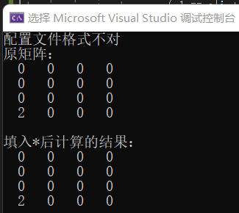
- Config和cmd文件均无：

- 只有config文件：
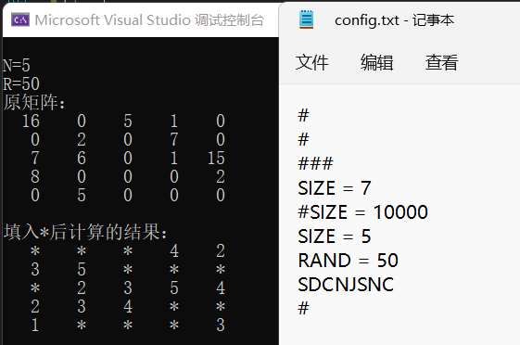

- 只有config且为空：
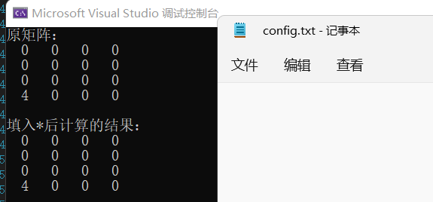

- 只有cmd：
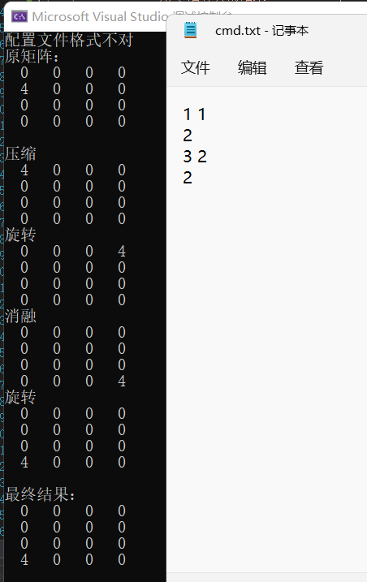

- 只有cmd且为空：
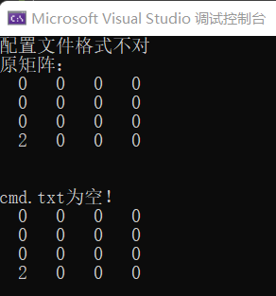

- Config和cmd均有但均空：结果与上一种情况类似

- Config和cmd均有且均非空：
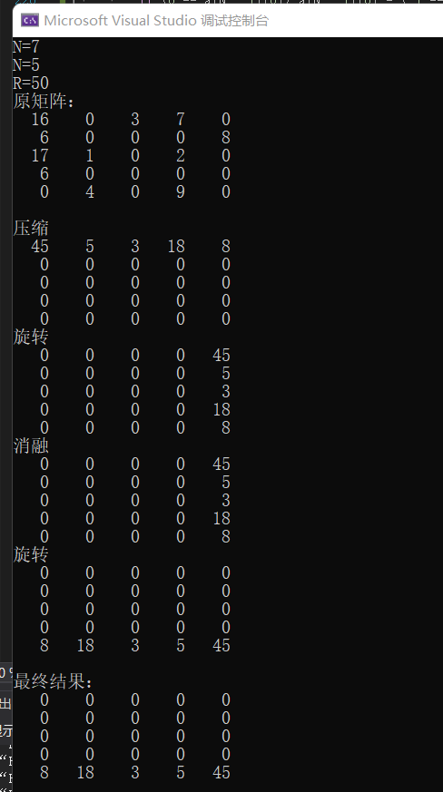

- N非正整数测试：
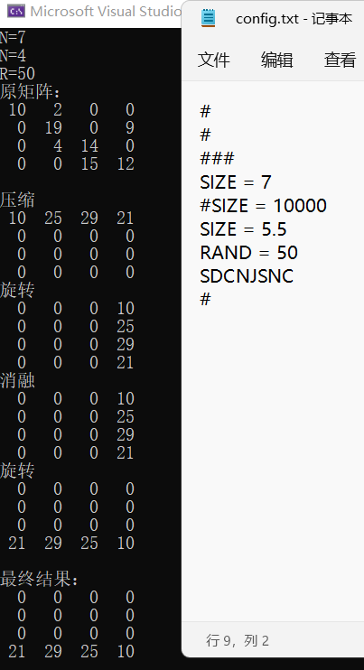

- R=0测试：
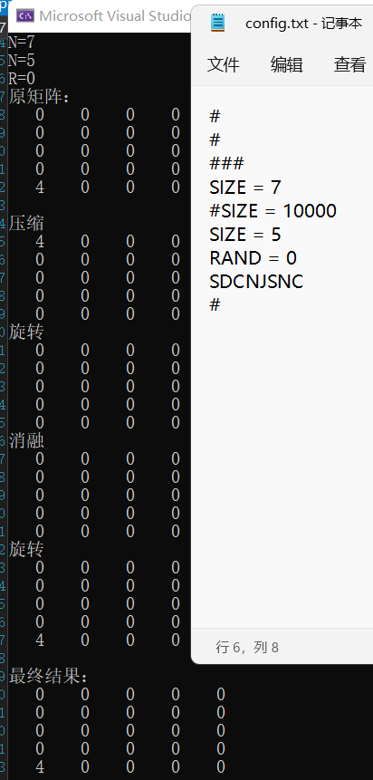

- Cmd文件中含有Q（退出）指令测试：
