实验任务一：
代码：
- #include <iostream>

- using namespace std;

- int a[4][4];

- void show() {
- for (int i = 0; i < 4; ++i) {
- for (int j = 0; j < 4; ++j) {
- int t = a[i][j],c=0;
- while (t >= 10) {
- ++c;
- t /= 10;
- }
- for (int q = 0; q < 2 - c; ++q) cout << ' ';
- if (0 != j) cout << ' ' << a[i][j];
- else cout << a[i][j];
- }
- cout << endl;
- }
- }

- int main() {
- srand(time(0));
- for (int i = 0; i < 4; ++i) {
- for (int j = 0; j < 4; ++j) {
- a[i][j] = rand()%20;
- }
- }
- show();
- cout << endl << "1——压缩 2——旋转" << endl;
- cout << "1234表示上下左右" << endl;
- int command = 0, arg = 0;
- cin >> command >> arg;
- if (1 == command) {
- if (arg < 0 || arg > 4) {
- cout << "wrong command!" << endl;
- return 1;
- }

- if (1 == arg) {
- for (int j = 0; j < 4; ++j) {
- for (int i = 1; i < 4; ++i) {
- a[0][j] += a[i][j];
- a[i][j] = 0;
- }
- }
- }
- else if (2 == arg) {
- for (int j = 0; j < 4; ++j) {
- for (int i = 0; i < 3; ++i) {
- a[3][j] += a[i][j];
- a[i][j] = 0;
- }
- }
- }
- else if (3 == arg) {
- for (int i = 0; i < 4; ++i) {
- for (int j = 1; j < 4; ++j) {
- a[i][0] += a[i][j];
- a[i][j] = 0;
- }
- }
- }
- else if (4 == arg) {
- for (int i = 0; i < 4; ++i) {
- for (int j = 0; j < 3; ++j) {
- a[i][3] += a[i][j];
- a[i][j] = 0;
- }
- }
- }
- show();
- }
- else if (2 == command) {
- int b[4][4] = { 0 };
- int temp[4] = { 0 };
- for (int k = 3; k >= 0; --k) {
- for (int i = 0; i < 4; ++i) {
- b[k][3 - i] = a[i][k];
- }
- }
- for (int i = 0; i < 4; ++i) {
- for (int j = 0; j < 4; ++j) a[i][j] = b[i][j];
- }
- show();
- }
- else {
- cout << "wrong command!" << endl;
- return 1;
- }
- return 0;
- }

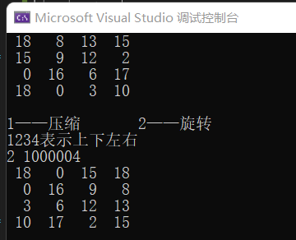
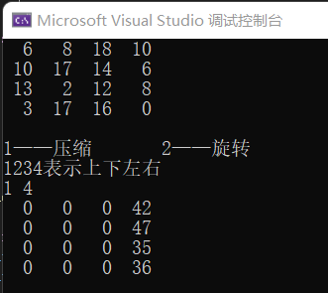
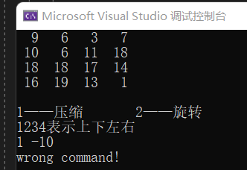
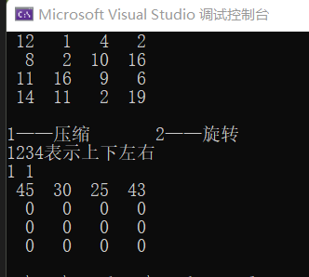
运行截图：

实验任务二：
代码：
- #include <iostream>
- #include <cmath>

- using namespace std;

- int a[4][4], b[4][4];

- void show() {
- for (int i = 0; i < 4; ++i) {
- for (int j = 0; j < 4; ++j) {
- int t = a[i][j],c=0;
- while (t >= 10) {
- ++c;
- t /= 10;
- }
- for (int q = 0; q < 2 - c; ++q) cout << ' ';
- if (0 != j) cout << ' ' << a[i][j];
- else cout << a[i][j];
- }
- cout << endl;
- }
- }

- bool isSame() {
- for (int i = 0; i < 4; ++i) {
- for (int j = 0; j < 4; ++j) if (b[i][j] != a[i][j]) return false;
- }
- return true;
- }

- int main() {
- for (int i = 0; i < 4; ++i) {
- for (int j = 0; j < 4; ++j) {
- a[i][j] = 0;
- }
- }
- float pr = 0;
- cout << "请输入比例值：";
- cin >> pr;
- srand(time(0));
- int counter = 0;
- while (counter < int(16 * pr)) {
- int pos = rand() % 16;
- if (0 == a[pos / 4][pos % 4]) {
- a[pos / 4][pos % 4] = pow(2, rand() % 5);//防止元素过大
- ++counter;
- }
- }

- show();
- cout << endl << "1——压缩 2——旋转 3——消融" << endl;
- char command;
- rewind(stdin);
- while (command = getchar()) {
- rewind(stdin);
- if ('1' == command) {
- int arg = 0;
- cout << "1234表示上下左右" << endl;
- cin >> arg;
- if (arg < 0 || arg > 4) {
- cout << "wrong command!" << endl;
- return 1;
- }

- if (1 == arg) {
- for (int j = 0; j < 4; ++j) {
- for (int i = 1; i < 4; ++i) {
- a[0][j] += a[i][j];
- a[i][j] = 0;
- }
- }
- }
- else if (2 == arg) {
- for (int j = 0; j < 4; ++j) {
- for (int i = 0; i < 3; ++i) {
- a[3][j] += a[i][j];
- a[i][j] = 0;
- }
- }
- }
- else if (3 == arg) {
- for (int i = 0; i < 4; ++i) {
- for (int j = 1; j < 4; ++j) {
- a[i][0] += a[i][j];
- a[i][j] = 0;
- }
- }
- }
- else if (4 == arg) {
- for (int i = 0; i < 4; ++i) {
- for (int j = 0; j < 3; ++j) {
- a[i][3] += a[i][j];
- a[i][j] = 0;
- }
- }
- }
- show();
- }
- else if ('2' == command) {
- int b[4][4] = { 0 };
- int temp[4] = { 0 };
- for (int k = 3; k >= 0; --k) {
- for (int i = 0; i < 4; ++i) {
- b[k][3 - i] = a[i][k];
- }
- }
- for (int i = 0; i < 4; ++i) {
- for (int j = 0; j < 4; ++j) a[i][j] = b[i][j];
- }
- show();
- }
- else if ('3' == command) {
- for (int i = 0; i < 4; ++i) {
- for (int j = 0; j < 4; ++j) b[i][j] = a[i][j];
- }
- do {
- for (int i = 0; i < 4; ++i) {
- for (int j = 0; j < 4; ++j) a[i][j] = b[i][j];
- }
- for (int j = 0; j < 4; ++j) {
- int temp[4] = { 0 };
- int counter = 3;
- for (int i = 3; i >= 0; --i) {
- if (b[i][j] != 0) temp[counter--] = b[i][j];
- }
- for (int i = 0; i < 3; ++i) {
- if (temp[i] == temp[i + 1]) {
- temp[i] = 0;
- temp[i + 1] *= 2;
- }
- }
- for (int i = 0; i < 4; ++i) b[i][j] = temp[i];
- }
- } while (!isSame());
- show();
- }
- else if ('Q' == command) {
- cout << "exit!" << endl;
- return 0;
- }
- else {
- cout << "wrong command!" << endl;
- return 1;
- }
- }
- return 0;
- }
运行截图：
