Smart Recipe and Pantry Planner
Task 3 Prepare the Project Plan

1 Scope and priorities
We will extend the V0 prototype using the iterative-incremental approach selected in Task 2. Two short iterations will deliver a usable V1 core application and a V2 enhancement. The proposed schedule is two five-working-day iterations. Our goal is to help home cooks manage ingredients, find suitable recipes and calculate what to buy.
The backlog below is ranked by user value and dependency. Must items form the V1 release gate; Should items are planned for V2. Expiry reminders are Could items and will be deferred if capacity is limited. Payments, delivery, custom AI training and medical nutrition advice remain outside scope.

2 Prioritised backlog and testable acceptance criteria
Rank and item | Acceptance criteria | Owner and target
1 · Must  Pantry management | Add 2 eggs and 1 tomato; edit and delete an item. Reject negative quantities. Saved values survive refresh and service restart; failed saves show an error, not success. | Peng Ke; HaoZhe Feng supports  Iteration 1
2 · Must  Recipe browsing | Each recipe shows ingredients, amounts, units and instructions. An empty pantry still permits browsing; returning from details preserves the previous list state. | ChangPeng Shi; Peng Ke supports  Iteration 1
3 · Must  Pantry matching | With 2 eggs and 1 tomato, a dish needing 2 eggs is ready; one needing 2 tomatoes shows 1 missing. Pantry edits update results. Incompatible units show “Check units”, never “ready”. | ChangPeng Shi  Iteration 1
4 · Must  Single recipe list | Generate the latest shortages without consuming stock. Adding the same recipe twice does not double its shortage. A fully stocked recipe shows that no purchase is needed. Saved lists survive restart. | ChangPeng Shi; HaoZhe Feng supports  Iteration 1
5 · Should  Combined list | Two selected dishes each need 2 tomatoes; with 1 on hand, the list shows 3 to buy. Purchased status can be checked and undone, survives refresh, and does not change pantry stock. | ChangPeng Shi; Peng Ke supports  Iteration 2
6 · Should  Daily inspiration | Show daily suggestions with an empty pantry. Label them as inspiration; recipe details show shortages so suggestions are not mistaken for pantry matches. | Peng Ke  Iteration 2
7 · Should  Calorie estimates | A 600 kcal recipe with 3 servings shows 200 kcal per serving. Display source and estimate label; unknown data or servings show “unavailable”, not zero. | ChangPeng Shi  Iteration 2
8 · Should  Feedback improvement | ZheKai Mao records V1 observations and selects at least one usability issue. Repeating the same task after the change demonstrates that the issue is resolved. | ZheKai Mao; Peng Ke implements  Iteration 2
Dependencies: matching uses pantry data and recipe requirements; shopping uses matching. V2 combines recipe requirements before subtracting stock once. Core defects take priority over all enhancements.

3 Team responsibilities and coordination
Each member has an accountable role below. Another member reviews each implementation and verifies its acceptance criteria.
Member | Accountability and handoff
ZheKai Mao · Product and evaluation | Maintain priorities and acceptance cases; facilitate user trials; record defects and feedback; coordinate iteration reviews. Give Peng Ke and ChangPeng Shi agreed screen states and retest changes.
Peng Ke · Interface and pantry | Own pantry entry, navigation, validation, responsive layout and daily inspiration. Agree ingredient IDs and units with ChangPeng Shi; review ChangPeng Shi’s user-facing flows.
ChangPeng Shi · Recipes and calculation | Own recipe fixtures, matching, shortage calculation, shopping aggregation and calorie estimates. Supply expected results to HaoZhe Feng; review Peng Ke’s changes.
HaoZhe Feng · Integration and quality | Own service/database integration, migrations, startup instructions, automated checks and release packaging. Verify persistence, merge changes daily and maintain recovery instructions. ZheKai Mao reviews release evidence.

4 Two short iterations
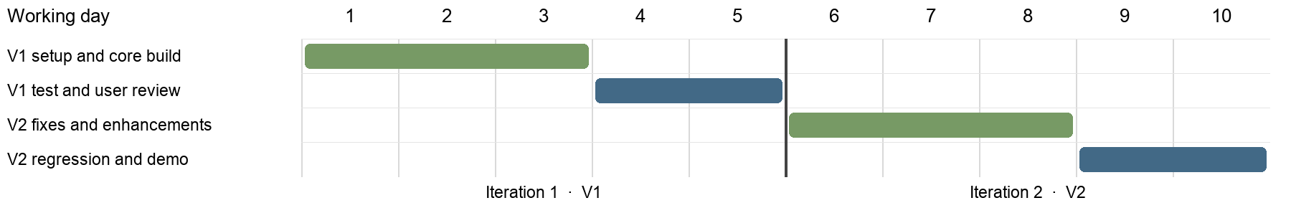
Iteration | Goal and activities | Review and exit evidence
1 · Days 1–5  Working V1 | Day 1: inspect V0, confirm reusable code, agree schema and fixtures, and establish a service plus persistent database. Days 2–3: implement backlog 1–4 and integrate daily. Day 4: test the full journey, invalid input, unit mismatch and failed writes. Day 5: fix blockers and run a user review. | Demonstrate pantry → matched recipe → missing-item list. HaoZhe Feng records expected and actual results, including restart recovery. ZheKai Mao aims to test with 5 target users and records actual participation, independent completion and confusion points.
2 · Days 6–10  Enhanced V2 | Day 6: rank V1 feedback and repair core failures. Days 7–8: implement backlog 5–8 in priority order. Day 9: run V1 regression cases and new V2 cases. Day 10: repeat user tasks, demonstrate both versions and package the release. | Demonstrate combined shopping, inspiration and calorie estimates, plus one verified feedback fix. HaoZhe Feng records regression results and data migration/recovery checks. ZheKai Mao compares task observations and documents remaining limitations.

5 Completion and change control
An item is done when acceptance cases pass, code is reviewed and merged, error states work, and notes are updated. Another member must reproduce setup. Tests cover the sample pantry, empty stock, shortages, incompatible units, failed writes and restart recovery.
The proposed usability target is 4 of 5 users completing the core task unassisted; report actual counts and sample limits. Data loss, false-ready matches and incorrect shopping totals block release.
Hold a brief daily check-in and integrate daily. ZheKai Mao manages priorities, Peng Ke and ChangPeng Shi cross-review, and HaoZhe Feng checks integration. Review the working build after each iteration; defer lower-ranked enhancements if needed and record unmet goals.

6 System overview and design decisions
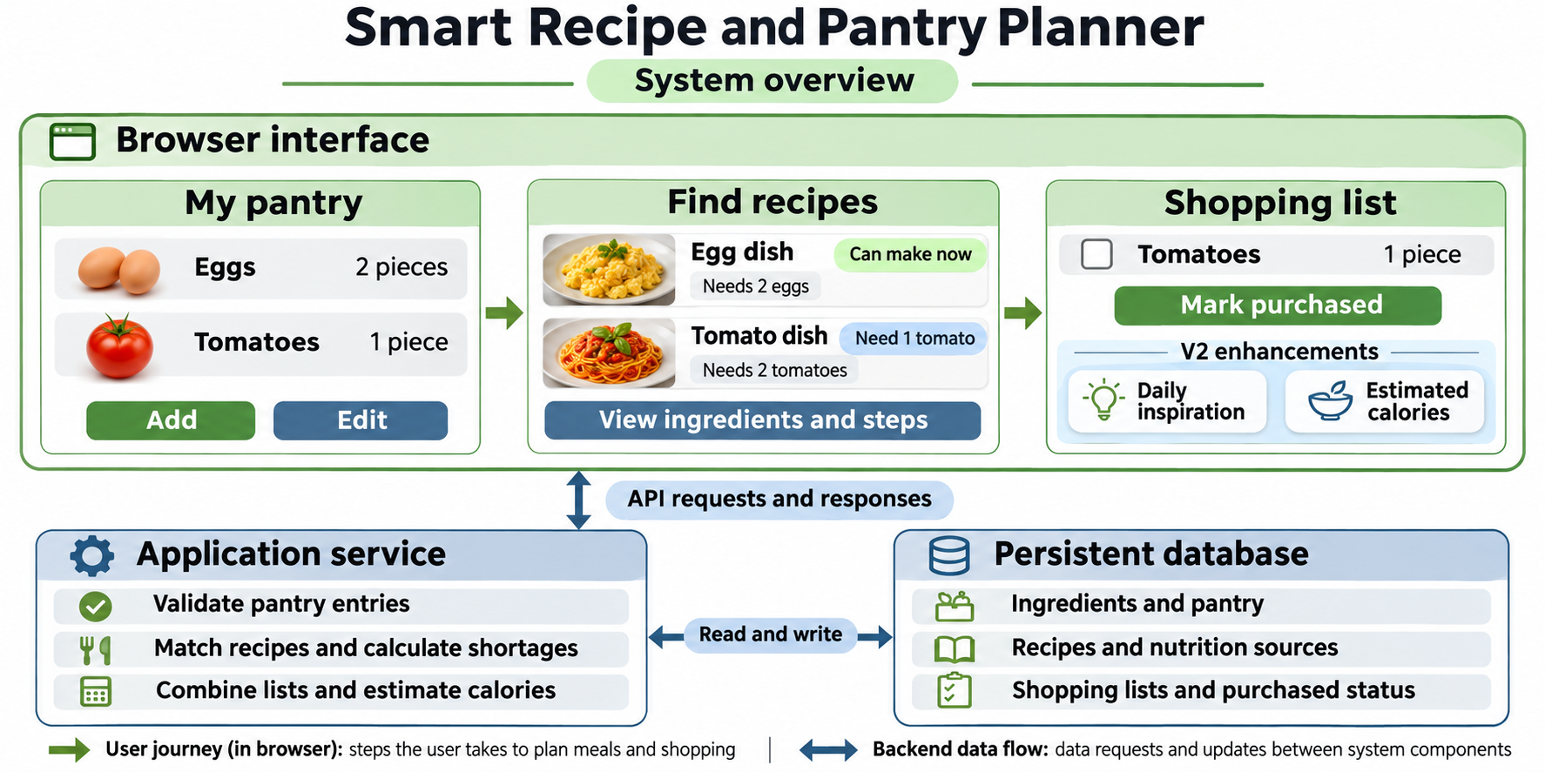
Figure 1. Proposed system concept with illustrative screens. Green arrows show the user journey; blue arrows show data flow. V2 adds purchased status, inspiration and calorie estimates.
A single application service and one database keep integration manageable for four students. The browser handles interaction; the service owns validation and calculations so all screens use the same rules. The team will confirm a compatible stack after inspecting V0 on Day 1. A supervised local demo is the initial deployment target.
Canonical ingredient IDs and explicit units prevent name and quantity mismatches. Convert only supported compatible units; never assume grams equal pieces. For several recipes, sum requirements first and subtract pantry stock once. Curated recipes and calorie data make the demo reproducible without a live external API; calorie values remain labelled estimates with sources. Daily inspiration is separate from pantry matching because it can suggest dishes requiring shopping.

7 Key risks and management
Risk and priority | Management and response | Owner
Incorrect matching or totals  High | Agree units and IDs on Day 1. Test insufficient stock, duplicate additions, incompatible units and combined demand. Any false-ready result or wrong total blocks release. | ChangPeng Shi
Scope exceeds ten days  High | Review progress daily. Finish Must items first; if work slips, defer expiry reminders and then lower-ranked V2 items. Record any unmet V2 goals at review. | ZheKai Mao
Integration or data loss  High | HaoZhe Feng integrates daily; test service restart and failed saves. Keep schema migrations and a pre-change backup, rehearse restore on test data, and revert to the last compatible build if needed. | HaoZhe Feng
Unreliable recipe or kcal data  Medium | Use a small checked dataset with recorded sources and usage rights. Check quantities and servings manually; show missing nutrition as unavailable. | ChangPeng Shi
Limited feedback or member absence  Medium | ZheKai Mao recruits users before Day 5 and records sample limits. Pair reviews and shared run notes let a backup continue work; HaoZhe Feng backs up Peng Ke/ChangPeng Shi integration and Peng Ke backs up ZheKai Mao’s trial facilitation. | ZheKai Mao
Pilot exposure or outage  High if hosted | Keep trials supervised and local initially. Before any shared pilot, HaoZhe Feng verifies workspace isolation, HTTPS, durable storage, startup recovery and backups, and names a primary and backup operator. Otherwise retain the local demo. | HaoZhe Feng

