Analysis of COVID-era Apple Mobility Data

Kekoa Kon

10/3/2021

## Setup

## Project Description

This rmarkdown file will use ggplot2 (Wickham 2016) and dplyr (Wickham et al. 2021) packages to analyze the Apple maps mobility data from the time before the COVID-19 pandemic through the initial shutdowns and the continuing changes over the course of the year.

The goal will be to create a subset to a particular state, tally up the number of cities and counties in that state with mobiltiy data, and then to make several plots to visualize those data subsets.

The state that this document will analyze is California.

## Subsetting Data

## Figures

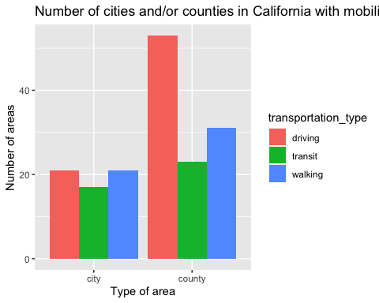

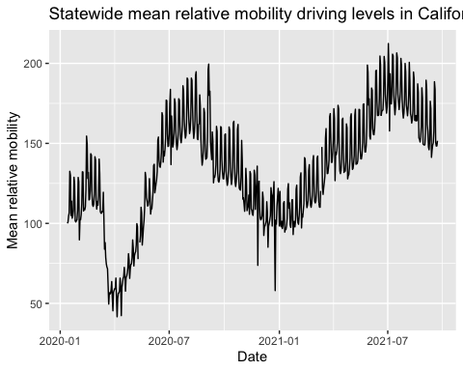

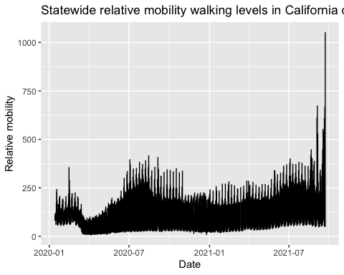

## Session Info

## ─ Session info ───────────────────────────────────────────────────────────────  
## setting value   
## version R version 4.1.1 (2021-08-10)  
## os macOS Big Sur 10.16   
## system x86_64, darwin17.0   
## ui X11   
## language (EN)   
## collate en_US.UTF-8   
## ctype en_US.UTF-8   
## tz America/Los_Angeles   
## date 2021-10-25   
##   
## ─ Packages ───────────────────────────────────────────────────────────────────  
## package * version date lib source   
## assertthat 0.2.1 2019-03-21 [1] CRAN (R 4.1.0)  
## bit 4.0.4 2020-08-04 [1] CRAN (R 4.1.0)  
## bit64 4.0.5 2020-08-30 [1] CRAN (R 4.1.0)  
## cachem 1.0.6 2021-08-19 [1] CRAN (R 4.1.0)  
## callr 3.7.0 2021-04-20 [1] CRAN (R 4.1.0)  
## cli 3.0.1 2021-07-17 [1] CRAN (R 4.1.0)  
## colorspace 2.0-2 2021-06-24 [1] CRAN (R 4.1.0)  
## crayon 1.4.1 2021-02-08 [1] CRAN (R 4.1.0)  
## DBI 1.1.1 2021-01-15 [1] CRAN (R 4.1.0)  
## desc 1.4.0 2021-09-28 [1] CRAN (R 4.1.0)  
## devtools * 2.4.2 2021-06-07 [1] CRAN (R 4.1.0)  
## digest 0.6.28 2021-09-23 [1] CRAN (R 4.1.0)  
## dplyr * 1.0.7 2021-06-18 [1] CRAN (R 4.1.0)  
## ellipsis 0.3.2 2021-04-29 [1] CRAN (R 4.1.0)  
## evaluate 0.14 2019-05-28 [1] CRAN (R 4.1.0)  
## fansi 0.5.0 2021-05-25 [1] CRAN (R 4.1.0)  
## farver 2.1.0 2021-02-28 [1] CRAN (R 4.1.0)  
## fastmap 1.1.0 2021-01-25 [1] CRAN (R 4.1.0)  
## fs 1.5.0 2020-07-31 [1] CRAN (R 4.1.0)  
## generics 0.1.1 2021-10-25 [1] CRAN (R 4.1.1)  
## ggplot2 * 3.3.5 2021-06-25 [1] CRAN (R 4.1.0)  
## glue 1.4.2 2020-08-27 [1] CRAN (R 4.1.0)  
## gtable 0.3.0 2019-03-25 [1] CRAN (R 4.1.0)  
## highr 0.9 2021-04-16 [1] CRAN (R 4.1.0)  
## hms 1.1.1 2021-09-26 [1] CRAN (R 4.1.0)  
## htmltools 0.5.2 2021-08-25 [1] CRAN (R 4.1.0)  
## knitr 1.36 2021-09-29 [1] CRAN (R 4.1.0)  
## labeling 0.4.2 2020-10-20 [1] CRAN (R 4.1.0)  
## lifecycle 1.0.1 2021-09-24 [1] CRAN (R 4.1.0)  
## lubridate * 1.8.0 2021-10-07 [1] CRAN (R 4.1.0)  
## magrittr 2.0.1 2020-11-17 [1] CRAN (R 4.1.0)  
## memoise 2.0.0 2021-01-26 [1] CRAN (R 4.1.0)  
## munsell 0.5.0 2018-06-12 [1] CRAN (R 4.1.0)  
## pillar 1.6.4 2021-10-18 [1] CRAN (R 4.1.0)  
## pkgbuild 1.2.0 2020-12-15 [1] CRAN (R 4.1.0)  
## pkgconfig 2.0.3 2019-09-22 [1] CRAN (R 4.1.0)  
## pkgload 1.2.3 2021-10-13 [1] CRAN (R 4.1.0)  
## prettyunits 1.1.1 2020-01-24 [1] CRAN (R 4.1.0)  
## processx 3.5.2 2021-04-30 [1] CRAN (R 4.1.0)  
## ps 1.6.0 2021-02-28 [1] CRAN (R 4.1.0)  
## purrr 0.3.4 2020-04-17 [1] CRAN (R 4.1.0)  
## R6 2.5.1 2021-08-19 [1] CRAN (R 4.1.0)  
## readr * 2.0.2 2021-09-27 [1] CRAN (R 4.1.0)  
## remotes 2.4.1 2021-09-29 [1] CRAN (R 4.1.0)  
## rlang 0.4.12 2021-10-18 [1] CRAN (R 4.1.0)  
## rmarkdown 2.11 2021-09-14 [1] CRAN (R 4.1.0)  
## rprojroot 2.0.2 2020-11-15 [1] CRAN (R 4.1.0)  
## rstudioapi 0.13 2020-11-12 [1] CRAN (R 4.1.0)  
## scales 1.1.1 2020-05-11 [1] CRAN (R 4.1.0)  
## sessioninfo 1.1.1 2018-11-05 [1] CRAN (R 4.1.0)  
## stringi 1.7.5 2021-10-04 [1] CRAN (R 4.1.0)  
## stringr 1.4.0 2019-02-10 [1] CRAN (R 4.1.0)  
## testthat 3.1.0 2021-10-04 [1] CRAN (R 4.1.0)  
## tibble 3.1.5 2021-09-30 [1] CRAN (R 4.1.0)  
## tidyr * 1.1.4 2021-09-27 [1] CRAN (R 4.1.0)  
## tidyselect 1.1.1 2021-04-30 [1] CRAN (R 4.1.0)  
## tzdb 0.1.2 2021-07-20 [1] CRAN (R 4.1.0)  
## usethis * 2.1.2 2021-10-25 [1] CRAN (R 4.1.1)  
## utf8 1.2.2 2021-07-24 [1] CRAN (R 4.1.0)  
## vctrs 0.3.8 2021-04-29 [1] CRAN (R 4.1.0)  
## vroom 1.5.5 2021-09-14 [1] CRAN (R 4.1.0)  
## withr 2.4.2 2021-04-18 [1] CRAN (R 4.1.0)  
## xfun 0.27 2021-10-18 [1] CRAN (R 4.1.0)  
## yaml 2.2.1 2020-02-01 [1] CRAN (R 4.1.0)  
##   
## [1] /Library/Frameworks/R.framework/Versions/4.1/Resources/library

## Sources cited

Wickham, Hadley. 2016. *Ggplot2: Elegant Graphics for Data Analysis*. Springer-Verlag New York. <https://ggplot2.tidyverse.org>.

Wickham, Hadley, Romain François, Lionel Henry, and Kirill Müller. 2021. *Dplyr: A Grammar of Data Manipulation*. <https://CRAN.R-project.org/package=dplyr>.